APPROVAL SHEET

Title of Dissertation: The Disruption of Bursting Behavior in Pancreatic Islets: A Network and Dynamical Systems Analysis of Multicellular Clusters

Name of Candidate: Janita Patwardhan
Doctor of Philosophy, 2020


Dissertation and Abstract Approved:
Dr. Bradford E. Peercy Associate Professor
Department of Mathematics & Statistics

Date Approved: April 14, 2020

2014-Present

ABSTRACT

Title of dissertation: The Disruption of Bursting Behavior
in Pancreatic Islets: A Network and Dynamical Systems Analysis
of Multicellular Clusters

Janita Patwardhan, Doctor of Philosophy, 2020

Dissertation directed by: Dr. Bradford E. Peercy

Department of Mathematics & Statistics

Pancreatic β cells, responsible for secreting insulin into the bloodstream and maintaining glucose homeostasis, are organized in the islets of Langerhans as clusters of electrically coupled cells. Gap junctions, connecting neighboring cells, coordinate the behavior of the islet, leading to the synchronized oscillations in the intracellular calcium and insulin secretion in healthy islets that is lost in diabetic islets. Recent experimental work has shown that optogenetically silencing certain β cells, called hub cells, can lead to a disruption in the coordinated behavior, calling into question the democratic paradigm of islet insulin secretion with equal input from each β cell. These islets were shown to satisfy three major criteria: scale-free functional connec- tivity, a loss of functional connectivity with hub cell silencing, and a loss of activity with hub cell silencing. In order to further investigate the notion of hub cells, a computational model representing the electrical and calcium dynamics of β cells during insulin secretion was applied to a network of cells connected by gap junc-

tions in this work. A functional connectivity network, often used in computational neuroscience, was built from the simulations by correlating the calcium concentra- tions of β cells. From the functional connectivity, some islets were observed to have scale-free network structures. Using centralities, hub cells, which emerge from the hub-follower property of scale-free networks, were identified as focal points in the islet and silenced to observe the impact on the islet activity. While a loss of functional connectivity was observed, the islet remained active, thus not fulfilling the three outlined conditions. To test scale-free networks with desynchronization, a predetermined hub cell was placed in the islet, which led to a loss of activity and functional connectivity with silencing, but not scale-free connectivity. As only two of the three properties could be satisfied, the focus shifted away from functional connectivity towards finding desynchronization with a network of heterogeneous cells. Switch cells, which were not highly functionally connected β cells, were found to turn off the islet activity when silenced. Results indicate that these cells have highly active cellular properties with neighbors near the threshold of activity, but need to be investigated further.

The Disruption of Bursting Behavior in Pancreatic Islets: A Network and Dynamical Systems Analysis of Multicellular Clusters

by

Janita Patwardhan

Dissertation submitted to the Faculty of the Graduate School of the University of Maryland Baltimore County in partial fulfillment
of the requirements for the degree of Doctor of Philosophy
2020

Advisory Committee:
Dr. Bradford E. Peercy, Chair/Advisor Dr. Arthur Sherman
Dr. Kathleen Hoffman Dr. Hye-Won Kang Dr. Matthias Gobbert

Qc Copyright by
Janita Patwardhan
2020

Acknowledgments

I would like to express my great appreciation to those who have assisted me during my graduate career, making this dissertation possible.
Most importantly, I must thank my advisor, Dr. Bradford E. Peercy for his patient guidance and encouragement. Our weekly meetings that ensured I was on track were a space for me to get advice on this challenging project. It has been an immense pleasure working with him the past few years.
I also need to thank my other committee members: Dr. Kathleen Hoffman, Dr. Arthur Sherman, Dr. Hye-Won Kang, and Dr. Matthias Gobbert. Dr. Hoffman has helped improve my technical writing skills, providing critiques both in and out of the classroom. Dr. Sherman provided me with this very interesting problem that has led to years of research and a dissertation, initiated as part of the NSF-REU (#1460652) project with Team 4 [1]. His suggestions provided crucial avenues of investigation. Dr. Hoffman and Dr. Sherman deserve an extra thanks for reviewing this manuscript. Dr. Kang pointed out some concerns regarding the addition of noise to this work. Dr. Gobbert was able to assuage the numerical issues that are discussed in this dissertation.
I would like to acknowledge other professors and lecturers in the department who have been invaluable to my graduate school experience either through classes or external guidance (listed alphabetically): Raji Baradwaj Dr. Animikh Biswas, Dr. Andrei Draganescu, Dr. Muddappa Gowda, Dr. Osman Gu¨ler, Dr. Weining Kang, Dr. Kalman Nanes, Dr. Nagaraj Neerchal, Dr. Florian Potra, Dr. Muruhan

Rathinam, Dr. Rouben Rostamian, Dr. Jinglai Shen, Dr. Bimal Sinha, Dr. Bedˇrich Soused´ık, Dr. Elizabeth Stanwyck, Bonny Tighe, and Dr. Justin Webster. The staff in the Department of Mathematics & Statistics have provided a great deal of help and support, in particular Maggie Kennedy, Boris Alemi, Janet Burgee, and Marshall Turner.
My deepest thanks go towards my family and friends. Without the depend- able and constant support from parents, Drs. Rita & Girish Patwardhan, and fianc´e, Joseph Hogan, I would not have been able to finish smoothly. Words cannot express the gratitude I owe them. I must also acknowledge the friendships and support of those in the department past and present (listed alphabetically): Neha Agarwal, Sumaya Alzuhairy, Aryana Arsham, Abhishek Balakrishna, Carlos Barajas, Lillian Chow, Ashley Copenhaver, Maria Deliyanni, Ellie Gurvich, Sylvia Gutowska, Kate- lynn Huneycutt, Eswar Kammara, Neil Kpamegan, Reetam Majumder, Nicole Mas- sarelli, Luan Chip Nguyen, Michael Retzlaff, Jeremy Rubin, and Kevin Williamson. The hardware used in the computational studies is part of the UMBC High Performance Computing Facility (HPCF). The facility is supported by the U.S. National Science Foundation through the MRI program (grant nos. CNS–0821258, CNS–1228778, and OAC–1726023) and the SCREMS program (grant no. DMS– 0821311), with additional substantial support from the University of Maryland,
Baltimore County (UMBC). See hpcf.umbc.edu for more information on HPCF and the projects using its resources.
I deeply apologize to anyone I inadvertently left out. Thank you all.

Table of Contents

List of Tables  List of Figures  1 Network Analysis Applied to Pancreatic Islets | vi  vii 1
1.1 Introduction . . . . . . . . . . . . . . . . . . . . . . . . . . . . . . . . | 2
1.2 Beta Cell Networks are Essential for Mechanistic Islet Simulations . . | 4
1.2.1 Mouse islets have a simpler organization than human islets . . | 4
1.2.2 Dysfunction without gap junctions . . . . . . . . . . . . . . . | 5
1.2.3 Beta cell configurations: simplistic to complex . . . . . . . . . | 6
1.3 Functional Connectivity Gives Additional Insight into Islet  Dynamics . . . . . . . . . . . . . . . . . . . . . . . . . . . . . . . . . | 8
1.3.1 Six degrees of separation and beyond . . . . . . . . . . . . . . | 8
1.3.2 The birth of functional connectivity in neuroscience . . . . . . | 10
1.3.3 Applying graph theory techniques to islets . . . . . . . . . . . | 11
1.3.4 Can hub cells coordinate islets? . . . . . . . . . . . . . . . . . | 14
1.3.5 What about subpopulations instead of hub cells? . . . . . . . | 15
1.4 Do Calcium Waves Explain Functional Connectivity? . . . . . . . . . | 16
1.4.1 Calcium waves can coordinate the islet . . . . . . . . . . . . . | 16
1.4.2 Gap junctions and cell heterogeneity make waves . . . . . . . | 18
1.4.3 Waves and avalanches: self-organized criticality . . . . . . . . | 19
1.5 Quantifying Islet Synchronization . . . . . . . . . . . . . . . . . . . . | 20
1.6 Conclusion . . . . . . . . . . . . . . . . . . . . . . . . . . . . . . . . . | 21
1.7 Recent Literature Results . . . . . . . . . . . . . . . . . . . . . . . . | 22
2 Flipping the Switch: Islet Desynchronization Through Cell Silencing | 25
2.1 Introduction . . . . . . . . . . . . . . . . . . . . . . . . . . . . . . . . | 25
2.2 Methods . . . . . . . . . . . . . . . . . . . . . . . . . . . . . . . . . . | 28
2.2.1 Model Equations, Heterogeneity, & Islet Structure . . . . . . . | 28
2.2.2 Methods of Analysis . . . . . . . . . . . . . . . . . . . . . . . | 32
2.3 Results . . . . . . . . . . . . . . . . . . . . . . . . . . . . . . . . . . . | 37

    - Scale-free networks do not imply desynchronization with
silencing 37
    - Predetermined hub cells are not functional hub cells 40
    - Switch cells desynchronize the islet 43
    - Spatially distributed parameters can also lead to switch cells . 46
    - Switch cells can have a variety of properties 48
    - Silencing cells is not the same as removing them 53
  - Discussion 55
- Quantitative Measures 59
  - Functional Connectivity 60
  - Scale-free Networks 69
  - Centralities 71
  - Synchronization 74
  - Wave Speed 79
- More Details Behind Finding Switch Cells 86
  - Numerical Study 86
  - Searching for Scale-Free Networks 93
    - Sensitivity Analysis 95
  - Predetermined Hub Cell 98
  - Switch Cells 101
    - Switch cells do not require high structural connectivity 102
    - Centralities do not label switch cells important 104
    - Cellular heterogeneity is important for the emergence of switch
cells 105
    - Cellular and structural heterogeneity do not follow a centrality pattern 108
    - A nucleus of switch cells 109
    - Islets with switch cells require fewer intrinsically active β cells
than average 111
    - Strong Coupling Cases 112
    - Switch Islets in the IOM 114
- Determining Active Cells 118
  - Using an Applied Current 119
  - Fast-slow subsystem analysis on a single cell 121
  - Extending fast-slow subsytem analysis to many cells 123
  - Reducing complexity 126
- Concluding Remarks 130
A Single Slow Channel Model Equations & Parameters 134
Bibliography 139

List of Tables

2.1 Cell Heterogeneity. Heterogeneous parameter values were selected from Gaussian distributions with the given means and standard deviations. . . 31
3.1 Comparison of Synchrony Indexes Corresponding to Fig 3.9 . . . 79
  - Cell Parameter Perturbation on Fig 2.4. The number of cells in the 57 cell islet that resulted in a loss of scale-free connectivity (i.e. R² < 0.7 for the power law fit), broke the condition of at least 50% loss of functional connectivity with the silencing of hub cell 43, or led to minimal changes
when the individual cell was perturbed 1% in the indicated manner. 97
  - Distribution of Switch and Nonswitch Islets. Classification of 500 parameter sets drawn with the indicated mean coupling value and g_{KAT} _{P} ∼ N (135, 13.5) as switch islets (containing at least one switch cell), active nonswitch islets (active islets without switch cells), or silent islets (islets
with little to no activity). 113
  - Distribution of Switch and Nonswitch Islets in the IOM. 1000 parameter sets of 13 cells drawn with g_{C} ∼ N (10, 5) and the indicated g¯_{KAT} _{P} value were classified as switch islets (containing at least one switch cell) and active nonswitch islets (active islets without switch cells), or silent islets (islets with little to no activity). The percentage of switch islets out
of the total number of active islets is also denoted. 115
  - Homogeneous Model Parameters. 137
  - Heterogeneous Model Parameters. Heterogeneous parameter and initial values were selected from distributions with the given
means and standard deviations. 138

List of Figures

  - Islet structures. Different computational schematics for β cells in an islet: (a) cubic lattice from [2], (b) hexagon closest packing from [3], (c)
spherical packing from [4], (d) drawn from experiments from [5]. 7
  - Functional connectivity networks at varying glucose. Functional connectivity represented with yellow (weaker) to brown (stronger) lines be- tween the red nuclei of cells for 5 different regimes: low glucose (B1), initial activation to high glucose (B2), high glucose (B3), initial deactivation to
low glucose (B4), and low glucose (B5). Taken from [6]. 12
  - Clustering in functional connectivity at different glucose. Experi- mentally measured functional connectivity at (a) 6 mM glucose, (b) 7 mM glucose, (c) 8 mM glucose, (d) 9 mM glucose, (e) 10 mM glucose and (f) 12 mM glucose taken from [7]. The colors denoted different clusterings in
the small-world network. 13
  - Hexagonal Closest Packing Lattice for Islet. The schematic of a hexagonal-closest-packed lattice with m = 3 (57 cells). (A) A side view of
the islet. (B) The view from above the islet. 32
  - Spatial Distributions for gK(ATP ) and g_{Ca}. An example of the spatially distributed cell parameters with the orienting cell 53. The darker blue for
    - gK(ATP ) and green for (B) g_{Ca} denote the higher conductance values. 33
  - Synchronization of a model islet Raster plots of (A) completely syn- chronized, (B) a desynchronized, and (C) silent islet. A point is plotted whenever a cell was considered active. 36
  - Scale-free connectivity and a loss of functional connectivity with hub cell silencing. This parameter set had gK(ATP ) ∼ N (143, 14.3) pS and g_{C} ∼ N (4, 2) pS with 33% of connections killed. (A) The distribution of functional connections fitted to a power law with R² = 0.77. (B) The
functional connectivity graphs before (top panel) and after (bottom panel) the silencing of cell 43, the hub cell. (C) The raster plots before (top panel)
and after (bottom panel) cell 43, indicated in green in (B), was silenced. 39

  - Predetermined hub cell. This parameter set had gK(ATP )(nonhubs) ∼ N (145, 7.25) pS, gK(ATP )(hub) = 100 pS, and g_{C} ∼ N (4, 2) pS. (A) The distribution of functional connections fitted to a power law with R² =
0.13. (B) The functional connectivity graphs before (top panel) and after (bottom panel) the silencing of hub cell 1. (C) The raster plots before (top panel) and after (bottom panel) hub cell 1 was silenced. 41
  - Switch cell silencing. The parameter set for (A)-(C) had gK(ATP ) ∼ N (145, 14.5) pS and g_{C} ∼ N (5, 2.5) pS while the cells in (D)-(F) followed gK(ATP ) ∼ N (135, 13.5) pS and g_{C} ∼ N (200, 100) pS . The distribution of functional connections fit a power law with R² = 0.028 in (A). No fit
was found for (D). The functional connectivity graphs before (top panel) and after (bottom panel) the silencing of (B) switch cell 11 and (E) switch cell 57. The raster plots before (top panel) and after (bottom panel) (C)
switch cell 11 and (F) switch cell 57 was silenced. 45
  - Switch cell silencing with spatially distributed cell parameters. The distribution of (A) gK(ATP ) and (B) g_{Ca} of the islet are denoted with the darker blue and green representing higher values. The orienting cell was selected as cell 7. (C) The intrinsically active cells in the islet are shown in red. (D) The distribution of functional connections did not have a fit. (E) The functional connectivity graphs before (top panel) and after (bottom panel) silencing switch cell 18. The raster plots before (top panel)
and after (bottom panel) switch cell 18 was silenced. 47
  - Cell Parameter Sensitivity for Switch Cell Islets. Perturbing cell parameters (A) g_{Ca}, (B) gK(ATP ), and (C) g_{K}, g_{S}, and k_{Ca} resulted in being pushed out of the loss of activity regime with both a 10% decrease and 10% increase (blue cells), with a 10% increase (yellow cells), with a 10% decrease (magenta cells), or minimal to no change at all (white cells).
The switch cell for this parameter set is cell 11. The red lines connecting
cells denote the nonzero gap junction connections in the network. 49
  - Initiator versus Percolator Switch Cell. Switch cells are denoted in green, their gap junctionally connected neighbors in blue, and remaining cells in navy. The islet structure with (A) an initiator and (B) a percolator switch cell. (C) Raster plots for islets with switch cells in green to indicate the differences in period between initiators (top panel) and percolators (bottom panel). The activation parameters for each cell in the islet are shown for a parameter set with (D) an initiator and (E) a percolator switch cell. The black line represents the Hopf bifurcation below which a cell, when isolated, will burst. Calcium time courses for (F) an initiator
and (G) a percolator switch cell relative to the rest of the islet. 51
  - Histogram of Active Cells at a Fixed Level of Glucose. The number of active cells per parameter set for parameter sets with switch cells (red, N=50) and some of the parameter sets without switch cells (blue, N=321). The region of overlap is denoted in the darker brown color. The distribu- tions for parameters are g_{Ca} ∼ N (1000, 50) and gK(ATP ) ∼ N (145, 14.5)
where g_{C} ∼ N (5, 2.5). 52

  - Swapping Switch Cell Properties. (A) Activation parameters for cells in the islet with the switch cell in green, its neighbors in blue, and all other cells in navy. (B) Raster plots for the islet before silencing (top panel), with switch cell 42 silenced (middle panel), and for cell 12 silenced (bottom panel). (C) Raster plots for an islet with the cellular properties of cells 42 and 12 swapped before silencing (top panel), with the new cell 42 with properties of the original cell 12 silenced (middle panel), and for the new
cell 12 with properties of the original cell 42 silenced (bottom panel). 53
  - Silencing Versus Isolating. (A) A parameter set with g_{C} ∼ N (5, 2.5) and gK(ATP ) ∼ N (145, 14.5) with the switch cell silenced (top panel) and the switch cell isolated (bottom panel). (B) A parameter set with g_{C} ∼ N (200, 100) and gK(ATP ) ∼ N (135, 13.5) with the switch cell silenced (top panel) and the switch cell isolated (bottom panel). (C) The percentage of parameter sets with silencing (blue) and isolating (green) switch cells out of the number of active parameter sets as the gap junction was increased
with gK(ATP ) ∼ N (135, 13.5) pS. 54
  - Pearson Correlation and Altered Sine Curves. The impact of dif- ferent modifications to a sine curve on the Pearson correlation coefficient.
    - Vertical shift by 1 with ρ_{1,2} = 1, (b) scaling factor of ⁶ with ρ_{1,2} = 1,
5
(c) horizontal shift by 1 with ρ_{1,2} = 0.543, and (d) period doubling with
ρ_{1,2} = −0.041. 61
  - Correlation Coefficients for Two Cell System at Different Cou- pling Strengths. The same cell parameters were used for all three sub- figures. Increasing the coupling strength increased the correlation from
    - g_{C} = 0 pS with ρ_{1,2} = −0.128 to (b) g_{C} = 5 pS with ρ_{1,2} = 0.33 to (c)
g_{C} = 10 pS with ρ_{1,2} = 0.47. 62
  - Similarity Coefficient and Altered Sine Curves. The impact of different modifications to a sine curve on the similarity coefficient (C_{1,2}) given the binarization threshold of 1. (a) Vertical shift by 1 with C_{1,2} =

0.934, (b) scaling factor of ⁶
5
with C_{1,2} = 0.991, (c) horizontal shift by 1

with C_{1,2} = 0.681, and (d) period doubling with C_{1,2} = 0.497. 65
  - Similarity Coefficients for Two Cell System at Different Coupling Strengths. The same cell parameters were used as in Fig 3.2. Increasing the coupling strength increased the correlation from (a) g_{C} = 0 pS with C_{1,2} = 0.44 to (b) g_{C} = 5 pS with C_{1,2} = 0.635 to (c) g_{C} = 10 pS with
C_{1,2} = 0.724. 66
  - Comparison between Functional Connectivity Measures on 57 Cell Islet. The functional connectivity of a 57 cell islet with g_{C} ∼ N (5, 2.5) for an active islet with g_{KAT} _{P} ∼ N (130, 13) measured using
    - Pearson correlation coefficient and (b) similarity coefficient. The func- tional connectivity was then calculated for a silent islet with g_{KAT} _{P} ∼ N (155, 15.5) using (c) Pearson correlation and (d) similarity coefficient. 68

  - The Difference in Fits with a Shift in the Distribution. The func- tional connectivity distribution was shifted to the right by (a) c = 1 with R² = 0.7738, (b) c = 2 with R² = 0.7534, (c) c = 3 with R² = 0.7362, (d)
c = 4 with R² = 0.7223, and (e) c = 5 with R² = 0.7111. 70
  - Centralities. The (a) degree centrality, (b) eigencentrality, (c) closeness centrality, and (d) betweenness centrality measure on the same structural connectivity distribution visualized where the darker red cell color indi- cates the more influential cells in the network and lines between cells show
the gap junction connections. 73
  - Unweighted and Weighted Centralities. The degree centrality mea- sure on the structural connectivity of an active islet with the darker red color representing a higher ranked cell in (a) unweighted and (b) weighted calculations. Similarly the eigencentrality for (c) unweighted and (d) weighted calculations and the closeness centrality for the (e) unweighted
and (f) weighted calculations. 75
  - Traces for Synchrony Comparison in Table 3.1. The top panel shows the traces while the bottom panel displays the raster plot of the binarized activity for (a) a silent islet, (b) a desynchronized islet,(c) a medium coupled islet, and (d) a synchronized islet. 78
  - Wave Across a Line of 8 Cells. (a) The calcium traces of the 8 cells
where the first cell is active (in darker blue) and the remaining cells are close the threshold. The cyan trace represents the average calcium trace.
(b) The cross-correlation coefficients with various time lags. 80
  - Functional Connectivity Increases with Wave Velocity. Wave ve- locity and functional connectivity for a line of 8 cells with coupling ranging
from 0-100 pS. 81
  - An Example of a Negative Wave Velocity. A line of 5 cells where the first cell in dark blue initiates the wave and the cyan trace represents
the average calcium trace. 82
  - Subthreshold Signal Propagation. In the top panel, 3 uncoupled cells where only cell 3 (in yellow) is active, but cell 1 (in blue) is close the threshold for activity. In the bottom panel, the same three cells, but now
cell 2 (orange) is coupled to cell 1 and 3 with conductance 3 pS. 84
  - Differences between MacBook Air solution and HPCF solution.
Using the same parameter set and code, two different solutions found by
    - MacBook Air and (b) high performance computing facility 87
  - Nonconverging traces. Traces for a single cell (part of a larger islet of 57 cells) found at different relative tolerances RelTol with absolute tolerance
AbsTol = RelTol / 100. 88
  - Impact of including the Jacobian in the differential equations solver. Traces of a single cell from a 57 cell islet found at different relative
error tolerances (a) without using the Jacobian and (b) with the Jacobian. 89

  - Variation Across Tolerances on Synchrony (a) The synchrony index of the same cell’s traces across different relative tolerances at increasing coupling values. (b) The synchrony index of the same islet at different
relative tolerances for different coupling strengths. 91
  - Mean Islet Synchrony Across Relative Tolerances. The average with standard deviation taken across the synchrony indexes for a param- eter set with different relative tolerances as varied by conductance. Each
color denotes a single parameter set. 92
  - Scale-Free Functional Connectivity Distributions for Increasing Coupling. Examples of the functional connectivity distributions classified as scale-free for (a) g_{C} ∼ N (3, 1.5) pS, (b) g_{C} ∼ N (3.5, 1.75) pS, and (c)
g_{C} ∼ N (4, 2) pS. 94
  - Adding Heterogeneity to a Predetermined System. (a) The ho- mogenenous system with the center cell 1 as the predetermined hub cell,
- the nonhub cells have g_{KAT} _{P} ∼ N (133.5, 1.335), (c) the nonhub cells have g_{KAT} _{P} ∼ N (133.5, 13.55), (d)-(f) the other cell parameters are drawn heterogeneously with the standard deviation 1%, 2%, and 5% of the mean,
respectively with g_{KAT} _{P} ∼ N (145, 7.25) for the nonhub cells. 99
  - Killing the Connections of the Switch Cell. Parameter set from Fig 2.6(a)-(c). Top panel: the original simulation before silencing. Middle panel: the connection is killed between switch cell 11 and neighbor cell 4.
Bottom panel: the connection is killed between switch cell 11 and neighbor
cell 26. 103
  - Centrality Measures to Find the Switch Cell. Parameter set from Fig 2.6(a)-(c). Darker colors indicate higher ranked cells according to
    - unweighted degree centrality, (b) weighted degree centrality, (c) un- weighted eigencentrality, (d) weighted eigencentrality, (e) unweighted close-
ness centrality, and (f) weighted closeness centrality 105
  - Increasing and Decreasing Cell 11 Parameters & Synchrony. The increasing marker size corresponds to the percentage of perturbation: 0.1%, 1%, 5%, and 10%. The colors represent the different parameter values that were perturbed: g_{Ca} (red), g_{K} (yellow), g_{KAT} _{P} (green), g_{S} (cyan), and k_{Ca} (blue). The axes are the synchrony indexes before silencing (x−axis) and the synchrony indexes while cell 11 is silenced (y−axis). The black lines
denote the synchrony for both scenarios before any perturbations. 106
  - Varying g_{Ca} of Cell 11. Top panel: the original simulation, middle panel: g_{Ca} of cell 11 increased by 10%, and bottom panel: g_{Ca} of cell 11 decreased by 10%. 107
  - Raster Plots from an Islet with Multiple Switch Cells. The top panel shows synchronized islet bursts before the silencing of any cell. The second, third, and fourth panels depict the effects of silencing cell 21, 32,
and 36 respectively on the islet. 110

  - Examples of 13 Cell Switch Islets using the IOM. Subfigures (a)-
- are from a parameter set with g¯_{KAT} _{P} ∼ N (28000, 2800) while the
parameter set in (d)-(f) had g¯_{KAT} _{P} ∼ N (30000, 3000). In (a) and (d),
the raster plots before and while silencing the switch cell, (b) and (e) the distribution of functional connections, and lastly (c) and (f) the functional connectivity network. 117
  - Example of 57 Cell Switch Islet Using the IOM. The parameter set was drawn with g¯_{KAT} _{P} ∼ N (30000, 3000) and g_{C} ∼ N (10, 5). (a) The
raster plot of the cells activity before and while silencing cell 43, (b) the distribution of functional connectivity, and (d) the functional connectivity network. 117
  - Bifurcation Diagram for an Active and Silent Cell. The stable steady state is denoted by the red line, the unstable by the black line. The Hopf bifurcation (HB) is designated with a black square from which the green stable orbit arises. The two limit points (LP1, LP2) are shown by the black circles. The s-nullcline of the full system is the cyan curve, with its intersection (SS) with the bifurcation diagram marked with a black triangle. The full system trace is overlaid in blue. The parameters selected were g_{Ca} = 990 pS and (a) g_{KAT} _{P} = 130 pS and (b) g_{KAT} _{P} = 140 pS.
Figure (c) is a zoomed in section of (a). 122
  - Comparison of V_{lim} and V_{int} for 2 Coupled Cells. (a) The V_{lim} − V_{int} for the incorrectly predicted cells with blue representing cells that were predicted to be one active-one silent but both were silent, red for cells that were predicted to be both active, but was one active-one silent, and red for cells predicted to be one active-one silent but both were active. (b)
The same graph from (a) on top of all the correctly predicted cells in cyan. 125
  - Impact of Weaker Coupling on Activity for Two Cells. Each pa- rameter set, represented by the g_{KAT} _{P} of cell 1 (x-axis) and cell 2 (y-axis), is designated as two active cells (red), one active cell and one silent cell (blue), and two silent cells (green). The coupling increases from (a) 0 pS,
(b) 1 pS, (c) 2 pS, (d) 3 pS, (e) 4 pS, and (f) 5 pS. The dashed black lines represent the g_{KAT} _{P} threshold for activity for a single cell. 127
  - Impact of Stronger Coupling on Activity for Two Cells. Each parameter set, represented by the g_{KAT} _{P} of cell 1 (x-axis) and cell 2 (y- axis), is designated as two active cells (red), one active cell and one silent cell (blue), and two silent cells (green). The coupling increases from (a) 6 pS, (b) 8 pS, (c) 10 pS, (d) 15 pS, (e) 20 pS, and (f) 100 pS. The dashed
black line represents the g_{KAT} _{P} threshold for activity for a single cell. 129

Chapter 1: Network Analysis Applied to Pancreatic Islets

Much of the content in this chapter has been accepted to be published as an encyclopedia chapter in Systems Medicine: Integrative, Qualitative and Com- putational Approaches [8]. In this chapter, we discuss the network analysis tools recently developed in mathematical biology, allowing a deeper insight into biolog- ical systems, with a focus on the islets of Langerhans. Computational models of a single β cell have been applied to various network structures consisting of cells connected by gap junctions. A functional connectivity network, often used in com- putational neuroscience, is built from the results of the simulations or experiments by correlating the calcium concentrations of β cells. From the functional connectiv- ity, islets are observed to have small-world and scale-free network structures, which have been observed both computationally and experimentally [6, 7, 9, 10]. Using centralities, hub cells, which emerge from the hub-follower property of scale-free networks, are identified as focal points in the islet [10]. Experimentally silencing the activity in hub cells has shown a desynchronization in islet behavior, some as- pects of which have been replicated in simulations [5]. Other experiments focus on heterogeneous subpopulations to describe the nature of β cell dynamics in the islet, where some more metabolically active subregions recruit neighboring clusters into

electrical bursting [4]. Mechanistically, calcium waves coordinate the heterogeneous clusters, thus synchronizing the islet’s activity. As it was submitted in December 2018, there is some more recent relevant work that should be mentioned. This has been added to the end of this chapter in Section 1.7.

Introduction

Much of the world around us can be represented as a network, from airline transportation [48] to the spread of information [11]. Network analysis has been a growing field over the past twenty years, allowing for further investigation into the properties of complex systems like the power grid [12], the internet [13], and social networks [14]. More recently the study of networks in biological systems arose through neuroscience, examining the synaptic connections between cells in the brain [15]. Advances in imaging technology have allowed for more focused and noninvasive high-speed measurements, capturing simultaneous data from a larger number of cells over long time periods. With observations from individual cells, the techniques from neuron network analysis can now be applied to the study of electrically coupled cells in the islets of Langerhans, located in the pancreas.
Pancreatic islets play a critical role in diabetes mellitus, which is characterized by high levels of glucose in the blood. Through the process of digestion, glucose is absorbed into the bloodstream. Pancreatic β cells, the predominant cell type in islets, then secrete a peptide hormone called insulin that signals cells to absorb glucose, which is the primary source of energy for most cells. Type 1 diabetes,

commonly known as juvenile diabetes, involves an autoimmune response destroying β cells in the pancreas, leading to a near complete loss of insulin and the inability to lower the levels of glucose in the blood. It has become apparent that while type 1 diabetes is generally first diagnosed in children, adult-onset of type 1 diabetes has occurred in many patients. Type 2 diabetes, also known as adult-onset diabetes but which has also been diagnosed in children, is generally caused by insulin resistance and a dysfunction in insulin secretion [16]. Thus, understanding the process behind insulin secretion is critical for grasping the mechanisms behind type 2 diabetes, for which various measures are required.
A difference observed between healthy and diabetic islets relates to the pul- satility of insulin in the blood stream. It has been experimentally measured that blood insulin levels are pulsatile over time, implying that insulin must be secreted by β cells in a synchronized manner between both cells in the islet and islets them- selves. A loss of this synchrony has been characterized in islets of type 2 diabetic patients [17]. The many islets located in the pancreas may synchronize through a glucose/insulin feedback, as all islets are exposed to the blood stream [18]. The coordinated activity within an islet has been attributed to strong coupling between β cells via gap junctions that connect the cytosol of neighboring cells, allowing ions to flow from one cell to another [19].
By investigating properties of the islet as a whole through the lens of network analysis, more can be understood about insulin secretion from pancreatic β cells. We first delve into islet structure biologically and their construction computationally. Next, we discuss the idea of small-worldness, scale-free networks, and functional

connectivity, starting with their origins before moving into an exploration of their applications in pancreatic islets. This will segue into an examination of calcium waves, which are thought to lead to synchronous activity in clusters of β cells. We will end with some methods to quantify coordinated activity in islets, as it is an important indicator of proper islet function.

Beta Cell Networks are Essential for Mechanistic Islet Simula- tions
While insulin secretion is straightforward for a single β cell, β cells are orga- nized in a network of many cells. Through gap junctions, the cytosol of neighboring β cells are connected. The nearest neighbors influence a cell’s activity, leading to a difference in the behavior of β cells in a network compared to single, isolated β cells. A cell that when isolated is activated at higher levels of glucose can begin to burst at lower levels of glucose due to the electrical influence of its active neighbor. This difference in activation levels has been confirmed experimentally [20]. Thus, it is important to study β cells in a network with gap junctions, experimentally and computationally.

Mouse islets have a simpler organization than human islets

The islets of Langerhans are dense clusters of cells located in the pancreas, con- sisting of multiple different cell types. The most prominent cell type, encompassing around 80% of the mouse islet and 60% of a human islet, is the β cell, responsible

for secreting insulin and lowering blood glucose levels [21, 22]. Islets also contain glucagon-secreting α cells, somatostatin-secreting δ cells, ghrelin-secreting ε cells, and pancreatic polypeptide-secreting PP cells, all of which play roles in maintaining glucose homeostasis.
The organization of cells in mouse and rat islets is well understood. Beta cells are centrally clustered, forming the core of the islet while the remaining cells create a mantle-like formation around the β cells [23]. The contact from neighboring β cells improve islet function, suggesting a beneficial impact of a core-mantle islet structure [24]. Meanwhile, human islets have α and δ cells dispersed among the β clusters, with a slightly higher proportion of α cells and lower percentage of β cells than in a mouse islet [21]. With the increased number of α cells, human islets are more responsive to hypoglycemia, which activates α cells [21]. When glucose concentrations are elevated, α cells enhance β cell activity.

Dysfunction without gap junctions

Experimental measurements from intact islets are different than those of iso- lated β cells [25, 26]. Islets have a decreased, but appropriate insulin response at low glucose while also having increased secretion at elevated glucose compared to isolated β cells. This can be attributed to cell-cell communication through gap junc- tions. In the membrane of a β cell, a protein (e.g. connexin 36) forms a channel called a gap junction that is connected to gap junction proteins in its neighbor- ing cell, allowing small ions and molecules to diffuse from one cell to the other.

Through gap junctions, electrical activity during low glucose can be suppressed by the less excitable β cells, preventing the secretion of superfluous insulin and poten- tially hypoglycemia. On the other end of the spectrum, in high glucose, those less excitable cells will activate due to the diffusion of pulsatile activity of the neigh- boring cell through gap junctions. Mouse models without gap junctions experience a loss of coordinated oscillations, elevated basal release of insulin, and no increase in insulin secretion with postprandial glucose concentrations [27–31]. The loss of synchronization has been observed in humans with diabetes [17, 32, 33].

Beta cell configurations: simplistic to complex

With gap junctions represented as edges in a graph, networks of β cells can be built for simulations. The most often used islet structure is a cubic lattice, allowing for a cell to have at most 6 nearest neighbors [2, 19, 34–36]. A visualization of this can be seen in Figure 1.1(a), taken from [2]. Another idea for a β cell network structure with regular spacing is a hexagon closest packing lattice [3, 9]. Shown in Figure 1.1(b), this structure consists of alternating layers of regular and irregular hexagons, allowing a cell in this structure to have at most six connections on the same layer and three connections each with cells on the layer above and below, for a total of at most 12 nearest neighbor connections.
A different technique involves randomly assigning cells a position in a square, with a given minimum distance between cells [37]. Two cells with a distance less than a selected radius, dependent on the desired average degree and total number

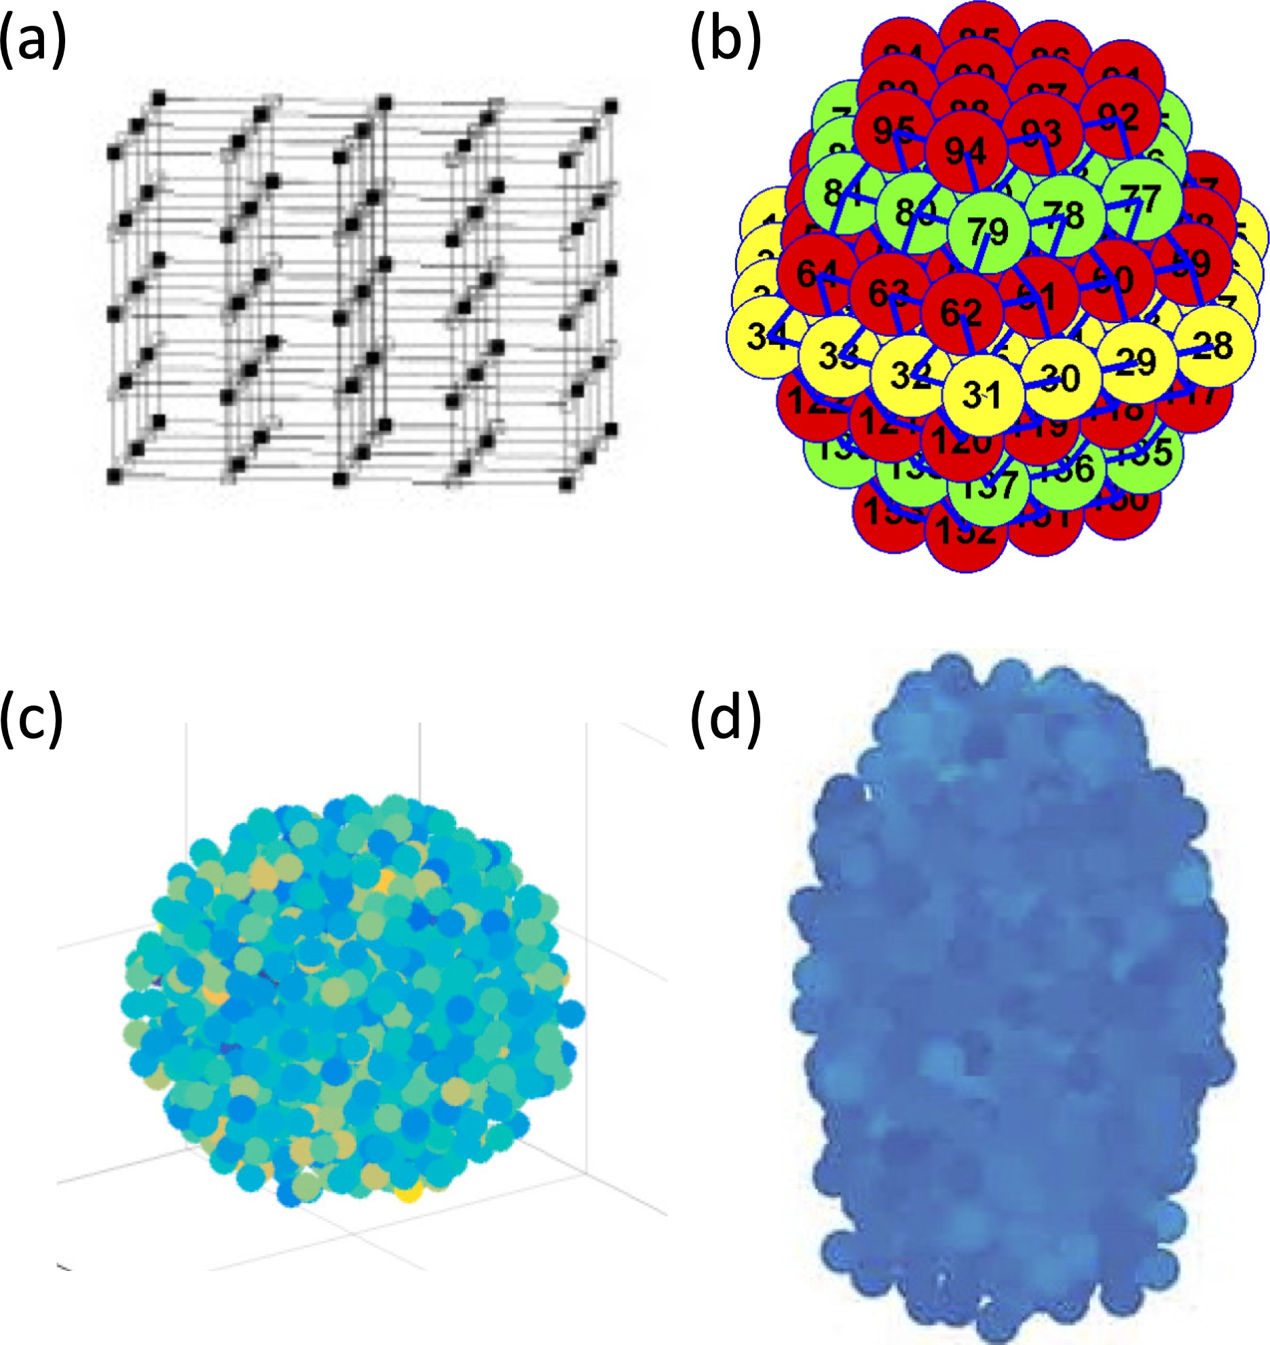

Figure 1.1: Islet structures. Different computational schematics for β cells in an islet:

(a) cubic lattice from [2], (b) hexagon closest packing from [3], (c) spherical packing from [4], (d) drawn from experiments from [5].
of cells in the structure are considered to be coupled via gap junction connections. A spherical packing algorithm, seen in Figure 1.1(c), has also been utilized, where cells are considered connected if their distance is within 20% of the cell radius [4]. Multiple groups build their computational structure off experimental data. Striegel et al. [38] used a published data set of over 9000 control and 8000 type 2 diabetic 2D sections of islets while Lei et al. [5] utilized the coordinates gathered experimentally from 3D structures of human and mouse islets from four donors each to determine the location of each β cell in their structure as depicted in Figure 1.1(d). The connectivity between the coordinates was found similarly by setting a threshold distance between cells.

Functional Connectivity Gives Additional Insight into Islet Dynamics
While the structural connectivity plays a key role in islet research, it does not completely describe the relationship between the activity of cells in the islet. Thus a new functional connectivity network, built from correlations in calcium traces, is needed to be able to study the dynamics of the network. Various computational measures can be applied to the functional connectivity network to understand the properties of the islet and the cell-to cell communication.

Six degrees of separation and beyond

With a complex network made of nodes and edges, graph theoretical methods can be utilized to study the network independent of the system associated with it. One measure of interest is the clustering within a network. Most real-world networks, such as social networks, tend to have dense clusters of nodes [39]. A local clustering coefficient can be measured for each node indicating the degree to which that node and its neighbors are a clique, a graph with every distinct node adjacent to each other. This coefficient is calculated as a ratio between the edges in the neighborhood of that node and the total possible edges in the neighborhood [15]. This is then averaged over all the nodes in the network to get the global clustering coefficient, C_{avg}. In a social network, the local clustering coefficient represents the degree to which friends of a person are friends with each other while the global

clustering represents the extent to which the group of friends is tight knit.

Another measure of interest of a network is its path length. This is calculated by finding the smallest number of edges connecting two nodes and averaging that over the network [15]. The path length represents the separation between nodes in the graph. The inverse of the average path length is called the global efficiency, E_{glob} of the network, measuring the effectiveness of network connectivity [40].
Many real-world systems, such as neural networks, social networks, and the power grid, are observed to have a high clustering coefficient, but small path lengths, leading to the introduction of small-world networks [15]. A small-world network is described as having a higher level of clustering, but a similar efficiency to a random network. Thus, to calculate the small-worldness of a network, a clustering coefficient, C_{rand}, and global efficiency, E_{rand}, need to be calculated for a random graph with the same number of cells, connections, and average degree, used to normalize the coefficients of the network of interest. A parameter to describe small-worldness is
computed by
Cavg/Crand
S =
Erand/Eglob

where C_{avg} represents the clustering coefficient of the network and E_{glob} is the global efficiency, with S > 1 signifying a small world network [41].
Another type of network designation often seen in real world networks is a scale-free network, characterized by a degree distribution asymptotically following a power-law distribution [42]. The degree of a node represents the number of edges it has and the degrees of all nodes in the network make the degree distribution.

Thus, a scale-free network has very few highly connected nodes and many sparsely connected nodes. This can be realized by new vertices in the network attaching to well established and connected nodes. Various properties are known about different types of networks, and thus being able to classify a network of β cells as a small-world or scale-free network brings additional insight into any analysis.

The birth of functional connectivity in neuroscience

An area of interest in neuroscience is understanding regions of the brain that share functionality. To assist with that goal, the idea of functional connectivity was developed. Using temporal correlations of activity, regions or cells in the brain can be functionally connected, developing a network that can then be analyzed. When considering a network of neurons, some functional connections could result from neighboring contact, such as gap junctions, or from synaptic connections. Through analyzing magnetoencephalographic recordings of the brain, which measures the magnetic fields generated from electric currents of neurons, it has been observed that the brain is organized as a small-world network [43]. It has been suggested that this organization is the optimal balance between segregation (clustering) and integration (efficiency) [44].
With these neuron networks, centralities can be applied to find the more ‘im- portant’ or functional regions in the brain. There are many different types of cen- trality, which rank the nodes of a graph in order of influence on the network. The degree centrality, which is most often used, orders nodes based on their number

of edges, which can be interpreted as arranging cells according to the degree with which they interact with the network [45]. Another centrality is the eigencentrality, which considers the importance of a node’s neighbors by looking at the dominant eigenvector of the adjacency matrix, a square matrix denoting adjacent or connected pairs of vertices [46]. These centralities assist in determining the network hubs in the brain [47].

Applying graph theory techniques to islets

These techniques of classifying and analyzing neuronal networks have recently been applied to pancreatic islets, with a focus on β cells. From experimentally measured calcium gathered from confocal calcium imaging, functional networks are built [6]. Highly correlated cells are deemed to be functionally connected using a Pearson correlation (coefficient above a threshold value, for example 0.75) with cal- cium traces of β cells in an islet. Connectivity is measured during five time periods: low glucose, initial activation of β cell in high glucose, high glucose, initial deacti- vation of β cells in low glucose, and low glucose after stimulation. The functional connectivity graphs vary across the defined time periods as seen in Figure 1.2, with the initial activation (B2) and deactivation (B4) phases having the most function- ally connected cells. The high density of connections in these two transitional time periods implies that the cells’ responses to a change in glucose levels is coordinated in nature.
High clustering coefficients of individual cells correlate strongly with smaller

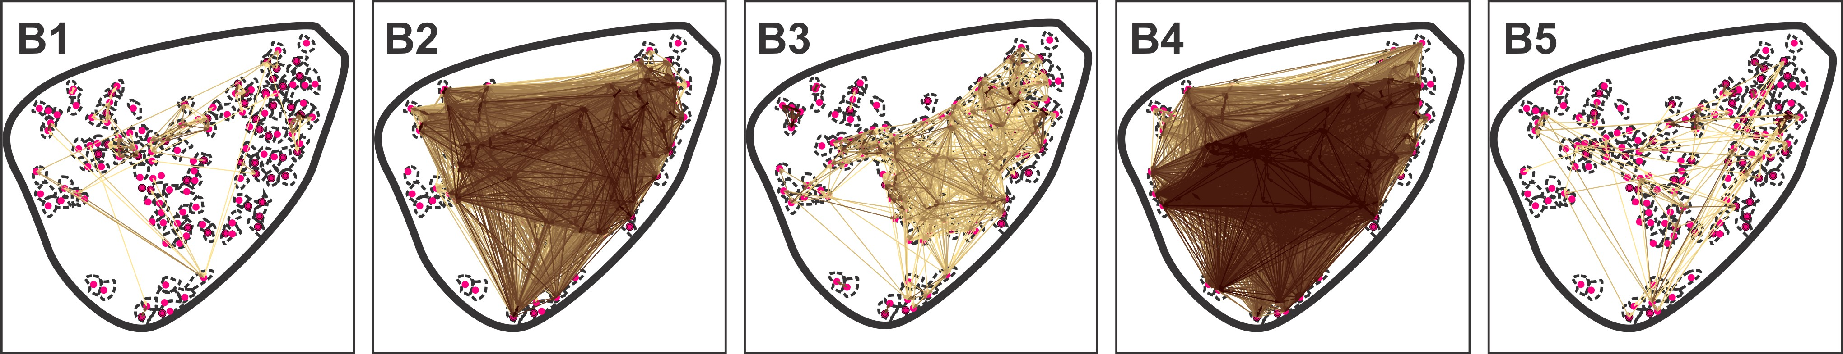

Figure 1.2: Functional connectivity networks at varying glucose. Functional connectivity represented with yellow (weaker) to brown (stronger) lines between the red nuclei of cells for 5 different regimes: low glucose (B1), initial activation to high glucose (B2), high glucose (B3), initial deactivation to low glucose (B4), and low glucose (B5). Taken from [6].
average path lengths or, equivalently, cells with long connections are connected to the more isolated cells. A benefit of high clustering could be protection from the dysfunction of individual β cells. During the activation, high glucose, and deactivation regimes, β cells form small world networks with the clustering and efficiency ratios increasing during high glucose and decreasing during deactivation. The increase in efficiency due to the shorter path lengths plays a larger role in the increase seen in the small world parameter.
With a similar procedure for creating functional connectivity graphs from ex- perimental data, functional connectivity was measured with stepwise increasing glu- cose from 6 mM to 12 mM [7]. At basal levels of glucose, very little coordinated activity was observed, leading to a sparsely connected functional network. As the glucose concentration increased, more densely connected networks were formed, giv- ing rise to small-world networks with short path lengths and a high degree of clus- tering. Possibly due to spatial constraints, the network saturates when the glucose

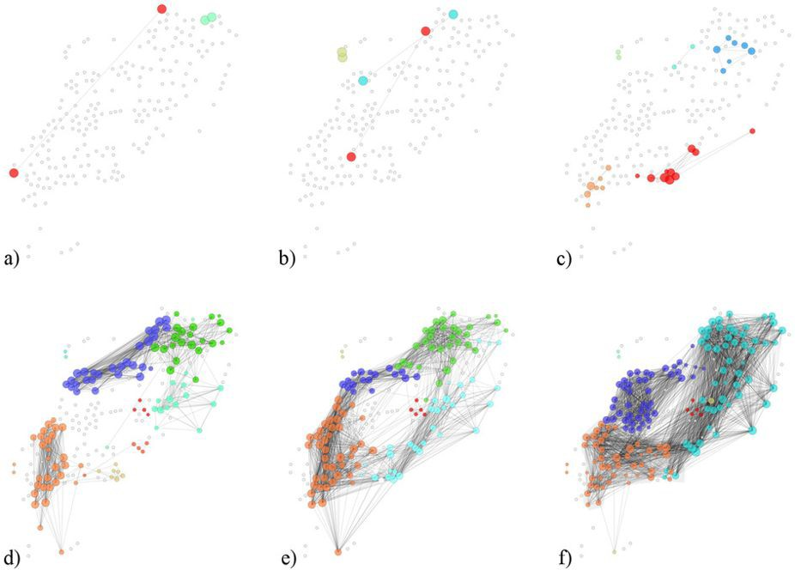

Figure 1.3: Clustering in functional connectivity at different glucose. Experi- mentally measured functional connectivity at (a) 6 mM glucose, (b) 7 mM glucose, (c) 8 mM glucose, (d) 9 mM glucose, (e) 10 mM glucose and (f) 12 mM glucose taken from [7]. The colors denoted different clusterings in the small-world network.
concentration was around 10 mM. The increase in clustering and connectivity with higher glucose can be seen in Figure 1.3, which was taken from [7].
A different technique involving durations of activity has also been used to calculate functional connectivity [10, 48]. Cell activity is first binarized into active and inactive. The correlation of two cells is determined by the ratio of the time the cells are coactive and the square root of the product of the total active time for the individual cells. These correlations are then subject to a Monte Carlo shuffling to assess the significance of each connection. With this method, scale-free networks, in addition to small-world properties, were observed. These networks have very few high degree nodes and many low degree nodes, leading to a degree distribution asymptotically following a power-law distribution. These network classifications are heavily reliant on gap junction communication as networks built from islets with a

gap junction blocker no longer displayed small world or scale free properties [10].

Functional connectivity networks have also been built from simulated calcium traces, confirming experimental results. Even with a higher threshold for the corre- lation coefficient (0.8 or 0.95), small-worldness is still computationally observed as dependent on the strength of the gap junction coupling conductance [9, 34]. Het- erogeneity in β cell parameters was found to be essential for small-worldness in the functional connectivity graphs of β cells in an islet as observed through computa- tions [9].

Can hub cells coordinate islets?

The scale free property of the functional connectivity graphs of β cells is indica- tive of a hub-follower structure. The hubs can be found using the degree centrality, which finds the nodes with the highest number of edges. The theory of hub-followers in islets was tested by effectively silencing hub cell activity using optogenetics to target their expressed halorhodopsin chloride pumps [10]. When silencing a follower cell, very little impact was discerned in the calcium traces of cells in the islet. How- ever, a decrease in coordinated activity was observed in the calcium traces while silencing a hub cell. Without the activity from the hub cell, the remaining cells were less active, with lower calcium concentrations seen from the calcium imaging. These hub cells had more hyperpolarized mitochondria, indicative of increased ATP generation, increased glucokinase levels, decreased expression of SERCA pumps, and a lower number of insulin granules.

This hypothesis has also been investigated computationally [5]. Certain β cells in the islet were predetermined to be hub cells with cell properties above threshold while most follower cells were set to be below the threshold for bursting electrical activity at the given glucose level. The more metabolically active hub cells, due to increased glucokinase flux, were able to bring the rest of the islet above the threshold, resulting in synchronous behavior. When the hub cells, about 2% of the islet, were silenced, a loss of coordinated activity was observed. However, the functional network from the computational traces did not have scale-free or small- world properties. It also required the silencing of 15-45 hub cells in a 1000 cell islet to achieve desynchronization in the islet.

What about subpopulations instead of hub cells?

Instead of individual cells dictating the behavior of the islet, the idea of sub- populations has been introduced [7]. The modular nature of islets follows from the structure of small world networks. Cells are clustered into subcompartments that recruit other subcompartments into electrical activity as the glucose concentration increases [4]. As these subpopulations become more interconnected when exposed to higher glucose, the network becomes more efficient.
Using optogenetics with channelrhodopsin, individual cells or subregions were stimulated, eliciting heterogeneous responses [7]. Both computationally and exper- imentally, some regions were found to have the ability to recruit more cells into responding to the stimulus than others, which suggests there is a heterogeneous

property of cells that controls the excitability. Regions with high electrical control were correlated with high metabolic activity. Moreover, heterogeneity of intrinsic cell properties affects islet performance depending on their spatial organization, re- vealing subpopulations with similar properties such as more active cells clustered together.

Do Calcium Waves Explain Functional Connectivity?

While gap junctions can lead to nearest neighbor functional connections, in- tuition behind longer range functional connectivity is less well understood. One possible explanation is calcium waves through the islet. While calcium may diffuse through gap junctions, a depolarization of one cell can lead to the depolarization of a neighboring cell, leading to an influx of calcium from outside of the cell. These electrical waves that emerge due to gap junction connectivity and cell heterogeneity can synchronize the islet’s activity, leading to long range functional connectivity.

Calcium waves can coordinate the islet

It is well established that gap junctions are essential for proper activity in the islet [30, 49]. It was previously thought that they allowed β cells to synchronize instantaneously [50]. However, a slight time delay is observed when comparing calcium traces from different cells in an islet [19, 51]. This offset has been attributed to the calcium waves that propagate via gap junctions in the islet. This would allow regions of the islet that do not receive external glucose stimuli to respond to the

calcium activity of neighboring cells.

When observing an islet in the five different glucose regimes (low glucose, activation of β cell in high glucose, high glucose, deactivation of β cells in low glucose, and low glucose after stimulation), there were no calcium waves during the activation or deactivation phases, but instead individual cells were responding with no apparent relation to the distance from the first responding cells [6]. From this lack of wave, it was inferred that the synchronous behavior was not due to gap junctions, but from each cell responding to its higher glucose environment. While the islet is in the high-glucose regime, the correlation coefficient between two cells falls off as the distance between the two cells increases, supporting the idea of a calcium wave coordinating the islet. For pairs of cells with higher correlations in activity, there was a broad range of distances between the pairs, hinting that calcium waves travel both shorter and longer distances within the islet.
Calcium waves and their impact within islets have been replicated computa- tionally as well [9, 19, 34]. Synchronization of the islet depends upon the existence of waves [9]. It was also found that calcium waves lead to long range functional connections as calculated through the Pearson correlation. As the Pearson correla- tion considers two almost identical traces with one having a slight temporal delay to be highly correlated, cells on either end of a calcium wave can be considered functionally connected. These calcium waves allow distant synchronized clusters in the islet to coordinate their activity.

Gap junctions and cell heterogeneity make waves

When using a gap junction blocker, the calcium waves still propagated, albeit more slowly [19]. To test the importance of gap junctions in calcium waves, gap junction knockdown and knockout mice were used, meaning that gap junctions would be reduced by half or completely in the islets of these mice. The heterozygous knockouts islets (with 50% reduced coupling) displayed less synchronous behavior, but some islets still had a slow wave propagate. As predicted, the islets from the homozygous knockout (complete knockout) displayed very little synchronization or evidence for a propagating wave, which hints at the connection between coordinated activity and calcium waves.
The decrease in calcium wave velocity and desynchronized behavior were re- produced computationally as well, which also led to additional insights [19]. The calcium waves were thought to begin in regions of higher excitability. However, experimentally with the use of optogenetics, it was found that the origin of calcium waves correlates with regions in the islet with lower metabolic activity and excitabil- ity [4]. These regions had a lower NAD(P)H level while the regions where the waves ended had a much higher level, implying lower and higher metabolic regions for the beginning and end, respectively, of the wave.
Partial excitation of the islet has also been explored [34]. With one side of the islet simulated with high levels of glucose, a wave of bursting would travel across the islet only if gap junctions existed from one cluster in the small world network to another. Others have noted through computational methods that cell parameter

heterogeneity is essential for the propagation of calcium waves [9, 19].

Waves and avalanches: self-organized criticality

The idea of self-organized criticality was introduced in physics with a sand pile model [52]. As small grains of sand are dropped on top of each other, they begin to pile in a mountain-like structure with occasional grains falling off to the side lost at the boundaries. There is a critical point at which adding one more grain causes an avalanche, where the feedback from the grains falling causes more grains to follow. These grains are lost to the boundary and the system resets, again going towards that critical point. The amount of sand affected by adding additional grains is usually minimal, but during the avalanche, many more grains are disrupted, implying that the distribution of effected grains follows a power-law distribution.
Self-organized criticality was identified using space-time cluster analysis on calcium waves in β cell networks [37]. The volume of the space-time cluster gives an indication of the wave size, describing the extent of the activated cells during a wave. In both computational and experimental results, a distribution created from the average number of occurrences for a specific wave size asymptotically follows a power law distribution during the activation regime, meaning there are very few large calcium waves coordinating most of the islet with a larger quantity of smaller waves. For low glucose levels, most cells only coordinate with a small number of their neighbors, leading to many compact waves. When the stimulatory conditions for β cells are changed by increasing the glucose concentration, increasing wave sizes

begin to appear and activate the coordinated behavior of the islet. At high glucose, the wave size reaches its maximum as most β cells become connected via calcium waves, resulting in more stable activity. The change in organization of the islet due to the increasing glucose levels is a critical point, switching from an uncoordinated state to a more synchronized one, which is observed during the initial activation of the islet. Similarly, the initial deactivation in low glucose critically transitions from a more synchronized state to one less organized.

Quantifying Islet Synchronization

As coordinated activity is important in pancreatic islet response to glucose, a measure is required to capture that idea. Multiple different synchronization indices have been utilized for this purpose. A simpler index considers the correlation of calcium traces between individual cells and the average islet trace [9]. A cell syn- chronized to the islet is defined as having a Pearson correlation coefficient between its calcium trace and the average calcium trace of the islet greater than 0.85. The synchronization index is then given as the percentage of synchronized cells in the islet.
A similar index looks at a phase map of cross correlations [19]. Each pixel in the map represented the time at which there was a maximum in the cross-correlation coefficient, denoting areas that began the calcium wave with low times. If the maximal coefficient is below 0.5 in a pixel, it is not synchronized with the islet. The synchronization index is the percentage of pixels in the islet that are considered

synchronized.

A slightly more complicated index used phase synchronization analysis [3]. First a Hilbert transformation is used on the detrended membrane potential traces to determine the instantaneous phase of each cell at a given time. Using the cir- cular mean on the individual phase angles, the mean field value is calculated. The synchronization strength of each cell to the mean field is determined by averaging over time the exponential of the product of the imaginary number i and the differ- ence between that cell’s instantaneous phase angle and the mean. Averaging the synchronization strength over the cells in the islet then give the cluster synchroniza- tion index. These indices, or other similar formulations not mentioned here, help quantify the qualitative property that is essential to proper islet network function: synchronization.

Conclusion

Extensive research has been done in isolated β cells, both experimentally and mathematically, to better understand insulin secretion. Recently, research has be- gun using network analysis to study β cells and insulin secretion as gap junctions connecting β cells in an islet play an important role in their function. β cells are structurally connected in islets creating a network upon which analysis can be per- formed. By creating these connectivity graphs, analysis can be performed on the system without the intricacies of the original dynamical system. Another type of connectivity is being utilized, originally from neuroscience, to examine networks of

β cells. With the use of functional connectivity, small world networks have been observed in islets. The idea of hub cells in islets arising from functional connec- tivity that synchronize islet behavior has been investigated. Others have discussed subpopulations in the small world network recruiting other clusters into bursting electrical activity. Whether the origin of organized bursting behavior is metaboli- cally active hub cells or developmentally immature subpopulations, or some other organizing principle combining individual cell characteristics and network topology remains to be determined. Regardless of origin, however, calcium waves, observed experimentally and reproduced computationally, explain coordination in the islet. In general, computational experimentation involving network analysis will be critical for a mechanistic understanding of islet function.

Recent Literature Results

Since the writing of this encyclopedia chapter [8] in December 2018, more research has been published investigating the islet of Langerhans as a network.
Stamper and Wang computationally studied the impact of different glucose levels on insulin secretion of an islet [53]. Their model had two main components, membrane potential (set up similarly to [3]) and insulin granule dynamics, which were connected by assuming granule fusion rate is a saturating function of calcium. Using a hexagon closest packing lattice with 587 cells, a fraction of cells were consid- ered to be nonfunctional β cells or non-β cells. At lower glucose levels, they found that the islet with fewer functioning β cells had more active subpopulations, leading

to higher levels of insulin secreted. In medium and high glucose concentrations, cell activation and average insulin secretion per cell increased with glucose levels and was higher with lower β cell loss. As expected, reduced network connectivity negatively impacts insulin secretion activity from the islet.
Stoˇzer et al. continued to probe the idea of self-organized criticality, introduced in Section 1.4.3 [54]. Using both a two-dimensional iterative map to denote the membrane potential and potassium gating variable of a β cell and experimental findings, they used space-time analysis to investigate the criticality of calcium waves. The distribution of wave clusters was found to follow a power law distribution, implying critical behavior. They found that cells have a two phase response to glucose stimulus: (1) a critical activation phase with transient increase in calcium, fast oscillations, and recruitment of neighboring cells and (2) a supercritical plateau phase with periodic oscillations.
Xavier and Rutter published a review article exploring the importance of het- erogeneity in β cells [55]. They reiterated the idea of different subpopulations, formed most likely due to coupling, playing different roles in the islet. Hub cells emerged due to the heterogeneity of intrinsic properties with a less mature phenotype and a higher mitochondrial membrane potential. They reiterated that photoablat- ing hub cells led to a complete loss of activity in the islet, which was not observed with the photoablation of follower cells.
Loppini and Chiodo began to model the effect of an islet with 10% hub cells on cell correlations in different bursting regimes [56]. These predetermined hub cells were given a higher excitability than the remaining cells in the islet. In spiking and

fast bursting regimes, correlations in cell activity were lowered when hub cells, which had a higher frequency for the spiking regime and longer plateau fraction for the fast bursting regime, were included in the islet. The hub cells acted as a pacemaker in the spiking regime, but were only able to synchronize their nearest neighbors. Meanwhile, the hub cells in the fast bursting regime acted as sources of noise, de- creasing the cell correlations. For slow bursting, hub cells led to increased correlated activity, which was attributed to the synchronization of glycolytic oscillations.
Salem et al. used the technique of photoablation to irradiate β cells in zebrafish, mouse, and human islets [57]. They defined the the first cells to respond to a glucose stimulus as the leader cells in the islet. A substantial difference in zebrafish islet activity was observed between photoablating leader and follower cells, with minimal activity in islets with photoablated leader cells. Using Granger causality analysis [58], a technique often used in computational neuroscience, they determined that the highly functionally connected leader cells in mouse islet had a causal relationship with other cells in the islet.
While more research has been done regarding hub or leader cells in pancreatic islets, there is still much to be understood about them, including their existence. This dissertation will discuss our investigation of hub cells in pancreatic islets in detail using some of the past work described in this chapter for guidance.

Chapter 2: Flipping the Switch: Islet Desynchronization Through Cell Silencing

The majority of the content in this chapter has been submitted as a paper in the PLoS Computational Biology [59]. More details about the methods and results from this chapter can be found in Chapters 3-4.

Introduction

Dysregulation of blood glucose can lead to diabetes mellitus and its various complications including cardiovascular disease, chronic kidney disease, and stroke. Consequently, the health of the pancreatic islet, which secretes hormones responsible for maintaining glucose homeostasis, is paramount. Located in the pancreas, the islets of Langerhans primarily consist of β cells, representing about 60% of the cells in human islets [21]. These cells secrete insulin into the bloodstream assisting mainly liver, adipose, and skeletal muscle cells with the uptake of glucose from the blood. Since dysfunction in insulin secretion has been linked to type 2 diabetes [60], a further understanding of this phenomena may provide crucial insight into the disease.
Observed in mouse and human islets [61], the electrical activity of β cells

in an islet, to which insulin secretion is tied [62], undergoes both fast (period of tens of seconds) and slow (period of several minutes) oscillations in response to a glucose stimulus. While β cells are heterogeneous in their response, their be- havior is coordinated within the islet through gap junctions (Connexin36), which connect the cytosols of neighboring cells allowing ions to diffuse from one cell to an- other [29,30,63]. In elevated levels of glucose, this leads to synchronized oscillations, attributed to electrical waves traveling through gap junctions. This is supported by the disappearance of synchronization and electrical waves in gap junction knockout islets [19]. Some sub-regions within the islet were found to be more effective at triggering activity, where the more active cells were co-localized [4]. Subpopula- tions of β cells with differing functions are beginning to be revealed within the islet through studying biomarkers, allowing for further investigation of β cell heterogene- ity [64]. A loss of coordinated activity has been observed in human islets with type 2 diabetes [17, 65, 66], and thus is a focus of much research.
Using optogenetics to activate transfected light sensitive halorhodopsin chlo- ride pumps that hyperpolarize a cell, mouse islets were desynchronized with the silencing of certain β cells, called hub cells [10]. To investigate the β cell network, functional connectivity graphs, often used in computational neuroscience [45], were created based on calcium trace comparisons. The functional connectivity networks for these islets were scale-free, which implies a hub-follower scheme in the islet [48]. The hub cells were both (a) highly functionally connected and (b) essential for maintaining oscillations in the islet. They had more hyperpolarized mitochondria, indicative of increased ATP generation, and were more metabolically active due to

increased glucokinase protein expression levels [10].

In a computational model to achieve desynchronization with silencing, prede- termined hub cells required increased glucokinase flux and preferential gap junction coupling while the cellular properties of the nonhub cells were chosen to be below the threshold for activity [5]. However, silencing around 2-6% of the islet (with 10% of cells in the islet as hubs) was necessary to attain the same level of desynchronization as seen experimentally. In addition, the functional connectivity networks were not found to be scale-free. In another study, the presence of hub cells in a computational islet lowered the correlations in cell activity for spiking and fast bursting regimes, while it increased the correlated behavior in slow bursting islets [56]. The difference was explained by the synchronization of the glycolytic oscillator due to metabolic coupling.
Another technique used to study the desynchronization of islets is photoabla- tion, which involves a laser irradiating cells. In zebrafish islets, leader cells, defined as the first to respond to a glucose stimulus, were photoablated, resulting in a notable loss of activity in the islet compared to the minimal differences for the photoabla- tion of follower cells [57]. Granger causality analysis [58] used on the leader cells of mouse islets, which were found to be highly functionally connected, confirmed the predicted causal relationship between the leader and follower cells.
The objective of this study is to further investigate the ideas of hub cells, func- tional connectivity, and desynchronization within the islet through computational methods. A simple model for the individual cells is used to represent the electrical and calcium activity of each β cell connected in a hexagon closest packing lattice.

Various graph theory measures were applied to the network to study specific charac- teristics found by Johnston et al. [10]: a scale-free functional connectivity network, a loss of functional connectivity with hub cell silencing, and desynchronization with hub cell silencing. While we were unable to find cells that satisfied all three prop- erties, we did find switch cells, whose silencing leads to the loss of activity within the islet, but which have no relation to functional connectivity.

Methods

In order to computationally investigate hub cells, a mechanistic model for a single β cell is needed, which is then applied to a network structure. The resulting calcium traces are then transformed into a functional connectivity network, upon which various measures are utilized.

Model Equations, Heterogeneity, & Islet Structure

As pancreatic β cells are electrically excitable, their activity can be simulated with models similar to the Hodgkin-Huxley model for neurons. For cell i in the β cell network, there are four differential equations that describe its electrical and

calcium dynamics:

−C_{M}
dVi = I (V ) + I (V ) + I (V , n ) + I (V , s ) + I (V ) + I (V )
dt K(ATP ) i Ca i K i i S i i Coup i Cl i

(2.1)

dn_{i} dt ds_{i} dt
= n∞(V_{i}) − n_{i}
τ_{n}
= s∞(V_{i}) − s_{i}
τ_{s}

(2.2)

(2.3)

dc_{i} dt
= f [−αI_{Ca}
(V_{i}) − k_{Ca}
c_{i}]. (2.4)

There are four main ionic currents in the single cell model selected for this study [67]: an ATP/ADP ratio dependent potassium current (I_{K(AT} _{P} ₎) whose closing begins the process of insulin secretion, a voltage-dependent calcium current (I_{Ca}) that leads to the further depolarization of the cell’s membrane, a voltage-gated potassium current (I_{K}) which mediates spike repolarization and a slow inhibitory potassium current (I_{S}) that is responsible for transitions between the active and silent phases of bursting. The full model, with all functional forms, can be seen in the supporting information. For this study, two currents were included in the voltage equation shown in Equation (2.1). The impact of gap junctions was accounted for by the inclusion of a passive coupling current modeled as

ICoup =

∀j∈N (i)
g_{c}ij · (V_{j} − V_{i}) (2.5)

for cell i where N (i) represents its nearest neighbors. To simulate optogenetic control over the halorhodopsin chloride pumps in the cell’s membrane, a passive chloride

current

I_{Cl} = g_{Cl} · σ · (V_{i} − V_{Cl}) (2.6)

was added where
1, chloride pumps are activated

σ =
0, otherwise.

When activated, the cell is sufficiently hyperpolarized and thus its activity is si- lenced.
Several experimental and computational studies have recently highlighted the importance of β cell heterogeneity within an islet [4,55,68,69]. Heterogeneity was in- corporated into the model by selecting a subset of the cell parameters from truncated (to keep values positive) normal distributions with mean and standard deviation as shown in Table 2.1. Most of the parameter values were chosen in accordance to lit- erature [3, 9]. The means of the cell parameters were shifted such that a significant number of cells were active when isolated, while the remaining cells were close to the threshold for activity, as it has been experimentally shown that a large portion of β cells are intrinsically active in high levels of glucose [30]. To include the possi- bility of incomplete gap junction connections, the gap junction conductances were randomly set to 0 with probability 33% [9]. Initially due to the smaller islet size, the gap junctional conductances were chosen to be low since connectivity strength scales with network diameter. The same tests were then repeated for islets with stronger coupling. A table of all parameter values can be found in the appendix.
The islet network was simulated as a hexagonal closest packing lattice, which allows for more nearest neighbor coupling than the more often used cubic lattice [3]. The main layer of the lattice is a regular hexagon with m cells along the edge. There

Table 2.1: Cell Heterogeneity. Heterogeneous parameter values were selected from Gaussian distributions with the given means and standard deviations.
Parameter | Symbol | Mean | SD
Voltage-gated potassium channel conductance | g_{K} | 2700 pS | 5%
Voltage-gated calcium channel conductance | gCa | 1000 pS | 5%
ATP/ADP dependent potassium channel conductance | gK(ATP ) | 100-145 pS | 5-10%
Slow inhibitory potassium channel conductance | g_{S} | 200 pS | 5%
Gap junction conductance | g_{c} | 4-200 pS | 50%
Calcium pump rate | kCa | 0.2 s⁻¹ | 5%

are m − 1 alternating layers of irregular and regular hexagons above and below the main layer. An example of this structure can be seen in Fig 2.1 with m = 3, resulting in an islet of 57 cells.

In some cases, the activation cell parameters (g_{Ca} and g_{K(AT} _{P} ₎) were spatially distributed, motivated by the notion of spatially clustered subpopulations within the islet [4]. A cell in the hexagonal lattice was randomly selected as the orienting cell for the distribution, which had cell parameters following g_{K(AT} _{P} ₎ ∼ N (120, 6)
and g_{Ca} ∼ N (1100, 55), most likely making it an intrinsically active cell that bursts
when uncoupled. For the remaining cells in the islet, the mean value for g_{Ca} and g_{K(AT} _{P} ₎ depended on their distances from the orienting cell. Cells further from the orienting cell were less likely to be active as the mean values for g_{K(AT} _{P} ₎ increased and g_{Ca} decreased. The mean values for cell i with orienting cell j were defined as g_{K(AT} _{P} ₎ = 120 + 10 · d(i, j) and g_{Ca} = 1100 − 50 · d(i, j), where d(i, j) represents the

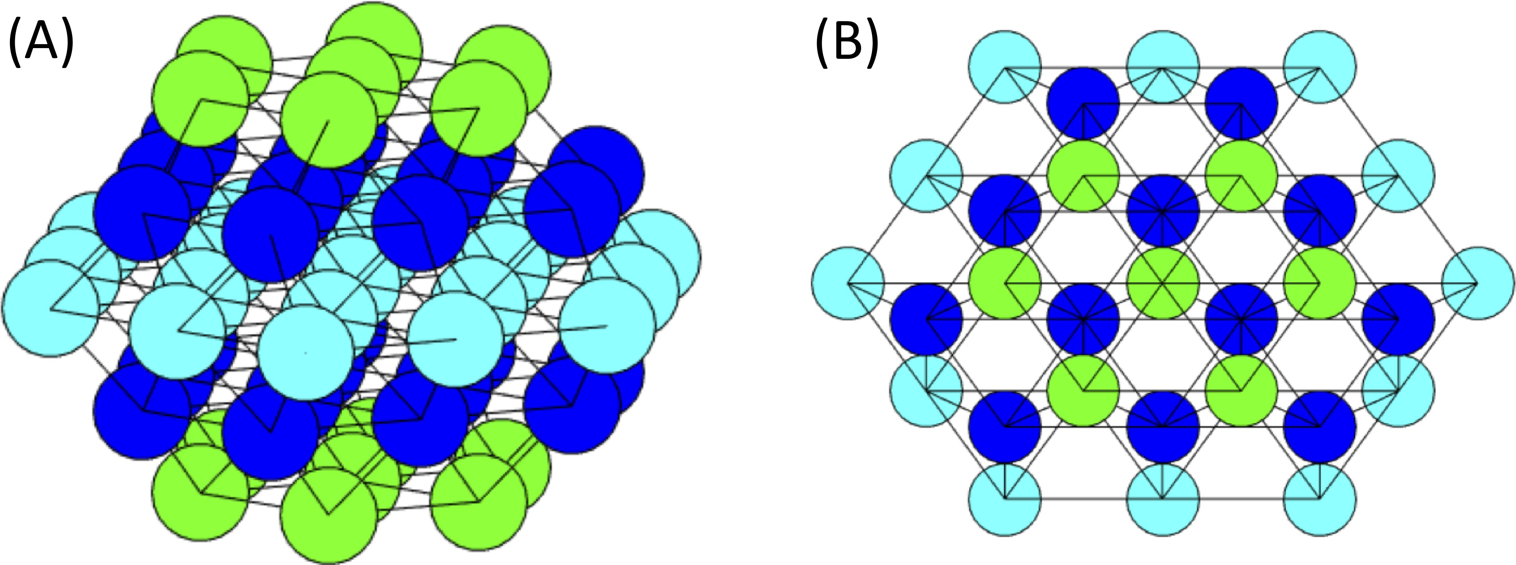

Figure 2.1: Hexagonal Closest Packing Lattice for Islet. The schematic of a hexagonal-closest-packed lattice with m = 3 (57 cells). (A) A side view of the islet.
(B) The view from above the islet.

lattice spacing between cells i and j. Neighboring cells were defined in the lattice as having distance 1. The mean distance between a pair of cells in an m = 3 islet was
2.13. An example of the spatially distributed parameters is illustrated in Fig 2.2 where (A) portrays the g_{K(AT} _{P} ₎ values in the islet and (B) the g_{Ca} values with the orienting cell chosen as cell 53. The cells further from cell 53 have a darker blue in Fig 2.2(A), denoting a higher g_{K(AT} _{P} ₎, and a lighter green in Fig 2.2(B), showing a lower g_{Ca}.

Methods of Analysis

The solutions to the 57 cell (m = 3) system, consisting of 228 coupled dif- ferential equations, were numerically computed using a built-in MATLAB differen- tial equation solver (ode45), which implements a variable step-size, variable order Runge-Kutta method. The default settings were used, except for a convergence test. It was run on both a personal MacBook laptop and the high performance computing cluster at UMBC. Various techniques then were used to analyze the network.

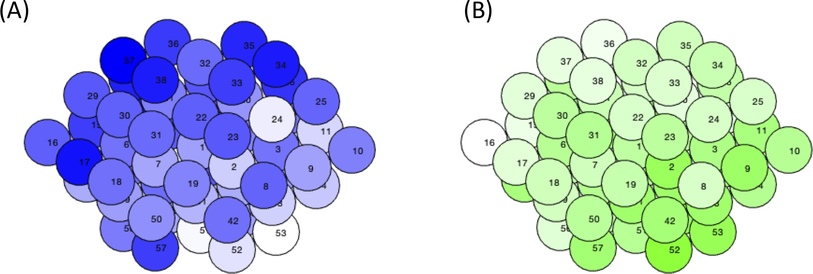

Figure 2.2: Spatial Distributions for gK(ATP ) and g_{Ca}. An example of the spatially distributed cell parameters with the orienting cell 53. The darker blue for (A) gK(ATP ) and green for (B) g_{Ca} denote the higher conductance values.

Functional Connectivity

Functional connectivity was first introduced as a method in computational neuroscience for determining regions of the brain with similar electrical behavior, which could imply similar functionality [45]. While various methods of calculating the functional connectivity exist, most focus on correlations of activity between cells in the network. A correlation method with an emphasis on the active phases of cells was selected for this study [70]. First, the cells were binarized as active or silent using a calcium threshold of 0.15 µM. The similarity coefficient C_{i,j} for each pair of cells i and j was calculated using the duration of time cells i and j were coactive
√

(T_{i,j}) and the active duration for each individual cell (T_{i} and T_{j}): C_{i,j} = ^{T}i,j
T_{i}T_{j}
. The

similarity coefficient ranges from 0, when the two cells were not active at the same time, to 1, when the cells were only active together. To ascertain the significance of each connection (i.e. if the connection occurred due to chance), each of the two

binarized traces was permuted 10,000 times. For each permutation, the coactive time was recalculated. A p-value was determined by calculating the probability the permuted coactive time was greater than the simulation coactive time, T_{i,j}. If C_{i,j} > 0.85 and p < 0.01, cells i and j were defined to be functionally connected. A new network arises from the functional connectivity upon which different network measures were calculated.

Centralities and Hub Cells

Centralities are measures of importance in the network that rank the nodes of a graph in order of influence on the network. These measures are often used on functional connectivity, rather than the structural connectivity based on gap junc- tions and, in neuroscience, synapses [45]. There are various types of centralities such as degree centrality, eigencentrality, betweeness centrality, and closeness cen- trality that differ in their definition of influence on a network. Johnston et al. [10] used the degree centrality that considers the number of links per node, called the degree of the node, to determine the hub cells they silenced. In β cell functional connectivity networks, it can be interpreted as ordering cells by their level of cor- related behavior with the other cells in the islet. The cell with the highest degree shares behavior with the greatest number of cells in the islet. We designated this cell as the functional hub cell in the network. A second notion of hubness is related to the desynchronization of the islet. The synchronization hub acts as the leader of the islet, synchronizing the activity of the cells in the network. Without the

synchronization hub, the islet’s activity is either uncoordinated or lost completely. Our goal was to find a single cell that satisfies both definitions of functional and synchronization hubs, as experimentally reported [10].

Scale-free Measure
Johnston et al. [10] found their islets containing hub cells had a scale-free func- tional connectivity network, which has a hub-follower structure [10]. It is defined as a network whose degree distribution asymptotically follows a power law distri- bution, P (x) ∼ x^{−k} with x, k > 0 [42]. The magnitude of k gives an indication of the level of influence of the hub cells in the network, with k < 3 denoting a stronger hub-follower structure [71]. This type of network, which has been observed experimentally in islets [10, 48, 57], has very few high degree nodes, many low de- gree nodes, and is known for its scale invariance. This condition was checked by log transforming the distribution of functional connections and performing a linear regression. A goodness of fit threshold of R² > 0.7 was chosen to classify a network as scale-free.

Synchronization Index

Since a focus of this study was the desynchronization of the islet, a measure was needed to quantify the synchrony of a network. The Fast Fourier Transform was used to determine the most prominent period for each cell trace through the frequency domain representation. The cells of a well synchronized islet should have

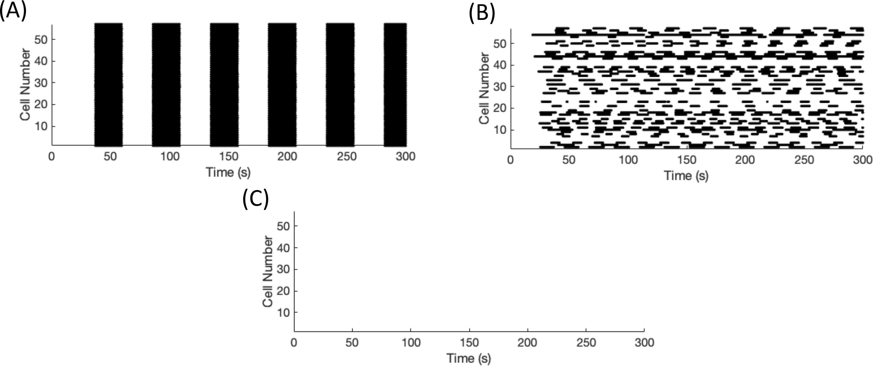

Figure 2.3: Synchronization of a model islet Raster plots of (A) completely synchro- nized, (B) a desynchronized, and (C) silent islet. A point is plotted whenever a cell was considered active.
similar periods. Therefore the mode of cell periods was found for the islet and the synchronization index was the percentage of cells with a period within a few seconds of the mode. Inactive cells, which would have an infinite period, were not considered in the modal calculations, but were included in the total count of cells in the network. Thus, a completely silent islet resulted in a zero synchronization index while a desynchronized islet, which is still active but not synchronized, had a nonzero result. This method was preferred as it did not consider a silent islet to be synchronized, unlike other synchronization measures [3, 9].
To visually capture the desynchronization, raster plots were used. The calcium traces for all the cells were binarized as active or silent, using the same threshold as for functional connectivity, 0.15 µM. The raster plots capture when each cell is considered active by plotting a point for each time a cell is active, with the cell number along the vertical axis. Fig 2.3 shows an example of a highly synchronous islet (SI=100), a desynchronized islet (SI= 8.77), and a silent islet (SI=0).

Results

With a computational model applied to a network and various network mea- sures, the goal was to satisfy the three criteria laid out in [10]: scale-free functional connectivity, a loss of functional connectivity with hub cell silencing, and a sub- stantial decrease in activity of the islet with hub cell silencing. However, we were unable to achieve all three at one time as scale-free functional connectivity and desynchronization tend to be at odds.

Scale-free networks do not imply desynchronization with silencing
We first sampled parameter space to find networks with scale-free functional
connectivity. Each parameter set was drawn from the normal distributions given in Table 2.1 with g_{K(AT} _{P} ₎ ∼ N (143, 14.3). After an initial simulation was run, the functional connectivity of the network was calculated. If the distribution of functional connectivity was determined to be a power law distribution, the functional hub cells were identified using the degree centrality. Each simulation was then rerun with the silencing of a single functional hub cell and the functional connectivity was recalculated. If the islet was found to have more than one functional hub cell, each functional hub cell was tested individually. Since another focus of the hypothesis was a loss in functional connectivity with hub cell silencing, parameter sets with a 50% decrease in the number of functional connections were saved to check for

desynchronization.

For the gap junctional coupling mean set to 4 pS, around 5% of parameter sets (49 parameter sets out of 1000 tested) fit the two criteria of scale-free functional connectivity and a loss of functional connectivity with functional hub cell silencing. An example is shown in Fig 2.4. The functional connectivity of this parameter set had a distribution fitting a power law with R² = 0.77, establishing the network as scale-free by our definition, as shown in Fig 2.4(A). A plurality of cells had no functional connections while very few had a high number of functional connections. Fig 2.4(B) illustrates the loss of functional connectivity through silencing. A higher level of connectivity was observed in the initial simulation seen in the top panel, which decreased over 65% once the functional hub cell was silenced depicted in the bottom panel. However, the last objective was not met, displayed in Fig 2.4(C). The silencing of the functional hub was unable to desynchronize the islet and could not be classified as a synchronization hub. The initial synchrony was low (SI=49.12) as seen in the top panel, which only decreased to SI=31.58 when the hub cell 43 was silenced in the bottom panel. This lack of drastic desynchronization was common to all the parameter sets fitting the two criterion in this search.
A trade off between scale-free connectivity and islet desynchronization was observed when the above procedure was repeated for a range of g_{C} values. Fewer parameter sets were found to satisfy the scale-free functional connectivity condition as the gap junctional coupling was strengthened. Cell activity synchronized more strongly, resulting in higher correlations between cells. Each cell had more functional connections and the distributions were less likely to satisfy power law distributions.

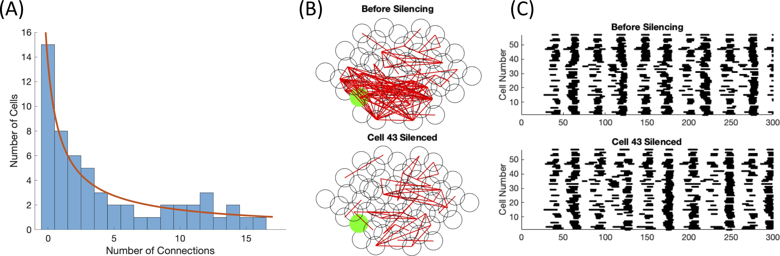

Figure 2.4: Scale-free connectivity and a loss of functional connectivity with hub cell silencing. This parameter set had gK(ATP ) ∼ N (143, 14.3) pS and g_{C} ∼ N (4, 2) pS with 33% of connections killed. (A) The distribution of functional connections fitted
to a power law with R² = 0.77. (B) The functional connectivity graphs before (top panel) and after (bottom panel) the silencing of cell 43, the hub cell. (C) The raster plots before (top panel) and after (bottom panel) cell 43, indicated in green in (B), was silenced.
For smaller gap junctional coupling, fewer cells had correlated activity, which re- sulted in more parameter sets with scale-free functional connectivity. However, the functional hub cells had less impact on their neighboring cells due to the weaker coupling currents, and minimal changes were observed in the synchronization and functional connectivity when the functional hub cell was silenced.
The two main parameters in the system that alter cell activity are g_{Ca}, which controls excitability through depolarization, and g_{K(AT} _{P} ₎, which represents the glu- cose concentration of the cell. The mean values for these parameters were varied independently in an attempt to find a network with the three desired properties. Increases in g_{Ca} and decreases in g_{K(AT} _{P} ₎ led to more active cells, resulting in higher connectivity and fewer parameter sets with a scale-free network. On the other hand,

parameter sets with fewer active cells from decreasing g_{Ca} or increasing g_{K(AT} _{P} ₎ had less functional connectivity. While more of these parameter sets were found to have connectivity following a power law distribution, the majority of cells had no functional connections and the initial synchronization was too low to be affected by silencing. A contradiction was appearing between scale-free connectivity and desynchronization.

Predetermined hub cells are not functional hub cells
As the well-connected islet was unsuccessful in establishing the desired net- work, a predetermined hub cell was placed randomly in the islet with certain pa- rameter values, making it more excitable and more strongly connected based on experimental results [10]. This set up is similar to previous work [5] but with a single predetermined hub cell in the islet and a simpler model. The predetermined hub cell with g_{K(AT} _{P} ₎ = 100 pS was randomly placed in the islet while the remaining cells had g_{K(AT} _{P} ₎ ∼ N (145, 7.25) pS. The g_{Ca} was still drawn from the distribution given in Table 2.1. For the given mean values, a Hopf bifurcation occurs when g_{K(AT} _{P} ₎ = 133.31 pS, denoting a threshold value for the uncoupled electrical ac- tivity. The structural connectivity, described by the gap junctional connections, between the predetermined hub cell and its nearest neighbors was also set to be twice the strength of the other cells in the islet. The aim of this schematic was to predetermine a cell that could satisfy the definitions of both a functional and synchronization hub.

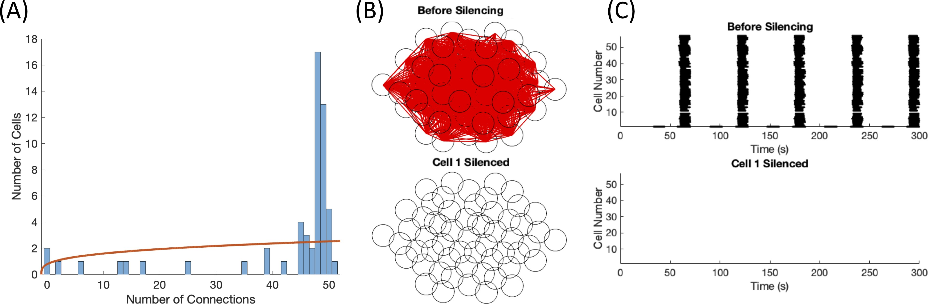

Figure 2.5: Predetermined hub cell. This parameter set had gK(ATP )(nonhubs) ∼ N (145, 7.25) pS, gK(ATP )(hub) = 100 pS, and g_{C} ∼ N (4, 2) pS. (A) The distribution of functional connections fitted to a power law with R² = 0.13. (B) The functional
connectivity graphs before (top panel) and after (bottom panel) the silencing of hub cell

1. (C) The raster plots before (top panel) and after (bottom panel) hub cell 1 was silenced.

As expected, the initial synchrony was high (SI=96.5) for the example shown in Fig 2.5(C) top panel, since the center cell was able to provide enough stimulus to neighboring cells to activate the rest of the islet. Once the predetermined hub cell was silenced, the remaining cells in the islet were no longer recruited into activity and remained silent as well, depicted in Fig 2.5(C) bottom panel. In the initial simulation, almost all of the cells were behaving similarly and thus the majority of the islet was tightly functionally connected as shown in Fig 2.5(B) top panel. With no activity in the islet post-silencing, the functional connectivity disappeared as it depends on correlated activity in the islet, illustrated in Fig 2.5(B) bottom panel. As seen in Fig 2.5(A), the distribution of functional connections did not follow a power law distribution as the fit had R² = 0.13.
It is important to note that the predetermined hub cell had no functional

connections. The predetermined hub cell was set to be highly active, which led to a difference between the periods of the predetermined hub cell and the remaining cells in the islet. As the similarity coefficient, which determined the existence of a functional connection, considered the difference between the duration of each cell’s burst and the duration the two cells are coactive, the difference in periods greatly affected the coefficient. In the example in Fig 2.5, the predetermined hub cell (cell 1) bursts twice for every time the other cells in the islet burst, resulting in the duration coactive between the predetermined hub cell and a nonhub cell to be equivalent to
the duration of the nonhub cell’s burst and a similarity coefficient C_{i,j} ≤ √1 .
2
Multiple variants of this case were tested in an attempt to get a network with a single functional and synchronization hub. Varying the coupling strength pushed the islet out of the loss of activity regime. As the conductance was increased, the activity of the predetermined hub cell was silenced by its neighboring cells, resulting in a silent islet. Lower conductance values decreased the stimulation from neighboring cells, leading to activation of only a few cells in the islet. We were unable to find a parameter set where the predetermined hub cell had the same bursting rhythm as the other cells under these conditions.
To test the effect of small perturbations, Gaussian noise was added to the voltage dynamics of each cell. There was a threshold for the variation of noise, below which no impact was observed in the raster plots and above which a nonhub cell would become active resulting in an active islet regardless of the activity of the predetermined hub cell. The hub cell was randomly placed throughout the islet, instead of only in the center, with minimal difference on the overall islet behavior,

pre- and post-silencing. In order to see a little activity in the islet while the hub cell was silenced, a second predetermined hub cell was randomly placed in the network. However, instead of the intended effect, the islet remained fully synchronized post- silencing. Thus, this systematic search did not result in any cases satisfying our three constraints.

Switch cells desynchronize the islet

As using functional connectivity to determine the hub cell was not resulting in desynchronization with silencing, our focus shifted towards finding a synchronization hub, which desynchronized the islet when silenced. A heterogeneous parameter set was drawn from the distributions in Table 2.1 such that a fraction of cells were just below the threshold and required only a small stimulus for activity. If the synchrony of the initial simulation was above SI=60, then each cell in the islet was systematically silenced and the synchrony was measured for the new simulation.
Two examples of the drastic loss of activity can be observed in Fig 2.6. For Fig 2.6(A)-(C), the coupling and excitability was set to g_{C} ∼ N (5, 2.5) pS and
g_{K(AT} _{P} ₎ ∼ N (145, 14.5) pS. When cell 11 was silenced, the majority of the islet be-
came silent, indicating that cell 11 was a synchronization hub as seen in Fig 2.6(C). The functional network transitioned from highly connected before silencing to only nine functional connections, displayed in Fig 2.6(B). However, cell 11 was not func- tionally connected to any cell in the islet as its period was a fourth of the period of the majority of cells in the islet, and thus was not a functional hub. Fig 2.6(A)

illustrated the poor power law fit for the functional connectivity with R² = 0.028. Thus, the network was not classified as scale-free.
When g_{C} was increased to g_{C} ∼ N (200, 100) pS, cells had to be made more
active in the islet to overcome the coupling to silent cells. Thus, the K(ATP) conductance values were selected from the distribution, g_{K(AT} _{P} ₎ ∼ N (135, 13.5) pS, for the example shown in Fig 2.6(D)-(F). The silencing of cell 57 led to a complete silencing of the islet, classifying it as a synchronization hub, and a total loss of functional connectivity, as seen in Fig 2.6(F) and (E), respectively. Due to the high structural connectivity, every cell was bursting together in the initial simulation, resulting in every cell functionally connected to each other. Therefore, the functional connectivity does not follow a power law distribution, illustrated by Fig 2.6(D). To differentiate these cells from the hub cells in the work of Johnston et al. [10], we have relabelled the synchronization hubs as switch cells, as these cells seem to act as a switch turning the activity of the islet on or off. Switch cells are synchronization hubs that are not functional hubs.

It is important to note that as g_{C} changes, the presence of switch cells is
altered. For the parameter set with g_{C} ∼ N (5, 2.5) shown in Fig 2.6(A)-(C), cell 11 was no longer a switch cell if the coupling was strengthened to g_{C} ∼ N (10, 5). Instead, the silencing of either cell 19 or 50 led to a loss of activity within the islet, making cells 19 and 50 the switch cells in the islet. It has been observed at higher coupling levels, there was more likely to be multiple switch cells in an islet.

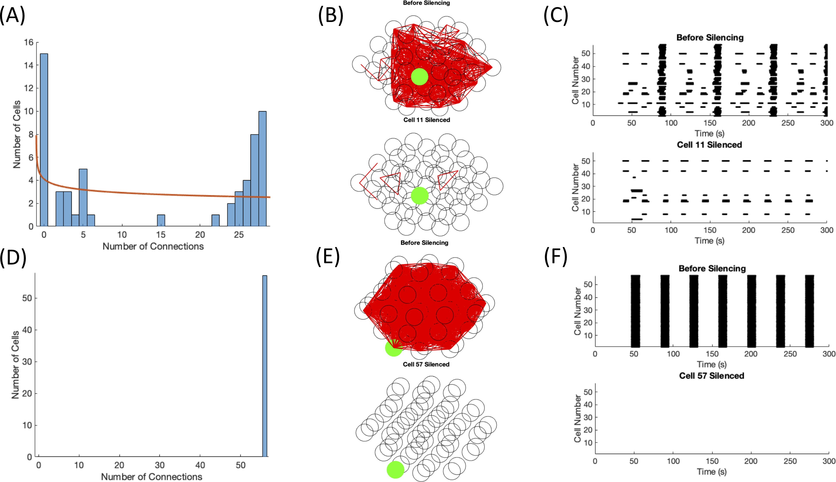

Figure 2.6: Switch cell silencing. The parameter set for (A)-(C) had gK(ATP ) ∼ N (145, 14.5) pS and g_{C} ∼ N (5, 2.5) pS while the cells in (D)-(F) followed gK(ATP ) ∼ N (135, 13.5) pS and g_{C} ∼ N (200, 100) pS . The distribution of functional connections fit a power law with R² = 0.028 in (A). No fit was found for (D). The functional connectivity graphs before (top panel) and after (bottom panel) the silencing of (B) switch cell 11 and

(E) switch cell 57. The raster plots before (top panel) and after (bottom panel) (C) switch cell 11 and (F) switch cell 57 was silenced.

Spatially distributed parameters can also lead to switch cells

The notion of cell parameter clustering, recently investigated [4], gave rise to the idea of spatially distributed parameters. After selecting cell parameters for islets as described in the Methods section, cells in the islet were systematically silenced to search for switch cells.
Fig 2.7 depicts an example of a spatially distributed islet with switch cells
with strong coupling (g_{C} ∼ N (200, 100)). In Fig 2.7(A) and (B), the distributions of g_{K(AT} _{P} ₎ and g_{Ca} are shown, respectively. The orienting cell was randomly chosen as cell 7. As cell 7 had parameters selected to be active and g_{K(AT} _{P} ₎ increases and g_{Ca} decreases radially further from cell 7, there is a cluster of intrinsically active cells surrounding cell 7 displayed in red in Fig 2.7(C). There were two switch cells uncovered in the islet, cells 18 and 19. The impact of silencing cell 18 is shown in Fig 2.7(E) and (F). The initial high connectivity in the top panel and high synchronization in the top raster plot gave way to no activity and thus no connectivity in the bottom panels when cell 18 is silenced. It is interesting to note that both switch cells were neighbors of the orienting cell 7, but the orienting cell 7 was not a switch cell itself. The cell with a differing period than the remaining islet in the top raster plot was the switch cell 18, which was highly active as its g_{K(AT} _{P} ₎ was low (115.28 pS). Due to its period, its trace was not highly correlated with any other cell in the network, leading to no functional connections for cell 18. However, every other cell was behaving similarly, leading to 56 cells with 55 functional connections and one cell with no functional connections. Fig 2.7(D) illustrates the lack of a

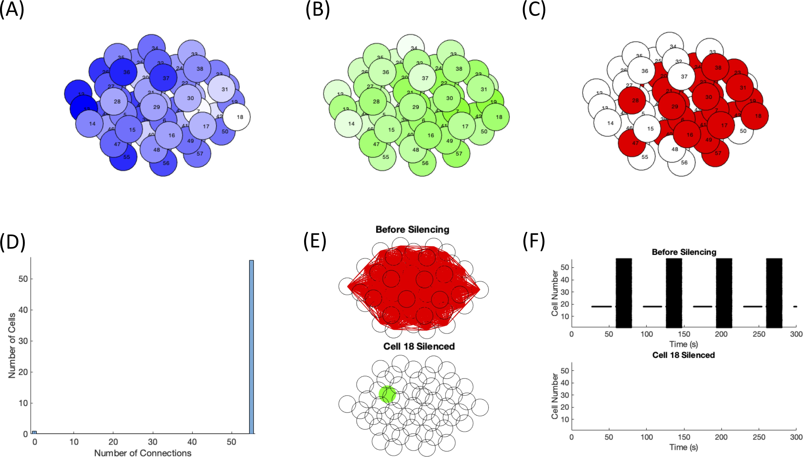

Figure 2.7: Switch cell silencing with spatially distributed cell parameters. The distribution of (A) gK(ATP ) and (B) g_{Ca} of the islet are denoted with the darker blue and green representing higher values. The orienting cell was selected as cell 7. (C) The intrinsically active cells in the islet are shown in red. (D) The distribution of functional connections did not have a fit. (E) The functional connectivity graphs before (top panel) and after (bottom panel) silencing switch cell 18. The raster plots before (top panel) and after (bottom panel) switch cell 18 was silenced.

power law fit for the functional connectivity. The silencing of cell 19 showed very similar behavior to the silencing of cell 18, with the only difference being the raster plot while silencing. As cell 18 was highly active, it continued to burst even when cell 19 was silenced.

Switch cells can have a variety of properties

A sensitivity analysis was performed on the cell parameters in the first switch cell example with lower coupling (in Fig 2.6(A)-(C)), the results of which are shown in Fig 2.8. Systematically each cell parameter was increased or decreased by 10%, after which the simulations before and after silencing the switch cell were rerun. Perturbations to the cell parameters g_{K}, g_{S}, and k_{Ca} had a minimal to no effect on the behavior of the network, observed in Fig 2.8(C), which is reasonable since they do not strongly impact the excitability of the individual cells. The initial simulation had synchronized islet-wide bursts that disappeared with the silencing of the switch cell. When g_{Ca} for the yellow cells in Fig 2.8(A) was increased, the silencing of the switch cell was no longer sufficient for the loss of islet-wide bursting. The cells with increased g_{Ca} were more excitable and thus exhibited bursting without the stimulus of a bursting neighboring cell. Similarly, decreasing g_{K(AT} _{P} ₎ led to more excitable cells that pushed the islet out of the switch cell regime, seen in Fig 2.8(B) with the magenta cells. Interestingly, perturbing the g_{Ca} of the switch cell in either direction had a large impact on the islet behavior. When g_{Ca} was increased by 10%, the switch cell was always active and unable to excite the rest of the islet. On the other hand, a 10% decrease in g_{Ca} of the switch cell lowered its excitability, resulting in a silent cell.
Switch cells can be classified into two categories: initiators that start the calcium wave spreading through the islet or percolators which assist in the propa- gation of calcium beyond local networks, but do not initiate the wave. The initiator

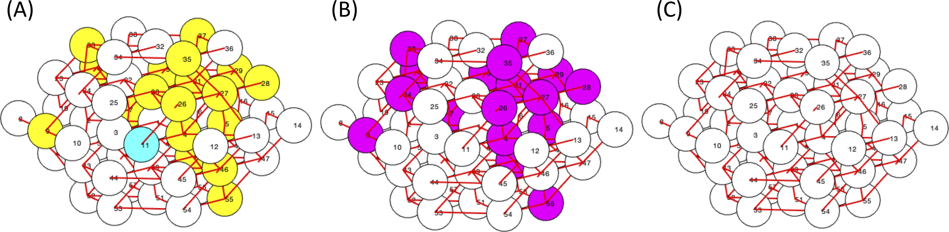

Figure 2.8: Cell Parameter Sensitivity for Switch Cell Islets. Perturbing cell parameters (A) g_{Ca}, (B) gK(ATP ), and (C) g_{K}, g_{S}, and k_{Ca} resulted in being pushed out of the loss of activity regime with both a 10% decrease and 10% increase (blue cells), with a 10% increase (yellow cells), with a 10% decrease (magenta cells), or minimal to no change at all (white cells). The switch cell for this parameter set is cell 11. The red lines connecting cells denote the nonzero gap junction connections in the network.
switch cells have a low g_{K(AT} _{P} ₎ and a high g_{Ca}, values that are separated in param- eter space from those of the remaining cells in the islet as shown in the examples in Fig 2.9(D) compared to a parameter set with a percolator switch cell in Fig 2.9(E). Percolator switch cells are not required to be active when isolated, but need to be close enough to threshold that a small stimulus from a neighboring cell can pull them into bursting activity. It is important for a percolator switch cell to be gap junctionally connected to a highly active cell, as seen in Fig 2.9(E) with switch cell 23 and cell 33. A notable difference between the two types of switch cells is their periods compared to the islet burst period shown in Fig 2.9(C). As initiator switch cells are more active, they burst at a higher frequency than most cells in the islet. Since the function of a percolator is to assist in the spreading of a calcium wave, it only bursts when the majority of the network does. Thus, percolators will have

a large number of functional connections while the initiator will have very few to none. However, neither type of switch cell is a hub cell in the sense of high func- tional or structural connectivity. The initiator cells are similar to the leader cells introduced in [57]. The initiators are the first cells to burst in an electrical wave, which then spreads electrically though gap junctional coupling to neighboring cells, seen in Fig 2.9(F) while percolators have a slightly delayed response, but still turn on near the beginning of a calcium wave after one or more of their neighbors, as shown in Fig 2.9(G).
With the distributions g_{Ca} ∼ N (1000, 50) and g_{K(AT} _{P} ₎ ∼ N (145, 14.5), the
probability of an individual cell being intrinsically active was 24.83%. Thus the expected number of cells that were active when uncoupled in this system was 14.15 with standard deviation 3.26. It is notable that all parameter sets found with at least one switch cells had 13 or fewer active cells as seen in Fig 2.10. In order for a cell to behave as a switch cell, the number of intrinsically active cells in the rest of the islet needed to be smaller than average, or silencing the switch cell would not silence most of the islet. For this excitability level and g_{C} ∼ N (5, 2.5), it was found that the average number of intrinsically active cells for parameter sets with switch cells was 10.21±1.7. However, many cells that were intrinsically active were held silent in the islet by gap junctional coupling to intrinsically silent cells. A small stimulus from a calcium wave started by an initiator switch cell activated these follower cells, spreading the wave to neighboring cells and leading to an islet-wide burst. If too many cells in the islet were intrinsically active, the network activity was not silenced with the silencing of any cell.

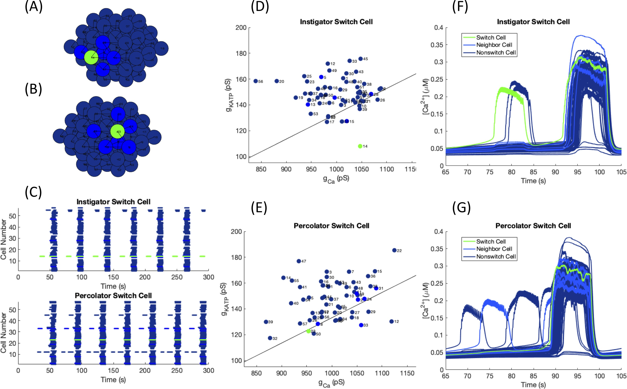

Figure 2.9: Initiator versus Percolator Switch Cell. Switch cells are denoted in green, their gap junctionally connected neighbors in blue, and remaining cells in navy. The islet structure with (A) an initiator and (B) a percolator switch cell. (C) Raster plots for islets with switch cells in green to indicate the differences in period between initiators (top panel) and percolators (bottom panel). The activation parameters for each cell in the islet are shown for a parameter set with (D) an initiator and (E) a percolator switch cell. The black line represents the Hopf bifurcation below which a cell, when isolated, will burst. Calcium time courses for (F) an initiator and (G) a percolator switch cell relative to the rest of the islet.

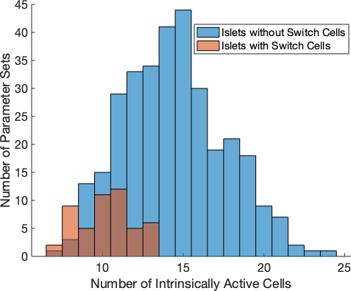

Figure 2.10: Histogram of Active Cells at a Fixed Level of Glucose. The number of active cells per parameter set for parameter sets with switch cells (red, N=50) and some
of the parameter sets without switch cells (blue, N=321). The region of overlap is denoted in the darker brown color. The distributions for parameters are g_{Ca} ∼ N (1000, 50) and
gK(ATP ) ∼ N (145, 14.5) where g_{C} ∼ N (5, 2.5).

Thus, while the excitability properties of the switch cells are critical, the con- nectivity properties of the network and cellular properties of the neighbors may be similarly important. An example of this point is shown in Fig 2.11. In this islet, cell 12 had very similar activation parameters to the switch cell 42. Both cells had a higher frequency of bursting than the islet-wide burst, shown in the top panel of Fig 2.11(B). However, islet-wide bursts continued when cell 12 was silenced shown in Fig 2.11(B) bottom panel and islet-wide bursting was lost when switch cell 42 was silenced in the middle panel. Fig 2.11(C) illustrates the minimal impact of swapping the cell parameters for cells 12 and 42. Cell 42 remained the switch cell while silencing cell 12 was unable to silence the islet, implying that the structural properties around switch cell 42 led to the loss of activity behavior.

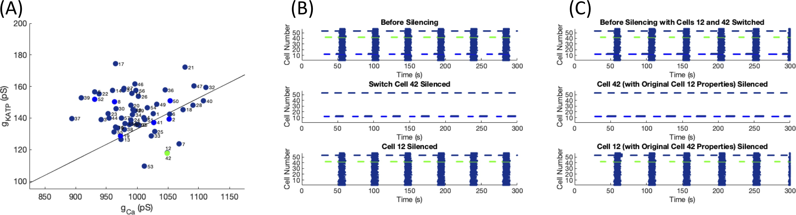

Figure 2.11: Swapping Switch Cell Properties. (A) Activation parameters for cells in the islet with the switch cell in green, its neighbors in blue, and all other cells in navy.
(B) Raster plots for the islet before silencing (top panel), with switch cell 42 silenced (middle panel), and for cell 12 silenced (bottom panel). (C) Raster plots for an islet with the cellular properties of cells 42 and 12 swapped before silencing (top panel), with the new cell 42 with properties of the original cell 12 silenced (middle panel), and for the new cell 12 with properties of the original cell 42 silenced (bottom panel).

Silencing cells is not the same as removing them

Cell silencing has been used experimentally to temporarily remove cells from an islet to measure the impact of that cell on the network [10] rather than cell abla- tion that completely removes a cell from the network [57]. Through computational methods, a cell can be easily removed and added back into a network. By killing all of a cell’s gap junction connections, it could no longer affect its neighboring cells and was effectively removed from the network. Thus, we briefly studied the differ- ences between the two techniques computationally. In many cases, isolating switch cells found through silencing also led to a loss of activity in the islet. However, there were some cases in which isolating switch cells would have little impact on

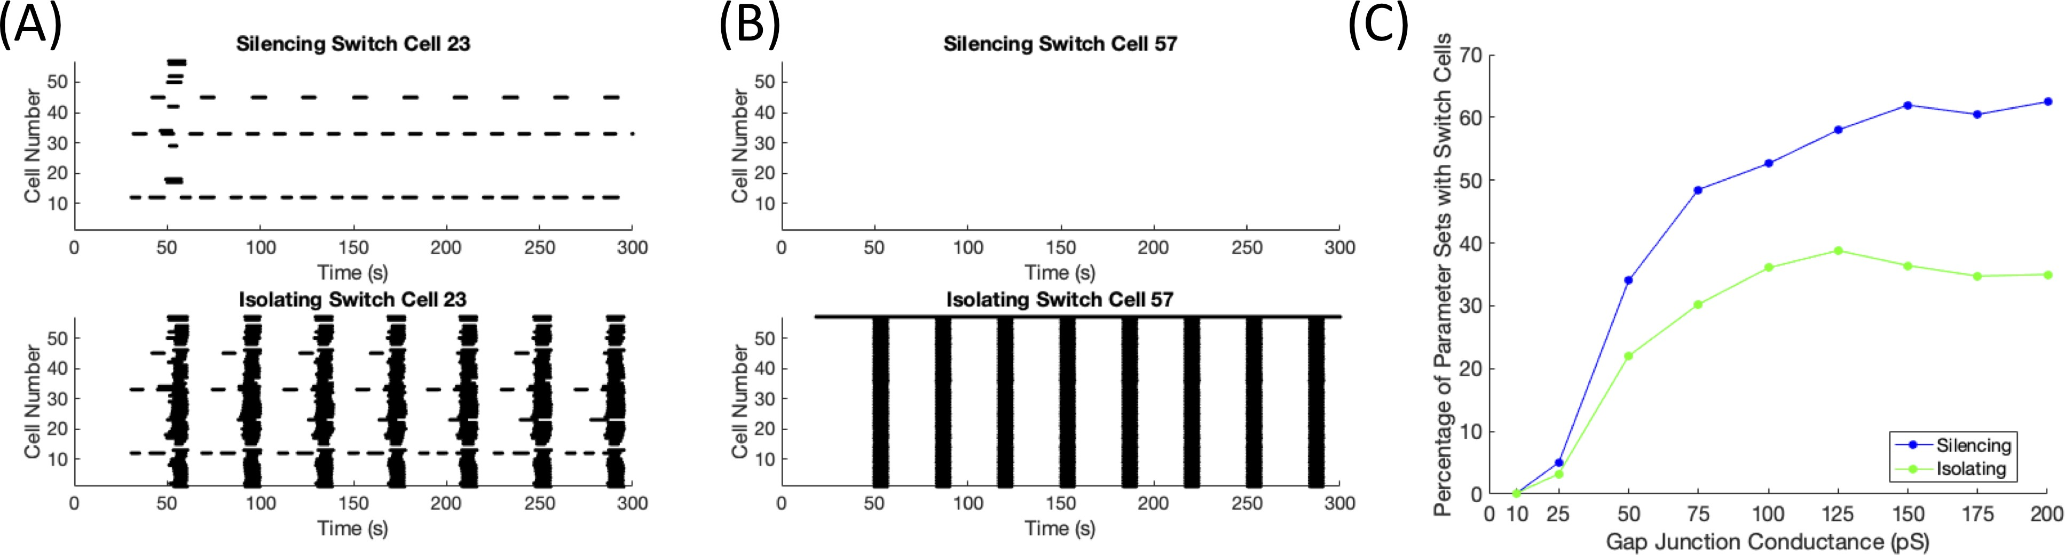

Figure 2.12: Silencing Versus Isolating. (A) A parameter set with g_{C} ∼ N (5, 2.5) and gK(ATP ) ∼ N (145, 14.5) with the switch cell silenced (top panel) and the switch cell isolated (bottom panel). (B) A parameter set with g_{C} ∼ N (200, 100) and gK(ATP ) ∼
N (135, 13.5) with the switch cell silenced (top panel) and the switch cell isolated (bottom panel). (C) The percentage of parameter sets with silencing (blue) and isolating (green) switch cells out of the number of active parameter sets as the gap junction was increased with gK(ATP ) ∼ N (135, 13.5) pS.
the islet bursting. Examples for low coupling (g_{C} ∼ N (5, 2.5)) and high coupling (g_{C} ∼ N (200, 100)) are shown in Fig 2.12(A) and (B), respectively. As the coupling was increased from 10 pS to 200 pS with g_{K(AT} _{P} ₎ ∼ N (135, 13.5) pS, the percentage
of parameter sets with silencing switch cells increased faster than the percentage of parameter sets with isolating switch cells. These results can be seen in Fig 2.12(C). These differences can be accounted for by the hyperpolarizing current silencing the rest of the islet through coupling. As such, the stronger coupling leads to a larger gap between silencing and isolating.

Discussion

Islets are well-coupled populations of heterogeneous cells, which have been often modeled as homogeneous due to the synchronizing effects of electrical coupling. Recent experiments have suggested that individual β cell heterogeneity can in some cases dominate the collective islet.
This study was a search for model islets of β cells that satisfied the condi- tions proposed experimentally for silencing an islet through individual hub cells: a scale-free functional connectivity network and a loss of connectivity and desyn- chronization with hub cell silencing [10]. While scale-free functional networks were found assuming heterogeneity of cell parameters and coupling, confirming previous computational work [9], and these networks lost functional connectivity when the functional hub cell was silenced, desynchronization was never observed. As this approach proved unsuccessful, predetermination of hub cells was tested, similar to previous work [5]. For desynchronization with silencing, it was necessary for the predetermined hub cell to be the only intrinsically active cell in the islet. However, it has been shown experimentally that most cells can oscillate independent of the activity of neighboring cells [20]. These islets were also not characterized as scale- free nor were the predetermined hub cells considered to be functional hubs cells, bringing into question the utility of functional connectivity measure.
Multiple methods of determining functional connectivity have been utilized on

pancreatic islets. The more straightforward Pearson correlations have shown islets as small world networks [6, 7, 9, 34]. The binarized method, used in this study, has

revealed scale-free properties in the islets of zebrafish, mice, and humans [10, 57]. In a comparison between the two methods, a noticeable difference is the connectivity of silent cells. The calcium traces of two silent cells are highly correlated and thus functionally connected by the Pearson correlation method. As the binarized method puts an emphasis on the activity of cells in functional connections, two silent cells are not considered functionally connected. In mouse islets, the binarized method led to scale-free networks while the Pearson correlation method did not [57].
The binarized method of functional connectivity was unsuccessful in assist- ing in the uncovering of hub cells that silence the islet. Since it focuses on the correlations in activity, using the degree centrality on the functional connectivity network results in locating the cells with the most common behavior in the islet. By considering this cell the leader of islet behavior, the assumption is being made that correlation implies causation. However, silencing the functional hub cell was unable to desynchronize the islet in our simulations, dispelling this notion. A trade off was found between scale-free connectivity, which is necessary for functional hub cells, and islet desynchronization. Highly functionally connected cells, which have many strong gap junctional connections, are more likely to have their activity si- lenced than initiate a wave. On the other hand, a less connected cell is more likely to remain active and initiate a smaller local wave that may spread through out the islet due to connectivity of neighboring cells.
In order to find cells that would replicate the desynchronization of an islet with individual cell silencing, cells were systematically silenced computationally, search- ing for a dissipation of coordinated oscillations. Depending on the conductance

levels, 15-65% of active islets tested contained at least one switch cell, which led to a loss of islet-wide bursting when silenced. Two types of switch cells were found: initiator and percolator. While highly active cellular parameters were needed for an initiator switch cell, the structural properties and cellular properties of neighbors also played a critical role in the emergence of switch cells.
A motivation behind silencing a cell is to study the impact of the loss of that cell’s activity on the network, imitating the effect on the islet of that cell becoming dysfunctional or dying. However, silencing a cell by hyperpolarizing it may have some unintended consequences. When the genetically added pumps are activated optically, the membrane potential of the targeted cell decreases due to the chloride ions moving into the cell. This hyperpolarization can lead to the hyperpolarization of neighboring cells through gap junctions, which can cause an islet to go silent, especially a strongly connected islet. The number of switch cells with differing behavior between isolation and silencing grew as the coupling was made stronger, implying that the silencing technique may not be suitable to determine the effect of cell removal from the network if the islet is tightly coupled.
As the network properties were the focus, a simple model looking only at the electrical and calcium dynamics was selected. The metabolic impact was in- cluded through the conductance of the ATP/ADP ratio dependent potassium chan- nel (g_{K(AT} _{P} ₎), which was held constant for a given cell. However, that ratio and thus the conductance is dynamic due to the phosphorylation of ADP through metabolism and the dephosphorylation of ATP for energy use. Our results can be interpreted as the activity of an islet at a certain level of glucose. A given islet may have a low

probability of having switch cells for a certain glucose level and may not consistently have the same switch cells, but different switch cells may emerge at differing levels of glucose, leading to a possible dysfunction in behavior at specific glucose levels. Initial tests on a more sophisticated model [72] containing a dynamic metabolic component have shown islets, with a parameter regime consistent with that used in this study, containing switch cells. However, further work with this model is needed to determine the cellular and network properties required for the emergence of switch cells. This work also focused on small networks with 57 β cells for effi- ciency in testing many cases exhaustively. While similar results have been found in a few trial cases, more work will need to be tested on larger islets.
Islets were previously thought to be quite democratic in nature where all cells contributed more or less equally to islet behavior. Recent experiments [10, 57] and computational results [5] have introduced the idea of hub cells that are highly func- tionally connected and govern islet activity. This paper has identified a different type of cell, switch cell, whose loss has a similar effect of silencing the islet. While switch cells do not relate to functional connectivity, some switch cells can be leader cells [4, 57]. Gaining further insight into the mechanisms behind switch cells may assist in understanding the hub cell experiments and the loss of synchronization occurring in type 2 diabetes.

Chapter 3: Quantitative Measures

After solving the system of differential equations given in Equations 2.1-2.4, various quantitative measures were applied in order to study the network behavior. The main measures used were mentioned in Chapter 2: functional connectivity, scale-free determination, degree centrality, and synchronization. However, there were many other measures that were tested, which are explained further here.
We first tested different functional connectivity measures that have been used for networks of pancreatic β cells, deciding to use the measure from the work moti- vating our research. As one of the main properties we initially wanted our network to satisfy was scale-free, we developed a method to characterize a functional network as scale-free. Next, various centrality measures were tested to identify potential hub cells. Since a loss of synchronization or activity was an essential part of our search, we tested various synchrony measures, ultimately devising our own measure to suit our needs. Lastly, we briefly tested the notion of identifying calcium waves as a type of switch cell initiated waves.

3.1 Functional Connectivity

As discussed in Chapter 1, the notion of functional connectivity began in com- putational neuroscience to examine regions in the brain that had similar behavior and thus maybe functionality. Stoˇzer et al. [6] introduced this idea to study sim- ilarly behaving β cells in the islet. They defined a functional connection between two cells i and j if the Pearson correlation coefficient of their calcium traces was

above a threshold,
T
i
i
j
j

ρi,j
1 c (t) − c¯

T − 1
t=0
σ
i
c (t) − c¯

σ
j

where T denotes the total number of seconds, c_{i}(t) the calcium concentration of cell i at time t, c¯_{i} the calcium concentration of cell i averaged over all time points, and σ_{i} the standard deviation of the calcium concentration of cell i over time. Others have used the same definition for functional connectivity with varying thresholds ranging from R_{thresh} = 0.75 to R_{thresh} = 0.95 [6, 9, 34]. A higher threshold leads to fewer functional connections in the network.
=
·
> R
thresh
,
We started by testing this definition with a simple two node case where the dynamics for one node was described by a sine curve (y = 5 sin (t)). The second node was described by an altered sine curve to measure the impact of variations on the functional connectivity. All of the modifications and the resulting coefficients can be seen in Fig 3.1. As the Pearson correlation examines the linear relationship between two variables, a vertical shift, seen in Fig 3.1(a), and scaling, shown in Fig 3.1(b), result in a correlation coefficient of ρ = 1. The horizontal shift by 1

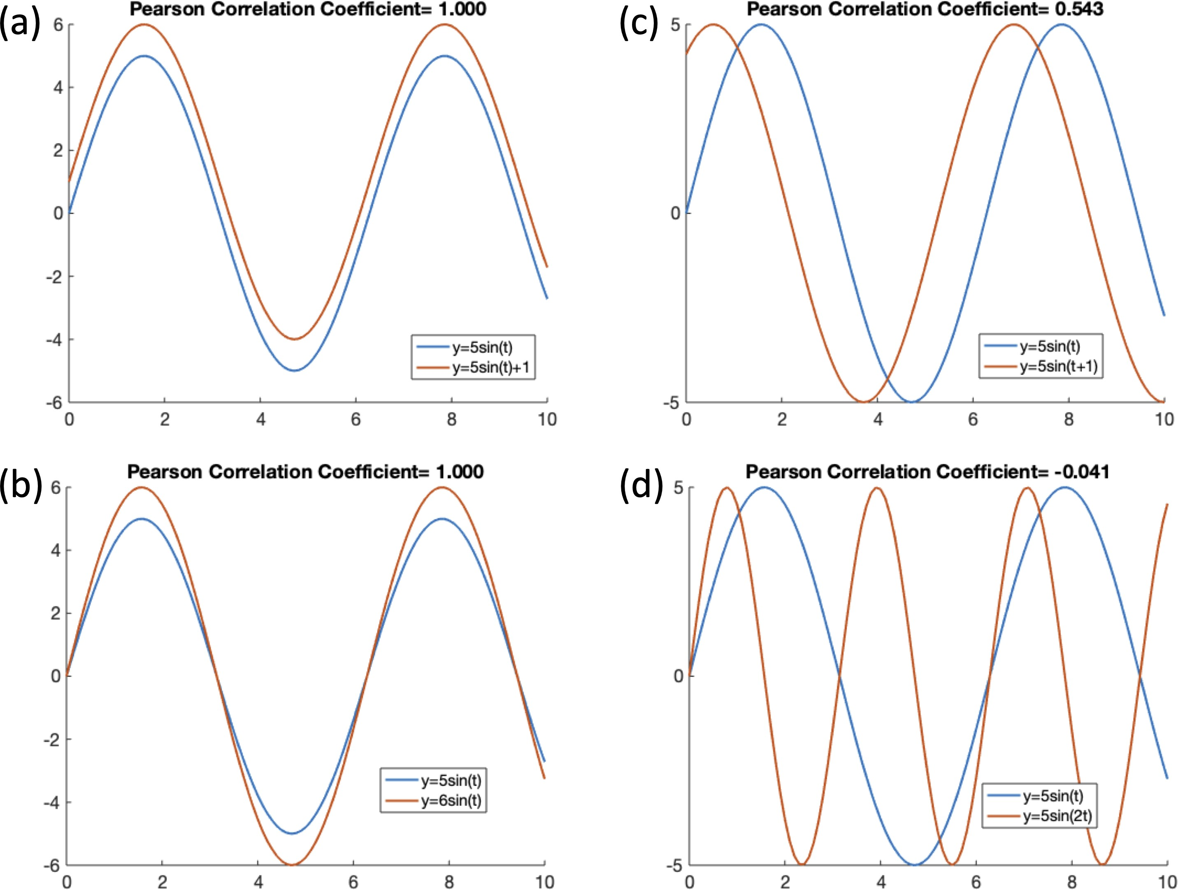

Figure 3.1: Pearson Correlation and Altered Sine Curves. The impact of different modifications to a sine curve on the Pearson correlation coefficient. (a) Vertical shift by

1 with ρ_{1,2} = 1, (b) scaling factor of ⁶
5
with ρ_{1,2} = 1, (c) horizontal shift by 1 with

ρ_{1,2} = 0.543, and (d) period doubling with ρ_{1,2} = −0.041.

displayed in Fig 3.1(c), which was no longer a linear shift, dropped the coefficient to ρ = 0.543. Lastly, the period doubling in Fig 3.1(d) led to a negative coefficient.
We next investigated the case of the Pearson correlation coefficient for a two cell system at different coupling strengths using the Eq 2.1-2.4, shown in Fig 3.2. As the coupling strength was increased, the correlation coefficient increased, as ex- pected. However, even at g_{C} = 10 pS in Fig 3.2 when the two cells were active around the same time with a delayed upstroke for cell 1, the correlation coeffi-

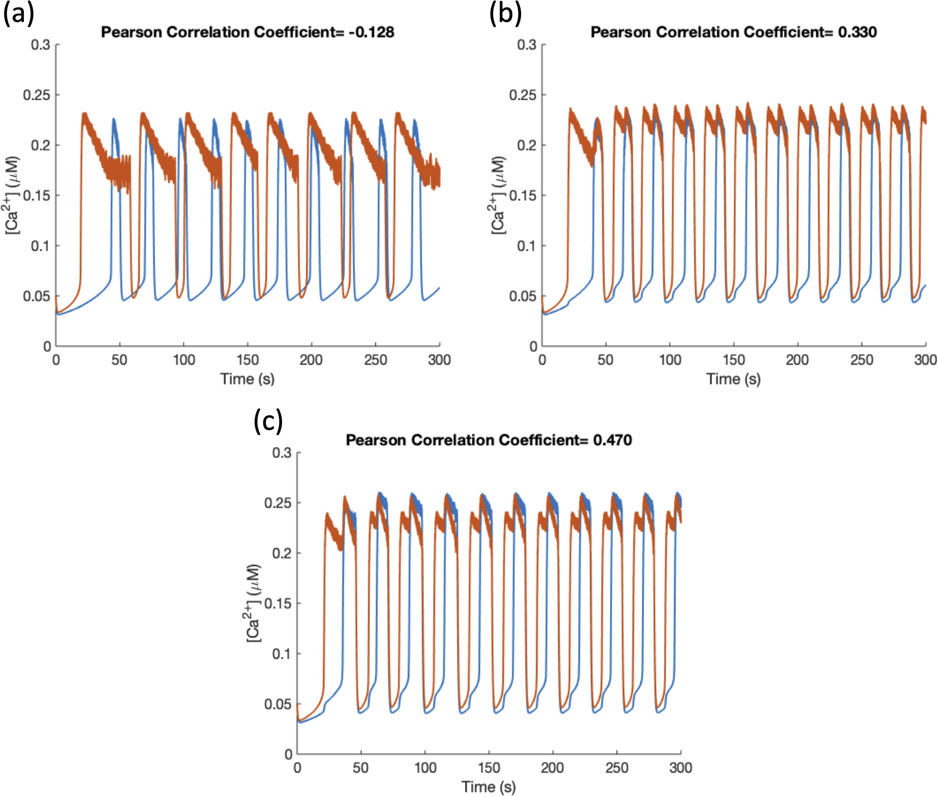

Figure 3.2: Correlation Coefficients for Two Cell System at Different Coupling
Strengths. The same cell parameters were used for all three subfigures. Increasing the coupling strength increased the correlation from (a) g_{C} = 0 pS with ρ_{1,2} = −0.128 to (b) g_{C} = 5 pS with ρ_{1,2} = 0.33 to (c) g_{C} = 10 pS with ρ_{1,2} = 0.47.

cient was lower than the threshold for functional connectivity, which we had set to

R_{thresh} = 0.95. Thus, these two cells were not considered functionally connected.

Meanwhile, two silent cells would be functionally connected, as their coefficient ρ would be close to 1. This raised some questions regarding the use of the Pearson correlation for determining functional connectivity. Our intuition behind functional connectivity said that two functionally connected cells impact each other in some manner. For nearest neighbors, a functional connection arose due to their gap junction. When cell 1 began to burst, a depolarizing current traveled through the

gap junction to cell 2, raising it above the voltage threshold for bursting. Thus, the two cells had a highly correlated time course and were functionally connected. It has been discussed that longer range functional connections emerge from calcium waves [9]. However, when two cells were silent and were functionally connected, there was no intuition behind their connection. Our understanding of functional connectivity is that it should reflect similar bursting patterns and thus, the functional connectivity measure should account for silent versus active cells.
The measure by Johnston et al. to determine functional connectivity consid- ered this idea by using a similarity coefficient dependent on the duration the two cell are active [10]. The calcium trace for cell i was binarized as active or silent

based on a set threshold,

b_{i}(t) =
1, c_{i}(t) > c_{thresh}
0, c_{i}(t) ≤ c_{thresh}.

From the binarized traces, the duration cell i was active, T_{i}, was calculated by

T

T_{i} = b_{i}(t).
t=0

In order to compare the activity of two cells, the duration of time cells i, j were coactive was determined by
T

T_{i,j} = b_{i}(t) · b_{j}(t).
t=0

Using these durations, the similarity coefficient was defined as

Ti,j C_{i,j} = T T .
i
j

Thus two perfectly synchronized cells had T_{i} = T_{j} = T_{i,j}, resulting in C_{i,j} = 1. On the other hand, two asynchronous cells that had opposing bursting patterns would have T_{i,j} = 0, leading to C_{i,j} = 0.
The example of the sine and modified sine curve with its similarity coefficients are shown in Fig 3.3, where the threshold for activity was selected as 1, indicated by the black dashed line. The vertical shift in Fig 3.3(a) and the scaling in Fig 3.3(b) no longer had a coefficient of 1 as they did with the Pearson correlation, but the coefficient was still high. The coefficients for a horizontal shift in Fig 3.3(c) and period doubling in Fig 3.3(d) were above those of the Pearson correlation coefficient, but still below any of the R_{thresh} mentioned.
To compare the similarity coefficient to the Pearson correlation on the model,

we calculated the similarity coefficient for the same two cell example from Fig 3.2 in Fig 3.4, where the calcium threshold for binarization was c_{thresh} = 0.15 µM. Like the Pearson correlation coefficient, the similarity coefficient increased as the gap junctional coupling was raised. One major difference was that the g_{C} = 0 pS case had a much higher similarity coefficient than correlation coefficient (ρ_{1,2} =
−0.128 compared to C_{1,2} = 0.44). It is important to note though that the Pearson
correlation ranges from -1 to 1, while the similarity coefficient has the range 0 to 1.

The description from Johnston et al. [10] of denoting a functional connection did not describe a threshold for the similarity coefficient. By looking at many examples of cell pairs with different levels of activity, we designated the threshold as R_{thresh} = 0.85, which meant none of the examples in Fig 3.4 were functionally connected.

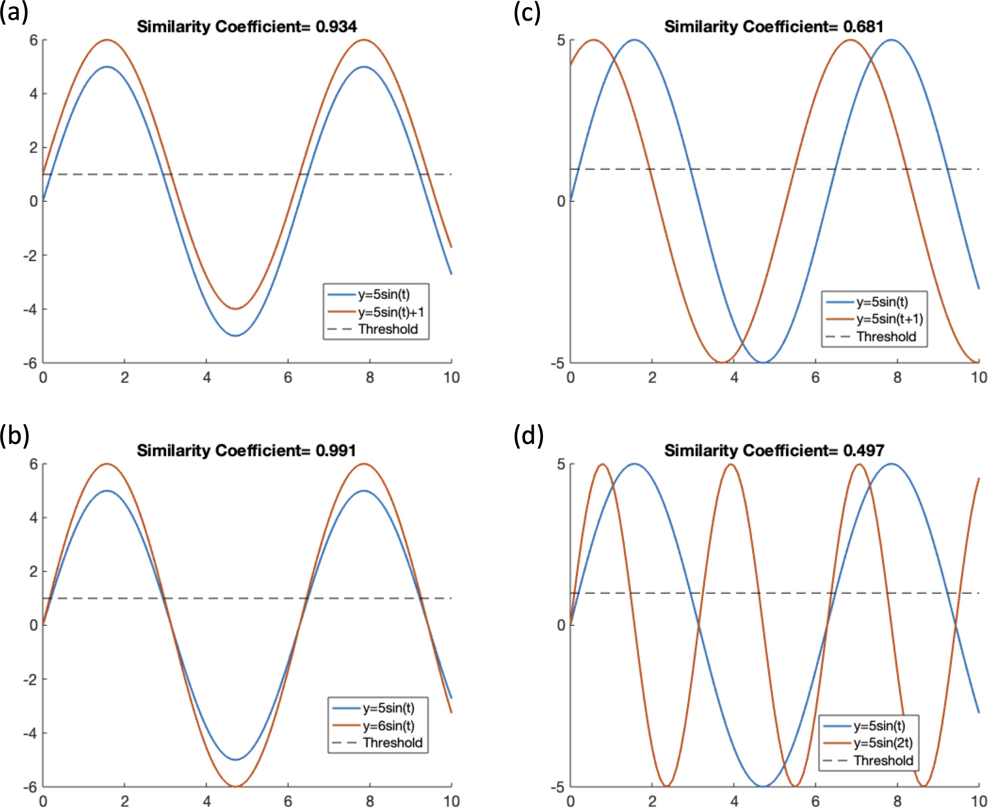

Figure 3.3: Similarity Coefficient and Altered Sine Curves. The impact of different modifications to a sine curve on the similarity coefficient (C_{1,2}) given the binarization

threshold of 1. (a) Vertical shift by 1 with C_{1,2} = 0.934, (b) scaling factor of ⁶
5
with

C_{1,2} = 0.991, (c) horizontal shift by 1 with C_{1,2} = 0.681, and (d) period doubling with

C_{1,2} = 0.497.

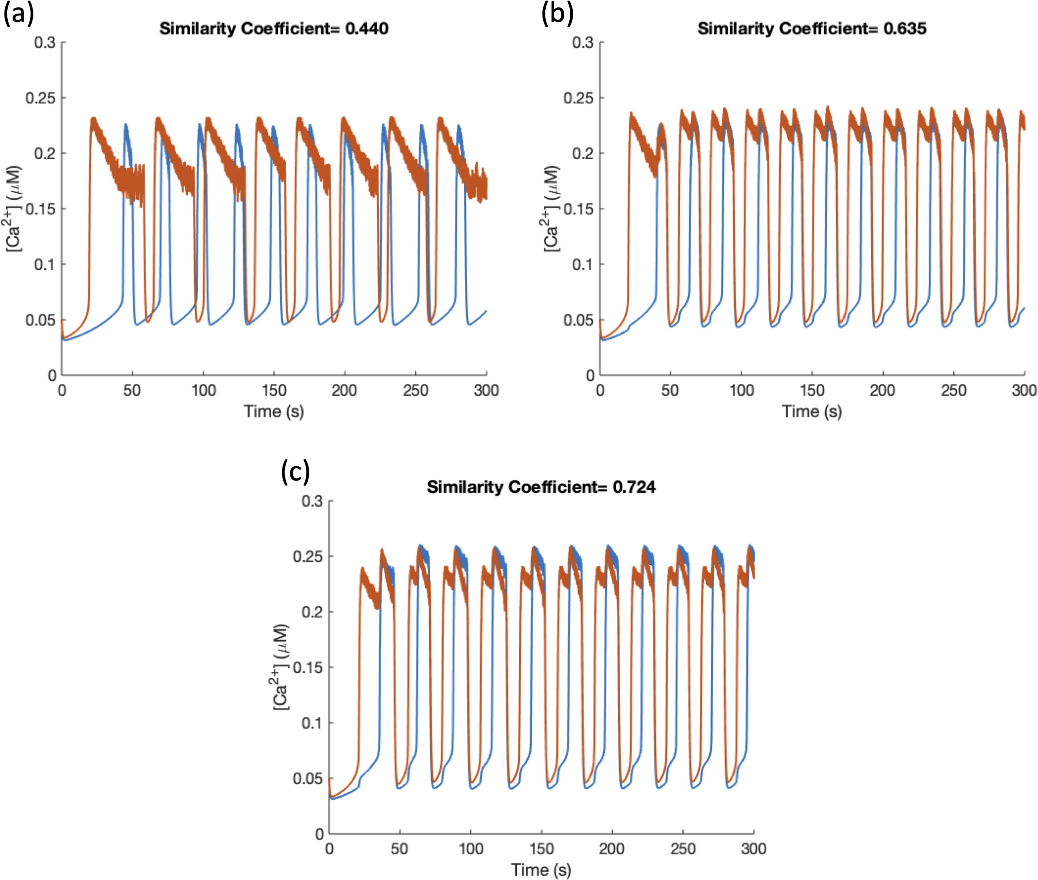

Figure 3.4: Similarity Coefficients for Two Cell System at Different Coupling Strengths. The same cell parameters were used as in Fig 3.2. Increasing the coupling strength increased the correlation from (a) g_{C} = 0 pS with C_{1,2} = 0.44 to (b) g_{C} = 5 pS with C_{1,2} = 0.635 to (c) g_{C} = 10 pS with C_{1,2} = 0.724.

Johnston et al. [10] guarded against connections by chance by permuting the binarized traces over 9,999 times and computing the significance. We originally included this into our protocol for the determination of functional connections. Each binarized trace was permuted and the time coactive was recalculated each time. If the probability of getting the T_{i,j} calculated from the simulation was less than
0.01 according to the permuted traces, the functional connection was considered not by chance. After testing many cases, it was found that a pair of cells with C_{i,j} > 0.85 were very unlikely to be a connection by chance. As the computation time for calculating the significance of a connection was high, it was removed from the calculation. Thus, our qualification for a functional connection was only a similarity coefficient C_{i,j} > 0.85.
Most importantly, with this new measurement for functional connectivity, two silent cells were no longer considered to be functionally connected. Even though the similarity coefficient for two silent cells would be indeterminate as T_{i,j} = 0 = T_{i} = T_{j}, we decided that a T_{i,j} = 0 meant no functional connection.
A comparison of the two methods for functional connectivity can be seen in Fig 3.5 for a coupled islet. For consistency, both methods used a threshold R_{thresh} =
0.85 to determine connectivity from the calculated coefficients. There is a total of 1596 possible functional connections in a 57 cell islet. Using the Pearson correlation method on an active islet in Fig 3.5(a) resulted in a total of 275 connections while the similarity method calculated 1016 connections in Fig 3.5(b). On the other hand for a silenced islet, the Pearson correlation method had a highly connected islet with 1276 connections shown in Fig 3.5(c) while the similarity method had no functional

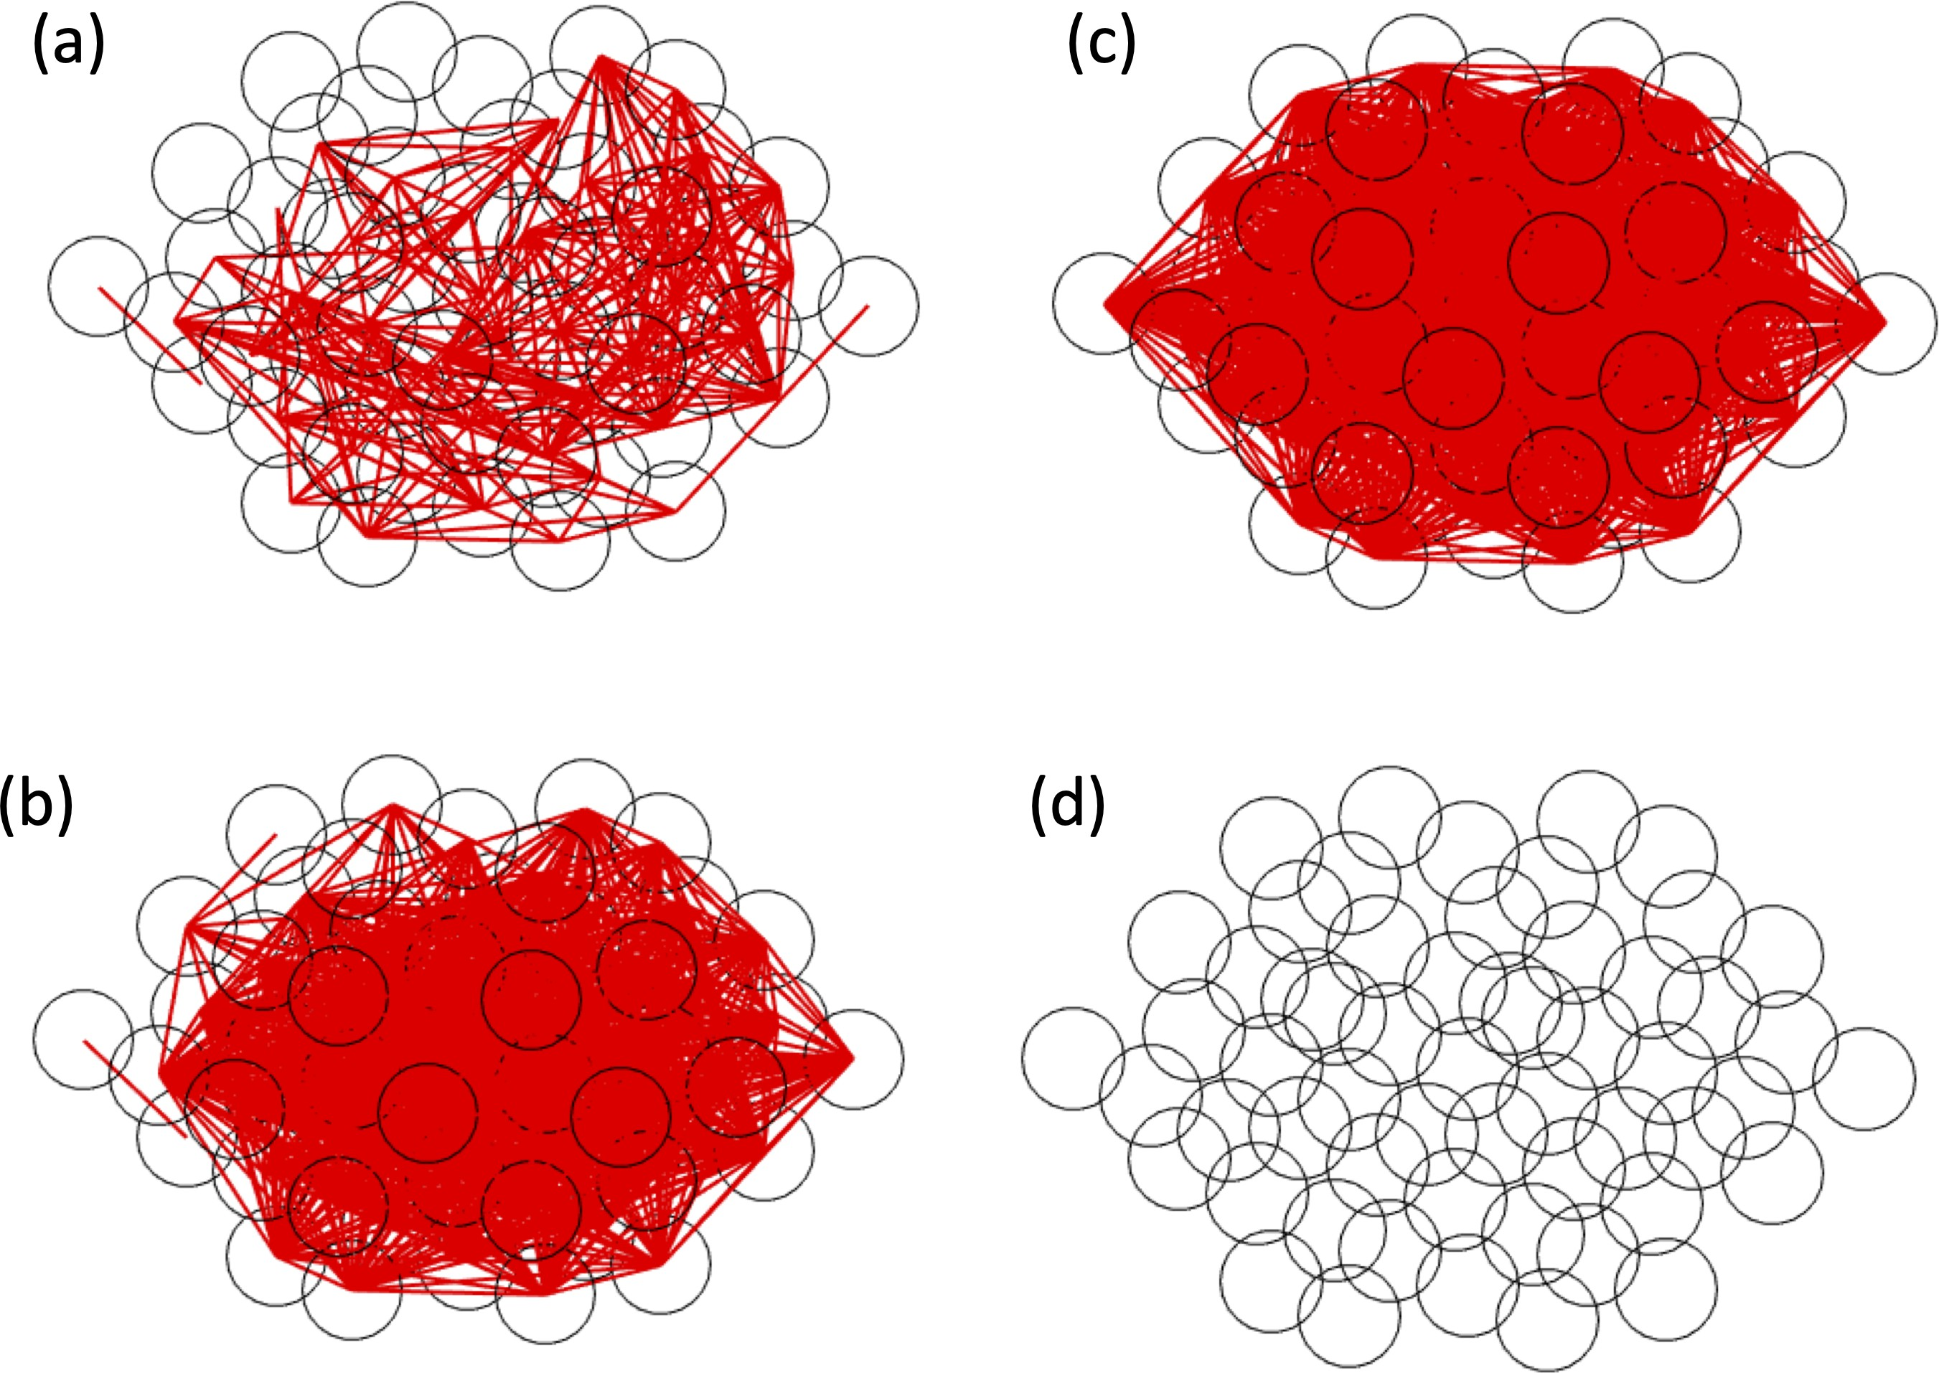

Figure 3.5: Comparison between Functional Connectivity Measures on 57 Cell
Islet. The functional connectivity of a 57 cell islet with g_{C} ∼ N (5, 2.5) for an active islet with g_{KAT} _{P} ∼ N (130, 13) measured using (a) Pearson correlation coefficient and (b) similarity coefficient. The functional connectivity was then calculated for a silent islet with g_{KAT} _{P} ∼ N (155, 15.5) using (c) Pearson correlation and (d) similarity coefficient.

connections in Fig 3.5(d). As the similarity method treated silent cells as desired, we chose to use that method for our functional connectivity calculations.
The idea of dynamic functional connectivity was introduced by Stoˇzer at al. [6] and Markoviˇc et al. [7]. Their correlation coefficients were a function of time and thus, their functional connectivity was dynamic. They chose this method as it allowed for a study of the different connectivity patterns that arose from increasing glucose concentrations.
We briefly tested this idea by calculating functional connectivity in a window of 300 seconds and shifting the window every 100 seconds. The initial time windows (t ∈ [0, 300], [100, 400]) had differing functional connectivity networks due to the

initial transience. As our glucose concentration, which was included in the model through g_{KAT} _{P} , was not dynamic, the functional connectivity did not change after the initial transience.

Scale-free Networks

A technique that was important to our work earlier on was characterizing a functional network as scale-free. A network is defined as scale-free if its distribution of links follows a power law distribution [42]. This implies a large number of nodes with very few edges and a small number of nodes with many edges. Johnston et al. classified their islet as scale-free by fitting their functional connectivity to the power law function p(x) = ax^{k} [10]. They determined the goodness of fit (R²) through a log transformed linear regression model.
As our initial goal was to replicate the work of Johnston et al. [10], we similarly ascertained the scale-freeness of our network. We began by log transforming our distribution of functional connectivity. As we wanted to fit to p(x) = ax^{k}, a log transformation resulted in the distribution ln p(x) = ln a + k ln x, allowing for an easier linear regression. However, a problem arose from the log transformation. Often there were cells with no functional connections, resulting in taking the natural log of 0. To avoid this initially, the number of connections was changed in the distribution from 0 to 1e-15. However, this alteration greatly affected the power law fit.
Instead, shifting the distribution by a constant was tested, leading to the new

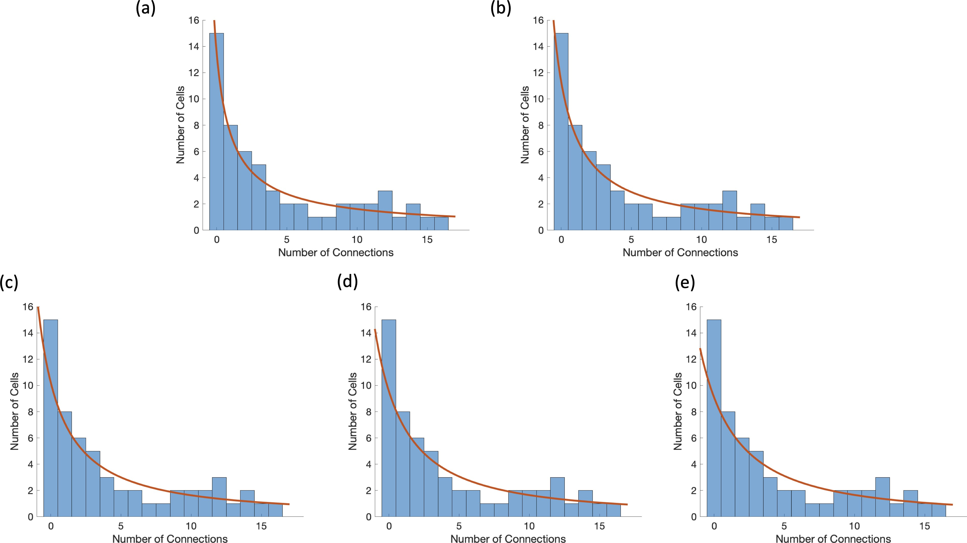

Figure 3.6: The Difference in Fits with a Shift in the Distribution. The functional connectivity distribution was shifted to the right by (a) c = 1 with R² = 0.7738, (b) c = 2 with R² = 0.7534, (c) c = 3 with R² = 0.7362, (d) c = 4 with R² = 0.7223, and (e) c = 5 with R² = 0.7111.
fit ln p(x) = ln a + k ln (x + c). Multiple different constants were assessed. Fig 3.6 shows the different fits found for the same distribution of functional connections for different constants. The goodness of fit did not vary greatly over constants ranging from 1 to 5. Visually, shifting the distribution to the right by 1 seemed to have the best fit, which matched the highest R² value. Thus, we decided to shift the distribution by 1 in order to take the log transformation.
In Johnston et al. there was no threshold set for a network to be considered scale-free [10]. Their example of a scale-free islet was said to have R² = 0.72. Thus, we considered all islets with functional connectivity following a power law distribution with R² > 0.7 as scale-free networks.

Centralities

To determine the influential cells in a network, various centrality measures have been developed that all differ in their definition of influence. Johnston et al. classified all cells in the 60-100% range of connectivity as hub cells [10]. This is similar to the degree centrality, which considers the number of links per node. The i, jth entry of the adjacency matrix A is calculated for a given network as

Ai,j =
1, nodes i, j are connected
0, otherwise.

The degree centrality for node i is then given as

C_{i} = A_{i,j}.

j

The node with the largest number of links is considered the degree hub. In our case, the degree hub represented the cell with the most similar activity to all the other cells in the network. The thought was that the degree hub was driving the behavior in the islet, leading to its large number of functional connections.
Another common centrality called the eigencentrality takes into account the degree of a node and the degree of its neighbors. It defines the centrality of a node

i as
n
C = 1 A C ,

j=1

where λ is the largest eigenvalue of the adjacency matrix A. Thus, the centrality calculates the dominant eigenvector where the most influential cell has the largest
i
λ
i,j
j

entry. In the context of the islet, an eigenhub was a cell that had a high similarity with other highly similar cells.
The closeness centrality considers how “close” a cell is to another by calculating the shortest path length between that cell and every other cell in the network. The
centrality for a cell i is
1

Ci = d(i, j) ,
j
where d(i, j) represents the shortest path length between cells i, j. The last centrality we investigated was the betweeness centrality, which measures how often a cell is along the minimal path length between all pairs of cells, given by

C_{i} =

jI=iI=k
np_{j,k}(i) , npj,k

where np_{j,k} is the total number of shortest paths from cell j to cell k and np_{j,k}(i) is the number of shortest paths from cell j to cell k that pass through cell i.
While we initially used the centrality measures on the functional connectivity, a goal was to be able to determine influential cells a priori. Thus, we tested these centrality measures on the structural connectivity network determined by the gap junction conductances as well. A comparison between the four methods on the structural network is shown in Fig 3.7. Each of the four centralities designated a different cell as the most influential for this islet: degree centrality in Fig 3.7(a) chose cell 5, eigencentrality in Fig 3.7(b) selected cell 21, the closeness centrality in Fig 3.7(c) yielded cell 1, and the betweenness centrality in Fig 3.7(d) gave cell 41. Each of these cells was silenced with minimal effect observed in the islet. It is clear from Fig 3.7(d) that the betweeness centrality is biased towards the center of the

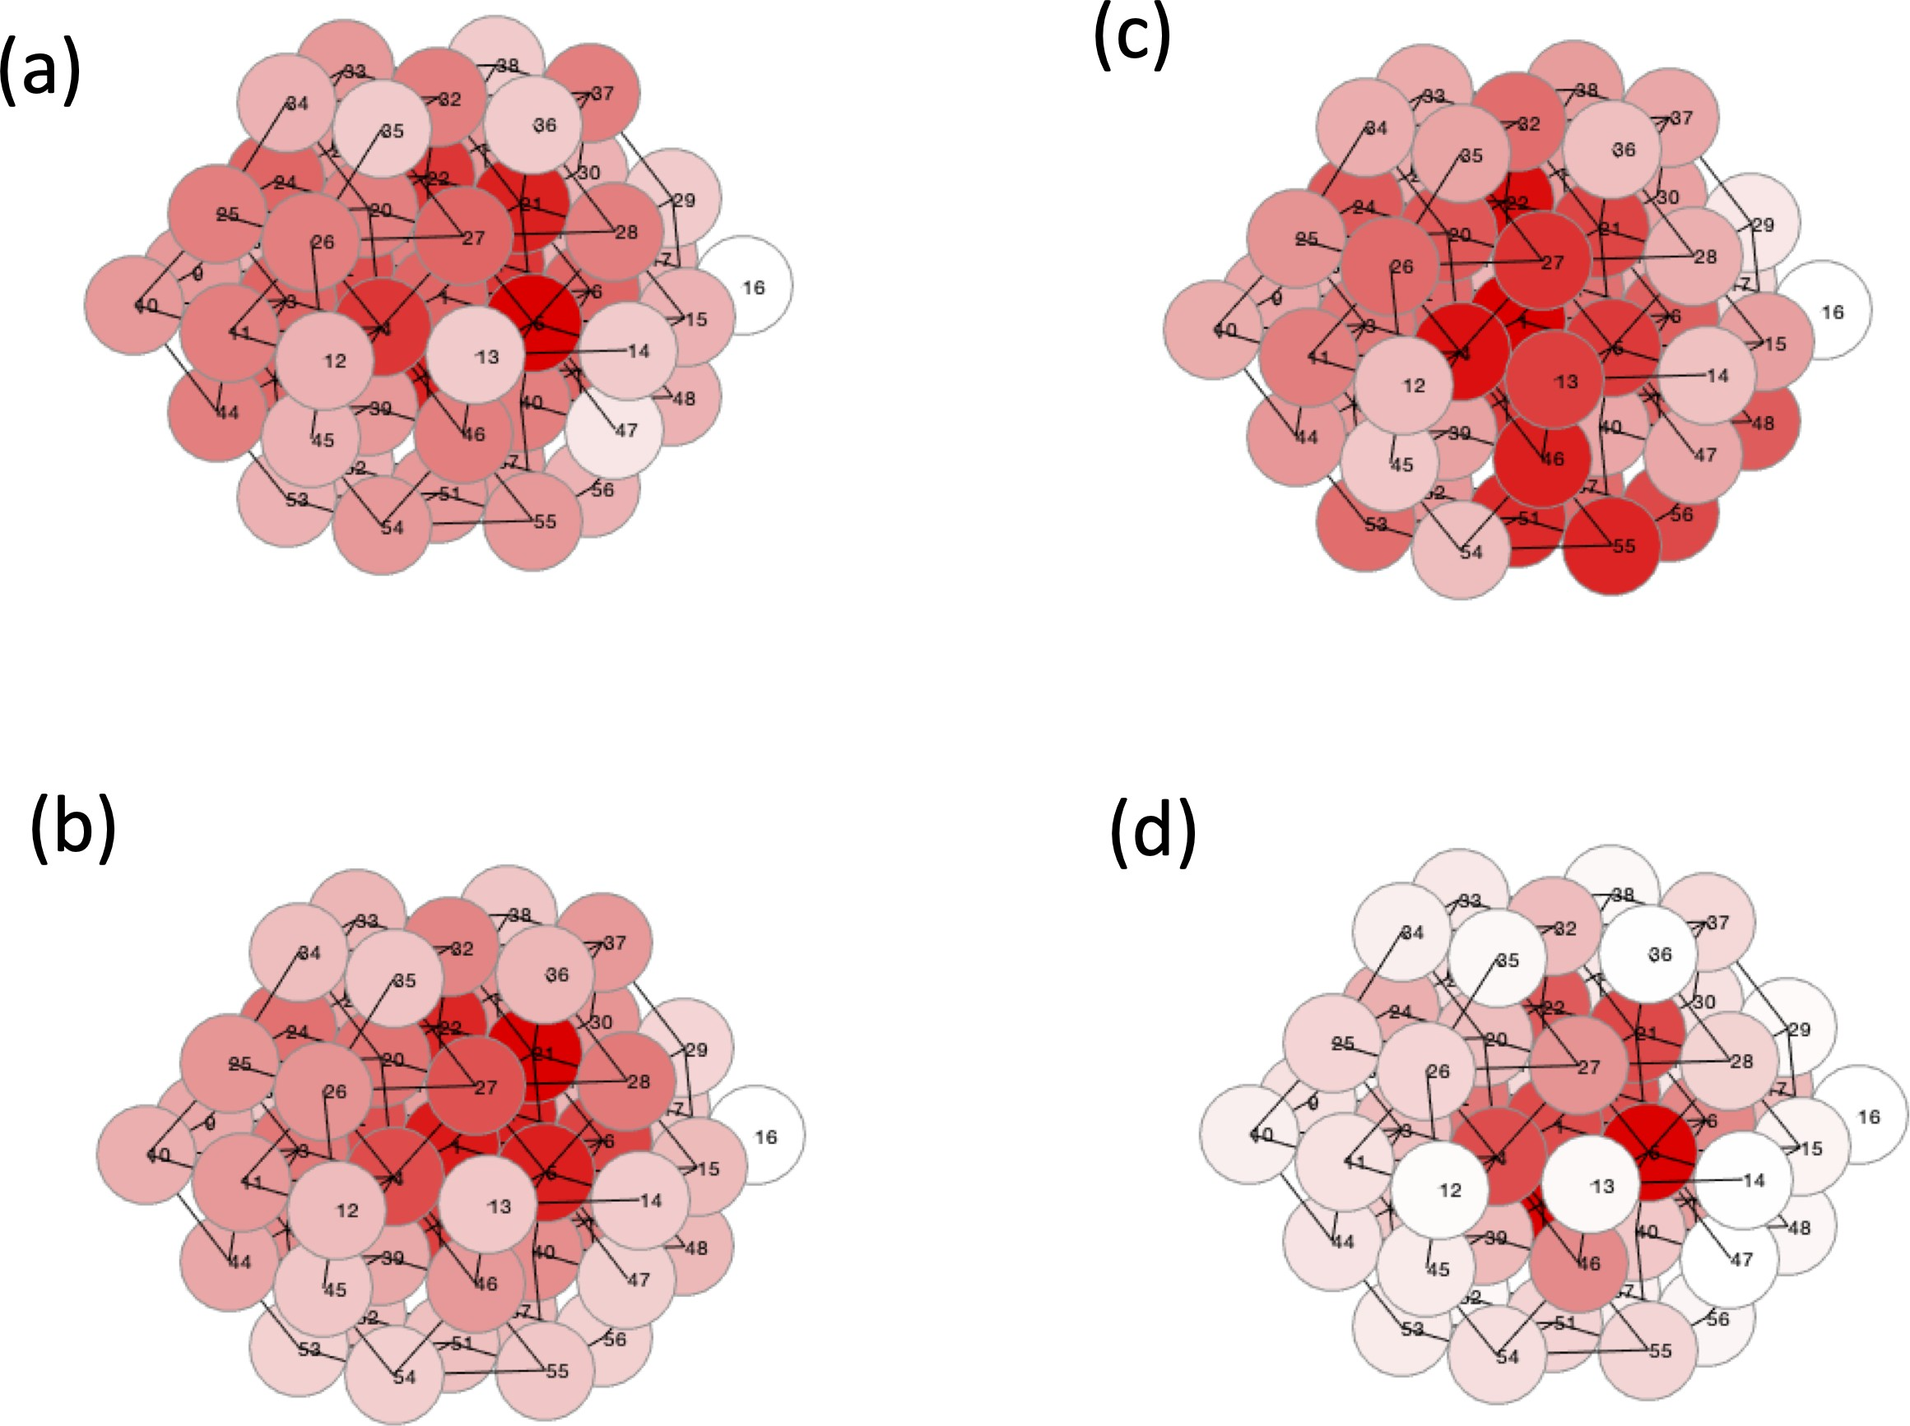

Figure 3.7: Centralities. The (a) degree centrality, (b) eigencentrality, (c) closeness centrality, and (d) betweenness centrality measure on the same structural connectivity distribution visualized where the darker red cell color indicates the more influential cells in the network and lines between cells show the gap junction connections.
islet and thus was not used further.

The unweighted centrality measures mentioned above used an adjacency ma- trix indicating the existence of connections. However, when measuring the centrality of the structural connectivity, including the gap junctional weights could prove use- ful. Thus the centrality measures were altered to account for these weights. For the degree centrality, rather than summing the number of connections per node, the sum of the gap junctional weights of all the connections of a node was considered. In the calculation of the eigencentrality, the dominant eigenvector was found for the gap junctional coupling matrix with zeros along the diagonal.
Adding weights to the closeness centrality was a slightly more difficult task. A

common method for finding the shortest path length between two cells is Dijkstra’s algorithm [73]. It can be applied to any weighted graph with nonnegative weights where the shortest paths avoid the heavier weights. As we wanted the shortest path lengths to include the stronger gap junctional conductances, we used the inverse of the coupling conductances as the weights for the algorithm.
A comparison between the unweighted and weighted centralities can be seen in Fig 3.8. The top row calculates the degree centrality, eigencentrality, and closeness centrality respectively without weights, while the bottom row has the weighted calculations. With the inclusion of the gap junction conductances for the degree centrality, there was very little change. The most central cell for the weighted degree centrality was still cell 5. Meanwhile the eigencentrality shifted the most influential cell from cell 21 without weights to cell 2 with the inclusion of the coupling conductances. In the weighted closeness centrality, the highest ranked cell was cell 7, while the unweighted closeness centrality ranked cell 1 as the highest. Again, silencing the central cells was unable to greatly impact islet activity.

Synchronization

A key objective was to desynchronize the network of β cells, which meant characterizing initial simulations as synchronized and silencing simulations as desyn- chronized. Using the raster plots that showed activity in the islet over time, it was easy to visually classify an islet as synchronized or desynchronized. However, a quantification was necessary in order to search through thousands of heterogeneous

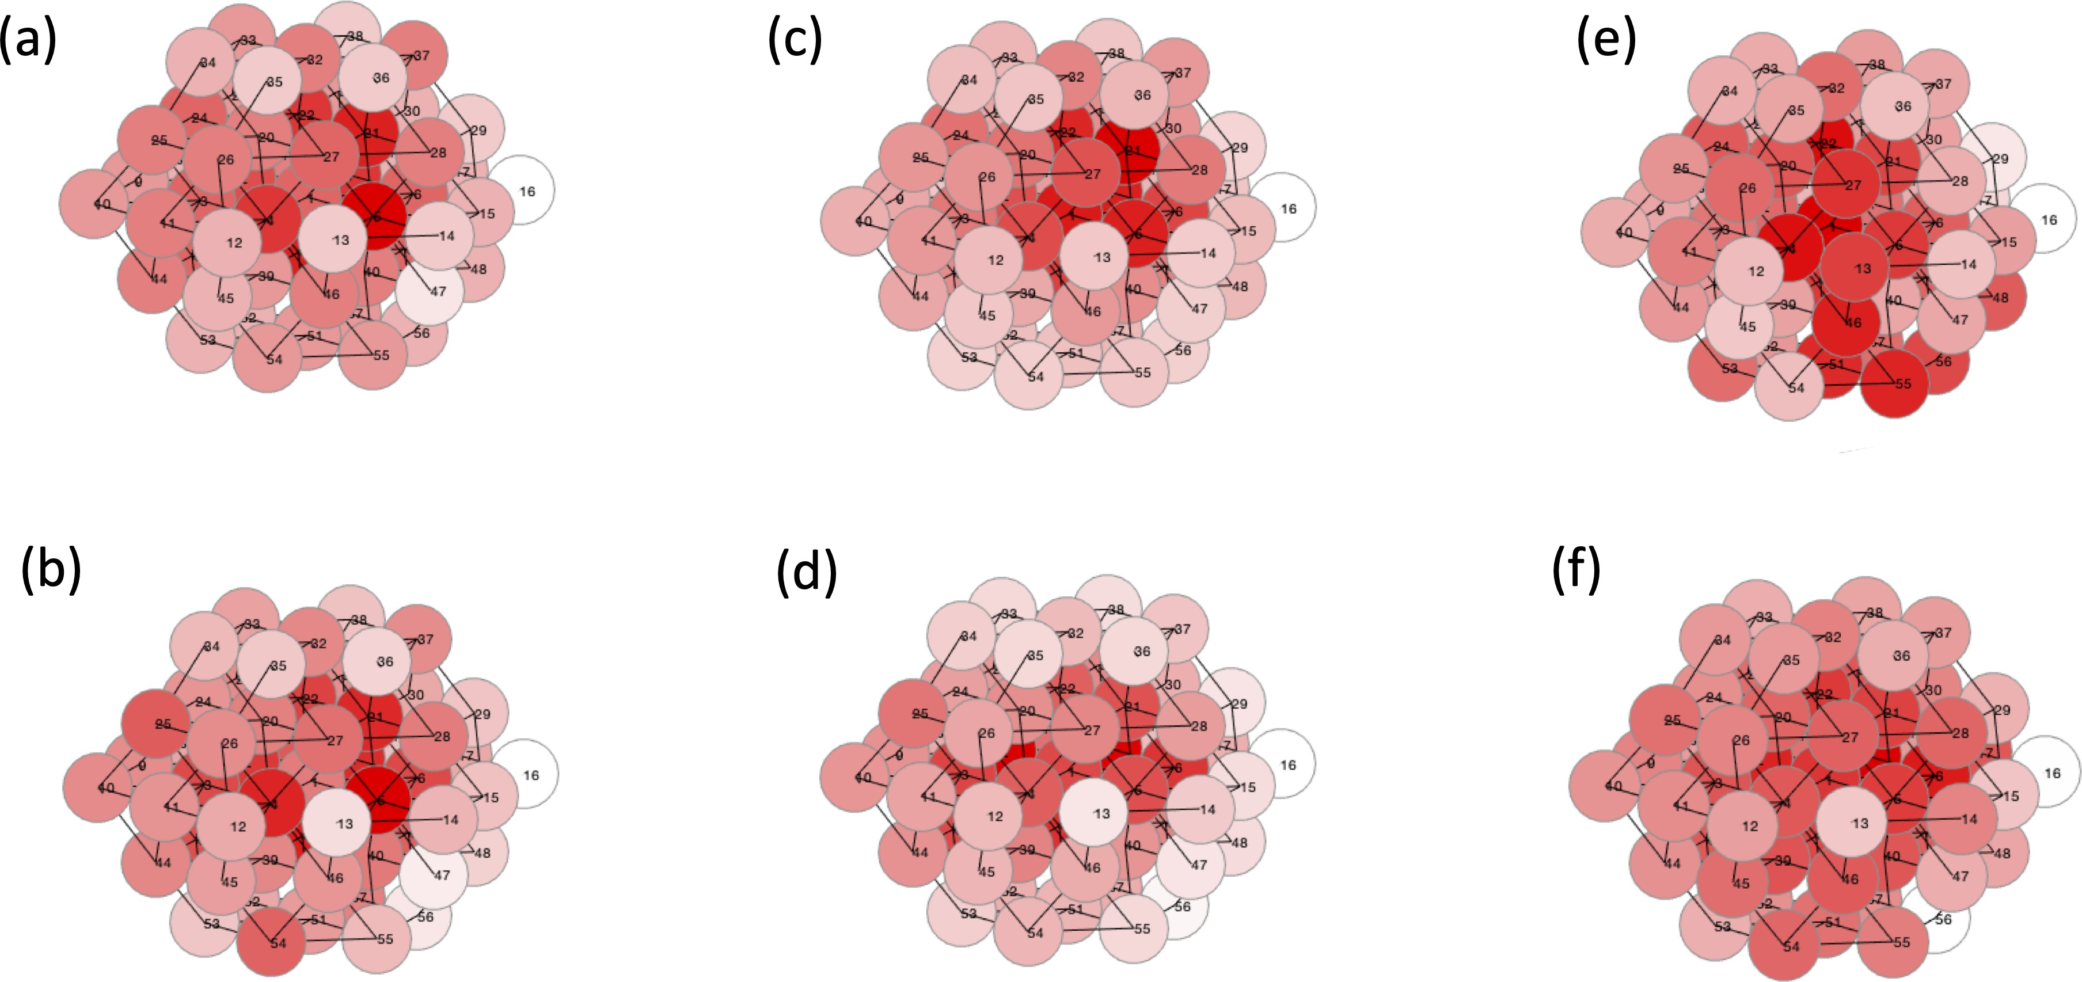

Figure 3.8: Unweighted and Weighted Centralities. The degree centrality measure on the structural connectivity of an active islet with the darker red color representing a higher ranked cell in (a) unweighted and (b) weighted calculations. Similarly the eigen- centrality for (c) unweighted and (d) weighted calculations and the closeness centrality for the (e) unweighted and (f) weighted calculations.

parameter sets.

Various methods have been utilized for the purpose of quantifying the syn- chronization of a network of β cells as described in Section 1.5. We tested two of the mentioned indexes from [3, 9]. Briefly resummarizing, Cappon and Pedersen [9] used Pearson correlations with the average calcium trace while Nittala et al. [3] used phase synchronization analysis.
We ended up developing our own algorithm for quantifying the synchrony of the islet as the measure from Nittala et al. [3] considered a fully synchronized islet to be desynchronized and the method from Cappon and Pedersen [9] considered a silent islet to be synchronized. Since we were interested in detecting large changes between a previously synchronized islet and the islet while silencing a cell, we did not want a silent islet, which would be a remarkable difference from a synchronized, bursting islet, to have the same quantification.
As described in Section 2.2.2, our algorithm used the Fast Fourier Transform to calculate the most prominent period from the frequency domain. The Fast Fourier Transform for cell j is described as
T
Y (f ) = c (t)e −2πi(t−1)(f −1) .
j
j
T
t=0
The most prominent period for cell j is the inverse of the most prominent frequency,

τ ∗ = ¹ , where

j fj∗

fj∗ = arg max
f

Y_{j}(f ).

A distribution of prominent periods p(τ ) is formed, from which the mode period

τ_{m} = arg max
j
p(τj∗) is determined. The synchronization of the islet was the per-

centage of cells within a few seconds of the mode of the most prominent periods of

the cells:
card({τ ∈ p(τ ) : |τ − τ_{m}| ≤ 2})
SI = ,
N

where card(·) denotes the cardinality of the set and N is the total number of cells. A well synchronized islet had many cells with the same period and thus had a high
synchrony index. In the case of a desynchronized islet with all different periods,
there is no true τ_{m}. Thus MATLAB selects the first element τ₁∗ of the distribution of most prominent periods as τ_{m}, resulting in SI ≈ 1 . Most importantly, a silent cell had no period and thus a silent islet gives SI = 0.
N

A comparison between the three methods can be seen in Table 3.1, where the indexes range between 0 and 100, with the corresponding traces and raster plots in Fig 3.9. As previously mentioned, the Cappon and Pedersen [9] method considered the silent islet in Fig 3.9(a) to be a synchronized islet with an index of 98.25. However, it was able to correctly identify a desyncrhonized islet in Fig 3.9(b) and a well synchronized islet in Fig 3.9(d). While the traces of the medium coupled islet in Fig 3.9(c) look desynchronized just as the Cappon and Pedersen index indicates with 28.07, the raster plot shows the majority of cells bursting at the same time, which should be computed as more synchronized.
Meanwhile, the method from Nittala et al. [3] considered the silent islet to be the most synchronous out of the four examples in Fig 3.9. In fact, the desynchronized islet had a higher index than the well-synchronized islet. It is important to note that the Nittala et al. method uses the voltage traces to compute the synchrony

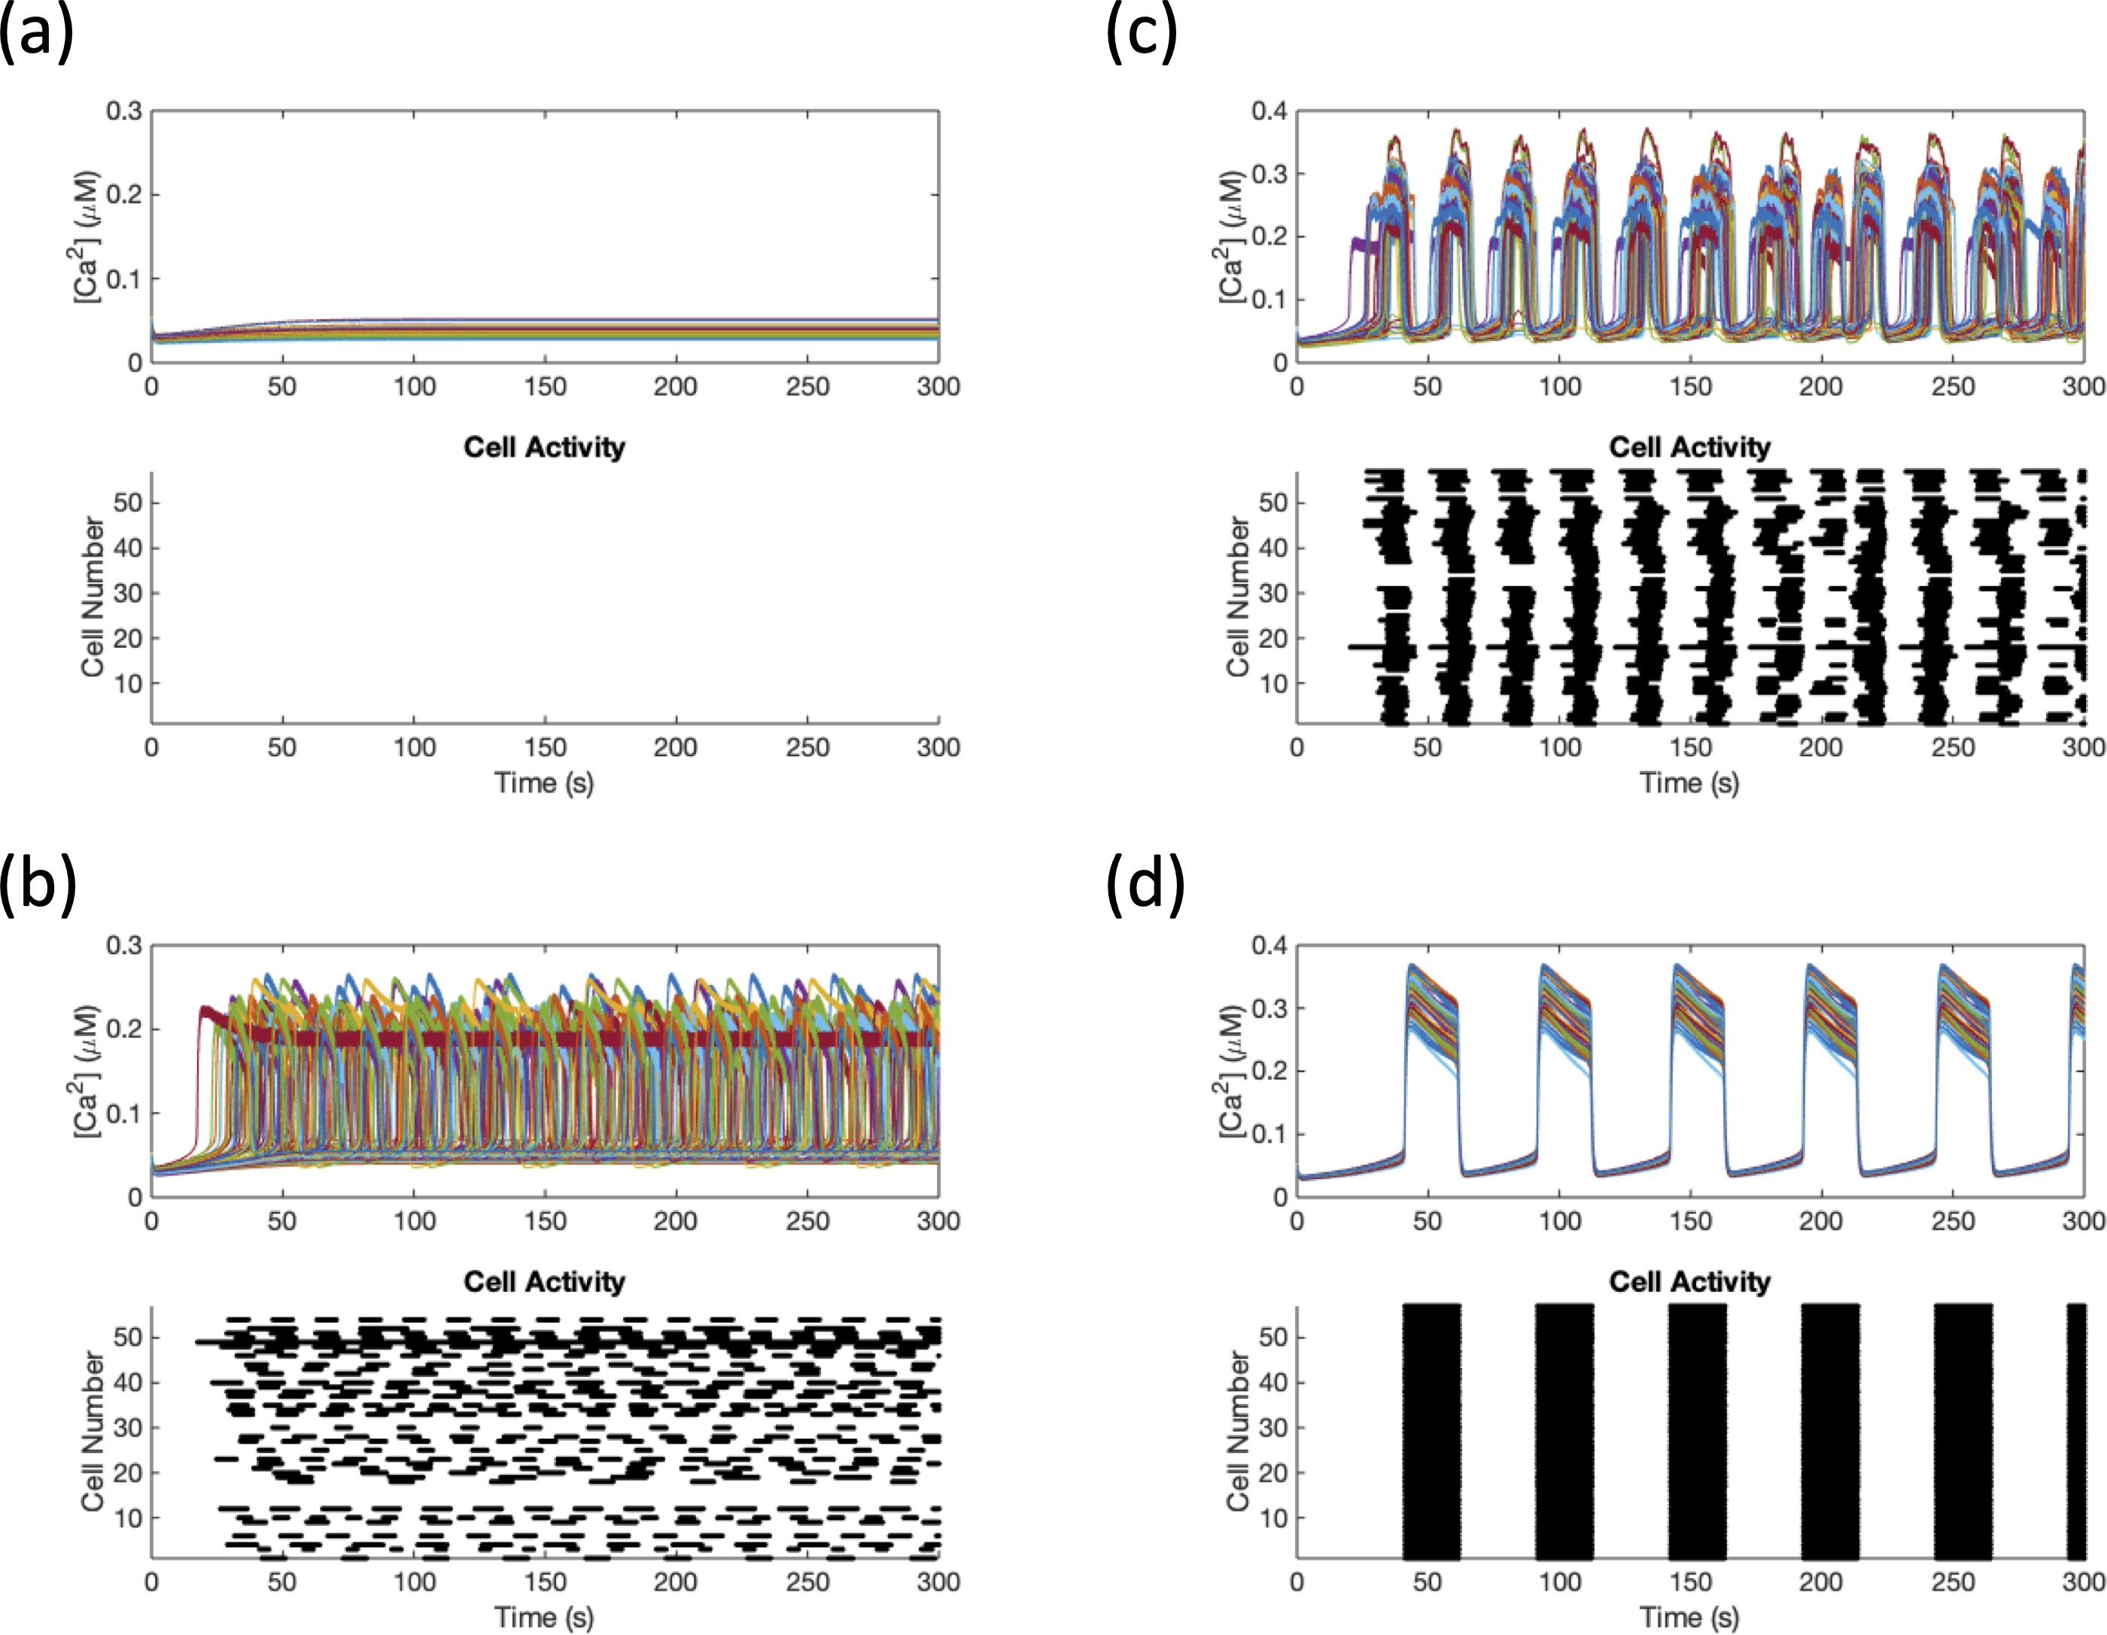

Figure 3.9: Traces for Synchrony Comparison in Table 3.1. The top panel shows the traces while the bottom panel displays the raster plot of the binarized activity for (a) a silent islet, (b) a desynchronized islet,(c) a medium coupled islet, and (d) a synchronized islet.
while the others utilize the calcium traces of the cells. When the method is applied to the well-synchronized calcium traces shown in Fig 3.9(d), the synchrony index improves only slightly to 20.75, up from 19.6.
Our synchrony index suited our purposes the best out of the three methods. The silent islet was characterized by a 0, which differs from the desynchronized islet with 10.53. Thus a distinction can be made between a loss of activity and desynchronization when testing the impact of silencing a cell on the entire islet.

Table 3.1: Comparison of Synchrony Indexes Corresponding to Fig 3.9
Synchrony Index | (a) | (b) | (c) | (d)
Cappon and Pedersen [9] | 98.25 | 0 | 28.07 | 100
Nittala et al. [3] | 30.80 | 27.54 | 13.73 | 19.60
Our Index | 0 | 10.53 | 52.63 | 100

Wave Speed

Calcium waves are known to travel throughout the islet as discussed in Sec- tion 1.4. As calcium waves were thought to coordinate the islet and explain the long range functional connections, we applied an algorithm for capturing calcium wave velocities to a string of a few cells.
We implemented the wave velocity algorithm from [19]. First a cross corre- lation was performed between calcium traces of each cell and the average calcium trace of the islet. This measured the correlations between the average calcium trace,
c¯, and the calcium trace of a particular cell i with time delay m, given as
T −m−1

Rˆi,avg (m) =
t=0
c_{i}(t + m) · c¯(t).

A phase map was then constructed with the time index of the maximum correlation

for each cell, where φ(i) = arg max Rˆi,avg (m). Cells earlier in the wave began to
m

burst first relative to those closer to the end of the wave. Thus, when compared to the average calcium trace, the cells at the beginning of the wave had a maximum correlation with a negative time lag and the cells at the end of the wave had their maximum correlation with a more positive time lag. The wave velocity was then

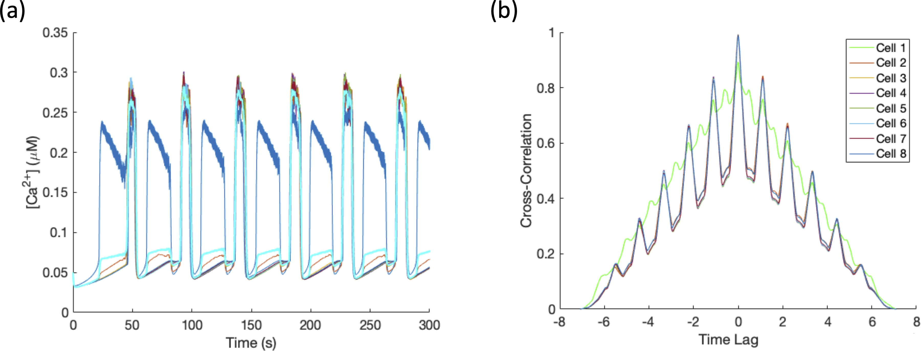

Figure 3.10: Wave Across a Line of 8 Cells. (a) The calcium traces of the 8 cells where the first cell is active (in darker blue) and the remaining cells are close the threshold. The cyan trace represents the average calcium trace. (b) The cross-correlation coefficients with various time lags.

calculated by ν_{[Ca]} = ^{∆r}12
∆t₁₂
where where ∆r₁₂ is the spatial separation between the

beginning and end of the wave and ∆t₁₂ is the difference in the time index.

We tested the wave velocity on a line of 8 cells, where the first cell was active and the remaining were close to threshold. The traces can be seen in Fig 3.10(a) where the dark blue trace denotes the calcium of the first cell in the line and the cyan trace represents the average calcium trace. The algorithm correctly said the wave began at cell 1, since its maximum correlation occurred with -0.044 time lag, and ended with cell 8 with the time lag 0.042 for its maximum correlation, as seen in Fig 3.10.
We measured the wave velocity and functional connectivity for the line of 8 cells with gap junctional coupling ranging from 0pS to 100 pS. While there are only 7 gap junctions in this system, each cell can have at most 7 functional connections, indicating 56 total possible functional connections. As seen in Fig 3.11, the func-

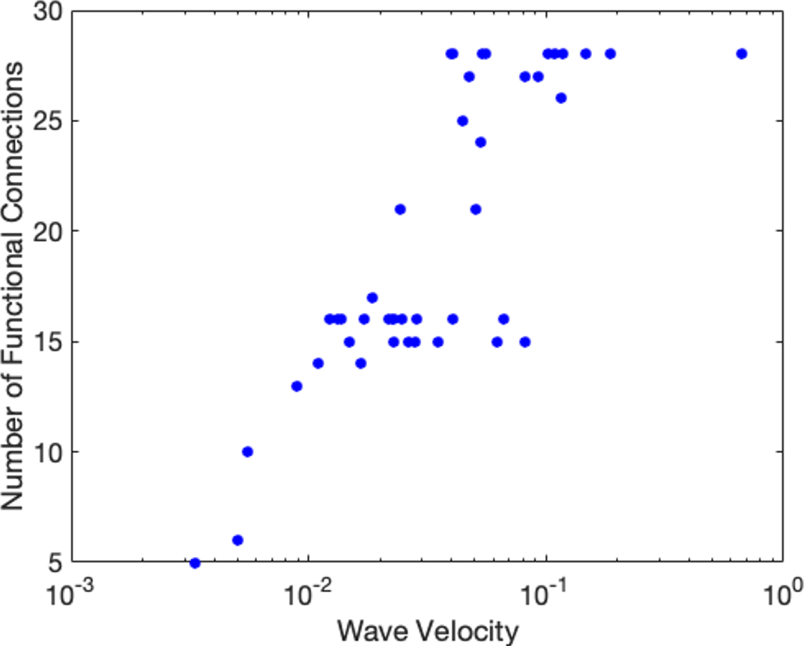

Figure 3.11: Functional Connectivity Increases with Wave Velocity. Wave ve- locity and functional connectivity for a line of 8 cells with coupling ranging from 0-100 pS.
tional connectivity increased as the wave traveled faster through the islet. This supported our intuition behind long range functional connectivity depending on cal- cium waves. Since functional connectivity depended on similar behavior between cells, faster calcium waves led to higher similarity coefficients between cells at the beginning and the end of the wave, resulting in a long range functional connection. When examining a system of 5 cells in a line, some strange cases of negative ve- locities arose. An example of the corresponding calcium traces is shown in Fig 3.12. The parameters of the system were selected such that cell 1 was intrinsically active while the remaining cells were close to threshold so when cell 1 began to burst, the signal traveled through the gap junctions and the remaining cells burst. However, the algorithm claimed that wave began with cell 2 and ended at cell 1. As cell 1 had a longer burst than the other cells, it needed a positive time lag in order to have

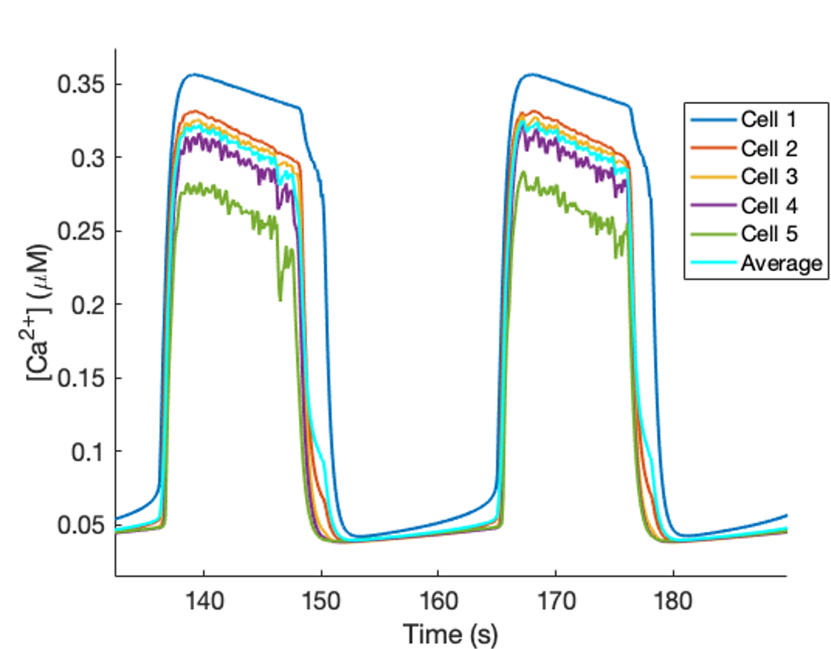

Figure 3.12: An Example of a Negative Wave Velocity. A line of 5 cells where the first cell in dark blue initiates the wave and the cyan trace represents the average calcium trace.
the highest correlation with the average calcium trace. Thus, it was considered the end of the wave.
We began to build our own algorithm to calculate the ordering of cells in a wave. The first step was to calculate the peaks in the difference quotient of each trace to determine the upstroke for each trace. Peaks within 10 seconds of each other were considered to be part of the wave. The algorithm was correctly able to predict the ordering of the wave down the line for some of the bursts. However, as the algorithm only considered upstrokes within 10 seconds of each other as part of the same wave, the algorithm was not correctly able to predict the wave order for all of the bursts in the 300s period. The algorithm was also briefly tested on an islet of 57 cells. It was able to capture the the smaller waves as well as the islet wide waves. However, more work needed to be done on this algorithm for it to be valid. While testing calcium waves in cases with fewer cells, a theory about sub-

threshold propagation arose: cells that were subthreshold, or not active due to their cell properties, could still propagate a signal through gap junctions causing neigh- boring cells that were suprathreshold to burst. Fig 3.13 shows an example of a three cell case. When uncoupled, cell 3 was the only active cell. However, cell 1 was close to the threshold. Once cell 2, which was well below the threshold for activity when isolated, was coupled to both cells 1 and 3 with a small conductance of 3 pS, cell 1 began to fire. While the coupling current from cell 3 was not enough to bring cell 2 above its voltage threshold to burst, it created a current that was propagated to cell 1, leading it to burst. In some cases with a higher coupling current, it was observed that that cell 2 would begin to burst after receiving the stimuli from both cells 1 and 3.
Cell 3 acts similarly to a switch cell. It is able to activate a nearby cell, which could then in turn activate other cells in the islet. However, if cell 3 is silenced or isolated from the network, cell 1 no longer receives the propagated stimulus from cell 3 and remains silent, no longer activating any other cells. A case of subthreshold propagation playing a key role in a switch islet is described in Section 4.4.5.
This wave propagation theory could help to explain the desynchronization observed from silencing a single β cell. While many cells in the islet may be intrinsi- cally active, their activity can be silenced by the hyperpolarizing coupling currents from their intrinsically silent neighbors. The switch cell initiates the wave when it begins to depolarize, which leads to a depolarizing coupling current propagating to its nearest neighbors. Some of these neighbors may remain silent with the stimulus, but as shown with the subthreshold propagation theory, they still propagate the

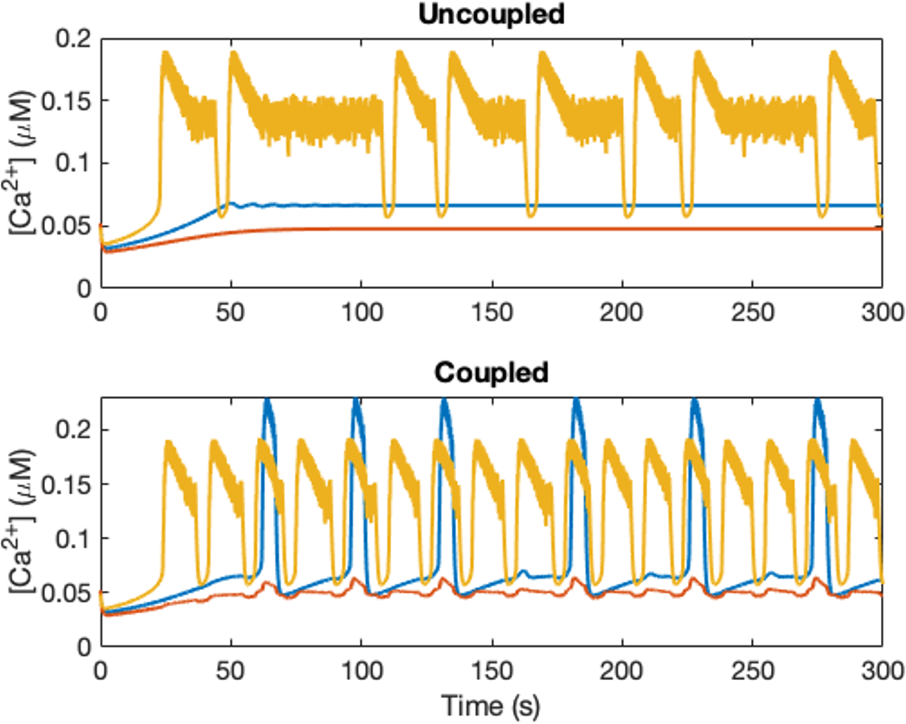

Figure 3.13: Subthreshold Signal Propagation. In the top panel, 3 uncoupled cells where only cell 3 (in yellow) is active, but cell 1 (in blue) is close the threshold for activity. In the bottom panel, the same three cells, but now cell 2 (orange) is coupled to cell 1 and 3 with conductance 3 pS.

depolarizing signal to their neighbors. These cells whose activity was suppressed by the previously hyperpolarizing coupling current are now activated, resulting in more depolarizing currents and activated cells. This leads to the islet wide bursts. How- ever, once the initiating cell is silenced, there is no depolarizing current to activate this process and thus the islet remains mainly silent.

Chapter 4: More Details Behind Finding Switch Cells

Numerical Study

During this research, multiple machines had been utilized to solve the different systems of differential equations. The two most prevalent were a personal MacBook Air and the high performance computing facility (HPCF) at UMBC. The larger pa- rameter sweeps that could take up to a couple of days in serial were often submitted to the cluster to search in parallel, cutting down on the time. The parameter sets of interest were then saved and analyzed more carefully on the MacBook laptop.
Through these analyses, a few numerical concerns arose. Some of the param- eter sets that fit criteria on the cluster, such as having a fit to a power law with an R² > 0.7 for the functional connectivity, did not satisfy those conditions on a personal laptop. An example of the differences can be seen in Fig 4.1. The same parameter set and code were used on both platforms, but resulted in different so- lutions. While neither solution of the 57 cell system is synchronized, the calcium traces between 100s and 150s are observably different. In fact, the solution from the personal laptop looks slightly synchronized in the up and down strokes of the bursting while the traces from the HPCF look more disorderly.

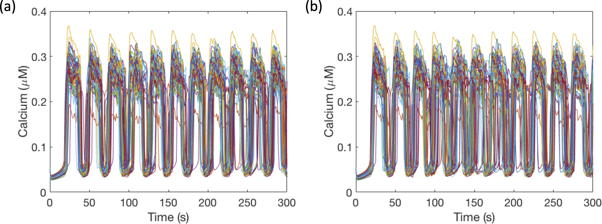

Figure 4.1: Differences between MacBook Air solution and HPCF solution. Using the same parameter set and code, two different solutions found by (a) MacBook Air and (b) high performance computing facility.

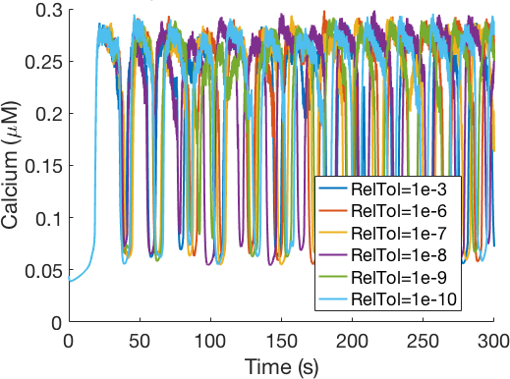

Figure 4.2: Nonconverging traces. Traces for a single cell (part of a larger islet of 57 cells) found at different relative tolerances RelTol with absolute tolerance AbsTol = RelTol / 100.
This led to an investigation of the built-in MATLAB variable time step, Runge- Kutta differential equations solver, ode45. While we had been utilizing the default options for the solver, some of these, such as the relative error tolerance that is preset to 1e-3, can be altered to get a more precise solution. As the tolerance becomes smaller, the solutions for a single trace are expected to converge. However, this is not observed in the example shown in Fig 4.2. The trace of cell 1 from an islet of 57 cells shown for different relative error tolerances, with absolute tolerance a factor 100 smaller than the relative tolerance, did not converge to a single solution. It is
important to note that this islet was weakly coupled with g_{C} ∼ N (2, 1). For zero
coupling and high coupling, there was less variation in the traces of a cell found at difference absolute tolerance levels. Without convergence across relative tolerance levels, the solution resulting from the differential equations solver may not be the true solution of the system, leading to the analysis of incorrect traces.

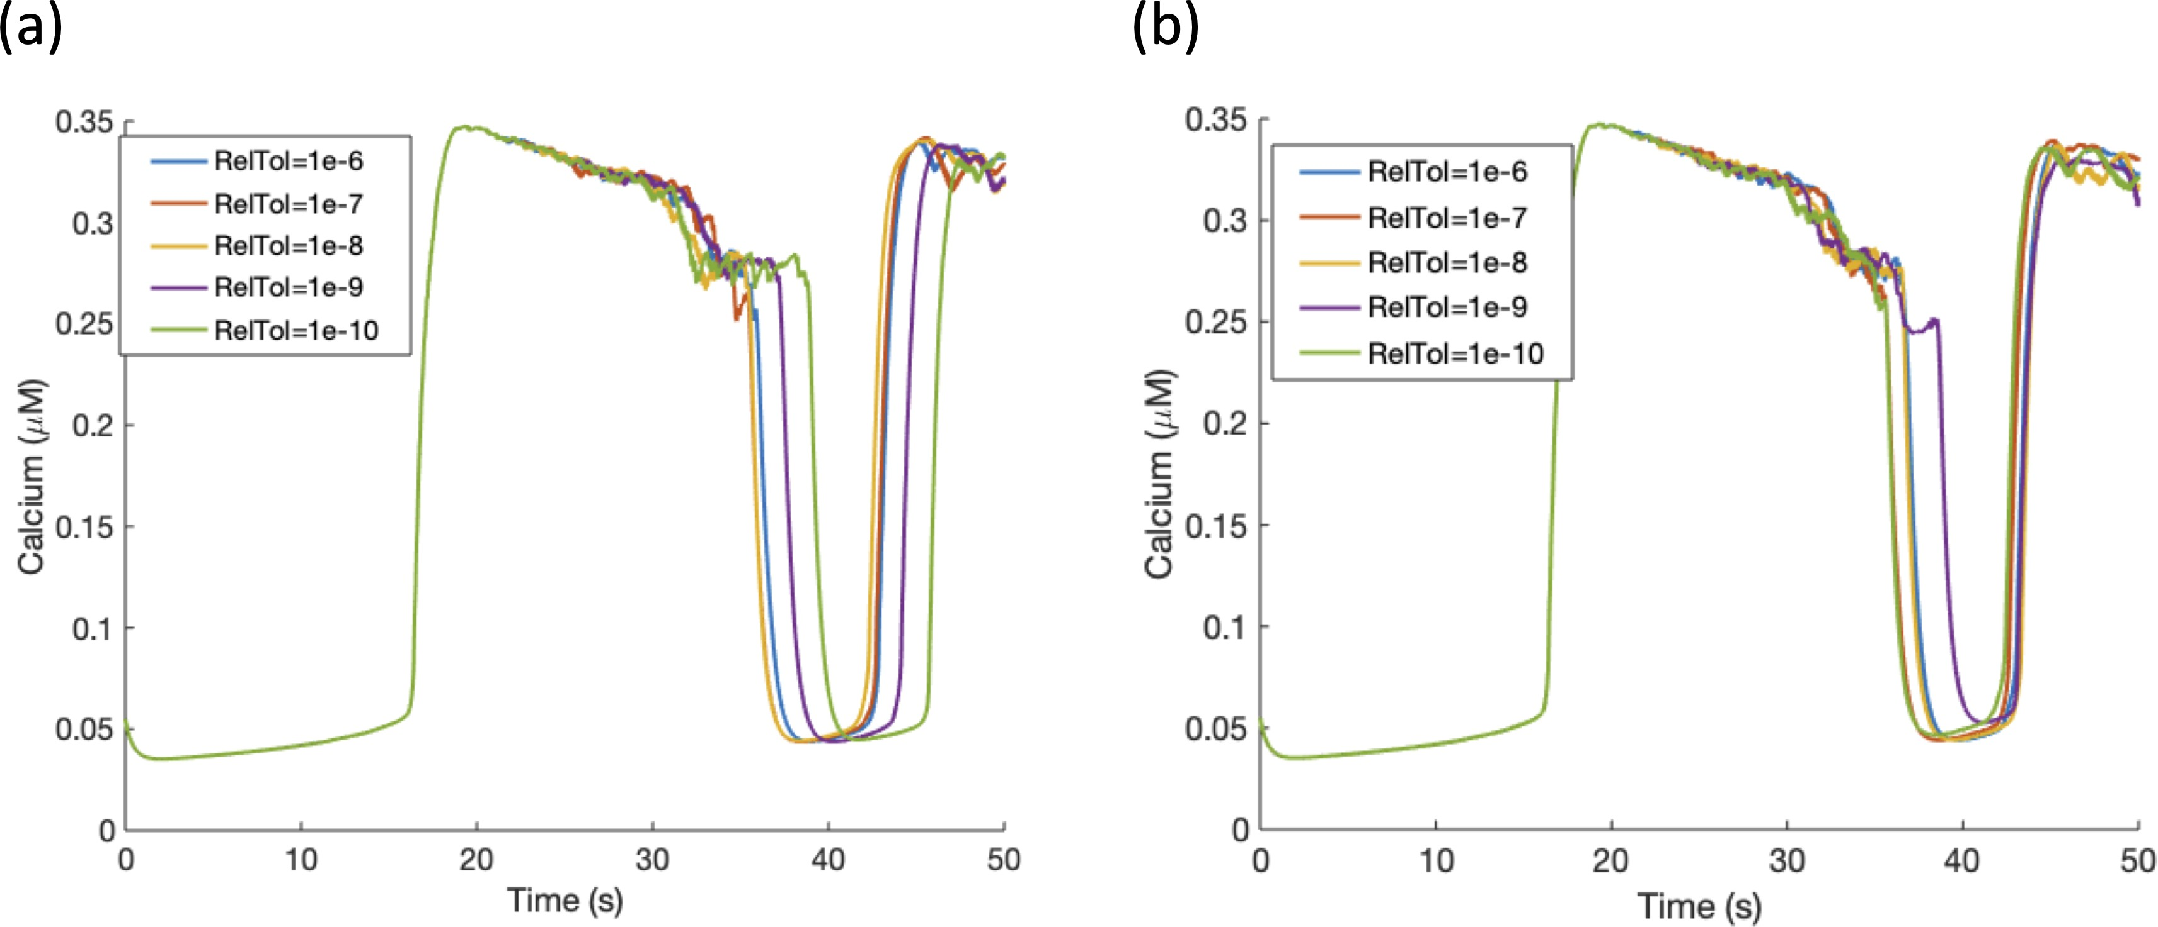

Figure 4.3: Impact of including the Jacobian in the differential equations solver. Traces of a single cell from a 57 cell islet found at different relative error tolerances (a) without using the Jacobian and (b) with the Jacobian.
Another option for differential equations solvers in MATLAB is to include the Jacobian of the system [2]. Through the symbolic package in MATLAB, a Jacobian could easily be created and turned into a function given to the solver. While this did not completely solve the problem of the nonconvergent traces, the spread of traces decreased, as shown in Fig 4.3. In particular, the timing of the upstroke of the second burst no longer varied over a 5 second window, but instead converged within a second. Thus, it was decided to include the Jacobian in future simulations, even though it added to the computation time.
In order to determine inconsistencies in cell traces across relative tolerances levels, indicating an imprecise solution, a synchrony measure was utilized from [9], rather than the norm of the difference. A synchrony measure quantifies all of the traces at one time and results in a larger distinction than the norm of the dif- ference. For a single cell, an average trace was calculated across the different

relative tolerances, c^{(avg)}(t). The cell’s trace at a given relative tolerance level,
i

tol was compared to the average trace through a Pearson correlation, ρ_{tol,avg} =

₁ T

c(tol)(t)−c¯(tol)

σtol
c(avg)(t)−c¯(avg)

σavg

(tol)

of cell i solved with the relative tolerance tol, c¯^{(tol)} and c¯^{(avg)} are the time averages
T −1 t=0
i
i
·
i
i
, where ci (t) represents the calcium trace
i i

of c^{(tol)}(t) and c^{(avg)}(t) respectively over the simulation period [0, T ], and σ_{tol} and
i i

σ_{avg} denote the standard deviations of c^{(tol)}(t) and c^{(avg)}(t) respectively. A trace is
i i

considered synchronized if ρ_{tol,avg} >0.85 and the synchrony index is calculated as the percentage of synchronized traces. A cell with the same trace or convergent traces across the different tolerances would be expected to have a high synchrony index, while nonconvergent traces such as those shown in Fig 4.2 would have a low synchrony index. In Fig 4.4(a), a single parameter set of 57 cells was solved with different gap junction conductances and at various relative tolerances ranging from 1e-3 to 1e-10. The synchrony was measured for 3 cells with differing locations: cell 1 in the center of the islet, cell 27 in the top half of the islet, and cell 57 in the
bottom half of the islet. For g_{C} = 0 pS and g_{C} ≥ 4 pS, all three cells had fairly high
synchrony indexes. However, when 0 < g_{C} < 4, there was a lot more variance in the traces across tolerances for some cells, dropping as low as zero synchrony for cell 57 with 0.5 < g_{C} < 2. Fig 4.4 confirms that weak coupling results in nonconvergent cell traces over different relative tolerances. Even more, the inconsistency in single cell traces does not occur for all three cells at lower coupling to the same degree, evidenced by the different synchrony indexes at fixed coupling.
While the traces were different for weaker coupling, the impact of the different tolerances on the synchrony of the whole islet was more important to study as

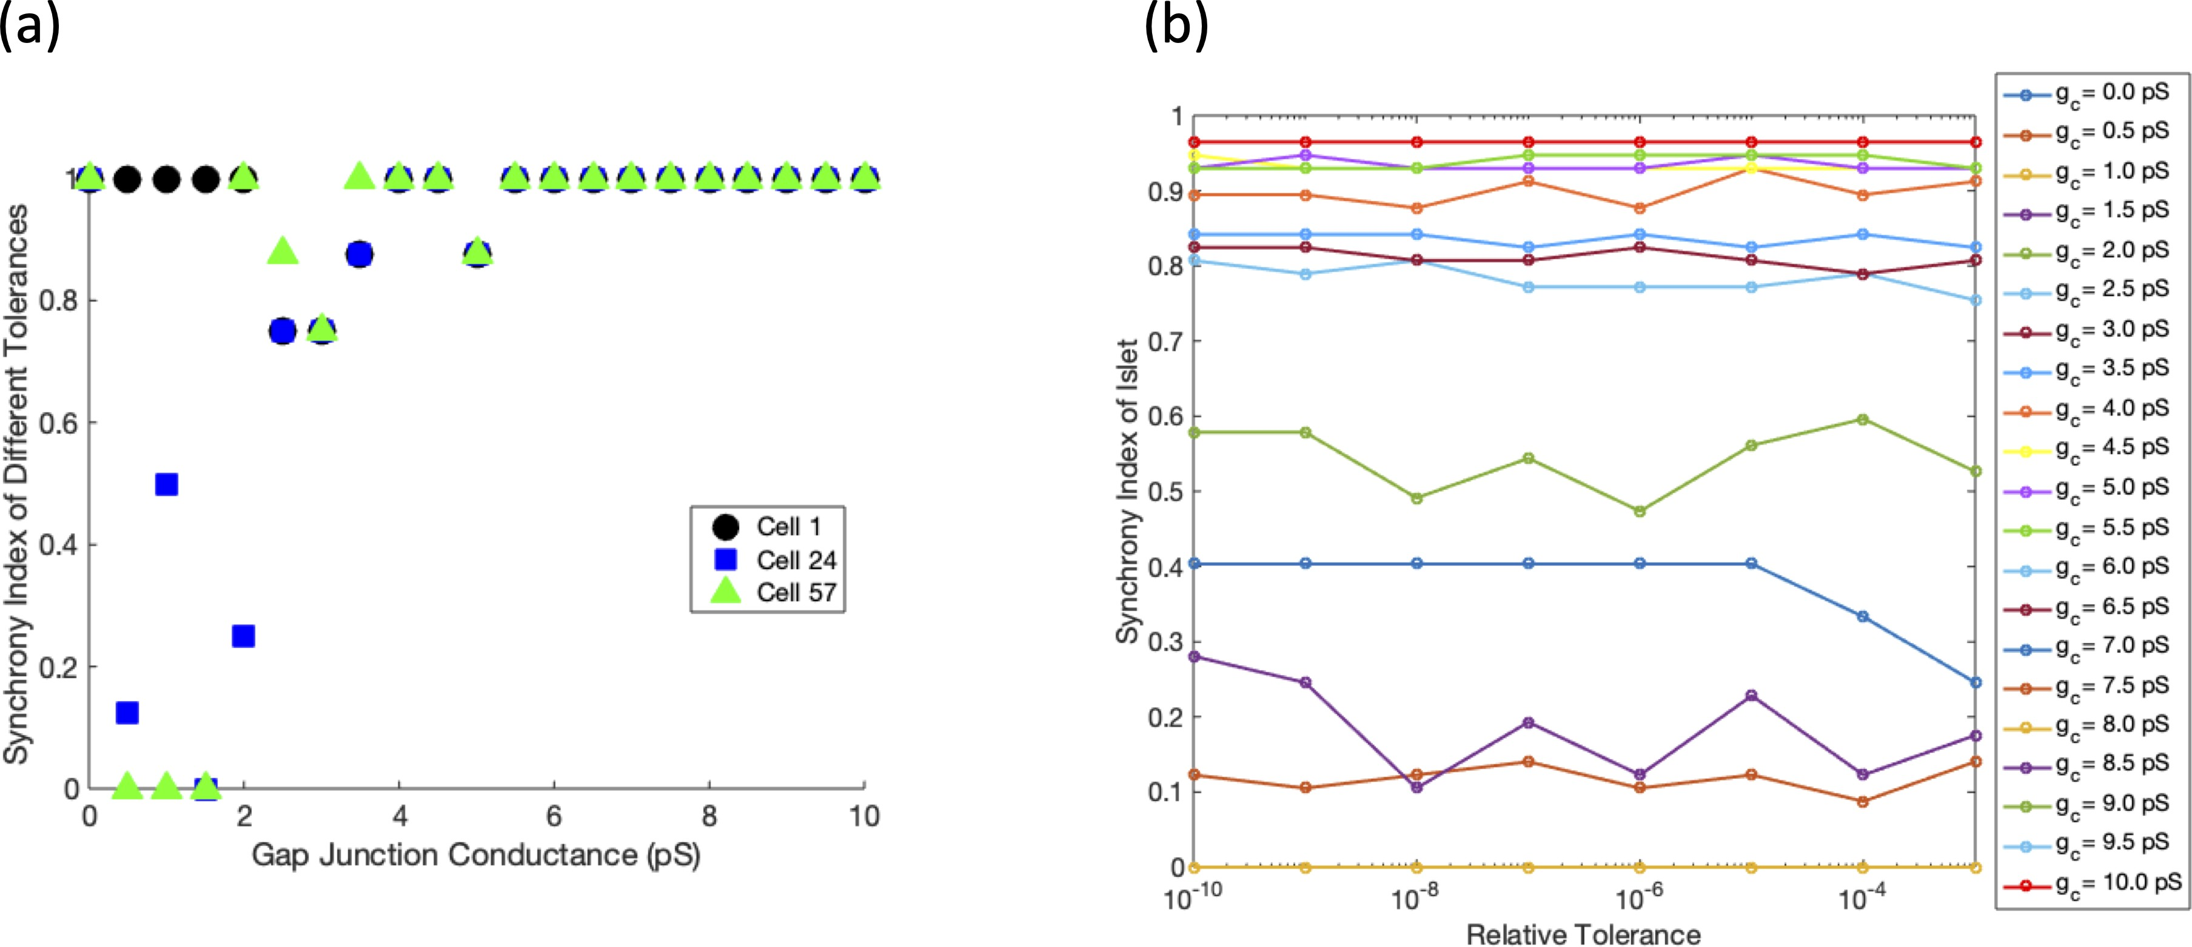

Figure 4.4: Variation Across Tolerances on Synchrony (a) The synchrony index of the same cell’s traces across different relative tolerances at increasing coupling values. (b) The synchrony index of the same islet at different relative tolerances for different coupling strengths.
the synchrony is an essential measure in this work. Using the parameter set from Fig 4.4(a), the synchrony index was measured across the islet for different gap junction conductances at the various tolerance levels. Fig 4.4(b) shows the synchrony index as a function of the relative tolerance, where the different colors correspond to the indicated coupling conductances. For the most part, there was only a slight variance in the islet synchrony for coupling conductances lower than 2 pS. When an islet was highly synchronous, there was very little disparity across the relative tolerances. Interestingly, the uncoupled system has a higher synchrony than the weakly coupled system, for example the 0 synchrony when g_{C} = 1 pS.
Fig 4.5 combines the results of Fig 4.4(b) for five different parameter sets. For

each parameter set denoted by a different color, the synchrony index was measured at different relative tolerances, repeated for the different gap junction conductances

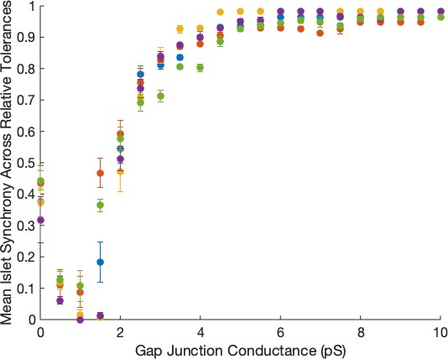

Figure 4.5: Mean Islet Synchrony Across Relative Tolerances. The average with standard deviation taken across the synchrony indexes for a parameter set with different relative tolerances as varied by conductance. Each color denotes a single parameter set.
g_{C}
8
g_{C}

SI^{(tol)}. The mean values, SI
g_{C}
= 1 SI(tol)

tol
with their standard deviations are

shown in Fig 4.5. The standard deviations give an indication of the level of agree- ment in the synchrony index across the different relative tolerances.
These results reiterate the notion that the numerical differences occur for low coupling values, as the largest standard deviations are for 0 < g_{C} < 4. As the coupling utilized was not in the troublesome region, it was decided that the addi- tion of the Jacobian to the differential equations solver was sufficient to tackle any numerical concerns that could arise.

Searching for Scale-Free Networks

Using the method mentioned in Section 2.2.2 and explained in further detail in Section 3.2, our focus began as a search for β cell islets that could be classified as scale-free networks. We started with 200 parameter sets each at six mean coupling values: g_{c} =3, 3.5, 4, 4.5, 5 pS. The g_{KAT} _{P} was selected to follow the distribution N (133, 13.3) in order to have a combination of intrinsically active and silent cells. For each parameter set drawn, an initial simulation was run, from which the func- tional connectivity was calculated. If the functional connectivity followed a power law distribution with R² > 0.7, the parameter set was saved for more analysis.
With a gap junctional conductance mean set to 3 pS, 15 out of 200 parameter sets were found to satisfy our requirements for a scale-free network. As the coupling increased, the number decreased to only 10 out of 200 parameter sets for a mean coupling of 3.5 pS, 4 out of 200 parameter sets for a coupling mean of 4 pS and then 0 out of 200 parameter sets for the two higher couplings. Examples of the functional connectivity distributions found for the three coupling values 3 pS, 3.5 pS, and 4 pS are shown in Fig 4.6. While a higher goodness of fit R² was found for the weakest coupling at 3 pS, there were fewer functional connections in the islet. In fact, the islet in Fig 4.6(a) only had 22 functional connections out of the 1596 possible connections. This corresponds with the low islet synchrony of 29.82. As the islet was desynchronized, the similarity coefficient between most pairs of cells was low, leading to a small number of functional connections. As the coupling increased, cells began to behave more similarly with a higher synchronization, leading to a larger

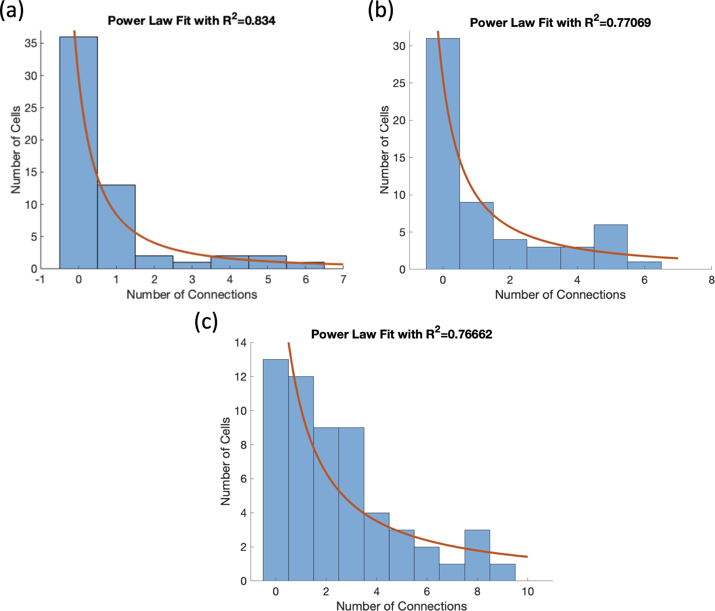

Figure 4.6: Scale-Free Functional Connectivity Distributions for Increasing Coupling. Examples of the functional connectivity distributions classified as scale-free for (a) g_{C} ∼ N (3, 1.5) pS, (b) g_{C} ∼ N (3.5, 1.75) pS, and (c) g_{C} ∼ N (4, 2) pS.
number of functional connections, 37 connections for the example in Fig 4.6(b) and 74 functional connections in Fig 4.6(c).
As the synchrony and number of functional connections was higher for g_{C} ∼
N (4, 2) pS, we refocused our search for scale-free connectivity to only parameter sets with a mean coupling of 4 pS. The condition of a loss of functional connectivity was added as well to the requirement for parameter sets to be saved, as Johnston et al. [10] had seen a substantial decrease in the functional connectivity when the hub cell was silenced. If a network was characterized as scale-free, its hub cells were determined using the degree centrality. A simulation was rerun for the silencing of each individual hub cell to measure the new number of functional connections. A decrease of 50% in the connectivity was required for a parameter set to be saved for

later analysis.
With 1000 parameter sets tested, only 49 islets satisfied the two set conditions of R² > 0.7 and SI > 0.85. An example is shown in Fig 2.4 where the func- tional connectivity distribution fit a power law with R² = 0.77 and the number of functional connections decreased 65.87% with the silencing of the most functionally connected cell. In fact, as seen in Fig 2.4(B), the majority of the functional connec- tivity surrounded the functional hub cell in the top panel, implying that much of the functional activity was due to the functional hub cell. This theory was supported by the loss of functional connectivity in the bottom panel when the functional hub cell was silenced. However, the raster plots refuted this idea as there was not a substantial difference between the initial simulation and silenced simulation.

Sensitivity Analysis

A sensitivity analysis was performed for the parameter set in Fig 2.4. The heterogeneous cell parameters, g_{Ca}, g_{K}, g_{KAT} _{P} , g_{S}, and k_{Ca}, for each cell were perturbed 1% systematically. Two checks were performed for each perturbation: the functional connectivity distribution needed to be scale-free and loss of functional connectivity with functional hub cell silencing had to be at least 50%.
The results of the perturbations can be seen in Table 4.1. Each entry in the table represents the number of cells in the 57 cell islet whose perturbation led to a decrease in the R² for the power law fit, a reduction to less than 50% in functional connectivity with hub cell silencing, or minimal to no effect. All but one of the

substantial changes due to perturbations resulted in a loss of a scale-free network. Many of the goodness of fit R² values after the perturbations went as low as 0.2, though there were a few that dropped just below the threshold to 0.69.
It was surprising that a 1% perturbation in the cell parameters was able to affect the islet so substantially. While there was intuition behind changes for some of the parameters like g_{Ca} and g_{KAT} _{P} , others were a little more puzzling. By increasing the g_{Ca} or decreasing g_{KAT} _{P} of a cell, it became more excitable. In many cases, the increase in g_{Ca} or the decrease in g_{KAT} _{P} led to cell becoming active, which led to a higher synchronization and similarity coefficient between the pairs of cells. With a higher number of functional connections, the distribution was no longer a power law distribution, leading to an islet that was not scale-free. On the other hand, decreasing g_{Ca} or increasing g_{KAT} _{P} causes a cell to be less excitable. Thus, the perturbed cell was more likely to be silent and decrease the number of functionally connected cells, affecting the distribution.
Since the 1% perturbation in some cell parameters led to an islet that no longer satisfied our conditions, we were unable to find a region in parameter space that could satisfy the conditions of scale-free functional connectivity and a loss of functional connectivity with hub cell silencing. We concluded that scale-free functional connectivity is a sensitive criterion.

Table 4.1: Cell Parameter Perturbation on Fig 2.4. The number of cells in the 57 cell islet that resulted in a loss of scale-free connectivity (i.e. R² < 0.7 for the power law fit), broke the condition of at least 50% loss of functional connectivity with the silencing of hub cell 43, or led to minimal changes when the individual cell was perturbed 1% in

the indicated manner.  Perturbation | R² < 0.7 | < 50% Decrease in Connectivity | Minimal Impact
Increase in g_{Ca} | 51 | 0 | 6
Decrease in g_{Ca} | 52 | 0 | 5
Increase in g_{K} | 52 | 0 | 5
Decrease in g_{K} | 51 | 0 | 6
Increase in g_{KAT} _{P} | 52 | 0 | 5
Decrease in g_{KAT} _{P} | 52 | 1 | 4
Increase in g_{S} | 55 | 0 | 2
Decrease in g_{S} | 50 | 0 | 7
Increase in k_{Ca} | 0 | 0 | 57
Decrease in k_{Ca} | 0 | 0 | 57

Predetermined Hub Cell

The well-connected islet with heterogeneity was unsuccessful in creating a network of β cells that was scale-free and experienced a loss of both functional connectivity and synchronization with hub cell silencing. Thus we attempted to predetermine a network that could satisfy these conditions. Once created, such a network could provide an example to orient a generalization.
When looking at the bifurcation diagrams in g_{KAT} _{P} for a single β cell with the mean cell parameters listed in Table 2.1, a supercritical Hopf bifurcation occurs at g_{KAT} _{P} = 133.31 pS. Johnston et al. [10] had mentioned that the hub cells were more metabolically active. Thus, single cells with g_{KAT} _{P} < 133.31 pS were bursting while cells with g_{KAT} _{P} > 133.31 pS were silent. For our predetermined islet, we wanted to designate a single cell as active, which would be the predetermined hub cell. This cell was selected to have g_{KAT} _{P} = 100 to ensure it would burst. Initially, the remaining cells in the islet had g_{KAT} _{P} = 175 pS, which was then lowered to g_{KAT} _{P} = 133.5 pS in order to bring the neighboring cells closer to threshold for activity. Similar to the work of Lei et al. [5], we set the coupling for the predetermined hub cell to be higher than that between other cells in the islet. Thus, the coupling followed the
distribution g_{C} ∼ N (5, 2.5), but the connections of the predetermined hub cell were
doubled.

Through gap junctional coupling, the predetermined hub cell could activate its neighbors as seen in the raster plots in Fig 4.7(a). Heterogeneity was slowly added back into the system by first making the g_{KAT} _{P} of the nonhub cells to follow

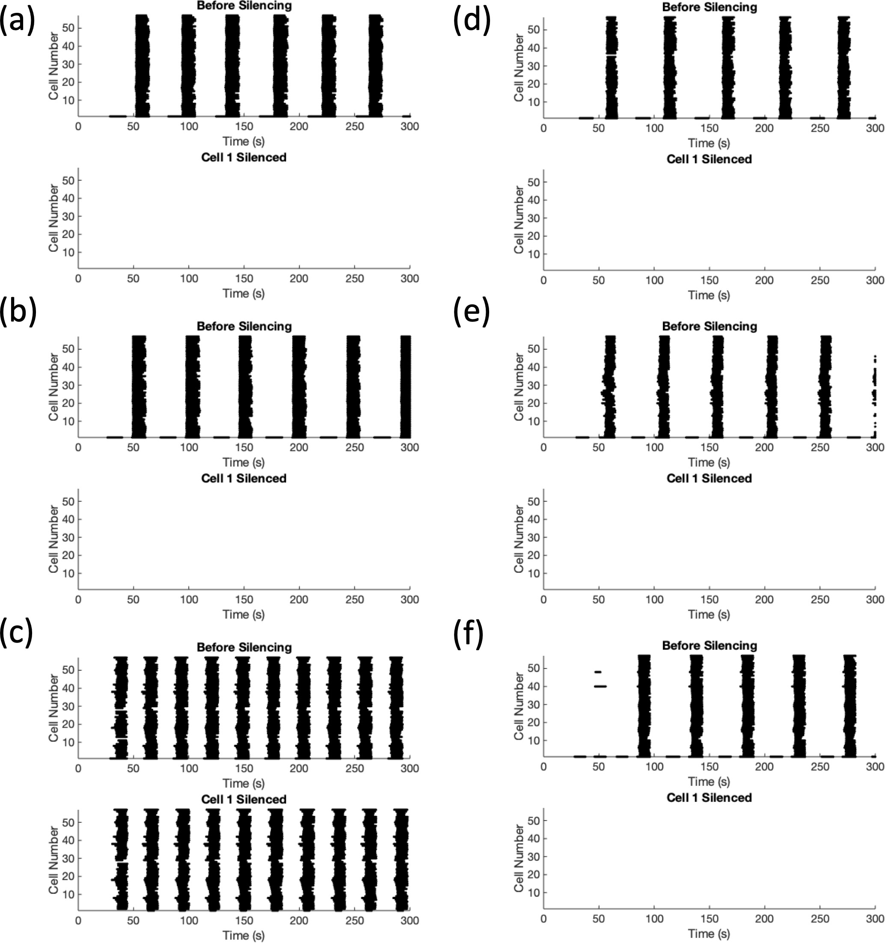

Figure 4.7: Adding Heterogeneity to a Predetermined System. (a) The homo- genenous system with the center cell 1 as the predetermined hub cell, (b) the nonhub
cells have g_{KAT} _{P} ∼ N (133.5, 1.335), (c) the nonhub cells have g_{KAT} _{P} ∼ N (133.5, 13.55), (d)-(f) the other cell parameters are drawn heterogeneously with the standard deviation
1%, 2%, and 5% of the mean, respectively with g_{KAT} _{P} ∼ N (145, 7.25) for the nonhub cells.
N (133.5, 1.335) in Fig 4.7(b) and N (133.5, 13.35) in Fig 4.7(c). The large variation led to a high number of active cells and the islet no longer needed the hub cell in order to be active as seen in Fig 4.7(c). Thus, the excitability of the nonhub
cells was decreased slightly by having g_{KAT} _{P} ∼ N (145, 7.25). In Fig 4.7(d)-(f), the
remaining cell parameters of the system were drawn from normal distributions with mean values given in Table 2.1 and standard deviation 1%, 2%, and 5% of the mean value.
While a loss of activity and functional connectivity with hub cell silencing was

observed for most of the examples shown in Fig 4.7, the functional networks were not scale-free. An example is shown in Fig 2.5(a) with R² < 0.7 where the islet had heterogenenous cell parameters, the predetermined hub cell had g_{KAT} _{P} = 100
pS while the others followed g_{KAT} _{P} ∼ N (145, 7.25), and g_{C} ∼ N (4, 2) with the hub
cell connections doubled in strength. Since the islet was so highly synchronized, every cell was functionally connected to every other cell, with the exception of the predetermined hub cell. With the low g_{KAT} _{P} , the predetermined hub cell had a smaller period of bursting. The remaining cells in the islet however did not burst every time the predetermined hub cell did. In fact, they had a 1 to 2 rhythm with the predetermined hub cell. Thus the duration coactive between the predetermined hub cell 1 and any other cell j in the network was the same as the duration cell j was active, which was half of the time cell 1 was active. Thus as T_{1,j} = T_{j} ≈ 1 T₁,
2

T1,j

C1,j = T
1
· T_{j}

T_{j}

≈ T_{j} · 2T_{j}
1
= √2 < R_{thresh} = 0.85,
so the predetermined hub cell is not functionally connected to any cell in the net- work. Thus, it could not be the functional hub of the network. This behavior was observed for all cases with predetermined hub cells. We increased g_{KAT} _{P} for the predetermined hub cell in an attempt to find a scenario where the the hub cell had the same period as the rest of the islet. However, due to the gap junctional coupling, either the predetermined hub cell would be silenced or with weaker coupling, the wave would not spread through the islet activating the other β cells.

We were unable to predetermine a network to satisfy scale-free functional connectivity, a decrease in functional connectivity with the silencing of the hub cell, and a loss of activity with hub cell silencing. The conflict between scale-free connectivity and high synchronization, which first arose in the search for scale-free networks, was made more apparent with the predetermined network.

Switch Cells

For a scale-free network, only a few cells could have a high number of functional connections, which are defined by a similarity coefficient C_{i,j} > R_{thresh}. For most pairs of cells, the similarity coefficient is below the threshold, since the duration the cells are coactive is small relative to the duration each cell is active. However, in order for an islet to desynchronize, it needs to initially be well synchronized with SI > 60. This implies that at least 60% of cells, which is 35 cells for the 57 cell islet, have a similar most prominent period. While similar periods do not automatically mean that cells are active at the same times, the inclusion of coupling pulls cells’ activity closer to each other. Thus, in a coupled islet, cells with similar periods should have a high duration coactive and thus a high similarity coefficient, contradicting the requirements for a scale-free functional network. Thus, our work shifted towards finding cells that could desynchronize the islet or cause the islet to lose the majority of its activity without any regard for the functional connectivity. We termed these cells switch cells as they acted as a switch turning the islet on and off.

We drew a heterogeneous parameter set, ensured the initial simulation was synchronized, and then systemically silenced each cell in the islet to determine if any silencing had a substantial impact on the islet. Various distributions for g_{KAT} _{P} were selected for these parameter sets and it was determined that a distribution with many cells near the threshold for activation were required. The functional connectivity was calculated for the islets containing switch cells and as expected, there was a decrease when the switch cell was silenced. However, the connectivity did not follow a power law distribution as many cells had a high functional connectivity. Two example islets are shown in Fig 2.6 with lower coupling in (a)-(c) and high coupling in (d)-(f).

Switch cells do not require high structural connectivity

We delved further into the properties causing the emergence of switch cells by focusing on the islet shown in Fig 2.6(a)-(c). Switch cell 11 burst at a higher frequency than the islet with a 4:1 bursting rhythm. There was also a cluster of cells that was active independent of cell 11, as they continued to burst even when cell 11 was silenced. However, the silencing of cell 11 led to the loss of the large islet-wide bursts.
Switch cell 11 only had two gap junctional connections to cells 4 and 11. When each connection was killed independently, the islet wide bursts continued, though at a different frequency, as seen in Fig 4.8. However, after breaking both connections, cell 11 is isolated and the islet no longer bursts. Thus at least one connection is

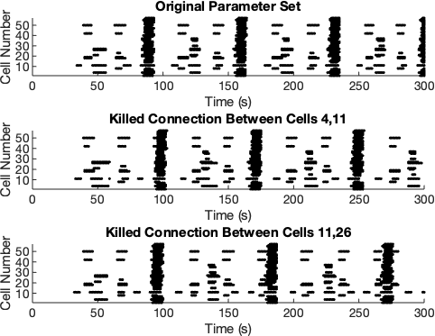

Figure 4.8: Killing the Connections of the Switch Cell. Parameter set from Fig 2.6(a)-(c). Top panel: the original simulation before silencing. Middle panel: the connection is killed between switch cell 11 and neighbor cell 4. Bottom panel: the con- nection is killed between switch cell 11 and neighbor cell 26.
necessary for the electrical, depolarizing wave to spread from the switch cell to the rest of the islet.
Meanwhile, switch cell 57 in the islet shown Fig 2.6(d)-(f) had four gap junc- tional connections to cells 49, 50, 51, and 56. Killing each connection independently resulted in minimal to no difference in the islet behavior; the islet still experienced islet wide bursts. Similarly, when all connections of the switch cell but one were removed, all of the cells still burst synchronously.
While most switch cells have multiple structural connections, only one con- nection is required for an initiator switch cell to affect the islet activity. Percolator switch cells may require more as the electrical wave will travel in through one gap junction and then will need to spread out through at least one more.

Centralities do not label switch cells important

Various centrality measures described in Section 3.3 were used to describe the structural connectivity of this parameter set. The centrality measures applied to the gap junctional connectivity are shown in Fig 4.9 where the top row uses unweighted centralities and the bottom their weighted counterparts. There were three cells that were considered the degree hubs, only one of which was within two connections of the switch cell 11. Cell 4, a nearest neighbor of cell 11, was ranked with the second most structural connections, but cell 11 only had 2 connections and thus could not be a degree hub. When including the gap junctional conductances, neither cell 11 nor its neighbors is within the top 5 most influential cells. Thus, the degree centrality was not useful in locating switch cells.
As cell 11 was connected to a cell with a high number of connections, the unweighted eigencentrality seemed promising. However, cell 11 was ranked among the bottom half for both the unweighted and weighted eigencentrality. Similarly, the unweighted and weighted closeness centrality was also unsuccessful in locating switch cell 11.
When tested on over 50 parameter sets with one switch cell, none of the centrality measures is able to accurately predict the switch cell as the most influential cell in the islet using the structural connectivity. This suggests that more than structural connectivity is required for the emergence of a switch cell.

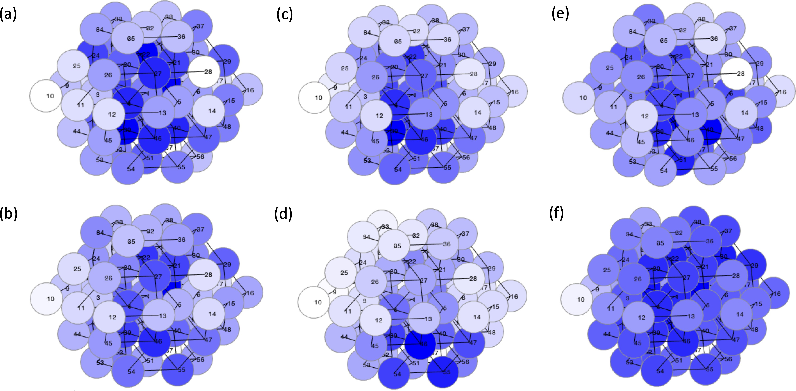

Figure 4.9: Centrality Measures to Find the Switch Cell. Parameter set from Fig 2.6(a)-(c). Darker colors indicate higher ranked cells according to (a) unweighted de- gree centrality, (b) weighted degree centrality, (c) unweighted eigencentrality, (d) weighted eigencentrality, (e) unweighted closeness centrality, and (f) weighted closeness centrality.

Cellular heterogeneity is important for the emergence of switch cells
As the centrality measures only considered the structural properties of the islet, we examined the cellular properties of the switch cell. A summary of the effects of increasing and decreasing the parameters of cell 11 can be seen in Fig 4.10. The different colors correspond to the parameter perturbed while the size indicates how large the perturbation was. The goal was to observe if any perturbation led to cell 11 not being a switch cell, either because the synchrony before silencing decreased or the synchrony while silencing increased. Thus, the both synchronization indexes for each perturbation are depicted in Fig 4.10.

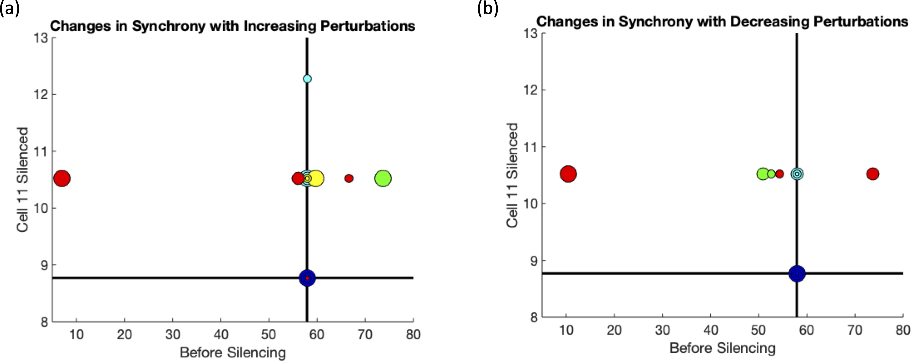

Figure 4.10: Increasing and Decreasing Cell 11 Parameters & Synchrony. The increasing marker size corresponds to the percentage of perturbation: 0.1%, 1%, 5%, and 10%. The colors represent the different parameter values that were perturbed: g_{Ca} (red),
g_{K} (yellow), g_{KAT} _{P} (green), g_{S} (cyan), and k_{Ca} (blue). The axes are the synchrony indexes before silencing (x−axis) and the synchrony indexes while cell 11 is silenced (y−axis). The
black lines denote the synchrony for both scenarios before any perturbations.

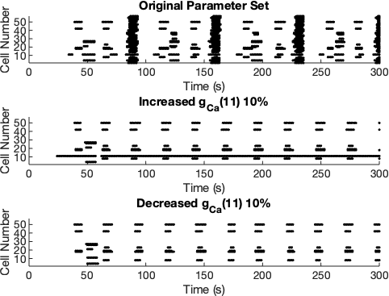

Figure 4.11: Varying g_{Ca} of Cell 11. Top panel: the original simulation, middle panel:

g_{Ca} of cell 11 increased by 10%, and bottom panel: g_{Ca} of cell 11 decreased by 10%.

Some of the perturbations led to minor changes in the synchrony, but only two pushed the islet out of the switch regime. When g_{Ca} was increased or decreased 10%, the initial synchrony dropped to below 10, as seen by the largest red marker in Fig 4.10(a) and (b), respectively. The raster plots corresponding to a 10% increase and 10% decrease in g_{Ca} of cell 11 are shown in the middle and bottom panels, re- spectively, of Fig 4.11. Raising g_{Ca} of cell 11 increased its excitability. In fact, cell 11 transitioned from bursting to spiking. However, the constant depolarizing coupling current from the spiking cell 11 was not sufficient to depolarize neighboring cells 4 and 26 and initiate the electrical wave through out the islet. Meanwhile, decreasing g_{Ca} lowers the excitability of cell 11 to where it no longer bursts, leading to the dis- appearance of the islet-wide burst. A sensitivity analysis regarding perturbations of the other cells in the islet can be seen in Section 2.3.5.
While structural connectivity was found to be important for the emergence of switch cells, the excitability of the other cells in the islet can impact switch cells as

well. Increasing the excitability of a single cell in the islet led to a new initiation point for the electrical wave, decreasing the effect of silencing cell 11. Thus cellular heterogeneity of islet plays a key role in the emergence of switch cells.

Cellular and structural heterogeneity do not follow a centrality pattern
As the cellular properties were shown to be important, we looked at the g_{Ca}, g_{KAT} _{P} graphs shown in Fig 2.9(d)-(e) with an additional axis incorporating the structural properties. While separation was sometimes seen with the initiator switch cells, it was not a sufficient condition to find them and often there would be multiple very active cells removed from the other cells in the islet. The goal was that a boundary would be more clear allowing for a classification of switch and nonswitch cells with the addition of a third axis.
The different unweighted and weighted centrality measures were used to no success. The eigencentrality in addition to the g_{Ca}, g_{KAT} _{P} values was able to predict a switch cell more often than the other centralities as the neighbors of switch cells tended to be highly connected, but it was only right around 50% of the time.
Another idea was to label each cell with a_{i} = 1 for an active cell or a_{i} = −1 for a

silent cell. The z coordinate for the ith cell would be calculated as z_{i} =
j∈N (i)
aj ·Mi,j

where N (i) is the set of neighbors of cell i and M is the coupling matrix. This measure not only incorporated the structural connectivity, but the behavior of the neighbors, which has proven to be an essential part of switch cells. Unfortunately,

no separation was observed with this measure.

A nucleus of switch cells

We also found some islets with multiple switch cells, an example of which is shown in Fig 4.12. The three switch cells 21, 32, and 36 formed a small nucleus with cell 21 structurally connected to both cells 32 and 36. This group of three cells is an example of the subthreshold propagation theory mentioned in Section 3.5. Cell 36 was highly active while middle cell 21 was far below threshold and cell 32 was near the threshold for activity. In fact, cell 32 was intrisically active, but was silenced by the hyperpolarizing coupling currents from its neighbors. When cell 36 began to burst, the depolarizing current traveled through cell 21, but was not enough to push it above threshold. Instead, the current passed through to cell 32, activating it. With the double stimulus from cells 32 and 36, cell 21 then became active. The electrical wave traveled through the rest of the islet from cells 21 and 32. The wave was unable to begin when cell 36 was silenced, as it was the initiator. With cell 21 silenced, the signal no longer propagated to cell 32 to spread through the islet. When cell 32 was silenced, the double stimulus required to activate cell 21 disappeared. Thus, a small nucleus of switch cells was formed in the islet.

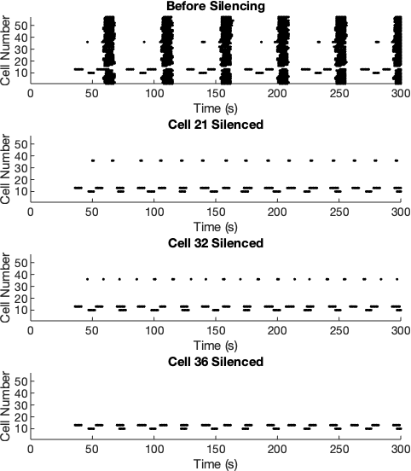

Figure 4.12: Raster Plots from an Islet with Multiple Switch Cells. The top panel shows synchronized islet bursts before the silencing of any cell. The second, third, and fourth panels depict the effects of silencing cell 21, 32, and 36 respectively on the islet.

Islets with switch cells require fewer intrinsically active β cells than average
When looking at the number of intrinsically active cells, a pattern emerged for switch islets shown in Fig 2.10. The number of active cells in islets with at least one switch cell was always less than 14 cells. As g_{Ca} and g_{KAT} _{P} determine the activity of an uncoupled cell, we were able to calculate their distributions. Using XPPAUT, a two parameter (g_{Ca}, g_{KAT} _{P} ) bifurcation diagram was found for a single cell. As the Hopf curve was near linear, we approximated the curve by the line:
g_{KAT} _{P} = 0.196 · g_{Ca} − 62.88. Cells above the Hopf curve were silent while cells
below the line were active. Thus we wanted to find P (g_{KAT} _{P} < 0.196g_{Ca} − 62.88) =
₋P

0.196g_{Ca} g_{KAT P}
62.88
> 1 . Taking W = ^{0.196g}Ca−gKATP , the expectation of W was cal-

culated:
62.88

0.196 · g_{Ca} − g_{KAT} _{P}
1
E[W ] = E
62.88
0.196 · E[g_{Ca}] − E[g_{KAT} _{P} ]
=
62.88

≈ 0.784132.

Similarly, the variance of W was calculated:

Var[W ] = Var 0.196 · gCa − gKAT P
1
62.88
0.196² · Var(g_{Ca}) + Var(g_{KAT} _{P} )

=

≈ 0.077465.
62.882

Thus, W ∼ N (0.784, 0.278), which means P [W > 1] = 1 − P [Z < 0.77559] =
0.2483, where Z is the standard normal variable. The number of active cells in the islet follows the binomial distribution with probability 0.2483, implying the the expected number of active cells in an islet of 57 cells is 14 with the standard deviation 3.26. The average number of active cells for islets with switch cells was found to be 10.21 ± 1.7. As shown in Fig 2.10, there is some overlap in between the two distributions. This is further evidence that both cellular heterogeneity and structural connectivity affect switch cells.

Strong Coupling Cases
Most of the switch islet investigation was done on islets following the dis- tributions g_{C} ∼ N (5, 2.5) and g_{KAT} _{P} ∼ N (145, 14.5). However, we were able to find switch islets in other scenarios as well. For more tightly coupled islets, a lower g_{KAT} _{P} mean value was needed in order to overcome the strong hyperpolar- izing coupling currents. Thus, we increased the cell excitability by drawing from g_{KAT} _{P} ∼ N (135, 13.5) for mean coupling conductances ranging from 10-200 pS. We drew 500 parameter sets per coupling conductance and the results are summarized in Table 4.2. As the mean coupling increased, the number of silent islets increased. This is important to keep in mind when considering the number of switch islets present. Initially, number of switch islets is increasing, but after 75 pS, it begins to drop. However, the fraction of switch islets out of the total number of active islets continues to increase as seen in the blue line in Fig 2.12.

Table 4.2: Distribution of Switch and Nonswitch Islets. Classification of 500 parameter sets drawn with the indicated mean coupling value and g_{KAT} _{P} ∼ N (135, 13.5) as switch islets (containing at least one switch cell), active nonswitch islets (active islets
without switch cells), or silent islets (islets with little to no activity).
Mean Coupling | Switch Islet | Active, Nonswitch Islet | Silent Islet
10 pS | 1 | 496 | 3
25 pS | 25 | 470 | 5
50 pS | 139 | 270 | 91
75 pS | 146 | 155 | 199
100 pS | 130 | 117 | 253
125 pS | 127 | 92 | 281
150 pS | 114 | 70 | 316
175 pS | 101 | 66 | 333
200 pS | 100 | 60 | 340

Larger islets of 323 cells were also tested with coupling conductances ranging

from g_{C} ∼ N (15, 7.5) with g_{KAT} _{P} ∼ N (145, 14.5) to g_{C} ∼ N (200, 100) with g_{KAT} _{P} ∼
N (135, 13.5). Switch cells were found in similar proportions as shown in Table 4.2.

Switch Islets in the IOM

Most recently, we studied a more physiologically sophisticated model for pan- creatic β cells, the Integrated Oscillator Model (IOM) [72], for the presence of switch cells. The Single Slow Channel Model (SSCM) used for the investigation up until this point simplified the model of a β cell to its electrical dynamics, with a cal- cium readout variable. However, the metabolism of a β cell plays a large role in oscillations. The process of insulin secretion begins when glucose enters the cell and undergoes metabolism. Through glycolysis, the ratio of ATP/ADP increases, which causes the ATP/ADP ratio dependent potassium channel to close and the cell begins to depolarize. In the SSCM, the conductance of the ATP/ADP ratio dependent potassium channel is held constant. However, as ATP is dynamic, the ratio and thus the conductance should be as well.
The IOM is an 8 variable model, described in [72], that incorporates both the electrical and glycolytic oscillations that are coupled for a single cell. Two additions were made to this model to include the coupling current from nearest neighbors and the optogenentic chloride pumps. The new currents followed the same form as those added to the SSCM: Eq 2.5-2.6. As this model is more computationally intensive than the SSCM, all of the simulations and analysis were performed on the high

Table 4.3: Distribution of Switch and Nonswitch Islets in the IOM. 1000 pa- rameter sets of 13 cells drawn with g_{C} ∼ N (10, 5) and the indicated g¯_{KAT} _{P} value were classified as switch islets (containing at least one switch cell) and active nonswitch islets
(active islets without switch cells), or silent islets (islets with little to no activity). The percentage of switch islets out of the total number of active islets is also denoted.
g¯KAT P | Silent Islet | Switch Islet | Active, Nonswitch Islet | % Switch
28000 | 69 | 61 | 870 | 6.55
29000 | 184 | 219 | 597 | 26.8
29500 | 308 | 273 | 419 | 39.5
30000 | 474 | 261 | 265 | 49.6
35000 | 1000 | 0 | 0 | 0

performance computing facility. The parameters for the model were selected for slow bursting, as described in Figure 2 left panel in [72]. The conductances of the ionic currents were taken to be heterogeneous drawn from a normal distribution with the means as given in [72] and the standard deviations 5% of the mean. We also raised the mean value of g¯_{KAT} _{P} , which is the maximal ATP/ADP dependent potassium channel conductance. For switch islets with the Single Slow Channel Model, a proportion of the cells needed to be intrinsically silent. We found that the transition for a single cell between active to silent occurred between g¯_{KAT} _{P} = 29000 − 30000. Initially, smaller islets of 13 cells were tested for switch cells with 1000 pa- rameter sets per search. Table 4.3 breaks down the classifications of the islets studied for different mean values of g¯_{KAT} _{P} . As expected, the number of silent islets

grows as g¯_{KAT} _{P} increases. The highest proportion of switch islets to total active
islets occurs for g¯_{KAT} _{P} ∼ N (30000, 3000). We then increased the coupling to fol- low g_{C} ∼ N (25, 12.5) with g¯_{KAT} _{P} ∼ N (30000, 3000). The number of switch islets relative to the lower coupling case increased to 371 out of 581 total active islets. Ex- amples of 13 cell switch islets are shown in Fig 4.13 with raster plots, distribution of functional connections, and the functional connectivity network before silenc- ing. In all examples found in the 13 cell case, none of the functional connectivity distributions followed a power law, as the high synchrony meant many functional connections.

For larger islets of 57 cells, a search through 1000 parameter sets took over a
week with g¯_{KAT} _{P} ∼ N (30000, 3000) and g_{C} ∼ N (10, 5). The raster plot, distribu- tion of functional connectivity, and functional connectivity network can bee seen in Fig 4.14. Again as the traces were synchronized before silencing, there was a high number of functional connections, leading to a distribution that did not follow a power law.

Finding switch cells in a different model solidifies them as a concept since they are not an artifact of a single model.

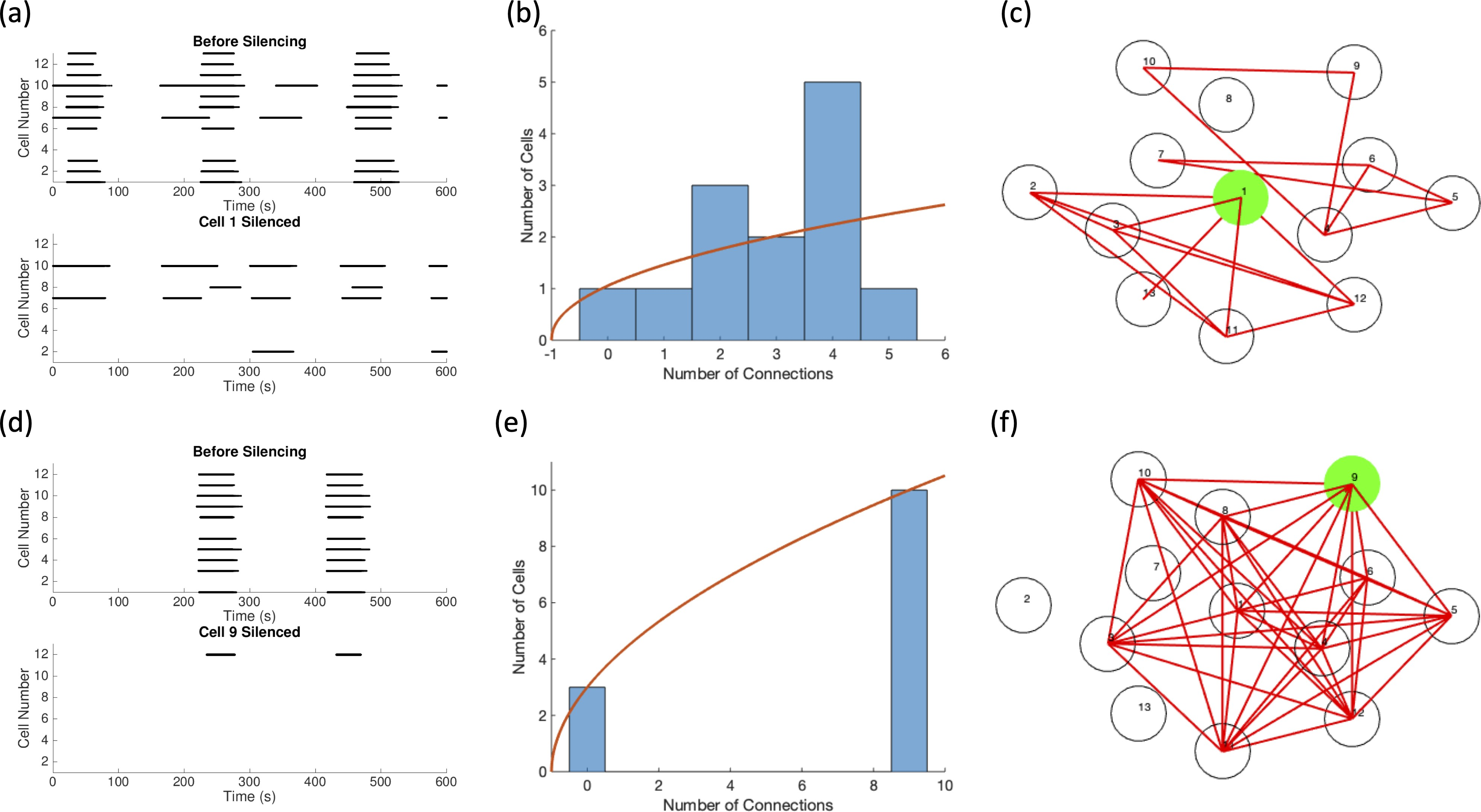

Figure 4.13: Examples of 13 Cell Switch Islets using the IOM. Subfigures (a)-(c)
are from a parameter set with g¯_{KAT} _{P} ∼ N (28000, 2800) while the parameter set in (d)-(f) had g¯_{KAT} _{P} ∼ N (30000, 3000). In (a) and (d), the raster plots before and while silencing the switch cell, (b) and (e) the distribution of functional connections, and lastly (c) and (f) the functional connectivity network.

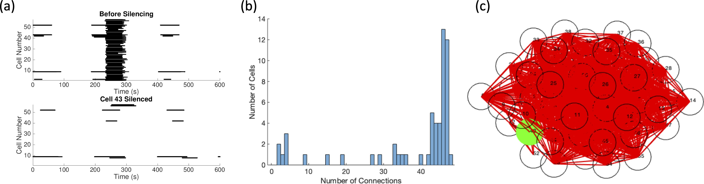

Figure 4.14: Example of 57 Cell Switch Islet Using the IOM. The parameter set was drawn with g¯_{KAT} _{P} ∼ N (30000, 3000) and g_{C} ∼ N (10, 5). (a) The raster plot of the cells activity before and while silencing cell 43, (b) the distribution of functional
connectivity, and (d) the functional connectivity network.

Chapter 5: Determining Active Cells

In order to identify switch cells, it is important to understand the effects of coupling on β cell dynamics. Currently there are multiple ways of determining the behavior of a single, uncoupled cell based on its cell parameters. As previously mentioned, there is a Hopf curve in g_{Ca} and g_{KAT} _{P} , above which a cell is silent and below which a cell is active. Another method uses fast-slow subsytem analysis, as done for the SSCM in [74, 75], which will be described in detail below.
We aimed to apply this understanding of the activity of a single β cell to build an algorithm to define the β cell network required to sustain switch cells. We began by adding an additional dimension to the g_{Ca}, g_{KAT} _{P} Hopf curve in order to investigate the effect of an applied current that could be used to imitate a coupling current. When this proved unsuccessful, we shifted to using the fast-slow subsystem analysis.
The algorithm was initially tested on a system of two cells with an eye towards an expansion to larger systems of cells. While there was some success in identifying conditions under which we would get switch cell like behavior, this approach was not able to reveal more than a modest majority of conditions under which switch cells emerged.

Using an Applied Current

The first algorithm we attempted for determining the activity of cells used the notion of modeling the coupling current as an applied current. The coupling current, given in Eq 2.5, for cell 1 has the form I_{coup} = g_{C} · (V₂ − V₁) in a two cell system, which is added to the right hand side of the voltage dynamics given in Eq 2.1 resulting in the membrane potential equations

C dV₁
M
dt
= − I

(V , n , s ) + g
ion
1
1
1
· (V
— V )

C dV₂
M
dt
= − I

(V , n , s ) + g
C
2
1
ion
2
2
2
· (V
— V ).

From bifurcation theory, we can find exactly when these cells would oscillate. How- ever, we need a method that will scale for larger networks of cells. Simplifying the
C
1
2
coupling current to an applied current by claiming that I_{app} ≈ I_{coup}, we are able to
decouple the cells and perform an analysis on each cell individually.

We had previously found the g_{Ca}, g_{KAT} _{P} Hopf curve for a single cell with I_{app} = 0 in Section 4.4.6. This procedure was repeated for a large range of I_{app}. Using MATLAB’s fit function with the option of ‘poly22’, meaning a two-variable polynomial each of degree 2, an equation for the Hopf surface in I_{app}, g_{Ca}, and g_{KAT} _{P} was found with a goodness of fit of R² = 0.9997:
I_{app} = − 2330 − 43.94 · g_{KAT} _{P} + 9.038 · g_{Ca} − 0.08695 · g²
KATP

+ 0.04412 · g_{KAT} _{P} · g_{Ca} − 0.005194 · g² .
Ca

Given this surface, we are able to calculate the applied current necessary to transition a cell from active to silent (I_{app} < 0) or from silent to active (I_{app} > 0).

The first step of the algorithm was to determine the intrinsic activity of each

cell i and assign its coupling voltage:
−

25 mV, if intrinsically active
V_{C}(i) = .
−60 mV, if intrinsically silent
Along with the gap junctional conductance g_{C}i,j , this value would be used to calcu-

late an estimated coupling current from cell i to cell j:

I_{coup}(i, j) ≈ g_{C}i,j · (V_{C}(i) − V_{C}(j)).

Two active cells or two silent would have a minimal coupling current in the full system, which is represented by a 0 nA current in our approximation. Meanwhile, a system with one silent and one active cell would have a large coupling current approximated by the expression above. This value is recalculated for all neighbors of cell j to find its total estimated coupling current

I_{coup}(j) ≈

i∈N (j)
g_{C}i,j · (V_{C}(i) − V_{C}(j)) .

The applied current I_{app}(j) needed for cell j to transition from its intrinsic state is calculated by estimated Hopf surface. The two currents are compared:
|I_{app}(i)| ≥ |I_{coup}(i)| ⇒ No change to behavior of cell i
|I_{app}(i)| < |I_{coup}(i)| ⇒ Behavior of cell i flips.

If the estimated coupling current is larger in magnitude than the estimated applied current, then the thought is that the coupling current is strong enough to transition the cell from active to silent or silent to active. When tested on the two coupled cell system with 1000 parameter sets, this algorithm only had a 66% success rate.

Fast-slow subsystem analysis on a single cell

As previously mentioned, another way to determine the activity of a cell is to consider fast-slow subsytem analysis. In Fig 5.1, the z-curve in the bifurcation diagram shows the behavior of the fast system, V where s is held as a parameter. The s-nullcline in cyan and the full system behavior in blue are overlaid the bifurcation diagram. More description of this analysis can be seen in [74,75]. A major difference between their work and ours however is that we shifted the z-curve as it is a function of the two parameters that control the excitability of our cells rather than the s- nullcline.
As V is a fast variable relative to s in the full system, traces will hug the lower stable portion of the z-curve, slowly traveling to the left (i.e. decreasing s). When the intersection point occurs on the unstable branch as in Fig 5.1(a) (seen more clearly in the zoomed in portion in (c)), the trace hugs the lower stable portion of the z-curve until it falls off at the limit point (LP2). Searching for stable behavior, the trace finds the stable orbit and oscillates until it falls off and goes back to the lower stable branch, indicating an oscillatory, active cell. When the intersection between the s-nullcline and the z-curve occurs on the stable branch of the z-curve as seen in Fig 5.1(b), the cell goes towards its steady state behavior, which occurs at that intersection, resulting in a silent cell. Fig 5.1 shows the difference an alteration in g_{KAT} _{P} can make as both cells have g_{Ca} = 990, but a 10 pS difference in g_{KAT} _{P} .
Thus, in order to determine the activity of a cell, two points need to be found:

(1) the intersection between the s-nullcline and z-curve SS= (s_{int}, V_{int}) and (2)

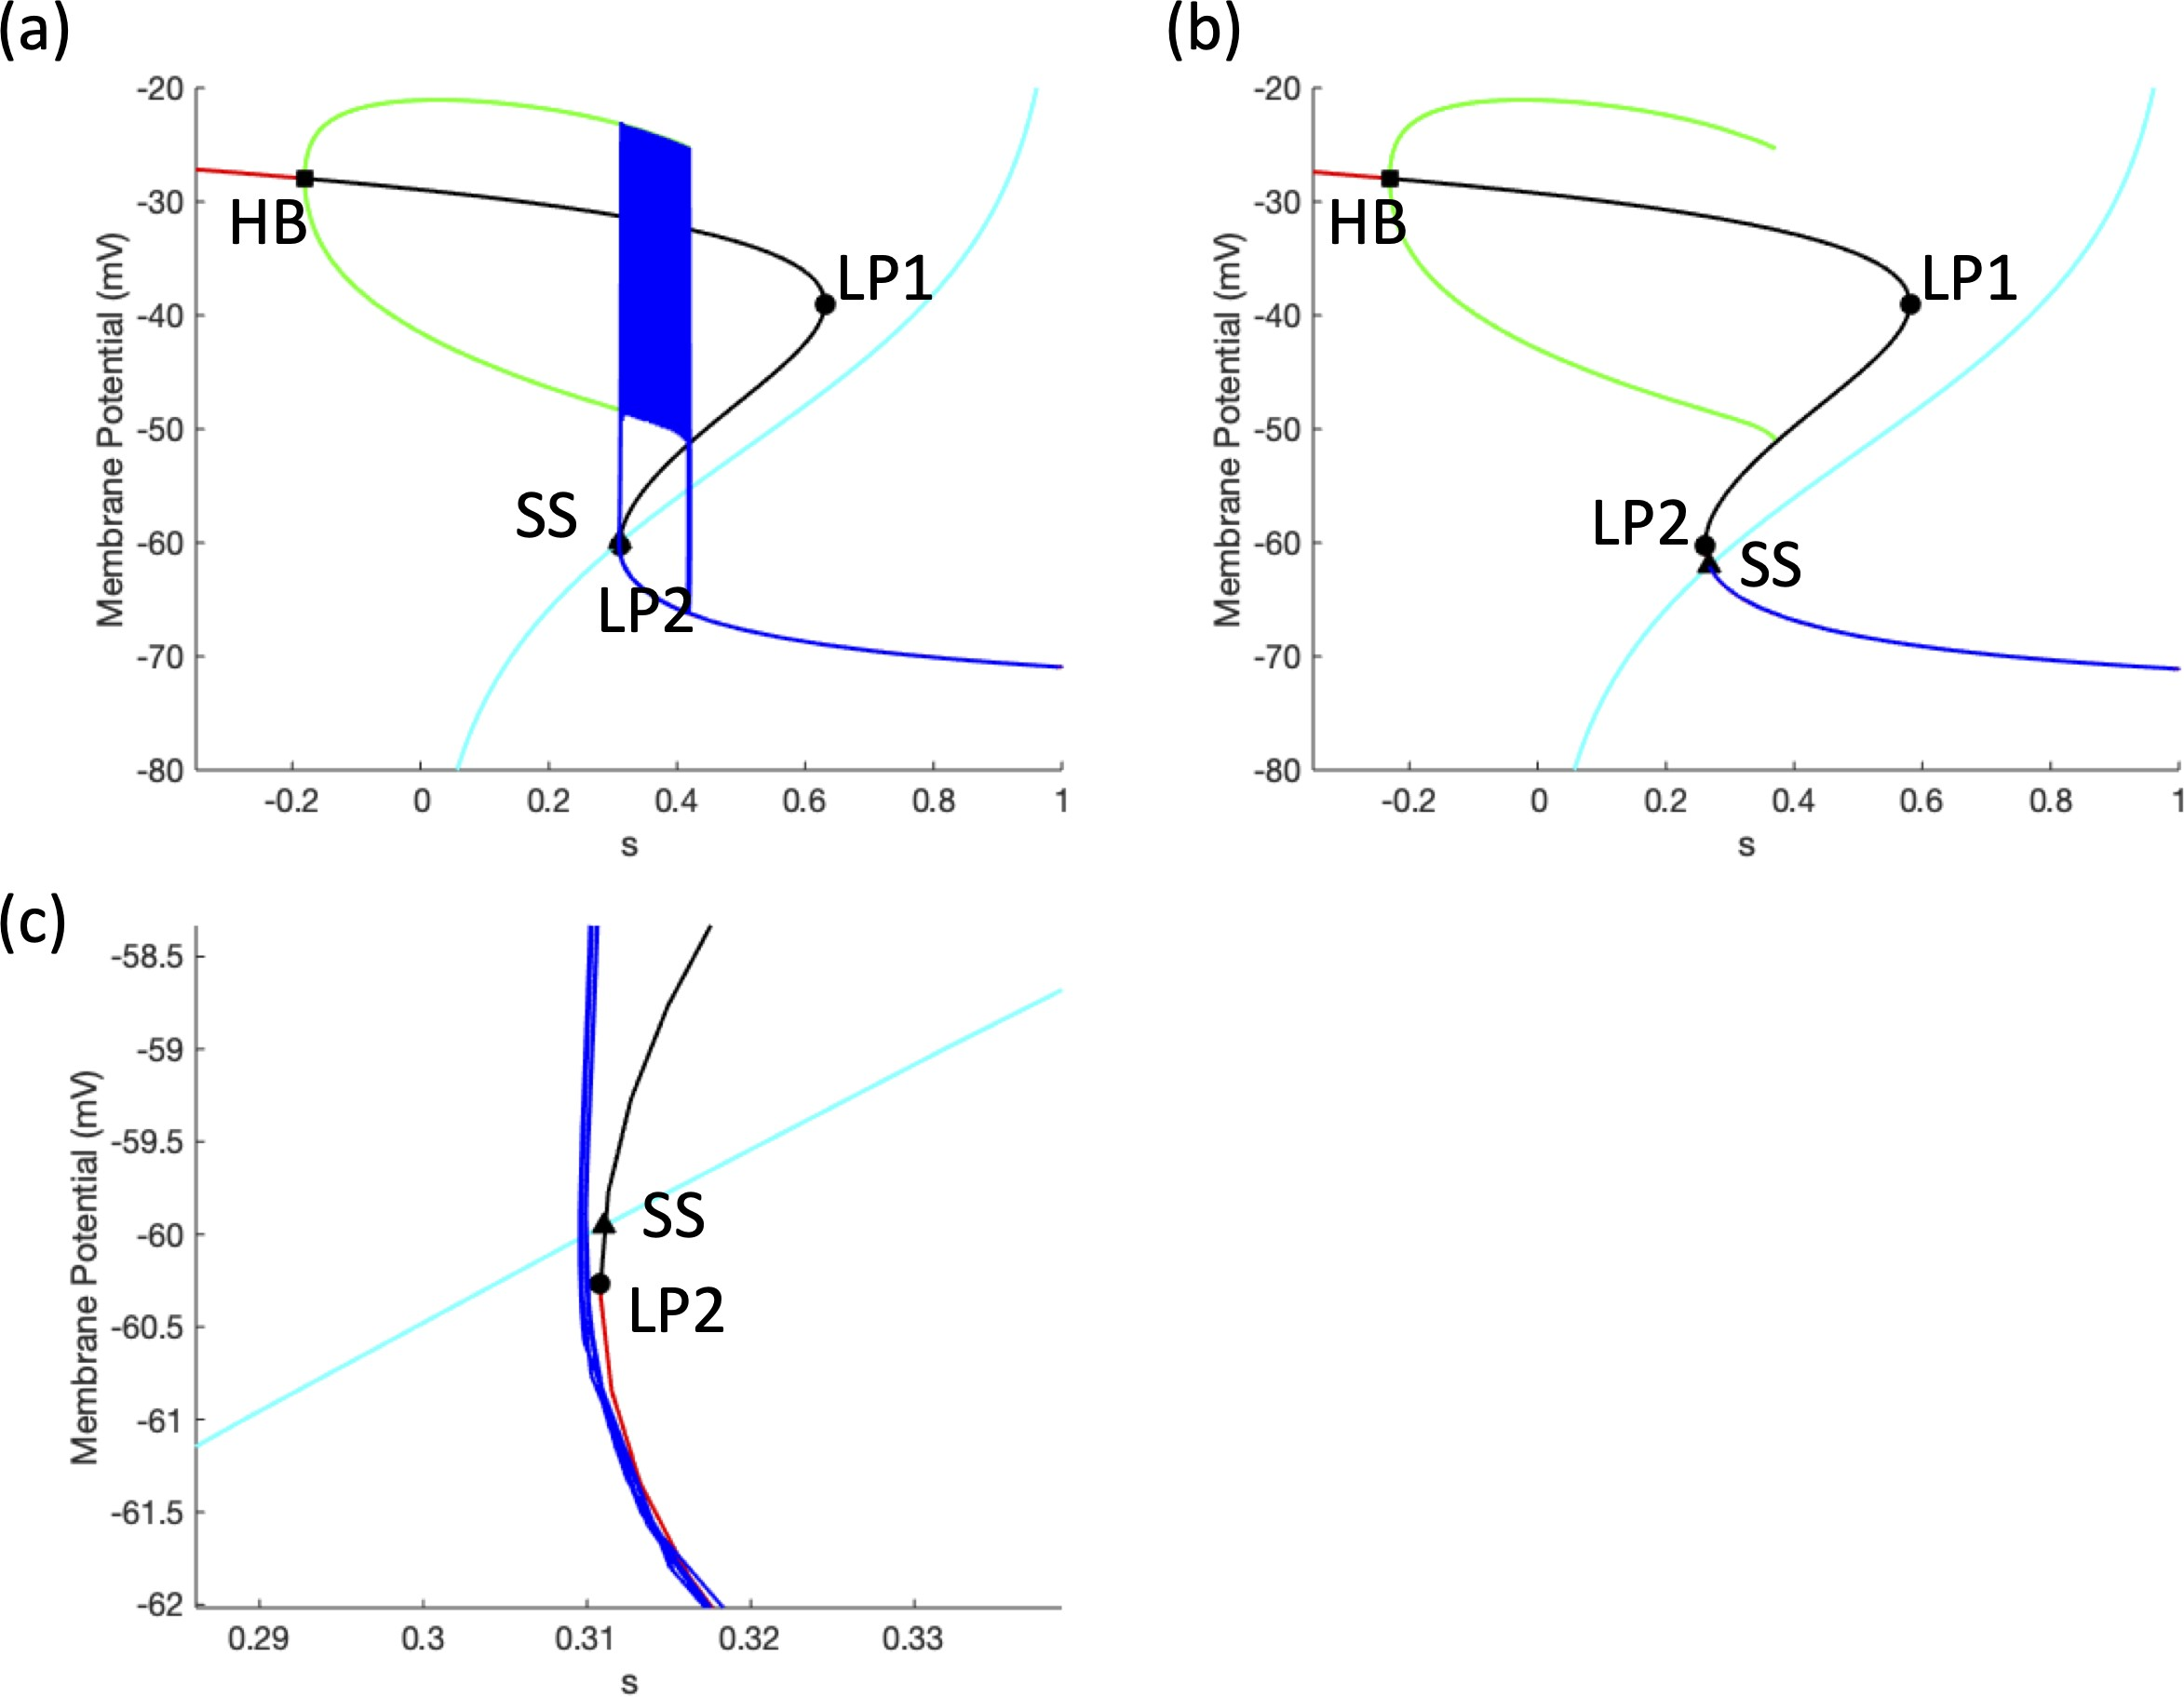

Figure 5.1: Bifurcation Diagram for an Active and Silent Cell. The stable steady state is denoted by the red line, the unstable by the black line. The Hopf bifurcation (HB) is designated with a black square from which the green stable orbit arises. The two limit points (LP1, LP2) are shown by the black circles. The s-nullcline of the full system is the cyan curve, with its intersection (SS) with the bifurcation diagram marked with a black triangle. The full system trace is overlaid in blue. The parameters selected were g_{Ca} = 990 pS and (a) g_{KAT} _{P} = 130 pS and (b) g_{KAT} _{P} = 140 pS. Figure (c) is a zoomed in section of (a).

the lower limit point where the z-curve changes stability LP2=(s_{lim}, V_{lim}). If the intersection point is above the limit point (i.e. V_{int} > V_{lim}, then the cell can be classified as active. Otherwise if the limit point is above the intersection point (i.e. V_{lim} > V_{int}), then the cell is characterized as silent.

Extending fast-slow subsytem analysis to many cells

Our next algorithm borrowed some of these ideas from the single cell fast-slow subsystem analysis. For each cell in the system, the limit point LP2= (s_{lim}, V_{lim}) and intersection point SS= (s_{int}, V_{int}) were found for their uncoupled curves. The difference |V_{int} − V_{lim}| was compared amongst all the cells with the idea that the cell with the largest difference would dominate the behavior. This was tested on the two cell case with a success rate of 78.1%. A major flaw of this algorithm was that it never considered the case of low to intermediate coupling where cells could behave differently, instead focusing on the strong coupling case.

In order to handle the situation where two cells may have different behaviors, a faux coupling current was added to each z-curve. Similar to the first algorithm, each cell was assigned a provisional membrane potential based on its intrinsic behavior. Cells were assigned a coupling voltage similar to the algorithm in Section 5.1:

V_{C}(i) = .
−25 mV, if intrinsically active
−60 mV, if intrinsically silent

An approximate coupling current was calculated I_{coup} ≈ M (V − V_{C}) for all of the

cells and I_{coup}(i) was added to the z-curve of cell i:

s(V ) = − (I_{Ca}(V ) + I_{KAT} _{P} (V ) + I_{K}(V, n) + I_{coup}(i)) .
g_{S} · (V − V_{K})
We calculated V_{lim} and V_{int} using this new z-curve. If the limit point was above the intersection point (V_{lim} > V_{int}), the cell was designated as silent; otherwise it was active. When tested on the two cell case, it had a success rate of 65.9%. As we wanted to extend this algorithm to a network of 57 cells or larger, we next tried it on a system of 3 connected cells. The success rate increased to 69.2% for the 1000 three cell cases tested.
There were two main problems with the algorithm. The first was especially apparent in the 3 cell case. Suppose there is a network of 3 connected cells where cell 1 is intrinsically active, but cell 2 and 3 are intrinsically silent. This algorithm determined that cell 1 remains active, cell 3 remains silent, but cell 2 becomes active. However, in actuality, cell 3 became active as well due to the influence from now two active cells. This issue was fixed with the notion of an iterative algorithm. For any cell that flipped its behavior, the comparison between V_{lim} and V_{int} would be recalculated for all neighbors of that cell. This would be repeated until cells were no longer flipped. The iterative algorithm now has a success rate of 75.5%.
Secondly, all of the misclassified cases had cells with |V_{lim} − V_{int}| < 2, as
seen in Fig 5.2(a). However, as noted in Fig 5.2(b), there was a much higher proportion of cells in with a difference within 2 mV that were correctly predicted. Thus an assumption cannot be made that any cell with a difference in that range was incorrectly predicted.

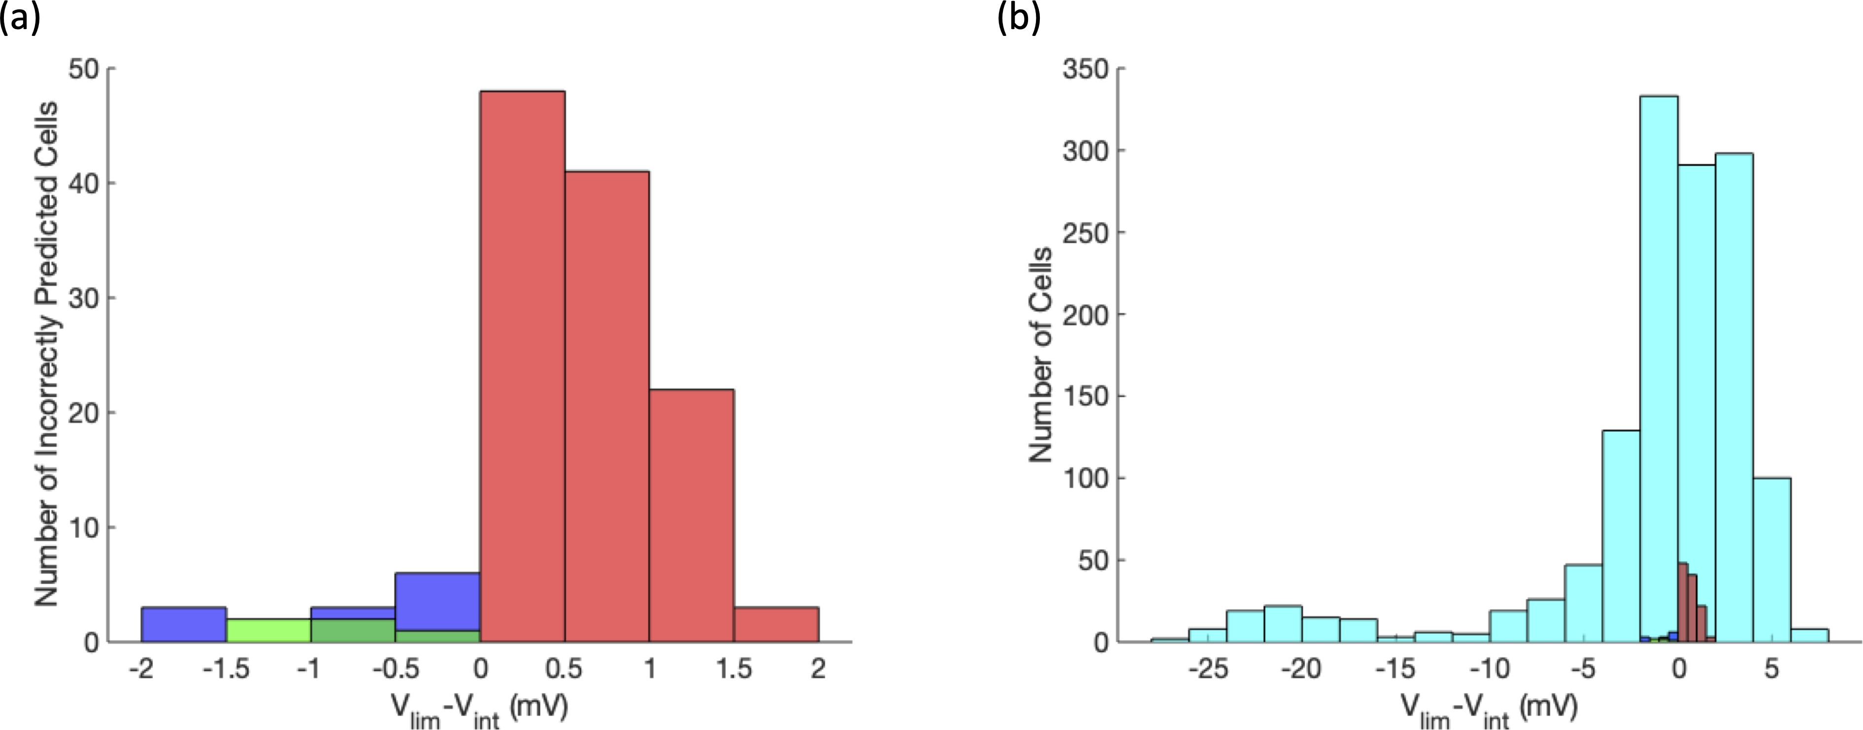

Figure 5.2: Comparison of V_{lim} and V_{int} for 2 Coupled Cells. (a) The V_{lim} − V_{int} for
the incorrectly predicted cells with blue representing cells that were predicted to be one active-one silent but both were silent, red for cells that were predicted to be both active, but was one active-one silent, and red for cells predicted to be one active-one silent but both were active. (b) The same graph from (a) on top of all the correctly predicted cells in cyan.

One attempt to fix this was to consider the behavior of the uncoupled neigh- bors. The V_{lim,uncoup} and V_{int,uncoup} was calculated for the uncoupled system where the z-curve is described by
s(V ) = − (I_{Ca}(V ) + I_{KAT} _{P} (V ) + I_{K}(V, n)) .
g_{S} · (V − V_{K})
The difference V_{lim,uncoup} − V_{int,uncoup} for each neighbor was multipled by the cou- pling coefficient between the cell and the neighbor to account for the differences in

coupling and that was summed up over all the neighbors, κ =

j∈N (i)
gCi,j
(i)
lim,uncoup
·V
−

(i)
V
int,uncoup
. The thinking was similar to that of the second algorithm attempted. The

cells with the largest difference magnitude, scaled by the coupling, would dominate the behavior. If κ > 0, the more silent cells were thought to be pulling the active cells down. Meanwhile, active cells were thought to be activating silent cells if κ > 0. This alteration brought the success rate of testing on the 3 cell system up to 81.8%. A new problem arose from the solution of incorrectly predicting cells with
|V_{lim} − V_{int}| < 2. Often in the incorrect cases, cells that were silent were heavily
dominating the calculation of κ causing it to have a large, positive value when in the simulations, they were having little impact on their neighbors.

Reducing complexity

Since we were unable to understand the activity of the heterogenenous 2 or 3 cell system, we decided to look at a simpler system of 2 cells where only g_{KAT} _{P} was drawn from a normal distribution, N (130, 13) fixing g_{Ca} = 1000 pS. This can be viewed as selecting g_{KAT} _{P} values along the vertical line g_{Ca} = 1000 pS in the

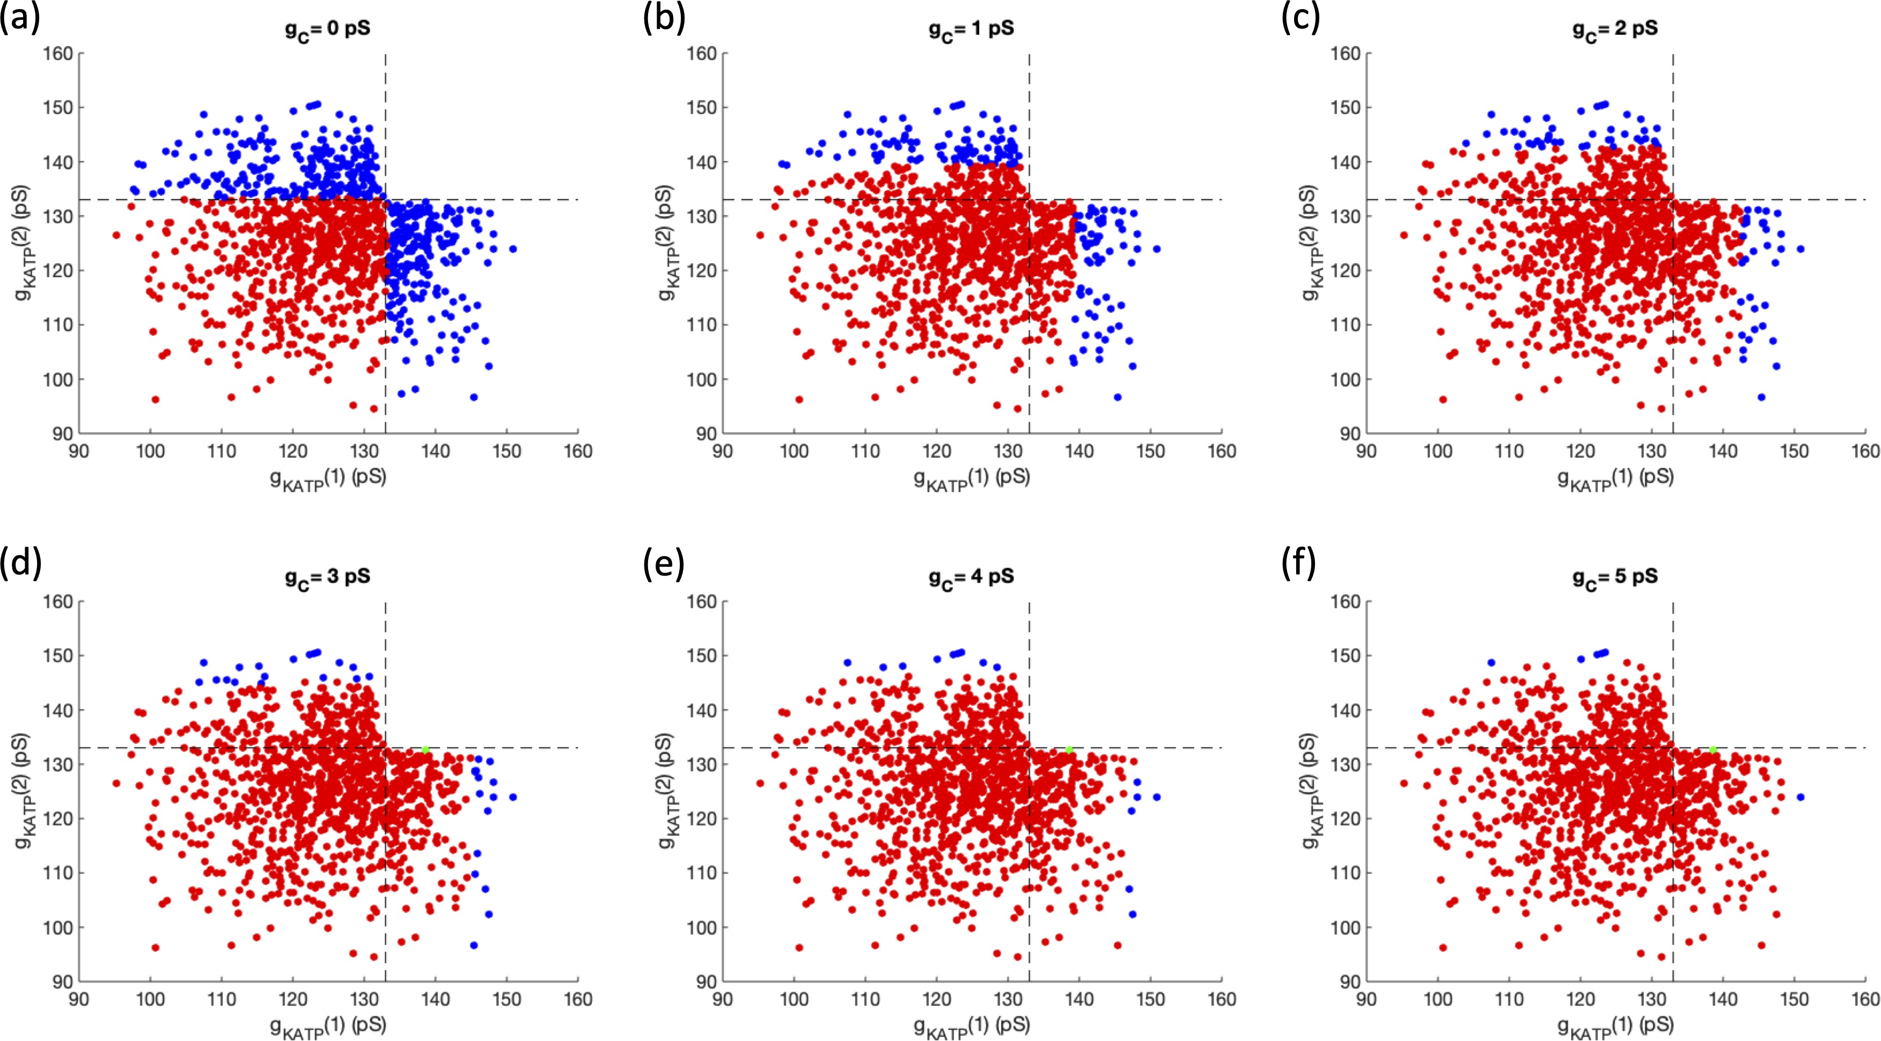

Figure 5.3: Impact of Weaker Coupling on Activity for Two Cells. Each param- eter set, represented by the g_{KAT} _{P} of cell 1 (x-axis) and cell 2 (y-axis), is designated as two active cells (red), one active cell and one silent cell (blue), and two silent cells (green). The coupling increases from (a) 0 pS, (b) 1 pS, (c) 2 pS, (d) 3 pS, (e) 4 pS, and (f) 5 pS. The dashed black lines represent the g_{KAT} _{P} threshold for activity for a single cell.
g_{Ca},g_{KAT} _{P} plane. By reducing the complexity of the system, more insight could be gleaned that would be generalizable to a more heterogeneous system. Out of the 2000 parameter sets drawn, only 1142 parameter sets had at least one active cell. We wanted to see how the coupled cells changed their activity as the coupling was increased. A visualization of this can be seen in Fig 5.3.
When there is no coupling in Fig 5.3(a), the cells behave as their g_{KAT} _{P} value dictates. However, as coupling increases from 0 to 5 pS in Fig 5.3(b)-(f), there is a linear boundary between the two active cells and the one active-one silent case that

seems independent of the other cell.

We can denote the system of cells as

dV₁ C_{M} · dt
dV₂ C_{M} · dt
= f (V₁) − g
= f (V₂) − g

KATP 1

KATP 2
· (V₁
· (V₂
- V_{K}
- V_{K}
) + g_{C}

) + g_{C}
· (V₂
· (V₁
— V₁) (5.1)
— V₂). (5.2)

Consider the case where cell 1 is active and cell 2 is silent. We denote V_{2int} as the intersection between the z-curve and s-nullcline for cell 2 and V¯1 as the average voltage for cell 1 as it oscillates. The coupling current I_{coup} = g_{C} · (V₁ − V₂) can be
approximated with I_{coup} ≈ g_{C} · (−35 − (−65)) = 30 · g_{C}. While this is a slightly
hyperpolarizing current for cell 1, it has a minimal effect on the dynamics of the active cell. However, this current is sufficient to raise cell 2 above its threshold for activity, independent of g_{KAT} _{P} ₁ of an active cell. Consequently, weak coupling is ineffective at silencing an active cell 1 but will activate cell 2 near enough threshold, which increases with increasing g_{C} as seen in Fig 5.3(b)-(f).
The stronger coupling case can be seen in Fig 5.4. Once g_{C} reached 6 pS in Fig 5.4(a), no cases remain with one active and one silent cell. In fact, the two silent cell case begins to appear. As the coupling is increased, the cells tend towards the strong coupling limit. For g_{C} large, the membrane potential of the two cells behave the same: V₁ = V₂ = V . Thus Eq 5.1-5.2 can be added together and rewritten as

2 · C_{M} ·
dV
dt = 2 · f (V ) − (g_{KAT} _{P} ₁ + g_{KAT} _{P} ₂) · (V − V_{K})
2
K

⇒ C_{M}
dV
· dt
= f (V ) − gKAT P 1 + gKAT P 2 · (V − V ).

The two cells act as a single cell with the average g_{KAT} _{P} = ^{g}KATP 1+gKATP 2
2
value.

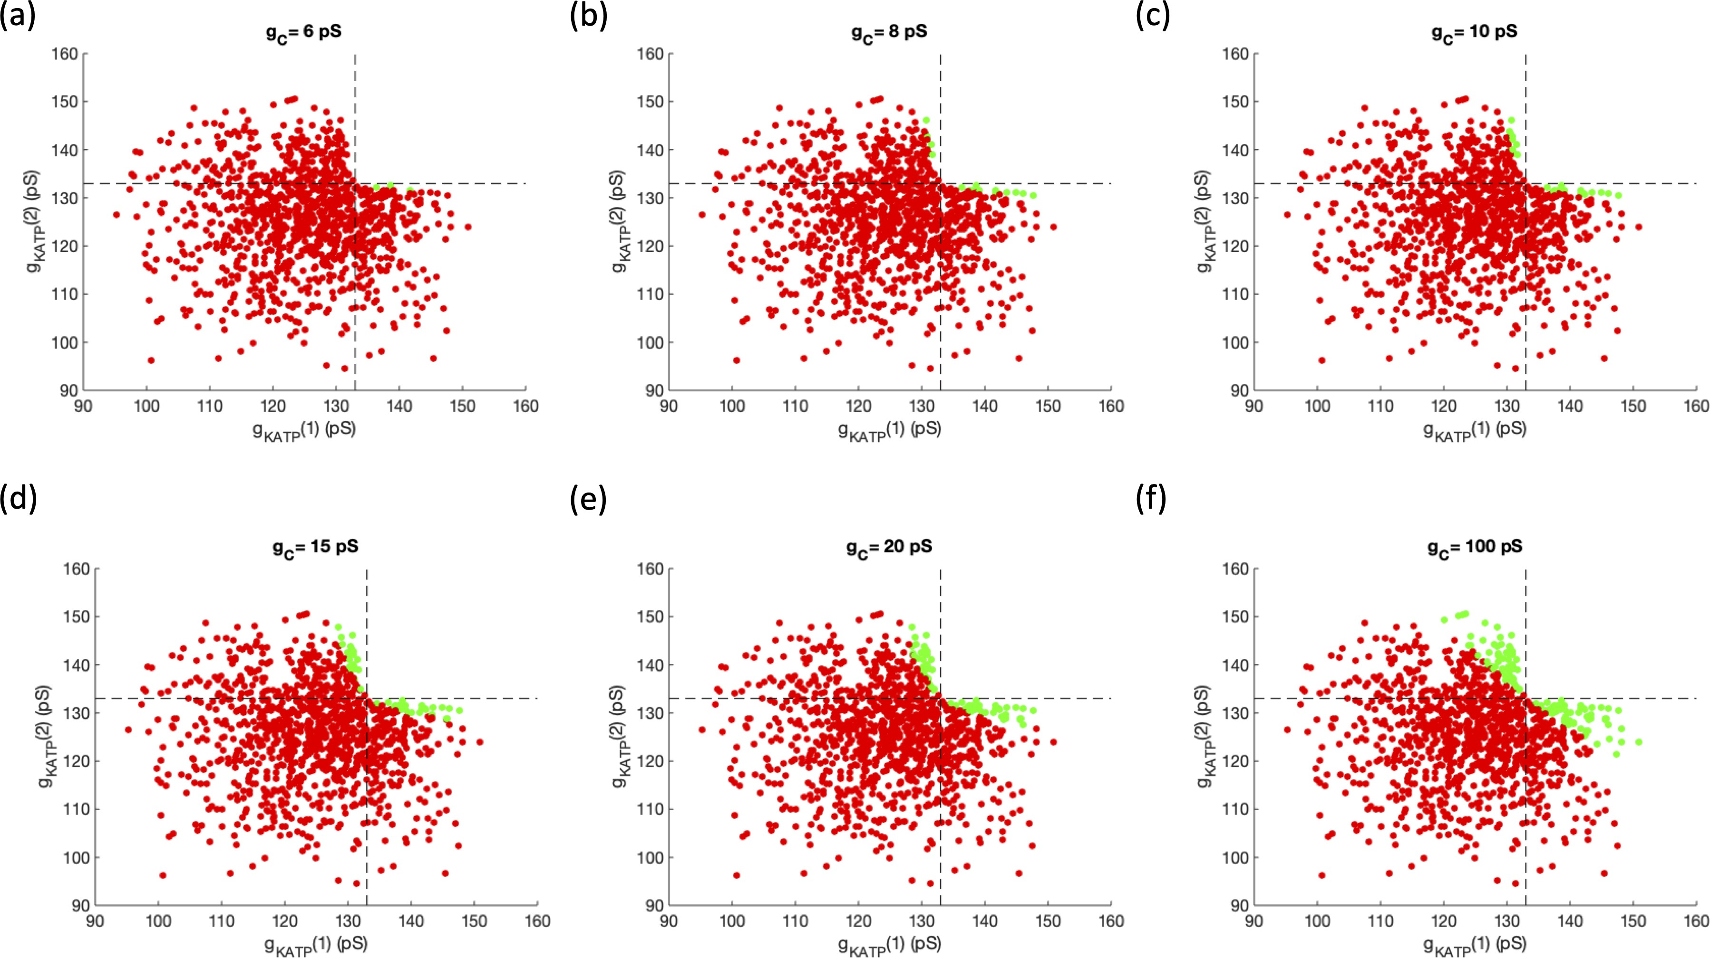

Figure 5.4: Impact of Stronger Coupling on Activity for Two Cells. Each param- eter set, represented by the g_{KAT} _{P} of cell 1 (x-axis) and cell 2 (y-axis), is designated as two active cells (red), one active cell and one silent cell (blue), and two silent cells (green). The coupling increases from (a) 6 pS, (b) 8 pS, (c) 10 pS, (d) 15 pS, (e) 20 pS, and (f) 100 pS. The dashed black line represents the g_{KAT} _{P} threshold for activity for a single cell.
Hence, at g_{C} = 100 pS in Fig 5.4(f), the boundary between the active and silent coupled cells is close to the line y = 266 − x.
These results suggest that switch cells situations are different in weak and

strong coupling. Thus, a different algorithm may be needed for each case.

Chapter 6: Concluding Remarks

This work began in response to the results from Johnston et al. that indicated some special β cells could dominate the behavior of all other cells in the islet [10]. The implications, if this were true, could be enormous for the field of type 2 diabetic research. Previously, β cells were thought to have a more or less equal impact on neighboring cells through gap junctions. A cell could activate its neighbor that was near threshold for activity, but would not have long range effects on other cells in the islet. However, the notion of a hub cell questioned this thinking as the silencing of a single hub cell could disrupt the activity of the entire islet.
Using a computational model, we tested this hub cell hypothesis, with the goal of uncovering the cellular and network properties causing the emergence of hub cells. Johnston et al. established three main properties of their islet containing a hub cell: a scale-free functional connectivity network, a loss of functional connectivity with hub cell silencing, and a mainly nonactive islet with silencing of the hub cell [10]. As the hub-follower property emerges in scale-free networks, we originally thought it was essential to have a scale-free network.
Once we found an islet with scale-free functional connectivity, we silenced its functional degree hub. While there was a substantial loss of functional connectivity

measured while silencing the functional hub cell, there was a minimal effect observed on the synchrony of the islet.
Functional connectivity seemed heavily tied to synchronization as both were some measure of correlation between cells. Functional connectivity considered the common activity of cells while the synchronization measured the similarity between periods of cell activity. If an islet was well-synchronized, there would be a high number of functional connections in the islet, pushing the distribution away from a scale-free network. Thus, it seemed unlikely to have an islet with high synchroniza- tion and a scale-free functional connectivity.
We tested this idea using a predetermined, highly active hub cell in an islet with cells below the threshold for activity. The islet was activated by the predetermined hub cell and thus was silent when the predetermined hub cell was silenced. However, as the cells were almost perfectly synchronized, almost all cells were considered functionally connected with each other, with the exception of the predetermined hub cell. This islet, while satisfying the loss of activity and functional connectivity requirements when the hub cell was silenced, was not scale-free.
As we were unable to achieve a scale-free network with desynchronization, we transitioned to searching for islets that could be desynchronized with the silencing of a single cell. By systemically silencing each cell in the islet, we discovered switch cells that could turn off the activity of the islet. The emergence of switch cells depended on the cellular properties of the switch cell, the network properties surround the switch cell, and the cellular properties of the neighbors of the switch cell. We observed two types of switch cells: highly active initiators that were the originating

point for an electrical wave activating the islet and less active percolators that were essential for the spread of the electrical wave.
To ensure that switch cells were not an artifact of the model we chose to use, we searched for switch cells through islets described by a more complex model of β cell activity that also incorporated the glycolytic components. By including heterogeneity and shifting the distribution of cells such that only a fraction were intrinsically bursting, switch cells emerged, confirming the existence of switch cells. In order to find switch cells a priori, we began to look at determining the ac- tivity of a cell as a function of the cell parameters. A switch cell was usually active despite its neighbors and in fact initiated an electrical wave, activating its neigh- bors. Using the fast-slow subsystem analysis, the relationship between the lower limit point for the V -s bifurcation diagram and the intersection point between the bifurcation curve and the s-nullcline indicate the activity of a single β cell. However, once coupling was included, our intuition no longer worked. We developed an iter- ative algorithm that incorporates our knowledge from the fast-slow subsystem, but there were certain situations where the algorithm may fail to correctly characterize
cells.

Various experiments can be suggested in order to study switch cells in pan- creatic islets. For example, from our simulations, we expect a higher number of switch cells in a tightly coupled islet. Using optogenetic silencing, this theory could be tested by systemically silencing each cell in the islet. If this is found, then a gap junction blocker can be slowly added to the islet to decrease the connectivity. The simulations show that the number of switch cells in the islet would decrease

as more gap junction blocker is added. This process is critically dependent on the level of g_{KAT} _{P} or g_{Ca}, which is less dynamic on a short time scale. It is unlikely that switch cells would be apparent in low or high glucose where g_{KAT} _{P} is large or small, respectively. Intermediate levels of glucose where significant numbers of beta cells are active but many, if they were to be uncoupled, still are not will provide the type of situation necessary to find switch cells.
While the clinical implications of our findings remain uncertain, it is clear that switch cells emerge in computational islets in medium levels of glucose where not all cells, were they uncoupled, have been activated by a glucose stimulus. This could imply that the vulnerability of islets only exists in the transition phases as the glucose concentration begins to ramp up or down. Another possibility is that the long-term dysfunction of β cells could create an environment where cellular conductances provide a substrate for the presence of switch cells. Switch cells may be able to explain the hub and leader cell experiments, which when further understood could lead to deeper insight into the desynchronization observed in type 2 diabetes.

Appendix A: Single Slow Channel Model Equations & Parameters

A four variable model adapted from [67] was used for the simulations in this paper. The first variable tracked the membrane potential of a cell i with the dy- namics given by the Hodgkin-Huxley like differential equation
dV_{i}
−C_{M} · dt = I_{Ca}(V_{i})+I_{K(AT} _{P} ₎(V_{i})+I_{K}(V_{i}, n_{i})+I_{S}(V_{i}, s_{i})+I_{Coup}(V_{i})+I_{Cl}(V_{i}). (A.1)

The membrane capacitance is given by C_{M} , listed in Table A.1. I_{Ca} is the voltage dependent calcium current, I_{K(AT} _{P} ₎ is the ATP/ADP ratio dependent potassium current, I_{K} is the delayed rectifier potassium current, I_{S} is the slow inhibitory potassium current, I_{Coup} is the gap junctional coupling current, and I_{Cl} is the op- togenetically controlled chloride current. Their forms are given below:

I_{KAT} _{P} (V_{i}) = g_{KAT} _{P} · (V_{i} − V_{K}) (A.2)
I_{Ca}(V_{i}) = g_{Ca} · m∞(V_{i}) · (V_{i} − V_{Ca}) (A.3)
I_{K}(V_{i}, n_{i}) = g_{K} · n_{i} · (V_{i} − V_{K}) (A.4)
I_{S}(V_{i}, s_{i}) = g_{S} · s_{i} · (V_{i} − V_{K}) (A.5)

ICoup(Vi) =
∀j∈N (i)
g_{c}ij · (V_{j} − V_{i}) (A.6)

I_{Cl}(V_{i}) = g_{Cl} · σ · (V_{i} − V_{Cl}). (A.7)

Each g_{X} represents the maximal conductances of the respective current and V_{X} denotes the ion’s Nernst potential, listed in Table A.1 and A.2. The currents given in Equations S4 & S5 each have gating variables, n and s respectively, whose dynamics are given by the differential equations

dn_{i} dt
= n∞(V_{i}) − n_{i}
τ_{n}

(A.8)

ds_{i} dt
= s∞(Vi) − si . (A.9)
τ_{s}

The time constants are represented by τ_{n} and τ_{s}, listed in Table A.1, while the steady state forms of n and s are given by n∞ and s∞ respectively. As the gating variable for the voltage gated calcium channel reaches its equilibrium at a faster time scale, it is set to its steady state m∞ in Equation S3. The functional forms for the steady states are

m∞(V_{i}) =

1 + exp
1
V i Vm
₋
θm
(A.10)

n∞(V_{i}) =
1
V −V
(A.11)

1 + exp
1
₋
i n
θn

s∞(V_{i}) =

1 + exp

V i Vs
θs
. (A.12)

The parameters V_{m}, V_{n}, V_{s}, θ_{m}, θ_{n}, and θ_{s} are listed in Table A.1. In Equation S6, the coupling current is summed over all neighbors of cell i, N (i). The σ in Equation S7 denotes the optogenetic control over the halorhodopsin pumps in the membrane of cell i. When the chloride pumps are optogenetically activated, σ is set to 1 and otherwise is 0.

The last equation in the model denotes the change in calcium concentration

dc_{i} dt
= f · [−α · I_{Ca}
(V_{i}) − k_{Ca}
· c_{i}]. (A.13)

The parameter f accounts for the fraction of free calcium, α converts the current to a rate of increase in the concentration, and k_{Ca} represents the rate at which calcium is being pumped out of the cell. Their values are given in the Tables A.1 and A.2.

Parameter | Symbol | Value
Membrane capacitance | C_{M} | 5.3 pF
Optogentic chloride pump conductance | gCl | 100 pS
Optogenetic control of the chloride pumps | σ | 0 or 1
Potassium Nernst potential | V_{K} | -75 mV
Calcium Nernst potential | VCa | 25 mV
Chloride Nernst potential | VCl | -70 mV
Half-maximal potential for m∞ | V_{m} | -20 mV
Half-maximal potential for n∞ | V_{n} | -17 mV
Half-maximal potential for s∞ | V_{s} | -22 mV
Slope of m∞ at V = V_{m} | s_{m} | 12 mV
Slope of n∞ at V = V_{n} | s_{n} | 5.6 mV
Slope of s∞ at V = V_{s} | s_{s} | 8 mV
Mean opening time of the slow  inhibitory potassium channel | τ_{s} | 20 s
Mean opening time of the voltage-gated  potassium channel | τ_{n} | 0.02 s
Fraction of free calcium in the  intracellular space | f | 0.01
Conversion factor from electrical  gradient to chemical gradient | α | 0.0045 µM/(fA × s)

Table A.1: Homogeneous Model Parameters.

Parameter or Initial Value | Symbol | Mean | SD
Voltage-gated potassium channel  conductance | g_{K} | 2700 pS | 5%
Voltage-gated calcium channel conductance | gCa | 1000 pS | 5%
ATP/ADP dependent potassium channel  conductance | gK(ATP ) | 100-145 pS | 5-10%
Slow inhibitory potassium channel  conductance | g_{S} | 200 pS | 5%
Gap junction conductance | g_{c} | 4-200 pS | 50%
Calcium pump rate | kCa | 0.2 s⁻¹ | 5%
Initial value for the membrane potential | V₀ | -65 mV | 5%
Initial value for the voltage gated potassium  channel gating variable | n₀ | 0.5 | 5%
Initial value for the slow inhibitory  potassium channel gating variable | s₀ | 1.01 | 5%
Initial value for the calcium concentration | c₀ | 0.05 µM | 5%

Table A.2: Heterogeneous Model Parameters. Heterogeneous parameter and initial values were selected from distributions with the given means and standard deviations.

Bibliography

    - Elise Falgout, Destiny Frett, Lorenzo Neil, Ryan Schumm, Janita Patwardhan, Brad Peercy, and Arthur Sherman. An investigation of small worldness in pan- creatic islets. Technical report, UMBC Mathematics and Statistics Department, 2017.
    - Samuel Khuvis, Matthias K Gobbert, and Bradford E Peercy. Time-stepping techniques to enable the simulation of bursting behavior in a physiologically realistic computational islet. Mathematical Biosciences, 263:1–17, 2015.
    - Aparna Nittala, Soumitra Ghosh, and Xujing Wang. Investigating the role of islet cytoarchitecture in its oscillation using a new β-cell cluster model. PLoS One, 2(10):e983, 2007.
    - Matthew J Westacott, Nurin WF Ludin, and Richard KP Benninger. Spa- tially organized β-cell subpopulations control electrical dynamics across islets of Langerhans. Biophysical Journal, 113(5):1093–1108, 2017.
    - Chon-Lok Lei, Joely A Kellard, Manami Hara, James D Johnson, Blanca Ro- driguez, and Linford JB Briant. Beta-cell hubs maintain ca²⁺ oscillations in human and mouse islet simulations. Islets, 10(4):151–167, 2018.
    - Andraˇz Stoˇzer, Marko Gosak, Jurij Dolenˇsek, Matjaˇz Perc, Marko Marhl, Marjan Slak Rupnik, and Dean Koroˇsak. Functional connectivity in islets of Langerhans from mouse pancreas tissue slices. PLoS Computational Biology, 9(2):e1002923, 2013.
    - Rene Markoviˇc, Andraˇz Stoˇzer, Marko Gosak, Jurij Dolenˇsek, Marko Marhl, and Marjan Slak Rupnik. Progressive glucose stimulation of islet beta cells re- veals a transition from segregated to integrated modular functional connectivity patterns. Scientific Reports, 5:7845, 2015.
    - Janita Patwardhan and Bradford E. Peercy. Network analysis applied to pan- creatic islets. In Olaf Wolkenhauer, editor, Systems Medicine: Integrative, Qualitative and Computational Approaches. Elsevier, 2020.

    - Giacomo Cappon and Morten Gram Pedersen. Heterogeneity and nearest- neighbor coupling can explain small-worldness and wave properties in pan- creatic islets. Chaos: An Interdisciplinary Journal of Nonlinear Science, 26(5):531031–531037, 2016.
    - Natalie R Johnston, Ryan K Mitchell, Elizabeth Haythorne, Maria Paiva Pes- soa, Francesca Semplici, Jorge Ferrer, Lorenzo Piemonti, Piero Marchetti, Marco Bugliani, Domenico Bosco, et al. Beta cell hubs dictate pancreatic islet responses to glucose. Cell Metabolism, 24(3):389–401, 2016.
    - Meeyoung Cha, Alan Mislove, and Krishna P Gummadi. A measurement-driven analysis of information propagation in the flickr social network. In Proceedings of the 18th International Conference on World wide web, pages 721–730, 2009.
    - R´eka Albert, Istv´an Albert, and Gary L Nakarado. Structural vulnerability of the North American power grid. Physical Review E, 69(2):025103, 2004.
    - Lada A Adamic and Bernardo A Huberman. Power-law distribution of the world wide web. Science, 287(5461):2115–2115, 2000.
    - Noel M Tichy, Michael L Tushman, and Charles Fombrun. Social network anal- ysis for organizations. Academy of Management Review, 4(4):507–519, 1979.
    - Duncan J Watts and Steven H Strogatz. Collective dynamics of ‘small-world’ networks. Nature, 393(6684):440, 1998.
    - American Diabetes Association et al. Diagnosis and classification of diabetes mellitus. Diabetes Care, 37(Supplement 1):S81–S90, 2014.
    - Stephen O’Rahilly, Robert C Turner, and David R Matthews. Impaired pul- satile secretion of insulin in relatives of patients with non-insulin-dependent diabetes. New England Journal of Medicine, 318(19):1225–1230, 1988.
    - Morten Gram Pedersen, Richard Bertram, and Arthur Sherman. Intra-and inter-islet synchronization of metabolically driven insulin secretion. Biophysical Journal, 89(1):107–119, 2005.
    - Richard KP Benninger, Min Zhang, W Steven Head, Leslie S Satin, and David W Piston. Gap junction coupling and calcium waves in the pancreatic islet. Biophysical Journal, 95(11):5048–5061, 2008.
    - Rachel T Scarl, Kathryn L Corbin, Nicholas W Vann, Hallie M Smith, Leslie S Satin, Arthur Sherman, and Craig S Nunemaker. Intact pancreatic islets and dispersed beta-cells both generate intracellular calcium oscillations but differ in their responsiveness to glucose. Cell Calcium, 83:102081, 2019.
    - Over Cabrera, Dora M Berman, Norma S Kenyon, Camillo Ricordi, Per-Olof Berggren, and Alejandro Caicedo. The unique cytoarchitecture of human pan- creatic islets has implications for islet cell function. Proceedings of the National Academy of Sciences, 103(7):2334–2339, 2006.

    - Patrick E MacDonald and Patrik Rorsman. Oscillations, intercellular coupling, and insulin secretion in pancreatic β cells. PLoS Biology, 4(2):e49, 2006.
    - Lelio Orci and RogerH Unger. Functional subdivision of islets of Langerhans and possible role of D cells. The Lancet, 306(7947):1243–1244, 1975.
    - Domenico Bosco, Lelio Orci, and Paolo Meda. Homologous but not heterol- ogous contact increases the insulin secretion of individual pancreatic b-cells. Experimental Cell Research, 184(1):72–80, 1989.
    - Philippe A Halban, Claes B Wollheim, Benigna Blondel, Paolo Meda, Eric N Niesor, and Daniel H Mintz. The possible importance of contact between pan- creatic islet cells for the control of insulin release. Endocrinology, 111(1):86–94, 1982.
    - ˚A Lernmark. The preparation of, and studies on, free cell suspensions from mouse pancreatic islets. Diabetologia, 10(5):431–438, 1974.
    - Richard KP Benninger, W Steven Head, Min Zhang, Leslie S Satin, and David W Piston. Gap junctions and other mechanisms of cell-cell commu- nication regulate basal insulin secretion in the pancreatic islet. The Journal of Physiology, 589(22):5453–5466, 2011.
    - Richard KP Benninger, MS Remedi, WS Head, A Ustione, DW Piston, and CG Nichols. Defects in beta cell Ca²⁺ signalling, glucose metabolism and in- sulin secretion in a murine model of KATP channel-induced neonatal diabetes mellitus. Diabetologia, 54(5):1087–1097, 2011.
    - W Steven Head, Meredith L Orseth, Craig S Nunemaker, Leslie S Satin, David W Piston, and Richard KP Benninger. Connexin-36 gap junctions reg- ulate in vivo first-and second-phase insulin secretion dynamics and glucose tol- erance in the conscious mouse. Diabetes, 61(7):1700–1707, 2012.
    - Magalie A Ravier, Martin Gu¨ldenagel, Anne Charollais, Asllan Gjinovci, Doroth´ee Caille, Goran S¨ohl, Claes B Wollheim, Klaus Willecke, Jean-Claude Henquin, and Paolo Meda. Loss of connexin36 channels alters β-cell coupling, islet synchronization of glucose-induced Ca²⁺ and insulin oscillations, and basal insulin release. Diabetes, 54(6):1798–1807, 2005.
    - Stephan Speier, Asllan Gjinovci, Anne Charollais, Paolo Meda, and Marjan Rupnik. Cx36-mediated coupling reduces β-cell heterogeneity, confines the stimulating glucose concentration range, and affects insulin release kinetics. Diabetes, 56(4):1078–1086, 2007.
    - DA Lang, DR Matthews, M Burnett, and RC Turner. Brief, irregular oscil- lations of basal plasma insulin and glucose concentrations in diabetic man. Diabetes, 30(5):435–439, 1981.

    - Ole Schmitz, N Porksen, Birgit Nyholm, Christian Skjaerbaek, Peter C Butler, Johannes D Veldhuis, and Steven M Pincus. Disorderly and nonstationary insulin secretion in relatives of patients with NIDDM. American Journal of Physiology-Endocrinology And Metabolism, 272(2):E218–E226, 1997.
    - Amlan K Barua and Pranay Goel. Isles within islets: The lattice origin of small-world networks in pancreatic tissues. Physica D: Nonlinear Phenomena, 315:49–57, 2016.
    - Alessandro Loppini, Morten Gram Pedersen, Matthias Braun, and Simonetta Filippi. Gap-junction coupling and ATP-sensitive potassium channels in human β-cell clusters: Effects on emergent dynamics. Physical Review E, 96(3):032403, 2017.
    - Alessandro Loppini, Christian Cherubini, and Simonetta Filippi. On the emer- gent dynamics and synchronization of β-cells networks in response to space-time varying glucose stimuli. Chaos, Solitons & Fractals, 109:269–279, 2018.
    - Marko Gosak, Andraˇz Stoˇzer, Rene Markoviˇc, Jurij Dolenˇsek, Matjaˇz Perc, Marjan S Rupnik, and Marko Marhl. Critical and supercritical spatiotemporal calcium dynamics in beta cells. Frontiers in Physiology, 8:1106, 2017.
    - Deborah A Striegel, Manami Hara, and Vipul Periwal. The beta cell in its cluster: Stochastic graphs of beta cell connectivity in the islets of Langerhans. PLoS Computational Biology, 11(8), 2015.
    - Ronald L Breiger, Scott A Boorman, and Phipps Arabie. An algorithm for blocking relational data, with applications to social network analysis and com- parison with multidimensional scaling. Journal of Mathematical Psychology, 12:328–383, 1975.
    - Vito Latora and Massimo Marchiori. Efficient behavior of small-world networks.
Physical review letters, 87(19):198701, 2001.
    - Mark D Humphries and Kevin Gurney. Network ‘small-world-ness’: a quanti- tative method for determining canonical network equivalence. PloS One, 3(4), 2008.
    - Albert-L´aszl´o Barab´asi and R´eka Albert. Emergence of scaling in random net- works. Science, 286(5439):509–512, 1999.
    - Danielle Smith Bassett and ED Bullmore. Small-world brain networks. The Neuroscientist, 12(6):512–523, 2006.
    - Olaf Sporns and Christopher J Honey. Small worlds inside big brains. Proceed- ings of the National Academy of Sciences, 103(51):19219–19220, 2006.
    - Mikail Rubinov and Olaf Sporns. Complex network measures of brain connec- tivity: Uses and interpretations. Neuroimage, 52(3):1059–1069, 2010.

    - Gabriele Lohmann, Daniel S Margulies, Annette Horstmann, Burkhard Pleger, Joeran Lepsien, Dirk Goldhahn, Haiko Schloegl, Michael Stumvoll, Arno Vill- ringer, and Robert Turner. Eigenvector centrality mapping for analyzing con- nectivity patterns in fMRI data of the human brain. PloS One, 5(4), 2010.
    - Olaf Sporns. Contributions and challenges for network models in cognitive neuroscience. Nature Neuroscience, 17(5):652, 2014.
    - Guy A Rutter and David J Hodson. Beta cell connectivity in pancreatic islets: A type 2 diabetes target? Cellular and Molecular Life Sciences, 72(3):453–467, 2015.
    - Jonathan V Rocheleau, Maria S Remedi, Butch Granada, W Steven Head, Joseph C Koster, Colin G Nichols, and David W Piston. Critical role of gap junction coupled KATP channel activity for regulated insulin secretion. PLoS Biology, 4(2), 2006.
    - Paolo Meda, Lelio Orci, Illani Atwater, Andrew Bangham, Eduardo Rojas, and Ari Gon¸calves. The topography of electrical synchrony among β-cells in the mouse islet of Langerhans. Quarterly Journal of Experimental Physiology: Translation and Integration, 69(4):716–735, 1984.
    - Oleg V Aslanidi, Oleg A Mornev, Ole Skyggebjerg, Per Arkhammar, Ole Thas- trup, Mads P Sørensen, Peter L Christiansen, Knut Conradsen, and Alwyn C Scott. Excitation wave propagation as a possible mechanism for signal transmis- sion in pancreatic islets of Langerhans. Biophysical Journal, 80(3):1195–1209, 2001.
    - Per Bak, Chao Tang, and Kurt Wiesenfeld. Self-organized criticality: An ex- planation of the 1/f noise. Physical Review Letters, 59(4):381, 1987.
    - I Johanna Stamper and Xujing Wang. Integrated multiscale mathematical modeling of insulin secretion reveals the role of islet network integrity for proper oscillatory glucose-dose response. Journal of Theoretical Biology, 475:1–24, 2019.
    - Andraˇz Stoˇzer, Rene Markoviˇc, Jurij Dolenˇsek, Matjaˇz Perc, Marjan Slak Rup- nik, Marko Marhl, and Marko Gosak. Heterogeneity and delayed activation as hallmarks of self-organization and criticality in excitable tissue. Frontiers in Physiology, 10:869, 2019.
    - Gabriela Da Silva Xavier and Guy A Rutter. Metabolic and functional hetero- geneity in pancreatic β cells. Journal of Molecular Biology, 2019.
    - A Loppini and L Chiodo. Biophysical modeling of β-cells networks: Realistic architectures and heterogeneity effects. Biophysical Chemistry, page 106247, 2019.

    - Victoria Salem, Luis Delgadillo Silva, Kinga Suba, Eleni Georgiadou, S Neda Mousavy Gharavy, Nadeem Akhtar, Aldara Martin-Alonso, David CA Gaboriau, Stephen M Rothery, Theodoros Stylianides, et al. Leader β-cells coordinate Ca²⁺ dynamics across pancreatic islets in vivo. Nature Metabolism, 1(6):615, 2019.
    - Clive WJ Granger. Investigating causal relations by econometric models and cross-spectral methods. Econometrica: Journal of the Econometric Society, pages 424–438, 1969.
    - Janita Patwardhan and Bradford E. Peercy. Flipping the switch: Islet desyn- chronization through cell silencing. PLoS Biology, in press.
    - Christian Weyer, Clifton Bogardus, David M Mott, and Richard E Pratley. The natural history of insulin secretory dysfunction and insulin resistance in the pathogenesis of type 2 diabetes mellitus. The Journal of Clinical Investigation, 104(6):787–794, 1999.
    - Patrik Rorsman and Matthias Braun. Regulation of insulin secretion in human pancreatic islets. Annual Review of Physiology, 75:155–179, 2013.
    - Patrick Gilon and Jean-Claude Henquin. Influence of membrane poten- tial changes on cytoplasmic Ca²⁺ concentration in an electrically excitable cell, the insulin-secreting pancreatic B-cell. Journal of Biological Chemistry, 267(29):20713–20720, 1992.
    - G. T. Eddlestone, A. Gon¸calves, J. A. Bangham, and E. Rojas. Electrical coupling between cells in islets of Langerhans from mouse. Journal of Membrane Biology, 77(1):1–14, 1984.
    - Richard KP Benninger and David J Hodson. New understanding of β-cell heterogeneity and in situ islet function. Diabetes, 67(4):537–547, 2018.
    - DR Matthews, DA Lang, MA Burnett, and RC Turner. Control of pulsatile insulin secretion in man. Diabetologia, 24(4):231–237, 1983.
    - Kenneth S Polonsky, Bruce D Given, Laurence J Hirsch, Hartmut Tillil, E Tim- othy Shapiro, Christine Beebe, Bruce H Frank, John A Galloway, and Eve Van Cauter. Abnormal patterns of insulin secretion in non-insulin-dependent diabetes mellitus. New England Journal of Medicine, 318(19):1231–1239, 1988.
    - Arthur Sherman. Contributions of modeling to understanding stimulus- secretion coupling in pancreatic beta-cells. American Journal of Physiology- Endocrinology And Metabolism, 271(2):E362–E372, 1996.
    - Richard KP Benninger, Troy Hutchens, W Steven Head, Michael J McCaughey, Min Zhang, Sylvain J Le Marchand, Leslie S Satin, and David W Piston. In- trinsic islet heterogeneity and gap junction coupling determine spatiotemporal Ca2+ wave dynamics. Biophysical journal, 107(11):2723–2733, 2014.

    - Giselle Dominguez Gutierrez, Jesper Gromada, and Lori Sussel. Heterogeneity of the pancreatic beta cell. Frontiers in Genetics, 8:22, 2017.
    - DJ Hodson, F Molino, P Fontanaud, X Bonnefont, and P Mollard. Investigat- ing and modelling pituitary endocrine network function. Journal of Neuroen- docrinology, 22(12):1217–1225, 2010.
    - Albert-L´aszl´o Barab´asi and Zoltan N Oltvai. Network biology: understanding the cell’s functional organization. Nature Reviews Genetics, 5(2):101, 2004.
    - Isabella Marinelli, Theodore Vo, Luca Gerardo-Giorda, and Richard Bertram. Transitions between bursting modes in the integrated oscillator model for pan- creatic β-cells. Journal of Theoretical Biology, 454:310–319, 2018.
    - Edsger W Dijkstra. A note on two problems in connexion with graphs. Nu- merische Mathematik, 1(1):269–271, 1959.
    - Gerda De Vries, Arthur Sherman, and H-R Zhu. Diffusively coupled bursters: effects of cell heterogeneity. Bulletin of Mathematical Biology, 60(6):1167–1200, 1998.
    - Gerda De Vries and Arthur Sherman. From spikers to bursters via coupling: help from heterogeneity. Bulletin of Mathematical Biology, 63(2):371–391, 2001.

