Discourse of Faith and Power
Turnaround Tuesday, A Case Study
Isabella Cronin Favazza
Abstract
This paper explores the spiritually ambiguous identity of the jobs movement Turnaround Tuesday and how it is reflective of Baltimore City’s history of utilizing the church as a reactive force against structural violence. Due to long lasting effects of segregation, black Baltimoreans continue to struggle with generational poverty, high incarceration rates, and limited employment options. Time and again, congregations have taken their concerns to city hall and have made progress in resolving some of these issues. However, in today’s world, where unaffiliated Americans make up the largest religious group in the United States, this model of organizing is quickly losing influence. This paper does not wish to question the role of faith within the individual’s life, but that of the community. Striking a balance of church and faith-based activism, Turnaround Tuesday is learning how to navigate contemporary questions of faith, while still fighting against the same cyclical oppressions of time’s past.

Table of Contents

Acknowledgements………………………………………………………… 3

Chapter 1
Turnaround Tuesday and the Changing Roles of the Church and Community Engagement………………………………………………………………….. 5

Chapter 2
Foundations of Change: Effects of Redlining on Housing, Loans, and Employment… 22

Chapter 3
A Case Study of Turnaround Tuesday: Qualitative Methodology and Findings........... 34

Conclusion..……………………………………..…..……………………...47

Figure 1…………………………………………………………………… 52
Figure 2…………………………………………………………………… 53
Figure 3…………………………………………………………………… 54
Figure 4…………………………………………………………………… 55
Figure 5…………………………………………………………………… 56

Appendix...………………………………………………………………... 57

Works Cited……………………………………………………………….. 63

Works Referenced………………………………………………………… 68

Acknowledgements
When creating my interdisciplinary major at Goucher College, I was given a variety of choices for what I could do for my capstone presentation, including an exit interview, independent study, or some type of special innovative project. Immediately, I said I wanted to write a thesis. It seemed like a natural conclusion to my undergraduate experience, especially as a writing center tutor, teacher’s assistant, and on occasion supplemental instructor. It was not until I began writing that I realized this was going to be one of the most challenging academic endeavours I had ever undertaken. And now that my thesis is finished, and I have caught up on some sleep, I would be absolutely remiss if I did not take the time to thank a few people who helped me along the way.
First and foremost, I would like to say thank you to all of the Turnaround Tuesday (TAT) staff and leaders, former and present; specifically Pastor Prentice, Melvin Wilson, Shunbrika Johnson, Tia Gross, Terrell Williams, Cheryl Finney, William Glover-Bey, and Percy Smith. TAT is truly a beautiful movement, and I whole-heartedly believe that it is going to change the world. It has already changed mine and I am deeply appreciative to have been able to learn from all of you.
To the members of my thesis review board – Jennifer Bess, Ann Duncan, Irline Francois, and Lana Oweidat – I could not have done this without you. Special thanks to Ann Duncan and Jennifer Bess; each of you was an amazing director. Professor Duncan, I greatly appreciate all of the meetings, emails, and patience regarding this project. And Dr. Bess, although your criticisms can be brutally honest, you really pushed me to do my best work. And I am constantly amazed by your sheer dedication to your students, research, and knitting. Thank you.
To all of my co-workers at the Goucher College Writing Center, especially Emma Villalon-Iglesias, Katie Monthie, McKenna Hickox, Chi Tran, Patrick Slater, Skyler Aikerson, and Alex Steitz, who sat with me for hours as we tried to piece together citations and footnotes for this interdisciplinary paper. Thank you for your support, affirmation, snacks, and hugs.
In terms of emotional support, I still cannot believe how many 2 AM phone calls my boyfriend answered, knowing that to pick up the phone meant that he would have to pick up the pieces of my sanity. Gabriel Thomas Engfer Peterson, I love you so much. Thank you for keeping me laughing when all I wanted to do was cry. And thank you for putting up with my incessant cravings for chalupas from Tijuana Tacos 3.
To my mom and dad, thank you for the phone calls, text messages, emails, edits, and care packages. I am so proud to be your daughter and I seriously cannot imagine having better parents than you. Y’all are my sunshine.
And finally, to all those who have been a part of me getting here: Bianca Stern, Petr Favazza, Analise Favazza, Emily Rios, Daniel Baldwin, Scotty Lind, Dr. Rick Pringle, Dr. Kelly Brown Douglas, and to all of the students I have assisted with their writing and the students who have inspired me – thank you for your love and guidance.

Chapter 1 TAT and the Changing Roles of the Church and Community Engagement
Sitting in Pastor Prentice’s office, my hands are clammy and I can hear myself breathe. I’ve just spent the last thirty minutes asking him about his faith and the religiosity of Turnaround Tuesday (TAT), a jobs movement that he helped start. A bookshelf spans the length of his wall, full of literature, pictures, mugs, and cards. It is clear that this man is beloved by his community. I know who Pastor Prentice is; I’ve been volunteering with TAT since 2017, but up until this moment we have never had a conversation. Listening to him speak is a powerful experience; his voice is soft, consistently hoarse, but his hand gestures provide a testimony to his passions and ideas.
Tentatively, I bring our interview to an end, “Well those were all my questions for you, but if you have anything for me…” My voice trails off, not sure how to finish this unprecedented endeavour. Pastor Prentice does not hesitate for a second and says, “Well, you shared with me and I thank you for letting me know about your journey. But tell me a little bit more about your faith journey before you close.”
My cheeks flush. I begin to tell Pastor Prentice, a dedicated follower of God and Jesus Christ, my story. “Okay. Um, so I always had trouble with the church and God.” I tell him how I’ve struggled with the idea of faith and how I refuse to accept that a person should believe something just because they are told to do so. In a room next door to a church I visit weekly to volunteer and observe, I tell Pastor Prentice that I left the church years ago and only engage with religion in the classroom, reading books and theories about faith. “I really, really, really love learning about it and I can see myself developing a relationship with God, but I don't think I'm there yet.” I’d always imagined going back to the church eventually, but not until I found some answers.
Pastor Prentice listens patiently, nodding along, holding my gaze. When I finally feel as though I’ve embarrassed myself into oblivion and stop talking, he says, “But could I ask what would be one of the questions you might want to ask? I'm not going to judge your choice. But what would be one?” I think for a moment and say, “If God is in all of us and if God is in our interactions with each other and is there when we love each other, then how come it's so hard for people to love one another and to forgive?”
Pastor Prentice replies, “When I understand how He loves, I can love.” Pastor Prentice believes that people can learn to love once they learn to love God. At the same time, he says God gives people free will to do anything, including choosing not to forgive, to hurt the ones they love, or decide that someone does not deserve another chance. The phenomenon of TAT is that it offers its participants the unconditional patience and understanding that one might be more likely to find in a congregation, rather than an employment program. TAT is not another jobs training service; it is a movement because it sincerely aims to turn each participant’s life around, through contemporary essential skills curriculum and time-honored religious beliefs. It is this unique blend of the religious and the secular that provided the foundation on which this project was built.

TAT (TAT) utilizes spirituality as a type of cultural glue in order to organize the community around the lack of employment opportunities within Baltimore City. Beginning in 2014, TAT’s works “to prepare ‘returning’ citizens and unemployed citizens to reenter the workforce and to lead in creating job opportunities in Baltimore” (“TAT”). In the last 5 years, TAT has helped over 654 people find gainful employment, making at least $15 an hour, with an 87% retention rate. TAT accomplishes its goal through community organizing and developing relationships with some of Baltimore’s prevailing institutions, such as Johns Hopkins Hospital, in order to provide equal employment to areas of the city that have historically been prevented from job opportunities. Due to years of de jure and de facto segregation that have led to food deserts and little to no options for employment within city limits, Baltimore’s black community has habitually found solace within the walls of the church. However, since 2016, more than 25% of US citizens have identified themselves as unaffiliated with any particular religious institution (Jones et al.). The purpose of this project is not to examine the validity of faith, but rather its role within the community and to ask the following questions: as it has become a pattern for Baltimore’s black community to turn to the church for social service and community engagement, to what extent does TAT’s use of spirituality participate in this history? And, how do its participants perceive the role of faith within community organizing?
TAT is essential to Baltimore City because it is trying to improve the employment rate of the city, where 23% of the population is living in poverty (“Quick Facts”). This statistic is more than double the overall rate at which people in Maryland experience poverty and is higher than the percentage of the US general population living in poverty; moreover, Baltimore City has consistently had higher rates of poverty than Maryland and the United Sates since 1988 (see fig. 1). And, unless change is enacted quickly, the children of Baltimore City today will face similar problems in the future. Using data provided by the United States Census Bureau, professors of Economics from Harvard and Brown University created a map of the US that measures the likelihood of social mobility. These predictions were created using data from 20 million American citizens, accumulated from the time they were children to adults in their mid-30s (Chetty). As demonstrated by figures 2, 3, and 4, respectively, because of the current unemployment and poverty rates of Baltimore City, children within the city limits are 6% more likely to be incarcerated as adults, most likely to have an annual income of less than 10,000 dollars, and face an employment rate of 64%. By aiding Baltimore’s adults to find jobs now, TAT’s efforts could induce a ripple effect, potentially offering Baltimore City’s youth a brighter future. Building upon previous community activism, led by congregation-based community organizations, TAT employs spirituality as a method by which to support its participants and motivate them to keep looking for work.
Keeping this in mind, from the start of the twenty-first century, the rate at which US citizens have ceased identifying with religious institutions has skyrocketed; today, Americans who do not identify with a formal religion officially make up the largest “religious group” in the United States (Jones et al.). Across the board people are becoming more religiously unaffiliated. That being said, race, income, and education level factor into the rate at which different communities are disaffiliating; for instance, areas with a high population of minorities and/or people from a lower socio-economic status are separating from religious institutions less often than white, affluent neighborhoods (“‘Nones’ on the Rise”). This comes as no surprise given the extensive history of religious institutions providing support to neglected populations and necessary amenities to those in need. Of the people who are religiously affiliated, one fourth do not belong to a religious institution; “these trends are not just numbers, but play in the reality that thousands of U.S. churches are closing every year” (Jones). Furthermore, two-thirds of Americans, both religiously affiliated and not, believe that religion is losing its influence on society. And while some argue this is for the best and that religion is an outdated system, close to 50% of US citizens regret this trend (“‘Nones’ on the Rise”). Although religious institutions may not be as popular as they once were, people still value the role religion plays in teaching life lessons and building community. Additionally, 58% of Americans say that religion is important to their lives and 76% pray on a daily basis (“‘Nones’ on the Rise”). Even among unaffiliated Americans, one-third thinks it is necessary to believe in God in order to develop morals and have good values (Jones et al.). And while recently there are have been more reasons to leave religious institutions, such as the publicized cases of sexual assault within the church, homophobic experiences, or just a general feeling of disbelief; only 16% of unaffiliated Americans claim to have left their congregation because it became too focused on politics (Jones et al.). One conclusion is that people are comfortable with religion playing a role in the political public world, despite the US’s culture of separation of church and state. Taking place in two churches, what makes TAT unique is that it is has cultivated a spiritually ambiguous identity, while navigating religious spaces of the disenfranchised in Baltimore City.
I first became involved with TAT in September, 2017, when I was introduced to the movement as a Goucher College student researcher in the class “Returning Citizens”; the purpose of the course was to teach students about different methods of qualitative research, as well as mass incarceration. Mass incarceration is the term used to describe the exponential growth the US prison system has faced over the past 30 years, specifically incarcerating people from low-income minority neighborhoods (Clear 5). Because TAT works with returning citizens, people who were recently released from incarceration, we learned what the movement had been doing to effect change against this problem. Additionally, we conducted different qualitative research projects on behalf of TAT so as to better understand what obstacles the participants faced, as well as how TAT could better improve its practices; looking into topics such as how to teach participants to be more confident when interviewing, potential financial partners, and housing. This class not only initiated my relationship with TAT, but provided the methodology for how I would conduct my research for this qualitative project: interviews and observations, in addition to traditional research involving written documents by and about TAT.
I developed an interest in the spiritual component of TAT because it opens the door to all of TAT’s job training services. Although TAT functions Monday through Friday and provides a variety of resources and training to help its participants to become employed, its Tuesday sessions are the backbone of the whole operation and have a strong focus on spirituality. Before receiving any type of aid, a person must attend TAT’s Tuesday session a minimum of four times. At these sessions, TAT staff ground employment training around spiritual motivation. Opening in prayer, each session pinpoints a specific job readiness skill and helps participants to understand it through different spiritual examples, skits, models from the real world, and practice. Afterwards, TAT staff will make announcements about upcoming events and training, before closing in prayer. Even during the parts of the session that are solely focused on job readiness, religious rhetoric is used by the TAT staff and its participants as a reason to keep fighting for a job: “I know God has a plan for me,” or “If you put your faith in God, everything will turn out just fine.”
It is at these Tuesday sessions where participants receive an orientation from TAT and learn it is a jobs movement and not another jobs program. TAT is a movement because its ultimate focus is changing lives, as well as Baltimore City’s culture of economic disparity; not simply finding jobs for people, but careers that will actually allow them to become upwardly mobile. In the following pages, theories about community organizing, social capital, liberation theology, and structural violence will be discussed in order to explain the organizing model of TAT, pinpoint similar religious platforms used to garner political action, and describe the types of institutional injustices that TAT seeks end.
Community Organizing
The field of community organizing experienced a noticeable period of expansion in the 1980s, and can be defined as collaboration around investigating and addressing social issues of mutual concern by a collective (Christens and Speer 193-197). One form of organizing that emerged during this period falls under the term congregation-based organizing. While TAT is not an example of congregation-based organizing, and instead would more accurately be defined as faith-based community organizing, it is clear that its origins are based in this method and that the two share parallel interests. Similar to TAT, congregation-based community organizing emphasizes values such as “community and justice… and healthy communities and economic fairness” (198). Additionally, congregation-based and faith-based community organizing can be included under the umbrella term of institution-based community organizations, or IBCOs (Fulton and Wood 399). While there has been an overall increase of IBCOs since 1999, there has been far greater growth in the non-congregation community organizations as opposed to organizations based within religious institutions. This is to say, while TAT has its origins in congregation-based community organizing, it is more effective as a faith-based community organization because congregation-based community organizations are not experiencing as much progress, which may be due to the fact that people are moving away from formal religion altogether. Nevertheless, this history is important, as it has aided in advancing different types of community organizing models today, as well as the development of TAT.
The Industrial Areas Foundation (IAF) is the most prominent IBCO in the United States and has been widely accredited for providing an organizing model that is frequently used today. IAF has launched over 60 citizen’s organizations across 20 states and the District of Columbia (Gecan 4). In Baltimore specifically, the IAF created and commenced the first living wage movement in the United States (15). Using institutions as mechanisms that have already brought together large groups of people, such as congregations and unions, IAF is successful because it unites institutions along personal beliefs instead of issues; this is called relational organizing (Warren). IAF achieves this method of organizing by teaching its members the art of story telling and having one-on-one meetings. By connecting people through shared experiences, this tactic creates relationships among people, groups, and institutions, from all different walks of life. Furthermore, because this bond is not created to combat a specific issue, it can continue to thrive even after it has tackled a variety of community-organized projects. Baltimoreans United In Leadership Development (BUILD), TAT’s parent organization, is an associate of IAF and has utilized its model to address economic disparity within Baltimore’s black community. TAT was initially founded through BUILD congregations dedicated to nurturing social capital with the aim of liveability in Baltimore City.
Social Capital
IAF’s model of community organizing is founded on the principal of social capital, which is power created by social networks. As defined by Robert D. Putnam, Lewis M. Feldstein, and Don Cohen, authors of the book Better Together, social capital is “developing networks of relationships that weave individuals into groups and communities” (1). It comes in two types: binding and bridging. While all social capital can be understood as a local phenomenon, based on connections among people, binding social capital is more about forming individual relationships between people who share similar interests, whereas bridging social capital aims to unite groups of people from different areas of interest (9). TAT uses religious rhetoric, prayer, and spiritual vitamins to bind social capital within the black community and bridge social capital with institutions outside of it, such as Johns Hopkins Hospital, in order to find employment opportunities for its participants. Spiritual vitamins are quotes that TAT staff pull from religious texts in order to illustrate the job teaching of that day. While typically the spiritual vitamin comes from the Bible, occasionally they will pull from other sources. Though the movement is not attached to a specific religion, it uses faith as a mechanism to organize people and train them for different job positions, teaching its participants to combat oppression through leadership development. By including leadership development within its mission to train people to re-enter the professional environment, TAT is not only tackling the current issue of unemployment within the city, but is also creating a legion of local leaders who are capable and willing to organize around future conflicts; this is reflective of the IAF community organizing model and shares its attention to social capital.
TAT’s teaching methodology can be understood as “problem-posing,” a concept introduced by Paulo Freire in his book Pedagogy of the Oppressed. There, Freire discusses problem-posing as one of the several educational methods used to free people form cycles of violence and oppression. As Freire explains, “In problem-posing education, people develop their power to perceive critically the way they exist in the world with which and in which they find themselves; they come to see the world not as a static reality, but as a reality in process of transformation” (83). Similar to the structure of IAF, BUILD, and TAT, problem-posing education acknowledges that people can learn from one another, thereby eliminating hierarchy and the ability of people and institutions to withhold power from certain individuals (79). Moreover, problem-posing education has allowed for TAT participants to reflect critically, engage each other in discussions of change, and access their own power – effectively producing community leaders. While this educational model has been used in community organizing, it has also been used within the fields of liberation theology and black theology of liberation.
Liberation Theology
Liberation theology and the succeeding discipline of black theology of liberation are different methods of community organizing that exist on the platform of religious engagement and an understanding that God stands with the oppressed. Freire’s Pedagogy of the Oppressed provided the foundation on which these ideologies were built, supplying the educational model pastors and priests used to teach their congregations about oppression. Created by Gustavo Gutiérrez, a Peruvian philosopher, theologian, and Dominican priest, during the wake of the United States’ invasion of Latin America; liberation theology argues that to ignore systemic oppression is to ignore the very moral code of God (2). Liberation theology was a social movement in the 1960s that sought to bring about God’s salvation by reminding people that they cannot claim to have faith in Him if they did not fight against institutional violence. Gutiérrez explained, “wherever oppression resides, one can also find resistance” (1). Since its invention, the term liberation theology has been incorporated to not only confront classist issues, but those of race. James H. Cone is widely known as the founder of black liberation theology. Most celebrated for his books Black Theology and Black Power (1969) and A Black Theology of Liberation (1970), Cone contextualizes Christianity in relation to history, saying it is a liberation theology even if it has historically been used for social subjugation. Cone not only paved the way in understanding the role of liberation within the black faith, but explained how all religious faiths need to be understood within the context in which they are created. Utilizing Cone’s theory of contextualization as an analysis tool, it is easy to understand why TAT uses faith in its movement when the black community of Baltimore City has been conditioned to depend on its religious institutions for social services, instead of the city’s government.
However, contextualizing a faith created under oppression only does so much; in order for change to actually occur, religious institutions need to become more politically engaged. Cornel West, a public activist and scholar, qualifies the different stages of black liberation theology in his book Prophesy Deliverance!: An Afro-American Revolutionary Christianity. Beginning with slavery, West argues that black liberation theology has evolved over time depending on the different types of rights and oppression afforded to black people within the United States (101). Drawing on Marxism, West then critiques black liberation theology, saying that it is not enough to talk about oppressive cultures that have contributed to black faith today, unless religious institutions within the black community can encourage its members to participate in democracy (121). He explains:
Human liberation occurs only when people participate substantively in the decision-making processes in the major institutions that regulate their lives. Democratic control over the institutions in the productive and political processes in order for them to satisfy human needs and protect personal liberties of the populace constitutes human liberation. (112)
While Cone has provided a method by which to analyze Baltimore’s history, West illuminates why TAT uses spirituality as a means by which to teach leadership. If Baltimore City’s black community has relied on its religious institutions historically, then it is reasonable that TAT would begin by teaching about leadership within the leading institutions of the communities it is trying to change: the church. Although TAT does not advertise a relationship with a specific religion, such as Christianity, holding spiritually inclined services within a church still engages with a certain level of religion that has been seen time and again within Baltimore City’s past. While TAT is not claiming that it is a part of the church, it functions inside of its space as a method by which to keep people’s faith in religion by replacing the lack of community interest, due to a rise in religious disaffiliation, with community organizing.
Structural Violence
The reason why community organizing persists, and has found a variety of outlets both religious and not, is because it is forever battling its ultimate nemesis: structural violence. Johan Galtung, a Norwegian sociologist and the founder of the discipline Peace and Conflict Studies, defines structural violence as “violence [that] is built into the structure and shows up as unequal power and consequently as un-equal life chances” (171). While structural violence can lead to personal violence, wherein an individual is physically harmed, personal violence occurs in a single moment in time (170). Structural violence is recurring because structurally violent societies can only maintain the status quo by keeping certain individuals or groups of people oppressed. Galtung offers examples of what cyclical oppression looks like: “Resources are unevenly distributed, as when income distributions are heavily skewed, literacy/education unevenly distributed, medical services existent in some districts and for some groups only, and so on” (171). Within Baltimore City, structural violence rears its ugly head in the form of thousands of foreclosed homes, high incarceration rates, underfunded schools, and children on the streets with squeegees trying to clean cars for some change. TAT believes that the first step in solving any number of these problems is creating job opportunities for people, thereby providing financial stability and upward mobility.
Although structural violence exists on a larger scale, affecting populations of people at a time, it is also more apparent at the individual level; it is because of this that TAT’s mission – to rebuild Baltimore’s economy one employee at a time – is making a difference. In his article, “Understanding and Overcoming Social-Structural Violence,” David G. Gil, a professor emeritus of social policy at Brandeis University, builds upon Galtung’s theory by defining the six basic human needs. Drawing from Abraham Maslow’s hierarchy of needs, Gil says that a human being has six basic needs, and unless every one of them is fulfilled a person will not be able to meet their full potential. The needs are as follows: biological-material, social-psychological, productive-creative, security, self-actualization, and spiritual (26). Additionally, Gil defines the inherent human condition as “the pursuit of development of innate potential and enhancement of quality of life, through individual and collective action, propelled by critical consciousness” (26). Having recognized Baltimore’s history as one entrenched in structural violence, as well as the history of tactics used to try and change its oppressive system, TAT is changing the culture of disenfranchisement in the city altogether by aiding the unemployed in reaching their full potential through collective action. While societies can exist where people face structural violence and do not live up to their innate potential, Gil says that these societies are doomed to fail because they are under-developed and a waste of human capacities (26). Because Baltimore City is structurally violent against its black residents, who make up over 62% of the overall population, it is inhibiting itself from economic advancement and productive improvement (“Quick Facts”). TAT addresses this concern as it is working to ensure that citizens of Baltimore are not just surviving, but thriving, thereby guaranteeing that the city is doing the same.
Statement of Purpose
Because it is the human condition to pursue a better quality of life, community organizing will not cease until structural violence does not exist, but it will evolve. From congregation-based community organizing and liberation theology, TAT was created. Using methodologies steeped in religious traditions, TAT is different, as it has cultivated a spiritually ambiguous identity that builds social capital in order to end generational poverty. This paper explores the changing role of religion and faith within the black community of Baltimore City, asking how peoples’ views of the church have changed and the ways in which community engagement provided by TAT challenges new perspectives on religion
In the following chapter, “Foundations of Change: Effects of Redlining on Housing, Loans, and Employment,” redlining and blockbusting will be discussed, as well as TAT’s predecessor BUILD. Detailing Baltimore City’s history surrounding segregation and housing will reveal the cyclical oppression black people in the city have had to face for decades, thereby illuminating the longstanding issue of generational poverty. This era also marks the formation of BUILD and the bringing together of congregations, unions and neighborhood associations, across race and class lines in order to confront structural violence. Describing how BUILD affected change in Baltimore City as a congregation-based community organization will make clear the foundation on which TAT was created as a faith-based community organization. After which, TAT’s day-to-day functions and weekly habits will be explained so as to illustrate how the movement goes about tackling its main objective: creating a more economically stable Baltimore for all people, particularly returning citizens and unemployed citizens.
In the next chapter, “A Case Study of TAT: Qualitative Methodology and Findings,” the methods for this research project will be explained, along with the results they yielded. In addition to writing about my interview and observational process, I will provide the consent form all interviewees read and signed before being interviewed, and the interview questions asked. An important aspect of this project was developing the trust of members from the community, who very reasonably were at first weary of an outsider coming in and studying their lifestyle. Great care was taken to forge meaningful relationships with all of the people who agreed to take part in this study. As for the results of the study, it is my hope that they will shed light on how faith-based community organizing models operate, and why this understanding is vital today, in the world of religious disaffiliation.
In the final chapter, “Looking Forward: The Sustainability of TAT,” predictions and critiques of TAT will be offered, with a focus on the movement’s sustainability. Further suggestions and research questions will be provided.
TAT is a bright light in Baltimore City, where the recorded number of murders in 2017 was 342, and as such it is important to understand what makes it effective (MacGillis). This faith-based movement has breathed life back into a decaying city and ignited a sense of courage in those that need it the most: those who have been incarcerated, those living in poverty, those struggling to make it every day. TAT paints a new horizon, colored with faith in God, as well as faith within one’s own power, effectively leaving structural violence, institutional racism, and even pessimistic disbelief in the dark.

Chapter 2
Foundations of Change: Effects of Redlining on Housing, Loans, and Employment

Recounting TAT’s roots, the effects of segregation and the accomplishments of TAT’s parent organization Baltimoreans United In Leadership Development (BUILD), will reveal how poverty in Baltimore is cyclical and that the city is accustomed to using religion as a means of effecting change against structural violence. The racialized class disparities of Baltimore City are nothing new, redlining and block busting created a chain reaction that still persists today, however, TAT’s spiritually ambiguous identity in attacking these issues is. And with many of TAT’s participants coming from neighborhoods where BUILD has prioritized its focus, specifically in regards to its urban renewal projects, recognizing TAT’s relationship with BUILD is fundamental in understanding the religious background TAT’s participants carry and how this affects their understanding of the relationship between faith and community engagement.
Segregation: Redlining and Blockbusting
Baltimore City’s tradition of generational poverty within the black community started in 1917 when housing officially became desegregated; rather than this being an occasion marked by a celebration of human rights, this moment in history signifies a transition from de facto segregation to de jure (Power 322). The Real Estate Board of Baltimore, the City Building Inspector, and the Health Department enforced racial separation by creating discriminatory guidelines surrounding the rental and sale of property to black people. These parameters fell into two categories, clearance and containment: “Clearance was used to remove Negro slums from areas where they were not wanted; containment was used to prevent the spread of black residential districts” (316). These subtle systems of segregation continued unofficially until 1922, when the National Housing Association of Real Estate Broker (NAREB) put them into writing as a formal rule published in the book Principles of Real Estate Practice. This was the textbook used by all realtors at the time and it “emphasized that ‘the purchase of property by certain racial types is very likely to diminish the value of other property.’ It was deemed unethical to sell to blacks property that was located in white neighborhoods” (318). This textbook supported the selling of row houses to exclusively white people, as well as redlining, which implemented Baltimore’s culture of generational poverty within black communities.
Redlining began under the New Deal and was used as a way to boost the economy after the Great Depression. Essentially, certain neighborhoods’ property value would decrease in order to increase property values located elsewhere. Because redlining in Baltimore began less than a decade after NAREB released its textbook encouraging de jure segregation, most neighborhoods were already separated by race. The neighborhoods that would lower in value were determined by Homer Hoyt’s list of favorable lending traits; “Hoyt graded various nationalities in the order of their real estate desirability” (Pietila 62).
        - English, Germans, Scots, Irish, Scandinavians
        - North Italians
        - Bohemians or Czechoslovakians
        - Poles
        - Lithuanians
        - Greeks
        - Russian Jews of the lower class
        - South Italians
        - Negroes
        - Mexicans (Pietila 62)
Using a map of Baltimore, neighborhoods were outlined in different colors based on which race or ethnicity was the densest in that region; the lowest rated neighborhoods being outlined in red ink (see fig. 5). Afterwards, depending on the color of the neighborhood, it would receive a grade: A, B, C, or D (Nelson). Neighborhoods that had a racial identity that was valued as better on Hoyt’s list would receive a better grade, thereby permitting the residents of that region the ability to receive a loan or own property. The people who were ranked at the bottom of Hoyt’s list, such as black people, were considered a risk to property appeal and therefore their neighborhoods would receive a low grade.
Living in a neighborhood with a low grade instantly marked people from the area as untrustworthy and dangerous, thus providing the justification to constrain them from receiving bank loans or purchasing property. With Baltimore’s black residents forced to live in areas where the only housing available was rentable, this meant that taxes typically brought in from mortgage payments were non-existent, and therefore could not pay for proper infrastructure in these regions, or fund public schools. Additionally, businesses wanting to open in areas with a lower grade could not acquire loans; limiting the options for business owners to purchase storefronts, and creating food deserts and narrow employment options. Hoyt justified the redlining system saying, “If the entrance of a colored family into a white neighbourhood causes a general exodus of white people, such dislikes are reflected in property values” (Pietila 63). Hoyt’s explanation supplied a thin veil by which real estate brokers and health inspectors could conceal their racist practices, passing it off as the norm. By rationalizing racism through economic rhetoric, segregation kept black Baltimoreans living in disadvantaged areas of the city for decades.
Families that could afford to leave redlined areas did, and as a result this brought about block busting. Block busting occurred through multiple steps, the first being the spread of mass hysteria. Realtors would talk about how dangerous and close low-rated neighborhoods were to white neighborhoods, to a point where the white residents would undersell their homes in order to move to allegedly safer environments as quickly as possible. At this stage in the process, realtors scooped up the houses being undersold at bargain prices and resold them to families of color at a ridiculously high mark-up rate (Power 315). After a certain percentage of the white residents left and people of color occupied the majority of the neighborhood, the block would then be busted. The final step of block busting is repeating redlining; the neighborhood’s grade would decrease to reflect the property hazards of the people living in it (315). Through block busting the message became clear: regardless of where people of color lived, they were neither welcome nor cared for by Baltimore City.
The quantity of white people trying to flee intersectional living situations in the city, wherein they might encounter people of color, primarily black people, ultimately led to suburbanization and white flight. By 1950, though NAREB updated its textbook it still maintained that “the realtor should not be instrumental in introducing into a neighborhood a character of property or occupancy, members of any race or nationality or any individual whose presence will clearly be detrimental to property values in the neighborhood” (Nicolaides 332). With the desegregation of schools due to Brown v. Board, as well as the Federal Aid Highway Act, which allowed for the construction of 41,000 miles of interstate highway, it was only a matter of time for Baltimore City to become known as a black city and Baltimore County as its white counterpart (Weingroff). This trend persists to this day.
Though the Federal Housing Law was created in 1968, “prohibit[ing] discriminatory practices by real estate brokers, builders, and lenders,” the effects of redlining and blockbusting are still present (Power 322). As a result of there being few employment options available in the city’s limits, this has bred crime within black communities, which has only served to further prevent people from finding employment due to stigma present when hiring returning citizens. Comparing the redlined map on page 52, created in 1930, to those on pages 49, 50, and 51, created in 2018, it is evident that redlining and blockbusting has scarred the city irrevocably and will likely continue to do so in the future.
Baltimoreans United In Leadership Development (BUILD)
TAT’s parent organization BUILD, which began in 1977, has made efforts to attack Baltimore City’s racial and class disparities as “a broad-based, non-partisan, interfaith, multiracial community power organization rooted in Baltimore’s neighborhoods and congregations” (“About BUILD”). BUILD’s mission is to make Baltimore a prosperous place to live, with ample opportunity for all (“About BUILD”). At its core, BUILD achieves its mission by following IAF’s model of congregation-based relational organizing, which has four major steps: dues, fundraising, recruitment, and leadership development (Gecan 137). The congregations pay dues so that the organization has money saved up for potential projects; BUILD will then also fundraise around specific issues, recruit more people to help carry out civic actions, and train each of its members to be leaders in order to create a system of shared community power. Cheryl Finney, who has been involved with BUILD for 6 years and is the senior program manager of TAT, says, “The idea behind organizing congregations, is that people are already driven to a place with a purpose and a structure.” When BUILD was first created, it was supported by ten churches and its focus was on small-scale issues, such as the eradication of rats and better police protection; but as it has grown its attention has been drawn to larger concerns, including gun violence and funding for school programs and college tuition, and it “is now one of the three or four most effective power groups in the nation” (“About BUILD”; Gecan 138). As of today, members of BUILD include 23 congregations, 9 neighborhood and civic associations, and 12 schools and educational services (“Members”). Though BUILD has achieved numerous successes, this section will look expressly at those related to banking, housing, and income, as these topics relate to TAT’s work in rebuilding Baltimore’s economy.
This being said, one of BUILD’s first actions aimed to mitigate the effects of redlining by utilizing the Maryland Housing Fund, which provides mortgages to low-income neighborhoods (Constable). While the Federal Housing Law managed to stop unfair practices of realtors and real estate brokers, it was a lot more difficult to enforce when it came to lenders or banks. Because people can be denied a loan for any number of reasons, it was tough trying to track whether or not the decision to give a person a loan was biased. However, this changed two years before BUILD’s establishment when the Home Mortgage Disclosure Act was made, thereby obliging banks to release their mortgage data to the public (Consumer Financial Protection Bureau). Using this information, BUILD noticed that many of the banks in Baltimore City did not invest in impoverished areas. In fact after conducting a study in 1979, BUILD found that one of the most greatly used banks in Baltimore City, Provident Savings Bank, had only invested 660 thousand dollars back into the city, or approximately one per cent of the available 50 million dollars it had for mortgage loans (“75 from BUILD Hold Provident ‘Bank-in’”). When the bank’s president failed to meet with BUILD to discuss why this happened, 75 organizers staged a “bank-in,” wherein they approached tellers and had them break large sums of money into pennies, completely disrupting the work day. After this very public and widely reported incident, Provident Savings Bank agreed to contribute 2 million dollars to the Maryland Housing Fund (“75 from BUILD Hold Provident ‘Bank-in’”). According to BUILD’s website, “More than 500 low-income families acquired home mortgages as the result of these agreements.” While this action did allow for more people to purchase homes, which in turn has provided more tax dollars to fund public schools and generally improved the different neighborhoods in the city, a problem still remained: there were not many properties available for purchase.
Redlining and blockbusting had left a lot of streets with foreclosed homes, crumbling buildings, and empty lots. In 1987 BUILD and IAF lobbied for affordable homes to be developed, which led to the US Congress passing the Nehemiah Bill (“About BUILD”). Essentially, the United States Department of Housing and Urban Development was authorized to give grants to non-profits, assisting them to offer loans to low-income families so that they might purchase a home. The bill was named after “the Hebrew leader who organized the rebuilding of Jerusalem,” and it cost 20 million dollars (McDougal 139). An additional 2.2 million dollars came from religious institutions in Baltimore as well (LoLordo). Partnering with the Enterprise Nehemiah Development Corporation, a subsidiary of the Enterprise Foundation, BUILD started construction on 300 Nehemiah homes. As of today, over 767 Nehemiah homes have been built in Baltimore City, which “has enabled families to develop millions of dollars’ worth of equity and helped to make… neighborhoods much more safe” (“About BUILD”). While Baltimoreans could now receive loans to purchase brand new houses, the fight was not over.
In 1992 BUILD hired Jonathan Lange, an expert organizer and researcher, to study wages and benefits offered in Baltimore City; “BUILD discovered that many of the people using social services offered by BUILD churches were low-wage workers in service jobs, and that many low-wage workers were employed by contractors doing business with the city” (“About BUILD”). Bus companies, janitorial firms, and security companies often did not guarantee a fixed number of weekly hours or benefits, and there were not any laws any place that required them to do so. Additionally, workers were paid minimum wage, which at the time was only $4.25 an hour (Gecan 78). BUILD demanded a living wage for all, “defined as a wage that could bring a family of four above the poverty line” (“About BUILD”). After 2 years of extensive meetings with the Mayor and the City Council President, BUILD successfully designed and passed a bill that would increase wages from $4.25 to $8.80 over the course of three years. Since it’s passing, more than 40 living wage bills have been created across the country (Gecan 78). BUILD’s ability to coordinate congregations, labor unions, nonprofits, business associations, and neighborhood and civic organizations aided Baltimore City in, not only addressing city-wide concerns from a place of power, but creating a sense of community across race and class lines (“Members”). Finney believes that this could not have been done without BUILD congregations, because “the black churches led a lot of” BUILD’s civic actions. The accomplishments of BUILD would not have occurred without funding from religious intuitions, or members of congregations willing to participate.
However, with more people becoming disaffiliated from religious institutions, some of BUILD’s veterans worry what this might mean for the organization’s future. Reverend Vernon Dobson from Union Baptist Church, one of the first ten institutions to be apart of BUILD, fears how “The clergy are mobilized to attack power inequities in society at large, but they’re not prepared to give up any of the power that they wield inside their own churches” (McDougal 180). Fellow BUILD organizer Dr. Douglas Miles recently echoed this concern at the 2019 Religion and Cities Conference, saying the black church has become an institution too interested in religious service as opposed to relationships. Miles believes relational organizing is the only way to bring the church back to what it used to be: a community. He says, “The black church cannot be changed from the inside; it must be changed from the outside… That’s why community organizing is important, it makes the church relational” (Miles). TAT is unique in that its spiritual identity was formed in order to accommodate people who have become disengaged from religious institutions, while at the same time connect those institutions to a broader understanding of faith so as to focus more attention on the community.
TAT’s Origins
In fact, TAT started by bringing people out on the street inside a BUILD church, Zion Baptist, in order to address a shared concern: unequal access to employment. In the Fall of 2014, one of BUILD’s organizers, Terrell Williams, had a one-on-one meeting with the church’s pastor, Pastor Prentice, to talk about the construction of affordable houses in the neighborhood; it happened around ten o’clock in the morning on a weekday. Pastor Prentice was looking out the window at all of the people standing on the street corners and did not understand why they were not at work. Williams, who is now one of TAT’s co-directors, recounts:
He looked out the window and he said, “you know, it's so unfortunate that those young men out there will not get the benefit of these houses that we're building… I just don't understand why they choose to sell drugs or do whatever it is that they're doing – putting their lives in jeopardy and everything that they worked for – it disappears”… He was like, “you really don't know, and I really don't know… why don't we go ask them?” And so we got a clipboard and we went out there and we just started talking to people, just started listening to people, and we just kept hearing these stories… [with a] central theme of people really trying to turn their life around, but employers just not giving them an opportunity.
Williams and Pastor Prentice asked if people would be interested in meeting the following Tuesday morning to talk more. When the time came, they opened the church’s doors and invited people into its basement; the purpose of the meeting was to understand why each of these people could not find a job. And again and again, the same story kept coming up – a person had made a mistake earlier in their life, served time in jail, and then no one would hire them after they were released from incarceration. The group decided it would meet every Tuesday morning to try and figure out how to increase hiring in Baltimore, specifically hiring returning citizens. And while TAT struggled at first to gain institutional backing, both in forming partnerships and funding, TAT gradually found the support it needed to become the dynamic, faith-based jobs movement it is today.
Because TAT’s mission is ultimately to prepare people to re-enter the workforce and to create job opportunities, its weekly tasks primarily focus on that. Monday, Wednesday and Thursday afternoons, participants have individual meetings with TAT staff; TAT’s staff keeps a thorough record of participants’ progress in job applications and any other goals they might have, such as finishing a degree, training, or certificate. On Tuesdays, TAT has its Tuesday sessions from 9-11 AM and 2-4 PM, taking place at two different churches, Zion Baptist Church on the east side of the city and Macedonia Baptist Church on the west side (“Turnaround Tuesday”). At these sessions, first-time attendees will experience orientation, returning participants will receive training around a specific job skill, and religious rhetoric is employed to encourage leadership development. In between these sessions, academic counselling is provided from 11-12 PM. Resource Day is on Wednesdays and Thursdays from 10-1 PM; this is when participants will receive assistance on their resumes, cover letters, and job applications. Additionally on Thursday, from 10-11:30 AM, a semester-long class covering basic computer skills is offered. TAT’s essential skills course is offered every other month over the span of eight days, totalling thirty hours; this class is provided to TAT’s participants who are training to become community health workers. An abridged version of the course is also provided as a refresher to people who have been employed for a long time. Even after participants have found stable employment, they receive phone calls for several months after from TAT staff, and regular check-ins for up to two years (Finney). TAT works around the clock to meet its objective and while the function of each of these support systems cannot be understated, neither can the role of spirituality in leading TAT’s participants to economic stability.
There is no question that TAT’s existence can be understood as the human condition, people pursuing a better quality of life by combatting the structural violence in Baltimore City; however, the spiritual elements of TAT are not a result of the structural violence, but rather BUILD. Knowing the history of redlining and blockbusting is fundamental to understanding how generational poverty within the city’s black communities first began, and thus why TAT was created. Nonetheless, the spiritual motivation derived from its parent, congregation-based community organization, is what attracts TAT’s participants to the movement and encourages them to become leaders. In the following chapter, my research methodology surrounding TAT’s spirituality will be discussed, along with the results it yielded.

Chapter 3
A Case Study of TAT: Qualitative Methodology and Findings

TAT was chosen as a case study because it was created by a congregation-based community organization during the religious recession within the United States. The jobs movement illustrates the changing religious landscape in Baltimore, and how this shift could potentially affect how social activism in the city functions, as religious institutions have historically been very active in confronting Baltimore City’s structural violence. Detailing my methodology for this qualitative research project is necessary in order to reflect on my positionality as a researcher who is not from the community I chose to study, as well as the care that was taken to forge relationships and build trust with the people who agreed to contribute to this project.
Similar to how TAT utilizes relational organizing to build social capital, I wanted to form relationships with the people I interviewed and observed. Beginning with an indwelling for two months, I regularly attended TAT’s Tuesday sessions before beginning my research. At these sessions there are several moments where the room is directed to divide into pairs or smaller groups and talk to people about a specific topic or question; these moments are called pair-shares. Through pair-shares, I exchanged stories with many of TAT’s participants and people became familiar with my face. With every passing week, people were more willing to greet me when I walked in. Although there were many instances when people asked me where I was from or how I racially identified, I responded by talking about where I was born or the roots of my family tree. While some days this did not faze me, other days I was frustrated by how often I had to justify me appearance. Reflecting on this now, I think it was helpful to remember that many of TAT’s participants experienced institutional racist trauma and therefore it is understandable that my presence as an outsider was under question.
After two months of solely attending TAT’s Tuesday sessions, I began to volunteer at Resource Day as well. Attending every Wednesday, I helped participants with their resumes, cover letters, online job applications, interview practice, expungency letters, and letters of regret. I learned people’s names and the reasons why they came to TAT. And although I never asked, people seemed compelled to explain why they were there, or at least why there were gaps in their work history. A lot of TAT’s participants wanted me to know that their experience in prison was not who they were, but just a mistake they made; some were tired of explaining this and others were embarrassed. I did my best to be supportive and validating of their feelings and experiences. As a result of relationship-building, each of the people I worked with remembered me and updated me about their lives, like if they received a job offer or were interested in going back to school. While eventually I began to conduct interviews, this occurred after months of purely engaging with community members and aiding TAT participants in finding employment.
In total, I conducted fifteen interviews for this project; including ten participants, four TAT staff, and one TAT alum. I interviewed each set of people about different topics. For the TAT participants, my questions focused on their religious beliefs, as well as their feelings in regards to the spiritual traits of TAT. When interviewing the staff, I was more interested in learning about what each person brought into the movement, why they thought it was necessary, and how they perceived TAT’s participants’ reactions to the spiritual components of TAT. As for the one alum interviewed, his interview was a bit more free form, asking that he describe his experience with TAT, both as someone who has utilized its services, as well as contributed time to the movement as a volunteer.
Due to Baltimore City having a majority black population, TAT’s staff and I agreed that the case study would be more conclusive if all TAT participants interviewed came from this population. Additionally, half of the TAT participants interviewed were men, the other half were women, and in total their ages spanned from 29 to 69; all of them were interviewed during Resource Day. All TAT participants interviewed, as well as the alum, were explained the purpose of the study and the content of the consent form and all interviewees signed it prior to being interviewed (A sample of the consent form, as well as all of the interview questions, can be found in the Appendix). Additionally, in writing about this process, all names have been changed, with the exception of the TAT leaders, as they are public representations of TAT.
Interviewing TAT Participants
When interviewing the TAT participants, I started by asking them to read a poem out loud. It is called “Higher Purpose,” and is read at every Tuesday session. Based on Philippians 3:13-14, “Higher Purpose” is a mantra used to motivate TAT’s participants to forgive themselves for past mistakes and move forward with their lives. After the participants read it out loud, I asked them what the poem meant to them. I did not expect to learn anything from this question, as the poem’s meaning is explored every week at TAT; rather this question was to help the participants to get into the mind set they have when they attend TAT’s Tuesday sessions. After this, the questions became more personal, asking about their religious, faithful, or spiritual beliefs and practices. Because the interview questions focused on religion, the majority of the questions were open-ended, allowing participants to be as detailed or vague as they felt comfortable. Additionally, having open-ended questions allowed me to have a better understanding of what beliefs TAT’s participants were bringing into the movement’s spiritually charged environment. The remainder of the questions concentrated on how the participants felt about TAT’s use of faith, whether or not this impacted their willingness to attend, and if there were any things they thought the movement could do better. Interviews with participants concluded by me asking a few demographic questions.
Interviewing TAT Staff
Of TAT’s staff, I interviewed the two Co-Directors Melvin Wilson and Terrell Williams, the Senior Program Manager Cheryl Finney and the Spiritual Leader Pastor Prentice. The questions I asked them primarily focused on the history of the movement, what their role was, and how they felt about TAT’s use of faith. Recognizing how busy each of them is I am tremendously grateful that they took the time to talk with me. Interviewing Wilson and Williams was enlightening as the pair are the face of TAT, taking turns speaking during TAT’s Tuesday sessions. Speaking with Finney was helpful as she was very knowledgeable and descriptive about the movement’s timeline. And lastly, although Pastor Prentice is not as involved with the movement as the other three staff members interviewed, I was interested in hearing his perspective as TAT takes place in his church.
Interviewing TAT Alum
The TAT alum I interviewed was Benjamin – a man often times referred to as the poster child of TAT. My interview with Benjamin went a little differently, in that it was shared with another researcher Bianca Stern. Stern’s paper is about the effects of mass incarceration on a person’s health and what resources are available to returning citizens after their release. She and I asked Benjamin to tell his story, beginning when he first came home from incarceration and what his experience with TAT was like. Afterwards, he took questions from both of us. Stern’s questions focused on healing, whereas mine were about his faith and how he related to the spiritually inspired characteristics of TAT.
Observations
Observations were more difficult than interviews, the main reason being that I did not take notes as I was observing. On one occasion I took notes during the Tuesday session of TAT; however, I did this after eight months of regular attendance and I only did so in order that I might write down certain things TAT staff say every week. Working under the assumption that the constant surveillance and supervision in prison had left many of TAT’s participants traumatized, I chose not to write down my observations as they were happening. Instead, I attempted to write reflections every week of instances that stood out to me, but this was also highly edited. A large part of my observations included listening to people’s stories, how they ended up at TAT, and I did not want to write this down in my notes or in this paper so as to protect people’s identities. Furthermore, I felt very uncomfortable with the idea of using other people’s stories without their signed consent, even if it was just for my own notes. I did not want my presence to make people feel exposed.
Because TAT’s Tuesday sessions were the most spiritually inclined out of all of the services the movement offered, this was where I completed my observations. I would arrive about fifteen minutes before the start of the session, around 8:45 AM and choose a seat near the back, saving the front seats for the participants. Before the session began, I would talk to TAT leaders about different aspects of this project, or greet TAT participants that I knew. If a new participant sat down next to me, I would spend time telling them about TAT’s mission and my connection to the movement. After Wilson announced the start of the session, I would sit quietly and listen. When it came time to break into pair-shares, I would participate, but I would never volunteer to speak in front of the group unless the person or people I was with asked me to. Because I was researching TAT, I did not feel that it was my place to volunteer for any public speaking positions during the Tuesday sessions; these instances were created for the participants to learn how to be better leaders and therefore my participation would take away from someone else’s learning opportunity. I wanted to observe in a way that did not make people uncomfortable, but also did not make the focus be about my research. Furthermore, I wanted TAT to function as normally as possible, thus I would participate so as to not stand out and disrupt how TAT ran things, but I tried to not take up space.
Moreover, although the participants interviewed were evenly divided by gender, this is not reflective of the gender divide at TAT’s Tuesday sessions. Typically, TAT draws in more men than women; however, it is probable that this is because black men are more likely to become imprisoned than any other demographic, thereby making it more likely that men would respond to a jobs movement created to help returning citizens (Roberts 1274). While the incarceration of black women is also increasing, typically mass incarceration has impacted women within targeted communities in a different way. With more men being arrested, this leads to more communities functioning with women as leaders. In my observations I noticed that more women were willing to use religious rhetoric than men during pair-shares. This trend could potentially be a result of more women utilizing their religious communities for support while their partners were incarcerated.
Findings
While it is obvious that people come to TAT in order to find employment, what is not as apparent is just how inaccessible employment is to the neighborhood the participants come from. As mentioned earlier, 23% of Baltimore City is living in poverty; and Greenmount East, the neighborhood where TAT’s east side is located, is no exception. Located in a previously redlined area, TAT’s neighborhood experiences poverty at a slightly higher rate of 24.2% (“Greenmount East”). Statistics from the Baltimore Neigborhood Indicators Alliance of the Jacob France Institute specify that the unemployment rate in this region is 23.1%, but this information is misleading. Of the residents between the ages 16 and 64, 38.2% of people are not included in the labor force (“Greenmount East”). In economics, the term “discouraged worker” is used to describe people who are unemployed, but who have not actively looked for work in four weeks; people identified as discouraged workers are not included in the labor force or the rate of unemployment (United States Department of Labor). With 42.4% of households in this region without Wi-Fi, an increasing necessity in what is the digital world, this would make it tremendously difficult to apply for jobs on a regular basis; this skews the rate of unemployment because people who are not actively looking for work, whether by circumstance or choice, are classified as discouraged workers and therefore removed from the labor force and the unemployment rate (“Greenmount East”). Understanding the living situations of those attending TAT is necessary in order to interpret the spirituality of the participants and how they perceive TAT’s use of faith.
Additionally, TAT staff primarily conduct outreach through word of mouth on the streets and in BUILD congregations, meaning that although the movement aims to be spiritually ambiguous, it tends to attract people who already have faith or a connection to a religious institution. And while it is common for areas with high rates of poverty to be more religious, as religious institutions provide needed material goods and amenities to disenfranchised populations, it would be reckless to assume that every person from a low-income neighborhood in Baltimore is religious. Although TAT does not exclude unemployed people who do not ascribe to a faith, as seen through its spiritually ambiguous identity, it could be doing more to advertise its services in locations that are not spiritually inclined, such as libraries. Many people who go to libraries during the weekday are unemployed and use the internet to search for jobs; I was informed of this after asking an Enoch Pratt library branch manager if I could leave some of TAT’s literature at the library he operates, which he was very enthused about as doing so would probably be very useful for a lot of the people he sees every day. Additionally, after volunteering to table for a day at the library on behalf of TAT, it did bring in two new participants.
Due to TAT’s outreach practices, the TAT participants interviewed for this project were more religious than what US trends would suggest. However, as previously stated, although religious disaffiliation is occurring nationally, the rate at which certain areas and communities are disaffiliating is dependent on different demographics, race and socioeconomic status included. Because the majority of the city’s residents are minorities, and approximately one quarter of the population is living below the poverty line, these demographics reflect the possibility that Baltimore City is becoming religiously disaffiliated at a slower rate than the nation at large. Moreover, the majority of TAT participants preferred TAT to other job services available because of the spiritual component, as shown by their comments:
A lot of programs aren’t structured around religious or a spiritual movement… [At TAT] it's like you’re part of something versus someone just shoving a booklet of paperwork in front of you.
I don’t think you can get a stronger guidance than drawing from religious focus to teach people… it’s better to have the guidance of the religious community.
It's a safe haven. I do hope that I get a job through this movement, but if I don’t it wouldn’t be time wasted because I look forward to every Tuesday.
In fact, the faith-based traits and the church location made people want to attend even more; participants said that they loved the spiritual aspect because it made them feel like they were a part of something bigger than themselves. Three people said these characteristics had no impact, but no one said that they did not want to attend because of TAT’s spiritual identity. Theses results can be explained as a side effect of the interviews taking place at Resource Day. Because all of TAT’s participants can only attend Resource Day after having attended TAT’s Tuesday session a minimum of four times, if a person did become disinterested from the movement due to its spirituality, then they would not have been interviewed as it is likely that they would have stopped attending TAT’s Tuesday sessions before ever receiving aid at Resource Day.
This being said, after interviewing TAT participants about their own faith, it became clear that while religious institutions can be used as a way to foster a relationship with God, TAT participants primarily understand religious institutions to be a place for community and spirituality to be of personal concern. All interviewed participants identified themselves as either religious, spiritual, or faithful, with four people saying they were all three. Rather than providing definitions, I asked participants what they did to express their faith. Of the eight participants who regularly attend a religious institution, seven attending church and one attending a mosque, seven identified themselves as religious. The one person, who attends church but did not say she was religious, instead opted for the terms spiritual and faithful because as she explained, “My spirituality is a personal thing for me, I go inward and look for God.” For the remaining two participants who do not attend a religious institution, one described himself as faithful and the other described herself as spiritual. Both also engage in prayer and said that their relationship with God was personal. Moreover, though most people mentioned God in their interviews, the people who attended a religious institution were more likely to talk about the community, saying things like “I do want to make a difference in my community and my city,” or “I have become… a very strong person in my religious community.” While it seems as though the people who defined themselves as religious are more community-oriented than those who described themselves as faithful, this pattern can most likely be attributed to TAT’s job training about personal and private relationships. In this training, TAT staff explain how certain relationships are more public than others, the idea being that there are certain people who one should always act professional around; in this training, relationships with people from church are viewed as public and faith is classified as private. Consistent with this, individual examples of what the terms religious, spiritual, and faithful mean to TAT participants suggest that religious beliefs are personal, having an independent relationship with God; and on a different level, religious institutions are viewed more as a means by which to create community, with spirituality factoring in less.
Moreover, when asked if there was a specific turning point in their lives that made TAT participants want to become more religious, three people said they experienced a religious encounter. One woman explained how she was sitting alone and suddenly felt a presence, saying, “God was speaking to me… I felt that spiritual divine moment.” Another woman talked about how her last job made her feel like she was dying and said she was saved on her job after seeing a manifestation, and found comfort in how “there is no death in God.” The last person who experienced an encounter described how he heard God’s voice when he was very sick as a child: “And since that day, [he has] never questioned if there was a God or not.” The remaining participants found faith after the death of a loved one, inspiration from a religious leader, or purely wanting a better life for themselves and their family. Religious institutions provided people with a support system, as well as a space where they could reflect on their mistakes without judgement.
The alum interviewed, Benjamin, who has been with TAT since its second week, believes that the feeling TAT participants have that they are a part of something greater is what drives them to want to be greater. He says, TAT “makes you rediscover that there is a higher power, regardless of what you call a higher power. They might call the innate program a higher power. They might call their job a higher power.” Regardless of whether or not a TAT participant is religious, the spiritual identity of the movement has an innate way of cultivating trust and community; without this support system, Benjamin thinks more people might be susceptible to recidivism. Reflecting on his own experience, he believes that “God helped me… if I had to do it on my own, I wouldn’t have made it.” TAT is successful because it is able to simulate certain aspects of a religious institution, in that it provides a space that fosters community development. At the same time, because it is more spiritually ambiguous than a religious institution, it requires that people look inward to their own beliefs about what a higher power is and, in so doing, the participants become empowered by themselves.

TAT’s staff understands that people want to have a spiritual space wherein community building is the focus, as opposed to scripture and religious practice, and therefore it has created this type of environment. Holding weekly job readiness trainings inside a church both mimics the routine gathering of religious institutions, while also challenging the traditional roles and discussions people have in this space. TAT does open in prayer, but as Wilson explains, “Our prayers are generic. They are not meant to force religion on anybody, but we are in a church and we are going to pray. We are a spiritual movement and we are not ashamed of that.” Even though the movement’s mission is to prepare returning citizens to re-enter the workforce, the spirituality of the space, as well as the spiritual vitamins, prayer, and presence of a pastor impacts how people approach this mission. Finney says that this influence is necessary in order to open participants up to learning new skills; saying, “I think spiritual centering gives a person a chance to develop trust and feel safe and feel worthy, and that's sort of the prerequisite for learning some new behavior and being ready for work.” From Finney’s perspective, TAT needs to have spirituality involved in order to cater to the emotional needs of its participants, many of whom need a safe space wherein they can confront their trauma, heal, and work towards a brighter future. Williams affirms Finney’s thoughts, understanding that the community needs a space for growth but that traditional religious institutions can no longer provide this; “While the people around the church are not connected to it now, and we're seeing that across the city, we're hoping that [TAT] can feel something like church, but not church because not everybody's religious… It has to be a place where everybody, every religious perspective feels comfortable.” Keeping the structure of church intact, TAT replaces conventional religious ideologies with job readiness skills, thus allowing for the development of a more inclusive community. Even Pastor Prentice, a church leader, said, “Don't look at the institution. Look at God. And watch him transform those in the institution.” Religious institutions are not losing their value; rather the focus is being drawn towards the community built around them, and adapting these institutions to become more inviting to outside perspectives. Because TAT utilizes a spiritually ambiguous identity, its participants strive to understand their own higher purpose outside of what some might call God’s plan, thus allowing TAT’s participants to focus more on what they can do to improve their lives and how they can become community leaders.

Conclusion

TAT adapted models of social capital created in congregations, such as the IAF organizing model or liberation theology, in order to draw in more participants to be trained as employees and leaders, effectively bettering the lives of the individual and the community, therefore completing TAT’s goal to uplift Baltimore City’s economy. The movement is distinct because it is a fusion of the secular and the sacred, resting on the middle ground that many disaffiliated Americans are looking for. While TAT is able to garner interest in the community it is currently located in, it is probable that its hybridity will be of interest elsewhere; as aforementioned, half of the US population regrets how religious institutions are losing their influence, yet of the religiously affiliated only a quarter are connected to a religious institution. This pattern of religious recession, followed by nostalgia of what religious institutions used to represent, would suggest that religious institutions either need to change to better exemplify the needs and wants of the people, or the people need to find new institutions altogether. Because TAT is able to address secular issues using a spiritually ambiguous lens, its job training skills are both useful and transformative to the individual and thus society.
As mentioned by the TAT alum Benjamin, TAT helps its participants rediscover a higher power, and this is exemplary of liberation theology. At its core, liberation theology argues that God is a God of the oppressed, favoring subjugated populations over individuals in power who exploit them. By helping its participants find a higher power, religious or otherwise, TAT is aiding individuals in finding a belief system predicated on the idea that they are valuable and undeserving of oppression. For instance, if a person’s higher power is their job, this can encourage feelings of being a part of something greater; this could be their company, a contributing member of the family, or simply a representative of the community. Creating a corrective cycle to cycles of structural violence, believing in a higher purpose allows for people to habitually be validated both as individuals and as members of the greater good.
What makes TAT different from liberation theology, however, is that it adheres to West’s concerns and not only acknowledges oppressive forces in Baltimore City, but trains it participants how to be leaders and become more engaged in the community. Understanding the complaints Baltimoreans have shared about the changing role of the church, it is clear that people want the church to focus more on community. Without a community focus, religious institutions will never be able to connect religious teachings to social capital, and therefore will not be able engage its members in participatory democracy, a necessary first step towards enacting change against structural violence. TAT replicates the people-focused religious institutions of the past, by introducing individuals to leadership development and the ways in which they can rise above oppression, while also modifying the parts of religious institutions that no longer serve the best interests of the public.
One of the ways in which TAT is able to escape the overwhelming issues of religious institutions, such as political entanglements or out-dated beliefs, is through its spiritually ambiguous identity. Because TAT does not claim an affiliation with any religion, the complicated and oppressive histories of religious institutions, such as western imperialism or child molestation by priests, does not factor into potential participants deciding whether or not they are interested in becoming involved in the movement. Additionally, concerns’ regarding one’s identity not being welcome is a non-issue. TAT is still serving the community in a way that is sentimental of how religious institutions used to function, it is focusing on the community; nevertheless, rather than forcing its participants to conform to ideologies, it instead molds the training to fit the individual’s needs.
In terms of what other faith-based organizations should learn from TAT, it is ultimately productive in working towards its mission for two reasons: the ability to make a person feel respected on the individual level and that of the community. Similar to how interviewed TAT participants felt that spirituality was personal and religious institutions were public, participants were drawn to TAT because it reflects both. On the larger side of the scale, TAT’s participants are taught to believe in a higher power, and in this they learn the value of their presence in the community, a necessary reminder for returning citizens who have been removed for a long time. Then, looking inward to define what this higher power is as it is undetermined by a religious institution, TAT’s participants discover how to trust themselves again, becoming confident and thus engaging as community members more. TAT demonstrates the importance of understanding an individual’s needs within the context of its community, illustrating Cone’s theory of a black theology of liberation and how it can be applied to a more flexible spiritual space.
Were TAT interested in expanding its accommodating perimeter, I would recommend that the movement become more intentional about its recruitment process; as this would allow TAT to become even more spiritually ambiguous and thus even more adaptable to its participants. As it is right now, TAT typically attracts people who are affiliated with religious institutions, typically churches, or already believe in God as a higher power. That being said, if TAT wants to appeal to a broader audience, then it will need to disengage from religious institutions further, but more specifically the church. While the movement claims a spiritually ambiguous identity, it could be doing more in terms of including non-Christian faiths in its Tuesday sessions. Taking place in two churches, with pastors present, and primarily drawing on the Bible for the spiritual vitamin, TAT could easily be mistaken for a Christian movement, possibly even congregation-based. If TAT can become more spiritually ambiguous, as well as do outreach in non-religious spaces, it would increase its participants and effect change in Baltimore City’s economy faster. The ability to connect with more diverse religious institutions is established through creating social capital, as TAT will be unable to encourage other types of religious institutions to be involved with the movement without first beginning relationships with these institutions. Due to TAT’s work fundamentally being grounded in social capital, it has the skills to form these relationships and become a more inviting faith-based organization.
Additionally, future research that TAT and similar movements could utilize should focus on the relationship between unemployment and spirituality, and documenting the specific ways in which religious institutions are changing. Until TAT begins recruiting participants in public spaces, it is unknown if unemployment guides people towards wanting a more spiritual or religious lifestyle. Moreover, although religious disaffiliation within people has been well documented, it is unclear how religious institutions are evolving in a way that is making them less desirable. While Baltimoreans claim that the church has become too focused on scripture, it would be interesting to see if this trend is nationwide, and if so, when did it start?
In a world where the religious landscape is disappearing, there is potential for more secular-sacred hybrid movements to be created. While religious institutions have been around for a long time, the evolution away from them is occurring rapidly, and now TAT has provided the blueprints for how to adapt religious traditions in a way that still honors them in the new world. Amending religious practices that create social capital to fit the spiritual needs of the people and community today, TAT provides a possible solution for how religious institutions and congregation-based organizations can acclimate and continue to exist in the future.

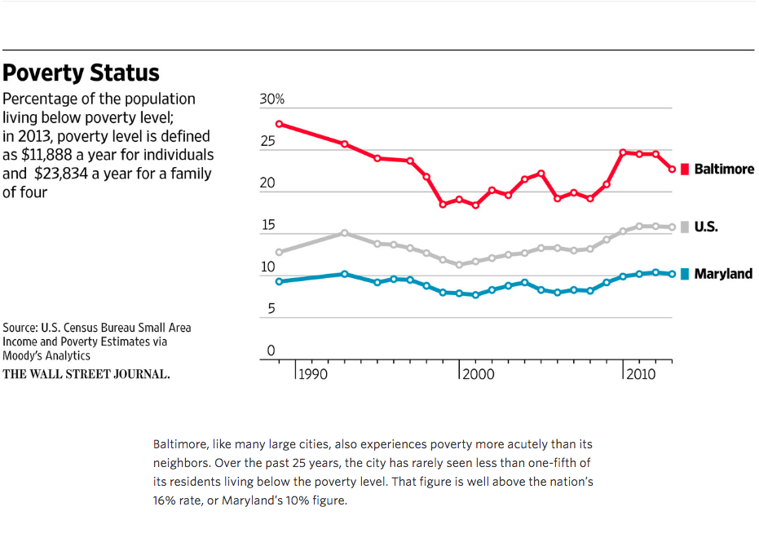

Figure 1

Yiep, Randy. Poverty Status. 2015, Baltimore’s Demographic Divide. The Wallstreet
Journal, http://graphics.wsj.com/baltimore-demographics/
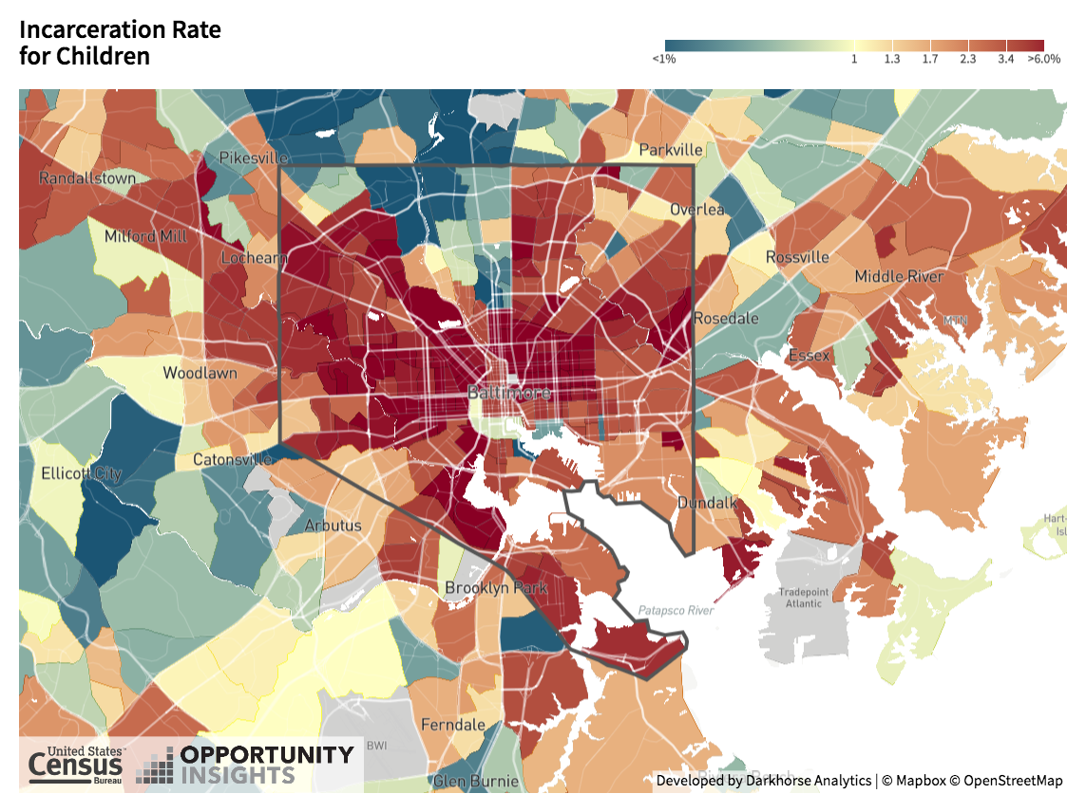

Figure 2

Chetty, Raj, et al. Incarceration Rate for Children. 2018, Opportunity Atlas: Mapping the
Childhood Roots of Social Mobility. Opportunity Insights, https://www.opportunityatlas.org/.

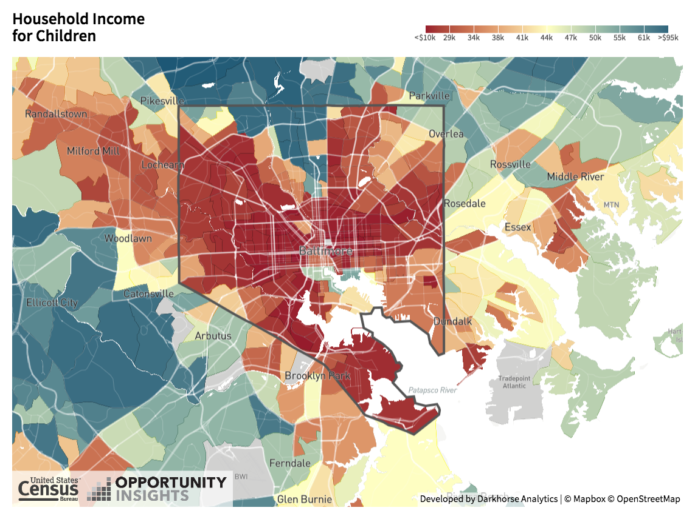

Figure 3

Chetty, Raj, et al. Household Income for Children. 2018, Opportunity Atlas: Mapping the
Childhood Roots of Social Mobility. Opportunity Insights, https://www.opportunityatlas.org/.

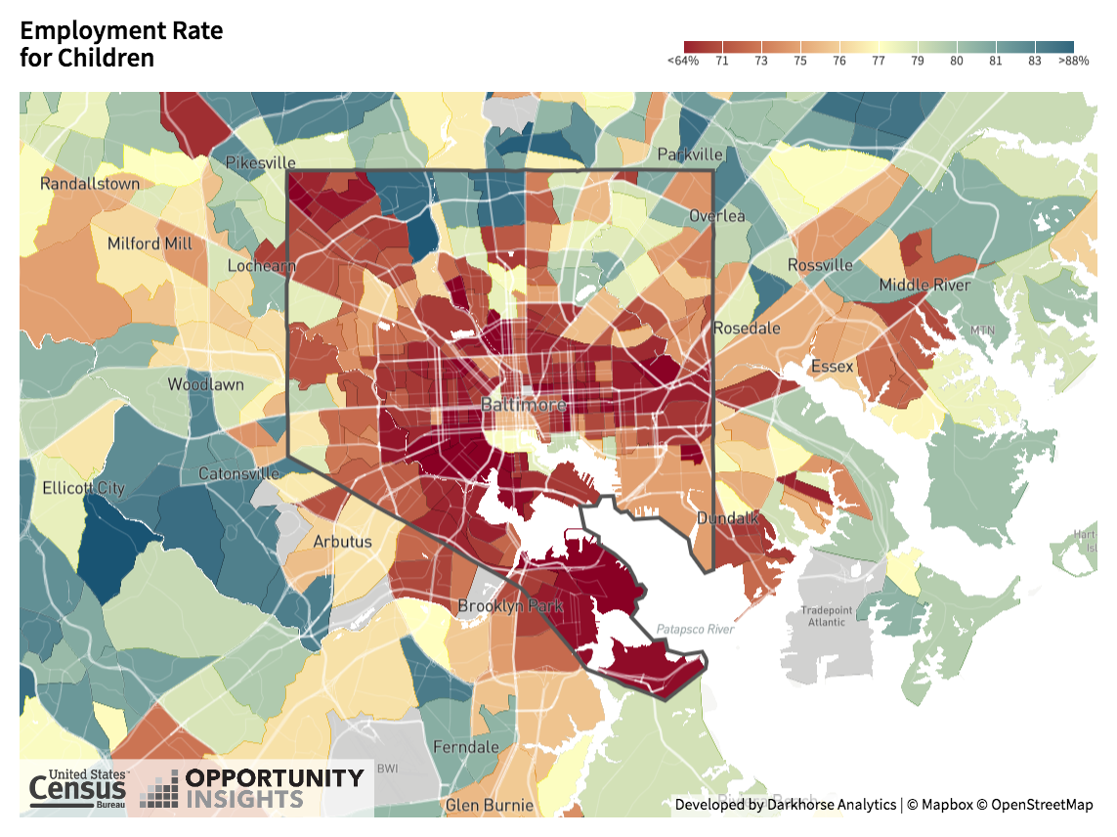

Figure 4

Chetty, Raj, et al. Employment Rate for Children. 2018, Opportunity Atlas: Mapping the
Childhood Roots of Social Mobility. Opportunity Insights, https://www.opportunityatlas.org/.

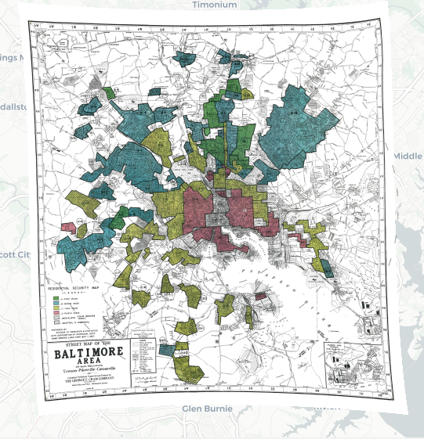

Figure 5

Nelson, Robert K., et al. Mapping Inequality: Redlining in New Deal America. Baltimore,
Maryland. American Panorama, https://dsl.richmond.edu/panorama/redlining/#lo c=11/39.2971/-76.6111&opacity=0.8&city=baltimore-md.

Appendix

G O U C H E R C O L L E G E

IRB CONSENT FORM

[To be used with adult participants who can give consent. Those doing research with children, use the parent-consent and child-assent forms on the website.]

____________________________________________________________

Title of Study: “Discourse of Faith and Power: TAT, a Case Study”

For questions regarding the research project, please contact:

Researcher(s): Isabella Cronin Favazza

Supervisor: Jennifer Bess, Ann Duncan, Irline Francois

For questions regarding your rights as a research subject, please contact:

IRB Contact: Provost’s Office
410-337-6044

____________________________________________________________

Description

From a religiously oriented environment TAT (TAT) combats problems within the public sphere, specifically mass incarceration and unemployment. While TAT accepts members of all faiths and is not connected to a specific religion, it uses “spiritual vitamins” and weekly prayer to motivate participants. Furthermore, the movement resembles that of a 12-step program and asks it participants to forgive themselves. I am conducting research on the religious aspects of TAT and am interested in looking at whether these specific aspects impact participants, positively, negatively, or neutrally.

Your participation is voluntary, and you may terminate interviews at any time. In order for an interview to take place, you must read, approve and sign this consent form. Interviews will take place at Zion Baptist Church or another public location. They will take 15-40 minutes, depending on your interest in the topic. I may ask for follow-up interviews, and you can choose to participate again or to refuse. All research will be turned over to TAT at the end of the semester. Final documents (without your names) will be maintained over time so that we can understand trends related to TAT participation and effectiveness, as well as local trends related to living-wage jobs.

Risks

The risks related to this study are minimal. If you are asked questions that you’re not comfortable answering, you are welcome to skip the question or stop the interview. Risks regarding confidentiality are also minimal. Names will be deleted from notes, and you’ll be referred to only via data or a pseudonym in written documents.

Payments

No payments will be provided for participating in this study.

Confidentiality

Confidentiality will be maintained throughout this study. A voice recorder may be used to record interviews, but recordings will be saved in password-protected files. Transcriptions and written documents will not include your names. At the end of the semester (December), all recordings will be deleted. Information will be kept in password-protected files and will not contain your names. Final written documents will not contain your names.

Right to Withdraw

Your participation is completely voluntary. You have the right to take a break, skip questions, or terminate interviews at any time with no consequences. Please only answer questions and participate to the extent you feel comfortable.

Voluntary Consent

[The following statement of consent must be included]

1. I have read the information above and freely volunteer to participate in this research project.
2. I understand that all aspects of this project will be carried out in the strictest of confidence and in a manner in which my rights as a human subject are protected.
3. I have been informed in advance as to what my task(s) will be and what procedures will be
followed.
4. I have been given the opportunity to ask questions, and have had my questions answered to my satisfaction.
5. I am aware that I have the right to withdraw consent and discontinue participation at any time, without prejudice.
6. If I decide not to participate in this research project my performance and/or grade in any
course associated with this research project will not be affected.
7. I understand that I must be at least 18 years old to participate in this project, or have a “Parental Consent Form for Research Participation” on file with the Provost’s Office with my parent’s or guardian’s signature. I also understand that I must present a copy of this form to the researcher prior to consenting to this study.
8. My signature below may be taken as affirmation of all the above, prior to participation.

I confirm that I am at least 18 years old: yes no

For Goucher students under the age of 18: I have a form on file with the Provost’s Office with parent/guardian approval that permits me to choose to consent to participate in research. I am giving a copy of this form to the researcher now.

yes no

[Note to researchers doing research on children: please use parent-consent and child-assent forms on the IRB website, in place of this consent form.]

Printed Name: ________________________________________________________

Signature: ____________________________________________________________

Date _____________

Interview Questions:

- Could you please read the following out loud?

Higher Purpose
Your misery is your ministry.
Your pain is your
purpose.
Your suffering is your service
Your Mess becomes Your
Message.
Your test becomes your
testimony.
God allows us to hurt to heal
others, because you cannot heal
what you cannot feel.
So, don’t let the pain of your
past punish your present and
paralyze your progress and purpose.

Based on Philippians 3:13-14

- What does this mean to you?

- Would you consider yourself to be religious, spiritual, or faithful?
  - What does this look like (e.g. church, prayer, wearing religious jewelry)
  - Do you remember a specific turning point in your life that guided you toward wanting a more religious/spiritual lifestyle?

- How do you feel about the faith-based traits of TAT (e.g. Spiritual Vitamins, prayer)? Does this make you want to attend more, less, or does it have no impact?

- How do you feel about TAT being held in a church? Does this make you want to attend more, less, or does it have no impact?

- Other than the potential to find steady work, are there other reasons why you actively participate and attend TAT (TAT)? If so, what are they?

- Do you feel the movement accomplishes its mission to heal the spirit, mind, and body? Why or why not?

- Are you satisfied with how TAT is run? Why or why not?

Demographic Questions
- How did you hear about TAT?

- What is your zip code?

- What does your housing situation look like?

- What year were you born?

- How do you identify racially?

- What is your ethnicity?

- What is your gender identity?

The following are my questions for TAT staff who agree to be interviewed:

- Can you tell me a little bit about the history of this movement?

- When did you become involved with TAT (TAT)?

- What is your role at TAT? How do you prepare for each session?

- How have you noticed the movement has changed and grown since its conception?

- What is your favorite part about being involved in TAT?

- What were you responsible for bringing to the TAT curriculum(e.g. Spiritual vitamins, story telling, role plays, etc.)? If so, why did you think these traits were necessary? And has the role of these traits lived up to your expectations?

- What has been your experience of TAT’s inclusion of spirituality in its healing practices? From your perspective, how do the participants generally react to this?

Works Cited
“About BUILD.” BUILD Baltimore, 2019, https://www.buildiaf.org/about-build/.
Chetty, Raj, et al. Opportunity Atlas: Mapping the Childhood Roots of Social Mobility. 2018, [Interactive map of Baltimore, Maryland]. Opportunity Insights, https://www.opportunityatlas.org/.
Christens, Brian D, and Paul W Speer. “Community Organizing: Practice, Research, and Policy Implications.” Social Issues and Policy Review, vol. 9, no. 1, 2015, pp. 193–222, doi:10.1111/sipr.12014.
Clear, Todd R. Imprisoning Communities: How Mass Incarceration Makes Disadvantaged Neighborhoods Worse. Oxford University Press, 2007.
Constable, Pamela. “Bank Answers BUILD with $2 Million Offer.” The Sun (1837- 1993), Jul 10 1981, p. 1.
Consumer Financial Protection Bureau. Mortgage data (HMDA). Available at:
https://www.consumerfinance.gov/data-research/hmda/.
“Faculty: James H. Cone (1928 – 2018).” Union. Union Theological Seminary, 2019, https://utsnyc.edu/faculty/james-h-cone/.
Finney, Cheryl. Personal Interview. 20 February 2019.
Freire, Paulo. Pedagogy of the Oppressed. New rev. 20th-Anniversary ed., Continuum, 1993.
Fulton, Brad, and Richard L Wood. “Interfaith Community Organizing Emerging Theological and Organizational Challenges.” International Journal of Public Theology, vol. 6, no. 4, 2012, pp. 398–420, doi:10.1163/15697320-12341252.
Galtung, Johan. “Violence, Peace, and Peace Research.” Journal of Peace Research, vol. 6, no. 3, 1969, pp. 167–191.
Gecan, Michael. Going Public : An Organizer's Guide to Citizen Action. 1st Anchor Books ed., Anchor Books, 2004.
Gil, David G. “Understanding and Overcoming Social-Structural Violence.” Contemporary Justice Review 2.1 (1999): 23-35.
“Greenmount East: Workforce and Economic Development.” Baltimore Neighborhood Indicators Alliance. The Jacob France Institute, 2018, https://bniajfi.org/ community/Greenmount%20East/.
Gutiérrez, Gustavo. A Theology of Liberation: History, Politics, and Salvation. Trans.
Caridad Inda and John Eagleson. Maryknoll, NY: Orbis, 1973.
Jones, Jeffrey M. “U.S. Church Membership Down Sharply in Past Two Decades.”
Politics, 18 Apr. 2019. Gallup. https://news.gallup.com/poll/248837/church-
membership-down-sharply-past-two-decades.aspx.
Jones, Robert P., Daniel Cox, Betsy Cooper, and Rachel Lienesch. “Exodus: Why American Are Leaving Religion – and Why They’re Unlikely to Come Back.” PPRI. 2016.
LoLordo, Ann. “Nehemiah Project Donors Celebrate Successful Start New Homes for Poor in West Baltimore.” The Sun, Jun 26 1992, p. 1E.
MacGillis, Alec. “The Tragedy of Baltimore.” The New York Times Magazine, The New York Times Company, 12 Mar. 2019.
McDougall, Harold A. Black Baltimore: A New Theory of Community. Temple University Press, 1993.
“Members.” BUILD Baltimore, 2019, https://www.buildiaf.org/members/.
Miles, Bishop Douglas. “Baltimoreans United in Leadership Development/BUILD.” Religion and City Conference, 6 April 2019. Center for the Study of Religion and the City. Baltimore, Maryland. Conference.
Nelson, Robert K. et al. Mapping Inequality: Redlining in New Deal America. [Interactive map of Baltimore, Maryland from 1930 through 1940, demonstrating redlined areas of the city]. American Panorama. https://dsl.richmond.edu/panora ma/redlining/#lo c=11/39.2971/-76.6111&opacity=0.8&city=baltimore-md.
Nicolaides, Becky M. and Andrew Wiese. The Suburb Reader. Routledge, 2006, pp. 322- 337.
“‘Nones’ on the Rise.” Pew Research Center's Religion & Public Life Project, Pew Research Center, 5 Aug. 2013.
Pietila, Antero. Not in My Neighborhood: How Bigotry Shaped a Great American City. Ivan R. Dee, 2010.
Power, Garrett. “Apartheid Baltimore Style: the Residential Segregation Ordinances of 1910-1913.” Maryland Law Review, vol. 42, no. 2, 1983, https://digitalcommons. law.umaryland.edu/cgi/viewcontent.cgi?article=2498&context=mlr.
Prentice, Marshall. Personal Interview. 19 February. 2019
Putnam, Robert D., Lewis M. Feldstein, and Don Cohen. Better Together: Restoring the American Community. New York, NY: Simon & Schuster, 2004.
“Quick Facts: Baltimore city, Maryland.” U.S. Department of Commerce (1 July 2018). Available from: https://www.census.gov/quickfacts/fact/table/baltimorecitymaryl
and/PST045218.
Roberts, Dorothy E. “The Social and Moral Cost of Mass Incarceration in African American Communities.” Stanford Law Review, vol. 56, no. 5, April 2004, pp. 1271-1306. HeinOnline, https://heinonline.org/HOL/P?h=hein.journals/stflr56&i= 1288.
“75 from BUILD Hold Provident ‘Bank-in’.” The Sun (1837-1993), May 29 1981, p. 1. ProQuest. Web. 15 Apr. 2019.
The Democratic Promise: Saul Alinsky and His Legacy. Dir. Bruce Orenstein and Bob Hercules. Prod. Bob Hercules and Bruce Orenstein. Berkeley Media, 1999. Academic Video Online: Premium Database.
“TAT.” BUILD Baltimore, 2019, www.buildiaf.org/turnaround-tuesday/.
United States Department of Labor: Bureau of Labor Statistics. Labor force characteristics: Discouraged workers. Available at: https://www.bls.gov/ cps/lfcharacteristics.htm#discouraged.
Warren, Mark R. “Community Building and Political Power.” American Behavioral Scientist, vol. 42, no. 1, 1998.
Weingroff, Richard F. “Federal Highway Act of 1956: Creating the Interstate System.” Public Roads (Summer 1996). Available from: https://www.fhwa.dot.gov/
publications/publicroads/96summer/p96su10.cfm.
West, Cornel. Prophesy Deliverance!: An Afro-American Revolutionary Christianity. 1st ed., Westminster Press, 1982.
Williams, Terrell. Personal Interview. 27 February 2019.
Wilson, Melvin. Personal Interview. 21 February 2019.
Works Referenced
Cone, James H. “Theology's Great Sin: Silence in the Face of White Supremacy.” Black
Theology, vol. 2, no. 2, 2004, pp. 139–152, doi:10.1558/blth.2.2.139.36027.
Douglas, Kelly Brown. Stand Your Ground: Black Bodies and the Justice of God. Orbis
Books, 2015.
Hopkins, Dwight N. Down, Up, and Over : Slave Religion and Black Theology. Fortress Press, 2000.
Meehan, Sarah. "Baltimore among most Gentrified; Seven U.S. Cities Accounted for nearly Half of U.S. Places that had Displacement." The Baltimore Sun, Mar 20 2019, ProQuest. Web. 12 May 2019 .
Mintz, Steven. Moralists and Modernizers : America's Pre-Civil War Reformers. Johns Hopkins University Press, 1995.
Raboteau, Albert J. Slave Religion : The "Invisible Institution" in the Antebellum South. Updated ed., Oxford University Press, 2004.
Tocqueville, Alexis de, and Arthur Goldhammer. Democracy in America. Library of America, 2004.

Throughout history, religious institutions have served as a support system, providing community care and material needs and services to individuals. For more information on this history, I recommend reading the following sources: Mintz, Steven. Moralists and Modernizers : America's Pre-Civil War Reformers. Johns Hopkins University Press, 1995. Raboteau, Albert J. Slave Religion : The "Invisible Institution" in the Antebellum South. Updated ed., Oxford University Press, 2004. Tocqueville, Alexis de, and Arthur Goldhammer. Democracy in America. Library of America, 2004.
Although TAT has two locations, research for this project was restricted to its east side location as it had more people attending weekly than the west side location.
The person who presents the spiritual vitamin changes every week; this allows it to be a bit more inclusive to other faiths and practices. In times past, the Quran, personal mantras, and Native American stories, have also been used as spiritual vitamins.
TAT does not identify as being tied to any formal religious faiths, maintaining that it has a spiritually ambiguous identity. However, it is worth noting that it is supported by primarily Christian organizations; for instance, this relationship is demonstrated by the fact that TAT is located in two churches.
Redlining and blockbusting also led to gentrification, which is a new method of urban renewal wherein deteriorated neighborhoods receive renovations and increase in value. The problem with gentrification is that while it has led to better housing and schools, this also creates an increase in rent and taxes, thereby forcing people to move who can no longer afford to live in their own neighborhood. Between 2000 and 2013, Baltimore was one of seven other US cities that accounted for nearly half of all of the gentrification in the United States. However, unlike the other cities that primarily displaced minority residents, in 2019 it was found that Baltimore’s gentrification has led to the relocation of equally white and none-white families. If interested and would like to learn more, I recommend the following article: Meehan, Sarah. "Baltimore among most Gentrified; Seven U.S. Cities Accounted for nearly Half of U.S. Places that had Displacement." The Baltimore Sun, Mar 20 2019, ProQuest. Web. 12 May 2019.
Michael Gecan, author of the book Going Public, which documents the achievements and challenges of IAF, uses the term “power groups” to describe community organizations that emphasize creating social capital in order to activate individual and collective power to effect change.
Adjusted for inflation, that’s approximately $7.29 today.
With inflation, $8.80 would be about $14.00 now.

