Supporting information
Immunomodulatory functions of human mesenchymal stromal cells are enhanced when cultured on HEP/COL multilayers supplemented with interferon‐gamma (IFN‐γ)
Mahsa Haseli^{1,d}, David A. Castilla-Casadiego^{1,2,d}, Luis Pinzon-Herrera¹, Alexander Hillsley², Katherine A. Miranda-Muñoz³, Srikanth Sivaraman³, Adrianne M. Rosales², Raj R. Rao³, and Jorge Almodovar^{1*}

¹Ralph E. Martin Department of Chemical Engineering, University of Arkansas, 3202 Bell Engineering Center, Fayetteville, AR 72701, USA
²Mcketta Department of Chemical Engineering, University of Texas at Austin, Austin, TX, 78712, USA
³Department of Biomedical Engineering, College of Engineering, University of Arkansas, Fayetteville, AR 72701, USA

^{d} M.H., and D. A. C-C. contributed equally.

*Corresponding author: Address correspondence to Jorge Almodovar, Ralph E. Martin Department of Chemical Engineering, University of Arkansas, 3202 Bell Engineering Center, Fayetteville, AR 72701, USA. Electronic mail: jlalmodo@uark.edu

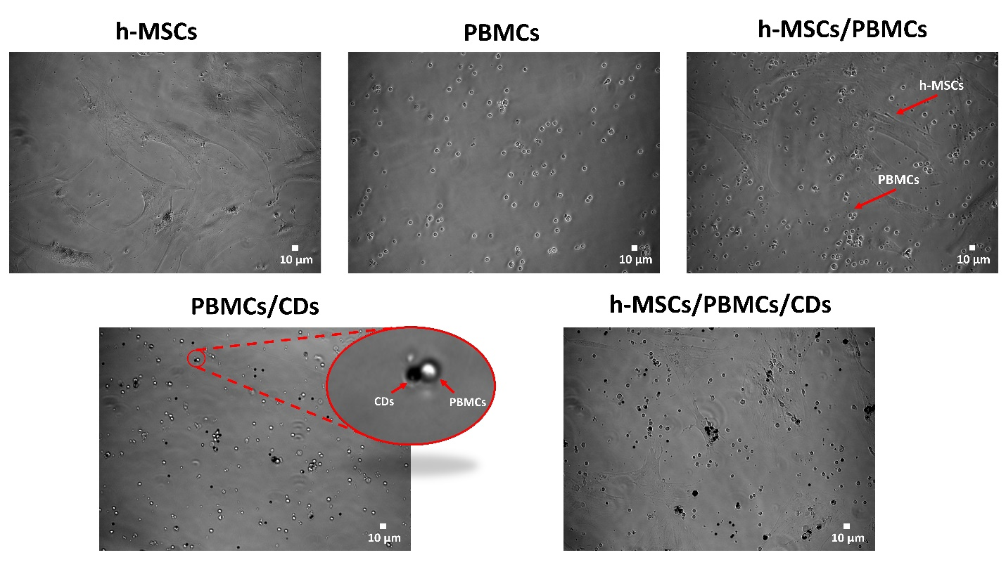
Figure S1. PBMCs with Human T Activator CD3/CD28 Dynabeads (CDs) suspended in hMSCs attached to the surfaces.

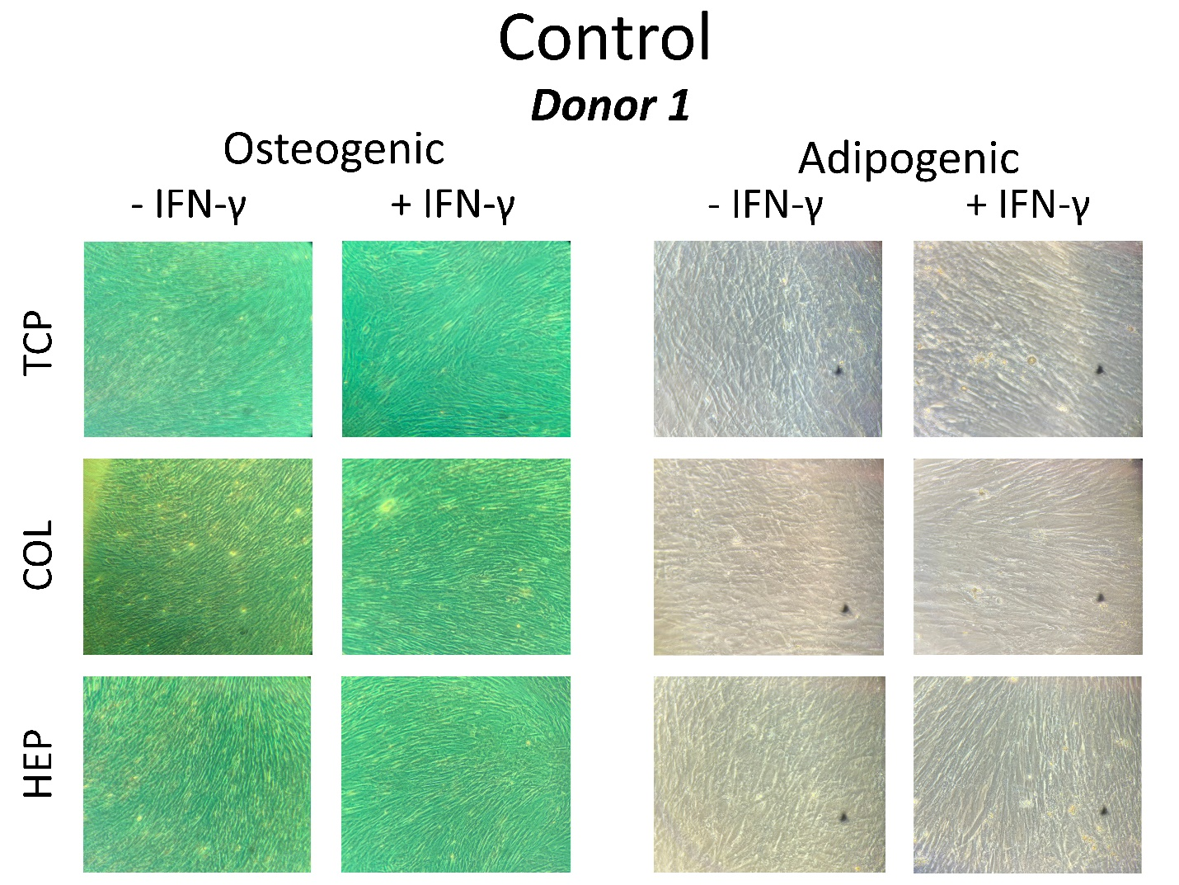
Figure S2. Alizarin Red and Oil-red O staining of hMSCs from donor#1 cells cultured on normal expansion medium.
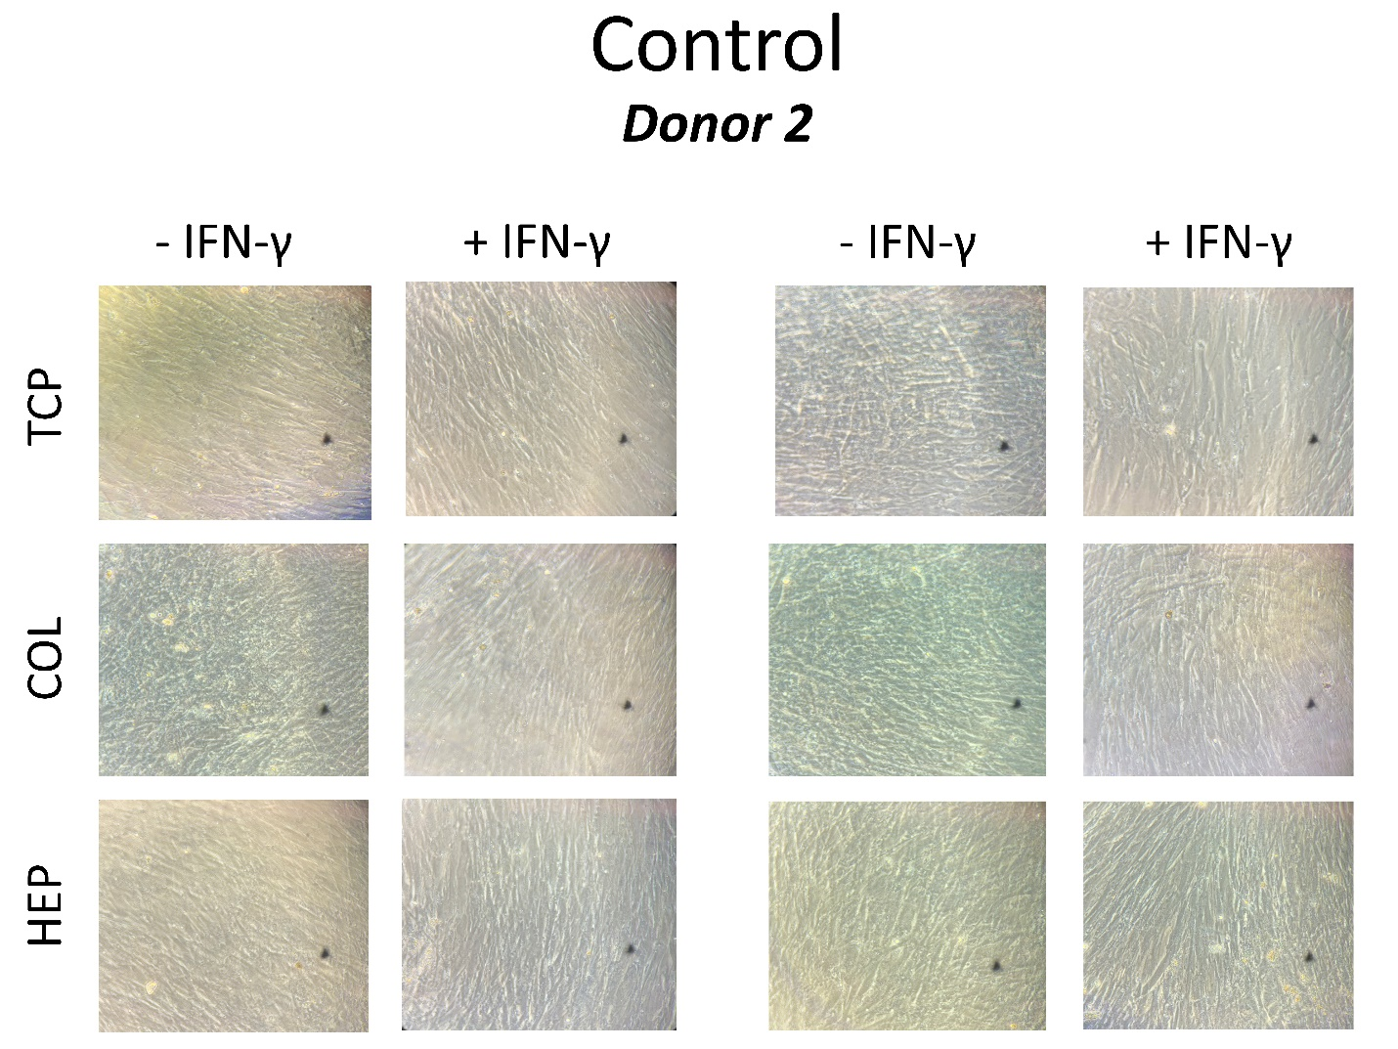
Figure S3. Alizarin Red and Oil-red O staining of hMSCs from donor#3 cells cultured on normal expansion medium.

