Influences of Vegetative Best Management Practices on Macroinvertebrate Populations in Agricultural Streams of Montgomery County, Maryland

Submitted By:
Michael G. Weyand
B.A. (West Virginia University) 2012
Independent Research Project
Submitted in partial satisfaction of the requirements
for the degree of
MASTER OF SCIENCE
in
ENVIRONMENTAL BIOLOGY
in the
GRADUATE SCHOOL
of
HOOD COLLEGE
May 2018
Accepted:

Susan L. Carney, Ph.D.
Independent Project Advisor
Director, Environmental Biology Program

April M. Boulton, Ph.D.
Dean of the Graduate School

STATEMENT OF USE AND COPYRIGHT WAIVER

I, Michael Weyand, authorize Hood College to lend this project report, or reproductions
of it, in total or in part, at the request of other institutions or
individuals for the purpose of scholarly research.

ABSTRACT
Best management practices are critical for mitigating the pernicious effects of urbanization on water quality within the Chesapeake Bay Watershed. This study examined the influences of vegetative best management practices on stream benthic macroinvertebrate populations within Montgomery County, Maryland. Databases from the Department of Environmental Protection and Maryland Department of Agricultural were analyzed and cross-referenced to evaluate vegetative practices and the condition of macroinvertebrate populations. Using ESRI ArcMap Geographic Information Systems, impervious surface area and agricultural land use were determined within six watersheds. Average BIBI health condition ranged from scores of 20 to 34 (within the fair to good range) while annual cover crop sizes ranged from 0 to 4,387 acres. Best management practices and stream benthic macroinvertebrate populations exhibited no discernable trends. In contrast, an inverse relationship between watershed imperviousness and macroinvertebrate populations was observed. Watersheds with the lowest percent imperviousness (3%) had a “good” health condition score (31 and 34) while the watershed with the highest imperviousness (24%) had a “fair” health condition score (20). Although no direct relationship was observed with cover crop acres, it is possible that vegetative practices have an indirect influence on benthic macroinvertebrate populations through conservation of natural ground cover and reduction in impervious surface.

ACKNOWLEDGEMENTS AND SPONSORSHIP
This project was supported by the Montgomery County Soil Conservation District and would not have been possible without the helpful guidance of District staff, particularly Jay Harne, Paul Meyers, and John Zawitoski. I would also like to thank Alisha Mulkey and the Maryland Department of Agriculture for providing BMP and cover crop information. Thank you to Mark Rockman and the Montgomery County Department of Environmental Protection for sharing benthic macroinvertebrate information, to Yeon Kim and Justin McCubbin for aid in impervious surface delineation, and to MSCD Board of Directors, Jeremy Criss, Meredith Strider, David Plummer, and Mike Scheffel for their continued support throughout the project. Finally, I would like thank Dr. Carney, Dr. Alavanja, and two anonymous reviewers for helpful comments on earlier versions of this project.

TABLE OF CONTENTS
List of Tables v
List of Figures vi
Introduction 1
Materials & Methods 5
Results 20
Discussion 28
References 31

LIST OF TABLES
Table 1 — BIBI health condition metric 7
Table 2 — Watershed sum of benthic averages & impervious cover 21
Table 3 — Watershed delineation with BIBI breakdown 25
Table 4 — Summary of data investigation from conservation tracker database 26

LIST OF FIGURES
Figure 1 — BIBI health condition metric 8
Figure 2 — Overlapping watershed boundary into surrounding counties 9
Figure 3 — MDE 8-digit watershed overlaying DNR12-digit sub-watersheds 10
Figure 4 — Raw impervious layer before geoprocessing 12
Figure 5 — Impervious layer after geoprocessing depicting a singular parcel 13
Figure 6 — Total impervious surface cover in Montgomery County, Maryland 14
Figure 7 — Total impervious cover overlaying County’s agricultural reserve 15
Figure 8 — Illustration of the AR-zone parameter 16
Figure 9 — Locations of monitoring stations in the County 19
Figure 10 — Linking natural ground cover and impervious surface acres 22
Figure 11 — Relationship between watershed health and impervious surface 22
Figure 12 — Short-term benthic macroinvertebrates and cover crop trends 27

LIST OF ABBREVIATIONS
AR — Montgomery County’s Agricultural Reserve
BIBI — Benthic Index of Biotic Integrity
BMP — Best Management Practices
CC — Cover Crops
FIBI — Fish Index of Biotic Integrity
GW — Grass Waterway
IBI — Index of Biotic Integrity
RFB — Riparian Forest Buffer
SCI — Stream Condition Index

INTRODUCTION
Conservation efforts to monitor Maryland’s streams and the Chesapeake Bay watershed have improved over the last 30 years through the implementation of stricter water quality regulations (Chanat et al. 2016). The use of stream-monitoring methods, like Maryland’s multi-metric Index of Biotic Integrity (IBI), offers conservation scientists an innovative method for quantifying specific anthropogenic influences on stream biota (Riseng et al. 2011, Brightbill & Frankforter, 2010). IBI identifies problematic streams and watersheds by establishing the extent to which stream biota is degraded. Once these streams and watersheds are identified, watershed restoration methods can be implemented to reverse the identified degradation and improve overall water quality (Miller et al. 2013). The successful use of IBI to improve water quality will assist in the development of more sophisticated approaches for implementing comprehensive water quality programs.
In Montgomery County, Maryland, the local Department of Environmental Protection (DEP) specifically uses an IBI-type system known as the Stream Condition Index (SCI) to monitor local stream water quality (Southerland et al. 2007). The comprehensive index integrates local stream-benthic IBI (BIBI) with fish IBI (FIBI) monitoring data to create an SCI score from 0 to 100. This SCI score is then used to rate the County’s watersheds into one of the following four health conditions: (1) “Poor”, (2) “Fair”, (3) “Good”, and (4) “Excellent”. Currently, the SCI health conditions have been applied to over 150 sub-watersheds within the county (DEP, 2017).
Although SCI has been useful for assessing waterbody health and as a tool for coordinating local watershed restoration efforts, critics of SCI note that using only aquatic organisms as an indicator of water quality may be overly simplistic when other parameters such as land use or industrial development can also have a significant impact on water body health (Arnold & Gibbons, 1996, Bernhardt & Palmer, 2007). A study by Barker et al. in 2006 indirectly addresses this criticism by analyzing the ecology of streams located in agricultural areas based on surrounding land use. This study quantified and compared landscape characteristics with Maryland IBI data using multiple linear regressions (MLR) and ANOVA models. BIBI scores in the Piedmont region streams were significantly higher in areas where the surrounding land use encompassed greater amounts of forest buffers. FIBI was shown to be predominantly controlled by flow conditions with land use cover, suggesting an indirect effect on FIBI in Piedmont region streams. This study demonstrated that landscape cover significantly impacts BIBI scores and that the use of SCI data sets in agriculture Piedmont regions can be used to accurately assess water body health.
An earlier study by Moore & Palmer (2005) examined the effects of urbanization of agricultural land in Montgomery County on waterbody health. In this study, the importance of agricultural conservation strategies was evaluated based on survey taxa richness in head waters of 29 streams within the county. The macroinvertebrate richness was strongly correlated with surrounding land usage. Streams in agricultural areas had significantly higher macroinvertebrate diversity than streams located in urbanized sectors. It was proposed that vegetative Best Management Practices (BMPs) are likely driving higher macroinvertebrate diversity in these agricultural streams. However, empirical data pertaining to the influences of vegetative BMPs on stream taxa richness were not included in the analysis. The authors suggest that future research should include existing BMP data for a more comprehensive understanding of watershed health. The amount of impervious surface within a watershed is also known to have a significant effect on stream health (Arnold & Gibbons, 1996) and is often a result of urbanization.

Montgomery County farmers install BMPs to reduce nutrient losses, prevent soil erosion, and protect water quality. The three vegetative BMP groups selected for this study were: grassed waterway (GW), cover crops (CC), and riparian forest buffer (RFB). Designed specifically to emulate natural drainage and prevent gully erosion, grassed waterways are bowl shaped swales functioning as vegetative filters that alleviate nutrient runoff on County agricultural land. Likewise, cover crops tie up residual nutrients, prevent sediment runoff, and improve soil health. In Montgomery County, cover crops are cereal grains such as rye, barley, and wheat planted in the fall following the summer harvest. Riparian forest buffers improve stream health by intercepting surface water runoff as well as prevent sediment and other contaminates from entering waterways.
The purpose of this study was to examine the scale to which land use in agricultural areas influences stream macroinvertebrate populations. The selected vegetative BMPs are known to effectively mitigate pollution by altering land use (NRCS 2017), although current circumstances have called into question the cost effectiveness of these practices (Fleming, 2017). For these reasons, the selected BMPs are not only relevant but could be reasonably thought to influence stream BIBI conditions.
Regulations such as Municipal Separate Storm Sewer System (MS4), Total Maximum Daily Loads (TMDL), and Watershed Implementation Plans (WIP) set water quality targets for local municipalities like Montgomery County (Allmendinger et al. 2007). The implementation of BMPs is the primary means by which the County’s agriculture sector achieves these water quality targets before their regulated deadlines (Lichtenberg et al. 2010). Several cost-share programs have been utilized by private landowners to alleviate the financial burden of constructing BMPs. This in turn greatly helps the County with achieving their water quality targets. However, recent budgetary reductions to Federal and State cost-share programs have forced landowners to search for alternative BMP funding sources (Fleming, 2017). For this reason, Montgomery’s local BMP cost-share assistance program, known as the Water Quality Protection Charge (WQPC), is under mounting pressure to fill the cost-share assistance void left by the reduction of Federal and State programs. Montgomery’s need to meet 60% of Chesapeake Bay TMDL, MS4, and WIP water quality targets by 2018 (Provolo et al. 2016) is increasing the demand for agricultural BMPs. The funding cutbacks of Federal and State cost-share programs along with this fast approaching deadline for environmental compliance will compel Montgomery County to identify more cost-effective BMPs for its limited WQPC program funds.
This research project evaluates watershed health by analyzing local agricultural stream BIBI data which are then compared to existing quantitative BMPs data for six defined watersheds within Montgomery County, Maryland. An estimate of total impervious surfaces within each watershed is also included for comparison. This research sought to better understand the influences of BMPs by examining an existing data set of local vegetative practices along with agricultural stream BIBI scores. This observational study is intended to provide insight into the importance of vegetative BMPs for maintaining high water quality within County agricultural streams and to further the scientific understanding of previous research investigating BMPs influences on stream biodiversity.

MATERIALS & METHODS
Gaining access to locational and quantitative information for vegetative Best Management Practices (BMPs) was accomplished by contacting Maryland Department of Agriculture. The department oversees an asset management system called Conservation Tracker. This system has compiled BMP implementation records dating back to the late 1980s for Montgomery County, Maryland.
The Conservation Tracker database provided detailed accounting for all vegetative cost-shared BMP practices established in Montgomery County. Information in this program is generated in accordance with Federal environmental and Maryland Department of Agriculture (National Research Council, 2011) regulatory standards, which requires detailed documentation of all Federal and State cost-shared BMPs implemented in the Chesapeake Bay Program Watershed Model. This data set is extremely precise due to the strict quality control measures used to ensure the validity of information entering the Bay Watershed Model.
A limitation of the Conservation Tracker program is the lack of information on non-cost-shared or farmer-implemented BMPs (MDA 2012). Thus, Montgomery Soil Conservation District was contacted to obtain data on what is known as Functional Equivalent BMPs. These Functional Equivalent BMPs meet all the standards of cost-shared practices and are tracked by the Soil District to obtain further credits for nutrient reducing BMPs in the Chesapeake Bay Model. This avenue of data exploration has ensured high degree of confidence in capturing the majority of existing vegetative BMPs for Montgomery County. The vegetative BMP information collected was further reviewed by the Soil District for erroneous outliers that resulted from human error which lead to incorrect entries into Conservation Tracker.
An additional constraint of the BMP data collected from Maryland Department of Agriculture was the scale at which the information was presented. Non-employees of the Department are limited to BMP information at the 8-digit watershed scale and denied access to BMP data recorded at the 12-digit sub-watershed scale. Consequently, direct statistical connections with BIBI scores recorded at the 12-digit sub-watershed scale were not possible and therefore restricted this study to make observations at the less precise 8-digit watershed scale. To account for this limitation, BMP information was pooled into three conservative groups and averaged across each of the study’s eight established watersheds.
The selected vegetative BMPs (cover crops, grassed waterways, and riparian forest buffer) were assessed at the 8-digit watershed scale with the total applied practice amount being assessed in unit acres. Historical cover crop data are also represented and partitioned out within the appropriate watersheds.
Stream health was quantified by using Stream Condition Index (SCI) data collected by the Montgomery County Department of Environmental Protection. This information is collected using similar quality assurance protocols as the Conservation Tracker program (DEP, 2017), and as a result is highly accurate and precise. SCI methodology has been used within the County for over 14 years, has undergone stringent peer-review (Southerland et al. 2016), and uses standardized field methods to monitor fish and benthic macroinvertebrates (Roth et al. 1998). The accuracy of SCI data for tracking stream health is sustained by resurveying streams at a minimum of every five years for local stream-benthic IBI (BIBI) and fish IBI (FIBI). Previous studies have demonstrated that surrounding land use is the primary influencer on stream macroinvertebrate populations (Barker et al. 2006, Moore & Palmer 2005). Thus, stream-benthic IBI (BIBI) data described in Table 1 were isolated from SCI scores and used in this analysis as an indicator of stream health.
Table 1 BIBI health condition metrics and scoring criteria used in Montgomery County, Maryland. Eight metrics scored as a 1, 3, or 5 for a maximum score of 40.
Scoring Criteria
36-40 = Excellent
26-35 = Good
17-25 = Fair
0-17 = Poor
Metrics
Taxa Richness
Biotic Index
Ratio of Scrapers
Proportion of Hydropsyche & Cheumatopsyche
Proportion of Dominant Taxa
Total Number of EPT Taxa
Proportion of EPT Individuals
Proportion of Shredders
BMP data and BIBI scores used within this study were all located inside Montgomery County and examined at the MDE 8-digit watershed scale. ArcMap 10.3 Geographic Information Systems was used to ascertain the County’s watershed parameters. Watershed boundaries often overlap political boundaries (NAP & NRC 2009), and the same is true for Montgomery County (Figs. 1 & 2). To narrow the scope of this investigation, watersheds overlapping into nearby Frederick, Howard, and Prince George’s Counties were disassociated and separated out by using a combination of established GIS methodologies (Johnson & Zelt 2005, Goetz et al. 2003, Brabec & Smith, 2002, Bockstael 1996). This involved using geoprocessing tools that intersected both watershed and county boundaries to generate a total of eight distinct watersheds: Anacostia River, Brighton Dam, Cabin John Creek, Lower Monocacy River, Seneca Creek, Potomac River, Rock Creek, and Rocky Gorge Dam. Each of the established watersheds illustrated in Fig. 3 are represented at Maryland Department of Environment’s 8-digit watershed scale.
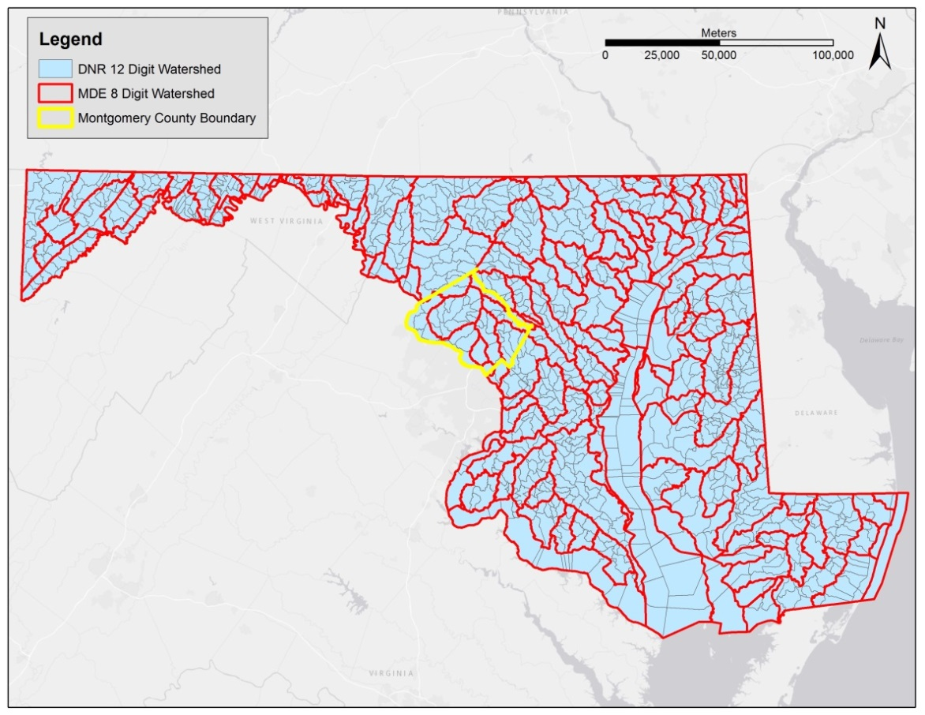
Figure 1 Illustration of all MDE 8-digit (red outline) and DNR 12-digit (light grey) watersheds in Maryland.
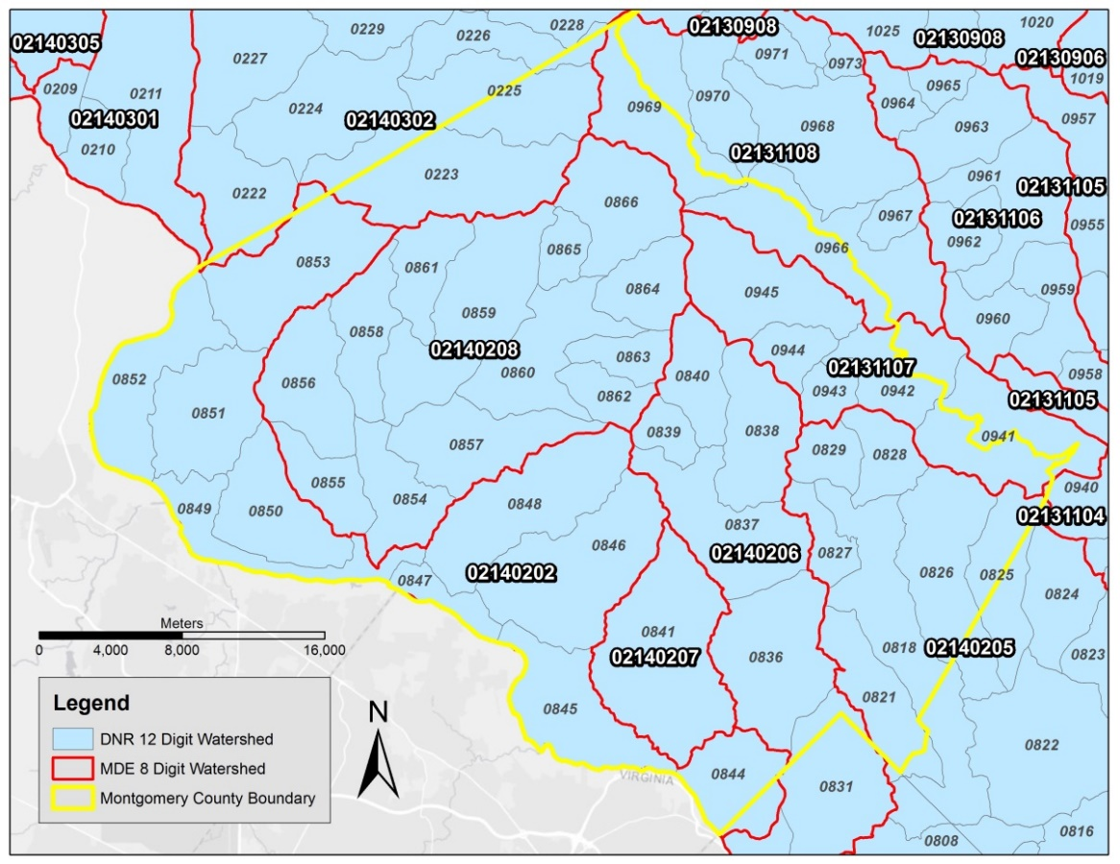
Figure 2 Watershed boundaries overlapping into the surrounding Frederick, Howard, and Prince George’s counties in Maryland.
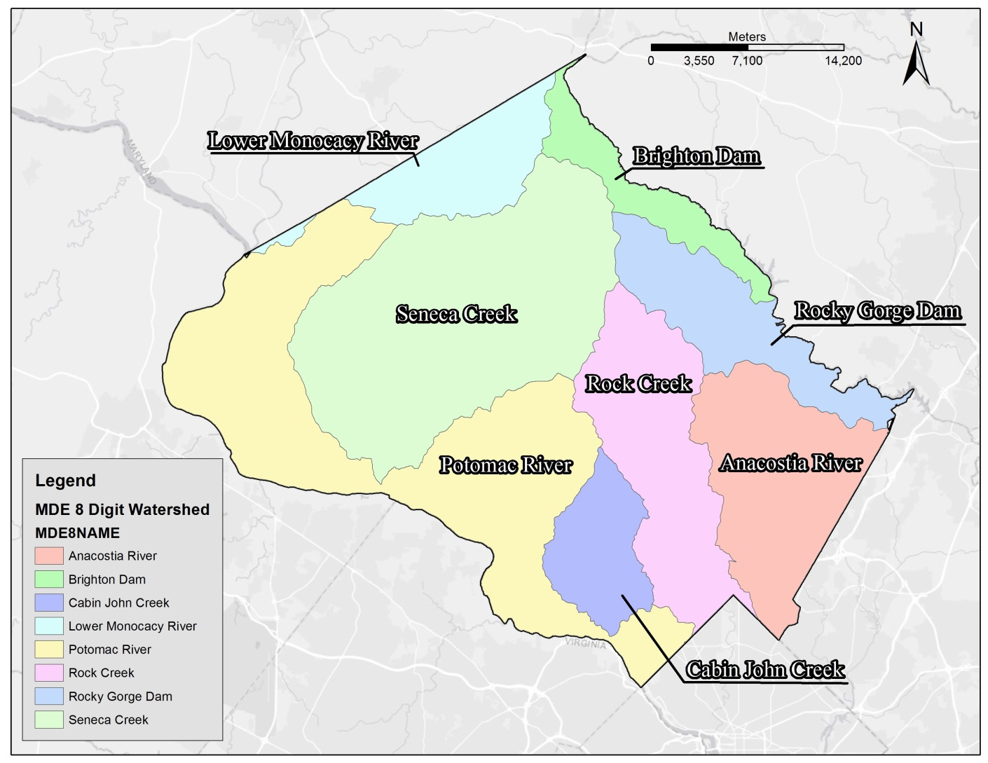
Figure 3 Montgomery County, Maryland MDE 8-digit watersheds.

Property within Montgomery County is subjected to the Water Quality Protection Charge (WQPC). The WQPC determines tax fees based on the total amount of impervious surface found on each property parcel. To determine the tax fee associated with each parcel, WQPC administrators use remote sensing techniques to generate a GIS impervious surface layer. This layer is highly scrutinized for accuracy because of its primary use to determine tax rates. The eight watersheds selected in this study are assessed based on WQPC’s impervious surface layer. The use of this layer allowed for observational adjustments that minimize the confounding effects of heterogeneous land use on stream health noted in Moore & Palmer (2005).
The study acquired impervious surface data from Montgomery’s GIS Division which allowed the study to adjust for the influence of impervious surfaces on water quality. The raw impervious data set was an itemized attribute list of every impervious parcel within Montgomery County (Fig. 4). In order to calculate the total amount of impervious surface for each watershed, the data were analyzed and condensed using ArcMap’s geoprocessing dissolve tool. This reduction is illustrated in Fig. 5 and shows the merging of all distinct parcels into one uniform impervious surface layer. To further delineate impervious surfaces within the county, the intersect geoprocessing tool was used to “cookie cut-out” the impervious surface layer for each pre-established watershed boundary (illustrated within Figs. 6 & 7). The geospatial field geometry tool was then used to transform the impervious layer shape from the default square feet into acres, thereby accurately obtaining the total amount of impervious surface within each of the established watersheds.
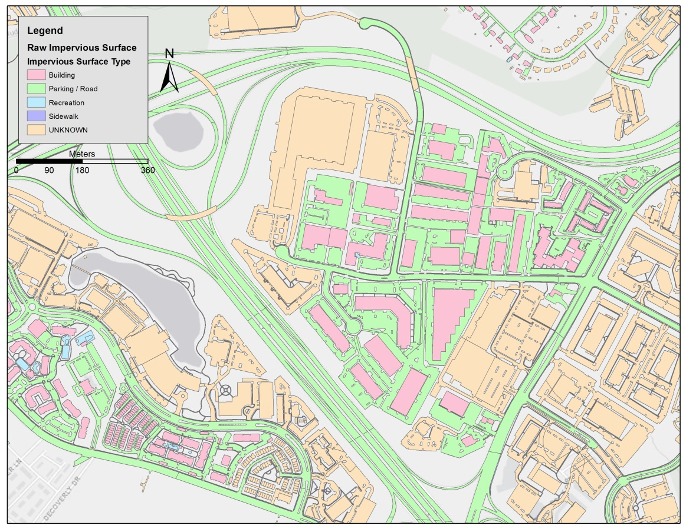
Figure 4 Raw impervious layer before geoprocessing, showing large amounts of distinctive parcels IDs within Montgomery County, Maryland.
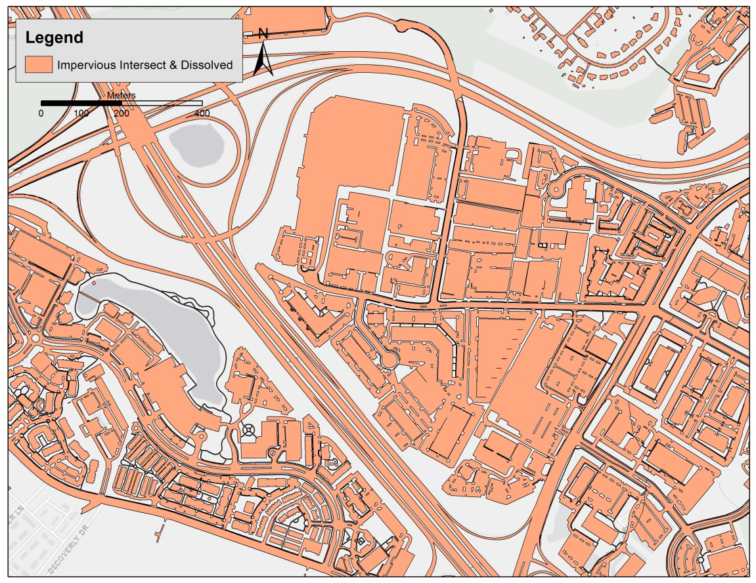
Figure 5 Uniform impervious surface layer within Montgomery County, Maryland after using the geoprocessing dissolve tool.

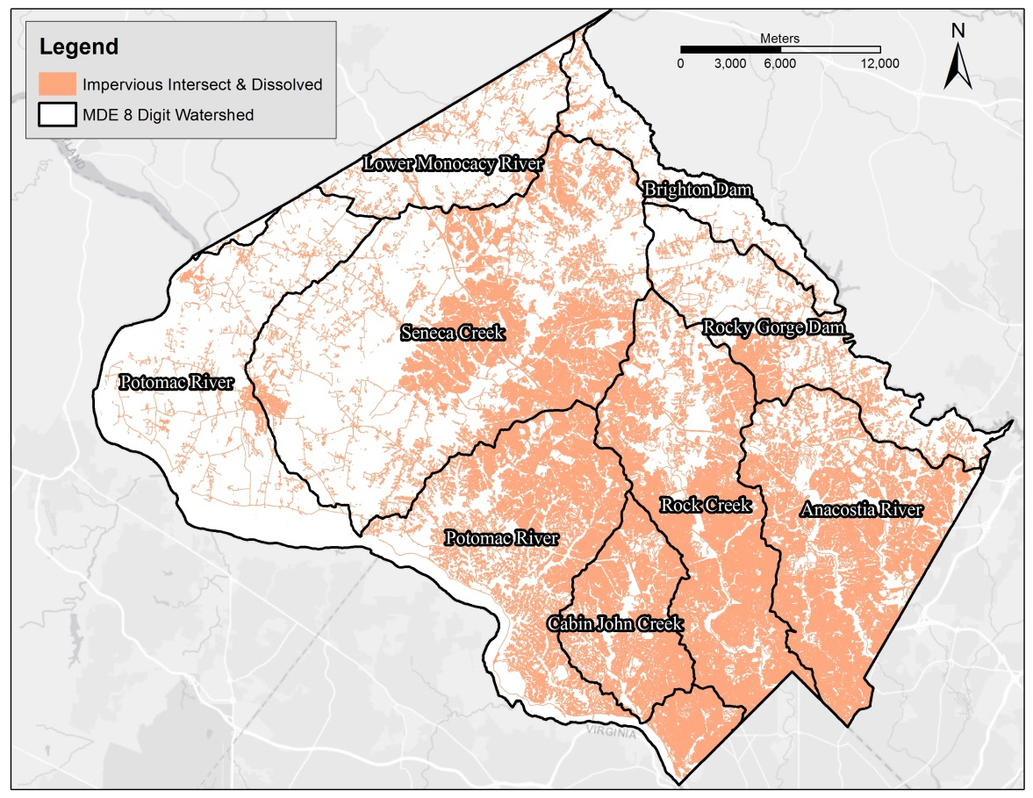
Figure 6 Total impervious cover in Montgomery County, Maryland.

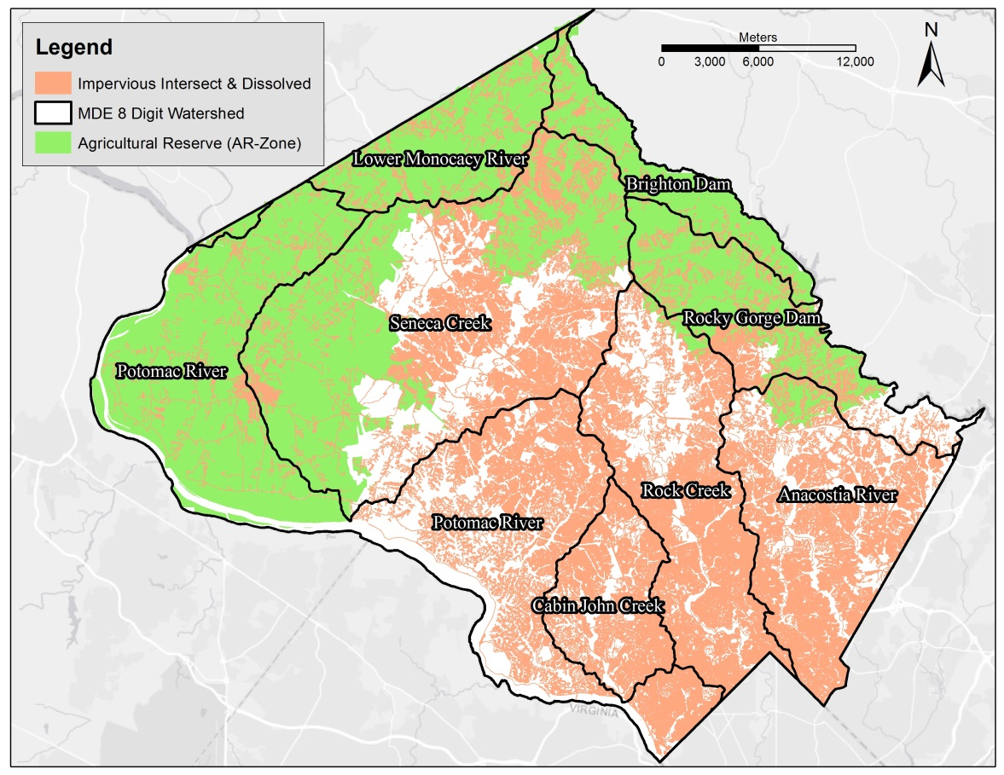
Figure 7 Total impervious surface cover overlaying the County agricultural reserve within Montgomery County, Maryland.

Watershed parameters were further defined by their location within Montgomery’s agricultural reserve (AR-zone). Property data obtained from Montgomery’s GIS Division provided the information needed for delineating the agricultural reserve watersheds. Much like the impervious surface layer, all agricultural parcels were first dissolved into a uniform layer and then intersected with MDE 8-digit watershed boundaries. By way of geoprocessing tools in ArcMap, the delineation process resulted in an accurate representation of agricultural land use within Montgomery County. The surface’s area representation of the agricultural reserve is illustrated in Fig. 8. The newly delineated AR-zone was then used as the parameter for interpolating data from both MDA’s Conservation Tracker and DEP’s SCI databases. The study was unable to obtain sufficient vegetative BMP data for both Cabin John and Anacostia watersheds and for that reason they were not included in the watershed analysis.
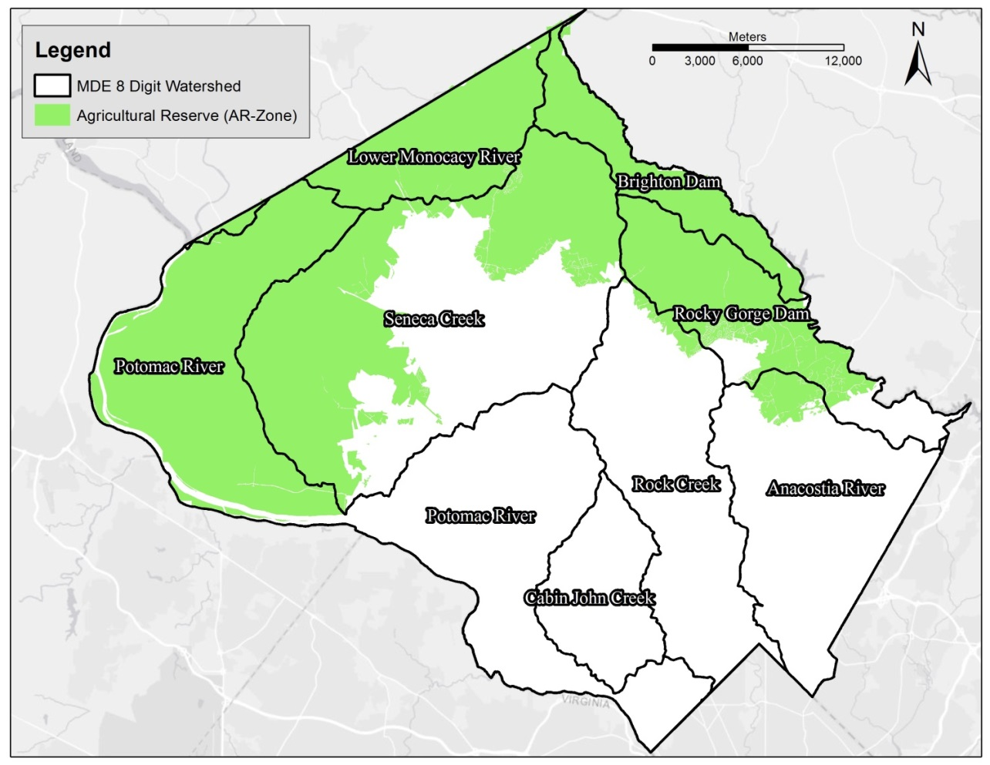
Figure 8 Illustration of the AR-zone parameter in Montgomery County used for cross referencing vegetative best management practices with derived BIBI scores.

Montgomery DEP has established approximately 1,411 water quality monitoring stations within the County (Fig. 9). Monitoring stations are not mutually exclusive and can record a diverse set of information. Each station can log yearly information in addition to numerous data categories such as: benthic macroinvertebrates IBI metrics, fish IBI metrics, herpetofauna metrics, stream habitat data, as well as physical and chemical data such as stream temperature, channel survey, and dissolved oxygen levels. The environmental characteristics present at each station are ultimately the decisive factor for determining what categories will be logged at that specific station. Therefore, benthic macroinvertebrate IBI data were not recorded at each of the 1,411 stations. Monitoring stations with no BIBI records were considered “null” stations and removed from the watershed analysis.
In order to remove “null” monitoring stations as well as account for historic macroinvertebrate scores, over 66,000 individual BIBI records were analyzed. Upon entry into DEP’s database, benthic macroinvertebrate records are linked with a 12-digit sub-watershed number. For this reason and by using ArcMap geoprocessing tool, the study categorized individual BIBI records by Montgomery’s sub-watersheds thereby pooling the information and creating a detailed chronological record of BIBI scores at each monitoring station. Further geospatial extrapolation rescaled BIBI data from the 12-digit sub-watershed to the larger 8-digit watershed extent. Pre-scaled to the 8-digit extent, the vegetative BMP data from MDA’s conservation tracker were interposed alongside BIBI records within ArcMap. However, rescaling spatial data in this manner can result in reduced accuracy due to multicollinearity and the introduction of new variables.
To combat the negative impacts of geospatial rescaling, each individual BIBI record was first temporally adjusted to represent the historic average. For example, GSGS30, a monitoring station located in the 12-digit sub-watershed “0866”, recorded eight separate survey accounts dating back to 1993, three of which were conducted within the same year. For this station, the study first averaged the three benthic survey records occurring within the same year, followed by averaging the remaining five macroinvertebrate survey records. This created the historical average of station GSGS301 and was used in unity with every other monitoring station’s historic average to generate the overall benthic record for sub-watershed “0866”. This process was repeated for all 12-digit sub-watersheds. Next, the geospatial rescaling procedure averaged together all of the 12-digit sub-watershed benthic records located within each of the larger 8-digit watershed in order to extrapolate watershed information.
The complete data extrapolation process yielded multiple comparable categories between the watersheds; average individual benthic count, BIBI health condition scores, and total number of surveys. The average individual benthic count is a measure of all the individual benthic macroinvertebrates found during a single survey. This measurement was used in place of BIBI health condition scores that were not specific enough to discern trends from historic cover crop data. BIBI health condition scores are compiled averages of the scoring criteria and metrics displayed in Table 1. The total number of surveys (shown in column 5 in Table 3) represents the amount of surveys performed in each watershed and was used to support explanations for data anomalies. All 1,411 points are not visible on Fig. 9 and a single point on the map may represent multiple surveys.
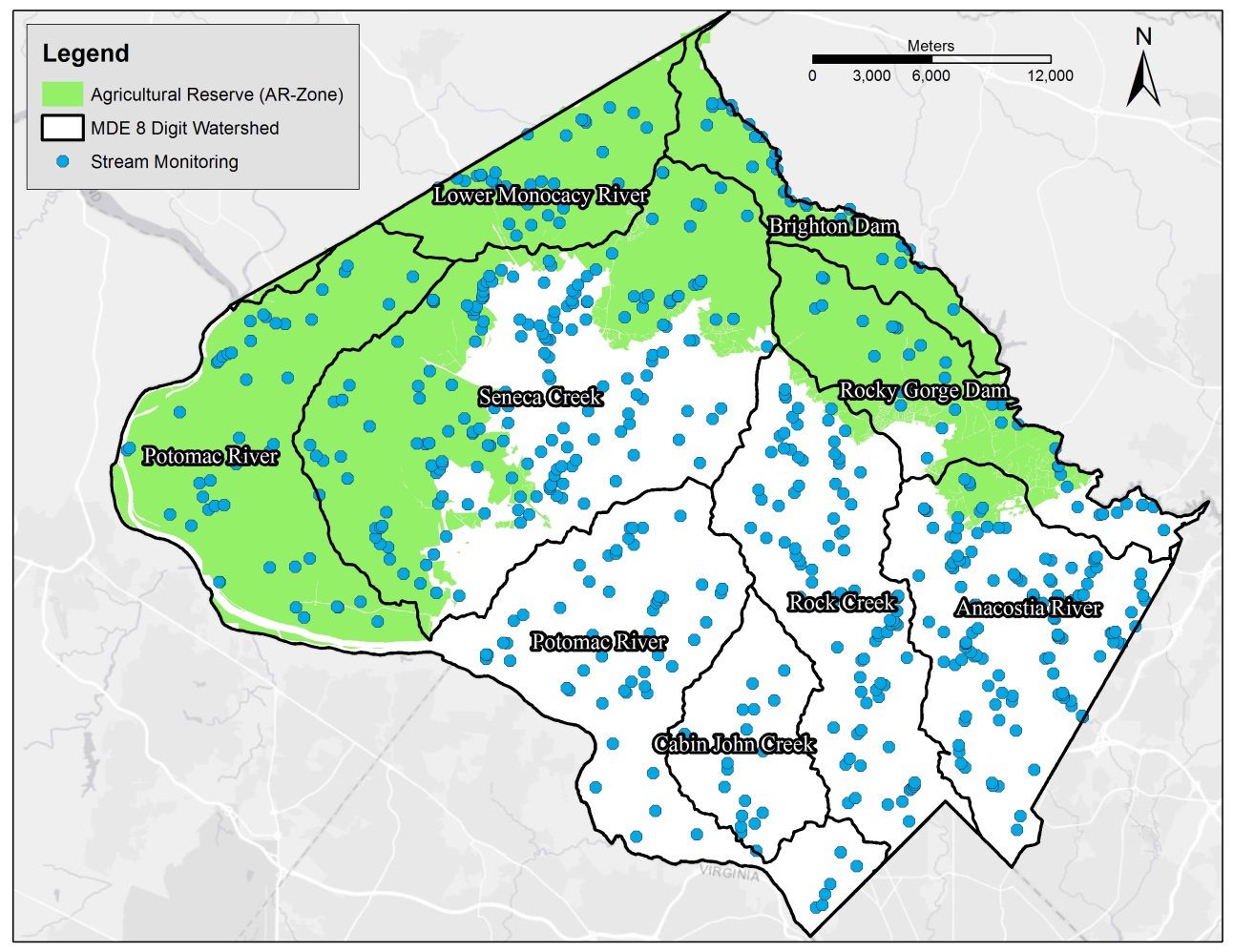
Figure 9 Locations of the sampling stations within the eight established watersheds located within Montgomery County, Maryland. Multiple surveys may be located within each point.

RESULTS
Listed in Table 1 are BIBI health condition metrics and scoring criteria used in Montgomery County. The average BIBI health condition scores ranged from “fair” to “good” with the lowest score of 20 recorded in the Rock Creek watershed. The highest recorded BIBI health condition score was 34 in the Brighton Dam watershed. No agricultural watersheds recorded a health condition score within the “poor” or “excellent” metric range. The remaining Potomac River, Rocky-Gorge Dam, Seneca Creek, and Lower Monocacy River watersheds logged scores between 24 and 31.
Average individual benthic counts were recorded at a low of 165 in the Rock Creek watershed with a high of 243 in the Lower Monocacy River watershed. The benthic count record for Brighton Dam, Potomac River, Seneca Creek and Rocky Gorge Dam watersheds ranged from 218 to 177. In this study, the individual benthic scores were not indicative of average BIBI health condition scores for all watersheds with the exception of Rock Creek and Seneca Creek watershed. For example, the Potomac River watershed had relatively high individual counts of 206 which would have been expected to result in a high health condition score. However, despite the high benthic score, the health condition score fell within the “fair” health range at 24. The low categorical scores in metrics such as taxa richness and proportion of EPT individuals are the likely cause of low BIBI health condition score in areas with high individual counts.

Table 2 Benthic averages, impervious cover, and average acres of cover crop in agricultural watersheds upstream from Montgomery County, MD, water quality monitoring stations.
Watershed Name | MDE 8-digit Watershed | Average Individual Benthic Count | Average BIBI Health Condition Score | Percent Impervious Cover | Average Annual Cover Crop Acres
Rocky Gorge Dam | 02-13-11-07 | 177 | 27 | 7 | 859
Brighton Dam | 02-13-11-08 | 218 | 34 | 3 | 1240
Potomac River | 02-14-02-02 | 206 | 24 | 10 | 4387
Rock Creek | 02-14-02-06 | 165 | 20 | 24 | —
Seneca Creek | 02-14-02-08 | 192 | 25 | 11 | 3960
Lower Monocacy River | 02-14-03-02 | 243 | 31 | 3 | 1683

Rock Creek watershed was found to have the greatest impervious surface cover at 24% while the Brighton Dam and Lower Monocacy River watersheds recorded the lowest total impervious surface cover at 3%. Rocky Gorge Dam, Potomac River, and Seneca Creek watersheds were found to have similar impervious cover. The study observed that watersheds with the highest total acres of impervious ground cover were not necessarily associated with watersheds that recorded the highest percent impervious surface. This observation was a byproduct of urbanization and total watershed size. The Potomac River watershed includes approximately 9,087 acres of impervious surface which is roughly equal to Rock Creek’s 9,038 acres of impervious surface (Fig. 10). However, watersheds’ percent imperviousness varied greatly with Potomac River watershed at 10% impervious surface and Rock Creek considerably higher at 24% impervious surface. Nearly twice the size, the Potomac River watershed is less developed than Rock Creek, a watershed extending down into the highly urbanized area of Rockville. This suggests that impervious surface as an environmental indicator is best accounted for as percent metric and not total acres of impervious surface found within a given watershed. This study also observed that watersheds having the lowest percent of impervious surface have the highest average BIBI health condition scores (Fig. 11).
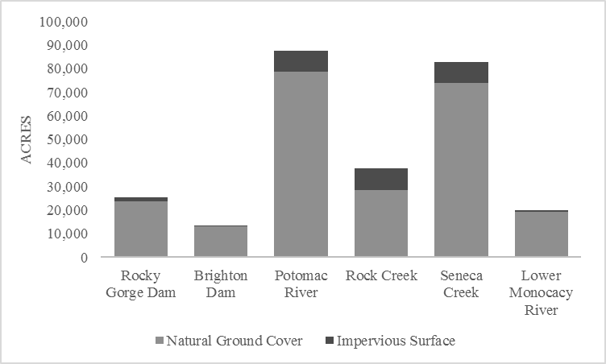
Figure 10 Stacked column chart comparing natural ground cover and impervious surface acres in watersheds of Montgomery County, Maryland.
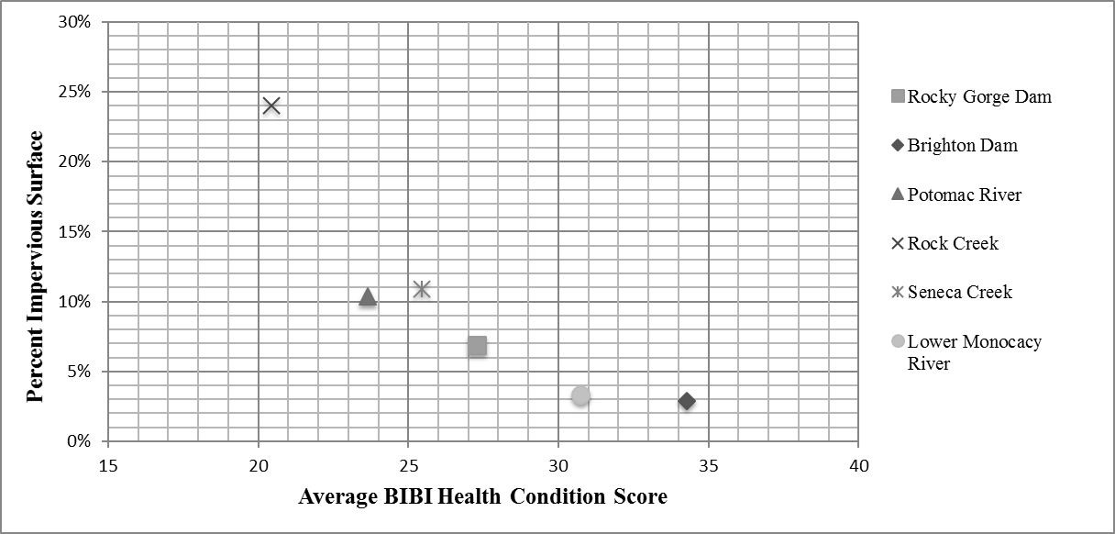
Figure 11 Relationship between watershed health and impervious surface in Montgomery County, Maryland.

The MDE 8-digit agricultural watersheds listed in Table 3 were further categorized by their DNR 12-digit sub-watershed classification in order to display the trends of BMP data and BIBI scores shown in Table 2. The largest average individual benthic count was found in the Lower Monocacy River sub-watersheds 0225 with an individual count of 412. However, this count was the result of only two surveys. In contrast, the adjacent sub-watershed, 0223, recorded an average benthic count of 167 which was derived from 121 individual surveys. Therefore, it is plausible that the overall average individual benthic count score is inflated for the Lower Monocacy River due to having been surveyed only twice.
Impervious surface and BIBI health condition data in Table 3 were consistent and further supported trends shown in Fig. 11. Notably, two sub-watersheds of Rock Creek, 0836 and 0837, recorded the lowest health scores of 12 and 13, respectively. These sub-watersheds also recorded very high impervious surface cover with 0836 at 34% and 0837 at 29%. Correspondingly, two sub-watersheds of Brighton Dam, 0966 and 0969, recorded the highest average BIBI health condition score at 34 and 35 coupled with having an impervious surface cover of 2% and 4%. Seneca Creek’s sub-watershed, 0862, was a slight outlier having a health condition score of 23 despite recording an impervious surface cover of 36%. It is possible that the limited number of surveys (nine) conducted in sub-watershed 0862 have skewed the benthic health condition scores at this location.
Listed in Table 2, both the Potomac River and Seneca Creek watersheds were found to contain the highest amount of planted cover crops annually at 4,387 and 3,960 acres. The Lower Monocacy River, Brighton Dam, and Rocky Gorge Dam recorded the smallest amount of cover crops planted. In Fig. 12, historic cover crop data from Table 4 were plotted alongside the average individual benthic count. The amount of cover crops planted each year fluctuated greatly within each watershed. Likewise, each watershed experienced oscillations in benthic counts over the five to six-year time frame. However, no discernable trends were found between the amount of cover crops planted and total count of benthic macroinvertebrates.
Results from Conservation Tracker BMP data discovery are summarized in Table 4. Grassed waterway and riparian forest buffer acres were found to be most abundant in Potomac River, Seneca Creek, and Lower Monocacy River watersheds. Less than 20 acres of vegetative BMPs were present in Rocky Gorge Dam, Brighton Dam, and Rock Creek watersheds. The total amount of grassed waterway and riparian forest buffer acres were much less than the amount of cover crops plant annually. This was likely due to the established watersheds’ large area and because the study was unable to obtain BMP data at the more precise 12-digit sub-watershed scale. The study did not find a correlation between vegetative BMP acres and BIBI health condition scores.

Table 3 Watershed delineation with BIBI breakdown from Montgomery County, Maryland.
MDE 8 digit watershed | DNR 12-Digit Sub-watershed | Average Individual Benthic Count | Average BIBI  Health Condition Score | Total Number of Surveys | Total Acres in Watershed | Impervious Surface Acres | Percent Impervious  Surface
Rocky Gorge Dam
 | 0941 | 197 | 32 | 47 | 5,237 | 340 | 7
 | 0942 | 167 | 25 | 7 | 4,568 | 299 | 7
 | 0943 | 187 | 22 | 17 | 2,415 | 459 | 19
 | 0944 | 155 | 26 | 9 | 2,880 | 292 | 10
 | 0945 | 177 | 31 | 68 | 10,475 | 376 | 4
Brighton Dam
 | 0966 | 206 | 34 | 37 | 6,708 | 132 | 2
 | 0969 | 230 | 35 | 106 | 6,892 | 256 | 4
Potomac River
 | 0844 | 183 | 11 | 29 | 5,129 | 1,467 | 29
 | 0845 | 175 | 22 | 20 | 9,205 | 1,057 | 11
 | 0846 | 176 | 21 | 219 | 14,272 | 2,990 | 21
 | 0847 | 147 | 31 | 12 | 2,479 | 45 | 2
 | 0848 | 169 | 20 | 57 | 12,526 | 2,650 | 21
 | 0849 | 267 | 31 | 10 | 5,901 | 75 | 1
 | 0850 | 232 | 24 | 17 | 8,296 | 168 | 2
 | 0851 | 202 | 28 | 33 | 9,155 | 209 | 2
 | 0852 | 250 | 27 | 142 | 9,037 | 174 | 2
 | 0853 | 263 | 22 | 68 | 11,580 | 252 | 2
Rock Creek
 | 0831 | - | - | - | - | - | -
 | 0836 | 146 | 12 | 76 | 11,703 | 3,932 | 34
 | 0837 | 108 | 13 | 79 | 10,484 | 3,025 | 29
 | 0838 | 192 | 29 | 96 | 7,995 | 1,088 | 14
 | 0839 | 196 | 18 | 13 | 2,314 | 505 | 22
 | 0840 | 182 | 30 | 82 | 5,150 | 489 | 9
Seneca Creek
 | 0854 | 189 | 28 | 18 | 5,913 | 192 | 3
 | 0855 | 217 | 24 | 20 | 4,487 | 126 | 3
 | 0856 | 293 | 28 | 22 | 7,950 | 237 | 3
 | 0857 | 175 | 22 | 98 | 8,857 | 1,194 | 13
 | 0858 | 170 | 29 | 23 | 5,773 | 124 | 2
 | 0859 | 178 | 27 | 369 | 13,730 | 2,039 | 15
 | 0860 | 160 | 20 | 58 | 9,049 | 1,918 | 21
 | 0861 | 184 | 31 | 199 | 4,801 | 150 | 3
 | 0862 | 171 | 23 | 9 | 3,045 | 1,090 | 36
 | 0863 | 130 | 12 | 10 | 3,031 | 778 | 26
 | 0864 | 236 | 29 | 14 | 4,907 | 309 | 6
 | 0865 | 197 | 32 | 26 | 2,370 | 118 | 5
 | 0866 | 204 | 26 | 33 | 8,824 | 725 | 8
Lower Monocacy River
 | 0222 | 194 | 34 | 19 | 725 | 20 | 3
 | 0223 | 167 | 32 | 121 | 12,282 | 397 | 3
 | 0225 | 421 | 26 | 2 | 6,260 | 219 | 3
 | 0226 | 189 | 31 | 21 | 824 | 37 | 4

Table 4 Summary of data investigation from Conservation Tracker database.
 | Riparian Forest Buffer  (acres) | Grass waterway  (acres)
Rocky Gorge Dam | 0 | 16.35
Brighton Dam | 6.40 | 10.37
Potomac River | 232.10 | 26.10
Rock Creek | 14.70 | 2.90
Seneca Creek | 122.90 | 22.24
Lower Monocacy River | 49.90 | 7.62
Total BMP Acres | 426 | 85.58

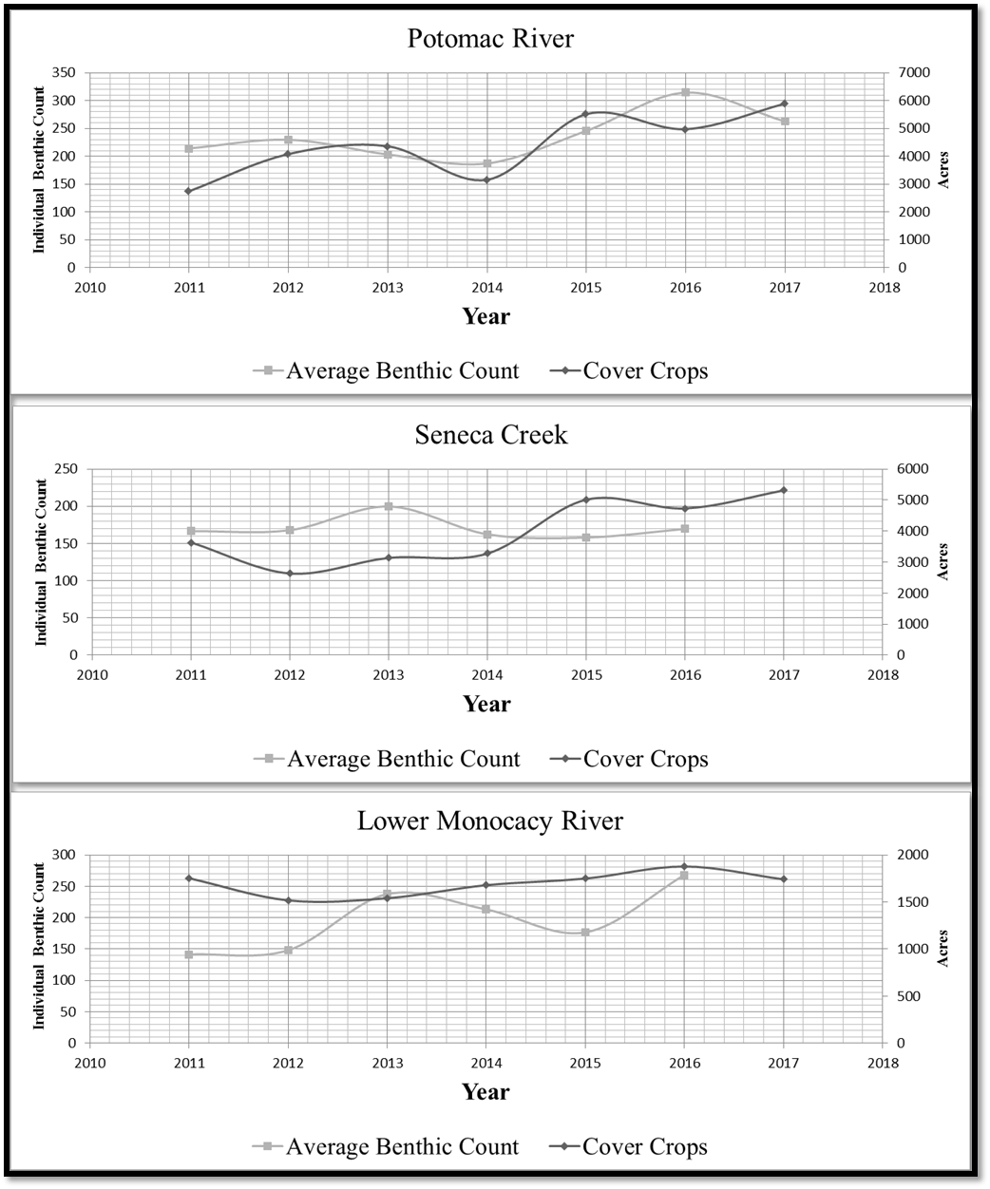
Figure 12 Short-term benthic macroinvertebrates and cover crop trends in Montgomery County, Maryland, agricultural watersheds between 2011 to 2017.
DISCUSSION
Best management practices are critical for mitigating the pernicious effects of urbanization on water quality within the Chesapeake Bay Watershed. The influences of vegetative best management practices on stream benthic macroinvertebrate populations within Montgomery County, Maryland were evaluated in this research. BMP and BIBI data from Montgomery’s GIS Division was retrieved, refined, and cross-referenced to compare the impacts of land use on agricultural watersheds. No direct relationship between vegetative BMPs on BIBI scores was observed. However, vegetative BMPs conserve natural ground cover and prevent the development of new impervious surfaces within these areas. This suggests that riparian forest buffer and grassed waterways could function indirectly to preserve water quality.
Furthermore, an inverse relationship between BIBI scores and impervious surface was observed and is consistent with a study by Moore & Palmer (2005). Benthic health scores decline rapidly as watersheds become more urbanized with higher percentages of impervious surfaces. It is clear that urbanization increases impervious surfaces which reduces natural ground cover and can lead to lower water quality. Although there was no direct correlation with vegetative BMPs and water quality, it is reasonable to speculate that agricultural land use coupled with vegetative BMPs are significant factors in preserving natural ground cover and therefore watershed health. Thus, programs supporting the preservation of agricultural lands, preserves, and open spaces are imperative to maintaining healthy watersheds (Lynch & Lovell, 2003, Brabec & Smith, 2002).
An important area of future research would be to develop smart growth strategies which better control urbanization and minimize the amount of impervious surface development that occurs during urban sprawl. Watershed managers will need to incorporate strategies that increase surface water infiltrations while reducing impervious surface area in reclamation and redevelopment projects. By limiting the amount of impervious surface and maintaining natural ground cover, the adverse effects of urban development can be mitigated. Managing local water resources in this manner will benefit both residence and the environment.
Another area of research would be to further develop water treatment methods and land use alternatives for well-established urban areas with large amount of impervious surface. Greater understanding of environmental indicators as well as effective watershed metrics will be critical for developing successful treatment methods. Consistent with findings from Barker et al. (2006), this study found that individual benthic counts are not necessarily indicative of average BIBI health condition scores. This suggests that health condition scores and individual benthic counts should not be used as interchangeable environmental indicators for gauging a watershed’s health. This observation validates the use of multi-metric Indices of Biotic Integrity when determining watershed health and furthermore supports the continuation of DEP’s data collection. It is also plausible that annual weather conditions may have contributed to the observed fluctuations in cover crop data. Similarly, unfavorable weather conditions coupled with inadequate stream bank habitat may have contributed to declines in benthic macroinvertebrates population as speculated in Hose et al. (2007). Including information on annual weather conditions and stream bank habitat when assessing the effect of cover crop and benthic macroinvertebrate counts on watershed health may help to better define the observed fluctuations.
Further investigations examining the effects of agricultural BMPs on stream benthic macroinvertebrate populations should consider using BMP information at the DNR 12-digit watershed scale. Since it is known that the process of rescaling geospatial data on a macro scale can potentially mask subtle BMP influences on water quality, the use of more localized data may help to better define local BMP impacts on stream water quality. In particular, rescaling geospatial data may help to define the effects of riparian forest buffer and grassed waterways within vegetative BMP systems.

REFERENCES

Allmendinger, N. E., Pizzuto, J. E., Moglen, G. E., & Lewicki, M. (2007). A Sediment Budget for an Urbanizing Watershed, 1951‐1996, Montgomery County, Maryland, USA. JAWRA Journal of the American Water Resources Association, 43(6), 1483-1498.
Arnold Jr., C. L., & Gibbons, C. J. (1996). Impervious surface coverage. Journal Of The American Planning Association, 62(2), 243.
Barker, L. S., Felton, G. K., & Russek-Cohen, E. (2006). Use of Maryland biological stream survey data to determine effects of agricultural riparian buffers on measures of biological stream health. Environmental Monitoring and Assessment, 117(1), 1-19.
Bernhardt, E. S., & Palmer, M. A. (2007). Restoring streams in an urbanizing world. Freshwater Biology, 52(4), 738-751.
Bockstael, N. E. (1996). Modeling economics and ecology: the importance of a spatial perspective. American Journal of Agricultural Economics, 78(5), 1168-1180.
Brabec, E., & Smith, C. (2002). Agricultural land fragmentation: the spatial effects of three land protection strategies in the eastern United States. Landscape and Urban Planning, 58(2), 255-268.
Brightbill, R.A., and Frankforter, J.D. (2010), Environmental and biological data for assessment of the nutrient enrichment effects on agricultural stream ecosystems, 2006-08: A project of the National Water-Quality Assessment Program: U.S. Geological Survey Data Series 517, 12 p.
Chanat, J. G., Moyer, D. L., Blomquist, J. D., Hyer, K. E., & Langland, M. J. (2016). Application of a weighted regression model for reporting nutrient and sediment concentrations, fluxes, and trends in concentration and flux for the Chesapeake Bay Nontidal Water-Quality Monitoring Network, results through water year 2012 (No. 2015-5133). US Geological Survey.
DEP, Montgomery County Maryland. (2017). Montgomery County Stream Conditions 2011 - 2015. Retrieved from https://www.montgomerycountymd.gov/water/streams/watershed-health.html.
Fleming, P. (2017). Agricultural Cost Sharing and Water Quality in the Chesapeake Bay: Estimating Indirect Effects of Environmental Payments. American Journal of Agricultural Economics, 99(5), 1208-1227.
Goetz, S. J., Wright, R. K., Smith, A. J., Zinecker, E., & Schaub, E. (2003). IKONOS imagery for resource management: Tree cover, impervious surfaces, and riparian buffer analyses in the mid-Atlantic region. Remote Sensing of Environment, 88(1), 195-208.
Hose, G., Walter, T., & Brooks, A. (2007). Short-term colonisation by macroinvertebrates of cobbles in main channel and inundated stream bank habitats. Hydrobiologia, 592(1), 513-522.
Johnson, M. R., & Zelt, R. B. (2005). Protocols for mapping and characterizing land use/land cover in riparian zones. Department of the Interior Washington DC.
Lichtenberg, E., Parker, D., & Lane, S. (2010). Best Management Practice Use and Nutrient Management in Maryland: A 2010 Snapshot. Retrieved from: https://drum.lib.umd.edu/handle/1903/15008.
Lynch, L., & Lovell, S. J. (2003). Combining spatial and survey data to explain participation in agricultural land reservation programs. Land Economics, 79(2), 259-276.
MDA, Maryland Department of Agriculture. (2012). Agricultural Best Management Practices (BMP) Implementation Reporting Procedures. Quality Assurance Project Plan. Retrieved from:https://www.chesapeakebay.net/channel_files/18593/maryland_qapp_agriculture_bmp_072612.pdf.
Miller, C. V., Chanat, J. G., & Bell, J. M. (2013). Water quality in the Anacostia River, Maryland and Rock Creek, Washington, DC: continuous and discrete monitoring with simulations to estimate concentrations and yields of nutrients, suspended sediment, and bacteria (No. 2013-1034, pp. i-37). US Geological Survey.
Moore, A. A., & Palmer, M. A. (2005). Invertebrate biodiversity in agricultural and urban headwater streams: implications for conservation and management. Ecological Applications, 15(4), 1169-1177.
National Academies Press, & National Research Council. (2009). Urban Stormwater Management in the United States. Washington, D.C.: National Academies Press.
National Research Council. (2011). Achieving nutrient and sediment reduction goals in the Chesapeake Bay: An evaluation of program strategies and implementation. National Academies Press.
Natural Resource Conservation Service. (2017). Field office technical guide. State: Maryland, Section V, Standards and Specifications. Retrieved from https://efotg.sc.egov.usda.gov/.
Provolo, G., Sali, G., Gandolfi, C., Jang, J., Cho, Y., & Magette, W. (2016). Situation, Strategies and BMPs to Control Agricultural NPS Pollution In The European Union. Irrigation & Drainage, 6586-93.
Riseng, C. M., Wiley, M. J., Black, R. W., & Munn, M. D. (2011). Impacts of agricultural land use on biological integrity: a causal analysis. Ecological Applications, 21(8), 3128-3146.
Roth, N., Southerland, M., Chaillou, J., Klauda, R., Kazyak, P., Stranko, S., Hall, L., Weisberg, S. & Morgan II, R. (1998). Maryland Biological Stream Survey: development of a fish index of biotic integrity. Environmental Monitoring & Assessment, 51(1/2), 89.
Southerland, M., Rogers, G., Roth, N., & Zaveta, D. (2016). Design update of the Anne Arundel county biological monitoring program. Retrieved from: http://www.aacounty.org/departments/public-works/wprp/ecological-assessment-and-evaluation/Design%20Update%20of%20the%20Anne%20Arundel%20County%20Biological%20Monitoring%20Program_Round%203.pdf.
Southerland, M. T., Rogers, G. M., Kline, M. J., Morgan, R. P., Boward, D. M., Kazyak, P. F., Klauda, R. J. & Stranko, S. A. (2007). Improving biological indicators to better assess the condition of streams. Ecological Indicators, 7(4), 751-767.

