Figure S2. Residential addresses and vacancy rates in Camp Fire burn area by quarter: 2010-2023 and scaled by area

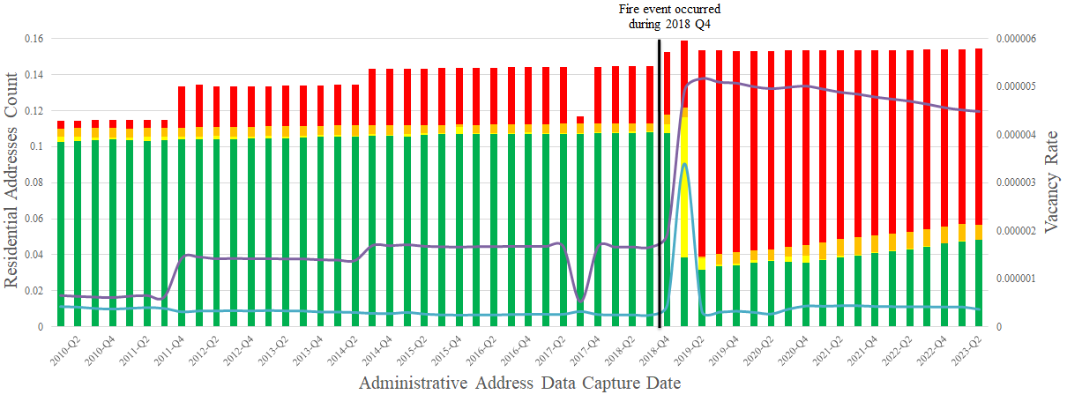

Source: Authors’ construction using data from Monitoring Trends in Burn Severity (MTBS) and U.S. Postal Service (USPS).
Figure S3. Deviations of vacancy rates in Camp Fire burn area by quarter: 2010-2023 and scaled by area

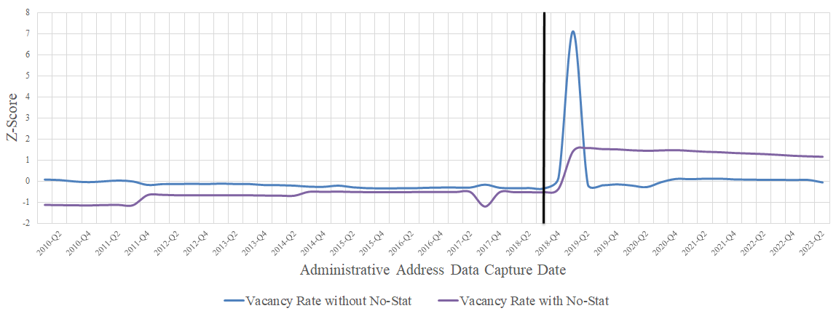

Source: Authors’ construction using data from Monitoring Trends in Burn Severity (MTBS) and U.S. Postal Service (USPS).

Figure S4. Residential addresses and vacancy rates in remaining burn areas by quarter: 2010-2023 and scaled by area

Panel A. Chimney Tops 2 Fire Panel B. Valley Fire

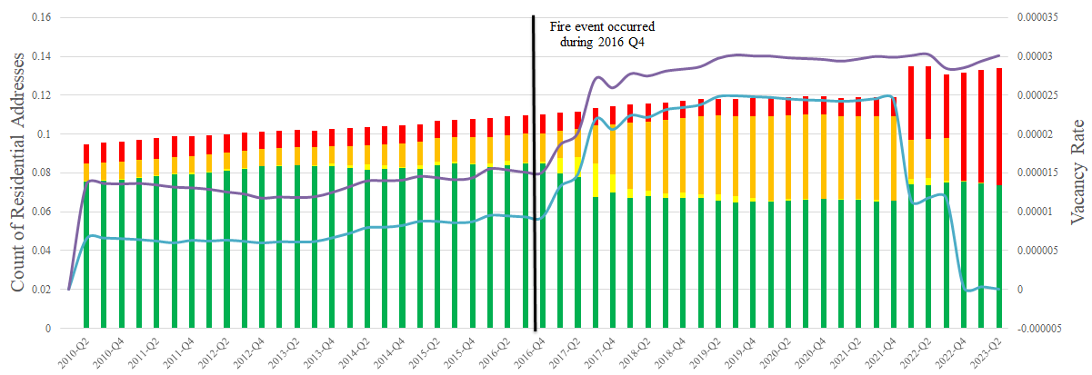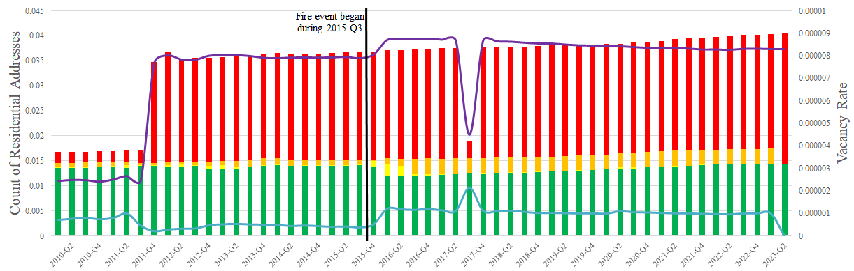

Panel C. Woolsey Fire Panel D. Carr Fire

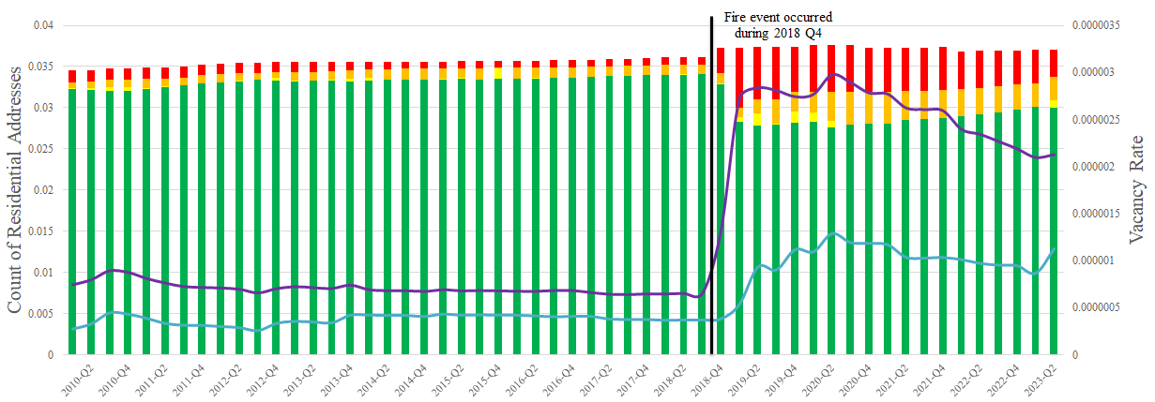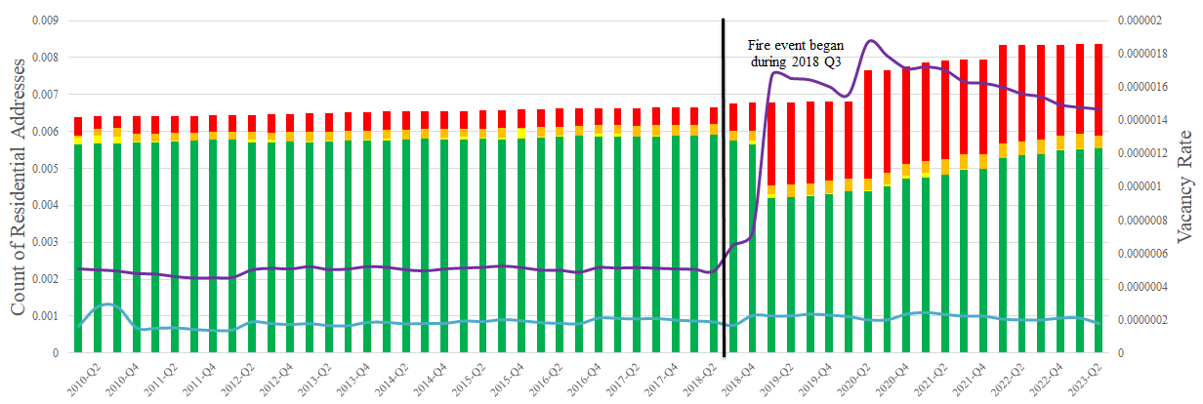

Source: Authors’ construction using data from Monitoring Trends in Burn Severity (MTBS) and U.S. Postal Service (USPS).
Figure S5. Deviations of residential vacancy rates in remaining burn areas by quarter: 2010-2023 and scaled by area

Panel A. Chimney Tops 2 Fire Panel B. Valley Fire

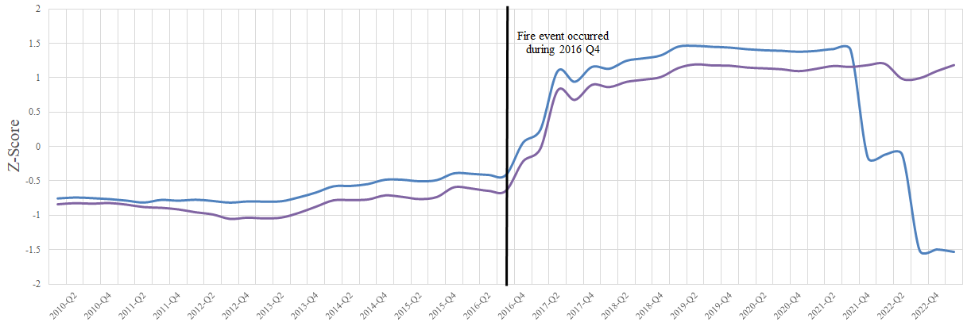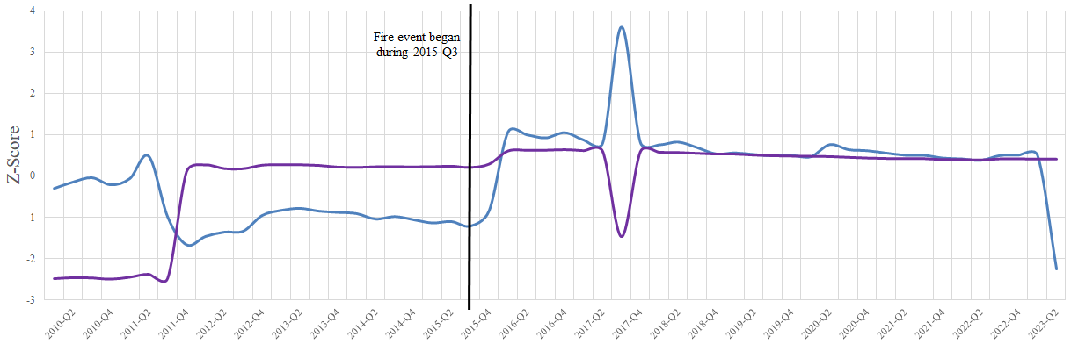

Panel C. Woolsey Fire Panel D. Carr Fire

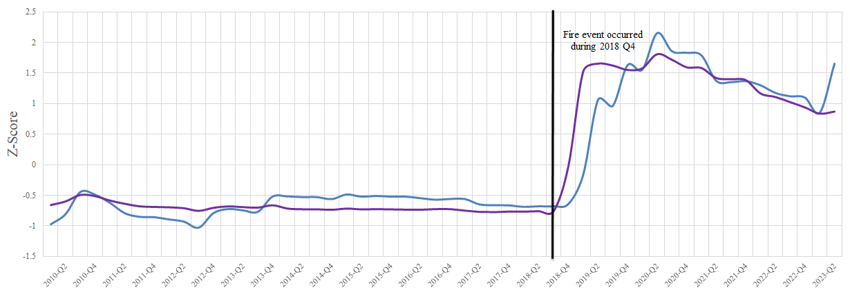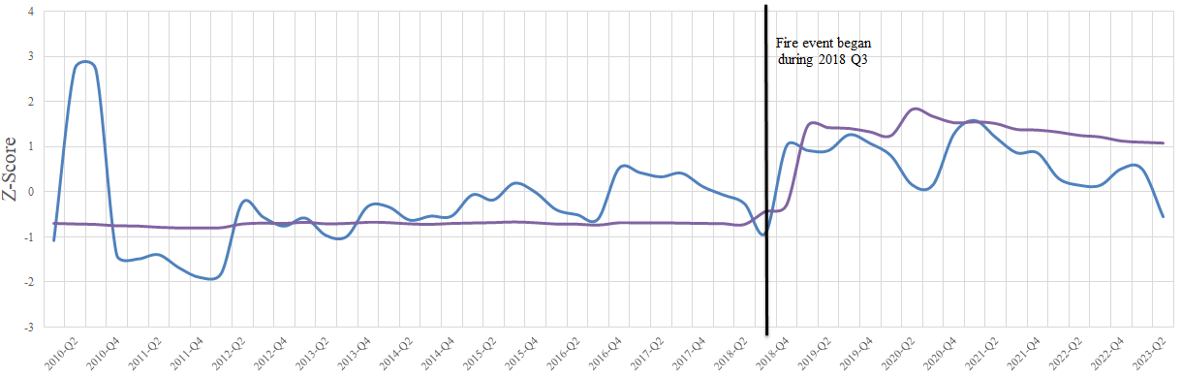

Source: Authors’ construction using data from Monitoring Trends in Burn Severity (MTBS) and U.S. Postal Service (USPS).

