Evaluation of Novel NASA MODIS and VIIRS Aerosol Products and Assessment of Smoke Height Boundary Layer Ratio During Extreme Smoke Events in the Western U.S.

S. Marcela Loría-Salazar^{1,2}

Andrew M. Sayer ^{3,4}

John Barnes⁵

Jingting Huang^{1,6}

Connor Flynn²

Neil Lareau¹

Jaehwa Lee^{3,7}

Alexei Lyapustin³
Jens Redemann²
Ellsworth J. Welton³

Joseph L. Wilkins^{8,9}

Heather A. Holmes^{1,6}

¹Atmospheric Sciences Program, Department of Physics, University of Nevada Reno, Reno, Nevada, USA

² School of Meteorology, University of Oklahoma, Norman, Oklahoma, USA
³ NASA Goddard Space Flight Center, Greenbelt, Maryland, USA
⁴ Goddard Earth Science Technology and Research, Universities Space Research Association, Columbia, Maryland, USA
⁵ NOAA Global Monitoring Laboratory, Colorado, USA
⁶ Department of Chemical Engineering, University of Utah, Salt Lake City, Utah, USA
⁷ Earth System Science Interdisciplinary Center, University of Maryland, College Park, Maryland, USA
⁸ U.S. Environmental Protection Agency, Durham, North Carolina, USA
⁹ Pacific Wildland Fire Sciences Laboratory, School of Environmental and Forest Sciences, University of Washington, Seattle, Washington, USA

Corresponding author: S. Marcela Loría-Salazar, School of Meteorology, University of Oklahoma, Norman, Oklahoma, USA, mloria@ou.edu
Note: This work started as a collaboration between the University of Nevada, Reno, and NASA, and was completed at the University of Oklahoma.

Supplemental Materials
Table SI.1. Locations and elevations of balloon sounding, AERONET, LIDAR, and air quality station (AQS) stations.
 | Station ID | Latitude | Longitude | Elevation (m ASL)
Balloon Sounding | ABQ | 35.04 | -106.62 | 1619
Balloon Sounding | BOI | 43.56 | -116.21 | 874
Balloon Sounding | DNR | 39.77 | -104.87 | 1625
Balloon Sounding | EPZ | 31.86 | -106.7 | 1252
Balloon Sounding | FGZ | 35.23 | -111.82 | 2192
Balloon Sounding | GGW | 48.21 | -106.61 | 700
Balloon Sounding | GJT | 39.11 | -108.53 | 1475
Balloon Sounding | LKN | 40.86 | -115.73 | 1608
Balloon Sounding | NKX | 32.85 | -117.11 | 128
Balloon Sounding | OAK | 37.73 | -122.21 | 3
Balloon Sounding | OTX | 47.68 | -117.63 | 728
Balloon Sounding | REV | 39.56 | -119.8 | 1516
Balloon Sounding | RIW | 43.06 | -108.48 | 1703
Balloon Sounding | SLC | 40.77 | -111.95 | 1289
Balloon Sounding | SLE | 44.91 | -123 | 61
Balloon Sounding | TFX | 47.46 | -111.39 | 1134
Balloon Sounding | TUS | 32.23 | -110.96 | 751
Balloon Sounding | UIL | 47.95 | -124.55 | 62
Balloon Sounding | VEF | 36.05 | -115.18 | 693
AERONET | Cal Tech | 34.137 | -118.126 | 260
AERONET | El Segundo | 33.913 | -118.382 | 25
AERONET | Fresno 2 | 36.785 | -119.773 | 100
AERONET | Trinidad Head | 41.05 | -124.15 | 110
AERONET | Goldstone | 35.233 | -116.792 | 1100
AERONET | Boulder | 40.045 | -105.006 | 1604
AERONET | Bozeman | 45.662 | -111.045 | 1507
AERONET | Missoula | 46.917 | -114.083 | 1028
AERONET | Frenchman Flat | 36.809 | -115.935 | 940
AERONET | Railroad Valley | 38.504 | -115.962 | 1435
AERONET | Univ of Nevada Reno | 39.541 | -119.814 | 1410
AERONET | HELSTF | 32.635 | -106.338 | 1207
AERONET | Sevilleta | 34.355 | -106.885 | 1477
LIDAR | Dodge Ridge Ski Resort | 38.2 | -119.97 | 2010
LIDAR | Donell Vista | 38.5 | -119.9 | 1922
LIDAR | MPLNet Trinidad Head | 41.05 | -124.15 | 110
AQS | Fresno, CA  (06-019-0011) | 36.79 | -119.77 | 100
AQS | Trinidad Head, CA  (06-023-1005) | 40.72 | -124.12 | 170
AQS | Reno, NV  (32-031-0016) | 39.53 | -119.81 | 1340

Table S.2. Association of AERONET stations with PM_{2.5} stations, and balloon sounding stations.
AERONET | AQS | Balloon  sounding
Fresno 2 | 06-019-0011 | --
Trinidad Head | 06-023-1005 | --
Univ. of Nevada Reno | 32-031-0016 | REV

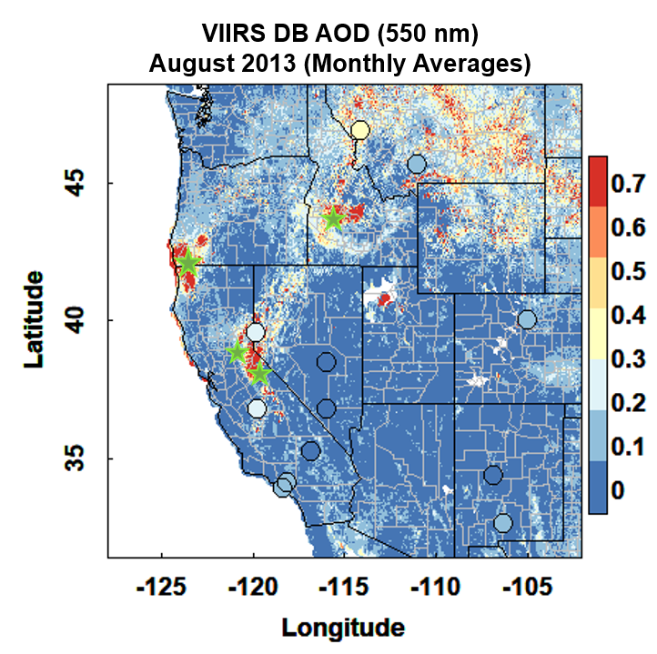
Figure SI.1. Monthly averages of VIIRS DB AOD over the western U.S. during August 2013. The circles represent AERONET stations from Table SI.1, and the stars represent the location of four fires in California (Yosemite Rim and American fires), Oregon, and Idaho during August 2013.

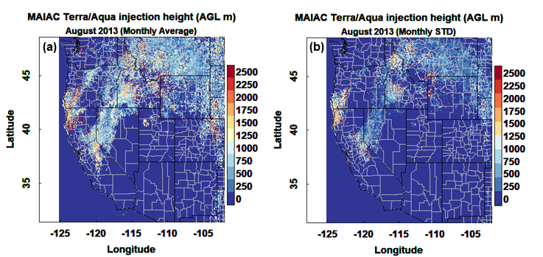
Figure SI.2. (a) Monthly averages and (b) monthly standard deviations (STD) of Terra and Aqua overpass times showing MAIAC plume injection height over the western U.S. during August 2013.

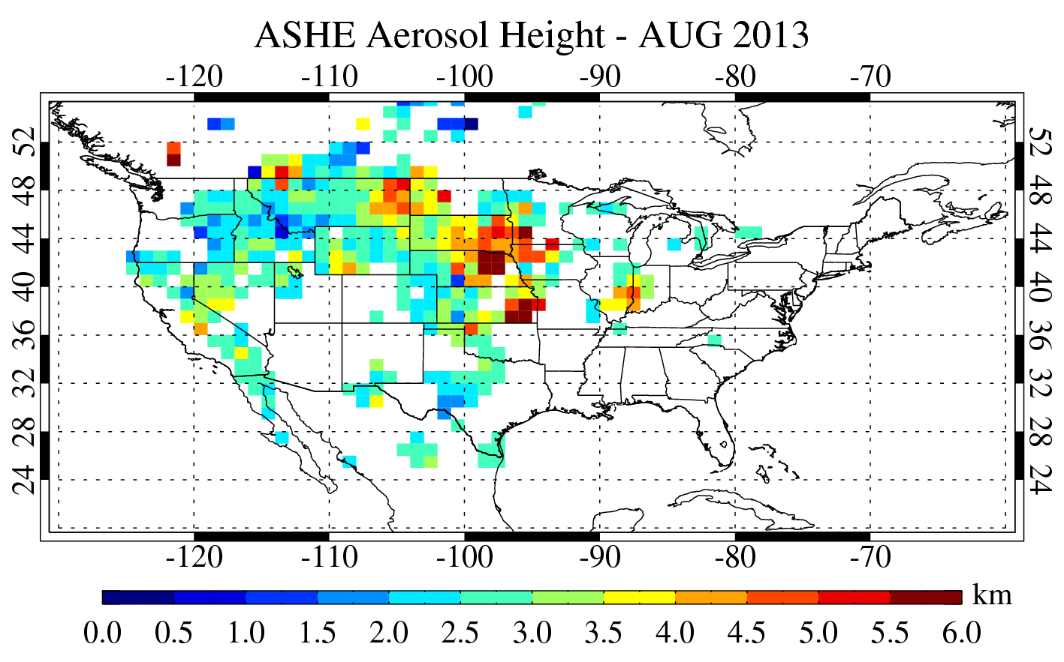
Figure SI.3. Monthly averages of ASHE plume injection heights (ASHE aerosol height) over the U.S. during August 2013.

Because there is uncertainty in the PBLH calculated in WRF outputs, a comparison at corresponding times between PBLH retrieved from balloon soundings and from WRF is shown in Figures SI.3-SI.22. There are some differences between PBLH values from WRF outputs and balloon soundings, especially in the variability of the datasets. However, PBLH from WRF presents a fair agreement with balloon soundings in the monthly (Figure SI.3) and diel (Figures SI.4-SI.22) averages.
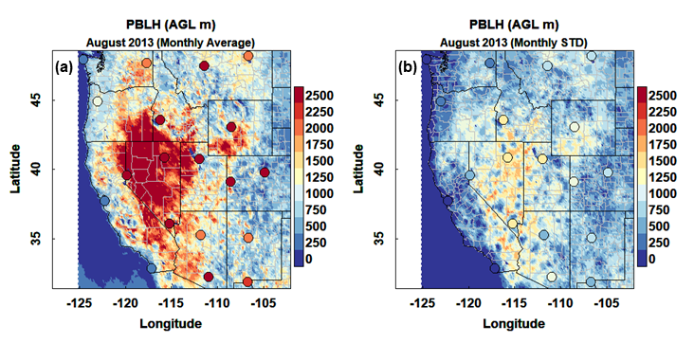
Figure SI.4. (a) Monthly averages and (b) monthly standard deviations (STD) for balloon sounding (circles) PBLH (00:00 UTC) and WRF PBLH (00:00 UTC)) over the western U.S. during August 2013.

In this section (SI.4-22), the figures were labeled using Atmospheric Boundary Layer Height (ABLH) as a synonym of Planetary Boundary Layer Height (PBLH)
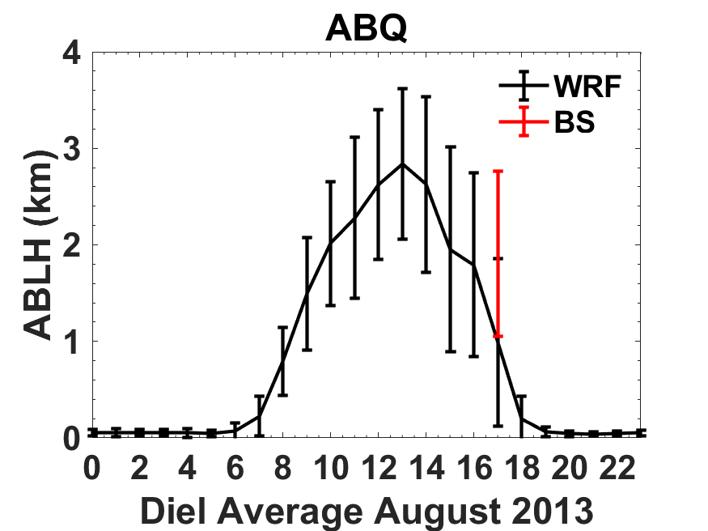
Figure SI.5. Diel averages and standard deviations (error bars) of WRF and balloon sounding (BS) PBLH (Atmospheric boundary layer height, ABLH) during August 2013. Station name: Albuquerque, NM (ABQ). 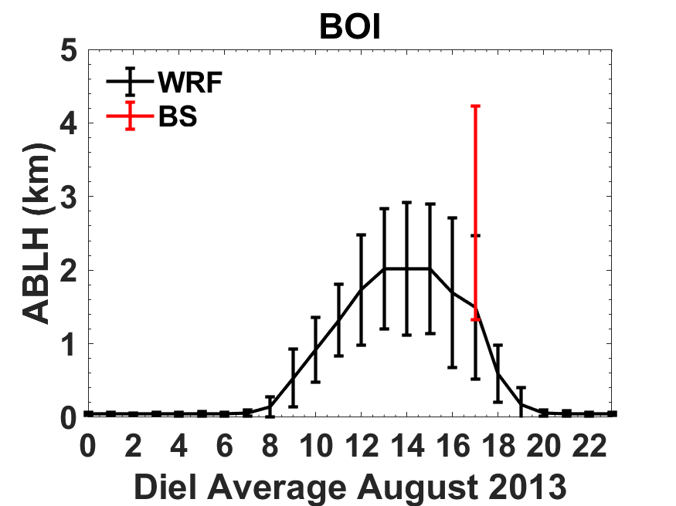
Figure SI.6: Diel Averages of WRF and balloon sounding PBLH during August 2013. Station name: Boise, ID (BOI). Error bars represent stand deviation.
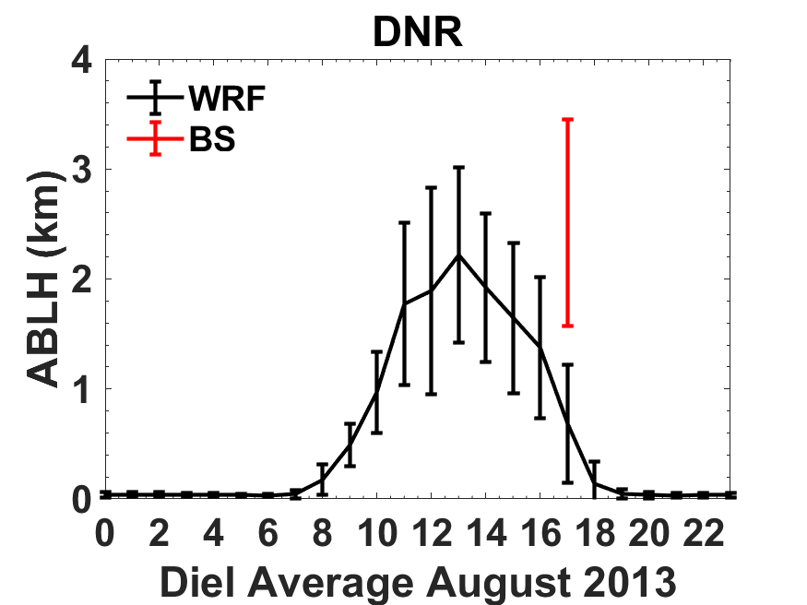
Figure SI.7: Diel Averages of WRF and balloon sounding PBLH during August 2013. Station name: Denver, CO (DNR). Error bars represent stand deviation.
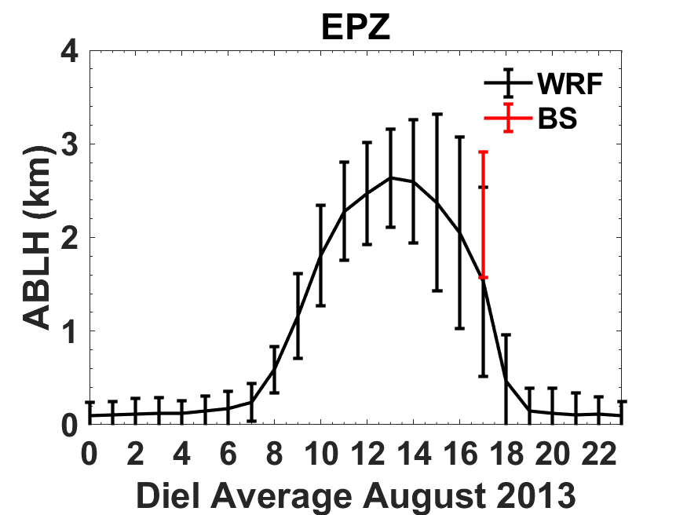
Figure SI.8: Diel Averages of WRF and balloon sounding PBLH during August 2013. Station name: Santa Teresa, NM (EPZ). Error bars represent stand deviation.
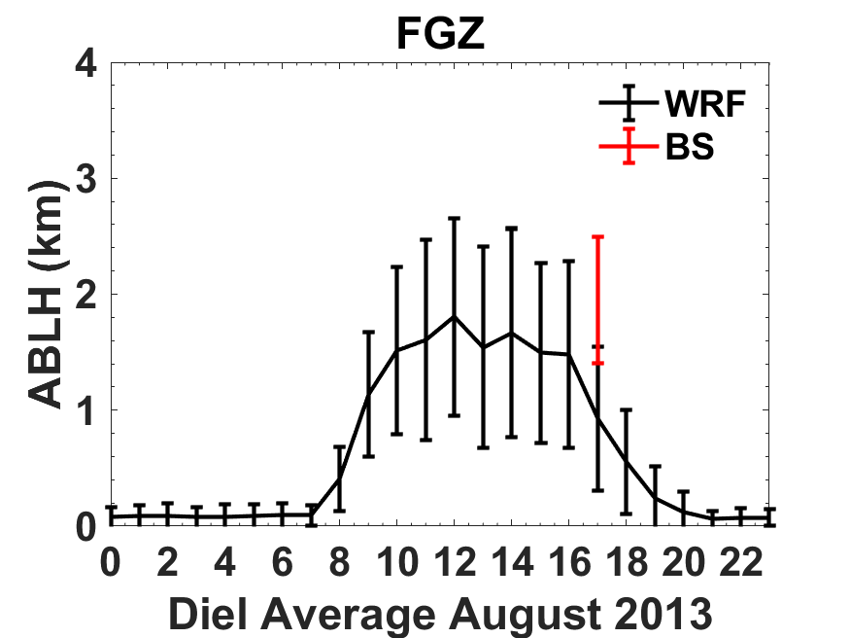
Figure SI.9: Diel Averages of WRF and balloon sounding PBLH during August 2013. Station name: Flagstaff, AZ (FGZ). Error bars represent stand deviation.
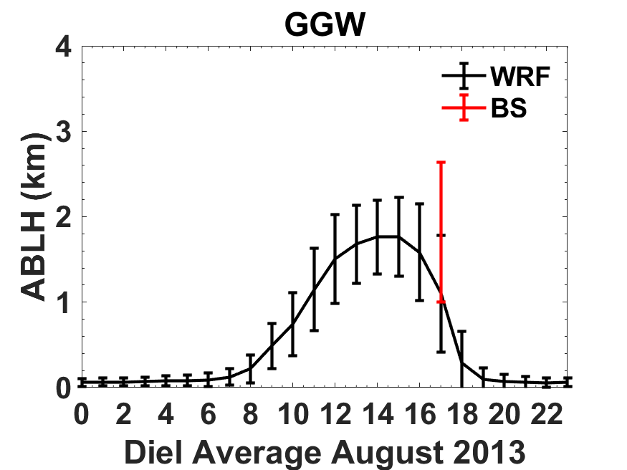
Figure SI.10: Diel Averages of WRF and balloon sounding PBLH during August 2013. Station name: Glasgow, MT (GGW). Error bars represent stand deviation.
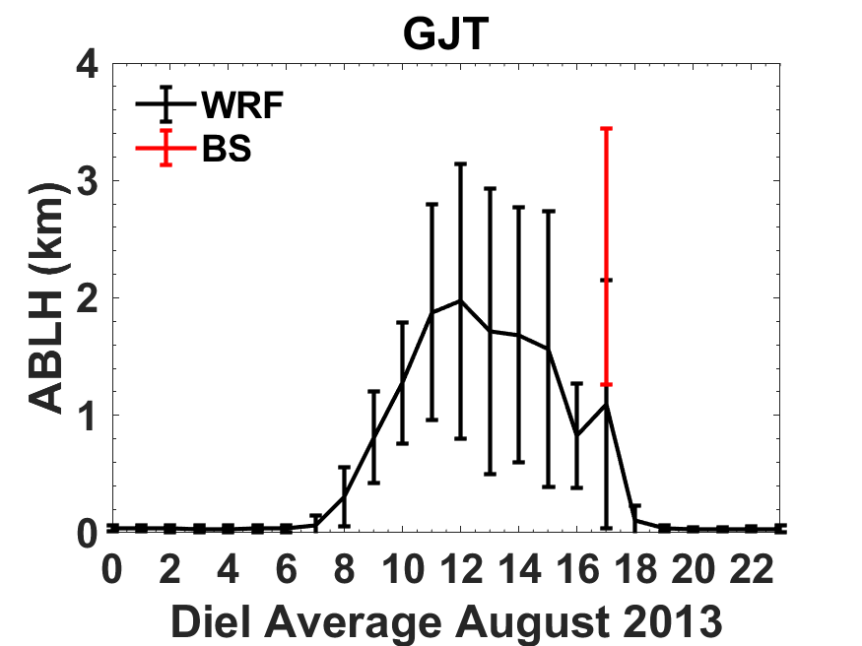
Figure SI.11: Diel Averages of WRF and balloon sounding PBLH during August 2013. Station name: Grand Junction, CO (GJT). Error bars represent stand deviation.
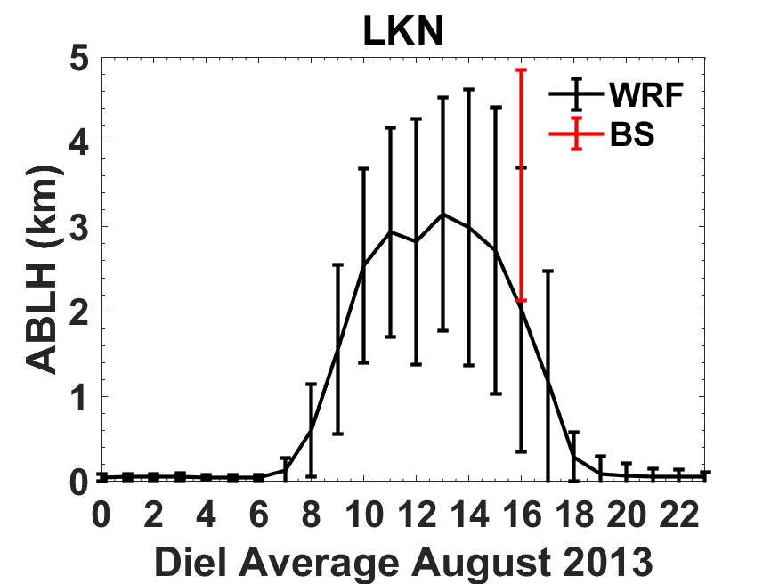
Figure SI.12: Diel Averages of WRF and balloon sounding PBLH during August 2013. Station name: Elko, NV (LKN). Error bars represent stand deviation.
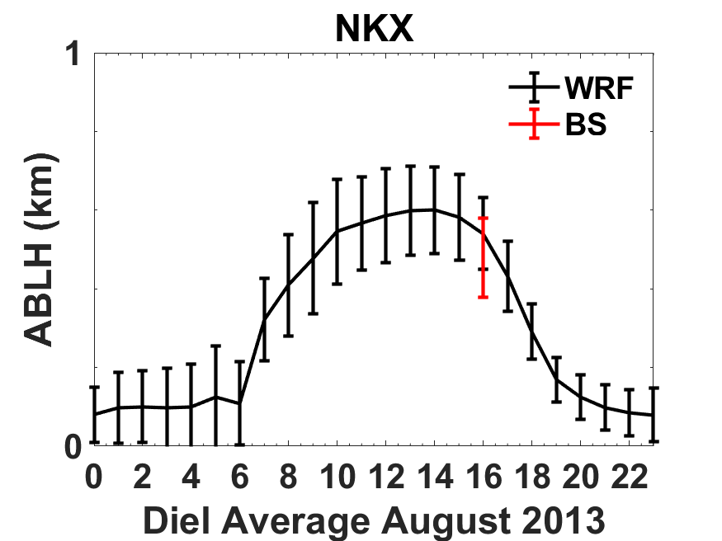
Figure SI.13: Diel Averages of WRF and balloon sounding PBLH during August 2013. Station name: San Diego, CA (NKX). Error bars represent stand deviation.
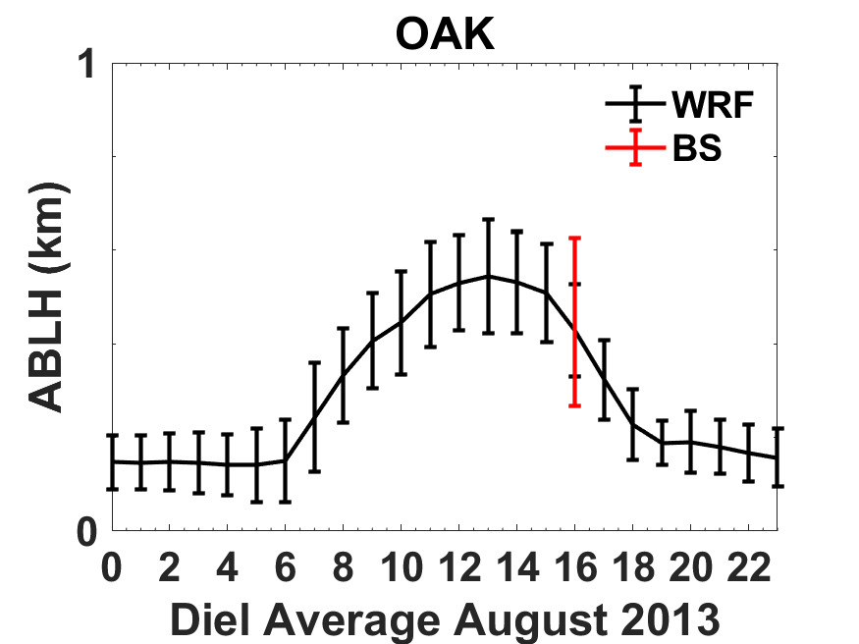
Figure SI.14: Diel Averages of WRF and balloon sounding PBLH during August 2013. Station name: Oakland, CA (OAK). Error bars represent stand deviation.
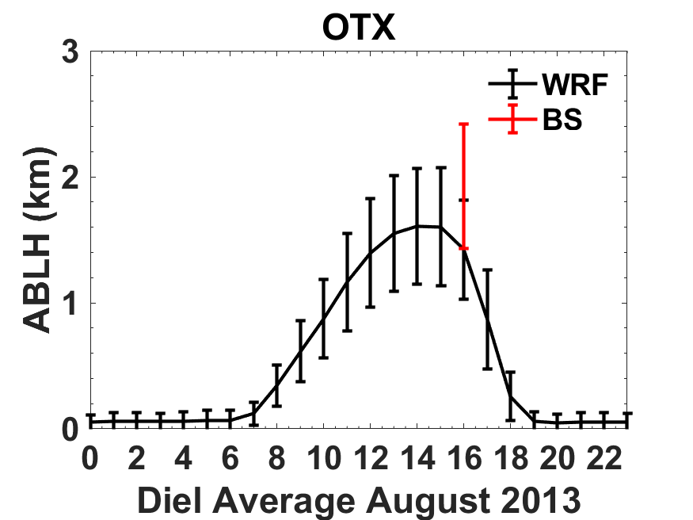
Figure SI.15: Diel Averages of WRF and balloon sounding PBLH during August 2013. Station name: Spokane, WA (OTX). Error bars represent stand deviation.
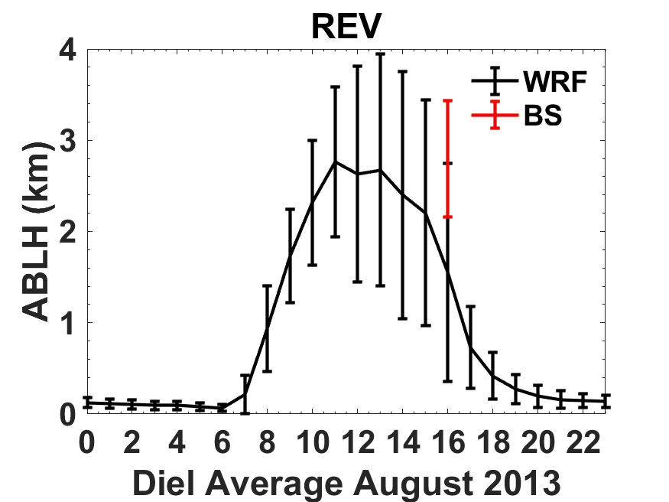
Figure SI.16: Diel Averages of WRF and balloon sounding PBLH during August 2013. Station name: Reno, NV (REV). Error bars represent stand deviation.
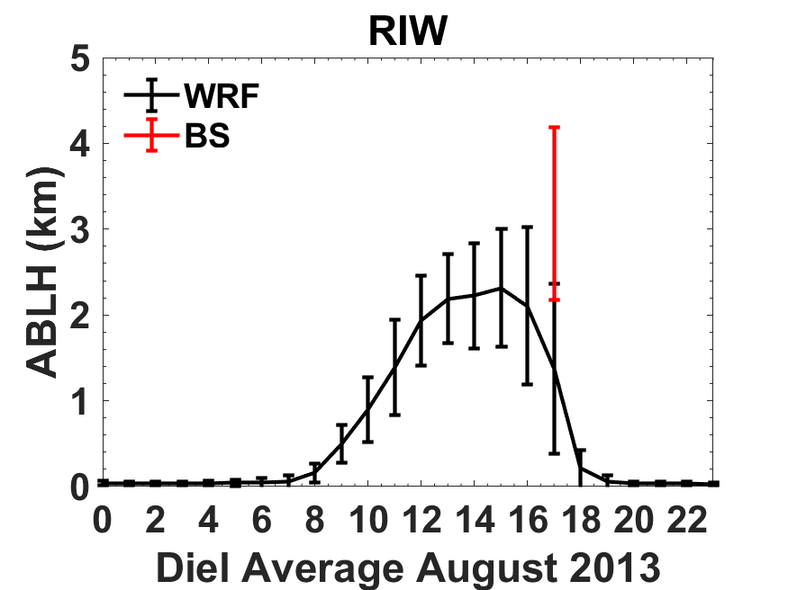
Figure SI.17: Diel Averages of WRF and balloon sounding PBLH during August 2013. Station name: Riverton, WY (RIW). Error bars represent stand deviation.
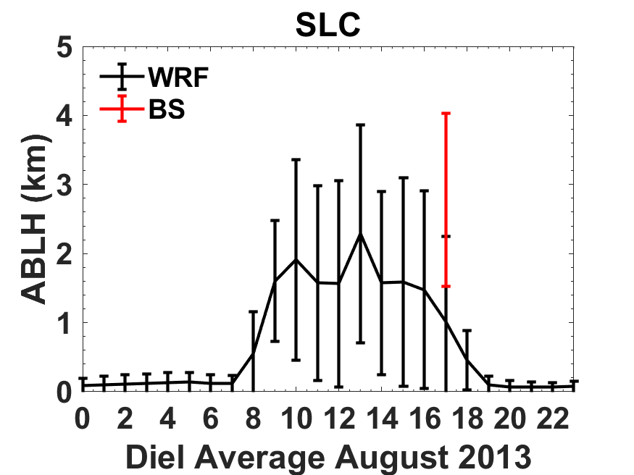
Figure SI.18: Diel Averages of WRF and balloon sounding PBLH during August 2013. Station name: Salt Lake City, Utah (SLC). Error bars represent stand deviation.
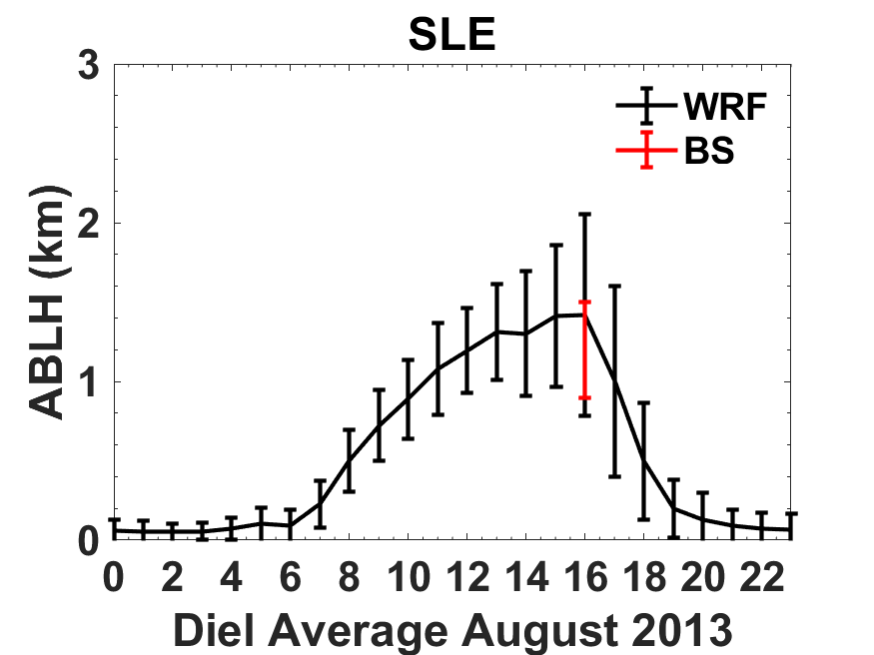
Figure SI.19: Diel Averages of WRF and balloon sounding PBLH during August 2013. Station name: Salem, OR (SLE). Error bars represent stand deviation.
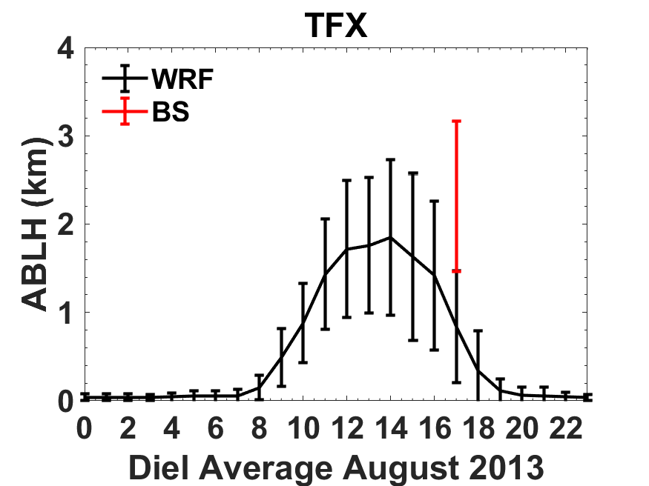
Figure SI20: Diel Averages of WRF and balloon sounding PBLH during August 2013. Station name: Great Falls, MT (TFX). Error bars represent stand deviation.
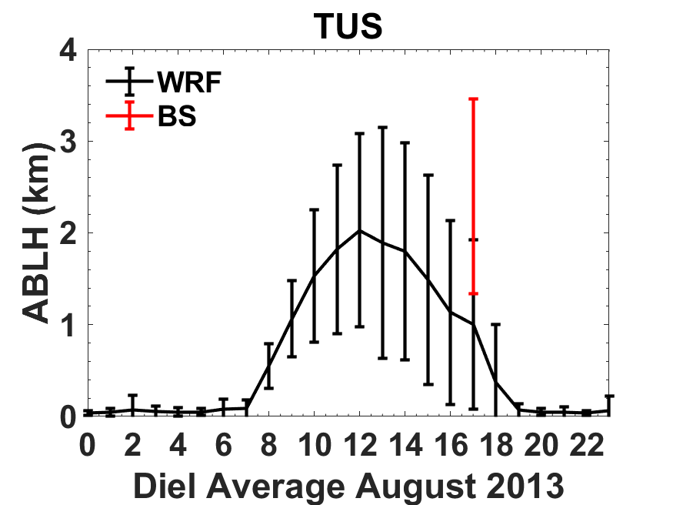
Figure SI.21: Diel Averages of WRF and balloon sounding PBLH during August 2013. Station name: Tucson, AZ (TUS). Error bars represent stand deviation.
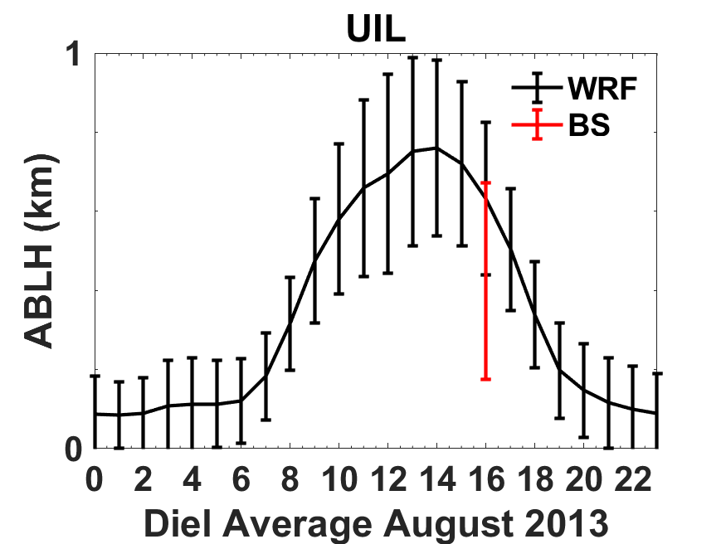
Figure SI.22: Diel Averages of WRF and balloon sounding PBLH during August 2013. Station name: Quillayute, WA (UIL). Error bars represent stand deviation.
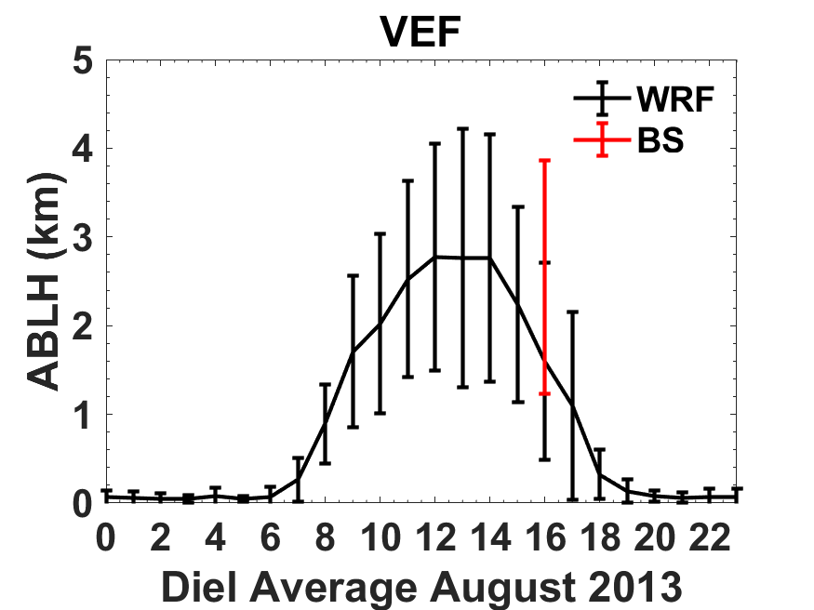
Figure SI.23: Diel Averages of WRF and balloon sounding PBLH during August 2013. Station name: Las Vegas, NV (VEF). Error bars represent stand deviation.

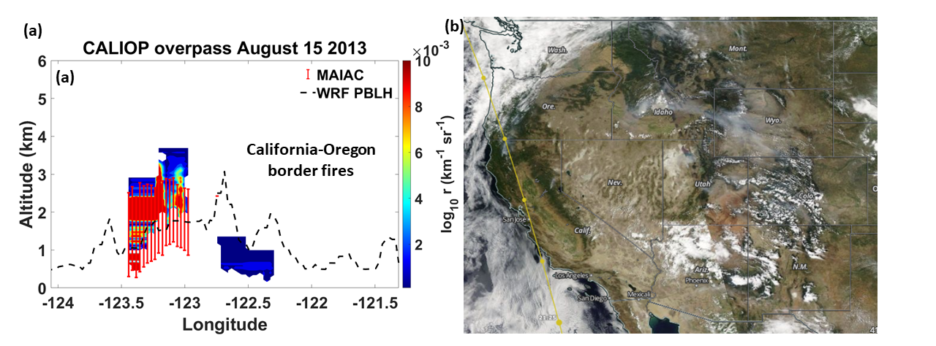
Figure SI.24. CALIOP overpass during August 15, 2013. (a) Back scattering light attenuation from CALIOP lidar and plume injection height from MAIAC algorithm on August 15, 2013. Dashed line: PBLH from WRF. (b) Visible image from Aqua MODIS and CALIPSO day-time overpass.

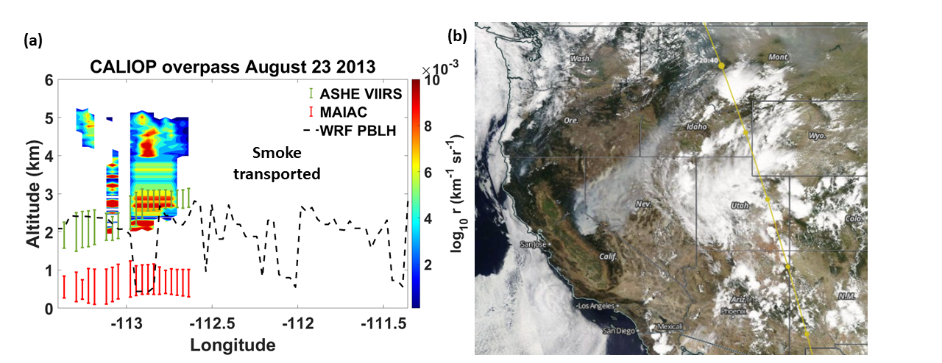
Figure SI.25. CALIOP overpass during August 23, 2013. (a) Back scattering light attenuation from CALIOP lidar and plume injection height from MAIAC and ASHE VIIRS algorithm on August 23rd 2013. The dash line represents the PBLH from WRF. (b) Visible image from Aqua MODIS and CALIPSO day-time overpass.

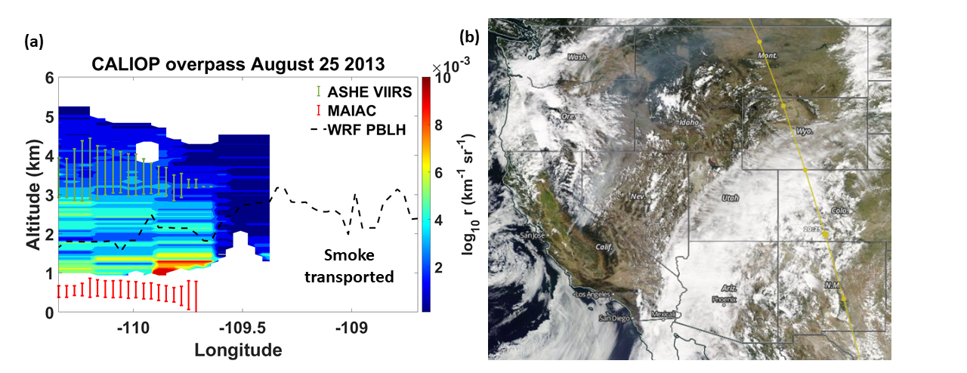
Figure SI.26: CALIOP overpass during August 25, 2013. (a)Back scattering light attenuation from CALIOP lidar and plume injection height from MAIAC and ASHE VIIRS algorithm on August 25th 2013. The dash line represents the PBLH from WRF. (b) Visible image from Aqua MODIS and CALIPSO day-time overpass.

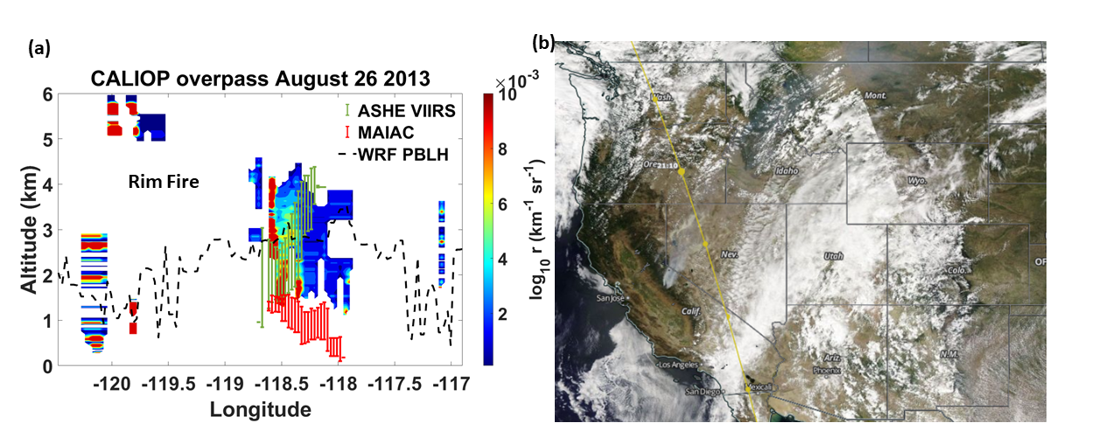
Figure SI.27: CALIOP overpass during August 26, 2013. (a) Back scattering light attenuation from CALIOP lidar and plume injection height from MAIAC and ASHE VIIRS algorithm on August 26th 2013. The dash line represents the PBLH from WRF. (b) Visible image from Aqua MODIS and CALIPSO day-time.

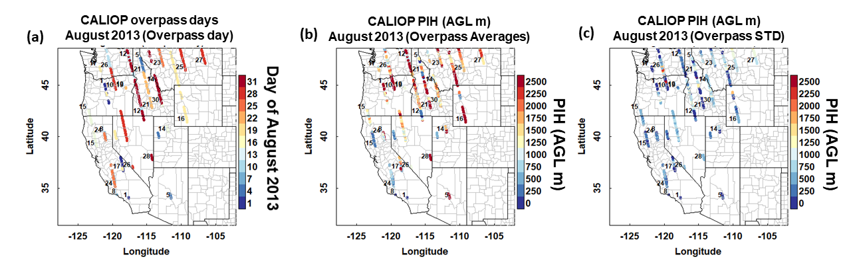 Figure SI.28. CALIOP PIH from CALIPSO daytime overpasses during August 2013. (a) Daily overpass trajectory in the western U.S. (b) Average of aerosol height. (c) STD of aerosol height.

