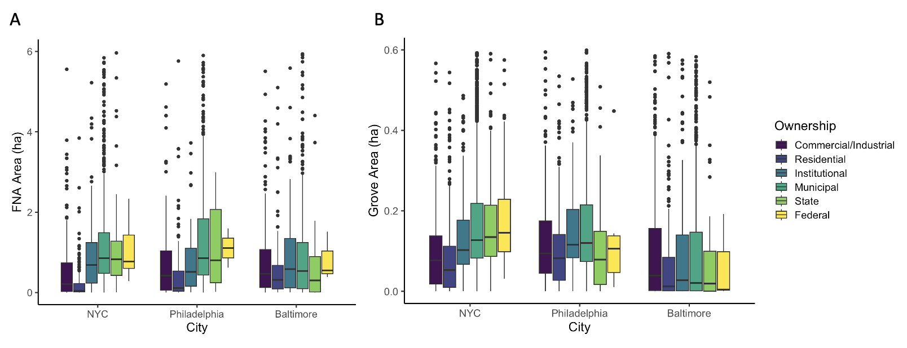
Figure S1. Median contiguous area of ownership within forest patches by city and ownership type. Box plots depict median and interquartile range with outliers removed. Statistical differences between ownership types within each city and patch type are shown in Table S2.

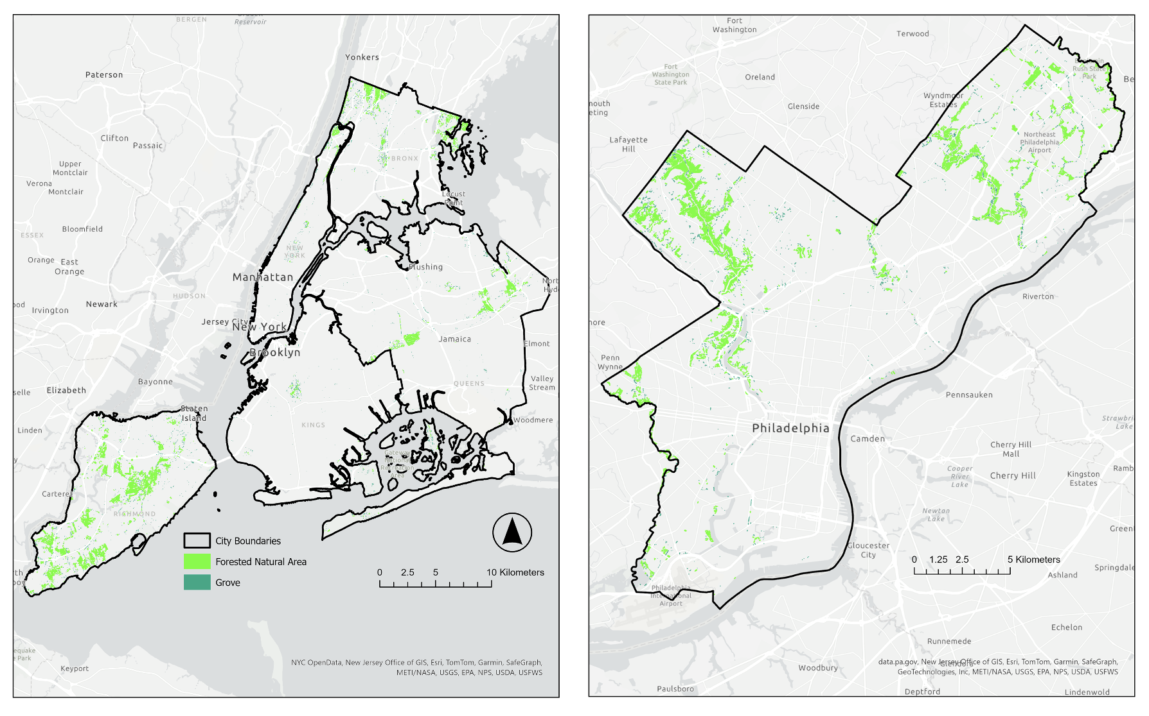
Figure S2. Citywide forest patch maps for New York, NY and Philadelphia, PA depicting forested natural areas and groves within city boundaries. Philadelphia’s forest patches are clustered along stream valleys, while many of New York City’s large protected forest areas are located along the terminal moraine or large metamorphic rock formtions.

Table S1. Terms and their operating definitions used in this manuscript. See methods section for more details. Terms are listed generally in the order in which they are introduced and used in the analysis.
Term | Definition used in analysis
Urban Tree Canopy (UTC) Cover | Percentage of land area covered by tree branches, leaves, stems and other vegetation greater than 2.44 m tall
Hard Canopy | Tree canopy overhanging impervious surfaces (e.g., rooftops, pavement)
Soft Canopy | Tree canopy overhanging pervious surfaces (e.g., lawn, soil)
Core Forest | Interior forest conditions delineated using morphological spatial pattern analysis (MSPA)
Edge Forest | Edge forest conditions delineated using MSPA with 15 m edge width
Forest Patch | Forest Canopy Cover | Areas of core forest and adjacent edge forest
Forested Natural Area (FNA) | Forest patch with minimum core thickness greater than 22.6 m
Grove | Forest patch that does not meet minimum core thickness of an FNA

Table S2. Forest patch structure and ownership characteristics by city. Parentheses indicate minimum and maximum values for patch structure metrics. Letters represent significant differences in forested natural area (FNA) or grove metrics across cities, with the exception of median patch size by ownership class which shows significant differences among ownership types within each city (Kruskal-Wallis test with pairwise comparisons). Alpha = 0.05 for pairwise comparisons with the exception of median patch size of forested natural areas where Kruskal-Wallis test p = 0.04 and p = 0.058 for pairwise comparisons.
 | Forested Natural Areas |  |  | Groves
 | NYC | Philadelphia | Baltimore | NYC | Philadelphia | Baltimore
Median patch size (ha) | 1.16a  (.29, 130.00) | 1.31ab  (.31, 50.49) | 1.47b  (.33, 102.84) | 0.15a  (.07, 1.49) | 0.15ab  (.07, 1.58) | 0.16b  (.07, 1.82)
Median patch thickness (m) | 69.011a  (53.16, 266.71) | 70.24a  (52.43, 390.46) | 74.90b  (52.32, 541.07) | 36.07a  (31.09, 58.52) | 35.98a  (30.48, 60.22) | 37.00b  (31.00, 56.04)
Median patch shape index | 3.07a  (1.58, 77.17) | 2.95a  (1.57, 26.81) | 3.56b  (1.65, 24.22) | 1.64a  (1.49, 6.40) | 1.73b  (1.53, 23.51) | 1.64c  (1.45, 8.25)
Median property parcels per patch | 1a | 2b | 4c | 1a | 1b | 2c
Median owner types per patch | 1a | 1a | 2b | 1a | 1b | 1c
Median contiguous area of ownership within forest patches (ha)
Commercial/industrial | .22a | .44a | .48ab | .08a | .09a | .06a
Private residential | .04b | .11b | .35a | .05b | .08b | .01b
Institutional | .70c | .58ac | .59b | .10c | .12c | .04ab
Municipal | .94d | 1.01d | .59b | .13d | .12cde | .05a
State | 1.05d | 0.83cd | .32ab | .14de | .08abde | .03ab
Federal | .77cd | 1.11abcd | .55ab | .16e | .11abcde | .10ab
Citywide edge:core forest
Commercial/industrial | 0.96 | 1.33 | 1.11 | 8.09 | 7.33 | 7.61
Private residential | 2.23 | 2.13 | 1.29 | 11.50 | 11.50 | 9.52
Institutional | 1.08 | 0.85 | 0.95 | 9.00 | 7.33 | 8.78
Municipal | 0.75 | 0.85 | 0.61 | 8.09 | 7.33 | 7.85
State | 0.69 | 0.69 | 1.10 | 8.09 | 3.00 | 11.27
Federal | 2.13 | 1.63 | 1.52 | 7.33 | 3.76 | 172.00

