Supporting Information
A 3D-Printed Transfusion Platform Reveals Beneficial Effects of Normoglycemic Erythrocyte Storage Solutions and a Novel Rejuvenating Solution

Yueli Liu,¹ Laura Hesse,¹ Morgan Geiger,^{2,3} Kurt Zinn,^{2,3} Timothy McMahon,⁴ Chengpeng Chen⁵, and Dana M. Spence^{2, 3}

Departments of Chemistry¹, Biomedical Engineering², and Institute for Quantitative Health Sciences and Engineering³, Michigan State University, East Lansing, MI, 48824
Department of Medicine⁴, Duke University, Durham, North Carolina, 27710
Department of Chemistry and Biochemistry⁵, University of Maryland Baltimore County, Baltimore MD, 21250
spenceda@msu.edu

Supplementary Figure S1.
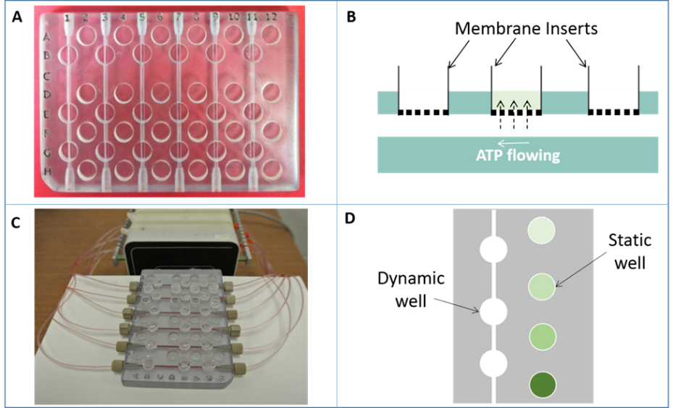

Figure S1. In (A), the reusable 3D-printed circulation mimic device used for ATP quantification will be modeled after the dimensions of a 96-well plate. Column and row markers make it convenient to localize wells. Six channels are printed on the odd number columns, with three wells above each channel. Commercial (or in-house printed) membrane inserts can be plugged into the wells to form a membrane barrier between the flow and the area above the wells. (B), the side view of a channel with membrane inserts integrated. When a sample is flowing in the channel, ATP molecules diffuse through the membrane and will be collected in preloaded buffer above the membrane. The amount of collected ATP in the insert is proportional to the amount of molecule that was flowing in the channel. Therefore, by quantifying the ATP in the inserts, the ATP concentration flowing in the channel can be determined. (C), system (without transfusion Y-connector that was used for studies to collect data in figure 6) in action showing three RBC samples being introduced into the six channels of the device in duplicate, after which, both ends of a channel were connected by Tygon tubing to form a circulation loop. A peristaltic pump was used to drive the samples circulating at a flow rate of 200 µL/min. Screw threads were 3D-printed at the ends of the channels so that the tubing could be connected via commercial finger tight fittings. (D), in addition to the dynamic wells above channels, static wells can be included on the device for on-chip calibration. Four ATP standards can be loaded in these wells to quantify the key molecules collected in a dynamic well.

Supplementary Figure S2.
Figure S2. The 3D-printed i.v. injection device. As shown in (A) the device comprises three parts: a flow splitter, a flow controller, and a stop cock. Screw threads were printed on each part for easy but tight connection. When the hole that goes through the stopcock was adjusted along the channel in the flow controller, liquid can be injected through. Otherwise, the flow will be stopped. The device is shown in action in (B) where injection of fluorescein into a water circulation. Water was circulating in the loop that connects the low branch of the splitter and the other end of a channel, while fluorescein was injected in by a syringe pump.
Supplementary Figure S3

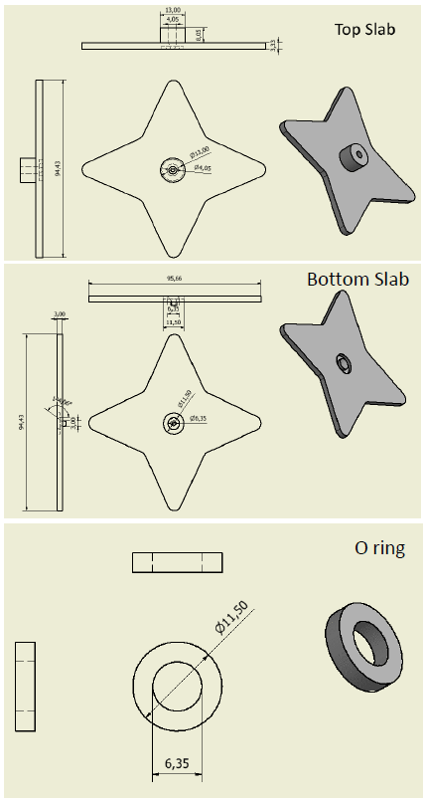
Figure S3: Technical drawings of the top slab, bottom slab, and O-ring for the 3D-printed cell filter device. The O-rings were assembled to both slabs in the software, before sending the files to the printer, so that they could be printed simultaneously. All units are in mm.

Supplemental Figure S4.

Figure S4. The desired CPD collection solution (either conventional CPD or a modified CPD-N) is injected into a vacuum collection tube that has no other anti-coagulant coatings (i). Whole blood is drawn into the tube from the consented donor (ii). After centrifugation, the plasma and white cell layer is removed by vacuum aspiration (iii). Next, the appropriate additive solution (here, either AS-1 or AS-1N) is added to the ERYs in an ~ 2:1 volume ratio (iv). This is the same ratio that would occur in normal blood banking practices. An initial aliquot is removed for day 1 measurements upon transfer to the appropriate PSS-based buffer (v). Periodic feeding occurs by opening the sealed bag and adding μL volumes of a sterilized glucose solution into the bag and resealing (vi). Subsequent measurements after predetermined storage durations are performed after aliquots are transferred to either PSSN or PSSH, normoglycemic and hyperglycemic versions of a physiological salt solution described in the main text.
Fresh Erythrocyte Deformability
Fresh erythrocyte (ERY) samples were prepared by suspending freshly purified ERYs to a 5% hematocrit in PSSN, PSSN containing 10 nM human C-peptide and Zn²⁺, PSSN containing 10 nM human C-peptide, and PSSN containing 10 nM Zn²⁺.
In control experiments where fresh ERYs were incubated with either 10 nM C-peptide or Zn²⁺, no improvement in deformability was observed, shown in Figure S5. However, fresh ERYs incubated with both C-peptide and Zn²⁺ showed a 40% increase of deformability. This data matches our previous finding that both C-peptide and Zn²⁺ are required for an increase in ERY-derived ATP release. Data in this part strongly suggested a causal link between the increase in deformability and the subsequently increase in ATP release.
Figure S5. Cell membrane deformability of fresh ERYs increased by C-peptide (Cp) and zinc (Zn). Cell membrane deformability of freshly purified ERYs was increased by 45% after incubated with C-peptide and zinc, whereas C-peptide or zinc alone at the same concentration did not. Error bars are ±SEM, n=5.

Supplementary Table S1.
Fluorescein  (μM) | 30.3±2.4 | 29.3±1.1 | 30.7±0.9 | 29.2±0.8 | 30.5±1.2 | 30.0±1.0
Table S1. The concentration of fluorescein in each loop after an injection
N = 5; error=stdev

Supplementary Table S2

Table S2. The concentrations of fluorescein in each part of a loop
Fluorescein  (μM) | loop 1 |  |  | loop 2 |  |  | loop 3
Fluorescein  (μM) | P1 | P2 | P3 | P1 | P2 | P3 | P1 | P2 | P3
Fluorescein  (μM) | 30.6±1.2 | 30.5±0.1 | 30.6±1.1 | 29.5±1.7 | 29.6±1.7 | 30.1±1.2 | 29.8±0.9 | 30.5±1.3 | 29.8±1.1
Fluorescein  (μM) | loop 4 |  |  | loop 5 |  |  | loop 6
Fluorescein  (μM) | P1 | P2 | P3 | P1 | P2 | P3 | P1 | P2 | P3
Fluorescein  (μM) | 29.5±1.4 | 29.5±1.7 | 29.9±1.5 | 29.8±0.3 | 28.7±0.5 | 28.3±0.1 | 30.4±0.6 | 30.4±0.7 | 31.0±1.3
N=5; error=stdev

Supplementary Table S3.
 | loop 1 | loop 2 | loop 3 | loop 4 | loop 5 | loop 6
Hct, % | 10.3±0.6 | 9.7±0.5 | 10.1±1.0 | 10.7±1.3 | 10.7±0.8 | 10.4±0.5
Table s3. The hematocrit of ERYs in each loop after an injection
N = 5; error=stdev

Supplementary Table S4.
Table S4. The hematocrit of ERYs in each part of a loop
Hct, % | loop 1 |  |  | loop 2 |  |  | loop 3
Hct, % | P1 | P2 | P3 | P1 | P2 | P3 | P1 | P2 | P3
Hct, % | 9.9±0.4 | 10.2±0.5 | 10.7±0.2 | 10.4±0.3 | 10.4±0.3 | 10.2±0.3 | 10.3±0.1 | 10.4±0.7 | 10.4±0.5
Hct, % | loop 4 |  |  | loop 5 |  |  | loop 6
Hct, % | P1 | P2 | P3 | P1 | P2 | P3 | P1 | P2 | P3
Hct, % | 9.9±0.1 | 10.0±0.3 | 10.3±0.3 | 10.3±0.3 | 10.4±0.1 | 10.3±0.5 | 9.7±0.5 | 10.1±0.5 | 10.3±0.3
N=5; error=stdev

