
Journal of Geophysical Research Atmospheres
Supporting Information for
Comparison of Near-surface NO2 Pollution with Pandora Total Column NO2 during the Korea-United States Ocean Color (KORUS OC) Campaign
Anne M. Thompson^{1,2}, Ryan M. Stauffer^{1,3}, Tyler P. Boyle², Debra E. Kollonige^{1,4}, Kazuyuki Miyazaki⁵, Maria Tzortziou⁶, Jay R. Herman^{1,7}, Nader Abuhassan^{1,7}, Carolyn E. Jordan⁸, Brian T. Lamb⁶

¹Earth Sciences Division, NASA/Goddard Space Flight Center, Greenbelt, Maryland 20771

²Dept. of Atmospheric and Ocean Sciences, Univ. Maryland-College Park, College Park, MD 20742 tboyle@terpmail.umd.edu

³USRA, Columbia, Maryland 21046

⁴SSAI, Lanham, MD 20706

⁵Jet Propulsion Lab, Cal Tech, Pasadena, California 91109

⁶Earth Sciences Dept., CCNY, City Univ. New York, New York, NY 10031

⁷JCET, Univ. Maryland-Baltimore County, Baltimore, Maryland 20218

⁸National Institute of Aerospace, Hampton, Virginia 23666 carolyn.jordan@nianet.org

Contents of this file

Figure S1

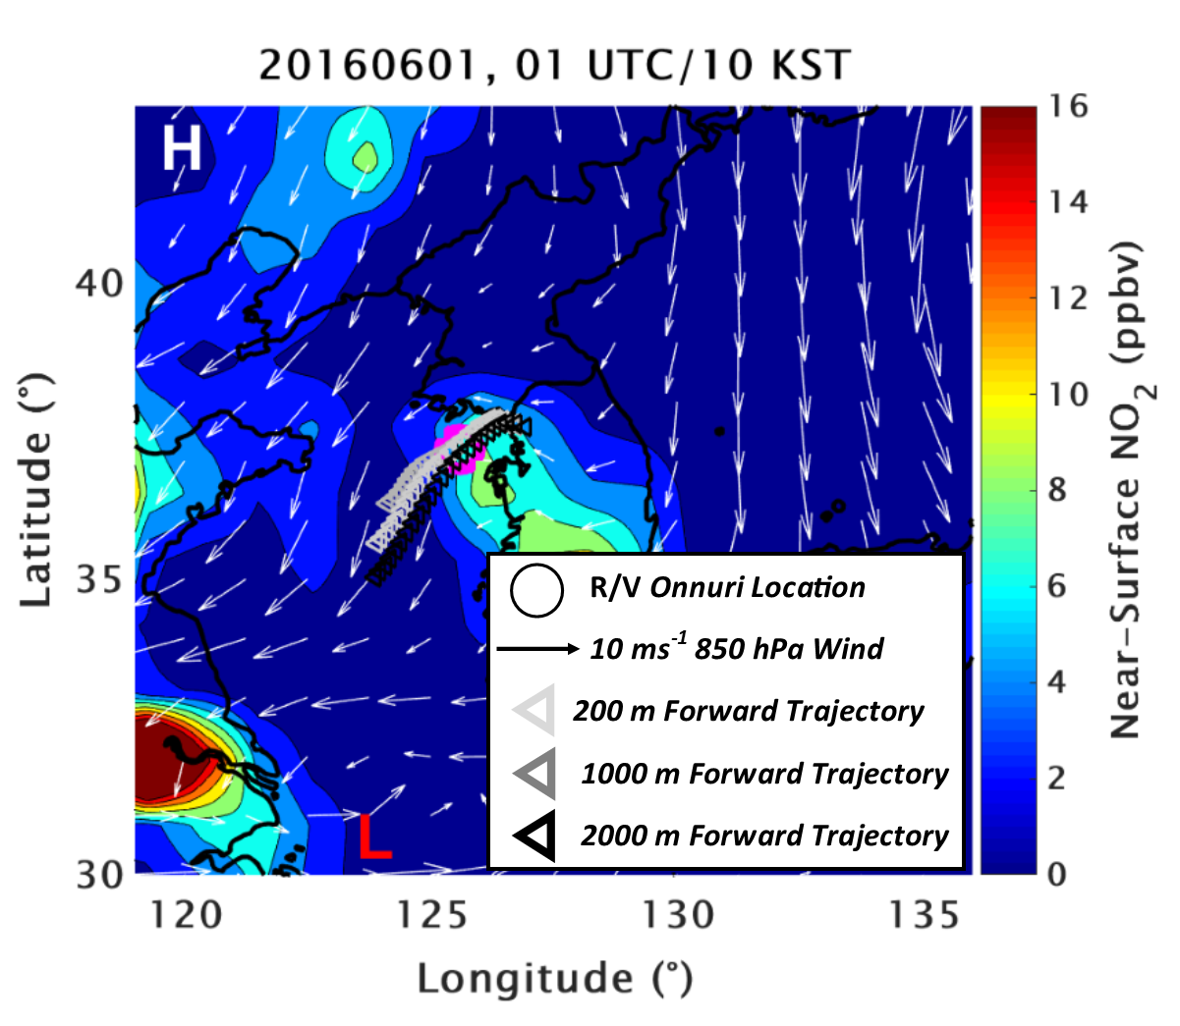
Figure S1. Chemical reanalysis output of NO₂ from Case Study 3 at 01 UTC on 01 June, 2016. Contoured colors are near-surface values of NO₂ in ppbv, with 850 hPa wind vectors shown as gray arrows. NO₂ values are contoured every 2 ppbv. HYSPLIT forward trajectories initialized from Seoul at 01 UTC at three altitudes are indicated by the gray arrows. The “L” and “H” indicate surface low and high MSLP centers, and the R/V Onnuri location is shown as the open magenta circle.

