analysis of Acetate ester production in wild yeast
to identify strains that improve flavor in commercial fermentation
by
Katie L. Powell
B.S. Biology (Shippensburg University) 2005
MOCK GRANT PROPOSAL
Submitted in partial satisfaction of the requirements
for the degree of
MASTER OF SCIENCE
in
BIOMEDICAL SCIENCE
in the
GRADUATE SCHOOL
of
HOOD COLLEGE
May 2018
Accepted:

________________________________ ________________________________
Ann Boyd, Ph.D. Ann Boyd, Ph.D.
Committee Member Director, Biomedical Science Program

________________________________
Craig Laufer, Ph.D.
Committee Member

________________________________ ________________________________
Miranda Darby, Ph.D. April M. Boulton, Ph.D.
Project Adviser Dean of the Graduate School

STATEMENT OF USE AND COPYRIGHT WAIVER

I do authorize Hood College to lend this mock grant proposal, or reproductions of it, in total or in part, at the request of other institutions or individuals for the purpose of scholarly research.

ACKNOWLEDGEMENTS

I would like to extend my sincere gratitude to Dr. Ann Boyd and Dr. Craig Laufer for serving on my committee, and to Dr. Miranda Darby for her role as my project advisor and her tireless support with project design, writing, and troubleshooting. I would also like to thank the guys at Cushwa Brewing Company for the initial project idea.

Mock Grant Application  Modeled after Department of Health and Human Services  Public Health Services  (based on Form PHS 398) |  |  |  |  |  |  |  |  |  |  |  | LEAVE BLANK—FOR OFFICIAL USE ONLY.
 |  |  |  |  |  |  |  |  |  |  |  | Type |  |  |  |  | Activity |  |  |  |  | Version – HCBMS.011712
 |  |  |  |  |  |  |  |  |  |  |  | Review Group |  |  |  |  |  |  |  |  |  | Formerly
 |  |  |  |  |  |  |  |  |  |  |  | Council/Board (Month, Year) |  |  |  |  |  |  |  |  |  | Date Received
1. TITLE OF PROJECT (Do not exceed 81 characters, including spaces and punctuation.)

2. RESPONSE TO SPECIFIC REQUEST FOR APPLICATIONS OR PROGRAM ANNOUNCEMENT OR SOLICITATION NO YES
(If “Yes,” state number and title)
Number: |  |  |  |  | Title:
3. PROGRAM DIRECTOR/PRINCIPAL INVESTIGATOR |  |  |  |  |  |  |  |  |  |  |  | New Investigator No Yes
3a. NAME (Last, first, middle) |  |  |  |  |  |  |  |  |  |  |  | 3b. DEGREE(S) |  |  |  |  |  |  |  |  | 3h. eRA Commons User Name
Powell, Katie L. |  |  |  |  |  |  |  |  |  |  |  |  | B.S. Biology |  |  |  |  |  |  |  | N/A
3c. POSITION TITLE  Graduate Student |  |  |  |  |  |  |  |  |  |  |  | 3d. MAILING ADDRESS (Street, city, state, zip code)  401 Rosemont Ave.  Frederick, MD 21201
3e. DEPARTMENT, SERVICE, LABORATORY, OR EQUIVALENT
Department of Biology
3f. MAJOR SUBDIVISION
Biomedical Science Program
3g. TELEPHONE AND FAX (Area code, number and extension) |  |  |  |  |  |  |  |  |  |  |  | E-MAIL ADDRESS:
TEL: | N/A |  |  |  |  | FAX: |  | N/A |  |  |  | klb29@hood.edu
4. HUMAN SUBJECTS RESEARCH |  |  |  |  |  |  |  |  | 4a. Research Exempt
No Yes |  |  |  |  |  |  |  |  | N/A
4b. Federal-Wide Assurance No. |  |  |  |  |  |  |  |  | 4c. Clinical Trial |  |  |  |  |  |  |  |  | 4d. NIH-defined Phase III Clinical Trial
N/A |  |  |  |  |  |  |  |  | No Yes |  |  |  |  |  |  |  |  | No Yes
5. VERTEBRATE ANIMALS No Yes |  |  |  |  |  |  |  |  |  |  |  | 5a. Animal Welfare Assurance No. |  |  |  |  |  |  |  |  |  | N/A
6. DATES OF PROPOSED PERIOD OF  SUPPORT (month, day, year—MM/DD/YY) |  |  |  |  |  |  |  |  |  |  | 7. COSTS REQUESTED FOR INITIAL  BUDGET PERIOD |  |  |  |  |  |  |  |  | 8. COSTS REQUESTED FOR PROPOSED  PERIOD OF SUPPORT
From |  |  |  | Through |  |  |  |  |  |  | 7a. Direct Costs ($) | 7b. Total Costs ($) |  |  |  |  |  |  |  | 8a. Direct Costs ($) |  |  |  | 8b. Total Costs ($)
06/2017 |  |  |  | 3/2019
9. APPLICANT ORGANIZATION |  |  |  |  |  |  |  |  |  |  |  | 10. TYPE OF ORGANIZATION
Name |  |  | Katie L. Powell |  |  |  |  |  |  |  |  | Public: → Federal State Local
Address |  |  | Department of Biology  Hood College  401 Rosemont Ave  Frederick, MD 21701 |  |  |  |  |  |  |  |  | Private: → Private Nonprofit
For-profit: → General Small Business
Woman-owned Socially and Economically Disadvantaged
 |  |  |  |  |  |  |  |  |  |  |  | 11. ENTITY IDENTIFICATION NUMBER
 |  |  |  |  |  |  |  |  |  |  |  | DUNS NO. |  |  |  | N/A |  |  |  |  | Cong. District |  |  |  |  | N/A
12. ADMINISTRATIVE OFFICIAL TO BE NOTIFIED IF AWARD IS MADE |  |  |  |  |  |  |  |  |  |  |  | 13. OFFICIAL SIGNING FOR APPLICANT ORGANIZATION
Name |  |  | Katie L. Powell |  |  |  |  |  |  |  |  | Name |  |  | Katie L. Powell
Title |  |  | Graduate Student |  |  |  |  |  |  |  |  | Title |  |  | Graduate Student
Address |  |  | Hood College  401 Rosemont Ave  Frederick, MD 21701 |  |  |  |  |  |  |  |  | Address |  |  | Hood College  401 Rosemont Ave  Frederick, MD 21701
Tel: | N/A |  |  |  |  |  | FAX: |  |  | N/A |  | Tel: |  | N/A |  |  |  |  |  |  |  |  | FAX: |  | N/A
E-Mail: |  |  | klb29@hood.edu |  |  |  |  |  |  |  |  | E-Mail: |  |  | klb29@hood.edu
14. APPLICANT ORGANIZATION CERTIFICATION AND ACCEPTANCE: I certify that the statements herein are true, complete and accurate to the best of my knowledge, and accept the obligation to comply with Public Health Services terms and conditions if a grant is awarded as a result of this application. I am aware that any false, fictitious, or fraudulent statements or claims may subject me to criminal, civil, or administrative penalties. |  |  |  |  |  |  |  |  |  |  |  | SIGNATURE OF OFFICIAL NAMED IN 13.  (In ink. “Per” signature not acceptable.)  N/A |  |  |  |  |  |  |  |  |  |  |  |  |  |  | DATE
Face Page

PROJECT SUMMARY (See instructions):

Craft beer has become a huge industry and every brewer is seeking a flavor blend that sets them apart. Small differences in flavor profiles in beer have been accomplished by varying ingredients, temperature, pitching rate, and top pressure, but differences in yeast gene expression may have a larger impact on flavor. The enzyme alcohol acetyl transferase I (AATase I) is encoded by ATF1 and catalyzes the reaction that produces acetate esters from ethanol and acetyl-CoA. The acetate esters have distinct attributes that are detected by smell and taste, and minute fluctuations in concentration can positively or negatively affect the flavor of the final product. In order to create commercial brewing strains that produce better tasting beer, we will take two different approaches. In the first approach we will collect yeast from the “wild” to compare to industrial strains. In the second approach we will induce mutations in ATF1 and its regulatory sequences to identify variations to generate commercial strains with an improved flavor profile. Our goal is to be able to unearth at least one viable strain for commercial fermentation use that will enhance the flavor of beer.
RELEVANCE (See instructions):
Finding a specific genetic sequence of ATF1 that causes the desired flavor profile phenotype will lead to increased success in the craft beer industry. The success of this study will open the door to analyzing other gene sequences and finding the associated phenotype; allowing brewers to customize their yeast strains to produce an even larger array of flavors than what is currently attainable.

PROJECT/PERFORMANCE SITE(S) (if additional space is needed, use Project/Performance Site Format Page)
Project/Performance Site Primary Location
Organizational Name: |  |  |  | Department of Biology, Hood College
DUNS:
Street 1: |  | 401 Rosemont Ave |  |  |  |  |  |  | Street 2:
City: | Frederick |  |  |  |  |  |  | County: | Frederick |  |  | State: | MD
Province: |  |  |  |  | Country: |  | United States |  |  |  | Zip/Postal Code: |  | 21702
Project/Performance Site Congressional Districts: |  |  |  |  |  | 6th Congressional District
Additional Project/Performance Site Location
Organizational Name:
DUNS:
Street 1: |  |  |  |  |  |  |  |  | Street 2:
City: |  |  |  |  |  |  |  | County: |  |  |  | State:
Province: |  |  |  |  | Country: |  |  |  |  |  | Zip/Postal Code:
Project/Performance Site Congressional Districts:

Page 2

BIOGRAPHICAL SKETCH
Provide the following information for the key personnel and other significant contributors in the order listed on Form Page 2.
Follow this format for each person. DO NOT EXCEED FOUR PAGES.
NAME  Katie L. Powell |  | POSITION TITLE  Graduate Student
eRA COMMONS USER NAME (credential, e.g., agency login)

EDUCATION/TRAINING (Begin with baccalaureate or other initial professional education, such as nursing, and include postdoctoral training.)
INSTITUTION AND LOCATION | DEGREE  (if applicable) |  | YEAR(s) | FIELD OF STUDY
Hood College, Frederick, DM | M.S. |  | 2018 (anticipated) | Biomedical Science
Shippensburg University, Shippensburg, PA | B.S. |  | 2005 | Biology

- Positions and Honors

Leidos Biomedical Research, Inc. 2013 – 2018
NCI RAS Initiative
Major Goal: To create and produce cellular reagents utilized in downstream applications with the goal of improved diagnosis, prevention and treatment of mutant RAS gene human cancers.
Role: Research Technician

Leidos Biomedical Research, Inc. 2008 – 2013
Viral Technology Group
Major Goal: To create and produce lentiviral particles for cancer discovery and therapeutics in support of National Cancer Institute Investigators.
Role: Research Technician

Leidos Biomedical Research, Inc. 2005 – 2008
Radiation Modifiers Evaluation Module
Major Goal: To determine compounds that sensitized cancer cells to radiation treatment that could progress from in vivo mouse studies to clinical trials.
Role: Research Technician

- Selected peer-reviewed publications (in chronological order)

Tina L. Yuan, Arnaud Amzallag, Rachel Bagni, Ming Yi, Shervin Afghani, William Burgan, Nicole Fer, Leslie A. Strathern, Katie Powell, Brian Smith, Andrew M. Waters, David Drubin13, Ty Thomson, Rosy Liao, Patricia Greninger, Giovanna T. Stein, Ellen Murchie, Eliane Cortez, Regina K. Egan, Lauren Procter, Matthew Bess, Kwong Tai Cheng, Chih-Shia Lee, Liam Changwoo Lee, Christof Fellmann, Robert Stephens, Ji Luo, Scott W. Lowe, Cyril H. Benes, Frank McCormick. 2018. Differential Effector Engagement by Oncogenic KRAS. Cell Rep. 22(7):1889-1902.

Jean-Pierre Gillet, Jesper B. Andersen, James P. Madigan, Sudhir Varma, Rachel K. Bagni, Katie Powell, William E. Burgan, Chung-Pu Wu, Anna Maria Calcagno, Suresh V. Ambudkar, Snorri S. Thorgeirsson, and Michael M. Gottesman. 2016. A Gene Expression Signature Associated with Overall Survival in Patients with Hepatocellular Carcinoma Suggests a New Treatment Strategy. Mol Pharmacol. 89(2): 263–272.

Andrew Baschnagel, Andrea Russo, William E. Burgan, Donna Carter, Katie Beam, Diane Palmieri, Patricia S. Steeg, Philip Tofilon and Kevin Camphausen. 2009. Vorinostat enhances the radiosensitivity of a breast cancer brain metastatic cell line grown in vitro and as intracranial xenografts. Mol Cancer Ther. 8(6):1589-95.

Andrea Russo, Hyuk-Chan Kwon, William Burgan, Donna Carter, Katie Beam, Xu Weizheng, Jie Zhang, Barbara Slusher, Arnab Chakravarti, Philip Tofilon, Kevin Camphausen. 2009. In vitro and In vivo radiosensitization of glioblastoma cells by the poly (ADP-ribose) polymerase inhibitor, E7016. Clin Cancer Res.15(2):607-12.

Prakash Chinnaiyan, David Cerna, William E. Burgan, Katie Beam, Eli S. Williams, Kevin Camphausen and Philip J. Tofilon. 2008. Postradiation Sensitization of the Histone Deacetylase Inhibitor Valproic Acid. Clin Cancer Res. 14(17):5410-5.

Whoon Jong Kil, David Cerna, William E. Burgan, Katie Beam, Donna Carter, Shoichiro Ohta, Philip J. Tofilon, and Kevin Camphausen. 2008. In vitro and In vivo Radiosensitization Induced by the DNA Methylating Agent Temozolomide. Clin Cancer Res. 14(3):931-8

- Research Support

Program Director/Principal Investigator (Last, First): Last Name, First Name

RESOURCES
FACILITIES: Specify the facilities to be used for the conduct of the proposed research. Indicate the project/performance sites and describe capacities, pertinent capabilities, relative proximity, and extent of availability to the project. If research involving Select Agent(s) will occur at any performance site(s), the biocontainment resources available at each site should be described. Under “Other,” identify support services such as machine shop, electronics shop, and specify the extent to which they will be available to the project. Use continuation pages if necessary.
Laboratory:
All major equipment to be used in this project will be located at the Advanced Technology Research Facility (ATRF) of the Frederick National Laboratory for Cancer Research in Frederick, MD. Laboratory space in the C-wing will be available for research purposes and are equipped with for all cellular and molecular techniques to be used in this study. Fermentations will be carried out in controlled brewery space.
Clinical:
Not Applicable
Animal:
Not Applicable
Computer:
The site will contain a computer with internet access, keyboard, mouse, and printer.
Office:
Paper, pens, stapler, tape, notebooks, printer paper, etc will be available.
Other:

MAJOR EQUIPMENT: List the most important equipment items already available for this project, noting the location and pertinent capabilities of each.

The following major equipment is available on site:  - Centrifuges - For isolastion of cell pellets and DNA  - PCR machines - DNA amplification  - Incubator with shaker - For bacterial and yeast transformations, plate and liquid cell growth  - SpectraMAX M5 Spectrophotometer - For OD measurements  - Zeiss AX10 VERT25 Microscope - For visualization of cells  - Scale - For measuring reagent solids  - Water Bath - For incubation  - Micromanipulator | The following consumables will be purchased  with grant funding:  - Yeast Peptone dextrose  - Sterile swabs  - API 20 C AUX test strip by bioMérieux, Inc  - Dry Malt Extract  - 500 mL bottle with airlock lid  - Qiagen’s DNeasy Blood & Tissue Kit  - High-Capacity cDNA Reverse Transcription Kit  - PCR primers  - Phusion® High-Fidelity DNA Polymerase  - dNTPs  - DH10B chemically competent cells  - Brewer’s yeast Saccharomyces cerevisiae  - pGSHU CORE plasmid

SPECIFIC AIMS

Aim 1: Identify wild yeast strains that produce beer with a preferable flavor and translate these findings to generate a commercially viable yeast strain that produces better tasting beer.
Aim 1A: Identify wild yeast that produce a better flavor when fermenting malt.
- Gather materials from wild, isolate yeast strains, and identify.
- Filter potential candidates by analysis of wort and alcohol survival, and evaluate the fermentation potential
Aim 1B: Generate a commercially-viable brewing strain with improved flavor profile of wild yeast.
- Identify whether wild yeast strains with good flavor profile are useful for commercial brewing.
- If wild yeast strains are not useful for commercial brewing, then identify sequence variations in the wild yeast that may contribute to improved flavor profile, then introduce candidate sequence variations in a commercially viable strain.
Aim 2: Induce random mutations in ATF1 and regulatory regions in commercial yeast strains and test for improved flavor. If mutations lead to improved flavor profile, create a non-genetically modified version for commercial use.

BACKGROUND AND SIGNIFICANCE
The flavors that people look for in beer have become as unique as their own personality. Craft brewers must keep up with the trend of developing new flavor profiles to stay on top of the market. The whole process of fermentation from start to finish can influence the way a beer or style of beer tastes. Some breweries have been innovative with their use of malt and hop varieties to create variety in their recipes; while some others are looking for different methods by utilizing aging barrels from distilleries for second fermentation and aging of the final product. There is a player in the mix that is rarely looked at for modification, but the workhorse of beer fermentation, yeast, may be the answer to increasing the flavor potential for brewers.

Yeasts’ Role in Beer Fermentation
What was once thought to be a magical gift from the gods was determined to be a biochemical reaction involving yeast by a French chemist, Louis Pasteur (Steensels and Verstrepen 2014). Pasteur replicated fermentation experimentally and determined that the alcohol fermentation is a byproduct of yeast replication and that the yeast must be alive for the reaction to occur (Alba-Lois 2010). When a cell-free extract was produced from yeast by Eduard Buchner, he discovered a mixture of enzymes that fermented sugar and concluded that the internal matter of the yeast was accountable for the reaction (Alba-Lois 2010). These enzymes are used by the cell machinery to break down sugar to produce energy when oxygen is not present for respiration. Brewers utilize the anaerobic respiratory process of the yeast to convert simple sugars into ethanol by fermentation, but the yeast also perform additional biochemical reactions that affect the flavor of the beer.
Beer is produced by the fermentation of grains, but the yeast involved, usually Saccharomyces cerevisiae, is only able to ferment sugar, not the starch-heavy grains. Germinated and dried barley seeds, called malt, provides an enzyme, amylase, that breaks down the starch into numerous sugars (Hartsock). In the absence of oxygen, the yeast utilizes the sugars for energy (ATP) in a specific order of simplest to process to more complex: glucose, fructose, sucrose, then maltose and maltotriose (Campbell). Glucose and sucrose can directly enter the glycolytic pathway, but the three more complex sugars must first be broken down into the simpler glucose and fructose molecules. Following the glycolytic pathway schematic outlined in Figure 1, in the absence of oxygen, the pyruvate produced from glycolysis does not continue through oxidation and the citric acid cycle, the electron transport chain does not run, and the NADH made in glycolysis is not oxidized back into NAD+ . Instead, a carboxyl group is removed from pyruvate, a product of glycolysis, and released as carbon dioxide, producing a two-carbon molecule called acetaldehyde. NADH then passes its electrons to acetaldehyde, regenerating NAD+ and forming ethanol. This reaction for regeneration of NAD+ is not unlimited. The ethanol is toxic to the yeast cell, but certain strains can survive in low percentages, allowing the alcohol content of beer to reach a certain threshold before the yeast cells become unviable and fermentation ceases.
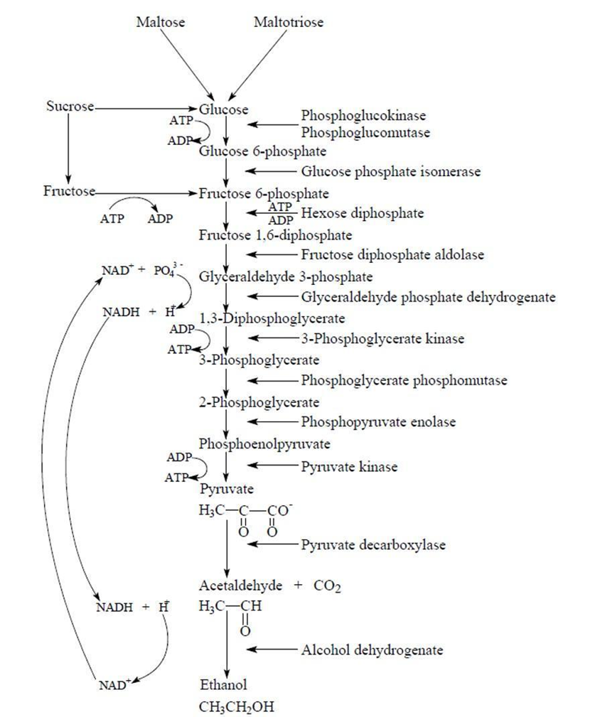
Figure 1: The glycolytic pathway for ethanol fermentation during anaerobic respiration of yeast (Campbell).

Flavors in Beer/ Role of ATF1 in Yeast
Ethanol and carbon dioxide are not only products produced by yeast during fermentation, but they are also used in other metabolic pathways that produce additional byproducts including sulfur-containing molecules, organic acids, higher alcohols, carbonyl compounds, and volatile esters that can change the flavor, aroma, and mouthfeel of fermented beverages (Verstrepen, Moonjai et al. 2003, Verstrepen, Derdelinckx et al. 2003). The alcohol acetyl transferase (AATase) enzymes are encoded by ATF1, ATF2, and Lg-ATF1 (only in S. bayanus strains), which have been cloned and characterized, and catalyze the reaction that produces acetate esters from ethanol and acetyl-CoA (Saerens, Delvaux et al. 2010). Pyruvate is converted to acetyl-CoA by oxidative decarboxylation (Saerens, Delvaux et al. 2010). When oxygen is not present to repress translation, Atf1 then esterifies the acetyl-CoA with a higher alcohol to produce acetate esters: ethyl acetate, isoamyl acetate, phenyl ethyl acetate, or isobutyl acetate (fig 2) (Pires, Teixeira et al. 2014). The two most abundant acetate esters are ethyl acetate, which produces a solvent-like aroma, and isoamyl acetate, which gives a fruity aroma similar to banana (Saerens, Delvaux et al. 2010). The concentrations of these compounds are usually found around the flavor threshold for humans in fermented products, and this lends to the idea that small changes in concentrations or ratios of these compounds can significantly impact the discernment of the ester (Dzialo, Park et al. 2017), and therefore the flavor of beer. Different species and strains of yeast have varying enzyme activities and affinities towards different higher alcohols that lead to differences in ester production. For example, S. kudriavzevii and S. uvarum produce much more phenylethyl acetate than S. cerevisiae, because their Atf1 has a higher affinity for phenylethanol than that of S. cerevisiae (Dzialo, Park et al. 2017).
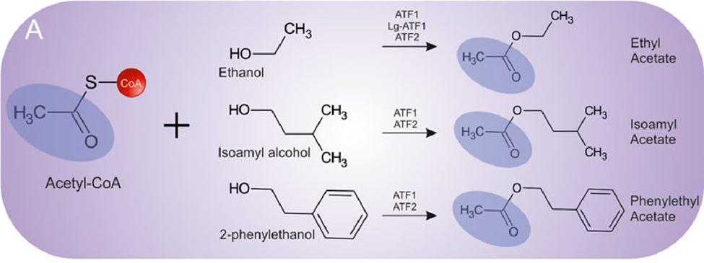
Figure 2: Schematic of the biosynthesis of acetate esters (Pires, Teixeira et al. 2014).

The synthesis of the aroma compounds can be influenced positively and negatively by many factors. The most important factor that influences the acetate ester levels is the expression level of ATF1, which catalyzes the rate limiting step for acetate ester biosynthesis (Saerens, Delvaux et al. 2010). Several different labs have shown that a higher percentage of sugar (specific gravity) and nitrogen in the wort will increase ester production by stimulating expression of ATF1 (Saerens, Delvaux et al. 2010, Dzialo, Park et al. 2017). In contrast, the presence of dissolved oxygen in the wort represses transcription of ATF1 (Saerens, Delvaux et al. 2010, Dzialo, Park et al. 2017). In addition, different strains of S. cerevisae express ATF1 at different levels and therefore produce beer with different flavor profiles (Saerens, Delvaux et al. 2010).
The industrial yeast strain that is chosen for each type of beer is not done based on it being optimal for the application, but because the specific strain is historically used for that beer type although it may actually be suboptimal (Steensels, Snoek et al. 2014). A large analysis of wild and industrial yeast strains uncovered a calculated 7.27 x 10⁻³ genetic sequence diversity (the average number of nucleotide differences per site between any two randomly chosen DNA sequences of a sample population) among the sampled set (Steensels, Snoek et al. 2014). This was more than one order of magnitude larger than what was present in small group of yeast used in wine making (Steensels, Snoek et al. 2014). To put this in perspective, nucleotide diversity among humans is about 1 x 10⁻³ (Steensels, Snoek et al. 2014). According to the numbers there is great potential for increased diversity of strains that has yet to be explored, and Figure 3 outlines the potential to increase yeast genetic diversity.
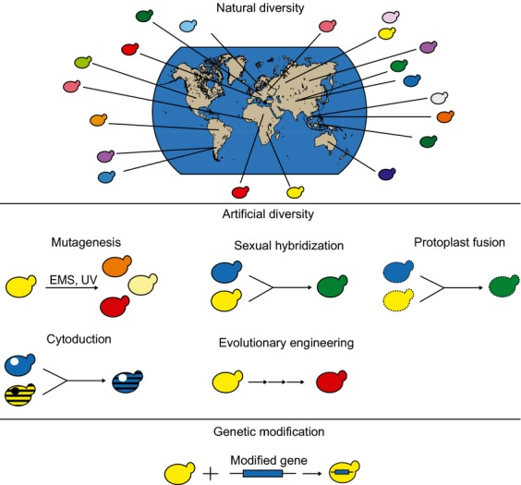
Figure 3: Overview of strategies to obtain superior industrial yeast strains. Natural diversity would select strains from all over and screen based on a selected expression of ATF1. Artificial diversity would be a non-genetically modified method used to introduce genetic diversity. A final option, would be to genetically modify yeast (Steensels, Snoek et al. 2014).

In the first aim of this proposal, we will identify wild yeast strains that are able to ferment barley to produce beer with a preferable flavor. The successful strains will be tested for their usefulness in commercial brewing. We will test whether the strains can withstand the stress of the brewing process demands, but still consistently and efficiently produce a quality product. If the wild yeast strains are not viable for commercial use, we will mutate ATF1 and other candidate genes in commercial strains to match the sequences found in wild yeast. In our second aim, we will induce targeted variations in ATF1 and the promoter region of commercial yeast strains to isolate sequence changes that result in flavor differences. The ability to identify these specific changes that drive flavor will enhance the options for brewers when creating new products.
Aim 1A: We will collect wild yeast strains and evaluate them for fermentation potential. Flavor and aroma of fermented products will be analyzed by a professional panel focusing on pear, banana, and solvent-like flavors. In addition, the presence of ethanol, isoamyl acetate and ethyl acetate will be evaluated by headspace gas chromatography.
Aim 1B: Most yeast strains are not viable in the conditions required for commercial brewing as they cannot survive in sufficiently high concentrations of ethanol, have slow or inefficient wort attenuation, and a higher mutation rate which leads to a less consistent product. The optimum result would be to isolate a wild yeast strain that could hold up under the pressures of the brewing process by remaining genetically stable and viable. If these criteria are not met then methods to artificially generate diversity without modifying the yeast genetically will be explored.
We will serially perform whole genome sequencing of the most successful strains to monitor genome stability. If the wild yeast strains are determined not to be robust enough for commercial use, we will use the whole genome sequencing information of the wild yeast to identify candidate mutations to make in reference industrial yeast strains.
ATF changes in this aim do not rule out the potential effects of other unknown enzymes that may also play a role in the biosynthesis of acetate esters. Previous work indicates that there may be at least one other unknown enzyme in S. cerevisiae that generates 50% of the ethyl acetate (Verstrepen, Van Laere et al. 2003). We will therefore perform a full BLAST analysis to find other regions of the S. cerevisiae and wild yeast genomes with significant sequence similarity to ATF1, ATF2, or Lg-ATF1 that is suggestive of the potential to perform a similar function. Once all mutations in ATF1, ATF2, Lg-ATF1, its regulatory sequences, and sequences with homology have been identified, we will evaluate the effects of these changes in a commercial brewing strain.
According to the Non-GMO Project, “Genetically modified organisms (GMOs) are living organisms whose genetic material has been artificially manipulated in a laboratory through genetic engineering. This creates combinations of plant, animal, bacteria, and virus genes that do not occur in nature or through traditional crossbreeding methods”. To increase the chances of producing a non-genetically modified commercial strain from the potential wild yeast candidates we will attempt a rare mating cross with an industrial strain. The lager yeast strain S. pastorianus is an example of an interspecies hybrid that was derived from tanks of a brewery. Rare matings can occur in diploid populations when the mating-type locus in one cell becomes homozygous and crosses with a cell of the opposite mating type (Steensels, Snoek et al. 2014). The success of the cross will be verified by PCR to validate the presence of parental strain specific genome targets of both parents in the hybrid and presence of the desired ATF1 sequence.
If the rare mating method is unsuccessful, we will induce site-specific mutations in the commercial strain by integrating a selectable marker module cassette, called a CORE, into the locus by targeted homologous recombination (Moqtaderi and Geisberg 2001). The CORE cassette contains an I-SceI target site and an I-SceI galactose-inducible endonuclease (Figure 4). After the yeast is transformed with the CORE cassette, a double strand break is introduced by culturing the cells on galactose to induce I-SceI cutting by the expression of the endonuclease (Moqtaderi and Geisberg 2001). Oligonucleotides with the site-specific mutations are targeted to the site by a 50-nucleotide flanking sequence. Integration of the mutant oligo excises the CORE cassette and leaves no other artifacts behind in the yeast genome.
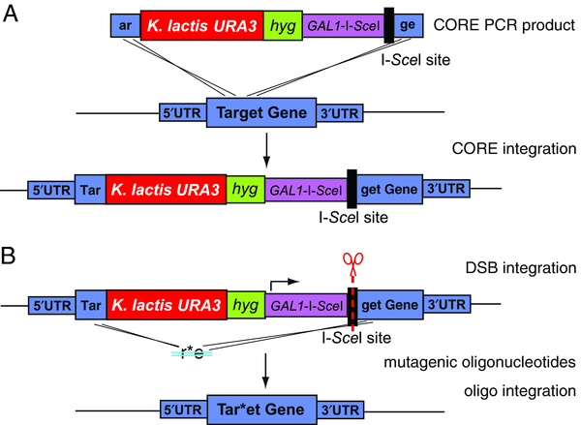
Figure 4: Step-wise overview of modifications to introduce site-specific mutations into a target locus without leaving residual sequence in the genome.

Using this method, site-specific mutations can be introduced into yeast cells without leaving anything extra in the genome that would make it unusable in commercial brewing because of the negative appeal of genetically modified organisms to the general public.
Aim 2
In Aim 2 of this proposal we will investigate whether sequence changes in ATF1 or its promoter sequence will lead to improved flavor of beverages that are fermented by the mutant yeast. The fact that the expression of ATF1 and therefore the translation of the alcohol acetyl transferase I enzyme is the limiting factor of acetate ester synthesis makes this the obvious target for aroma profile tweaking.
The sequence regions of interest are marked in bold in Figure 5 and have been shown to regulate the transcription of ATF1. These regions include not only the ATF1 promoter, but also two regions upstream of the gene promoter that can be activated or repressed. The presence of oxygen represses ATF1 transcription by binding of a Rox1p complex from the oxygen-induced pathway to a site 150 – 100 bp up stream of the ATF1 promoter (Fujiwara, Kobayashi et al. 1999). There is another 18bp region 85-68 bp upstream that is repressed by unsaturated fatty acids in an unknown manner and activated by Rap1p, a nuclear protein upregulated in response to glucose for growth regulation (Fujiwara, Kobayashi et al. 1999). Variability in these two binding sites and in the ATF1 coding region will be evaluated to see if they produce an increase in acetate ester production and thereby change the flavor profile of the fermented product.
Figure 5: Nucleotide sequences of the regulatory region in the ATF1 promoter and supposed upstream response element. Numbers are relative to translation start for ATF1. Underlined sequences represent the sequences for Rox1p binding (-123 -113) and Rap1p binding (-79 -72) (Fujiwara, Kobayashi et al. 1999).

In addition to nonsynonymous mutations, the Atf1p coding sequence will also be examined to determine if there is a possibility of a silent mutation where the mismatch in DNA sequence still codes for the same amino acid which is called a synonymous codon. Each organism has a bias towards a particular set of codons over others (Quax, Claassens et al. 2015). This codon bias can affect protein folding, general protein expression levels, and the differential regulation of protein expression (Quax, Claassens et al. 2015). The occurrence of synonymous codons has been observed in highly expressed genes that contain increased ratios of codons recognized by abundant, charged tRNAs that increases translation efficiency (Quax, Claassens et al. 2015). It has also been found that there is not a randomness to synonymous codons as one would expect, but that they tend to cluster by recognition of the same tRNA (Quax, Claassens et al. 2015). This is more prominent in genes that must be rapidly induced like those involved in stress response (Quax, Claassens et al. 2015). There is a possibility that the codon bias that has been selected for in industrial Saccharomyces cerevisiae limits the expression of ATF1, so that the sequence from a higher expressing mutated yeast could overcome the codon bias and allow fine-tuning of ATF1expression. Using the Delitto Perfetto method described in Aim 1, we will introduce random mutations in ATF1 and its regulatory regions. Integration of the mutant oligonucleotides will be verified by the presence or absence of growth on 5-fluoroorotic acid and hygromycin. Three purified clones from each mutation introduced will be expanded and evaluated for flavor by a professional panel, and the concentration of acetate ester production will be quantified by headspace gas chromatography.

Benefits & Caveats
The commercial process of high gravity brewing produces an undesirable solvent-like aroma that is brought about by the disproportionate amount of ethyl acetate production (Verstrepen, Van Laere et al. 2003). This will require the isoamyl acetate and ethyl acetate concentration ratio to be optimized to fall within a certain range. The manipulation of the ATF1 sequence in the industrial strain will allow the true outcome from commercial fermentation to be evaluated (Verstrepen, Van Laere et al. 2003). In addition, we will be able to directly evaluate the effects of these mutations without altering other aspects of the fermentation pathway that allow efficient and consistent fermentation of malt beverages in an industrial setting. Since additional pathways may also contribute to the complex flavor of beer, leaving them untouched is also the best way to ensure that any changes in flavor are due to the mutation of ATF1. However, there are some caveats. There is the possibility that the CORE integration scheme described in AIM 1B will not be successful. In that case, we will induce the candidate mutations using the CRISPR-Cas9 system. Induction of ATF1 sequence variants in the commercial brewing yeast may pose difficulty as industrial yeast strains have low-efficiency mating and sporulation and are usually polyploid (Ryan and Cate 2014). These traits would make traditional crossings difficult to achieve the desired ATF1 mutant genotypes, so CRISPR genome editing may be a better option. Clustered Regularly Interspaced Short Palindromic Repeats (CRISPR) and CRISPR-associated (Cas) systems target specific DNA sequences by utilizing a single guide RNA that base pairs with the protospacer DNA that precedes the Protospacer adjacent motif (PAM) sequence (5’NGG or 5’ NAG) (Ryan and Cate 2014, Roointan and Morowvat 2016). Once targeted, the Cas9 endonuclease creates a double strand break in the genomic DNA that the cell machinery will kick in to repair (Ryan and Cate 2014). The DNA can be repaired by non-homologous end joining that creates disruptions in the gene by insertions or deletions, or a linearized DNA containing sequence homology to the area around the double strand break can be inserted by homologous directed recombination to edit the gene of interest (Ryan and Cate 2014, Roointan and Morowvat 2016).
The CRISPR-Cas9 system can have poor transformation efficiency and also cause off-target mutations (Ryan and Cate 2014, Roointan and Morowvat 2016). In the case of poor transformation efficiency, we will employ alternative methods such as: direct mating, two-step PCR based cloning, or transformation of knockout libraries with plasmid vectors. The knockout libraries would be less favorable since their genetics are less complex than industrial S. cerevisiae and would not be a true representative (Steensels, Snoek et al. 2014). Another potential caveat is the negative appeal of genetically modified organisms by consumers, which may lead industrial brewers to avoid using a yeast strain that is genetically altered using CRISPR-Cas9. This caveat is addressed by our preferential use of The CORE cassette method, which does not introduce exogenous sequences and is therefore not considered to be genetic modification by the Non-GMO Project.

PRELIMINARY REPORT / PROGRESS REPORT

There have been several studies completed related to ATF1 and copious information has been learned from them about its physiological role, genetic regulation, and how the expression of ATF1 varies across yeast strains. Although none have directly linked specific sequence changes in the ATF1 and promoter region to increasing or decreasing acetate ester synthesis to change the flavor of beer.
Aim 1A, to look for wild yeast strains, is supported by work completed by Christiaens et al., who fluorescently labeled a wildtype yeast strain with yECitrine and the ATF1 null yeast strain mCherry. These strains were used to spot inoculate an agar dish. A single starved D. melanogaster CS10 fly was placed in the dish for a period of time, removed, and then the agar plate was incubated, and the yeast growth was visualized and examined for fluorescence to distinguish if the fly had a preference to the wildtype yeast or ATF1 null. From the image of the plate you can see that there is much more wildtype yeast (green) growth present as opposed to the ATF1 null yeast (red). This led them to believe that the attraction of the D. melanogaster CS10 fly to the wildtype ATF1 yeast is used to benefit the spread of the yeast to new areas and increase mating and genetic diversity. It can then be hypothesized that if a prominent gene benefits yeast survival then ATF1 from wild yeast has the potential to be different or better than that of the commercial fermentation strains.
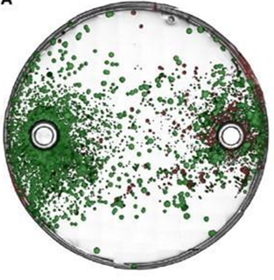
Figure 6: Image of plate after 48-hour incubation. The green is the labelled Wildtype yeast strain and the red are the ATF1 null yeast strain. It is clear that there is less spreading of the ATF1 null cells by the fly (Christiaens, Franco et al. 2014).

Aim 2
The studies by the Verstrepen and Schneiderbager Labs show that ATF regulation amongst lager, ale, and wheat yeast strains lead to different flavor profiles. If the ATF1 sequence variations intra-strain elicit change then it can be hypothesized that there is potential to establish specific control of flavor based on sequence. Kevin Verstrepen from the Centre for Malting and Brewing Science at the Katholieke Universiteit Leuven has produced knockouts and over-expressers of ATF for fermentation analysis. He used the BY4742 strain for the deletion experiments because it is easier to delete all copies of the gene in the haploid strain than the aneuploid industrial strain, but the industrial strain CMBS33 was used to analyze the overexpression for a truer-to-life evaluation of the fermentation procedure (Verstrepen, Van Laere et al. 2003). The overexpressing industrial strain was made by inserting a vector with PGK1 overexpression cassette driving either the allele from the industrial lager ATF or the industrial ale ATF (Verstrepen, Van Laere et al. 2003). The data in Table 1 was compounded from headspace gas chromatography analysis of six independent fermentations from ATF deletion strain samples collected 36 hours after fermentation. The deletion of ATF1 does not inhibit all production of ethyl acetate or isoamyl acetate, but it decreases it by 38% and 84% respectively from wild type. The deletion of both ATF1 and ATF2, nearly abolished all production of isoamyl acetate, but ethyl acetate production was only decreased by 50% (Verstrepen, Van Laere et al. 2003). These results indicate ethyl acetate is not solely synthesized by the Atf enzymes, but that the ability to vary the expression of ATF1 alone should give enough power to change the flavor profile for beer production.
Table 1: Headspace gas chromatography measurement of acetate esters produced from ATF1 deletion in the BY4742 strain (Verstrepen, Van Laere et al. 2003).
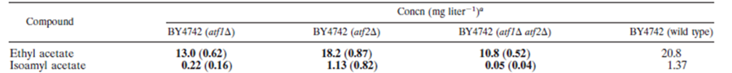
In contrast, when overexpression of ATF1 in the CMBS33 industrial strain was analyzed by evaluating fermentation products from six independent fermentations in the same manner, the concentrations of ethyl acetate or isoamyl acetate were greatly increased relative to the concentrations in wildtype strains. Independent of allele overexpression, isoamyl acetate concentration was increased 180-fold and ethyl acetate by about 30-fold. Overexpression of ATF2 or Lg-ATF1 alone did not increase the acetate ester concentration anywhere near as much. The ATF1 allele of CMBS33 (lager) and CMBS212 (ale) were sequence analyzed and the results showed a difference of only 9 bp that varied the amino acid sequence by six (Verstrepen, Van Laere et al. 2003).
Table 2: Headspace gas chromatography measurement of acetate esters produced from ATF1 overexpression in the industrial lager strain (Verstrepen, Van Laere et al. 2003).
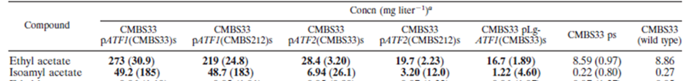
Different yeast strains used in the production of wheat beer were evaluated on their level of gene expression and synthesis of acetate ester at different time points during fermentation (Schneiderbanger, Koob et al.). The expression level of ATF1 varied greatly among the 5 yeast strains (Figure 7), but the concentration of the isoamyl acetate, fruity/banana aroma that wheat beer is known for (Figure 8) seems to increase and plateau at a consistent rate across strains during the initial fermentation step (Schneiderbanger, Koob et al.). Schneiderbanger concluded that some AATase I enzyme may already be present in the yeast cells from propagation, so this could explain why some strains have low upregulation, but still have the equal isoamyl acetate production. Most ester concentrations hover around the threshold during fermentation, so small changes in concentration can cause larger differences in the sensorial quality of the fermented product (Saerens, Delvaux et al. 2010). This study used quantitative methods to evaluate ATF1 activity and did not examine qualitative changes to the fermentation product, so no conclusion can be drawn as to how the gene expression data correlated to the taste of the final product. This also supports the use of a single strain for genetic modification to evaluate if a specific mutation that produced a preferred flavor in wild yeast will cause a flavor change in the industrial yeast strain.
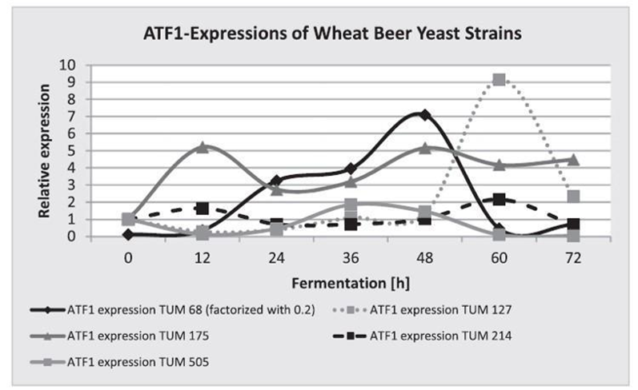
Figure 7: The normalized expression of ATF1 in different strains of yeast used in wheat beer production (Schneiderbanger, Koob et al.).

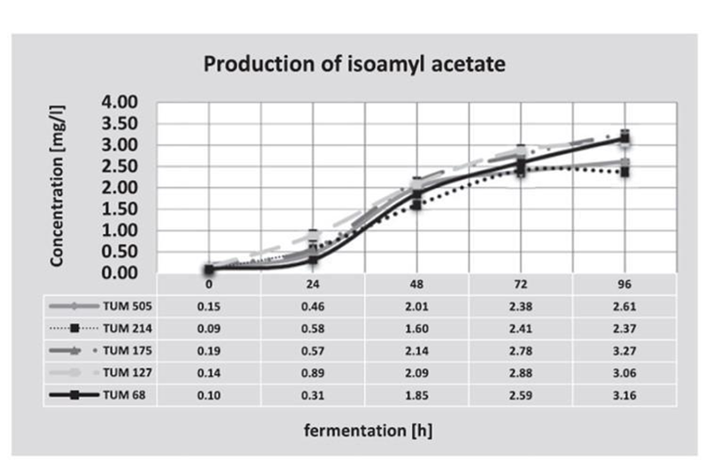
Figure 8: The concentration of isoamyl acetate synthesized during initial fermentation of different wheat beer yeast (Schneiderbanger, Koob et al.).

RESEACH DESIGN / METHODS
Aim 1: Identify Wild Yeast Strains that Produce Beer with a Preferable Flavor and to Translate these Findings to Generate a Commercially Viable Yeast Strain that Produces Better Tasting Beer.
The samples that will be used to isolate yeast will be gathered from orchards and farms. The ideal site to gather a sample will be produce that is beginning to rot but has not fallen from the plant (Lee, Choi et al. 2011, Lentz, Putzke et al. 2014). Such fruits and vegetables will be collected and stored in a dark cool place. Individually wrapped sterile cotton swabs will also be used to wipe down surfaces in the produce housing areas and stored in the same manner as the other samples. The collected samples are then diced and placed into 15-mL conical tubes containing 9 mL of yeast peptone dextrose (YPD) broth (1% yeast extract, 2% peptone, 2% dextrose, pH 4.5). The swabs that are used to collect samples are submerged and swirled in 15-mL conical tubes containing 9 mL YPD broth. All samples are then vortexed vigorously for several minutes to ensure that the microbes contained in the samples are inoculated into the sterile broth. The liquid cultures are stored at 25ºC for no more than 7 days. After 2 days, growth should be evident in most cultures by the turbidity of the YPD broth. After 7 days, 200 μl from each sample that yielded growth is spread on to YPD agar plates and incubated for 2 days at 30ºC (Lee, Choi et al. 2011, Lentz, Putzke et al. 2014).
Colonies that display yeast-like morphology, white, smooth, and round, are isolated and quadrant streaked onto new YPD agar plates to further purify the yeast strain. A small amount of each colony picked is suspended in H₂O and then a drop is placed on a microscope slide with a cover slip. A Zeiss AX10 VERT25 is used to visualize the morphology and determine the purity of the cells at 400x. After 2 days at 30ºC the individual isolated colonies are picked with a sterile inoculating loop and added to 5 mL YPD broth and grown for another 5 days. Each sample is cryopreserved for future use by taking 1 mL from each sample mixing it with 20% glycerol and storing them at -80ºC. The remainder of the sample is split into two aliquots, 3 mL and 1 mL. The 3-mL aliquot of sample is centrifuged, media removed, and the cell pellet is flash frozen using dry ice and methanol and stored at -80ºC for DNA extraction. Inoculating 10 mL YPD broth with the other 1 mL and placing it at 30ºC for 72 hours will expand the cells for further analysis.
A sample of each isolated yeast is used to test for alcohol tolerance and the ability to ferment wort. The ability of the yeast to grow in alcohol is determined by cell growth measured at OD₆₀₀ on a spectrophotometer (SpectraMAX M5; Molecular Devices, Sunnyvale, CA). Absolute ethanol is added to YPD broth at a final concentration ranging from 0 to 15% percent. A volume of 200 μl of each dilution of ethanol in YPD broth is added to a 96-well plate in triplicate. Two microliters of each yeast isolate is added to the range of YPD-ethanol concentrations and an initial, time 0, OD₆₀₀ reading is obtained on the SpectraMAX M5. The 96-well plate is placed at 30ºC. After 4 days of growth the final OD₆₀₀ reading is taken and used to calculate growth for each sample by subtracting the initial (time 0) value from the final value for each concentration of ethanol. The greater the final value, the more tolerant the yeast is to that percentage of ethanol.
To assess the potential for fermentation, dry malt extract (DME) is used to make wort at three different original gravities (OG): 1.040 OG (10ºP), 1.048 OG (12ºP), or 1.056 OG (14ºP). Each yeast is added to the starter culture at a final concentration of 1 million cells per milliliter, and the cultures are covered with air lock lid and shaken at 20ºC for four weeks. After the 4 weeks, the final gravity is determined for each sample and used to calculate the apparent attenuation, or the percentage of conversion of sugar to alcohol and CO₂, which indicates the strains fermentation ability. The strains that reach 70% apparent attenuation are used to produce a small batch of beer. In order to minimize variability a large volume of wort is prepared from DME at 12ºP and bittering hops are added to a calculated 30 IBU. Forty milliliters of each starter culture is added to 400 mL of the wort in sterile 500 mL bottles with air lock lids. Each beer is fermented for four weeks at 20ºC before being bottled with a dextrose solution to generate CO₂ and capped. The bottled beer is aged for another four weeks and then samples of each are judged by a professional panel of beer judges for flavor and aroma. A sample of each fermented beer batch is also sent for analysis by headspace gas chromatography to look for the presence of ethanol, isoamyl acetate, and ethyl acetate. All of the collected data will be analyzed to determine the wild yeast clone that passes all categories and produces the best flavor.
The selected wild yeast strain will be identified by PCR. DNA is extracted from the wild yeast isolates using Qiagen’s DNeasy Blood & Tissue Kit per the supplementary protocol to extract DNA from yeast. The individual yeast colony DNA is used for identification of the specific strain by performing PCR and looking at the 5.8s rDNA and 26s rDNA nucleotide sequences. PCR using primers NL1 (^{5'}GCATATCAATAAGCGGAGGAAAAG^{3'}), NL4 (^{5'}GGTCCGTGTTTCAAGACGG^{3'}), ITS1 (^{5′}TCCGTAGGTGAACCTGCGG^{3’}) and ITS4 (^{5′}TCCTCCGCTTATTGATATGC^{3’}) is carried out under the following conditions: initial denaturation at 94ºC for 5 min and 36 cycles of denaturation at 94ºC for 1 min, annealing at 58ºC for 2 min, extension at 72ºC for 2 min, with a final extension at 72ºC for 8 min (Lee, Choi et al. 2011, Lentz, Putzke et al. 2014). The 26s rDNA, NL1 and NL4, and 5.8s rDNA, ITS1 and ITS4, primers are used to sequence the PCR products. The resulting sequence is analyzed by BLAST against the National Cancer for Biotechnology Information (NCBI) metagenomics database to identify yeast species and strains with matching sequences of the 5.8s rDNA and 26s rRNA gene (Lee, Choi et al. 2011, Lentz, Putzke et al. 2014).
The wild yeast that yielded moderate growth in >4% ethanol, fermented wort to at least 70% attenuation, and had no off-putting aromas noted by the tasting panel is selected for its preferential flavor and is used for continuous brewing to assess its potential for commercial use. A 40-mL starter culture that will be added to a 500-mL bottle with air locking lid that contains a 400 mL batch of wort prepared from DME at 12ºP. Each batch is fermented for one week at 20ºC before being split at a 1 to 40 ratio into new 400 mL 12ºP DME (Lentz, Putzke et al. 2014). This process is repeated for eight weeks, and then the final split is pitched into 400 mL 12ºP DME with bittering hops and allowed to ferment for four weeks at 20ºC before being bottled with dextrose solution. The bottled beer is aged for another four weeks and then samples of each are judged by a professional panel of beer judges for flavor and aroma. The yeast that settle at the bottom of the bottle after the second fermentation are collected for whole-genome sequencing. The data is compiled and analyzed for commercial brewing potential. The wild yeast strain would be an ideal candidate for commercial use if there is no genetic drift or mutation in the whole-genome sequence over time and the flavor profile remains consistent.
If a wild yeast strain that produces a desirable flavor profile is not identified as a viable option for commercial brewing, then a direct mating and a rare mating will be conducted with the top wild yeast candidate and an industrial yeast strain with a greater ethanol tolerance than the wild yeast. Sporulation of both parental lines was induced by plating each strain on YPD plates containing 1% (w/v) potassium acetate and incubating for 4 days at 25ºC (Treco and Winston 2001). A light microscope is used to assess the tetrads before the ascus cell wall is digested with 0.5mg/mL Zymolyase-100T. The yeast tetrads are dissected by micromanipulation and single spores from each parental strain are placed together on YPD agar plates and grown at room temperature until zygote formation is seen (Treco and Winston 2001). Potential hybrids are picked and purified by streaking on YPD agar plates. For the rare mating, the two yeast strains are combined in YPD liquid at OD₆₀₀. Shake this culture at 30ºC and allow to grow until OD₆₀₀ is equal to 5.0. The cells are then plated on YPD agar plates and grown overnight at 30ºC. To select for potential hybrids that will produce an improved flavor production profile from either of the matings, the colonies that grow are replica-plated on YPD agar plates that contain double selection. The two selection reagents will be the higher percentage of ethanol tolerated by the industrial yeast strain and 5,5,5-trifluoro-D,L-leucine that will inhibit synthesis of amino acids and increase isoamyl alcohol or pregnenolone to increase isoamyl acetate production (Steensels, Snoek et al. 2014). Potential hybrids that grow out on the double selection are streaked for single colonies and then grown up. The clones are analyzed by PCR by amplifying parental strain specific genome targets. The presence of two PCR bands confirms that the clone is an interspecies hybrid. The interspecies hybrids can then be expanded for analysis of commercial brewing stability as completed previously on the wild yeast.
In the event that a successful hybrid is not developed, the whole-genome sequence will be aligned with a commercial S. cervisiae strain and evaluated for significant sequence differences in ATF1, ATF2, and Lg-ATF1. Once all mutations in ATF1, ATF2, Lg-ATF1, its regulatory sequences, and sequences with homology from the BLAST analysis have been identified, we will evaluate the effects of these changes in a commercial brewing strain. Hypotheses as to the mutations that are most likely to produce the desired flavor will be made based on missense, nonsense, or frameshift mutations identified by comparison of the wild sequences to the standard brewing strain, and tested by genetic modification of a control Saccharomyces cerevisiae strain to mimic the mutations.
Once the sequence variations to be tested are identified from the wild yeast strain, these sequences need to be altered in the Brewer’s yeast Saccharomyces cerevisiae to test if the change in genetic sequence will produce the same flavor profile in beer that was desirable from the wild yeast. Custom oligos are designed for each of the two required transformations. The pGSHU CORE plasmid will be amplified by primers 5’-upstream flanking sequence from TARGET locus- TAGGGATAACAGGGTAATCCGCGCGTTGGCCGATTCAT -3’ and 5’-downstream flanking sequence from complementary strand of TARGET locus- TTCGTACGCTGCAGGTCGAC -3’ (Moqtaderi and Geisberg 2001). The oligonucleotides used to create the identified mutations need to have at least 50 nucleotides from the region being target on each end to increase efficiency. The CORE plasmid amplification, transformation of parental industrial yeast strain, and integration of the mutant oligonucleotide to excise the CORE cassette will be carried out following the methods outlined in the Delitto Perfetto Method of Unit 13.10C of Supplement 104 in Current Protocols in Molecular Biology. Isolated mutant yeast colonies will be expanded for fermenting a small batch of beer for flavor analysis and cryogenic preservation. A large volume of wort is prepared from DME at 12ºP and bittering hops are added to a calculated 30 IBU. Starter culture is added to wort in sterile bottles with air lock lids. Each beer is fermented for four weeks at 20ºC before being bottled with a dextrose solution to generate CO₂ and capped. The bottled beer is aged for another four weeks and then samples of each are judged by a professional panel of beer judges for flavor and aroma. A sample of each fermented beer batch is also sent for analysis by headspace gas chromatography to look for the presence of ethanol, isoamyl acetate, and ethyl acetate. The flavor results and the gas chromatography results for the modified Brewer’s Saccharomyces cerevisiae are then compared to the results obtained from the wild yeast strains looking for similarities in flavor profile and concentration of aroma-active esters that can be linked to the specific mutations in ATF that were introduced.
An alternative to the Delitto Perfetto method would be to edit the Brewer’s Yeast by CRISPR technology utilizing Cold Spring Harbor’s protocol for genome editing utilizing the pCAS plasmid that only requires a single cloning modification to insert the 20-bp guide RNA sequence that is target specific (Ryan, Poddar et al. 2016). Depending on the number of variations and their location within ATF1 multiple 20-bp target sequences may need to be designed. CT-finder (http://bioinfolab.miamioh.edu/ct-finder) is used to design the guide RNA (gRNA) by uploading the FASTA sequence for the ATF sections of Brewer’s yeast that will be targeted for alteration. The 20 bp sequence needs to be directly 5’ of the protospacer adjacent motif (PAM) sequence that is identified from the CT-finder program to fit in the sgRNA cassette of the pCAS plasmid. Use the ^{5’}CGGGTGGCGAATGGGACTTT-[20-bptargetsequence]-GTTTTAGAGCTAGAAATAGC^{3’} sequence to design a 60-mer oligonucleotide to the coding sequence and reverse complement for cloning. These custom oligos are ordered from Eurofins Louisville, KY. The mutant allele 60-mer oligo that will be integrated also needs to be ordered now. These oligos will match the sequences from the wild type yeast that were chosen after comparing all initial data. Amplification primer sets with 50 bp homology to the genome target need to be designed for each mutant oligo. The pCAS plasmid is prepared for cloning by performing a PCR reaction as outlined in the Cold Spring Harbor protocol to ligate the sgRNA cassette to the pCAS plasmid. The final product is digested with DpnI endonuclease to degrade any non-mutated template that may still be present. DH10B chemically competent E. coli cells are transformed by adding the Dpn1 treated cloning reaction and allowing the mix to incubate. The uptake of the plasmid into the E. coli cells is increased by a heat shock that is performed at 42ºC for 1 minute in a water bath. The cells then recover for 1 hour at 37ºC in 200 μl LB liquid medium before being spread onto LB+ kanamycin plates. After incubating overnight at 37ºC, five to 10 colonies that grow are chosen and added to individual tubes containing LB+ kanamycin. The selected E. coli colonies are further expanded by shake-incubating overnight at 37ºC. The plasmid is extracted from the cells by using the Qiagen DNeasy Blood & Tissue Kit per the manufacture’s protocol and a NanoDrop is used to quantify the plasmid concentration. In order to determine which E. coli clone contains successful pCAS cloning sgRNA constructs each DNA is sequenced using Sanger sequencing with primer ^{5’}CGGAATAGGAACTTCAAAGCG^{3’}. The ATF1 mutant oligos are amplified by PCR and size verified on a 2% agarose TAE gel.
For the commercial brewing yeast to be able to take up the pCAS plasmid and oligonucleotide for testing the mutation in ATF1 during transformation they need to be made competent. A single colony from a YPD agar plate is used to inoculate YPD liquid. The culture is shaken at 220 rpm overnight at 30ºC, and then an OD₆₀₀ reading is taken and used to calculate how much is needed to make YPD liquid at OD₆₀₀ 0.2. Shake this culture at 30ºC and allow to grow until OD₆₀₀ is equal to 1.0. Three 50-mL conical tubes are used to divide the culture, 33 mL per tube, to make multiple aliquots of competent cells. All three 50-mL conical tubes are centrifuged at 1,400 x g at room temperature for 2 minutes to pellet the cells out of suspension. The supernatant is removed, and the cells are resuspended in 500 µl solution containing 100 mM lithium acetate and 1X TE buffer (LATE solution). This suspension is transferred to 1.5-mL Eppendorf microcentrifuge tube and centrifuged at 8,600 x g at room temperature for 1 minute. The resulting supernatant is removed, and the yeast cell pellet is resuspended in LATE solution. 50% glycerol is added at a 1:1 ratio as a cryopreservative, mixed well by pipetting, and stored at -80ºC until use (Ryan, Poddar et al. 2016).
The competent Brewer’s yeast will be co-transformed with the modified pCAS plasmid and the linear ATF1 mutant allele oligo according to the “CRISPR-Cas9 Genome Engineering in Saccharomyces cerevisiae Cell” protocol by (Ryan, Poddar et al. 2016). The cells for each reaction are pelleted by centrifugation, the supernatant is removed, and YPD liquid is added for recovery and each tube is incubated at 30ºC for two hours. The co-transformed yeast cells are cloned by plating the mixture onto YPD agar plates containing G418 to select for the presence of the plasmid. These plates are incubated for 48 hours at 37ºC, and then single colonies are chosen for expansion and analysis. Each colony is grown in YPD liquid at 30ºC while shaking overnight, streaked again on YPD agar plates to isolate clones, and allowed to incubate overnight at 37ºC. The clones that grow out are selected and grown in YPC liquid with shaking overnight to expand the colony. A small bit of the colony is also streaked onto YPD agar plates containing G418 to verify that the pCAS plasmid has been lost indicating that the CRISPR-Cas9 is not present. Half of the YPD liquid containing the expanded clones is removed and centrifuged to pellet the cells. The DNA is extracted from the cell pellets using Qiagen’s DNeasy Blood & Tissue Kit per the supplementary protocol for extracting DNA from yeast, and the correct integration of the mutant allele is verified using the allele specific primers to complete PCR and sequencing. The clones that contain the correct mutant allele integration are then used to grow a 40-mL starter culture that will be added to a 500-mL bottle with air locking lid that contains a 400 mL batch of wort prepared from DME at 12ºP and bittering hops added to a calculated 30 IBU. Each beer is fermented for four weeks at 20ºC before being bottled with a dextrose solution to generate CO₂ and capped (Lentz, Putzke et al. 2014). The bottled beer is aged for another four weeks and then samples of each are judged by a professional panel of beer judges for flavor and aroma looking for the pear, banana, and solvent-like aromas indicative of ATF1. A sample of each fermented beer is also sent for analysis by headspace gas chromatography to look for the presence of ethanol, isoamyl acetate, and ethyl acetate. The flavor results and the gas chromatography results for the modified Brewer’s Saccharomyces cerevisiae are then compared to the results obtained from the wild yeast strains looking for similarities in flavor profile and concentration of aroma-active esters that can be linked to the specific mutations in ATF1 that were introduced.

Aim 2: Induce Random Mutations in ATF1 and Regulatory Regions in Commercial Yeast Strains and Test for Improved Flavor.
The same industrial strain that was used in Aim 1 will be utilized for inducing random mutations in ATF1 via a CORE cassette and mutant oligonucleotides to identify sequence changes that will result in better flavor of the beer produced. Custom oligos are designed for each of the two required transformations. The pGSHU CORE plasmid will be amplified by primers 5’-upstream flanking sequence from ATF1 locus- TAGGGATAACAGGGTAATCCGCGCGTTGGCCGATTCAT -3’ and 5’-downstream flanking sequence from complementary strand of ATF1 locus- TTCGTACGCTGCAGGTCGAC -3’ (Moqtaderi and Geisberg 2001). The oligonucleotides used to create random mutations in ATF1 and the regulatory regions need to have at least 50 nucleotides from the region being targeted on each end to increase efficiency. The CORE plasmid amplification, transformation of parental industrial yeast strain, and integration of the ATF1 mutant oligonucleotide to excise the CORE cassette will be carried out following the methods outlined in the Delitto Perfetto Method of Unit 13.10C of Supplement 104 in Current Protocols in Molecular Biology. Once mutant oligo integration is verified, three independent clones from each random mutant transformation will be expanded for fermenting a small batch of beer for acetate ester quantification and cryogenic preservation. To minimize variability due to nutrient concentrations, a large volume of wort is prepared from DME at 12ºP and bittering hops are added to a calculated 30 IBU. Starter culture for each isolated mutant clone is added to a small volume of wort in sterile bottles with air lock lids. Each beer is fermented for four weeks at 20ºC before being bottled with a dextrose solution to generate CO₂ and capped. The bottled beer is aged for another four weeks and then samples of each are sent for analysis by headspace gas chromatography to look for the presence of ethanol, isoamyl acetate, and ethyl acetate. The clones that show different concentrations of acetate esters from the parental strain will be used to brew a larger batch of beer that will be judged by a professional panel of beer judges for flavor and aroma looking for the pear, banana, and solvent-like aromas indicative of the ATF1 activity. The gas chromatography results will be charted with the flavor profile noted by the panel for each mutation tested. The results will be compared to the parental industrial yeast profile and links between specific site mutations and the resulting phenotype can be made. The preferred ATF1 mutants will be analyzed as the wild yeast were for stability to be used for commercial fermentation. The site-specific mutations introduced should not have targeted any other part of the yeast genome, so most mutant strains should be viable commercial fermenters. This method could be repeated for multiple commercial ale or lager strains.
REFERENCES

"Fermentaion and anaerobic respiration." Cellular Respiration Retrieved September 6, 2017, from https://www.khanacademy.org/science/biology/cellular-respiration-and-fermentation/variations-on-cellular-respiration/a/fermentation-and-anaerobic-respiration.

Alba-Lois, L. S.-K., C. (2010). "Yeast Fermentation and the making of beer and wine." Nature Education 3(9): 17.
Campbell, S. L. "The Continuous Brewing of Beer." New Zealand Institute of Chemistry, 1-8.

Christiaens, J. F., L. M. Franco, T. L. Cools, L. De Meester, J. Michiels, T. Wenseleers, B. A. Hassan, E. Yaksi and K. J. Verstrepen (2014). "The fungal aroma gene ATF1 promotes dispersal of yeast cells through insect vectors." Cell Rep 9(2): 425-432.

Dzialo, M. C., R. Park, J. Steensels, B. Lievens and K. J. Verstrepen (2017). "Physiology, ecology and industrial applications of aroma formation in yeast." FEMS Microbiol Rev 41(Supp_1): S95-S128.

Fujiwara, D., O. Kobayashi, H. Yoshimoto, S. Harashima and Y. Tamai (1999). "Molecular mechanism of the multiple regulation of the Saccharomyces cerevisiae ATF1 gene encoding alcohol acetyltransferase." Yeast 15(12): 1183-1197.

Hartsock, A. "Yeast Fermentation: Using Fermentation to Make Alcohol." Microbiology 101: Intro to Microbiology Retrieved 9/5/2017, from http://study.com/academy/lesson/yeast-fermentation-using-fermentation-to-make-alcohol.html#lesson.

Lee, Y. J., Y. R. Choi, S. Y. Lee, J. T. Park, J. H. Shim, K. H. Park and J. W. Kim (2011). "Screening wild yeast strains for alcohol fermentation from various fruits." Mycobiology 39(1): 33-39.

Lentz, M., T. Putzke, R. Hessler and E. Luman (2014). "Genetic and physiological characterization of yeast isolated from ripe fruit and analysis of fermentation and brewing potential." Journal of the Institute of Brewing: n/a-n/a.

Moqtaderi, Z. and J. V. Geisberg (2001). Construction of Mutant Alleles in Saccharomyces cerevisiae without Cloning: Overview and the Delitto Perfetto Method. Current Protocols in Molecular Biology, John Wiley & Sons, Inc.

Pires, E. J., J. A. Teixeira, T. Branyik and A. A. Vicente (2014). "Yeast: the soul of beer's aroma--a review of flavour-active esters and higher alcohols produced by the brewing yeast." Appl Microbiol Biotechnol 98(5): 1937-1949.
Quax, T. E., N. J. Claassens, D. Soll and J. van der Oost (2015). "Codon Bias as a Means to Fine-Tune Gene Expression." Mol Cell 59(2): 149-161.

Roointan, A. and M. H. Morowvat (2016). "Road to the future of systems biotechnology: CRISPR-Cas-mediated metabolic engineering for recombinant protein production." Biotechnol Genet Eng Rev 32(1-2): 74-91.

Ryan, O. W. and J. H. Cate (2014). "Multiplex engineering of industrial yeast genomes using CRISPRm." Methods Enzymol 546: 473-489.

Ryan, O. W., S. Poddar and J. H. Cate (2016). "CRISPR-Cas9 Genome Engineering in Saccharomyces cerevisiae Cells." Cold Spring Harb Protoc 2016(6): pdb prot086827.

Saerens, S. M., F. R. Delvaux, K. J. Verstrepen and J. M. Thevelein (2010). "Production and biological function of volatile esters in Saccharomyces cerevisiae." Microb Biotechnol 3(2): 165-177.

Schneiderbanger, H., J. Koob, S. Poltinger, F. Jacob and M. Hutzler "Gene expression in wheat beer yeast strains and the synthesis of acetate esters."

Steensels, J., T. Snoek, E. Meersman, M. P. Nicolino, K. Voordeckers and K. J. Verstrepen (2014). "Improving industrial yeast strains: exploiting natural and artificial diversity." FEMS Microbiology Reviews 38(5): 947-995.

Steensels, J. and K. J. Verstrepen (2014). "Taming wild yeast: potential of conventional and nonconventional yeasts in industrial fermentations." Annu Rev Microbiol 68: 61-80.

Treco, D. A. and F. Winston (2001). Growth and Manipulation of Yeast. Current Protocols in Molecular Biology, John Wiley & Sons, Inc.

Verstrepen, K., N. Moonjai, G. Derdelinckx, J.-P. Dufour, J. Winderickx, J. Thevelein, I. Pretorius and F. Delvaux (2003). Genetic regulation of ester synthesis in brewer’s yeast: new facts, insights and implications for the brewer. Brewing Yeast Fermentation Performance. K. Smart, Blackwell: 234-248.

Verstrepen, K. J., G. Derdelinckx, J. P. Dufour, J. Winderickx, J. M. Thevelein, I. S. Pretorius and F. R. Delvaux (2003). "Flavor-active esters: adding fruitiness to beer." J Biosci Bioeng 96(2): 110-118.

Verstrepen, K. J., S. D. M. Van Laere, B. M. P. Vanderhaegen, G. Derdelinckx, J. P. Dufour, I. S. Pretorius, J. Winderickx, J. M. Thevelein and F. R. Delvaux (2003). "Expression Levels of the Yeast Alcohol Acetyltransferase Genes ATF1, Lg-ATF1, and ATF2 Control the Formation of a Broad Range of Volatile Esters." Applied and Environmental Microbiology 69(9): 5228-5237.

