Visualizing and Animating Data in Python

There is a need for mathematicians and scientists, especially computer scientists, to be able to visualize and animate data. This hackathon will teach you how to set up your own Python development environment and use it to develop your own visualizations and animations.
Prerequisites: To participate, you should be familiar with basic programming, say in Java, C, or Python. Prior experience in Python is not required.

The Development Environment: Anaconda
Python is available in many places, including directly from source at the Python Software Foundation. Python code can be developed with little more than a text editor- I often work with just Notepad++ and a command prompt.
One of the powers of Python is that it is extendable with various modules. For example, if my data is in Excel files, I might use the openpyxl module if I am reading from a modern .xlsx document, or the xlrd module if I am reading from an older .xls document.
Anaconda is a tool that provides both a full featured development environment for Python code and provides an easy way to download and manage Python modules.
Download and install Anaconda from https://www.anaconda.com/products/individual.
Anaconda has installers for Windows, MacOS, and Linux.
The download is substantial and will take a few minutes; the installer is almost half a gigabyte in size. The installation process also takes a few minutes to complete.

Building a custom environment
When Anaconda is first launched, you will be presented with a tool that looks like Figure 1. The default behavior for Anaconda Navigator is to set up a base (root) environment that is used by default. This environment will be used by all the tools that you install and will be the location of the Python modules that you download.
This default environment can be used as-is, but it can lead to problems. There are many (many) Python modules that can be downloaded and used. Some of these are important, and regularly maintained. Others can be as simple as a student’s or a hobbyist’s side project. Each package has one or more dependencies- these can be libraries or executables on your computer or can be other Python modules. The interactions between these dependencies are the problem. Installing or upgrading one Python module may require a particular version for a dependent Python module, but you may have another Python module that requires a different version of the same dependency.

Figure 1: Anaconda Navigator
One solution is to set up custom environments for each major project or application; this the approach that will be outlined here.
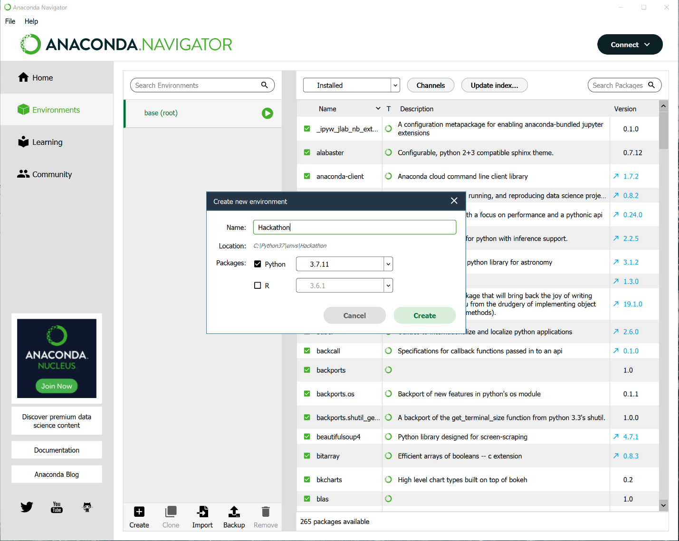
Select Environments from the menu on the left side of the navigator window. From the bottom select Create. Give your new environment a name; “Hackathon” as an example. Anaconda supports both Python and R; choose Python. You can specify a Python version. Python 2 was deprecated in 2020 and should not be used. Most Python 3 releases are all reasonable choices; this example will use Python 3.7.11. The result is seen in Figure 2.
Figure 2: Creating a development environment
When the process completes, the new environment will be created and appear in the list of environments (Figure 3). The current active environment is marked with an equilateral triangle inside a circle.
The panel on the right shows the Python modules installed in that environment; the initial install shows just a small handful are present.

Installing the Spyder IDE
There are several integrated development environments (IDE) that can be used with Python; an excellent choice is Spyder, which is included with Anaconda.
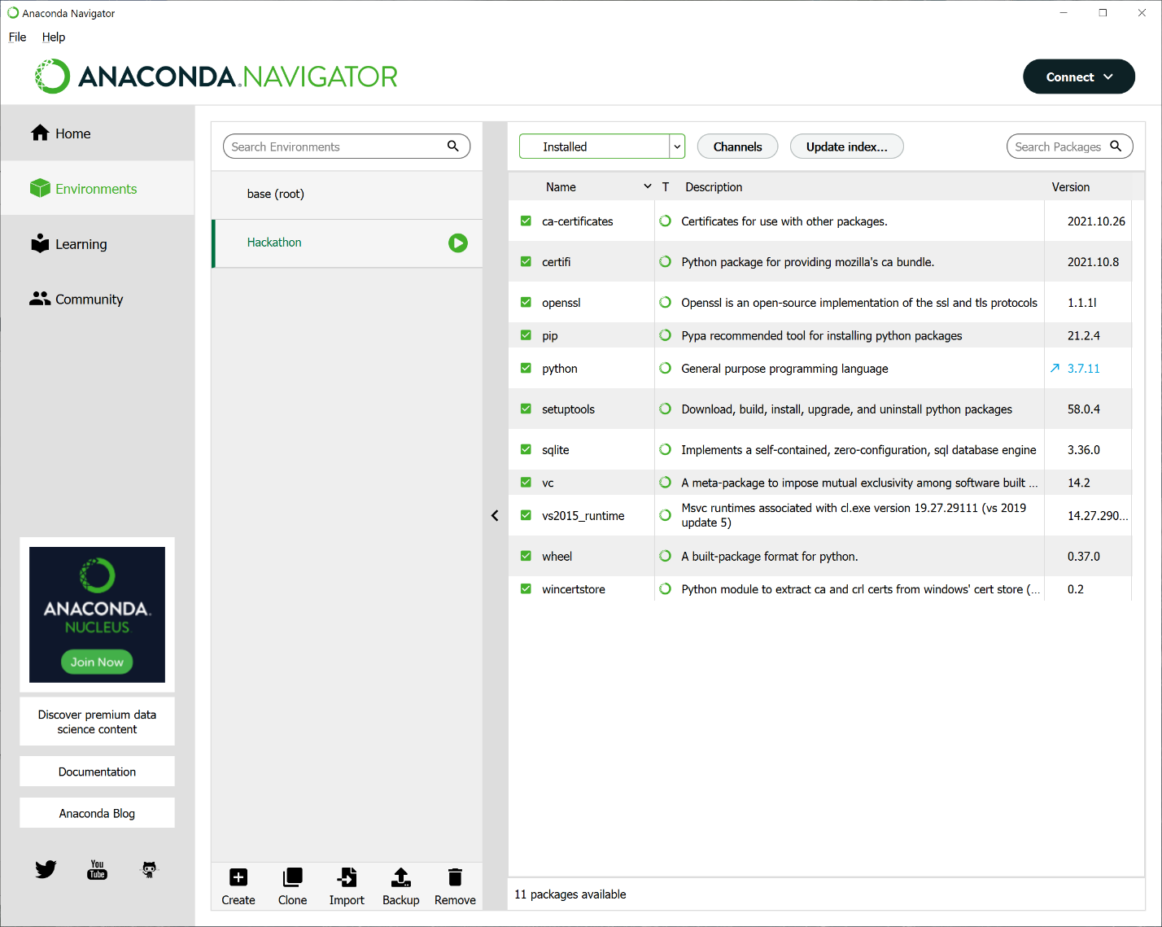
Anaconda takes an interesting approach to installing and running Spyder. Spyder can be installed as a stand-alone tool, and then configured to use different Python environments. This all works, but to change the development environment, the user has to know exactly where to make all of the manual configuration changes, both in Spyder, and in Python itself. By contrast, Anaconda automates this process.
Figure 3: Navigator Python environments
Return to the home menu in Anaconda Navigator, however, change the channel from base (root) as seen in Figure 1 to the just installed Hackathon environment as seen in Figure 4. Note that many of the applications that are installed in the base (root) environment have not been installed in the Hackathon environment.
Spyder is listed in the collection of available applications on Hackathon and can be installed by clicking on the Install button. (Or can it!)
If you are running Windows 10, do not install Spyder 5, as it will not work. This is a problem with the fonts. (Really!) Spyder 5 uses custom fonts, and Windows 10 has security settings that block them https://docs.microsoft.com/en-US/troubleshoot/windows-client/shell-experience/feature-to-block-untrusted-fonts. If you install Spyder 5 and try to run it, it will fail, silently. You can either follow the Microsoft instructions to allow the fonts to be used or use a different version of Spyder.


Figure 4: Applications in an environment
Different versions of each software package can be installed by selecting the gear icon in the top right of the panel, then selecting Install specific version.
The various versions of Spyder 4 are excellent, and this demonstration uses Spyder 4.2.5.
Launch Spyder from the Anaconda Navigator using the Hackathon channel; the result is something like Figure 5.

A word about versions....
There are slight differences between versions of Python, and more substantial differences in the version of Spyder. I will be using Python 3.7 and Spyder 4.2.5 in this document. References to documentation will be to Python 3.7. When reading documentation, always take a moment to check the Python version.
Do not use Python 2.x. It has been deprecated, and there are enough differences between Python 2.x and Python 3.x that code in one version will not run in the other version.

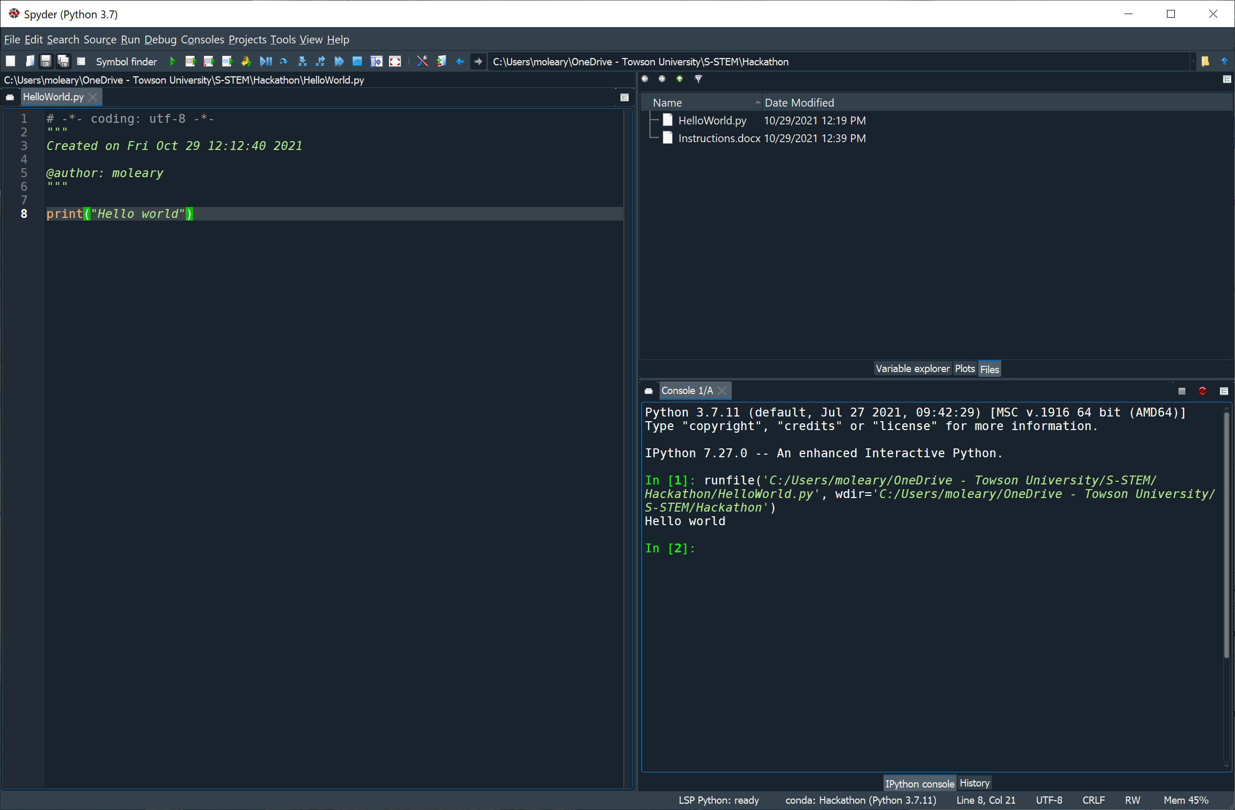
Figure 5: Spyder 4.2.5 running Hello World

Programming in Python
The tradition when learning a new programming language is to start by learning how to print something to the screen.
From Spyder, create a new file, say HelloWorld.py. Give it the content
print("Hello world")
Save the result.
The program can be run directly within Spyder from the Run menu, by pressing F5, or using the Run icon in the main toolbar. The result is shown in Figure 5. The left panel shows the source code. The top right panel can be used to show the variables in the program during debugging, any plots generated by the program, or the files in the current directory. The bottom right panel is an interactive Python command prompt. Figure 5 shows that HelloWorld.py was run and shows the output from the program.
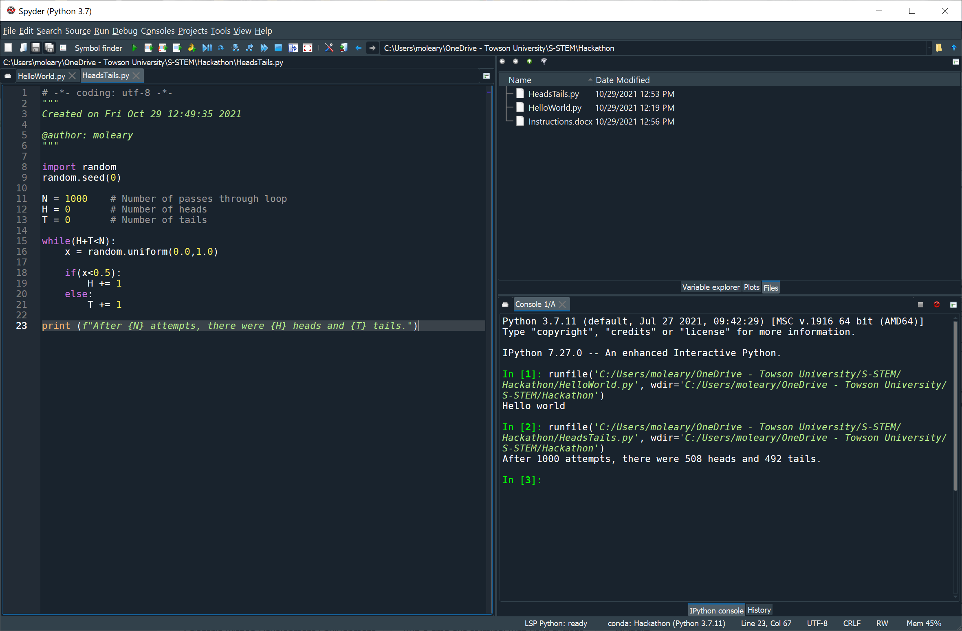
Figure 6: Heads and Tails

Example: Flipping a coin
As a more complex example that starts to show some of the features of the Python language, consider the code to randomly flip coins in Figure 6
Here are the key components of the code
import random
random.seed(0)

N = 1000 # Number of passes through loop
H = 0 # Number of heads
T = 0 # Number of tails
while(H+T<N):
x = random.uniform(0.0,1.0)
if(x<0.5):
H += 1
else:
T += 1

print (f"After {N} attempts, there were {H} heads and {T} tails.")

The code begins with the line import random. The import keyword is used to import a library into the code; here the pseudo-random number generating library random has been added to the code. The functions imported from the random library are stored in a private namespace; to access one of the functions, the full namespace is specified (though this behavior can be changed).
The second line random.seed(0) shows this process in action; it calls the function seed() from the random library. This function controls the seed for the random number generator. By setting the seed to be zero, this ensures that the results will be the same whenever the code is run.
The next three lines of code set the values for three variables. Python has five standard data types: numbers, strings, lists, tuples and dictionaries. Numbers are integers, floats, or complex numbers. All the variables assigned in the sample code are integers.
Next, the code makes use of a while loop. Note that Python does not make use of brackets to enclose loops, instead, it uses indentation. The elements of the main while loop are indented by four characters. Any nonzero number of whitespace characters can be used, so long as you are consistent within the loop. The Spyder IDE is smart enough to do perform the automatic indentation as you type.
There is an issue with whitespace- a tab character \t is often represented in a text editor as a set number of spaces- however it is not actually a set number of spaces. Thus, if your editor uses a tab as four spaces, then a line that starts with a tab will look identical to a line that starts with four spaces. Python will see these as different and the program will not run. Fortunately, Spyder will handle these issues for you.
Next, the code uses the pseudo-random number generating library random to choose a float between 0.0 and 1.0 using a uniform distribution so that all floats are equally likely.
Next, the code uses an if/else construct. Like the while loop, Python does not use brackets to enclose code lines for an if/else construct, but instead uses more indentation. The inner blocks need to be indented more than the outer blocks, and all the elements in a block need to have the same indentation. However, it is allowable (but goofy) to have the outer blocks indented by four spaces, and the inner blocks by five (or six or whatever) spaces. The Spyder IDE by default adds an additional four spaces of indentation for each additional block.
Finally, the code ends with a print statement. Unlike the HelloWorld.py example, this example uses variables in the string. The string inside the print statement is what Python calls an f-string. If a Python variable name appears inside an f-string within curly brackets, then the f-string will replace the variable name with its value. Examining the program’s output in Figure 6, the portions of the string {N}, {H}, and {T} have been replaced by the values of the variables N, H, and T.

Example: Flipping a coin, part 2
One of the ways Python is different from lower-level languages like C, C++, and Java is how it handles more complex data structures like lists, tuples, and dictionaries.
Consider the updated version of the coin-flipping program shown in Figure 7
import random
random.seed(0)

N = 1000 # Number of passes through loop
H = 0 # Number of heads
T = 0 # Number of tails

while(H+T<N):
flip = random.choice(['H','T'])
if(flip[0]=='H'):
H+=1
else:
T+=1

print (f"After {N} attempts, there were {H} heads and {T} tails.")

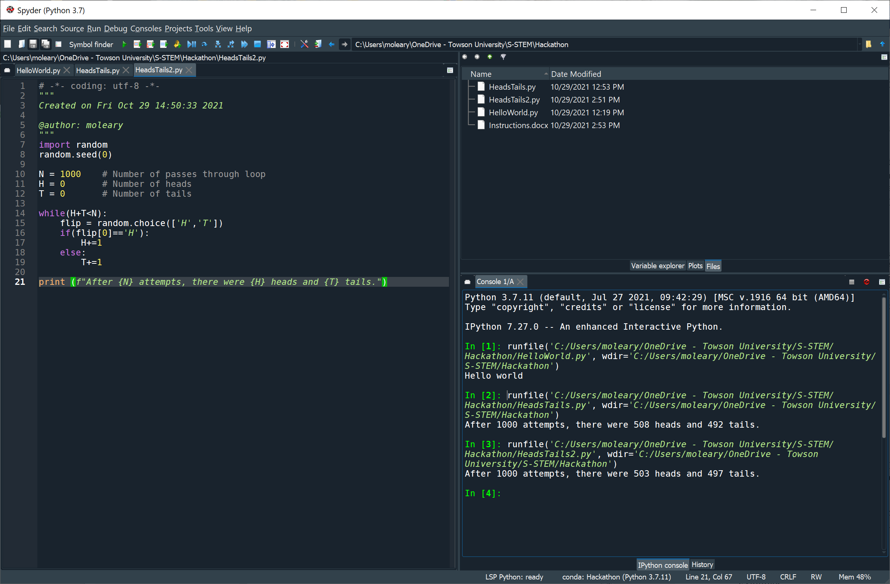
Figure 7: Coin-flipping with a list
The difference here is that the function random.choice is used, rather than random.uniform. The function random.choice selects exactly one element the sequence, which in the code is a list [‘H’,’T’]. Lists in Python are a commonly used and powerful data structure. Users can add, delete, and modify lists; more interestingly list comprehensions are a way to make one list from another.
The list [‘H’,’T’] contains two elements- the string “H” and the string “T”. In the code in Figure 7, you can imagine that these represent the physical state of the coin. After each flip, the state of the coin is chosen pseudo-randomly as heads or tails, and then the corresponding counter is incremented.

Example: Throwing two dice
As another, more complex example, consider the code in Figure 8.

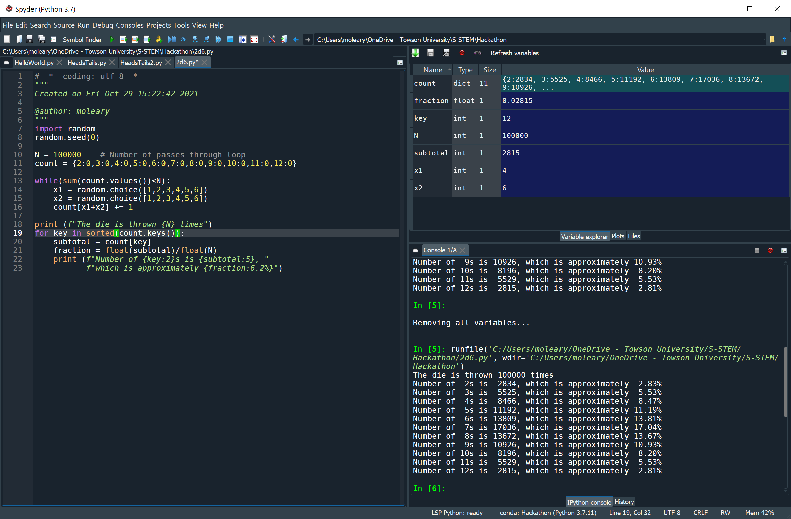
Figure 8: Throwing two dice
import random
random.seed(0)

N = 100000 # Number of passes through loop
count = {2:0,3:0,4:0,5:0,6:0,7:0,8:0,9:0,10:0,11:0,12:0}

while(sum(count.values())<N):
x1 = random.choice([1,2,3,4,5,6])
x2 = random.choice([1,2,3,4,5,6])
count[x1+x2] += 1

print (f"The die is thrown {N} times")
for key in sorted(count.keys()):
subtotal = count[key]
fraction = float(subtotal)/float(N)
print (f"Number of {key:2}s is {subtotal:5}, "
f"which is approximately {fraction:6.2%}")

This code is meant to simulate throwing a pair of six-sided dice many times, where the result of each throw is the sum of the number of pips shown in the throw.
Like the coin flipping programs, this starts by importing the pseudo-random number generator random, setting the seed, and determining the number of tosses of the dice. The next line though, is new; it reads
count = {2:0,3:0,4:0,5:0,6:0,7:0,8:0,9:0,10:0,11:0,12:0}
This defines count as a dictionary. A dictionary is a collection of key:value pairs, the key comes first, then the colon (:), the, the value. The collection of keys in this dictionary are the integers 2, 3, 4, 5, 6, 7, 8, 9, 10, 11, 12, while the value for each key is zero.
Accessing the value of a dictionary element is done by using the key, much as if it were an array. Suppose that you have the dictionary
x = {‘a’:10, ‘b’:20, ‘c’:30, 5:7, 6:’blue’}
then the value x[‘a’] is 10, the value x[5] is 7, and the value x[6] is ‘blue’. Changing the value is done by assignment, so the command x[‘a’]=5 changes the value of x[‘a’].
Key/value pairs can be added to an existing dictionary by assignment. If the command x[10]=20 is run, then the dictionary would become
x = {‘a’:5, ‘b’:20, ‘c’:30, 5:7, 6:’blue’, 10:20}
For Python up to 3.6, there is no guarantee that the key/value pairs in a dictionary will be in any particular order. Beginning with Python 3.7, the dictionary would be in the same order as the insertion order of the keys.
The function x.keys() returns all of the keys in the dictionary x, while the function x.values() returns all of the values. To determine, for example, the sum of all of the values in the dictionary count, a programmer can call sum(count.values()). This is the approach taken in Figure 8. The main while loop continues until the sum of all the values stored in the count dictionary is at least N.
Inside the while loop, a pseudo-random choice of x1 and x2 are made from the list [1,2,3,4,5,6]. Then x1+x2 is an integer between 2 and 12, which is used as a key for the count dictionary, and the corresponding value is incremented.
When the while loop concludes, an f-string is used to print out the total number of times the two dice are thrown.
Next comes a for loop, but one that looks different than a for loop in C, C++, or Java.
for key in sorted(count.keys()):
The expression count.keys() provides all of the keys for the dictionary keys. To ensure that they are in numerical order, these are passed to the sorted function. The for loop then iterates for each possible key.
Inside the loop, the code stores the value for count[key] in the variable subtotal. To find the fraction of the total, this is divided by the number N of passes through the main loop. Because both subtotal and N are integers, these are explicitly cast as floats before performing the division.
Next comes another print statement, this one involving f-strings. Python generally insists that each line of code be on its own separate line. One exception is for strings; if a string ends one line and begins the next line, then they are implicitly concatenated. This occurs in the code
print (f"Number of {key:2}s is {subtotal:5}, "
f"which is approximately {fraction:6.2%}")

Because the strings are being concatenated, the extra space at the start of the second line is being ignored. This is one of the cases where the amount of whitespace at the start of a line is ignored. This is done in this example to make more readable code.
This code also introduces another feature of f-strings, formatting. The portion of the f-string {key:2} produces the value of the variable key formatted so that it takes up two characters; similarly {subtotal:5} produces subtotal over 5 characters. Last is {fraction:6.2%} which prints the value of fraction over 6 characters, formatted as a percentage with two digits after the decimal point. The resulting output is nicely spaced.
Number of 2s is 2834, which is approximately 2.83%
Number of 3s is 5525, which is approximately 5.53%
Number of 4s is 8466, which is approximately 8.47%
Number of 5s is 11192, which is approximately 11.19%
Number of 6s is 13809, which is approximately 13.81%
Number of 7s is 17036, which is approximately 17.04%
Number of 8s is 13672, which is approximately 13.67%
Number of 9s is 10926, which is approximately 10.93%
Number of 10s is 8196, which is approximately 8.20%
Number of 11s is 5529, which is approximately 5.53%
Number of 12s is 2815, which is approximately 2.81%
The results can be displayed in descending order by modifying the for loop and using
for key in sorted(count.keys(),reverse=True):

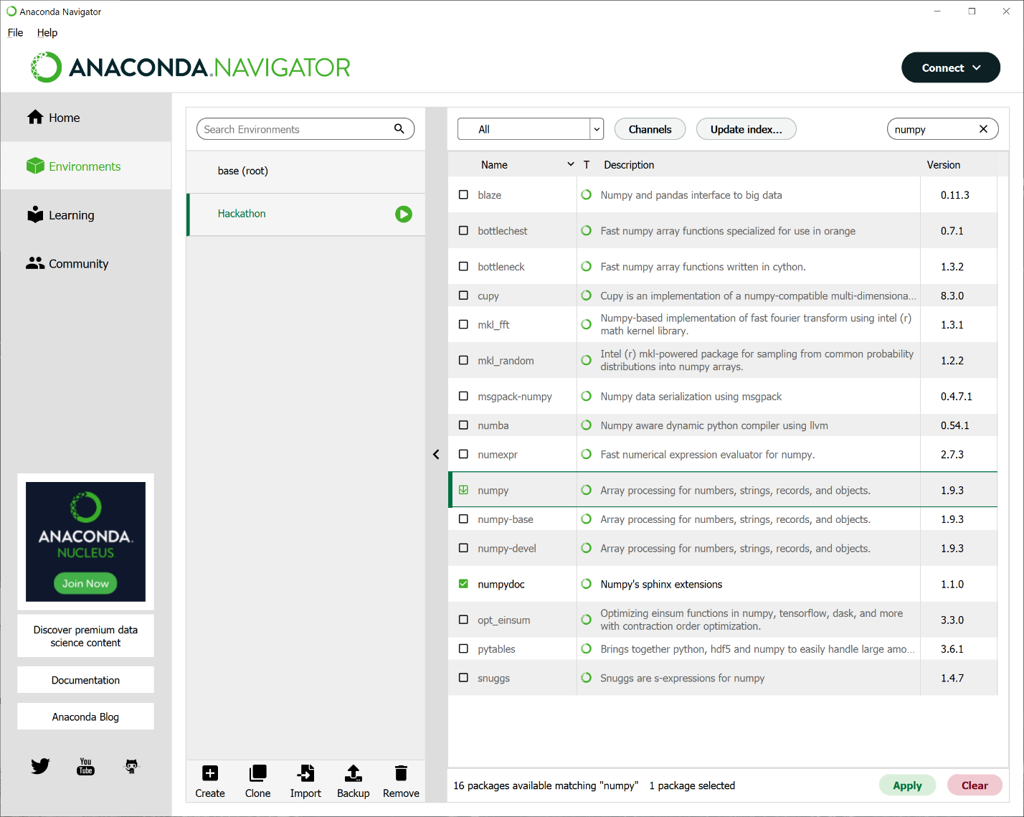
Graphics and Visualizations
Figure 9: Installing Numpy
Graphs, figures, and visualizations can be generated done in Python. One of the commonly used libraries is called Matplotlib. Matplotlib has a gallery of common and uncommon uses; whenever you want to use Matplotlib to generate a figure, it is always a good idea to visit the gallery to see if there is already an example that is close to what you want.
Another important scientific package is Numpy which calls itself the fundamental package for scientific computing in Python. Most of the examples in the Matplotlib gallery use Numpy.

Installing Matplotlib and Numpy
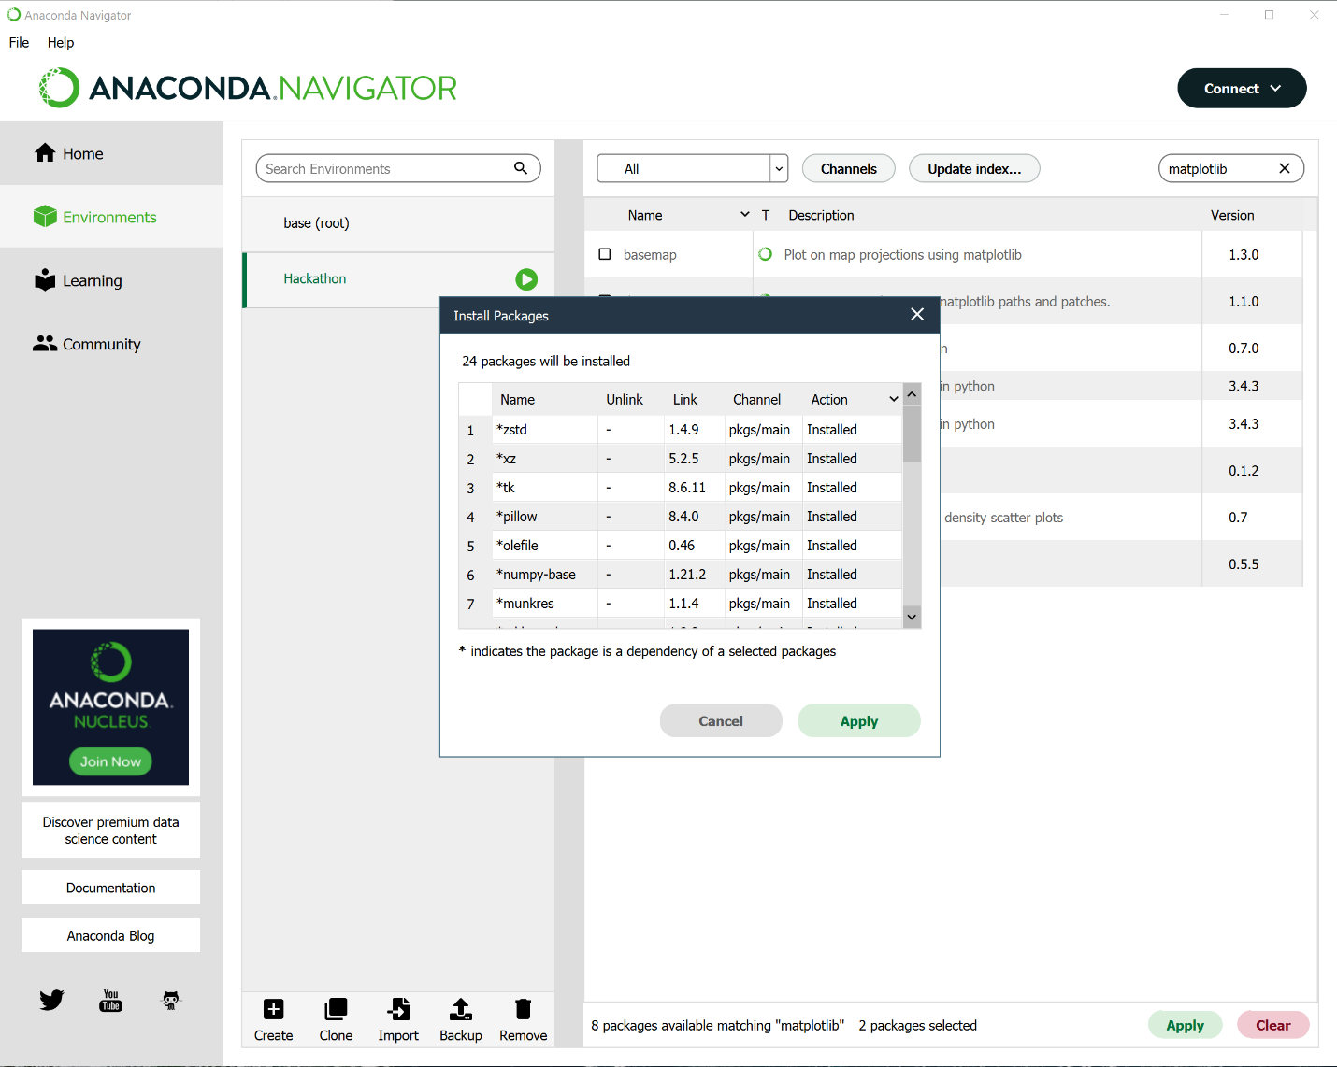
If you used Anaconda to build a custom Python environment, then Matplotlib and Numpy may not be present. To install them, head back to Anaconda navigator, then from the Hackathon environment, search for all packages (not just the installed ones), then choose the numpy package as in Figure 9. Do the same for Matplotlib, then accept and let Anaconda install the needed packages (Figure 10).
Figure 10: Installing Matplotlib
Once the installation is complete, the packages can be used in Python via an import command, in much the same fashion as the random pseudo-random number generating package was used.

Example: Graphing the normal curve
As an example, consider the problem of creating a graph of the probability density function for the normal distribution. This is a family of functions of the form
$$f\left(x\right)=\frac{1}{σ\sqrt{2π}}e^{-\frac{{\left(x-μ\right)}^{2}}{2σ^{2}}}.$$
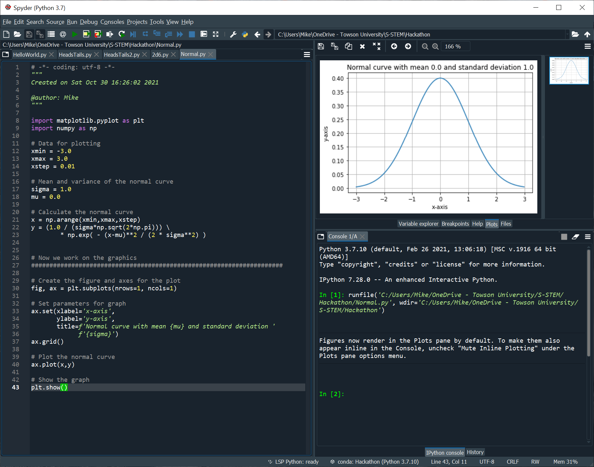
Here the parameter $μ$ represents the mean of the distribution, while $σ$ represents the standard deviation. To use Matplotlib to graph this function, consider the code in Figure 11.
Figure 11: Graphing the normal distribution
import matplotlib.pyplot as plt
import numpy as np

# Data for plotting
xmin = -3.0
xmax = 3.0

xstep = 0.01

# Mean and variance of the normal curve
sigma = 1.0
mu = 0.0

# Calculate the normal curve
x = np.arange(xmin,xmax,xstep)
y = (1.0 / (sigma*np.sqrt(2*np.pi))) \
* np.exp( - (x-mu)**2 / (2 * sigma**2) )

# Now we work on the graphics
#####################################################################

# Create the figure and axes for the plot
fig, ax = plt.subplots(nrows=1, ncols=1)

# Set parameters for graph
ax.set(xlabel='x-axis',
ylabel='y-axis',
title=f'Normal curve with mean {mu} and standard deviation '
f'{sigma}')
ax.grid()

# Plot the normal curve
ax.plot(x,y)

# Show the graph
plt.show()

This code has several differences from previous examples. The first two lines are import lines

import matplotlib.pyplot as plt
import numpy as np

The keyword as is used in Python to change the namespace for the imported module. If the programmer writes import numpy then to get the numpy value for pi, the programmer writes numpy.pi. This is a bit clunky, and it is traditional to shorten this. The line import numpy as np means that the programmer would access the numpy value for pi as np.pi.
The first line serves a similar purpose, but rather than importing the entire matplotlib package, the programmer imported only the pyplot module from Matplotlib.
The programmer then sets some variables- some are intended for use in the graph, and others to define the function.
Things get interesting with the line
x = np.arange(xmin,xmax,xstep)

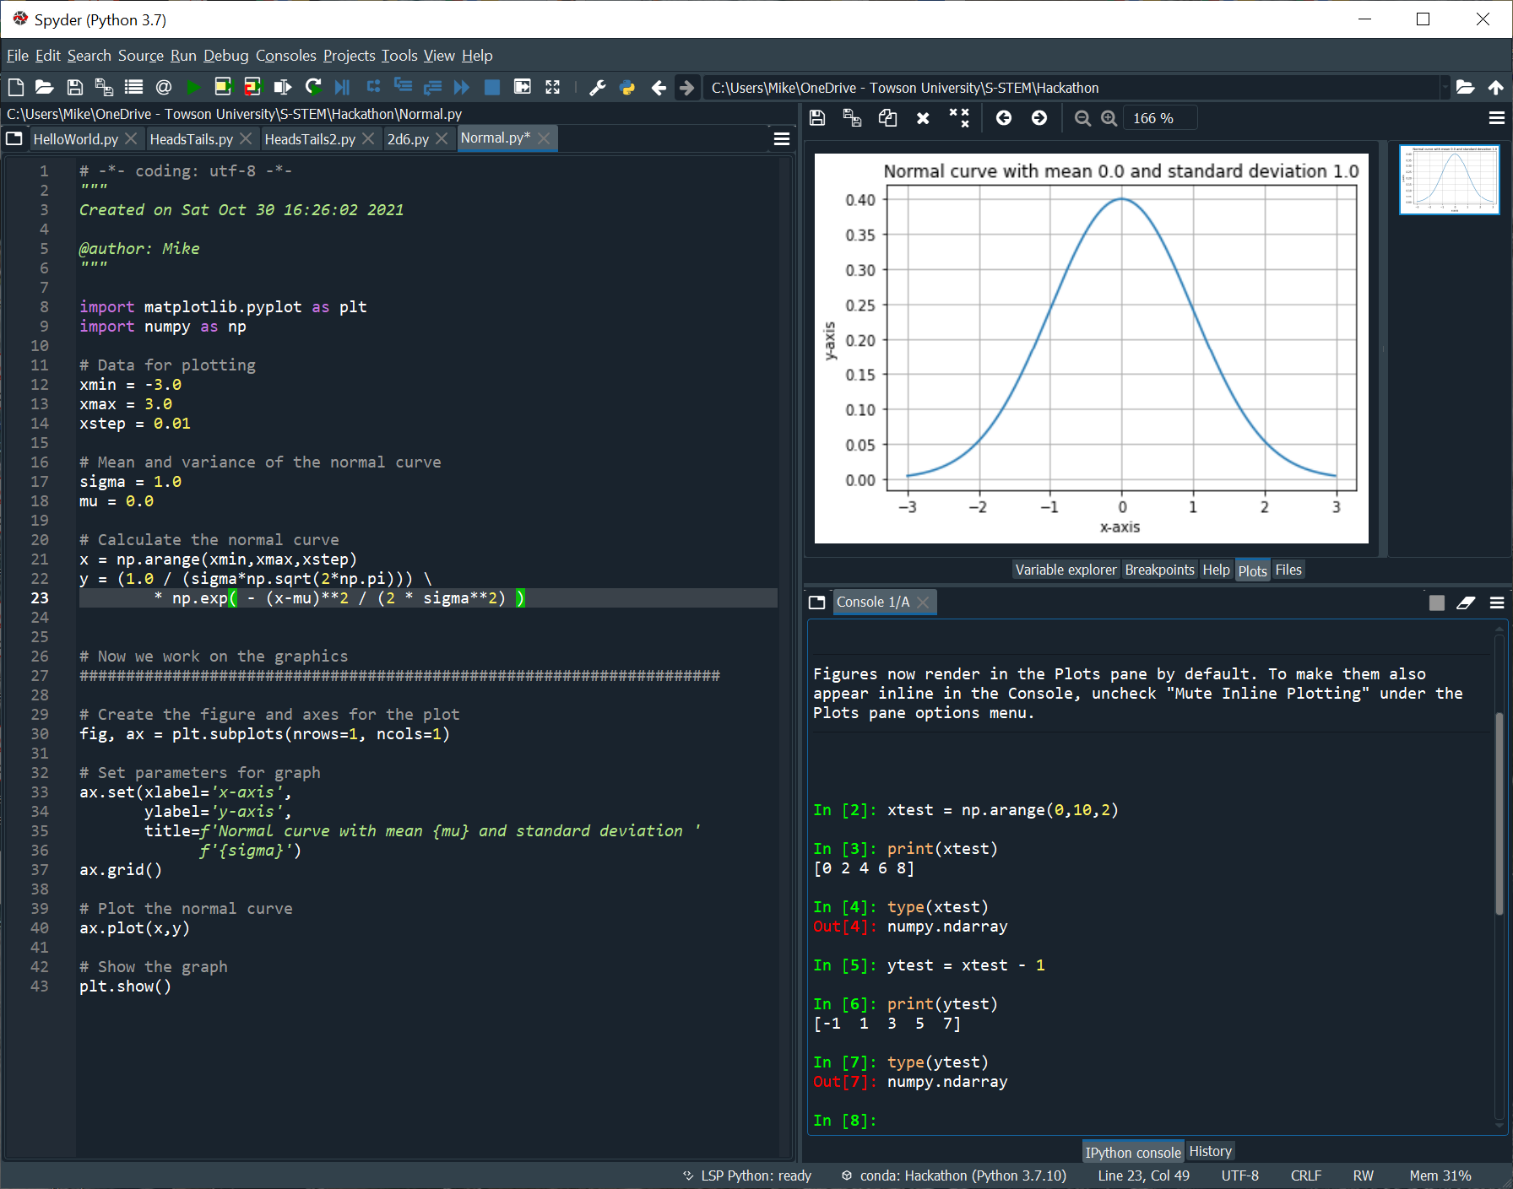
This uses the numpy method arange to generate a numpy array of evenly spaced values; here they go from xmin to xmax with a step size of xstep. More precisely, the result is an element of the class numpy.ndarray. These numpy arrays are like lists, but are optimized for speed in scientific computing.
Figure 12: Running commands in the IPython console
The next two lines are
y = (1.0 / (sigma*np.sqrt(2*np.pi))) \
* np.exp( - (x-mu)**2 / (2 * sigma**2) )

Because this line of code is too long to fit on a single line, it has been extended. Whenever a Python line ends with a backslash \ then it is continued on the next line. Note that there can be nothing on the line following the backslash. In particular, there can be no blank spaces.
At first glance, this appears to be defining the variable y using the definition of the normal distribution $y=\frac{1}{σ\sqrt{2π}}e^{-\frac{{\left(x-μ\right)}^{2}}{2σ^{2}}}.$ The value of the constant $π$ is given by the numpy variable np.pi, and the exponential function is given by the numpy function np.exp. The catch here is that the variable x is a numpy array, meaning a variable of type numpy.ndarray. When Python sees the code fragment (x – mu) where x is a numpy array and mu is a float, it returns another numpy array, where each value is found by subtracting mu from the array element. To make this clearer, examine Figure 12.
The console in the bottom right of Spyder can be used to execute additional Python commands; it retains This console retains the variables and imported modules that have already been executed. In Figure 12, the following commands are executed.
In [2]: xtest = np.arange(0,10,2)

In [3]: print(xtest)
[0 2 4 6 8]

In [4]: type(xtest)
Out[4]: numpy.ndarray

In [5]: ytest = xtest - 1

In [6]: print(ytest)
[-1 1 3 5 7]

In [7]: type(ytest)
Out[7]: numpy.ndarray
These command begin by creating the new variable xtest with np.arange; the value of that variable and its type are printed to the screen. The new variable ytest is created by ytest = xtest – 1, where an integer is being subtracted from a numpy array. Checking the value of ytest shows that Python handled the computations one element at a time in the array.
This process occurs when (x-mu) is squared in the line
y = (1.0 / (sigma*np.sqrt(2*np.pi))) \
* np.exp( - (x-mu)**2 / (2 * sigma**2) )

Indeed, this happens for all the mathematical operations in the line. This is one of the big benefits of the Python numpy module, namely that it uses vectorized operations, meaning that the operation occurs on all the elements at the same time.
Python has another module for mathematical calculations, namely the math module. It also has an exponential function that function works on scalars, but not on numpy arrays. To see the difference, in the console, use np.exp to take the exponential of xtest.
In [8]: np.exp(xtest)
Out[8]:
array([1.00000000e+00, 7.38905610e+00, 5.45981500e+01, 4.03428793e+02,
2.98095799e+03])

Now import the Python math module and try to use the math.exp function.
In [9]: import math

In [10]: math.exp(xtest)
Traceback (most recent call last):

File "<ipython-input-10-1c3f98fb82df>", line 1, in <module>
math.exp(xtest)

TypeError: only size-1 arrays can be converted to Python scalars

Whenever writing code in Python (or in any other language) it is important to know the variable types that are being used. The Python math module can take floats or integers as inputs. To perform vectorized operations on numpy arrays, then the numpy functions must be used.
Returning to the highlighted lines in Figure 12, notice the power of Python. Rather than writing a manual for loop to generate all the values of x, this is done in one line. Rather than doing another loop over all the values of x to determine the corresponding values of y, this is done in just a single vectorized line, which is much easier to read. Finally, because the functions in numpy are optimized for speed, the values in the arrays x and y are calculated almost as rapidly as they would be calculated in a compiled C program; this approach is dramatically faster than using a for loop in Python.

Example continued: Drawing the normal curve.
Now that the values for the numpy arrays x and y have been calculated, the next step in the program of Figure 12 is to draw the results as a figure.
When writing programs that combine scientific computations as well as graphical operations, it is good programming practice to separate these components. This is a way to manage a program’s complexity. If scientific calculations were intertwined with code to display or graph the result, it becomes much more difficult to modify the program later. In the example in Figure 12, there is a clear, explicit dividing line between the calculations and the graphics.
The first line of the graphics section creates a figure and an axis for the plot.
fig, ax = plt.subplots(nrows=1, ncols=1)
There are several ways that Matplotlib can be used to generate a graph; the use of subplots, figures, and axes shown here is not the only way, or even the most efficient for this problem. However, it is an approach that (a) works, (b) will let us do our animations.
The function being called here is plt.subplots. The subplots function is used to create a figure that can include one or more graphical elements. In this case, there is a single graph, because the number of rows and the number of columns in the figure are both 1.
The subplots function returns a pair or values, first is a Matplotlib figure, and the second is either a single or an array of Matplotlib axes objects. Python functions can return multiple values; the result uses the tuple data type. Tuples are like lists but are defined by enclosing the result in parentheses () instead of brackets [] and cannot be modified. Python even allows the parentheses to be omitted in some cases, which is what is occurring in this example.
A Matplotlib figure object is the top-level container for a Matplotlib graphical object. A Matplotlib axes object contains most of the elements of the figure- these can be lines, points, labels, titles, and legends.
The line of code fig, ax = plt.subplots(nrows=1, ncols=1)creates a top-level container fig with a single plot named ax.
The next steps are to begin to set the parameters for ax; this is done with the following lines
ax.set(xlabel='x-axis',
ylabel='y-axis',
title=f'Normal curve with mean {mu} and standard deviation '
f'{sigma}')
ax.grid()

The first of these sets some basic properties for the axes- the label on the x-axis, the label on the y-axis, and the title of the graph. To ensure that the graph includes gird lines, the programmer calls ax.grid().
Next, the program includes the line
ax.plot(x,y)
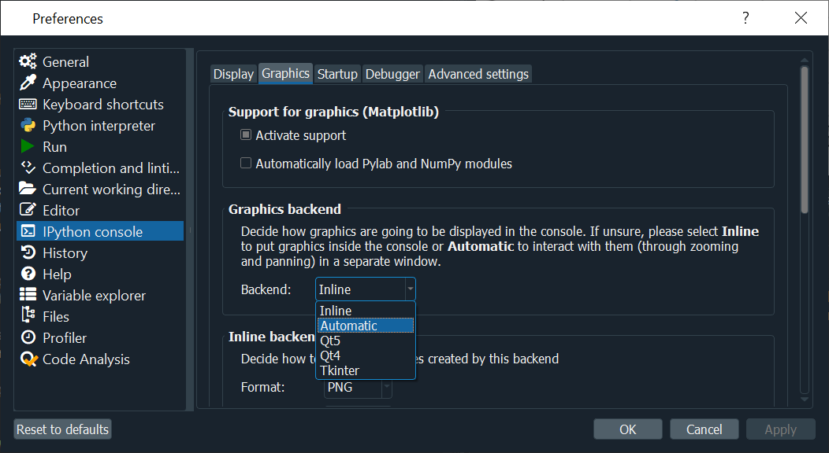
This plots the numpy arrays x and y which form the graph of the normal curve that were calculated earlier in the code.
Figure 13: Changing the graphical backend in Spyder
The program ends with the line
plt.show()
This is call to the function matplotlib.pyplot.show() which actually displays the graphic to the screen; it is generally the last line when creating graphics.

Example continued: Displaying the graph
Figure 12 shows the result of running the program in Spyder; the graph is shown in the top right panel. If the program is re-run, or if a different program is run, then the panel will add the new graph(s) while retaining the old ones.
There are times when it is preferred to have the graphical result appear in a new window- this is especially the case when creating animations.
To change this behavior in Spyder, navigate the main Spyder menu Tools → Preferences. From the Preferences dialog, on the left side navigate to IPython Console, then select the Graphics tab (Figure 13).
The Inline backend is what is shown in Figure 12. Set the backend to Automatic to have the graphs appear in a separate window as seen in Figure 15.
Notice that the window has several controls that can be used to zoom, pan, modify, and save the figure.

Example: Graphically calculating the area under the normal curve using Monte-Carlo techniques
An important question that comes up often in probability is the calculation of the area under a portion of a normal curve. More precisely, suppose $-∞≤a<b≤∞$, and suppose that $μ$ and $σ$ are known. Then calculate the area
$$I=\int_{a}^{b}{\frac{1}{σ\sqrt{2π}}e^{-\frac{{\left(x-μ\right)}^{2}}{2σ^{2}}} dx}.$$
The integrand does not have an antiderivative expressible in elementary form, so performing this calculation is more complex than evaluating the antiderivative at $a$ and $b$ then performing a subtraction. There are several clever and fast numerical methods that can be applied.
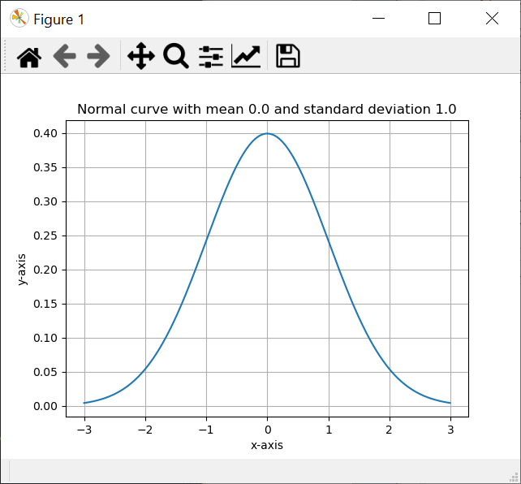
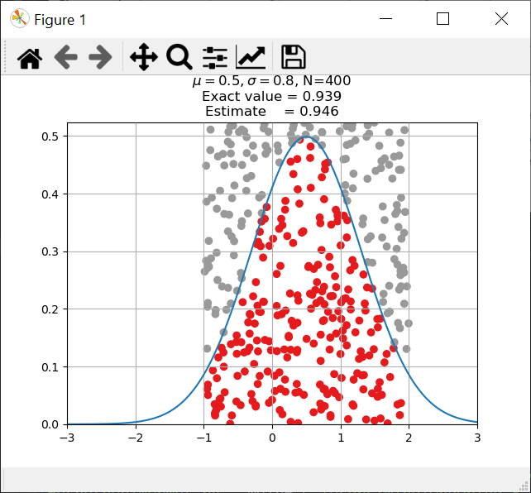
A much simpler and naive approach is to simulate the integral using Monte-Carlo techniques; this can be done when the endpoints are both finite, so $-∞<a<b<∞$. The value of the integral $I$ is the area under a portion of the normal curve. The idea behind Monte-Carlo methods is first to create a rectangle that than encloses the area being calculated. Consider the rectangle
Figure 15: Graphics in a separate window
Figure 15: Monte-Carlo integration
$$R=\left\{\left(x,y\right):a<x<b, 0<y<c\right\}.$$
The boundaries of the rectangle in the $x$-direction are the limits of integration. The value of $c$ is chosen to be at least as large as the largest value of the integrand, so $c≥ \frac{1}{σ\sqrt{2π}}$. The smallest value of $y$ is zero because $\frac{1}{σ\sqrt{2π}}e^{-\frac{{\left(x-μ\right)}^{2}}{2σ^{2}}}≥0.$ This way the region of integration is contained within the rectangle $R$.
Randomly choose a large number of points from the rectangle $R$. These points must be chosen from a uniform distribution so that each point is equally likely. Then it is reasonable that, if the number of chosen points is sufficiently large, then
$$\frac{\text{Number of points below curve}}{\text{Number of points in rectangle}}≈\frac{\text{Area below curve}}{\text{Area of rectangle}}$$
If $N$ points are chosen, and of these $B≤N$ are in the rectangle and below the curve, then
$$I≈\text{Area of rectangle}×\frac{B}{N}=\frac{B\left(b-a\right)c}{N}.$$
Equation 1: Monte-Carlo Integration
Figure 15 shows the process graphically. In this example, $μ=0.5$, $σ=0.8$, $a=-1$, and $b=2$. There were $N=400$ points chosen. Points below the normal curve were colored red, and points above the curve were colored grey. Equation 1 was used to calculate the estimated value of the integral, and this is compared to the exact value.

Example continued: The code
The code used to generate Figure 15 is the following:
import math
import matplotlib.pyplot as plt
import numpy as np

def normal(x, mu, sigma):
y = (1.0 / (sigma*np.sqrt(2*np.pi))) \
* np.exp( - (x-mu)**2 / (2 * sigma**2) )
return y

# Set seed for pseudo-random number generator
np.random.seed(0)

# Mean and variance of the normal curve
sigma = 0.8
mu = 0.5

# Windows for plotting
xmin = -3.0
xmax = 3.0
xstep = 0.01

# Calculate the normal curve
x = np.arange(xmin,xmax,xstep)
y = normal(x,mu,sigma)

# How many random sample points will be plotted?
n_samples = 400

# What is the region for the random sample points?
xleft = -1.0
xright = 2.0
ybottom = 0.0
ytop = 1.05 * np.amax(y)

# (Empty) array of point locations, colors, and the fraction
# of points below the normal curve
samples = np.zeros(n_samples,
dtype=[('xpos', float),
('ypos', float),
('color', float)])

# Choose (x,y) for each sample point uniformly
samples['xpos'] = np.random.uniform(xleft,xright,n_samples)
samples['ypos'] = np.random.uniform(ybottom,ytop,n_samples)

# Set the color for each sample point if it is above or below the normal
samples['color'] = np.where(
samples['ypos']>normal(samples['xpos'],mu,sigma),
1,
0)

frac_points_below_curve = sum(1-samples['color'])/ float(n_samples)
estimate = (xright-xleft)*(ytop-ybottom)*frac_points_below_curve

# Exact value of the area under this normal curve between xleft and xright
exact_value = 0.5*math.erf((xright-mu)/(math.sqrt(2)*sigma)) \
-0.5*math.erf((xleft-mu)/(math.sqrt(2)*sigma))

###############################################################
# Now we work on the graphics

# Create the figure and axes for the plot
fig, ax = plt.subplots(nrows=1, ncols=1)

# Set parameters for graph
ax.grid()
ax.set(xlim=(xmin,xmax),ylim=(0,ytop))
ax.set(title= \
f"$\mu={mu:0.3}, \sigma={sigma:0.3}$, N={n_samples}\n"
f"Exact value = {exact_value:<05.3}\n"
f"Estimate = {estimate:<05.3}")

# Plot the normal curve
ax.plot(x,y)

# Plot the sample points
ax.scatter(
samples['xpos'],
samples['ypos'],
c = samples['color'],
cmap = "Set1")

plt.show()

Example continued: Code Initialization
This example is based on the previous code that draws the normal curve. It begins with a set of imports
import math
import matplotlib.pyplot as plt
import numpy as np

These play the same role in this program as they did in the previous program.
Next the code defines a function to calculate values of the normal curve
def normal(x, mu, sigma):
y = (1.0 / (sigma*np.sqrt(2*np.pi))) \
* np.exp( - (x-mu)**2 / (2 * sigma**2) )
return y

Function definitions in Python begin with the def keyword, then the name of the function, followed by the parameters of the function. The body of the function is indented in the same fashion as code blocks are indented for loops (e.g. for, while) and for control structures (e.g. if, else).
This is the same calculation that was used in the previous program, but now it is moved to its own function because it is used more than once in this example.
The code continues by setting the seed for the pseudo-random number generator
np.random.seed(0)
Because this program uses vectorized functions, pseudo-random number generation is not handled using the random module from the earlier examples, but rather from numpy.random, which is why the command to set the seed is different.
The next few lines of the code set up some variables for the normal curve and for the plotting window.
The points on the normal curve are created as numpy arrays as in the previous example
x = np.arange(xmin,xmax,xstep)
y = normal(x,mu,sigma)

One difference though, is that the function normal is used to find the y-values for the normal curve. Notice the convenience of using vectorized operations on numpy arrays.
Next the code sets the number of randomly chosen points (n_samples=400). The boundaries of the rectangle $R$ are chosen; the top boundary of the rectangle is just a bit larger than the maximum value of the normal curve.

Example continued: Building the array of Monte-Carlo points.
The next step in the code is to determine the locations of the randomly chosen points inside the rectangle $R$ and to determine which points are below the normal curve.
To do so, the code continues with the command
samples = np.zeros(n_samples,
dtype=[('xpos', float),
('ypos', float),
('color', float)])

The command numpy.zeros generates a new numpy array consisting of all zeros. One interesting feature of this command is that it can be used to specify the data type, which is being done here. The result is an array so that for each sample in samples
- sample[‘xpos’] is a float, initialized to zero
- sample[‘ypos’] is a float, initialized to zero
- sample[‘color’] is a float, initialized to zero
One advantage of this data structure is that by using numpy array, the programmer can use vectorized operations. Because the x-position, y-position, and the color are all part of the same numpy array, it also makes it clearer that these are related and that the various components of an entry in the samples array all refer to the same object.
The next two lines of code are
samples['xpos'] = np.random.uniform(xleft,xright,n_samples)
samples['ypos'] = np.random.uniform(ybottom,ytop,n_samples)

These choose random values for the positions of the points. In the HeadsTails.py example, we used random.uniform to choose a single random number from a uniform distribution. The numpy version np.random.uniform creates an entire array in one vectorized line.
The next lines of code are used to record whether each point is above or below the normal curve.
samples['color'] = np.where(
samples['ypos']>normal(samples['xpos'],mu,sigma),
1,
0)

Here the programmer wants to do the following- for each point $(x,y)$, check to see if $y$ is larger than normal(x); if so, set the corresponding value in the color array to 1; otherwise set it to zero.
If this program were written in a language like Java, C, or C++, this could be accomplished with pseudo-code like
for(i=0; i<len(x); i++) {
if y[i] > normal(x[i],mu,sigma) {
color[i] = 1;
}
else {
color[i] = 0;
}

The single line of Python code does all of this in one step. The function numpy.where is used to select elements from an array depending on the value of the condition. The condition is the first argument; the second argument is the value when the condition is true, while the third argument is the value when the condition is false. Moreover, the result is fully vectorized, so loops are not needed, and this is done element-by-element for the entire array.
The next few lines of the code calculate the estimated value for the integral $I$ following Equation 1.
frac_points_below_curve = sum(1-samples['color'])/ float(n_samples)
estimate = (xright-xleft)*(ytop-ybottom)*frac_points_below_curve

Remember that value of samples[‘color’] is 1 if the point is above the normal curve, so to count the number of points below the curve, the code calculates the sum of
1-samples[‘color’]. This sum is divided by the number of sample points to obtain the fraction of the sample points below the curve; then Equation 1 is used to estimate $I$.
The mathematical section of the code ends with the line
exact_value = 0.5*math.erf((xright-mu)/(math.sqrt(2)*sigma)) \
-0.5*math.erf((xleft-mu)/(math.sqrt(2)*sigma))

This calculates the exact value of the integral
$$I=\int_{a}^{b}{\frac{1}{σ\sqrt{2π}}e^{-\frac{{\left(x-μ\right)}^{2}}{2σ^{2}}} dx}.$$
This is done using the error function $erf⁡(x)$ which is defined as
$$erf⁡(x)= \frac{1}{\sqrt{2π}}\int_{0}^{x}{e^{-x^{2}} dx}.$$
This function occurs commonly in probability and statistics, and application of the change of variables theorem in the integral shows that
$$I=\int_{a}^{b}{\frac{1}{σ\sqrt{2π}}e^{-\frac{{\left(x-μ\right)}^{2}}{2σ^{2}}} dx}=\frac{1}{2}\operatorname{erf}\left(\frac{b-μ}{σ\sqrt{2}}\right)-\frac{1}{2}\operatorname{erf}\left(\frac{a-μ}{σ\sqrt{2}}\right).$$
This is the formula in the program, which uses the erf function from the Python math module for the calculation.

Example continued: Graphics
At this point in the program, the mathematical calculations have been completed. The program continues with the code that will be used to display these results to the screen. In a more complex program this might be handled by a separate function or a separate class; since this is a small program, it is being handled all in one script.
This portion of the code begins in the same fashion as the example Normal.py and creates the figure and the axes for the plot.
fig, ax = plt.subplots(nrows=1, ncols=1)
Next, the code sets the basic parameters for the graph- the gridlines, the graph size, and the title.
ax.grid()
ax.set(xlim=(xmin,xmax),ylim=(0,ytop))
ax.set(title= \
f"$\mu={mu:0.3}, \sigma={sigma:0.3}$, N={n_samples}\n"
f"Exact value = {exact_value:<05.3}\n"
f"Estimate = {estimate:<05.3}")

This takes the same approach as the previous example Normal.py, though it uses some more complex string formatting options; the ‘<’ is used to ensure that the result is left-justified.
The code continues with the line
ax.plot(x,y)
This is the same line that was used in the previous example to plot the normal curve (which is stored in the numpy arrays x and y).
The code continues by plotting the sample points using the Matplotlib scatter function.
ax.scatter(
samples['xpos'],
samples['ypos'],
c = samples['color'],
cmap = "Set1")

The Matplotlib scatter function is used to plot points or arrays of points, and these are the first two arguments in the function. Now we discover another feature of Python- function arguments can be passed by position, or they can be passed by keyword. The definition in the source code for the scatter function is
def scatter(
x, y, s=None, c=None, marker=None, cmap=None, norm=None,
vmin=None, vmax=None, alpha=None, linewidths=None, *,
edgecolors=None, plotnonfinite=False, data=None, **kwargs)

The first two parameters in this function are the x- and y- locations of the points to be plotted. The remaining parameters may or may not be included in a function call and are specified by keyword. This is important for functions like this that can take as many as 15 different parameters. Rather than trying to remember which parameter comes (say) thirteenth in the list, the programmer specifies the parameter by its keyword.
The parameter c in the scatter function specifies colors of the points; in this case it is an array of floats that match the number of points being plotted. Earlier in the program the values of samples[‘color’] were set to either 0 or 1 depending on whether the point was above or below the normal curve.
How does Python choose a color from a float? In this example, it uses a colormap, which is chosen with the cmap argument. Python has several ways to specify colors, and colormaps are just one way. Each colormap has a name; in our example we are using the colormap named “Set1”. For a given color map and for each float between 0 and 1 there is a corresponding color. Here is a collection of some of the color maps that are included by default in Python
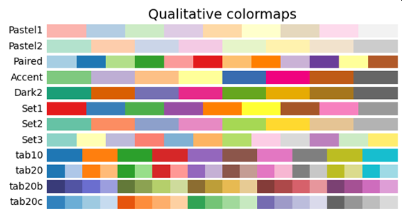
Figure 16: Qualitative color maps in Python
Because our example code sets the colormap to “Set1”, so if the value of the float is near zero, then the point is colored red, while if the value of the float is near 1, then the point is grey.
There are many available colormaps already included in Python which can be used by a programmer; see https://matplotlib.org/stable/tutorials/colors/colormaps.html to see them.
The program ends by calling the Matplotlib show() function.

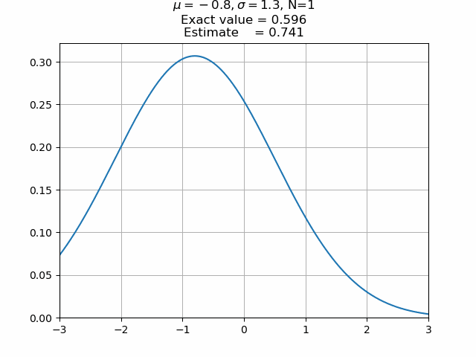
Animations
Figure 17: Animated Monte-Carlo
Creating static visualizations is nice. Not great, but nice.
What is be more interesting would be to create animated visualizations so that the user can see how things evolve over time. As an example, suppose we repeat the process to find the area under a portion of the normal curve, but animate the result so each point is plotted in turn and so that the plot title is dynamically updated. This is the approach taken in Figure 17.

Example: Animating Monte-Carlo Integration
The code used to generate Figure 17 is below. This is the same as the code for the Monte-Carlo program, except for the marked lines.
import math
import matplotlib.pyplot as plt
from matplotlib.animation import FuncAnimation
import numpy as np

def normal(x, mu, sigma):
y = (1.0 / (sigma*np.sqrt(2*np.pi))) \
* np.exp( - (x-mu)**2 / (2 * sigma**2) )
return y

# Set seed for pseudo-random number generator
np.random.seed(0)

# Mean and variance of the normal curve
sigma = 1.3
mu = -0.8

# Windows for plotting
xmin = -3.0
xmax = 3.0
xstep = 0.01

# Calculate the normal curve
x = np.arange(xmin,xmax,xstep)
y = normal(x,mu,sigma)

# How many random sample points will be plotted?
n_samples = 400

# What is the region for the random sample points?
xleft = -1.5
xright = 0.8
ybottom = 0.0
ytop = 1.05 * np.amax(y)

# (Empty) array of point locations, colors, and the fraction
# of points below the normal curve
samples = np.zeros(n_samples,
dtype=[('xpos', float),
('ypos', float),
('color', float),
('est',float)])

# Choose (x,y) for each sample point uniformly
samples['xpos'] = np.random.uniform(xleft,xright,n_samples)
samples['ypos'] = np.random.uniform(ybottom,ytop,n_samples)

# Set the color for each sample point if it is above or below the normal
samples['color'] = np.where(
samples['ypos']>normal(samples['xpos'],mu,sigma),
1,
0)

for i in range(0,len(samples)):
samples[i]['est'] = (xright-xleft)*(ytop-ybottom) \
* sum(1-samples[0:i+1]['color'])/ float(i+1)

# Exact value of the area under this normal curve between xleft and xright
exact_value = 0.5*math.erf((xright-mu)/(math.sqrt(2)*sigma)) \
-0.5*math.erf((xleft-mu)/(math.sqrt(2)*sigma))

###############################################################
# Now we work on the graphics

# Create the figure and axes for the plot
fig, ax = plt.subplots(nrows=1, ncols=1)

# Function that draws the normal curve and some sample points
def draw_sample(last_point):

# This is going to be called often- delete existing graphics
ax.clear()

# Set parameters for graph
ax.grid()
ax.set(xlim=(xmin,xmax),ylim=(0,ytop))
ax.set(title= \
f"$\mu={mu:0.3}, \sigma={sigma:0.3}$, N={last_point+1}\n"
f"Exact value = {exact_value:<05.3}\n"
f"Estimate = {samples[last_point]['est']:<05.3}")

# Plot the normal curve
ax.plot(x,y)

# Plot the first sample points
ax.scatter(
samples['xpos'][0:last_point],
samples['ypos'][0:last_point],
c = samples['color'][0:last_point],
cmap = "Set1")

animation = FuncAnimation(fig,
draw_sample,
frames = n_samples,
interval = 10,
repeat = False)
plt.show()

Example continued: Building the array of animated Monte-Carlo points.
The first difference between the animated example and the non-aminated example is that an additional function, FuncAnimation is imported from the Matplotlib library.
The next few changes are cosmetic, so that the graph in Figure 17 looks different than the graph in Figure 15
The first substantial changes occur in the line
samples = np.zeros(n_samples,
dtype=[('xpos', float),
('ypos', float),
('color', float),
('est',float)])

The title in Figure 17 updates along with the animation. Because it is best practice to separate the calculations from the code that displays the results, the values need to be precomputed- and these will be stored in samples[‘est’].
This is calculated in the next new section of code
for i in range(0,len(samples)):
samples[i]['est'] = (xright-xleft)*(ytop-ybottom) \
* sum(1-samples[0:i+1]['color'])/ float(i+1)

Although most of the examples have not used for loops or referenced array elements by index, this is not because Python can’t, but rather because in many cases accessing array elements by index is not the best programming strategy. This is one of those cases where accessing the array by index is the better choice.
This portion of the code begins with a Python for loop. The Python len() function is used to determine the number of elements in the samples array. Python lists are indexed beginning with zero, so a Python list called x of length 3 would have the elements x[0], x[1], and x[2], while len(x)=3. The Python range() function returns a sequence of numbers beginning with the first, but not including the last and is used primarily in these kinds of loop constructs. The value of range(0,3) are the numbers 0, 1, and 2. Thus, this for loop iterates over all of the indices available in the samples array.
This is just one of many (many) ways Python allows programmers to manage lists and to loop over lists. For example, suppose that you wanted to print out the squares of all the numbers between 0 and 10. This can be done using what Python calls list comprehension as follows
In [1]: squares = [x*x for x in range(0,10)]

In [2]: print(squares)
[0, 1, 4, 9, 16, 25, 36, 49, 64, 81]
Python also allows access to portions of a list or an array. To print just the first five elements of this list, a programmer can use
In [3]: print(squares[0:5])
[0, 1, 4, 9, 16]

Notice that the list squares[0:5] includes the value for the index 0, but does not include the last value when the index would be 5.

Returning to the animation example, the code loops over all the indices in the sample array. Inside the loop is the line
samples[i]['est'] = (xright-xleft)*(ytop-ybottom) \
* sum(1-samples[0:i+1]['color'])/ float(i+1)

Here the construct samples[0:i+1][‘color’] returns the array up to and including samples[i][‘color’]. As before, the value of samples[‘color’] is 1 if the point is above the normal curve, so to count the number of points below the curve, the code calculates the sum of 1-samples[‘color’]. Thus, the sum determines the number of points $\left(0,1,2,…, i\right)$ that are below the curve; then Equation 1 is used to calculate the estimate for the area below the curve using only these points, remembering that there are $i+1$ points in the list $\left(0,1,2,…,i\right)$.

Example continued: Animating the Monte-Carlo points.
The biggest difference between this program and the previous is in how the graphics are drawn. The code begins as before by creating a figure and axes for the plot.
Next is the function draw_sample(last_point). This function looks much like the corresponding code used in the previous program. For example, it calls ax.plot(), ax.scatter() and ax.set() though the arguments differ. The key thing to note about this function though is variable scope. The function is being passed the value of last_point, yet it uses the axis variable ax that was defined outside the function. How can the function use the variable ax if it is not being passed to the function? For that matter, how can the function use any of the other variables, like x, y, xmin, xmax, ytop and the like that is uses?
The answer is in how Python handles variable scope. If a variable is defined within a function, then it is accessible only within the function. However, if a variable is defined outside a function in the top-most level of a script, then it is accessible globally. Recall the line
fig, ax = plt.subplots(nrows=1, ncols=1)
This line is being executed at the top-level of the script, so the variables fig and ax are available globally, even inside a function like draw_sample.
This approach allows the definition of the function draw_sample to focus only on the parameters that are changing.
The first line in draw_sample is
ax.clear()
This call clears the axis of all its graphical elements. Next, the code sets the grid, plot size, and the title with the code
ax.grid()
ax.set(xlim=(xmin,xmax),ylim=(0,ytop))
ax.set(title= \
f"$\mu={mu:0.3}, \sigma={sigma:0.3}$, N={last_point+1}\n"
f"Exact value = {exact_value:<05.3}\n"
f"Estimate = {samples[last_point]['est']:<05.3}")

This is the same approach that was taken in the previous program, but value for the estimate of the area under the curve uses the value of samples[last_point]['est'] instead of the estimated value when all of the points are used.
The code plots the normal curve as before with ax.plot(x,y), and uses the scatter function to plot the points, but it only plots the portion of samples up to last_point.
ax.scatter(
samples['xpos'][0:last_point],
samples['ypos'][0:last_point],
c = samples['color'][0:last_point],
cmap = "Set1")

Whenever the function draw_sample(last_point) is called, it clears the axis, then re-draws the graphical elements using the sample points with index up to but not including last_point.
To generate an animated figure, we want to call this function over and over again; this is the purpose of the next line
animation = FuncAnimation(fig,
draw_sample,
frames = n_samples,
interval = 10,
repeat = False)

The function FuncAnimation was imported at the program’s start from the Matplotlib animation library. The first argument to this function is the figure that is to be animated; in this case this is fig which was created from the plt.subplots command. The second argument is a function that will be called for each frame of the animation. This function should accept a single parameter which is the number of the frame. In this example, the function is draw_samples which takes a single argument that determines the number of points to be displayed.
The named argument frames is an integer that provides the number of frames that will be used in the animation. The named argument interval is the delay between frames, in milliseconds. If omitted, the default is 200 ms. The last named argument repeat is a Boolean to determine if the animation should repeat when the sequence of frames completes.
The last line in the program shows the resulting plot.

Example continued: Saving the animation
A programmer may wish to save the result of the animation as a file. This can be done by making the following modifications of the previous program.
First, import the PillowWriter module into the program with a line like
from matplotlib.animation import PillowWriter

Then, after the animation variable is declared in the program, add the lines
filename = "animation.gif"
writergif = PillowWriter(fps=30)
animation.save(filename,writer=writergif)

This begins by setting the name of the file that will be used to store the output. Next, a PillowWriter object is created. The named argument fps is the number of frames per second that will be used in the result.
The last line calls the save method from the animation object. It specifies the filename that will be used to store the result followed by a named argument that specifies the writer that will be used to create the file; in this case this is the PillowWriter object that creates an animated gif. There are several other ways to save the result of an animation, the approach shown is just one simple approach.

Next Steps
This is just the first of several planned hackathons for Python and data science; the next will run in Spring 2022. I would very much like to get your feedback about the format of today’s event and what you might like to see in the Spring (Computer vision? Geospatial data analysis? Simulation modeling?).
Please complete our surveys
- Consent to collect the survey https://towson.az1.qualtrics.com/jfe/form/SV_b2d38ecFKjOIkuy
- Hackathon https://towson.az1.qualtrics.com/jfe/form/SV_9R1j283fTq17Sia

Acknowledgements
This hackathon was supported by the National Science Foundation, through grant NSF-DUE 2031345.


I would love to say that the approach I am going to outline is foolproof and that if you follow all these steps then everything will work. However… The reason tools like Anaconda exist is because the interactions between the various dependencies do cause problems. Although Anaconda tries to resolve all of them, it does not always succeed. Despite all of my testing, it would not surprise me if some unexpected error crops up and causes trouble. My debugging process would be the following- start by stopping/closing any existing Python programs. On Windows, CTRL+ALT+DEL will bring up Task Manager that would allow you to identify and close Python processes that might be running in the background without a corresponding window. Then try re-starting Anaconda. If the problem persists, it may be because of an un-caught dependency error; in this case you may wish to create a new Python environment and try again with different versions on Python and/or any installed packages. Anaconda is recommended in this guide because is generally works well. If you prefer to install Python directly and to manage your dependencies manually (e.g. with pip) then feel free to do so.
For an introduction to print in Python, check out https://realpython.com/python-print/. The official documentation for print is at https://docs.python.org/3.7/library/functions.html#print. For information about input/output in general, try https://docs.python.org/3.7/tutorial/inputoutput.html.
To learn more about the Python import statement, check out https://realpython.com/lessons/import-statement/. The official documentation is at https://docs.python.org/3.7/reference/import.html.
The documentation for the pseudo-random number generator library is available at https://docs.python.org/3.7/library/random.html, which includes the source code.
Let me add a short interlude on pseudo-random number generators. A pseudo-random number generator is not a random number generator. Instead, is starts with an initial state (the seed) and generates a sequence of numbers that pass several tests for randomness, so they appear random. Do not think that you can choose the seed randomly- if there were a way to choose a random number, you would not need the pseudo-random number generator. Setting the seed explicitly to zero in this example is done to make the code reproducible, but also to emphasize this point about seeds and pseudo-random number generators. For more information about Python pseudo-random number generation, see https://realpython.com/python-random/.
For more information about data types in Python, check out https://realpython.com/python-data-types/. The section there on the different types of strings, along with the various escape codes (e.g. for a newline, or a quote) is worth a shore read. The official documentation for Python built-in types is at https://docs.python.org/3.7/library/stdtypes.html. If you want to see more esoteric data structures (e.g. how do you represent a date/time?) see https://docs.python.org/3.7/library/datatypes.html.
For more information about while loops, check out https://realpython.com/python-while-loop. The official documentation for control structures in Python is available at https://docs.python.org/3.7/tutorial/controlflow.html while the documentation for while itself is at https://docs.python.org/3.7/reference/compound_stmts.html#while.
For more information on how Python handles if/else constructs, see https://realpython.com/python-conditional-statements/. The official documentation is at https://docs.python.org/3/reference/compound_stmts.html#if.
Python f-strings are new in Python 3.6 and have quickly become one of my favorite features of the language. For a short introduction to how they work, try https://realpython.com/python-f-strings/. Official documentation is available at https://docs.python.org/3.7/tutorial/inputoutput.html#tut-f-strings and at https://docs.python.org/3.7/reference/lexical_analysis.html#f-strings.
To learn more about lists or tuples, check out https://realpython.com/python-lists-tuples/. Official documentation for lists and tuples is available at https://docs.python.org/3.7/tutorial/datastructures.html.
For more about dictionaries, try https://realpython.com/python-dicts/. The official documentation is https://docs.python.org/3.7/tutorial/datastructures.html#dictionaries.
For the official documentation, see https://docs.python.org/3.7/tutorial/controlflow.html. For a broader introduction, see https://realpython.com/python-for-loop/.
There is a style guide for writing Python code at https://www.python.org/dev/peps/pep-0008/; the section on line length recommends that all lines are limited to 79 characters, and in text blocks the line should be no more than 72 characters. If you plan to write code professionally, then you should be aware of this and other common style guides and write your own code in conformity.
https://matplotlib.org/stable/index.html
https://matplotlib.org/stable/gallery/index.html
https://numpy.org/
The normal distribution is used extensively in probability and statistics. For a quick refresher, check out https://en.wikipedia.org/wiki/Normal_distribution
https://numpy.org/doc/stable/reference/generated/numpy.arange.html
https://numpy.org/doc/stable/reference/generated/numpy.ndarray.html
For a quick introduction to the Python math module, check out https://realpython.com/python-math-module/. To see the official documentation, see https://docs.python.org/3.7/library/math.html.
If that argument is not sufficient, head over to the Matplotlib gallery https://matplotlib.org/stable/gallery/index.html and look through the result for a simple plot https://matplotlib.org/stable/gallery/lines_bars_and_markers/simple_plot.html#sphx-glr-gallery-lines-bars-and-markers-simple-plot-py. This is the approach that they use in that example, with the title “About as simple as it gets, folks”.
https://matplotlib.org/stable/api/_as_gen/matplotlib.pyplot.subplots.html
For documentation, see https://matplotlib.org/stable/api/figure_api.html
For documentation, see https://matplotlib.org/stable/api/axes_api.html
The collection of properties that can be set, see the optional keyword arguments for matploblib.axes at https://matplotlib.org/stable/api/axes_api.html. See also https://matplotlib.org/stable/api/_as_gen/matplotlib.axes.Axes.set_xlabel.html, https://matplotlib.org/stable/api/_as_gen/matplotlib.axes.Axes.set_ylabel.html, and https://matplotlib.org/stable/api/_as_gen/matplotlib.axes.Axes.set_title.html
https://matplotlib.org/stable/api/_as_gen/matplotlib.axes.Axes.grid.html?highlight=ax%20grid
Documentation is available at https://matplotlib.org/stable/api/_as_gen/matplotlib.axes.Axes.plot.html. The plot function can be used in a wide variety of ways and supports many options for interesting graphs; be sure to check out the Matplotlib gallery or the examples on the documentation page to see the possibilities.
https://numpy.org/doc/stable/reference/random/generated/numpy.random.seed.html
This is done using the function numpy.amax which can (quickly) find the maximum value of a numpy array. See https://numpy.org/doc/stable/reference/generated/numpy.amax.html.
https://numpy.org/doc/stable/reference/generated/numpy.zeros.html
Suppose instead that the programmer had created three arrays- one for the x-position (say xp), one for the y-position (say yp), and one for the color (say clr). Then the only way to get all three components for a single point is to create an index (say i) and then refer to xp[i], yp[j], and clr[i]. It becomes the programmer’s responsibility to ensure that these indexes always match. Did you notice the deliberate typographical error? The previous sentence should refer to yp[i], not yp[j]. This is the kind of error that the data structure in the example prevents.
The full documentation for numpy.random.uniform is available at https://numpy.org/doc/stable/reference/random/generated/numpy.random.uniform.html while the documentation for random.uniform is at https://docs.python.org/3.7/library/random.html
The official documentation is available at https://numpy.org/doc/stable/reference/generated/numpy.where.html, though I honestly feel that the documentation is a bit confusing. The examples on that page- especially the last one- are what provided insight for me.
You might be thinking here that a better choice would have been to set the value to 1 if the point is below the curve, and 0 if it is above the curve. If so, you are not wrong! That approach makes this portion of the code a bit easier to understand. On the other hand, later in the code the color value is used to, well, set the color of the point we are going to draw. The color map that is going to be used has grey=1 and red=0, and I wanted the points below the curve to be red and the points above the curve to be grey. The approach in the example makes the current lines harder, but the plotting of points easier. Both are reasonable options.
One way to become a better programmer is to always be aware of the variable types that appear in your code. The variable n_samples is the number of sample points that are being selected, and it an integer. The values in sample[‘color’] are all floats. What happens in Python if you divide a float by an integer? For that matter what happens in Java? Or C/C++? You can look up or memorize the rules for implicit type conversion, but a better habit is to always make your type conversions explicit. And in case you think I am being pedantic here, check out https://www.python.org/dev/peps/pep-0238/ where they explain how in 2001 Python changed how division works in part because of issues like these. And if you are wondering if I have ever had a program go wrong because I misunderstood how implicit casting should work, well, …
This formula is on Wikipedia at https://en.wikipedia.org/wiki/Error_function so it must be true.
https://docs.python.org/3.7/library/math.html#math.erf
https://matplotlib.org/stable/api/_as_gen/matplotlib.pyplot.scatter.html
https://matplotlib.org/stable/_modules/matplotlib/pyplot.html#scatter
To see the official documentation for function arguments, see https://docs.python.org/3.7/glossary.html#term-parameter and https://docs.python.org/3.7/glossary.html#term-argument. If you want a broader introduction to Python functions, including how to pass arguments and how to return values, see https://realpython.com/defining-your-own-python-function/.
There are other color maps with cooler names, like viridis, plasma, and inferno.
Source: https://matplotlib.org/stable/tutorials/colors/colormaps.html
A-ha! This is why points above the normal curve have the value of the color set to 1, and why points below the curve have the color set to 0- this is where grey and red appear in the Set1 colormap. If you want to simplify the calculation used to count the number of points below the normal curve and want to keep the same color map, then the values passed to the scatter function need to be modified. This is easy enough to do.
https://docs.python.org/3.7/library/functions.html#len
We already know the length of the samples array from when we built it. However many Python list-like structures allow the programmer to add or delete elements, so this construct of using len() to be certain of the size of the list is good defensive programming,
https://docs.python.org/3.7/library/stdtypes.html#typesseq-range
https://docs.python.org/3.7/tutorial/datastructures.html#list-comprehensions; see also https://realpython.com/list-comprehension-python/
This description is a simplification of the full set of Python variable scoping rules; check out https://realpython.com/python-scope-legb-rule/ for a broader introduction to the topic. See also https://docs.python.org/3/faq/programming.html#what-are-the-rules-for-local-and-global-variables-in-python, though that explanation may not be as helpful as you would like it to be.
For the full documentation for this function, check out https://matplotlib.org/stable/api/_as_gen/matplotlib.animation.FuncAnimation.html
It is possible to use a function that takes more than one argument and to pass those variables as part of the FuncAnmination command- see the documentation for the function. Notice that Python’s approach to variable scope has made this function call much simpler to understand, as the function call does not need to pass the values of ax, x, y, xmin, xmax, ytop and the like.
https://matplotlib.org/stable/api/_as_gen/matplotlib.animation.PillowWriter.html
https://matplotlib.org/stable/api/_as_gen/matplotlib.animation.Animation.html#matplotlib.animation.Animation.save

