A Customizable Continuous and Near Real-time TEER Platform to Study Anti-cancer Drug Toxicity in Barrier Tissues

Supplementary Information

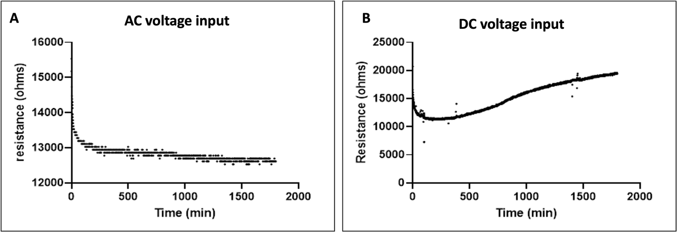
Fig. S1. The difference between using AC and DC power. Using DC power, the EDL forms, which causes a constant signal drift as resistance builds up. When AC power was used, this constant signal drift was not observed because the EDL is effectively a capacitor, and AC can pass through capacitors with ease due to the constant reversal of current.

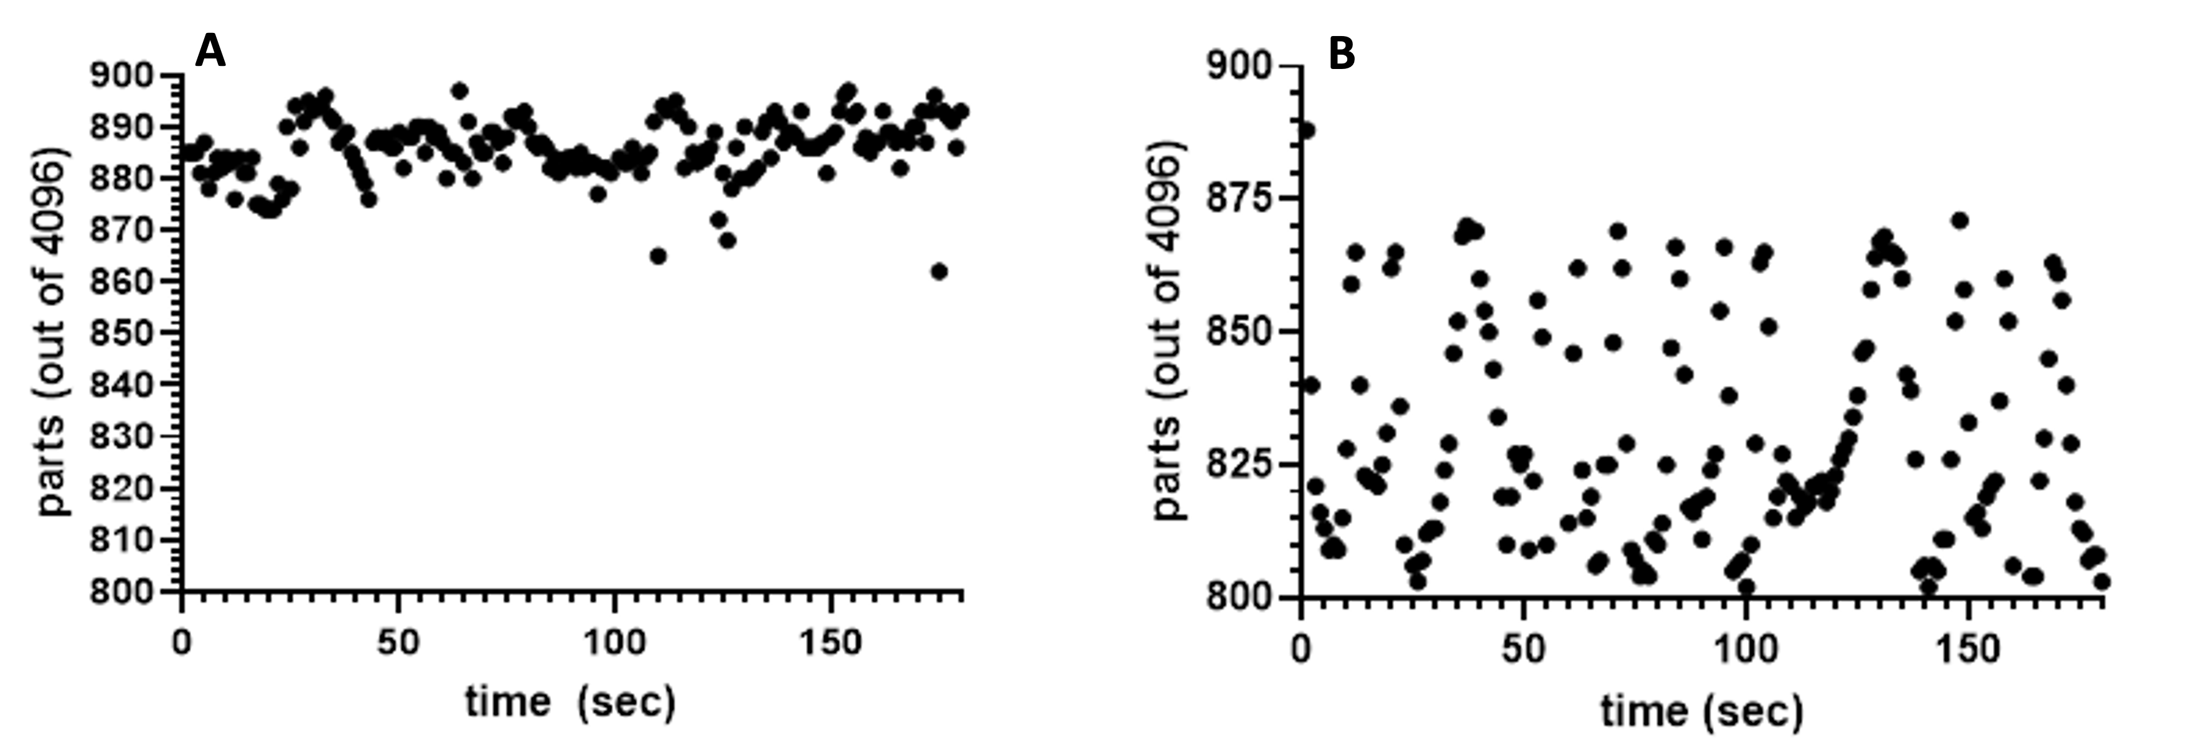
Fig. S2. (A) Observation of signal fluctuation from a 1 µF capacitor. (B) Observation of the signal fluctuation using a 22 µF capacitor.

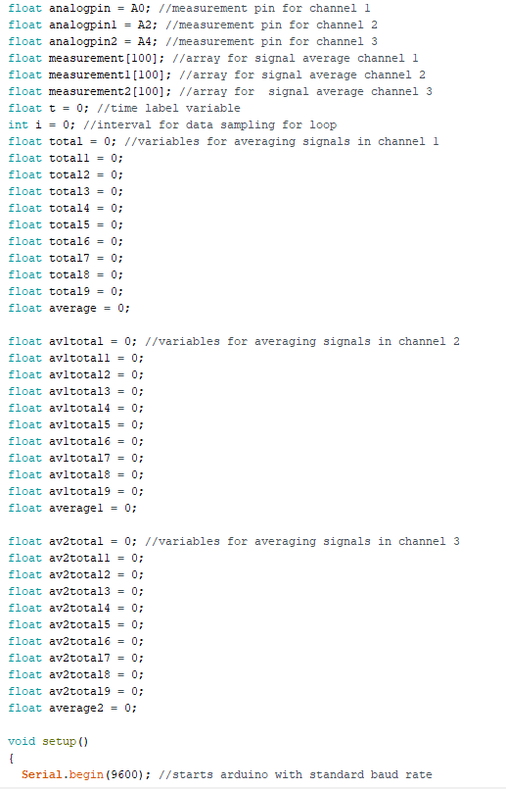

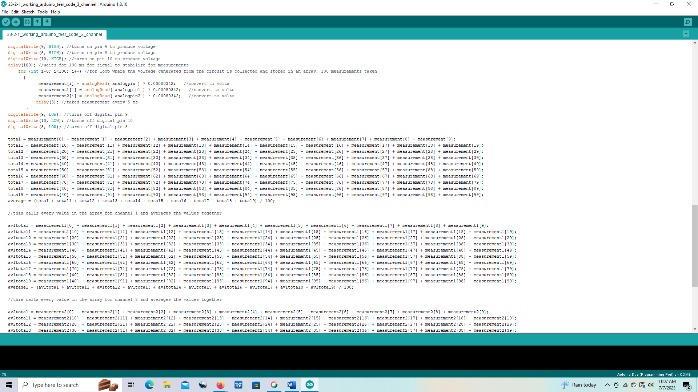
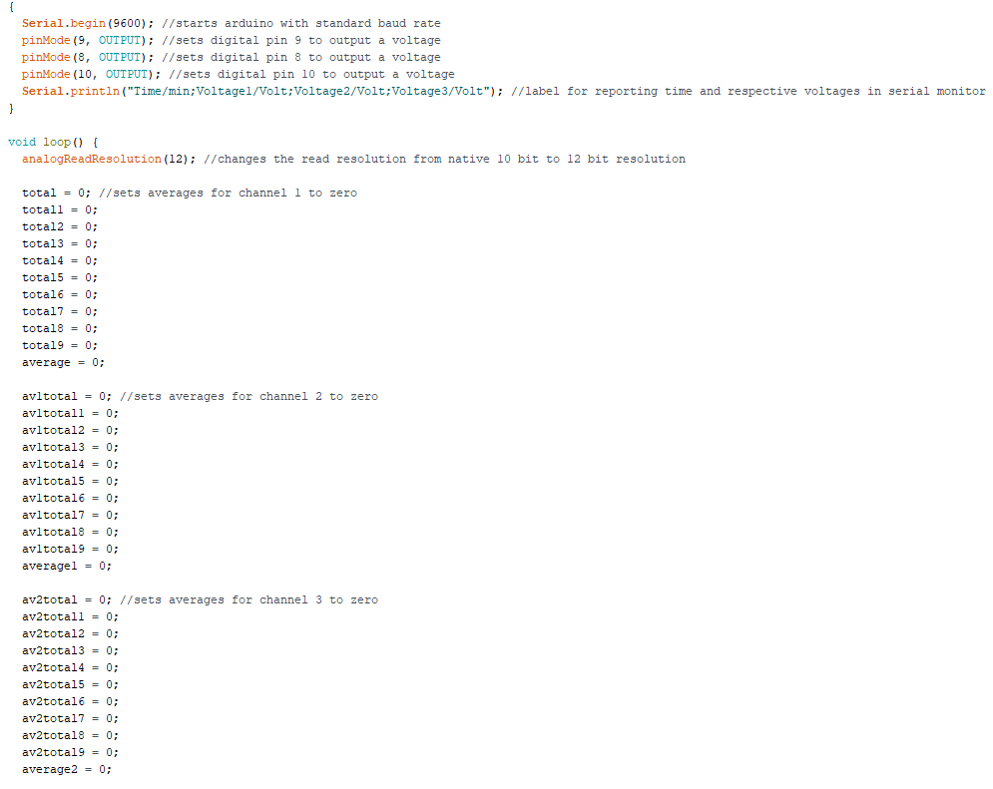

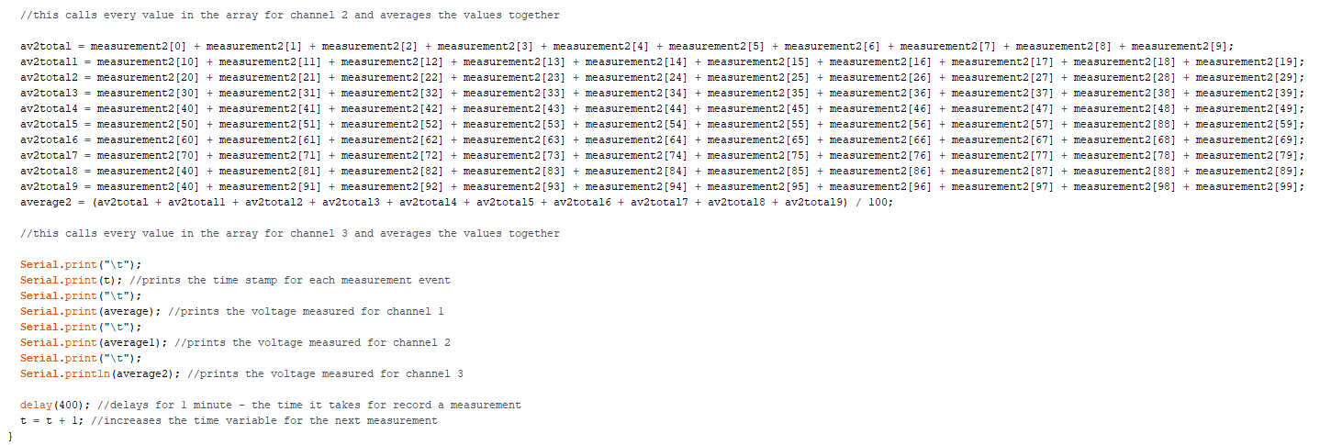
Fig. S3. The coding in Arduino, with comments

The coding

This was the entirety of the coding in Arduino to measure the voltage in the TEER meter. Rather than calculate the resistance in the program itself, this program converted the signal, measured in parts, into a voltage and reported that to the serial monitor. This way, calibration curves of each sensor relating voltage to a known resistor could be created. When scaling up or changing modules, the code did not need to be modified to account for the small but invariable differences associated with the positioning of the electrodes. Essentially, quick modification could be done to the circuit without changing the program, streamlining post-construction modifications. Regardless of whether the program calculates the resistance itself or that is done post-analysis in a program such as Microsoft Excel, the device needed to be characterized, and a calibration curve would be developed. Doing it this way, one less step was involved in building the system to record TEER measurements, reducing the total potential points of failure in the system.
While this system was developed to record 3 simultaneous measurements, the system can be scaled up to as many measurements as there are analog ports on the Arduino unit. The only things in the programming that would need to be added are extra matrices and variables to store measurement data. A 12-bit Arduino is recommended for this system as opposed to a 10-bit system due to the increased sensitivity that comes with measuring out of 4096 parts instead of 1024 parts.
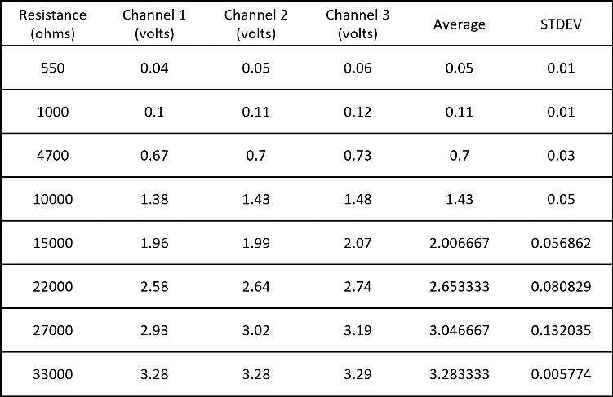

Fig. S4. This table displays the voltage measured for a specific resistor for the three individual channels (TEER sensors), which were used to make the calibration curve. After 27000 ohms, our TEER meter was unable to report quantitative measurements. The next highest resistor tested, 33,000 Ω, reported an average voltage signal of 3.283 ± 0.005 volts. The voltage of the Arduino board when it overflowed (too high of a voltage is present) was 3.29 volts.

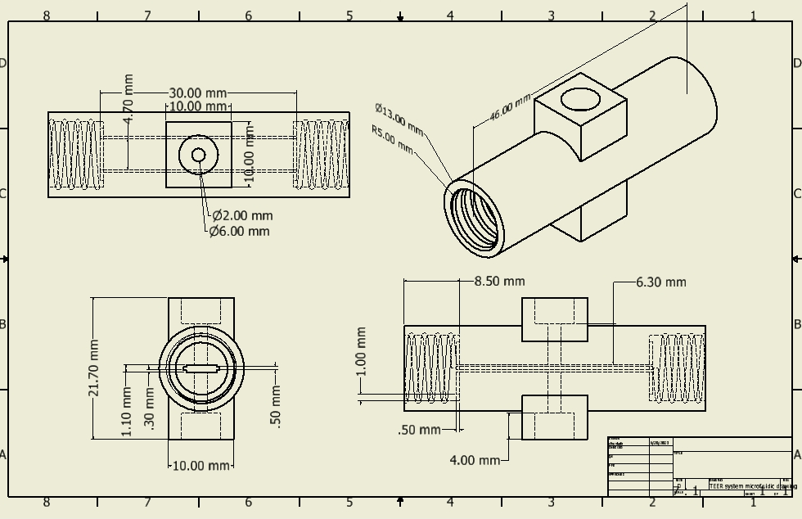
Fig. S5. Engineering sketch of the microfluidic module with relevant dimensions.

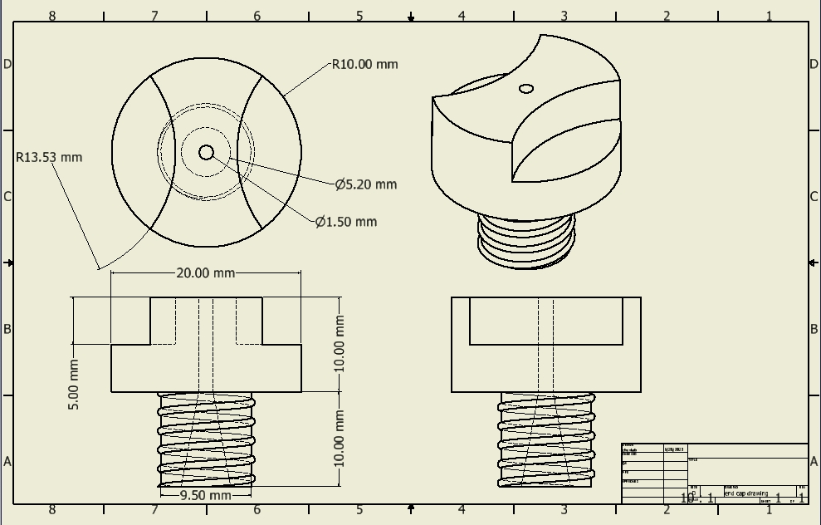
Fig. S6. Engineering sketch of the end cap with relevant dimensions.

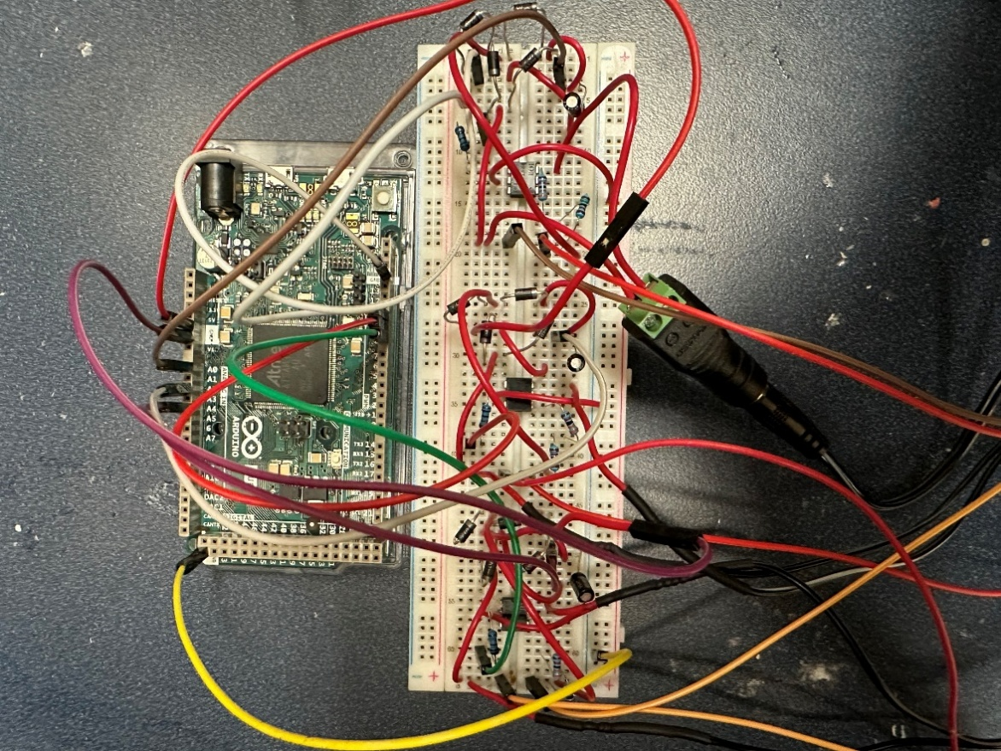
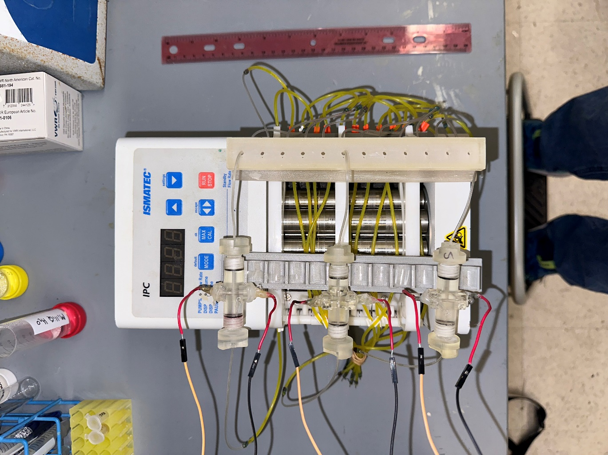
Reservoir
Circuit for each individual sensor
Arduino Board
A
B
Microfluidic devices
Wires going to
circuit

Fig. S7. The experimental setup. (A) Shows the circuit built on the breadboard and connected to the microcontroller unit. (B) shows the actual setup on the peristaltic pump.

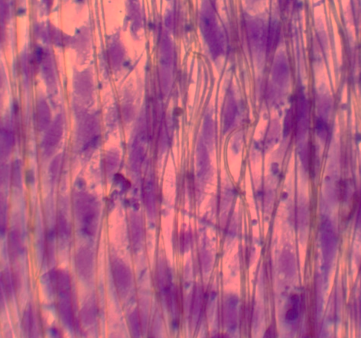
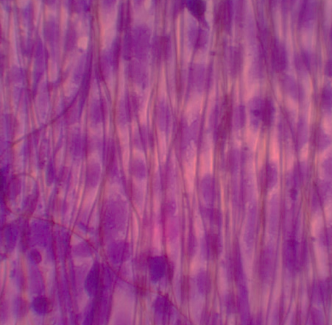
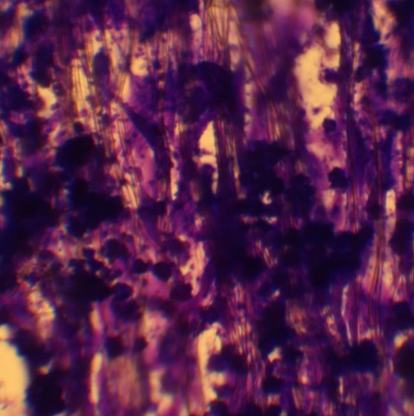
5 µm
5 µm
5 µm
C
B
A

Fig. S8. (A) The fixed and stained cells of the control group, with no doxorubicin administered. (B) An image of the fixed and stained endothelial cells treated with 0.5 µM doxorubicin. These cells had retained their elongation after a 24-hour period and still displayed a tightly packed monolayer. (C) An image of the crystal violet stained cells treated with 2.5 µM doxorubicin. After the treatment, larger gaps were seen between cells. Cell damage and the resulting fragment coagulation were also observed.

