SOCIAL MEDIA ANALYSIS

Title of Thesis: LOST EDGEHILL: URBAN RENEWAL, COLLECTIVE AGENCY,

AND GENTRIFICATION IN A SOUTH NASHVILLE NEIGHBORHOOD

Degree Candidate: Drew Mahan

Degree and Year: Master of Arts in Historic Preservation, 2024 Thesis Directed by: Betsy Bradley
Welch Center for Graduate and Professional Studies Goucher College

Social Media Project
For the social media portion of this project, I utilized images of Nashville’s Edgehill neighborhood from the Metro Development and Housing Agency collection at Metro Nashville Archives. Over the course of three months in the fall of 2023, I posted 83 times in total to Facebook and Instagram. Each post used at least one archival image to show a street level view of a building or intersection in the Edgehill neighborhood from 1960 to 1970. These archival images were complemented with historic Sanborn Maps and modern Google Street View snapshots to show the contrast between the eras I documented. I documented three eras in the posts: the Urban Renewal Era (1960 to 1970), the Turnkey Homes Era (1970 to 2010), and the gentrification era (2010 to present).
Generally, the format used in each post included an archival image from the 1960s, a Google Street View snapshot showing the area in the last decade, and a Sanborn map for visual orientation. Additionally, I created a mapping tool in Google Maps to show where the historic buildings would be oriented on the modern streetscape of the neighborhood. These images were posted to initiate a conversation with anyone who viewed the content, provide accessibility to previously unseen photos, and to provide a historical narrative of the neighborhood in the second half of the twentieth century.

Methods for Choosing Photographs
The images I posted were chosen from a collection of approximately 175 35-millimeter slides at Metro Nashville Archives. For this project, I chose images for several reasons, including visual appeal, availability of context, and if they appealed to my personal research interests. Visual appeal is largely subjective, but I found that I gravitated toward images with lots of color or a dearth of color. Photos of buildings with lots of signage and murals often spoke to me. On the contrary, images with stark scenes showing abandonment and decay also drew my attention. This phenomenon, know as “ruin porn,” has become a popular internet and television trope in the last twenty years. The appeal of the “ruin porn” comes from the way these images make us feel. These images are meant to provoke an emotional reaction; often sadness or grieving for a time that has passed. I am not immune to these feelings, and I admit to being drawn to such dismay while engaging in this project. Images of decaying buildings illicit strong reactions from some users, with some noting that the cities in the South “do not care about old buildings.” Although these images can be the cause for strong emotional reactions, they often trivialize the social and psychological implications of those who experience the changes in the neighborhood.
On the contrary, I felt like it was important to include posts that showed the resistance and agency of Edgehill’s residents during this turbulent time in their neighborhood. I included posts about the residents’ fight to get free bus service to access trips to the grocery store after several were demolished in the area. Several posts were dedicated to owners of Turnkey homes, which chronicled residents transitioning to homeownership in the area. The final images I posted showed the headquarters of the neighborhood coalition that fought against a large-scale public housing project and won. Because of these residents, the Turnkey homes were constructed in the area, resulting in a more stable neighborhood and a path to homeownership for those who previously thought it was impossible. These posts were made to provide an anecdote for posts that may have been deemed “ruin porn” and to provide a “fuller” history of the last 70 years of Edgehill’s history.

Metrics
As of February 2024, the Facebook page of “Lost Edgehill” has 75 “likes” and 103 “followers” and the Instagram page of “Lost_Edgehill” has 341 “followers.” On Facebook, metrics are measured in “reach” and “engagement.” Reach is defined as “the estimated number of users from the organic or paid distribution of your post, including if it was boosted. Reach is only counted once if it occurs from both organic and paid distribution.” Engagement is defined as “the total number of actions people take involving your posts. This includes liking/reacting, commenting, sharing, claiming your offers, clicking the link, etc.”
While Instagram does not provide advanced metrics past the last 30 days, Facebook does. From August to December 2023, I posted 27 times to Facebook. The post on November 28 chronicling the history of Dennison’s B-Rite had the least organic reach of any post with 64 users, while the aerial photograph of the neighborhood that was posted on September 28 with a reach of over 7,000 users reached the most users. Additionally, this aerial photograph was “shared” eight times, the second most of any post. Another post from October 12 generated 13 “likes” and 13 “shares,” with an overall engagement of almost 7,000 users. Posts that showed a wider view, such as streetscapes and aerials, showed more context, and generally were viewed, shared, and liked more than images that contained a single building. The notable exceptions to this rule include the two posts on September 8 and September 21 that detailed the history of two Black-owned grocery buildings on South Street. These posts generated a reach of 4,300 users and 3,700 users respectively.
Comments on the posts were limited to users posting additional questions regarding orientation of the photo, general questions about additional history of the building, comments lamenting the loss of a building from demolition, general praise for the page and photo, and simple emojis. No substantial conversation was gleamed from the comments section.

Goals
During the thesis proposal process I outlined several goals for this project. These goals were to tell the stories of the people, spaces, and buildings of Edgehill prior to Urban Renewal, add to the fuller Nashville and American story, provide accessibility to a previously “unseen” collection, inspire a new generation of preservationists with social media, create a forum for conversation surrounding Nashville’s urban renewal history and current gentrification, and create relationships with Edgehill residents past and present.
The posts I created told the stories of those who lived, worked and played in the buildings I highlighted. These stories were based on primary source material, including newspapers, maps, city directories, and photographs. In the beginning, I knew I could not tell the entire story of Edgehill with this project, as it was supposed to start a conversation, not be the ultimate and definitive history of the area. The major limitation with this goal was that primary sources can only tell a portion of the story. I was unable to have conversations with those who experienced the neighborhood in the period I was studying. This created a void that cannot be filled with facts alone. Ultimately, I believe that the project was successful in showcasing some of the buildings and people of Edgehill in the last 70 years using the resources that were available to me as a white historian that never lived there.
Telling more complete stories of a place has become a priority for preservationists in the twenty-first century. As an archivist working in Nashville for nearly a decade, I saw first-hand how archival records and photographs pertaining to the Black community were not as accessible as those related to the rich white areas. Often, the only records pertaining to Black communities were the photos of what the areas looked like before they were destroyed during Urban Renewal. This project highlighted a community that underwent massive change from urban renewal to present day, and the images I posted provided a historic context for an area that has gentrified. This project also shared the history of an area that physically no longer exists. I believe that this project provided a counterweight to the overpublished histories of great Civil War mansions and “trendy” white neighborhoods.
Over two months, these posts were viewed by over 10,000 unique users across both platforms. My goal of providing access to these images has been a success. As this is an online-only project, those without internet access were unable to view it. Also, there are many who never discovered the page who would be interested in this topic, leaving room for growth. My plan is to continue the account to expand my reach in the future.
Social media was used to bring new eyes to preservation issues. Ultimately, I’m not certain that I inspired anyone to become a preservationist. At worst, I probably reinforced some ideas that Urban Renewal was “bad” and at best I showed what a group of concerned citizens can do to a landscape through sheer will and tenacity. In retrospect, Facebook was probably not the correct platform for this project, as all metrics point to millennials and generation Z users leaving the platform in droves, while baby boomers remain. Instagram is a valuable tool to use with youth audiences, and it still retains a “cool factor.” In the past decade, Youtube and TikTok have become popular platforms for younger audiences to engage with. Looking back, I should have utilized one of these platforms.
The project does succeed at creating a forum surrounding issues of building loss, agency, and gentrification. Since the posts will live in perpetuity, there is always opportunity to comment or reach me via social media. The comment section is always open for anyone to view, so it is truly a forum. This forum is limited to those who follow the pages, it is missing lots of voices. If I could have succeeded in getting thousands of more followers, we may have had a forum that was more inclusive of those concerned with the issues outlined above.

Conclusions and Recommendations
In conclusion, some aspects of the project were more successful than others. I was able to use my knowledge as a historian of Nashville to mine primary sources in order to tell stories of Edgehill and its people. The stories I shared were compelling and provided context to the history of the area. I am proud that there is now a virtual space that people can access in order to view what Edgehill looked like throughout the last 70 years with narrative context. I am also proud that I was able to share these images with the world. Before this project, only a handful of archivists had viewed the images.
Some aspects of the project were not as successful. For starters, I would have started to engage on social media far sooner than August 2023 if I could do it again. I have learned that gaining traction on social media is a process that can take months or even years to develop. I should have started a year before the actual launch, releasing snippets and teasers every few days. This would have led me to have a larger audience once the project launched. The limited audience of the posts also led to limited comments. If I had a larger audience, I surmise I would have had more interaction on my posts.
Other projects like this should start with a broad view of the area to establish a project area and to orient the users and followers. I found that the broader posts led to more engagement, while those that included a single story were not engaged with as much. This is possibly due to some followers unfamiliarity with the geography of the area.
My project was limited to primary source documents to develop my posts. Projects like this should include the voices of those who directly experienced the stories I detailed in my posts. These limitations were due to time constraints and the difficulty in locating the diaspora of Edgehill since they moved away from the area.

Post Date: August 28, 2023
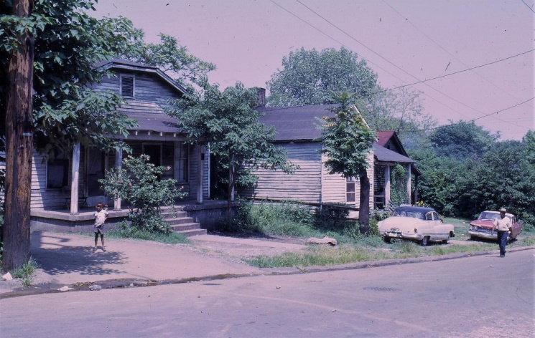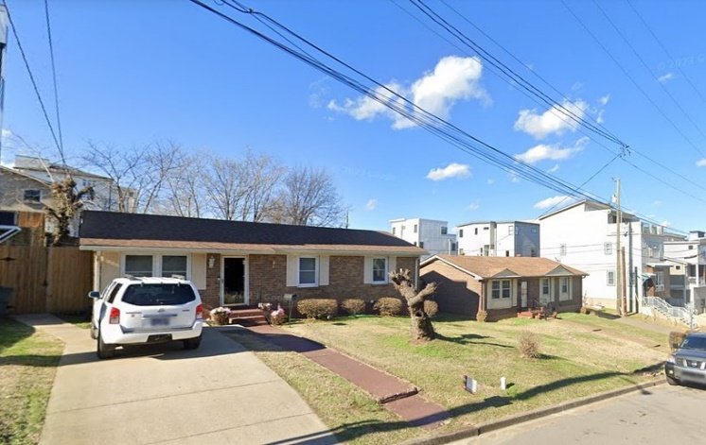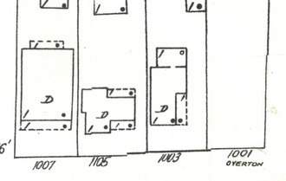 | On October 25, 1899, Buist Vaulx was born in the house at 1007 Overton Street. By 1920, the twenty-year old had moved to Chicago and was employed as a butcher in a meatpacking plant. Buist died in Chicago on December 23, 1964, two years before the houses in this image were demolished for the Edgehill Urban Renewal Project. Buist Vaulx's south side Chicago home was demolished for the construction of I-57 in the mid-1960s.  📸Photo 1: 1007 to 1011 Overton Street. 1966.  📸Photo 2: Approximate location in January 2023.  📸Photo 3: Sanborn Map. 1957  #nashville #edgehill #nashvillehistory #urbanrenewal #urbanphotography #architecture #thenandnow #landscape #gentrification #sanborn #urbanphotography #streetscape #design #density #urbanexplorer

Post Date: August 30, 2023
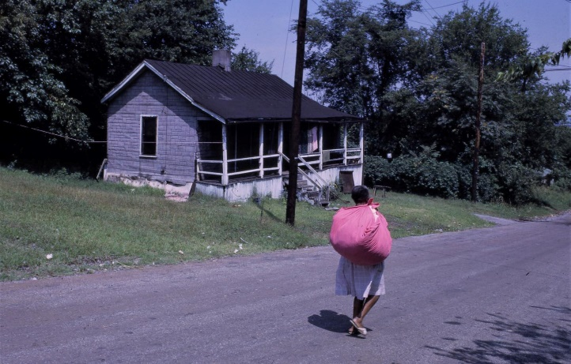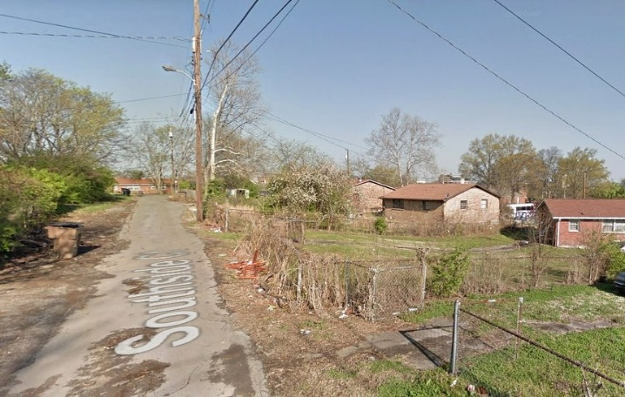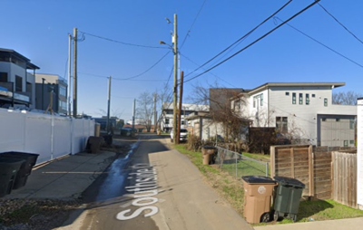 | The dwelling at 913 11th Avenue South was constructed around 1910. Being at the heart of the Edgehill Urban Renewal zone, it was demolished in 1966. After the land was cleared, this portion of 11th Avenue South was removed from the street grid, cutting off direct access to the South Street commercial district down the hill. This area was filled-in with "Turn-Key" homes in the 1970s, and an alley known as Southside Court was constructed near the approximate location of the home in the first image. Around 2015, large two and three-story homes replaced the small "Turn-Key" homes in this area.  📸Photo 1: 913 11th Avenue South. 1966  📸Photo 2: Approximate location in 2014  📸Photo 3: Approximate location in 2022  📸Photo 4: Sanborn Map 1914 to 1950  #nashville #edgehill #nashvillehistory #urbanrenewal #urbanphotography #architecture #thenandnow #landscape #gentrification #sanborn #urbanphotography #streetscape #design #density #urbanexplorer
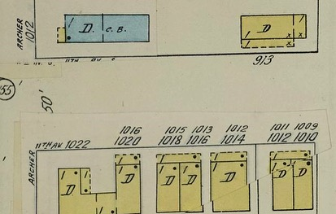

Post Date: September 1, 2023
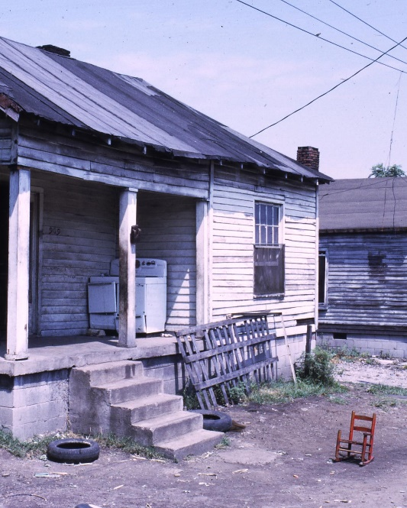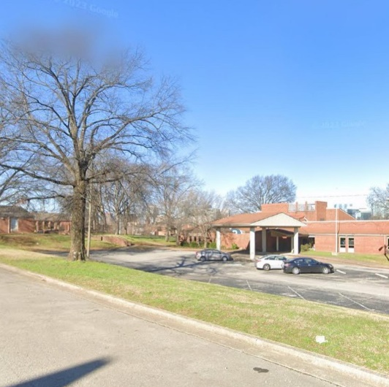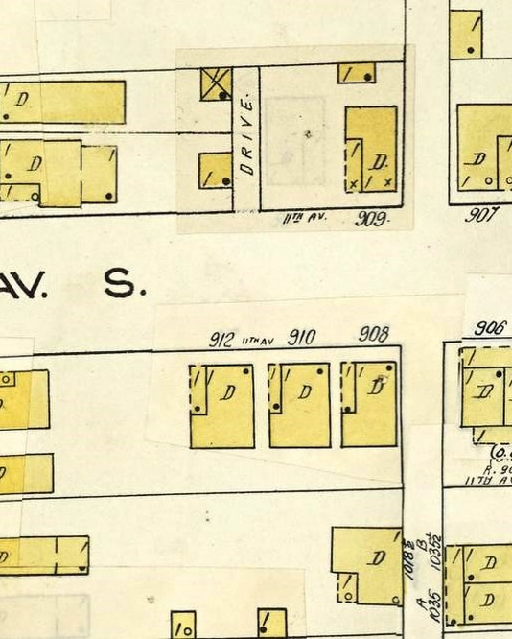 | Ruby Byrd lives with eight children in a five-room house with no water and a bathroom that is inoperable. The family goes to a neighbor’s house next door to wash.  “I want a better place to live,” she said.  She pays $40 per month in rent for the dimly lit and crowded house.  Shortly after this photograph was taken, this entire block was demolished as part of the Edgehill Urban Renewal project. In 1976, construction began on the “turnkey homes” in this area. Today, this approximate location is a parking lot for the Rochelle Center.  📸Photo 1: 909 11th Avenue South in 1966  📸Photo 2: Approximate location of 909 11th Avenue  South in 2022  📸Photo 3: Image of Sanborn Map depicting the block from 1914  to 1950  #nashville #edgehill #nashvillehistory #urbanrenewal #urbanphotography #architecture #thenandnow #landscape #gentrification #sanborn #urbanphotography #streetscape #design #density #urbandecay

Post Date: September 5, 2023
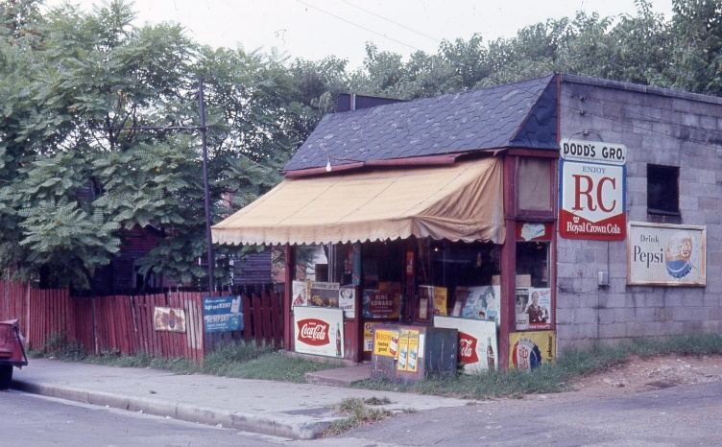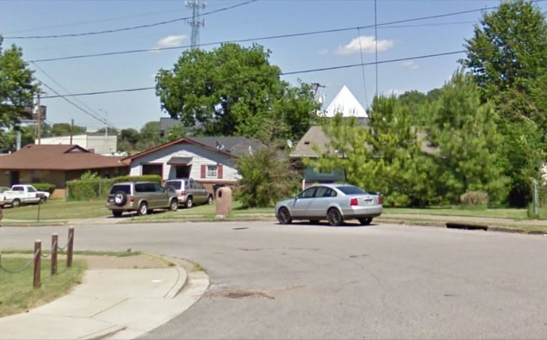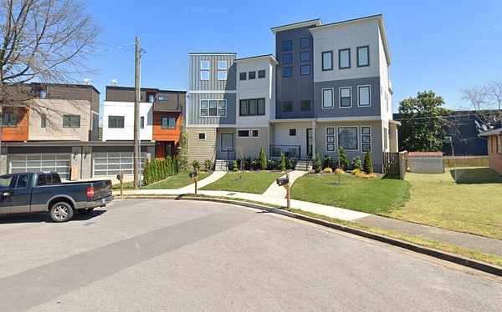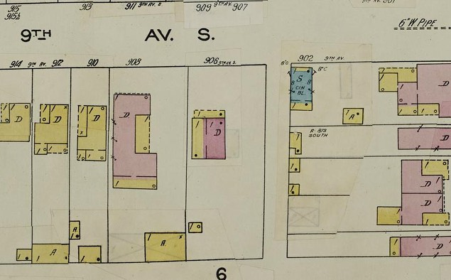 | Ruby and Lloyd Dodd operated this grocery store at 902 9th Avenue South from the late 1940s to the late 1960s. When the Edgehill Urban Renewal Project demolished this block, concerned neighbors petitioned the Nashville Housing Authority to provide free weekly bus fare to local grocery stores due their absence in the neighborhood.  Known as the Edgehill Project Area Committee, this group noted that "since the NHA has begun its Urban Renewal activities in the Edgehill area, many stores (particularly Black-owned stores) have been closed."  (Source: The Tennessean 1970:3)  📸Photo 1: 902 9th Avenue South in 1966  📸Photo 2: Approximate location of 902 9th Avenue  South in 2009  📸Photo 3: Approximate Location of 902 9th Avenue South in 2019  📸Photo 4: Sanborn Map 1914 to 1950  #nashville #edgehill #nashvillehistory #urbanrenewal #urbanphotography #architecture #thenandnow #landscape #gentrification #sanborn #urbanphotography #streetscape #design #density #urbandecay

Post Date: September 8, 2023
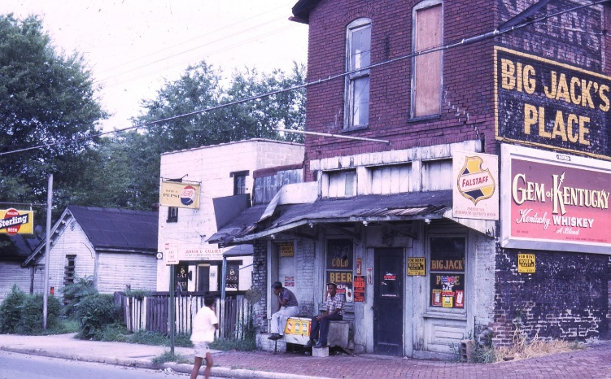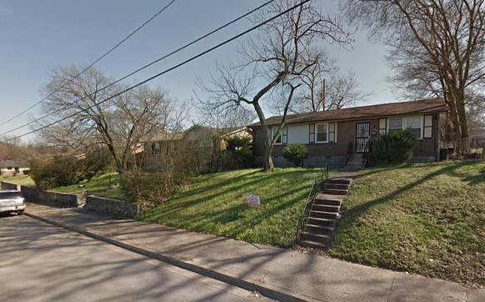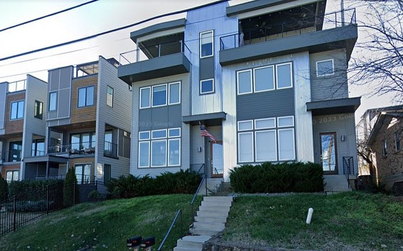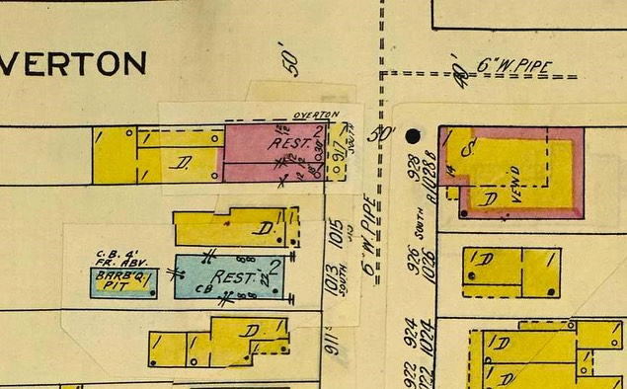 | Constructed around 1890, the brick commercial building at 1017 South Street was occupied by a series of grocery stores and restaurants in the first half of the twentieth century. According to city directories, some of these included Lee Chumbley Grocery (1911), J.D. Nolan Grocery (1915), E.E. Birchett Grocery (1924), Sweeny’s Grocery (1935), Fred Brooks Restaurant (1955), and the Colleen Inn Restaurant (1958). At some point in the 1950s or 1960s this building was referred to as “Big Jack’s Place.”  In 1911, Mary Couve operated a lunchroom for African-Americans inside the building. This was one of the few restaurant options for Black residents during the early twentieth century in Nashville. During prohibition, Federal prohibition agents seized 48 half-pints of liquor on this site. The three men were arrested on the charges of selling intoxicating liquor.  Known as Lucy’s Dinner Club in the 1950s, the white concrete block building to the left of the frame became known as Junior and Callies in the 1960s. Junior and Callies served “cold beer, southern-fried chicken, and fish dinners.”  Both buildings were demolished for the Edgehill Urban Renewal project in the late 1960s. The project forced the closure of 15 grocery stores in the area, forcing residents to take taxi cabs to stores further away. In 1970, a resolution to provide bus service to grocery stores for low-income residents in the area was defeated by one vote.  A small “turn-key” home was constructed on the site in the mid-1970s. In 2017, a three-story, 2,600 square-foot dwelling was built on the site.  (Source: Nashville City Directories; Nashville Banner 1924; The Tennessean 1970).  📸Photo 1: 1013 to 1017 South Street in 1966  📸Photo 2: Approximate location of 1013 to 1017 South Street in 2015 (turn-key home)  📸Photo 3: Approximate location of 1013 to 1017 South Street in 2022  📸Photo 4: Sanborn Map 1914 to 1950  #nashville #edgehill #nashvillehistory #urbanrenewal #urbanphotography #architecture #thenandnow #landscape #gentrification #sanborn #urbanphotography #streetscape #design #density #urbandecay

Post Date: September 12, 2023
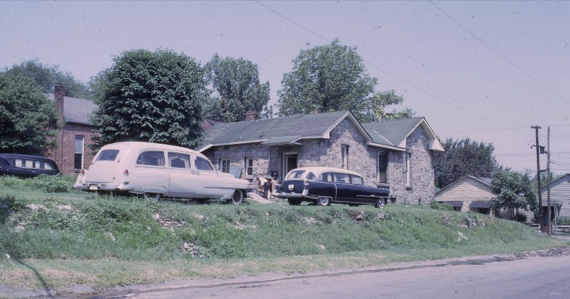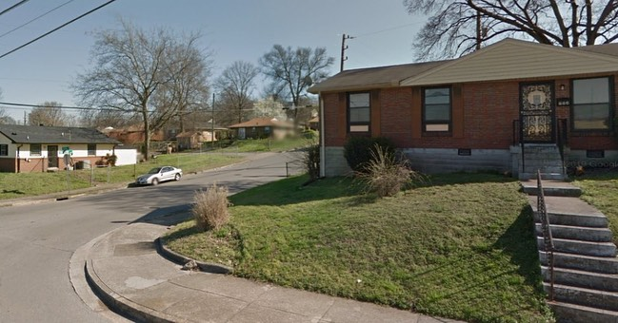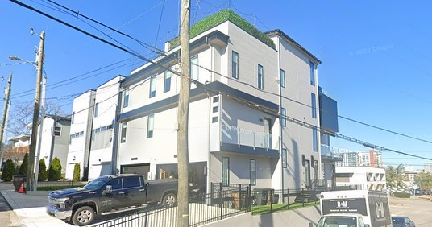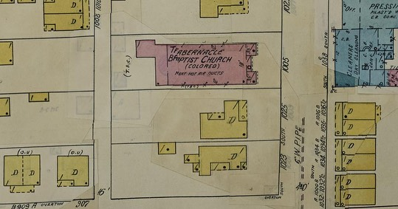 | The building at the southwest corner of Overton Street and South Street was occupied by the Hillcrest Salon in the 1950s, and later became a residential dwelling in the 1960s. The brick building at the left of the frame is the former home of the Tabernacle Baptist Church, one of the oldest Black congregations in Nashville. Founded in 1892, the Tabernacle Baptist Church moved from 8th Avenue North to this South Street location in the early 1900s. The buildings in the first image were demolished in 1966, making Tabernacle Baptist one of the four churches that were forced to close or relocate due to the Edgehill Urban Renewal Project.  In the mid-1970s, a “turnkey” home was constructed on the site (Photo 2). By 2020, all the turnkey homes in this area had been demolished, and a three-story, 3,600 square-foot duplex was constructed on the corner lot.  (Source: Nashville City Directories; Tabernacle Baptist Church)  📸Photo 1: Southwest corner of Overton Street and South Street, looking northwest, 1966.  📸Photo 2: Approximate location in 2015, looking southeast.  📸Photo 3: Approximate Location in 2022, looking northwest.  📸Photo 4: Sanborn Map 1914 to 1950  #nashville #edgehill #nashvillehistory #urbanrenewal #urbanphotography #architecture #thenandnow #landscape #gentrification #sanborn #urbanphotography #streetscape #design #density #blackhistory #church #churchhistory

Post Date: September 14, 2023
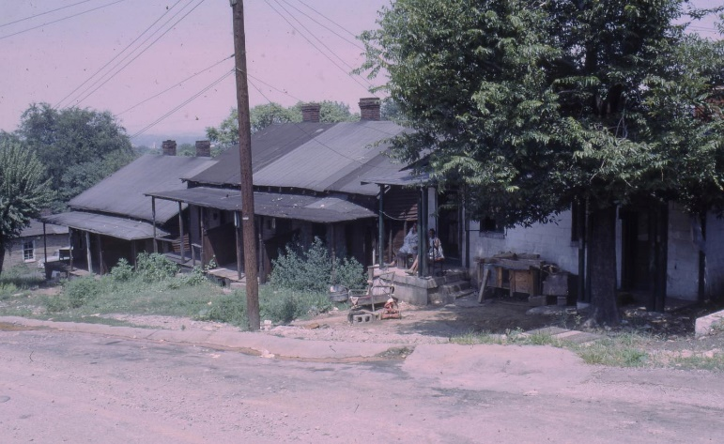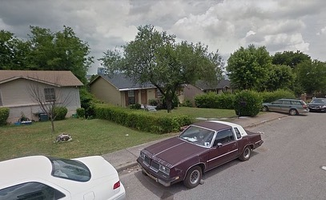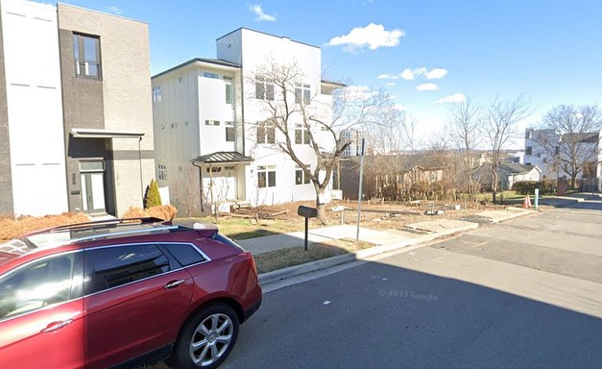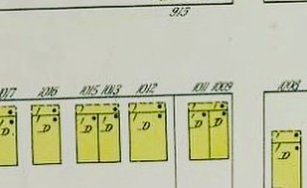 | Constructed between 1908 and 1914, these wood-frame duplexes were located on 11th Avenue South, south of Archer Street. According to city directories, some of the earliest residents of these dwellings were Nelson Carter, a laborer, Wayman Collins, a porter, Nellie and Susie Briley, laundry workers, Thomas Eldridge, a laborer, Mary Keith, a seamstress, and Florence Manier, a maid. In the late 1950s, William Adam Coles moved into the duplex at far left (1st photo). Mr. Coles was a cook and painter, making $675 per year in the 1940s.  In the late 1960s, this block was demolished for the Edgehill Urban Renewal Project. The project removed this section of 11th Avenue South from the street grid, cutting off access to the commercial district along South Street. In 1972, “turnkey homes” were constructed on the site. In 2023, a 2,800 square-foot duplex was constructed near this location.  (Sources: Nashville City Directories; U.S. Census 1930, 1940)  📸Photo 1: 1000 block of 11th Ave South, looking northeast, 1966.  📸Photo 2: Approximate location in 2016, looking northeast.  📸Photo 3: Approximate Location in 2023, looking northeast.  📸Photo 4: Sanborn Map 1914 to 1950  #nashville #edgehill #nashvillehistory #urbanrenewal #urbanphotography #architecture #thenandnow #landscape #gentrification #sanborn #urbanphotography #streetscape #design #density #blackhistory #duplex #historichome #historicduplex #workershousing #rowhouse

Post Date: September 19, 2023
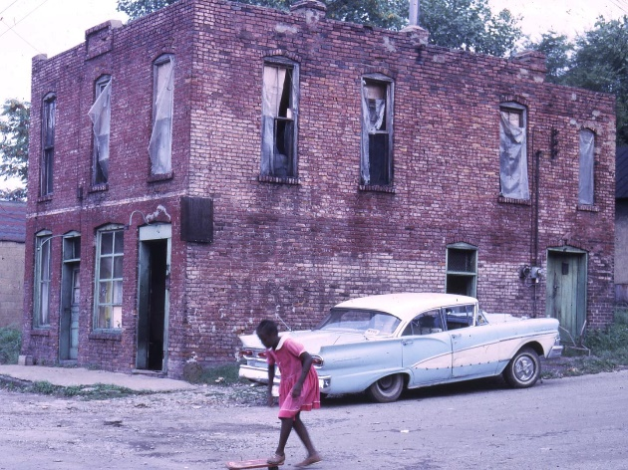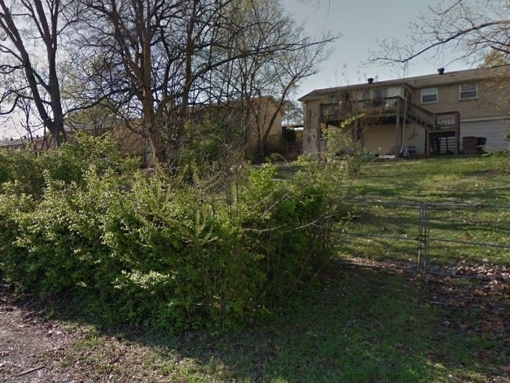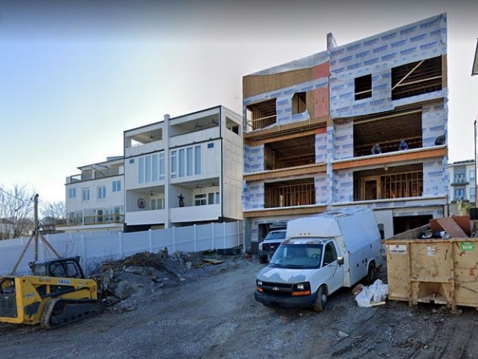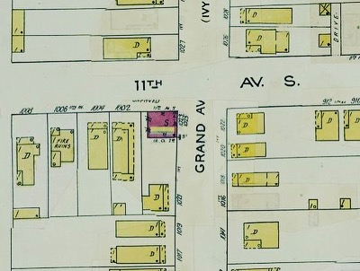 | Constructed in 1922, the two-story, brick commercial building at 1023 Grand Avenue was first occupied by Chase Rich, a coal and ice worker. Thomas Petty and S.S. Webb operated two of the earliest-known Black-owned grocery stores here in the mid-1920s. By 1928, the building entered a period where it was vacant for five years.  In 1933, Mrs. Berdie Mantz operated a grocery store in the building, with William R. Simmons living there as a tenant. Wood fuel peddler and truck driver Joseph Ussery was a tenant in the building in the mid-to-late 1930s.  From 1942 to 1956, Arthur E. Sager and Minnie Sager lived and worked at 1023 Grand Avenue. They operated Sager Market and lived in the apartment above. The Sagers were the last known tenants of the building.  Newspaper advertisements show that the building was put up for auction in 1963. These ads promoted two apartments that rented for $50 per month. Sometime between 1966 and 1970, the building was demolished for the Edgehill Urban Renewal Project.  In the mid-1970s, this corner was removed from the street grid, and an 800-square-foot dwelling was built near the site. The new layout removed 11th Avenue South from this area, and Grand Avenue was replaced with an alley. In 2023, a 2,800-square foot duplex was constructed on the site. The duplex has an appraisal value of over $840,000.  (Sources: Nashville City Directories 1922 to 1955; The Tennessean 1963; U.S. Census 1930, 1940, 1950)  📸Photo 1: 1023 Grand Ave, looking southeast, 1966.  📸Photo 2: Approximate location, looking southeast, 2015.  📸Photo 3: Approximate location, looking southeast, 2022.  📸Photo 4: Sanborn Map 1914 to 1950  #nashville #edgehill #nashvillehistory #urbanrenewal #urbanphotography #architecture #thenandnow #landscape #gentrification #sanborn #urbanphotography #streetscape #design #density #blackhistory #duplex #historichome #historicduplex #workershousing #rowhouse #commercial #abandoned #grocery #cornerstore #livework

Post Date: September 21, 2023
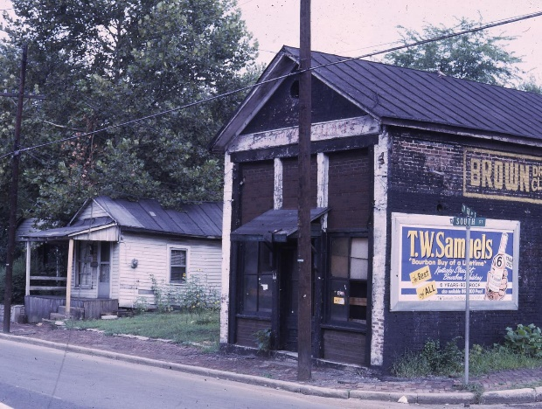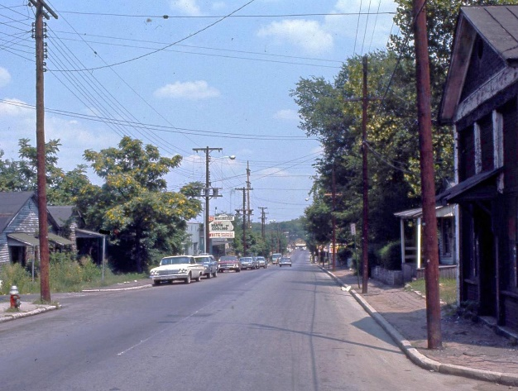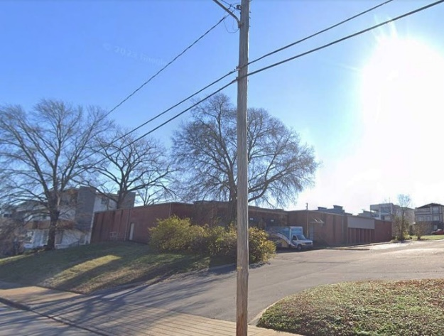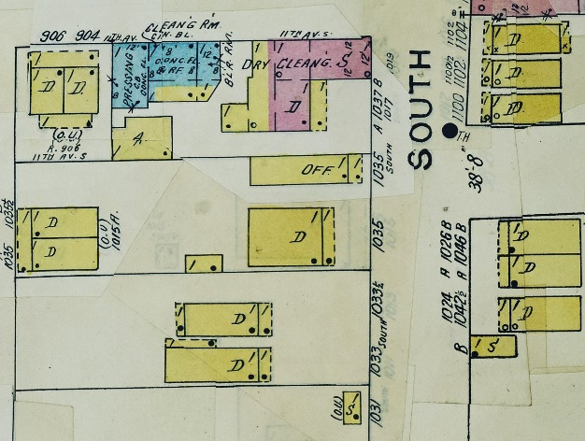 | Constructed in 1922, the two-story, brick commercial building at 1037 South Street was at the heart of the Black business district in this area of Edgehill. C.L. Harding opened a grocery store here in 1922, making this one of the earliest Black-owned stores to operate in the area. From 1923 to 1924, a white grocer named E.E. Birchett opened a meat market and grocery in the building. Around 1925, C.R. Sandman took over the building to operate his grocery store. Walter L. Hicks, a Black businessman, entrepreneur, and reverend, opened his grocery store on this site in 1930.  The grocery store was converted into a dry cleaner when Jason Franklin opened his business here in the late 1930s. In 1946, Aaron Brown took over the dry-cleaning business, posting frequent advertisements in the newspaper in search of “wool and silk finishers” and truck drivers. In 1956, the City of Nashville assessed the value of the building at $3,500. The building was vacant for nearly a decade before being demolished during the Edgehill Urban Renewal Project in 1970. The Brown Dry Cleaner mural can be seen on the west side of the building in the first historic photograph.  During the Urban Renewal period, the brick sidewalks were removed, South Street was widened and turned into a "boulevard" with a median. The building at 1037 South Street was one of dozens of Black-owned businesses that were demolished because of the project.  In 1973, The Rochelle Center completed construction of a campus and parking lot near this site. The 4.5-acre parcel is currently valued at over $12 million.  (Sources: Nashville City Directories 1922 to 1955; Nashville Banner 1956; U.S. Census 1930, 1940, 1950)  📸Photo 1: 1037 South Street, looking southeast, 1966.  📸Photo 2: 1000 block of South Street, looking east, 1966.  📸Photo 3: Approximate location, looking southeast, 2022.  📸Photo 4: Sanborn Map 1914 to 1950  #nashville #edgehill #nashvillehistory #urbanrenewal #urbanphotography #architecture #thenandnow #landscape #gentrification #sanborn #urbanphotography #streetscape #design #density #blackhistory #duplex #historichome #historicduplex #workershousing #rowhouse #commercial #abandoned #grocery #cornerstore

Post Date: September 25, 2023
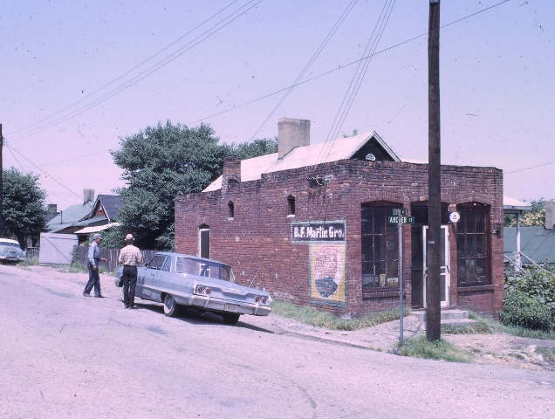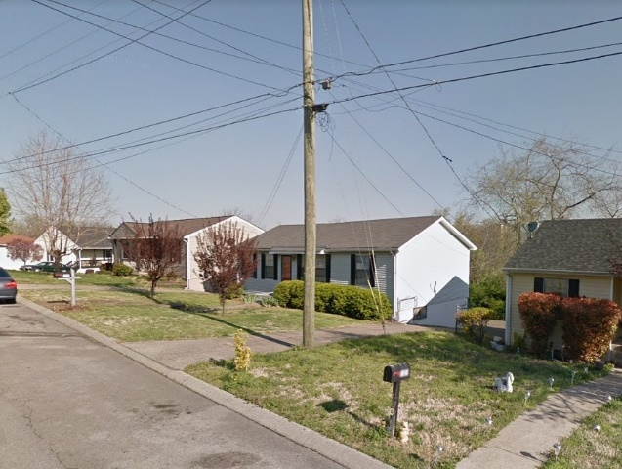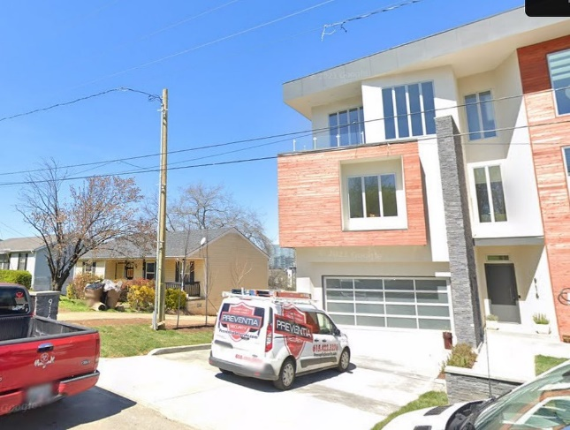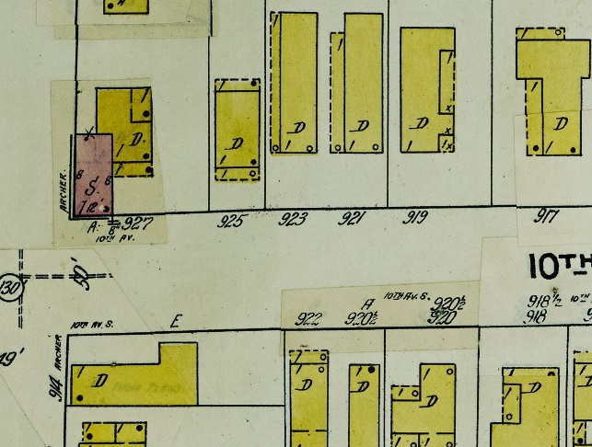 | Constructed in 1912, The B.F. Martin grocery store was a one-story, brick commercial building at 927 10th Avenue South. Benjamin F. Martin and his wife Mary Martin lived in the home attached to the store until they constructed a four-room frame house at 1011 Archer Street in 1924. The Martin family operated the grocery store until the early 1960s, when they demolished the store and house on the lot. In 1968, they listed the grocery store fixtures for sale via an advertisement in the Tennessean. The B.F. Martin grocery was one of 14 grocery stores in the area that closed during the Edgehill Urban Renewal Project.  During the Urban Renewal Project, 10th Avenue South was completely erased from the street grid in this area, and this portion of Archer Street was truncated with a cul-de-sac. A small, Ranch-style dwelling was constructed near the site of the grocery in the mid-1970s. In 2019, the Ranch house was demolished, and a 3,500 square-foot house was constructed near the site. In 2021, the appraisal value for the extant house was $1,175,000.  (Sources: Nashville City Directories 1910 to 1955; Nashville Tennessean 1963, 1968)  📸Photo 1: 927 10th Avenue South, looking northwest, 1966.  📸Photo 2: Approximate location of 927 10th Avenue South looking northwest, 2014.  📸Photo 3: Approximate location of 927 10th Avenue South looking northwest, 2022.  📸Photo 4: Sanborn Map 1914 to 1950 showing the store in pink  #nashville #edgehill #nashvillehistory #urbanrenewal #urbanphotography #architecture #thenandnow #landscape #gentrification #sanborn #urbanphotography #streetscape #design #density #blackhistory #duplex #historichome #historicduplex #workershousing #rowhouse #commercial #abandoned #grocery #cornerstore
Post Date: September 28, 2023
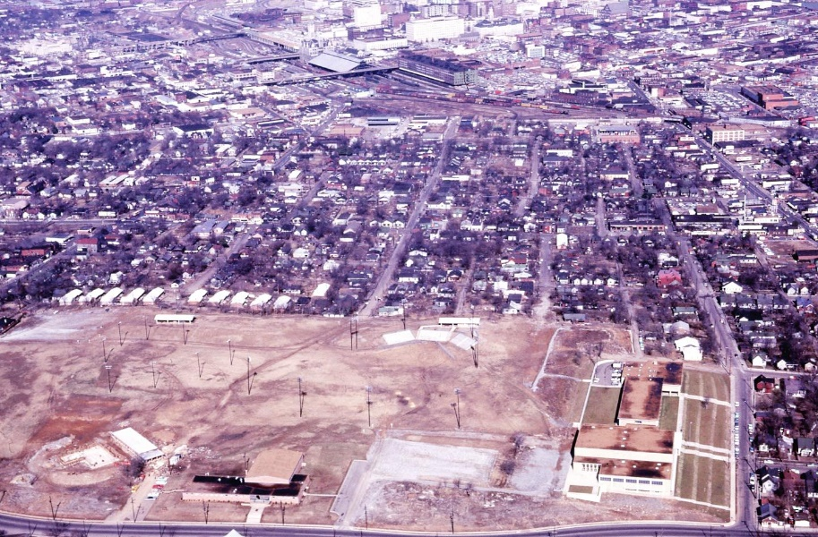  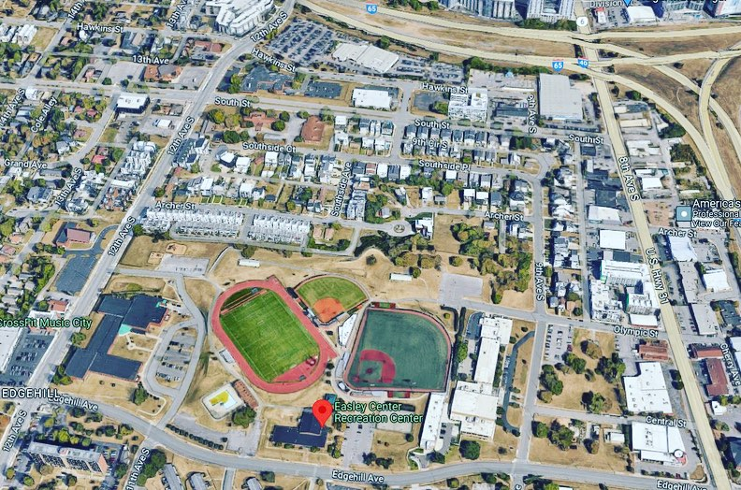 | In 1961, the city of Nashville turned their five-acre holding of land atop “Rock Crusher Hill” (also known as Currey’s Hill or Meridian Hill) over to the park board, and work began immediately to fill the former quarry into developable land. Project engineer Billy Sumner estimated that it took 150,000 cubic yards of rock and dirt to fill the pit. Sumner left a ridge at the northern edge of the project area, near the grandstands in the historic image. Named for his wife, “Sue’s Ridge” has a "fine" view of Downtown Nashville.  During this time, the city constructed the Easley community center (1963), Rose Park School (1964), and the Rose Park pool (1965) on top of the former quarry. The 2022 aerial photograph shows the addition of a baseball, softball, and soccer fields on top of the hill.  (Sources: Tennessean 1963, 1964, 1965).  📸Photo 1: Looking north at Rock Crusher Hill and the Edgehill neighborhood, 1965  📸Photo 2: Approximately the same view as Photo 1, 2022.  #nashville #edgehill #nashvillehistory #urbanrenewal #urbanphotography #architecture #thenandnow #landscape #gentrification #sanborn #urbanphotography #streetscape #design #density #blackhistory #duplex #historichome #historicduplex #workershousing #rowhouse #commercial #abandoned #grocery #cornerstore #quarry #community #school #aerial #aerialphotography

Post Date: October 4, 2023
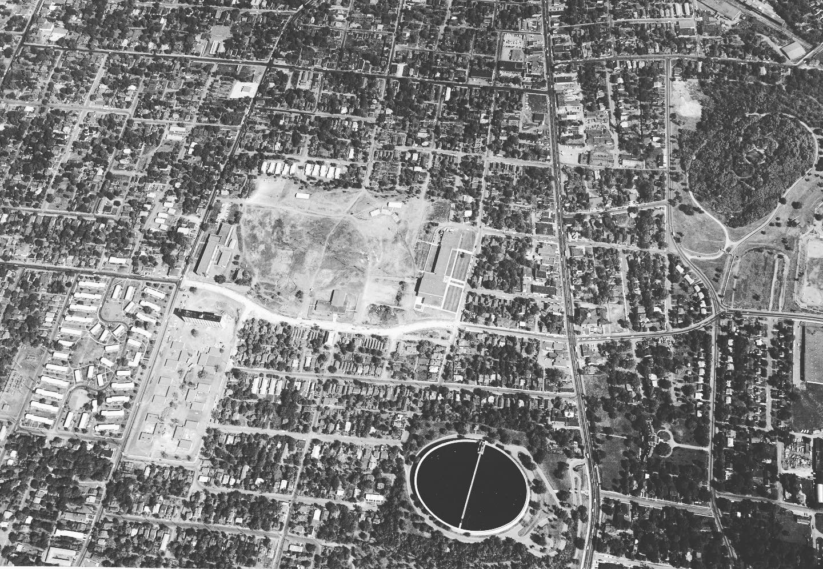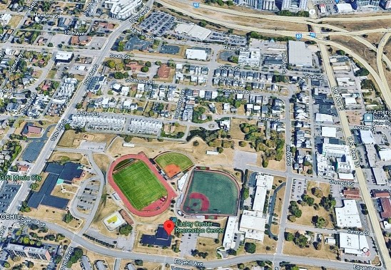 | This aerial photograph from 1964 shows the Edgehill neighborhood and the surrounding areas just before most of the area was demolished around 1970. Notable landmarks include the 8th Avenue Resevoir (bottom right) and Fort Negley (far right).  📸Photo 1: Looking north at Rock Crusher Hill and the Edgehill neighborhood, 1964  📸Photo 2: Approximately the same view as Photo 1, 2022.  #nashville #edgehill #nashvillehistory #urbanrenewal #urbanphotography #architecture #thenandnow #landscape #gentrification #sanborn #urbanphotography #streetscape #design #density #blackhistory #duplex #historichome #historicduplex #workershousing #rowhouse #commercial #abandoned #grocery #cornerstore #quarry #community #school #aerial #aerialphotography

Post Date: October 5, 2023
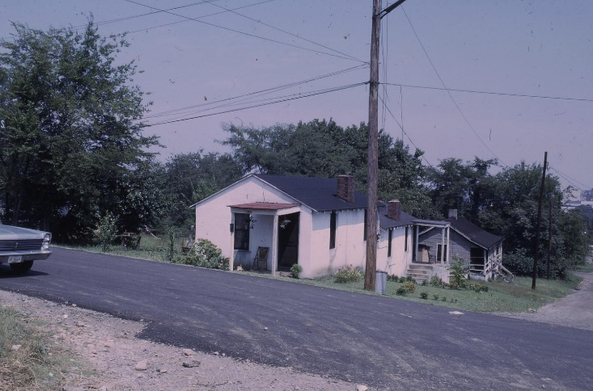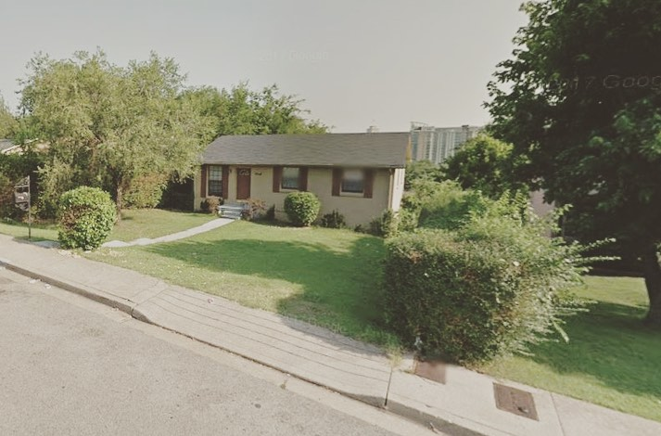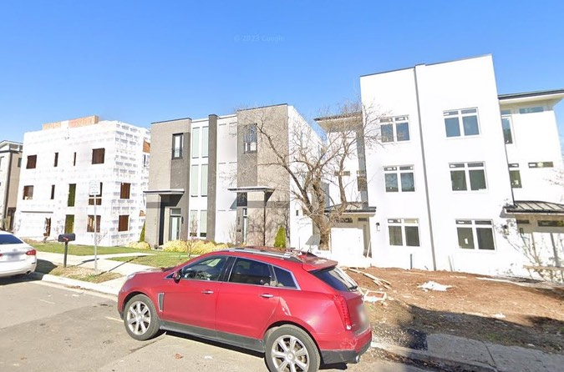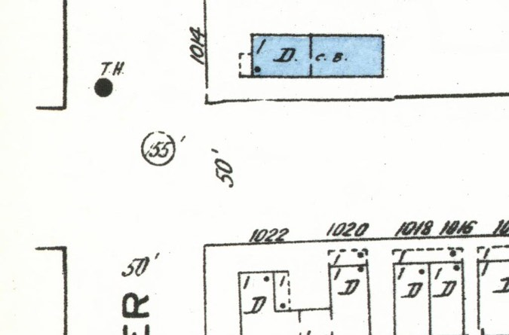 | Constructed around 1940, this concrete block duplex was occupied by Chase E. Reynolds and his wife Allene in the 1950s. During this time, Reynolds was employed as a barber at George Holiday’s barber shop at 1000 12th Avenue South. Around 1970, the Edgehill Urban Renewal Project demolished this block, and 11th Avenue was removed from the street grid from Archer Street to South Street.  Around 1974, Zeitlen Construction Company built 54 single-family homes near this site. Named Southside Estates, the new homes were available for around $16,000, and they offered financing via FHA loans to low-income families.  In 2019, a developer constructed a three-story, 3,000 square-foot duplex on the site. The Duplex was appraised for $950,000 in 2023.  (Sources: Nashville City Directories 1950 to 1960, Tennessean 1971).  📸Photo 1: Northwest corner of 11th Avenue North and Archer Street, looking northwest, 1966.  📸Photo 2: Approximate location in 2011.  📸Photo 3: Approximate location in 2022.  📸Photo 4: Sanborn Map from 1957 showing the building in blue  #nashville #edgehill #nashvillehistory #urbanrenewal #urbanphotography #architecture #thenandnow #landscape #gentrification #sanborn #urbanphotography #streetscape #design #density #blackhistory #duplex #historichome #historicduplex #workershousing #rowhouse #commercial #abandoned #grocery #cornerstore #barber #barbershop
Post Date: October 9, 2023
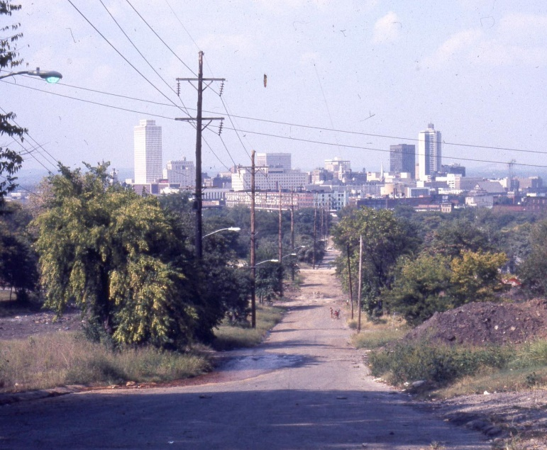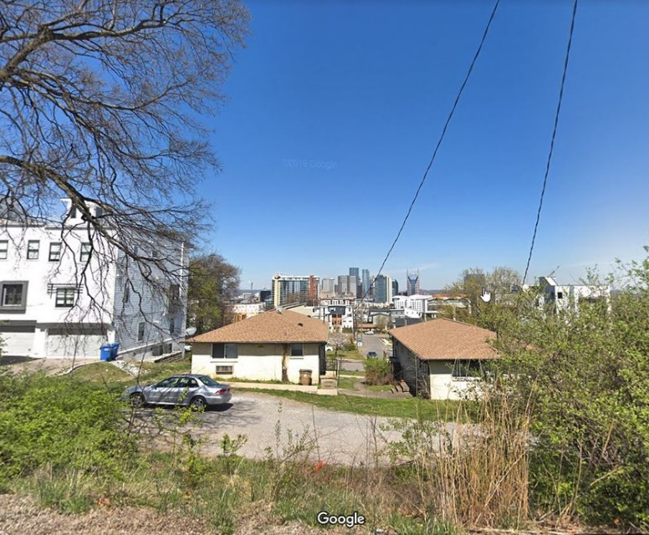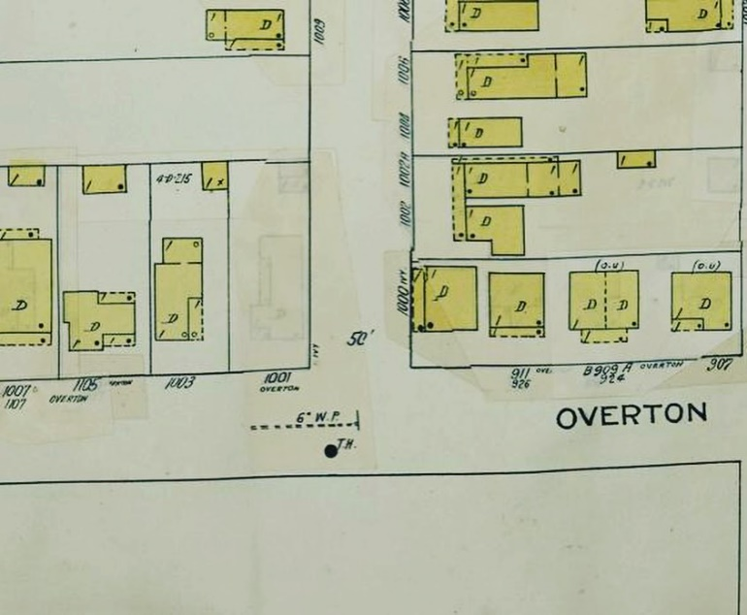 | By 1970, Metro Nashville demolished 48 dwellings and St. Paul’s Missionary Baptist Church along the Overton Street corridor, from Olympic Street to South Street. Looking south on top of “rock crusher hill,” the newly completed Tennessee Tower can be seen toward the left side of the frame in the first photograph.  This area remained undeveloped until 1975, when 120 “Turnkey homes” were constructed in the area. The turnkey homes were rent-to-own single-family dwellings built for low-income residents. Those who qualified for a turnkey home paid rent to the Nashville Housing Authority, eventually being able to convert their “rent equity” into a down payment if they were able to maintain their property.  The turnkey homes were the result of a long battle between the Organized Neighbors of Edgehill (One of the city's first neighborhood organizations) and the Nashville Housing Authority. These single-family homes were constructed after concerned citizens organized against a large-scale housing project in the area. As of 2023, only 24 of the 120 turnkey homes remain.  📸Photo 1: Near Overton Street and Olympic Street, looking north, 1966.  📸Photo 2: Approximate location, looking north, 2019  📸Photo 3: Sanborn Fire Insurance Map showing the area, 1914 to 1950.  #nashville #edgehill #nashvillehistory #urbanrenewal #urbanphotography #architecture #thenandnow #landscape #gentrification #sanborn #urbanphotography #streetscape #design #density #blackhistory #duplex #historichome #historicduplex #workershousing #rowhouse #commercial #abandoned #grocery #cornerstore #hill #rosepark #demolished #quarry #rockcrusherhill #skyline
Post Date: October 12, 2023
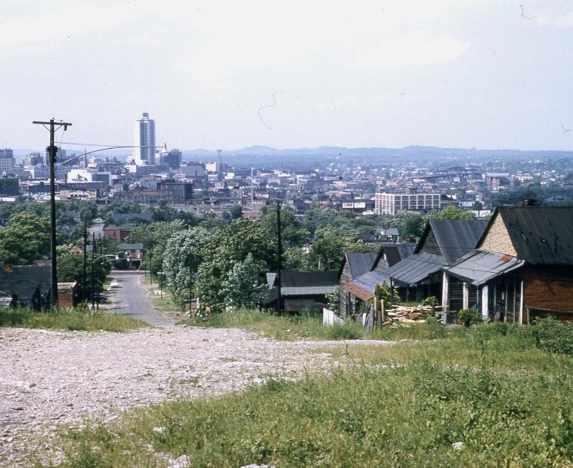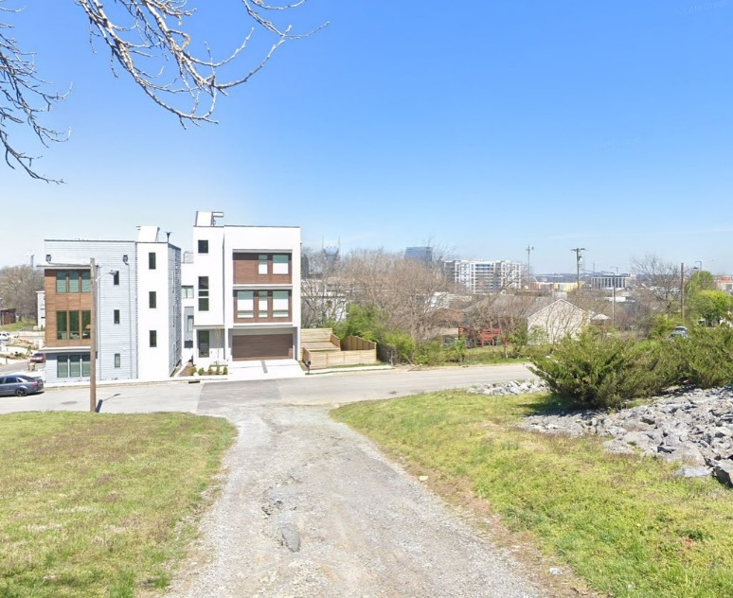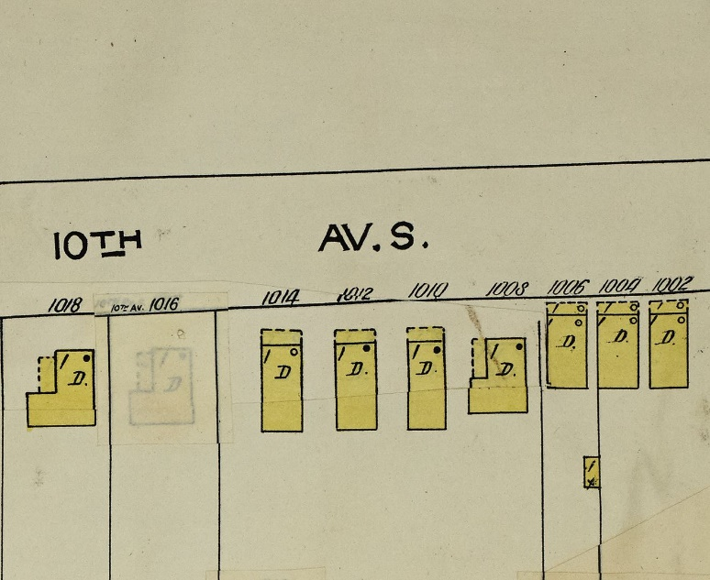 | Constructed before 1908, the shotgun dwellings on the east side of the 1000 block of 10th Avenue South were occupied by Remus Davison (1014), Dave Cowan (1012), and Emma E. Bauguss (1010) in the late 1950s. General laborers Remus and Annie Davison occupied the shotgun dwelling closest to the photographer as late as 1957. Dave Cowan, a car washer, lived with his wife Annie L. at 1014 10th Avenue South as late as 1958. Emma E. Bauguss occupied the shotgun at 1010 10th Avenue South from 1950 to 1959.  During the Edgehill Urban Renewal Project, 10th Avenue South was completely erased from the street grid in this area, and a portion of Archer Street below was truncated with a cul-de-sac. In 2023, these lots are part of Rose Park.  (Sources: Nashville City Directories 1950 to 1959)  📸Photo 1: 1000 block of 10th Avenue South, looking north, 1966.  📸Photo 2: Approximate location of the 1000 block of 10th Avenue South, looking north, 2019.  📸Photo 3: Sanborn Fire Insurance Map of the block, 1950.  #nashville #edgehill #nashvillehistory #urbanrenewal #urbanphotography #architecture #thenandnow #landscape #gentrification #sanborn #urbanphotography #streetscape #design #density #blackhistory #duplex #historichome #historicduplex #workershousing #rowhouse #commercial #abandoned #grocery #cornerstore #shotgunshack #shotgunhouse #quarry

Post Date: October 20, 2023
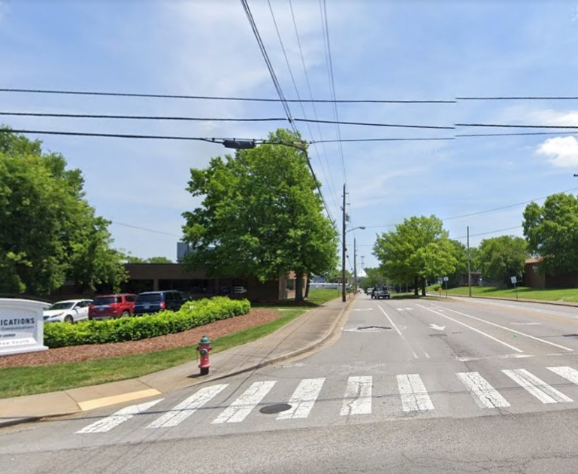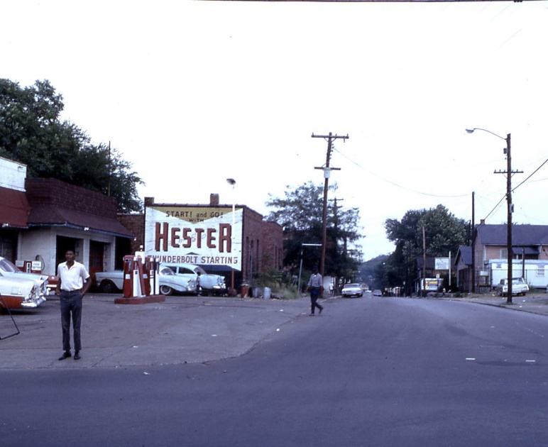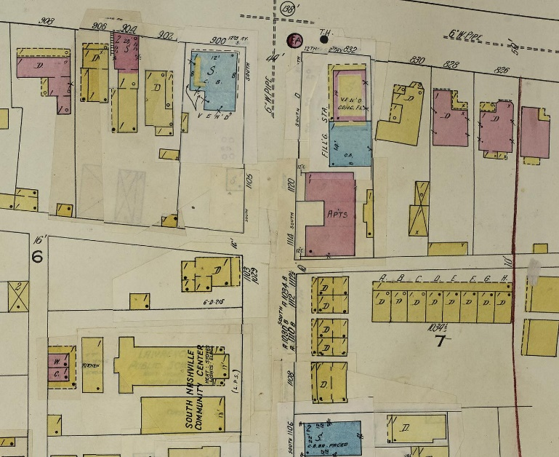 | Looking east from 12th Avenue South, this view of South Street from 1966 shows the Esso service station (left), South Street Community Center (right), and a brick apartment building (left) that used to occupy this block. In the late 1950s, the apartment building was occupied by Mrs. Terry Young, a maid, Mrs. Mary C. Vaughn, a cook, Clifford Phillips, Clarence Kennerd, and George Bell, a porter for General Shoe Company.  During the Edgehill Urban Renewal Project, South Street was widened, and a median was added to the center lane. All the buildings in the first photograph were demolished between 1966 and 1970.  (Sources: Nashville City Directories 1950 to 1959)  📸Photo 1: 12th Avenue South and South Street, looking east, 1966.  📸Photo 2: 12th Avenue South and South Street, looking east, 2019.  📸Photo 3: Sanborn Fire Insurance Map of the area, 1950.  #nashville #edgehill #nashvillehistory #urbanrenewal #urbanphotography #architecture #thenandnow #landscape #gentrification #sanborn #urbanphotography #streetscape #design #density #blackhistory #duplex #historichome #historicduplex #workershousing #rowhouse #commercial #abandoned #grocery #cornerstore #shotgunshack #shotgunhouse #quarry #servicestation #communitycenter #vintagegastation

October 24, 2023
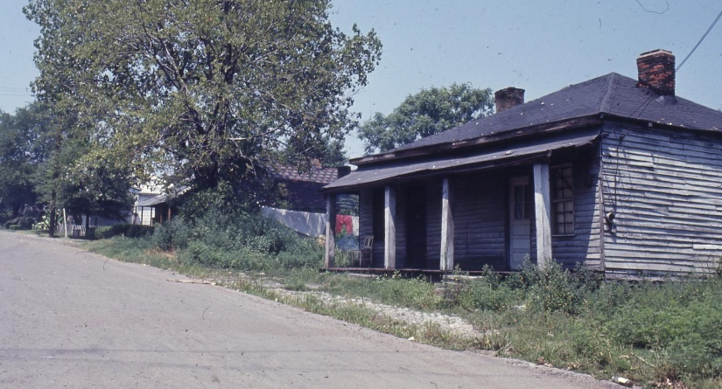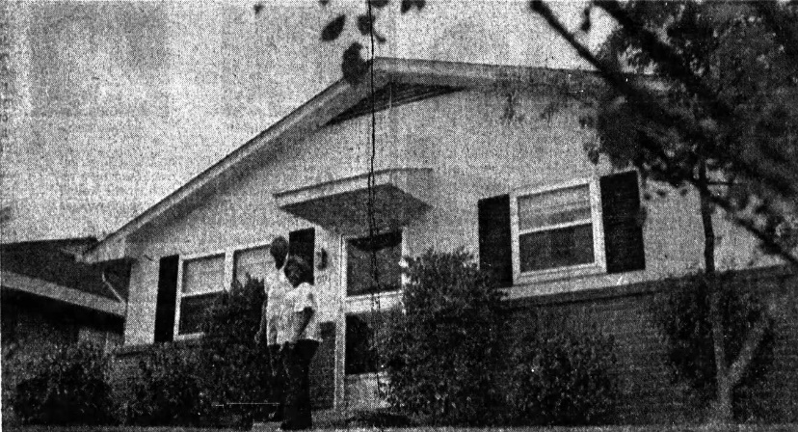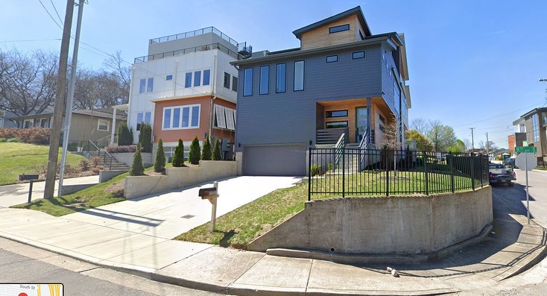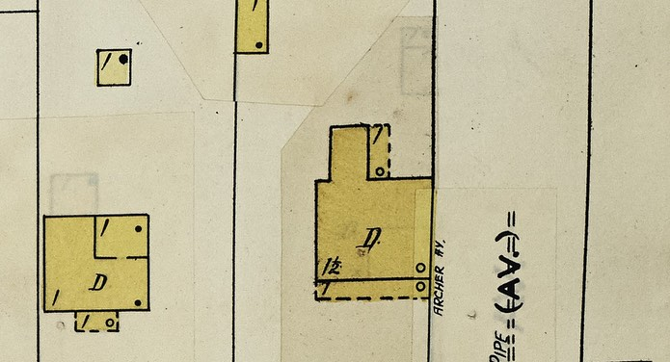 | Constructed before 1908, this wood-frame dwelling at 1001 9th Avenue South was occupied by Mrs. Rosie B. Williams in the late 1950s.  From 1966 to 1970, all the buildings in this area were demolished during the Edgehill Urban Renewal Project. During the mid-1970s, the Metropolitan Development and Housing Agency (MDHA) constructed dozens of federally subsidized Turnkey Homes in the area. The Turnkey III program was designed to give low and moderate-income families a chance at home ownership through monthly “rent” payments that went toward their mortgage. The initial cost of these Turnkey III homes in this Edgehill Estates area was around $25,000 each.  In 1977, Howard and Cecil Fuqua moved into their Turnkey Home at 1001 9th Avenue South. Two years later, they accumulated enough credit through the program to purchase their dwelling. The Fuqua family lived in the Andrew Jackson Courts public housing projects for 37 years while raising their five children prior to moving to Edgehill.  “We could have bought a home, but instead we educated our four children. Two of our daughters graduated from Fisk, our middle son graduated from the University of San Francisco, and one other boy spent time at Fisk. But it is just a blessing through the grace of God…it’s not that we didn’t want a house, we were just not in a position to buy (before).”  Members of the Fuqua family sold the house at 1001 9th Avenue South for $526,000 in 2017. The Turnkey Home was demolished, and a three-story, 2,500 square-foot dwelling was constructed on the lot.  (Sources: Nashville City Directories 1958, 1959; Tennessee 1982: 84).  📸Photo 1: 1001 9th Avenue South, looking southwest, 1966.  📸Photo 2: The Fuqua’s Turnkey Home at 1001 9th Avenue South, 1982.  📸 Photo 3: 1001 9th Avenue South, looking southwest, 2019.  📸Photo 3: Sanborn Fire Insurance Map of the house, 1950.  #nashville #edgehill #nashvillehistory #urbanrenewal #urbanphotography #architecture #thenandnow #landscape #gentrification #sanborn #urbanphotography #streetscape #design #density #blackhistory #duplex #historichome #historicduplex #workershousing #rowhouse #commercial #abandoned #grocery #cornerstore #shotgunshack

Post Date: October 25, 2023
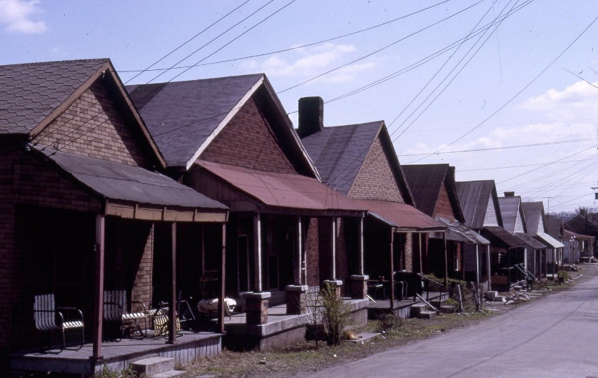 | Our new project mapping site can be viewed here:  https://www.google.com/maps/d/edit...  Photo: Wood-frame worker's housing in Edgehill. Unknown location, 1966.  #historicmaps #geotag #googlemaps #edgehill #nashville  #historicphotos

Post Date: November 1, 2023
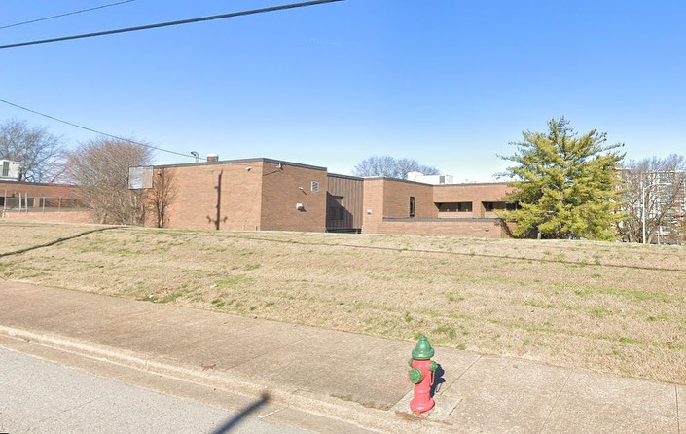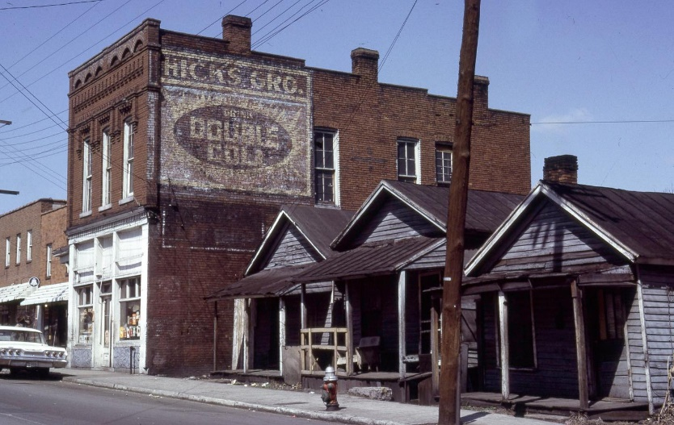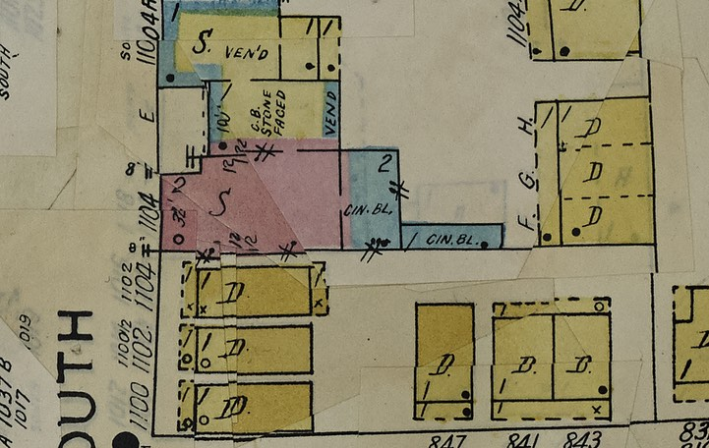 | In the early twentieth-century, South Street became a bustling commercial area, largely because of African American communities surrounding it. On South Street, from 9th Avenue to 12th Avenue, there were numerous African American owned businesses including a jeweler, a lunch counter, a barber, a service station, a soda fountain, a restaurant, and a grocer. Within a five-block radius there were also seven Black churches and the Lawrence School, one of the earliest public schools built for African-Americans in Nashville.  The two-story building at 1104 South Street was constructed Ca. 1908. A series of residents occupied the space during its first decade of existence, with its most notable use being the Lawrence school annex in 1916. The brick building would not be occupied by a commercial business until 1922, when J.C. Thagard opened a grocery store there. Around 1930, Rena Hicks opened a restaurant in the space, starting a 45 year run of Hicks family owned businesses that would occupy 1104 South Street.  Walter L. Hicks operated a grocery store and restaurant out of this brick commercial building from 1933 to 1967. The restaurant served "pit barbecue" and purchased several ads in the Tennessean proclaiming "barbecue eaters and beer drinkers wanted." Hicks was also a reverend who started churches in the surrounding areas. Walter L. Hicks was married to Bernice, who died in 2002 at the age of 102. They lived for many years at their home at 911 Villa Place. Newspaper articles indicate that Hicks and his wife Bernice welcomed many students from rural Perry County to stay in the rental units behind this building on South Street, so they could attend public school in the city and work at the Hick’s restaurant.  In 1966, the Metro Development and Housing Authority purchased the property at 1104 South St as part of a large urban renewal project. The buildings sat vacant from 1968-70, and were razed sometime ca. 1970. The lot has remained vacant since.  📸Photo 1: 1104 South Street, looking northwest, 1966  📸Photo 2: 1104 South Street, looking northwest, 2022  📸Photo 3: Sanborn Fire Insurance Map of the block, 1950  #urbanrenewal #nashvillehistory #edgehill

November 3, 2023
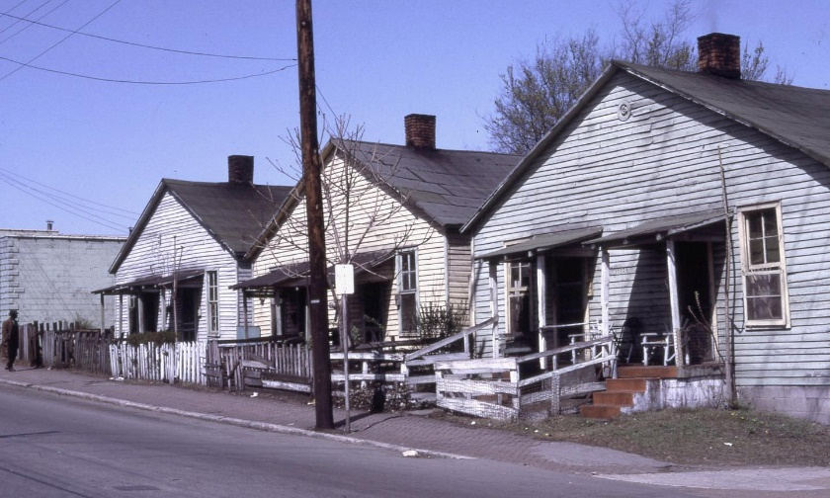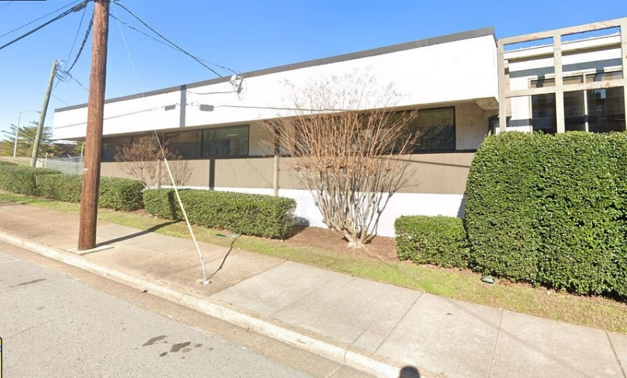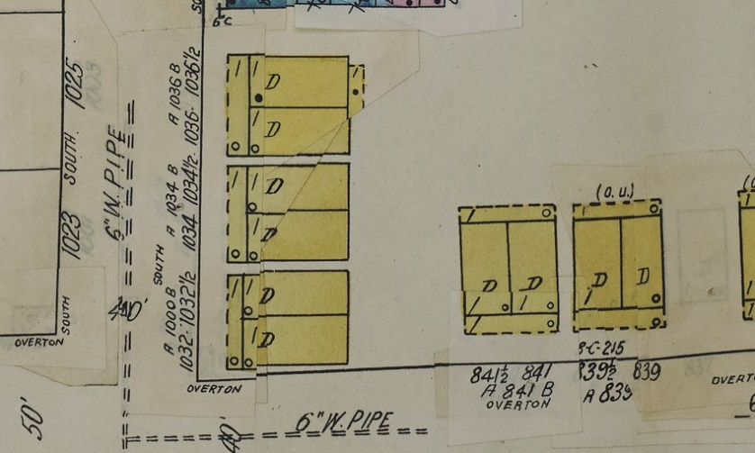 | These three wood-frame duplexes at 1032 to 1036 South Street were constructed before 1908 on a parcel of land once owned by prominent Nashville attorney William N. Bilbo. Bilbo’s real estate holdings, consisting of five or six hundred Black tenement houses like these shown, totaled over $1,000 in value when he died in 1909. Bilbo’s former nineteenth-century brick estate was located roughly one hundred yards to the northwest of these dwellings. The old Bilbo dwelling was demolished sometime between 1908 and 1950.  Around 1970, this block was demolished as part of the Edgehill Urban Renewal Project. In 1980, a stucco-clad office building was constructed on the site.  📸Photo 1: Duplexes at 1032 to 1036 South Street, 1966  📸Photo 2: 1032 to 1036 South Street, 2022  📸Photo 3: Sanborn Map showing the duplexes, 1950  #nashville #edgehill #nashvillehistory #urbanrenewal #urbanphotography #architecture #thenandnow #landscape #gentrification #sanborn #urbanphotography #streetscape #design #density #blackhistory #duplex #historichome #historicduplex #workershousing #rowhouse #commercial #abandoned #grocery #cornerstore #shotgunshack

Post Date: November 9, 2023
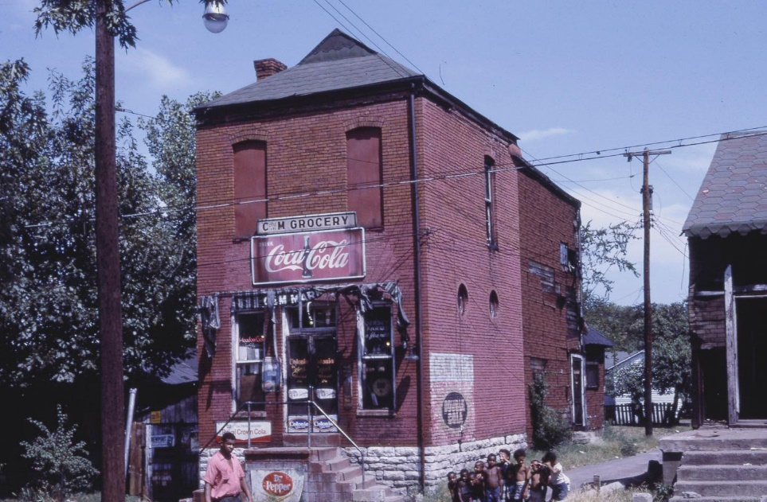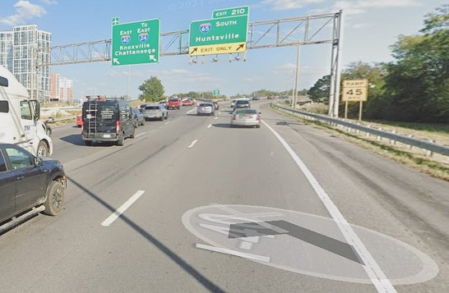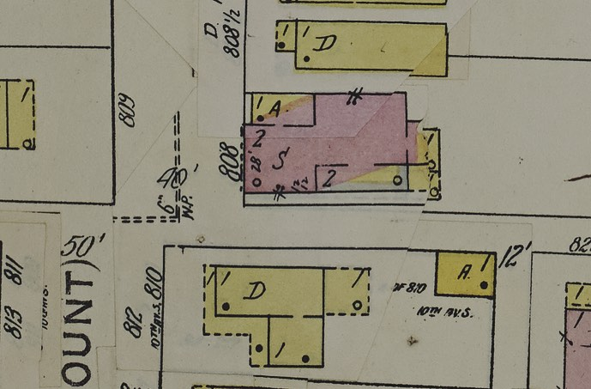 | Historic maps indicate that the C&M Grocery building was constructed around 1900. Around 1970, this building at 10th Avenue South and Woods Street was demolished for the construction of the Interstate 40/65 interchange. Interstate 40 follows the approximate east-west path where Woods Street used to be.  📸Photo 1: C & M Grocery, northeast corner of 10th Avenue South and Woods Street, 1966  📸Photo 2: The approximate location of the building, 2022  📸Photo 3: Sanborn Map showing the building, 1950  #nashville #edgehill #nashvillehistory #urbanrenewal #urbanphotography #architecture #thenandnow #landscape #gentrification #sanborn #urbanphotography #streetscape #design #density #blackhistory #duplex #historichome #historicduplex #workershousing #rowhouse #commercial #abandoned #grocery #cornerstore #shotgunshack #highway #freeway #demolished

Post Date: November 11, 2023
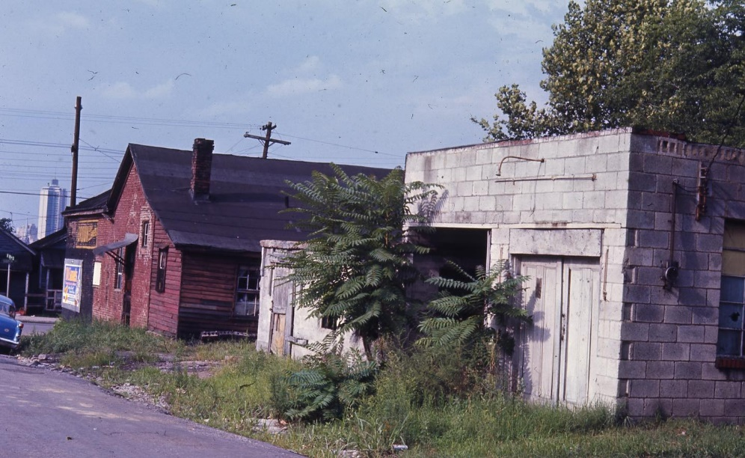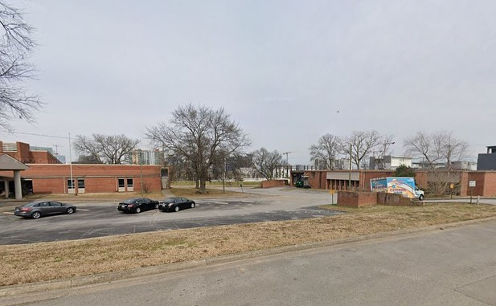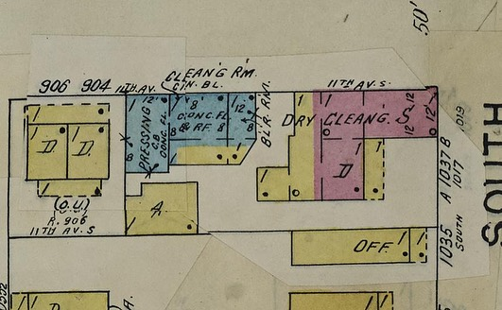 | 📸Photo 1: 11th Avenue South near South Street, looking north, 1966  📸Photo 2: Approximate location, looking north, 2022  📸Photo 3: Sanborn Map showing the area, 1950  #nashville #edgehill #nashvillehistory #urbanrenewal #urbanphotography #architecture #thenandnow #landscape #gentrification #sanborn #urbanphotography #streetscape #design #density #blackhistory #duplex #historichome #historicduplex #workershousing #rowhouse #commercial #abandoned #grocery #cornerstore #shotgunshack #highway #freeway #demolished

Post Date November 12, 2023
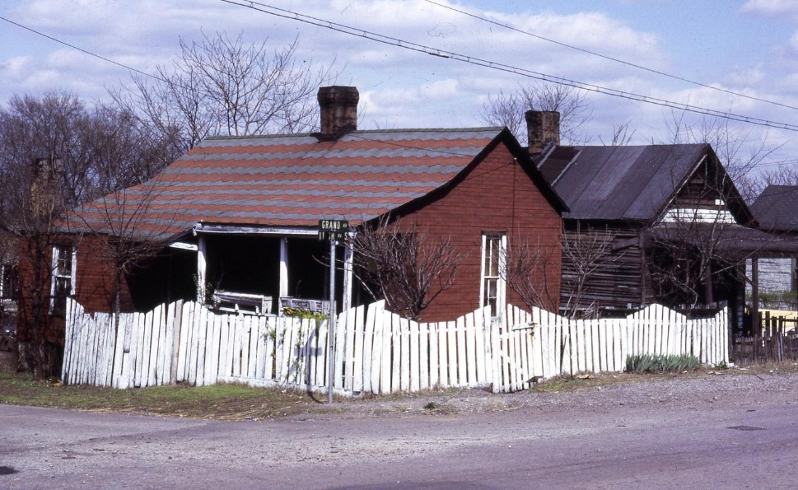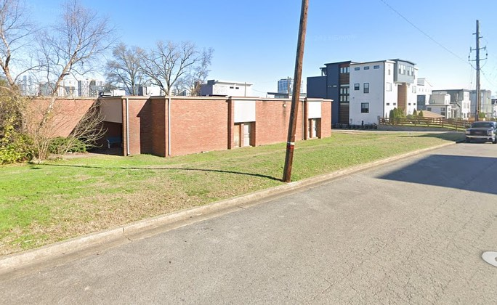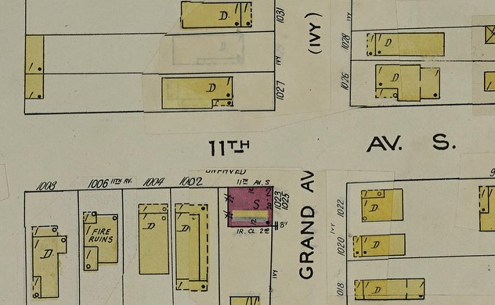 | 📸Photo 1: 11th Avenue South at Grand Ave, looking northeast, 1966  📸Photo 2: Approximate location, looking northeast, 2022  📸Photo 3: Sanborn Map showing the area, 1950  #nashville #edgehill #nashvillehistory #urbanrenewal #urbanphotography #architecture #thenandnow #landscape #gentrification #sanborn #urbanphotography #streetscape #design #density #blackhistory #duplex #historichome #historicduplex #workershousing #rowhouse #commercial #abandoned #grocery #cornerstore #shotgunshack #highway #freeway #demolished

Post Date: November 20, 2023
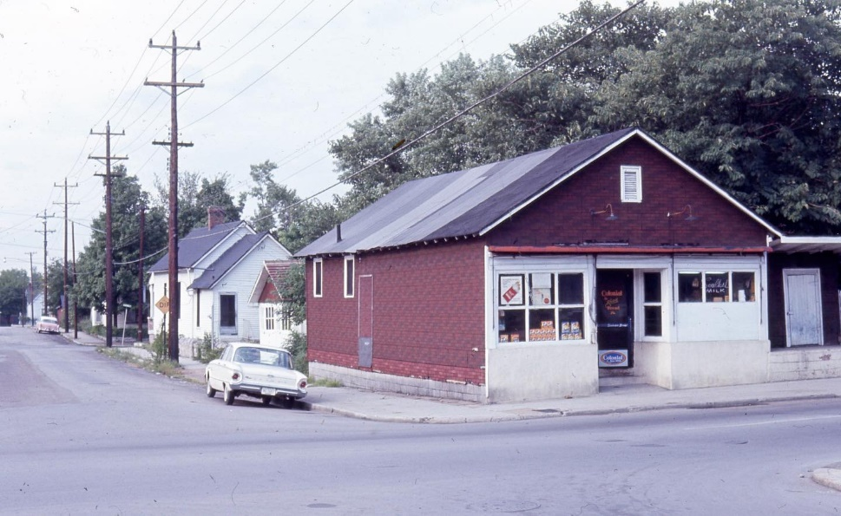  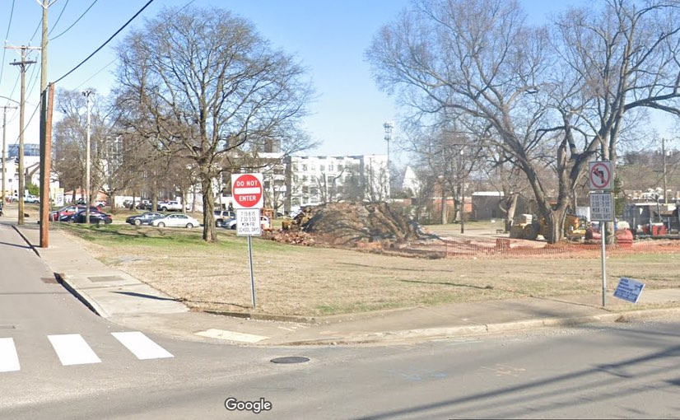  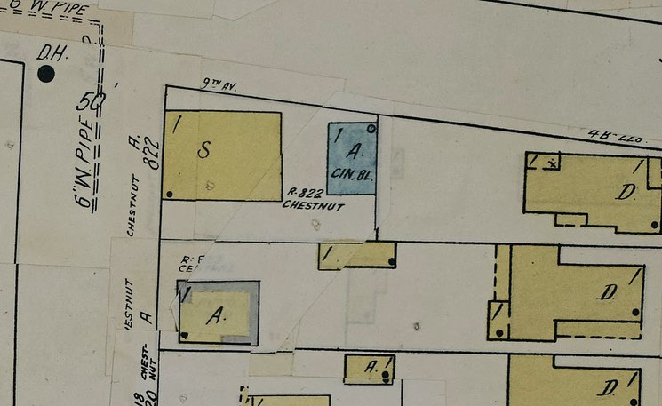 | This one story, wood-frame grocery store was operated by Emmet W. Sanford in the 1940s and 1950s. Sanford's grocery was one of 14 stores that were demolished from 1966 to 1970 for the Edgehill Urban Renewal Project. The lot has remained vacant since the early 1970s.  📸Photo 1: 822 Chestnut Street, looking northeast, 1966  📸Photo 2: Approximate location at 9th and Edgehill, looking northeast, 2022  📸Photo 3: Sanborn Map showing the area, 1950  #nashville #edgehill #nashvillehistory #urbanrenewal #urbanphotography #architecture #thenandnow #landscape #gentrification #sanborn #urbanphotography #streetscape #design #density #blackhistory #duplex #historichome #historicduplex #workershousing #rowhouse #commercial #abandoned #grocery #cornerstore #shotgunshack #highway #freeway #demolished

Post Date November 28, 2023
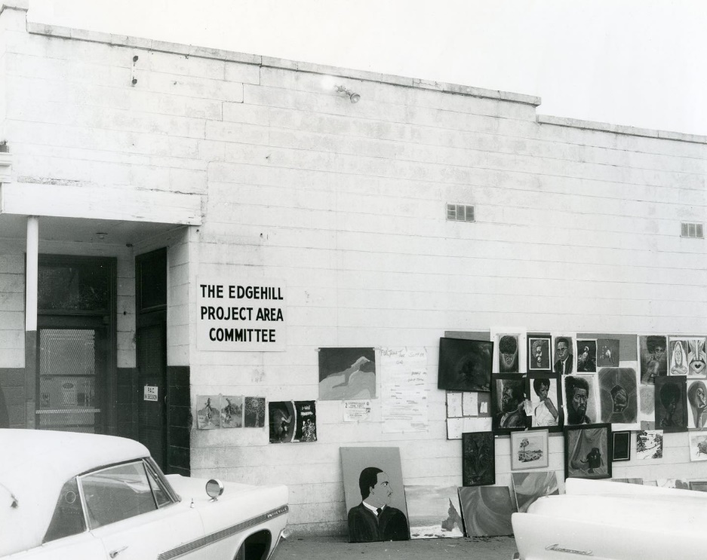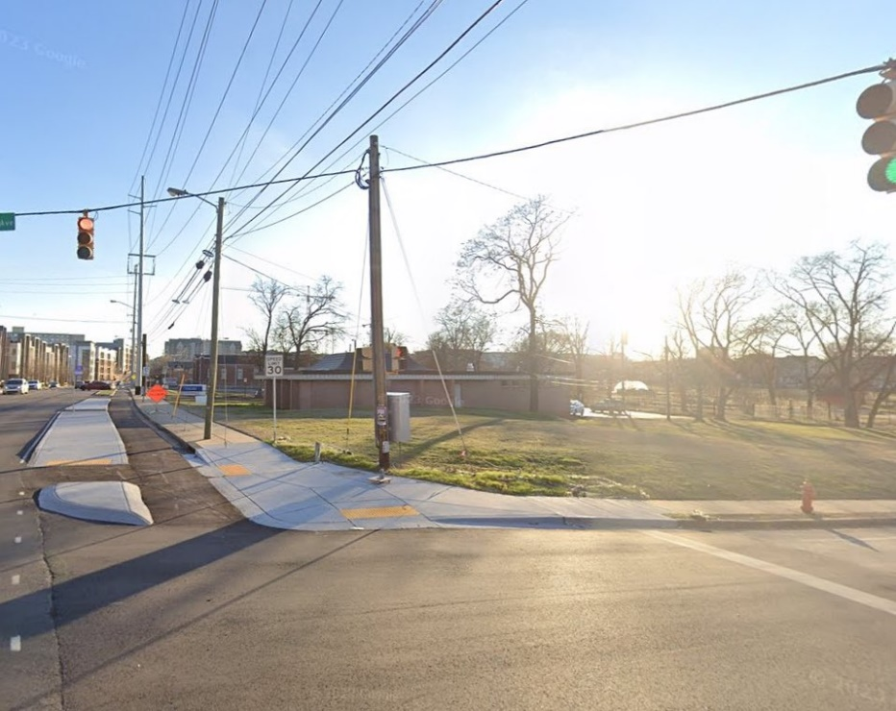 | Formerly the home of Dennison's Bi-Rite from the 1950s to the 1960s, this one-story building became the headquarters for the Edgehill Area Project Committee (PAC) in the late 1960s.  The PAC was a citizen group formed by federal law to encourage residents to participate in Urban Renewal Projects. After the land north of Rose Park was cleared by demolition, members of the PAC filed a lawsuit against the Nashville Housing Authority to stop a 320-unit housing project and tower for the elderly that was planned for the area.  After years of litigation, the Nashville Housing Authority scrapped its original plans. Because of the PAC's fight, 120 single-family homes were constructed in the area. The Turnkey III homes were the first single-family public housing in Nashville when the first batch was completed in 1977. Approximately 25 of these Turnkey III homes are extant today.  📸Photo 1: 1405 12th Avenue South, looking southwest, circa 1970  📸Photo 2: Approximate location, looking southwest, 2022  #nashville #edgehill #nashvillehistory #urbanrenewal #urbanphotography #architecture #thenandnow #landscape #gentrification #sanborn #urbanphotography #streetscape #design #density #blackhistory #duplex #historichome #historicduplex #workershousing #rowhouse #commercial #abandoned #grocery #cornerstore #shotgunshack #highway #freeway #demolished

Siobhan Lyons, “Ruin Porn and the Obsession with Decay,” (Palgrave Macmillan, 2018)
Kati Terzinski, “Facebook Insights: Distinguishing Reach vs. Engagement,” accessed February 23, 2024, https://pyxl.com/blog/facebook-insights-distinguishing-reach-v-engagement/

