Listening in the City:

Designing Better Portable Listening Devices for Changing Environments

by
Lance Spicer
May 2018

Presented to the
Division of Science, Information Arts, and Technologies
University of Baltimore

In Partial Fulfillment
of the Requirements for the Degree of
Master of Science

Approved by: _________________________________

Dr. Bridget Blodgett, Thesis Advisor

_________________________________

Dr. Ian Power, Committee Member

Abstract
The focus of this thesis is how the design of portable listening devices (PLDs) can improve the interaction between urban users and their environment. First, in a literature review, topics such as the sociology of PLD use, sound studies and soundscape, and existing PLD technology are discussed to identify gaps in both theory and product design. Then, in order to design for the whole user experience, the results of user surveys and semi-structured interviews are presented to identify how participants use their devices and what motivates their behaviors. As expected, the survey and interview participants revealed how differently people use listening devices. Most significantly, users often employ PLDs in one two ways: (1) to escape from those sounds and people around them or (2) to mix the intentional sound from headphones with incidental sounds of the environment as a way to aestheticize an experience. The data showed, however, people will often, over the course of the day, use PLDs both ways—at times as escapism and other times to mix with environmental sound. In addition, the data revealed how a user’s age and gender can affect how and when the device is used. Based on user feedback, this paper recommends that an ideal design is one which can adapt to the environment, improve safety and situational awareness, and allow the user to configure the device to accommodate their preferences. Finally, these recommendations are presented as wireframes to illustrate how these concepts can be implemented in future applications.

Acknowledgements
I would like to thank, first, those friends and colleagues at the University of Baltimore who gave support and guidance during my studies. Especially important were Dr. Bridget Blodgett and Dr. Ian Power for their counsel during this project. And, I would like to thank, most importantly, my wife, Diana Peters, for her love and support along the way.

Table of Contents

List of Tables …….………………………………………………………………………………………………………….III
List of Figures ……………………………………………………………………………………………………….………IV

Chapter 1: Introduction …………………………………………………………………………………………….…..1
Chapter 2: Portable Listening Devices and Society……………………………………………………….…5

Chapter 3: Humans, Sound, and the Environment…………………………………………….……….…12
Chapter 4: Portable Listening Devices Technology……………………………………………………….22

Software Applications………………………………………………………….……………………..…23
Audio Playback Applications………………………………………………………………..24

Song, Television, Film and Advertising Identification Applications……….30
Generative Music Applications………………………………………………………….…32

Musician Assistance Applications…………………………………………………………34
Real Time Spectrum Analysis Applications…………………………………………..36

Mindfulness, Meditation, Psychoacoustic Applications…………………..…..37
Portable Listening Device Hardware………………………………………………………………..42

Headphones and Personal Speakers…………………………………………………...42
Circumaural (or over-the-ear) Headphones……………………………………..….43

Supra-aural (or on-ear) Headphones……………………………………………………43
Open and Closed Back Designs……………………………………………………….……43

Earbud Headphones and In-Ear Monitors…………………………………….…..…44
Bone Conduction Headphones…………………………………………………………....44

Wearable Speakers………………………………………………………………………………45
Wired vs. Wireless headphones……………………………………………………….….45

Chapter 5: Gaps…………………………………………………………………………………………………………..47
Chapter 6: Data…………………………………………………………………………………………………………..49

Survey Results………………………………………………………………………………………………….49
Semi-Structure Interview Participants Demographics………………………………………54

Coded Themes…………………………………………………………………………..……………………55
Chapter 7: Discussion…………………………………………………………………………………………………..62

Wireframes…………………………………………………………………………………………..………..65
Chapter 8: Conclusion………………………………………………………………………………………………….71
References……………………………………………………………………………………………………………….….74

List of Tables

Table 1: Survey Results…………………………………………………………………………………………………49
Table 2: Semi-Structured Interview Participants Demographics……………………………………54

List of Figures

Figure 1: Complexity of Information and Motivation………………………………………..…..…..…18

Figure 2: N7 Player tag cloud library navigation……………………………………….……………….….24
Figure 3: N7 Player cover art search on drill-down…………………………………………….…………24

Figure 4: Stellio circular song seek function………………………………………………..………………..25
Figure 5: Stellio EQ function instructions………………………………………………………………….….25

Figure 6: TSC Music user hearing test…………………………………………………………………………..27
Figure 7: TSC Music active EQ to suit test results………………………………………………………….27

Figure 8: TSC Music graph of weekly hearing condition………………………………………………..27
Figure 9: TSC Music listener detail entry screen……………………………………………………………27

Figure 10: Impulse Music Player gestured controlled Now Playing view……………………….28
Figure 11: Boom 3D Music Player surround sound settings………………………………………….29

Figure 12: XPlayer Music Player 3D surround sound settings………………….…………………….29
Figure 13: Shazam spectrogram of violin fingerprint…………………………….………………………30

Figure 14: Shazam capturing acoustic sound……………………………………….……………………….30
Figure 15: Soundhound application………………………………….………………………………………….31

Figure 16: Watch with Soundhound integration……………………….………………………………….31
Figure 17: Bloom application listen mode mood selection……………………………………..…….33

Figure 18: Trope application……………………………………..………………………………………………….33
Figure 19: Reflection application…………………………………….……………………………………………33

Figure 20: Wotja Mix view………………………………………………….………………………………………..34
Figure 21: Capo Touch application……………………………………….………………………………………35

Figure 22: KeyOmeter circle of fifths……………………………………………….…………………………..36
Figure 23: Spectrum Analyzer………………………………………….…………………………………………..37

Figure 24: Headspace biorhythmic play button…………………………………………….……………..39
Figure 25: Environments swiping gesture to next track……………………………….……………….39

Figure 26: Wireframe overview……………………………….…………………………………………………..65
Figure 27: Now Playing wireframe……………………………………………………………………………….66

Figure 28: Settings Menu wireframe………………………………….…………………………………………67
Figure 29: Library – List View wireframe…………………………………………….…………………………68

Figure 30: Library – Art View Tags wireframe……………………………………………………………….69
Figure 31: Library – Art View wireframe ….…………………………………………………………………..70

Chapter 1: Introduction

Two hours north of New York City in Woodstock, before the town would become synonymous with 1960’s hippie culture, a pianist named David Tudor performed a new work by composer John Cage that had an indelible impact on music history. That August night in 1952, an audience of preeminent classical musicians and composers (among others) assembled in Maverick Concert Hall to hear Cage’s new work. David Tudor began Cage’s piece, titled 4’33”, by closing the piano lid and starting a stopwatch. After thirty seconds, without playing a single note, Tudor reset the watch for the second movement, lasting two minutes forty seconds. Then, with the piano lid still closed, he reset his watch one minute twenty seconds for the final movement. Although Tudor’s performance was virtually silent, Maverick Concert Hall probably was not. The audience likely heard people shuffling in their seats around them, or the wind passing the building outside, or the sound of animals moving in the trees above the concert hall.

By removing all intentional sound, Cage asks, with 4’33”, whether unintentional sounds in music can equally as beautiful and important to the experience. In his writings, Cage wrestled with his own concepts of beauty and sound discrimination—why he found some sounds beautiful and others not (Cage, 1961). He likened developing a bias for musical sounds to developing an ego. The listener will begin to refuse those sounds which are not musical, and will, ultimately, be cut off from a good deal of experience. When the listener works to diminish this bias to the extent that both intentional and unintentional sounds can be appreciated, Cage suggests that one can live life more affirmatively (Dickinson, 2014).

The impact of 4’33” was significant. Along with his writings, many believe Cage set the course for a generation of recording artists using ambience in music (Prendergast, 2000). Through the 20th century, he initiated many advancements in the fields of electronic music, mixed-media, Serialism, and experimental music. A luminary to artists such as Pierre Boulez, Stockhausen, The Velvet Underground, and Brian Eno, Cage is recognized as having a huge impact on the dissemination of Ambient music.

In the 1960s, as Cage’s ideas spread, a German national named Andreas Pavel began work on a device to bring music wherever he went (Rohter, 2005). While living in Brazil, Pavel worked on a portable cassette player powered by batteries that allowed him to “add a soundtrack to real life”. In 1977, Pavel filed a patent for a portable listening device he called the Stereobelt. Although battery-powered, portable reel-to-reel players were available, they were impractical, weighing close to 20 pounds. Pavel’s design used newly available cassettes that, being roughly the height and width of an index card, allowed for a lighter playback device. However, Pavel struggled to secure large scale production and the Stereobelt remained largely unknown.

In 1979, Sony released The Walkman, the world’s first mass-market, portable listening device (PLD) that fit comfortably in your pocket or bag (Hormby, 2013). The device became an international craze and, by 1983, cassettes outsold vinyl records for the first time. The Walkman revolutionized the way people listen to music throughout their day. Over the coming years, as music media changed, the portable devices improved on sound quality and size. By the early 2000s, with the popularity of internet file sharing, the MP3 would eventually widely replace physical media, making way for smaller devices that held more songs. Soon, the MP3 player would integrate with cell phones, giving users access to huge libraries of recorded music. In 2015, The Pew Research Center found that nearly two-thirds of Americans were smartphone owners (Smith, 2015), and of those users, 68% use their device to stream music (Hassan, 2016).

Headphone use became ubiquitous. For some, it was a means to establishing a private space—a way to shut out the world. In 2012, Derek Thompson wrote in the Atlantic, “Headphones did for music what writing and literacy did for language. They made it private.” Thompson argues that “loneliness is one of the first things ordinary Americans spend their money achieving.” But, shutting out the world can come at a price. According to a study published in The Journal of the American Medical Association, the number of teenagers with hearing loss from slight to severe has increased 33 percent since 1994 (Heffernan, 2011). One in five American teenagers can’t hear rustles or whispers. Given the ubiquity of headphone use by the mid-2010s, many researchers attribute this outcome to prolonged exposure to loud music at close range.

In a New York Times Magazine article titled “Against Headphones”, author Virginia Heffernan makes an impassioned case against prolonged headphones use. Unfortunately, she makes the mistake of accepting the status quo of current design. After listing the drawbacks of headphone use, including an argument that headphone use fosters anti-social behavior, Heffernan’s only advises readers to abstain from prolonged exposure. She, however, never ponders a solution. Could these problems be solved with better design? As smartphone adoption becomes more widespread, the challenges of our portable listening devices will certainly increase.

In part, I think the solution lies in John Cage’s ideas about unintentional sounds. Instead of shutting out the world, we should design devices that enable users to live more affirmatively by integrating intentional and unintentional sounds. My thesis project, in a general sense, hopes to answers the question: How can portable listening devices improve our interaction with the world around us? Moreover, this work will investigate how can intentional and unintentional sounds work together to improve the PLD experience and how design can mitigate the adverse effects of headphone use.

The following literature review will investigate hardware and software designs, how others have approach the problem, and to provide basis for novel solutions to the design problem. Then, using surveys and semi-structured interviews, I will research habits of current users and design wireframes for future designs. I hope to highlight how existing technology has failed to use sound to its full utility to improve the user's experience.

Chapter 2: Portable Listening Devices and Society

Portable Listening Devices (PLDs), beginning with the Sony Walkman, have become widely adopted over their 35+ year history and now, in the form of smartphones, pervade the modern world (Smith, 2015). Although much has been written about the cultural effects of television and radio technologies, the literature on the impact of mobile listening devices is limited.

By the late 1990s, sociologists began writing about the cultural relevance of the new technology, the two most notable being Michael Bull, a professor of Sound Studies at the University of Sussex, and Tia Denora, professor of Sociology of Music at the University of Exeter. Both, by no coincidence, cite critical theorist and composer Theodor Adorno (1903-1969), as a central influence on their ideas about how we use music in the modern world.

Theodor Adorno, a leading thinker in Marxist theory, wrote about how aesthetics, class and capitalism intersect (Witkin, 2003). He had a particular interest in music and recognized its powerful force, for good or ill, on society. Tia Denora, in Music in Everyday Life, writes, “...Adorno’s work represents the most significant development in the twentieth century of the idea that music is a ‘force’ in social life, a building material of consciousness and social structure (Denora,2000).” With such strength, Adorno argues that the ‘culture industry’ has the power to nourish self-formation or to undermine it. Adorno views a work of art (in this case music) as healthy if it develops using a dialectical method, that is, the creator examines the objects in relation to other objects and the whole system. For Adorno, the creator of art has a responsibility to the public to exercise this power with great care. In her own work, Denora combines Adorno’s theory with ethnographic interviews as the basis for her theory of how people use music to mediate their lives.

Denora cites a study conducted by Centre for the Study of Musical Development at Keele University, where sixty-seven people were interviewed about their emotional response to music (Denora, 2000). In the analysis of replies, respondents reported using music in six thematic categories: memory, spiritual matters, sensorial matters (for pleasure, for example), mood change, mood enhancement, and activities (including things such as exercise, bathing, working, eating, etc.). Music, for the participants, holds more than aesthetic value. Participants, in fact, were using music to manage their lives. In regards to the study, Denora writes, “This research points clearly to the ways in which music is appropriated by individuals as a resource for the ongoing constitution of themselves and their social psychological, physiological and emotional states.” She concludes that listeners “...exhibited considerable awareness about the music they ‘needed’ to hear in different situations and at different times...They drew upon elaborate repertoires of musical programming practice, and were sharply aware of how to mobilize music to arrive at, enhance and alter aspects of themselves and their self-concepts.” Listeners know what they need and, in some cases, what they don’t need to maintain their self-concept.

Where Denora investigates general use of music in everyday life, Michael Bull in his book Sounding Out the City focuses on the cultural effects of the Sony Walkman as seen through the lens of Adorno and Richard Sennett, a leading sociologist who studies the effects of urban living (Bull, 2000). Bull argues that all media is used for sensory filtering—we either use media to enhance a sense or to deprive one. With that notion, he sees PLDs serving two distinct functions for users. Firstly, for some, headphones provide a way to escape their surroundings—to block unwanted noise or communication. Through ethnographic interviews, Bull discovered, that personal stereos can make users feel more secure, insofar as the headphones act as kind of ‘boundary maker’ between us and the threats around us. Bull makes a distinction between those seeking escapism and those who use headphones to ‘color’ their experience with sounds to suit their mood. In this way, music can be used to support our internal narratives—casting the listener as a kind of leading actor in their own film. This phenomenon has been described as “urban mise-en-scène” (Beer, 2007). Similar to designing a theater production, the listener sets the scenery and soundtrack of their day.

Writing about modern city life, philosopher and cultural critic Walter Benjamin referred to these concepts as Erlebnis and Erfahrung (Seal, 2013). Although both words roughly translate to the English word “experience”, in German, Erfahrung connotates a particularly invigorating experience where Erlebnis is often used to describe unremarkable, every-day experiences. In Benjamin’s context, Erlebnis is characterized as a condition of “shock-induced anaesthesia” brought about from long exposure to stimuli of the city. Erfahrung, on the contrary, describes the positive act of “mobility, wandering or cruising” the city as a means of experiencing “the wealth of sights, sounds and smells the city has to offer”. Through dialectical analysis, Benjamin writes of using city “wandering” as a method for turning Erlebnis into Erfahrung.

Drawing from Benjamin, Bull writes of PLD users as special type of city stroller who, in academic discussions, is often referred to as a flâneur. To the outsider, this stroller may appear to be an idle figure, however, for Benjamin, the flâneur is one who walks the streets keenly aware of their surroundings, like an amateur investigator attempting to discover how a modern city functions (Stephen, 2013). In 19th century Paris, Charles Baudelaire characterized the flâneur as “...having a key role in understanding, participating in, and portraying the city (Seal, 2013).” Baudelaire argued that traditional art was “inadequate for the new dynamic complications” one faced in a newly industrialized world. Therefore, the artist must immerse themselves in the city by becoming, as Baudelaire’s puts it, “a botanist of the sidewalk.” In today’s cities, PLD users have become, in a sense, technologized flâneurs who use aesthetic control to better understand the city around them (Bull, 2000).

In Sounding out the City, Bull relays an excerpt of an interview with a subject named Donna that illustrates how she uses PLDs to ‘color’ an experience (Bull, 2000):

I use it lying on the beach. You need music when you’re tanning yourself. There’s the waves and everybody’s around. You just need your music. On the plane we were listening to Enigma and things like that. It fitted in...Not bored, it livens everything up. Everything’s on a higher level all the time. It makes it seem a bit busier. You get excited. Everything’s happening.

As opposed to escapism, Donna explains that her motives are not to alleviate boredom. Rather, Donna uses PLDs to enrich her experience while maintaining an awareness of her surroundings. She explains how “[the PLD] livens everything up” by making her experience more “happening.”

Familiar music, in particular, can conjure memories of past places or experiences, such as the listener’s childhood home or a favorite film. In a 2011 lecture, Bull relays a story about visiting a graveyard at a Buddhist sanctuary while on a trip to Japan (Bull, . There, among gravestones and nature sounds, Bull begins to hear music playing through outdoor speakers. The music, he describes as sounding like “celestial shopping music”, immediately evoked memories of the dystopian and dark television series Twin Peaks. Bull remembers, “The whole thing had become kind of sinister (Bull, 2011).” Then concludes, “This is an innocent example of how space can be involuntarily colonized, in terms of the subject, by sound.” This experience is what he refers to as a “mediated” event, such that, he superimposed the emotions experienced while watching Twin Peaks onto the Japanese gravesite. He argues, as time goes on, that an increasing amount of our experiences will be mediated in this way.

To put mediated experiences in historical context, Bull places PLDs, as a tool to mediate our lives, in terms often used to discuss economics and marketing (Bull, 2011). Named for Henry Ford’s innovations in industrial production, Bull uses the term Fordism to describe mediated situations where a listener’s preferences are not considered. Like Ford, whose Model T was famously only produced in the color black, the choice of media is selected by a top-down, one-size-fits-all method where all listeners are offered only one media source. For example, the songs and videos played to spectators at a football stadium where individual preferences are less important. During post-World War II growth, however, the public began to demand more variety in products; niche market began to emerge. By the 1960s, marketing created segments as consumers demanded a tailored experience. Bull uses the term Post-Fordism to explain mediated environments which cater to these niche interests. He illustrates this scenario with an example of the multiplicity of radio stations, separated by genre, which emerged to meet the listener’s range of tastes. By the 1980s, markets developed products that enable, as Bull refers to it, a Hyper-Post-Fordism where consumers create personalized experiences with devices such as the Walkman. In a Hyper-Post-Fordist world, the genre radio stations become unnecessary when we have tools to create our own playlists. In this context, we can examine the portable listening devices as a tool to provide a mediated experience, that exists solely for users, of which they have total control.

Of course, these three concepts are not linear periods in time, but rather overlap in contemporary culture (Bull, 2011). On any given day, we may experience a mixture of all three. For example, when, as customers, we enter a retail store wearing headphones connected to our listening device. The store is most likely playing music over a loudspeaker. The retailer strengthens their brand by matching in-store music to the taste of their customer. Bull describes this interaction as a Post-Fordist experience, in that the brand uses music, along with the product, to target a niche market. However, when the customer walks in listening to headphones, the customer is creating an individualized, Hyper-Post-Fordist experience. In this scenario, we have both mediated experiences happening concurrently. Bull predicts that Hyper-Post-Fordist interactions, in time, will become more common. And, with a rise in “mixed” environments, we can assume that these interactions will be increasingly more important to consider when designing devices for the future.

Although it’s useful for this project to use Bull’s nomenclature, he fails to explain why he choose the terms Fordism and Post-Fordism. It appears he’s attempting to distinguish between the degrees of the power a listener possesses in these mediated spaces and how, with the adoption of PLDs in the 1980s, users employ devices to reclaim this space. However, by using the terms Fordism and Post-Fordism, Bull risks implying all the market connotations of the terms on mediated environments. For the sake of discussion in this paper, I will utilize Bull’s terminology to explain this phenomenon, however it may, in the future, warrant exploring new terms with fewer implications.

Bull concludes Sounding Out the City with a warning about unchecked aestheticization. He worries that those users seeking escape from the urban cacophony may, ultimately, exhibit narcissistic behavior. By “casting” unwitting strangers in our film-like experiences, we participate in dehumanizing those around us (Bull, 2000). For many, of course, aestheticization is the central motivation to use PLDs. It seems that Bull is taking issue with the degree (or frequency) in which aestheticization is "in check". Unfortunately, Bull's concern runs close to infantilizing the user. The idea, however, does raise an important design challenge. How can we encourage users to engage with the environment in a way that humanizes those around us? In designing better PLDs for the future, we must consider how our devices inhibit and/or enable interaction with those around us.

Chapter 3: Humans, Sound, and the Environment

Through the twentieth century, advances in musical style track closely with advances in electrical machines. Innovation in electrical instruments (theremin, synthesizer) and recorded sound (phonograph, CD, MP3) enabled composers to create new sounds for a larger audience (Pendergrast, 2000).

Recorded sound, in particular, allows for use of music in novel ways. Before recordings, a musical performance was not reproducible. A concert performance, for example, would be performed for an audience and exist only as a memory until the next presentation. At the time, music was to be heard live or not at all. Starting in 1877, with the invention of the phonograph, the rise in usefulness of music correlates to the rise in convenience of each new listening device. A modern MP3 player, for example, provides more opportunities for use than, say, a one-hundred-pound Victrola phonograph sitting in a living room.

The splitting of a sound from its source, sometimes referred to as schizophonia, may explain the strong movement in the late-nineteenth and twentieth century towards more immersive experiences. While earlier composers often wrote music around a narrative, compositions became increasingly used to define a sonic space with landscape qualities (Eno, 2000), as is evident in the work of Mahler, Debussy, Satie, Varese and later in Cage and Terry Riley.

It is this analogy to landscape that was used to define a new field of study which, in the late 1960s, became known as soundscape. As landscape is to our eye, soundscape is to our ears. In his book, Tuning the World (1977), Canadian composer R. Murray Schafer argues that our modern society has prioritized the eye at the expense of the ear. In simpler, pre-industrial communities the soundscape was uncluttered by machine noise that is now commonplace in modern cities. It was his hope that with acoustic ecology—the study of the effects of the soundscape on those creatures living within it—urban planners and architects could design more humane environments. In the years since its release, Schafer's work, among others, has provided the foundation for the interdisciplinary field known as sound studies.

In Tuning the World, Murray lays out a new vocabulary for thinking about soundscapes. In a rural setting where few machines are audible, the soundscape is described as hi-fi. Characterized by favorable signal-to-noise ratio, the hi-fi soundscape allows us to hear discrete sounds clearly because of low ambient noise. Generally, the country is more hi-fi than the city; night more than day; ancient societies more than modern ones. In a lo-fi setting where sounds become over dense with broadband noise, our ability to perceive our surroundings is lost. We struggle to determine distance or height of sounds in relation to ourselves. Our perception, subsequently, becomes less accurate.

In both settings, however, the soundscape have figure and ground. Similar to visual perception, the figure is the focus of the listener’s attention while the ground gives our focus its outline and mass. For soundscape, Schafer adds a field dimension which is the context in which we hear the figure and ground. The field can change how a particular sound registers in our minds. The sound of a crowd screaming, for example, has a different meaning at a sporting event than at a crime scene. In the soundscape, the field provides important referential meaning to the listener.

Our soundscape is comprised of many smaller sounds called sound objects. These small sound “particles” have three stages: the attack (beginning), body (middle), and decay (end). The variation in duration and timbre of each stage gives the sound its individual character. The striking of a cymbal with a drum stick, for example, has a short attack and body followed by a long decay as the metal slowly comes to rest. In the field, however, sound objects are difficult to isolate and rarely, if ever, exist in nature. By itself, a sound object lacks the important acoustic information humans need to register meaning. With a collection of sound objects in a particular setting, known as a sound event, we can better orient ourselves in the environment.

To properly survey a soundscape the analyst must identify those sounds that are important based on either their uniqueness or their domination. The musical term keynote describes the anchor or fundamental tone of the soundscape. Although they do not to have to be listen to consciously, keynote sounds become listening habits in spite of themselves. Schafer argues, that keynotes may be so intrinsic to human life that without them we would sense a distinct impoverishment. They may be ingrained so deeply in the human psyche as to affect behavior or lifestyle of a society. In a rural landscape, keynote sounds are created by geography or climate, such as water, wind, forests, plains, birds, insects and animals. Of course, in modern cities, many of these natural sounds are masked by machines. Keynotes in these areas are often marked by car traffic, trains, crowds, or recorded music. It’s worth noting that, in urban environments, where users are often on foot, recorded music has become prevalent in public spaces. The keynotes for urbanites moving through commercial areas—stores, restaurants, offices—is often dictated by the music playing over the loudspeaker.

In these scenarios, it is evident how sounds have power over us. Noise, or unwanted sound, has been used evoked fear and respect since the earliest times. In primitive societies, noise was seen as a divine force that registered god’s displeasure (Schafer, 1977, pg. 76). Thunder, wind, and volcano eruption were louder than any other in the soundscape. With organized religion, sound became a tool used by the church to establish authority over its parish. In the village, the loudest sounds were church bells and singing choirs heard from large cathedrals. Schafer refers to this phenomenon as sacred noise which characterizes any social noises that exert power over the community, but are exempt from banning.

Today, in modern cities, machine noise like those from police sirens, airplanes, and loudspeakers dominate our soundscape. Like a country extending its power by territory acquisition, Schafer describes these new sounds as imperialistic in the soundscape. As such, a man with a megaphone is more powerful than a man talking because he can dominate more acoustic space. I do not see the importance of making value judgements about these types of sounds which Schafer appears to do by naming them “imperialistic.” Whether a listener finds them annoying or pleasant is only of interest to the project in that the device should adapt accordingly to them. Also, it is important to understand that, since the writing of Tuning the World, the ubiquity of PLDs has transformed our ability to reclaim this power. We now have the choice to cancel out imperialistic noise with headphones.

When viewed visually, as a waveform, natural sounds (with the possible exception of cicadas) reveal a familiar signature of attack, body and decay. The sound of a tree falling, for example, begins, exists, and then recedes. For most of human history, sound was experienced this way. However, unlike pre-industrial sounds, machine noise can be endless. A running air conditioner, by comparison, emits a seemingly perpetual hum that appears, when viewed as waveform, as a flat line. Flat line sounds may be a continuous drone like a series of car tires rolling over pavement, rough-edged sound like a mechanical saw, or rhythmic concatenations like a train moving over train tracks. These sounds present us with continuous keynotes and a flood of broadband noise that possess little personality or progression. Flat line sound emerged as industry demanded speed. When the speed of rhythmic pulses reach 20 cycles per second the machine will produce a pitch. Over time, discrete sounds gave way to the drone of flat line sounds, which philosopher Henri Bergson described as the “narcotic to the brain” and created listlessness in modern life. For this reason, drones can be beneficial in reducing thought and are often used in mindfulness techniques such as meditation. Again, this is important to consider, not because these sounds are to be eliminated necessarily, but rather, to identify opportunities for a design to accommodate a listener’s preference to these types of sounds.

The soundscapes of modern cities have a distinct frequency range. Where the sounds of seventeenth-century villages were mostly mid-range frequencies, urban areas with a concentration of machine noise tend to be bass heavy (Schafer, 1977, pg. 117). For a listener, the direction from which low frequency sounds originate is hard to determine. As a result, we feel more immersed in these sounds. This effect has been increasingly used in the sound profile of contemporary pop music which seeks blend and diffusion. In contrast, mid and high-range frequency sounds of earlier musics provide focus and clarity and are easier for the human ear to ascertain directionality. In a classical concert setting, this was achieved by separating performers and the audience in counter-poised groups, commonly facing each other.

By itself, a singular sound object can possess a range of frequencies. Some sounds have clearly pronounced frequencies or pitches, while others can be entwined cluster of frequencies. The frequency range may be small and focused or broadband and wide. French composer and writer, Pierre Schaeffer, described mass as the bulk of where the frequency or pitch lies. As we move through urban areas, sound mass dictates the dominant pitch of each area.

German sociologist Detlev Ipsen argues that high and low fidelity is not determined by location (country vs. city), as Schafer posits, but rather by the level of acoustic complexity (Ipsen, 2002). In his Theory of Complexity, Ipsen observes how a listener’s response to unwanted sounds is closely related to the psychology of frustration. Frustration is the emotional response to an interruption of a process, action or behavior due to an inability to change or achieve something. Tolerance for noise, or the extent to which we find a soundscape attractive or unattractive, can differ from person to person and culture to culture. Ipsen illustrates:

If a student concentrates on the solution of a mathematical problem and in the same moment a baby starts to cry this will interrupt him. If the student is stressed this acoustic stimulus will frustrate him. He will interpret the baby’s cry as noise. On the other hand parents might perceive the same cry as a lovely signal.

Whether we perceive the crying as pleasurable or distracting depends largely on the context and our background (personal experience and cultural predilection). This example, however, is a rather simple scenario. For soundscapes with multi-layered sounds, Ipsen argues that the degree to which we find the environment pleasing (curiosity) depends not only on our background, but also on the level of acoustic complexity. For instance, if the complexity of the sound information is low, humans find the acoustic environment less attractive compared to a more complex soundscape. On the other hand, if we find a situation too complex, we look to alleviate the frustration by escaping. The following graph illustrates the optimum level of complexity between the two extremes.

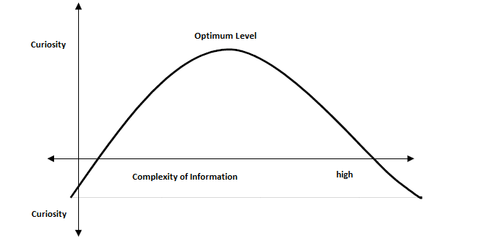

Figure 1: Complexity of Information and Motivation (curiosity)

In his paper, after a theoretical discussion, Ipsen then proposes a structure for designing better acoustic environments. He identifies three types of soundscapes to use as a framework to reach an optimum level of complexity for diverse populations. If a listener's background determines the degree of tolerance to acoustic complexity, Ipsen proposes that, in an increasingly pluralistic world, designers will need to address the demands of different people, groups and cultures. He describes the ultimate goal of a designer is to create pluralistic soundscapes.

The most traditional type is the dual soundscape. We experience this general structure in historic European cities where people can move from louder to quieter areas quickly. Ipsen characterizes dual soundscapes as an opposition of either time or location. For example, we perceive the soundscape as urban or rural, night or day, public or private. We often associate city sounds with traffic, crowds, and factories. While the sound of village life corresponds with animal noises, church bells, and the sounds of work in craftsman shops. Sections of the city, however, can offer quieter environments where urbanites can find refuge from the cacophony of the city. Take for example Central Park in New York City, where a vast city park provides a peaceful environment for contemplation among the rushing of a dense cityscape. Ipsen proposes we can analyze any space—urban, suburban, rural—to identify the potential to increase listener curiosity by mixing these environments.

The conversational soundscape describes the sounds of communication. Of course, human speech can add to the soundscape, we also experience conversational sounds between cab drivers sounding their horns, the sirens of ships docking in port, or a crowing rooster. Dialogue can also be designed. For example, church bells call worshippers to service or announce the times of prayer. For blind pedestrians, an audible crosswalk signal announces a safe moment to cross an intersection.

Perhaps Ipsen's last pattern type is most important in designing PLDs for urban spaces. Ipsen refers to synthetic soundscapes as a combination of sounds and images that do not belong together. Anyone who's spent time in the Telegraph Hill neighborhood of San Francisco may be familiar with the bird calls of wild parakeets. Although native to Ecuador and Peru, the flock most likely grew from escaped birds sold in the US as exotic pets. In the urban soundscape of San Francisco, these animal sounds don't match with the typical industrial sounds of a North American city. The synthetic pattern could also describe the mediated experience that PLD users superimpose on the city images around them. Ipsen argues the more our world becomes intercultural the more our environment will demonstrate characteristics of synthetic soundscapes. Of course, no modern city is without a mix of cultures and sounds. Some would argue that, in fact, a city’s cultural identity (and its soundscape) has been, and will remain, in a constant state of evolution. By using the word synthetic, Ipsen implies this mixing of sounds is in some way unnatural which I think is a mistake. For this project, however, it is helpful to consider how PLD users can modify the complexity of the soundscape with recorded sound and how that may be beneficial.

Much of Schafer's Tuning of the World is dedicated to how to analyze the acoustic ecology — how the soundscape affects the behaviors of living creatures who live within it. This analysis, Schafer argues, is the first step in designing humane sound environments—the process known as acoustic design. As with Bauhaus scholars, who combined fine arts and industrial craft to invent industrial design, he calls on leading thinkers of sonic studies for an equivalent revolution in acoustic design. He explains:

The best way to comprehend what I mean by acoustic design is to regard the soundscape of the world as a huge musical composition, unfolding around us ceaselessly. We are simultaneously its audience, its performers and its composers. Which sounds do we want to preserve, encourage, multiply?

Acoustic design, however, is not a set of paradigms or formulae to be imposed on the soundscape, but rather principles to assess the problem in order to improve it. Schafer explains the principles as such:

- A respect for ear and voice — when the ear suffers a threshold shift or the voice cannot be heard, the environment is harmful (Schafer, 1977). Almost all of human speech information is contained between 300 Hz to 7000 Hz. To cancel interference the noise at that frequency must be 30 DBs lower than signal (voice) (Brunt, 2000)
- An awareness of sound symbolism — the designer must be aware of the meaning of sound beyond the obvious and immediate meaning
- A knowledge of the rhythms and tempos of natural soundscape — including our own body rhythms such as our heartbeat or circadian rhythms
- An understanding of the balancing mechanisms by which an eccentric soundscape may be turned back on itself — the balance illustrated in Chinese philosophy and art by yin and yang; that opposites define each other (sound/not sound, technological sounds/human sounds, etc.)

The soundscape as described by Schafer, along with Ipsen's Theory of Complexity, will be important when designing PLDs that interact with changing environments. Although Schafer shows a particular bias towards soundscapes of natural environments, I personally do not discount the beauty of the city soundscape where the complexity of cultures and attitudes enrich our listening experience. One gets the impression that Schafer would prefer a soundscape scrubbed of any imposing, ugly noises. But, in practice, a listener must accept ugly sounds with beautiful sounds since each gives the other its definition. How would we know beauty without the existence of ugly to draw comparison? Also, it’s worth noting that the writing of Tuning of the World predated the widespread adoption of the Walkman in the 1980s. Schafer does not foresee the power of the individual to mix and reclaim their personal listening space with devices. However, from Schafer, we can take a language with which to speak about soundscape and, also, his mission to determine which sounds we want to preserve, encourage, and multiply.

Chapter 4: Portable Listening Devices Technology

This first portable listening device (PLD), called the Stereobelt, was invented by German designer Andreas Pavel and patented in 1977 (Rohter, 2005). Equipped with a cassette player, the belt enabled a user to listen to audio with headphones while on the move. Pavel designed the devices for playback to "add a soundtrack to real life" as a way to "multiply the aesthetic potential of any situation." Hoping to market his invention, Pavel shopped the Stereobelt to electronics manufacturers including Grundig, Philips, Yamaha, and ITT. He struggled to convince them of its potential and they rejected his vision as a useless gadget. Without industry backing, Pavel's Stereobelt languished in obscurity until Sony introduced the Walkman.

In 1979, Sony began selling The Walkman, the first mass-produced PLD, with huge success (Hormby, 2013). Although Sony paid Pavel royalties, the manufacturer refused to recognize him as the inventor until a court settlement in 2003. In the first ten years of production, Sony sold 50 million units and revolutionized the way we live with music. By 1984, as CD sales increased, Sony introduced the portable CD player called the Discman. With each new format came a new device.

By the early 2000s, digital technologies rendered physical analog media unnecessary and devices became smaller. The most popular device of the nascent market, the Apple iPod, was released in October 2001. At the time, Apple CEO Steve Jobs announced the new device contained a 5GB hard-drive that held approximately 1,000 songs. Although the original iPod was available to Mac users only, the 2nd generation release included Windows compatibility which allowed users to sync their playlists with Windows PCs (Hormby, 2013). With access to the wider market iPod sales grew exponentially. In December 2001, following its launch, Apple sold 25,000 units. By January 2004, with new Windows support, Apple sales reached 2 million worldwide.

Although capacity grew, user interaction with MP3 players remained similar to old portable players. Like the earliest Walkman, MP3 players followed dominant design for playback, stop/pause, seeking, and skipping (Vasilash, 2000). It wasn't until the introduction of the smartphone, with advanced processing power and internet connectivity, that functionality began to evolve.

4.1 Software Applications

Current versions of the iPhone iOS and Android devices come with native music applications (apps) for which usability follows the established design. Traditionally, these devices played locally stored music files, but with the popularity of streaming services like Spotify and YouTube, listeners now have access to huge libraries of albums, online radio, and playlists.

Beyond the native applications, the app libraries, such as the Apple App Store and Google Play, include many audio applications from third party developers. Software that is applicable to this project falls into the following six categories:

- Audio playback applications
- Generative music applications
- Song, television, film and advertisement identification applications
- Musician assistance applications
- Real Time spectrum analyzer applications
- Mindfulness, meditation, and psychoacoustic applications

4.1.1 Audio Playback Applications
Where a majority of applications follow the dominant design, the following players incorporate novel navigation or features that could be useful to consider in my final design.
N7player (Android and iOS, released Aug. 2012). Although it lacks streaming and cloud service support, the n7player (n7 software development, 2012) has a unique library search function that is great for searching large libraries. The tag cloud (see Fig. 2) of artist names offers quick searching. From this view, tap and pinching gestures reveal album cover art to begin playback (see Fig. 3).
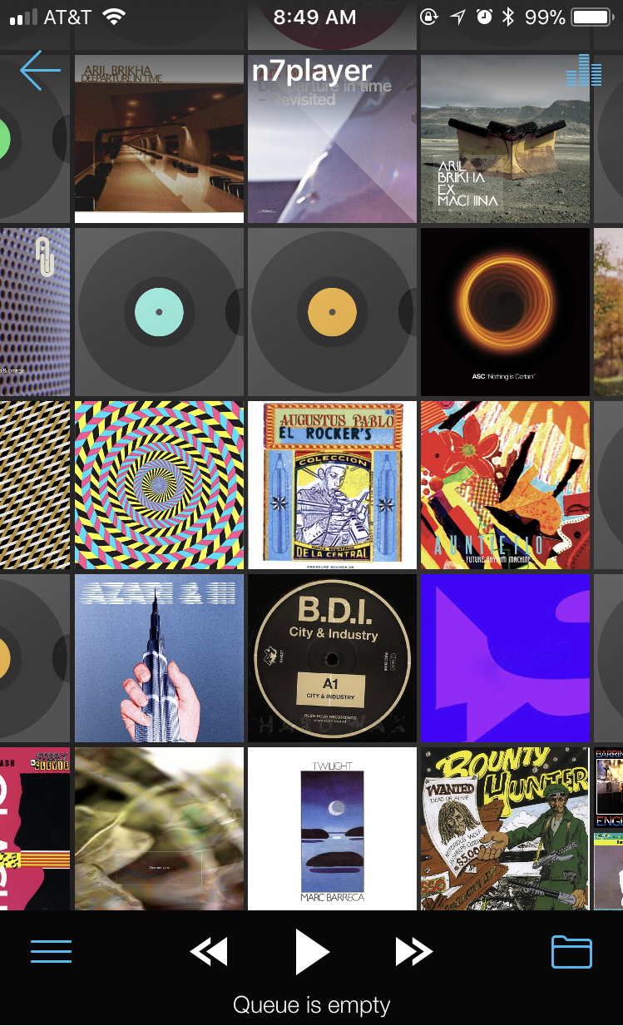
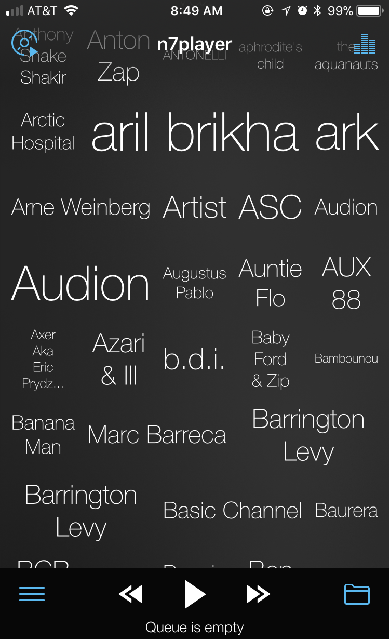
Fig. 2 Tag cloud library navigation Fig. 3 cover art search on drill-down

Stellio Music Player (Android, released May 2015). Available for Android devices, the Stellio Music Player features a unique circular seek function (see Fig. 4) that increases accessibility by isolating the seek control from other playback controls that are often close to the more common seekbar (Stellio Team, 2016). For users new to Stellio, dialog boxes give instruction as the user steps into a new feature. The dialog boxes in the EQ functions, for example, explain how different frequency ranges affect the listener (see Fig. 5). Stellio also offers automatic gain control which can raise and lower the volume as needed to maintain a consistent level.
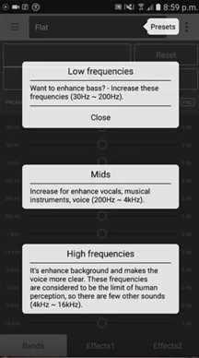
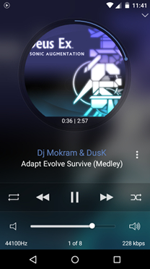
Fig. 4 Circular song seek function Fig. 5 EQ function instructions

TSC Music (iOS, released Feb 2017). Like many music players, TSC Music will play local files and links to streaming and cloud services for music listening (Earlogic Corporation, 2017). TSC Music, however, offers unique functionality that equalizes sound based on individual hearing capacity and claims to prevent hearing loss. New users are asked to complete a hearing test to calibrate the left and right ear. After connecting headphones, the app records when a sound at five frequency intervals becomes audible (see Fig. 6). When complete, the system will tailor the EQ (see Fig. 7) for each song during playback to match the listeners hearing capacity. From listening history, gender, and age, the user can monitor their hearing condition on live graphs (see Fig. 8, 9).
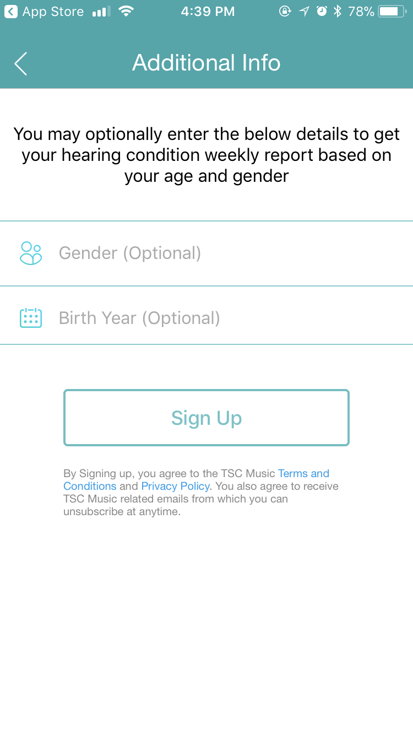
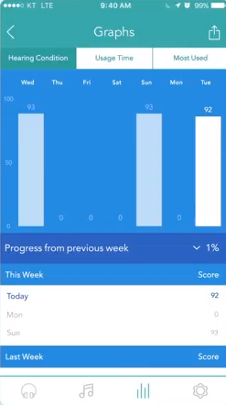
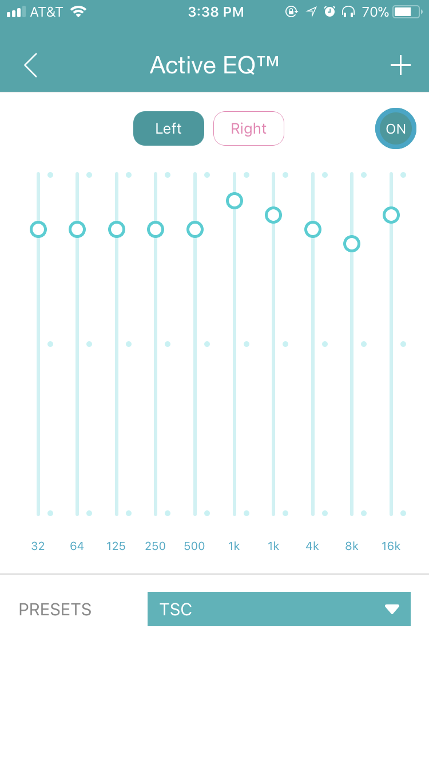
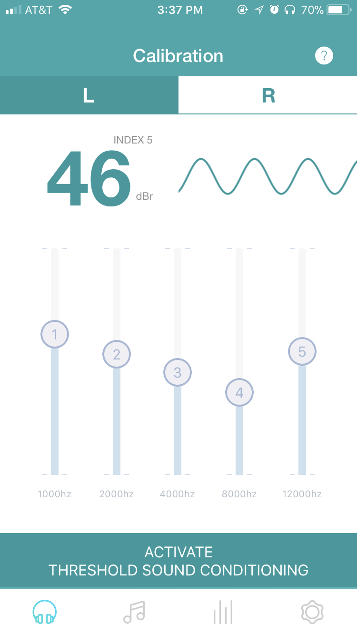
Fig. 6 - User hearing test Fig. 7 - Active EQ to suit test results
Fig. 8 - Graph of weekly hearing Fig. 9 - Listener detail entry screen
condition

Impulse Music Player (Android, released Aug 2017). Described as a "true gesture controlled" music player, the developer claims the user can control the playback functions without looking at the device screen (Appmetric, 2017). Rather than buttons for play/pause, skip, and seek, the interface responds to user gestures that can be used anywhere on the screen in Now Playing view (see Fig. 10). For example, to skip to next or previous song the user swipes left or right. To fast-forward or rewind within song, the user holds down to engage control then swipes right or left.


Fig. 10 - gestured controlled Now Playing view

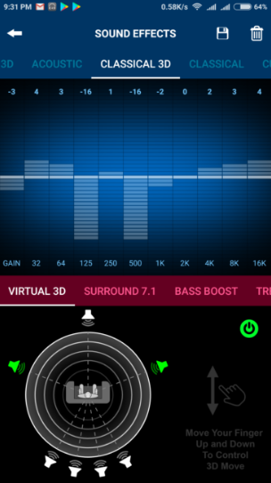
Boom 3D Music Player (iOS, release date unknown) and XPlayer 3D (Android, release date unknown). Both Boom 3D and XPlayer 3D music players have a unique feature that allows the user to toggle on surround sound effects (Global Delight Technologies Pvt. Ltd., 2017). The user can select from which direction the sound is originating in relation to the listener's orientation (see Fig. 11 & Fig. 12). The developer's literature, however, fails to explain how this is beneficial to the listening experience. Of course, most recorded music is intended for 2-channel stereo systems in which sounds are placed in particular pan position by a mixing engineer. While 3D surround apps may make more dynamic or wider sounding audio, the user should keep in mind that this, in effect, overrides the intended experience of the recording artist.
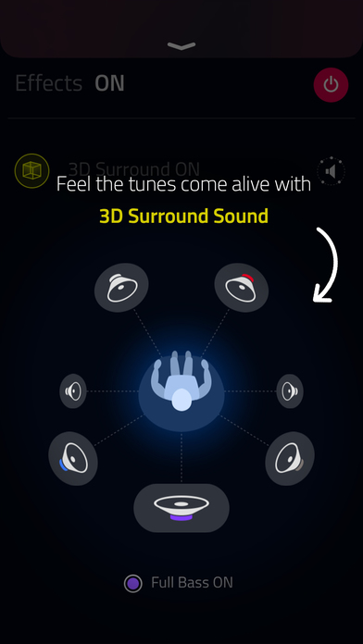
Fig. 11 - Boom 3D surround sound settings Fig. 12 - XPlayer 3D surround sound
settings

Google Play Music (iOS and Android, released 2015). Google's Play Music application functions as a free radio service much like Pandora and Spotify radio where the user creates a "radio station" based on one particular artist (Google, Inc., 2015). Although radio applications aren't new, Play Music's location based radio is of particular interest to this project. On installation, the application prompts the user to enable location based playlists. If the user opts in, Google will predict the activity based on where the user is "checked in". For example, if google identifies the location of the device as a gym, Play Music will display a "gym mix" with upbeat songs to motivate a workout. In the context of this project, location services could be used in a similar way to identify the metadata of a location's sound, such as the song playing in a grocery store, to sync with a shopper's headphone audio, etc.

4.1.2 Song, Television, Film and Advertising Identification Applications

Shazam (iOS and Android, released 2008). Initially launched in 2002 as a dial-in phone service for song identification, Shazam was one of the first apps available in the Apple App Store (Jacobs, 2010). Using a spectrogram (see Fig. 13), a graph of a song's frequencies over time, Shazam identifies a song or other media by analyzing the captured song. From the acoustic fingerprint, Shazam matches the fingerprint to their database of millions of songs and returns the results to the user.
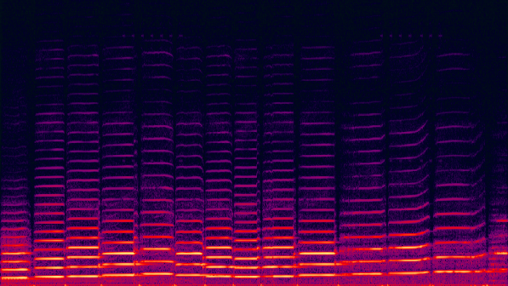


Fig. 13 - Spectrogram of a violin Fig. 14 Shazam capturing acoustic fingerprint sound

Soundhound (iOS and Android, released 2009). Like Shazam, the Soundhound app (see Fig. 15) can capture recorded music and match the acoustic fingerprint to their database (Papanicholas, 2012). This lesser known competitor, however, takes the functionality a step further. Using their own voice, a user can hum the melody of a song to be identified. In recent years, Soundhound has partnered with other brands to integrate their services. In 2014, Hyundai and Kia car manufacturers teamed with Soundhound to bring song identification to their car models (Brian, 2014). The following year, Casio integrated the service into their Bluetooth enabled G-Shock wrist watch (see Fig. 16) that can capture audio to be identified from the environment (Arvizo, 2015).

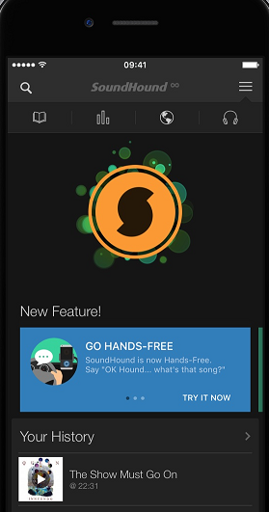
Fig. 15 Soundhound application Fig. 16 Watch with Soundhound
integration

4.1.3 Generative Music Applications

Reflection, Trope, and Bloom (iOS, released 2017, 2009, 2008). Pioneered by Brian Eno and software developers Tim and Pete Cole, generative music describes music created by a system rather than a composer (Eno, 1996). Like the conceptual art of Sol Lewitt, rules provide parameters for the piece but the execution is ever-changing and different each time. In the early 1990s, Tim and Pete Cole of company SSEYO, developed the first real-time music generation system called Koan. Working with the Koan Pro software, Eno produced his 1996 album titled Generative Music 1. When smartphones launched in the late 2000s, Brian Eno and musician/software designer Peter Chilvers released the Bloom app (see Fig. 17). With an intuitive interface, users in Bloom (see Fig. 18) can trigger soothing sounds by tapping the screen in CREATE mode. Or, in LISTEN mode, set the app to generate endless ambient tones in different "moods" of the user's choosing. Trope, released the following year, added the ability to create music with different gestures on the device screen. Then, with the release of an album by the same name, Eno and Chilvers released Reflection (see Fig. 19) which dropped the CREATE functions but added generative imagery to the interface to accompany the music.


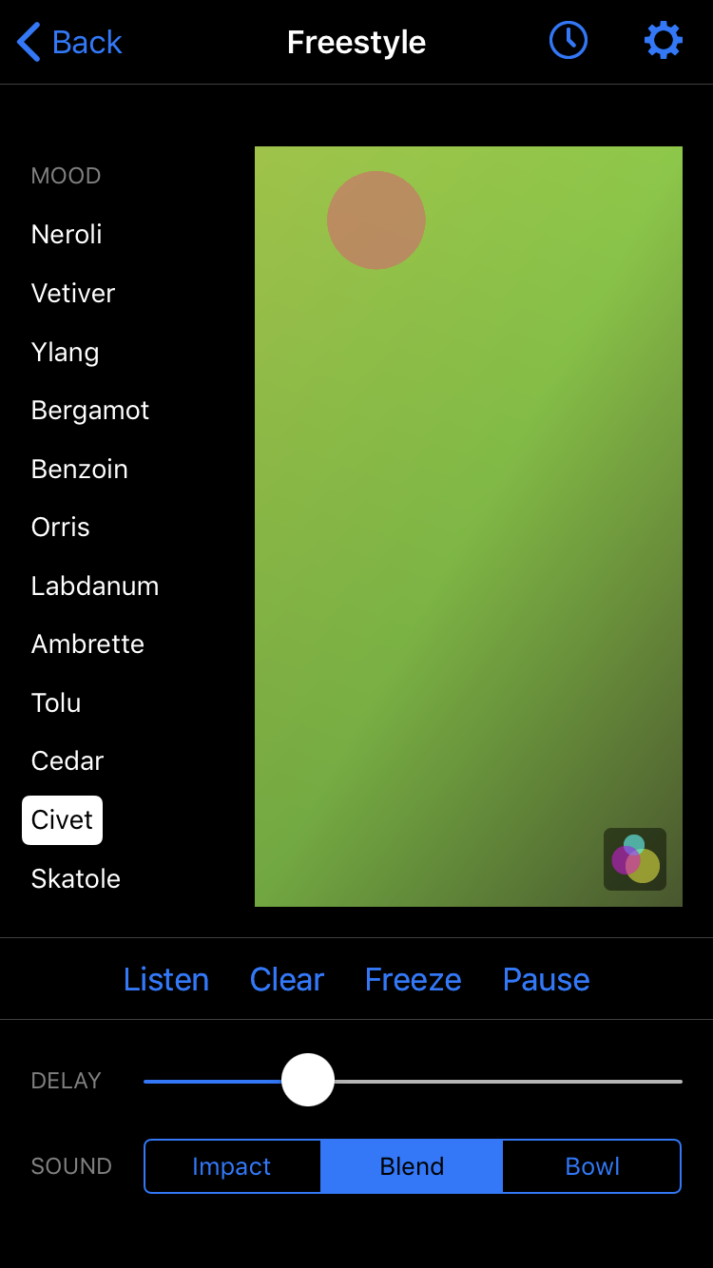
Fig. 17 Bloom LISTEN mode Fig. 18 Trope application Fig. 19 Reflection
mood selection application

Wotja (iOS and Mac, unknown release date). By 2007, Tim and Pete Cole of SSEYO co-founded the Intermorphic company to develop "creative relaxation" apps using generative music and cut-up techniques for text generation (Intermorphic, 2018). Their newest application, called Wotja, is a combination of all previous work. Wotja gives the user more functionality to shape the sound. However, the result is far less intuitive than Eno's apps. Most users would be well served with experience in music production. Like Ableton and Pro Tools sequencing software, the interface consists of a grid of cells where sounds (voices) are placed in separate tracks for mixing and manipulation (see Fig. 20). Then, a "mix" is created for playback based on Wotja randomization settings.
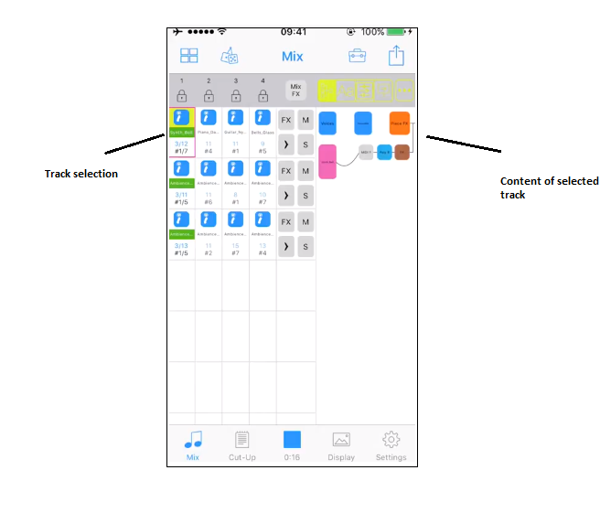
Fig. 20 Wotja Mix view

4.1.4 Musician Assistance Applications
Before the internet and smartphones, learning to perform your favorite pop songs on an instrument wasn't easy. Rarely is sheet music available for newer songs. For most musicians, trial and error was the only option. With the assistance of smartphone apps, players can now easily identify the structure of a song. For my project, the following applications are useful as examples of how audio can be analyzed in real time for tempo, key, and chord progressions.

From an audio file, Capo Touch (iOS, released date unknown) will identify a song's chords and display the finger placement (see Fig. 21) for guitar, ukulele, banjo, mandolin and bass (SuperMegaUltraGroovy, Inc., 2017). Once the chords are learned, the user can change tempo, change key, and loop sections of the song to play along at a comfortable pace.

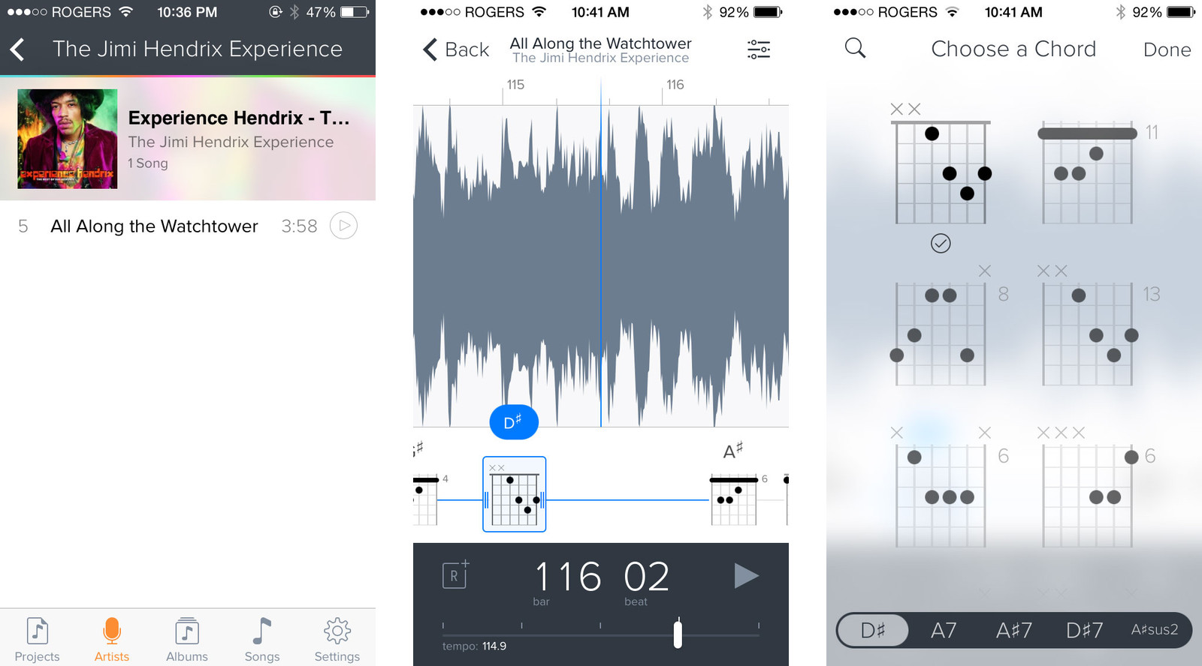

Fig. 21 Capo Touch application

KeyOmeter (iOS, released 2012) will capture a song from the environment to identify the key changes in the audio (Intelligent Gadgets, 2018). The interface shows the user a "circle of fifths" which is a visual representation of the 12 keys of the Western chromatic scale (see Fig. 22). Because most pieces of music is not in a single key but will move from one to another, KeyOmeter will follow the key modulations in real time.

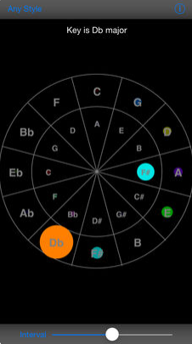

Fig. 22 KeyOmeter's circle of fifths

4.1.5 Real Time Spectrum Analysis Applications

Spectrum Analyzer (iOS, released 2015). Designed with musicians and recording engineers in mind, the Spectrum Analyzer app will display the sound frequencies (see Fig. 23) of a given environment in real time (Onyx Apps, 2015). When used with an external microphone, this smartphone app can help sound professionals and amateurs optimize the acoustics of an environment. For this project, a spectrum analyzer may be helpful when combining the soundscape of the city with audio in headphones. Ideally, when analyzed together, a system would adjust its output for an optimal blend of the two.

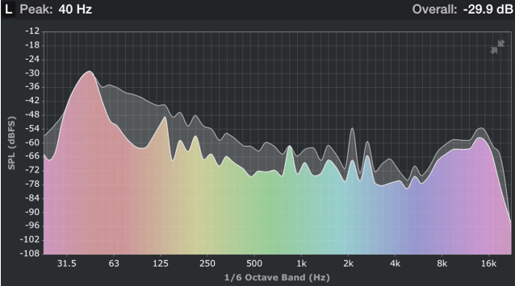

Fig. 23 Spectrum Analyzer

4.1.6 Mindfulness, Meditation, Psychoacoustic Applications
In designing listening devices for both escapists and soundtrackers, much can be gleaned from the techniques used in guided meditation and ambient sound apps. The following use novel ways to reach the desired effect of relaxation and mindfulness that may be useful to consider in this project.

Headspace (iOS and Android, released 2012). Co-founded by a former Buddhist monk, Headspace is one of more popular guided meditation applications available (Headspace Meditation Limited, 2018). For those new to meditation Headspace can teach the basics of meditation, but also supports more advanced users. To give the experience a calm, humanistic feel, the interface uses animation to give a certain living quality to the experience. This experience mimics the body's biorhythms like breathing and heart rate. For example, in play mode, the wobbly circle that makes the multi-state play/pause button moves much like an amoeba under a microscope (see Fig. 24). The effect is soothing but also communicates that the meditation session is in PLAY mode. Providing this visual feedback helps the user understand their current position in the system at a given time (Babich, 2017).

Environments (iOS, released 2018). In 1969, field recordist Irv Teibel, in the guise of Syntonic Research, Inc., released the first in a series of albums capturing the sounds of rolling ocean waves and enclosed birds at the Bronx Aviary (Giaimo, 2016). The Environments series was billed as "a decongestant for the mind" that listeners could use to relax, sleep, concentrate—a tool for a job. Teibel emphasized his recordings were meant to be "heard" rather than listened to, much as Eno would later intend his Ambient series to be "as ignorable as it is interesting" (Richardson, 2002). With each side playing roughly 25 minutes of continuous sound, the albums were promoted as "psychologically perfect aural environments which can be left on indefinitely without fatigue or boredom" as a way to cope "with ever-increasing problem of disturbing noise." Although the liner notes claim the record was the outcome of extensive research, the research was more marketing hype than reality. The tactic worked, however, and Teibel's concept albums sold well. In the following 10 years he would release ten more albums under the Environments series for a total of 22 soundscape recordings. With the popularity of the series many attribute the worldwide interest in field recordings to Teibel's pioneering work (Cummings, 2010).

In 2018, all 22 recordings of Environments were reissued as a smartphone app by record label Numero Group (Blais-Billie, 2018). Known for comprehensive reissues of obscure music on physical media, Numero Group's release of Environments marks a new direction for the archival record label who ostensibly saw the series as a psychoacoustic tool well suited for mobile technology. The app's design is simple to navigate without superfluous functionality. To play each recording, the user swipes left or right on a large image of a natural scene matching each recorded soundscape (see Fig. 25). Multi-state toggle buttons on bottom toolbar allow for Play/Pause and Non-Continuous/Continuous playback.

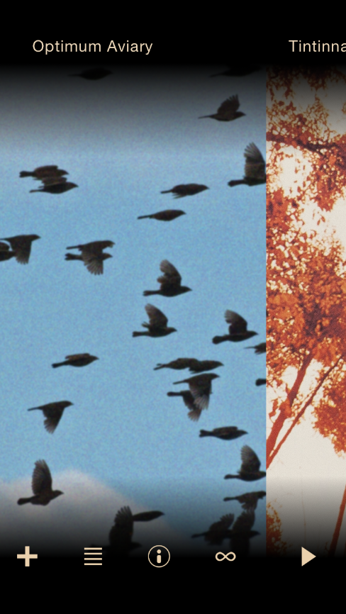
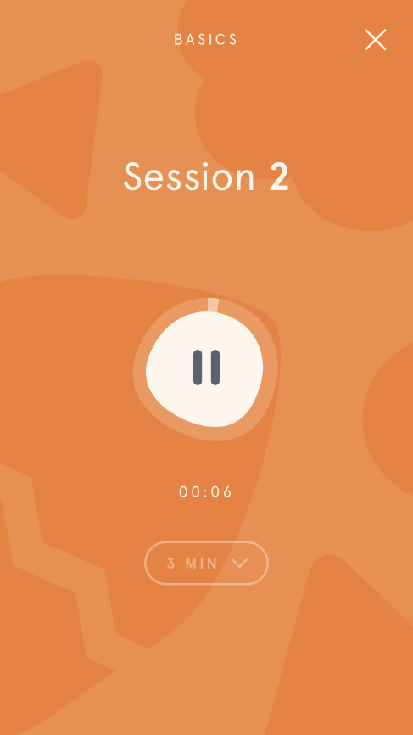
Fig. 24 Headspace biorhythmic Fig. 25 Environments swiping gesture to
play button next track

Brain.fm (iOS and Android, unknown release date). Publicized as a neuroscience music therapy app, Brain.fm claims to improve focus, ease relaxation and sleep using rhythm and sound. By matching frequencies and rhythms to an activity, the technology synchronizes the auditory system (what we're hearing) with biorhythms deep within the brain. Brain.fm builds on Dynamic Attending Theory (DAT) which describes how our brains use actions which are rhythmically organized (e.g. speech, walking, among others), or stimuli (music, etc.) to predict the occurrence of subsequent events in order to optimize the processing speed in our brains (Hewett & Morillon, n.d.). From a neurological perspective, humans accomplish this with neuronal entrainment—the mechanism by which brain waves synchronize (i.e. entrain) with external stimuli. Using empirical MRI and EEG data, the developers at Brain.fm have determined which frequencies and rhythms will synchronize with desired states (e.g. concentration or relaxation). Using proprietary software to compose extremely long pieces of music, Brain.fm claims to have the most advanced AI music composer ever built. This is necessary because the app must be capable of playing extremely long pieces of music. If the user chooses SLEEP, for example, the session must play through the night. As it applies to this project, Brain.fm offers novel solutions for both task-oriented listening session and AI generated music.

Spatial Audio. With the limited range of sight, humans developed the ability to localize sound as way for the brain to determine the location of out-of-sight objects (Grothe et al., 2010). Likely evolving to hunt prey and elude predators, the ability to locate threats and other animals in space was essential to survival.

Although we sense the sound of the natural world in 360 degrees, most recorded music and radio is mixed in stereo to mimic the left and right orientation of musicians on a stage. The counterpoised groups of performers and audience, however, can be inadequate for certain types of media. For example, a stereo mix is less ideal for gaming, film and some styles of music, where the audience instead seeks an immersive experience.

Beginning with film, surround sound evolved in the 20th century to strengthen the emotional impact for a viewing audience. With sophisticated speaker systems that project sound from all directions the audience could now be in the story rather than merely an onlooker, as if watching through a window.

By the early 1980s, surround sound was no longer consigned to the realm of megaplexes. In 1982, Dolby Laboratories introduced the first home theater systems for consumer markets (Dolby Laboratories Inc., 2014). Dolby Pro Logic utilized four channels to spatially locate film audio. Subsequently, Dolby led the development of 5.1 and 7.1 systems that allowed for more channels. But, with 9.1 and 11.1 systems, the addition of more channels reached a point of diminishing returns. Parsing a limited signal into more channels didn't create more realistic sound.

To fix the problem, Dolby began work on new technology to allow filmmakers to choose exactly where a sound should be, and how it moves, in three dimensions. Released in 2012, Dolby Atmos allows up to 128 audio tracks each encrypted with spatial audio metadata for location and pan automation. Disney/Pixar's film Brave was the first theatrical release to use Atmos. Since then, all major Hollywood movie studios have adopted the technology. By December 2016, Dolby had installed 2,000 Atmos-enabled movie screens and released 500 movie titles with Atmos surround sound (Cohen, 2016).

By converting the Atmos tracks into 360-degree binaural output, Dolby released Atmos for Headphones to bring the same spatial capabilities of theater applications to normal, stereo headphones (Lopez, 2017). Using a head-related transfer function (HRTF) to determine how sounds from different directions will arrive at the ear, Atmos for Headphones maps and modifies sounds to create a three-dimensional effect. The modification, however, is made in the recording rather than in real-time with hardware or software. The major benefit of the headphone application is its simplicity. As long as the user is wearing headphones, Atmos for Headphones does not need to accommodate for speaker positioning, room size, etc. The effect is ideal for gaming and virtual reality applications where events and characters are moving in and out of frame. Atmos mixes of recorded music, however, have been limited. Released in November 2017, R.E.M.'s 1992 Automatic for the People was the first commercially released album with an Atmos mix (Farley, 2017). The press release of the album claims to "[transport] the listener inside the recording studio with multi-dimensional sound." From the marketing, you must assume that this experience is one that appeals to a casual listener. In the case of R.E.M.’s music, or similar counterpoised recordings where stage players are theoretically facing listeners, spatial audio may be less applicable than more immersive styles, like Ambient or field recordings.

4.2 Portable Listening Device Hardware

Headphones and Personal Speakers. First developed in the 19th century to keep telephone operator's hands free, headphones which once were industrial devices are now, in the age of smartphones, ubiquitous (Petrusich, 2016). In 2012, headphone manufacturers saw a quick thirty-two percent increase in sales, likely due to an increased adoption of smartphones, which continues to grow. For mobile listeners, headphones are an essential component of the experience. Alas, portable listening would not be feasible without developments in headphone technology. Choosing the proper headphone is often a balance between convenience and comfort, sound performance, price and safety. When considering factors that contribute to hearing damage caused by headphones, the only relevant variable is volume (Kaplan, 2016). No style of headphone is inherently good or bad for hearing health. Headphones which reduce external sound (noise cancellation), however, are inherently safer because they allow users to listen at lower decibel levels. For those users who are interested in hearing those external sound along with PLD audio, it is important to be mindful of keeping the volume at a low, safe levels. In the following section, I will review the types (and features) of personal speaker technology and how their differences affect listening in public places.

Circumaural (or over-the-ear) Headphones. Often referred to as full size headphones, circumaural headphones fully enclose the ear with large ear pads resting on the listener's head rather than ear (Munz, 2014). Although originally developed for home listening, more manufacturers are marketing circumaural headphones for mobile use due to the ubiquity of smartphones and advances in comfort and sound quality. As of this writing, Amazon's three top selling over-the-ear headphones are noise cancelling models. Often marketed to frequent flyers to block out in-flight engine noise, these headphones do not make the best accessory for mobile listening where situational awareness is important.

Supra-aural (or on-ear) Headphones. At a glance, the construction of supra-aural headphones looks quite similar to circumaural designs (Munz, 2014). Both styles have soft ear pads that surround the driver, but rather than enclose the ear, supra-aural headphones sit directly on the outer ear. For this reason, on-ear styles offer less sound isolation than larger styles. However, for use with portable devices, this style provides better situational awareness because it lets in more environmental noise. Being slightly smaller, on-ear headphones are more portable than over-the-ear styles, but users find the pressure to outer ear becomes uncomfortable after long periods of use.

Open and Closed Back Designs. Both supra-aural and circumaural headphones are offered with either "closed back" or "open back" designs (Munz, 2014). As the terms suggest, an open back design allows air to freely move into the back of the ear cup while the closed back has sealed cups. For sound isolation, closed back designs provide the most noise attenuation, but leads to an "in your head" listening experience that can complicate situational awareness. With air moving freely, open back designs tend to put less strain on hearing resulting in reduced ear fatigue. Although the possible of disturbing people those with leaking sound increases, situational awareness improves with open back as environment sound can enter the ear cup.

Earbud Headphones and In-Ear Monitors. By far the most portable styles, earbud and in-ear headphones are lightweight, comfortable for longer use, and easy to pack (Munz, 2014). Earbuds sit on the outer ear and, on average, provide the least passive noise cancellation resulting in the best situational awareness for mobile users. Sitting on the ear, however, cause these styles to fall out easily especially during vigorous activity such as running or biking (Ireland, 2017). In-ear monitors (IEMs) insert into the ear canal forming a tighter seal and provide more sound isolation than earbuds (Munz, 2014). They are not prone to falling out but often comfort can be a problem with ill-fitting pairs. With a plugged ear canal, however, many users complain of an "in your head" sound that can be disorienting. This effect, along with high passive noise cancelling, makes this style less ideal than earbuds for portable use.

Bone Conduction Headphones. First used in hearing aids in the early 20th century, bone conduction allowed the deaf to hear through their teeth (Kennedy, 1958). By vibrating the bones of the skull, a device can bypass the outer and middle ears to transmit sound directly to the inner ear where the hearing organ lies (Banks, 2018). In the 21st century, bone conduction is being deployed to advanced wearable devices. The ill-fated wearable device Google Glass used bone conduction to communicate information to the wearer. When asked a question the Google AI assistant would respond via bone conduction that made the response almost inaudible to others (Arthur, 2013). In 2008, Audio Bone became the first mainstream headphone built with bone conduction technology. In the following years, many more manufacturers have released similar headphones, although users report that sound performance is lower than traditional air conduction headphones (Banks, 2018).

Wearable Speakers. As an alternative to headphones, wearable speaker designs are having a resurgence. Originally developed in 1979, the Bone Fone, a personal speaker that was draped over the neck like a scarf, resonated sound through the wearer's bones (JS&A Group, Inc., 1979). In ways resembling the Bone Fone design, yet without bone conduction, Bose released the Soundwear Companion Speaker to enthusiastic reviews in September 2017 (Hertsens, 2017). When connected to a Bluetooth device, a mobile listener can be enveloped in sound without cumbersome headphones. Although, for the wearer, the sound is heavy with bass, minimal sound "leaks" to people nearby. At a certain volume, only the high frequencies are audible to those close by while the bass is almost undetectable. For certain situations, such as public transportation, this may not be the best option for portable users in urban environments. However, some may see this design as ideal for ease of use, increased situational awareness, and better soundscape mixing.

Wired vs. Wireless headphones. Developments in Bluetooth-enabled headphones have made wireless headphones an attractive alternative for portable listeners. Both styles have their advantages, but with improved technology and user demand (not to mention Apple removing the iPhone's headphone jack) it is not difficult to envision wired technology becoming obsolete. Among those new to wireless headphones, however, some have reported increased anxiety caused by no longer having their device tethered by wires (Gartenberg, 2018). When wired headphones are physically connected and music is playing, a user can be confident their devices is not lost. Nonetheless, the convenience of wireless headphones is increasing user demand for smaller, high-fidelity speakers. For those who become comfortable with wireless setups, the freedom of movement is a welcome change. The setup works particularly well for those engaged in fitness or commuting activities where mobility is prioritized. Small, fully wireless earbuds, however, can be particularly easy to misplace or drop, and earlier wireless models were prone to connection drops or audio delays (O'Kane, 2018). To fix these problems, Bluetooth 5 was released in 2016. The Bluetooth Special Interest Group claims Bluetooth 5 is twice as fast, provides four times the signal range, and has eight times the payload capacity of earlier versions (Bluetooth SIG, 2017). Some have reported Bluetooth 5 has greatly improved reliability and reduced drop connections (O'Kane, 2018).

Chapter 5: Gaps

This review of existing theory and technology seeks to inform a design for better PLD interaction in cities. The design should address not only how we interact with the device itself, but also, how it can assist interaction with the people, buildings and vehicles around us. Although some developers have incorporated acoustic design and neurology, existing PLDs fail to connect the disciplines of sound studies in portable listening device (PLD) product design. The design of common PLD applications appears stuck in time. Smartphones have increased the convenience of portable listening, yet still mimic the dominant design found in the earliest Walkman. Subsequently, product developers have failed to leverage the smartphone processing power to make progress beyond basic PLAY, STOP, FAST-FORWARD, REWIND functions. In my review, I have found the following areas unresolved in today's PLD technology. Personal Listening Devices:

1. Do not alert or adapt to external dangers.
PLDs lack the intelligence to alert users of impending dangers common in urban environments (e.g. approaching cars). For pedestrians, whose sense of hearing can be impaired by headphones playing loud audio, awareness of approaching objects can be reduced to the 120 degrees of peripheral vision. Unlike other software, such as that developed for driverless cars, PLD devices do not alert a user and/or adapt playback to approaching dangers.

2. Do not adapt audio to the soundscape
Smartphones can identify the key, tempo, and frequency spectrum of a recording. However, these features have not been used to adapt PLD audio to environmental sound. Many applications offer equalizers to adjust playback tone, but these features are configured in advance and do not adjust in real time to each new environment.

3. Do not adapt audio to the user's body movements
Activity trackers like Fitbit and Apple Watch now quantify much of our daily activity. Our steps, heart rate, and quality of sleep are measured and recorded in real time. No existing PLD technologies use these metrics to synchronize audio (tempo, etc.) with our body movements.

4. Adapting audio when speaking or being spoken to
A PLD user will often stop playback or remove their headphones when talking. Although many smartphones now feature personal assistants (e.g. Siri and Google Assistant) which respond to voice commands, no PLD application uses this technology to adjust playback to accommodate the human voice. For urban users, who frequently interact with store clerks, etc. today's device will only resolve these interactions when the user executes an explicit command such as turning volume down or audio off.

5. Music players lack connectivity to most popular cloud and streaming services
Although some services are available on a majority of third party applications, I have yet to find one that will import libraries from most of the popular services.

6. Music players do not utilize animation to communicate player state/function
On meditation applications, animation and finger gestures are used to create a playful, life-like experience while also communicating function simply. Unfortunately, most music player applications have prioritized stale dominant design over an engaging user experience.

Chapter 6: Data

Survey Results
The following table presents the thirteen survey questions that were asked of participants. To the right of each question are the tabulated responses from eighty-nine portable listening device (PLD) users who participated.

What is your gender? | Male: 77.8%  Female: 21.1%  Transgender: 1.1%
How old are you? | 18-25 years: 26.7%  26-35 years: 28.9%  36-50 years: 32.2%  51-64 years: 11.1%  65 years or older: 1.1%
How many hours in a day do you typically use a portable listening device (not including at home or office)? | Less than 1 hour: 1%  1 hour: 22%  2 hours: 39%  3 hours: 18%  4 hours: 9%  5 hours: 4%  6 hours: 3%  >6 hours: 1%
Would you characterize where you most frequently use a portable listening device as: | Urban: 70%  Suburban: 21.1%  Rural: 8.9%
Please rank media type commonly used | (see Graph 1 below)
Are there other media types not listed that you commonly use? | Gaming: 1%  Watching video: 7%  Voice memos: 1%  Music production: 1%
Which activities do you engage in while using a portable listening device? | (See Graph 2 below)
Are there any other activities you engage in frequently while using a portable listening device? | Studying: 7%  Commuting (nonpublic trans.): 5%  Strolling: 1%  Travelling: 3%  Making art: 1%  Being alone: 1%  Web calls: 1%
What style of music do you listen to? | Rock: 74%  Jazz: 52%  rap/hip hop: 33%  Electronic: 72%  Ambient: 54%  Country: 13%  Classical: 41%  Dance: 41%  R&B: 19  Metal: 4%  I don't listen to music: 1%
When listening to music, do you tend to listen at a volume that makes it difficult to hear the environment around you? | Yes: 68.5 %  No: 31.5 %
How often does the music have lyrics? | Always: 10%  Most of the time: 31%  Some of the time: 55%  Never: 3%
In order to talk or hear external sounds while using your portable listening device, do you tend to: | Remove headphones: 64%  Stop playback while leaving headphones in: 13.5%  Continue playback but turn down volume: 10%  Remove only 1 earphone: 4%
Which style of headphones do you use most often? | Earbud: 66%  In ear: 9%  Over the ear: 15%  On ear: 4%  Bone conducting: 3%
Is the style of headphones you use most (not including at home or office): | Not noise cancelling: 58%  Semi-noise cancelling: 19%  Noise cancelling: 15%  I'm not sure: 8%
How often do you use headphones (not including at home or office) to talk on the phone in a week? | Never: 49%  1-2 times: 23%  3-4 times: 13.5%  5-10 times: 7%  More than 10 times: 7%

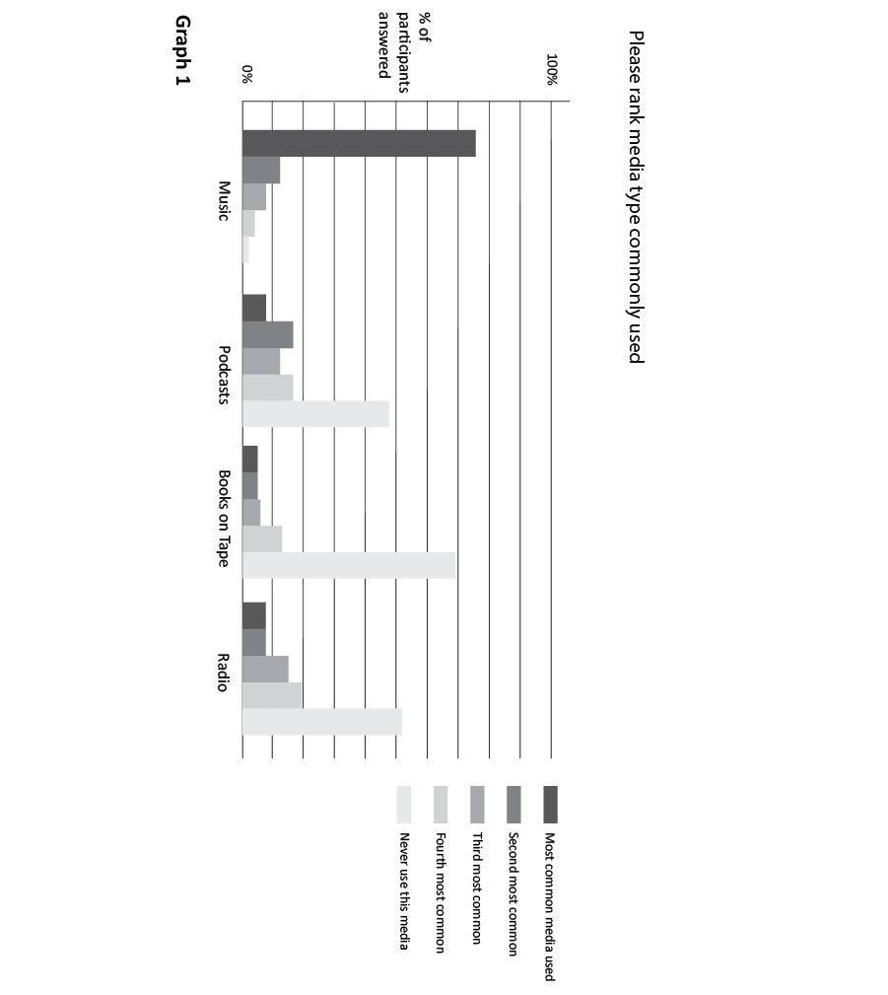

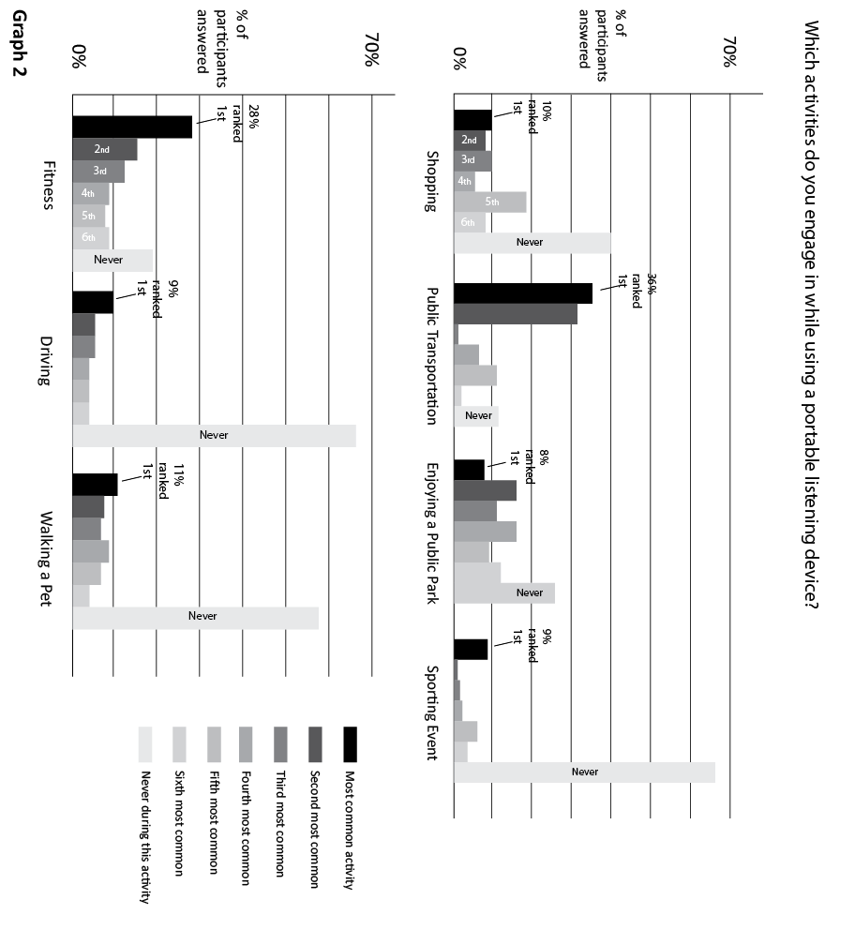

Semi-Structure Interview Participant Demographics

Eight PLD users participated in a semi-structured interview conducted in-person or on video call online. The following table describes the demographic information of each interviewee (real names have been replaced with fictitious ones to protect study participants' identities).

1 | Nathan | Age: 18-25 years old  Gender: Male  Country of Residence: Ukraine
2 | Paul | Age: 36-50 years old  Gender: Male  Country of Residence: USA
3 | Bill | Age: 36-50 years old  Gender: Male  Country of Residence: USA
4 | Aidan | Age: 18-25 years old  Gender: Male  Country of Residence: USA
5 | Barry | Age: 51-64 years old  Gender: Male  Country of Residence: USA
6 | Lane | Age: 18-25 years old  Gender: Male  Country of Residence: Scotland
7 | Patrick | Age: 36-50 years old  Gender: Male  Country of Residence: Germany
8 | Gabby | Age: 26-35 years old  Gender: Female  Country of Residence: USA

Coded Themes

The interview and survey data was coded to identify themes common among PLD users. These themes reveal particular user behaviors that will be helpful when designing future systems. Where applicable, I included quotes from interviewees that illustrate each theme.

1. Concerns about Safety
Of those surveyed, 68% of participants reported listening to music at a volume that makes it difficult to hear their surroundings. In an urban setting, where pedestrians and cars are in close proximity, this can create a dangerous scenario for PLD users (Lichenstein et al., 2012). When asked about feeling unsafe while using PLDs, participants reflected the concern:

I live on one of the busiest streets in Glasgow. It seems like there is constant road construction if front of my place. Usually I leave my house listening to music loud just to mask the street noise. But sometimes I miss approaching cars when I walk into intersections. (Lane, Interview #6)

Participants using PLDs were most often engaged in commuting or fitness activities in urban environments. In regard to public transportation, 88% reported using PLDs during commuting. While those participating in fitness activities, such as outdoor jogging, 81% reported using PLDs with engaged in this activity. These activities proved worrying for some users in areas with less "eyes on street". With our sense of hearing masked by loud music, PLD use can be too much for some:

I don't listen to headphones downtown a lot. When I leave work, especially if it's dark, I won't listen to headphones because you're not as aware of your surroundings. [There's less people around] after work when I walk to the train and I feel the need to be more precautious. (Gabby, Interview #8)

2. Loss of Situational Awareness
Although a lack of situational awareness may, in some cases, lead to unsafe conditions, which is not always the case. In other scenarios, listening at a high volume may only be an inconvenience. Of those surveyed, 64% of users will remove headphones from their ears to hear external sounds such as someone speaking to them. But, in scenarios where listeners are unaware of the speaker (announcements, a speaker out of sight, etc.) those interactions go unnoticed:

I often listen to music on headphones when I'm travelling on planes. Waiting at the gate, I've missed the boarding announcement because I can't hear over my music. And, then on the plane I miss questions from flight attendants or the pilot's announcements. It can be frustrating. (Barry, Interview #5)

Similarly, Pedro also misses announcements. Although, conceivably, in a situation more difficult to rectify:

I use headphones during group exercise classes at my gym. I prefer my music over that being played in the room, but sometimes I miss directions from the instructor. (Paul, Interview #2)

3. Using headphones as a barrier
Seventy percent of those surveyed use PLDs in the city. On busy city streets, where a higher concentration of noises are pulling our attention, headphones are often used to place a barrier between us and those sounds around us. Headphones, particularly larger, corded models that are visible to those who pass, can signify that we are unable to hear them and are often used to deter unwanted attention. Whether actually listening to audio or not, a person can maintain a level of decorum in public while reducing engagement:

In the public markets of my hometown in Ukraine, everyone is trying to sell you something. I usually put on my headphones so the vendors will talk to me less. (Nathan, Interview #1)

Although effective in thwarting unwanted attention, the line between safety and convenience can be tenuous:

As a woman, sometimes I use headphones to just tune people out, especially like cat calling and stuff like that. And there's even times where I'm not even listening to music and I can keep them in my ear so that people won't approach me. Yeah, it's a little barrier between yourself and other people. And I don't know, I guess for me I think like sometimes I like having that barrier there but then other times I feel less safe because of it. So it's like this line you walk where you're kind of letting people not approached you but at the same time someone could come up behind you. (Gabby, Interview #8)

4. Frustration with PLD use in hyper-post-Fordist environments
Of those surveyed, the majority of users (76%) ranked recorded music as the most commonly used media over other forms such as podcasts and books on tape. When asked when they most frequently use PLDs, 91% of users reported using PLDs during activities where, conceivably, other music (i.e. music over loudspeakers) may be heard (shopping, sporting events, fitness). As described by sociologist Michael Bull, hyper-post-Fordist music environments such as these are becoming more commonplace in our mediated world. PLD users can now create a personal soundtrack using headphones, but more increasingly, the structures and environments where we find ourselves are fitted with loudspeakers playing music. Unless the user is listening at a volume that blocks all noise, the various keys and tempos of 2 or more audible media can disorient a user and can quickly lead to frustration:

In group exercise class, I use headphones because I rather listen to my own music than the songs played by the instructor. The rhythm helps me maintain my pace, but when I hear the tempos of both songs mixed it can throw off my movements. (Paul, Interview #2)

In these situations, a user's options to rectify the problem are (1) remove headphones, (2) continue listening to both (signal and noise), (3) turn the PLD volume above environmental noise, or (4) leave the environment. These options, however, are less than ideal. Philippe explains how he handles the problem:

When shopping, I use headphones mainly in supermarkets to keep from hearing the supermarket's music. If I listen at a low volume, I hear whatever music their playing inside which I don't like. So I usually listen crank up the volume to drown it out. (Patrick, Interview #7)

5. Enjoyment of mixing environmental sound with music
From John Cage, we learned how unintentional sounds are virtually inescapable in everyday life. He believed to find beauty in the mixture of intentional and unintentional sounds was a path to living life more affirmatively. Over the sixty-plus years since 4'33", and his influential book Silence, Cage's concepts have influenced creators and listeners alike. Many seek out these experiences:

I like to hear the traffic next to the music. I don't try to get the background noises completely out. I want a soundtrack to what's happening around, but I don't want to block out my surroundings. I really enjoy the music next to the street sounds. (Patrick, Interview #7)

Of the users surveyed, the majority (58%) use non-noise-cancelling headphones, a style that allows in the most environmental noise. Although that choice may be more practical than aesthetic, others use this style headphones as a way to balance intentional and environmental sounds:

I often go to the cafe where I like to listen to music without lyrics while I'm reading. I try to find the right mix of my own music with the sounds from the crowd around me. It's like a perfect balance of both where neither distracts me from what I'm reading. (Lane, Interview #6)

6. Using music to mediate and/or regulate mood
As in film, soundtracking our lives with headphones is a way to, as Andreas Pavel put it, "multiply the aesthetic potential of any situation." In the case of film, music can modulate the emotional impact of a scene. While PLDs allow us to experience this in ordinary life. For many users, this is an end in and of itself. In other situations, however, music has a more practical use—a way to manage our lives. Bob explains how he regulates his mood with music:

I like to enjoy music wherever I am and escape from the reality of the situation that I am currently in. It helps me and my brain to rest, after a hectic session of class or work, and prepares me to focus more and aids deep understanding (Bill, Interview #3)

Throughout the study, it was common to hear how people use music to either (1) match their mood or (2) to reach a desired state. Pedro explains his routine:

I use upbeat music to motivate myself on hikes. But, I may pick something more calming when I'm home trying to decompress and relax at the end of the day. (Paul, Interview #2)

7. Using music to focus on a task
I was surprised to find that 8% of study participants reported using PLDs while studying. Even though I failed to give the option, 7 people wrote-in this response. Interviewees, who elaborated on the process, explained how they use PLDs to focus their attention:

In the city I lose concentration very, very fast because I react to everything that's happening, so the music kind of helps me to keep a focus a bit because I don't react to everything and it's like a one train of thought. (Patrick, Interview #7)

Others, like Luke, explained how music helps them reach a state of flow where accomplishing a task is seemingly effortless:

When I worked in the kitchen of a restaurant I would often listen to upbeat music like dance music. The beat energized me to work that night. I could reach this point where I was just in the zone where time just flew by and I was totally concentrated on the job. (Lane, Interview #6)

Chapter 7: Discussion

This project aims to find solutions to common problems which arise from using portable listening device (PLD) in cities. Many have written about the dangers of PLDs, from safety concerns (Lichenstein et al., 2012) to causing anti-social behavior (Heffernan, 2011). These articles, however, rarely engage in brainstorming a solution. Rather, they often accept technology as it exists and merely suggests abstinence from prolonged use. Unfortunately, this tactic seems unlikely to solve the problem at a time when two-thirds of Americans own smartphones and, arguably, more people are using headphones/PLDs than ever before (Smith, 2015). Instead, I hope to shift the discussion to how design can facilitate these interactions with our surroundings more intelligently. By reviewing existing theory and technology, identifying gaps, then surveying user needs, this project identifies how to make intuitive, user-centered portable listening devices. This process has identified that user needs vary. Therefore, the design should be adaptable to the different scenarios.

The data supports the writing of Michael Bull who identified that all media is used for sensory filtering—either to enhance a sense or deprive one. Like Bull, I found that study participants use their devices in one of two ways: (1) to block environmental stimuli as an escape into another world of music, podcasts or books-on-tape, or (2) to heighten the aesthetic potential of an experience—much in the way soundtrack functions in film. Like film, these users mix diegetic with non-diegetic sounds to reach a suitable level of sound complexity. Designing an adaptive device for both users will be necessary to meet the needs of the largest user base.

It's also worth noting that women use PLDs differently than men. At first, I struggled to find an acceptable gender balance among music and technology enthusiasts. Fortunately, by searching outside of these groups, I recruited female participants who revealed slight, yet important, differences in how the sexes use PLDs. Both men and women often use PLDs in public to ward off nuisances (e.g. solicitors and beggars), however, many women rely on the visibility of headphones in cities to resist sexual harassment. In the coming years, headphones will undoubtedly become smaller, wireless, and less visible. Unless those users stay with larger, corded models, the application itself will need to attend to safety concerns for these users. Also, female users listen to music with lyrics more often than men. Eighty-three percent of female participants claim to listen to lyrics always or most of the time. In contrast, only 30% of male participants had similar responses. Many interviewees spoke of how lyrics strengthen the emotional impact of a song and explained how vocal music energizes them during physical exertion. For studying and reading activities, participants reported listening to instrumental music more suitable. Research has shown vocal music significantly impair one's abilities to engage in complex cognitive tasks (Crawford and Strapp, 1994). Having access to libraries for work and studying, like Brain.fm, would better serve users during tasks that require higher cognitive focus. While incorporating cloud (Google Drive, Dropbox, etc.) and streaming (Spotify, Pandora, etc.) services will accommodate a range of media types for varying preferences.

Also, this study shows that age can determine user behavior. Those users aged 51 and older ranked shopping with headphones the least common among other activities. This activity, however, was more widespread among users 18-25 and 26-35 years old. As I learned from ethnographic interviews, the frustration caused by the conflict of two (or more) sound sources will be more prevalent among for these younger users who frequent mediated stores. The oldest and youngest age groups, 51 and older and 18-25 respectively, reported using PLDs in public parks more than middle aged users (likely because they have more free time). Working adults, on the other hand, reported using PLDs most frequently while commuting to their job. As such, users in a quiet park will likely require a different experience than those on a train in a bustling city. For changes to setting such as this, the PLD will better serve the user if the application can sense and adapt the audio to changing environments in real time. By using existing technology to sense changes in key, tempo, and frequency magnitude, applications can adapt the headphone audio as they move through different environments. Instead of requiring a user to modify themselves to endure a harsh environment, the interactive device will adapt the audio, in these environments, automatically in real time. Of course, this application will require significant amounts of processing and battery resources. Present day technology may struggle with this constant, real time computing. If the speed of mobile technology proceeds, however, it's reasonable to expect that, in time, processors and batteries will be able to handle this level of data processing.

From the start, I proposed the solution for better PLDs lay in mixing intentional and unintentional sounds. From my research, however, I've learned that users who prefer this experience are in the minority (by a rate of 2:1). Although my survey question may have lacked the granularity to gauge to what degree, I discovered from interview responses that many people use PLDs both ways—sometimes to escape, other times to soundtrack their day. Therefore, to satisfy the needs of most users, I propose designing a device application which allows the user to toggle between these states. The following wireframes show the design concepts to provide such user configuration. In addition, I outline features that will adapt the audio to the environment in real time. The following features were designed to either relieve user pain-points or improve the experience as identified in the coded themes found in the Data section.

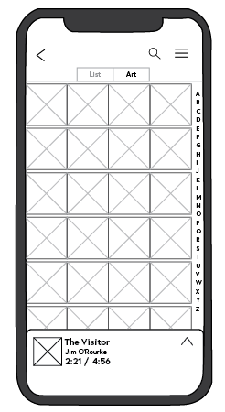
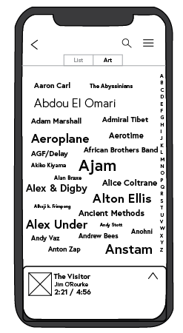
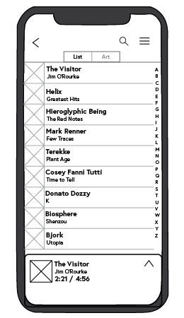
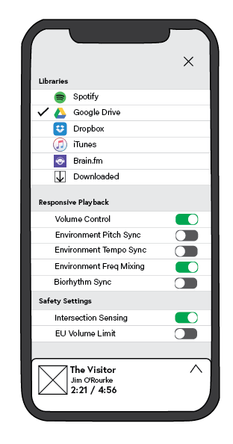
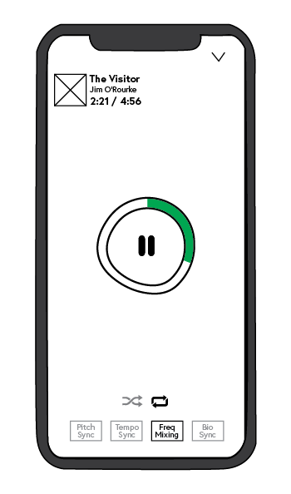
Wireframe Overview
Now Playing View Settings Menu Library List View Library Tag Cloud View Library Art View

Fig. 26 Wireframe overview

Now Playing Wireframe
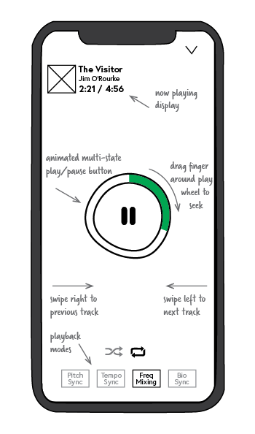

The Now Playing screen incorporates finger gestures to control functions commonly found as button controls on music players.

Animated multi-state Play/Pause button
Space is saved by designing one button to serve both play and pause. The Play wheel is animated to give interface a life-like quality but also communicates the song is playing

Finger gestures control track seeking around play wheel
To eliminate small track progress bar that are difficult to control, track seeking (fast-forward and rewind) is controlled by dragging-finger gesture around play wheel. Green graphic shows progress of track.

Replaced skip buttons with swipe gestures
Instead of small skip button that are difficult to click on the move, users skip to next or previous by left and right swiping gestures

Playback Modes

Users can toggle between playback modes (see Settings wireframe)

Shuffle and Repeat Buttons
Shuffled play will randomly play files in selected folder. Repeat play will play songs in order then repeat files in folder when complete.

Fig. 27 Now Playing wireframe

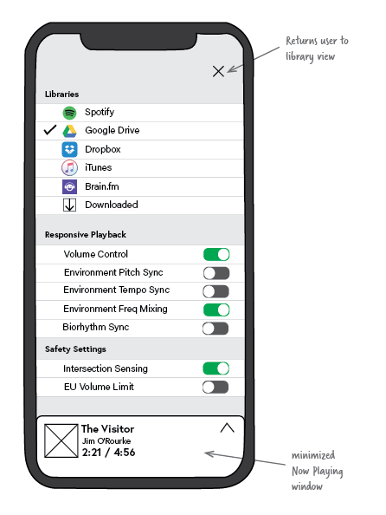
Settings Menu Wireframe

The Settings Menu allows user to control level of interaction with environment

Library Selection
User can select from cloud services, streaming services, and those files saved locally

Volume Control

Automatically adjust device volume for ideal mix with environmental sound.

Environmental Pitch Sync
Identifies key of environmental music and synchronizes PLD music key to reduce acoustic dissonance; maintains original tempo

Environmental Tempo Sync
Identifies tempo of environmental music and synchronizes PLD music tempo to reduce acoustic dissonance; maintains original key

Environmental Frequency Sync
Identifies magnitude of frequencies in environmental sound and equalizes PLD music for ideal mixing in real time. Also, reduces PLD audio around 85-255 Hz to make room for voice when speaking human in vicinity.

Fig. 28 Settings Menu wireframe

Biorhythm Sync
Identifies tempo of body movement (walking, running, etc.) and synchronizes PLD music tempo to set pace; maintains original key.

Intersection Sensing

Reduces volume to safe level when smartphone GPS identifies user is approaches a street intersection.

EU Volume Limit

Sets maximum volume to EU standard for safe listening

Library - List View Wireframe

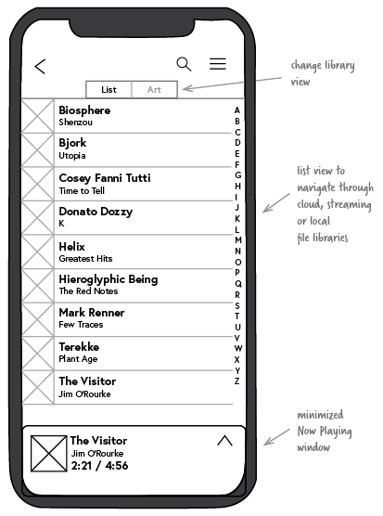
After selecting a library, the user can navigate to audio files by two methods (1) list view or (2) art view (see below). The list view displays cover art, artist name, and album title.

View selection

User can toggle between both views here

Search bar

Access by clicking on magnifying glass, the search bar locates keywords within selected library.

Hamburger button

Used to access Settings Menu screen (see above).

Fig. 29 Library – List View wireframe

Library - Art View Tags Wireframe
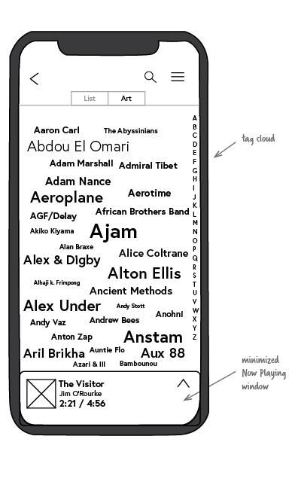

The Art View Tags allows the user to quickly search for a file from the selected library. First, the user selects an artist from a tag cloud which arranges the artist's name in alphabetical order.

Tag Size

Larger tags correspond to more titles by that tag.

Tag Navigation
Users navigate library to desired tag, then either click on zoom (using a pinching gesture) into the album art (see Album Art View wireframe below).

Fig. 30 Library – Art View Tags wireframe

Library - Art View Wireframe

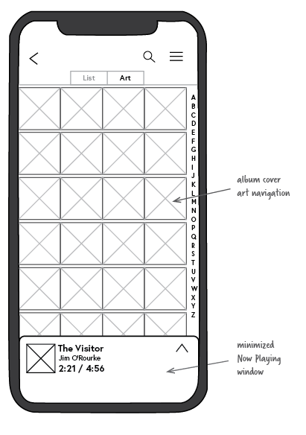
Once the search is narrowed from the tag cloud, the Art View displays album cover art near that tag in the library. The user then selects (taps) the cover art to view the album tracks. Using a pinching gesture, the user can zoom in and out between the tag cloud and album art views.

Fig. 31 Library – Art View wireframe

Chapter 8: Conclusion

In this thesis I address the gap in portable listening device (PLD) design between theory and product design. In the past, hardware and software designers have failed to integrate sound studies and sociology into everyday PLDs. Understanding soundscape can help designers consider how we listen and why environmental sound is important, and provides a vocabulary for these ideas. Because these devices have become ubiquitous, sociology can explain how these designs create positive and negative outcomes in society. Unfortunately, today's music player applications still mimic designs created on outdated, mechanical technology. PLD design has yet to match the adaptive technologies found in gaming, AR and VR applications. In this thesis I connect these related disciplines to create a user-centered listening device. Although some applications tailor a listening session to the user's hearing or music, my design is the first to adapt portable audio to its environment in real time.

This is important at a time when smartphone use has become habitual. Studies show that young adults use their smartphones roughly twice as much as they think (Andrews et al., 2015). On average, in fact, they use smartphones 5 hours a day—about one-third of waking hours. This statistic may not be surprising to those who have witnessed how smartphones, in a short time, have substantially altered the way we spend our time. Idle minutes of the day are now taken to text friends or shop online or scroll through Instagram and Facebook. Perhaps in hindsight, the way we now use smartphones and tablets (staring down into a backlit screen) will appear ill-conceived or even ridiculous. These devices will likely appear archaic, by comparison, much as we see the pager, fax machine, and phone book today. It is easy to imagine that mobile technology will eventually converge with the body. New applications for augmenting reality are bridging that gap between the digital and physical worlds. Yet, wearable technology still has not delivered on the promise of a web-enabled, unobtrusive device. Top technology companies have tried and failed to make wearables that we actually want to wear (Bilton, 2016). Google Glass and the Apple Watch are regarded by many as failed products. While, in recent years, the market capitalization of activity trackers, like Jawbone and Fitbit, are in decline. Some speculate that clunky design and prohibitive prices have kept these devices from larger adoption. In time, however, as these barriers fall, it is reasonable to expect that integrated devices will be more commonplace. Ideally, our devices will adapt to each situation a user finds themselves. Over the course of a day, PLD users in urban areas may walk through many mediated places. Perhaps a typical day finds them commuting on the train to work before stopping into a cafe or running to lunch after the gym. My design offers these users a novel experience that conforms to changing environments and requires little user attention.

The scope of this project has been limited by time and resources. Future work will require both testing with users in real urban environments and engineering. Constructing a working prototype based on the above wireframes will be useful to test both (1) the usability of the interface and (2) how features improve interaction with urban soundscapes. Using rapid prototyping software, the interface will be fairly easily to test for usability. The adaptive features (like Environmental Pitch Sync), however, will require a more creative test environment. In lieu of fully coding such algorithms, a simulated testing session could be devised wherein the tester manually adjusts the pitch, tempo and volume of PLD audio to synchronize with the sound of each new environment. Following test sessions, iterative designs informed by participant feedback can gauge how well particular features meet the design goals. After testing and gathering user feedback, the implementation phase will require developing both traditional playback functions of a music player application and adaptive functions that sense environmental conditions. Special attention will be required to develop those features which modify audio to environmental sound. A system that is too sensitive could cause wild fluctuations in audio and lead to user frustration. While, conversely, a system which react quick too slowly would be ineffective in adapting to the environment. A balance between these states will be important for engineers to calibrate.

References

Andrews, Sally, David A. Ellis, Heather Shaw, and Lukasz Piwek. (2015). Beyond Self-Report: Tools to Compare Estimated and Real-World Smartphone Use. PLOS ONE 10, no. 10: e0139004. Retrieved from https://doi.org/10.1371/journal.pone.0139004.

Appmetric. (2017). Impulse Music Player Software (Version 2.0.7). Available from https://play.google.com/store/apps/details?id=com.appmetric.impulse.free

Arthur, Charles. (2013). Google Glass – Hands-on Review. The Guardian, July 2, 2013. Retrieved from http://www.theguardian.com/technology/2013/jul/02/google-glass-review-augmented-reality.

Arvizo, Sarah. (2015). SoundHound First Music Discovery Service to Be Live on Wearables. Business Wire. Retrieved from https://www.businesswire.com/news/home/20150313005592/en/SoundHound-Music-Discovery-Service-Live-Wearables.

Banks, Lindsey. (2018). Best Bone Conduction Headphones of 2018: A Complete Guide. Everyday Hearing. Retrieved from https://www.everydayhearing.com/hearing-technology/articles/bone-conduction-headphones/.

Babich, Nick. (2017). 3 Key Uses for Animation in Mobile UI Design. UX Planet, February 19, 2017. Retrieved from https://uxplanet.org/3-key-uses-for-animation-in-mobile-ui-design-4d7c482dd84b.

Beer, David. (2007). Tune Out: Music, Soundscapes and the Urban Mise-En-Scène. Information, Communication & Society 10, no. 6: 846–66. Retrieved from https://doi.org/10.1080/13691180701751031.

Bilton, Nick. (2016, Jan. 20). Where Wearable Technology Ends Up (Hint: Not Your Wrist). The New York Times, January 20, 2016, sec. Style. https://www.nytimes.com/2016/01/21/style/where-wearable-technology-ends-up-hint-not-your-wrist.html.

Blaise-Billie, Braudie. (2018). Numero Group Launch New Ambient Sound App. Pitchfork. Retrieved from https://pitchfork.com/news/numero-group-launch-new-ambient-sound-app/.

Bluetooth SIG. (2017, Feb.). Bluetooth 5 Is Setting the Stage for the Future. Retrieved from https://www.youtube.com/watch?time_continue=80&v=t9DtI0nYW9A.

Brian, Matt. (2014, Jan. 14). Hyundai and Kia Tap SoundHound to Help You Identify Music in Your Car. Engadget. Retrieved from https://www.engadget.com/2014/01/14/hyundai-kia-soundhound-music-tagging/.

Brunt, Chris. (2000) Speech Interference Levels in Aircraft Interior Noise Measurement. Their Use and Interpretation. Armchair World. Retrieved from http://www.armchair.com/sci/brunt1.html.

Bull, Michael (2000). Sounding Out The City: Personal Stereos and the Management of Everyday Life. Oxford, UK: Berg

Bull, Michael. (2011). Thematic Series: Sonic Impressions – Mobile Sound Technologies. Retrieved from https://www.youtube.com/watch?v=y66YIG7p_7c&t=936s

Cage, John (1961). Silence. Hanover, NH: Wesleyan University Press

Cohen, Steven. (2016). Dolby Exceeds 2,000 Dolby Atmos Enabled Cinema Screens & 500 Released Movie Titles. High-Def Digest. Retrieved from https://www.highdefdigest.com/news/show/Dolby/Dolby_Atmos/dolby-cinema/Dolby_Vision/VUDU/Streaming/Home_Audio/Ultra_HD/dolby-exceeds-2000-dolby-atmos-enabled-cinema-screens-500-released-movie-titles/37163.

Crawford, Helen J., and Chehalis M. Strapp. (1994). Effects of Vocal and Instrumental Music on Visuospatial and Verbal Performance as Moderated by Studying Preference and Personality. Personality and Individual Differences 16, no. 2 (February 1, 1994): 237–45.

Cummings, Jim. (2010). Irv Teibel Died This Week: Creator of 1970s ‘Environments’ LPs. Earth Ear. Retrieved from http://earthear.com/blog/archives/198.

Denora, Tia (2000). Musician Everyday Life. Cambridge, UK: Cambridge University Press

Dickinson, Peter. (2014). CageTalk: Dialogues with and about John Cage. University Rochester Press.

Dolby Laboratories Inc. (2014). Dolby Atmos for the Home Theater. Retrieved from http://cdn-blog.dolby.com/wp-content/uploads/2014/08/Dolby-Atmos-for-the-Home-Theater.pdf.

Earlogic Corporation (2017). TSC Music Player Software (Version 1.3.9.0). Available from https://itunes.apple.com/us/app/tsc-music-the-ultimate-sound/id1132990735?mt=8

Eno, Brian. (1996) Generative Music. In Motion Magazine. Retrieved from http://www.inmotionmagazine.com/eno1.html.

Eno, Brian. (2000). Foreword to The Ambient Century: From Mahler to Moby--The Evolution of Sound in the Electronic Age. London: Bloomsbury USA

Farley, Donovan. (2017). R.E.M. Reissue Automatic for the People for Its 25th Anniversary: Stream/Download. Consequence of Sound. Retrieved from https://consequenceofsound.net/2017/11/r-e-m-reissue-automatic-for-the-people-for-its-25th-anniversary-stream-download/.

Gartenberg, Chaim. (2018). Wireless Earbuds Are Too Wireless for Me. The Verge. Retrieved from https://www.theverge.com/circuitbreaker/2018/2/18/17021304/wireless-earbuds-wired-cord-bluetooth-issues.

Giaimo, Cara. (2016). The Man Who Recorded, Tamed, and Then Sold Nature Sounds to America. Atlas Obscura. Retrieved from http://www.atlasobscura.com/articles/the-man-who-recorded-tamed-and-then-sold-nature-sounds-to-america.

Global Delight Technologies Pvt. Ltd. (2017). Boom Music Player Software (Version 1.2.7). Available from https://itunes.apple.com/us/app/boom-music-player-equalizer/id1065511007?mt=8

Google, Inc. (2015). Google Play Music Player Software (Version 3.41.1002). Available from https://play.google.com/music/listen#/sulp

Grothe, Benedikt, Michael Pecka, and David McAlpine. (2010). Mechanisms of Sound Localization in Mammals. Physiological Reviews 90, no. 3 (July 2010): 983–1012. Retrieved from https://doi.org/10.1152/physrev.00026.2009.

Hassan, Charlotte. (2016). 68% of Smartphone Owners Stream Music Daily, Study Finds. Digital Music News. Retrieved from https://www.digitalmusicnews.com/2016/03/11/parks-associates-68-of-u-s-smartphone-owners-listen-to-streaming-music-daily/.

Headspace Meditation Ltd. (2018). Headspace Meditation Software (Version 3.23.0). Available from https://itunes.apple.com/us/app/headspace-meditation/id493145008?mt=8

Heffernan, Virginia. (2011, Jan. 7). The Argument Against Headphones. The New York Times, sec. Magazine. Retrieved from https://www.nytimes.com/2011/01/09/magazine/09FOB-medium-t.html.

Hertsens, Tyll. (2017). Bose SoundWear Companion Speaker. InnerFidelity. Retrieved from https://www.innerfidelity.com/content/bose-soundwear-companion-speaker.

Hewett, Adam, and Benjamin Morillon. (n.d.). Brain.fm - Science FAQ. Retrieved from https://www1.brain.fm/assets/pdfs/science_FAQ.pdf.

Hormby, Tom. (2013). The Story Behind the Sony Walkman. Low End Mac. Retrieved from http://lowendmac.com/2013/the-story-behind-the-sony-walkman/.

Intelligent Gadgets. (2018). KeyOmeter Software (Version 2.0). Available from http://intelligentgadgets.us/doc/keyOmeter.shtml

Intermorphic. (2017). Wotja Generative Music Software (Version 5.5.0). Available from https://intermorphic.com/wotja/

Ipsen, Detlev. (2002). The Urban Nightingale or Some Theoretical Considerations about Sound and Noise. Soundscape Studies and Methods. The Finnish Society for Ethnomusicology Publ 9 (2002): 185–197.

Ireland, Kay. (2017). Running With Earbuds. Livestrong. Retrieved from https://www.livestrong.com/article/271140-running-with-earbuds/.

Jacobs, Bryan. (2010). How Shazam Works To Identify (Nearly) Every Song You Throw At It. Gizmodo. Retrieved from https://gizmodo.com/5647458/how-shazam-works-to-identify-nearly-every-song-you-throw-at-it.

JS&A Group, Inc. (2018). Bone Fone - Mechanix Illustrated (Nov, 1980). Modern Mechanix. Retrieved from http://blog.modernmechanix.com/bone-fone/.

Kaplan, Rachel Feltman and Sarah. (2016, Nov. 14). Dear Science: Is Listening with Ear Buds Bad for Your Ears? Washington Post, sec. Speaking of Science. Retrieved from https://www.washingtonpost.com/news/speaking-of-science/wp/2016/11/14/dear-science-is-listening-to-ear-buds-bad-for-your-ears/.

Kennedy, T R. (1958). From Coherer to Spacistor. Radio-Electronics. Retrieved from
http://www.swtpc.com/mholley/RadioElectronics/Apr1958/Coherer_to_Spacistor.pdf.
Krebs, Michelle. (2003, Jan. 3). DRIVING: BELLS & WHISTLES; A Century Of Fords. The New York Times, sec. Travel. Retrieved from https://www.nytimes.com/2003/01/03/travel/driving-bells-whistles-a-century-of-fords.html.

Lichenstein, Richard, Daniel Clarence Smith, Jordan Lynne Ambrose, and Laurel Anne Moody. (2012). Headphone Use and Pedestrian Injury and Death in the United States: 2004 -2011. Injury Prevention 18, no. 5 (October 2012): 287–90. Retrieved from https://doi.org/10.1136/injuryprev-2011-040161.

Lopez, Napier. (2017). Dolby Atmos and Windows 10 Will Finally Bring Surround Sound to Everyone. The Next Web. Retrieved from https://thenextweb.com/opinion/2017/01/05/dolby-atmos-windows-10-going-finally-bring-surround-sound-masses/.

Munz, Steve. (2014). Headphones: Comparision Buying Guide. Audioholics. Retrieved from http://www.audioholics.com/loudspeaker-design/understanding-the-types-of-headphones.

N7 Software Development. (2018) N7 Music Player Software (Version 3.0.8). Available from http://n7player.com/#download

Onyx Apps. (2015) Spectrum Analyzer Software (Version 1.9.1). Available from http://spectrumanalyzerapp.com/

O’Kane, Sean. (2018). Anker Zolo Liberty+ Wireless Earbuds Review: Right and Wrong. The Verge. Retrieved from https://www.theverge.com/circuitbreaker/2018/2/21/17032160/anker-zolo-liberty-plus-wireless-earbuds-review.

Papanicholas, Jason. (2012). Top 5 Apps for Identifying Songs. Evolver.fm. Retrieved from http://evolver.fm/2012/10/10/top-5-apps-for-identifying-songs/.

Petrusich, Amanda. (2016, July 12). Headphones Everywhere. The New Yorker. Retrieved from https://www.newyorker.com/culture/cultural-comment/headphones-everywhere.

Prendergast, Mark (2000). Ambient Century: From Mahler to Moby — the Evolution of sound in the Electronic Age. New York City, USA: Bloomsbury

Richardson, Mark. (2002). As Ignorable As It Is Interesting: The Ambient Music of Brian Eno. Pitchfork. Retrieved from https://pitchfork.com/features/resonant-frequency/5879-resonant-frequency-17/.

Rohter, Larry. (2005, Dec. 17). An Unlikely Trendsetter Made Earphones a Way of Life. The New York Times, sec. Americas. Retrieved from https://www.nytimes.com/2005/12/17/world/americas/an-unlikely-trendsetter-made-earphones-a-way-of-life.html.

Schafer, R. Murray (1977). The Soundscape: Our Sonic Environment and Tuning of the World. Rochester, Vermont: Destiny Books

Seal, Bobby. (2013). Baudelaire, Benjamin and the Birth of the Flâneur. Psychogeographic Review. Retrieved from http://psychogeographicreview.com/baudelaire-benjamin-and-the-birth-of-the-flaneur/.

Smith, Aaron. (2015). U.S. Smartphone Use in 2015. Pew Research Center: Internet, Science & Tech. Retrieved from http://www.pewinternet.org/2015/04/01/us-smartphone-use-in-2015/.

Stellio Team. (n.d.) Stellio Music Player Software (Version 4.13.2). Available from https://stellio.ru/en/

Stephen, Bijan. (2013, Oct. 17). In Praise of the Flâneur. The Paris Review. Retrieved from https://www.theparisreview.org/blog/2013/10/17/in-praise-of-the-flaneur/.

SuperMegaUltraGroovy. (2017) Capo Touch Software (Version 2.7.2). Available from http://supermegaultragroovy.com/products/capo/ios/

Thompson, Derek. (2012, May 30). How Headphones Changed the World. The Atlantic. Retrieved from https://www.theatlantic.com/technology/archive/2012/05/how-headphones-changed-the-world/257830/.

Witkin, Robert (2003). Adorno on Popular Culture. London, UK: Routledge. Retrieved from http://www.verlaine.pro.br/txt/witkin-adorno-pop-culture.pdf.

