SUPPORTING INFORMATION

The structure of Vibrio cholerae FeoC reveals conservation of the helix-turn-helix motif but not the cluster-binding domain

Janae B. Brown¹, Mark A. Lee¹, and Aaron T. Smith^{1*}

¹Department of Chemistry and Biochemistry, University of Maryland, Baltimore County, Baltimore, Maryland, 21250 USA

*To whom correspondence should be addressed. Tel: 410-455-1985; E-mail: smitha@umbc.edu

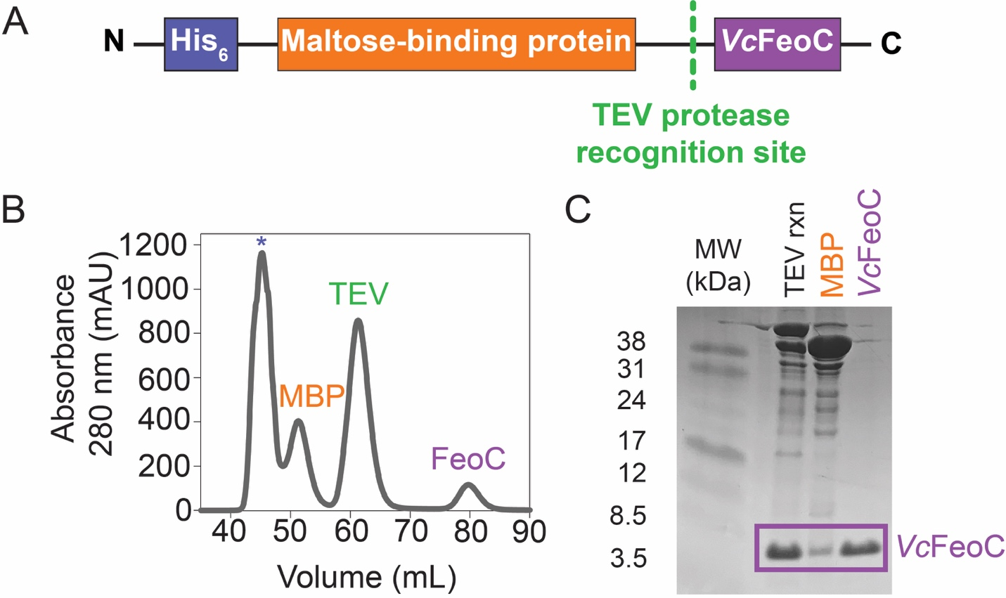
Figure S1. Construct design and purification of VcFeoC. A. Cartoon representation of the MBP-VcFeoC expression construct. An N-terminal (His)₆ tag (blue box) is followed by maltose-binding protein (MBP) (orange box) and separated from VcFeoC (purple box) by a Tobacco Etch Virus (TEV) protease recognition site (green). B. The Superdex 75 size-exclusion chromatography profile of MBP-VcFeoC after TEV protease reaction shows good separation of aggregated protein (asterisk), cleaved MBP (orange), TEV protease (green), and VcFeoC (purple). C. Representative 20% SDS-PAGE analysis highlighting the efficiency of the TEV cleavage reaction and the purity of VcFeoC after size exclusion chromatography (final right-hand lane).

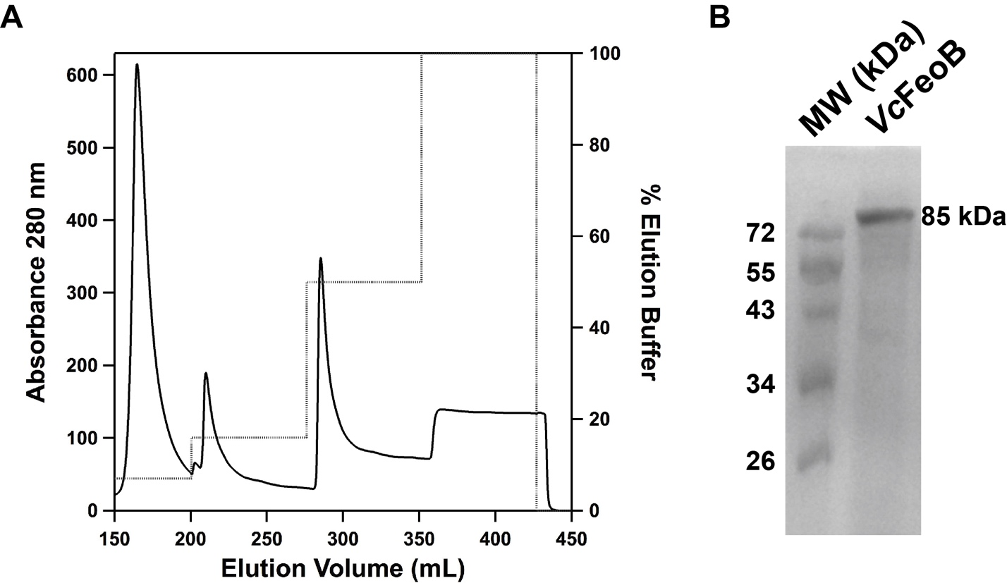
Figure S2. Immobilized metal affinity chromatography (IMAC) purification of Vibrio cholerae FeoB (VcFeoB) solubilized in n-dodecyl-β-D-maltoside (DDM). A. IMAC chromatogram of the VcFeoB purification demonstrates that the protein elutes at 50% elution buffer (50 mM Tris, pH 8.0, 100 mM sucrose, 200 mM NaCl, 0.05% DDM, 1 mM TCEP, 150 mM imidazole). B. 15% SDS-PAGE analysis demonstrating the purity of VcFeoB after IMAC purification (right lane). The molecular weight of VcFeoB is estimated at 85 kDa.

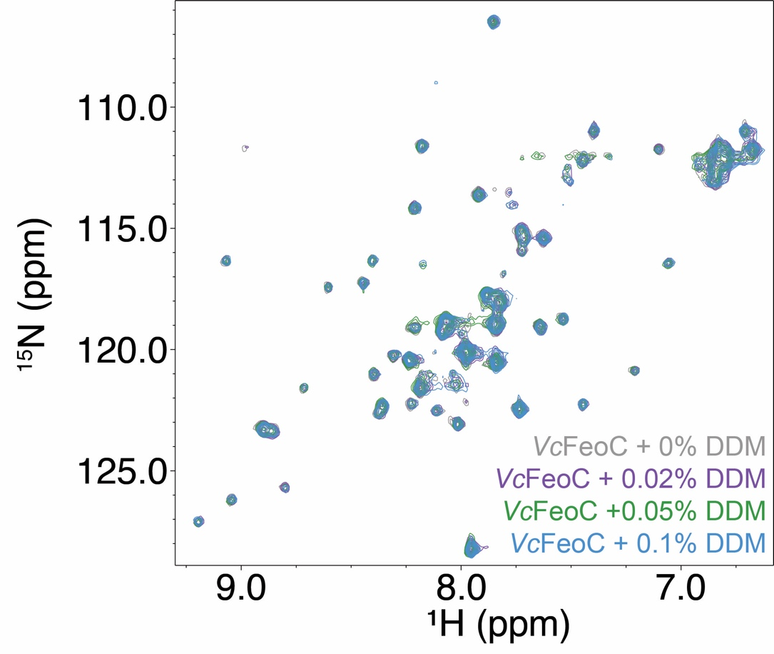
Figure S3. Overlaid ¹H-¹⁵N HSQC spectra of VcFeoC in the presence of increasing concentrations of n-dodecyl-β-D-maltoside (DDM). The spectra of VcFeoC were acquired in the absence (0%) (gray), and the presence of 0.02% (purple), 0.05% (green), 0.1% (blue) w:v DDM, respectively. These results demonstrate that VcFeoC does not interact adventitiously with DDM under the conditions employed for FeoB binding assays (50 mM Tris, pH 8.0, 100 mM sucrose, 200 mM NaCl, 1 mM TCEP, 0.05% DDM).

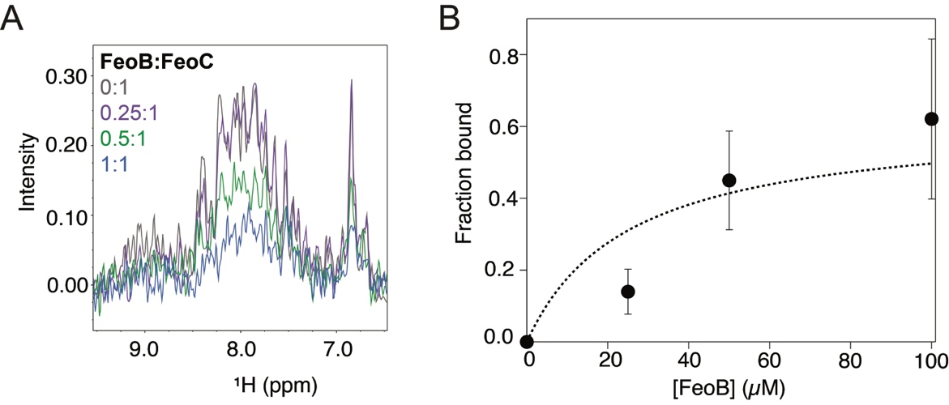
Figure S4. NMR titrations approximate the VcFeoC-VcFeoB binding affinity. A. The 1D ¹H data extracted from 2D HSQC analyses were integrated over the region in which VcFeoC amide signals are detected (6.5-9.5 ppm) at stoichiometric mole ratios (mol:mol) of FeoB to FeoC including 0:1 (gray), 0.25:1 (purple), 0.5:1 (green), and 1:1 (blue), respectively. Signal broadening and intensity loss is attributed to formation of the VcFeoC-VcFeoB complex (ca. 94 kDa) that exceeds the detection limit of NMR. B. The free-VcFeoC signal (0:1, gray) was used to calculate the mole ratio of VcFeoC bound to VcFeoB as the membrane protein was titrated into VcFeoC. The binding isotherm gives rise to a K_{d} of approximately 25 µM.

