Exploring Ozone Production Sensitivity to NO_{x} and VOCs in the New York City Airshed in the Spring and Summers of 2017-2019
Abby E. Sebol¹, Timothy P. Canty¹, Glenn M. Wolfe², Reem Hannun^{2,3}, Allison M. Ring¹, Xinrong Ren^{1,4}
¹Department of Atmospheric and Oceanic Science, University of Maryland ²Atmospheric Chemistry and Dynamics Laboratory, NASA Goddard Space Flight Center ³Department of Geology and Environmental Science, University of Pittsburgh ⁴Air Resources Laboratory, National Oceanic and Atmospheric Administration

Supplemental Material:

Table S1: All observed species reported from the whole air samples. When applicable, the corresponding MCMv3.3.1 and CB6r2 identifier are included.
Observation Name | MCMv3.3.1 Name | CB6r2 Name
Acrolein | ACR | ALDX
aPinene | APINENE | APIN
Benzene | BENZENE | BENZ
bPinene | BPINENE | TERP
x1Butene | BUT1ENE | OLE
Ethyne | C2H2 | ETHY
Ethylene | C2H4 | ETH
Ethane | C2H6 | ETHA
Propylene | C3H6 | OLE
Propane | C3H8 | PRPA
x13butadiene | C4H6 | -
Isoprene | C5H8 | ISOP
Cis2Butene | CBUT2ENE | IOLE
x11dichloroethene | CCL2CH2 | -
Dichloromethane | CH2CL2 | -
x112TCEA | CH2CLCHCL2 | -
Bromomethane | CH3BR | -
x111TCEA | CH3CCL3 | -
Chloroethane | CH3CH2CL | -
Chloromethane | CH3CL | -
CH4 | CH4 | CH4
x11DCEA | CHCL2CH3 | -
x1122Tetrachloroethane | CHCL2CHCL2 | -
Chloroform | CHCL3 | -
Cyclohexane | CHEX | PAR
x12DCPA | CL12PROP | -
CO | CO | CO
cis2Pentene | CPENT2ENE | IOLE
x12Dibromoethane | DIBRET | -
Ethylbenzene | EBENZ | BENZ
HCHO | HCHO | FORM
x1Hexene | HEX1ENE | OLE
Isobutane | IC4H10 | PAR
Isopentane | IC5H12 | PAR
Isopropylbenzene | IPBENZ | BENZ
x22Dimethylbutane | M22C4 | PAR
x23Dimethylbutane | M23C4 | PAR
x2Methylhexane | M2HEX | PAR
x2Methylpentane | M2PE | PAR
x3Methylhexane | M3HEX | PAR
x3Methylpentane | M3PE | PAR
x1Butene_Isobutene | MEPROPENE | OLE
mEthyltoluene | METHTOL | TOL
MTBE | MTBE | -
mpXylene | MXYL | XYL
nDecane | NC10H22 | PAR
nUndecane | NC11H24 | PAR
nDodecane | NC12H26 | PAR
nButane | NC4H10 | PAR
nPentane | NC5H12 | PAR
nHexane | NC6H14 | PAR
nHeptane | NC7H16 | PAR
nOctane | NC8H18 | PAR
nNonane | NC9H20 | PAR
NO | NO | NO
NO2 | NO2 | NO2
O3 | O3 | O3
oEthyltoluene | OETHTOL | TOL
oXylene | OXYL | XYL
nPropylbenzene | PBENZ | BENZ
x1Pentene | PENT1ENE | OLE
pEthyltoluene | PETHTOL | TOL
SO2 | SO2 | SO2
Styrene | STYRENE | -
trans2Butene | TBUT2ENE | IOLE
PERC | TCE | -
t12DCEE | TDICLETH | -
x123Trimethylbenzene | TM123B | BENZ
x124trimethylbenzene | TM124B | BENZ
x135trimethylbenzene | TM135B | BENZ
Toluene | TOLUENE | TOL
trans2Pentene | TPENT2ENE | IOLE
TCE | TRICLETH | -
VinylChloride | VINCL | -
BenzylChloride | - | -
CarbonTetrachloride | - | -
CHBrCl2 | - | -
Chlorobenzene | - | -
cis13DCPE | - | -
Cyclopentane | - | -
Dichlorodifluoromethane | - | -
Ethane_12dichloro1122tetrafluoro | - | -
HCBD | - | -
IsocyanatoMethane | - | -
mDCB | - | -
mDiethylbenzene | - | -
Methylcyclohexane | - | -
Methylcyclopentane | - | -
mpXylenes | - | -
Naphthalene | - | -
oDCB | - | -
pDCB | - | -
pdiethylbenzene | - | -
trans13DCPE | - | -
Trichlorofluoromethane | - | -
x112122Trichlorotrifluoroethane | - | -
x124TCB | - | -
x13Diethylbenzene | - | -
x14Diethylbenzene | - | -
x224TrimethylHexane | - | -
x224Trimethylpentane | - | -
x22Dimethylpentane | - | -
x233TrimethylPentane | - | -
x234Trimethylpentane | - | -
x23Dimethylpentane | - | -
x24Dimethylpentane | - | -
x25Dimethylhexane | - | -
x2Methylheptane | - | -
x3Ethyl1Octene | - | -
x3EthylHexane | - | -
x3Methylheptane | - | -
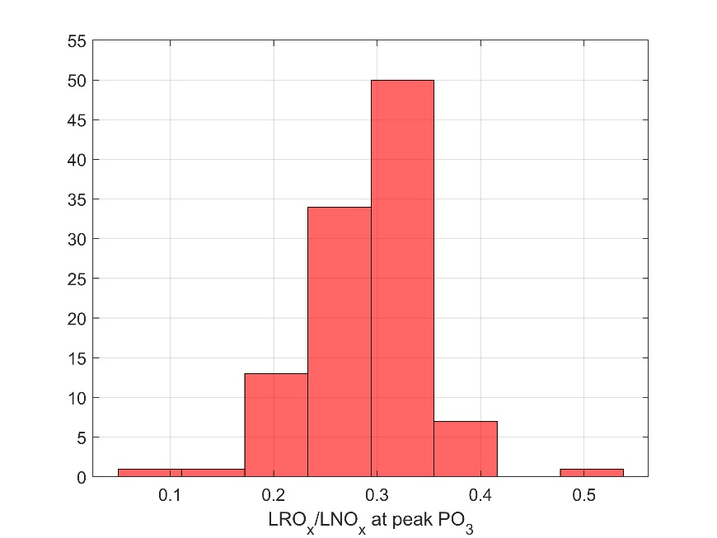

Figure S1: Histogram of the LRO_{x}/LNO_{x} value calculated at the peak of each individual PO₃ curve (Fig. 2). These values range from 0.09 to 0.54 and have an average value of 0.30.
On average, the value of LRO_{x}/LNO_{x} at the peak of the PO₃ curves is 0.30. This represents the threshold where ozone production becomes VOC-limited. The variation of this value is likely due to different VOC compositions. Schroeder et al., 2017 provides a range of 0.25-0.35 which encompasses 80% of these data.

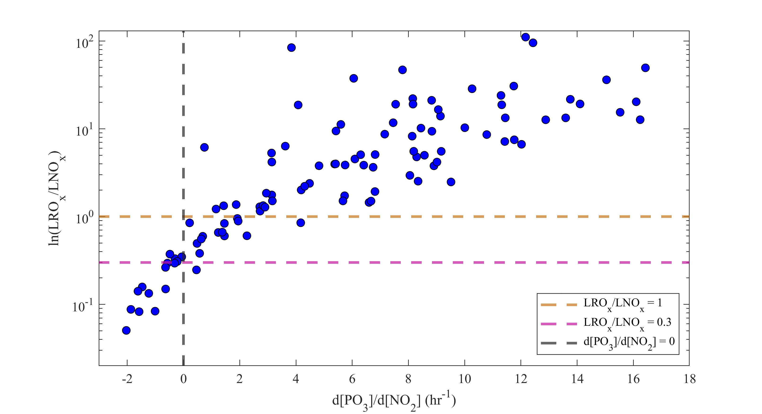
Figure S2: The logarithmic relationship between d[PO₃]/d[NO₂] and LRO_{x}/LNO_{x} at observed NO₂. Dashed reference lines are included for d[PO₃]/d[NO₂] = 0 (black), LRO_{x}/LNO_{x} = 1 (yellow) and LRO_{x}/LNO_{x} = 0.30 (pink).
As stated in section 3.1.1, LRO_{x}/LNO_{x} and slope are used to define a shift between a NO_{x}-limited and VOC-limited regime. Based on these data, LRO_{x}/LNO_{x} is equal to 0.30 where the slope is equal to zero. We define the transition region to be 0.3 <= LRO_{x}/LNO_{x} <= 1 where 1 is the point at which the radicals are removed at the same speed through self- radical reactions as through NO_{x} reactions. Values below 0.30 indicate a VOC-limited regime, while samples above 1 indicate a NOx-limited regime.

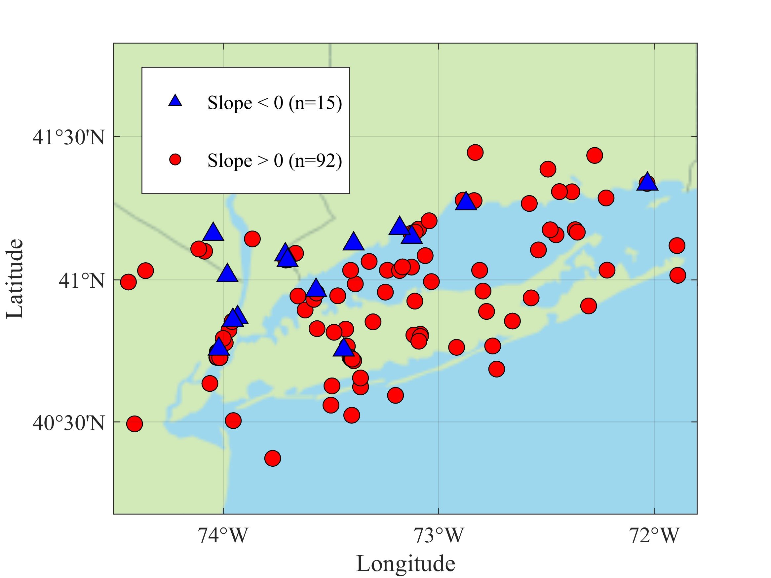
Figure S3: Map of ozone production regime for each sample as classified by slope at the point of observed NO₂. Blue triangles represent a VOC-limited regime and red circles a NO_{x} limited regime.
The spatial variability of PO₃ regime based on slope is similar to LRO_{x}/LNO_{x}. Most samples (86%) are in a NOx-limited regime. However, along the Hudson River and CT coastline (I-95 corridor), we find several samples with a VOC-limited regime. Samples taken further away from NYC and Long Island tend to be closer to the peak PO₃ and, while still having a positive slope, are close to the turning point into a VOC-limited regime given small increases in NO₂.

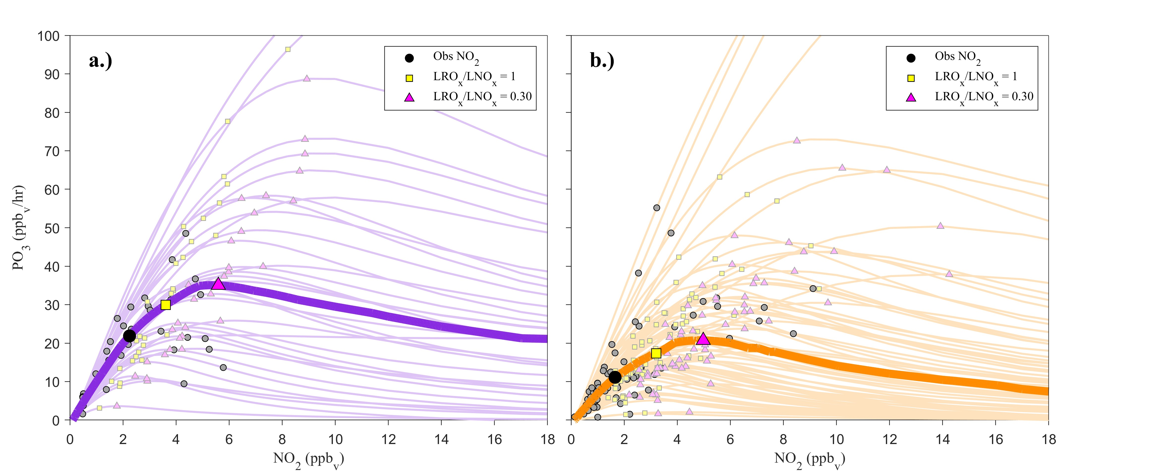
Figure S4: Same as Figure 5 but separated by (a) AM and (b) PM samples.
A diurnal pattern of PO₃ is discussed in section 3.1.3. There is greater control PO₃ in the morning compared to the afternoon (22 ppb/hr and 10 ppb/hr, respectively) as well as peak PO₃ (35 ppb/hr and 20 ppb/hr, respectively).

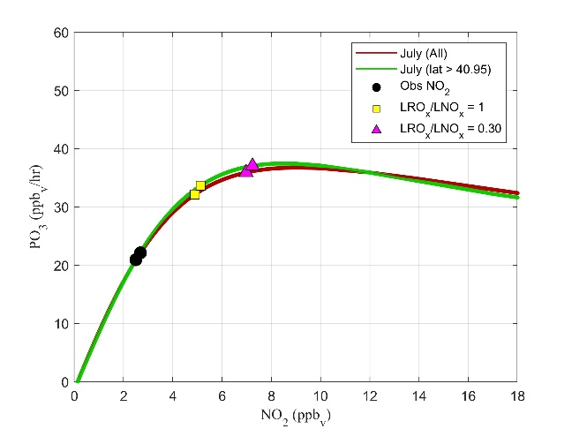
Figure S5: Mean PO₃ curves comparing all July samples (red, n=57) and all July samples north of latitude 40.95 (green, n=25). Both lines include the observed NO₂ (black/gray circle), LRO_{x}/LNO_{x} = 1 (yellow square), and LRO_{x}/LNO_{x} = 0.30 (pink triangle).
Text S1:
We recognize a potential sampling bias where May observations were predominantly taken in the Long Island Sound and near the CT coast, while July and August samples were more concentrated over Long Island and NYC (Fig.1). These research flight paths in May were motivated by a forecasted ozone exceedance in the CT and Long Island Sound area (Ring et al., 2023). To investigate whether analysis of seasonal differences in section 3.1.3 is impacted by such bias, we look at subsets of July samples as these were taken across the entire domain (Fig. 1). Fig. S5 shows two mean PO₃ curves, one with all July samples (red) and one excluding 32 July samples taken at latitudes less than 40.95. This threshold was chosen because it roughly marks the point where no May samples are taken in the given domain. These two average curves are very similar with near equal peak PO₃. There is a slightly greater mean observed NO₂ when considering all samples (2.7 ppb) to just the northern subset (2.5 ppb). This subset does not include samples taken in NYC, which has higher NO₂. The increase in observed NO₂ leads to greater PO₃ for all samples (1.2 ppb/hr increase). This suggests that should there have been samples taken in NYC during the month of May, those data points would not impact the seasonal comparison.
The similarity in the average isopleths suggests the subset of data north of latitude 40.95 is representative of the entire domain when looking at the monthly averages. The sampling bias in the May observations is unlikely to be impacting the results discussed in section 3.1.3.

Text S2: PO₃ sensitivity to formaldehyde
Formaldehyde is a reactive oxygenated volatile organic compound (oVOC) that makes up the largest portion of modeled OH reactivity (18% in MCM) after CO (Fig. 9). It is a major source of HO₂ through reactions with OH and photolysis.
Simultaneous HCHO observations are available for 41 of 107 samples. For consistency, model runs discussed in the main text were not constrained to HCHO. 0-D box models do not always accurately model HCHO (Zhang et al., 2021; Souri et al., 2023), as steady state assumptions may not be valid near emission sources or when highly reactive alkenes dominate VOC reactivity (Fried et al., 2011). However this issue does not significantly impact overall modeled radical chemistry (Olson et al., 2004; Schroeder et al., 2020). The model also does not include additional primary emissions of HCHO. It has been estimated that ~90% HCHO in NYC is formed from secondary production in the summer (Lin et al., 2012).
For those 41 available measurements, we test the model’s ability to calculate HCHO. All observations of HCHO are between 2 and 10 ppb, while model-generated HCHO ranges from 1 to 23 ppb. Fig. S6 shows the absolute bias in HCHO (the difference between the modeled HCHO and the observed HCHO) versus the total modeled OH reactivity (not including reactivity due to HCHO) calculated in the unconstrained run. The model tends to overestimate HCHO when OH reactivity is high and underestimate HCHO when OH reactivity is low (<7 s⁻¹). Fig. S7 shows overall little impact on the concentrations of OH, HO₂, HO₂/OH, or PO₃, compared to model runs with HCHO constrained to observations. The agreement of PO₃ is poorest at greater values of PO₃, where steady state assumptions are likely less valid due to high NO_{x} from strong local emissions. The slope of [HO₂] (Fig. S7c) indicates that the inclusion of HCHO as a constraint will increase the calculated HO₂ at relatively lower values and decrease HO₂ concentrations at relatively greater values as determined by the unconstrained runs.
If model calculations of HCHO are not in good agreement with the observations, then it is possible that other oVOC are also not being simulated accurately. More observations of species such as HCHO and acetaldehyde would provide a starting point for assessing model performance regarding oVOC predictions and their cumulative impacts on PO₃. We further note that these issues may be less severe in full 3-D chemical transport models that explicitly simulate emissions and transport.
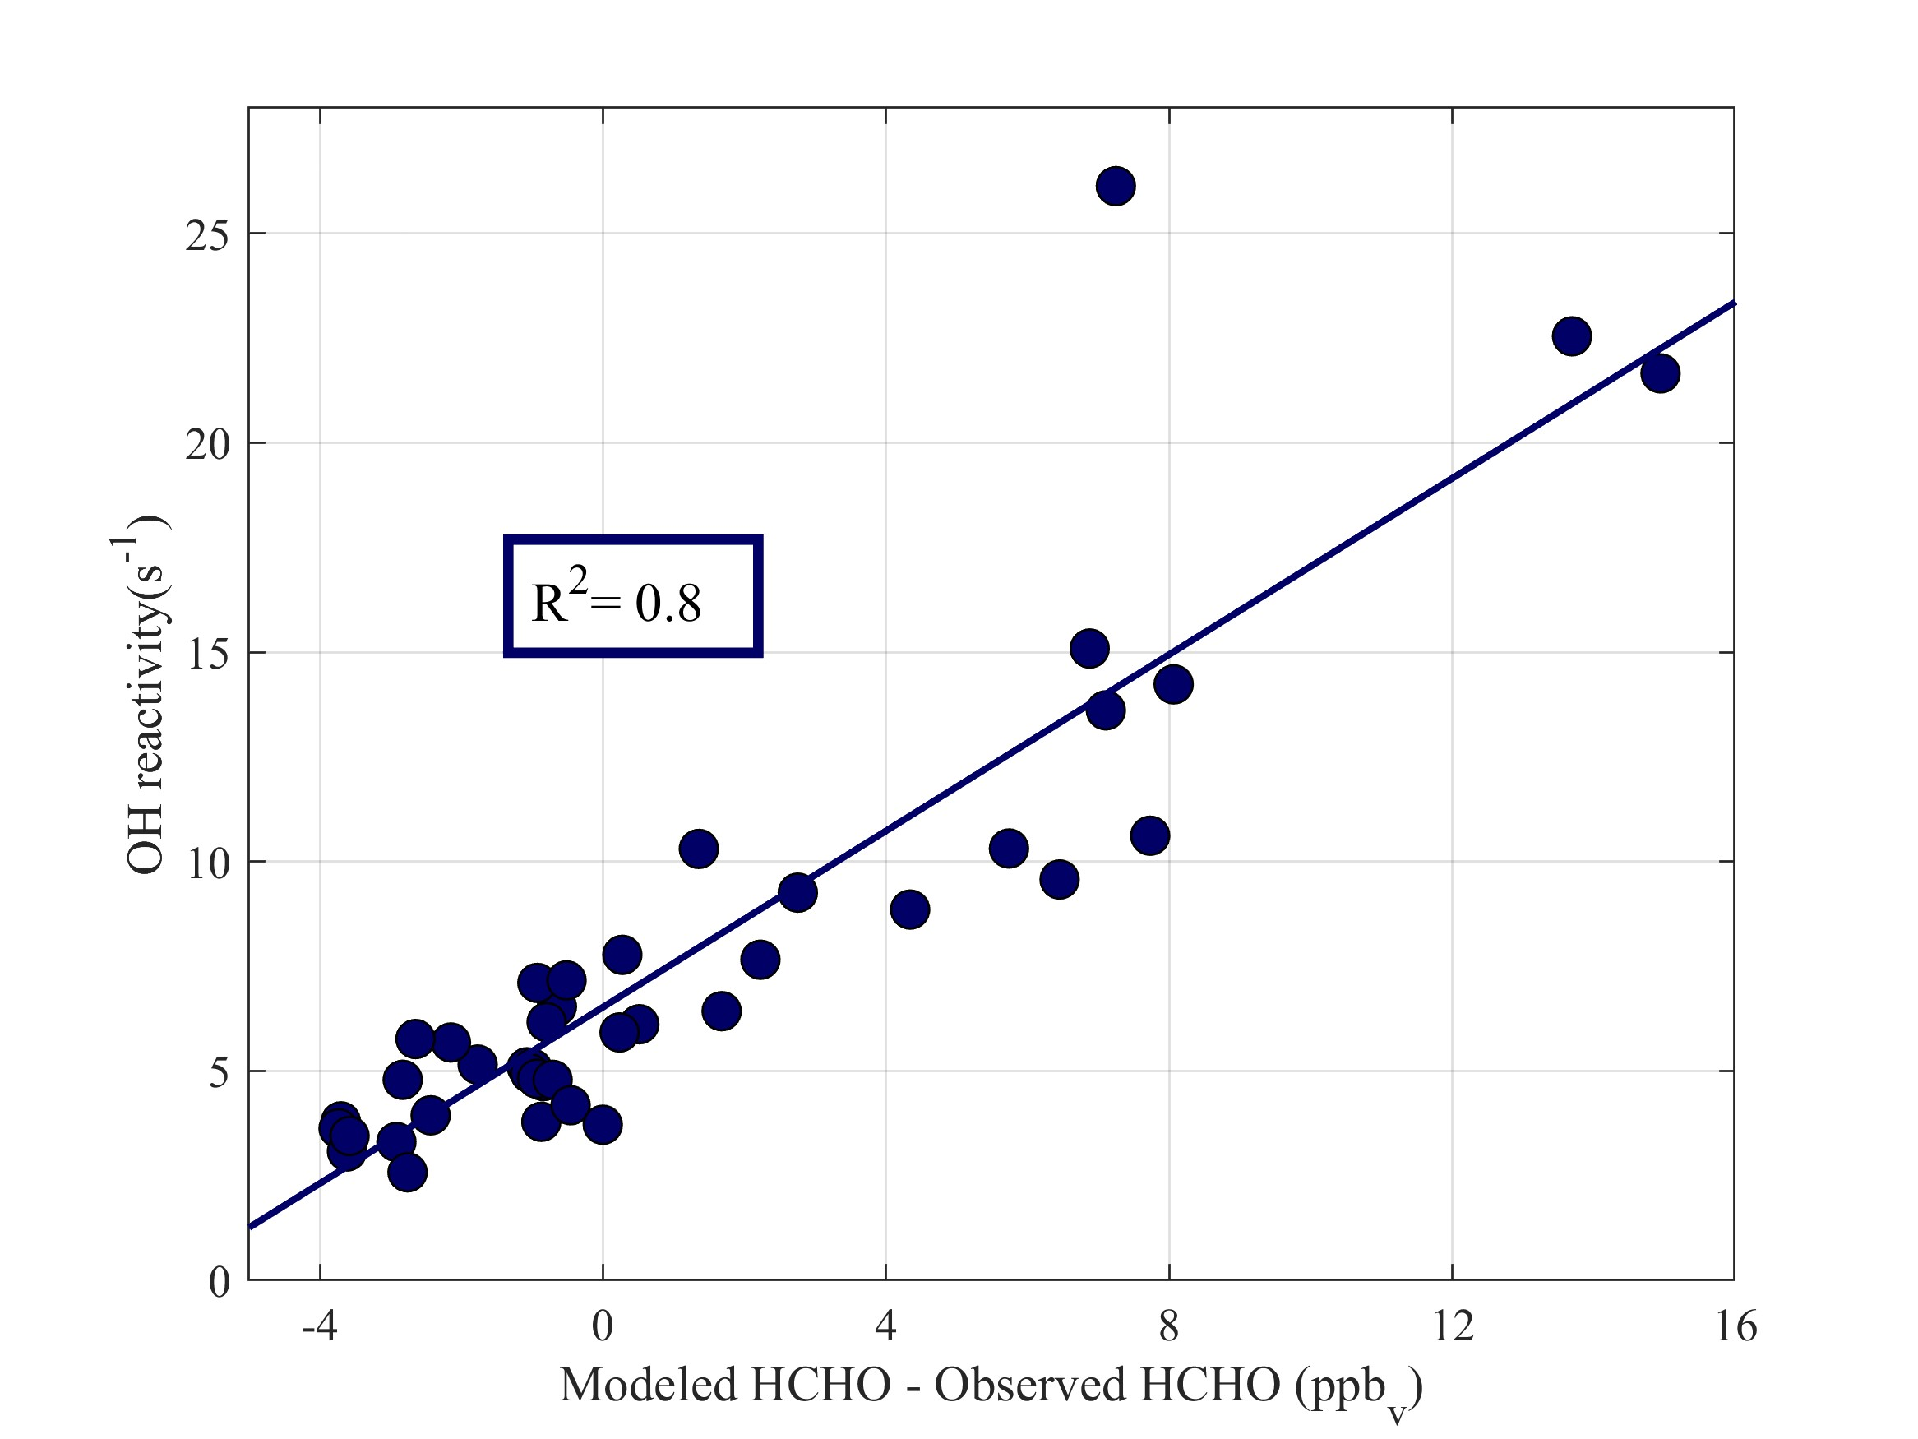
Figure S6: A comparison of the modeled minus observed HCHO with the total OH reactivity (excluding HCHO). All HCHO observations are between 2 and 10 ppb.
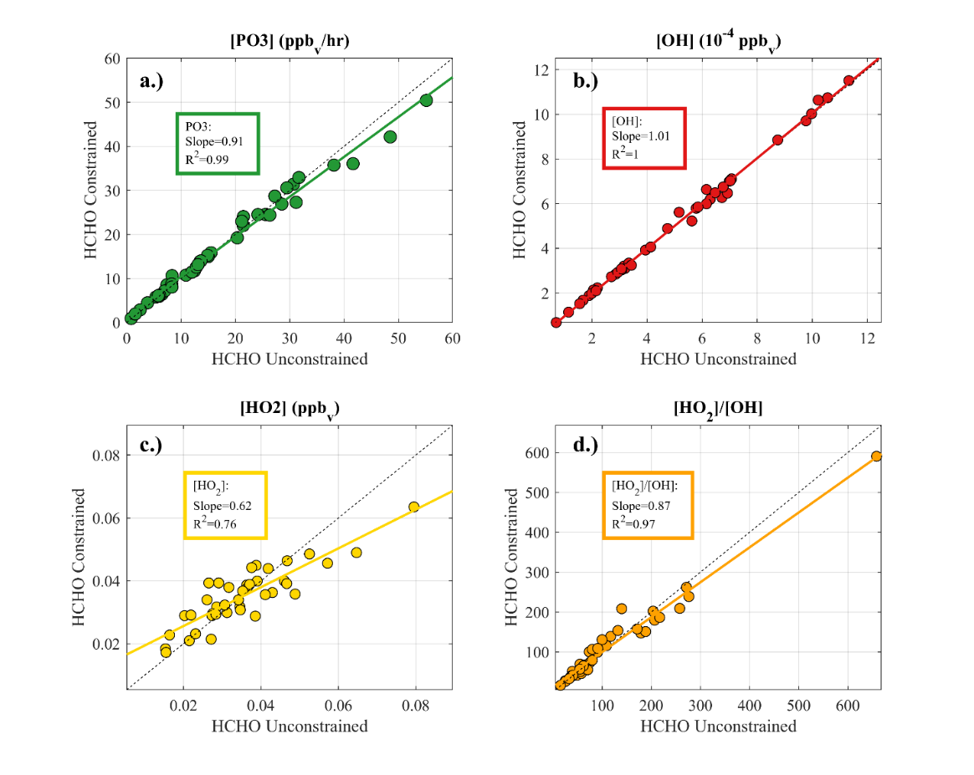
Figure S7: A comparison of (a) PO_{3,} (b) [OH], (c) [HO₂], and (d) [HO₂]/[OH] when HCHO is unconstrained in the box model to when HCHO is constrained. Lines of best fit are included in all panels. Dashed black lines are 1:1 reference lines.

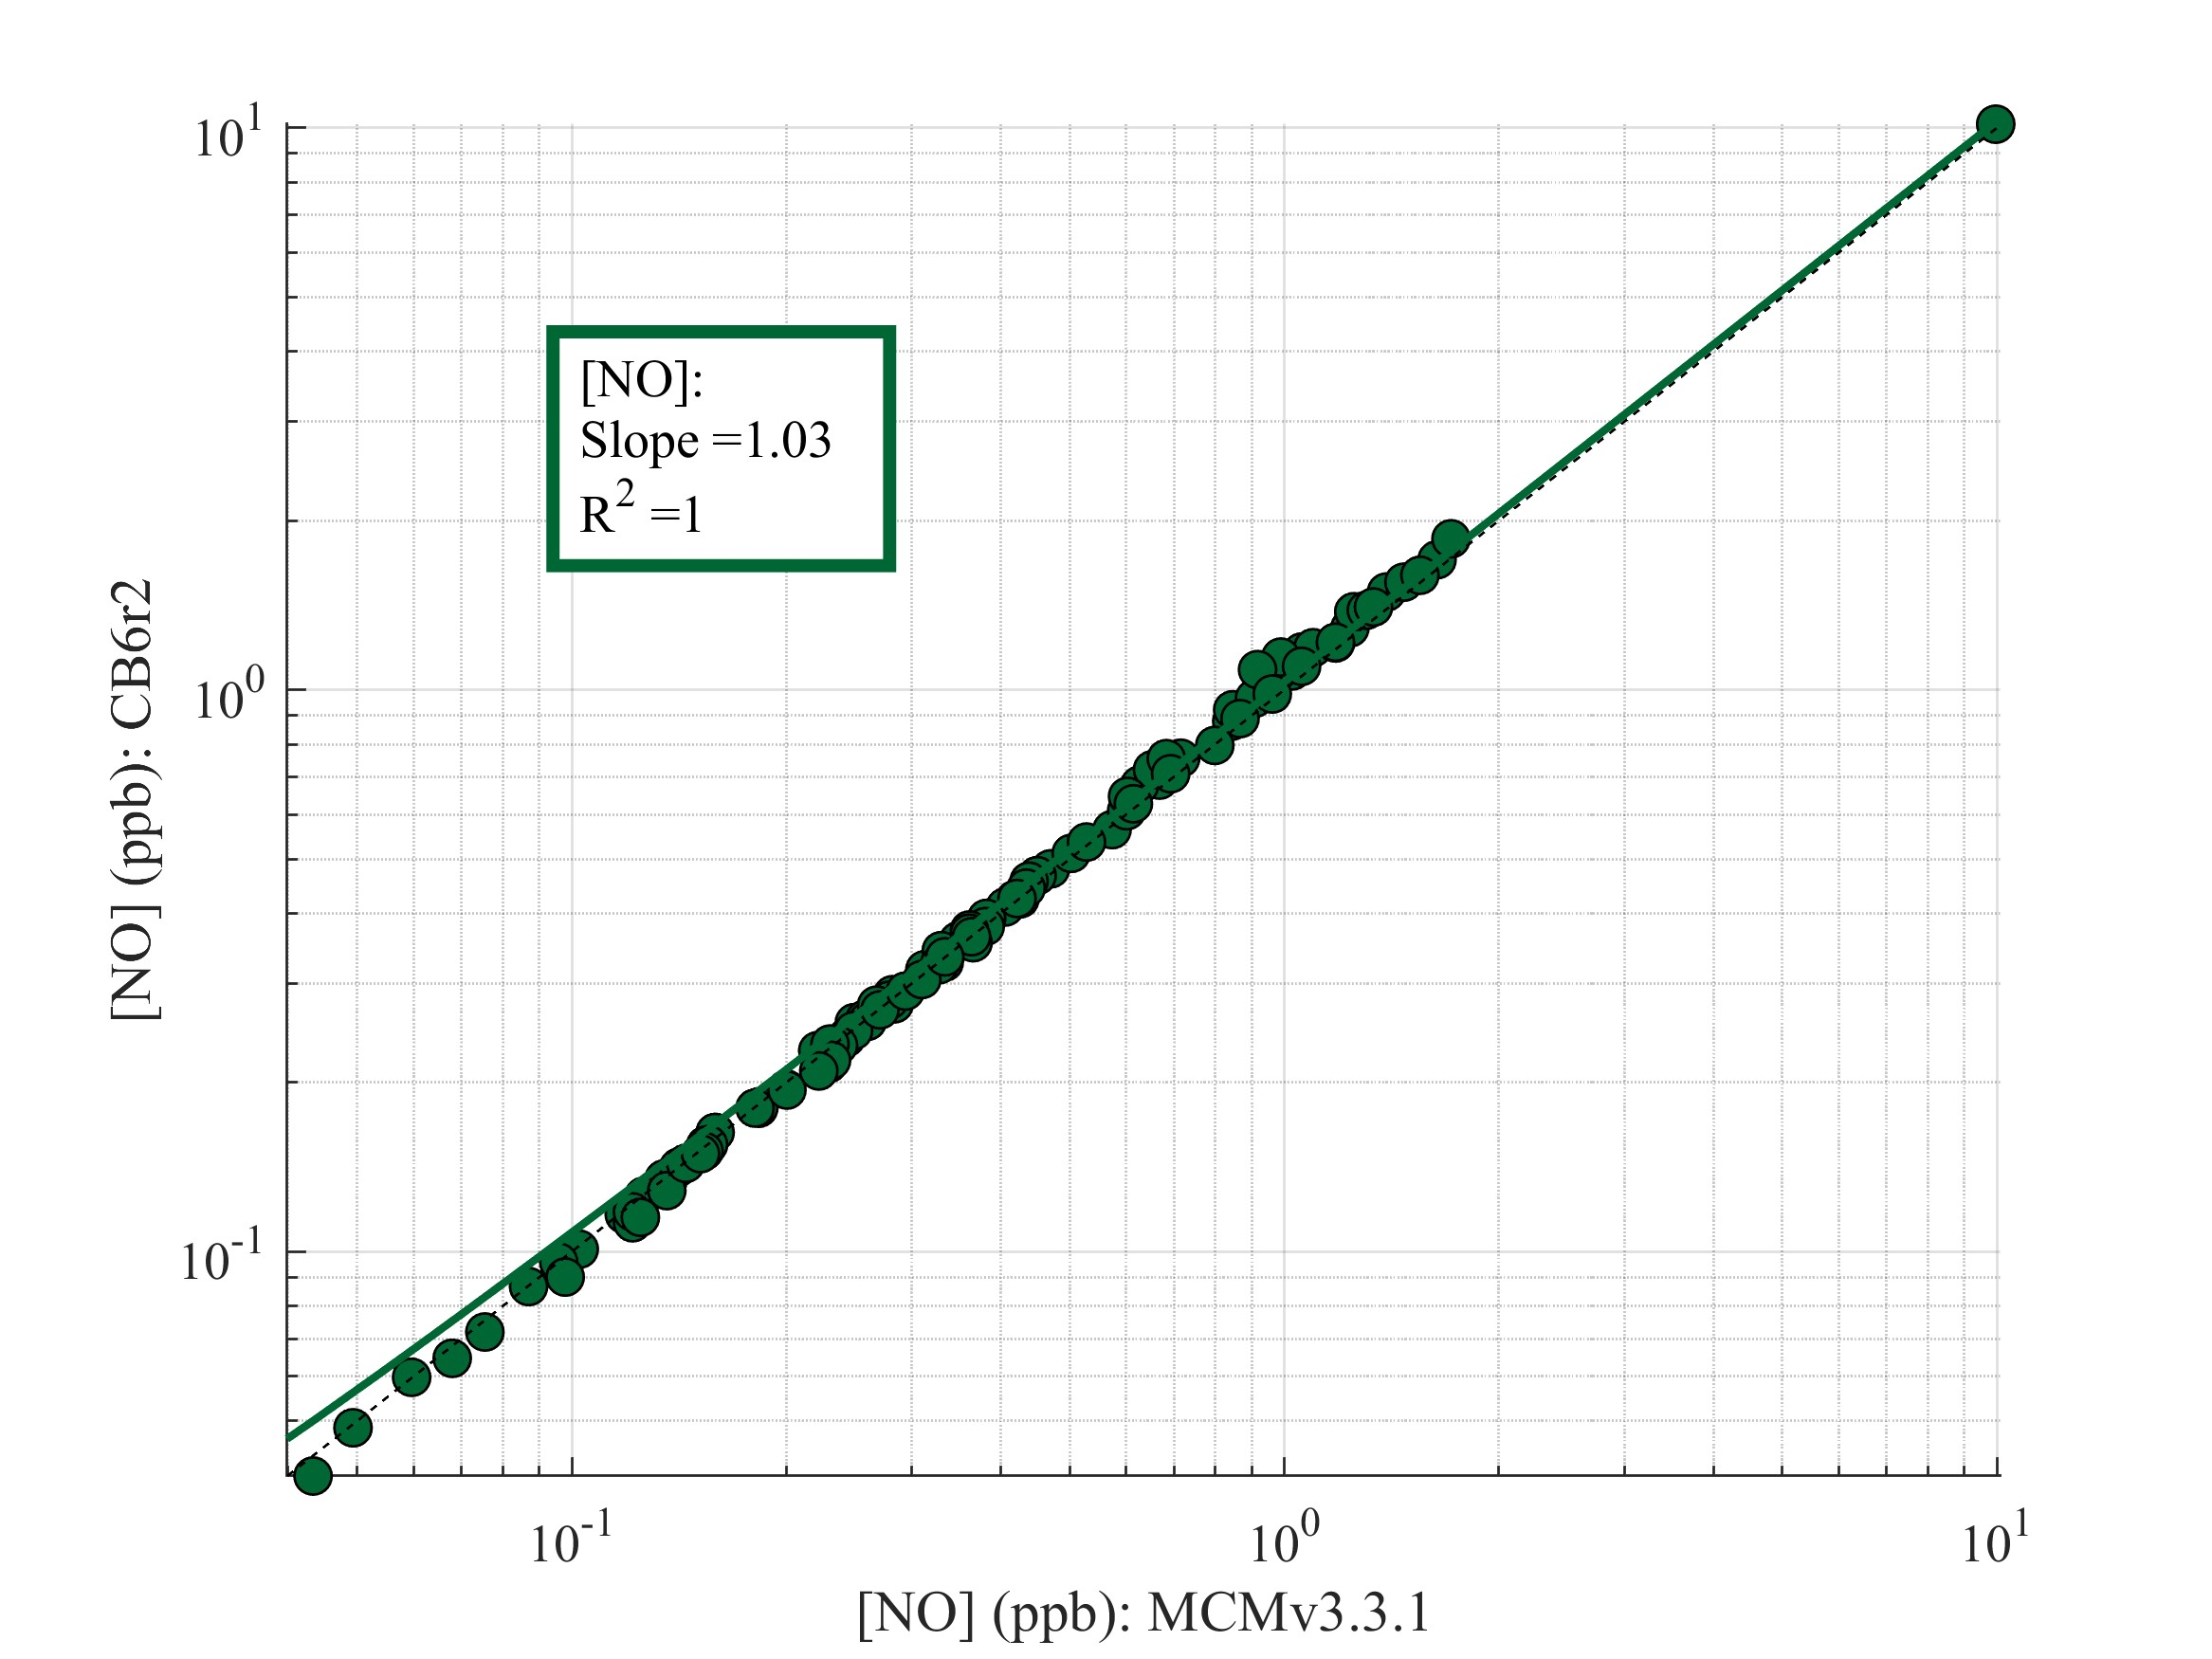
Figure S8: A comparison of MCMv3.3.1 to CB6r2 for the final mixing ratio of NO. Line of best fit (green) and 1:1 line (dashed black) are included.
There is good agreement in the final NO mixing ratio between MCM and CB6r2. The differences in Fig. 6b are not due to [NO], but rather disagreement in [HO₂], total [RO₂], and rate coefficients as discussed in section 3.1 in the main text.

Supplemental References
Fried, A., C. Cantrell, J. Olson, and Coauthors, 2011: Detailed comparisons of airborne formaldehyde measurements with box models during the 2006 INTEX-B and MILAGRO campaigns: potential evidence for significant impacts of unmeasured and multi-generation volatile organic carbon compounds. Atmos. Chem. Phys., 11, 11867-11894.
Lin, Y. C., J. J. Schwab, K. L. Demerjian, M. S. Bae, W. N. Chen, Y. Sun, Q. Zhang, H. M. Hung, and J. Perry, 2012: Summertime formaldehyde observations in New York City: Ambient levels, sources and its contribution to HOx radicals. J. Geophys. Res.-Atmos., 117.
Olson, J. R., J. H. Crawford, G. Chen, and Coauthors, 2004: Testing fast photochemical theory during TRACE-P based on measurements of OH, HO2, and CH2O. J. Geophys. Res.-Atmos., 109.
Ring, A. M., R. R. Dickerson, A. E. Sebol, X. Ren, S. E. Benish, R. J. Salawitch, A. Galasyn, and P. J. Miller, 2023: Anthropogenic VOCs in the Long Island Sound, NY Airshed and their role in ozone production. Atmospheric Environment, 296, 119583.
Schroeder, J. R., J. H. Crawford, A. Fried, and Coauthors, 2017: New insights into the column CH2O/NO2 ratio as an indicator of near-surface ozone sensitivity. J. Geophys. Res.-Atmos., 122, 8885-8907.
Schroeder, J. R., J. H. Crawford, J. Y. Ahn, and Coauthors, 2020: Observation-based modeling of ozone chemistry in the Seoul metropolitan area during the Korea-United States Air Quality Study (KORUS-AQ). Elementa-Science of the Anthropocene, 8.
Souri, A. H., M. S. Johnson, G. M. Wolfe, and Coauthors, 2023: Characterization of errors in satellite-based HCHO/NO2 tropospheric column ratios with respect to chemistry, column-to-PBL translation, spatialrepresentation, and retrieval uncertainties. Atmos. Chem. Phys., 23, 1963-1986.
Zhang, K., Y. S. Duan, J. T. Huo, L. Huang, Y. J. Wang, Q. Y. Fu, Y. H. Wang, and L. Li, 2021: Formation mechanism of HCHO pollution in the suburban Yangtze River Delta region, China: A box model study and policy implementations. Atmospheric Environment, 267.

