Supplementary Materials
S1. Legend of Study Variables for Extraction
Variable Name | Description | Coding
General

Author | First author
Year | Year of publication
Type | Type of publication | - Journal article  - Book chapter  - Thesis or dissertation  - Conference paper/presentation  - Other
Clinical measures and design

Diagnostic criteria | Name of the diagnostic criteria used for each group (e.g., DSM)
Depressive symptom measure | Name of self-report depressive symptom measure
Sample size in rMDD group | Number of participants included in effect size calculation/analyses
Sample size in CTL group | Number of participants included in effect size calculation/analyses
Sample type | What type of population does the sample comprise of? | - Students only  - Community only  - Mixed  - Unclear
Demographic characteristics of the rMDD group

rMDD group age | Mean age
rMDD group % female | Percent female participants
CTL group age | Mean age
CTL group % female | Percent female participants
Clinical features of the rMDD group

Depressive symptoms | Average depressive symptom level
Depressive episodes | Number of previous depressive episodes
Last MDE | Time in weeks since the last MDE
Comorbid anxiety disorder | % Comorbid anxiety disorder e.g., generalized, social, phobia, panic
Comorbid OCD | % Comorbid obsessive-compulsive disorder
Comorbid PTSD | % Comorbid trauma or stressor-related disorders
Antidepressant medication | % Currently receiving antidepressant treatment
Inclusion and exclusion criteria for the rMDD group

Inclusion – symptom level | Participants scoring below a certain depressive symptom level were included | 1. Yes  2. No
Symptom level cut score | Enter the depressive symptom measure and cutoff score used (e.g., BDI < 10)
Episode related criteria | Describe criteria related to the number of episodes and the time since the last episode
Exclusion – psychiatric disorder in self | Other psychiatric disorder diagnosis was used as an exclusion criterion | 1. Yes  2. No
Psychiatric disorders excluded in self | Enter the psychiatric disorders used as exclusion criteria
Exclusion – psychiatric disorder in relative | First-degree relative’s history of psychiatric disorders was used as an exclusion criterion | 1. Yes  2. No
Psychiatric disorders excluded in relative | Enter the psychiatric disorders used as exclusion criteria
Other criteria | Describe any other inclusion or exclusion criteria that were used
Clinical features and inclusion and exclusion criteria of the CTL Group

Depressive symptoms | Average depressive symptom level
Inclusion – symptom level | Participants scoring below a certain depressive symptom level were included | 1. Yes  2. No
Symptom level cut score | Enter the depressive symptom measure and cutoff score used (e.g., BDI < 10)
Exclusion – psychiatric disorder in self | Psychiatric disorder history was used as an exclusion criterion | 1. All psychological disorders  2. Only MDD history
Exclusion – psychiatric disorder in relative | First-degree relative’s history of psychiatric disorders was used as an exclusion criterion | 1. Yes  2. No
Psychiatric disorders excluded in relative | Enter the psychiatric disorders used as exclusion criteria
Other criteria | Describe any other inclusion or exclusion criteria that were used
Experimental design and task

Executive control domain | Primary domain of executive control examined. If multiple domains are examined by the task, code in separate rows. | - Inhibition  - Shifting  - Updating  - Broad executive control
Task | Name of experimental task used
Stimulus | Stimulus used in experimental task | 1. Words  2. Pictures (non-faces)  3. Faces  4. Two or more of the above
Positive stimuli | Enter the exact type of valence used, if applicable (e.g., happy)
Negative stimuli | Enter the exact type of valence used, if applicable (e.g., sad)
Neutral stimuli | Neutral stimuli were included in the experimental task | 1. Yes  2. No
Induction procedure | Induction procedures were completed prior to the executive control task | 1. Yes  2. No
Induction procedure type | Name of induction procedure utilized
Study quality (sum of items) | Items on inclusion criteria, subject and setting, measure of construct, measure of condition, identification of confounds, addressing confounds, statistical analysis, plus assessment of reliability of diagnosis and sample size rationale | 0. No  1. Yes  (per item)
Outcome variables

Outcome – RT | Reaction time was computed as an outcome variable of the experimental task | 1. Yes  2. No
RT type | Type of RT used | 1. Mean  2. Median
RT outlier removal | Were RT filters used to exclude outliers? | 1. Yes  2. No
RT outlier description | Describe RT outlier removal criteria and method (e.g., excluded RTs < 300 ms, winsorized RTs > 2 SDs)
Accuracy of RTs | Were RTs from only accurate trials used in the analyses? | 1. Yes  2. No
Outcome – accuracy | Accuracy or error rate was computed as an outcome variable of the experimental task | 1. Yes  2. No
Accuracy index | Index of accuracy provided in the study | 1. # of accurate responses  2. # of erroneous responses  3. Accuracy rate  4. Error rate
Accuracy type | Type of accuracy or error index | 1. Overall  2. Commission error  3. Omission error  4. Perseverative error
Accuracy outlier removal | Were accuracy filters used to exclude outliers? | 1. Yes  2. No
Accuracy outlier description | Describe accuracy outlier removal criteria and method (e.g., excluded cases with < 75% accuracy)
Effect sizes for the rMDD group [code RTs and error rates in separate tabs]

Correlation neg pos | Correlation coefficient between positive vs. negative trials
Correlation neg neut | Correlation coefficient between negative vs. neutral trials
Correlation pos neut | Correlation coefficient between positive vs. neutral trials
Spread measure | Measure of spread used | 1. Standard deviation  2. Standard error
Mean pos | Mean for positive stimuli
Spread pos | Spread for positive stimuli
Mean neg | Mean for negative stimuli
Spread neg | Spread for negative stimuli
Mean neut | Mean for neutral stimuli
Spread neut | Spread for neutral stimuli
Difference neg - pos | Difference score for negative – positive stimuli
Spread neg - pos | Spread for the negative – positive difference score
Difference pos - neut | Difference score for positive – neutral stimuli
Spread pos - neut | Spread for the positive – neutral difference score
Difference neg - neut | Difference score for negative – neutral stimuli
Spread neg - neut | Spread for the negative – neutral difference score
Effect sizes for the CTL group [code RTs and error rates in separate tabs]

Correlation neg pos | Correlation coefficient between positive vs. negative trials
Correlation neg neut | Correlation coefficient between negative vs. neutral trials
Correlation pos neut | Correlation coefficient between positive vs. neutral trials
Mean pos | Mean for positive stimuli
Spread pos | Spread for positive stimuli
Mean neg | Mean for negative stimuli
Spread neg | Spread for negative stimuli
Mean neut | Mean for neutral stimuli
Spread neut | Spread for neutral stimuli
Difference neg - pos | Difference score for negative – positive stimuli
Spread neg - pos | Spread for the negative – positive difference score
Difference pos - neut | Difference score for positive – neutral stimuli
Spread pos - neut | Spread for the positive – neutral difference score
Difference neg - neut | Difference score for negative – neutral stimuli
Spread neg - neut | Spread for the negative – neutral difference score
Analyses and statistics [code RTs and error rates in separate tabs]

If means and SDs were not reported, what analyses were conducted to compare the two groups?
- Independent t-test -> t statistic
- One-way ANOVA -> F statistic
- Factorial design (repeated measures ANOVA, MANOVA, etc.) -> mean difference and SE in pairwise comparisons
- Other -> describe
Analysis: neg vs. pos in rMDD | Enter the value corresponding to the type of analysis above
Analysis: pos vs. neut in rMDD | Enter the value corresponding to the type of analysis above
Analysis: neg vs. neut in rMDD | Enter the value corresponding to the type of analysis above
Value: neg vs. pos in rMDD | Enter test statistic value
Value: pos vs. neut in rMDD | Enter test statistic value
Value: neg vs. neut in rMDD | Enter test statistic value
Analysis: neg vs. pos in CTL | Enter the value corresponding to the type of analysis above
Analysis: pos vs. neut in CTL | Enter the value corresponding to the type of analysis above
Analysis: neg vs. neut in CTL | Enter the value corresponding to the type of analysis above
Value: neg vs. pos in CTL | Enter test statistic value
Value: pos vs. neut in CTL | Enter test statistic value
Value: neg vs. neut in CTL | Enter test statistic value
Analysis: rMDD vs. CTL for negative | Enter the value corresponding to the type of analysis above
Analysis: rMDD vs. CTL for positive | Enter the value corresponding to the type of analysis above
Analysis: rMDD vs. CTL for neutral | Enter the value corresponding to the type of analysis above
Value: rMDD vs. CTL for negative | Enter test statistic value
Value: rMDD vs. CTL for positive | Enter test statistic value
Value: rMDD vs. CTL for neutral | Enter test statistic value
Note. Missing variables are to be entered as -999.

S2. Non-Significant Moderation Effects
Clinical Features
Twenty-eight studies reported the levels of depressive symptoms using the BDI, and the mean BDI scores for the rMDD group were used in the meta-regressions. The level of depressive symptoms did not moderate the between-group difference in the negative RTs, B = .018, SE = .028, p = .525, 95% CI [-.043, .079], positive RTs, B = .010, SE = .022, p = .652, 95% CI [-.037, .057], neutral RTs, B = .0012, SE = .036, p = .973, 95% CI [-.080, .083], or the negative-positive RT difference score, B = -.039, SE = .036, p = .274, 95% CI [-.12, .037].
Twenty-three studies reported the number of MDEs, and 11 studies reported the time since the last MDE. The number of MDEs did not moderate the between-group differences in negative RTs, B = .026, SE = .056, p = .641, 95% CI [-.094, .15], positive RTs, B = .058, SE = .057, p = .309, 95% CI [-.063, .18], neutral RTs, B = -.086, SE = .12, p = .452, 95% CI [-.34, .17], or the negative-positive RT difference score, B = -.025, SE = .056, p = .631, 95% CI [-.15, .092]. The time since the last MDE did not moderate the between-group differences in negative RTs, B = .0013, SE = .0044, p = .776, 95% CI [-.0089, .011], positive RTs, B = .00079, SE = .0034, p = .815, 95% CI [-.0070, .0085], neutral RTs, B = -.0070, SE = .0044, p = .110, 95% CI [-.019, .0052], or the negative-positive RT difference score, B = .000099, SE = .0035, p = .978, 95% CI [-.0080, .0082].
Thirty studies provided information on current antidepressant use in the rMDD group. The percentage of rMDD participants with antidepressant use did not moderate the relation between group status and the negative RTs, B = .00086, SE = .0023, p = .713, 95% CI [-.0040, .0057], positive RTs, B = .00062, SE = .0023, p = .787, 95% CI [-.0042, .0054], neutral RTs, B = .0013, SE = .0026, p = .628, 95% CI [-.0043, .0068], or the negative-positive RT difference score, B = .0002, SE = .0020, p = .920, 95% CI [-.0043, .0039]. Eleven studies provided information on comorbid anxiety, obsessive-compulsive, and trauma and stressor-related disorders. None of the analyses examining the effects of comorbid conditions yielded significant findings, all ps >.40.
Participant Characteristics
Thirty-three studies provided information on age. The mean age of the overall sample did not moderate the relation between group status and the negative RTs, B = .0053, SE = .0073, p = .470, 95% CI [-.0097, .020], positive RTs, B = .0042, SE = .0060, p = .480, 95% CI [-.0080, .017], neutral RTs, B = -.0051, SE = .0073, p = .487, 95% CI [-.021, .010], or the negative-positive RT difference score, B = -.00077, SE = .0050, p = .878, 95% CI [-.0095, .011]. Thirty-five studies provided information on the percentage of female participants, which also did not moderate the significant group differences in negative RTs, B = .0036, SE = .0045, p = .424, 95% CI [-.0057, .013], positive RTs, B = .0067, SE = .0037, p = .074, 95% CI [-.0010, .014], neutral RTs, B = -.0045, SE = .0047, p = .338, 95% CI [-.014, .0054], or the negative-positive RT difference score B = -.0035, SE = .0035, p = .307, 95% CI [-.011, .0036].
Study Design
Experimental task did not moderate the between-group differences for neutral RTs, F (1,11) = .028, p = .879, or the negative-positive RT difference score, F (3,18) = 1.38, p = .709. Subgroup analysis for stimulus type (face vs. word) indicated that the type of stimulus utilized did not moderate the between-group difference for positive RTs, F (1,24) = 3.52, p = .061, or the difference in the negative-positive RT difference score, F (1,24) = .59, p = .443.
The moderating effect of induction procedure was also examined. For studies that utilized a repeated measures design, data from the stress condition were included. The inclusion of an induction procedure did not moderate the significant group differences in negative RTs, F (1,24) = .28, p = .597, positive RTs, F (1,24) = .78, p = .377, neutral RTs, F (1,14) = .28, p = .595, or the negative-positive RT difference score, F (1,24) = .016, p = .899.
Lastly, sample size, publication year, and study quality were reported for all studies and were examined as moderators. Sample size did not moderate the significant group differences in positive RTs, B = .000076, SE = .00056, p = .892, 95% CI [-.0011, .0012], negative RTs, B = .00012, SE = .00076, p = .873, 95% CI [-.0014, .0017], neutral RTs, B = -.00032, SE = .00051, p = .528, 95% CI [-.0014, .00076], or the negative-positive RT difference score, B = .00026, SE = .00037, p = .479, 95% CI [-.00050, .0010]. Similarly, publication year did not moderate the significant group differences in positive RTs, F (1,25) = .42, p = .522, negative RTs, F (1,25) = .61, p = .444, neutral RTs, F (1,15) = 1.69, p = .214, or the negative-positive RT difference score, F (1,25) = 0.068, p = .
797. Likewise, study quality did not moderate the significant group differences in positive RTs, B = .0086, SE = .060, p = .886, 95% CI [-.12, .13], negative RTs, B = .014, SE = .074, p = .851, 95% CI [-.14, .17], neutral RTs, B = -.021, SE = .067, p = .750, 95% CI [-.16, .12], or the negative-positive RT difference score, B = -.046, SE = .046, p = .321, 95% CI [-.14, .049].
S3. Analyses of Publication Bias for Other Significant Group Differences
The funnel plot, Egger’s test, and Rosenthal’s fail-safe N were investigated for the significant group comparisons. Apart from the between-group difference in the negative-positive RT difference score that was presented in the main text, these also included the between-group difference in the negative, positive, and neutral trial RTs. As displayed in Figures S1-S3, the funnel plots for these analyses appear relatively symmetrical, suggesting little evidence for publication bias. Consistent with this interpretation, results from the Egger’s test were not significant for the between-group difference in negative RTs, t(26) = .082, p = .935, positive RTs, t(26) = .54, p = .593, and neutral RTs, t(16) = 1.92s, p = .075. Lastly, fail-safe N analyses indicate that the number of additional studies with an effect size of 0 required to nullify these significant results would be: 245 for negative RTs, 142 for positive RTs, and 242 for neutral RTs.

Figure S1
Funnel plot of the between-group comparison on the negative RTs
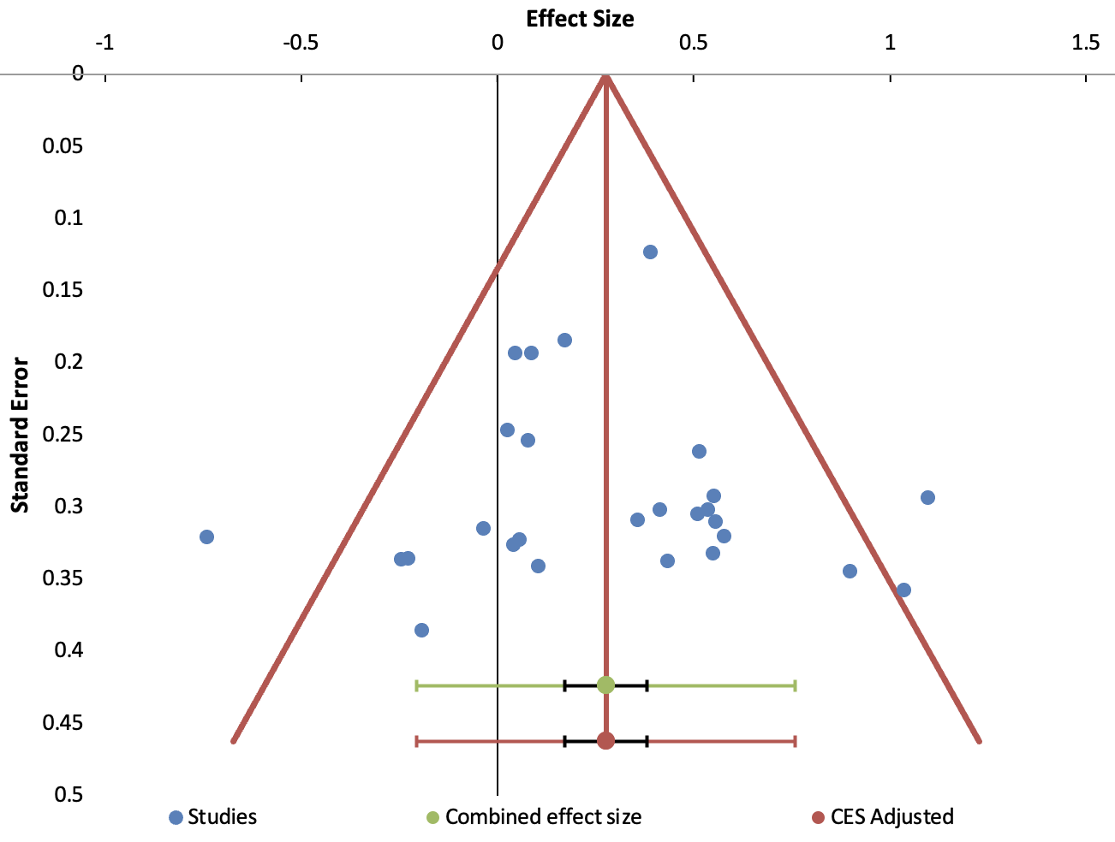
Note. CES = combined effect size.

Figure S2
Funnel plot of the between-group comparison on the positive RTs
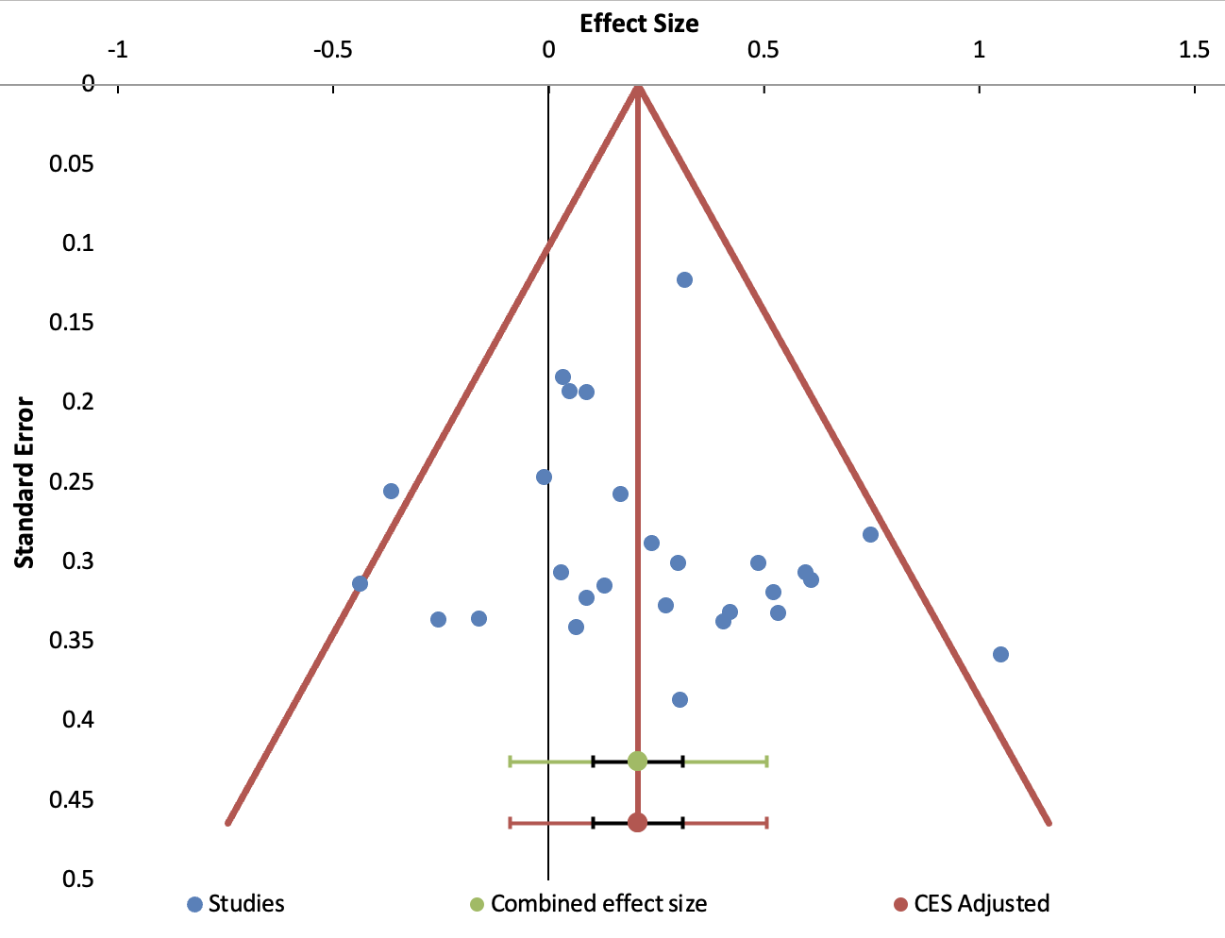
Note. CES = combined effect size.

Figure S3
Funnel plot of the between-group comparison on the neutral RTs
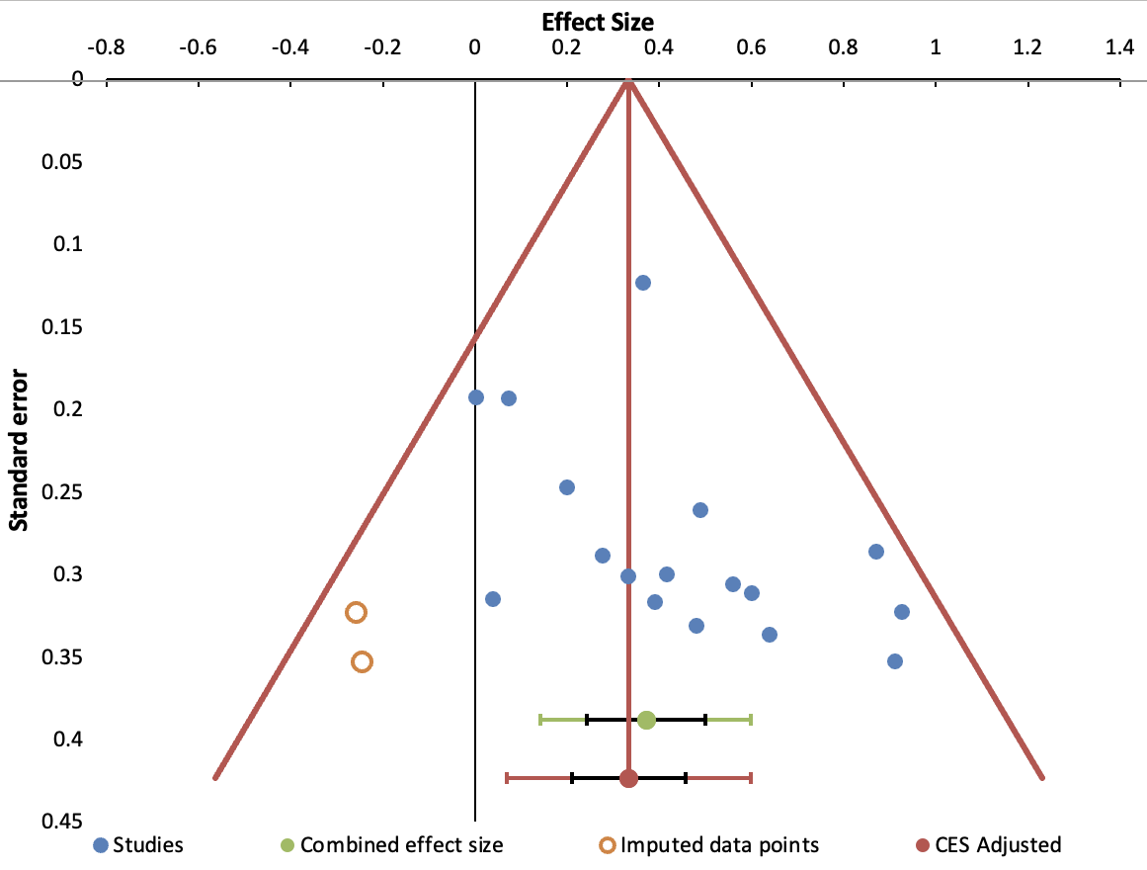
Note. CES = combined effect size.

The moderation analysis of experimental task on the group difference in neutral RTs did not include the NAP task as the studies that used this task did not include neutral stimuli.

