How Does Government-Sponsored Participation Influence Public Policy?
An Evaluation of the Remediation Efforts at Fort George G. Meade and the Aberdeen Proving Ground

Ayo Omololu

A dissertation submitted in partial fulfillment
of the requirements for the degree of
Doctor of Public Administration

College of Public Affairs
School of Public and International Affairs

University of Baltimore
Baltimore, Maryland

3 November 2017

Abstract

This study examines how decision inputs obtained during government-sponsored public participation influence public policy. The study adopts an evaluative approach to a qualitative analysis to test the element of influence in the framework advanced by Rowe and Frewer (2000). The units of analysis are the Aberdeen Proving Ground and Fort George G. Meade, both of which are active military installations located in Maryland impacted by the Base Realignment and Closure (BRAC) effort of 2005, and active Restoration Advisory Boards (RABs) designed to incorporate public participation in decision-making. Themes inherent in the influence element of the Rowe and Frewer (2000) framework are applied in a document and interview coding process to determine coverage. The coverage of the influence themes associated with records of decision, the RAB meeting minutes, and semi-structured interviews with RAB members was compared to the predictions made by Rowe and Frewer (2000) on how public participation influences public policy. The results indicate that decision inputs and recommendations made by RAB members and the general public influence policy.

Table of Contents

Abstract 2
Table of Contents 3
List of Figures 5
List of Tables 6
Chapter 1. Introduction 9
Why Should We Be Concerned about Environmental Issues on Military Bases 9
What is the Extent of Environmental Contamination at Military Installations across the Nation 11
What is the Extent of Environmental Contamination at Installations in Maryland? 13
Barriers to the Remediation of Environmental Issues on US Military Bases 14
Changes in Requirements for Public Participation during Environmental 16
Decision-Making 16
Research Problem 21
Research Questions 23
Significance of the Present Study for Theory 24
Significance of the Present Study for Policy and Practice 24
Limitation of the Present Study 25
Chapter 2. Literature Review: Government-Sponsored Public Participation 26
Emergence of Government-Sponsored Public Participation 26
Government-Sponsored Public Participation in Policy Arenas 33
Theories Relevant to Government-Sponsored Public Participation 34
Models of Citizen Participation 38
Analyzing Rowe and Frewer’s (2000) Framework for Evaluation 44
Current Research on the Contributors to Participation Introduced by
Rowe and Frewer (2000) 45
Need to Examine Decisions during Environmental Decision-Making 49
Chapter 3. Literature Review: BRAC and Public Policy Decision-Making 51
Adopting the Rowe and Frewer (2000) Framework to Evaluate BRAC
Decision-Making 51
History of the BRAC Effort 52
Implementation of the 2005 BRAC Act 53
Amount of Contamination on BRAC Sites 53
Legal Framework for Public Participation during BRAC Remediation Efforts 54
The BRAC Process 55
Current Remediation Process 56
Cleanup Process Summary 57
Development and Operational Structure of the RAB 60
RABs Serving the Military as Citizen Advisory Committees 61
Chapter 4. Research Methodology 63
Research Procedures 64
Why Was the Case Study Method Selected for this Research? 68
Gaining a Deeper Understanding through the Case Study Approach 71
Case Study Site Selection Strategy 72
Research Setting 74
Data Collection and Analysis 77
Discussion on Interview Instruments Utilized in the Research 85
Data Analysis 89
Data Coding Strategy 89
Coding Strategy Using the NVivo Tool 98
Chapter 5. Findings 103
Data Sources 103
Document Review and Analysis 104
Interviews Conducted with RAB Members 105
Results of the Official ROD Analysis 106
Reasonability Check of ROD Documents at the APG and FGGM 106
Strategy for Identifying Significant Changes during the Reasonability Check 107
Results of the ROD Analysis 110
Results of the RAB Meeting Minutes Analysis 116
Results of the Analysis of RAB Member Interviews 126
Chapter 6. Discussion 133
Limitations of the Research 144
Recommendations on How to Improve the Effects and Influence of Public Participation Inputs/Outputs on Policy and Final Cleanup Decisions 144
Areas for Future Research 147
References 148
Appendices

List of Figures

Figure 1. Expected Relationship between Usability of Public Information and
Public Participation 32
Figure 2. DOD Cleanup Process as Stipulated by CERCLA and SARA 59
Figure 3. Dialogical Approach in Research Showing How Theory Relates to a Case Study 69
Figure 4. Objective Triangulation Methods of the Case Study Approach 78
Figure 5. Advantages of Document Analysis as a Qualitative Research Method 79
Figure 6. Process of Data Analysis to Develop Codes, Categories, Themes, and Theory 91
Figure 7. Relationship between Prior Acceptance and Influence on Policy 138
Figure 8. Relationship between Use of Media to Inform and to Influence Policy 140
Figure 9. Relationship between Agency Receptiveness and Influence on Policy 142
Figure 10. Relationship between One-Way Communication Methods and
Influence on Policy 143
List of Tables

Table 1. Sample of US Military Installations with Hazardous Sites and Health Impacts 12
Table 2. Statutory and Administrative Mandates Associated with the Evolution of
Public Participation 33
Table 3. Shared Objective of the Rowe and Frewer (2000) Framework and
BRAC Remediation 51
Table 4. Final Selection Criteria Authorized for the 2005 BRAC Implementation 56
Table 5. Sources of Document Review Data for Case Study Sites 64
Table 6. Conditions for Selecting a Qualitative Research Strategy 69
Table 7. Case Study Selection Requirements and the Research Questions 70
Table 8. Purposeful Selection Strategy Utilized in the Case Study 73
Table 9. Document Analysis Strategy for this Study 79
Table 10. ROD Document Analysis 81
Table 11. Strengths of Data Collection Methods Utilized in the Study 86
Table 12. Interview Instrument Designed to Measure Influence 87
Table 13. Data Condensation for Testing the Research Questions of the Study 94
Table 14. Relationship between the Nodes Created Using NVivo, Research Questions, and the
Rowe and Frewer (2000) Framework 101
Table 15. Reasonability Analysis for RODs at the APG and FGGM 108
Table 16. ROD Analysis on the Effects of Participation Inputs/Outputs on Policy 111
Table 17. ROD Analysis on Utilization of Participant Recommendation 112
Table 18. ROD Analysis on Prior Acceptance 113
Table 19. ROD Analysis on the Media and Policy Influence 114
Table 20. ROD Analysis on Sponsor Receptiveness 115
Table 21. Notable Differences between the RODs at the APG and FGGM 115
Table 22. RAB Analysis on Inputs/Outputs of the Participation Process and Policy 117
Table 23. RAB Analysis on Participant Recommendation 119
Table 24. RAB Analysis on Prior Acceptance 120
Table 25. RAB Analysis on Media and Influence 121
Table 26. RAB Analysis on the Adoption of Public Suggestion Despite Sponsor Resistance 123
Table 27. RAB Analysis on Sponsor Receptiveness to Decision Inputs 124
Table 28. Demographic Data for Respondents in the APG and FGGM 125
Table 29. Comparison of the Degree of Influence of Public Participation Efforts on Policy 126
Table 30. Summary of Policy Influence Factor Results from All Data Sources 127
Table 31. Comparison of the Specific Effects of the Participation Process on Policy 128
Table 32. Comparison of the Degree of Responsiveness by the Cleanup Agency 129
Table 33. Summary of Receptiveness/Responsiveness Influence Factor Results from All Data
Sources 130
Table 34. Comparison of the Degree to Which the Cleanup Agency Accepted and Implemented Decision Inputs Provided by Participants 130
Table 35. Comparison of the Communication Methods Utilized by the Cleanup Agency during Public Participation 131
Table 36. Contaminants of Concern Located at Case Study Sites 136
Table 37. List of Environmental Groups Active in the Case Study Areas 136

Chapter 1. Introduction

Why Should We Be Concerned about Environmental Issues on Military Bases?

In the past, hundreds of thousands of acres of land formerly owned by the US military have been transferred to local communities for repurposing. Property transfers to communities are realized through Formerly Used Defense Sites (FUDS) and iterations of the Base Realignment and Closure (BRAC) efforts (1988, 1991, 1993, 1995, and 2005). As documented in a 2006 report by the US Bureau of Land Management (BLM), over five million acres of the land in its inventory containing munitions and explosives were transferred by the military. As General Daniel Allyn, Vice Chief of Staff of the US Army, stated: “The United States Army is saving $1 billion per year from the 2005 BRAC and $2 billion per year from all the BRACs in prior years.” The criticality of the issue is that the transferred property may at some point in the future be accessible to the general public.
Firing ranges operated by the US military are known to be contaminated with munitions from decades of readiness training to fight the nation’s wars. MacDonald et al. (2005) noted that a vast majority of the ordnances utilized by the US military possess a failure rate of 2-30%, meaning that a deployed ordnance could remain unexploded for an unpredictable length of time at its resting place. The dangers of unexploded ordnances to the civilian community cannot be overemphasized. MacDonald et al. (2005) described an incident that occurred in a neighborhood previously utilized by the US Navy (Camp Elliott) where two teenagers lost their lives when they unearthed an unexploded ordnance near their homes and began playing with it.
A cursory review of the Department of Defense Safety and Occupational Health Network and Information Exchange database reveals the following incidents associated with the hazards of formerly used defense sites (repurposed for civilian use) and active military bases. In 1995, while vacationing near an active military base, a family discovered some unidentified objects and picked them up as souvenirs without realizing they were unexploded ordnances. The munitions subsequently exploded injuring the family’s five children. Similarly, in 2000, a teenager wandering near a former artillery range unearthed an object and decided to retain it as a souvenir. After a year and half, while playing with the object in his garage, the munition exploded resulting in a catastrophic loss of limbs. Another incident occurred in 2001 when a man struck a metal object while raking leaves in the backyard of his home. Local law enforcement, called to examine the metal object, discovered that it was in fact a live military munition and subsequently discovered that the family’s home was built on land transferred to the community that was previously utilized as a military training area. These are all dangerous circumstances that could arise when formerly used defense sites are transferred to communities during the BRAC process or through the conventional transfer of excess land by an active military installation.
On its website, the Environmental Protection Agency (EPA), affirms that “hazardous contamination present as a result of military munitions could have severe soil, ground water, and surface water impacts on communities surrounding the installation.” A Congressional Budget Office report in 1992 also identified other types of pollutants present in closed and existing military installations: PCB transformers; landfills; fuel and paint dumps; asbestos; radon; leaking underground storage tanks; 1,2,3 Trichloropropane (TCP); 1,4 Dioxane; 2,4,6 Trinitrotoluene (TNT); Dinitrotoluene (DNT); Hexahydro-1,3,5-trinitro-1,3,5-triazine (RDX); N-Nitroso-dimethylamine (NDMA); and tungsten.

What is the Extent of Environmental Contamination at Military Installations across the Nation?

The hazards of environmental contamination at Department of Defense (DOD) and US Army installations have been documented across the nation. From Camp Lejeune’s drinking water exposure in which the Agency for Toxic Substances and Disease Registry identified levels of perchloroethylene (PCE) 43 times over the current US maximum contaminant level to the contamination of a residential area and playground with the dangerous chemical polychlorinated biphenyl (PCB), which was traced to the military activities of the Naval Computer and Telecommunications Master Station in Hawaii. The Agency for Toxic Substances and Disease Registry also reported varying degrees of toxic contamination in the following US Army facilities: (1) Schofield Barracks in Hawaii, which recorded trichloroethylene (TCE) at a dangerous level contaminating groundwater and soil surfaces of communities surrounding the installation; (2) Fort Dix Army Training Center in New Jersey, which reportedly produced radiological contaminants that affected the groundwater utilized by surrounding communities; and (3) the now closed George Air Force Base, which was responsible for the levels of TCE that substantially polluted the Mojave River.
Studies by Levy and Sidel (1997) and Wegman (1994) examined the daunting challenge of cleaning up contaminated military facilities that have undergone the BRAC process and utilized specific examples to highlight the precarious issue. The closure of the Jefferson Proving Ground in the first round of base closures unearthed a serious level of contamination involving low levels of radioactive waste and pesticides. It was also alarming to note that 53,000 of the 55,000 acres ready for potential transfer to the state of Indiana were contaminated. The health hazards of contaminants associated with some US military installations are shown in Table 1 below. The grave and long-lasting effects of these hazards/contaminants on the surrounding communities cannot be over-emphasized. A collaborative cleanup effort that adopts the current best practices utilized by industry is necessary.

Table 1. Sample of US Military Installations with Hazardous Sites and Health Impacts
Location | Observation
Otis Air Force Base, Massachusetts | Groundwater contaminated with TCE, a carcinogen. Towns adjacent to the installations were reported to have lung cancer and leukemia rates 80% above the documented state average.
Picatinny Arsenal, New Jersey | TCE contamination of the groundwater/major aquifer is reported to be 5,000 times more than the EPA standards. Other contaminants include: lead, cadmium, PCBs, phenols, furans, chromium, selenium, toluene, and cyanide.
Rocky Mountain Arsenal, Colorado | Installation was reportedly utilized for 30 years in the production of nerve gas and pesticides.
Hill Air Force Base, Utah | On-base groundwater contamination. Volatile Organic Compounds (VOCs) are up to 27,000 ppb and TCEs are 503 ppb.
McChord Air Force Base, Washington | Carcinogens such as Benzene detected as high as 503 ppb which is 1,000 times the limit permitted in Washington State.
Source: Levy and Sidel. War and Public Health (2012).

What is the Extent of Environmental Contamination at Installations in Maryland?

Because the present study is focused on environmental decision-making at US Army installations, data on the number of US Army installations currently listed on the Superfund National Priorities List (NPL) maintained by the EPA was obtained. The US Army currently has 146 contaminated sites spanning 27 states listed on the NPL, with 10 of the sites located in Maryland (see Appendix A). With regard to the contaminants at sites selected for the case study analysis and how government-sponsored public participation affects environmental policy, the Agency for Toxic Substances and Disease Registry concluded first that the US Army Aberdeen Proving Ground (APG) facility had serious groundwater and soil surface contamination caused by PCBs and polyaromatic hydrocarbons (PAHs). Additionally, the contamination of fish and aquatic animals with Dichlorodiphenyltrichloroethane (DDT), PCBs, lead, copper, chromium, and mercury has been reported within and outside the installation. Second, the agency also documented the off-post groundwater contamination of domestic/drinking water at the US Army installation known as Fort George G. Meade (FGGM) with a potential for harming the surrounding communities.
In a 2014 development reported by the Maryland magazine 360 Law, a real estate developer brought suit against the US Army’s Fort Detrick alleging that dangerous contaminants from the installation had migrated into a nearby property intended for development as a residential neighborhood. As a result of the migration, the plaintiff alleged that potential buyers canceled their prior offers.
Further examination of the Department of Defense Safety and Occupational Health Network and Information Exchange database on perchlorate sampling at military installations across the nation reveals that perchlorate was detected at the APG Field Training Area in 2001, while a remediation investigation was being conducted. The Field Training Area is located above the aquifer that supplies drinking water to the city of Aberdeen. The source of the perchlorate has been traced to the use of pyrotechnics in the form of stimulators, smokes, and obscurants during soldier training. Hunt’s (2011) study reviewed the empirical literature documenting the quantification and assessment of the impacts of contaminated water and hazardous chemicals on human health as input data for environmental decision-making. The study argued that there is a direct link between human exposure to hazardous chemicals such as arsenic and/or chromium and serious health impacts such as lung, skin, and bladder cancer. Cadmium and/or mercury exposure is linked to kidney failure.

Barriers to Remediation of Environmental Issues on US Military Bases

The key barriers to the remediation of property transferred under the BRAC process and the FUDS are litigation and national security concerns. These issues may be interwoven in some instances resulting in a rather complex situation for the parties concerned. Prolonged conflicts between the communities impacted by environmental contamination and the agency responsible for the cleanup may result in extensive litigation by the parties concerned. During periods of litigation, the cleanup process may be stalled indefinitely until the relevant court makes a ruling.
In a 2010 report, the Government Accountability Office (GAO) also identified three key factors that may serve as barriers to environmental remediation. This first involves issues related to the availability and affordability of new technology, which may limit the DOD’s ability to accurately identify, detect, and clean up unexploded ordnances and other contaminants of concern. The second barrier known to occur during the cleanup process at these installations is previously undetected contamination that may result in the need for further cleanup and/or increased cleanup costs. The detection of the new contaminants of concern during the implementation of the cleanup strategy disrupts the budgetary process/cycle and may subsequently jeopardize the funding requirements needed to make the installation safe for the surrounding communities. The third barrier occurs as a result of prolonged negotiations between environmental regulators such as the EPA and state environmental agencies regarding the extent to which the DOD’s actions are found to be in compliance with applicable laws and environmental regulations.
On the issue of national security and cleanup efforts, the US military, while tasked with the revered responsibility of safeguarding sensitive information related to military operations, is also bound by the requirements of the Freedom of Information Act (FOIA). One example is the lawsuit brought forward by the APG Superfund Citizens Coalition against the US Army. The group alleged that it received maps from the installation during a regularly scheduled Restoration Advisory Board (RAB) meeting meant to display areas of hazardous contamination at the facility, but the landmarks that were needed to interpret the maps, such as roads and buildings, were missing and street names were masked. The APG security and public affairs office subsequently argued that releasing the maps with these sites offered terrorists easy information to locate potential targets. The US Justice Department ruled that the practice of withholding landmarks on contamination maps would not stand as a waiver of the FOIA rights of citizens. Hooks and Smith’s (2004) analysis reiterated the impact of the national security requirements as a barrier to understanding the extent of contamination at US military facilities. The most dangerous weapons of mass destruction in the world are located on active installations with information on the dangers posed to communities, but this information is protected by national security restrictions.
Additionally, as noted by Albright (2012), an organizational structure unique to the military may also serve as a critical barrier to cleanup efforts on installations operated by the DOD. It is standard military practice to rotate active duty personnel within and outside the continental US (CONUS and OCONUS) to meet operational and tactical needs. The personnel rotation may negatively impact an effective tracking of the environmental practices/incidents that occurred on military installations in the past. It is challenging to maintain accurate environmental records for an installation that may have served the military for over a century.
Another obvious barrier to the cleanup effort at US military installations is the issue of the technical competence of the participants during public participation. As noted by Mihaly (2009), environmental decision-making generates complexities that surpass the general understanding and comprehension of the average citizen who is willing to participate. To engage meaningfully with the goals of influencing environmental decision-making, the lay citizen often solicits the services of attorneys and experts.

Changes in Requirements for Public Participation during Environmental Decision-Making

The beginning of the environmental law revolution in the US can be considered a critical factor in the institution of the current public participation framework that defines the role of the citizen in the implementation and subsequent enforcement of environmental policies (Doremus 1999). In their book entitled Communication and Public Participation in Environmental Decision-Making, Depoe et al. (2004) noted that federal and state environmental laws enacted in the 70s, 80s, and 90s served as a much-needed catalyst in the public participation discussion by setting minimum levels of opportunities to participate during environmental decision-making. Depoe et al. (2004) also concluded that citizens now have the wherewithal to serve on community planning boards and advisory committees and that they possess the capability to provide direct and calculated feedback to the public officials tasked with decision-making. A brief analysis of the statutes relevant to the public participation argument and the role they play in environmental decision-making is conclusive that congressional intent was the conferment of a legal and structural framework on the public participation continuum.

Administrative Procedures Act

The landmark policy that propelled and subsequently changed the public participation movement was the enactment of the Administrative Procedures Act in 1946. Craig and Ruhl (2014), Doremus (1999), and Fontana (2005) argued that the act created the democratic structure and process needed to involve the citizens of a community in the decision-making process when the operations of a governmental agency posed potential or actual negative impacts on the citizens of that community. In an assessment of a landmark case on public participation brought before the Supreme Court in 1984 (Chevron USA, Inc. v. Natural Resources Defense Council), the court’s holding centered on the notice-and-comment framework prescribed by the Administrative Procedures Act. The Supreme Court stated emphatically that the framework “creates a pre-publication dialogue which allows the agency to educate itself on the full range of interests, while introducing a representative public voice that ensures fairness to affected parties during governmental decision-making.” The notice-and-comment period currently engrained in the cleanup process at contaminated military installations can be traced directly to the provisions of the Administrative Procedures Act.

Clean Air Act

The enactment of the Clean Air Act by Congress in 1963 was designed to expand the public participation efforts initiated by the objectives of the Administrative Procedures Act. Burrows (2009), Guana (1995), and Calhoun (2009) noted that the capability to enforce and bring legal action against the EPA air polluters marked a defining point in the policy-making potential of the public participation process and supported the argument to involve the public during environmental decision-making. The Clean Air Act is critical to the public participation movement as it serves to ensure the public is afforded opportunities to engage in determining how the law is implemented. The framework under which it was enacted changed the public policy culture by making the required reports accessible to the public through a technical information clearinghouse.

National Environmental Policy Act (NEPA)

Stern and Hoover (2014), Yang (2005), Hourdequin et al. (2012), Karkkaine (2002), and Braeuer (2012) all concluded that the enactment of NEPA in 1969 played a critical role in defining the process of public participation and its intended influence on the environmental decision-making process. The act required public agencies to involve the public in the decision-making process to determine and possibly quantify the environmental burden on the community that would be impacted. Stated expressly, the act “requires that agencies of the US government or those seeking to use federal funds to construct projects study the environmental and social impacts of such projects.”
Ichter (1983) also explained the implication of the country’s first major environmental legislation and its purpose of facilitating a productive and enjoyable harmony between citizens and their environment. The study further argued that NEPA promotes national policy by making environmental protection part of the mandate of every federal agency, including the DOD. In clarifying the statute’s applicability to the military, Ichter (1983) proceeded with the argument by citing a decision by the Court of Appeals in the District of Columbia. In the case Concerned about Trident v. Rumsfeld, the Court made it clear that “NEPA does not contain a military or national security exemption and applies to all federal agencies.”

Resource Conservation and Recovery Act (RCRA)/Superfund Act

Enactment of the RCRA by Congress in 1976 was described as a direct response to the grave concerns of communities across the nation about the ability of agencies and corporations to execute unilateral decisions in the disposal of toxic waste and hazardous material. In 1980, Congress moved a step further in its objective to protect communities from hazardous and toxic substances by enacting the Comprehensive Environmental Response, Compensation, and Liability Act (CERCLA or Superfund). The provisions of the act, which addressed information gathering and analyses of the agency/corporation involved, were centered on community involvement and public participation mandates. The site cleanup process stipulated in the act made the community involvement plan a mandatory document in conducting such efforts. The community involvement plan documents the public participation strategy that is adopted by the agency involved in the cleanup effort.

Superfund Amendments and Reauthorization Act (SARA)

The 1986 amendments were made to further strengthen the achievements of the original enactment of 1980. Amendments were specifically designed to shift the focus of innovative cleanup technologies resulting in long-lasting remedies, an emphasis on the human health concerns attributed to the negative effects of hazardous waste at contaminated sites, and an enhanced mandate for citizen participation.

Emergency Planning and Community Right-To-Know Act

Under the Superfund amendments of 1986, Congress passed the Emergency Planning and Community Right-To-Know Act to address the public’s concern about industrial operations in their communities that had the potential to produce explosions and/or toxic chemical leaks.

BRAC

BRAC was signed under Public Law 101-5-10 by President George H. W. Bush and the BRAC Commission was established in 1990. The act also established the Federal Facilities Restoration and Reuse Office (FFRRO), which was charged with accelerating the transfer of excess federal property to other federal agencies, the state, and to local governments. The act specified and also emphasized a mandate for public participation prior to the environmental cleanup and transfer of contaminated property to the state or local government for reuse.

Federal Advisory Committee Act (FACA)

The Facilities Environmental Restoration Dialogue Committee (FFERDC) was established under FACA in 1972 to seek consensus from a variety of stakeholders on issues related to the cleanup of contaminated federal facilities. The act recommended the formation of a community advisory committee at all federal facilities undergoing cleanup. Federally endorsed committees established under the FACA follow strict requirements regarding balanced membership, transparency, and government involvement.

Research Problem

Federal government agencies, including the DOD, are required to implement public participation requirements up to or exceeding the levels stated in the nation’s environmental laws. There have been numerous examples where decisions made by the responsible cleanup agency were not acceptable to the impacted community. In one example, a lawsuit was filed by the Maryland Department of Environment against the DOD in December 2008 with regard to the cleanup efforts at the FGGM US Army installation. A press release issued by the Maryland Attorney General’s office alleged that the Army failed to comply with an existing EPA cleanup order at FGGM. The complaint further stated that the presence of contaminants in the soil and groundwater, which exceeded the EPA’s maximum acceptable levels, could endanger the health of the community and the environment.
A similar lawsuit was filed in 2004 after the APG Superfund Citizens Coalition received maps from the base that showed contamination information, but the landmarks that were needed to interpret the maps, such as roads, buildings, and street names, were missing. The APG security office argued that releasing maps with landmarks would easily assist terrorists in finding potential targets. The US Justice Department struck down the practice of withholding landmarks on contamination maps. These lawsuits echo an observation made by Cramton (1972) and Rhodes and Nocon (1998) that the demand for increased public participation in the administrative process is based upon the perception that representatives of governmental agencies cannot be trusted to present and articulate the needs of ordinary citizens, environmental activists, minorities, or other under-represented groups. In general terms, the less responsive the agency is to the human health needs of the community, the more extensive and prolonged the litigation, resulting in a waste of taxpayer resources.
There is currently a dearth of research on how government-sponsored participation influences public policy decision-making. The cost of obtaining public input from citizens could be huge according to Rowe and Frewer (2000), who stated that the more complicated the issue, the more expensive it may become for a public participation sponsor. As a result of past, current, and future budget constraints, agencies may attempt to implement superficial public participation requirements to avoid non-compliance with prescribed mandates and environmental laws.
What is the benefit of the mandatory requirement for agencies to expend resources in sponsoring meaningful public participation if the impacts on final decisions are minimally productive or non-existent? To justify federal agencies’ continued expenditures of taxpayer funds on public participation, it must be determined whether the intervention has any impact on final decisions. There is a need to test an evaluative framework that can answer the question of how public participation influences decision inputs during environmental decision-making.

Research Questions

The research question for this study consists of a question and five sub-questions.
- How effective has government-sponsored public participation been in influencing environmental decisions in military cleanups?
- What level of influence can a government-sponsored participation effort (such as the efforts by an RAB) exert on environmental decision-making at US military installations?
- What degree of responsiveness to decision inputs is obtained through government-sponsored public participation?
- How are cleanup decisions communicated to government-sponsored participants during environmental decision-making at US military installations?
- What are the impacts of the decision inputs received during government-sponsored public participation efforts on the quality of the final decisions?
- How are direct decision inputs obtained from the general public to support government-sponsored participation efforts during environmental decision-making at US military installations?

Significance of the Present Study for Theory

A major objective of the present study is to adopt the theoretical evaluation criteria proposed by Rowe and Frewer (2000) to assess public participatory influence on public policy decision outputs when governmental agencies are required to sponsor public participation. The results of this study will add to the current body of knowledge regarding how public participation influences the public policy decision-making process. With regard to policy, this study will help decision-makers in the DOD and other federal agencies more rigorously utilize public participation approaches with clearly defined and agreed upon criteria. The expected results of such action will build a coalition with the public, resulting in positive effects on final policy/decision outputs during the cleanup of contaminated military facilities

Significance of the Present Study for Policy and Practice

With the history of citizen lawsuits at both sites selected for this case study, it can be deduced that citizen inputs during environmental decision-making were largely ignored. It may be argued that the contributors to public involvement or participation proposed by Rowe and Frewer (2000) could easily be translated into citizen satisfaction measures. Improved participatory influence will result in increased citizen satisfaction. The present study’s goal of expanding the theory proposed by Rowe and Frewer (2000) will facilitate productive evaluations of public participation programs with the objective of reducing conflicts that arise between the public and the agencies involved in environmental decision-making. Conflicts may arise when citizen satisfaction and the ability of citizens to influence final cleanup decisions are superficial.

Limitation of the Present Study

The qualitative case study approach adopted in this study is limited to two US Army facilities, both located in Maryland. Membership composition, the demographics of the communities’ involved, the influential backgrounds, and the capacity for the independent deliberation of RABs in other states may differ slightly.

Chapter 2. Literature Review: Government-Sponsored Public Participation

Chapter two focuses on the theories of public administration associated with public participation, historical analyses of the notable disasters that led the institution of government-sponsored public participation in public policy decision-making, and an overview of the relevant policy guidelines and administrative regulations for the emergence and growth of government-sponsored public participation. The evolution of government-sponsored participation as a strategy for public administrators/public agencies to garner public policy acceptance and implementation should not be underestimated.

Emergence of Government-Sponsored Public Participation

Notable disasters that have occurred in the US and other parts of the world have functioned as agents of change in the struggle to incorporate the voice of citizens in public government decisions. Gray (2002) noted one such disaster in a study on the chemical devastation experienced by the town of Institute, West Virginia in 1985, which resulted in landmark legislation intended to enhance the role of citizens as watch-dogs of the community. Congressional response to the disaster resulted in the enactment of the Emergency Planning and Community Right-to-Know Act of 1986 (EPCRA). The act drastically improved the congressional mandate for public participation by establishing requirements that federal agencies/organizations must inform and involve citizens when hazardous materials are being handled/managed in the vicinity of local communities. A crucial part of the legislation that initiates public participation efforts is the public information requirement. Information on the handling of hazardous materials by agencies/organizations must be maintained in a database accessible to the general public.
Another change linked to the emergence of government-sponsored participation in key policy arenas of Western societies lies in the transformation of 21st century citizens from non-experts with little or no public governance experience to citizens with the capacity to influence policy through sustainable and sophisticated contributions to the public governance process (Nabatchi and Leighninger 2015). Technological advancements have placed government-generated databases, previously inaccessible to the public, in the hands of citizens interested in shaping the outputs/outcomes of public policy processes. Other factors identified as aiding the emergence of government-sponsored public participation are follows:
- Issues associated with the policy acceptance of impacted communities;
- Increased rate/costs of litigation arising from dissatisfied citizens/communities;
- Trust issues between citizens/communities and public officials; and
- Enactment of the FOIA.
In terms of the policy arenas where government-sponsored participation has made the most impacts, Roberts (2008) cited areas involving education, the environment, and public budgeting processes.
Government-sponsored public participation also emerged as a direct product of the broader operational strategies of the lead agency tasked with environmental enforcements in the US – the EPA. Sirianni and Friedland (2001) illustrated this point with a story from the early 1970s where the Narragansett Homeowners Association in Rhode Island built a local coalition to save the Narragansett bay and estuary from nuclear waste. The EPA initiated the sponsorship of the Narragansett Homeowners Association in the 1980s as a public participation organization by providing resource funding and technical assistance efforts as a required strategy to foster the mission and vision of the EPA.
The following key concepts, discussed in individual subsections, are also associated with the emergence of government-sponsored public participation as critical components of public governance.

Technological Advancements

Kloby (2012) and Roberts (2008) assessed the dynamics between citizen participation and e-democracy/social technology by noting conscious changes initiated by government agencies in not only sharing information with the public but also engaging them as partners through stakeholder management efforts. The rapid growth in information technology also serves as a crucial enabler of the e-democracy concept required in optimizing collaborative stakeholder engagements. As a result of feedback from citizens on the issue of transparency and the inability to influence the programs impacting them, local and federal government agencies across the nation adopted the e-democracy/social media concept to enhance the elements of government transparency, trust, influential opportunities, and authenticity during public participation efforts.
There is evidence that technological developments leading to the creation and utilization of social media brought citizens and public governance organizations together in the government-sponsored public participation process. Through the utilization of social technology, government agencies, tasked with sponsoring public participation efforts, can do so without being overwhelmed by the number of citizens wishing to participate in problem-solving efforts (Shea and Garson 2010). The emergence of government-sponsored participation as a preferred tool for governance was enhanced through the use of computer networks that created a medium for direct communication between administrators and members of the public who wanted to participate in the deliberations that would lead to public policy decision-making.

Public Policy Acceptance by Communities

The recognition of Renn, Webler, and Wiedemann (1997) of the need for public participation discourse during public governance efforts led to the observation that when scientific analysis constitutes the dominant factor in a public policy decision-making process, the interests and voices of the public will be compromised. The results are problem-solving outputs/outcomes that are unworkable and unacceptable to the community. Public agencies and officials who have experienced such shortfalls in public policy acceptance levels have intensified their public involvement strategies to achieve desired levels of public policy acceptance. Miller (2005) analyzed how administrators translate citizen preferences into public policy and suggested that government responsiveness to popular public demands constitutes a critical framework for how the public policies approved for implementation are accepted by the community. Administrators of government agencies with the least success in implementing public policies due to community acceptance issues can only move forward with policy implementation when investments are made in the areas of public engagement and sponsorship.

Lessons Learned from Citizen Litigation

DiMento (1977) observed that after much time and expense, government disputes with citizens must often be resolved by the courts. The proactive and preferred remedy for resolving disputes between those who govern and those being governed is to institutionalize public engagement efforts as a critical component of bureaucratic policies.
Innes and Booher (2004) examined the rationale provided by the government on the need to invest public funds in the sponsorship of public participation, and they cited a classic example that occurred in the State of California. Environmentalist groups with deep-rooted interests in San Francisco Bay Area development efforts brought a lawsuit against the transportation agency alleging a lack of transparency and a failure to engage the community for input as required by federal regulations. Lawsuits such as the one described can result in protracted conflicts and delays in project implementation as well as enormous litigation costs.

Trust Issues between Citizens/Communities and Public Officials

When citizens exhibit distrust toward governmental agencies tasked with implementing public policy, one by-product may be cynicism. Watson and Hassett (2003) characterized the environment of distrust as having the following conditions: (a) the general public is of the view that the government uses its power discriminately, (b) the public is not engaged and feels ignored, and (c) citizens discover that policies being implemented by the government do not consider the interests of the community. Government-sponsored participatory efforts are likely to increase when governmental agencies are faced with a low level of trust from the citizens they govern. Correcting the negative perceptions and orientation of citizens after being consistently ignored by the government requires a detailed public engagement plan and the subsequent sponsorship of public participation efforts.
King (2016) traces the emergence of government-sponsored participation to trust issues between citizens and public administrators in the 1970s when the public seriously questioned the legitimacy of governmental agencies in their ability to implement public policy. The period was contentious as it was also the period in which the executive branch of government was churning out a multitude of executive orders with mandates for more citizen participation.

Freedom of Information Laws

The public’s access to information also serves as a critical enabler of government-sponsored public participation in the US. Dernbach’s (2002) analysis suggests that the 1990s witnessed a substantial change in the FOIA backed by numerous executive orders issued to expand the voices of the citizenry in decision-making. Voltmer (2013) characterized the impact of the law on public participation by suggesting that the intent of Congress at that time was to minimize the power of the state and to expand the rights of the media and private citizens to access and view the public information generated by government agencies. Government-sponsored participation was the strategy adopted by governmental agencies to manage the information flow between the agency and the citizens who wanted to participate in public policy analysis and decision-making. The access to public information afforded by the FOIA comes with the complexities of understanding what the data generated by governmental agencies represents.
Schachter and Yang (2011) found that the relationship between access to public information and the public’s ability to participate in public governance efforts leads to the question of usability. The usability of government data measures the level at which citizens can understand the information for useful analysis and/or synthesis.

Public Participation Rate

Access to Public Information (Usability)

Figure 1. Expected Relationship between Usability of Public Information and Public Participation

Figure 1 above shows the impact of the ease of access/information usability on public participation rates. The concept also applies to government-sponsored participation efforts; the more access and usability provided by a governmental agency to citizens willing to participate, the higher the level of participation recorded.

Government-Sponsored Public Participation in Policy Arenas

Roberts (2016) analyzed the evolution of direct citizen participation in the US and argued that the evolution of the concept is enshrined in most of the public policies and programs being promoted or scheduled for implementation by the government. Inclusion of the public in administrative endeavors has been achieved through laws enacted by Congress, executive orders, and through the use of administrative discretion. Table 3 below shows the statutory and administrative mandates that have enabled the evolution of public participation through the years.

Table 2. Statutory and Administrative Mandates Associated with the Evolution of Public Participation
Law | Citizen Participation Mandate (Requirement) | A Form of Government-Sponsored Participation?
Housing Act of 1949 | Required participation in urban renewal through public hearings. | Yes
Housing Act of 1954 | Required citizen participation through citywide advisory committees composed of public leaders. | Yes
Economic Opportunity Act of 1964 | Required area residents and members of the groups served to be involved in decision-making through the nonprofit Community Action Agency. | Yes
Demonstration Cities and Metropolitan Development Act of 1966 | Required mandatory and, subsequently, widespread citizen participation. | Yes
Housing and Community Development Act of 1974 | Required adequate opportunities for citizen participation. | Yes
Coastal Zone Management Act of 1972 | Required that citizens be encouraged to participate. | Yes

Theories Relevant to Government-Sponsored Public Participation

Democratic Theory

The analyses by Coenen et al. (1998) and Hourdequin et al. (2012) on the ethical implications of democratic theory as it impacts the dynamics of public participation in the US focused on the linear relationship between the democratic rights of citizens and the opportunities to participate as provided by the agency. They suggest that, at a minimum, governmental agencies involved in environmental management with the objective of implementing a public participation mandate to increase public involvement and citizen satisfaction should build their community involvement strategies on the ethical principles derived from democratic theory. These principles are as follows: an equal opportunity for all citizens to participate, equal access to information on the issues being discussed/resolved, genuine deliberation, and a shared commitment to make the process meaningful to all. An inherent value of the democratic rule practiced in Western communities is the openness and accountability of public officials who are expected to facilitate public participation efforts. Public officials are expected to be responsive to the communities they govern to sustain the democratic structure. When examined in theoretical terms, democratic and participatory theories display a complimentary overlap that serves as a key ingredient in the analysis of why citizen participation should be required for environmental decision-making and should precipitate fairness (Mihaly 2009).
Implementing the democratic ideals explained above can only be realized through dialogue or deliberations during the decision- and/or policy-making process. Because environmental issues introduce complexities to deliberations that may overwhelm the lay citizen, the deliberative process can only be meaningful if public officials serving in their bureaucratic role engage and collaborate with informed representatives of the community serving in a jury capacity. Kenyon et al. (1991) defined deliberative democracy as the process utilized for political decision-making with a capacity to facilitate rational arguments and the dialogue necessary for conflict resolution. The study evaluates how citizen juries might enable meaningful public participation in environmental decision-making and suggests that citizen juries could play a critical role in enhancing the democratic process by expanding the perceived overlap between representative and participatory democracy.

Bureaucratic Theory

Research on the interactions between the democratic theory and the bureaucratic theory are vast and it continues to be a stimulating topic for researchers in the field of public administration. Durant and Ali (2013) argued that the administrative theory developed in the early 1900s shaped the perception that public officials act as the conduit between the lay citizen and the government machine leading to an unintended emphasis of bureaucratic tendencies or responsiveness over democratic ideals.
Bryer’s (2009) study examined the theoretical framework associated with the bureaucratic responsiveness of governmental agencies when citizens are part of a collaborative effort in the policy-making process. Bryer (2009) argued that the perceptions of government officials and public participants about the role they play in the deliberative and decision-making process ultimately influence the overall quality of responsiveness during collaborative efforts. The impact of such differences in perception for public administration is that the “more administrators are willing to accept the decisions of a group, the more responsive they will be to citizen decision inputs in a collaborative process.” Another potential discourse between citizens and public officials during deliberative and collaborative processes resides in the issue associated with the risk of policy implementation. Moffitt (2014) examined how an agency’s reputation may be enhanced through public participation when utilizing an advisory committee, and argued that the more likely the risk for policy implementation failure, the more likely bureaucrats will involve the general public in the decision-making process. Moffitt (2014) asserted that it could be deduced from the above assessment that one reason why bureaucrats decide to publicize a risk-laden action or controversial issue is to seek public participation with the overall objective of disseminating the risks of policy implementation to the parties concerned.

Conflict Management Theory

Because democratic ideals serve as the bridging tool in the reconciliation of conflicts, it could be deduced that the collaborative governance theory was advanced by the founders of the concept in an attempt to mitigate inherent conflicts that arise when bureaucracies implement policies that have overarching impacts on the citizenry. Ansell and Gash (2008) defined collaborative governance as a mechanism that facilitates collective forums for public participants and agency officials so that consensus can be reached during decision-making. Their study reviewed a multitude of collaborative governance case studies across a mix of policy sectors and analyzed certain variables to determine the success of the collaborative efforts needed in conflict management. The suggested variables included a history of conflict and the motivation of participants to be involved in the process. In conflict management literature, governmental organizations are expected to initiate measures that bring stakeholders back to the deliberating table when a conflict arises. The critical component of a conflict management effort initiated by public officials is the capacity to show significant preference for inclusiveness, transparency, and legitimate acceptance. When these elements are deemed by the public and other stakeholders as absent, conflicts are inevitable. Jarrell et al. (2013) and Ventriss and Kuentzel (2005) suggested that the citizen involvement framework adopted by governmental agencies restricts the contentiousness of the conflict at hand by implementing illusive concepts of transparency and inclusiveness.
Branch and Bradbury (2006) studied how federal agencies adopted the collaborative management approach through a citizen advisory board framework to manage stakeholder conflicts. The study revealed that organizational elements such as agency policy, managerial approaches, and the structure of the citizen advisory boards play a critical role in how the agency implements public participation efforts to resolve conflicts that arise during environmental decision-making. Similarly, Robbins (2009) examined the stakeholder engagement efforts made by federal, state, and local governments to manage conflicts that occur during policy-making and suggested that extensive public participation processes should be directed at areas in the decision-making process with the highest probability of conflict. It is the general belief that public participation processes, when implemented effectively, will steer stakeholders toward the collaborative management approach to conflict resolution.

Models of Citizen Participation

Environmental Policy

Research has shown that an important public policy arena with the utmost requirement for extensive public involvement is the field of environmental decision-making that addresses waste management. Depoe et al. (2004) noted that public involvement efforts during environmental decision-making were engrained as a core vision of agencies at all levels of government in the US through the congressional enactment of NEPA in 1969. Environmental decision-making dealing with hazardous waste management is widely regarded by public administrators and the citizenry as having the greatest impact on communities around the world due to human health concerns. Environmental laws such as NEPA are aimed at preserving the well-being of citizens and they come with a requirement that governmental agencies initiate and sponsor public participation efforts when governmental action is expected to impact the community. An overall objective of such participation efforts is to gain the community’s acceptance of the environmental decisions that are being made. A review of the literature on how public participants sponsored by governmental agencies influence environmental decision-making indicates there are three schools of thought or arguments among researchers in the field: (1) the democratic ideals and social goals argument, (2) the collaborative governance or adaptive management argument, and (3) the risk management or scientific modeling argument.
Rowe and Frewer’s (2000) analysis addressed a recurring issue faced by Western democracies – the inability to transform the democratic ideals of public participation into a critical policy-making tool. The study suggested a theoretical evaluative framework consisting of mechanisms and techniques deemed acceptable to the general public: representativeness, independence, early involvement, influence, and transparency.
From the social goals perspective, which is also linked to democratic ideals, Beierle and Cayford’s (2002) study focused on the need to initiate and develop an understanding of the social benefits of public participation. The study adopted the suggestion that the following social goals be utilized as criteria for evaluating the influence of public participation on environmental decision-making:
- Educate the public,
- Utilize the public values assumption,
- Improve decision quality,
- Build participants’ trust in government agencies,
- Institute conflict management, and
- Perform decision-making tasks with the least cost to taxpayers.
Beierle and Cayford (2002) also suggested that by relating social goals to the defined characteristics of the participatory mechanism desired by the governmental agency, resources could be channeled towards attaining such goals and objectives. Similar to Beierle and Cayford’s (2002) study, Norton (2007) analyzed the social systems concept inherent in environmental public participation and suggested that such social systems should include “economic, legal, scientific, political, religious, and educational undertones which are critical constituents of our democratic society” (Beierle and Cayford 2002, p. 65).
From the collaborative governance approach, Booher and Innes’ (2010) study highlighted innovative governance practices predicated on new norms for interaction among stakeholders and structures for information sharing leading to decision-making. Booher and Innes (2010) concluded their study by advocating new formats of governance to address complex, controversial environmental issues that require an adaptive management approach. The critical need for a collaborative adaptive management model during public participation efforts was re-emphasized in the work of Monroe, Plate, and Oxarart (2013) when they suggested that governmental agencies tasked with environmental management and wanting to establish a viable public involvement processes should develop strategic concepts to attract and retain interested participants.
Similar to Fine and Owen’s (2005) analysis, Koontz (2005) examined the effects of stakeholder participation on policy-making at the local level and argued that the level of policy change is related to contextual factors. Bingham, Nabatchi, and O’Leary (2005) also added to the new governance discussion by arguing that such governance must involve a public participation process that includes deliberative democracy. The new governance approach facilitates the development of partnerships between citizens and other stakeholders to accomplish the work of the government; citizens must play a more critical role in public policy and decision-making. The dialogic approach, a variant of the new governance model, was highlighted in the analysis of Hamilton and Wills-Toker (2006), who argued for the expansive utilization of dialogue as a “sense making” concept during public participation in environmental decision-making.
Using the advocacy coalition framework to advance the collaborative governance argument, Weible, Sabatier, and Lubell (2004) applied a three-tiered model of the elite belief systems derived from the “advocacy coalition framework” to support their argument that stakeholder preferences are correlated with the core beliefs of stakeholders. The study concludes that the more pro-collaborative beliefs stakeholders possess, the more respect they will have for local knowledge during deliberations associated with environmental decision-making. Laurian (2004) conducted a study similar to that of Weible, Sabatier, and Lubell (2004), which focused on citizen participation in the policy planning process and suggested that individual motivation to participate and possibly collaborate in environmental decision-making is correlated with the level of personal concern and the length of a citizen’s residence in the impacted community.
Coglianese and Merchant (2004) investigated the role of science in environmental risk management as it relates to public participatory influence. They conducted an analysis on how the EPA utilizes scientific data to set health standards that impact communities in the US and concluded that policy-makers should not rely on science in its absolute form, but should also apply normative choice reasoning, which is a critical ingredient in public policy-making. Renn and Schweizer’s (2009) examination of the scientific risk management concept associated with environmental decision-making focused on inclusive risk governance and how the concept is applied in setting policy during controversial and complex environmental decision-making. The study highlighted the planning, organizing, and structural processes needed to facilitate public inclusion in decision-making and concluded that decision inputs should be received on the basis of the different societal systems and should include the social actors needed to broker acceptance. Additionally, in contributing to studies on the tension between science and public participation, Fine and Owen (2005) studied the use of scientific modeling in State Implementation Plans (SIPs), which are required for agency compliance with the Clean Air Act. Fine and Owen (2005) concluded that “the nation’s environmental laws are designed to facilitate an expanded involvement of citizens in public policy processes that are difficult to understand and also pose a challenge for the public to influence.”
For citizens to influence environmental decision-making, they must be motivated to participate in the process. Drawing on the direct linkage between scientific knowledge and policy-making, Webler, Tuler, and Dietz (2011) assessed the views of outreach professionals on the most suitable model for informing water quality policy-making and concluded that models are crucial in the planning stages of cleaning up contaminated groundwater resulting from military activities. The models derived from scientific analysis, however, must be integrated as critical components of the democratic discussion and decision-making process through public participation efforts.
Garnett and Cooper (2017) and Biber and Brosi (2010) contributed to the scientific modeling argument by analyzing an effective dialogue strategy between scientific experts and citizens as a means of facilitating community acceptance during waste-management decision-making. The studies suggested that a cultural change is needed on the part of public officials to appreciate the potential of participatory influence as a decision-making tool. If implemented, a change could help improve the overall performance of agencies involved in environmental decision-making through the accomplishment of the desired goals and objectives.

Public Budgeting Policy

The second policy arena in which government-sponsored public participation has emerged as a critical public governance tool in democratic societies is in the public budgeting arena. Shah (2007) suggested that the capacity to involve citizens in the public budgeting process is only achievable when a direct democratic approach is adopted by the agency involved. Government sponsorship of public participation in the public budgeting arena has been utilized by governmental agencies to improve transparency, public governance accountability, policy acceptance, responsiveness, service delivery satisfaction, and in educating the citizenry on national and global fiscal issues facing their constituencies (Lynch 1983). The emergence of government-sponsored public participation in the public budgeting arena could also be linked to the fiscal pressures faced by the government at the municipal, state, and federal levels on how best to balance the budget while delivering public services and implementing public programs.

Education Policy

Another policy area with a long-standing history of public participation involvement is the education policy arena. The boards of education that exist in most municipal school districts readily come to mind. Castillo (2013) researched how much influence public participation exerts in the education arena and concluded that such activities produce administrative and policy impacts when the participants and public officials practice collaborative management. Orr and Rodgers (2011) expanded on the influence of public participation in the education policy spectrum by suggesting that the election of members to boards of education in municipal schools facilitates democratic governance. Parents also have the capability to influence educational policies in their school districts by getting involved in parent-teacher associations and through interest group advocacy. Interest groups are ultimately welcomed and sponsored by school administrators to achieve the goals/objectives of the ruling political class in government.

Analyzing Rowe and Frewer’s (2000) Framework for Evaluation

The overarching goal of the framework proposed by Rowe and Frewer (2000) was to develop an evaluative standard through which administrators and public agencies could develop assessment methodologies to determine the effectiveness of public involvement efforts. Rowe and Frewer’s determination to formulate a framework for evaluating public participation as a public policy tool was largely based on the fundamental requirements enshrined in most democratic societies that the “governed” should be afforded an opportunity to provide input in the decision-making process and subsequently influence the mechanisms by which elected officials and bureaucrats formulate and develop public policy for implementation.
In their review of literature on the subject of public participation, Rowe and Frewer (2000) identified a marked delineation between the concept of public communication and public participation and argued that public communication was likely to occur at the lowest levels (operational) of engagement with the public, while public participation would occur at higher or more strategic levels of involvement. Rowe and Frewer’s (2000) analysis also highlighted the paucity of research methodologies on how higher levels of public involvement should be assessed and with what instruments. A delineation of the terms was expressly stated in Rowe and Frewer’s (2004) definition of public participation as “the practice of involving and consulting the general public in agenda-setting, decision-making, and policy-formulation.” Rowe and Frewer (2000), in developing a framework for evaluating the effectiveness of public participation efforts, recognized the need to define and standardize assessment tools. Their framework clarifies the definition of public involvement contributors as reminiscent of the criteria utilized in the determination of whether or not a society is democratic. Rowe and Frewer (2004) further argued that developing and operationalizing the definitions of the criteria for evaluation were comparable to the program evaluation requirements instituted in social programs in Western democratic societies.

Current Research on the Participation Contributors Introduced by Rowe and Frewer (2000)

The following contributing elements of public participation are taken from studies conducted by other contributors in the field to gain a current and broad-based understanding of how the elements have served to shape the public participation discussion and the development of an evaluative framework.

Element of Representativeness

Simonsen and Robbins (2000) argued in their analysis of citizen participation and resource allocation that the founding fathers of the US sought to balance the nation’s sovereignty with the rights of citizens to participate indirectly in public governance by electing representatives to serve on their behalf. Based on the current research, the following important question then becomes: How representative is the membership of the RAB at the DOD facilities undergoing environmental remediation? A study by Barnes et al. (2007) was designed to answer questions on how the term “public” is defined for public participation purposes and to examine the pre-conceived ideas of representativeness that citizens and public officials bring to the dialogue table for the purpose of legitimizing forum or group membership. Barnes et al. (2007) suggested that we expect the definitions of “public” from the perspectives of agency officials and the citizen to be different. The study’s conclusion was consistent with the observations of Marshall and Jones (2005), who conducted research on whether people who participate in NEPA events could be representative of watershed residents. The study suggested that what public officials consider as representative public participation is not viewed by the general public or concerned residents as an all-inclusive effort.
Representing the general public during public participation also comes with implied requirements as evidenced by Yang and Pandey’s (2011) analysis on representativeness during public participation. The study suggests that an increase in the level of competence of participants may negatively impact goals of representativeness of the public participation effort. A high level of participant competence is also linked to improved outcome decisions.

Early Involvement Element

In their analysis in the article “Public Participation and Decision Making,” Dietz and Stern (2008) recommended that government agencies make a concerted effort to involve affected parties and those interested in environmental decision-making early on by investing in the dissemination of information about public participation. Noller’s (2009) assessment on the timely implementation of the NEPA process and its impacts on project success are also predicated on the willingness of governmental agencies to expand public outreach beyond the Federal Register notification requirements. For the present study on remediation issues at DOD facilities, it is important to determine the stage at which the public and the members of the RAB get involved in solving environmental issues. The level and stage of involvement may also be related to the level and complexity of the conflict emanating from the process.

Transparency Element

Harrison et al. (2014) described the relationship between transparency and democracy as critical. Without such relationships, the capacity of citizens to hold their government accountable for decisions made on their behalf would be nearly impossible. For public participation to be meaningful, a significant level of transparency in the process is necessary. Because environmental decision inputs through public participation ultimately lead to decision outputs, Newig and Fritsch’s (2009) analysis attempted to draw a correlation between the ability to make high quality environmental decisions and the levels of governance driving the public participation effort. The study proposed that the higher the level of governance involved in the public participation effort, the less transparent the process may become to the participants. The study also concluded that the outputs of environmental decision-making may be dependent on the environmental preferences of the parties involved. In communities with a significant level of environmental activism, the preference of the public participants will be to make environmentally friendly decisions.

Influence Element

According to Chilvers (2007), even though there is an upward demand for knowledge on the types of participatory frameworks relevant to environmental decision-making in a modern democratic society, this field of governance continues to be understudied. In their book, Engaging the Community in Decision Making: Case Studies Tracking Participation, Voice and Influence, Roz Lasker and John Guidry (2009) also observed that the focus on community participation has increased tremendously in the last four decades. With a diverse range of terms such as public participation, citizen participation, community collaboration, and deliberative democracy, the overarching goal of this type of public policy governance is the capability to develop mechanisms and processes that ensure citizens are given an influential voice about the issues impacting their well-being and existence. Kim and Lee (2012) also established a positive association between public participation participants and their perceptions of how they can influence government decision-making.
Charnley and Engelbert’s (2005) study examined the statutory requirements of the Government Performance and Results Act (GPRA) in the Superfund Community Involvement Program. The focus of the study was to highlight the need for agencies to evaluate their public participation strategy and identify areas for improvement. The evaluative focus of the study was centered on a four-criteria format: citizen satisfaction with regulatory agency information about the site, ability of citizens to understand the environmental and human health risks prevalent at the Superfund site, citizen satisfaction with the opportunities to provide decision inputs during environmental decision-making, and satisfaction with the regulatory agency’s response to decision inputs from the public.
From a higher education policy-making perspective, Natow (2015) examined the major players that exert meaningful influence on higher education policy and suggested that political actors exert more influence when the issue involves high-profile policy proposals that are easily understood by the public. Bureaucrats seem to have the greatest influence in situations where a highly technical decision-making effort exhibits a low profile.

Need to Examine Decisions during Environmental Decision-Making

Research has classified the reasons why US military actions with environmental consequences are often scrutinized in two broad categories: perceived dependence on expert/scientific opinion and risk implications and environmental justice concerns. As noted in the work of Simpson et al. (2015), it is not feasible to resolve complex environmental issues facing communities around the world through the exclusive use of expert analysis. The controversies associated with environmental decision-making and the long-term effects of the decisions on the impacted communities drive the need for an inclusive risk assessment framework by the parties involved in the effort. Even when the risks are defined, Ager et al. (2013) suggested that reasonable implementation of environmental policies are plagued by an unprecedented focus on decision frameworks that minimize risks to “aggregate measures.” Scarlett’s (2013) work also argued that with the uncertainties, risk, and rapid changes associated with most environmental deliberation comes a need to adopt a collaborative management approach in which stakeholder management efforts are paramount. Chilvers (2008) and Howard (2004) suggested that the democratic component of environmental decision-making has not been evident in decisions sanctioned by governmental agencies and may also lack the evaluative focus needed to make adjustments for successful implementation.
In almost all the deliberations leading to decision-making to resolve environmental issues, there is an expert consultation initiated by the government agency or activist group having a stake in the environmental issue. Fischer et al. (2014) observed that one important reason why environmental decision-making outcomes should be scrutinized is associated with the issue of expert opinion, which is often received differently by the general public when compared to how it is received by public officials representing a bureaucracy. The issues with the most pronounced differences in the perception and understanding of stakeholders are described by Stahl and Cimorelli (2014) as “wicked” problems with limited options for solutions that are acceptable to stakeholders.
With regard to the environmental justice concept and the need to examine environmental decision-/policy-making outputs for cleanup efforts at US military installations, Hooks and Smith (2014) argued from a theoretical and substantive perspective that the environmental injustice endured by Native Americans due to the operational impacts of the US military cannot be explained using geopolitics or capitalism frameworks. The study offered empirical evidence suggesting that Native American lands are more likely to be affected by hazardous US military actions and concluded that environmental inequality may be an inadvertent product of US militarism.

Chapter 3. Literature Review: BRAC and Public Policy Decision-Making

Adopting the Rowe and Frewer (2000) Framework to Evaluate BRAC Decision-Making

BRAC efforts, when implemented, result in environmental remediation at the military facilities that have been ordered to close or to be realigned. The federal property at sites designated for closure must undergo a rigorous cleanup process and meet the standards for subsequent transfer to the states or other federal agencies. The federal properties at the installation site are also subject to the requirements of CERCLA during cleanup. The act stipulates that public participation must be utilized during remedial actions to allow the community to influence the decisions that impact it.
The framework proposed by Rowe and Frewer (2000) examined prerequisites for public participation to positively influence public policy. The need for a prior agreement on what to do with the inputs/outputs of the public participation process is described by the framework as the most important ingredient in the effort to influence public policy.

Table 3. Shared Objectives of the Rowe and Frewer (2000) Framework and BRAC Remediation
Framework/Statutory Requirements | Shared Objective: Public Policy Acceptance
Rowe and Frewer (2000) framework on public participation | The community’s acceptance of public policy will increase as opportunities to influence the process increase.
Public participation requirements of BRAC remediation efforts | Installations undergoing remediation actions are required by CERCLA to engage in public participation efforts to ensure final acceptance by the community.

As shown in Table 3, federal agencies must satisfy the requirements of CERCLA by involving the public in the decision-making process during the remediation of installations impacted by the BRAC effort. The overarching objective of such efforts is to gain the community’s acceptance when the final decisions are implemented. The main focus of the Rowe and Frewer (2000) framework is to highlight community acceptance of public policy. The framework provides a means for federal agencies to achieve the required public participation objectives.

History of the BRAC Effort

The GAO Report of 2011 (GAO-11-814) notes that the operation and maintenance of excess military infrastructure constitutes a significant drain on the DOD’s financial resources and is capable of jeopardizing the Force modernization efforts needed to win the current and future wars that may face the nation. Subsequently, the US Congress authorized iterations of the military BRAC actions executed in 1988, 1991, 1993, 1995, and 2005.
The facilities selected for the study are the FGGM and the APG. Both are located in Maryland and have been impacted by more than one BRAC action. As a part of the 1992 BRAC action, 7,600 acres of the 9,000 acres under the control of the FGGM were transferred to the US Fish and Wildlife Service and 500 acres of the former Tipton Airfield were transferred to Anne Arundel County, MD. The overarching goal of remediation efforts at these sites is to significantly reduce or eliminate the levels of exposure to contamination that compromise human health and the environmental systems of the communities surrounding the installation.
The five rounds of closures and realignments resulted in 121 major base closings, 79 major alignments, and 1,000 minor closures and realignments with a net savings to taxpayers in excess of $100 billion. Ewing, Tarantino, and Parnell (2006) observed in their decision criteria analysis that the 2005 BRAC Act was different from previous iterations because it adopted the multiple-decision analysis method to emphasize cost-savings and military transformation.

Implementation of the 2005 BRAC Act

The focus of this study is the 2005 round of closures, which marked the fifth wave of efforts to restructure the US military. Through the iterations of BRAC actions, community involvement became an important criterion in the reuse/realignment decisions for the bases impacted. The BRAC Act of 1990, as amended in 2005, stipulates that for the purpose of conducting an environmental assessment of the closure or realignment of an installation, the Secretary of Defense shall treat the redevelopment plan as part of the proposed federal action for the installation.
As the number of bases identified and approved for realignment and closure under the BRAC Act increased from the modest number in the 1988 effort to the sizeable number implemented in 2005, the amount of surplus land for repurposing and transfer around the nation grew substantially. Environmental remediation was also identified as a critical barrier to the property transfer effort of the DOD because the cost savings expected from the closure or realignment of a facility can only be realized when objectives are fully implemented.

Amount of Contamination on BRAC Sites

A 2105 GAO Report (GAO-15-830T) maps out the extensive nature of the contamination on excess infrastructure, now designated by BRAC, as occurring prior to the enactment of the federal laws of the 1970s and 1980s aimed at regulating the production, usage, storage, and disposal of hazardous contaminants. Millions of acres of soil and water on military installations across the US have suffered extensive and hazardous contamination from maintaining military equipment for troop deployments and training.
Another report by the GAO (GAO-05-614) highlights the transferability impact of contamination on BRAC sites, noting that environmental cleanup issues have resulted in significant delays by military services in the rapid transfer of excess infrastructure designated by a BRAC action to federal, state, and local government organizations for repurposing and subsequent utilization. Data obtained from by the GAO in 2005 indicates that 82% of the US Army’s 101,000 un-transferred acres contain environmental cleanup impediments.

Legal Framework for Public Participation during BRAC Remediation Efforts

Massey et al’s (2011) analysis noted that the enactment of NEPA by Congress in 1969 heralded the country’s first major environmental legislation. The overarching purpose of the act was the adoption of a national policy that could potentially facilitate productive and sustainable harmony between humans and the environment. NEPA’s strategy was to promote a national policy that made environmental protection a critical mandate of every federal agency, including the DOD. A cursory review of the act shows that Section 102(2) requires the inclusion of environmental considerations in the decision-making process in all federal agencies. In clarifying the statute’s applicability to the military, Massey et al (2011) cited the decision of the Court of Appeals of the District of Columbia. In the case Concerned about Trident v. Rumsfeld, the Court made it clear “that NEPA does not contain a military or national security exemption, and applies to all federal agencies.”
Along the same line of thought, Bearden (2007) noted that with an understanding that there would be undesirable under-enforcement of environmental laws, Congress equipped many federal environmental laws with citizen litigation provisions that confer private attorney general status on the citizenry. Under the provisions of the law, citizens have the statutory authority to bring a case against members of the regulated community (including the DOD) for unlawful violations of the requirements of environmental laws. The BRAC Act of 1990, as amended in 2005, must comply with the public participation requirements instituted by the following US statutes: NEPA, the Clean Air Act, the Clean Water Act, the Federal Water Pollution Act, and the FACA.

The BRAC Process

To reach a comprehensive understanding of how the strategic goals of the US military in the divesture and repurposing of excess infrastructure result in complex environmental decision-making with a capacity to exert negative long-term health impacts on communities across the nation, the congressionally-approved process leading to the remediation effort must be examined. For the purpose of the study, focus is placed on the 2005 BRAC effort. A 2012 GAO Report analyzed the key selection criteria for the 2005 iteration, which provides an overall understanding of the process with descriptions of the events prescribed by Congress:
- The DOD will propose the selection criteria for identifying candidates for realignment or closure consistent with the guidelines specified in the BRAC Act of 2005;
- The criteria are published by the DOD in the Federal Register for public comment; and
- Congress codifies the final selection criteria.

Table 4. Final Selection Criteria Authorized for the 2005 BRAC Implementation
Criteria | Definition
Current and future mission capabilities | How would the closure or realignment of a facility impact joint warfighting, training, and readiness?
Availability and condition of land and/or facilities for maneuver by ground forces | How would the closure or realignment of a facility impact homeland defense in the future?
Contingency and mobilization requirements | How would the closure or realignment of a facility impact operations and training?
Cost of operations | How would the closure or realignment of a facility impact overall human resources?
Cost savings analysis | Will the cost savings obtained exceed the costs associated with the closure or realignment of an installation?
Economic impact on communities | How will this impact a community dependent on the installation for employment and commerce?
Infrastructure requirements | Does the receiving (realignment candidate) installation possess the required infrastructure?
Environmental impact on communities | What are the costs needed to implement environmental restoration and waste management efforts to be in compliance with environmental laws?
Source: GAO-12-513T.

Current Remediation Process

Knopman and MacDonald (2004) and Massey (2011) observed that in recent years, the federal government placed significant emphasis on the cleanup of environmentally hazardous waste sites. As installations are increasingly identified for closure, budgetary pressure to complete cleanup efforts in the most efficient and effective manner becomes one of the principal management goals of the agencies involved. Rubenson and Anderson (1995) also noted that the need to design an effective and efficient cleanup remediation process led the military services to adopt the sequential process institutionalized in two major statutes enacted by Congress: CERCLA of 1980 and the Superfund Amendments and Reauthorization Act of 1986. Both have mandates for implementing a public participation plan and outright sponsorship of public participation during cleanup efforts at facilities impacted by the BRAC Act.

Cleanup Process Summary

- Preliminary Assessment/Site Inspection: This is utilized by the EPA to evaluate the potential for a release of hazardous substances from a site, and if there is such a threat, it is utilized to determine whether the threat requires further investigation. A preliminary assessment gathers readily available information about a site and its surrounding area and is designed to distinguish between sites that pose little or no threat to human health and those that may pose a threat and require further investigation. A site inspection is performed if the preliminary assessment determines a need for responsive action.
- Remedial Investigation/Feasibility Study (RI/FS): After being added to the NPL, a remedial investigation/feasibility study is performed at the site. The remedial investigation serves as a mechanism for collecting data to (a) characterize site conditions, (b) determine the nature of the waste, (c) assess risk to human health and the environment, and (d) conduct treatability testing to evaluate the potential performance and the cost of the treatment technologies that are being considered. Feasibility studies involve mechanisms for the development, screening, and detailed evaluation of alternative remedial actions.
- Record of Decision (ROD): This is a public document that explains which cleanup alternatives will be used to clean up a contaminated site. An ROD contains information on the site history, site description, site characteristics, community participation, enforcement activities, past and present activities, contaminated media, the contaminants present, scope and role of response actions, and the remedy selected for the cleanup.
- Remedial Design/Remedial Action: This is the phase of the site cleanup where the technical specifications for cleanup remedies and technologies are designed. Remedial action involves the actual construction or implementation phase of the contaminated site cleanup and is based on the specifications described in the ROD.
- Site Reuse/Redevelopment: The goal of the EPA is to ensure that at every cleanup site the agency, partners, and the community have an effective process and the necessary tools/information needed to fully explore future use before the cleanup remedy is implemented. The objective also streamlines the remedies selected in accordance with the likely future use of a site.

Process (Policy) Activities
Pre-Remedial Process
Preliminary Assessment
Site Investigation
Preliminary identification of site and evaluation of the need for action

RI/FS
Site Characterization
Baseline Risk Assessment
Development and Screening of Alternatives
Detailed Analysis of Alternatives

Gather information sufficient to support an informed risk management decision regarding which remedy appears to be the most appropriate for a given site

Remedy Selection Process
Government-Sponsored Public Participation
Efforts
Make initial identification of preferred alternative based upon preliminary balancing of tradeoffs among alternatives
Identification of Preferred Alternative
Proposed Plan

Present preferred alternative to RAB/public
Public Comment
Minimum 30-day public comment period held on the proposed plan, RI/FS, and other contents of the administrative record file
Remedy Selection

Make final determination on the remedy
ROD

Certify that the remedy complies with CERCLA, outline the technical goals of the remedy, provide background information on the site, summarize the analysis of alternatives, and explain the rationale for the remedy selected
Remedy Implementation (outcomes)
Remedial Design
Remedial Action
Design and construct remedy utilizing information contained in the ROD and other relevant documents

Figure 2: DOD Cleanup Process as Stipulated by CERCLA and SARA

Development and Operational Structure of the RAB

The evolution of the public involvement mandate in the BRAC cleanup effort was established through a statutory amendment of the BRAC statute in 1993, which created the RABs; the RABs were sponsored by the government to foster a collaborative approach among the EPA, state environmental agencies, and the local community (Sorenson 1998). Under the US Code of Federal Regulations (10 U.S.C. 2705(d)(2)(A)), the goals of the RAB are:
- To provide an expanded opportunity for stakeholder involvement in the environmental restoration process at DOD installations;
- To act as a forum for the discussion and exchange of restoration program information, to address the concerns of stakeholders, and to effectively reach key groups and representatives from DOD, regulatory agencies, tribes, and the community; and
- To provide an opportunity for RAB members to review progress and participate in a dialogue with the installation’s decision-makers concerning environmental restoration matters.
The public participation standards are set forth in the DOD Manual on the Environmental Restoration Program. According to the manual:

The Department of Defense shall involve the local community in the environmental restoration process as early as possible and shall seek continued community involvement throughout. The DOD component shall ensure that similar opportunities for public review and comment occur on proposed corrective actions.

A Community Relations Plan (CRP) is also required to be developed for each installation and BRAC location that implements environmental restoration actions.

RABs Serving the Military as Citizen Advisory Committees

Because the units of analysis for the study are the two RABs at the FGGM and the APG, an understanding and assessment of how citizen advisory committees, as a form of government-sponsored participation, impact environmental decisions and policy-making are required. Chess, Caron, and Purcell (1999) defined the citizen advisory committee as a group of individuals appointed for the purpose of examining an issue or set of issues impacting a community. The study highlighted the results of a survey developed by a task force consisting of Site Specific Advisory Board (SSAB) members and the Department of Energy (DOE) finding that more than 70% of SSAB members and site staff agreed or strongly agreed that SSABs are sponsored to facilitate interactions and the exchange of information and viewpoints. Beierle’s (1999) analysis complimented the assessment of Chess, Caron, and Purcell (1999) that citizen advisory committees consist of diverse organizations representing groups of citizens who are called together to represent ideas and attitudes of various groups or communities. To ensure representativeness, federally endorsed and funded citizen advisory committees established under the FACA follow strict requirements regarding balanced membership, transparency, and government involvement.
Santos and Chess (2003) observed that the overarching strategy of the DOD, when calling for the formation of RABs at installations undergoing cleanup as a result of BRAC actions, was to maximize stakeholder involvement. Santos and Chess (2003) further noted that in establishing the requirements for RABs, the DOD was seeking to establish community representativeness, transparency of the processes leading to decision-making, early involvement of the community, and the independence of the advisory board from undue influence of special interests to empower the board to influence the decision-making process in a positive fashion and, ultimately, to influence public acceptance of the site cleanup decisions.
In their study assessing the impact of a citizen advisory committee’s deliberations on the health technology process, Bombard et al (2013) suggested that citizen panels directly impact the process by facilitating public involvement efforts through collaborative exchanges between citizens and experts to define roles, reinforce accountability, and generate a sense of trust among stakeholders. Koontz (2005) examined the impact of stakeholder participation on policy-making at the local level when utilizing the citizen advisory committee approach and argued that the goals of agencies in public participation efforts to change policy outcomes depend on the resources provided to citizens and the timing in which citizen input can affect policy change in the decision-making process.

Chapter 4. Research Methodology

The methodology chapter consists of the following sections: introduction, research design, conceptual framework, research questions, research procedures, data collection methods, and data analysis methods.
The primary objectives of this study are to describe and evaluate the theory of public participation articulated in the Rowe and Frewer (2000) analysis using a case study approach that offers in-depth understanding of the phenomena. The study’s focus on government-sponsored participation involving the military is designed to add to the body of knowledge of public participation and public policy decision-making. The influence criterion for evaluating public participation suggested by Rowe and Frewer (2000) is deemed critical in contemporary public policy and administration. Public involvement in the administration of local school boards, city council boards, etc., has transcended from mere desire for participation by the public to a demand for effecting change in how policy decisions are introduced, deliberated, and subsequently implemented. A perceived benefit of testing the theory of public participation lies in the discovery of opportunities for refinement. As noted in the work of Dul and Hak (2007), research in public and business administration should not only focus on theory building but also on testing current theories that seek to explain the relevant phenomena. Dul and Hak (2007) also argued that unless theories are tested, it may prove difficult to determine if such theories are enduring and which domain they are most likely to be affect.
As shown in Table 4 below, the purpose of this research is to utilize a pre-defined criterion to determine the influence of government-sponsored participation on the final decisions made during environmental decision-making at contaminated military facilities impacted by the BRAC Act of 2005.

Table 5. Sources of Document Review Data for Case Study Sites
Data Source | APG | FGGM
Impacted by BRAC 2005 | X | X
Current listing on the EPA’s NPL | X | X
Active RAB | X | X
ROD for analysis and publication dates | Dove Cove (2012), Western Shore (2011), and Wright Creek | Former Pesticide Shop (2012), Manor View Dump, and the Former Mortar Range
Period of review for RAB meeting minutes | 2010-2015 | 2010-2015
Influence of government-sponsored public participation on final cleanup decisions | ? | ?

Research Procedures

Research Questions

Miles, Huberman, and Saldana (2014) described the research questions associated with a study as the focal points of a researcher to assist in exploring the phenomena of interest. Corbin and Strauss (2008) further enumerated that research questions employed during qualitative research defines the section of the phenomena to be studied. The research question for this study consists of a primary question and five sub-questions. Each will be described below along with the purpose for each question.

Primary Research Question. The primary research question is as follows: How does government-sponsored participation influence environmental decision-making at military installations impacted by BRAC 2005? The purpose of the primary research question is the need to determine how the government-sponsored participatory process affects policy. Daley’s (2007) study of how public participation by citizen advisory groups (representing the public) influence environmental policy suggested that the mere existence of such groups in the remediation planning process significantly influences the cleanup decisions that are considered and implemented.
Citizen satisfaction with the outputs of public policy decision-making may also serve as an indicator of how the citizens involved in the public participation process rate their level of influence (Maggioni, Nelson, and Mazmanian 2012). If citizens who are engaged in environmental decision-making perceive that their policy formulation inputs are solicited and received by agencies for the sole purpose of satisfying mandates imposed by statutes, the level of participation will decline to levels that are detrimental to democratic objectives.

Secondary Research Questions. The second sub-question is as follows: What is the degree of responsiveness to decision inputs obtained through government-sponsored public participation? According to research conducted by Halvorsen (2003), an expected positive effect of public participation is responsiveness and trustworthiness displayed by the governmental agencies during strategic sponsorship of public participation efforts for decision-making/policy acceptance. The more citizens perceive an agency as responsive to their decision inputs, the higher the levels of participation and the lower the dissatisfaction with the final decisions.
Responsiveness to citizen concerns about public policy is generally thought to be enshrined in the democratic attributes espoused by the founders of the US. The levels of such responsiveness garnered by a community may also depend on the ability to mobilize resources. Grimes and Esaiasson’s (2014) study examined how government responsiveness to public participation in two communities that differ in resource capabilities elicit different levels of responsiveness from the agency, even though similar issues impacted both communities. The more government officials perceived the community to be well-resourced to engage in prolonged conflicts regarding an issue, the higher the level of agency responsiveness to the community’s demands (Bryer 2009). One of the goals of the current study is to compare the levels of responsiveness displayed by the cleanup agency at the selected case study sites to determine if the known demographics of the communities surrounding the installation influence the level of responsiveness received.
The second sub-question is as follows: How are cleanup decisions communicated to government-sponsored participants during the environmental decision-making process at US military installations? Research by Rowe and Frewer (2000) on the communication strategies utilized during public participation efforts highlighted a key distinction between communications where the public has no input at all (the public and/or its representatives simply receive information from the sponsor) and genuine participation by the public in which participants and public officials adopt a collaborative management approach in the communication of ideas and decision inputs among stakeholders. This research question is designed to uncover such distinctions during interviews with RAB members and through a document review of the minutes recorded during scheduled board meetings.
Communication methods adopted by government agencies during environmental decision-making range from town hall sessions, written notifications using the Federal Register and/or local newspapers, and the use of survey questionnaires to communicate through electronic and social media. The more robust the methods of communication, the more transparent the democratic objectives. Freeman’s (2012) analysis of the impact of e-government communication on public participation and democratic reform goals suggested that e-government facilitates a preferred two-way dialogue between citizens and other stakeholders during environmental decision-making. Welch and Feeney (2016) also examined the communication outcomes when local government officials utilized e-participation technologies and noted that e-government initiatives that included e-participation significantly improved the participation input processes and collaborative/democratic outcomes.
The third sub-question is as follows: What are the impacts of the decision inputs obtained during a government-sponsored public participation effort on the quality of the final decisions made? A 2008 publication by the National Research Council on public participation and decision-making suggests that quality decisions are recognized as decisions that identify and define the values, interests, and concerns of all who are interested in or might be affected by the environmental process or decision. When implemented effectively, public participation may improve the quality and legitimacy of a decision.
The fourth and fifth sub-questions are as follows: What are the impacts of decision inputs (obtained during government-sponsored public participation efforts) on the quality of the final decisions and how are direct decision inputs obtained from the general public to support government-sponsored participation efforts during environmental decision-making?
The overall quality of decisions made during environmental decision-making can also be enhanced through strategic innovation. Seager, Lambert, and Gardner (2007) examined the benefits of implementing new technologies when agencies attempt to foster innovation during the treatment of contaminated sediments and suggested that the motivation to innovate may result from the public’s demand that new methods/technologies be considered during the decision-making or policy-making process.

Why Was the Case Study Method Selected for This Research?

In their work highlighting theory in case study research, , Rule and Vaughn (2011) argued that the research design establishes the relation between theory and practice in a recordable and assessable format. The research approaches available for the relation of theory and practice include but are not limited to the case study approach, action research, and appraisals. , Rule and Vaughn (2011) also presented a research design dialogical model as a sophisticated method of understanding the theory and the case study approach to research as illustrated in Figure 3 below.

Formulate,
research and
propose questions
Formulate findings
Identify and select case study: Public participation during environmental remediation at military sites impacted by BRAC 2005
Theory: Public participation

Review literature
Analyze and interpret data
Collect data: Semi-structured interviews and document review

Figure 3. Dialogical Approach to Research Showing How Theory Relates to Case Study
Source: Rule and Vaughn (2011) .

The theoretical aspect examined in this study is public participation with the phenomena of interest being its influence on public policy decision-making. The case study related to such theory is an examination of two sites where government-sponsored public participation exists and where public influence on environmental cleanup decisions is expected. According to Yin (2009), the case study approach is the preferred research method when conducting research in an event deemed to be contemporary. The efforts at contaminated US military facilities impacted by the BRAC Act of 2005 to obtain public participation input during policy formulation can be assertively defined as a contemporary phenomenon.

Table 6. Conditions for Selecting a Qualitative Research Strategy
Strategy | Form of Research Question | Requires Control of Behavioral Events? | Focuses on Contemporary Events?
Case Study | How? Why? | No | Yes
Archival Analysis | What? Who? | No | Yes
Source: Yin (2003).

Yin (2003) asserted three questions (illustrated in Table 6 above) that must be examined to justify the selection of a particular research strategy:
- What is the form of the research question? (What is the manner in which the question is framed?)
- Is there a requirement to control behavioral events? (Will the unit of analysis be subject to controls?)
- Is there a focus on contemporary events? (What is the focus of the research?)
The research questions for this study are consistent with the recommendations made by Yin (2003) in that the case study approach is appropriate when the primary objective of the research question (see Figure 4) is to explain how the phenomenon being studied is driven by theory. The primary research question in this study seeks to understand how government-sponsored public participation (a theoretical construct) is explained by the phenomenon described as its “influence on public policy decision-making.”
An analysis of the information displayed on Table 7 below indicates that the research questions postulated in this study meet the three case study conditions levied by Yin (2003).

Table 7. Case Study Selection Requirements and the Research Questions
Research Question | Form of Research Question | Requires Control of Behavioral Events? | Focuses on Contemporary Events?
1. How does government-sponsored participation influence environmental decision-making? | ‘How’ | No | Yes
1.1 What level of influence can a government-sponsored participation effort achieve during environmental decision-making? | ‘What’ | No | Yes
1.2 What is the degree of responsiveness to decision inputs obtained through government-sponsored public participation? | ‘What’ | No | Yes
1.3 How are cleanup decisions communicated to government-sponsored participants during the environmental decision-making process at US military installations? | ‘How’ | No | Yes
1.4 What are the impacts of decision inputs (obtained during government-sponsored public participation efforts) on the quality of the final decisions? | ‘What’ | No | Yes
1.5 How are direct decision inputs obtained from the general public to support government-sponsored participation efforts during environmental decision-making? | ‘How’ | No | Yes

Gaining a Deeper Understanding through the Case Study Approach

As highlighted in the work by Woodside (2010), the ultimate goal of research that adopts the case study approach is to gain a deep understanding of the characters involved, how they interact with one another, and their behavior over time. This research effort seeks to understand how members of the RAB (representing the general public and sponsored by the cleanup agency) exert their influence on the final decisions made at the case study sites.
Miles, Huberman, and Saldana (2014) elaborated on the strength of qualitative data and noted that because qualitative data emphasizes the natural occurrence of a phenomenon in its natural setting, it provides a much-needed local context for a deep understanding of herculean issues and those not obvious to the researcher.

Case Study Site Selection Strategy

Patton (2002) defined the purposeful sampling method of selecting case studies as occurring in core settings where “cases selected are rich in information and provide useful manifestations of the phenomenon of interest.” The purposeful sampling method was also analyzed by Emmel (2013) as a method of choosing a select number of case study sites regarded as crucial to the understanding of the phenomena being studied. The selection has the underlying capability of generating substantial information and adding to the body of knowledge associated with the study. The purposeful sampling method involves the conduct of a “deep-dive” analysis on the case studies known to be rich in information to answer the research questions.
The selection of the APG and the FGGM as case study samples in this study is consistent with the purposeful sampling strategy proposed by Patton (2002). As shown in Table 8 below, the “richness” of the data in selecting the case study sites are related to the 2005 BRAC implementation effort, an extensive duration of both sites being listed on the EPA’s NPL, active community involvement through the RABs, legal history surrounding the installations, historical utilization of the facilities in support of military operations, and proximity to a national environmental conservation treasure. The selection of the APG and FGGM as case study sites also meets the goal of the present researcher to remain within the state’s environmental jurisdiction.

Table 8. Purposeful Selection Strategy Utilized in the Case Study
Installation | Type of Pollutants Involved | Time Line of Remediation Action | Knowledge of Location and Contribution to Current Study | Percentage Change in Workforce Population (2006-2012) | Percentage Change in Community  Population (2006-2012)
APG | DDTs, lead, mercury, PCBs, chlordane, DDE, copper, chromium | Environmental investigation commenced in 1976 with subsequent placement on the NPL in 1989 | Utilizing the APG installation as a case study produces the benefit of having a detailed documentation of environmental contamination coupled with an extensive awareness/involvement of the community in the remediation process | +38.50 | +2.52
FGGM | Semi-volatile organic compounds (SVOCs), metals, pesticides, PCP, dioxin, PAHs, and PCBs | Environmental investigation commenced in 1995 with subsequent placement on the NPL in 1998 | Similar contributions as noted above | +47.21 | +2.52

Research Setting
The units of analysis for this study are the APG and the FGGM, both of which are US Army installations and are located in Harford and Anne Arundel Counties, respectively. The members of the RABs are citizens who reside in the community and represent the varied and diverse interests of the communities that surround and are impacted by the military installations identified above.

Description of Case Studies

Brief Description of the APG Installation. According to the EPA Superfund portal, the APG occupies approximately 79,000 acres of land and water in southern Harford County and southeastern Baltimore County, Maryland, near the head of the Chesapeake Bay. The Edgewood Area occupies 17,000 acres and includes Gunpowder Neck, Pooles Island, Carroll Island, and Graces Quarters.
Until 1971, Edgewood Area operated as a distinct military entity known as the Edgewood Arsenal. The primary missions of the arsenal and subsequently, the Edgewood Area of the APG, have been developing and testing chemical agent munitions. According to an Army Installation Assessment Report (1976):

From 1917 to the present, the Edgewood Area has conducted chemical research programs, manufactured chemical agents, and tested, stored, and disposed of toxic materials. As a result of these extensive programs, the Edgewood Area has large areas of land and water, and numerous buildings, which are contaminated or suspected of contamination. A ‘contamination map’ and discussion in the report indicate ‘contaminated or potentially contaminated’ areas in virtually every land portion and some water portions of the Edgewood Area.

Among the disposed substances are significant quantities of napalm, white phosphorus, chemical agents, and nerve agents, which are toxic and persistent enough to threaten human health and the environment for months or even years.

Demographic Highlights of the APG Area. According to the US Census Bureau, Harford County, the home of the APG, recorded a population per square mile of 560 in 2010. The area also recorded a land area in square miles of 437. The estimated population for the county in 2015 was 250,000.

Brief Description of the FGGM Installation. The FGGM is located in the northwestern corner of Anne Arundel County, Maryland, midway between Baltimore, Maryland, and Washington, D.C. The boundaries of the facility include the Baltimore-Washington parkway to the northwest, the Little Patuxent River and AMTRAK railroad tracks to the southeast, residential areas and the Patuxent River to the southwest, and State Route 175 to the northeast. The FGGM also borders other counties in the area such as Howard and Prince George County. The FGGM's current mission is to provide a wide range of support to 114 tenant organizations from all four services and to several federal agencies. Major tenant units include the National Security Agency, the Defense Information School and the US Army Intelligence and Security Command. The population of the FGGM includes approximately 8,000 military personnel, 25,000 civilian employees, and 5,700 family members of military personnel.
Among the sources of potential contamination are the Active Sanitary Landfill (ASL) (Source 6), the inactive Clean Fill Dump (CFD) (Source 7), and the Post Laundry Facility (PLF) (Source 10). Solid wastes were previously disposed at the ASL under a Maryland Department of the Environment (MDE) Solid Waste Division Permit. In November 1995, the MDE issued a Disposal Permit that allowed continued operation of the ASL until November 2000. However, since the issuance of this permit, the FGGM has decided to cease solid waste disposal operations and the ASL was closed in January 1996. The CFD operated from 1972 until 1985 and was used for the disposal of miscellaneous objects such as timber, concrete, old appliances, fill, garbage, ash, and potentially hazardous wastes. The PLF has been in operation since 1941. From 1941 until late 1991, the PLF operated mainly as a laundry with dry cleaning operations introduced in the late 1960s.
In 1991, laundry and dry-cleaning operations were discontinued and the PLF was converted into a recycling center. The FGGM continues to perform environmental investigations at these and other source areas in conjunction with federal and state regulators. Wastes stored at and disposed of in the source areas were generated from operations at the FGGM facility. The wastes include municipal and domestic wastes, pesticides, electrical transformers, solvents, PCBs, inert material, and waste petroleum, oil, and lubricant products. Hazardous substances detected in the source areas include volatile organic compounds (VOCs), semi-volatile organic compounds (SVOCs), metals, pesticides, and PCBs.
A release from the contamination source to the Upper and Lower Patapsco aquifers of VOCs, SVOCs, and pesticides has been documented in the installation area. Release to the Patuxent River watershed of PCBs, VOCs, and pesticides from the sources has also been documented. The Patuxent River and its tributaries include wetlands, fisheries, and habitats for endangered species.

Data Collection and Analysis

Triangulation and Case Study Research

Patton (2002) and Creswell (2009) suggested that different methodological combinations such as interviews/document reviews, document reviews/observations, etc. are available to provide a deeper understanding of qualitative research inquiries and subsequently, to achieve triangulation. Triangulation is regarded as a direct product of the case study methodology approach and includes situations in which the researcher observes the phenomenon directly in the set environment, eliciting responses from participants that facilitate an explanation and or interpretation of the data collected. It also includes a document review process on the data that already exists about the phenomenon. Additionally, the definitions by Yin (2009) and Woodside (2010) of the case study method of research as well as relying on multiple sources of information culminating in a triangulation of data points serve as the guiding principles in the adoption of the case study method for this study.

Document Review (site ROD and RAB Meeting Minutes)
Structured Interviews

Findings

Direct Observations

Figure 4. Objective Triangulation Methods of the Case Study Approach

Carter et al. (2014) and Bekhet and Zauszniewski (2012) also examined the use of triangulation in qualitative research and defined the term as the utilization of multiple data sources to enable a detailed understanding of the phenomena being studied. The type of triangulation strategy (see Figure 4) that involves multiple methods of data collection is appropriate for this research because a significant amount of written/archival data documents the influence of public participation on policy during environmental decision-making at the military sites selected. The methodological triangulation adopted will significantly enhance the analysis and interpretation of the findings and will broaden the knowledge of the underlying issues surrounding the influence of public participation on public policy.
Bowen (2009) highlighted document analysis as a qualitative research method to achieve triangulation and defined the analysis as a “systematic procedure for reviewing or evaluating electronic or printed documents.” Such documents include meeting minutes, public records, agendas, attendance registers, letters/memoranda, maps/charts, and program scripts. Bowen (2009) further argued that the document review method of attaining triangulation is not only a low-cost method but also facilitates the grounded theory research method where a systematic review of documents is performed concurrently with interviews and direct observations of the phenomena.

Material being analyzed already
exists as a published item for public consumption
Rationale for utilizing document review to achieve triangulation

Background information and historical insights on phenomena under investigation
Serves as supplementary data for semi-structured interviews and direct observation notes
Facilitates the generation of interview questions

Figure 5. Advantages of Document Analysis as a Qualitative Research Method

Table 9. Document Analysis Strategy for this Study
Documents Selected | Pertinent Data for Analysis
Site ROD | Influence, representativeness, transparency, and early involvement of the RAB members/public during decision-making and on final policies adopted
Meeting Minutes | Influence, representativeness, transparency, and early involvement of the RAB members/public during decision-making and on final policies adopted
Census Data of Communities Surrounding the Military Installation | Demographics and representativeness of RAB membership
DOD RAB Handbook | Purpose, composition, and structure of the board
Source: Bowen (2009).

The data available used to review, analyze, and investigate the influence of public participation on public policy during environmental decision-making at the military sites selected (Table 9) include the ROD, a mandatory document that records the entire remediation process leading to the final decisions.
Utilizing the document review approach to achieve triangulation during qualitative research also has its disadvantages. Grady (1998) argued that going through many documents to extract the pertinent data may be tedious and time consuming for the researcher.

Analysis of the ROD as it Relates to the Study

As envisioned by Holloway and Wheeler (2009), documents in the form of written texts and records serve as research data capable of providing knowledge on events that cannot be scrutinized by direct observation or query. Formal and official reports are found in the form of newspapers, minutes of meetings, official legal documents, and county reports.
In providing a clear and concise definition of the ROD, the EPA asserts that “the ROD is a legal, technical, and public document that explains which cleanup alternative will be used at a Superfund site.” It further states that “the ROD is based on information and technical analysis generated during the remedial investigation and feasibility study/consideration of public comments and community concerns.” For the purpose of this research, the ROD document analysis is used to extract the pertinent data on the acceptance criteria proposed by Rowe and Frewer (2000). The data elements reviewed and analyzed in the ROD are as follows:
- Influence: How were public inputs incorporated to change final decisions?
- Representativeness: Does the demographics of the participants mirror the profile of the community?
- Transparency: Were deliberations leading to open decision-making events?
- Early Involvement: In what stage of the process was the public involved?

Table 10. ROD Documents Analysis
Document | Pertinent Data for Analysis | Origin/Occurrence | Analysis Supporting the Theory of Public Participation
ROD | Influence, representativeness, transparency, and early involvement of the RAB members/public during decision-making and on final policies adopted. | The ROD is utilized in recording the remediation plan for a particular site while certifying that the remedy selected conforms to CERCLA requirements. The ROD is amended when changes to the selected remedy occur. | How influential were the comments and concerns articulated by the public and RAB members during the decision-making process leading to a final remedy selection? In other words, how does government-sponsored participation influence public policy?

How the ROD document analysis is linked to the study’s theory on public participation is highlighted in Table 10. The focal point of the ROD document analysis is to identify and examine all actions of the public and RAB members that could influence public policy.

Use of Interviews as a Source of Data

The data analysis strategy adopted in this case study is consistent with the suggestion by Hardy and Bryman (2009) that a qualitative data analysis should be implemented to answer the research questions formulated during the study and such analysis should relate to the existing literature, which serves as the analytical background. The study involves the selection of two active US Army installations located in Maryland. As noted above, both were impacted by the BRAC Act of 2005, and the US EPA listed them on the NPL due to extensive and catastrophic levels of contamination at the facilities. The RABs at the case study sites are active and constitute an integral part of the government-sponsored public participation effort mandated by statutory laws and regulations.

Strengths of Using Interviews to Collect Data

Patton (2015) noted that when utilized as a qualitative tool, interviews elicit descriptions from individuals about their knowledge, feelings, and opinions on the phenomena being investigated. According to Roller and Lavrakas (2015), the key strengths associated with conducting in-person or telephone interviews during qualitative studies are as follows:
- The researcher and interviewee are able to share similar stimuli,
- In-person interviews may enhance rapport and trust during the interview,
- Non-verbal cues are easily identified while conducting in-person interviews, and
- Telephone interviews also offer cost and time savings.

Weaknesses Associated with Using Interviews to Collect Data

Johnson and Christensen (2014) observed that a perceived weakness of the structured interview format may be a lack of flexibility because the interview questions are standardized. Klenke (2008) noted that the use of semi-structured interviews serves to mitigate the issue of flexibility by enabling the interviewer to probe further when the interviewee seems to be more comfortable during the session. Patton (2015) also weighed in the limitations of interviews as a research data collection tool by noting that there might be distortion of data through the personal bias, political inclinations, and worldview perspectives of the interviewees.

Types of Interviews Utilized in Qualitative Research

A review of the literature on the types of interview techniques utilized in qualitative research suggests that the selection of a particular type is dependent on the attributes of the research questions, the amount of structure required, and the interpretative alignment of the researcher. There are three common types of interviews utilized in qualitative research.

Structured Interviews. Also known as standardized interviews, Merriam and Tisdell (2016) noted that here, the questions and the order of implementation are substantially standardized with little or no room for additional probing or follow-up on questions. Structured interviews, according to Edwards and Holland (2013), are also utilized when the goal of the research includes the implementation of a survey questionnaire for data collection.

Semi-Structured Interviews. Wengraf (2001) described this technique as interviews constructed by the researcher prior to the interview session to facilitate an open yet structured format of questioning. The unique advantages of semi-structured interviews are crucial when the goal of the researcher is to allow interviewees to recant or narrate a story of experiences lived or associated with the phenomena being studied. Galletta and Cross (2013) also highlighted the critical capability of the semi-structured interview technique to produce the complete story lines needed to answer the research questions of the study. Other advantages mentioned are that it provides flexibility by allowing interviewees to accentuate important issues that are central to the study. An overarching objective of the present study is to have the members of the RABs at the APG and the FGGM tell the story of their lived experiences to explain how their participation in a governmental process has influenced policy and decision-making. To extract the rich data from the RAB members who have served on these boards for a significant length of time, it is critical to utilize a semi-structured method that enables the researcher to elicit the data from participants during the interview session.

Unstructured Interviews. Klenke et al (2016) described unstructured interviews as open-ended methods designed to collect subjective accounts of lived experiences. Such interview techniques do not utilize formal interview schedules, and are focused on the social interactions that occur between the researcher and interviewee. An obvious and devastating drawback to the use of unstructured interviews is the lack of consistency in the data collected from participants.

Discussion on the Interview Instruments Utilized in the Research

The interview format utilized in this study is a semi-structured scheme, described by Gallett and Cross (2013) as facilitating a range of prospects adequately organized to address precise themes associated with the study topic. Harrell and Bradley (2009) also analyzed the data-collection capabilities of the semi-structured interview format and concluded that such methods are used when the researcher’s goal is to conduct a deep-dive on a topic and to thoroughly discern the meanings of the answers collected.
The elite interviewing strategy proposed by Marshall and Rossman (1995) is also utilized in this study. An elite interview is a specialized form of interviewing that focuses on a particular type of interviewee. Elite individuals are considered to be influential, prominent, and well-informed people in an organization or community and are selected for interviews on the basis of their expertise in areas relevant to the research. An analysis of the membership composition and a review of the DOD handbook on RABs indicates that RAB members from the two case study sites are an excellent fit for the profile described by Marshall and Rossman (1995).
Public participation in environmental decision-making involves some ability of the participant to understand technical and scientific details. The members of the RABs at the case study sites were found to possess an understanding that regular citizens do not possess. According to the EPA, the responsibilities assigned to members of the RAB include but are not limited to the following:
- Attend regular and special meetings,
- Provide counsel and statements on restoration concerns to decision-makers,
- Characterize and convey the community interests to the cleanup agency,
- Act as a channel between the public and the DOD, and
- Analyze, assess, and remark on official papers/resources associated with remediation efforts at the installation.
Additionally, members of the board at the case study sites have served on the board for an average of 5-27 years. The triangulation efforts of this research rely on the accuracy of information obtained during the semi-structured interviews. The decision to interview members of the RABs at the APG and FGGM supports this requirement. A summary of the strengths associated with the strategic adoption of the elite interview and document review methods are displayed in Table 11 below.

Table 11. Strengths of Data Collection Methods Utilized in the Study
Strengths | Elite Interviews (RAB Members at the FGGM and APG) | Document Review:  -The ROD of the RAB  -Meeting Minutes
Data easy to manipulate and categorize for data analysis |  | X
Face-to-face encounters with informants | X
Ability to obtain large amounts of expansive and contextual data quickly | X
Easily quantifiable and amenable to statistical analysis |  | X
Useful for discovering complex interconnections in social relationships | X
Easy to establish generalizability |  | X
Good for documenting major events, crises, and social conflicts | X
Facilitates analysis, validity checks, and triangulation | X | X
Source: Marshall and Rossman (1995).

Table 12 below shows that the research objective of the semi-structured interview questions is to gather data on how public participation influences policy and decision-making.

Table 12. Interview Instrument Designed to Measure Influence

Interview Question | Data Collected on “Influence”
What is the degree to which the RAB (representing the public) influenced decision-making during the cleanup effort at the installation? If the influence was low, why? If the influence was medium, why? | Giering’s (2011) analysis of public participation strategies for transit asserted that agencies need to devise mechanisms to measure the degree to which public participation will influence decision-making in an eloquent manner. Time and resources are saved by agencies that develop such measures of efficacy. This measure seeks to establish the degree of influence exhibited by the RAB members on policy-making. The question posed in Giering’s (2011) study is also central to the primary research question of this study.
How did the RAB influence (specifically) decision-making during the cleanup effort at the installation? | This measure seeks to establish specific actions taken by the RAB members to influence public policy and decision-making. Rowe and Frewer (2000) suggested that agencies who are sponsors of public participation should explicitly document how the outputs of such participation efforts swayed public policy.
What was the degree of responsiveness by the cleanup agency to the decision inputs made by the RAB and the general public? How did the cleanup agency respond to decision inputs made by the RAB and the general public? What aspects of the decision inputs did the cleanup agency incorporate or not incorporate? Why? | Clark and Canter (1997) analyzed the congressional enactment of NEPA and argued that Congress demands that agencies be receptive to public influence by streamlining their approach to structuring public involvement efforts. There is a perceived direct relationship between agency responsiveness and public influence. The more an agency is responsive to the needs of the community, the more influential the public participation efforts.
How did the cleanup agency communicate the decisions made to the RAB and the general public? | Stern and Dietz (2008) noted that for public participation efforts to be influential and effective, a negotiated agreement on the rules of communication must be stated explicitly. The following question seeks to determine how decisions will be communicated to the public. What are the preferred media used for communications? A one-way communication strategy by an agency during public involvement will generally indicate a limitation on the influence of such efforts.
How did the decision inputs made by the RAB and the general public affect the quality of decisions made during the cleanup effort at the installation? How did the participation effort of the RAB and the general public affect public policy-making at the installation site during the cleanup? | Barnes, Newman, and Sullivan (2007), in their analysis on power, participation, and political renewal, concluded that enabling the decision-making processes to enhance the influence of public participants is generally regarded as a strategy to improve the quality and legitimacy of the decisions. Questions are designed to measure how decision processes were influenced to arrive at consensus-oriented and improved outcomes.
What could be done to make the RAB and the general public’s input more influential during environmental decision-making at the installation? | This involved data on the public participation best practices that RAB members may have adopted from installations undergoing similar remediation efforts as well as those designed to improve the level of influence on public policy.

Rowe and Frewer’s (2000) analysis on the capability of the public to influence policy was based on a process output evaluation. The results of any government-sponsored public participation event should have genuine impacts on policy decisions.

Data Analysis

The overarching goal of the present research is to examine how inputs from government-sponsored participation efforts will influence public policy decision-making using the public participation framework suggested by Rowe and Frewer (2000) for analysis. In essence, the propositions articulated by the framework will be tested to achieve an improved understanding of the present knowledge about the public participation phenomenon.

Data Coding Strategy
The descriptive data coding strategy suggested by Miles, Huberman, and Saldana (2016) facilitates the cataloging of data to encapsulate the basic topic of the study. An inventory of topics for indexing and categorizing is critical when conducting studies involving a range of data forms that include field notes, interview transcripts, and documents.
Saldana’s (2016) analysis offers a clarification on the transitional relationship between coding and creating categories during qualitative data analysis. While coding is regarded as a systematic arrangement of data, categories are defined as the researcher’s effort to classify the data as part of a system. The definition of a theme is described by Saldana (2016) as a “phrase that describes a subtle and tacit process.” From the grounded theory method of qualitative data analysis, Creswell (2007) elaborated on the open, axial, and selective phases of coding. The phases begin when the researcher cultivates groups of data (uncluttered coding) and interrelates the groups of data (axial coding) with a final link to the groups of data (discriminatory coding). When utilizing computer programs such as NVivo for qualitative data analysis, Creswell (2012) described the process as follows:
- Line by line review of text to determine what is happening or being communicated,
- A term (coded label) is assigned to define the situation, and
- The search function of NVivo is utilized to locate all text that matches the coded label.
In the example in Figure 6 below, the text excerpts from the data sources are reviewed and coded under the definition “RECEPTIVENESS.” The category that provides meaning to the text under review is “Agency Reaction to Participation Decision Inputs/Outputs,” and the theme defined under the acceptance criteria suggested by Rowe and Frewer (2000) is that the “output of the procedure produced a genuine impact on policy.” The theme will be compared to the “participant influence” theory/assertion made by Rowe and Frewer (2000) and other researchers in the field that if decision inputs/outputs are not well received by the sponsor of public participation, then it is less likely that policy will be impacted.

Theory/Assertion:
If decision inputs/outputs are not well received by the sponsor, it is less likely that policy will be impacted (Rowe and Frewer 2000).
Theme Identified from the Framework:
Output of the procedure produced a genuine impact on policy
Category/Node: Agency Reaction to Participation Decision Inputs/Outputs-
- Not well received
- Very Well received
Open Code:
RECEPTIVENESS
SENSITIVITY

Raw Data Source Review:
- ROD
- RAB Meeting Minutes
- RAB Member Interview Transcripts

Figure 6. Process of Data Analysis to Develop Codes, Categories, Themes, and Theory
Source: Saldana (2016).

Open Coding with NVivo

According to Jackson and Bazeley (2013), adopting the NVivo method for open coding during a qualitative data analysis will facilitate the following:
- Data Management: This aids in the management of raw data files from the interviews manually recorded by the researcher and original data sources. The open coding method using NVivo was utilized in the coding of the interview transcripts for members of the RAB, the ROD, and the RAB meeting minutes, which served as original data sources in the present study.
- Data Query: This assists in data manipulation and in retrieving queried data from the database. The capability to save queried data from the database enables sequential interrogation.
According to the QSR manual for NVivo applications, NVivo was built to enable common qualitative techniques for consolidating, evaluating, examining, and presenting data.

Axial Coding/Category Development Using the Nodes Structure in NVivo

As noted by Klenke (2015), axial coding was implemented in the analysis after the open coding process to hone in on the resulting segregated data. The crucial benefit of the axial coding process is that it establishes linkages between the categories and the goal of building a model. The nodes found in the NVivo suite for data analysis are utilized as categories and offer storage areas in NVivo for orientations to coded text (Jackson and Bazeley 2013). The nodes or categories were utilized as a foundation in the thematic analysis and selective coding of the data from the ROD, RAB meeting minutes, and RAB member interviews.

Selective/Thematic Coding

Klenke (2015) described selective coding as a method utilized in an abstract-level analysis of the core category around other categories pertinent to the research that may be grouped together for integration. The core category in this study is classified as actions taken by the cleanup agency to act on the recommendations or decision inputs/outputs made by participants during the deliberative process of the cleanup effort. The pattern of events recorded prior, during, and after the deliberative process between the cleanup agency representatives and the members of the RAB facilitates the selective coding efforts of the research.
Data Analysis on Themes

The analysis is presented using the following themes:
- Themes associated with the document review and the analysis of the RODs from the selected sites,
- Themes associated with the document review and analysis of RAB meeting minutes, and
- Themes associated with the semi-structured interview transcripts.

Coding Process and Data Condensation Strategy

As articulated by Miles, Huberman, and Saldana (2016), the data condensation strategy is a technique designed to enhance the research effort’s capability to select, focus, simplify, abstract, and transform the data documented in interview transcripts to data from RAB members, the RODs associated with the case study sites, and the minutes of the scheduled RAB meetings for the sites. The critical need to perform data condensation actions when preforming a document review analysis on numerous pages of documents is to obtain a well-organized analysis of data in order to make appropriate research conclusions.

Table 13. Data Condensation for Testing the Research Questions of the Study

Research Question  For Testing | Rowe and Frewer (2000) Evaluation Measures | Relevant Propositions Using the Rowe and Frewer (2000) Framework | Data Coding Labels | Data Categories: Nodes Structure in NVivo  (Rowe and Frewer [2000] Evaluation Requirements) | Thematic Analysis (illustrate relationships using models)
How Does Government-Sponsored Participation Influence Environmental Decision-Making at Military Installations Impacted by the 2005 BRAC Action? | Participation outputs will have a positive effect on policy  Participation inputs acted on  Expected use of participation outputs defined  Communication on specific effects of participation outputs  Public participation recommendations were adopted even when the sponsor did not support the idea | The more sincere the participation process, the more likely an impact will be made on policy  The more participation inputs and outputs are acted on by the sponsor, the more likely an impact will be made on policy  The more focus given to expected outputs of the participation process, the more likely an impact will be made on policy  The more the media is utilized in communicating the adoption of specific outputs of public participation, the more likely an impact will be made on policy  The more emphasis placed on the adoption of participation outputs that may not be favored by the sponsor, the more likely an impact will be made on policy | RESOLUTION  IMPORTANCE  PURPOSE  OPENNESS  SINCERITY  CANDOR  SANCTION  ENDORSEMENT  REPRESENTED  PERFORMED  FOCUS  AGREEMENT  UTILIZATION  EXPECTATION  FULFILMENT  INFORMATIVE  PARTNERING  COLLABORATIVE  ACCOMPLISHMENT  MESSAGING  OBJECTIVE  ACCOMMODATING  COMPROMISE  BEST PRACTICE  COMMENDATION | The inputs/outputs of the process have a visible impact on policy:  1= Low Impact  2= High Impact  Acting on recommendations made by public participants:  1=No Action  2=Action  Clear prior acceptance as to how the outputs will be used:  1= Clear  2=Not Clear  Use of the media to inform the general public about the specific ways  in which the output has influenced policy:  1=Frequently Used  2=Method not Used  Highlights  of areas where the public’s suggestions were adopted despite sponsor  resistance:  1=Frequently Highlighted  2=Not Highlighted | Will indicate that credible inputs/  outputs of the process can produce a genuine impact on policy  Will indicate sponsor’s assessment of how inputs/outputs will affect policy  Supports an indication that position differences are examined throughout the process for collaborative impacts on policy  Supports an indication that the sponsor acknowledges the success of partnering efforts between the sponsor and the public in order to shape policy  Supports an indication that sponsor actively seeks public participation inputs/outputs to solve problems and impact policy
What is the degree of responsiveness to decision inputs obtained through government-sponsored public participation? | Two-way flow of information between participants and the sponsor during the decision-making process | The more the sponsor is receptive (low, medium, and high) to decision inputs from participants, the more likely an impact will be made on policy | RECEPTIVENESS  FLEXIBILITY  SENSITIVITY  DIALOGUE  DELIBERATIVE  AWARENESS  REACTIVE | Sponsor was receptive to decision inputs during the participation process:  1=Highly Receptive  2=Low Reception | Will indicate that inputs/outputs of the process will be considered to produce a genuine impact on policy
How are cleanup decisions communicated to government-sponsored participants during environmental decision-making at US military installations? | Methods adopted by the sponsor should not be for the sole purpose of notification | The more often decision notifications are communicated to participants by the sponsor, the less likely an impact will be made on policy | ANNOUNCEMENT  STATEMENT  REPORTING | Communication methods adopted by sponsor:  1=One-Way  2=Two-Way | Will indicate existence of collaborative framework to solve problems that impact policy
What are the impacts of decision inputs obtained during a government-sponsored public participation effort on the quality of the final decisions? | Sponsor highlights specific instances where decision inputs improved the quality of the final decisions | The more decision inputs are adopted to improve the quality of the final decisions, the more likely an impact will be made on policy | ENHANCED  AMENDED  UPGRADED  VALUE-ADDED | Sponsor’s utilization of decision inputs improved the quality of the final decisions:  1=Yes  2=No | Will indicate sponsor’s buy-in that inputs/outputs of participation can improve the quality of the impacts made on policy

Bazeley (2013) described the qualitative data analysis method as a case-oriented method with a focus on the relationships and theme structures facilitating the explanation of the phenomenon being studied. As shown in Table 12, the overarching research strategy is to utilize the evaluative measures/propositions prescribed by Rowe and Frewer (2000) as guidelines in coding the text from the data sources through a cycle that identifies the categories and themes.
Miles, Huberman, and Saldana (2014) highlighted the data condensation process as one “involving the collection, converging, simplifying, intellectualizing, and transforming of data found in interview transcripts and documents.” The primary purpose of the data condensation process is to strengthen the data.

Data Condensation on the ROD

Bazeley and Jackson (2013) suggested that when computer programs are employed for data analysis, it adds the element of consistency to the process. Computer software used in qualitative analysis has the benefits of including recorded usage of terms at every occurrence, thereby facilitating consistent and rigorous interpretation of data. The following steps will be taken during the data condensation process for the ROD documents (obtained from public records) covering the six cleanup sites at the APG and the FGGM: Wright Creek, Dove Cove, Western Shore, Former Pesticide Shop, Former Mortar Range, and Manor View Dump:
- Electronic PDF copies of the ROD will be uploaded into the NVivo software suite, and
- A line-by-line and page-by-page review will be implemented to identify, isolate, and intellectualize text matching the defined codes, categories, and themes in the NVivo suite.

Data Condensation on the RAB Meeting Minutes

The well-documented RAB meeting minutes for the APG and the FGGM spanning a period of 36 months will be obtained from public records. The meeting minutes will be uploaded into the NVivo suite for analysis. A line-by-line and page-by-page review will be implemented to identify, isolate, and intellectualize text matching in defined codes, categories, and themes in the NVivo suite.

Coding Strategy Using the NVivo Tool

The present study utilizes the NVivo 10 Suite for Qualitative Data Analysis to perform theme and coding identification of the ROD documents, the RAB public meeting minutes, and the transcripts of the semi-structured interviews of the RAB members. Pre-defined codes and themes (nodes in the NVivo suite) were established from the framework suggested by Rowe and Frewer (2000) to support the theoretical test objective of the effort. Based on the public participation framework suggested by Rowe and Frewer (2000), the following nodes were created (using the NVivo tool):
Category 1: The inputs/outputs of the process have a visible impact on policy.
Sub-categories:
(I) The inputs/outputs of the process have a low impact on policy.
(II) The inputs/outputs of the process have a high impact on policy.
Coded labels from text: RESOLUTION, IMPORTANCE, PURPOSE, SINCERITY, CANDOR

Category 2: Acts on recommendations made by public participants.
Sub-category:
(I) No action on recommendations made by public participants.
Coded labels from text: SANCTION, ENDORSEMENT, REPRESENTED, PERFORMED

Category 3: Clear prior acceptance as to how the outputs will be used.
Sub-category:
(I) No clear prior acceptance as to how the outputs will be used.
Coded labels from text: FOCUS, AGREEMENT, UTILIZATION, EXPECTATION, FULFILMENT

Category 4: Use of the media to inform the general public about the specific ways
in which the output has influenced policy.
Sub-categories:
(I) Media frequently used to inform the general public about the specific ways
in which the output has influenced policy.
(II) Media not used to inform the general public about the specific ways.
in which the output has influenced policy.
Coded labels from text: INFORMATIVE, PARTNERING, COLLABORATIVE, ACCOMPLISHMENT, MESSAGING

Category 5: Highlights areas where the public’s suggestions were adopted despite sponsor resistance.
Sub-categories:
(I) Frequent highlights of areas where the public’s suggestions were adopted despite sponsor resistance.
(II) No highlights of areas where the public’s suggestions were adopted despite sponsor resistance.
Coded labels from text: OBJECTIVE, ACCOMMODATING, COMPROMISE, COMMENDATION

Category 6: Sponsor was receptive to decision inputs during the participation process.
Sub-categories:
(I) Sponsor was highly receptive to decision inputs during the participation process.
(II) Sponsor had low reception of decision inputs made during the participation process.
Coded labels from text: RECEPTIVENESS, FLEXIBILITY, SENSITIVITY, DIALOGUE, DELIBERATIVE, AWARENESS, REACTIVE

Category 7: Communication methods were adopted by the sponsor.
Sub-categories:
(I) One-way communication methods were adopted by the sponsor.
(II) Two-way communication methods were adopted by the sponsor.
Coded labels from text: ANNOUNCEMENT, STATEMENT, REPORTING

Category 8: Sponsor’s utilization of decision inputs improved the quality of the final decisions.
Sub-category:
(I) Sponsor’s utilization of decision inputs did not improve the quality of the final decisions.
Coded labels from text: ENHANCED, AMENDED, VALUE-ADDED

Table 14. Relationship between the Nodes Created in NVivo, Research Questions, and the Rowe and Frewer (2000) Factors
Nodes | Applicable Research Question | Expected Positive Outcome of the Rowe and Frewer (2000) Framework
The inputs/outputs of the process have a visible impact on policy | What are the impacts of decision inputs obtained during a government-sponsored public participation effort on the quality of the final decisions? | The higher the impact of decision inputs achieved during the public participation process, the more likely there will be an impact on public policy.
Action on recommendations made by public participants | How does government-sponsored participation influence environmental decision-making? | The more actions taken on the recommendations made by public participants, the more influence the process will have on public policy.
Clear prior acceptance as to how the outputs will be used | How does government-sponsored participation influence environmental decision-making? | The more prior acceptance on how the outputs of the public participation process will be utilized, the higher the level of influence on public policy.
Use of the media to inform the general public about the specific ways in which the output has influenced policy | How are cleanup decisions communicated to government-sponsored participants during environmental decision-making? | The more the media is utilized to inform the public on the specific ways public participation inputs and outputs have influenced policy, the greater the impact of the public participation policy process.
Highlights of areas where the public’s suggestions were adopted despite sponsor resistance | How does government-sponsored participation influence environmental decision-making? | The more highlights displayed, the more likely the public participation process will impact public policy.
Sponsor was receptive to decision inputs during the participation process | What are the impacts of decision inputs obtained during a government-sponsored public participation effort on the quality of final decisions made? | The more receptive the sponsor is, the more likely public policy will be impacted through the public participation process.
Communication methods adopted by the sponsor | How are cleanup decisions communicated to government-sponsored participants during environmental decision-making? | The more the sponsor utilizes a one-way communication method, the less likely there will be an impact on public policy.
Sponsor’s utilization of decision inputs improved the quality of the final decisions | What are the impacts of decision inputs obtained during a government-sponsored public participation effort on the quality of the final decisions? | The more the sponsor utilizes the decision inputs provided by public participants, the more opportunities to improve the quality of the final decisions.

Chapter Five: Findings

Durant (2007) and Jones (2002) provided ongoing evidence that communities involved in the cleanup efforts at military installations impacted by the BRAC efforts of 2005 feel that their inputs in the process are not being accepted or implemented by the cleanup agency sponsoring the public participation effort. One assessment is that agencies tasked with the cleanup of these facilities rely solely on the “notice and comment” guidelines to satisfy the public participation requirements in the statutes and regulations governing the process. Elfring and Gordon (2013) elaborated on the issue and argued that an inadequate opportunity for public involvement in policymaking and cleanup strategies may limit the nature of the cleanup approaches implemented.
In this chapter, the results of the qualitative document review and analysis designed to evaluate the record of events are presented. The chapter also contains the results of the policymaking experiences of a sample of RAB members at the APG and FGGM to help fill the gap identified in the literature. The review of the archival documents facilitates the content analysis and leads to the interpretation of the voices of participants during policy making deliberations associated with the cleanup efforts.
Data Sources

The ROD documents and RAB meeting minutes utilized in the study were retrieved from the publicly-accessible Installation Environmental Management web sites for the APG and the FGGM. These documents serve as the primary source of data for this research. The 2007 Code of Federal Regulations defines an ROD as “a public and legally-binding document explaining the cleanup method that will be utilized at a cleanup site based on the technical data gathered/analyzed during the remedial investigation process, public comment period, and concerns of the community received.” A summary of the documents and the number of pages reviewed for this study are listed below.
Document Review and Analysis

RODs
Document Pages
Wright Creek ROD 65
Western Shore ROD 60
Doves Cove ROD 58
Former Pesticide Shop ROD 70
Former Mortar Range ROD 46
Manor View ROD 103

RAB Meeting Minutes
Document Pages
APG RAB Meeting Minutes (2012-2016) 297
FGGM Meeting Minutes (2012-2016) 196

Interviews Conducted with RAB Members

Nine interviews were conducted during the course of the research with four participants at the APG, and five at the FGGM. Two of the respondents represented the US Army Garrison Commands at the APG and the FGGM, and there was one respondent for each of the following jurisdictions/organizations: Joppatowne/Edgewood area, Aberdeen/Havre de Grace area, Harford County Health Department, Columbia/Jessup area, Greater Anne Arundel County, Odenton/Ft. Meade/Gambrills/Crofton area, and the Laurel/Severn area.
Due to contractual obligations between the MDE and the US Army Environmental Command, members of the RABs at the APG and the FGGM representing the MDE could not participate in the interviews. The inability to obtain interview input from the MDE employees, who also serve on the RAB, had a minimal effect on the strategic objectives of the research because the views and policy positions of these individuals are visible in the excerpts of the RAB meeting minutes at the APG and FGGM.

Results of the Official ROD Analysis

A review of the APG ROD documents for the Doves Cove, Western Shore, and Wright Creek sites reveals the use of standard verbiage in the description of public participation during policy deliberations as required in the remedy selection process. The standard verbiage adopted states that “community acceptance is documented in the ROD following consideration of public comments on the proposed plan.”
In contrast, the FGGM ROD documents for the Former Pesticide Shop, Former Mortar Range, and Manor View Dump sites state that “sites had previously been discussed with the RAB, and copies of the proposed plan made available to the RAB members prior to public release.” A common theme in the ROD documents from the APG and FGGM sites was an acknowledgement that “[n]o significant changes were made to the proposed remedial action plan when they were provided to the public for review and comment.”
A reasonability check was conducted to expand on the similarities and differences between the ROD documents at the installations, and also to identify and highlight changes that may have occurred in the documents as a result of the public participation process. The importance of such analysis was to determine/corroborate the consistency of assertions and statements documented by the publisher (cleanup agency).

Reasonability Check of ROD Documents at the APG and FGGM

As shown in Table 15 below, the following categories serving as change indicators in the ROD documents for the APG and the FGGM installations were analyzed:
- Proposed remedial action alternatives considered
- Remedial plan selected by the US Army (cleanup agency)
- Date the US EPA and the MDE agreed upon a Proposed Remedial Action Plan
- Time frame in which the Proposed Remedial Action Plan was introduced to RAB members
- Date the Remedial Action Plan was introduced to the public for review and comment
- Public comment period
- Date of public meeting
- Number of comments received during the public review and final remedy selections
- Documentation of significant changes after public review and comment period
For the sites at the APG (see Table 15 below), the cleanup agency considered only two types of remedial options (No Action and Land Use Controls), while the sites at the FGGM considered a combination of alternatives. With regard to the indicator crafted to identify significant changes to the ROD after the public review and comment period, the sites at the APG received decision inputs from public participants, but lacked the ability to influence changes in the remedy selected by the cleanup agency. The sites at the FGGM lacked decision inputs from public participants during the public review and comments period of the ROD, and also lacked the ability to influence change in the remedy selection.

Strategy for Identifying Significant Changes during the Reasonability Check

The strategy adopted to determine if there were significant changes in the final cleanup policies as documented in the ROD was an in-depth comparative analysis conducted on the data displayed in the column titled “Remedial plan selected by the US Army (cleanup agency)” and the data in the column titled “Number of comments received during public review and remedy selections” (see Table 15). Significant changes are deemed to occur if the cleanup remedy suggested by RAB members and public participants during the review and comment period elicit a change in the cleanup remedy selected by the cleanup agency (US Army Environmental Directorates at the FGGM and APG).

Table 15. Reasonability Analysis for RODs at the APG and FGGM

Site | Proposed remedial action alternatives considered | Remedial plan selected by US Army  (cleanup agency) | Date the US EPA and the MDE agreed upon a Proposed Remedial Action Plan | Time frame in which the Proposed Remedial Action Plan was introduced to RAB members | Date Remedial Action Plan was introduced to the public for review and comment | Public comment period | Date of public meeting | Number of comments received during public review and final remedy selections | Documentation of significant changes after public review and comment period
Wright Creek | 1). No Action  2). LUCs | 2). LUCs | July 2010 | June 2009 | Aug. 4, 2010 | Aug. 4, 2010-  Sept. 2, 2010 | Aug. 17, 2010 | 13:  -No Action: 2  -LUCs: 11 | None: public  inputs received but had no influence on remedy selection
Western Shore | 1). No Action  2). LUCs | 2). LUCs | May 2011 | June 2009 | June 8, 2011 | June 8, 2011-  July 7, 2011 | June 14, 2011 | 11:  -No Action: 2  -LUCs: 9 | None: public  inputs received but had no influence on remedy selection
Doves Cove | 1). No Action  2). LUCs | 2). LUCs | May 2011 | June 2009 | June 8, 2011 | 8 June 2011-  7 July 2011 | June 14, 2011 | 11:  -No Action: 2  -LUCs: 9 | None: public  inputs received but had no influence on remedy selection
Former Mortar Range | 1). No Action  2). LUCs with LTM  3). Surface and subsurface removal with LUCs and LTM | 2). LUCs with LTM | MDE: Aug. 22, 2012  US EPA: Sept. 25, 2012 | July 2012 | July 19, 2012 | July 19, 2012-  Aug. 18, 2012 | July 19, 2012 | None | None: input was not received from the public to influence the remedy selection
Former Pesticide Shop | 1). No Action  2). LUCs with LTM  3). Soil Excavation with Off-site Disposal, ERD with LTM of Groundwater, and  LUCs | 3). Soil Excavation with Off-site Disposal, ERD with LTM of Groundwater, and  LUCs | MDE: Aug. 29, 2012  US EPA: Sept. 26, 2012 | July 2012 | Aug. 8, 2012 | Aug. 8, 2012-  Sept. 7, 2012 | Aug. 15, 2012 | None | None: input was not received from the public to influence the remedy selection
Manor View Dump Site | 1). No Action  2). Maintenance of Existing Soil Cover, LUCs, and LTM  3). Installation of Low Permeability Cap, LUCs, and LTM | 2). Maintenance of Existing Soil Cover, LUCs, and LTM | USEPA: Sept. 30, 2014  MDE: Sept. 24, 2014 | March 2014 | March 20, 2014 | March 20, 2014-April 19, 2014 | March 27, 2014 | None | None: input was not received from the public to influence the remedy selection
Notes: LTM: Long-Term Management, ERD: Enhanced Reductive De-chlorination

Results of the ROD Analysis

The Inputs/Outputs of the Participation Process on Policy

The content analysis results for the Wright Creek and Doves Cove ROD (Table 16) indicates there were instances in the document when the input or output of the community’s participation positively affected policy. An example in the Doves Cove and Wright Creek ROD that supports the analysis was highlighted in the cleanup agency’s response to a public comment seeking to emphasize the catastrophic effects of heavy metal pollutants on marine life in the Chesapeake Bay. The policy response was that “the installation will institute controls to prevent future residential development unless further studies are conducted.”
In contrast, the RODs for the Western Shore (APG), Manor View (FGGM), Former Mortar Range (FGGM), and Former Pesticide Shop (FGGM) sites produced results indicating that the influence factor was not visible in the analysis of the documents. A potential explanation of why the Western Shore ROD did not display effects of public participation input on policy could be the presence of unexploded ordnance (UXO) at the site. The Army’s policy on UXO remediation/cleanup is extremely rigid, standardized, well documented, and also complex. Inputs submitted by the public to influence such complex policies may not be practical from the perspective of the US Army. The lack of comments by the public to influence the remedy selection (by the cleanup agency) during the comment period documented in the RODs at the FGGM may be viewed as a sign of the public’s confidence in the RAB members’ ability to serve as the community’s voice during decision- or policy-making deliberations.

Table 16. ROD Analysis on the Effects of Participation Input/Output on Policy
Site | Installation | Positive Outcome Coverage (%)
Wright Creek | APG | 0.5
Doves Cove | APG | 0.4
Western Shore | APG | N/A
Manor View | FGGM | N/A
Former Mortar Range | FGGM | N/A
Former Pesticide Shop | FGGM | N/A

Participant Recommendation

The result of the content analysis for the Wright Creek (APG) ROD displayed an equal split of 0.75% coverage for the positive and negative outcomes of the influence factor. The split indicates there were instances when participants’ recommendations were accepted and implemented (also noted in the Former Mortar Range site at the FGGM), and instances when the decision inputs received were rejected because they failed to meet the cleanup threshold required for compliance with applicable statutes and regulations (also observed in the Doves Cove ROD). An example of such a rejection by the cleanup agency can be seen in the response to a written comment that “the agency does not agree with the recommendation because the alternative selected for the site cleanup must satisfy the threshold criterion.” The lack of visibility for the influence factor displayed at the Western Shore (APG), Manor View (FGGM), and Former Pesticide Shop (FGGM) sites indicates there were no instances in which participant recommendations were considered for implementation.

Table 17. ROD Analysis on Utilization of Participant Recommendation
Site | Installation | Negative Outcome Coverage (%) | Positive Outcome Coverage (%)
Wright Creek | APG | 0.75 | 0.75
Doves Cove | APG | 2.0 | N/A
Western Shore | APG | N/A | N/A
Former Mortar Range | FGGM | N/A | 0.25
Manor View | FGGM | N/A | N/A
Former Pesticide Shop | FGGM | N/A | N/A

Prior Acceptance as to How the Outputs Will Be Used

According to Rowe and Frewer (2000), a critical approach frequently utilized by sponsors of community involvement efforts is to re-assure public participants that time spent on the process is worthwhile and will likely bring meaningful results. The preferred strategy is to endorse a vibrant approval mechanism stating how outputs of decision-making will be utilized at the beginning of the participation process. In general, the RODs for all six sites at the APG and FGGM lacked prior documentation on how public participation would be utilized. A potential explanation of why the Wright Creek (APG) ROD (Table 18) recorded negative coverage for the influence factor could be the continued existence of UXO at the site. As stated above, policy decisions governing the safe handling of UXOs in the US military are highly complex, standardized, and rigid. The goal of public participants to reach an agreement with the cleanup agency on such complex issues may not be feasible at the preliminary stages of deliberations.

Table 18. ROD Analysis on Prior Acceptance
Site | Installation | Negative Outcome Coverage (%) | Positive Outcome Coverage (%)
Wright Creek | APG | 1.75 | 0.75
Doves Cove | APG | N/A | N/A
Western Shore | APG | N/A | N/A
Former Mortar Range | FGGM | N/A | <0.1
Manor View | FGGM | 0.1 | N/A
Former Pesticide Shop | FGGM | 0.1 | N/A

Use of the Media on Policy Engagement and Influence

One hundred percent of the sites listed in Table 19 display positive outcomes for the public participation influence factor. An analysis of the RODs indicates a combination of print (local, regional, and state-wide newspapers) and electronic media (postings on Facebook, Twitter, and on the Installation Management web page) outputs were utilized to communicate the opportunities available to the general public for deliberation and policy influence. The positive coverage for the influence factor is deemed an expected occurrence because various statutes (the Clean Water Act, the Clean Air Act, CERCLA, SARA, etc.) and applicable regulations (EPA and state regulations) governing environmental cleanup actions in the US require a robust advertising campaign on community involvement/public participation efforts through the media.

Table 19. ROD Analysis on the Use of Media to Influence Policy
Site | Installation | Negative Outcome Coverage (%) | Positive Outcome Coverage (%)
Wright Creek | APG | N/A | 0.25
Doves Cove | APG | N/A | 0.3
Western Shore | APG | N/A | 0.5
Former Mortar Range | FGGM | N/A | 0.3
Manor View | FGGM | N/A | 0.1
Former Pesticide Shop | FGGM | N/A | 0.4

Highlights of Areas Where the Public’s Suggestions Were Adopted despite Sponsor Resistance

The participant influence indicator was not visible from the analysis of the ROD documents in 100% of the sites at the APG and FGGM. The results of the content analysis were found to be consistent with Rowe and Frewer’s (2000) assertion that although the influence factor adds credibility to the public involvement process, it may be the most challenging and elusive factor to attain during environmental policy decision-making. It may be very difficult for the cleanup agency to state in a legally binding document, such as the ROD, that it accepted a public recommendation against its own wishes.

Sponsor Was Receptive to Decision Inputs during the Participation Process

Results of the content analysis for the RODs at the FGGM indicate the cleanup agency was generally less receptive to decision inputs than its counterpart at the APG. The principal reason for the difference was the non-receipt of comments from the community by the FGGM sites during the stipulated public comment period.
The Wright Creek ROD (APG), having both negative and positive coverage, indicates there were instances when the cleanup agency was receptive and other times when it was non-receptive to decision inputs produced during public participation efforts. An example of non-receptiveness in the Wright Creek ROD was highlighted in the cleanup agency’s response to a public recommendation that the “levels of toxicity for the site should be set at or close to zero.” The cleanup agency rejected the recommendation and responded that the preferred alternative (the US Army and the MDE) was “not designed to treat or reduce toxicity of pollutants at the site but to prevent further exposure through the utilization of land use controls.”

Table 20. ROD Analysis on Sponsor Receptiveness
Site | Installation | Negative Outcome Coverage (%) | Positive Outcome Coverage (%)
Wright Creek | APG | 1.0 | 0.5
Doves Cove | APG | N/A | 0.9
Western Shore | APG | N/A | 0.45
Former Mortar Range | FGGM | 0.75 | N/A
Manor View | FGGM | N/A | N/A
Former Pesticide Shop | FGGM | N/A | N/A

Table 21. Notable Differences between the RODs at the APG and FGGM

Stated Objectives of the Remedial Action | APG | FGGM
Inputs received during public comment period | Received during stipulated time | Not received during stipulated time
Remedial action objectives stated | “Prevent unacceptable risk to future residential receptors” | “Based on health and environmental factors”
Modifying criteria (change indicator) | “Community acceptance is documented in the ROD following consideration of public comments on the proposed plan” | No documentation of community acceptance

An important difference between the RODs of the APG and those of the FGGM can be found in the overarching objectives of the remedial action. While the APG RODs seem to be focused on the risk reduction of contaminants to future residents, the FGGM RODs seek to highlight current health and environmental issues impacting the community as a result of the contamination.

Results of the RAB Meeting Minutes Analysis

Impacts of the Inputs/Outputs of the Participation Process on Policy

The content analysis depicted in Table 22 below indicates that 100% of the meeting minutes reviewed for the APG and FGGM record positive impacts from community inputs on policy. These results contradict the ROD content analysis for all sites at the FGGM and the Western Shore site in the APG, which recorded that participation inputs had no impact on policy. A potential explanation for the contradiction could be that decision inputs provided by RAB members and the public during the scheduled RAB meetings were not documented or did not produce the desired impact on policy when final cleanup decisions were recorded in the ROD.
An example in which community involvement efforts served to influence policy during RAB meetings was evident in a document from the 2012 FGGM RAB meeting minutes. Members of the board and public participants in response to the Army’s change proposal (a request that meetings be held by the parties concerned only when required) were successful in their demand that the current schedule of RAB meetings be retained to enable continued dialogue with the community on the status of cleanup efforts. Another policy impact example was noted in a document from the 2015 APG RAB meeting minutes when a member of the board was successful in sponsoring a policy recommendation that operational range risk reduction initiatives be included in the APG’s Global Information System (GIS).

Table 22. RAB Analysis on Inputs/Outputs of the Participation Process and Policy
RAB Meeting Date/Year | Installation | Negative Outcome Coverage Spread (%) | Positive Outcome Coverage Spread (%)
Sept. 2015 | APG | N/A | 1.9
Sept. 2014  June 2014 | APG | N/A  N/A | 1.0  1.8
June 2013  Jan. 2013 | APG | N/A  N/A | 0.5  1.5
Oct. 2012  Jan. 2012 | APG | N/A  N/A | 2.5  0.8
Nov. 2015  Sept. 2015  May 2015  March 2015  Jan. 2015 | FGGM | N/A  N/A  N/A  N/A | 3.8  4.0  11.0  9.0  1.8
Nov. 2014  Sept. 2014  July 2014  May 2014  March 2014 | FGGM | N/A  N/A  N/A  N/A  N/A | 1.0  1.0  3.0  2.0  3.0
Nov. 2013  Sept. 2013  Mar. 2013 | FGGM | N/A  N/A  N/A | 2.0  4.0  3.5
Nov. 2012  Sept. 2012  July 2012  March 2012  Jan. 2012 | FGGM | N/A  N/A  N/A  N/A  N/A | 7.5  3.0  0.5  2.5  1.0

Participant Recommendations

In contrast to the ROD content analysis for the APG and FGGM sites, the analysis of the RAB meeting minutes displayed mostly positive impacts (Table 23) for the participant input utilization factor. An example that showcased a positive highlight of the influence factor was a 2013 RAB session at the FGGM. A member of the board proposed an important policy recommendation that the cleanup agency develop/provide tools for the visualization of environmental data presented to the board/general public during regularly scheduled meetings. The recommended visualization tool was successfully implemented to enhance the value of the decision inputs prior to the next meeting of the RAB. Positive utilization of participant input was also noted in a document from the 2012 RAB meeting minutes at the APG, where a member of the board initiated a policy recommendation that site tours be provided to RAB members/interested members of the general public prior to the presentation of technical and complex data at the regularly scheduled RAB meetings. An overarching benefit of the site tour is to promote operational and strategic understanding of issues during deliberations between the RAB members and the cleanup agency.
A logical explanation for the different results from the analysis of the RAB meeting minutes and the ROD for the factor discussed above could be that meeting minutes contain deliberations on policy recommendations between RAB members and the cleanup agency, while the ROD is a documentation of the steps leading to the final acceptance of the policy decisions.

Table 23. RAB Analysis on Participant Recommendation
RAB Meeting Date/Year | Installation | Negative Coverage Spread (%) | Positive Coverage Spread (%)
May 2015  Feb. 2015 | APG | N/A  1.9 | 1.8  N/A
Sept. 2014  June 2014 | APG | N/A  2.5 | 5.8  N/A
Sept. 2013  June 2013 | APG | N/A  N/A | 0.5  1.0
Jan. 2012 | APG | N/A | 2.0
Jan. 2015 | FGGM | N/A | 2.5
July 2014 | FGGM | N/A | 5.0
Sept. 2013  March 2013 | FGGM | N/A  N/A | 4.0  4.8
Jan. 2012 | FGGM | N/A | 1.4

Prior Acceptance as to How the Outputs Will Be Used

The results (Table 24) indicate negative outputs in the content analysis of the APG RAB meeting minutes, and they are also similar to the results of the content analysis obtained for the Wright Creek ROD. In contrast to the FGGM ROD analysis, the FGGM RAB meeting minutes displayed positive outputs for the factor, indicating that the board was resilient and successful at reaching agreements on the role of public participation at the inception of cleanup projects for the sites at the installation. An example of a positive outcome is highlighted in a document from the 2013 RAB meeting minutes where an agreement was reached between the RAB and the cleanup agency to utilize an engineering evaluation/cost analysis methodology in the assessment of the alternatives being considered as remedial actions for the cleanup sites.

Table 24. RAB Analysis on Prior Acceptance
RAB Meeting Date/Year | Installation | Negative Outcome Coverage Spread (%) | Positive Outcome Coverage Spread (%)
Jan. 2012  May 2012  Sept. 2012  Oct. 2012 | APG | 3  1.4  1  1.8 | N/A  N/A  N/A  N/A
Jan. 2013  Feb. 2013  May 2013  June 2013  Sept. 2013  Oct. 2013 | APG | 4  2  1  0.9  8.5  N/A | N/A  0.75%  3%  N/A  N/A  1.5%
Jan. 2014  June 2014  Sept. 2014  Oct. 2014 | APG | 2.5  7.9  5  2.5 | N/A  N/A  N/A  N/A
Feb. 2015  May 2015  June 2015  Sept. 2015  Oct. 2015 | APG | 1.5  1.2  9.5  2.4  6 | N/A  N/A  N/A  N/A  N/A
Jan. 2016 | APG | 1 | N/A
July 2012  Sept. 2012  Nov. 2012 | FGGM | N/A  N/A  N/A | 1.75  6  2.5
March 2013  July 2013  Sept. 2013  Nov. 2013 | FGGM | N/A  N/A  N/A  N/A | 1  2.8  12  13
Jan. 2014  March 2014  May 2014  July 2014  Sept. 2014  Nov. 2014 | FGGM | N/A  N/A  N/A  N/A  N/A  N/A | 9.5  1.5  11  5  26  23
March 2015  May 2015  Sept. 2015 | FGGM | N/A  N/A  N/A | 4.6  5.8  5

Use of the Media to Influence

The content analysis of the RAB meeting minutes for the APG and FGGM displayed positive outcomes for the public participation influence factor and was also consistent with the ROD results for both. The utilization of print and electronic media to publicize the role of public involvement in the cleanup efforts was referenced extensively throughout the RAB meeting minutes reviewed.

Table 25. RAB Analysis on Use of Media to Influence
RAB Meeting Date/Year | Installation | Negative Outcome Spread (%) | Positive Outcome Spread (%)
Jan. 2012  June 2012 | APG | N/A  N/A | 2.5  11
Feb. 2013  May 2013 | APG | N/A  N/A | 1.75  1.5
Sept. 2015  Oct. 2015 | APG | N/A  1 | 4  1
Jan. 2016 | APG | N/A | 5.8
March 2012  May 2012  July 2012 | FGGM | N/A  N/A  N/A | 0.5  4  1.8
Jan. 2013  March 2013  Nov. 2013 | FGGM | N/A  N/A  N/A | 8.4  8.5  4
March 2014  May 2014  July 2014 | FGGM | N/A  N/A  N/A | 2.8  2.5  1
March 2015  Nov. 2015 | FGGM | N/A  N/A | 4.5  3
Jan. 2016 | FGGM | N/A | 1.25

Highlights of Areas Where the Public’s Suggestions Were Adopted despite Sponsor Resistance

In a document from the 2013 RAB meeting minutes at the APG, a member of the board suggested that an in-depth analysis of the metals unearthed by hurricane Sandy and the metallic contamination of the peninsula surrounding the Western Shore cleanup site be conducted prior to conducting any feasibility studies. The board member decried the Army’s past methodology of utilizing magnetometers for the detection of metals as not being the most extensive process. Although the use of magnetometers was a preferred and widely used method, the Army agreed to seek and utilize other scientific and complimentary processes to detect metallic contaminants that may be buried deep on the peninsula.
The results of the content analysis are in contrast to those obtained from the ROD indicating the factor was not visible. It could be construed that even though the cleanup agency was not able to document reluctant changes to its cleanup process/decisions in the ROD, as a result of public inputs, such events still occurred.

Table 26. RAB Analysis on the Adoption of Public Suggestion despite Sponsor Resistance
RAB Meeting Date/Year | Installation | Negative Outcome Spread (%) | Positive Outcome Coverage (%)
June 2013 | APG | N/A | 5
Feb. 2015  Oct. 2015 | APG | N/A  N/A | 1  0.5
Nov. 2012 | FGGM | N/A | 0.8
July 2013 | FGGM | N/A | 0.5
May 2014 | FGGM | N/A | 5
Sept. 2015 | FGGM | N/A | 2

Sponsor Was Receptive to Decision Inputs during the Participation Process

The factor displayed positive outcomes for the RAB meeting minutes from both the APG and FGGM (Table 27). A distinction in the level of receptiveness between the cleanup agencies to decision inputs made by the RAB was evident in the schedule of site tours provided at the APG to RAB members. (No site tours were provided at the FGGM.) The site tours’ policy was implemented by the cleanup agency at the APG in response to the recommendations/requests made by the RAB members to achieve a better understanding of the dangers posed by contaminants, current threats to human health, future impacts on the community, and the cleanup alternatives available and being considered. The site tours at the APG were conducted at the beginning of the following remediation steps—set forth by the DOD—as prescribed by CERCLA and SARA:
- Preliminary assessment/site investigation,
- Remedial investigation/feasibility studies,
- Remedy selection/identification of preferred alternatives, and
- Request for public comment/ROD documentation.
The results of the content analysis for the RAB meeting minutes at the APG were also found to be consistent with the positive outcomes obtained in the analysis of the RODs at the APG. The results of the analysis of the FGGM RAB meeting minutes contrast with those obtained from the ROD content analysis.

Table 27. RAB Analysis on Sponsor Receptiveness to Decision Inputs
RAB Meeting Date/Year | Installation | Negative Outcome Spread (%) | Positive Outcome Spread (%)
Jan. 2012  Sept. 2012 | APG | N/A  N/A | 0.8  1.0
Jan. 2013  Feb. 2013  June 2013  Oct. 2013 | APG | N/A  N/A  N/A  N/A | 0.5  2.75  1.8  4.8
Jan. 2014  June 2014  Oct. 2014 | APG | N/A  N/A  N/A | 4  1.75  1
Feb. 2015  June 2015  Sept. 2015  Oct. 2015 | APG | N/A  N/A  N/A | 4.25  2  4.8  5.8
Jan. 2016 | APG | N/A | 7
March 2013  July 2013 | FGGM | N/A  N/A | 3.5%  1.25%
March 2014  May 2014  July 2014  Sept. 2014 | FGGM | N/A  N/A  N/A  N/A | 2.5%  2.5%  1%  1%

An explanation of why the cleanup agency at the APG seemed to be more receptive to decision inputs may be attributed to the service longevity of the board. As shown in Table 27 below, the average service years of the RAB members interviewed at the APG was 15 years compared to the FGGM average of 9.2 years. It is expected that the longer the cleanup agency and RAB members co-exist as deliberative partners, the more collaborative they become, the more the technical the understanding of the members, and the more likely that decision inputs will be received favorably by the cleanup agency.

Table 28. Demographic Data for Respondents in the APG and FGGM
Respondent | Community/Locality Represented | Years of Service on the RAB | Gender (M/F) | Education Level | Affiliation with Environmental Group (Y/N)
APG1 | Joppatowne  Edgewood | 23 | F | Some College | Y
APG2 | Aberdeen  Havre de Grace | 25 | M | Some College | Y
APG3 | US Army | 8 | F | College Degree | N
APG4 | Harford County | 4 | M | College Degree | N
FM1 | US Army | 15 | M | Graduate Degree | N
FM2 | Columbia  Jessup | 2 | F | Graduate Degree | N
FM3 | Greater Anne Arundel County | 12 | M | College Degree | Y
FM4 | Odenton  Ft. Meade  Gambrills Crofton | 9 | M | Graduate Degree | Y
FM5 | Laurel  Severn | 8 | M | Graduate Degree | Y

An analysis of the RAB meeting minutes also revealed that the RAB at the APG utilized the services of a Biological Technical Assistance Group (BTAG) funded through the federal government’s Superfund Program to assist RAB members at installations listed on the NPL in understanding the complex, scientific, and technical details of data presented during site visits and the regularly scheduled RAB meetings. Because the cleanup agency was aware that the APG RAB members took advantage of the knowledge management resources provided by the BTAG, its level of confidence was bolstered to respond favorably to the decision inputs/recommendations submitted.

Results of the Analysis of RAB Member Interviews

Manual coding of the responses to the interview questions administered to members of the RAB at the APG and the FGGM was implemented under the public participation influence framework suggested by Rowe and Frewer (2000).

What is the Degree of Influence of the Public Participation Effort on Policy?
Responses were coded as low, medium, and high (see Table 29 below).

Table 29. Comparison of the Degree of Influence of Public Participation Efforts on Policy
Degree of influence: coded
-low
-medium
-high
APG Respondents | Response | FGGM Respondents | Response
APG3 | medium | FM3 | low
APG1 | medium | FM4 | low
APG2 | medium | FM5 | low
APG4 | low | FM2 | low
 |  | FM1 | medium

As shown, four (or 80%) of the respondents at the FGGM assert that the degree of influence on policy as a result of public participation inputs on decision-making was low, while three (or 75%) at the APG view the degree of their policy influence experiences as medium. It is also worth noting that a RAB member at the APG, whose experience with the above influence factor was rated as low, “likened the scheduled RAB meetings to obtain decision inputs from RAB members and the public to mere out-brief sessions where the cleanup agency provides notification or information on final decisions made.”
Because the low rating of the influence factor is considered a negative outcome, the interview analysis results for the APG RAB are regarded as positive/desirable outcomes consistent with the findings obtained for the analysis of the RAB meeting minutes, but contradictory to the ROD results. The 80% negative outcome for the FGGM interview respondents is also consistent with the content analysis of the ROD but contradicts the analysis of the RAB meeting minutes.

Table 30. Summary of Policy Influence Factor Results from All Data Sources
Influence Factor | APG ROD | FGGM ROD | APG RAB  Meeting Minutes | FGGM RAB  Meeting Minutes | APG RAB Interviews | FGGM Interviews
Influence on Policy | No impact | No impact | Positive Outcome | Positive Outcome | Positive Outcome | Negative Outcome

What Are the Specific Effects of the Participation Process on Policy?
Responses were coded as identifiable or not identifiable.

Table 31. Comparison of the Specific Effects of the Participation Process on Policy
Specific effect recalled: coded
-identifiable
-not identifiable
APG Respondents | Response | FGGM Respondents | Response
APG3 | identifiable | FM3 | not identifiable
APG1 | identifiable | FM4 | not identifiable
APG2 | identifiable | FM5 | not identifiable
APG4 | not identifiable | FM2 | not identifiable
 |  | FM1 | identifiable

The requirement for interview respondents to provide specific policy influence examples from their experiences on the boards resulted in a 75% positive outcome (Table 31) for the APG RAB, and a negative outcome of 80% from the FGGM RAB members interviewed. Important evidence on why the APG RAB had a greater impact on policy than its counterpart at the FGGM is revealed in the response provided by a member of the APG RAB that “members would often request site tours of the actual cleanup sites in a fact-gathering effort with an ultimate goal of conducting an analysis from the community’s perspective.” The analysis conducted by the APG RAB members enabled coordination with the constituents represented and the submittal of strategic decision inputs.

What is the degree of responsiveness by the cleanup agency?
According to Merriam-Webster’s English Dictionary, the meaning of the word “receptive” is to be “open and responsive to ideas, impressions, or suggestions.” Therefore, for the purpose of this research, “receptiveness” will be regarded as an enabler of “responsiveness” in this study of public policy.
Responses were coded as low medium, and high.

Table 32. Comparison of the Degree of Responsiveness by the Cleanup Agency
Agency’s degree of responsiveness to decision inputs:
-low
-medium
-high
APG Respondents | Response | FGGM Respondents | Response
APG3 | high | FM3 | low
APG1 | medium | FM4 | medium
APG2 | medium | FM5 | medium
APG4 | low | FM2 | low
 |  | FM1 | high

The result (Table 32) of the deliberative experiences for respondents at the APG was a 75% positive outcome consistent with the outcome obtained in the content analysis of the ROD and RAB meeting minutes, while the respondents at the FGGM produced a 60% positive outcome of the influence factor, contrary to the ROD findings but consistent with the findings from the analysis of the RAB meeting minutes. A respondent from an FGGM site contended that based on his experience on the board, “the opportunity to provide decision inputs is at working level meetings with limited inputs from the RAB members.” An inability of the cleanup agency at the FGGM to solicit participant decision inputs at the appropriate level of decision-making resulted in the perception by participants that their voices were not heard. A cogent explanation of why the FGGM’s level of responsiveness was lower than that of the APG was attributed to the cleanup agency’s ability at the APG to leverage site tours provided to RAB members and the fact that the public attends working level, fact-finding, and decision solicitation events.
Table 33. Summary of Receptiveness/Responsiveness Influence Factor Results from All Data Sources
Influence Factor | APG ROD | FGGM ROD | APG RAB Meeting Minutes | FGGM  Meeting Minutes | APG Interviews | FGGM  Interviews
Receptiveness/Responsiveness | Positive Outcome | Negative Outcome at Former Mortar Range | Positive Outcome | Positive Outcome | 75% Positive Outcome | 60% Positive Outcome

What Is the Degree to Which the Cleanup Agency Accepted and Implemented Decision Inputs Provided by Participants?

Responses were coded as low, medium, and high.

Table 34. Comparison of the Degree to Which the Cleanup Agency Accepted and Implemented Decision Inputs Provided by Participants
Agency acceptance and implementation of decision inputs:
-low
-medium
-high
APG Respondents | Response | FGGM Respondents | Response
APG3 | medium | FM3 | low
APG1 | medium | FM4 | medium
APG2 | medium | FM5 | medium
APG4 | low | FM2 | low
 |  | FM1 | high

Agency responsiveness to the decision inputs provided by RAB members will set the stage for the degree of acceptance and subsequent implementation. The results displayed in Table 34 above indicate a 75% positive outcome when respondents from the APG shared current and historical experiences on the board. A member of the APG RAB recollects that from his experience on the board, “over 90% of the decision inputs presented to the cleanup agency as facts were accepted and implemented.”
There was a 40% negative outcome in the results of the influence factor at FGGM where a member of the RAB stated that “the technical content and structure of the scheduled RAB meeting reports/presentations were sometimes too complex to facilitate the provision of decision inputs by the RAB or general public.” The difference in the respondent results could be argued as the FGGM RAB’s inability to engage the services of a Technical Advisory Team as compared to its counterpart at the APG. The cleanup agency, the RAB members, and the general public may develop an enhanced collaborative relationship (where decision alternatives are shared) when technical experts assist public involvement participants in the deconstruction of complex data.

What Are the Communication Methods Utilized by the Cleanup Agency during Public Participation?

Responses were coded as one-way or two-way.

Table 35. Comparison of the Communication Methods Utilized by the Cleanup Agency during Public Participation
Communication methods utilized by cleanup agency:
-one-way
-two way

APG Respondents | Response | FGGM Respondents | Response
APG3 | two-way | FM3 | one-way
APG1 | two-way | FM4 | one-way
APG2 | two-way | FM5 | one-way
APG4 | one-way | FM2 | one-way
 |  | FM1 | two-way

The results of the analysis for the policy influence factor indicate a 75% positive outcome at the APG and a 20% positive outcome for the respondents at the FGGM (Table 35). Evidence of the APG’s extensive use of the two-way communication method was evident in a document from the 2015 RAB meeting minutes announcing the establishment of an initiative called the “Joint Land Use Study” (JLUS) with the ultimate goal of expanding communication and synchronization between the APG and the surrounding local communities. Under the initiative, the cleanup agency at the APG sponsored public workshops with an overarching objective of improving communication methods through the following:
- Informal open house sessions (project teams are available for one-on-one sessions with members of the RAB or the public),
- Formal presentations, and
- Interactive work sessions with the community.

Summary of Research Findings

The effect of government-sponsored participation on public policy requires the systematic collection, trend analysis, and management of the influence level indicators advanced in the Rowe and Frewer (2000) framework. Positive or negative outcomes of such indicators serve as metrics for predicting the success of public participation programs such as those operational in the two case sites utilized in this study. Since the Record of Decision is the most credible/legal document that includes the perspective of the cleanup agency, the analysis when compared to the experiential outcome should highlight the effects of government-sponsored public participation on policy at the case study sites.
The summary of the research findings (shown on Table 36 below) revealed that the following influence indicators significant in the development of program performance metrics: (1) Participant recommendation outcome, (2) Receptiveness/responsiveness outcome, and (3) Effects of the participation process on policy, recorded positive alignments with the Rowe and Frewer (2000) framework at the Aberdeen Proving Ground facility than at Fort Meade when analysis was conducted solely on the legally-binding archival data and experiential sources of information.

Table 36- Research Summary Finding based on Archival and Experiential Data Comparison
Site | Participant Recommendation Outcome | Receptiveness/Responsiveness Outcome | Effects of the participation process on policy
APG | ROD: Positive (0.75%) | ROD: Positive | ROD: Positive
APG | Experiential: Positive (75%) | Experiential: positive | Experiential: positive (75%)
Fort Meade | ROD: Positive (0.25%) | ROD: Negative or Not Visible | ROD: Not Visible
Fort Meade | Experiential: Positive (60%) | Experiential: positive | Experiential: negative (80%)

Chapter Six: Discussion

The overall goal of this study was to examine the influence of government-sponsored public participation on policy during decision-making deliberations while utilizing the guidelines advanced by Rowe and Frewer (2000) on obtaining successful outcomes in public involvement programs. The primary research question emphasized how government-sponsored participation influences environmental decision-making at US military installations that were impacted by the 2005 BRAC Act.
As noted in the literature review above, the Rowe and Frewer (2000) framework is among very few in this field of research used to develop and advance relevant indicators for analysis when the objective is to determine how the products of public participation are utilized to influence decision-making during policy deliberations. A discussion on the findings obtained for the following indicators will provide an answer to the primary research question of the study. The indictors are represented by the following questions: (1) How do decision inputs/outputs from public participation affect policy? (2) How were participant recommendations utilized? (3) Was there prior acceptance on how the outputs of the participation process would be utilized? (4) Where are there highlights of where the public’s suggestions were adopted despite sponsor resistance?
The secondary questions include the following designed to expand the body of knowledge on the influence of government-sponsored public involvement: (1) How was agency responsiveness to decision inputs affected by government-sponsored public participation? (2) How were media utilized to influence policy? (3) How were cleanup decisions communicated to government-sponsored participants?

How Did Decision Inputs /Outputs from Public Participation Affect Policy?

A critical influence indicator for public policy practitioners responsible for public involvement programs is the availability of an indicator to determine the effects of the decision inputs and outputs obtained during government-sponsored policy events. The Rowe and Frewer (2000) guidelines explicitly state that for any public involvement effort to be meaningful, it must demonstrate that policy will be shaped by the products of the public participation process. The basic products of public involvement efforts are identified as the decision inputs submitted by the public participants and the decision outputs of the collaborative deliberations that occur among citizens who represent the communities, the general public, and the public participation sponsor.
The practical policy implication revealed by this study on the factor described above is that government agencies that sponsor public participation may lack positive outcomes for decision inputs and outputs in their legally binding ROD document due to the community’s reluctance to participate during the public comment period, which is a mandatory step in the cleanup process and is required by guiding statutes and regulations. Because both case study installations adhered to the site remediation steps required by the DOD, CERCLA, and SARA for the solicitation of decision inputs from the general public, an explanation as to why the general public in communities surrounding the FGGM did not participate in the public comment period can be attributed to any one of the following: (1) the general public was satisfied with the status of the cleanup effort and did not see additional value in attempting to shape decisions through the submittal of inputs, (2) the general public was dissatisfied with the status of the cleanup effort and felt decision inputs in past public comment periods did not make a difference, (3) the cleanup issue/data requiring the public’s comment was too complex/technical for the general public, (4) a synchronization of ideas/concerns exists between the general public and the RAB members on the desired decision inputs for submittal, (5) the contaminants of concern at the FGGM were not as life threatening as those impacting the communities surrounding the APG, or (6) environmental activism is more widespread in communities surrounding the APG than the FGGM.
The interviews conducted in this study revealed that most of the RAB members at the case study sites that did not record a positive outcome on the ROD input/output influence indicator do not feel the cleanup agency solicited decision inputs at the appropriate level necessary to obtain positive outcomes. For example, a direct quote from an interviewee was that “although it may not be the intent of the cleanup agency, most of the decision-making seems to be done prior to the scheduled RAB meetings.” Another respondent at the same installation noted that “operational meetings with cleanup decision implications are devoid of public involvement and happen well after the cleanup agency would schedule an RAB meeting to discuss the decisions already made.” These statements, serving as the voice of the community, eliminate the first and fourth reasons listed above for the public’s non-participation. Because the issue of cleanup data complexity was also brought up during the interviews, this bolsters the reasoning behind the public’s non-participation during the public comment period.
Another significant finding revealed during the review of archival documents and interview analysis was that when an installation utilized the services of a Technical Advisory Group, a positive outcome was recorded for the decision input/output indicator for documentation in the ROD. A logical explanation for such development is that the engagement of the Technical Advisory Group by the RAB and general public will only serve to facilitate a better deconstruction/understanding of the complex cleanup data generated by the cleanup agency for policy deliberations and decision-making. Stated in different terms, the assistance provided by the Technical Advisory Group to the RAB and the general public will ultimately enhance the capability to submit decision inputs/outputs aimed at influencing policy.

Table 36. Contaminants of Concern Located at Case Study Sites
Case Study Site | APG | FGGM
Major Contaminants of Concern | Lead, Heavy Metals, PCBs, Perchlorate, Pesticides, VOCs. | Atrazine, Heavy Metals, PCBs, Tetrachloroethene, Trichloroethene, VOCs.

With regard to the contaminants of concern and environmental activism associated with the communities, Table 36 above reveals that the FGGM was impacted by contaminants equally dangerous to those found in the APG. Thus, this would not explain the community’s non-participation during the public comment period required for documentation in the ROD.

Table 37. List of Environmental Groups Active in the Case Study Areas
Case Study Site | APG | FGGM
Environmental groups active within the area | 1000 Friends of Maryland, Eastern Shore Land Conservancy, Chesapeake Bay Foundation | Sierra Club, Scenic Rivers Land Trust, Prince George’s Audubon Society, Potomac Conservancy, Maryland Native Plant Society, Howard County Conservancy, Chesapeake Bay Foundation

As evidenced by Table 37 above, there are more environmental groups active in the FGGM area than at the APG. Thus, this would also not explain the non-participation of the community in the submittal of decision inputs/outputs during the public comment period of the remediation process.
The triangulation strategy adopted in this research also reveals a significant finding that agencies who sponsor public participation efforts could experience a contradiction between the archival policy and legal documents, such as the ROD, meeting minutes, and the voice or experiences of RAB members interviewed, in terms of the effects produced. Positive outcomes obtained from the meeting minutes and interview analysis indicating that the decision inputs or outputs of the public involvement effort affected policy may not result in the changes desired by the community. The ROD produced a variance in results because positive outcomes achieved during the policy/decision-making deliberations (documented in the meeting minutes) between the sponsor and participants of public participation did not create a change in the final decisions and/or policies.

How Were Participant Recommendations Utilized?

The Rowe and Frewer (2000) framework makes a commonsensical assertion that the more participants of a public involvement effort feel or confirm that their recommendations are utilized in arriving at final cleanup decisions, the more connection and determination they will have on how to influence the process. The present study was able to confirm the above assertion through the experience of a respondent who stated with confidence that “well over 90% of the recommendations submitted to the cleanup agency were applied in the achievement of final decisions.”

Was There Prior Acceptance on How the Inputs/Outputs of the Participation Process Would Be Utilized?

This was described in the Rowe and Frewer (2000) guidelines as very critical to the entire public participation process. The influence indicator sets the fundamental basis for the establishment and operation of a public involvement program by the sponsoring agency or organization.

Figure 7. Prior Acceptance on and Influence on Public Policy (Model)

As shown in Figure 7 above, to achieve positive outcomes on policy, the suggested model is a linear relationship between the element of prior acceptance and the influence on policy factor. This study revealed that the relationship in some agencies may not necessarily be linear due to the nature and type of cleanup involved such as the cleanup activities associated with UXO. Positive outcomes of the influence indicator were very limited at case study sites involving an extensive UXO cleanup due to the unique, technical, highly complex, and uniform military guidelines utilized in the safe handling and disposal.

Were There Highlights of Where the Public’s Suggestions Were Adopted despite Sponsor Resistance?

This study revealed that agencies involved in the sponsorship of public participation efforts do not document occurrences of such events in the final cleanup document or the ROD. It was however evident from the voices of participants in archival documents and board experiences that such influence on policy exists in a limited form.

How Was the Level of Agency Responsiveness to Decision Inputs Affected by Government-Sponsored Public Participation?

Figure 8. Agency Receptiveness and Influence on Public Policy (Model)

The Rowe and Frewer (2000) model also proposes the existence of a linear relationship (Figure 8) between agency acceptance and the influence on public policy indicator for a successful/sustainable public participation program. The more an agency (sponsor) is receptive to decision inputs from representatives of the community and the general public, the more likely there will be an influence on the policies/final decisions made through the participation process. When the citizens of a community sense that their voices are not being heard due to agency non-receptiveness, the community’s acceptance of final decisions will be restricted and the consequence could instigate litigation between stakeholders.
This study revealed that agencies that invest in the development of receptiveness/responsiveness through the establishment of innovative programs that provide cleanup site tours, interactive workshops, one-on-one information sessions for community members, and collaborative engagements with Technical Assistance Groups financed by the Superfund effort ensure that the opinions of the public are incorporated when final decisions are implemented and recorded in the ROD.

How Was the Media Utilized during Public Participation?

The Rowe and Frewer (2000) guidelines on public participation are in line with the requirements entrenched in various statutes (NEPA, SARA, CERCLA, etc.) and other regulations governing the relationships between communities and agencies proposing an environmental action or policy. According to the EPA, the “National Environmental Policy Act process begins when a federal agency develops a proposal to make a major federal action.” The deployment of the media to effectively and efficiently inform the community about the agency’s intent is a critical indicator (as illustrated in Figure 9) that the public involvement effort will influence policy and the final decisions.

Figure 9. Use of the Media and Influence on Public Policy (Model)

This study affirmed the crucial role of the media in the goal of communities to influence public policy through inputs and products of public participation. The pervasive utilization of print or electronic media as a communication apparatus during the cleanup effort produced positive outcomes in the deliberative sessions recorded in the RAB meeting minutes and the RODs for both case study sites.
This study also conducted a deep-dive analysis by investigating the communication methods associated with the use of the media to influence policy during public participation efforts. A significant finding was that agencies could be successful in the fulfillment of statutory requirements on how the media should be utilized, while the adoption of one-way communication methods served to confine the agency’s ability to acquire decision inputs from participants, react to decision inputs from participants, and utilize decision inputs from participants leading to policy implementation. The majority of board experiences shared by respondents at the FGGM RAB revealed the unintended use of the one-way communication method in public involvement programs. Figure 10 depicts an inverse relationship between the one-way communication method and the level of policy influence during public participation efforts. The more a one-way method of communication is embraced by the sponsors of public participation programs, the less likely the decision inputs or outputs tendered by participants will influence policy.

Figure 10. Relationship between One-Way Communication Methods and Influence on Policy

Impacts of the Technical Complexity of Cleanup Actions on a Community’s Ability to Engage and Influence Policy Decisions

It is also visible from the results of the research that the complexities associated with environmental remediation efforts at US military installations also plays a crucial role on how the community is able to engage and influence policy decision-making during government-sponsored public participation. As indicated in the positive outcome obtained for the research question on ‘how agencies accept public recommendations opposed by the sponsor’, the utilization of a Technical Advisory Group by the APG RAB facilitated the simplification of technical and complex scientific data for a more informed understanding by the RAB members and the general public. The simplification of scientific data to aid public participation efforts has been coined by researchers in the field as ‘citizen science’. As noted in the observation made by Bryson, Crosby, and Bloomberg (2015), the benefits of citizen science involves the knowledge of scientific data from a particular project or initiative and the subsequent increase in scientific literacy of the public when they are required to participate in decisions associated with a scientific enterprise.
Limitations of the Research

The first limitation associated with this case study method of analysis is the selection of both US Army installations located in Maryland. Different insight may have been revealed if US Air Force or US Navy installations located outside of Maryland were selected as case study sites. The present researcher utilized the installations in Maryland as case study sites due to the costs associated with traveling outside the state to attend RAB meetings and to conduct interviews. Since cleanup efforts at US Army, US Air Force, and US Navy installations throughout the nation are governed by DOD policies/guidelines and federal statutes, the present researcher believes there will be limited variations in the results obtained.
The second limitation impacting the study was the fact that employees from the MDE were precluded from participating in the semi-structured interviews by a contract clause between the US Army and the MDE. The researcher sought to minimize the effect by noting and interpreting the policy positions taken by MDE employees during the deliberations of the RAB. The triangulation strategy adopted in the study was also designed to reduce or eliminate bias as multiple sources of data were deployed in the study to understand the phenomenon.

Recommendations on How to Improve the Effects of Influence of Public Participation Inputs/ Outputs on Policy and Final Cleanup Decisions

- The public involvement section in the RODs should contain specific data on how decision inputs solicited from the public made a difference in the final decisions and/or policies.
- Ensure that the government agencies mandated by regulations and statutes to act as public participation sponsors design and implement the effort as a process and not as a single occurrence. The process should be comprised of a sequence of actions and schedules set forth by the sponsoring agency over the entire life cycle of the plan for the purposes of informing community representatives and the public and obtaining their input.
- Agencies should involve the public participation stakeholders (private citizens, interest groups, and community representatives) in the design and approval of public engagement plans that guarantee the opportunity to engage and influence decisions affecting their livelihoods.
- The current legislation should be amended to require agencies involved in the sponsorship of public participation efforts to design/implement meaningful public participation programs that involve the pursuit of public inputs at precise points in the decision-making process and on specific matters where such inputs have a real potential to shape the final decision or action.
- Electronic participation (e-participation) should be embraced by public agencies during the design of the public engagement plan. Utilization of social media such as Facebook, Twitter, etc. should be expanded and sustained. Use of such media will ensure the following:
  - It will improve two-way communication methods and facilitate a real-time dialogue between the cleanup agency and stakeholders, and
  - It will improve the responsiveness/receptiveness of the cleanup agency.
- Develop and implement metrics to measure the following indicators of policy engagement and influence during public participation: agency responsiveness and the effective use of the media to inform the public. These metrics should be developed and monitored by an independent organization working on behalf of the sponsoring agency.
- Establish funding resources that provide quarterly stipends to cover expenses incurred by RAB members when engaged in community fact-finding on issues impacting the community.
- Mandate sponsoring agencies to embark on large-scale efforts to improve the level of diversity in RAB membership at the APG, FGGM, and other RAB locations.
- Establish a requirement that government agencies involved in the sponsorship of public participation include the RAB community co-chair as a signatory on the final RODs. This requirement will ensure the existence of a collaborative environment serving to promote stakeholder engagement and influence on policy as a desired performance metric.
- The cleanup agency should involve the general public in the development and/or update of the RAB Charter to include strategies to improve the RAB’s level of engagement and influence on policy-making.
- During the scheduled RAB meetings, the cleanup agency should solicit and facilitate the presentation of pertinent data by RAB members and members of the public willing to do so. Presentations by RAB members and the public will improve the two-way communication strategy; focus attention on the specific policy/decision that public participants wish to engage and influence; and enable the stakeholders in the public participation effort to identify prior acceptance on how to utilize the decision inputs and outputs.
- Agencies should consider documenting the engagement and influence data on policy decisions realized as the public participation effort proceeds rather than collecting such data at the end of the project.
- Agencies should monitor and track the utilization/usability of web-based interactive sessions developed as part of the innovation to bring simplified technical data on cleanup efforts to the citizen. Expanded use of such interactive session will assist the cleanup agency predict final acceptance of cleanup decisions in which the community was engaged to influence policy.

Areas for Future Research

“Engagement to Influence” as a Pre-defined Criteria for Evaluating Government-Sponsored Participation

The Rowe and Frewer (2000) model for the evaluation of public participation using influence as a pre-defined criteria, could be improved if the engagement of participants by sponsor is treated as a precursor. With very limited research existing in the field to capture and measure the influence of government-sponsored participation on public policy decision-making, it will be beneficial to create a pre-defined criteria possessing the full complements of engagement and influence factors. As evident in this research, positive outcomes were obtained for the influence criteria on how agencies respond to decision inputs and how such agencies accept public recommendations they oppose, when the agency sponsoring public participation implemented an effective engagement strategy for the RAB members/general public to influence the decision-making process at the appropriate level As noted in the observation made by Bruch (2005), public participation programs required to achieve an environmental agenda will require a sophisticated level of public engagement due to the scientific complexities associated with such efforts.
An engaged to influence criteria for evaluating public participation will ultimately streamline and facilitate the collection of the required influence data for specific public engagement events such as town hall meetings, public comment periods, and public-agency interactive sessions. A comparison of the ‘influence’ and ‘engaged to influence’ concept as pre-defined criteria in the evaluation of government-sponsored public participation is shown on Table 38 below.

Table 38. Comparison of ‘Influence’ and ‘Engaged to Influence’ as Pre-Defined Criteria
‘Influence’ as a pre-defined criteria | ‘Engage to Influence’ as a pre-defined criteria
Metrics/data may be difficult to collect | Ease of collecting metrics/data after specific engagement events are completed
Metrics/data for collection not attached to specific public participation events | Metrics/data for collection attached to specific public engagement events
Sponsoring agency’s focus on creating opportunities for influence on policy throughout the decision-making process may prove to be difficult | Agency strategically focused on engaging the public while creating policy influence opportunities as a concurrent effort
Level of decision-making required to enhance policy influence by public participants may not be available. As noted in the results of this research, participants felt they were not involved at the appropriate level of decision-making | Strategic engagement of the public to influence policy will ensure the utilization of appropriate levels of decision-making for participant inputs to make a difference
Monitoring/tracking influence data generated during government-sponsored participation by the agency may be difficult achieve throughout the decision-making process | Influence data can be monitored/tracked during specific engagement events by administering survey on participants to determine the level of engagement and subsequently establish the adequacy of policy influence opportunities in the decision-making process

While this study was focused on the RABs at two active military facilities located in Maryland, future research should be extended to study how government-sponsored participation at inactive/closed military facilities engage and influence final decisions during redevelopment efforts involving RABs, service cleanup agencies, and the Local Redevelopment Authorities (LRAs). Because inactive contaminated military facilities must be remediated to specified levels prior to transfer for reuse by the impacted communities, the degree of engagement and influence on final decisions, influence on the quality of the decisions made, and the degree of responsiveness of the cleanup agency will add to the body of knowledge produced by this research.
In addition, because this study was focused on two contaminated US Army facilities located in Maryland, a future study could include similar facilities from other services (US Air Force, US Navy, or US Marine Corp) located in the State of Maryland. Differences in the service culture may impact the dynamics of the government-sponsored participation efforts needed to engage and influence decision-making.

References

Abell, C. S. 1995. Ignoring the Trees for the Forests: How the Citizen Suit Provision
Of the Clean Water Act Violates the Constitution’s Separation of Powers Principle. Virginia Law Review. Vol. No.7.pp 1957-1987.
Achen, C. H. 1978. Measuring Representation. American Journal of Political
Science, 22, 475-510.
Abelson, J., Forest, P., Eyles, J., Smith, P., Martin, E., and Gauvin, F. 2003.
Deliberations about Deliberative Methods: Issues in the Design and Evaluation of Public Participation Processes. Social Science and Medicine. 57, 239-251.
Ager, Alan A., Michelle Buonopane, Allison Reger, and Mark A. Finney. 2013.
"Wildfire Exposure Analysis on the National Forests in the Pacific Northwest, USA". Risk Analysis. 33 (6): 1000-1020.
Albright, Richard. 2012. Cleanup of Chemical and Explosive Munitions Location,
Identification and Environmental Remediation. Second Edition. Elsevier
Science Ltd.
Ansell, Chris, and Alison Gash. 2008. "Collaborative Governance in Theory and
Practice". Journal of Public Administration Research and Theory. 18 (4): 543-571.
Aron, J. B. 1979. Citizen Participation at Government Expense. Public
Administration Review. 39. 477-485.
Arnstein, S. R. 1969. A Ladder of Citizen Participation. Journal of the American
Planning Association. 35. 216-244.
Arnstein, S. R. 1975. A Working Model for Public Participation. Public
Administration Review, Vol. 35, No. 1. Pp 70-73.
Ball, C. 2009. What is Transparency? Public Integrity. Vol. 11. 293-308.
Barreteau, O., Bots, P. G., and Daniell, K. A. 2010. A Framework for Clarifying
Participation in Participatory Research to Prevent its Rejection for the Wrong Reasons. Ecology and Society. 15-2.
Barnes, Marian, Janet Newman, and Helen Sullivan. 2007. Power, participation
and political Renewal: case studies in public participation. Bristol: Policy.
http://site.ebrary.com/id/10281152.
Bazeley, Patricia, and Kristi Jackson. 2013. Qualitative data analysis with NVivo.
Los Angeles [i.e. Thousand Oaks, Calif.]: SAGE Publications.
Bearden, David M. 2007. Exemptions from environmental law for the Department
of Defense: an overview of congressional action. [Washington, D.C.]:
Congressional Inforation
Service, Library of Congress.
Beierle, T. C. and Cayford, J. 2002. Democracy in Practice: Public Participation
in Environmental Decisions. RFF Press.
Beierle, T. C. Konisky, D. M. 2000. Values, Conflict, and Trust in Participatory
Environmental Planning. Journal of Policy Analysis and Management.
John Wiley and Sons Inc. 587-602.
Bekhet AK, and JA Zauszniewski. 2012. "Methodological triangulation: an
Approach to understanding data". Nurse Researcher. 20 (2): 40-3.
Berry, J.M., Portney, K.E., and Thomson, K.1993. The Rebirth of Urban
Democracy. Brookings Institution Press. Washington DC.
Biber, Eric, and Berry Brosi. 2010. "OFFICIOUS INTERMEDDLERS OR
CITIZEN EXPERTS? PETITIONS AND PUBLIC PRODUCTION OF
INFORMATION IN ENVIRONMENTAL LAW". UCLA Law Review.
58 (2): 321.
Bingham, Lisa Blomgren, Tina Nabatchi, and Rosemary O'Leary. 2005. "The
New Governance: Practices and Processes for Stakeholder and Citizen
Participation in the Work of Government". Public Administration Review.
65 (5): 547-558.
Bombard, Yvonne, Julia Abelson, Dorina Simeonov, and Francois-Pierre Gauvin.
2011."Eliciting ethical and social values in health technology assessment:
A participatory approach". Social Science & Medicine. 73 (1): 135-144.
Bowen G.A. 2009. "Document analysis as a qualitative research method".
Qualitative Research Journal. 9 (2): 27-40.
Box, R.C. 2007. Democracy and Public Administration. Routledge Taylor &
Francis Group. London. pp 194.
Braeuer, S. 2012. Slick Situation: The First Circuit Creates a Buzz and Turns to
NEPA to Strengthen Federal Oil Spill Regulation in the United States v.
Coalition for Buzzards Bay, 23 Villanova Environmental Law Journal.
175.
Brady, M. T. 1992. Environmental Review of Military Base Closures:
Implications for Affected Governments. Environmental Law and Policy
Forum. 89.
Branch, K. M., and Bradbury, J. A. 2006. Comparison of DOE and Army
Advisory Boards: Application of a Conceptual Framework for Evaluating
Public Participation in Environmental Risk Decision Making. The Policy
Studies Journal, Vol. 34, No. 4, pp 723-753.
Brossard, D., and Shanahan, J. 2003. Do Citizens Want to Have Their Say?
Media, Agricultural Biotechnology and Authoritarian Views of
Democratic Processes in Science. Mass Communication & Society, Vol.
6, No. 3, pp 291-312.
Brown, K., Snook, M.H., Hall, V.L., and Garvin, K. 2010. Sustainable Land
Development and Restoration: Decision Consequence Analysis.
Amsterdam. Elsevier.
Brown, M. B. 2006. "Survey Article: Citizen Panels and the Concept of
Representation”. JOURNAL OF POLITICAL PHILOSOPHY. 14 (2):
203-225.
Bryer, Thomas A. 2009. "Explaining Responsiveness in Collaboration:
Administrator and Citizen Role Perceptions". Public Administration
Review. 69 (2): 271-283.
Burrows, Vanessa K., 2010. Administrative Law Judges: An Overview.

[Washington, D.C.]: Congressional Research Service.
Buss, T. F., Redburn, F.S., and Guo, K. 2006. Modernizing Democracy:
Innovations In Citizen Participation. 15th edition.
Calhoun, Milburn, and Bernie McGovern. 2011. Louisiana almanac. Gretna, La:
Pelican Pub.
Callahan, K., Yang, K. 2007. Citizen Involvement Efforts and Bureaucratic
Responsiveness: Participatory Values, Stakeholder Pressures, and
Administrative Practicality. Essays on Citizen Participation and
Governance. pp 249-264.
Carter N, D Bryant-Lukosius, A DiCenso, J Blythe, and AJ Neville. 2014. "The
Use of triangulation in qualitative research". Oncology Nursing Forum.
41(5): 545-7.
Cassidy, K.J., and Bischak, G. A. 1993. Real Security: Converting the Defense
Economy and Building Peace. State University of New York Press.
Castillo, Marco Antonio. 2008. Learning our lesson: A study on the state of public
Participation in the New York City public schools system.
Chad L. Smith, and Gregory Hooks. 2004. "The Treadmill of Destruction:
National Sacrifice Areas and Native Americans". American Sociological
Review. 69 (4): 558-575.
Charnley, S. and Engelbert, B. 2005. Evaluating Public Participation in
Environmental Decision- Making: EPA’s Superfund Community
Involvement Program. Journal of Environmental
Management. Vol. 77. No. 3.
Chess, C. 2000. Evaluating Environmental Public Participation: Methodological
Questions. Journal of Environmental Planning and Management, Vol. 43,
No. 6. pp 769-784.
Chess, C., and Purcell, K. 1999. Public Participation and the Environment: Do We
Know What Works? Environmental Science Technology Vol. 33 No. 16,
pp 2685-2692.
Chilvers, J. 2008. "Deliberating Competence: Theoretical and Practitioner
Perspectives on Effective Participatory Appraisal Practice". SCIENCE
TECHNOLOGY AND HUMAN VALUES. 33 (2): 155-185.
Christensen, Larry B., Burke Johnson, and Lisa Turner. 2010. Research methods,
And design, and analysis. Harlow: Pearson Education.
Clark, Ray, and Larry W. Canter. 1997. Environmental policy and NEPA: past,
Present, and future. Boca Raton, Fla: St. Lucie Press.
Coenen, Frans H. J. M., Dave Huitema, and Laurence J. O'Toole. 1998.
Participation and the quality of environmental decision making.
Dordrecht: Kluwer Academic Publishers.
Coglianese, Cary, and Gary E. Marchant. 2004. "Shifting Sands: The Limits of
Science in Setting Risk Standards". University of Pennsylvania Law
Review. 152 (4): 1255-1360.
Corbin, Juliet M., Anselm L. Strauss, and Anselm L. Strauss. 2008. Basics of
Qualitative research: techniques and procedures for developing grounded
Theory. Los Angeles, Calif: Sage Publications.
Council on Environmental Quality (U.S.). 2007. A citizen's guide to the NEPA:
having Your Voice heard. [Washington, D.C.]: Council on Environmental
Quality, Executive Office of the President.
Craig R.K., and Ruhl J.B. 2014. "Designing administrative law for adaptive
Management". Vanderbilt Law Review. 67 (1): 1-87.
Cramton, R. C. 1972. The Why, Where and How of Broadened Public
Participation in the Administrative Process. Georgetown Law Journal,
Vol. 60, Issue 3, pp 525-550.
Creswell, J. W., and Clark, V.L. 2011. Designing and Conducting Mixed Methods
Research. Second Edition. SAGE. Los Angeles, pp 171-183.
Creswell J.W., and Zhang W. 2009. "The application of mixed methods designs to
Trauma research". Journal of Traumatic Stress. 22 (6): 612-621.
Creswell, J. W. 1994. Research Design: Qualitative and Quantitative Approaches.
SAGE. Los Angeles, pp 156-161.
Curtis, R. W. 2005. The Disposition of the Presidio of San Francisco: A Case
Study in Federal, State, Local, and Private Politics. Author house.
Daley, Dorothy M. 2007. "Voluntary Approaches to Environmental Problems:
Exploring the Rise of Nontraditional Public Policy". Policy Studies
Journal. 35 (2): 165-180.
Dalton, T. M. 2005. Beyond Biogeography: A Framework for Involving the
Public in Planning of U.S. Marine Protected Areas. Conservation Biology,
Vol. 19, No. 5, pp 1392-1401.
Denhardt, R.B., and Denhardt, J. V. (2009). Public Administration: An Action
Orientation. Sixth Edition. Belmont, CA. Thomson/Wadsworth.
Dernbach, J. C. 2002. "SUSTAINABLE VERSUS UNSUSTAINABLE
PROPOSITIONS". Case Western Reserve Law Review. 53: 449-476.
Depoe, S.P., Delicath, J.W., and Elsenbeer, M.A 2004. Communication and
Public Participation in Environmental Decision Making. New York. State
University of New York Press.
Dietz, T, and Stern, P.C. 2008. Public Participation in Environmental Assessment
And Decision Making. National Research Council of the National
Academies. Library of Congress, pp 75-86.
DiMento, Joseph F. 1986. Environmental law and American business: dilemmas
Of compliance. New York: Plenum Press.
Dul, Jan, and Tony Hak. 2007. Case study methodology in business research.
Boston, MA:Elsevier.
Doremus, H. 1999. "Preserving Citizen Participation in the era of Reinvention:
The Endangered Species Act Example". ECOLOGY LAW
QUARTERLY. 25 (4): 707-717.
Duncan, G. 1983. Democratic Theory and Practice. Cambridge University Press.
Durant, Robert F., and Susannah Bruns Ali. 2013. "Repositioning American
Public Administration? Citizen Estrangement, Administrative Reform, and
the Disarticulated State". Public Administration Review. 73 (2): 278-289.
Durant, Robert. 2007. "Toxic Politics, Organizational Change, and the

&#x201C; Greening&#x201D; of the U.S. Military". Administration &
Society. 39 (3): 409-446.
Edwards, Rosalind, and Janet Holland. 2013. What is qualitative interviewing?
Elfring, Chris. 2012. A National Strategy for Advancing Climate Modeling.
Emmel, Nick. 2013. Sampling and choosing cases in qualitative research: a realist
Approach. Los Angeles [etc.]: Sage.
Ewing, Paul L., William Tarantino, and Gregory S. Parnell. 2006. "Use of
Decision Analysis in the Army Base Realignment and Closure (BRAC)
2005 Military Value Analysis".Decision Analysis. 3 (1): 33-49.
Fine, J. D., and D. Owen. 2005. "Technocracy and Democracy: Conflicts between
Models and Participation in Environmental Law and Planning".
HASTINGS LAW JOURNAL. 56 (5): 901-982.
Fiorino, D.J. 2006. The New Environmental Regulation. Cambridge.
Massachusetts Institute of Technology.
Fiorino, D.J 1996. Toward a New System of Environmental Regulation: The Case
For an Industry Sector Approach. Environmental Law. Vol. 26, pp 457.
Fischer, Frank, Gerald Miller, and Mara S. Sidney. 2007. Handbook of public
Policy analysis: Theory, politics, and methods. Boca Raton: CRC/Taylor
& Francis.
Fischer, Andreas Holt, Daniel V., and Funke, Joachim. 2015. Promoting the
Growing field of Dynamic Decision Making. n.d. University Library
Heidelberg.
Folk, E. 1991. Public Participation in the Superfund Cleanup Process. Ecology
Law Quarterly.Vol. 18, Issue 1, pp 173-221.
Fontana, D. 2005. "Reforming the Administrative Procedure Act: Democracy
Index Rulemaking". FORDHAM LAW REVIEW. 74 (1): 81-128.
Freeman, Joshua Benjamin. 2012. American empire: the rise of a global power,
The democratic revolution at home, 1945-2000. New York: Viking.
Fung, A. 2006. Varieties of Participation in Complex Governance. Public
Administration Review. Vol. 66, Issue 6, pp 66-75.
Galletta, Anne, and William E. Cross. 2013. Mastering the semi-structured
Interview and beyond: from research design to analysis and publication.
http://public.eblib.com/choice/publicfullrecord.aspx?p=1187368.
Garnett, Kenisha, Tim Cooper, Philip Longhurst, Simon Jude, and Sean Tyrrel.
2017. "A conceptual framework for negotiating public involvement in
Municipal waste management decision-making in the UK". Waste
Management. 66 (1): 210-221.
Gauna, E. 1998. The Environmental Justice Misfit: Public Participation and the
Paradigm Paradox. Stanford Environmental Law Journal. Vol. 3, pp 57-
72.
Gauna, E. 1995. Federal Environmental Citizen Provisions: Obstacles and
Incentives on the Road to Environmental Justice. Ecology Law Quarterly.
Vol. 22, Issue1, pp 1-87.
Gellhorn, E. 1972. Public Participation in Administrative Proceedings. The Yale
Law Journal.Vol. 81, No. 3, pp 359-404.
Giering, S. 2011. Public Participation Strategies for Transit: A Synthesis of
Transit Practice. Transportation Research Board, National Academies of
Sciences Engineering Medicine.
Godschalk, D. R., and Stiftel, B. 1981. Making Waves: Public Participation in
State Water Planning. Journal of Applied Behavioral Science, Vol. 17,
Issue 4, pp 597-614.
Gould, L.C., Gardner, G.T., Deluca, D.R., Tiemann, A.R., Doob, L.W., and
Stolwijk, A. J. 1988. Perceptions of Technological Risks and Benefits.
Contemporary Sociology. Vol. 19, No. 1, pp 87-89.
Grady, Michael P. 1998. Qualitative and action research: a practitioner handbook.
Bloomington, Ind: Phi Delta Kappa Educational Foundation.
Green, J. E. 2010. The Eyes of the People: Democracy in an Age of
Spectatorship. New York. Oxford University Press.
Grimes, Marcia, and Peter Esaiasson. 2014. "Government Responsiveness: A
Democratic Value with Negative Externalities?" Political Research
Quarterly. 67 (4): 758-768.
Hamilton, Jennifer Duffield, and Caitlin Wills-Toker. 2006. "Reconceptualizing
Dialogue in Environmental Public Participation". Policy Studies Journal.
34 (4): 755-775.
Halvorsen, K.E. 2001. Assessing Public Participation Techniques for Comfort,
Convenience, Satisfaction, and Deliberation. Environmental Management.
Vol. 28, No. 2, pp 179-186.
Hardy, Melissa A., and Alan Bryman. 2009. Handbook of data analysis. Los
Angeles: SAGE.
Harrell, Margaret C., and Melissa Bradley. 2009. Data collection methods: semi-
Structured interviews and focus groups. Santa Monica, CA: RAND.
Harrison, Teresa M., and Djoko Sigit Sayogo. 2014. "Transparency, participation,
And Accountability practices in open government: A comparative study".
Government Information Quarterly. 31 (4): 513-525.
Hassett, Wendy L, and Douglas J Watson. 2001. "The Reflective Practitioner:
Long-Serving City Managers: Practical Application of the Academic
Literature". Public Administration Review. 62 (5): 622-629.
Hermans, C., Erickson, J., Noorddewier, T., Sheldon, A, and Kline, M. 2006.
Collaborative Environmental Planning in River Management: An Application of Multicriteria Decision Analysis in the White River Watershed in Vermont. Journal of Environmental Management. Vol. 84, No. 4, pp 534-546.
Hofstede, G. 2001. Culture’s Consequences: Comparing Values, Behaviors,
Institutions and Organizations across Nations. Second Edition. SAGE
Publications. Thousand Oaks.
Holloway, Immy, and Stephanie Wheeler. 2013. Qualitative Research in Nursing
and Healthcare. Chicester: Wiley.
http://www.123library.org/book_details/?id=64568.
Hoover, Katie, and Marc J. Stern. 2014. "Constraints to public influence in US
Forest Service NEPA processes". Journal of Environmental Planning and
Management. 57 (2): 173-189.
Hooks, Gregory, and Chad L. Smith. 2016.
"The Treadmill of Destruction: National Sacrifice Areas and Native
Americans". American Sociological Review. 69 (4): 558-575.
Hourdequin, Marion, Peter Landres, Mark J. Hanson, and David R. Craig. 2012.
"Ethical Implications of democratic theory for U.S. public participation in
environmental impact Assessment". Environmental Impact Assessment
Review. 35 (4): 37-44.
Howard, Jeff. 2004. "Toward Participatory Ecological Design of Technological
Systems". Design Issues. 20 (3): 40-53.
Hunt, Alistair. 2011. Policy Interventions to Address Health Impacts Associated
with Air Pollution, Unsafe Water Supply and Sanitation, and Hazardous
Chemicals. Paris: OECD
Publishing. http://dx.doi.org/10.1787/5kg9qx8dsx43-en.
Innes, J.E. and Booher, D.E. 2004. Reframing Public Participation: Strategies for
The 21st Century. Planning Theory and Practice. Vol. 5, Issue 4, pp 419-436.
Ichter, C. 1983. Beyond Judicial Scrutiny: Military Compliance with NEPA.
Georgia Law Review Vol. 18, pp 639.
Irvin, R. A., and Stansbury, J. 2004. Citizen Participation in Decision Making: Is
It Worth the Effort? Public Administration Review Vol. 64, No. 1, pp 55-
65.
Janelle, D.G., Warf, B., and Hansen, K. 2004. World Minds: Geographical
Jarrell, Melissa L., Joshua Ozymy, and Danielle McGurrin. 2013. "How to
encourage conflict in the environmental decision-making process:
imparting lessons from civic Environmentalism to local policy-makers".
Local Environment. 18 (2): 184-200. Perspectives on 100 Problems.
Netherlands. Kluwer Academic Publishers.
Jones, Gary. 2002. Waste cleanup: implications of compliance agreements on
DOE's cleanup program. [Washington, D.C.]: U.S. General Accounting
Office. http://www.gao.gov/new.items/d02852t.pdf.
Johnson, S.M. (1997). NEPA and SEPA’s in the Quest for Environmental Justice.
Loyola of Los Angeles Review. 565.
Jonassen, D. H. 2011. Learning to Solve Problems: A Handbook for Designing
Problem-Solving Learning Environments. Interdisciplinary Journal of
Problem-Based Learning. Vol. 5, Issue 2, pp 113-115.
Kaplan, D. H., and Jouni Hakli. 2002. Boundaries and Place: European
Borderlands in Geographical Context. Lanham. Rowman & Littlefield.
Karkkainen, B. C. 2002. "Toward a Smarter NEPA: Monitoring and Managing
Government's Environmental Performance". Columbia Law
Review. 102: 903-972.
Kenyon, Daphne A., and John Kincaid. 1991. Competition among states and local
governments:efficiency and equity in American Federalism. Washington,
D.C.: Urban Institute Press.
Kim, Soonhee, and Jooho Lee. 2012. "E-Participation, Transparency, and Trust in
Local Government". Public Administration Review. 72 (6): 819-828.
King, Cheryl Simrell. 2016. "Rethinking America's Public Lands". Public
Administration Review. 76 (6): 967-970.
King, C.S., K.M. Feltey, and B. Susel. 1998. "The Question of Participation:
Toward Authentic Public Participation in Public Administration". Public
Administration Review. 58 (4):317-326.
Klauenberg, B. Jon, and Erik K. Vermulen. 1994. "Role for Risk Communication
in Closing Military Waste Sites". Risk Analysis. 14 (3): 351-356.
Klenke, Karin, Suzanne M. Martin, and Randall Wallace. 2016. Qualitative
research in the study of leadership.
Klenke, Karin. 2008. Qualitative research in the study of leadership. Bingley, UK:
Emerald Group Pub.
Kloby, Kathryn, and Maria J. D'Agostino. 2012. Citizen 2.0: public and
governmental interaction through Web 2.0 technologies. Hershey, PA:
Information Science Reference.
Koontz, Tomas M. 2005. "We Finished the Plan, So Now What? Impacts of
Collaborative Stakeholder Participation on Land Use Policy". Policy
Studies Journal. 33 (3): 459-481.
Kweit, Robert W., and Mary Grisez Kweit. 1999. People and politics in urban
America. New York: Garland Pub.
Leach, W. D., N. W. Pelkey, and P. A. Sabatier. 2002. "Stakeholder Partnerships
As Collaborative Policymaking: Evaluation Criteria Applied to
Watershed Management in California and Washington". Journal of Policy
Analysis And Management. 21: 645-670.
Leach, W. D. 2006. "Collaborative Public Management and Democracy:
Evidence from Western Watershed Partnerships". Public Administration
Review –Washington DC-. 66: 100-110.
Lasker, Roz Diane, and John A. Guidry. 2009. Engaging the community in
decision making: case studies tracking participation, voice and influence.
Jefferson, N.C.: McFarland & Company.
Laurian L., and Shaw M.M. 2009. "Evaluation of public participation: The
practices of certified planners". Journal of Planning Education and
Research. 28 (3): 293-309.
Lemons, J, and Timothy O'Riordan. 1997. "Scientific Uncertainty and
Environmental Problem Solving". Nature. 385 (6616): 499.
Levy, Barry S., and Victor W. Sidel. 1997. War and public health. New York:
Oxford University Press.
Lynch, Thomas Dexter, and Peter L. Cruise. 2005. Handbook of Organization
Theory and Management: the Philosophical Approach. Boca Raton, FL: Taylor & Francis.
MacDonald, Robert, Tracy Shildrick, Colin Webster, and Donald Simpson. 2005.
"Growing Up in Poor Neighbourhoods". Sociology. 39 (5): 873-891.
Maggioni, Elena, Hal Nelson, and Daniel A. Mazmanian. 2012. "Industry
Influence in Stakeholder-Driven State Climate Change Planning Efforts".
Policy Studies Journal. 40 (2): 234-255.
Mandarano L.A. 2008. "Evaluating collaborative environmental planning outputs
and outcomes: Restoring and protecting habitat and the New York-New
Jersey harbor estuary program". Journal of Planning Education and
Research. 27 (4): 456-468.
Marshall, Brent, and Robert Jones. 2005. "CITIZEN PARTICIPATION IN
NATURAL RESOURCE MANAGEMENT: DOES
REPRESENTATIVENESS MATTER?"Sociological Spectrum. 25 (6):
715-737.
Marshall, Catherine, Gretchen B. Rossman, and Jacquelyn C. Campbell. 1990.
"Catherine; Marshall; Gretchen B.; Rossman; Designing Qualitative
Research; 1989; Sage Publications; Newberry Park, CA; 153 pages".
Journal of Professional Nursing. 6 (5): 313-313.
Massey, Andrew J., and Marcus C. Waldron. 2011. Pharmaceutical compounds in
Merrimack River water used for public supply, Lowell, Massachusetts,
2008-09. Reston, Va: U.S. Dept. of the Interior, U.S. Geological Survey.
http://purl.fdlp.gov/GPO/gpo17621.
McAllister, Donald M. 1995. Evaluation in Environmental Planning: Assessing
Environmental, Social, Economic, and Political Trade-Offs. Cambridge:
MIT.
McLucas, Alan C. 2003. Decision Making: Risk Management, Systems Thinking
and Situation Awareness. Canberra: Argos Press.
Merriam, Sharan B., and Elizabeth J. Tisdell. 2016. Qualitative research: a guide
to design and implementation.
Mihaly, Marc B. 2009. Citizen Participation in the Making of Environmental
Decisions: Evolving Obstacles and Potential Solutions through Partnership
with Experts and Agents. Digital Commons @Pace.
http://digitalcommons.pace.edu/pelr/vol27/iss1/6.
Miles, Matthew B., Alan Michael Huberman, and Johnny Saldaña. 2014.
Qualitative data analysis: a methods sourcebook. London: Sage
Publications.
Miles, Matthew B., and A. M. Huberman. 1994. Qualitative Data Analysis: An
Expanded Sourcebook. Thousand Oaks: Sage Publications.
Miller, A. 1999. Environmental Problem Solving: Psychosocial Barriers to
Adaptive Change. New York, N.Y.: Springer.
Miller, Hugh T., and Cheedy Jaja. 2005. "Some Evidence of a Pluralistic
Discipline: A Narrative Analysis of Public Administration Symposia".
Public Administration Review. 65 (6): 728-738.
Mittal, Anu K. 2010. Environmental contamination: information on the funding
and cleanup Status of defense sites: testimony before the Subcommittee on
Military Construction, Veterans Affairs, and Related Agencies,
Committee on Appropriations, House of
Representatives. [Washington, D.C.]: U.S. Govt. Accountability Office.
http://purl.access.gpo.gov/GPO/LPS122008
Moffitt, Susan L. 2014. Making policy public: participatory bureaucracy in
American Democracy.
Monroe, Martha C., Annie Oxarart, and Richard R. Plate. 2013. "A Role for
Environmental Education in Climate Change for Secondary Science
Educators". Applied Environmental
Education and Communication: an International Journal. 12 (1): 4-18.
Nabatchi, Tina, and Matthew Leighninger. 2015. Public participation for 21st
Century Democracy. http://site.ebrary.com/id/11052812.
Natow, Rebecca S. 2015. "From Capitol Hill to Dupont Circle and Beyond: The
Influence of Policy Actors in the Federal Higher Education Rulemaking
Process". Journal of Higher Education. 86 (3): 360-386.
Needle, D. 1989. Business in context: an introduction to business and its
environment. Chapman and Hall.
Newig, J., and O. Fritsch. 2009. "Environmental governance: participatory, multi-
level – and effective?" ENVIRONMENTAL POLICY AND
GOVERNANCE. 19 (3): 197-214.
Noller, B. 2009. "Timely Implementation of the National Environmental Policy
Act Process Aids Project Success". COST ENGINEERING -ANN
ARBOR THEN MORGANTOWN-. 51 (4): 20-23.
Norton, Todd. 2007. "The Structuration of Public Participation: Organizing
Environmental Control". Environmental Communication: A Journal of
Nature and Culture. 1 (2): 146-170.
Orr, Marion, and John Rogers. 2011. Public engagement for public education:
joining forces to Revitalize democracy and equalize schools. Stanford,
Calif: Stanford University Press.
http://public.eblib.com/choice/publicfullrecord.aspx?p=683247.
Patton, Michael Quinn. 2015. "Empowerment Evaluation: Knowledge and Tools
for Self- Assessment, Evaluation Capacity Building, and Accountability".
Evaluation and Program Planning. 52: 15-18.
Patton, Michael Quinn, and Michael Quinn Patton. 2002. Qualitative research and
Evaluation methods. Thousand Oaks, Calif: Sage Publications.
Peel, J. 2007. "The Precautionary Principle in Practice - Environmental Decision-
Making and Scientific Uncertainty". Journal of Environmental Assessment
Policy and Management.9: 381-383.
Petersen, James C. 1984. Citizen participation in science policy. Amherst, Mass:
University of Massachusetts Press.
http://search.ebscohost.com/login.aspx?direct=true&scope=site&db=nlebk&db=nlabk&AN=353 45.
Phillips, Louise, Anabela Carvalho, and Julie Doyle. 2012. Citizen Voices:
Performing Public Participation in Science and Environment
Communication. Bristol: Intellect.
http://public.eblib.com/choice/publicfullrecord.aspx?p=1107424.
Piotrowski, S. J., and G. G. Van Ryzin. 2007. "Citizen Attitudes toward
Transparency in Local
Government". AMERICAN REVIEW OF PUBLIC ADMINISTRATION.
37 (3): 306-
323.
Ran, B. 2012. Evaluating Public Participation in Environmental Policy-Making.
Journal of U.S.-
China Public Administration. Vol. 9, No. 4, 407-423.
RAND ARROYO CENTER SANTA MONICA CA, MacDonald, Jacqueline,
Knopman, Debra,
Lockwood, J. R., Cecchine, Gary, and Willis, Henry. 2004. Unexploded
Ordnance: A
Critical Review of Risk Assessment Methods. http://oai.dtic.mil/oai/oai?&verb=getRecord&metadataPrefix=html&identifier=ADA428211
Rechschaffen. C. 2004. Enforcing the Clean Water Act in the Twenty First
Century: Harnessing the Power of the Public Spotlight. Golden Gate
University School of Law.
Renn, O., and P. J. Schweizer. 2009. "Inclusive risk governance: concepts and
application to Environmental policy making". ENVIRONMENTAL
POLICY AND GOVERNANCE.
19 (3): 174-185.
Renn, Ortwin, Thomas Webler, Peter Wiedemenn, and Peter D Bailey. 1997.
"Fairness and
Competence in Citizen Participation: Evaluating Methods of
Environmental Discourse".
Science, Technology & Human Values. 22 (3): 386.
Renn, Ortwin, Thomas Webler, Horst Rakel, Peter Dienel, and Branden Johnson.
1993. "Public Participation in decision making: A three-step procedure". Policy Sciences. 26 (3): 189-
214.
Rhodes, Penny, and Andrew Nocon. 1998. "User involvement and the NHS
reforms". Health Expectations. 1 (2): 73-81.
Roberts, Nancy. 2016. "Public Deliberation in an Age of Direct Citizen
Participation". The American Review of Public Administration. 34 (4):
315-353.
Roberts, Debra. 2008. "Thinking globally, acting locally -- institutionalizing
climate change at the local government level in Durban, South Africa".
Environment and Urbanization. 20 (2): 521-537.
Robbins, Stephen P., and Tim Judge. 2009. Organizational behavior. Upper
Saddle River, N.J.:Pearson Prentice Hall.
Robbins, Mark D., Bill Simonsen, and Barry Feldman. 2008. "Citizens and
Resource Allocation:Improving Decision Making with Interactive Web-
Based Citizen Participation". Public
Administration Review. 68 (3): 564-575.
Rowe, G., and L. J. Frewer. 2000. "Public Participation Methods: A Framework
for Evaluation".Science Technology and Human Values. 25: 3-29.
Rowe, R., and Shepherd, M. 2002. Public Participation in the New NHS: No
Closer to Citizen Control? Social Policy Administration: An International
Journal of Policy and
Research. Vol. 36, Issue 3, 275-290.
Roller, Margaret R., and Paul J. Lavrakas. 2015. Applied qualitative research
design: a total quality framework approach.
http://public.eblib.com/choice/publicfullrecord.aspx?p=1823006.
Rubenson, David, and John R. Anderson. 1995. California base closure: lessons
for DoD's
cleanup program. Santa Monica, CA: RAND. http://www.rand.org/publications/MR/MR621.pdf.
Rule, Peter, and Vaughn John. 2011. Your guide to case study research. Pretoria:
Van Schaik.
Saldaña, Johnny. 2016. The coding manual for qualitative researchers.
Santos, Susan L., and Caron Chess. 2003. "Evaluating Citizen Advisory Boards:
The Importance of Theory and Participant-Based Criteria and Practical
Implications". Risk Analysis. 23(2): 269-279.
Scarlett, Lynn. 2013. "Collaborative Adaptive Management: Challenges and
Opportunities".Ecology and Society. 18 (3).
Schachter, Hindy Lauer. 2011. "Reflections on Political Engagement and
Voluntary Association Governance". Nonprofit and Voluntary Sector
Quarterly. 40 (4): 703-719
Schweitzer, Maurice, and Donald Gibson. 2008. "Fairness, Feelings, and Ethical
Decision-Making: Consequences of Violating Community Standards of
Fairness". Journal of
Business Ethics. 77 (3): 287-301.
Schweitzer, M., S. A. Carnes, E. B. Peelle, and A. K. Wolfe. 1996. "Defining
Success for Public Participation Programs". Energy Studies Review. 8 (3):
249.
Seager, T. P., J. H. Lambert, and K. H. Gardner. 2007. "Fostering Innovation in
Contaminated Sediments Management Through Multicriteria Technology
Assessment and Public
Participation". Risk Analysis. 27 (4): 1043-1052
Shah, Anwar. 2007. Participatory budgeting. Washington, D.C.: World Bank.
http://public.eblib.com/choice/publicfullrecord.aspx?p=459690.
Shea, Christopher M., and G. David Garson. 2010. Handbook of public
information systems.Boca Raton, FL: CRC Press.
Simmons, W. Michele. 2007. Participation and power: civic discourse in environmental
Policy Decisions. Albany: State University of New York Press.
http://public.eblib.com/choice/publicfullrecord.aspx?p=3407352.
Simpson, Adam John. 2015. Starting from year zero: Environmental governance
in Myanmar. Environmental Challenges and Governance: Diverse
Perspectives from Asia, Ch. 8, Pp.
152-165. UK : Routledge.
http://researchoutputs.unisa.edu.au/11541.2/114808.
Sirianni, Carmen, and Lewis A. Friedland. 2001. Civic innovation in America:
Community Empowerment, public policy, and the movement for civic
renewal. Berkeley: University
Of California Press.
http://public.eblib.com/choice/publicfullrecord.aspx?p=224450.
Sorenson, David S. 1998. Shutting down the Cold War: the politics of military
base closure. New York: St. Martin's Press.
Spyke, Nancy Perkins. 1999. "Article - Public Participation In Environmental
Decisionmaking at the New Millennium: Structuring New
Spheres of Public Influence". Boston College Environmental Affairs Law
Review. 26 (2): 263.
Stahl, Cynthia H. 2014. "Out of the Land of Oz: the importance of tackling wicked environmental problems without taming them". Environment Systems and Decisions :
Formerly The Environmentalist. 34 (4): 473-477.
Stave, K. A. 2002. "Using System Dynamics to Improve Public Participation In
Environmental Decisions". System Dynamics Review. 18: 139-168.
Steelman, T. A., and W. Ascher. 1997. "Public involvement methods in natural
resource policy Making: Advantages, disadvantages and trade-offs".
POLICY SCIENCES. 30 (2): 71-90.
Stoll-Kleemann, Susanne, and Martin Welp. 2006. Stakeholder dialogues in
natural resources
Management: theory and practice. Springer E-Books. Berlin: Springer.
http://public.eblib.com/choice/publicfullrecord.aspx?p=324614.
Thomson, Ann Marie, James L. Perry, and Theodore K. Miller. 2009.
"Conceptualizing and
Measuring Collaboration". Journal of Public Administration Research and
Theory. 19 (1): 23-56.
United States. 2007. Defense environmental programs: fiscal year 2010: annual
report toCongress. [Washington, D.C.]: U.S. Dept. of Defense.
https://www.denix.osd.mil/portal/page/portal/denix/environment/ARC/FY2010.
United States. 2007. Restoration Advisory Board rule handbook. [Washington,
D.C.]: U.S. Dept. Of Defense, Office of the Secretary of Defense.
United States. 2003. Modernizing NEPA implementation: the NEPA Task Force
report to the Council on Environmental Quality. [Washington, D.C.]:
Executive Office of the
President of the U.S., Council on Environmental Quality.
Ventriss, Curtis, and Robert Pecorella. 1984. "Community Participation and
Modernization: A
Reexamination of Political Choices". Public Administration Review. 44
(3): 224-231.
Voltmer, Katrin. 2013. The media in transitional democracies.
Wamsley, Gary L., and James F. Wolf. 1996. Refounding democratic public
administration:Modern paradoxes, postmodern challenges. Thousand
Oaks, Calif: Sage Publications.
Watson, Douglas J., and Wendy L. Hassett. 2003. "Long-Serving City Managers:
Why Do They Stay?" Public Administration Review. 63 (1): 71-78.
Webler, T., and S. Tuler. 2001. "Public Participation in Watershed Management
Planning: Views
On Process from People in the Field". HUMAN ECOLOGY REVIEW. 8:
29-39.
Webler, T. and Tuler, S. 2006. Four Perspectives on Public Participation Process
in Environmental Assessment and Decision Making: Combined Results
from 10 Case Studies. Policy Studies Journal, Vol. 34, Issue 4, pp 699-
722.
Wegman, R. A., and H. G. Bailey. 1994. "The Challenge of Cleaning Up Military
Wastes When U.S. Bases Are Closed". Ecology Law Quarterly. 21 (4):
865.
Weible, Christopher, Paul A. Sabatier, and Mark Lubell. 2004. "A Comparison of
A Collaborative and Top-Down Approach to the Use of Science in Policy:
Establishing Marine Protected Areas in California". Policy Studies
Journal. 32 (2): 187-207.
Welch, Eric W., Mary K. Feeney, and Chul Hyun Park. 2016. "Determinants of
data sharing in U.S. city governments". Government Information
Quarterly. 33 (3): 393-403.
Wengraf, Tom. 2001. Qualitative research interviewing: biographic narrative and
semi-structured methods. London: SAGE.
Woodside, Arch. 2010. Case Study Research: Theory, Methods and Practice.
Bradford: Emerald Group Pub.
http://public.eblib.com/choice/publicfullrecord.aspx?p=554822.
Yang, Kaifeng, and Sanjay K. Pandey. 2011. "Further Dissecting the Black Box
of Citizen Participation: When Does Citizen Involvement Lead to Good
Outcomes?" Public Administration Review. 71 (6): 880-892.
Yang, Kaifeng, and Gerald Miller. 2008. Handbook of research methods in public
Administration. Boca Raton: CRC Press.
Yin, Robert K. 2014. Case study research: design and methods.
Yin, Robert K. 2003. Applications of case study research. Thousand Oaks: Sage
Publications.

Appendix A

Definition of Codes:

RESOLUTION: a formal expression of opinion, will, or intention voted by an official body (as a legislature) or assembled group (examples are concurrent resolution and joint resolution).
IMPORTANCE: the quality or state of being important - value or significance.
PURPOSE: the reason why something is done or used - the aim or intention of something.
SINCERITY: the quality or state of being sincere - honesty of mind, freedom from hypocrisy.
CANDID: expressing opinions and feelings in an honest and sincere way.
SANCTION: official permission or approval.
ENDORSEMENT: an inscription (as a signature or notation) on a document or instrument. An inscription usually on the back of a negotiable instrument that transfers or guarantees the instrument.
REPRESENTED: to act or speak officially for (someone or something).
PERFORMED: to produce a desired effect.
FOCUS: a main purpose or interest
AGREEMENT: the state of being of one opinion about something. An arrangement about action to be taken.
UTILIZATION: to use (something) for a particular purpose.
EXPECTATION: a feeling or belief about how successful, good, etc., someone or something will be.
FULFILMENT: the state of being actual or complete. The doing of an action.
INFORMATIVE: providing information.
PARTNERING: one of two or more people, businesses, etc., that work together or do business together.
COLLABORATIVE: to work with another person or group in order to achieve or do something.
ACCOMPLISHMENT: a successful result brought about by hard work.
MESSAGING: a communication in writing, in speech, or by signals.
OBJECTIVE: based on facts rather than feelings or opinions - not influenced by feelings.
ACCOMODATING: willing to do what someone else wants or requests.
COMPROMISE: a way of reaching agreement in which each person or group gives up something that was wanted in order to end an argument or dispute.
COMMENDATION: a formal recognition of an achievement or praiseworthy deed.
RECEPTIVENESS: willing to listen to or accept ideas, suggestions, etc.
FLEXIBILITY: willing to change or to try different things.
SENSITIVITY: the state or quality of being able to sense slight impressions or differences.
DIALOGUE: a discussion or series of discussions that two groups or countries have in order to end a disagreement.
DELIBERATIVE: careful thought or discussion done in order to make a decision.
AWARENESS: knowing that something (such as a situation, condition, or problem) exists.
REACTIVE: done in response to a problem or situation - reacting to problems when they occur instead of doing something to prevent them.
ANNOUNCEMENT: a published statement informing the public of a matter of general interest.
STATEMENT: an act, process, or means of putting something into words.
REPORTING: a relating of events usually in the order in which they happened.
ENHANCED: to increase or improve in value, quality, desirability, or attractiveness.
AMENDED: to make better.
VALUE-ADDED: of, relating to, or being a product whose value has been increased.

Appendix B

Fort Meade Sites

Semi-Structured Interview Questions and Demographic Data
- What is the degree to which the Restoration Advisory Board (representing the public) influenced decision-making during the cleanup effort at Fort Meade?
- If the influence was low level, why?
- If the influence was medium level, why?
- How did the Restoration Advisory Board influence (specifics) decision-making during the cleanup effort at Fort Meade?
- What did the Restoration Advisory Board focus on during the cleanup effort at Fort Meade during decision-making: human health, level of toxicity, compliance with regulations, or cost? Why?
- What was the degree of responsiveness by the cleanup agency to the decision inputs made by the Restoration Advisory Board and the general public?
- How did the cleanup agency respond to decision inputs made by the Restoration Advisory Board and the general public?
- What aspects of the decision inputs did the cleanup agency incorporate or not incorporate? Why?
- How did the cleanup agency communicate the decisions made to the Restoration Advisory Board and the general public?
- How did the Restoration Advisory Board obtain direct decision inputs from the general public?
- How did the Restoration Advisory Board determine the most important issue (s) from the inputs provided by the general public?
- How was consensus reached on prioritization of issues for discussions/resolution with the cleanup agency?
- How did the Restoration Advisory Board resolve conflicts among the Restoration Advisory Board members, and with the public?
- How did the decision inputs made by the Restoration Advisory Board and the general public affect the quality of decisions made during the cleanup effort at Fort Meade?
- How did the participation effort of the Restoration Advisory Board and the general public affect public policy-making at Fort Meade during the cleanup?
- How did the environmental lawsuit filed by the State of Maryland in 2008 affect the Restoration Advisory Board and the general public’s influence on environmental decision-making at Fort Meade?
- What could be done to make the Restoration Advisory Board and the general public’s input more influential during environmental decision-making at Fort Meade?

Appendix C

Aberdeen Proving Ground Sites
Semi-Structured Interview Questions and Demographic Data
1. What is the degree to which the Restoration Advisory Board (representing the public) influenced decision-making during the cleanup effort at Aberdeen Proving Ground?
a. If the influence was low level, why?
b. If the influence was medium level, why?
2. How did the Restoration Advisory Board influence (specifics) decision-making during the cleanup effort at Aberdeen Proving Ground?
a. What did the Restoration Advisory Board focus on during the cleanup effort at Aberdeen Proving Ground during decision-making: human health, level of toxicity, compliance with regulations, or cost? Why?
3. What was the degree of responsiveness by the cleanup agency to the decision inputs made by the Restoration Advisory Board and the general public?
a. How did the cleanup agency respond to decision inputs made by the Restoration Advisory Board and the general public?
b. What aspects of the decision inputs did the cleanup agency incorporate or not incorporate? Why?
4. How did the cleanup agency communicate the decisions made to the Restoration Advisory Board and the general public?
5. How did the Restoration Advisory Board obtain direct decision inputs from the general public?
a. How did the Restoration Advisory Board determine the most important issue (s) from the inputs provided by the general public?
b. How was consensus reached on prioritization of issues for discussions/resolution with the cleanup agency?
c. How did the Restoration Advisory Board resolve conflicts among the Restoration Advisory Board members, and with the public?
6. How did the decision inputs made by the Restoration Advisory Board and the general public affect the quality of decisions made during the cleanup effort at Aberdeen Proving Ground?
a. How did the participation effort of the Restoration Advisory Board and the general public affect public policy-making at Aberdeen Proving Ground during the cleanup?
7. How did the environmental lawsuit filed by the State of Maryland in 2004 affect the Restoration Advisory Board and the general public’s influence on environmental decision-making at Aberdeen Proving Ground?
8. What could be done to make the Restoration Advisory Board and the general public’s input more influential during environmental decision-making at Aberdeen Proving Ground?

Appendix D

Responses to Interview Questions:

Q1a: What is the degree to which the Restoration Advisory Board (representing the public) influenced decision-making during the cleanup effort at APG and Fort Meade? If the influence was low or medium level, why?

Participant FM3:

Participant was of the view that the degree to which RAB members are able to influence decision-making during cleanup efforts at Fort Meade was low. When asked why the degree of influence by the RAB was low, participant FM3 responded that although it may not be the intent of the cleanup agency, most of the decision-making seems to be done prior to the scheduled RAB meetings. Respondent FM3 notes that the cleanup agency was doing all it can on maintaining transparency of the entire process but still has a lot of work to do when it comes to making the inputs obtained from the RAB members influential. The cleanup agency needs to modify/adjust the decision-making hierarchy to ensure that decision-making is done at a lower level with the capacity to make decision inputs by the RAB and public very relevant and timely.

Participant FM5:

MM1FM stated categorically that from his position on the Restoration Advisory Board, it was evident that the RAB was not involved at working level meetings deliberating on cleanup decisions. He theorized that at the working level, a more robust definition of the contamination issue, available alternatives and risk associated with such alternatives will exist to enable RAB members perform an analysis of alternatives while involving their constituents. With its present format, participant MM1FM observes that operational meetings with cleanup decision implications are devoid of public involvement, and happen well after the cleanup agency would schedule a RAB meeting to discuss the decisions already made.

Participant FM2:

Participant affirmed that the degree to which the Restoration Advisory Board influenced decision-making during cleanup at the facility was low and almost non-existent because the RAB members are not involved at the appropriate level to influence environmental decisions that may impact their community. She blamed the inability of the board to influence final cleanup decisions/policy on the exclusion of RAB members from the planning and management systems processes utilized by the cleanup agency. Participant FM2 observed that to enable the RAB influence environmental decision-making at the cleanup sites, there needs to be a cultural change to an integrated approach of decision-making. Participant FM2 was also of the view that improved transparency by the cleanup agency during environmental decision-making will translate into improved access of data systems and analytical methods utilized in decision-making to the RAB members, and ultimately improve the board’s influential capabilities.

Participant APG4:

Restoration Advisory Board members currently possess a low level of influence in shaping the final decision outputs of cleanup actions because decisions are made at a higher level prior to RAB discussions at scheduled meetings. Participant RG1APG likened the scheduled RAB meetings as being out-brief sessions where the cleanup agency provides notification/information on final decisions to the RAB members and the public. The current level at which the RAB members are involved in deliberations, does not make them influential and needs to be changed to an appropriate level where the cleanup agency will work directly with the board (representing the public), and consider their input throughout the decision-making process.

Participant FM1:

Participant notes that the Restoration Advisory Board (RAB) exerts a medium level of influence on the cleanup process at the facility by providing timely feedback on the communication material forwarded by the cleanup agency. Participant FM1 added that the goals of public participation and its capacity to influence decision-making is achieved when inputs/comments from the regulatory agency, in this case the Environmental Protection Agency (EPA) is subsequently validated by the RAB members through concerted inputs from the public.

Participant APG2:

Participant responded that in his experience and having served on the board in the last fifteen years, specific decision inputs have been provided by the RAB, with subsequent implementation by the cleanup agency (US Army). Participant rates the level of RAB influence on final cleanup decisions as being medium to high. The reasons offered for the medium to high level of influence of the RAB was because it kept good records of briefings/information provided during RAB meetings. The good record keeping feature enabled the RAB to track issues, request additional information, offer historical backgrounds, highlight inconsistencies where applicable, and subsequently influence cleanup/environmental decision-making efforts at the cleanup sites.

Participant APG1:

Participant rated the degree of influence by the RAB during decision-making at APG to be medium because the APG RAB was fortunate to have the assistance of technical advisors; making various environmental studies useful to the RAB and the general public at large.

Participant APG3:

APG RAB has been a beneficiary of extraordinary transparency displayed by the cleanup agency. In the early days of the efforts to clean up the facility, there was widespread distrust between the RAB members, the public, and the cleanup agency. Through improved community relations, the cleanup agency has engaged the RAB membership and the community at large to participate in the cleanup decision-making process and subsequently improved the RAB’s degree of decision-making influence to a medium level.

Participant FM4:

Current environmental crisis in the community dictates the level of influence exerted by the RAB. During periods of environmental crisis/disaster, citizens are on high alert, and the media may be involved. The result will be increased publicity, and higher level of responsiveness to the decision inputs put forward by RAB members/general public. During periods of routine cleanup efforts at the sites, the degree of influence displayed by the RAB during decision-making is deemed to be at a medium level.
Participant APG2:
Influence of RAB on the cleanup decisions made at Aberdeen Proving Ground is considered high.
Participant APG1:
Influence of RAB on cleanup/environmental decisions made at APG is medium.
Participant APG3:
Influence of RAB on cleanup/environmental decisions made at APG is medium.
Participant APG4:
Influence of RAB on cleanup decisions is characterized as low.
Participant FM4:
Influence of RAB on decision-making is characterized as low-medium.
Participant FM3:
Influence of RAB on overall cleanup effort is observed to be low level.
Participant FM2:
Influence is regarded as low level since decisions are made at a higher level prior to RAB discussion.
Participant FM1:
Influence of RAB is characterized as medium.
Participant FM5:
Low level influence by the RAB during the decision-making process.

Q2: How did the Restoration Advisory Board influence (specifics) decision-making during the cleanup effort at APG and Fort Meade?

Participant APG2:

The RAB at APG often will request site tours of the actual cleanup sites to help in the facts-gathering effort. Site visits helps the RAB members in the generation of the community's perspective. Since the presentations made by the cleanup agency during the scheduled RAB meetings are mostly technical, such site visits by the RAB members helps in explaining the issue, alternatives being considered, and the risk involved in the remedy selected.

Participant APG1:

The technical advisory team assisted the RAB in the conduct of analyses needed to present factual data as decision inputs. Environmental data are highly technical in nature. The RAB members are not required to be environmental experts or even knowledgeable in such field. The technical advisory team was instrumental in the analysis of the remediation alternatives considered by the cleanup agency. Such analysis and reports enabled the clear understanding of issues, processes, and technology available to the community.

Participant APG3:

RAB provided inputs that the Army was not initially focused on. Through a collaborative thought process, the RAB and the Army have been able to leverage technological advancement in environmental cleanup methods to arrive at the most efficient and effective cleanup remedy.

Participant APG4:

Specific inputs from the RAB on cleanup decisions not sought at the working levels. Cleanup decision proposal presented to the RAB/public after initial decisions have been made. Participant believed that although it was not the intent of the cleanup agency, most of the decision points in the process are devoid of community/RAB involvement.

Participant FM4:

Restoration Advisory Board was able to influence specific cleanup events also driven by the community and publicized by the media. As we all know, when the media gets involved, a negative view of the cleanup agency may be generated resulting in a friction/conflict between the cleanup agency, regulatory agencies, and the community.

Participant FM3:
Restoration Advisory Board was focused on clarification after scheduled meeting presentations. The technical approach of the selected cleanup effort elicits questions from the RAB members
Participant FM2:
Comment periods are limited to a 30-day event with the purpose of only communicating the decisions already made to the RAB and public by the cleanup agency. The technical data supplied to the RAB members prior to the scheduled meetings are not easy to translate into meaningful decision inputs to help the cleanup agency during environmental decision-making.
Participant FM1:
RAB plays a huge role in the process through its early involvement in the cleanup process. It has always been the objective of the restoration agency to involve the citizenry as early in the process as possible.

Participant FM5:

Since the agenda on cleanup decisions are driven by the cleanup agency, the RAB relies on collaborative and persuasive efforts in influencing the final remedy selection for a given site. One of the most effective strategies to influence policy is the art of persuasion and appeal. The members of the RAB rely on this critical method of shaping public policy.

Q2a: What did the Restoration Advisory Board focus on during the cleanup effort at APG and Fort Meade during decision-making: human health, level of toxicity, compliance with regulations or cost? Why?

Participant APG2:

Overall focus of the community was on human health. The community wants to be certain that the environment will be safe for their kids, grand kids, and great grand kids. Some of the Contaminants of Concern (COCs) found at these sites, are some of the most dangerous toxins/chemicals in the world.
Participant APG1:

Human health concerns were the initial and primary focus of the RAB. After consultations with the technical adviser team, toxicity became the next focus of the RAB. Compliance with EPA and other regulations was another critical focus of the RAB.

Participant APG3:

Human health concerns have always been the focus of the RAB. Toxicity becomes the next focus of the RAB when an immediate danger to human health has been minimized in the technical data presented to the board. Compliance with EPA and other regulations was another critical focus of the RAB.
Participant APG4:

As prominent in most environmental remediation efforts, the focus of the RAB was on human health and the toxicity levels of contaminants.

Participant FM4:

The RAB's focus is on current issues impacting the community such as groundwater concerns, aquafers, and toxicity levels of contaminants. RAB was not focused on routine cleanup efforts with any capacity of affecting the immediate community. The cleanup agency is also forthcoming in its effort to educate the RAB members and the general public on the analysis and status of cleanup efforts impacting the community.

Participant FM3:

RAB has always focused on the need to raise its awareness on the environmental impacts on communities outside the gates of Fort Meade. It is the belief of the RAB that in the event of groundwater contamination, surrounding areas to the military facility may be severely impacted if the right technology for remediation is not employed.

Participant FM2:

There was not enough data on human health impact, admissible levels of toxicity, or compliance requirements to facilitate the RAB's focus on any one of the issues.
Participant FM1:

Focus of RAB was on human health concerns. When it comes to water, air, or soil contamination, the community surrounding Fort Meade wants to know how the health of citizens will be impacted. The RAB has been consistently involved in the process.

Participant FM5:

Focus of RAB was on toxicity levels that would impact the citizenry. Focus was also on the immediate environmental issues facing the communities. Cost was the least of the factors considered by the RAB.

Q3. What was the degree of responsiveness by the cleanup agency to the decision inputs made by the Restoration Advisory Board and the general public?

- How did the cleanup agency respond to decision inputs made by the Restoration Advisory Board and the general public?
- What aspects of the decision inputs did the cleanup agency incorporate or not incorporate? Why?
Participant APG2:

In general terms, over 90% of inputs presented to the cleanup agency as facts by the RAB, were accepted and implemented.
Participant APG3:

The goal of the cleanup agency is to educate the community that cleanup efforts should be a collaborative effort between the cleanup agency and the RAB who represent the greater community.

Participant APG1:

The cleanup agency worked to educate the community that cleanup efforts take a long time to execute/implement. As an example, the shelter-in-place siren test notification system was explained to the community about the inherent dangers that exists during cleanup efforts

Participant FM4:

Decision inputs by RAB members are well-received when they fall within the Army's cleanup mission and budgetary constraints.
Participant FM3:

Opportunity to provide decision inputs done at the working level meetings with limited inputs from the RAB members.

Participant FM5:

Generally devoid of issues that prevents the cleanup agency from being responsive to decision inputs.

Participant APG4:

Suggestions/decision inputs are generally mentioned during future RAB meetings. The cleanup agency at APG is especially receptive to facts and data presented by the RAB.

Participant FM2:

Processes of inter-facing with the larger community to generate public inputs that add value to the cleanup decision-making process are difficult.

Participant FM1:

Agency has been very responsive to decision inputs made by the RAB. After-action answers are provided to RAB members via e-mails or a refined focus presentation.

Q3b: What aspects of the decision inputs did the cleanup agency incorporate or not incorporate? Why?

Participant APG2:
Decision inputs not incorporated by the cleanup agency were characterized as being outside the mission of the cleanup agency.

Participant APG1:

Cleanup agency incorporated as much of the decision inputs as possible. Decision inputs not considered were deemed by the cleanup agency as being outside the scope of the cleanup mission at APG.

Participant APG3:

The cleanup agency incorporates decision inputs from the RAB having a capacity to facilitate the overall attainment of the agency’s mission and objectives.

Participant FM4:

Cleanup agency rarely responds to decision inputs from RAB members when the decisions have already been made.

Participant FM3

Questions raised by the RAB after the cleanup decision briefs are sometimes not incorporated in the future Records of Decisions (RODs).

Participant FM2:

Technical content/structure of scheduled RAB meeting reports/presentations is sometimes too complex to facilitate provision of decision inputs by the RAB.
Participant FM1:

Due to other regional groundwater efforts progressing simultaneously, it may not be practicable to accept 100% of inputs from the RAB. Resource constraints also limit focus on overall watershed cleanup effort. The Army has tried to explain in clear terms, that the cleanup effort at Fort Meade may not include other watershed cleanup efforts outside of its mission.

Participant FM5:

Decision inputs submitted to the cleanup agency are received adequately. As an example, during an RAB meeting, a member suggested to the Army that Google Maps should be utilized during briefings and presentations by the Army/contractor to facilitate improved understanding of the technical reports.

Participant APG4:

Decision inputs backed by factual data and found to be within the mission/budgetary constraints of the Army are incorporated in the final cleanup decisions. The cleanup agency is focused and dedicated to cleanups within the proving ground.

Q4: How did the cleanup agency communicate the decisions made to the Restoration Advisory Board and the general public?

Participant APG2:

Communication between the Army, RAB, and public was done using the US Army Restoration Facebook Page, Installation web site, scheduled RAB meetings, site visits, flyers, e-mail, via the National Earth Day celebrations, and the Harford County Fairs.

Participant APG1:

Communication was done through scheduled RAB meetings, mail, e-mail notifications, use of designated library repositories, town hall meetings, and community meetings to explain the cleanup process and efforts.

Participant APG3:

Communication methods utilized include scheduled RAB meetings, mail, e-mail notifications, use of designated library repositories, town hall meetings, and community meetings to explain the cleanup process and efforts.

Participant FM4:
Communication done through media announcements, e-mail, scheduled RAB meetings, and town hall meetings.
Participant FM3:
Communications achieved through scheduled RAB meetings, electronic technical reports (forwarded by the cleanup contractor), and e-mail notifications.

Participant FM2:

Communication was mostly one-way, with cleanup decision-making documents sent to RAB members prior to RAB meetings with cleanup alternatives already selected.
Participant FM1:

Decisions made by the cleanup agency is communicated to the RAB and general public using a combination of e-mail notification, the cleanup website, and RAB meetings

Participant FM5:

Communication done through RAB meetings, e-mail notification about completion of cleanup sites, monthly e-mail report on the background of sites.

Participant APG4:
Communication methods include scheduled RAB meetings, e-mail, regular mail, and other public meetings.

Q5: How did the Restoration Advisory Board obtain direct decision inputs from the general public?

Participant APG2:

The RAB obtained direct decision inputs from the general public using Home Owners Association (HOA) meetings.

Participant APG1:

Individual RAB members are expected to hold special meetings with the constituent represented. Other stakeholders such as the Board of Education in Harford County were also involved.

Participant APG3:

Members of the RAB are encouraged to engage the constituent they represent and obtain direct inputs from the community.

Participant FM4:

The cleanup agency (US Army) sets the agenda; RAB may bring in issues on notice. Most important issues are the ones resulting from public complaints, or the issues highlighted by media attention. Routine cleanup issues are generally not brought up by the RAB or public.

Participant FM3:

At the end of the scheduled RAB meetings questions are raised by the RAB members to clarify issues. These questions are not regarded as decision inputs by the Army (cleanup agency).

Participant FM2:

RAB members are expected to reach back to all stakeholders in the community they represent through special meetings and dialogue.
Participant FM1:

RAB utilized various Home Owners Associations (HOA), and the Greater Odenton Business Association to obtain decision inputs from the general public. The RAB members take the message provided by the cleanup agency back out to the greater community. RAB members also give presentations to public groups as needed.

Participant FM5:

As the cleanup agency discovers environmental issues when conducting investigations, it brings such issues to the attention of the RAB.

Participant APG4:

Direct inputs sought from RAB are limited. Final decisions are communicated/presented to the RAB.

Q5a: How did the Restoration Advisory Board determine the most important issue (s) from the inputs provided by the general public?

Participant APG2:

These meetings between the RAB members and the general community facilitate prioritization of issues for presentation to the cleanup agency.
Participant APG1:

RAB collaborates with the cleanup agency to prioritize based on emerging issues in the community or locality. The assistance received from the technical advisory team also helped in the prioritization effort.

Participant APG2:

The preferred method to prioritize is based on emerging issues in the community or locality.

Participant FM4:
Prioritization is not done by the RAB unless it’s an emergency. Routine cleanup prioritization is driven by the cleanup agency.

Participant FM3:
The US Army through its presentation briefings at the RAB sets up the agenda and scope of issues to be discussed.

Participant FM2:
Issues are prioritized based on the perceived impact on the community and severity of the contaminants of concern (COCs). The prioritization of the cleanup is mostly accomplished by the cleanup agency.
Participant FM1:
RAB members interact among themselves to prioritize environmental issues facing the community.

Participant FM5:
Prioritization of such issues is done collaboratively between the RAB and the Army.

Participant APG4:
At the end of the scheduled RAB meetings questions are raised by the RAB members to clarify issues

Q5b: How was consensus reached on prioritization of issues for discussions/resolution with the cleanup agency?

Participant APG2:
Consensus was often reached by member-to-member communication and dialogue.

Participant APG1:

Consensus reached through collaboration with cleanup agency and HOAs.

Participant APG3:

The RAB members will communicate urgent issues to the cleanup agency through the designated communication channels, and ultimately reach a consensus after the scheduled RAB meetings.

Participant FM4:
Consensus is based on what the cleanup agency sets as the agenda, and presented by the cleanup contractor. Prioritization is not done by the RAB unless it’s an emergency. Routine cleanup prioritization is driven by the cleanup agency.

Participant FM3:

The Army sets the cleanup agenda on how the remedies or cleanups will be prioritized.

Participant FM2:
Member-to-member meeting or interaction is utilized in reaching consensus on controversial issues.
Participant FM1:
HOAs/group discussion with community to disseminate information received by RAB.
Participant FM5:
There are unofficial meetings between the board members to discuss whether an environmental contractor should serve as technical advisors to the RAB. The suggestion was not well received by the Army.

Participant APG4:

Consensus on issues during the scheduled RAB meetings as discussed in subsequent meetings/presentations.

Q5c: How did the Restoration Advisory Board resolve conflicts among the Restoration Advisory Board members, and with the public?

Participant APG2:

Conflicts among the RAB members and the community are generally resolved at the Home Owners Association meetings or other special meetings convened by the RAB members at their constituents.

Participant APG1:

The RAB at APG is fortunate to have extended longevity of service on the board. Conflicts are resolved effectively during the scheduled RAB meetings or follow on meetings.

Participant APG3:

Although conflicts among RAB members are rare, they are resolved through post-RAB meetings. Request for more information and data form the Army and cleanup contractor often solves the issue of conflicting viewpoints

Participant FM4:

No major conflict between RAB members. Issues are discussed to arrive at a consensus, although votes are not taken.

Participant FM3:

Did not observe major conflict during RAB meetings; debates and or discussions are mostly spirited and collegiate.

Participant FM2:
Conflicts between RAB members during deliberations were very limited because the sessions appear to be information-based.
Participant FM1:

RAB members will request more information if there are still issues for better understanding.

Participant FM5:

No conflicts between RAB memberships; harmonious relationship between contractors, RAB, and US Army.

Participant APG4:

Conflicts were resolved through scholarly discussions among RAB members and exchange of factual data. Conflicts also resolved during the Home Owners Association (HOA) meetings presided over by individual RAB members.

Q6: How did the decision inputs made by the Restoration Advisory Board and the general public affect the quality of decisions made during the cleanup effort at APG and Fort Meade?

Participant APG2:
Decision inputs from the RAB has resulted in the adoption of cutting edge technology for cleanup efforts, improved environment remediation policies, and improved decision-making efforts.

Participant APG1:

Improved quality of decisions made was realized through the participation of the RAB and the public in the process. Overall acceptance and satisfaction of the community was also improved.

Participant APG3:

The inputs received as a product of the RAB deliberations have helped in making community acceptance a shared goal and objective between the community and the cleanup agency.

Participant FM4:

Provision of decision inputs by the RAB definitely improved the overall quality of decisions made to select the preferred cleanup remedy for the various sites at Fort Meade.

Participant FM3:

Limited role by the RAB and public may not be a factor in improving the decision qualities associated with the cleanup effort.

Participant FM2:

Limited influence by RAB members due to time constraints in reviewing the technical information on the cleanup effort.
Participant FM1:
The Army and RAB work to re-assure the worst fears of the community. The Army goes over and beyond to sample additional wells and conduct detailed investigation when required. As an example, in coordination with the RAB, bottled water was provided to the Odenton community during an investigation of underground contamination.

Participant FM5:
Participation on the RAB has limited effect on the quality of decisions made during cleanup efforts at the facility.

Participant APG4:

Decision inputs form RAB, although limited, may help the cleanup agency obtain community acceptance of the selected cleanup alternative.

Q6a: How did the participation effort of the Restoration Advisory Board and the general public affect public policy-making at APG and Fort Meade during the cleanup?

Participant APG2:

Participation efforts of the RAB on cleanup decision-making have prevented a less-than thorough investigation of the facts and health impact on the community that surrounds APG.

Participant APG1:

Public meeting was held more frequently early on in the process. Due to a lack of public attendance during scheduled meetings, participation efforts have been on a decline. It could also be viewed that the cleanup agency (US Army) may have gained the community's confidence, resulting in the 'laid back' approach of the citizenry.

Participant APG3:

The inputs received as a product of the RAB deliberations have helped in making community acceptance a shared goal and objective between the community and the cleanup agency.

Participant FM4:

Participation in the cleanup efforts at Fort Meade is driven by the individual interest of the citizens to participate

Participant FM3:

The cleanup agency (US Army) typically limits the exploration/scope of water/aquifer contamination within Fort Meade. RAB is of the belief that more focus should be placed on the immediate community surrounding the gates.

Participant FM2:

RAB members generally lack an understanding of the technical information presented at the RAB meetings, so impact on public policy-making by the RAB may be limited.
Participant FM1:

Participation of the RAB members and the general public during environmental decision-making at Fort Meade served to shape the public policy process and subsequently improved community acceptance.

Participant FM5:
During emergency or crisis situations, participation on the board could produce the desired impact.
Participant APG4:
RAB members report back to the community via Home Owners Association (HOA) meetings. Community acceptance and satisfaction with the cleanup remedy was improved.

Q8: What could be done to make the Restoration Advisory Board and the general public’s input more influential during environmental decision-making at APG and Fort Meade?

Participant APG2:

The trust element between the US Army, the RAB, and general public needs to exist and be sustainable. The Army needs to follow up on the questions/issues raised by the RAB during the scheduled RAB meetings. A clear message from the cleanup agency on what cleanup/environmental issues are going is greatly required.

Participant APG1:

Because membership of the RAB is a voluntary commitment by the citizen, same issues that affect a voluntary organization are prevalent.

Participant APG3:

RAB influence could be improved by increasing the frequency of the scheduled RAB meetings and involving the RAB team on the working level meetings.

Participant FM4:

Institute monthly RAB meetings; create a staff support structure for RAB utilization. Provide stipends to RAB members to cover meeting attendance. Create structure that provides working level access to RAB members during deliberations involving decision making and analysis.

Participant FM3:

Decision inputs of the RAB should be considered during final decision-making. A renewed focus should be made on how the contamination within Fort Meade will impact the community. A two-way communication channel will aid the exchange of collaborative ideas between the RAB and the Army. It should be mandatory that the RAB members be involved in working level decision and analysis of alternatives.

Participant FM2:

Clearly define the mission and responsibility of the RAB. The board should be structured to serve as a true bridge between the community and the cleanup agency. The focus of the technical reports should also be expanded to clearly state the impact of cleanup decisions on the community's health, with toxicological analysis
Participant FM1:

Membership of the RAB should be grown, broadened, and diversified. Incentive to volunteer as a member of the RAB should be considered. A larger membership of the RAB will add to the pool of questions posed to the cleanup agency during the RAB meetings.

Participant FM5:

Relocating the meetings on Fort Meade grounds could be helpful by placing the cleanup effort in perspective. Regular site tours should be encouraged to make the process as close to reality as possible.
Participant APG4:

The greater public/community likely to be impacted by cleanup decisions should be present at the scheduled RAB meetings. RAB should also hold meeting after the status presentation by the cleanup agency.

Demographic Data for Respondents in APG and Fort Meade

Respondent | Community Represented | Years of Service on RAB | Gender (M/F) | Education Level | Affiliation to Environmental Group (Y/N)
APG1 | Joppatowne  Edgewood | 23 | F | Some College | Y
APG2 | Aberdeen  Havre de Grace | 25 | M | Some College | Y
APG3 | U.S. Army | 8 | F | College Degree | N
APG4 | Harford County | 4 | M | College Degree | N
FM1 | U.S. Army | 15 | M | Graduate Degree | N
FM2 | Columbia  Jessup | 2 | F | Graduate Degree | N
FM3 | Greater Anne Arundel County | 12 | M | College Degree | Y
FM4 | Odenton  Ft. Meade  Gambrills Crofton | 9 | M | Graduate Degree | Y
FM5 | Laurel  Severn | 8 | M | Graduate Degree | Y

Appendix E
NVIVO Analysis Graphic Result
Record of Decision Wright Creek APG Coding by Node

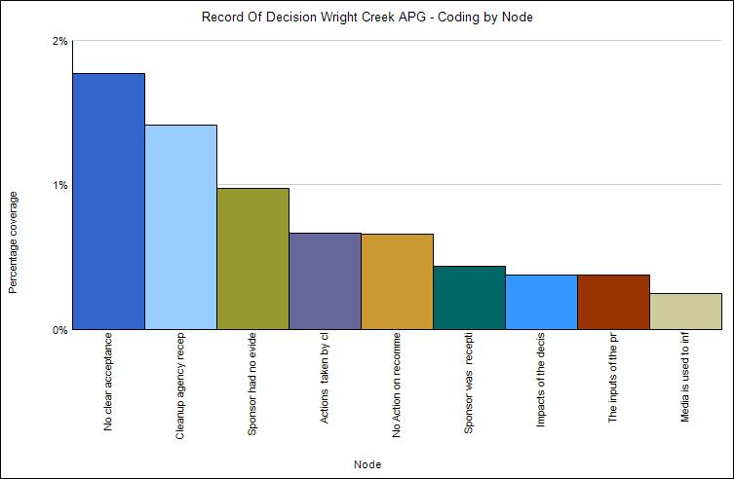

The themes evident in the analysis of the Record of Decision (ROD) documents for the Wright Creek site at Aberdeen Proving Ground indicates that there is no clear acceptance beforehand on how the output of the public participation process will be utilized. The least evident theme associated with the Wright Creek site was the use of the media to inform the general public on specific ways the public participation process influenced public policy.
In contrast to the Western Creek site, the analysis of the Western Shore Record of Decision (ROD) did not produce a dominant theme. The themes evident in the analysis (use of the media to inform the general public on specific ways the public participation process influenced public policy and sponsor receptiveness to decision inputs from public participants) were equally split.

Record of Decision Western Shore APG Coding by Node
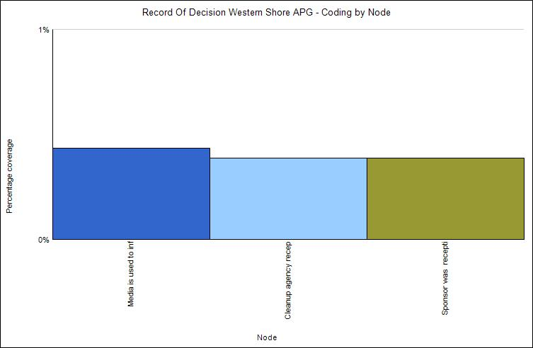

The themes evident in the analysis of the Doves Cove Record of Decision (ROD) were almost equally divided. It shows that there was no action on the recommendations provided by public participants, although the cleanup agency was responsive to the decision inputs of public participants. The Doves Cove site also did not utilize the media to inform the general public on specific ways the public participation process influenced public policy.

Record of Decision Doves Cove APG Coding by Node
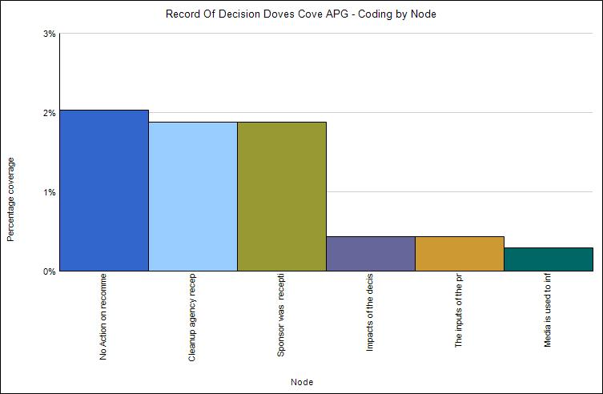

Fort Meade Record of Decision Analysis
Record of Decision Manor View Fort Meade Coding by Node
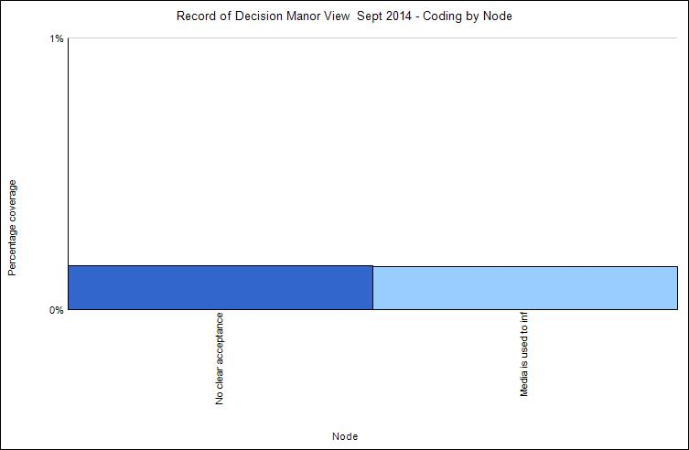
‘No clear acceptance beforehand as to how the output of the public participation process will be utilized’, and the use of the media to inform the general public on the specific ways in which the public’s input influenced public policy are the only evident themes in the analysis of the Manor View Record of Decision (ROD) site at Fort Meade.
The analysis of the Record of Decision (ROD) associate with the Former Pesticide Shop at Fort Meade indicates that the most evident theme was the use of the media to inform the public on how public participation decision inputs influences public policy, while the least visible theme was the lack of a clear acceptance beforehand on how the output of the process will be utilized. The results of the analysis performed on the Former Mortar Range Site Record of Decision shows an equal split between sponsor’s receptiveness to public participation decision inputs, and its unwillingness to be receptive to such inputs. The least visible theme for the site was a clear acceptance beforehand, as to how the output of the participation process will be utilized.
Record of Decision Former Pesticide Shop Fort Meade Coding by Node
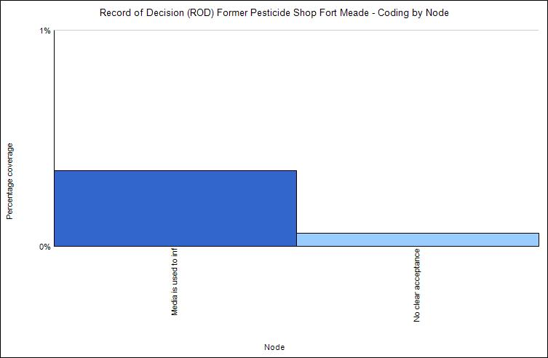
Record of Decision Former Mortar Range Fort Meade Coding by Node
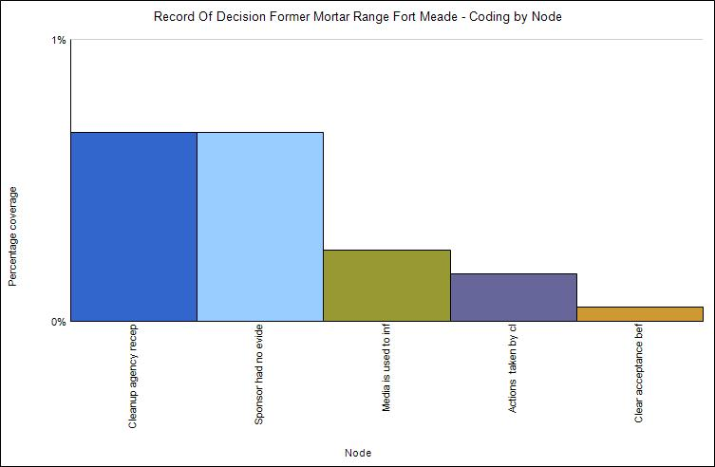

APG RAB Meeting Minutes Analysis
APG January 2016 RAB Meeting Minutes Coding by Node
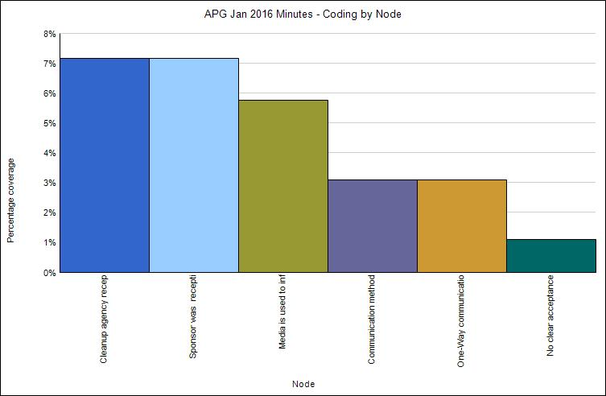

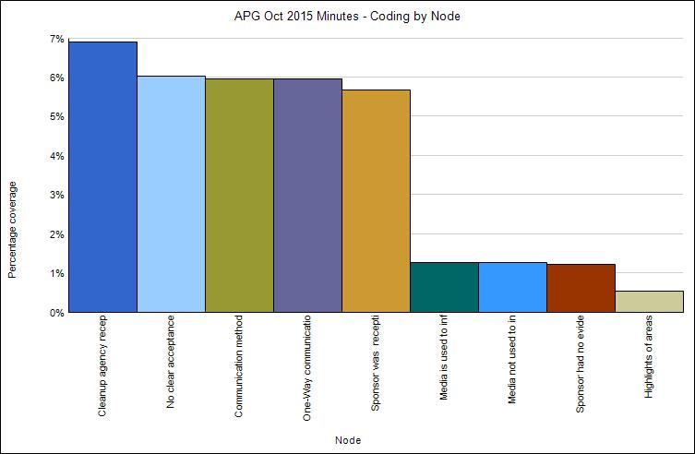
APG September 2015 RAB Meeting Minutes Coding by Node
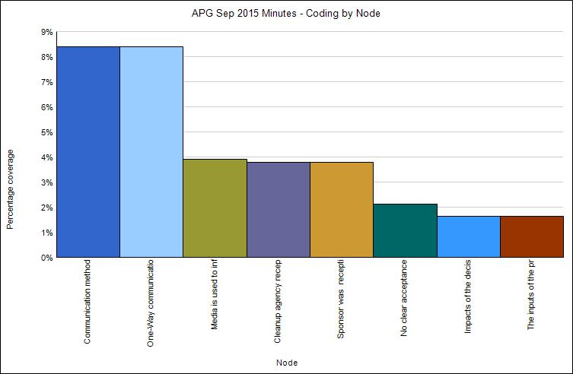
APG June 2015 RAB Meeting Minutes Coding by Node
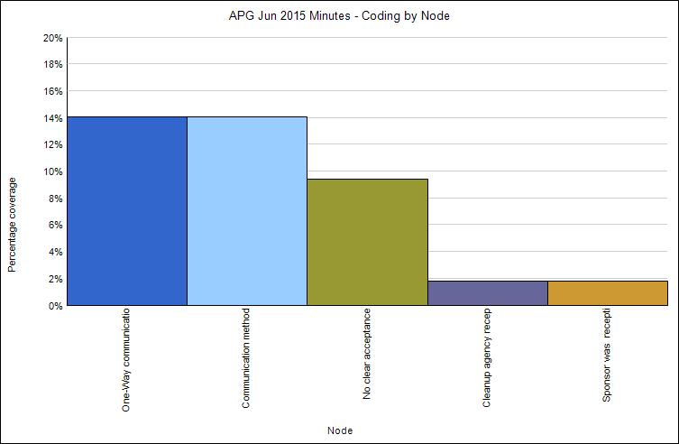
APG May 2015 RAB Meeting Minutes Coding by Node
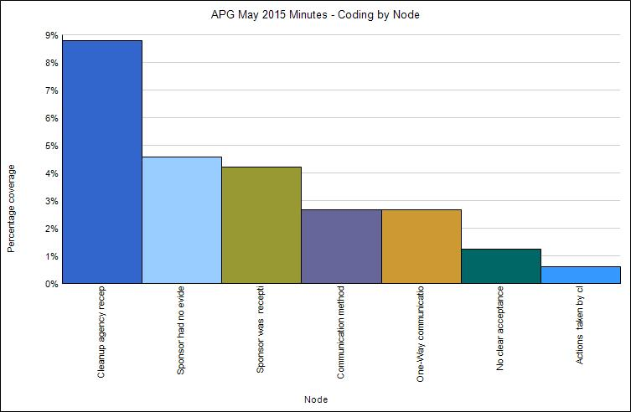
APG February 2015 RAB Meeting Minutes Coding by Node
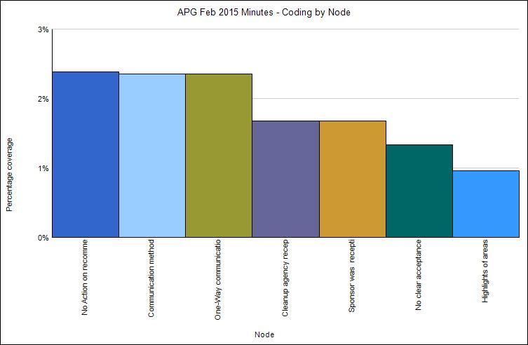
APG October 2014 RAB Meeting Minutes Coding by Node
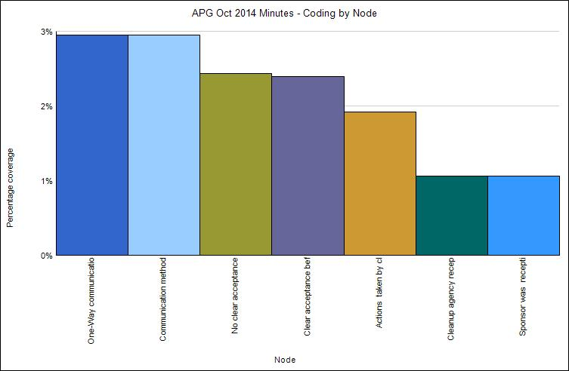
APG September 2014 RAB Meeting Minutes Coding by Node
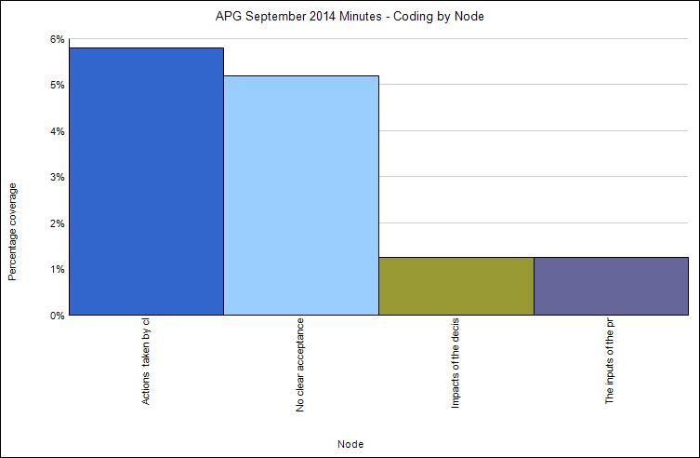

APG June 2014 RAB Meeting Minutes Coding by Node
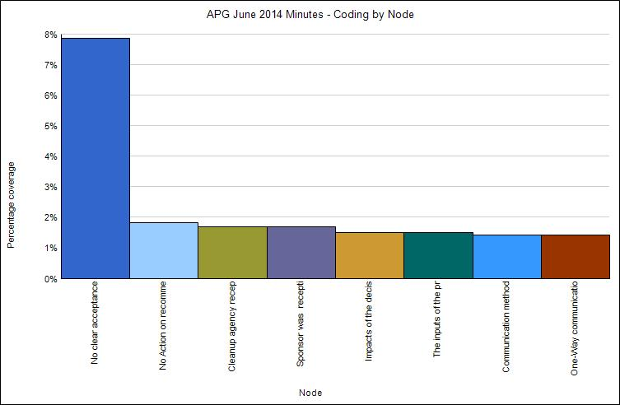

APG January 2014 RAB Meeting Minutes Coding by Node
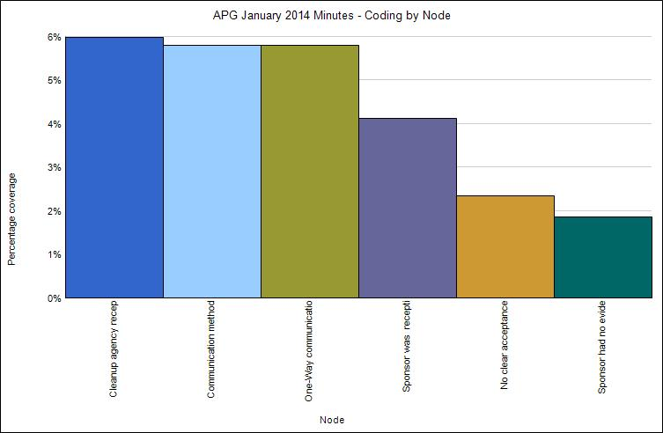

APG October 2013 RAB Meeting Minutes Coding by Node
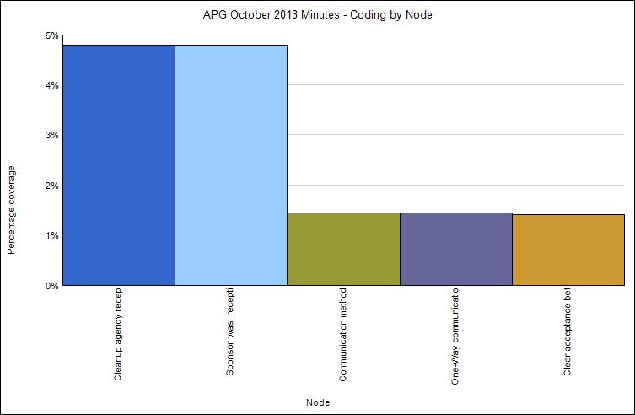

APG September 2013 RAB Meeting Minutes Coding by Node
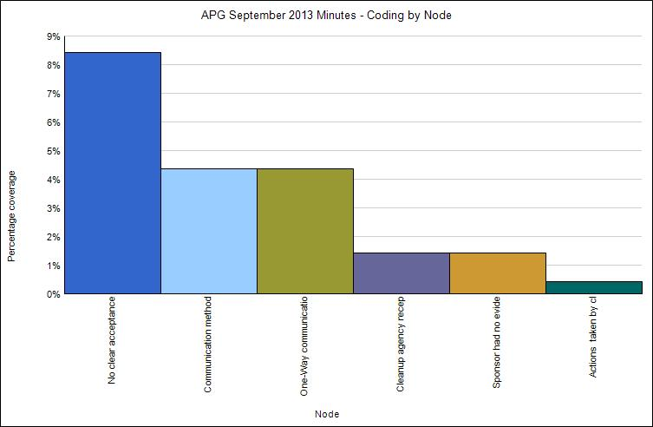

APG June 2013 RAB Meeting Minutes Coding by Node
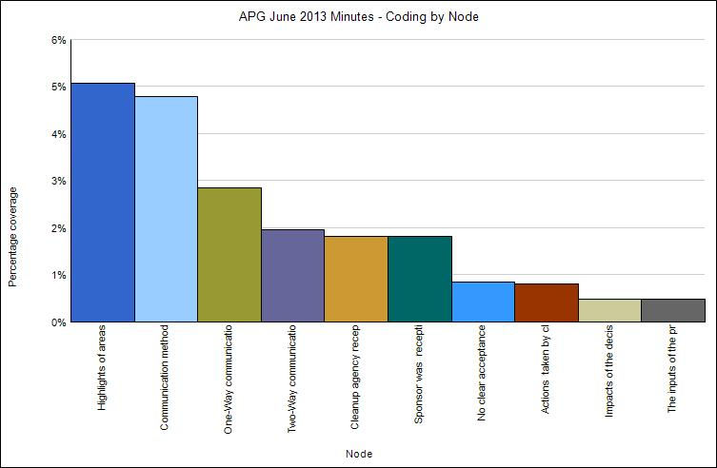

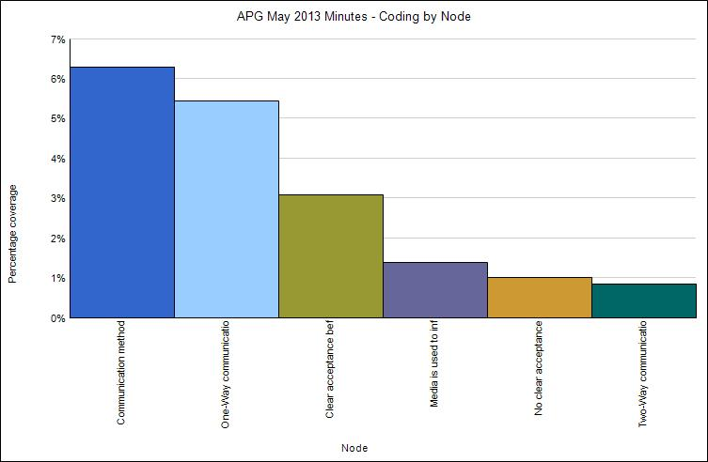

APG February 2013 RAB Meeting Minutes Coding by Node
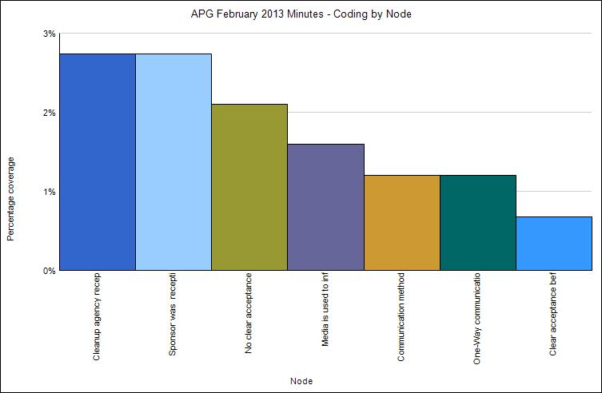

APG January 2013 RAB Meeting Minutes Coding by Node
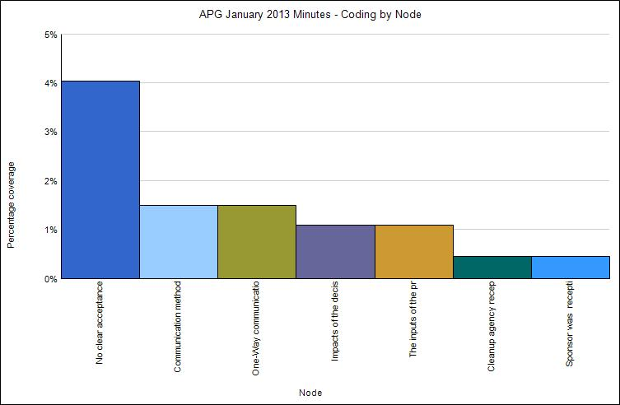

APG October 2012 RAB Meeting Minutes Coding by Node
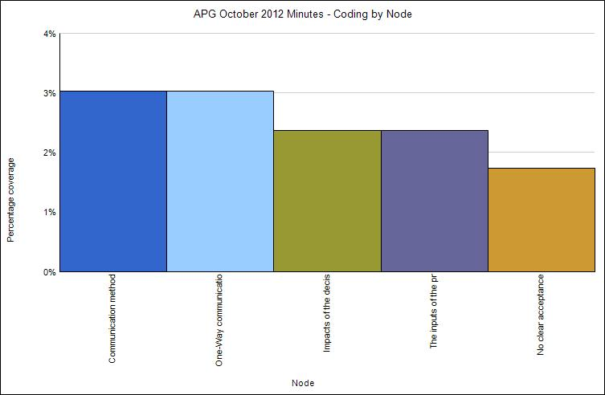

inform

APG September 2012 RAB Meeting Minutes Coding by Node
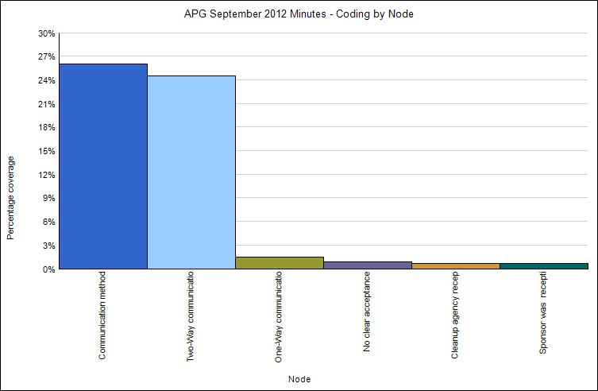

APG June 2012 RAB Meeting Minutes Coding by Node
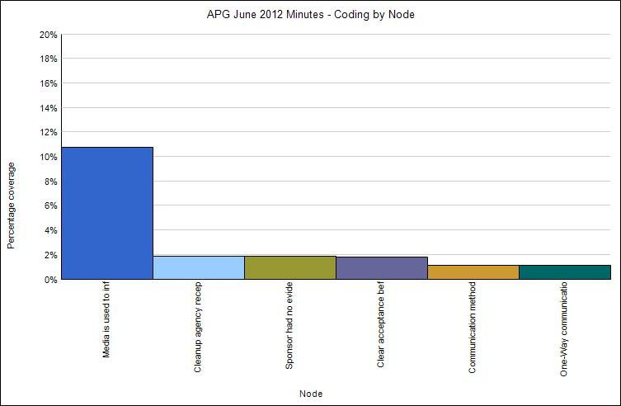

APG May 2012 RAB Meeting Minutes Coding by Node
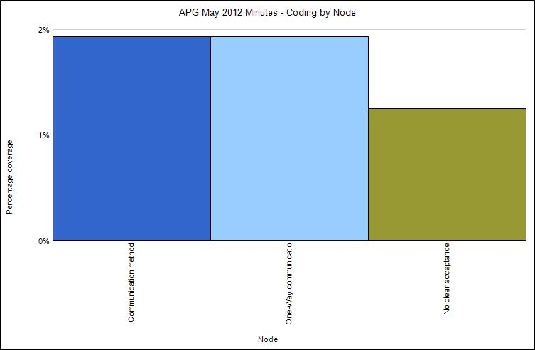

APG January 2012 RAB Meeting Minutes Coding by Node
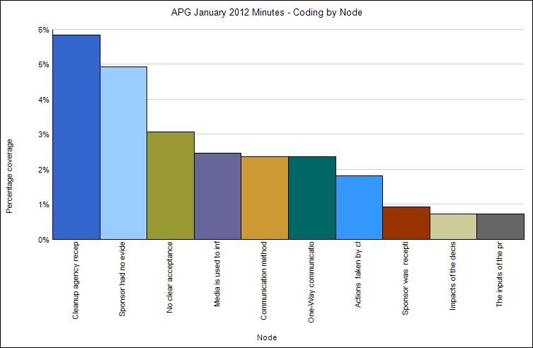

Fort Meade RAB Meeting Minutes Analysis
Fort Meade January 2016 RAB Meeting Minutes Coding by Node
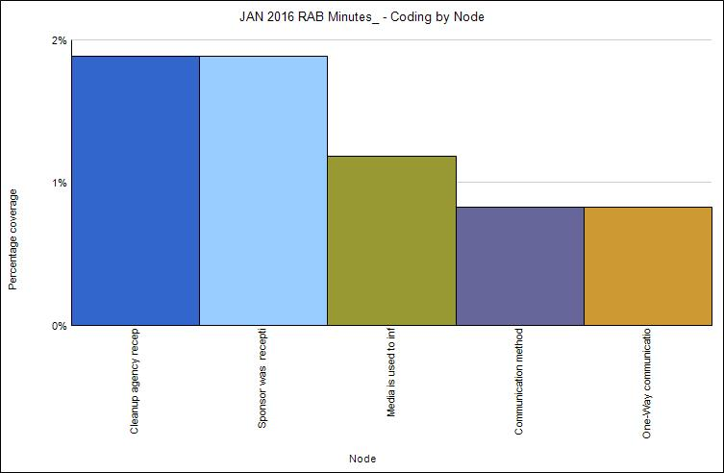

Fort Meade November 2015 RAB Meeting Minutes Coding by Node
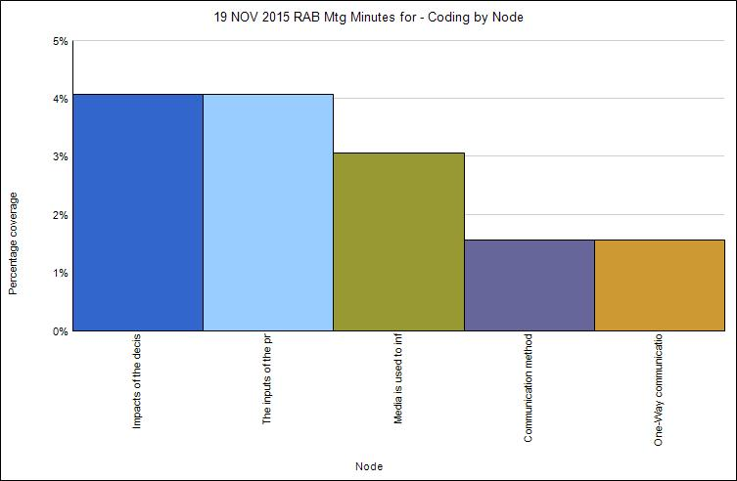

Fort Meade September 2015 RAB Meeting Minutes Coding by Node
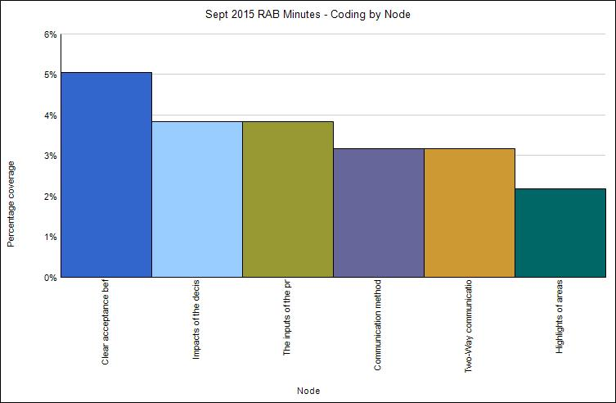

Fort Meade May 2015 RAB Meeting Minutes Coding by Node
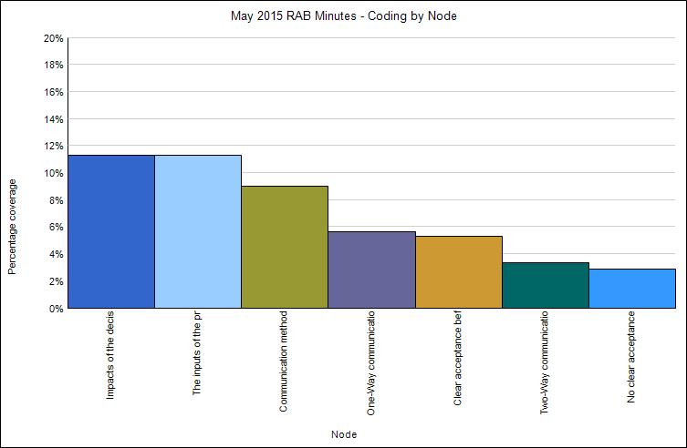

Fort Meade March 2015 RAB Meeting Minutes Coding by Node
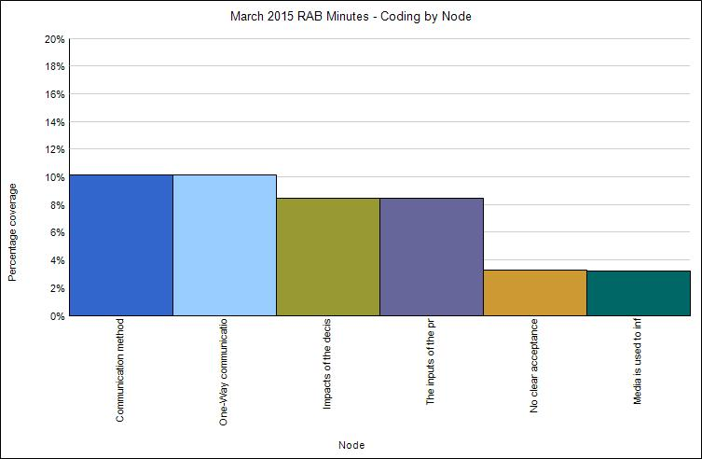

Fort Meade January 2015 RAB Meeting Minutes Coding by Node
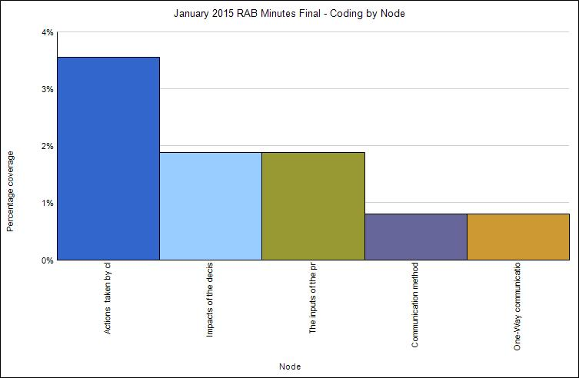

Fort Meade November 2014 RAB Meeting Minutes Coding by Node
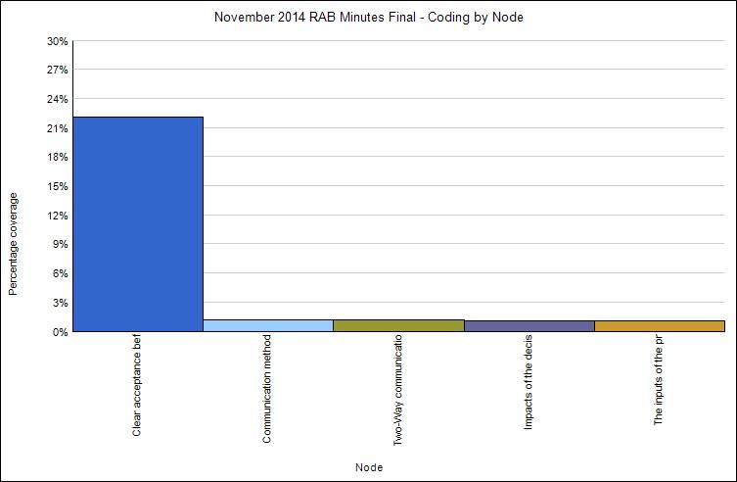

Fort Meade September 2014 RAB Meeting Minutes Coding by Node
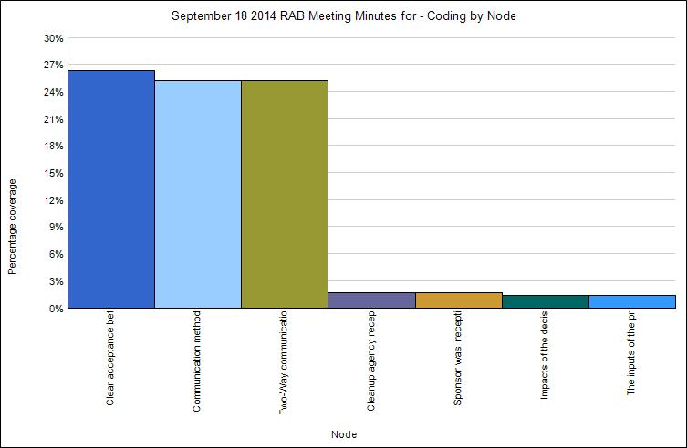

Fort Meade July 2014 RAB Meeting Minutes Coding by Node
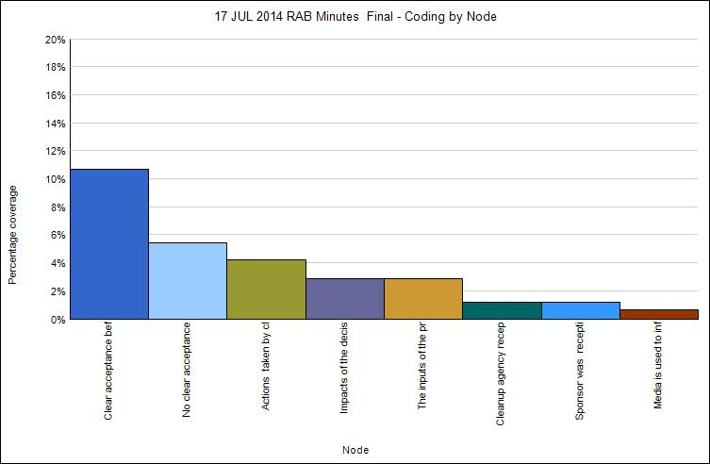

Fort Meade May 2014 RAB Meeting Minutes Coding by Node
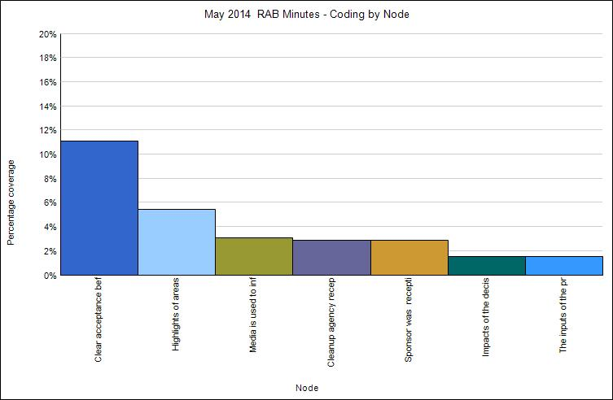

Fort Meade Mar 2014 RAB Meeting Minutes Coding by Node
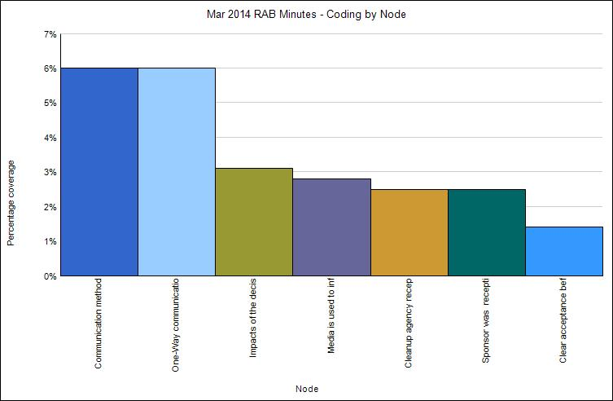

Fort Meade January 2014 RAB Meeting Minutes Coding by Node
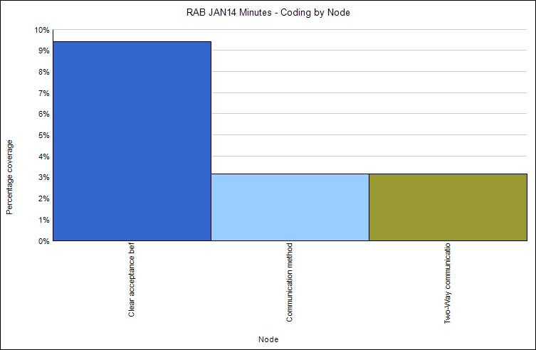

Fort Meade November 2013 RAB Meeting Minutes Coding by Node
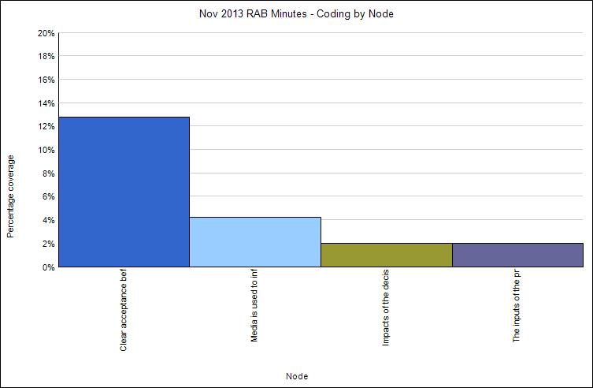

Fort Meade September 2013 RAB Meeting Minutes Coding by Node
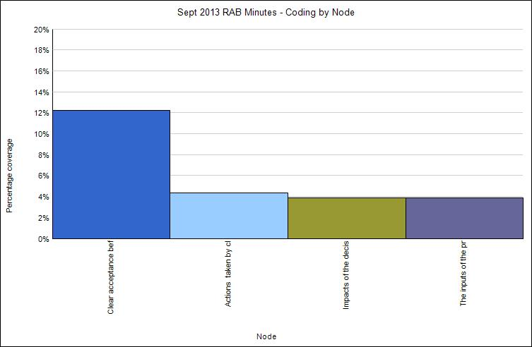

Fort Meade July 2013 RAB Meeting Minutes Coding by Node
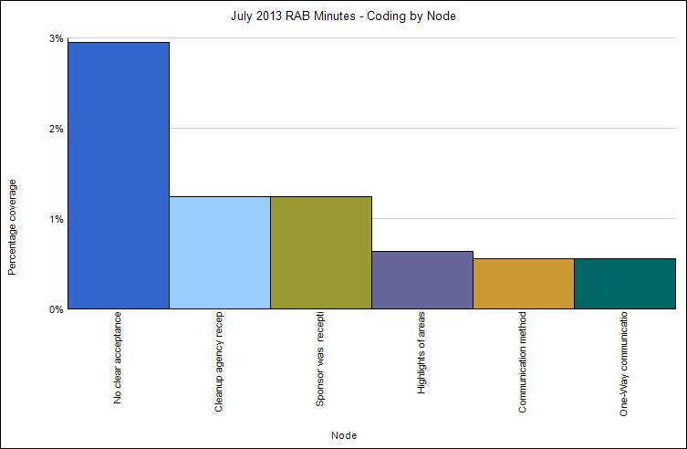

Fort Meade March 2013 RAB Meeting Minutes Coding by Node
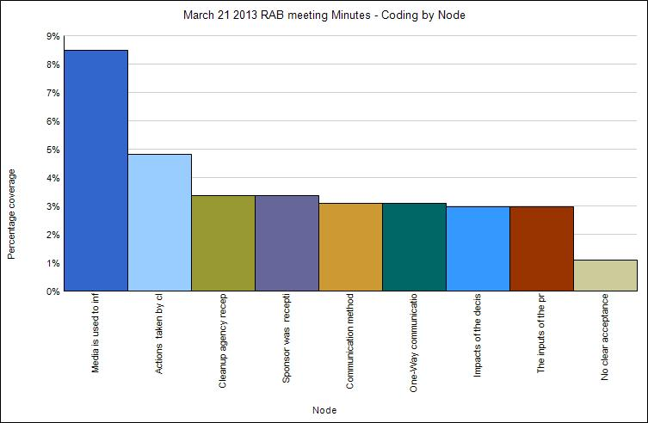

Fort Meade January 2013 RAB Meeting Minutes Coding by Node
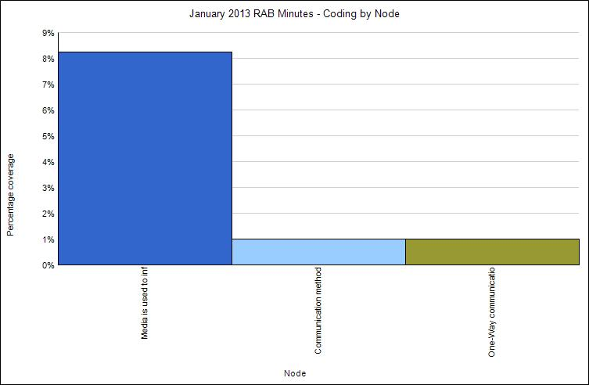

Fort Meade November 2012 RAB Meeting Minutes Coding by Node
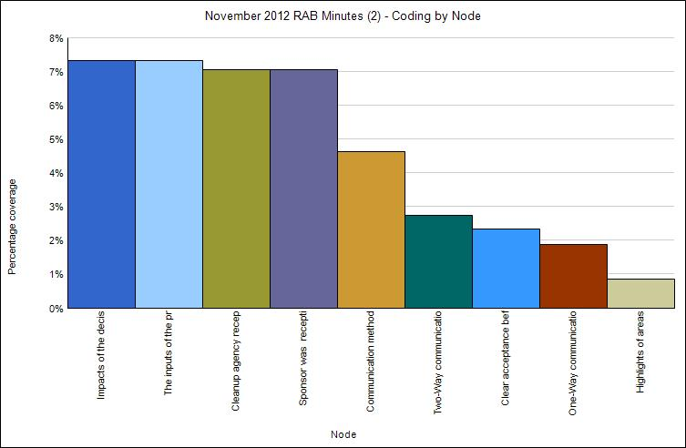

Fort Meade September 2012 RAB Meeting Minutes Coding by Node
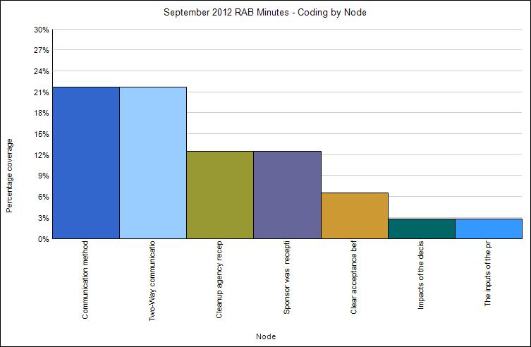

Fort Meade July 2012 RAB Meeting Minutes Coding by Node
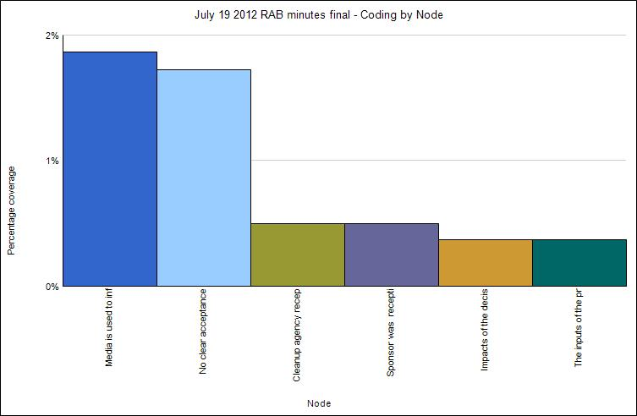

Fort Meade May 2012 RAB Meeting Minutes Coding by Node
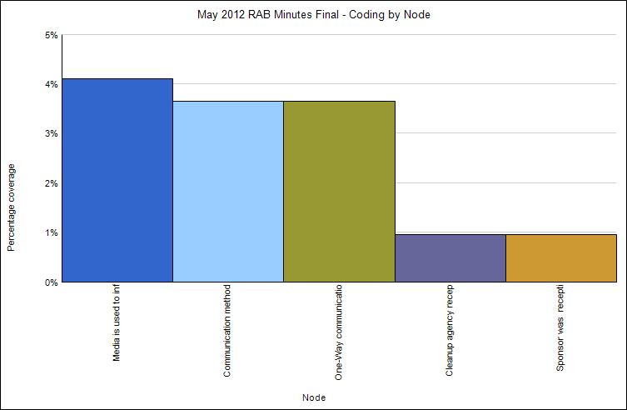

Fort Meade Mar 2012 RAB Meeting Minutes Coding by Node
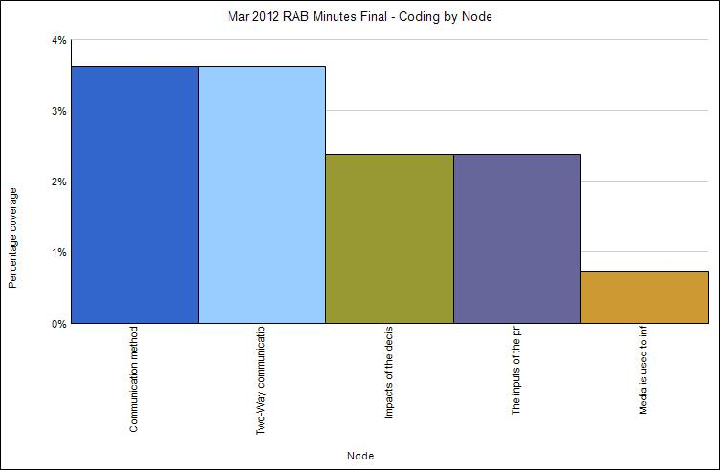
Fort Meade January 2012 RAB Meeting Minutes Coding by Node
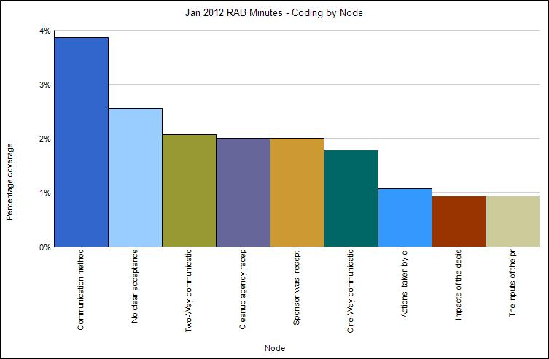

Bureau of Land Management. Public Land Statistics. vol. 191, 2006, p. 160.
See http://www.denix.osd.mil/.
See www.epa.gov/superfund.
Congressional Budget Office. CBO Papers: Environmental Cleanup Issues Associated with Closing Military Bases. August 1992, p. 4.
See http://search.cdc.gov/search?subset=atsdr&query=military+cleanup&utf8=%E2%9C%93&affiliate=cdc-main&sitelimit=www.atsdr.cdc.gov.
See http://search.cdc.gov/search?subset=atsdr&query=military+cleanup&utf8=%E2%9C%93&affiliate=cdc-main&sitelimit=www.atsdr.cdc.gov.
See http://www.law360.com/articles/576310/developer-fights-army-s-bid-to-toss-37m-contamination-suit.
See http://www.denix.osd.mil/perchloratesummaries/.
Government Accountability Office. Environmental Contamination: Information on the Funding and Cleanup Status of Defense Sites. GAO-10-547-T, 2010.
See http://www.law.umaryland.edu/environment/documents/env_newsletter_summerfall_2003.pdf.
See https://www.justice.gov/enrd/chevron-usa-v-natural-res-def-council.
See https://ceq.doe.gov/laws_and_executive_orders/the_nepa_statute.html.
See https://elr.info/sites/default/files/litigation/6.20787.htm.
See https://www.epa.gov/aboutepa/epa-history-resource-conservation-and-recovery-act.
US Department of Defense. Department of Defense Manual. 4715.20, March 9, 2012, p. 81.
See https://www.epa.gov/superfund/superfund-amendments-and-reauthorization-act-sara.
See https://www.epa.gov/epcra.
See https://search.epa.gov/epasearch/epasearch?querytext=g.%09Defense+Base+Closure+and+Realignment+Act &areaname=&areacontacts=&areasearchurl=&typeofsearch=epa&result_template=2col.ftl.
See https://www.epa.gov/laws-regulations/summary-federal-advisory-committee-act.
See http://www.mde.state.md.us/programs/PressRoom/Pages/1161.aspx.
See http://articles.baltimoresun.com/2004-02-08/news/0402080181_1_maps-citizens-coalition-unexploded-ordnance.
See http://www.bcdc.ca.gov/history.html.
Thomas A. Bryer, “Explaining Responsiveness in Collaboration: Administrator and Citizen Role Perceptions,” Public Administration Review 69, no. 2 (March/April 2009): 63, 271-283.
Thomas C. Beierle, “Using Social Goals to Evaluate Public Participation in Environmental Decisions,” Review of Policy Research (2005): 75-103.
Gene Rowe and Lynn Frewer, “Evaluating Public Participation Exercises: A Research Agenda,” Science, Technology, and Human Values 29, no. 4 (Autumn 2004): 512.
See http://www.denix.osd.mil/rab/upload/RAB-Rule-Handbook_Final.pdf.
See http://www.gao.gov/assets/220/219533.pdf.
Department of Defense, 2005 Defense Base Closure and Realignment Commission Report, p. 23.
See http://www.brac.gov/docs/brac05legislation.pdf.
Government Accountability Office. Military Base Realignments and Closures: Key Factors Contributing to BRAC 2005 Results, GAO-12-513T, 2012, p. 5.
See https://www.epa.gov/superfund/superfund-amendments-and-reauthorization-act-sara.
See http://www.aec.army.mil/Services/Restore/ArmyCleanupProgram.aspx.
See http://www.aec.army.mil/Services/Support/NEPA/Documents.aspx.
Department of Defense Manual 4715.20, March 9, 2012, p. 24.
See http://www.edwards.af.mil/shared/media/document/AFD-060516-006.pdf.
Department of Defense Manual 4715.20, March 9, 2012, p. 24.
See http://www.gsa.gov/portal/content/100916.
Jan Dul and Tony Hak, Case Study Methodology in Business Research (Great Britain: Elsevier Ltd., 2008), 9.
Elena Maggioni, Hal Nelson, and Daniel A. Mazmanian, “Industry Influence in Stakeholder-Driven State Climate Change Planning Efforts.” Policy Studies Journal 40, no. 2 (2012): 232.
https://www.nap.edu/catalog/12434/public-participation-in-environmental-assessment-and-decision-making
Michael Quinn Patton, Qualitative Research and Evaluation Methods (SAGE Publications, 2002), Fourth Edition (2014) p. 40.
See http://www.gao.gov/assets/660/654596.pdf.
Agency for Toxic Substances and Disease Registry, Public Assessment on Aberdeen Proving Ground, 2008.
See http://www.atsdr.cdc.gov/hac/pha/pha.asp?docid=1087&pg=1.
See http://www.atsdr.cdc.gov/hac/pha/pha.asp?docid=1087&pg=1.
See http://msa.maryland.gov/megafile/msa/stagsere/se1/se5/024000/024500/024560/pdf/msa_se5_24560.pdf.
Michael P. Grady, Qualitative and Action Research: A Practitioner Handbook (1998), Phi Delta Kappa Intl Inc Bloomington, IN, page 28.
Immy Holloway and Stephanie Wheeler, Qualitative Research in Nursing and Healthcare (2009), Wiley Blackwell West Sussex, page 118.
See https://ofmpub.epa.gov/sor_internet/registry/termreg/searchandretrieve/termsandacronyms/search.do?matchCriteria=Contains&checkedTerm=on&checkedAcronym=on&search=Search&term=record%20of%20decision.
United States Environmental Protection Agency: A Guide to Preparing Superfund Proposed Plans, Records of Decision, and Other Remedy Selection Decision Documents (July 1999), 1-5.
Anne Galletta, Mastering the Semi-Structured Interview and Beyond. (New York: NY University Press), 22.
Karin Klenke, Qualitative Research in the Study of Leadership (Emerald Group Publishing), 130.
Margaret C. Harrell and Melissa A. Bradley, Data Collection Methods: Semi-Structured Interviews and Focus Groups (RAND National Defense Research Institute, 2009), 27.
See https://www.epa.gov/fedfac/restoration-advisory-board-rab-implementation-guidelines.
Matthew B. Miles, A. Michael Huberman, and Johnny Saldana, Qualitative Data Analysis: A Methods Sourcebook (2014) third edition, SAGE Publications Inc London, 74.
Johnny Saldana, The Coding Manual for Qualitative Researchers (2016), second edition, SAGE Publications Inc London, 9.
John W. Creswell, Qualitative Inquiry and Research Design: Choosing Five Approaches (2012), third edition, SAGE Publications Inc, London. 160.
Patricia Bazeley and Kristi Jackson, Qualitative Analysis with NVivo (2013).
NVivo 10 for Windows: QSR International.
Karin Klenke, Qualitative Research in the Study of Leadership (2015), 100.
Patricia Bazeley and Kristi Jackson, Qualitative Data Analysis with NVivo (2013), 83.
Matthew B. Miles, A. Michael Huberman, and Johnny Saldana, Qualitative Data Analysis: A Methods Sourcebook (Sage Publications, 2014), 12.
Matthew B. Miles, A. Michael Huberman, and Johnny Saldana, Qualitative Data Analysis: A Methods Sourcebook (2014), 12.
Patricia Bazeley and Kristi Jackson, Qualitative Analysis with NVivo (2013).
See https://books.google.com/books?id=samriQZJyXwC&pg=PA117&lpg=PA117&dq=cleanup+at+military+installations+without+citizen+input&source=bl&ots=QMT_d55jbe&sig=zDVxDuM7__LUU5c4p-bS6CxClC8&hl=en&sa=X&ved=0ahUKEwjhwubcg9nSAhXC4iYKHeP6A_gQ6AEINzAF#v=onepage&q=cleanup%20at%20military%20installations%20without%20citizen%20input&f=false.
See http://ir.lawnet.fordham.edu/cgi/viewcontent.cgi?article=1446&context=elr.
See https://books.google.com/books?id=RlKvbHlE1psC&pg=PA237&dq=record+of+decision+definition+for+EPA+cleanup&hl=en&sa=X&ved=0ahUKEwiMwP74g5bVAhWJFj4KHYe7ByA4HhDoAQgnMAE#v=onepage&q=record%20of%20decision%20definition%20for%20EPA%20cleanup&f=false.
See https://books.google.com/books?id=AIVpuWBcXToC&pg=PA667&dq=record+of+decision+definition+for+EPA+cleanup&hl=en&sa=X&ved=0ahUKEwjU3_aw-ZXVAhXHbD4KHZyFDMMQ6AEILTAC#v=onepage&q=record%20of%20decision%20definition%20for%20EPA%20cleanup&f=false.
Record of Decision OEA Doves Cove Investigation Area Aberdeen Proving Ground, Maryland. August 2011, p. 48.
Record of Decision DEA Wright Creek Investigation Area Aberdeen Proving Ground, Maryland. May 2011, p. 49
Gene Rowe and Lynn Frewer, Public Participation Methods: A Framework for Evaluation (2000), 15.
See https://www.merriam-webster.com/dictionary/receptive.
See https://cecom.aep.army.mil/cecom/home/CG/Lists/STR/Open%20Items.aspx.
See http://www.eco-usa.net/superfund_sites/maryland_superfund_sites.shtml.
See http://www.eco-usa.net/orgs/md.shtml.
See https://www.epa.gov/nepa/national-environmental-policy-act-review-process.
See https://www.epa.gov/international-cooperation/public-participation-guide-introduction-public-participation.
See https://www.epa.gov/international-cooperation/public-participation-guide-introduction-public-participation.

