
Journal of Geophysical Research: Atmospheres
Supporting Information for
Formaldehyde column density measurements as a suitable pathway to estimate near-surface ozone tendencies from space

Jason R. Schroeder^{1,2}, James H. Crawford¹, Alan Fried³, James Walega³, Andrew Weinheimer⁴, Armin Wisthaler^{5,6}, Markus Müller⁵, Tomas Mikoviny⁶, Gao Chen¹, Michael Shook¹, Donald R. Blake⁷, Glenn Diskin¹, Mark Estes⁸, Anne M. Thompson^{9,10}, Barry L. Lefer^{11,*}, Russell Long¹², Eric Mattson¹³

¹ NASA Langley Research Center, Hampton, VA, USA, ² NASA postdoctoral program, NASA Langley Research Center, Hampton, VA, USA, ³ Institute of Arctic and Alpine Research, University of Colorado, Boulder, CO, USA, ⁴ National Center for Atmospheric Research, Boulder, CO, USA, ⁵ Institute of Ion Physics and Applied Physics, University of Innsbruck, Austria, ⁶ Department of Chemistry, University of Oslo, Oslo, Norway, ⁷ Department of Chemistry, University of California Irvine, Irvine, CA, USA, ⁸ Texas Commission on Environmental Quality, Austin, TX, USA, ⁹ Department of Meteorology, Penn State University, University Park, PA, USA, ¹⁰ NASA Goddard Space Flight Center, Greenbelt, MD, USA, ¹¹ Department of Earth & Atmospheric Science, University of Houston, Houston, TX, USA, ¹² National Exposure Research Laboratory, US EPA, Research Triangle Park, NC, USA, ¹³ Colorado Department of Public Health and Environment, Denver, CO, USA

* Now at NASA Headquarters, Washington, DC, USA

Contents of this file

Figures S1 to S13
Table S1

Introduction
This supporting information provides figures and tables referenced in support of the main text. All figures and tables in this document are referenced in the main text.

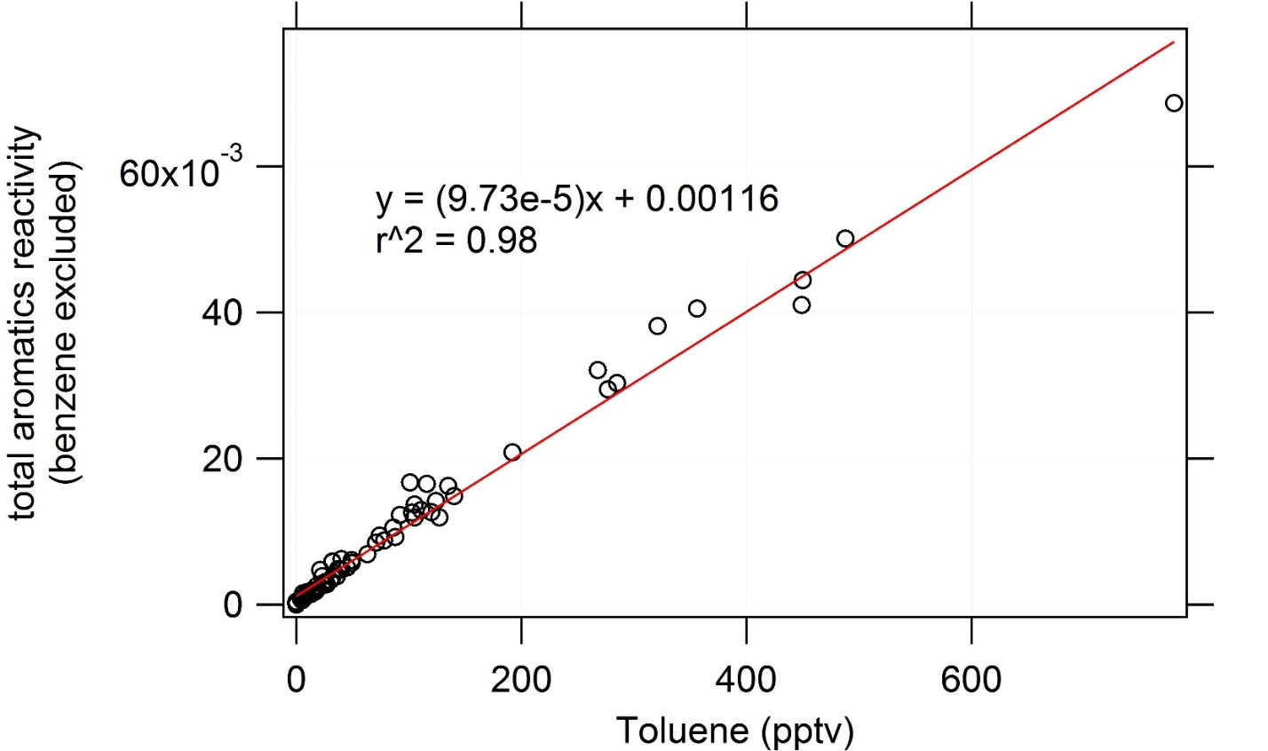

Figure S1. A plot of aromatic reactivity (as calculated from WAS collected during SEAC4RS) vs toluene (measured by WAS). Because toluene was also measured onboard the P-3B by the PTrMS, this relationship was used to estimate aromatic reactivity onboard the P-3B. Then, reactivity was converted to a mixing ratio using the rate constant for the reaction between OH and lumped aromatics in the model.

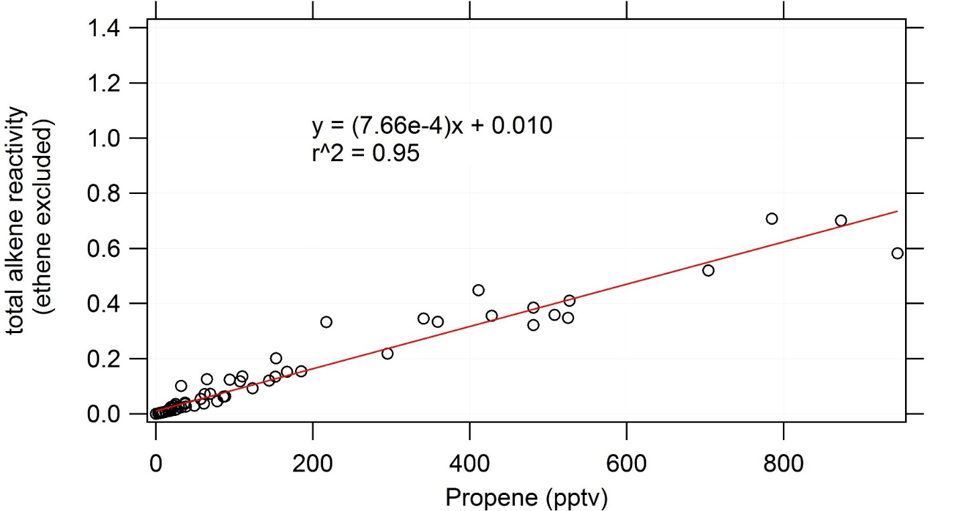
Figure S2. A plot of C3+ alkene reactivity (as calculated from WAS collected during SEAC4RS) vs propene (measured by WAS). Because propene was also measured onboard the P-3B by the PTrMS, this relationship was used to estimate C3+ alkene reactivity onboard the P-3B. Then, reactivity was converted to a mixing ratio using the rate constant for the reaction between OH and lumped C3+ alkenes in the model.
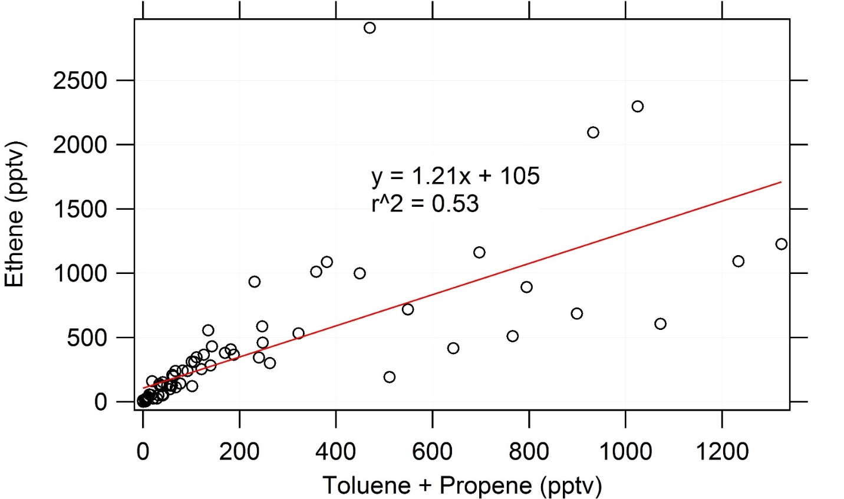
Figure S3. A plot of ethene mixing ratios (measured by WAS) vs the sum of toluene and propene mixing ratios (measured by WAS). Because toluene and propene were measured onboard the P-3B by PTrMS, this relationship was used to estimate ethene mixing ratios when generating inputs for model runs.

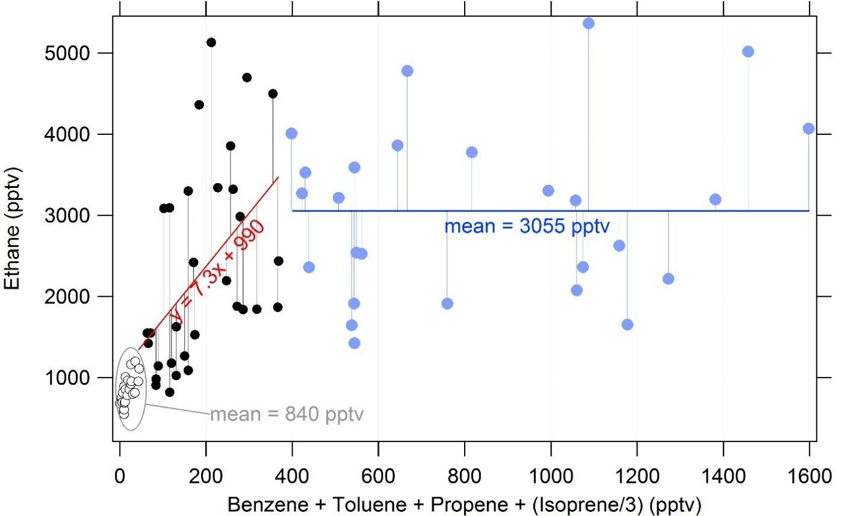
Figure S4. A plot of ethane (measured by WAS) vs the sum of benzene, toluene, propene, and isoprene/3 (measured by WAS). Here, the relationship was broken up into three parts to estimate ethane mixing ratios onboard the P-3B. When the sum of the species on the x-axis was less than 50 pptv, ethane was set equal to 840 pptv. When the sum was greater than 400 pptv, ethane was set equal to 3055 pptv. In between these values, ethane was fit to a line.
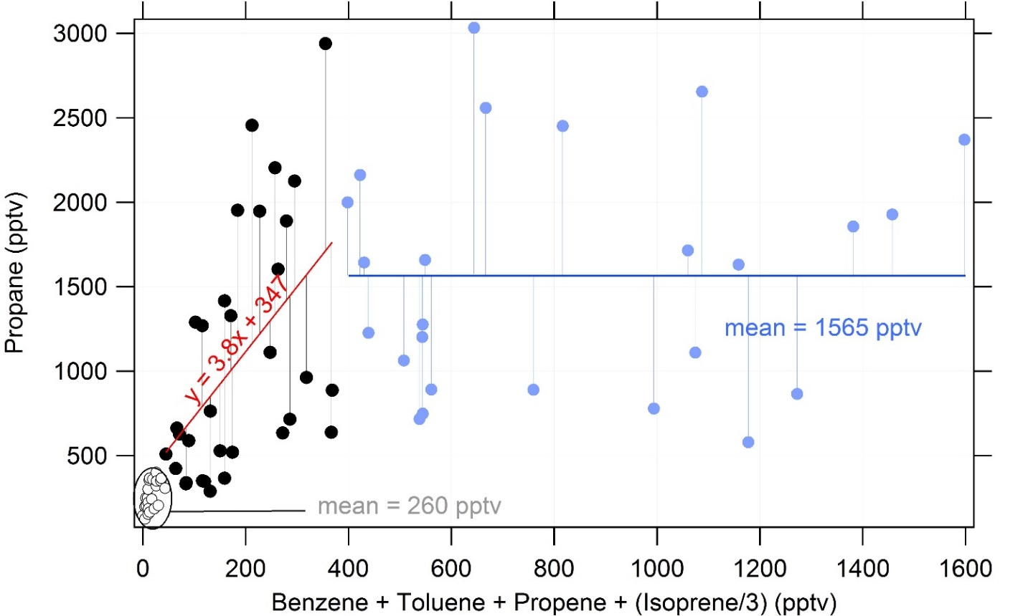
Figure S5. A plot of propane (measured by WAS) vs the sum of benzene, toluene, propene, and isoprene/3 (measured by WAS). Here, the relationship was broken up into three parts to estimate propane mixing ratios onboard the P-3B for use in model input files. When the sum of the species on the x-axis was less than 50 pptv, propane was set equal to 260 pptv. When the sum was greater than 400 pptv, propane was set equal to 1565 pptv. In between these values, propane was fit to a line.
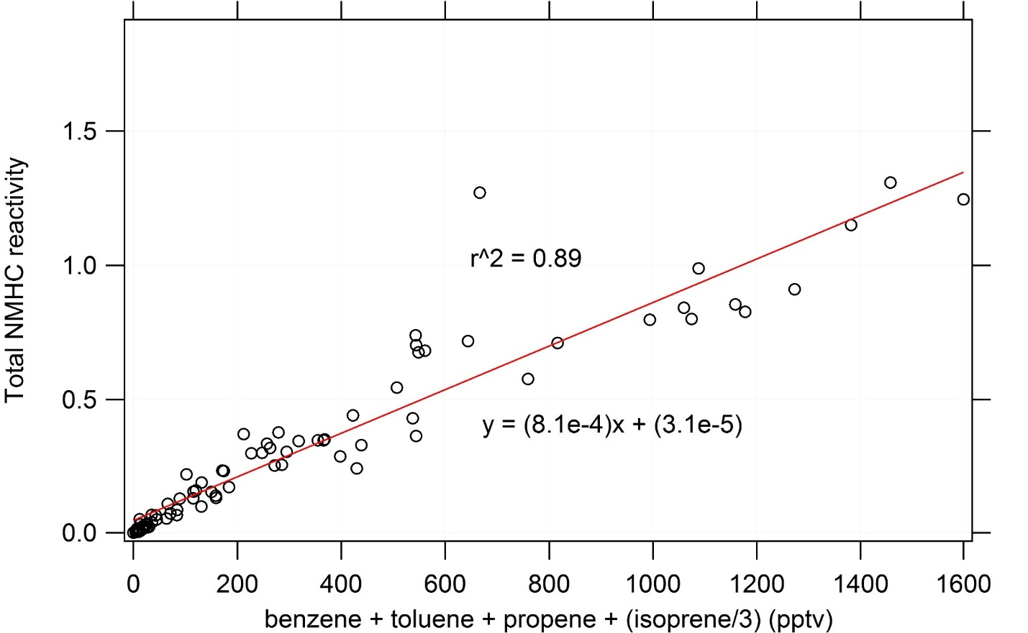
Figure S6. A plot of total NMHC reactivity (calculated from WAS data) vs the sum of the mixing ratios of benzene, toluene, propene, and isoprene/3. Because benzene, toluene, propene, and isoprene were measured onboard the P-3B, this relationship was used to estimate total NMHC reactivity when generating model input files. Using total NMHC reactivity, and the mixing ratios of other hydrocarbons (either measured directly onboard the P-3B or estimated using the relationships above), total C4+ alkane reactivity was calculate as the residual reactivity (i.e. total NMHC reactivity minus the reactivities of all measured/estimated NMHCs). Then, C4+ reactivity was converted to a mixing ratio using the rate constant between lumped C4+ alkanes and OH used in the model.

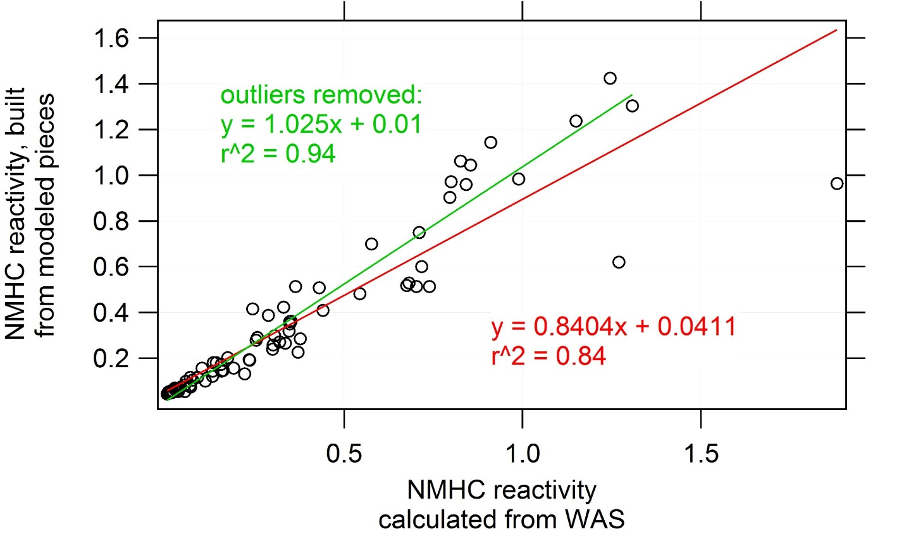
Figure S7. A comparison of NMHC reactivity as constructed using the relationships shown above vs the calculated NMHC reactivity obtained using WAS data.

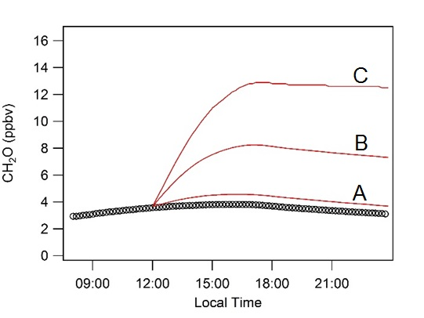
Figure S8. Box-model simulation of the diurnal profile of CH2O. The black trace represents a relatively clean “base case”, where trace gas mixing ratios are held constant throughout the day. Traces A, B, and C represent simulations where, at 12:00, the mixing ratios of certain trace gases are abruptly changed to new levels, and these new levels were maintained for the rest of the day. The trace gas mixing ratios used in these simulations are given in Table .
Table S1. Mixing ratios of trace gases that were varied in the simulation described in Figure S8. All mixing ratios are given in ppbv.
 | NOx | Ethane | Propane | Alkanes (lumped) | Ethene | Alkenes (lumped) | Isoprene
Base case | 0.2 | 1.0 | 0.6 | 0.15 | 0.1 | 0.4 | 0.1
A | 1.2 | 1.5 | 0.8 | 0.2 | 0.3 | 0.5 | 0.15
B | 3.2 | 2 | 1.1 | 0.3 | 0.9 | 0.8 | 0.5
C | 6.2 | 3.0 | 1.6 | 0.5 | 1.5 | 1.3 | 1

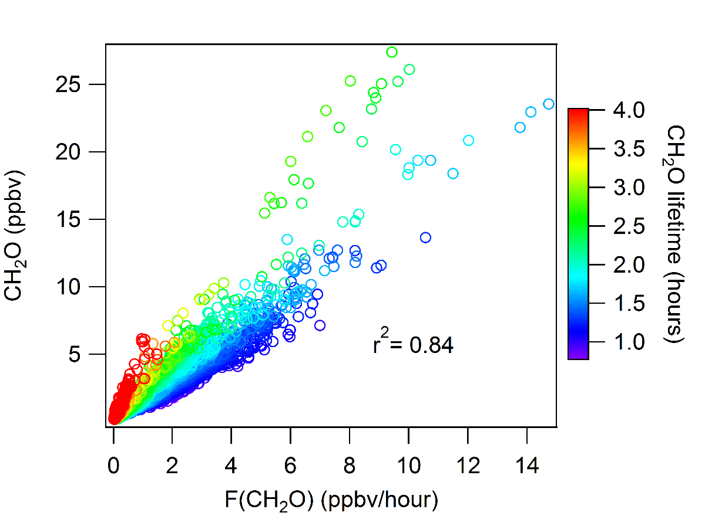
Figure S9. A plot showing the relationship between ambient CH2O mixing ratios and the instantaneous rate of CH2O formation. The relationship depends largely on the local CH2O lifetime.

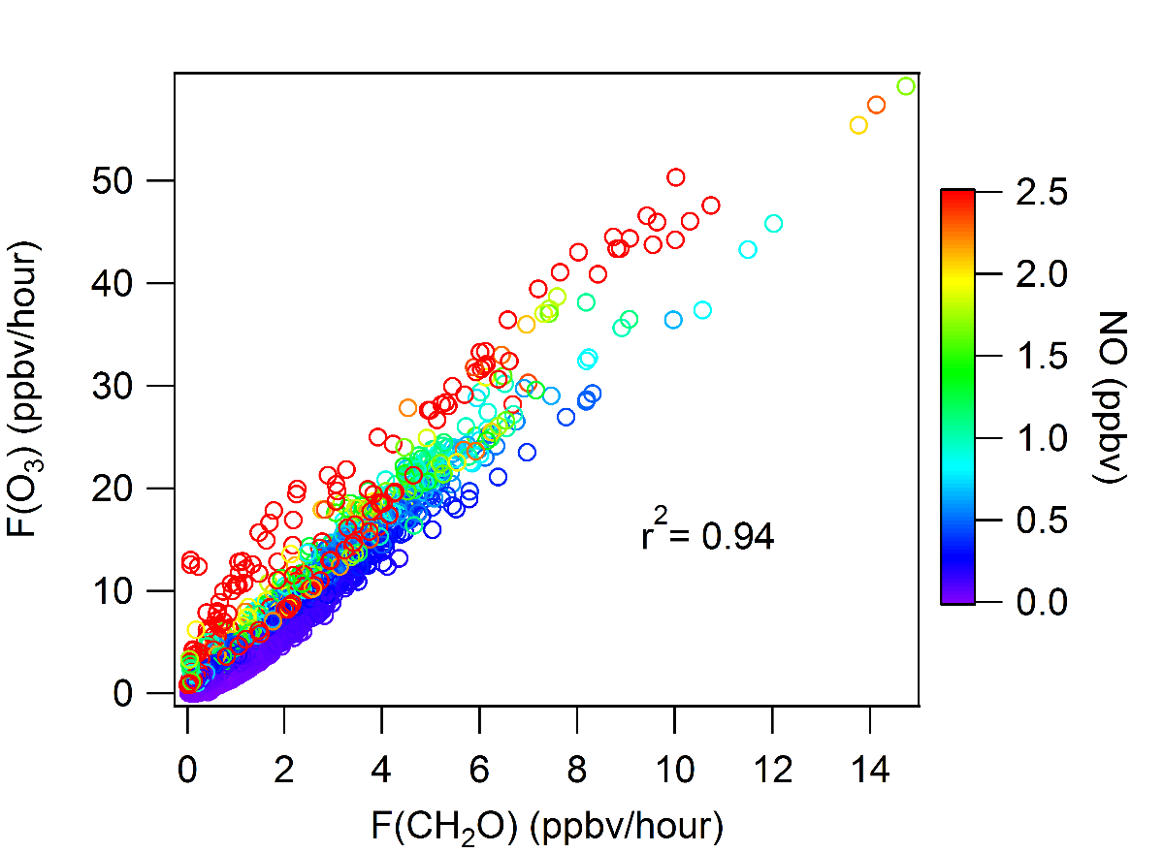
Figure S10. A plot showing the relationship between the instantaneous rate of formation of O3 and the instantaneous rate of formation of CH2O. The relationship depends largely on ambient NO mixing ratios.
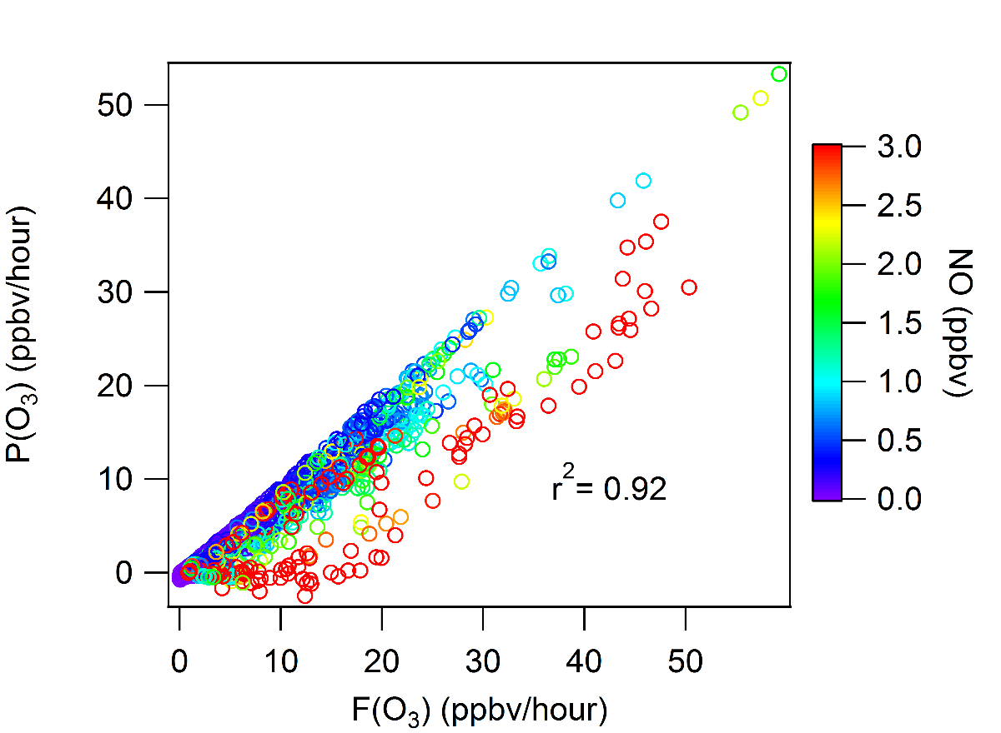
Figure S11. A plot showing the relationship between the net rate of instantaneous O3 production and the instantaneous rate of formation of O3. The relationship depends on ambient NO mixing ratios.
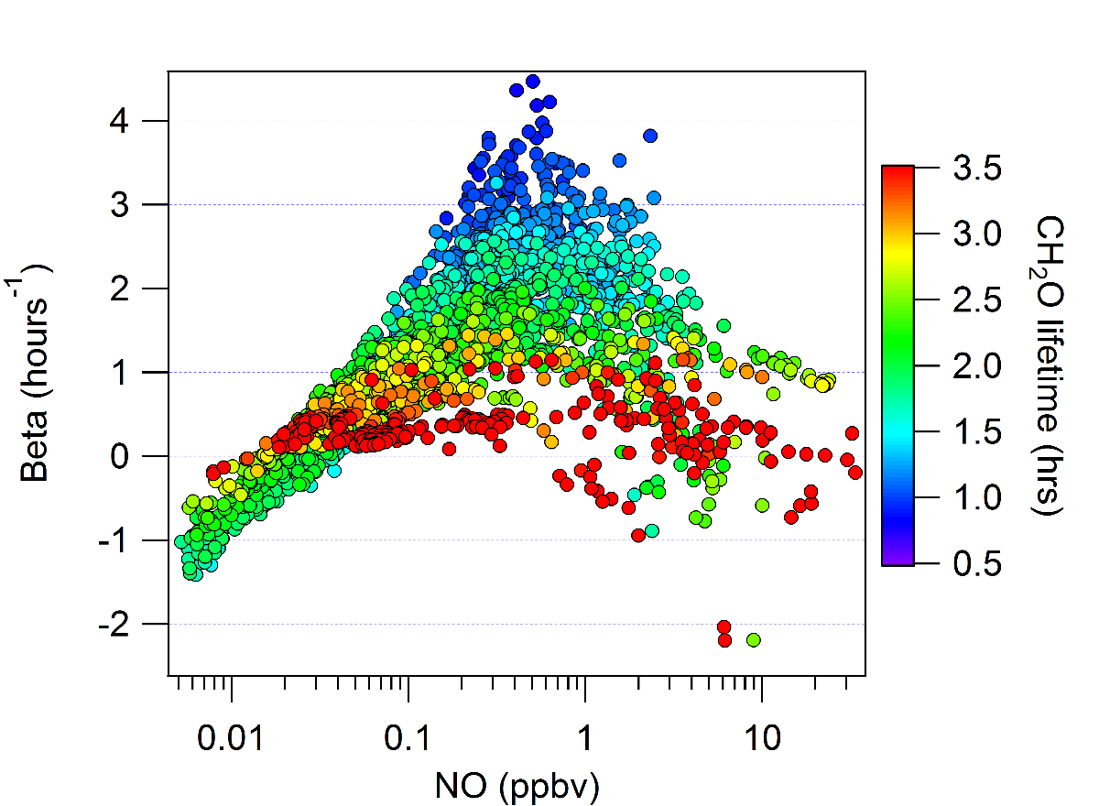

Figure S12. A plot of the proportionality factor β (shown in equation XIII in the main text) versus NO. The plot is colorized by the local CH2O lifetime.

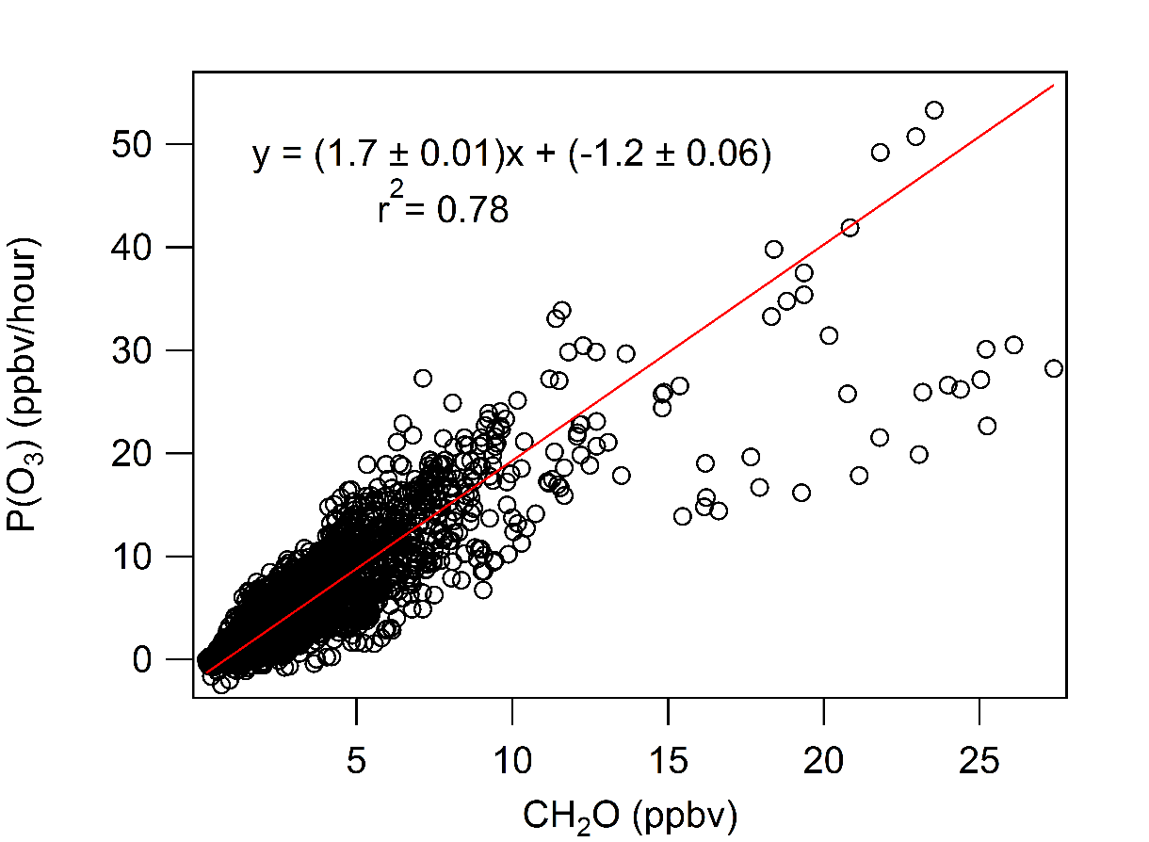
Figure S13. A plot of the instantaneous rate of O3 production versus ambient CH2O mixing ratios.

