Online Appendix: Additional Data Description

A.1. Identification of Agricultural Land Covers Using the CDL

The spatiotemporal resolution of the Cropland Data Layer (CDL) makes it a useful and practical resource for examining agricultural land use change over time. However, as several previous studies have noted, variability in sensor data, classification methodology, and accuracy are major drawbacks. The effects of such inconsistencies on analyses are difficult to quantify. Methods to improve accuracy and consistency for analytical purposes have been developed, such as filtering and using USDA Common Land Units to define individual farms with common land covers (Kline et al. 2013, Sahajpal et al. 2014, Laingen 2015, Noe 2015, Stevens 2015, Reitsma et al. 2016). We maintain the data’s raw format but aggregate classes into four groups: all crops, spring wheat, durum wheat, and fallow/idle. In our study area, spring and durum wheat are the dominant crop covers. Wheat classes, along with other major commodity crops such as corn, are classified with more accuracy relative to other crops (Laingen 2015).

CDL categories included in the aggregate “all crops” group include: Corn, Alfalfa, Apples, Cotton, Other Hay/Non Alfalfa, Grapes, Rice, Camelina, Christmas Trees, Sorghum, Buckwheat, Other Tree Crops, Soybeans, Sugarbeets, Citrus, Sunflower, Dry Beans, Pecans, Peanuts, Potatoes, Almonds, Tobacco, Other Crops, Walnuts, Sweet Corn, Sugarcane, Pears, Pop / ornamental Corn, Sweet Potatoes, Pistachios, Mint, Miscellaneous vegetables / fruits, Triticale, Barley, Watermelons, Carrots, Durum Wheat, Onions, Asparagus, Spring Wheat, Cucumbers, Garlic, Winter Wheat, Chickpeas, Cantaloupes, Other Small Grains, Lentils, Prunes, Double crop: Winter wheat and soybeans, Peas, Olives, Rye, Tomatoes, Oranges, Oats, Caneberries, Honeydew Melons, Millet, Hops, Broccoli, Speltz, Herbs, Peppers, Canola, Clover/Wildflowers, Pomegranates, Flaxseed, Sod/Grass Seed, Nectarines, Safflower, Switchgrass, Greens, Rapeseed, Cherries, Plums, Mustard, Peaches, and Strawberries.

In the 2006 North Dakota CDL, there is no fallow/idle area. Because this is likely due to differences in classification processes across years, we drop 2006 from analyses of the fallow/idle category, resulting in about an 11 percent decrease in the sample size relative to crop-based regressions.

For non-agricultural land cover, CDL pixels are classified using the most recent National Land Cover Database (NLCD) as training data (USDA 2017). Because the CDL is annual and the NLCD is not, non-agricultural land covers in the CDL lack temporal precision. For example, according to the CDL metadata, the 2013 North Dakota dataset was developed using the 2006 NLCD as training and validation data for non-agricultural land covers. As a result, we are unable to accurately analyze annual changes in non-agricultural land covers such as grassland, pasture, development, forests, and wetlands. Furthermore, the “grassland/pasture” category includes urban, grazing, and other types of grassland cover, and cannot be used for distinguishing agricultural pasture from meadows or wild rangelands (USDA 2017).

Our spatial units of observation are 90 by 90 meter raster cells, generated to align with the CDL. Using the Tabulate Area tool in ArcGIS, we calculate the land cover area in each class per 90 by 90 meter spatial unit. Figure A1 provides a visual example of how the CDL relates to our spatial units, with pink dots representing well locations.

Figure A1: Example of spatial observation units in relation to CDL cells and wells
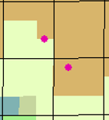

A.2. Identification of Wells and Well Pads Using DrillingInfo Data

Wells with no reported production are likely to be wells that were planned but never began production, and thus do not represent actual disturbances to the landscape. We verified this by visually inspecting USDA 2015 National Agriculture Imagery Program (NAIP) aerial imagery in a sample of such observations (USDA 2015). We found that more than 80 percent of sites showed no indication of an active well pad or historical disturbance.

Figure A2: Example of multiple wells sharing a single well pad
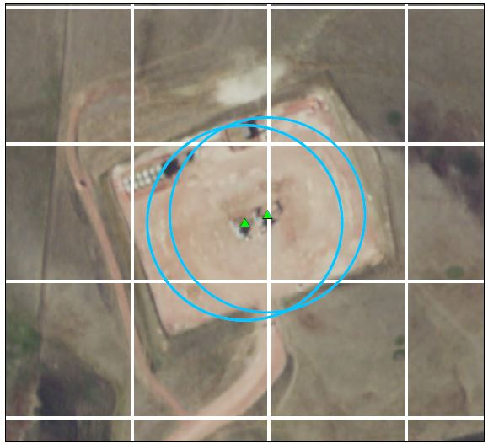

We also used NAIP imagery to establish a circular well pad footprint of about 3.2 acres, with a radius of 64 meters. This buffer size aggregates pads of nearby wells together if wells are within 128 meters of each other. We visually inspected aerial imagery at hundreds of well sites, comparing alternative buffer sizes, and found that 64 meters most frequently accurately represents the pad footprint, as well as the scale at which nearby wells are on common versus individual pads. Figure A2 illustrates an example. The white lines represent our 90 by 90 meter grid, the green triangles represent the locations of the wells provided by DrillingInfo, the blue 64 meter buffers represent well pads, and the NAIP imagery shows that the wells are located on a single well pad. Because the two wells are within 128 meters of each other, the buffers are merged and represent one well pad.

A.3. Average Cropland Values and Rental Rates Over Time
Figure A3: Average cropland values and rental rates over time
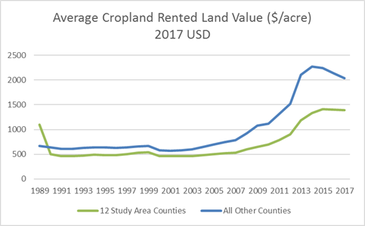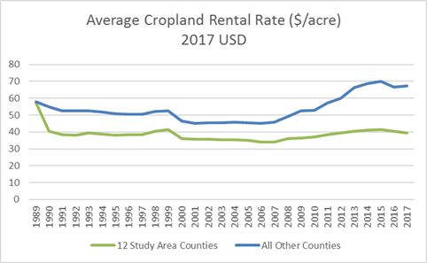

A.4. Robustness Check: Specifications with 2 Annual Leads and 7 Annual Lags

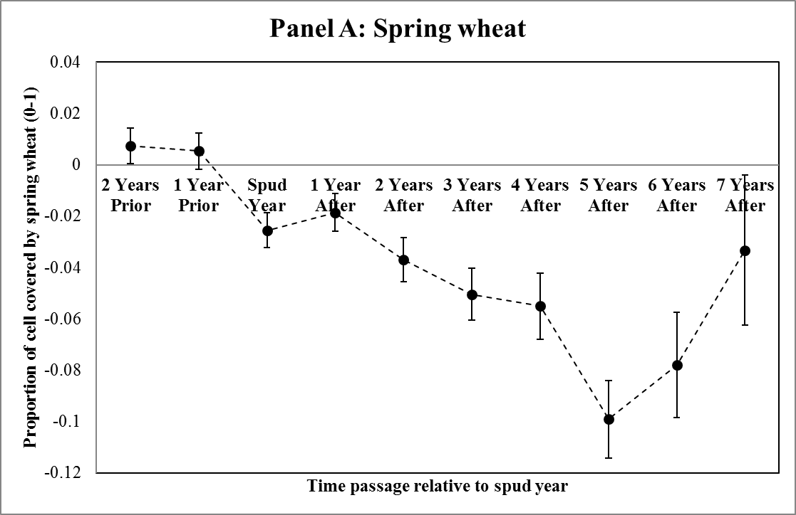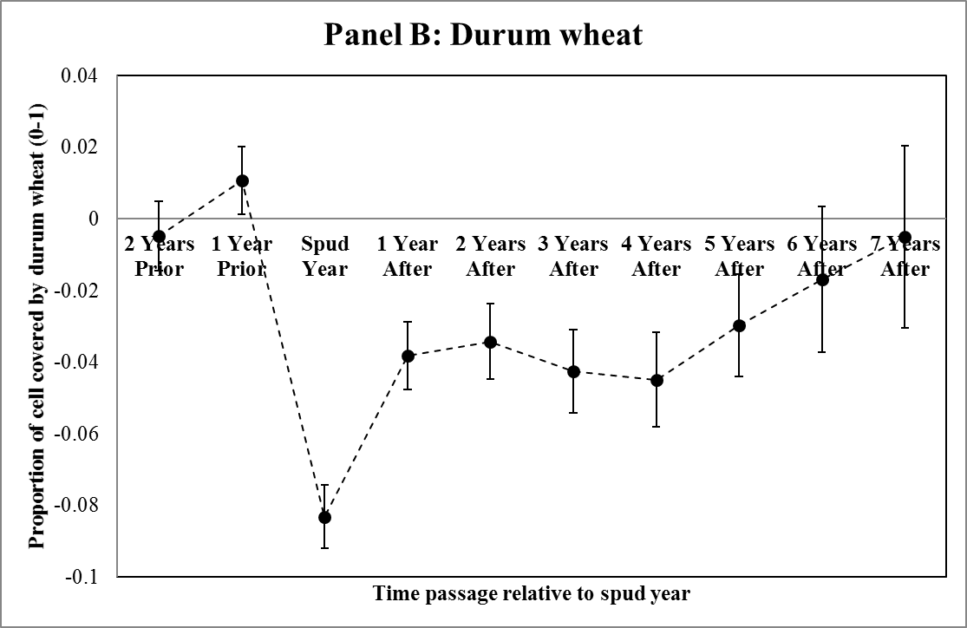

A.5. Data Sources for Other Spatial Features

Water features were acquired through the US Geological Survey (USGS) National Hydrography Dataset version 10.1 for North Dakota (accessed 2016). Bakken Shale play boundaries were acquired from the US Energy Information Administration (EIA) 2015 U.S. Shale Plays data (accessed 2016). Protected area data were acquired from the USGS Gap Analysis Program version 1.4 (accessed 2017). Road data were acquired from the US Census Bureau 2012 TIGER/Line.

A.6. Identification of Cells Covered by Wells or Well Pads

For each year’s set of active wells and well pads, we intersect well points and well pads with our spatial observation cell units. The result is information on the proportion of cell area covered by well pads and the number of wells on those pads. Well pad area is separated into “active” and “newly spudded” area by subtracting the previous year’s total active pad area from the current year. The difference represents the well pad area developed to accommodate newly spudded wells. In regressions which include both active and newly spudded pad area variables, the active pad area is the previous year’s area.

Online Appendix References

Kline, Keith L., Nagendra Singh, and Virginia H. Dale. “Cultivated hay and fallow/idle cropland confound analysis of grassland conversion in the Western Corn Belt.” Proceedings of the National Academy of Sciences 110, no. 31 (2013): E2863-E2863.

Laingen, Chris. “Measuring cropland change: A cautionary tale.” Papers in Applied Geography 1, no. 1 (2015): 65-72.

Noe, Ryan R. Uncertainty in Cropland Data Layer derived land-use change estimates: putting corn and soy expansion estimates in context. University of Minnesota, 2015.

Reitsma, Kurtis D., David E. Clay, Sharon A. Clay, Barry H. Dunn, and Cheryl Reese. “Does the US cropland data layer provide an accurate benchmark for land-use change estimates?” Agronomy Journal 108, no. 1 (2016): 266-272.

Sahajpal, Ritvik, Xuesong Zhang, Roberto C. Izaurralde, Ilya Gelfand, and George C. Hurtt. “Identifying representative crop rotation patterns and grassland loss in the US Western Corn Belt.” Computers and Electronics in Agriculture 108 (2014): 173-182.

Stevens, Andrew. Fueling Local Water Pollution: Ethanol Refineries, Land Use, and Nitrate Runoff. 2015 AAEA & WAEA Joint Annual Meeting, July 26-28, San Francisco, California, Agricultural and Applied Economics Association & Western Agricultural Economics Association, 2015.

USDA (United States Department of Agriculture). “CropScape and Cropland Data Layers: FAQ’s.” National Agricultural Statistics Service (NASS), 2017. https://www.nass.usda.gov/Research_and_Science/Cropland/sarsfaqs2.php

USDA (United States Department of Agriculture). Geospatial data gateway. Available at: http://datagateway.nrcs.usda.gov, 2015. Accessed April 2017.

