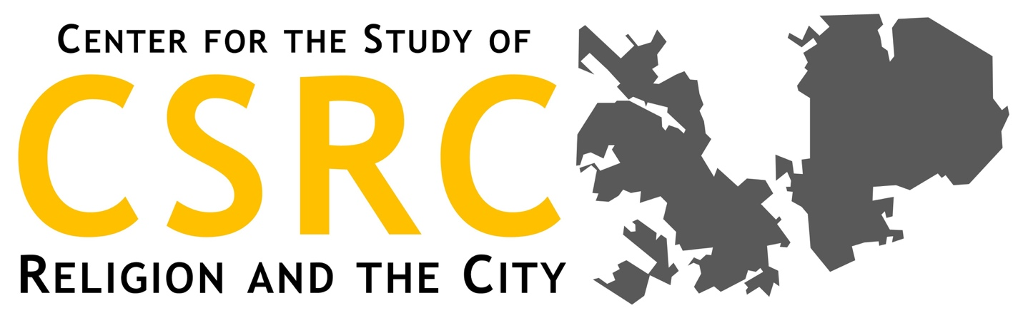
Center for the Study of Religion and the City (CSRC) Documentation of 2020 Relief and Restoration Work: Coding and Themes from the Oral History Interview 2 with Sogorea Te Land Trust

Topic 0

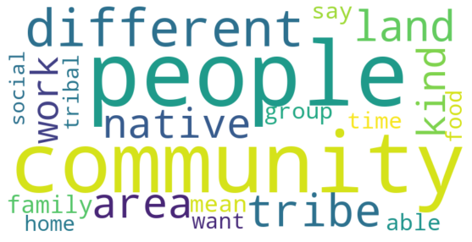
Sogorea Te Land Trust - Interview 2.txt, Nazshonnii Brown (00:45:25):
--------------------------
I think, it's just very, in the native community here, and in the Bay Area community as a whole, it's all about connecting people. Being able to, for educational purposes, or professional reasons, or just community gatherings, pow wows, dancing, having dance groups. There are a lot of traditional dance groups out here. I think that's a big way that we do that. I'm trying to think of how we honor, like if someone has experienced a loss, just being able to be there for them. And, then if there is some sort of ceremony in that particular way, the community comes together to support them.

Sogorea Te Land Trust - Interview 2.txt, Nazshonnii Brown (00:59:17):
--------------------------
So, that's something I think about, too. Like, my family on either side, none of them are from here, so it's like, I'm not an Oakland native, but I'm native. And, maybe you're California native, but not from this area, we all have to think about this conversation and how we can engage in it and do right by the traditional people of this land. And, that's something that's reciprocal, like the work that Corrina has done for more of her life, and also Johnella, with their activism and the work that we do as a organization, is thinking about our community as a whole. Yeah.

Topic 1 (N/A for this group)

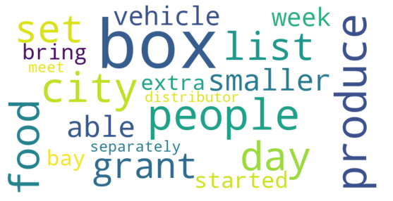

Topic 2 (N/A for this group)

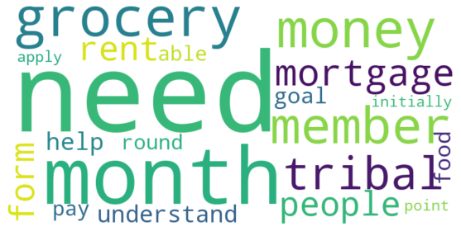

Topic 3

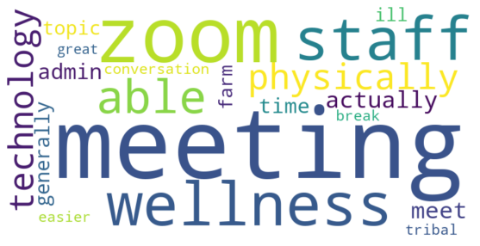
Sogorea Te Land Trust - Interview 2.txt, Nazshonnii Brown (00:01:30):
--------------------------
As a whole or just specific to... Okay. I would say that we usually have our staff meetings in person, so we're used to getting together in a small room, and we go over a lot of the things that need to be done that week. But, then we also have chance to see each other, to share a meal together. We usually try to get food for that, once a week, in the staff meeting. Then, sometimes we celebrate birthdays, so we're missing a lot of that community gathering aspect.

Sogorea Te Land Trust - Interview 2.txt, Nazshonnii Brown (00:04:01):
--------------------------
They're my favorite. Yeah, we do Zoom calls, we actually don't do that many, but for my position specifically, like I'm doing some admin stuff, and I'm also doing stuff on the land, so I'll have the staff meeting, then I'll have an admin meeting, then I'll have a farm meeting with the farm that we're at, conflict resolution for that farm, and then another organization where I'm representing Sogorea Te in that space. So, it's like, I feel like I get a lot of Zoom. But, that was a side note.

Sogorea Te Land Trust - Interview 2.txt, Nazshonnii Brown (00:04:40):
--------------------------
But yeah, we do do Zoom meetings. Initially that was great, being able to see each other and to check in, because there was a huge break in not seeing each other, but then after a while we noticed that some people were getting burned out from being on the Zoom meetings. So, while technology is amazing and it's keeping us together, we also recognize in how we have to be very mindful of how it impacts our health. And, like what you were saying about, after that two hour meeting, it's like, "Ugh. Another Zoom meeting." That's what it's turning into for some of us, but we also appreciate the fact that we're able to see each other's faces and hear each other's voices.

Sogorea Te Land Trust - Interview 2.txt, Nazshonnii Brown (00:08:22):
--------------------------
Yeah, I think that's what really pushed it, because it was kind of like, there was a break, and it was like, "Whoa. We have a lot of time without going out." So, I think that opened up some time for Pua and Corrina to get started and then brought it to the staff meeting and then like, "Hey, let's just do Zoom." Got a Pro Zoom account. But, definitely yeah, I think in that time where we had to shelter-in-place, it was kind of like, "Well, we need something to stay connected." So, that was our response.

Sogorea Te Land Trust - Interview 2.txt, Nazshonnii Brown (00:18:40):
--------------------------
So far, I think we've just had those two gatherings. We did have a conversation, just with a few people in the staff, because we wanted to discuss something, and it just wasn't working, necessarily in the Zoom meetings. Because we had the larger staff, and then we had the admin meeting, but then we need a more intentional circle for these conversations. So, we got together at the Arbor and were able to sit distanced in that space.

Topic 4
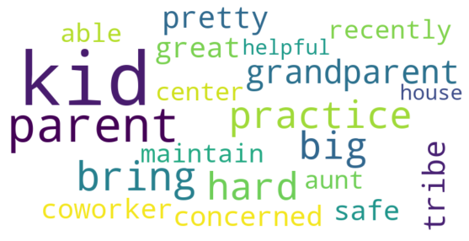
Sogorea Te Land Trust - Interview 2.txt, Nazshonnii Brown (00:23:41):
--------------------------
Because, most of these kids... I was one of those kids, myself, and it's like, I didn't really learn about the Ohlone Tribe until high school, so we think it's very important in getting to know who you are and to know these things, and also that [inaudible 00:23:59] community, I think is what holds a lot of people. Yeah, because I think some people don't always have access to that language that they're from, or sometimes they don't know which tribe, or some things are lost, or just their parents or grandparents are afraid to pass it on, so a lot of kids have to search for it.

Sogorea Te Land Trust - Interview 2.txt, Nazshonnii Brown (00:26:01):
--------------------------
Yeah, there's some different, and then CRC, American Indian Tribe Resource Center. I feel like there's another place. There used to be a school as well, so I feel like, the kids in these communities are usually like, "My aunt works in the San Francisco Health Center. My mom works at this one, I go to IFH for dance practice. I've gone to Stronghold Conference." Or, "I've gone to GONA." I think they move it every year, but it happens more in Headlands. Well, when I went it was. So, I notice that a lot of these kid are in the same communities, and they'll maybe go to one center, or go to that one.

