GirlsTeam: What if Kim Kardashian was a STEM role model?

by
Jessica Lieberman
August 2019

Presented to the
Division of Science, Information Arts, and Technologies
University of Baltimore

In Partial Fulfillment
of the Requirements for the Degree of
Master of Science

Approved by: ________________________________
[Dr. Greg Walsh, Thesis Advisor]

________________________________
[Dr. Bridget Blodgett, Committee Member]

Abstract
The purpose of this paper is to examine the lack of interest young women have in Science Technology Engineering and Math (STEM) degrees and careers. The numbers of available STEM jobs are increasing, but there is a lack of women filling those positions. This paper examines gender biases and stereotypes that may influence young women when choosing whether or not to pursue a STEM as a college major and/or career. I explored potential design solutions to the problem with girls from Baltimore City. The methodology used for this research was design thinking, which consists of emphasizing, defining, ideating, prototyping, and testing the problem. The research was executed in seven 60-minute sessions conducted in a classroom. During these sessions, we discussed STEM jobs, existing STEM resources, gender norms perceived of girls, and produced suggestions for new resources. Our discoveries yielded several recommendations for teachers, designers, and others. Specifically, STEM resources should: (1) Use co-design to expose students to STEM, (2) teach students about STEM professionals in a school setting, (3) introduce students to STEM professionals and encourage those relationships, and (4) teach students about STEM early on.

Table of Contents

List of Figures iv

List of Tables v

Chapter 1: Introduction 1
STEM Education Definition 1
Design Thinking and Co-Design 5
Research Question 5
Hypothesis 6
Synopsis 6

Chapter 2: Literature Review 6
Introduction 6
Why STEM is important for Girls 7
Women Role Models 7
Present Day Role Models 8
Existing STEM Camps, Programs and Workshops for Girls 8
STEM Camp Negatives 10
STEM Resources for Girls: Effective Alternative to Camps 11
Parental and Guardian Influence 15
Teacher Influence 17
Growth Mindset vs. Fixed Mindset & Gender Role Stereotypes 19
Girls Choosing STEM pathway 21
Research Gaps 25

Chapter 3: Methods 26
Design Thinking and Co-design 26
Methodologies 27

Chapter 4: Design Sessions 36
Pre-Session 36
Design Session 1 37
Design Session 2 40
Design Session 3 44
Design Session 4 46
Design Session 5 49
Design Session 6 50
Design Session 7 52

Chapter 5: Results 55
Findings from Design Session 1 55
Findings from Design Session 2 57
Use a game to connect girls with STEM role models 57
Findings from Design Session 3 58
Incorporate art in STEM activities 58
Findings from Design Session 4 58
Findings from Design Session 5 59
Findings From Design Session 6 59
Findings From Design Session 7 60

Chapter 6: Discussion 63
Real World Connections 63
Recommendations for Designing Resources to teach Girls about STEM Education 64
Use co-design to expose girls to STEM 64
Teach girls about STEM professionals in a school setting 65
Expose students to STEM professionals 65
Expose students to STEM early on 67
Introduce girls to STEM resources as games 68

Chapter 7: Conclusion 69

Chapter 8: Limitations and Future Research 70
Longer Co-Design Sessions 70
Interventions with Students 70
What role does gender fill 70

Appendix A 71

Appendix B 73

List of Figures
Figure 1: Pre-Survey Example 38
Figure 2: Powerpoint resources 43
Figure 3: Prototyping with hands on materials 45
Figure 4: Session 4 drawings 46
Figure 5: Cardboard templates 48
Figure 6: Laila presenting final prototype 52
Figure 7: Exit-Survey Example 54
Figure 8: Completed pre-survey, which shows the answer to #6 as "She is a math teacher"An example of a completed pre-survey, which shows the answer to #6 as “She is a math teacher” 58
Figure 9: Tara's Exit Survey Results 62

List of Tables
Table 1: Student Attendance 30
Table 2: Summary of Sessions 40
Table 3: Pre-Survey Sample 55
Table 4: Exit-Survey Sample 60

Chapter 1: Introduction

STEM Education Definition
What is STEM? Why is this a buzzword? Why is it so important? Where did this term come from? These are questions that you may ask yourself when you see the acronym STEM stamped on the side of a bus or printed on fliers taped to the window of your local coffee shop. STEM stands for Science, Technology, Engineering, and Math and is an expansive category spanning many careers and disciplines, such as chemistry, programming, data science, physics, engineering, psychology, economics, and beyond. STEM is more complex than simply what the four terms in the acronym represent.
The need to improve Science and Technology education in the U.S. has been reported and recognized in many education reports since the 1980’s. According to Breiner, Harkness, Johnson, and Koehler (2012), this new curriculum was first identified using the acronym SMET in the 1990’s, but subsequently the term was revised to STEM and used to reference a Science, Technology, Engineering, and Mathematics curriculum. The first use of STEM was introduced by Judith A. Ramaley, former director of NSF (National Science Foundation)’s Education and Human-Resources Division. Since then, the acronym has been adopted by several programs and institutions at national, state, and local levels. Its use within scientific communities is ubiquitous as it is an important topic for educational reform and global U.S. competitiveness. However, there has been a variance in interpreting what STEM should be, as the term has been construed differently from person to person. Those who are defining STEM hold varying perspectives, and come from different backgrounds, such as teacher, businessman, government official, parent, and student. To some, a STEM curriculum should reflect what real world engineers and scientists encounter in their daily lives. For others, the STEM field is about graduating students who will remain academically competitive with other countries. Research by Bybee (2010) supports STEM education is more complicated than solely science and mathematics instruction. A STEM education should encompass students’ understanding of how things work, problem solving methodology, and improving technologies approach. Bybee believes that a STEM education should include more engineering, since the skills and abilities learned through engineering design have proven to be highly useful in the world (Bybee, 2010). Various U.S. stakeholders and many programs have adopted this term as representing a renewed global competitiveness for the U.S. “STEM” is considered short term for creating a better-prepared high school experience in order to keep the United States globally on par with the rest of the world (Breiner et al., 2012).
Many STEM jobs consist of a high paying salary, good work-life balance, and an opportunity to advance professionally. The Department of Education reported that students who studied STEM related curricula during college have a higher salary, higher employment rate, and are more likely to hold only one full time job, as opposed to holding multiple jobs. The report indicated that STEM graduates earn an average of $65,000 yearly while non-STEM graduates, such as Social Studies, Humanities, and General Education earned roughly $15,500 less (Jacobs, 2014). According to The U.S. Bureau of Labor Statistics, there were nearly 8.6 million STEM jobs reported in May 2015. Specifically, computer and information systems jobs represent the majority of occupations in STEM disciplines. Also, STEM occupations’ national average wages are nearly double the national average wages for non-STEM occupations (Fayer, Lacey, & Watson, 2017). Employment in STEM disciplines is projected to increase over the next decade, varying by profession. Computer and mathematical professions are predicted to increase 14.3% (Simmons, 2016).
Even though employment rate predictions are in favor of STEM disciplines, many of these roles will go unfilled. Several high paying STEM occupations require people to hold higher education degrees. 16% of freshmen in high school are reported to have an interest in STEM-related fields (Fayer et al., 2017). However, by the time these students graduate from school, over half of them will lose interest. In 2009, an Educate to Innovate campaign was announced to motivate and inspire students in STEM subjects. Educate to Innovate’s mission was to attract students to the STEM disciplines in order to get Americans to the top of the pack internationally (Hom, 2014). Additionally, thirteen agencies were partners with Committee on STEM Education, or CoSTEM. CoSTEM worked to create a strategy that increased public and youth STEM engagement. Additionally, it improved the STEM experience for undergraduates as well as invested in federal funds for K-12 STEM education. Approximately $3.1 billion in federal programs were dedicated to STEM education, which was used to recruit STEM teachers and support STEM-focused high schools with STEM Innovation Networks (Hom, 2014). There is a national effort to increase the percentage of all students pursuing STEM.
Personal Experience with STEM
Who is interested in STEM? Does STEM interest start as early as elementary school age? Does it begin in middle school? What percentage of women and men pursue STEM degrees and occupations? What do girls think of STEM compared to boys? These are some of the questions I’ve asked myself during my experience as a Computer Science Instructor in Baltimore City.
I worked for the non-profit, Code in the Schools, for almost three years in the southern, eastern, and western neighborhoods of Baltimore City. The overarching goal of my job was focused on getting students interested in computer programming and computer science. My mission was to expand access to computer science education in the public schools of Baltimore City. Through teaching, I also wanted to create opportunities for students to be active participants in the growing technology sectors. I was full time for two years of my teaching career at an East Baltimore School, which will be referenced as EBS in this paper. EBS is a lower income school that has an enrollment consisting of 28% hispanic students, 65% black students, and the rest other. The school is made up of 53% boys and 47% females. I taught grades Pre-Kindergarten (PK) through fifth grade. By the means of lesson planning, I was able to expose students to technology learning tools and connect their experiences in the classroom with real world applications.
At EBS, the classes I taught were part of a rotation cycle with the Enrichment team. The length of each rotation was 6 weeks long. The name of the class I taught was Code. Therefore, I was lucky enough to have the opportunity to teach every student in the elementary school in one school year. I observed that students did not know what type of jobs exist in computer science, or any STEM related subject for that matter. It appeared that students were only be familiar with social media platforms such as Facebook, Instagram, Kik, and Snapchat. Men founded many of these popular social media platforms. Another observation was that students were unaware that what they learn in Code class directly applies towards their future. Students were energized and engaged in learning computer science through playing computer games, including Code.org and Scratch. These learning tools were fun and innovative, and made students excited about solving logic problems.
In all my time teaching, I never interacted with a student who was knowledgeable about successful STEM educated women. I noticed that the girls did not show an interest in computer science as much as the boys did. Girls were not as enthusiastic about the computer programming lessons and activities in comparison to the boys. Often, when working on a STEM related subject, the girls would get bored and lose interest quickly. My experience sparked an interest in investigating why girls lacked an interest in STEM compared to boys. The lack of communication about women STEM role models enhanced my interest in learning more about the STEM gender gap.
Women are represented in half the college-educated workforce, but constitute only 28% of the science and engineering workforce. Girls’ performance on tests are on par with their male counterparts, along with equal performance on higher level mathematical and science courses, excluding computer science and engineering (“The state of Girls.,” 2018). The STEM workforce has remained at the same consistent percentage with women being underrepresented, even as their share of all college-educated workers increased. Men continue to earn a majority of bachelor’s degrees in engineering, computer science, and physics (Beede, Langdon, McKitrick, Khan, & Doms, 2011).
Women bring a perspective to the world that differs from men. There are many female STEM degree graduates, professionals, and leaders who have contributed to bridging the gender gap in STEM. Because of their success in STEM, these women have the potential to be influencers and mentors for girls. Current STEM influencers and role models, such as model and entrepreneur Karlie Kloss (Tell, 2018), have created resources designed to alter the way STEM is viewed. These women have dedicated their lives to creating resources that make STEM a desirable option for young girls. There are also existing workshops, resources, initiatives and programs designed for girls to become interested in STEM.

Design Thinking and Co-Design
I believe there is not enough focus on analyzing the effects of the design thinking methodology, and the influence of co-design amongst girls. Co-design, more commonly known as participatory design, is a process involving users that combines exploratory research, which helps define the problem that requires a solution, with developmental design (“Principles of Co-design,” 2016). According to Stevens (2018), design thinking is an ideology and a process that is used for problem-solving. Design thinking profoundly focuses on humans and their needs. It can be summarized as a solution-based approach to solving problems. The process is used to understand the individual’s needs, wants, and objectives and solutions to those needs. The design thinking process is made up of 5 phases including empathize, define, ideate, prototype, and test. These phases are flexible and fluid which allows for researchers to evaluate and redefine previous work to move forward with the practice. The user-centered approach in design thinking typically initiates meaningful user experiences.

Research Question
My main research question is, “How can we bridge the gender gap in STEM through integrating co-design with girls during elementary school?” By addressing this question, I analyzed issues with education, parental and teacher influence, gender norms and stereotypes, and the gender gap in STEM professions. I questioned whether gender norms and biases have an impact on girls given their impressionable age. I examined whether or not those influences played a factor in young girls’ interest in STEM. I believe by using intergenerational co-design (the combination of adult and child researchers in a co-design group) each participant would provide meaningful input about the research subject.

Hypothesis
My hypothesis for this research project was, “If girls work in co-design teams to analyze why there is a lack of girls pursuing STEM, then they will be more interested in STEM.” Working with young girls as co-designers can help adult researchers understand the best options for designing resources that will bridge the gender gap in STEM. In the past, co-design has helped children understand how real-life difficulties influence decision-making (Kumar et al., 2018). If children experience resources that allow them to learn about STEM careers and professionals, then they will be more likely to enroll in STEM courses, pursue STEM as a major in college, and build a career in STEM.

Synopsis
In this paper, Chapter 1 introduces the reader to the origin of STEM education and a discussion of its link with this project. Chapter 2 presents a literature review of existing STEM efforts for outreach to girls. Chapter 3 describes the research performed, including a discussion of sampling methods and the two methodologies utilized; design thinking and intergenerational co-design. Chapter 4 is a review of the design sessions. A summary of the findings from the design sessions is given in Chapter 5. Chapter 6 is a discussion of the session findings and recommendations for designing resources to instruct girls in the future. Chapter 7 is a concluding summary of the studies performed and Chapter 8 discusses the limitations inherent in this study and the potential for further research along this line in the future.

Chapter 2: Literature Review

Introduction
In this section, I explain the relevancy and importance of STEM disciplines and occupations, review existing literatures, check empirical and design work, and discuss how intergenerational co-design informs children’s learning. I also explore literature that examines existing gender norms and stereotypes about STEM and how these concepts can influence children at a young age with choosing a STEM pathway during higher education. I review how connecting women role models in STEM with young girls could positively influence them to pursue STEM. I examine the productivity of STEM camps in correlation to girls’ interest in STEM. Additionally, I analyze the success of products, toys, web applications, and educational tools designed to increase girls’ interest in STEM. I then describe the design thinking method with integrated co-design principles, or participatory design, that was used for this study.

Why STEM is important for Girls
Often girls do not feel comfortable with STEM subjects during the primary stages in their lives, and therefore do not pursue a STEM career path. I believe that every girl should have the self-efficacy to believe they are capable of pursuing a career in the STEM field. The current gender gap in STEM is due in part to society’s expectations for women in the workforce. When girls have fewer STEM role models, they are less likely to land a job in those fields. Girls are less likely to imagine themselves in these STEM positions, since they are unaware of successful STEM professionals (Lyons, 2016). Additionally, girls may not have learned about the historical women role models in or outside the classroom setting. Exposing girls to STEM education, including education on female STEM professionals, helps them become motivated and encouraged, and opens the possibility that STEM is an option for them (Farah & Walas, 2012).

Women Role Models
Throughout history, there have been several recognizable woman role models in STEM, but not as many are well known compared to their male counterparts. The reason role models are important is for motivational processes, since they help indicate specific goals and suggest pathways that one should follow in order to achieve these goals (Collins, 1996). Famous successful STEM women role models include Marie Curie, a two-time Nobel Peace Prize winner for her contributions to science, Rosalind Franklin, who worked on X-Ray diffraction images for DNA, Lisa Meitner, who worked on radioactivity and nuclear physics, and Augusta Ada King-Noel, known as Ada Lovelace, who was considered the first female computer programmer (McFadden, 2018). However, these are all people from the early 20th century and may not strike students as relevant.

Present Day Role Models
A more recent role model is Emily Calandrelli, MIT graduate who hosts Xploration Outer Space and Bill Nye Saves the World. Calandrelli believes that the lack of encouragement from role models is a feasible reason as to why girls do not pursue STEM as a career. In her personal experience, she faced her teachers discouraging her from pursuing the higher STEM classes. Her mission as a STEM career woman is to educate young girls that there is a place for them in the STEM world alongside their male counterparts (Souhrada, 2018). Another icon is mechanical engineering graduate Xyla Foxlin, CEO and founder of Parihug, which is an app that connects people through digitally, controlled hugging plush toys. These toys are programmed to hug anyone, anywhere in the world. She has a creative mind, is an innovative thinker and is a continuing part of several STEM initiatives (Guth, 2016). A third successful STEM role model is Komal Singh, Program Manager for Google and mother of two. After discovering that there was a lack of women role models in STEM books and literature for children, Singh became inspired and an author of a children’s book series called Ara the Star Engineer. The series is about a young girl who uses courage, creativity, collaboration, and coding to solve problems. The book is designed to educate girls about what it’s like to be an engineer in a fun, creative way (Mastai, 2018).

Existing STEM Camps, Programs and Workshops for Girls
STEM programs and workshops designed for girls are offered in some areas of the world. Some of these programs have existed for years, but the STEM gender gap continues to grow despite success of certain programs. One example is Kitchen Science Investigators designed by Christina Gardner and Tamara Clegg. This program provided students with the necessary resources to cook and create food, while simultaneously learning about science (Lagorio, 2008). Others, such as Karlie Kloss, an American model and entrepreneur, started the phenomenal coding camp Kode with Klossy in 2015. This program empowers girls to learn to be leaders and code in tech. Kloss stated that the reason the coding boot camp environment is all girls is because this way girls can feel like they are in a safe environment. Kloss has a coding scholarship camp at the NYC based Flatiron School, which supports 50 camps in 25 cities. Over 1,000 girls have learned HTML/CSS, Ruby, Javascript, virtual reality programs, gaming and artificial intelligence and continue to do so. Several of the girls who have formally participated in Kode with Klossy camps have moved on to a STEM major in college (Tell, 2018).
Another example is the It Girls Retreat, which was created in 2011 by the Syracuse University School of Information Studies, which is an iSchool department. The iSchools organization was founded based on the effort to advance the information field in the 21st century. These schools, including Syracuse University focus on specific tracks such as library science, informatics, information science, and information technology (“The Ischools Organization”, 2012). It Girls Retreat is an overnight weekend for girls in high school to get exposed to STEM careers by interacting with barrier-breaking role models, along with participating in hands-on workshops and completing large-scale projects. In 2012, a study that examined the level of interest girls had in STEM before and after attending It Girls Retreat was conducted. The results indicated that 85% of participants claimed It Girls Retreat greatly increased their awareness of women in STEM (Farah & Walas, 2012). Another program, called Million Women Mentors, sought to mobilize STEM mentors to encourage and influence girls to be interested in STEM careers. The movement aims to boost the overall percentage of women in STEM to 50%. The mission also aims to create an environment for girls where they don’t feel isolated in their work environment, as well as encouraging them to stay in the STEM academic fields once they get there (Abdul-Alim, 2015). The results have yielded 1 million completed mentor relationships with girls and women STEM role models as of October 2018 (“What It Actually Takes,” 2018). Another camp, MiniGEMs, which stands for Girls in Engineering, Mathematics, and Science and created by Michael Frye, an associate professor of engineering at the University of Incarnate Word (UIW) in San Antonia, Texas, is a free middle school camp for girls, which serves lower income students (Mervis, 2018). The summer camp’s positive influence encouraged students to return for additional years, some of whom later became mentors and counselors. Reporting from the camps of Summer 2017 compared to Summer 2015 showed that participants at the latter MiniGEMS had a higher percentage interested in Engineering than previously (Frye, et al. 2018). MiniGEMS has always encouraged participants to return for additional years. Frye believes that sustaining exposure to STEM is a key attribute in attracting more girls into the STEM field (Mervis, 2018).

STEM Camp Negatives
Lack of Data. Although STEM camps have been around for many years, there is no way of knowing which camps (if any) help prod women into STEM careers and there also isn’t any data to suggest that greater spending results in more positive outcomes. The same goes for measuring the impact of any number of other variables, including the camp’s subject matter, curriculum, duration, and student population. This data doesn’t exist because researchers have not conducted high-quality evaluations of these programs (Mervis, 2018). Hammack, Ivey, and High’s (2015) analysis of short-term engineering summer camp concluded that since the study only addressed short-term impacts, there needed to be future research conducted long-term in order to understand the impacts of engineering outreach programs. According to Mervis (2018), many STEM camps typically only report pre-camp and post-camp attitudinal surveys, followed by anecdotal data from the participants. The data collected post-camp is not used to study the effectiveness of the camps, but rather to strengthen pitches to prospective donors. Although they may be reported as a success, there is insufficient data to suggest improvement in student interest in STEM (Mervis, 2018).
Protect Privacy. Another example comes from the Department of Energy’s Argonne National Laboratory in Lemont, Illinois, which runs an annual Introduce a Girl to Engineering Day. This is a STEM experience, which is designed to introduce girls to STEM and STEM careers, and to let them know that certain stereotypes are untrue and that these careers are possible for them. However, according to Lydia Finney, coordinator of the lab’s Women in Science and Technology program, there are no attempts to track what happens to the students in high school and beyond, as they are minors and federal institutions are hypersensitive about protecting their privacy.
Length of Camps and Lack of Resources. Another reason there might be a lack of long-term engagement is the relatively short duration of the camps. ScienceInsider reported on a detailed impact evaluation of For the Inspiration and Recognition of Science and Technology, also known as FIRST, an after-school robotics competition. The study found that female FIRST alumni were three times more likely to eye an engineering and computer science major than those in the control group, and five times more likely to be considering robotics as a career. According to study co-author Cathy Burack, a senior fellow at Brandeis’s Center for Youth and Communities, and her Brandeis colleague, Alan Melchior, the camp provides a nurturing and encouraging environment that will help students succeed. As Melchior points out, the format is a yearlong, hands-on competition with highly motivated adults as mentors, and that is the real secret to its success. Summer camps generally can’t provide that same experience, with regard to the attention provided and the length of sustained, direct engagement with the students (Melchior, Burack, & Hoover (2018).

STEM Resources for Girls: Effective Alternative to Camps
There are various other resources, which are intended to encourage girls to become more interested in STEM apart from STEM workshops and camps. These resources include games, books, puzzles, and more. Games that support self-paced learning and motivation that can inspire children to learn (Sethi, 2012).
During the early impressionable years, research has identified that early experiences related to initiating STEM involvement come from building, taking apart mechanical objects, tinkering with media, and playing outside; activities which boys are reported to participate in more often than girls. Socialization influences are largely at play; when parents encourage their girls to play with toys appropriated for boys only, thereafter they become more interested in STEM activities (Wang, Ming-Te & Degol, 2016). According to Dasgupta & Stout, children learn about gender in early childhood as they encounter gendered roles and expectations. Feminine gender role stereotypes orient girls to be communal and gravitate toward activities that emphasize interpersonal relationships while masculine gender role stereotypes orient boys to gravitate toward activities that emphasize problem solving. Interventions aimed at closing the gender gap need to target multiple time points in the developmental trajectory, with childhood obviously being the earliest one. Evidence-based policies and programs, if implemented, promise to eliminate barriers and increase female participation in STEM (Dasgupta & Stout, 2014). For example, when girls learn math via hands-on projects, rather than abstract instruction, they view the subject as more interesting, thus girls are more interested in math instruction taught from an applied perspective than boys are. It should be noted that children (under age 11), unlike adolescents (ages 11-17), are unaware of communal values inherent in stereotypes of STEM occupations (Dasgupta & Stout, 2014). Therefore, other factors aside, activities focused on expanding girls’ ambitions at an early age, especially utilizing hands-on activities, tend to be more effective than later attempts at persuasion.
An example of a STEM related book series for girls is the Ada Lace series, written by Emily Calandrelli. The Ada Lace series is about an 8 year old girl who loves science and technology. The character solves mysteries using technology. The book series is aimed at providing children with a female character to look up to (“The Ada Lace Books.,” 2018), who is also hands-on with respect to technology. Another example of an initiative to get girls interested in STEM is the interactive toy company, GoldieBlox, created by Debbie Sterling. Sterling’s goal was to capture girl’s interest in STEM through narratives and storytelling. The toys are designed to attract girls and teach children about engineering and problem-solving skills (Loudenback, 2015). Another toy, Roominate, developed by Alice Brooks and Bettina Chen, was designed to help bridge the gender gap in STEM by encouraging girls to get excited about engineering through play. Roominate is a toy series that consists of 12 sets developed for elementary age children. The toys allow children to build interactive sets, while using digital applications to control the motors and lights in collaboration with other players (Playthings Staff, 2016). Other toys include Yellow Scope: Science Kits for Girls, a foundation chemistry kit designed for girls, Ara the Star Engineer, a STEM book targeted at girls, and Beauty and the Bolt, an online maker community all are aimed at bridging the gender gap in STEM. Several of these approaches immerse learners in the narrative, which leverage the key elements of stories to attract girls.
Co-Design and Researchers
There are some existing studies that use co-design to influence girls’ opinions about STEM. “Co-design” may refer to a range of things, but can best be described as when the researcher designs in collaboration with the target group. Co-design differs from design thinking, but they complement each other. Co-design, co-creation, design thinking, and participatory design are all intertwined; they share the premise that creativity resides in people (Bason, 2010). Several types of research methods can be used in co-design workshops, including collages, storyboards, inspiration cards, modeling, paper prototyping and sketching, and games (Naranjo-Bock, 2012).
Co-design can help researchers understand the best ways to design educational resources that can support learning about a subject. The success of co-design within different studies has been documented. One study examined the data from six years of program evaluations on an all-girls computer science afterschool program called Build IT, and concluded that the processes used to implement the success of the program included co-design. Organizations worked together to combine research and development within youth development context in order to create the Build IT curriculum (Koch, M., & Gorges, T. (2012). Co-design overall helps develop ownership over designs, as well as strengthening STEM content, and makes it so that these designs can be used in a real-life setting (Roschelle, Penuel, & Schectman, 2006).
Co-design and Children
Using co-design with children can help these researchers to discover the answers to various problems. One study executed by Kumar et.al. (2018) examined how children can learn about online privacy by participating in university-based intergenerational co-design session. The study reviewed existing privacy resources with the children, which led to design ideas for creating new resources. Child design participants were able to voice their opinions about online privacy through open-ended questions, a quiz app, and discussions. The students were able to work together and create Privacy Doodle Jump mobile app. The educational prototype developed by the participants was able to promote learning goals (Kumar et al., 2018). STEAMpunk Girls, a program in Australia that educated girls on the importance of STEM, uses co-design to get their participants engaged in the activity. The program was created due to the steady decline of girls taking STEM subjects in school. This program exposed students to STEM industries, as well as to women role models across all fields. The study indicated that incorporating STEM activities within a curriculum would determine long-term benefits for students (Earp, 2017).
Other research has been known to use co-design because it elicits richer ideas from children in comparison with other methodologies. Specifically, there is the cooperative inquiry method, which emphasizes close partnerships with children (Woodward et al., 2018). According to Druin (1999), cooperative inquiry is based on the belief that teaming up with children as users is an important method for understanding what is needed in order to develop new technologies. Allison Druin’s research reflected other human center design methodologies that included using adult users in the design process, such as cooperative design, participatory design, and contextual inquiry. Those existing methodologies were adapted and changed to suit the intergenerational design teams that included children, rather than adults. The term cooperative inquiry, which means to co-design with children, was then coined. Another example of research that focused on including the users in the design life cycle is the previously mentioned research initiative Kitchen Chemistry (KC). This study was also focused on the decision-making processes of learners and how learners are able to make informed choices in science (Clegg, 2012). The student was intended to support collaborative dialogue among learners, peers, and adult researchers; in order to support scientific inquiry practices such as asking questions, developing ideas, and collecting data (Chinn & Malhorta, 2002).
The environment in which KC was held was designed to promote learning, as it was held after school hours. The laid-back environment allowed children to explore learning tools without the constraints of a school curriculum. The semi-structured activities allowed for students to familiarize themselves with cooking and science practices. During the other activities called Choice Days, the students were allowed to create their own recipe based on what they previously learned, practicing cooking. Overall, the study made recommendations such as having open conversations (whole group activities), which stimulate learners to make informed decisions, guidance to help learners realize the import of the decisions they make, and a sequence of activities that allows learners to refine their decision making. By empowering the participants (children) to make their own decisions during science practices, as opposed to by using traditional learning techniques, children will become more interested in learning (Yip et al., 2018).

Parental and Guardian Influence
There are many personal, behavioral, and environmental factors that may result in an outcome where fewer women pursue STEM as a career and continue to maintain interest in it. Women are increasingly pursuing STEM subjects at colleges and universities, but many who obtain the STEM degree end up leaving the field (Holman, Stuart-Fox, & Hauser, 2018). Research has determined that the reason behind these statistics derive from gender-biased beliefs, gender norms, gendered barriers, gaps in self-concept and aspiration between women and their male counterparts. Research shows that 66% of women reported that their involvement and interest with STEM developed prior to middle school (Master, Cheryan, Moscatelli, & Meltzoff, 2017). During the elementary school years, one environmental factor that can influence women into leaving the STEM field is parental and guardian influence (Maltese & Cooper, 2017). Each choice a child makes leads to the next, which overall could result in them becoming the next generation of STEM leaders, educators, and influencers (Dasgupta & Stout, 2018). A common discussion topic in the pertinent literature is the influence a parent or teacher has over their child, based on what they teach and expose to them at home.
Boys and Math
Studies revealed that generally parents tend to teach their sons math skills and teach their daughters verbal skills. Even by fifth grade, parents often have higher expectations for their boys in math than girls (Gunderson, Ramirez, Levine & Beilock, 2011). Parents’ influences can lead to children developing their own self-perceptions about math and sciences in a negative way which ends up affecting their achievement levels (Wang, Ming-Te & Degol, 2016). For example, a study conducted by Ing (2013) determined that there was a relationship between parent support and student achievement in science and found that there is a positive relationship between these factors for males in math and not with females. According to Goodnow (1990), mothers of sons believed that their child did not have to exert as much effort as much as their daughter did in order to achieve in mathematics.
Girls and Verbal Communication
Additional research, according to Leaper (1998), found that mothers were more likely to talk more and use supportive speech with their daughters than with their sons. Verbal performance favoring girls has been derived from parental socialization at young ages. Another example, by Baker and Milligan (2013) says that parents will spend way more time teaching their daughters verbal activities, such as storytelling and reading.
Cultural Environment
Despite achievement in the sciences that girls may have, many parents maintain a skeptical view about science with regards to girls’ participation. According to research by Goodnow (1990), parents may hold these expectations based on the larger cultural environment, which bombards them with subtle, and not so subtle, messages that signal that girls do not belong in STEM career tracks, particularly in the sciences. Therefore, ideologies and cultural patterns are more influential than children’s performance.
Parents, Self-Efficacy & Self-Concept
According to Hackett & Betz (1995), children’s self-confidence in participating in STEM has been found to be predicated on consideration of masculine-stereotyped careers. According to Frome and Eccles (1998), mothers’ attributions about math could be a stronger predictor of how children view math than their actual grades and academic progress in math courses. Research conducted by Tenenbaum and Leaper (2003), showed that the more interested mothers believed that their daughters were, in science, the more reinforcing this was. Thus, mothers' beliefs tended to be directly related to children's self-efficacy and interest.

Teacher Influence
In addition to parental influence, studies show that teachers have gender biases and expectancies when it comes to children’s math competence. Girls report to be strongly influenced on the subject of STEM by their teachers. Boys, on the other hand, report that their interest is more independently drawn, based on experiences. Girls are more actively influenced by their schoolteachers than boys. (Maltese & Cooper, 2017) For example, research has shown in a study with first and second graders that boys were also more likely to associate STEM with their own gender, than were girls. According to Mueller and Dweck (1998), research suggested that a teachers’ personal goals and mindsets related to learning may be powerful influences over a students’ mindset, which is discussed later in the paper. These associations are directly linked to gender-based stereotypes (Wang et al., 2016).
Projecting Math Anxieties
These gender-biased beliefs can have a strong impact on a child’s attitudes and perspective towards STEM. This is especially apparent with female teachers, who have innate attitudes about math and science. Their beliefs can transpire to their student’s attitudes. Many teachers display gender-stereotyped behavior by showing support for the boys in the class to pursue math and science, while girls are encouraged to pursue reading and writing. Since these teachers have gender biases themselves, it becomes apparent in the classroom where we see them often praising boys for their math skills while leaving their female counterparts to work on without praise (Gunderson et al., 2011). Studies have also indicated there is a lack of teacher influence and support for both boys and girls. In some cases, the barriers may be similar for both genders, but studies have indicated that girls are more influenced by their teachers. For example, recent research has investigated the impact of teachers’ math anxiety on students’ math attitudes and achievement in early elementary school (Gunderson et al. 2011). This study asked whether female teachers’ math anxiety affected students’ achievement in 1st and 2nd grades, and whether this effect was related to student gender. Findings showed that female teachers’ math anxiety was related to students’ math achievement, but that this was only true for female students. Girls who had a higher-math-anxious teacher had lower math achievement at the end of the year than girls who had a lower-math-anxious teacher, even after controlling for girls’ beginning-of-year math achievement. Importantly, this relation was facilitated by girls’ endorsement of traditional gender stereotypes (Gunderson et al. 2011).
Teachers, Self-Efficacy & Self-Concept
Teachers have a stronger impact on girls’ STEM choices, including whether or not to major in STEM in college. Girls tend to expose a lack of confidence in STEM subject matter, which is understandable given that stereotypes provide a big impact in terms of shaping behavior, even as it is generally acknowledged that there are negligible differences between men and women in innate intellectual aptitude. The inequity is indicated by the lack of gender-balanced teaching initiatives in math and science (Hand et. al, 2017)
Teaching Initiatives
In an effort to increase their confidence, initiatives have been developed to connect female students with real-world applications. Some of these examples involve linking science and technology with museums. Visiting museums can help demonstrate how STEM is something that can improve people’s lives, solve problems, and require collaboration; all of which are aspects of altruism. Exposing girls to such environments can be an effective learning arena for girls. Studies have also indicated that girls more frequently cite teachers, mentors, and peers in relation to triggering their interest in STEM fields, far more frequently than boys (Hand et. al, 2017).
Therefore, providing a teaching environment in which teachers are supportive of female students can promote the development of girls’ interest in STEM (Maltese & Cooper, 2017). Additionally, girls’ interest in STEM is malleable and can be influenced by interventions (Master, et al., 2017). Teachers do not intentionally or consciously realize that they are participants in perpetuating stereotypes about gender with their students or children. Therefore, it is important that we are aware of supporting girls (Wang et al., 2016).

Growth Mindset vs. Fixed Mindset & Gender Role Stereotypes
Considering the role of teachers in classroom settings on the establishment of gender norms and biases, there is substantial research on how these beliefs affect student’s (elementary age) performance in school. Girls and boys are naturally prone to comparing themselves. Children develop biases and discriminatory behaviors in elementary school, which is also when they begin to develop their career interests. Existing feminine gender role stereotypes promote girls to be socially skilled and helpful, and are more likely to focus on activities that allow them to build interpersonal relationships. (Konrad et al, 2000). Their male counterparts are influenced by gender role stereotypes to figure out how things work, and to gravitate toward activities that emphasize problem solving, status, and financial gain (Dasgupta & Stout, 2018). Masculine gender roles tend to line up with popular cultural representations of math and science, which are considered less people oriented (Buck et al, 2002).
Beliefs about the capacity to grow one's abilities are called implicit theories or mindsets. Children's mindsets about intelligence, as a quality they can grow vs. a trait they cannot change, strongly influence their motivation and achievement (Haimovitz & Dweck, 2017). The concept of “growth mindset vs. fixed mindset” becomes apparent in a classroom with girls and boys. Individuals with a fixed mindset believe that intelligence is an innate ability, while individuals with a growth mindset believe that intelligence is malleable and that effort can enhance ability over time.(Wang et al., 2016) In the classroom setting, girls are more likely to have a “fixed mindset” when it comes to tackling science or math problems. These students are more likely to give up because of fear of failure (Wang et al., 2016). With a “growth mindset”, they would try to confront that fear and would persist in the face of difficulty. Girls with growth mindsets have higher academic performance and higher completion rates of challenging math courses, than youth with fixed mindsets (Blackwell et al, 2007).
Girls can develop math anxiety and math avoidance at impressionable ages, even as young as pre-school. (Gunderson et al., 2011) Since girls can have the perspective that math and science is something they’re not innately good at, the mere presentation of it can create a negative connotation. Empirical research makes clear that these harmful math attitudes are powerful determinants of subsequent behaviors and outcomes; for example they can hinder their self-assessments of math ability (Correll, 2001). When a child assumes without trying that they are not good at something, it can lead to anxieties that can be hard to break, even as child development continues. If these girls develop latent, early stage attitudes that can set the stage for lifelong attitudinal and behavioral patterns (Gunderson et al., 2011).
Young girls are also motivated by good grades. If a girl does well in their math or science classes that may trigger an interest in STEM. However, male students have the advantage of becoming interested in STEM due to life experiences (Maltese & Cooper, 2017). Even though girls may do better or equally well on math and science tests, the gap in self-concept and aspirations is still very large. This can be further explained by the fact that traditionally math-related careers are stereotyped as masculine, whereas performing well in math is stereotyped as feminine (Cheryan, 2011). The more a domain is stereotyped as masculine, the less belonging women feel in that domain.
Although women have nearly attained equality with men in several formerly male-dominated fields, they remain underrepresented in STEM, as they tend to lose interest and not follow through with advanced courses. One important reason for this discrepancy is that STEM careers are perceived as less likely than careers in other fields to fulfill communal goals, like working with or helping other people (Diekman et al, 2010). Such perceptions might disproportionately affect women's career decisions, because women tend to endorse communal goals more than men. More work has to be done toward changing stereotypes of math-related careers which will assist in attracting more women to STEM careers. (Cheryan, 2011)

Girls Choosing STEM pathway
Many job attribute preferences can be linked to gender roles and stereotypes, and sex differences in self-concept and self-presentation can cause women to show differences in these preferences, when compared with men (Konrad et al, 2000). Men have a tendency to prefer working with things and gadgets or working outdoors and women prefer work that revolves around the social and artistic categories (Su et al, 2009). Women often prefer socially oriented occupations such as nursing and teaching over STEM careers that men prefer, such as engineers, chemists, and computer programmers (Wang et al., 2016). STEM careers are often considered incompatible with communal goals, leading many women to overlook those (Diekman & Steinberg, 2013). Even within STEM fields, women are more likely to choose degrees that emphasize community or are people oriented. Women, for example, obtain degrees in biomedical and environmental engineering at higher rates than in mechanical or electrical engineering (Ceci and Williams 2011). This evidence suggests that preferences may outweigh ability, even among women who select careers in STEM (Tai et al. 2006).
STEM curriculum are among the most popular programs for those entering college, however many students who begin programs in STEM do not complete them. More women than men choose to leave STEM fields to pursue other degrees (Chen, 2013). Studies have also shown that women who choose to leave STEM courses do so based on a number of factors, including negative classroom environments which indirectly affect students’ confidence in their ability to succeed in their STEM major. (Hardin & Longhurst, 2015). Other factors include inadequate academic advising and institutional support, feelings of isolation, and too few role models (Chen, 2013). This process of leaving STEM programs may be described as the “weed out method” that abounds in many classrooms. This attitude can be explained by stating that science is a cutthroat, competitive discipline and “not for everyone”, and that this is correlated with difficult grading standards as well as competitiveness with other students. The “weed out method” dictates that the best students will rise to the top without any additional support or resources and consequently all students shall be equally ignored. Because environments outside of the classroom are neither null nor equal, many women receive negatively stereotyped messages about their ability and often face greater barriers and fewer resources than men, making it more difficult for them to succeed (Hardin & Longhurst, 2015). Research suggests that universities, as well, are more likely to employ subtle bias in hiring male professors and teachers in STEM academic positions over women. Studies showed that faculty participants rated the male applicant as significantly more competent and hirable than the (identical) female applicant. (Moss-Racusin et al, 2012). This type of patterned occurrence is an unattractive one for girls and is a reason why they feel deterred from entering such fields (Wang et al., 2016).
When women do end up choosing STEM as their career choice in college and graduate with a degree, there is research that indicates that women do not stay in these careers. Female standard career paths deviate from their male equivalents. Of those people who have STEM college degrees, about 40% of the men work in STEM jobs and only 26% of the women with STEM degrees work in STEM jobs (Beede et al., 2011). One possibility is that rather than continually dealing with the anxiety of potentially confirming negative stereotypes, women may choose to instead pursue a stereotypically consistent field instead. (Oswald, 2008). In addition, women are more willing than men to make occupational sacrifices for the sake of their families (Eccles et al., 2000). When women make plans to have children, the tension between career and work results in many viewing STEM careers to be in conflict with achieving family-related goals (Ceci and Williams, 2011). Women will tend to exit the workplace after the birth of child more commonly when they are in STEM positions. Since women vacate STEM positions more often, this results in women missing opportunities for advancement (Wang et al., 2016). While women with children placed higher value on work flexibility, the preferences of men with families did not markedly differ from those without children. These findings suggest that highly talented women’s lifestyle priorities can shift to family-centered goals as they become parents (Dasgupta & Stout, 2018).
Considering the lack of women in higher positions, women may find it difficult to find a mentor that can educate them at their lower positions, as well as promote them for their accomplishments. This makes it difficult for a female to climb the ladder, as their male counterparts at work may not recognize their achievements (Dasgupta & Stout, 2018). Women also are known to earn less than their male counterparts; for every dollar a man makes in STEM, a woman earns 14 cents (14 percent) less than their male counterparts (Langdon, McKitrick, Khan & Doms, 2011). All of these stereotypes and obstacles indicate why women are more likely to leave the STEM workplace.
Recommendations for Policy, Looking Forward
There are several things that can be done to counter negative connotations and lack of support for girls and women in STEM, by providing support so they can enhance and broaden their education, lives and careers. Research shows that aptitude and interest are equally crucial to determining the career paths that women choose. Girls with high math achievement and little interest or motivation in pursuing a STEM occupation are far less likely to obtain a science degree than individuals with average math skills and high interest in science (Tai et al., 2006) Since women are more likely to prefer careers that allow them to work with people and make positive contributions to society, occupations in the sciences should be promoted as compatible with these career goals by stressing the more communal and altruistic aspects of the job (Su et al., 2009). Society places a high value on communal goals, as is reflected in the highly positive evaluations accorded to individuals who display these attributes (Diekman & Steinberg, 2013). Educators, for instance, can play up how advancements in areas such as computer science and engineering, which are not viewed as people-oriented professions, can improve the overall quality of life and require extensive collaboration with other researchers and colleagues (Wang et al., 2016).
Providing and sustaining positive classroom experiences for girls from elementary through secondary school is a pivotal goal in this effort. (Maltese and Tai, 2010). Part of this effort would be providing hands-on science and math activities that students can relate to in real-life. Replacing stereotypical masculine objects from STEM classrooms may also increase women’s interest in those fields by removing perceptions that these fields are not for women (Cheryan et al, 2011). Educators should also reinforce a growth mindset in girls to increase their understanding that math ability is cultivated through effort and persistence and is not an innate trait (Dweck, 2007). It is also important to have female role models appear prominently to visit schools, etc. so as to encourage and increase positive female attitudes toward STEM careers (Cheryan et al, 2011).
Opening career pathways encompasses the ability to pursue a career and the motivation to employ that ability (Dweck, 2002). Being capable in math and science does not necessarily mean that an individual will enjoy STEM-related activities or even attempt a STEM career. Therefore, in addition to cognitive ability, interest and value in the relevant subject plays a key role in career decision making.(Wang et al., 2016) When individuals feel capable and interested in math and science, they are more likely to pursue STEM occupations (Su et al. 2009).

Research Gaps
The focus in co-design is centered on students, in order to understand why there is a lack of interest in STEM education amongst girls and why there continues to be a gender gap in STEM. While there is a lot of research that focuses on why women are discouraged from STEM education and why they may tend to leave the workforce, few studies have explored understanding the gender-gap in STEM using the design thinking method and intergenerational co-design. There exists research relating to the co-design method as it has been applied in research, and those effects have often been positive, but not enough research is applied to understanding the gender-gap in STEM with young girls. There is a gap in teaching about female role models in schools, as it is mostly focused on males. The existing research is lacking in teaching girls about the existence of modern role models, especially relevant role models. Some of the toys that are focused on getting girls interested in STEM are designed for the individual, and not for the group. In this study, we explore how girls may want to design a prototype using various materials which will support getting girls interested in STEM by connecting girls with STEM female mentors through games and applications.

Chapter 3: Methods

Design Thinking and Co-design
Sampling Method
The sampling method used for this research was inspired by my personal experience teaching as a Computer Science Instructor in Baltimore City during the time frame of August 2014 through August 2017. After I transitioned from teaching to the user experience design field, I maintained a working-relationship with my former place of employment and former colleagues at one of the schools I predominantly worked in. I worked closely with the staff and students at EBS for almost two years of my teaching career. Before EBS, I was placed at multiple schools around Baltimore City teaching in-school classes, as well as after school programs all relating to Computer Science. Throughout my time in the classroom, I felt most connected with the students and staff at EBS. I worked on the Enrichment team at EBS with other enthusiastic and strong teachers. The teachers at EBS displayed extraordinary interest in STEM education, as they were very supportive of all my efforts of designing new ways of teaching computer science knowledge and skill sets to students.
Naturally, when deciding on where to conduct research, I decided that the EBS would be the most supportive environment for creating a successful space for participants to feel safe in being creative and participate in this assignment. I reached out through email to a former colleague, Mr. H who was the Enrichment team coordinator. Through email, I propositioned my research topic and enthusiasm for working with students of EBS. I explained how many sessions would be conducted, consent forms, and overall the purpose of my findings. The Enrichment team rotates classes based on rotation. Each teacher part of the Enrichment team starts on a certain rotation and rotates for 6 weeks. My former Enrichment block was called Code, where my former colleagues were teaching. I still remained a working-relationship with those employees. In the email to Mr. H, I suggested pulling the students from the Code class during the Code Enrichment block for the research sessions and bringing them to an empty classroom. Conducting the research away from the Code class space allowed students to separate their mindset that this was in fact not another Code class, but an environment focused on the topic being conducted.
When Mr. H. responded to my email, he proposed the two rotations with dates for fourth and fifth grade classes. Mr. H. proposed that between March 19th, 2018 and May 7th, 2018, two sets of rotations were available with Section 503 being from 9:30 -10:40 AM and Section 403 being from 12:10- 1:10 PM. Since I had experience working with all the elementary students at EBS, I had requested fourth and fifth grade schedules. I was happy to work with either 4th grade or 5th grade groups, seeing as they were all my former students and the age range was 9-11, which was the target demographic I was aiming for. Based on my current schedule, I decided to work with section 403. This was a group of 4th graders, whom I had taught when they were in 3rd grade. However, the group would be a different mix of the students I had in individual classes, so they were in a different environment with me. Therefore, the students were able to trust me as an educator, but the environment was completely different.

Methodologies
Methodologies Used
The study utilized two complementary methodologies; design thinking and co-design. Co-design, or also known as collaborative design, is a subset of participatory design. Participatory design is any activity that involves an end-user. Specifically, in co-design, the end-user is part of the design process (Walsh, Foss, Yip, & Druin, 2013). Co-design refers to the inclusion of users towards a solution that specifically services them.
For this research study, participants designed a solution to a problem collaboratively in a consistent working space. People involved in this intergenerational co-design research study had various levels of participation. The girls and the adults are the co-designers involved in the process; with the girls building the prototype and the adults facilitating, supervising, and guiding the lessons. Together, the adult researchers helped motivate, shift the conversation, and lead discussions on the research topic, thereby challenging the students to create a meaningful prototype, which will solve the problem under consideration. The users were empowered by being included in the design process. The young girl participants were able to examine the problem from their perspective and were encouraged to ask any questions. The designated time for discussion during the research process allowed for the girls to brainstorm and think about the topic being solved, rather than being asked to complete the task without questioning the purpose of the assignment. By including those who are being affected by the problem, allowed for the most important perspective to be considered. The participants were able to be part of every step in the design process, from the problem proposition, to developing a solution, picking the theme of the prototype, and finally executing the prototype, the girls were involved with every step. Therefore, the final product was unique to them, as they were included in every step of the way. As Selloni and Cantú (2013) worded it, the prototype developed allowed the users to envision using the product before actual use.
The research was broken down into five steps. According to the Interaction Design Foundation, the five steps used for design thinking are (Dam and Siang, 2018):

- Empathize
- Define (the Problem)
- Ideate
- Prototype
- Test
Participants. To examine our research question, we held seven design sessions called Global Girlsteam, an intergenerational design team at the school I used to work at in east Baltimore (EBS) during the months of April and May 2018. The team included two adult researchers and twelve female students ages 9-10. 60% of the students were black and 40% of the students were hispanic. Over the course of 6 weeks total, the team met for 7 design sessions. Some weeks we met twice a week, while others we met once a week. Each session was 50 minutes total. The sessions were held during school hours as a research club.
Pre-session protocol. Before the initial design sessions, the research participants attended EBS during their Code class. Mr. D and Ms. S were the Code class. They informed the class before we attended that two adults would be visiting and asking a question that would take between 20-30 minutes. The participants were selected from a classroom of 33 total students, boys and girls. The class was section 403, which was all fourth graders and was held Monday through Friday from 12:10 to 1:10 PM. The boys in the classroom were informed that they were not included in the participation process and that they were not being asked to be part of the research club. Of the 33 students total, 17 were girls. The researchers asked the girls in the classroom if they were interested in participating in a research club called Global Girlsteam, where they were asked to build a prototype related to STEM. 100% of the girls displayed an interest in STEM by raising their hands. Both the assent (See Appendix A for details) and consent (See Appendix B for details) forms were handed out to all of the girls. All 17 students signed the assent form in the classroom. The adult researchers collected all 17 assent forms and put them in a folder, where all the artifacts were being collected. The adult researchers communicated that the students must bring their consent form back if they wanted to participate in the research club during Code class hours. The girls were informed they would be missing their regular Code class in order to participate in the research club, which was exciting for the girls, as they would be participating in a learning activity in a more intimate setting. The researchers made sure to tell students if they did not bring back the consent form, they would have to stay in the Code class and not participate in the research club. The girls were informed that there were no exceptions, as the research club would be starting the following week and all students would need permission to begin the first session. The researchers communicated that it was important for the girls to attend all 7 design sessions, as they would be getting to create a lot of really awesome work using multiple types of materials, such as pom-poms, glue stickers, colored paper, markers, and other craft supplies. The type of hands-on material work differed than their regular Code class, which was mostly students working on the computer. Informing the girls that they would be using crafts was an incentive for them to bring their consent form back to school. Additionally, the researchers asked Mr. D and Ms. S to remind the students daily that they must bring their consent form signed before the following Wednesday if they wanted to participate. Mr. D and Ms. S collected the consent forms and put them in a folder that stayed in the classroom. The following Wednesday, which was the first design session, the researchers gathered all of the consent forms that were properly signed by the girls’ parent or guardian. 12 of the 17 students successfully had their consent form signed. The consents form were collected and placed into a folder along with the assent forms.
All names in this paper have been changed to protect participants’ identities and provide anonymity. The names used are pseudo names. All 12 students on the team were part of at least one of our sessions while 10 students were participants of all 7 sessions.

Table 1: Student Attendance
Pseudonym | Age | Session 1 | Session 2 | Session 3 | Session 4 | Session 5 | Session 6 | Session 7
Asia | 9 | Present | Present  | Present  | Present  | Present  | Present  | Present 
Tanashia | 10 | Present  | Present  | Present  | Present  | Present  | Present  | Present 
Tara | 10 | Present  | Present  | Present  | Absent  | Present  | Present  | Present 
Yasmine | 9 | Present  | Present  | Present  | Present  | Present  | Present  | Absent 
Liza | 10 | Present  | Present  | Present  | Present  | Present  | Present  | Present 
Ethel | 10 | Present  | Absent | Present  | Absent  | Absent  | Present | Present
Tamera | 9 | Present  | Present  | Present  | Present | Absent  | Present | Present
Laila | 10 | Present  | Present  | Present  | Present  | Present  | Present  | Present 
Karina | 9 | Present  | Present  | Present  | Present  | Present  | Present  | Present 
Yadera | 10 | Present  | Present  | Present  | Present  | Present  | Present  | Present 
Adeline | 10 | Present  | Present  | Present  | Present  | Absent  | Present  | Present 
Daisy | 9 | Present  | Present  | Present  | Present  | Present  | Present  | Present 

Dates. There were 7 research club sessions over the course of 6 weeks total in the Spring 2018. Each session was held within the 60-minute timeframe between 12:10 PM – 1:10 PM. For week 2 and 3, 2 sessions were held. For the other weeks, 1 session was held. The sessions were held on Mondays and Wednesdays.
Location. The location of the research club was at a school in East Baltimore (EBS). The research was conducted in an empty classroom with 3 large tables. The classroom was designed to hold 35 students. Each participant was able to sit spread out, with every other space filled. The craft supplies and materials were prepared in advance in individual large bags. The individual large bags were placed on each of the 3 tables.
Daily Schedule. From 12:10 PM to 12:20 PM, the girls were transitioned from the Code class to the empty classroom. The empty classroom was available during the homeroom teachers planning period. The homeroom teacher was not present during the time. The girls were asked to line up at the door and walk quietly to the classroom down the hall in a line. Between 12:20 PM to 12:30 PM, the group was given an introduction to the research topic and the instructors answered questions. From 12:30 – 1:00 PM, the group had workshop time. This is when the girls collaborated with each other and worked on the prototype using the materials. Between 12:40 - 12:50, the girls were given a snack. The snack usually consisted of juice boxes, pretzels, and goldfish. From 1:00 PM – 1:10, the girls were instructed to clean up materials, hand in any documents, and throw their snacks away. The girls also returned to their homeroom classroom during this time.
The group meeting began with the girls answering questions, relating to the session’s topic. The purpose of the question was to excite the group and warm them up for the activity for the day. Typically, the question asked was personal allowing the group to talk about something they like or know about. The adult researchers were able to relate their responses to the workshop activity of the day. For example, one adult researcher would ask the group something such as, “Who are some women in STEM you know?” or “What is your favorite application?” Individual participants would raise their hand and an adult researcher would call on them, asking them to say their answer out loud. When the other girls would hear the participant’s response, it would typically strike a discussion based off that response. For example, when asked about favorite apps, a participant responded, “Instagram”. When asked to elaborate on that answer, the participant would say “because I like to look at fashion and see what people are doing”. The others in the group would find this relevant to their interests and hobbies. Here, another girl would piggy back off the others’ response and say, “I like fashion too and Instagram is good for that”. The adult researchers would use these responses as an opportunity to tie them into the mission of the research project. For example, an adult researcher would respond to the participant talking about Instagram and fashion with, “Now, do you admire those fashion icons on Instagram? Are they role models to you?” The discussion would then continue until it was time to talk about the research topic. The adult researchers also would ask an alternative to the more personalized warm up questions. These questions usually entailed of asking the group in an enthusiastic tone to repeat the objective or reiterate what the goals of these meetings are. If the group was unable to respond correctly to the question, they would be guided by the adult researchers to the correct answer. The question & answer period tried to stay within the time parameters. Typically, the adult researcher would try to make a smooth transition to the research topic introduction.
The research topic introduction was facilitated by one of the adult researchers. Here, the session design activity and prompt were explained, first by stating the overall mission of the research project and secondly by the goal of the specific day. It was imperative for the group to understand that their work for the day would be tied into the overall mission of the research project. This reiterated how important it was for the girls to not lose focus when working on their goal of the individual session since they would be introduced to new materials. The design activity and prompt were explained verbally. Sometimes, to back up the design activity, a PowerPoint with online resources was projected for the group to further their understanding of what was expected of them. The visuals were images pulled from online resources, such as examples of STEM occupations. The images allowed the group to make a visual connection to what the instructors were explaining to the group. We also made sure there was time to tell the group how long they would be working with the craft supplies and materials, when they would receive their snack, and how there would be consequences if they do not follow instructions.
Since the research club was being held in the same school where they learn, we made sure to inform the students that all EBS school rules were still being enforced. For example, if a student were to touch the materials in the bag before given instructions to do so, then they were told they would not be able to use the materials when the time to use them happened. Another rule was that a student was not to leave their table unless specifically instructed to. If a student walked around the classroom without participating in the activity, they would be redirected as a warning. If they did not follow the direction the second time, then they would be sent back to the Code classroom. The consequences for not following the instructions were to be directed back to the classroom. We also asked Mr. D and Ms. S to inform us before the sessions if there were any of our students who was not behaving well in their class. If the student was not behaving well in their class, then they were not allowed to participate in our design sessions. The rules were well received, as we did not have any participants sent back to their Code class on bad behavior. However, we did have to redirect students back to their assignments, which was considered a “warning”. No students continued to not follow directions after receiving a warning signal.
After the design activity and prompt, the next step was for the instructors to give specific instructions on how to handle the materials during the design activity. As the instructions were given to the whole group, the snack was distributed to the girls. The snacks were assembled at one table, while the girls were spread out at all the tables. The group was scattered around the classroom, filling three tables. Table by table, the girls were called to retrieve their snack. While the group simultaneously listened to the instructions, they ate their snack in anticipation. When instructions were over, the students were allowed to begin the workshop using the materials. The group was allowed to eat the snack and work at the same time.
On the days that required workshop sessions, the girls, broken up into three groups were asked to use arts and craft materials that were provided on the table. The girls were only allowed to use the materials that were on their table, unless they asked the instructor for materials that they ran out of or needed. In that scenario, the instructors would either retrieve the item the student needed or ask another table if they had extras. The girls were not encouraged to walk around the room looking for materials they needed, as that would be distracting for the group as a whole. However, the girls were encouraged to work standing up and talk amongst their table. This encouraged collaboration between the girls. Based off the design activity and prompt (See Table 2), the group was given directions and guidance on what to create. For example, during Session 4, focusing on “creating characters” was an example of part of a design prompt for the session. The instructor would also provide the group with a descriptive example such as, “Think of a character you would like to meet. Maybe that character is a chemist and they make really cool experiments! Maybe she has a really good sense of fashion and she’s a scientist!” By providing relatable context to the design workshop, the group was able to get started, as well as feel inspired. The group worked on completing the design prompt for the remaining time period.
After the design session was over, the group cleaned up all the materials. Simultaneously, the instructors asked the group while they put away the materials an exit question that related to the design question. An example was, “What did you learn today?” or “What did you complete today?” The conversation continued as the group lined up at the door ready to transition out of the room.
During the length of the entire session, one of the adult researchers chronicled the experience using a recording device. Either one or both adult researchers took photographs of the girls working as well. The adult researchers summarized the emergent themes across the participant groups. The sessions concluded with the researchers asking each other questions about observations, progress and understandings from the session. Additionally, the adult researchers reviewed the recordings on the devices. One of the researchers would transcribe the recorded session and share it with the other researcher. The transcript of the session was recorded in an organized document online, where the researchers were able to look back at and review. Photographs of the sessions were also archived in the online document. Based on the transcript from the session, the researchers were able to analyze the results and decide on what to do in the next session.

Chapter 4: Design Sessions

Pre-Session
On April 6, 2018, the research team visited EBS’s Computer Science Enrichment block (12:00 PM – 1:00 PM). For 30 minutes during the 60-minute enrichment block, the researchers were able to present the project to the entire classroom. We introduced ourselves, explaining how we are Master’s students in the Interaction Design Information Architecture program at University of Baltimore. We then told the class that we are passionate STEM educators and wanted each student’s help in a project we are conducting that will help us learn more about the gender gap in STEM education.
We asked the class, “What does STEM stand for?” A majority of the students were able to answer. We went over the research protocol steps with the students, informing that they would be invited to participate in seven working sessions in which they would use creative tools to build a prototype in order to solve a problem. We informed the class that those of who wish to participate will be provided with a snack during the design session. This made the students very excited and motivated. 100% of the 17 girls in the classroom showed interest in the project. Then, we explained that in order to participate in this project, you must have both the assent and the consent form filled out. We explained that the assent form is stating that the student agrees in participating in this design research project and at any point, they are able to opt out of the sessions. All assent forms and consent forms were passed out to each girl. 100% of the girls signed the assent form and returned it at the end of the introduction session. 100% of the girls brought home the consent form to get it signed by their parent or guardian for the next time we attended EBS.

Design Session 1
We arrived at EBS for the first design session. We checked in with the front desk, received nametags, and headed to the same homeroom class that contained the 4th grade students who were asked to participate in the research project. The goal of the first session was to explain to the students what STEM is and what exactly consists of a STEM profession.
All 12 girls entered the classroom and sat at three different tables. Each student sat in every other in order to spread out around the classroom. We collected all the consent and assent forms from the twelve students. If a student asked to be part of the project, but did not provide a signed consent form the first session, then they were not permitted to attend any of the sessions. Students who presented the signed consent and assent form the first day were allowed to stay.
One of the adult researchers began with giving instructions and a review of what the project is about and what each session would consist of. We informed the students that the session would begin with a pre-survey (See Figure 1) assessment that I designed. The pre-survey was designed using rounded, bubbly typography and bright colorful colors. Additionally, the pre-surveys had boxy-shaped smiley faces that correlated with an emotion. The design was intended for the students to only view the colors and facial expression, without needing to read the caption. Some students asked what the “blue” face meant on the pre-survey, as it did not have a caption below it. After the pre-survey was completed, the researchers explained a quick visual snapshot of the topic and prompt, and lastly open-ended questions coupled with a discussion.

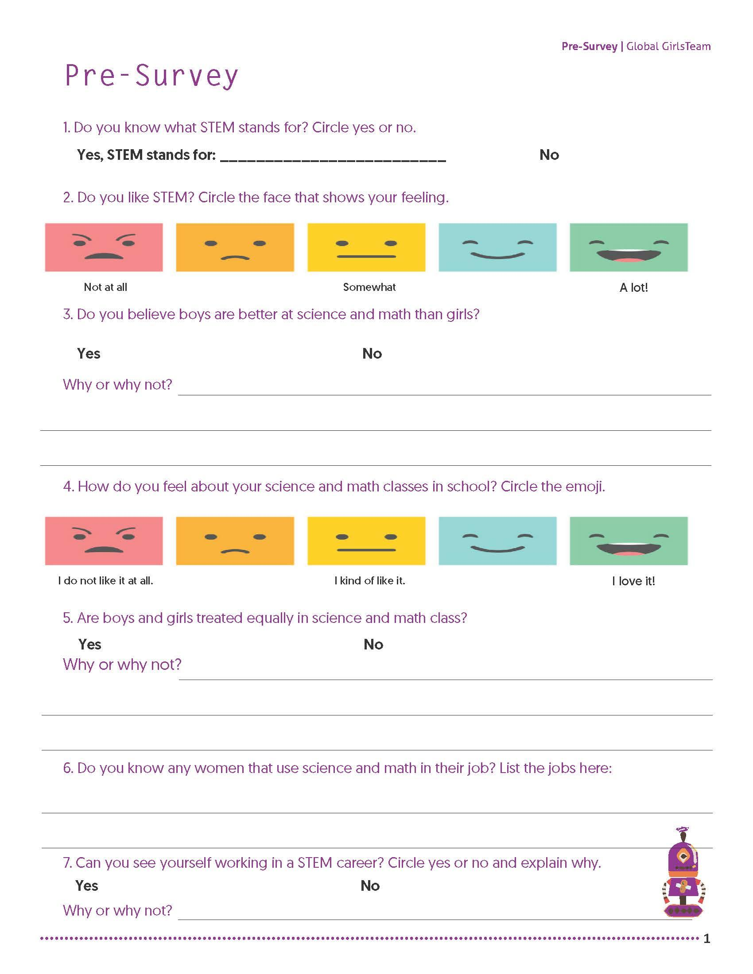
Figure 1: Pre-Survey Example

We handed out all of the pre-surveys to each girl and provided them with pencils. We decided to read each of the questions out loud to make sure the girls were following along. The first question asked was, “What is the meaning of STEM and to what does it stands for?” to which Asia asked whether if it was “Okay to write ‘I don’t know’?” For the second question, we asked “Do you like STEM?” and explained the Likert question that displayed cartoon emoji’s, which signified “not very much” to “very much” on a scale of 1-5. Another question was “Do you know any women who use science and math in their jobs?” which followed by Tanashia responding “Does it have to be a woman?” Tara asked “Can it be a teacher?” Another example of a question was “Can you see yourself working in a STEM career? Why or why not?” which had no response from the group of girls.
The group did not know of any STEM professionals who did not work at the school. The most common answer for the question “Did you know any women who use science and math at their jobs?” was their math teacher, Ms.D. One participant, Tara, responded “Ms. D. She is a math teacher”. We will discuss the results to the Pre-Survey in the Results section of this paper.
After we collected the surveys from the participants, we explained what everyone would be doing in the next session. We informed the group that we would be defining a problem statement and then work together to define a solution for that problem. We communicated that the session will be about the pre-survey they filled out. We also told the group we will be examining the results and asking more questions next session based off of their responses. We thanked everyone for showing commitment to the project and lined the girls up to walk back to the classroom. After the group left the classroom, Ms. Walker and I discussed the results. We made accommodations for the next session by considering the questions asked during the session. We decided that the next session would focus on re-iterating the problem and what the girls are trying to solve. We decided it was important for the group to understand that they are solving a problem that will help them.

Design Session 2
Ms. Walker and I visited EBS for another design session. Again, the girls were transitioned from their homeroom to the spare classroom down the hall. 12 participants were present. The girls reported to the seats they chose previously. The girls were eager to return to the design session (see Table 2).

Table 2: Summary of Sessions
Summary of Sessions
 | Goal | Summary of Session | Significant Quotes
Session 1 | Complete pre-survey | Girls completed the pre-survey. | N/A
Session 2 | Define the problem statement | Girls brainstormed the research question and ways to solve the problem. | “You could meet new people” (reference to video game idea)
Session 3 | Define the type of solution for the problem | Girls decided to work on creating a video game | “Kim Kardashian” “Interact with characters like Kim Kardashian”
Session 4 | Begin working on prototype, state the problem and solution | Girls created characters and environments | “Student will help girls get connected with women in STEM.”
Session 5 | Prototype workshop | Decided on theme of the game. The users of the game are the girls. Girls learn from the STEM characters. | N/A
Session 6 | Prototype workshop | The group glued materials onto the application templates. Some girls were gluing together materials arbitrarily, rather than focusing on the goal. Some girls were able to repeat the story-telling aspects of the prototype. | N/A
Session 7 | Complete exit-survey | The group finished the exit-survey | N/A

This session started out with the warm up question, based the previous session. Yasmine answered the question, “What kind of jobs are in STEM?” with “teacher”. We knew that this answer was a common response in the pre-surveys for that question. The girls were familiar with their math teacher, since she worked at the school.
In this session, the goal was for the girls to come up with a problem statement. We started out the class with a focus group discussion, followed by a visual representation.
Ms.Walker and I re-iterated the mission of the project by explaining to the girls that we want to close the gender gap in STEM between males and women. We explained also how there are more many more males working jobs in STEM positions than women. We told them how many young women are not interested in STEM in lower education, specifically their age. We explained the subject matter in a way to connect with the girls. We explained how several girls choose STEM pathways in higher education, but tend to drop out of college or their STEM jobs. I told them that we want the class to work together to find out why women choose to not pursue STEM, as well as leave their STEM jobs. I told them that they have the opportunity to find a solution to a very big problem. This excited the group very much.
I listed out examples of STEM jobs to the girls and explained what people do at these jobs. I said some of these jobs require people to build technology, build buildings and bridges, design tools that astronauts use in space, as well as use chemicals to come up with medicines that help cure diseases. I explained how STEM jobs are a lot of very good jobs that help people by being innovative problem solvers. When I asked, “Do you know any woman that are in STEM?” Liza responded, “We know you!” Another student responded, “I also know teachers that are in STEM!” I then proceeded to ask the class if they knew any women who work with computers or science besides the people they know through school. I then asked, “Do you know anyone, male or female who work in STEM?” None of the girls answered this question.
After the discussion, continued the design session and moved onto the next segment. We presented a slideshow in PowerPoint (Figure 2) that consisted of many photos of STEM jobs with descriptions. During the presentation, we asked the group if they’ve heard of these jobs before, whether at school or home. The girls were unable to recognize the jobs. The girls only recognized the jobs we had described to them that day. Ms. Walker went into detail about what requires of the jobs displayed in the PowerPoint. The group did not ask any further questions about the jobs. We then reiterated the fact that the girls did not know many women with STEM jobs, and that this is a problem we are facing. Ms. Walker asked the group “How will you know more about STEM if you don’t know anyone in STEM? How will young girls, like you, learn about women in STEM? ” The group did not respond to the question.


Figure 2: Powerpoint resources

I stated again that we are trying to bridge the gap between girls and boys who pursue STEM, and we want to make it even. I told them that we want people like you to be interested in STEM. We then asked the group, “What is the problem?” Ethel responded on behalf of the group, “We don’t know anyone.” I then asked, “What do you mean?” Ethel answered, “I don’t know any women in STEM.” We then elaborated on Ethel’s response, as the other girls listened. We discussed how the girls do not know about any real people who work these jobs and they need to learn about these people to see if STEM were something they would be interested in.
Problem Statement
After discussing Ethel’s response, we were able to develop the problem statement: Young girls do not know people in STEM and they do not have women role models and there needs to be a way for girls to connect with female STEM role models. We then wrote the problem statement in Microsoft word and used the projector to show the group what we came up with.
We told the girls that we will now do a brainstorming activity, where the girls brainstorm together to come up with an idea of how to solve the problem we just came up with. Some of the girls suggested that we use networking to connect the girls with female role models. Another student suggested that maybe we can go to the house to get to know them. The group suggested creating a google post, a social media platform, reading about women in STEM and contact them. As the girls brainstormed ideas, we recorded the ideas on Microsoft word and projected them. Some girls suggested calling or emailing the person. As the girls discussed, Ms. Walker reassured them that there are no wrong answers, as girls were becoming apprehensive about their suggestions. The girls discussed what they like to do at home as well. They like to use the computer and play games.
Ms. Walker propositioned, “How would you connect students with female STEM role models with a game?” Some girls responded with a blog-game, and others suggested games that already existed, such as Grand Theft Auto. We reiterated that they would be doing this from scratch, so you can’t use a game that already exists. However, we then asked the girls what they liked about those games. They said they liked interacting with the characters and talking to people. From there, Ms. Walker asked, “Can you talk to other people while playing this game?” Tamera answered, “Yes!” Her excitement translated to the rest of the group. Many of the girls agreed they would like to make a game. Piggy-backing off of Tamera’s response, we asked the group “What if you created a game that would connect you with female STEM role models?” to which the group showed a lot of excitement. Tamera said, “You could meet new people.” As a collective group, the girls said they would absolutely play a game that connected them with women in STEM.
We then passed out the snack. Afterwards, we decided as a group that our solution would be to build a game that connects girls with female STEM role models. We conducted a vote between creating an Application, Video Game, and Blog-game. Three participants voted for the app, three voted for the blog-game, and six voted for the video game.
In conclusion, the group agreed that the best way to connect the group with female role models was to create a video game, which could also be mobile, and which connects the girls with women STEM role models. We finally had our solution to the problem.

Design Session 3
On April 18, 2018, we completed our third design session. 12 students were present. The session was held from 12:20 to 1:10 PM due to the students arriving late to their homeroom classroom. We began the session with the Warm-Up question, which was asking the group what our problem statement and the game plan for the solution is.
As a group, we all said out loud, “We will work together to create a video game prototype using hands on materials that connects girls with role models.” together.
By repeating the mission of the research project, students were able to keep the correct mindset throughout the whole design process. With Ms. Walker and myself at the front of the group, we explained what a prototype is. We made sure to communicate that this is not the final product, but it something that can be turned into a real video game that everyone can play. We reassured that there are no wrong answers when creating the prototype.
Before we started the workshop, we compiled examples of video game resources, including video game professionals and how to build a video game and showed the group the resources in a PowerPoint. We explained how the video game creators work STEM jobs.
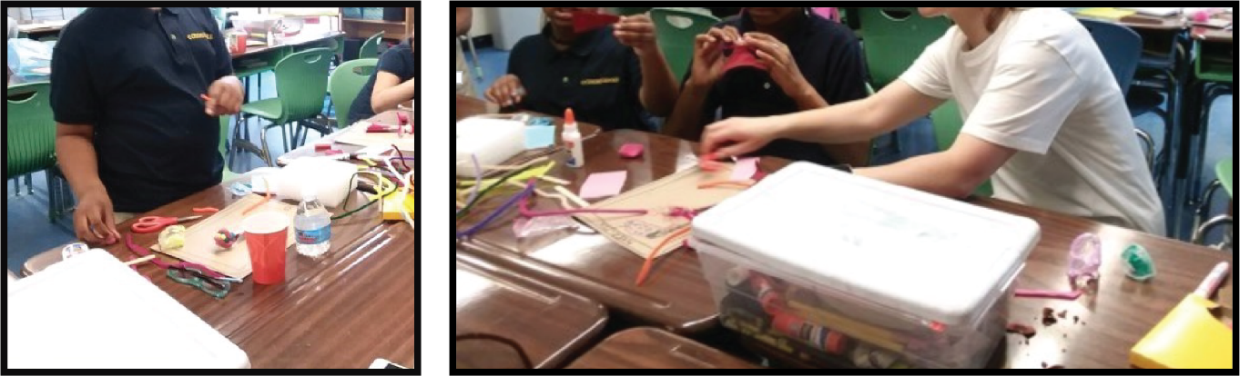
Figure 3: Prototyping with hands on materials

The girls then were assigned a letter between A, B, and C. Each table represented a different letter. The group were told to sit at the table they were assigned to, which allowed the girls to break up and sit with people they were not sitting with before. We informed the group that Ms. Walker and I will walk around the tables, listening and answering any questions they had. We told them that these seats would be your design working session seats and that you must report them for the rest of the sessions. We handed out snacks when the girls were at their new seats (see Figure 3).
After the girls finished their snack, we passed out papers and pencils for the activity session. We told them that they would start drawing ideas for the video game. Again, we told them that there were no wrong answers. Ms. Walker worked with half the group, while I circled around the other half, making sure to ask questions and keep the girls on track. While the girls were drawing their designs, we approached their tables and made suggestions. If a student was stuck, we told them to think about a character. Who would the user (you) meet in the video game? Tamera was excited and said “Oh! A scientist!”
After the girls were finished with their drawings (see Figure 4), we collected them. The session ended with the girls cleaning up the papers and pens and returning them to Ms. Walker and myself. Ms. Walker and I discussed how the group went, and decided that we would make sure girls have more time to work on their prototype in the next session.
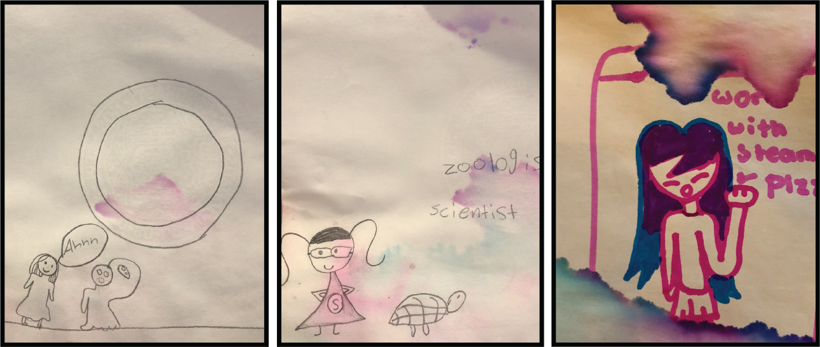

Figure 4: Session 4 drawings

Design Session 4
On April 23, 2018, we held our fourth design session at EBS. There were 12 participants. After the participants were transitioned from their homeroom classroom to the spare room, they were asked to break up into their groups from last time (A, B, and C). The session began with a warm up question of, “What is our goal?” The girls began to recite the goal of the research project quicker and with more enthusiasm.
We dove right into the activity session, as discussed after the last session. Ms. Walker and I handed out a bag filled with the materials to each group of girls. As a group, we made sure to review all of the materials that were in the bags on each of the tables. We explained how to use the materials properly, and asked the girls to respect the materials being handed to them. We explained that in this activity session, this is when we do the prototyping for the video game. I told the group, “You are going to continue to create a paper prototype of your video on these boards. What you do with a paper prototype is you show it to someone who can code and who can do STEM things, so if you guys do a really good job, we can pitch this to an actual game designer and we can make an actual game and make money.” By connecting the problem and solution with real life opportunities, the girls showed a lot of passion and eagerness.
Before the group started using the materials, we passed out the snack. While the girls were eating the snack, we continued to ask questions. One question was, “Okay, what is your favorite video game?” to which Tara replied “Kim Kardashian”, to which we replied back, “What do you do in the Kim Kardashian game?” The student answered, “Interact with characters like Kim Kardashian”. From there, we broke into discussion on “What if that character was a STEM professional? What if Kim Kardashian was a STEM role model?” The girls displayed interest in the discussion. We asked the girls to think about games they like, and refer back to their drawings from last session for inspiration.
After the girls finished the snack, Ms. Walker and I elaborated more on the goals of the session. We told them that a game needs to have rules and a goal. We explained that their game can be anything they want, but to keep in mind what the problem is that they’re solving. We told them they can create levels, characters, and environment.
In addition to the materials on the table, each student was given cardboard template (see Figure 5) that was pre-assembled consisting of a black marker drawing outline of a phone, to represent the game being used on a mobile or tablet device. The cardboard screens were created with hands on materials to give the girls a sense of causality, that this was not a final project, but rather a draft in which they are encouraged to explore their creative side and not be pressured to produce something that is the final. The girls were directed to attach all their designs to the cardboard template.
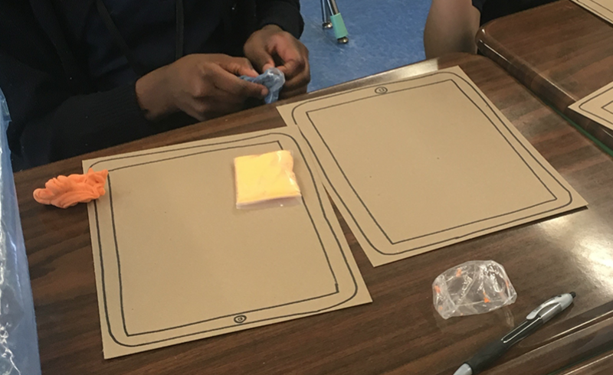
Figure 5: Cardboard templates

After all the instructions were given, we gave the girls permission to begin. Though each student was handed an individual template, they were encouraged to work with each other at their assigned table.
The girls used pipe cleaners, clay, glue, scissors, markers, pom-poms, cardboard, and tape to contrast their prototypes. Liza and Tamera had glued together pompoms with glue and pipe cleaners to construct the video game characters. When asked who the character was, a cartoonish human-like figure wearing a dress with long hair, Tamera responded, “This is a Scientist”. Asia explained they built a house and maze, which was the environment for where the characters lived. The girls worked during the design session for 30 minutes.
The group cleaned up the materials and put them back in the bag before the session was over. They were not permitted to leave the classroom until all the materials were put back in the bags.
After the design session, we asked the group to restate our problem. Ms. Walker asked, “Do we understand the problem?” to which Laila answered, and “Not enough women role models in STEM.” The group lined up at the door and returned to their homeroom. Ms. Walker and myself discussed what we learned from the session and decided that adding more time dedicated to the clean-up session would be needed for a smoother session.

Design Session 5
Session 5 was conducted on April 25, 2018. 11 girls were present for the group. We arrived at the school, signed in, and transitioned the girls from their homeroom class to the spare class. The girls were eager to resume working on their projects. We began the session with the warm up question, which was “What did you do last session?”
We communicated that the focus of the group was on storyboards, scenarios, characters, and interaction design, puzzle games, and coin prizes. Before handing out the materials, we discussed the prototypes the girls are working on. We asked the group if any of the girls had a good idea for the subject of the video game. Tamera stood up and shared her prototype with the group. She said, “So far we for our story—the student (player) goes through a maze and they use a map and they will have to use logic and math to get through the maze. As they progress through levels, it gets very hard. If they get stuck somewhere, a monster can come out and hurt them. Once they get it right, they can get a point and when they finish the game, they can win coins and get prizes. The characters in the game help them with solving math and teach them about science.” Additionally, all the characters were women. Since Tamera’s idea for the video game was so wildly popular within the group, we asked the girls if they would like to adopt Tamera’s idea and focus their project on that same plotline, rather than making bits and pieces of different video games. We took a vote, and the majority of the group wanted to work on Tamera’s concept.
We discussed the plot of our video game, as it was now a conjoined collaborative project. As a group, our discussion concluded the theme of the game: The user is an elementary age student. The users interact with the characters in the game. The group learn from the characters, defined as a mix of female STEM professionals. The users go through obstacles collecting coins until they've collected enough coins to become a monster, or advance to the next level.
After the theme of the game was defined, the girls were given permission to resume working on their prototypes. Ms. Walker and I walked around the classroom, encouraging girls to think about the problem they’re designing for. Ms. Walker sat with Malik at her table and helped design an environment for these characters.
The session ended with clean up. We did not have time for an exit question. While girls were cleaning, many girls requested more materials, such as clay.

Design Session 6
The sixth session was held on May 2nd 2018. 12 participants were present. Ms. Walker and I arrived at the school, checked in, and brought the participants from their homeroom to the spare room. The group sat at their designated seats.
We started the session with a warm-up question and discussion. We asked the group what they were working on and if anyone would like to share. No girl wanted to share, as they were eager to continue working on their video game prototype. The girls were required to state the problem statement and solution before beginning on their projects.
We handed out the materials and allowed the girls to begin working immediately. The girls crafted more characters, levels, and drawings on the cardboard templates. We handed out the snack and let the girls eat simultaneously while working. However, some girls seemed more engaged with creating anything, even if it had nothing to do with the research question. I stopped the group and asked them to repeat the problem and the solution. Repetitive directions made the girls stop and refocus on the purpose of their work, rather than just gluing pipe cleaners and felt together arbitrarily. The group felt lost during the process and did not know what to do. However, they all seemed very content with using the materials and being creative. The group worked for 40 minutes.
We asked the group to put down the materials and focus on Ms. Walker and I. The group did not clean up the materials at the end because we did not have time. We spent the last 10 minutes discussing the video game. We took photos of the girls and their final designs (see Figure 6). After the photos, the girls lined up at the door and walked back to their classroom. Ms. Walker and I cleaned up the materials in the classroom and discussed the research progress.
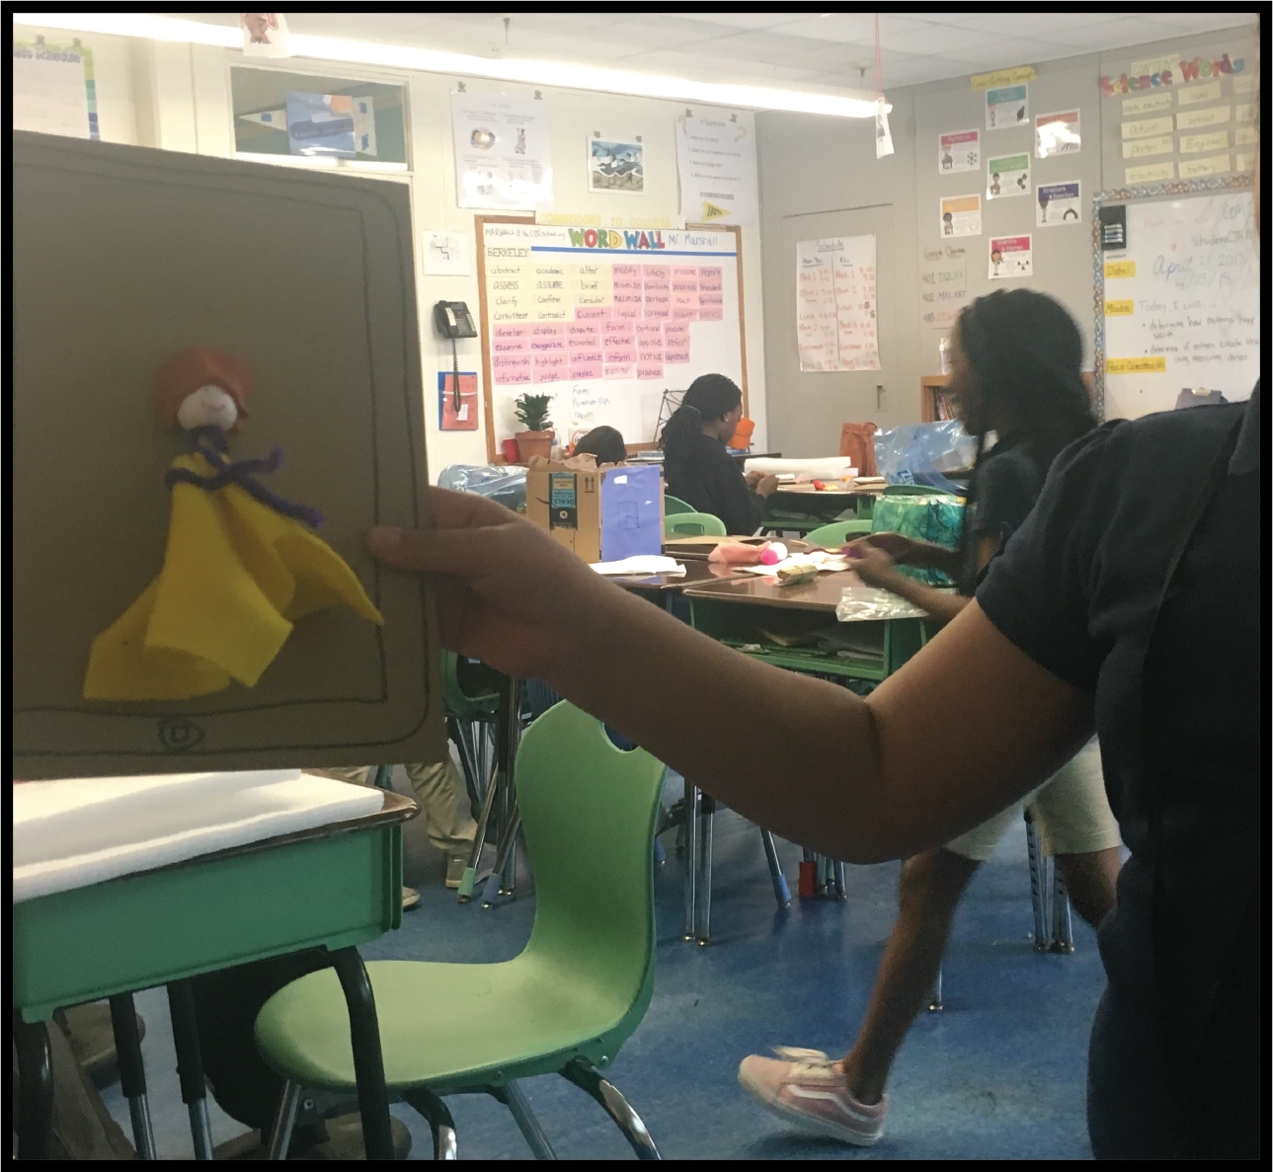
Figure 6: Laila presenting final prototype

Design Session 7
The last session took place on May 7, 2018. 12 participants were present. Ms. Walker, myself, and Mrs. Lieberman arrived at the school at the same time. Mrs. Lieberman was an adult helper who helped facilitate the lesson, as we needed to make sure participants were focused for the exit-survey.
The group had already transitioned enrichment rotations and we no longer had a spare classroom to work in. We did not have the space to conduct a full session. We shortened the session by cutting out the warm up question, activity session, and snack time. Our main goal was to make sure the girls completed the exit-surveys (see Figure 7). The design of the exit-surveys were created by me and modified to communicate clearer examples of emotions. The shapes of the smileys were altered to resemble smiley face icons, rather than the boxy shapes previously. They were also spaced out on the paper further than each other, to communicate that each image is distinguishable from one another. Also, each smiley face was coupled with words. This was altered because of the questions elicited during the pre-survey in regards to the absence of a verbal queue under the image.
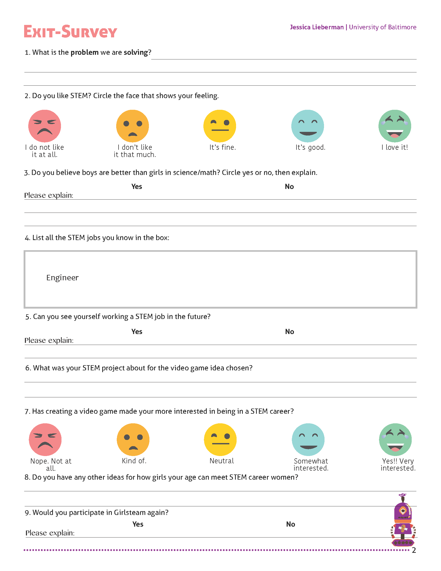
Figure 7: Exit-Survey Example
There was one adult facilitator assigned to 4 girls. For efficiency purposes, the survey was modified by removing the “please explain” space for the questions that had it. The girls were very engaged and completed the exit-surveys. The session was 25 minutes long.
After the students returned back to their homeroom, Ms. Walker and I discussed how the research went. We looked over the exit-surveys together and discussed what the students’ answers meant. We then parted ways.

Chapter 5: Results

Findings from Design Session 1
Based on the student’s responses from the pre-survey question, the 12 participants knew little to no people working in STEM. We handed out 12 pre-surveys. 50% responded that they are interested in working in a STEM career. 16.66% of girls responded with maybe. 33% of girls responded that they couldn’t see themselves working in STEM. Most of the girls commented on wanting to be a fashion designer as their career of choice.
We found that the group did not know any women role models besides their teacher. Tamera responded to the survey that she knew her math teacher as someone in STEM (Figure 8) Additionally, we found the girls do not know people, male or female who work in STEM positions, the girls “kind of” like science and math, the group experience boys and girls not being treated equally in the classroom, and girls can see themselves working in STEM jobs.

Table 3: Pre-Survey Sample
Pre-Survey Sample
Pseudonym | Can you see yourself working in a STEM career? Circle yes or no and explain why.
Asia | Maybe - I can see myself being a fashion designer because I like fashion.
Tanashia | Yes - I say yes because I am good at math.
Tara | Yes - Because I am good at math and know because I want to be a fashion designer.
Yasmine | Yes - Because I like fashion designing
Liza | Yes - it is good for your education
Ethel | Yes - because I want to get a lot of money
Tamera | No - Because I don’t like it
Laila | Maybe – N/A
Karina | Yes - b/c of money
Yadera | No - Because I don’t like it
Adeline | No - Because at school people do not like me
Daisy | No - because I do not like school

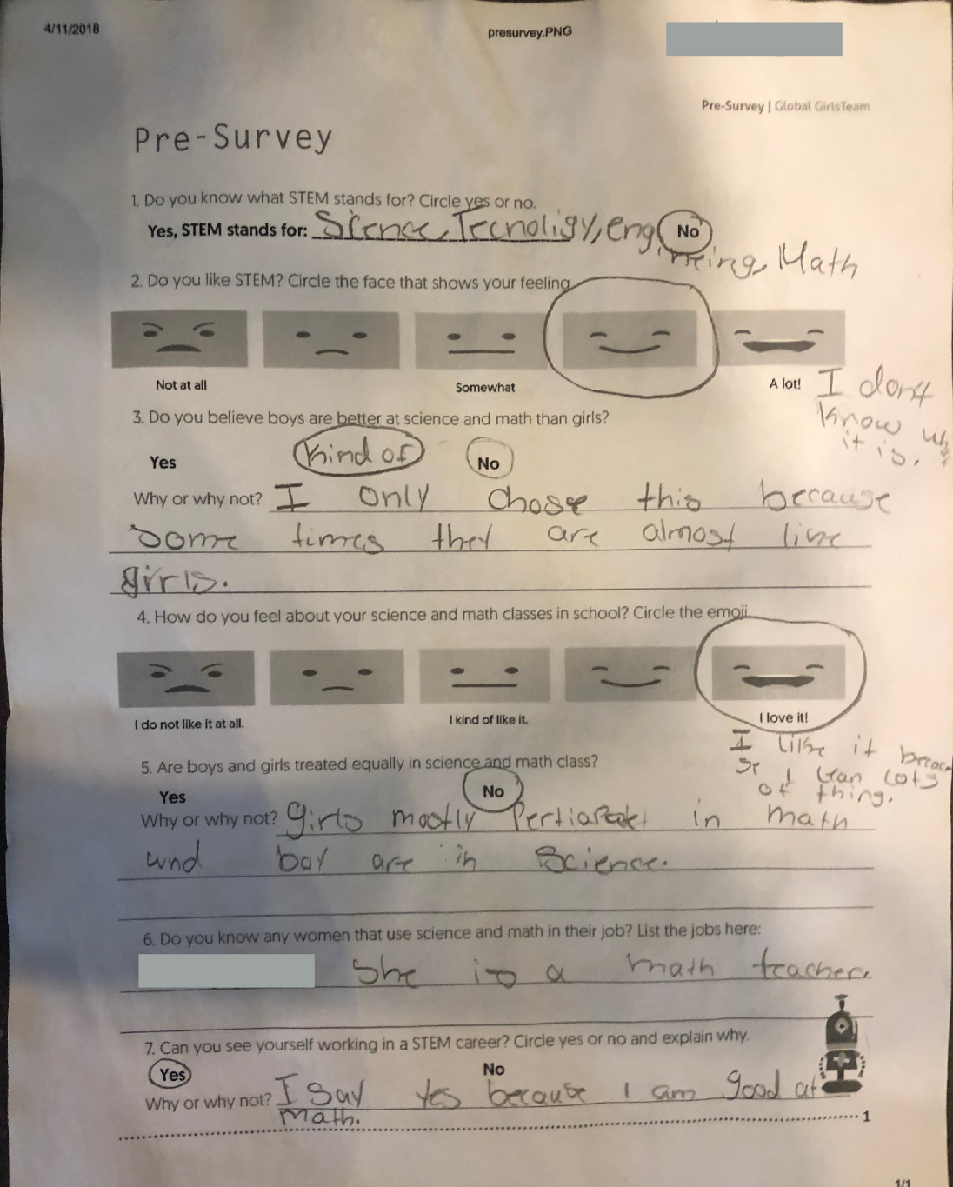
Figure 8: Completed pre-survey, which shows the answer to #6 as "She is a math teacher"An example of a completed pre-survey, which shows the answer to #6 as “She is a math teacher”

Findings from Design Session 2
Young female girls must connect with STEM professionals to be interested in STEM. Below, three main takeaways are summarized which emerged from the discussion.
Introduce STEM jobs and descriptions to girls in elementary school
The participants collectively could not describe a STEM job. Girls may have heard of STEM jobs, but are unable to describe these jobs.
Girls will associate STEM with the people they see
Student participants talked about teachers and people they saw daily. They responded that they knew female STEM role models, because they had Ms. D and Ms. W as their math teachers. The girls used verbs such as “see” to describe STEM people they knew. 9 year old Emily said, “I see Mr. D and Mr. E”.” They also claimed their mom or someone on the bus is in STEM, but when asked to explain the job, they were not able to do so. The girls also said they knew me and Ms. Walker, even though it was the first time for some girls meeting me, and they had never met Ms. Walker before. Since we were in the classroom talking about STEM, they associated us with STEM.

Use a game to connect girls with STEM role models
Student participants recommended making a video game that allowed users to connect with people. 10 year old Tamera suggested, “You could meet new people” through game design. The participants agreed that playing a game that connected them with STEM role models would make them more interested in STEM subjects. Another student suggested integrating mythological-type characters interacting with regular people, as it would be more appealing to play. The group agreed that there should be prizes in the game as well, and if a user gets a question right, they can advance to the next level.

Findings from Design Session 3
Student participants commonly suggested incorporating non-human characters into the game. When asked about connecting girls with role models, 10 year old Tara suggested “Robots. Robots can inspire girls to go to college in a STEM subject.” The emerging themes are discussed below in detail.
Use personification to connect girls with information
The girls suggested characters in the games such as monsters, talking animals, and robots. The girls were excited at the thought of animating non-human subjects to talk and interact with human figures. The girls also focused on characters from popular culture (e.g. Kim Kardashian).

Incorporate art in STEM activities
The girls were all motivated by the idea of using hands on materials and creating artwork for solving the problem. The girls collectively did not know that designing is similar to creating artwork.

Findings from Design Session 4
The girls made several recommendations to have the characters in the game interact. The girls were eager to share the stories that went along with the prototypes they were working on. The most common type of element created was characters. As an example, Yasmine suggested, “We can have a scientist ask the student if they want to do an experiment”. Yasmine is narrating two characters; the scientist and the student, in which she later elaborates on.
The girls suggested creating a story for the characters. The girls recommended illustrating a narrative for the characters in the game that included monsters coming out from behind shadows. This suggests that participants use storytelling as a learning tool. It underlines an opportunity for resources that offer help for girls to learn about connecting with real life STEM people.

Findings from Design Session 5
The girls displayed an eagerness and willingness to present their video game ideas to the group. Based on the positive results of the session, an emerging theme was gathered. Below, we explain the theme.
For most of the girls, when asked to present their prototypes with the group, they were excited. One student participant, Tamera shared the narrative for their video game prototype design. Other girls agreed that her idea was very good. Ms. Walker and I praised Tamera for being brave and sharing her thoughts, when it’s a very vulnerable thing to do. The rest of the group voted to adopt Tamera’s idea and help expand on that narrative. This notion of sharing with a group suggests the value in creating resources that encourage girls to share their ideas with an audience, rather than encouraging individual tasks and assignments.

Findings From Design Session 6
Participants were sidetracked while using the hands-on materials to build the video game prototype. During a longer activity session, it was observed that many girls lost interest in the problem statement. Below, the main theme realized is described.
Half the girls did not realize they were not focusing on the goal of the assignment during their workshops. I observed Asiah building a house, but when asked to explain what she was doing, she responded, “I don’t know. It’s fun.” Other girls were observed rolling the clay between their fingers. After a certain amount of workshop time, the materials became a distraction, as opposed to a tool. Some girls felt discouraged, lost, and wondered how their work could be an asset to the video game. I stopped the group and made everyone put their materials down to listen. I told the group that we need to make sure we focus on the problem statement and solution. This highlights how imperative it is to make sure the girls do to not get sidetracked and to remain focused on the goal.

Findings From Design Session 7
The results from the exit survey summarized the girls who were more interested in STEM as a whole since beginning the co-design workshops. We handed out 12 surveys to the girls. 50% of the girls said they were very interested in pursuing a STEM career.
Table 3 shows the results of the question, “Has creating a video game made you more interested in being a STEM career?” Additionally, Figure 9 depicted Tara’s survey results, in which answered the question by circling the green smiley face that stood for “Yes!! Very interested”, 16.66% said they kind of were interested, and 16.66% said they were not interested in pursuing a STEM career.

Table 4: Exit-Survey Sample
Pseudonym | Has creating a video game made you more interested in being in a STEM career?
Asia | Yes!! Very interested
Tanashia | Kind of
Tara | Yes!! Very interested
Yasmine | Nope. Not at all
Liza | Somewhat interested
Ethel | Yes!! Very interested
Tamera | Nope. Not at all.
Laila | Somewhat interested.
Karina | Yes!! Very interested
Yadera | Yes!! Very interested
Adeline | Kind of
Daisy | Yes!! Very interested

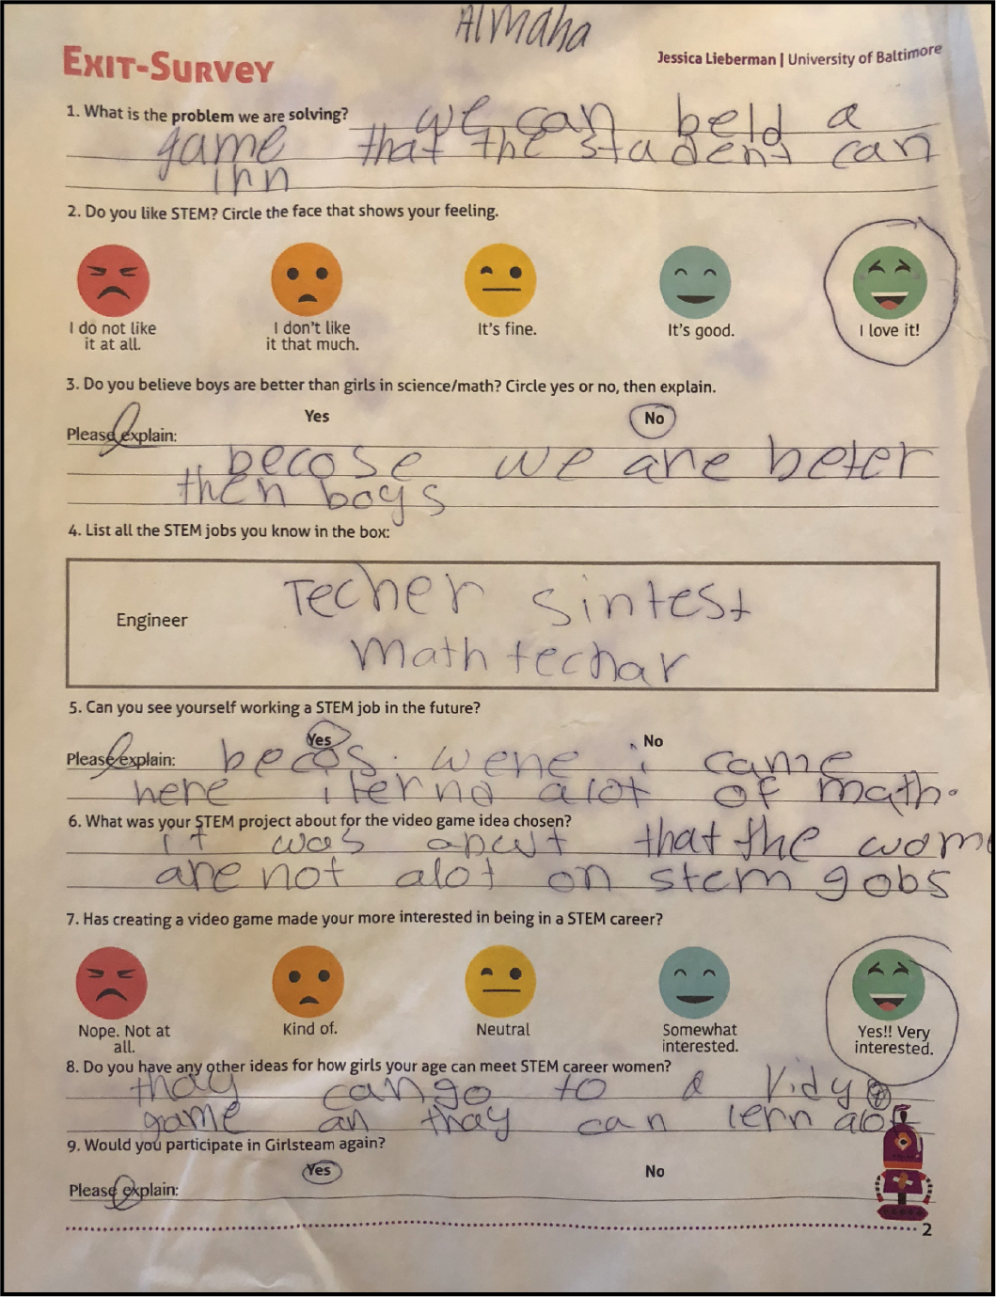
Figure 9: Tara's Exit Survey Results

Overall, between the pre-survey and the exit-survey, more girls responded that they were interested in pursuing STEM after participating in the Global GirlsTeam co-design sessions.

Chapter 6: Discussion

Real World Connections
All seven of the co-design sessions emphasized that when young girls are presented with tools to problem solve, be creative, and be innovative in order to create a solution that positively affects themselves, then the topic becomes more relevant to their lives, and they become invested/interested in the topic. School curricula often does not teach girls about existing STEM careers, STEM role models, or present face-to-face experiences with students and people. Materials often focus on the subject skills, such as math and science, without integrating how the subject matter relates to real life professions and people. Such straightforward resources can be useful for developing skillsets, but overlooks prepping young students for choices they may have to make in the future regarding their career path.
Existing resources do not equip young girls to learn about potential STEM opportunities and career pathways. Such exposure to female STEM role models are important as girls evolve through their education and gain autonomy to make choices about what STEM coursework, majors, and careers they can pursue. Exposing students to STEM professionals will create relationships and connections that can influence girls’ perspective of STEM. The students having myself, as I am a former educator and current tech professional as their teacher contributed to influencing the girls’ perspective of STEM positively.
Interpersonal Student-Mentor Relationships
My observations concluded that the participants were enthusiastic when and eager to learn when I worked with them in a smaller group setting, and especially one on one. Since I taught the same students previously, I had a working relationship with all of the participants. They knew me, respected me as an instructor, and trusted me to educate them. Previously, my classes consisted of 30+ students, both boys and girls. These students seldom had one-on-one time with me as an instructor. Participants showed a lot of enthusiasm to the subject matter, as well as they were more relaxed in an environment that was only girls. I observed the participants speaking more, discussing freely, as they weren’t constrained to the typical classroom rules they normally are. Since the students were in a safe, same-sex environment, they felt more comfortable to think freely and answer creatively. I believe the working relationship I had with these participants contributed to their enthusiasm and interested in STEM subject matter. Below, we offer recommendations for those who seek to create resources about STEM education.

Recommendations for Designing Resources to teach Girls about STEM Education

Use co-design to expose girls to STEM
We suggest co-design workshops for girls to elicit creative ways of thinking about a subject as well as to gain more of an interest in STEM. Our findings are in line with prior co-design work that suggests this method will elicit richer ideas rather than other methods. This recommendation is in line with previous research, such as Co-designing Online Privacy-Related Games and Stories with Children conducted by a combination of adult and child researchers, in which co-design sessions led to several recommendations that promoted learning goals about the importance of creating privacy-related resources for children (Kumar et al., 2018). Additionally, this recommendation is also is in line with Clegg’s (2012) Kitchen Chemistry which focused on life-relevant learning. Both research studies demonstrated that when girls are encouraged to make their own decisions in a supportive learning environment, they are more likely to gain an interest in the subject matter. For KC, the girls were empowered when creating recipes. As for this research study, girls were empowered when creating a prototype.
Since I was able to do an intergenerational design lesson with young girls, they are now exposed to STEM and are more interested in the subjects pertaining to STEM. Girls now want to learn more about STEM and will associate the co-design sessions we ran with future choices facilitating long-term benefits.

Teach girls about STEM professionals in a school setting
The design sessions suggested there is a lack of resources that expose girls to relevant STEM professionals in the school environment. The design sessions indicated that girls are not being exposed to STEM professionals outside the classroom environment. The sessions suggested that girls get excited when they learn they have the opportunity in the future to work in technology related fields. This makes sense considering young girls find excitement in relevant technology such as Instagram and Facebook.
We recommend creating resources that educate girls on modern day and historical women who have been important assets to the STEM world in the classroom setting. If lessons about STEM professionals become school assignments and in-school activities, then women may be motivated to do well in those subjects, and therefore develop an interest in STEM. The research indicated when students teach people who hold STEM jobs that create those applications and technologies; they become more interested in STEM. This recommendation is also in line with Cooper & Maltese’s (2017) research that girls are motivated by good grades, and classes they take in the school setting. Studies have indicated that girls and boys do just as well on math performance tests, but these tests are not related to subjects about existing female role models.

Expose students to STEM professionals
Our findings mirror existing work that found students who are exposed to real life professionals are more interested in STEM. I found that students associate opportunities and potential pathways with the people they see day by day. Personal relationships motivate students to be more curious about what people do.
Based on our findings, we recommend resources that go further than teaching students about STEM people and rather introduce these students to real people who work as STEM professionals. This recommendation is in line with previous research that suggests introducing students to real professionals will increase female’s awareness of women in STEM. It Girls Retreat exposed students to barrier-breaking role models and the results concluded that students were more interested in STEM at the end of the retreat (Farah & Walas, 2012). Additionally, this recommendation is also in line with Dasgupta and Stout’s (2012) research, which supports the concept that women are more likely to focus on experiences and activities that allow them to hold interpersonal relationships.
Since I was able to interact with a group of impressionable young girls, ages 9-10, and introduce myself to the students, they now know one more person who is a working STEM professional. I was able to talk about my life as User Experience Designer to students. I had the opportunity to tell my story to the students and explain to them why I believe closing the gender gap is so important. The students showed a lot of interest in the conversations I initiated in regard to my personal experience as a designer. I was able to communicate that I work with program developers and project managers, designing and problem solving for real world applications. I also explained how I work in a STEM position, but am an expert in art, which is an asset to STEM subject matter. I also was able to communicate that STEM can be described as more of a humanities subject, as we are designing to connect humans together and improve the lives of people. As Wang, et. al (2016) suggested, there are cultural theories that lead girls to believe that math-intensive careers are for boys, and therefore the more “altruistic” or helping careers are the group they belong to. By opening up the conversation to how my job helps people, sparked interest in the students, which is in line with the Wang, et al. (2016) research about the social orientation theory that girls are led to believe they need to fulfill the helping careers that benefit society as a whole. 100% of the participants had never met a User Experience designer before me. Participants were unaware that User Experience designers design and develop applications such as Facebook, Instagram, and Snapchat. In addition, I was able to communicate to the students that I was able to get better at STEM related subject matter (ex. Computer science software and languages) by believing in myself and knowing that I can learn something, and that it’s not fixed. Communicating this to students is in line with Hochanadel & Finamore research that says that the growth mindset, which is the idea that intelligence is not fixed, can be taught. By explaining my own experiences as a STEM professional, I was able to communicate to the participants that they can learn and get better at STEM subject matter, even when it’s hard, and that it’s not a “fixed” thing that they cannot improve on. By explaining my profession to students, they were engaged and fascinated about the subject matter coming from an original resource, me. Therefore, by giving the students the opportunity to make their lives relatable to mine, I was supporting the recommendation we gave about introducing students to real life STEM professionals.

Expose students to STEM early on
Our findings found that exposing young girls to STEM at a young age will generate positive perspectives about STEM, which will carry to higher education levels. Our design sessions were conducted with participants in the fourth grade, ages 9-10. Young girls were familiar with the acronym STEM, but did not know what the letters stood for. Alarmingly, the girls also did not know any STEM role models of either gender. The girls were unable to name many STEM jobs. They were only familiar with the terminology, not potential opportunities. The design sessions indicated that the girls are only scratching the surface of STEM education in the classroom, rather than having continuous interventions related to STEM throughout their entire education. Outside the classroom, these young girls are not interacting with STEM resources in their daily lives, nor do they experience any interventions based on available STEM resources.
We recommend exposing students to STEM education resources starting as soon as Pre-Kindergarten level, as well as continue to have interventions related to STEM throughout the many levels of education. This includes PK, K-12 education, and higher education. This recommendation is in line with previous research based on expectations about STEM for women and men. As exemplified in previous research, targeting resources to children during all the life stages will promise to eliminate gender norms and barriers. Gender norms about the relationship of children and STEM start early in the classroom and outside the classroom. These perceptions can influence students to developing their own self-perceptions about STEM. Additionally, this recommendation is in line with Gunderson et al.’s (2011) research that states women can develop anxieties about math and science at a young age, as early as PK. Negative connotations about math and science can be developed early on, which can lead to it being harder to break as child development continues.

Introduce girls to STEM resources as games
Our findings show that girls are more likely to be engaged and learn about a subject when the learning tool is disguised as a game due to the high level of enjoyment and engagement observed. This educational approach know as gamification allows girls to achieve their learning goals in a meaningful way. When the group was asked to find a solution to the problem being stated, they were more excited about creating a video game as opposed to any other type of learning technique, such as a blog or a book.
Based on our findings, we recommend STEM teachers and designers using gamification as an educational approach to teaching young girls about STEM. This recommendation is supported by how during the prototyping sessions, participants created level designs consisting of mazes and puzzles. Participants, such as Tamera, were able to explain their level design to the group with excitement. Additionally, the girls created characters that were designed to move through the levels of the video game, while interacting with obstructions, enemies, and obstacles. All these game elements initiated by the group were applied to the prototype applications from real life experiences and video games, such as “Grand-Theft Auto”. This recommendation is also in line with Sethi’s comments on video games, stating how they allow children to learn through self-paced learning processes.

Chapter 7: Conclusion

Now that STEM jobs are growing at a rapid rate, it is important for women to become educated on the subject starting as early as PK level. Yet STEM education targeted at women is rarely part of school curricula. Girls are not being exposed to STEM role models in their everyday life, therefore now more than ever it is important for STEM exposure to reach female audiences. With this design thinking study, we hope to inspire more STEM education work.
In the seven-session research initiative it has been found that elementary school young women are interested in learning about STEM, but lack the resources and tools that give them access to learning about STEM. Therefore, they are not actively pursuing STEM related activities, as it is not presented as a choice for them. However, the mindsets of young women are very optimistic, believing that boys and girls are to be treated equally and each have an equal opportunity for success.
Unfortunately, the lack of female role models has a negative effect on girls. The girls were unable to identify women who hold STEM related jobs. If the student did not experience learning about this subject in school, they would not be exposed to it at home. Without being exposed to female role models in the classroom setting, even starting at the elementary level, girls will develop a disadvantage because of the lack of knowledge they hold about STEM.
We explored how intergenerational co-design sessions can help girls develop solutions to problems that apply to them. We recommend that teachers educate female girls about STEM female role models and jobs through the use of video game applications, narratives, and storytelling. Designers and teachers who seek to create these resources start in the elementary school age.

Chapter 8: Limitations and Future Research

Longer Co-Design Sessions
Our study consisted of 12 girls, two adult researchers, six 60-minute design session and one 30-minute design session. Given that majority of the time in these sessions were dedicated to discussions and exposing students to background information about the topic, there was less time working in the co-design sessions as anticipated. Future work should dedicate a longer session with a more thought out and condensed way of communicating background information about STEM. Because students had no connections to ANY type of STEM role model, they were at a disadvantage when trying to focus on creating a solution that is more of a niche.
Due to the time limitations of the research, there was not enough time to create a fully functional prototype. A full prototype would help dive deeper into the subject matter being exposed. More recommendations would be influenced by a fully functional prototype, rather than a roughly started prototype.

Interventions with Students
Future work should also focus on maintaining those relationships with students. Though I personally was able to fulfill one of the recommendations we made about connecting students with real world STEM professionals, I was only able to have face-to-face engagement with the students for two months. Future work should extend over a long period of time, following a group of girls for multiple years and consistent interventions.

What role does gender fill
The research only scratched the surface of the relationships between gender and STEM interest. Our research focused on women who identify with their sex. However, there is a lack of research targeted at how people who are born with one sex, but identify themselves with another gender feel towards STEM. Future work should be targeted on how environment plays a role in their life to which whether or not they’re interested in STEM as a career. There should also be further research, which examines whether gender is what creates the STEM biased thinking, rather than the sex of the person.

Appendix A
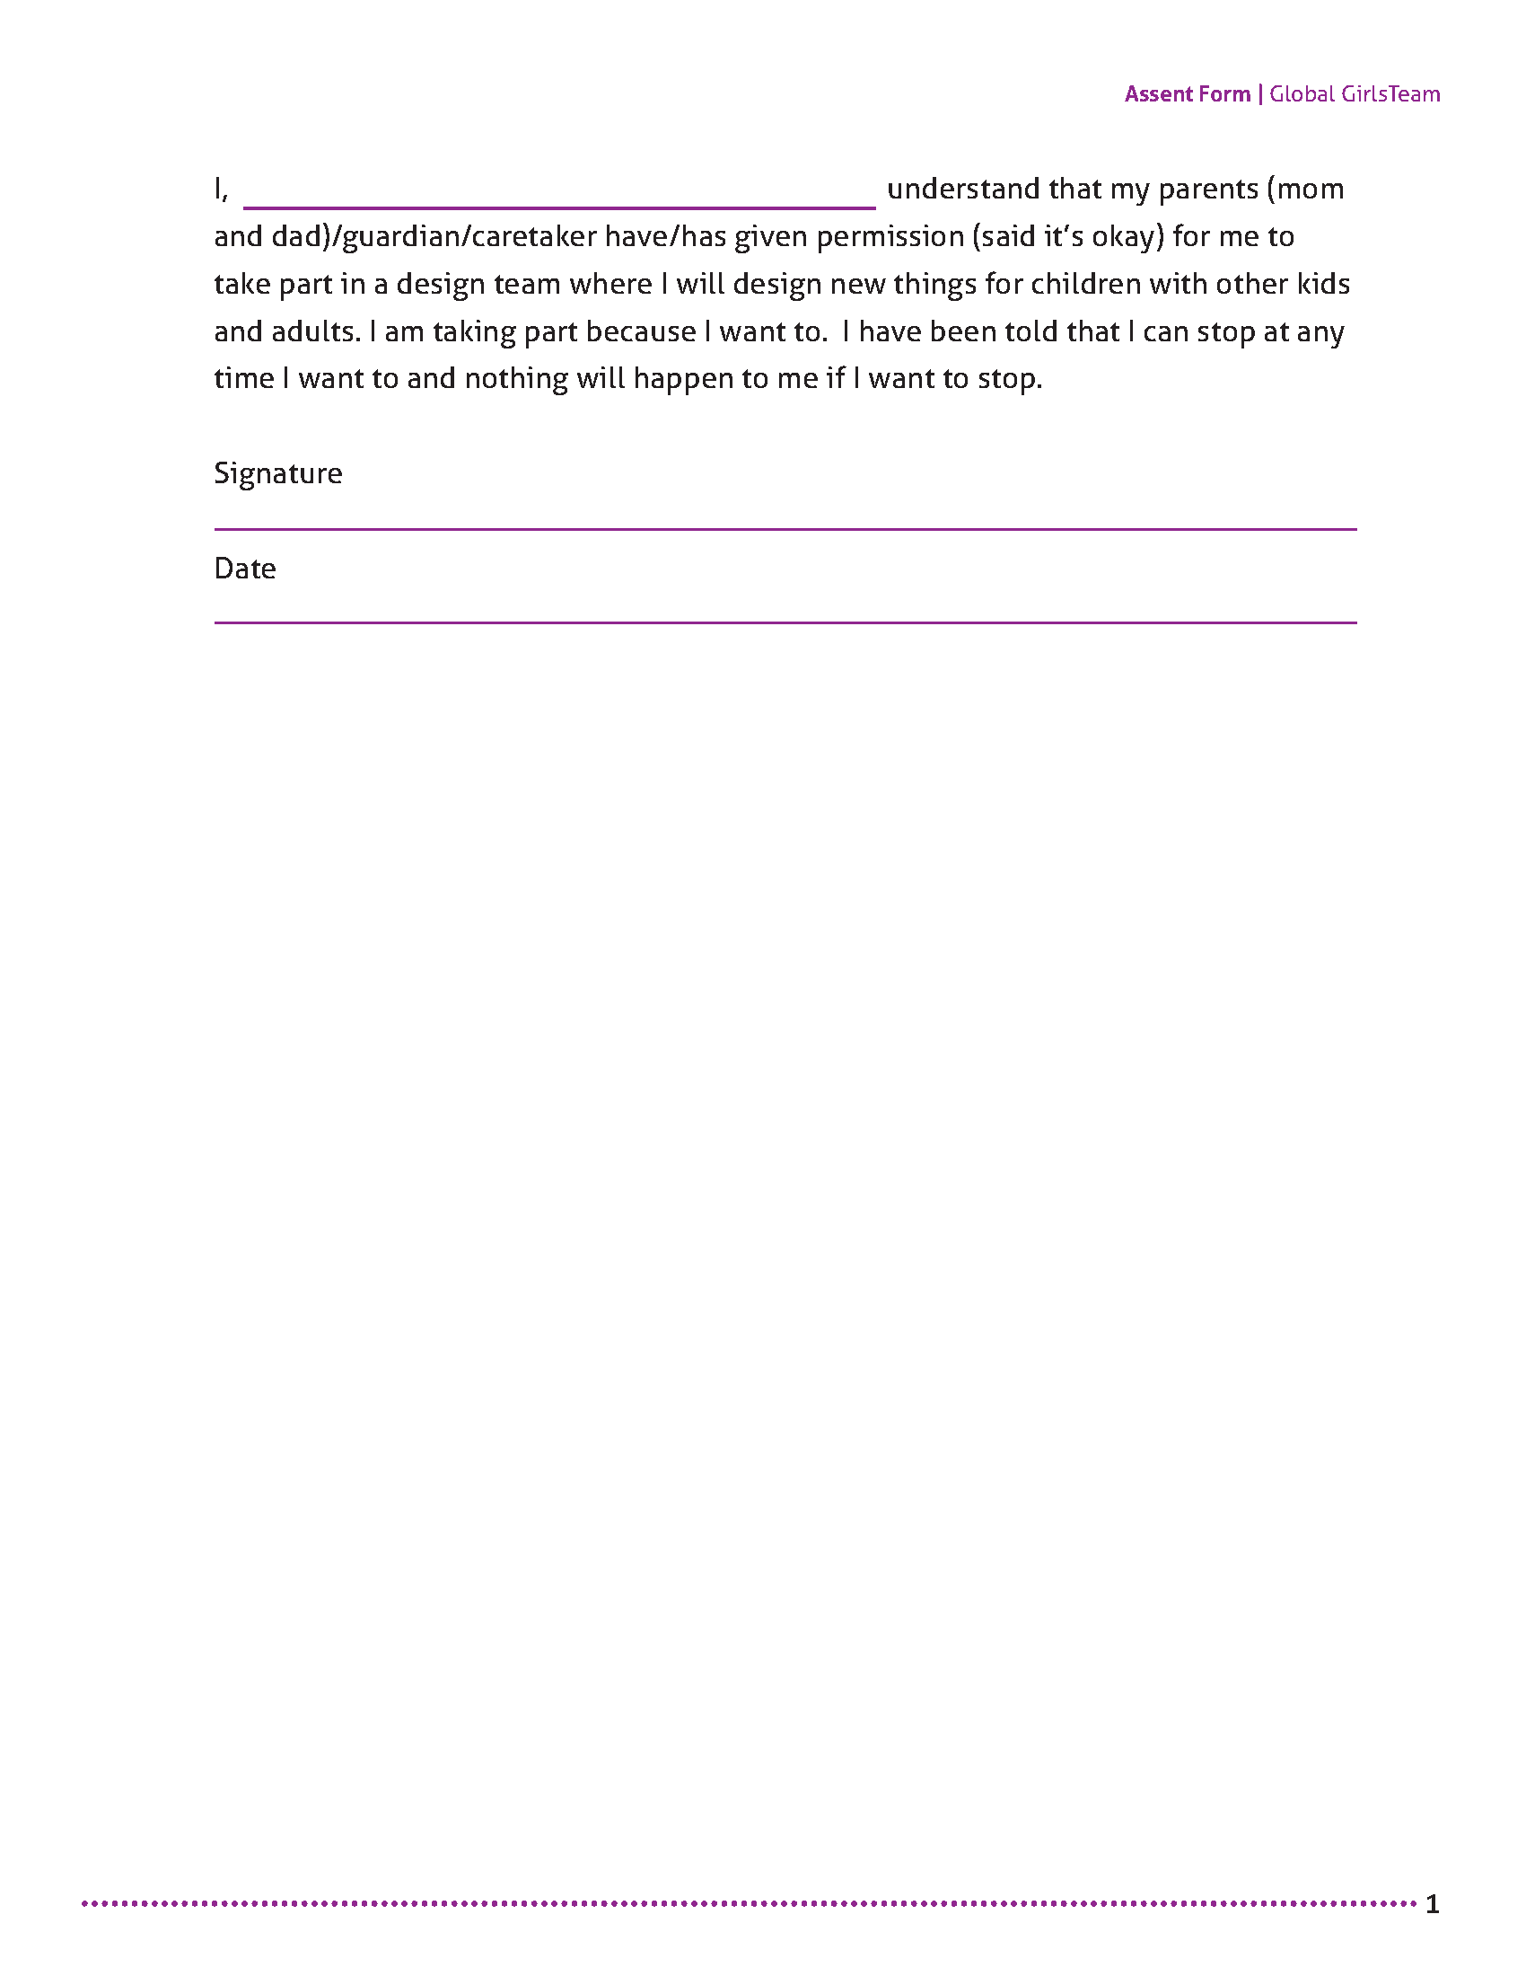

Appendix B

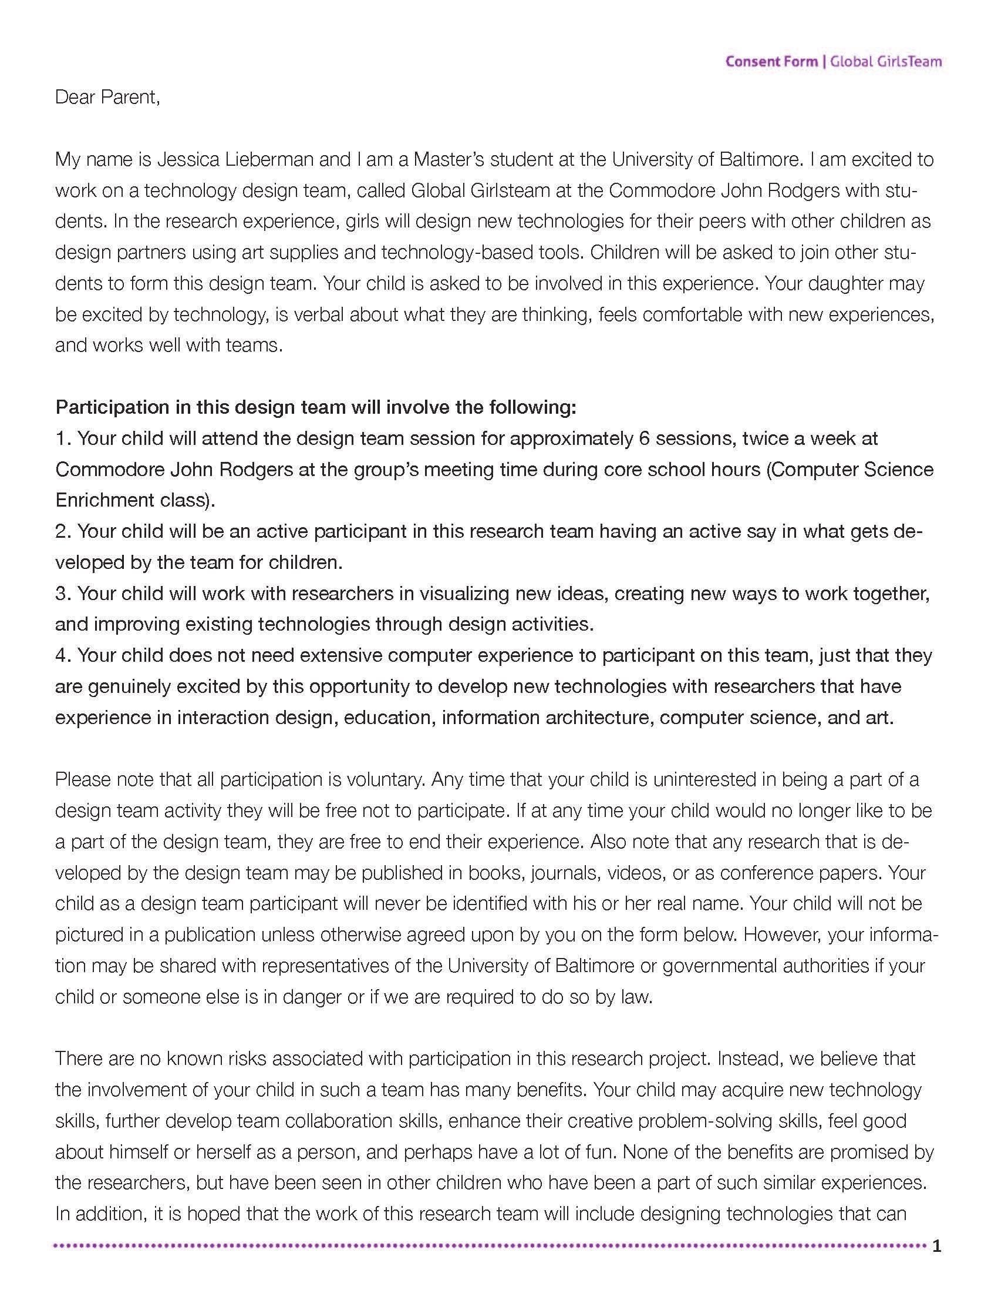
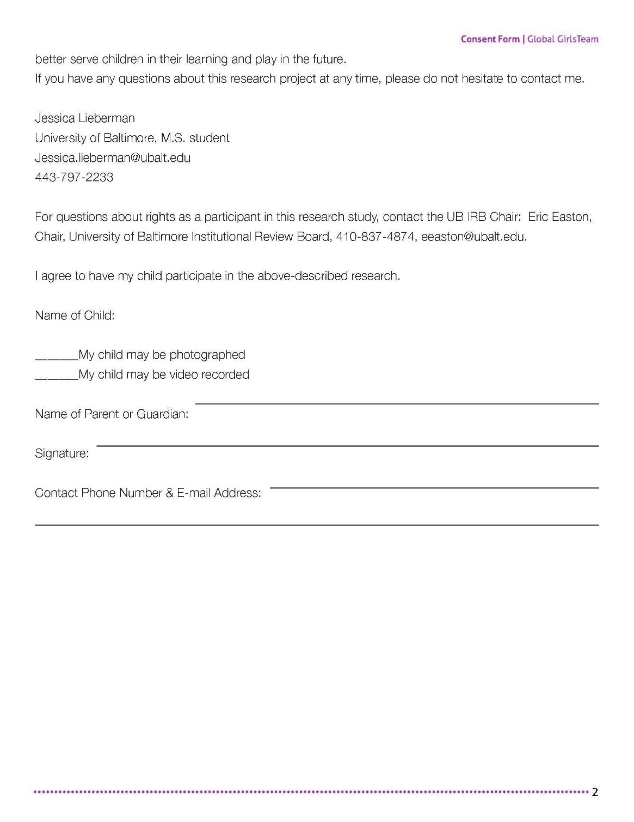
References

Abdul-Alim, Jamaal (2015). "Million Women Mentors Movement Guiding Women to STEM Careers." Diverse Issues in Higher Education. CMA , 22 Jan 2015. Web. <https://diverseeducation.com/article/68951/>.
Baker, M., & Milligan, K. (2013). Boy-girl differences in parental time investments: evidence from three countries. National Bureau of Economic Research (NBER) Working Paper 18893. Retrieved from http://www.nber.org/papers/w18893. doi: 10.3386/w18893
Bason, Christian (2010). Leading Public Sector Innovation. Co-creating for a better
society. Bristol: Policy Press.
Beede, D. N., Julian, T. A., Langdon, D., McKittrick, G., Khan, B., & Doms, M. E.
(2011). Women in STEM: A Gender Gap to Innovation. SSRN Electronic Journal. doi:10.2139/ssrn.1964782
Blackwell, L. S., Trzesniewski, K. H., & Dweck, C. S. (2007). Implicit theories of
intelligence predict achievement across an adolescent transition: a longitudinal study and an intervention. Child Development, 78, 246–263. doi:10.1111/j.1467-8624.2007.00995.x.
Breiner, J. M., Harkness, S. S., Johnson, C. C., & Koehler, C. M. (2012). What is STEM?
A discussion about conceptions of STEM in education and partnerships. School Science and Mathematics, 112(1), 3-11.
Buck, Gayle A.; Leslie-Pelecky, Diandra; Kirby, Susan K. (2002) Bringing Female Scientists into the Elementary Classroom: Confronting the Strength of Elementary Students' Stereotypical Images of Scientists. Journal of Elementary Science Education, v14 n2 p1-9 Fall 2002. (EJ654583), Database: ERIC
Bybee, Rodger W. "What is STEM education?." (2010): 996-996.
Chen, Xianglei (2013). ; STEM Attrition: College Students' Paths into and out of STEM Fields. Statistical Analysis Report. NCES 2014-001; National Center for Education Statistics (ED); RTI International. National Center for Education Statistics. 2013 103 pp. (ED544470); Database: ERIC
Cheryan, Sapna (2011). Understanding the Paradox in Math-Related Fields: Why Do Some Gender Gaps Remain While Others Do Not?. SEX ROLES; OCT 2011; 66; 3-4; p184-p190, Database: Social Sciences Citation Index
Chinn, C. A., & Malhotra, B. A. (2002). Epistemologically authentic inquiry in schools:
A theoretical framework for evaluating inquiry tasks. Science Education, 86(2), 175–218.
Christopher McFadden, C. M. (2018, May 2). 10 Greatest Women in STEM. Retrieved November 23, 2018, from https://interestingengineering.com/10-greatest-women- stem
CodeREV. (2016, October 25). What is STEM and Why is it So Important to Kids? Retrieved from https://www.coderevkids.com/blog/what-is-stem-and-why-is-it-so-important-to-kids/
Collins, R. L. (1996). For better or worse: The impact of upward social comparison on self-evaluations. Psychological Bulletin, 119, 51–69. doi:10.1037/0033-2909.119.1.51
Correll, S. J. (2001). Gender and the career choice process: The role of biased self-assessments. American Journal of Sociology, 106, 1691–1730. doi:10.1086/321299.
Dam, R., & Siang, T. (2018, October). What is Design Thinking and Why Is It So Popular? Retrieved from https://www.interaction-design.org/literature/article/what-is-design-thinking-and-why-is-it-so-popular
Dasgupta, N. and Stout, J. (2018). Girls and Women in Science, Technology, Engineering, and Mathematics: STEMing the Tide and Broadening Participation in STEM Careers - Nilanjana Dasgupta, Jane G. Stout, 2014. [online] Journals.sagepub.com. Available at: http://journals.sagepub.com/doi/abs/10.1177/2372732214549471 [Accessed 8 Nov. 2018].
Diekman, Amanda B.; Steinberg, Mia (2013).; Navigating Social Roles in Pursuit of Important Goals: A Communal Goal Congruity Account of STEM Pursuits.; Social & Personality Psychology Compass , Jul2013, Vol. 7 Issue 7, p487-501, 15p. Publisher: Wiley-Blackwell., Database: Complementary Index
Druin, A. (1999). Cooperative inquiry. Proceedings of the SIGCHI Conference on Human Factors in Computing Systems the CHI Is the Limit - CHI 99. doi:10.1145/302979.303166
Dweck, C. (2007). Is math a gift? Beliefs that put females at risk. In S. J. Ceci & W. M. Williams (Eds.), Why aren’t more women in science? Top researchers debate the evidence (pp. 47–55). Washington: APA Press. doi:10.1037/11546-004.
Dweck, C. S. (2002). The development of ability conceptions. In A. Wigfield & J. S. Eccles (Eds.), Development of achievement motivation. A volume in the educational psychology series: Vol. xvii, (pp. 57–88). San Diego, CA: Academic Press. doi:10.1016/B978-012750053-9/50005-X
Earp, J. (2017, May 22). STEAM education - taking a co-design approach. Retrieved from https://www.teachermagazine.com.au/articles/steam-education-taking-a-co-design-approach
Eccles, J. S., Freedman-Doan, C., Frome, P., Jacobs, J., & Yoon, K. S. (2000). Gender-role socialization in the family: A longitudinal approach. In T. Eckes and H. M. Trautner (Eds.), The developmental social psychology of gender (pp. 333–360). Mahwah, NJ: Lawrence Erlbaum Associates, Inc.
Farah, D., & Walas, J. (2012). The It Girls Overnight Retreat: An iSchool Recruitment Model for Prospective Female Undergraduate Students. , 3.
Fayer, S., A. L., & Watson, A. (2017). STEM Occupations: Past, Present, And Future. STEM Occupations: Past, Present, And Future,1-35.
Frye, Michael, et al. “MiniGEMS 2016 –STEM Summer Camp for Middle School Girls.” MiniGEMS STEAM and Programming Camp for Middle School Girls, 29 Apr. 2018, pp. 1–13.
Goodnow, J. J. (1990). The socialization of cognition: What’s involved? In J. W. Stigler, R. A. Shweder, & G. Herdt (Eds.), Cultural psychology: Essays on comparative human development (pp. 259–286). New York: Cambridge University Press.
Greenlee, E., Hand, S., & Rice, L., (2017). Exploring teachers’ and students’ gender role bias and students’ confidence in STEM fields Soc Psychol Educ (2017) 20:929–945; https://doi.org/10.1007/s11218-017-9408-8
Gunderson, E. A., Ramirez, G., Levine, S. C., & Beilock, S. L. (2011). The Role of Parents and Teachers in the Development of Gender-Related Math Attitudes. Sex Roles, 1-14. doi:10.1007/s11199-011-9996-2
Guth, D. J. (2016, August 18). Xyla Foxlin, 20, Parihug. Retrieved from https://www.crainscleveland.com/article/20160819/TWENTY16/160819756/xyla-foxlin-20-parihug
Hackett, G., & Betz, N. E. (1995). Self-efficacy and career choice and development. In J. E. Maddux (Ed.), Self-efficacy, adaptation, and adjustment: Theory, research, and application (pp. 249–280). NewYork: Plenum Press.
Haimovitz, Kyla; Dweck, Carol S. (2017). The Origins of Children's Growth and Fixed Mindsets: New Research and a New Proposal;Academic Journal; CHILD DEVELOPMENT; NOV-DEC 2017; 88; 6; p1849-p1859, Database: Social Sciences Citation Index
Hammack, R., Ivey, T. A., Utley, J., & High, K. A. (2015). Effect of an Engineering Camp on Students’ Perceptions of Engineering and Technology. Journal of Pre-College Engineering Education Research (J-PEER), 5(2). doi:10.7771/2157-9288.1102
Hardin, E. E., & Longhurst, M. O. (2016). Understanding the gender gap: Social cognitive changes during an introductory stem course. Journal of Counseling Psychology,63(2), 233-239. doi:10.1037/cou0000119
Holman, L., Stuart-Fox, D., & Hauser, C. E. (2018). The gender gap in science: How long until women are equally represented? PLOS Biology, 16(4), e2004956. doi:10.1371/journal.pbio.2004956
Hom, E. J. (2014, February 11). What is STEM Education? LIVESCIENCE, 1-3.
Ing, M. Int J of Sci and Math Educ (2014) 12: 1221. https://doi.org/10.1007/s10763-013-9447-3
Hochanadel, A., & Finamore, D. (2015). Fixed And Growth Mindset In Education And How Grit Helps Students Persist In The Face Of Adversity. Journal of International Education Research (JIER), 11(1), 47. doi:10.19030/jier.v11i1.9099
Inc., ISchools Organization (2012). "The iSchools Organization." About ISchools Organization. 2019 <https://ischools.org/about/>.
Jacobs, P. (2014, July 09). Science And Math Majors Earn The Most Money After Graduation. Retrieved from https://www.businessinsider.com/stem-majors-earn-a-lot-more-money-after-graduation-2014-7
MervisSep, Jeffrey, and Jeffrey Mervis (2018). “They're Fun. But Can STEM Camps for Girls Really Make a Difference?” Science | AAAS, American Association for the Advancement of Science, 4 Sept. 2018, www.sciencemag.org/news/2018/09/they-re-fun-can-stem-camps-girls-really-make-difference.
Koch, M., & Gorges, T. (2012). Inspiring Girls and their Female After school Educators to Pursue Computer Science and other STEM Careers. International Journal of Gender, Science, and Technology, 4(3), 1-19.
Konrad, Alison M.; Ritchie, J. Edgar Jr, Lieb, Pamela; Corrigall, Elizabeth; Sex differences and similarities in job attribute preferences: A meta-analysis..; Psychological Bulletin, Vol 126(4), Jul, 2000 pp. 593-641. Publisher: American Psychological Association; [Journal Article], Database: PsycARTICLES
Kumar, P., Vitak, J., Chetty, M., Clegg, T. L., Yang, J., Mcnally, B., & Bonsignore, E. (2018). Co-designing online privacy-related games and stories with children. Proceedings of the 17th ACM Conference on Interaction Design and Children - IDC 18. doi:10.1145/3202185.3202735
Lagorio, C. (2008, December 24). Kitchen Chemistry for Middle Schoolers. Retrieved from https://www.nytimes.com/2009/01/04/education/edlife/ideas-kitchenscience-t.html
Leaper, C., Anderson, K. J., & Sanders, P. (1998). Moderators of gender effects on parents’ talk to their children: a meta-analysis. Developmental Psychology, 34, 3–27. doi:10.1037/0012-1649.34.1.3.
Loudenback, T. (2016, June 15). This company's toys are helping mold in a new generation of engineers. Retrieved from https://www.businessinsider.com/goldieblox-ceo-debbie-sterling-2016-5
Maltese, A. V., & Cooper, C. S. (2017). STEM Pathways: Do Men and Women Differ in Why They Enter and Exit? AERA Open, 3(3), 233285841772727. doi:10.1177/2332858417727276
Mastai, B. (2018, August 29). Google engineer Komal Singh on encouraging girls to code with her new children's book. Retrieved from https://www.theglobeandmail.com/arts/books/article-google-engineer-komal-singh-on-encouraging-girls-to-code-with-her-new/
Master, A., Cheryan, S., Moscatelli, A., & Meltzoff, A. N. (2017). Programming experience promotes higher STEM motivation among first-grade girls. Journal of Experimental Child Psychology, 160, 92-106. doi:10.1016/j.jecp.2017.03.013
Melchior, A., Burack, C., & Hoover, M. (2018). The Impact of After-School Robotics Programs on STEM Interests, 1-17.
Morgan Lyons, M. L. (2016, November 28). The Importance of Women in STEM. Retrieved November 23, 2018, from https://ischool.syr.edu/infospace/2016/11/21/the-importance-of-women-in-stem/
Moss-Racusin, Corinne A.; Dovidio, John F.; Brescoll, Victoria L.; Graham, Mark J.; Handelsman, Jo. (2012); Science faculty's subtle gender biases favor male students; Proceedings of the national academy of sciences of the United States of America; OCT 9 2012; 109; 41; p16474-p16479, Database: Social Sciences Citation Index
Mueller, C. M., & Dweck, C. S. (1998). Praise for intelligence can undermine children’s motivation and performance. Journal of Personality and Social Psychology, 75, 33–52. doi:10.1037/0022-3514.75.1.33.
Naranjo-Bock, C. (2012, April 24). Creativity-based Research: The Process of Co-Designing with Users. Retrieved from https://uxmag.com/articles/creativity-based-research-the-process-of-co-designing-with-users
Oswald, Debra L. (2008) Gender Stereotypes and Women’s reports of liking and ability in traditionally masculine and feminine occupations. Psychology of Women Quarterly. Jun2008, Vol. 32 Issue 2, p196-203. 8p. 2 Graphs. DOI: 10.1111/j.1471-6402.2008.00424.x. , Database: Academic Search
Playthings Staff. (2016). Patch Products Acquires Roominate | Gifts & Dec. Retrieved from http://www.giftsanddec.com/article/527281-patch-products-acquires-roominate/
Popov, Vitaliy, and Tessa Tinkler. (2017). 2017 The Role of Books and Reading in STEM: An Overview of the Benefits for Children and the Opportunities to Enhance the Field, Nov. 2017, pp. 1–35.
Principles of Co-design - NCOSS. (n.d.). Retrieved November, 2018, from https://www.ncoss.org.au/sites/default/files/public/resources/Codesign principles.pdf
Roschelle, J., Penuel, W. R., & Shechtman, N. (2006). Co-design of innovations with
teachers: Definition and dynamics. In S. A. Barab, K. E. Hay & D. T. Hickey (Eds.)
Proceedings of the 7th International Conference of the Learning Sciences (Vol. 2,
pp. 606-612). Mahwah, NJ: Erlbaum.
Selloni, D. (2013) and Cantù, D. From Engaging to Empowering People: A Set of Co-design Experiments with a Service Design Perspective,1-16.
Sethi, C. (2012, September). Can Video Games Reshape STEM Education. Retrieved from https://www.asme.org/career-education/articles/students/can-video-games-reshape-stem-education
Simmons, S. (2016, February 29). STEM Job Growth Expected to Exceed Growth in Non-STEM Jobs Over the Next Decade. Retrieved from http://www.chmuraecon.com/blog/2016/february/29/stem-job-growth-expected-to-exceed-growth-in-non-stem-jobs-over-the-next-decade/
Stevens, E. (2018, September 5). What Is Design Thinking? Everything You Need To Know To Get Started. Retrieved from https://careerfoundry.com/en/blog/ux-design/what-is-design-thinking-everything-you-need-to-know-to-get-started/#2-the-design-thinking-proces
Souhrada, A. (2018, August 21). TV Host and Author Emily Calandrelli Inspires Interest in STEM. Retrieved from https://alltogether.swe.org/2018/08/tv-host-and-author-emily-calandrelli-inspires-interest-in-stem/
Su, R., Rounds, J., & Armstrong, P. I. (2009). Men and things, women and people: a meta-analysis of sex differences in interests. Psychological Bulletin, 135, 859–884. doi:10.1037/a0017364.
Tai, R. H., Liu, C. Q., Maltese, A. V., & Fan, X. (2006). Planning early for careers in science. Science, 312, 1143–1144. doi:10.1126/science.1128690
Tell, C. (2018, March 16). Karlie Kloss Teaches Teenage Girls How to Code. Retrieved from https://www.nytimes.com/2018/03/16/style/karlie-kloss-kan-kode.html
Tenenbaum, H. R., & Leaper, C. (2003). Parent-child conversations about science: The socialization of gender inequities?. Developmental psychology, 39(1), 34.
The Ada Lace Books Will Get Girls Interested in STEM. (2018, July 21). Retrieved from https://www.wired.com/2018/07/geeks-guide-ada-lace/
The State of Girls and Women in STEM. (2018, March). Retrieved from https://ngcproject.org/sites/default/files/ngcp_the_state_of_girls_and_women_in_stem_2018a.p
Walsh, G., Foss, E., Yip, J., & Druin, A. (2013). Facit Pd. Proceedings of the SIGCHI Conference on Human Factors in Computing Systems - CHI 13. doi:10.1145/2470654.2481400
Wang, Ming-Te, and Jessica L. Degol. “Gender Gap in Science, Technology, Engineering, and Mathematics (STEM): Current Knowledge, Implications for Practice, Policy, and Future Directions.” Educational Psychology Review, vol. 29, no. 1, 2016, pp. 119–140., doi:10.1007/s10648-015-9355-x.
"What It Actually Takes to Mentor Over a Million Women and Girls in STEM." STEMconnector. STEMconnector, 3 Oct 2018. Web. <https://www.stemconnector.com/what-it-actually-takes-to-mentor-over-a-million-women-and-girls-in-stem/>.
Woodward, J., Mcfadden, Z., Shiver, N., Ben-Hayon, A., Yip, J. C., & Anthony, L. (2018). Using Co-Design to Examine How Children Conceptualize Intelligent Interfaces. Proceedings of the 2018 CHI Conference on Human Factors in Computing Systems - CHI 18. doi:10.1145/3173574.317414
Yip, J., Clegg, T., Bonsignore, E., Lewittes, B., Guha, M., & Druin, A. (2012). Kitchen Chemistry: Supporting Learners’ Decisions in Science. Kitchen Chemistry: Supporting Learners’ Decisions in Science,1-8.

