Data Mapping Vacancies in Baltimore

by
Joel Stevenson
August 2017

Presented to the
Division of Science, Information Arts and Technologies
University of Baltimore

In Partial Fulfillment
of the Requirements for the Degree of
Master of Science

Approved by: ________________________________
[Greg Walsh, Advisor/Program Director]

Abstract
Currently, there is a wealth of data regarding property and vacancy information in Baltimore, but not a publicly cohesive way to access and report it. There exist many private software packages that require a user to log in to access this data, but currently, said software costs general user’s money and/or provides limited features. The goal was to analyze various existing Geographic Information Systems to construct the definitive publicly accessible data mapping tool for viewing and commenting on vacancies in Baltimore.
I found that users such as community leaders, lawyers, and community law committees prefer a system that visually combines datatypes in a mapping structure. Property vacancy data in Baltimore city at the moment is scattered; however, information is currently available at several websites. The process of reporting a property vacancy requires users to exit programs and open the public reporting system (311) application, or by calling a 311 operator. Lawyers, community leaders, and nonprofit organizational members preferred a system that could visually display property vacancy information on a map, as well as allow users to report new vacancy information if it’s not currently listed.

Table of Contents

List of Tables iii
List of Figures iv
Chapter 1: Introduction…….……………………………………………………………. 1
Literature Review…………...…………………………………………………… 1
Data Types..………………………………………………………………………. 3
Examples….……………………………………………………………………… 8
Conclusion………………………………………………………………………... 11
Chapter 2: Research……………………………………………………………………… 16
Paper Prototype 1…………...…………………………………………………..... 16
Participants……………………………………………………………….. 16
Test Taking Procedures…………………………………………………... 16
Recommendations………………………………………………………… 17
Paper Prototype 2 …….………………………………………………………….. 17
Participants……………………………………………………………….. 17
Test Taking Procedures…………………………………………………... 19
Recommendations………………………………………………………… 19
Chapter 3: Design……………………………………………………………………….… 18
Technical Prototype…………...………………………………………………..... 21 Participants……………………………………………………………….. 22
Materials………………………………………………………………….. 22
Exploratory search …………………………………………………......... 24
Property vacancy search …………………………………………………. 24
Vacancy reporting ………………………………………………….......... 25
Post Discussion/ Confidence Interval.…………………………………... 25
Analyzation……………………………………………………………… 26
Results…………………………………………………………………… 26
Chapter 4: Final Recommendations……………………………………………………… 29
Chapter 5: Conclusion…………………………………………………………………….. 33
Chapter 6: References…………………………………………………………………….. 34
List of Tables
Table 1 Follow-up questions………………………………………………………….…. 25

List of Figures
Figure 1. Real Property data search………….………………………………..... 2
Figure 2. BNIA vital signs map and vacancies………………………………..... 3
Figure 3. Vector data used to display line paths (top) and zone boundaries…..... 5
Figure 4. continuous data temperatures from January to December………….... 6
Figure 5. Examples of continuous and discrete raster data .................................. 7
Figure 6. Medical Facilities in Uganda ……………………………………….... 9
Figure 7. Low socioeconomic food centers Toronto…………………………... 10
Figure 8. GIS map Diabetes in Toronto…………………………………….….. 11
Figure 9. Paper Prototype v2…………………..………..…………………....... 14
Figure 10. Participant 1 and 2 suggestions.….……………………………….... 16
Figure 11. Participants 3, 4, and 5 suggestions ……………..………….……... 16
Figure 12. Final Paper Prototypes …………………………………………….. 18
Figure 13. Technical prototype Vacancies ……………………………………. 19
Figure 14. Vacancy reporting………………………………………………….. 20
Figure 15. Rasterized prototype……………………………………………….. 21
Figure 16. Application usage.………………………………………………….. 27
Figure 17. Confidence interval ………………………………………………… 27
Figure 18. Task completion times.….…………………………………………. 28
Figure 19. Prototype collapsed………………………………………………… 29
Figure 20. Table view………………………………………………………….. 31
Figure 21. Help menu………………………………………………………….. 32

Introduction

Baltimore city ranks “42” in the highest property vacancy rates among the 100 most popular vacant cities in the United States (The Vacant Dead: The 50 US Cities with The Most "Zombie" Foreclosures, 2015, June 10). In 2015 the United States census displayed an estimate of 23,782 vacant homes in the city of Baltimore with a 7.1% margin of error. Vacant properties can be the result of high crime in an area, declining property values, increased municipal costs, and diminishing general area welfare or health care (Accordino, J. and Johnson, G. T., 2000). While there exist several unaccounted vacancies in Baltimore City resulting from improper reporting or the lack of reporting entirely, tools exist for the public to capture said vacant properties. The examination of current vacancy reporting systems and the organizations that manage them will be discussed.

Design Process

Problem
Identification
Technical Prototypes
Paper Prototypes
Card Sorting
Research

Literature Review

The following literature review will highlight and examine existing organizations in Baltimore that use data mapping solutions to display property vacancies. Each organization provides their own sets of display tools to show information on their maps, and how to contact the organization that provides said information. This review also will explain in detail what Geographic Information Systems are and provide context to its problem-solving capabilities in the landscape of data mapping visualizations.

Open Data Baltimore allows the user to locate vacant properties in the Baltimore City area. Users can view vacant home data via data sheet, heat maps (a representation of data in the form of a map or diagram in which data values are represented as colors.), and charts. The user can also get in contact with the owner of the dataset to suggest changes or any updates that they see fit. To do so, the user clicks the “contact dataset owner” button, inputs a subject, composes a message in the message box explaining the edits or updates the dataset owner should make to the selected property, and submits an email for verification. Upon submission, the user will receive a response email from the dataset owner regarding the changes made or a request for additional information. One thing lacking is a visual representation of a pending or open user request on the map Open Data Baltimore provides.
The Maryland.gov Department of Assessment and Taxation (SDAT) has a real property database which allows users to type in an address to any property in Maryland. The user must select the county and know a method of search query (by address, property account identifier, map/parcel, or property sales). If the user selects the street address method, they must type in their street address (albeit text stating it’s not required) and a street name.

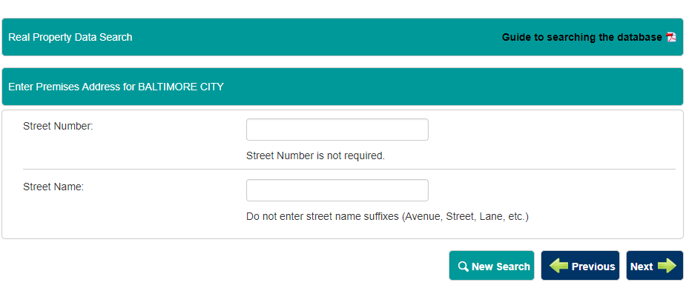
Figure 1. S. (n.d.). Real Property Data Search

The Baltimore Neighborhood Indicators Alliance “is a self-support research unit at the University of Baltimore whose core mission is to provide open access to meaningful, reliable, and actionable data about, and for, the City of Baltimore and its communities (BNIA, n.d.)”. BNIA is a nonprofit organization that provides a data mapping system that allows users view census demographics, crime and safety information, housing and community development, and more. One example of BNIA’s work, they provide a map which displays vacant homes that cause dirty water runoff in urban communities. Users have full access to this map’s data and it’s Vital Signs, but there is a process to attaining it. Users are required to locate their community on their mapping system and select “View more about this community” to receive more information. From there, the user can view, download, and print vacant information in that community.

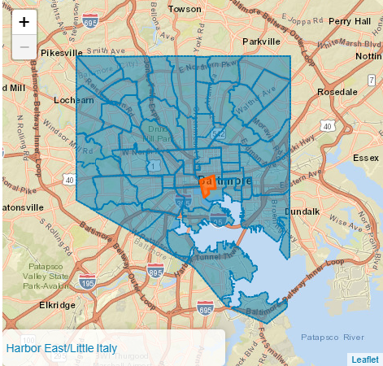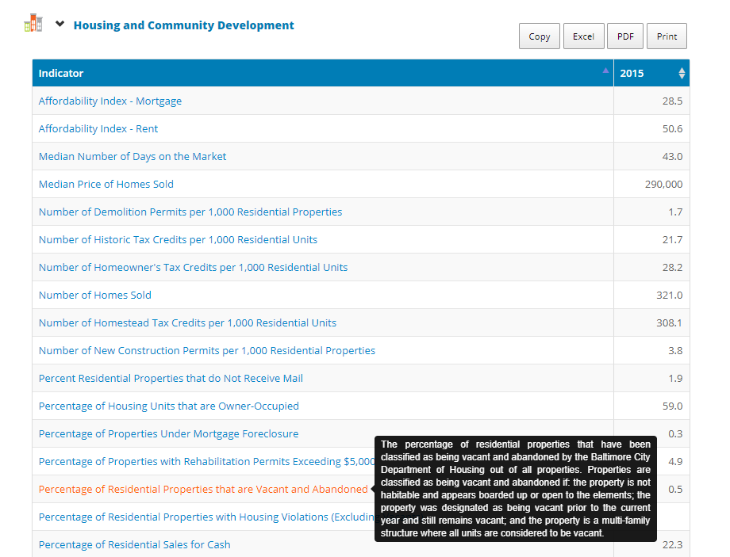
Figure 2. BNIA vital signs map and vacancies (BNIA, n.d.)

Geographic Information Systems, or GIS for short, lets users “Visualize, question, analyze, and interpret data to understand relationships, patterns, and trends (What is GIS?, n.d)”. GIS software is designed to “Capture manage and display all forms of geographical referenced data to view, understand, question, interpret, and visualize our world in ways that reveal relationships, patterns, and trends in the form of maps, globes, reports, and charts. (What is GIS?, n.d)”. That means by using captured datasets, GIS software will reference said data and display it topographically. Datasets can come from a near infinite number of formats, such as: API’s, comma separated values (csv), tables, xml integers, and many more. When the location of the data is identified, GIS software displays that data by positioning it on the Earth’s surface. This process of converting data to visual points on the Earth via GIS software is called spatial data conversion. GIS decodes and displays spatial data in two ways: vector and raster.

Data Types

Vector data is used to display information that does not consist of pixels but as polygons, and its points can be located on a map at any scale (regional and global). “Vector data types are stored as pairs of XY coordinates represented as a point. Attribute information like street name or date of construction could accompany it in a spatial database describing its current use (GIS Spatial Data Types: Vector vs Raster, 2017, January 22)”. Vector information can be used in a table and called on any size map because it’s information is comprised of mathematical paths which makes the data, when displayed, more cleanly represented on a map. For example, if a user searched for vacant properties in Baltimore in a view that shows the entire city, the vector icon chosen to label that search resulted property will not degrade in quality when viewed up close in a street view. This makes the experience of searching the GIS database flexible to numerous search habits and iconography transparent on multiple devices and hypothetical resolutions. Vector data can also be used to represent paths or boundaries using line data. “Line (or arc) data is used to represent linear features. Common examples would be rivers, trails, and streets. Line features only have one dimension and therefore can only be used to measure length. Line features have a starting and ending point” (Dempsey, 2013, (July 18). Another way vector data can be used, is to display real time updated information or information that’s changed over time. It can be used to display information called by an API or being updated by user generated content. Since it will not pixelate when it displays, information can be scaled or collapsed with no degradation to quality. For vacancy and property searches, line data could be used to display zoning boundaries and political jurisdiction of neighborhoods on the map.
The disadvantages of using vector data stems mostly on the backend with vector information requiring extensive processing power to compute the math required to display all its points. Also, “the technology is, at the moment, relatively expensive, particularly for the software and absolutely for the hardware” (UC Berkeley GIS & Remote Sensing. (n.d.)). If multiple vector icons are displayed on the map, algorithms become more complicated and more computational power may be required.

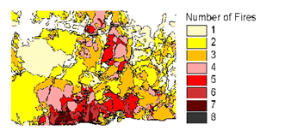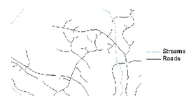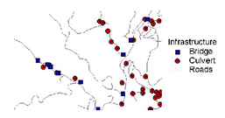
Fig 3. Vector data used to display line paths (top) and zone boundaries (bottom)(Dempsey, 2013, July 18)

Raster data is comprised of pixels and are usually regularly-spaced and square but they don’t have to be. Raster images often look pixelated because each pixel is associated with a value or class (GIS Spatial Data Types: Vector vs Raster, 2017). It is stored and displayed in a grid and can be called from cells within that grid. It’s generally used for displaying photographs and various map surfaces that are generated by (but not limited to) satellites, photo cameras, and drone/aerial capture devices. Raster data is separated into two categories: continuous and discrete.
Continuous data displays information that typically changes (over time, rate, distance) on a surface from a fixed point or from an emitting force (ArcGIS Desktop Help 9.3 - Discrete and continuous data. (n.d.)). Discrete data displays information generally what one would expect to see when viewing a map. It’s generally a two-dimensional image of the surface complete with: buildings, roads, parcels, trees, and other objects. Generally, the nouns that you see on the map represent discrete raster data. 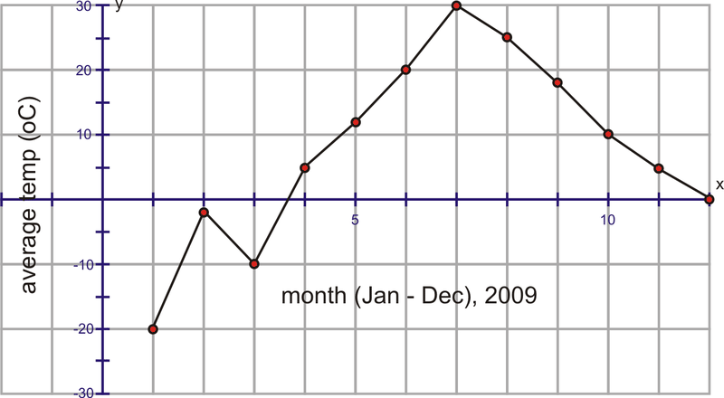
Figure 4. Continuous data representation shows the fluctuation of temperatures from January to December.

Discrete data can also display thematic information such as elevation or static vegetation areas. GIS systems use a combination of both raster data types to display interactive and searchable maps that provide fixed data that is stored in cells that update over time (updates that are user generated, API called, etc.).

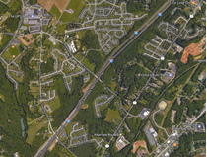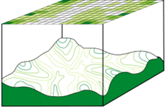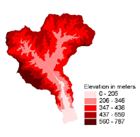
Fig. 5 Examples of continuous (top-left) and discrete raster data (top-right and bottom)

Some disadvantages to raster data includes potential degradations to visual quality, large data volumes with the potential of data loss, and network linkage issues. One potential solution to this would be to provide a toggle to alternate between raster and vector views. The other issue with raster maps is that the information that’s stored in cells can become quite large, so large in fact that that information could become unmanageable and potentially lead to data loss. Careful systems must be in place to help manage cell information and regulate parsing functionality.
GIS data handles and displays both vector and raster data types to convey numerous types of information in topographical and table format. Around the world, GIS mapping systems have been used to solve various problems from crime reports, climate changes, Medicinal locations, landmass information, weather and climate reports and much more. Some examples provided will show the impact of GIS mapping system’s ability to provide quality information for: countries with limited access to technology and medicinal facilities, indigenous medical plants, and smart food retailers.

Examples

In Uganda, “the overall malaria specific mortality is estimated to be between 70,0000 child deaths annually (Larocca, A., Visconti, R. M., & Marconi, M, 2016)”. Those numbers were captured in 2016 and expectations seem to reveal that those numbers are still on the rise. Instances of Malaria account for 30-50% of outpatient visits and 9-14% of patient deaths (President’s Malaria Initiative. Fighting malaria and saving lives, 2015). As it stands, the cost of testing at healthcare facilities in Uganda is a financial barrier for the poor and rural households. On top of that, medical information for Ugandan residents are only able to be viewed at these facilities. This immense epidemic spawned research for feasibly implemented digital solutions that would grant impoverished and solvent Ugandan citizens to have access as well as medical information. This digital solution would have to factor in that 2G is the baseline data transfer speed in Uganda and that the cost of entry/ implementation should be low, as the country's economic resources prohibit excessive spending. The hypothetical solution took the form of a GIS mapping system that could feasibly provide information to users using pre-existing technologies: The M-Health/ GIS healthcare system.
M-health or mobile health is used for the practice of medicine and public health supported devices (MHealth, 2016). It has been implemented in several countries that have smartphone support and provides information for medical and treatment facility locations, self-diagnosis information, terminologies and numerous ways to capture and exchange medical information with key systems (Mobile Health Technology, 2016). M-health applications require a smart device with data connection to exchange information. The integration between traditional and digital health solutions (m-health), represents a process innovation that could provide cheap, real time, geo referenced data (GIS) for real time response to disease outbreaks (Larocca, A., Visconti, R. M., & Marconi, M., 2016). The system is constrained to 2g data speeds to facilitate the lowest common denominator and up, and must display a range in signal strength for rural areas that have weaker connections. The GIS must be able to display a map that all Ugandans can access regardless of economic, geographic, or digital barriers.
The researchers had two assumptions, the first being that healthcare centers weren’t available or readily accessible to rural Ugandans and second, people wouldn’t want to travel an hour or more to go to said facilities. The researchers created a zone statistic tool to calculate the number of patients that were within 10 km and roughly 1 hour away from major cities that had healthcare facilities. They then displayed that information on a GIS map
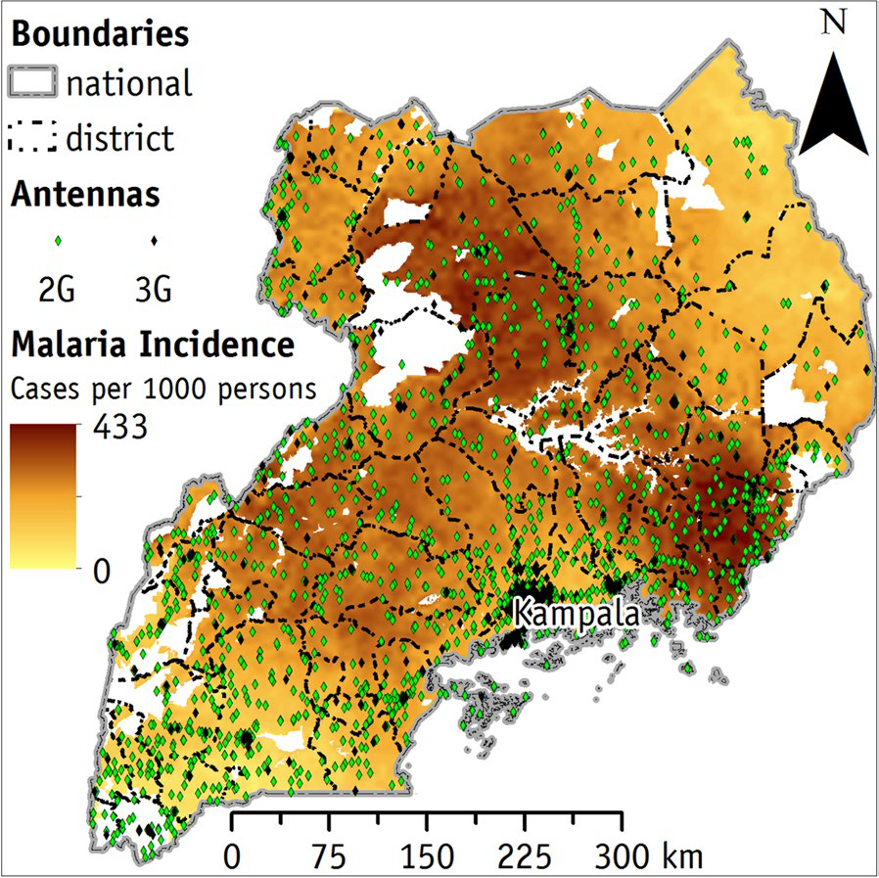
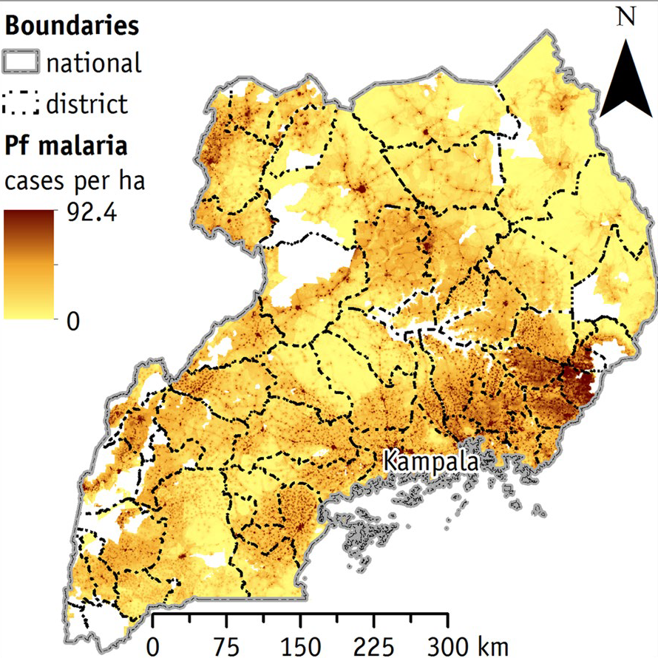
Fig. 6 Medical Facilities in Uganda

complete with iconography and boundary information. Displayed on these maps were vector icons indicating: 2G and 3G devices, district boundary lines, and medical facilities. Vector data imagery was also used to display the 2-dimensional map and the heat map of malaria incidences (cases per 1000 persons). If the information of the Malaria incidences were to change over time, continuous data will be displayed real time.
In Larrocca, Visconti, and Marconi’s (2016) research, there's a wealth of information that can be gathered and displayed through GIS data maps using 2G and 3G data connections. Since there are a good number of open source software solutions for GIS systems, it would be a great benefit to the Ugandan people to have information like this and wouldn’t be financially taxing to implement. This serves as an example where GIS maps can convert and visualize vital data that can truly help the urban as well as rural citizens of Uganda.
The next example shows how open source GIS mapping software can help non-profit and local food retailers identify and locate food shops. Also, how it can display areas that are at risk or have high rates of health-related issues due to the lack of access to fresh food. The GIS data map can help visualize the disparity of fresh food accessibility and can potentially be used to help combat food deserts (areas with little to no access to fresh food) in areas below the poverty line with limited access to fresh food resources and grocery stores.

In situations where cities and lower income neighborhoods have higher access to convenience stores and less to fresh food, open source software GIS mapping solutions can be an appealing way to spread awareness and possibly to combat that situation. Open source Programs such as GRASS GIS, MapWindow GIS, QGIS, and SAGA GIS. MapServer is an example of an open-source software that functions with a client (client-centric server) and server dynamic (server-centric server) use server-side client information to display information on a map. The researchers (Eric, V., & Monica, K., 2016) used geographical information to show the distribution of food centers in relation to lower socioeconomic areas on the map.
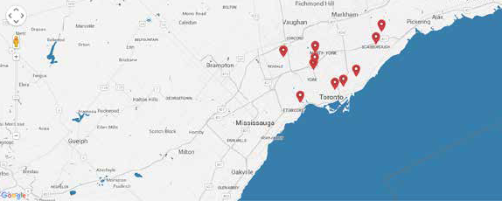
Fig 7. Low socioeconomic food centers Toronto

The researchers then used “Landscape and urban planning factors such as ravines, lakes, corridors, proximity of major highways impact food accessibility; preventing people from available healthy, fresh food” ( Eric, V., & Monica, K., 2016). Then they mapped areas in Toronto that had greater incidences of diabetes. The lack smart food locations and fresh resources in relation to areas with lower income coincided with the higher amount of health-related problems in that area.

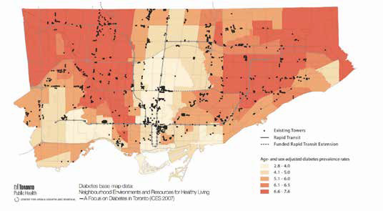
Fig 8. Diabetes GIS map in Toronto

Conclusion

GIS data mapping provides visual solutions to various problems across the world, within many socio-economic structures, and in a diverse landscape of situations. Using a combination of raster and vector data sets to visually display content that is static/cell based or updated over time via user generated data, programs, or APIs provides accurate and crucially pertinent data to various types of users. GIS data can be feasibly implemented and open source solutions are available for countries, companies, and nonprofit organizations with limited financial resources. For locating and reporting vacancies, parcel, and other general property data, GIS mapping systems offers an effective and visually appealing way to display that information.

Research

A wealth of property and general data about Baltimore city was granted to me by the Jacob France Institute. Some of the data included: service calls, 911 calls, property foreclosures, community statistical area, and property net value. To organize this data, I created 2 paper prototypes and a technical prototype in the form of an interactive map that users can search through. Users from various sectors of Baltimore city housing organizations were asked to participate in one of the 30 to 60-minute testing sessions using one of the 3 prototypes. Iteratively, the design evolved from a low fidelity paper prototype, to a higher fidelity paper prototype, to a fully intractable clickable prototype, to a final web deliverable.

Paper Prototype 1

Participants

The goal of this round was to see if the searching and the retrieval of information from participants of multiple professions was feasible using a filter system to access different parts of a newly constructed Baltimore city vacancy database. For unqualified pilot testing I used 2 academic participants. Then I used 3 professional participants from the perspectives of a pro bono, a lawyer, and community leader. I used paper to simulate the final prototype’s display complete with dropdown and accordion menus, and the table screen that the map screen switched to when the user clicks the “Display table” button.
Test taking procedures

This round of testing was exploratory, meaning users were instructed to freely navigate the prototype and comment on what struck them as useful or what needed refinement. Users were encouraged to think aloud and tell me (the moderator) if the flow of navigation was fluid or rigid, and what elements they’d include to make the process make sense. Users were given up to 30 minutes to complete this task with no moderator interjection, and once concluded, I asked them to tell me what they thought, or to elaborate on a comment they made during the session.

Recommendations

The first tester (pro bono) suggested that I remove the label “Income” and replace it with “Income and Property Information”. This was later changed to “Property and Mortgage info”.
I also stated, “I’d like to know where this data is coming from and when it was updated”. We’ve added sources, and when they’re updated to each category section. The user stated that visually representing sources, “Gives the person using the system he needs to find the information he wants; builds trust in the results”. The user wanted to display source information when the user hovered over a link or area of the map, but that couldn’t be replicated paper format.
The second tester (Lawyer) wanted us to “Add an ‘about us’ on the login page”. With the final design an about us link will be added, which will take the user to the home screen.
“When entering details about reports, add interior/ exterior information, add more detail to that.”. I added a list of check boxes and items in the dropdown boxes to properly report your vacancy issue, and a comment box for additional comments. “I want my information front facing, why do I have to have a filter to see my information?” I removed the dropdown box with categories and changed it to always to display that information.
The last participant (community leader) stated, “I should be able to search the map with more filters, also could you include a color-coded tagging system for reported violations (green for rats, red for roaches etc.)”. I added search tools for the user to be able to select or deselect options to fine tune their property search. Implemented via search filters /tools. “I want notifications (email) for when I submit my report”. “Income information for individuals is too invasive” changed into “Property and Mortgage information”. Lastly the participant asked, “Why do we have to login to view public data?” We changed the logging in requirement exclusively for reporting.

Paper Prototype 2

Participants

Taking the design recommendations from round 1 we’ve implemented, added and subtracted features for the second round of paper prototype testing. So far, we’ve gotten input from 4 professionals: a pro bono, tax sales service coordinator, a community development officer, and a community leader.
All data was consolidated into 3 accordion menus with the headings “Vacancies and Violations” “Tax Sales Information” and “Mortgage and Property Info”. These containers housed applicable data for the user to hone in on what they want to populate the map. Specifically, in the “Vacancies and Violations” menu, the user had access to open and closed 311 calls, owner occupation status, USPS mailing status (Does the address receive mail?), and information to see if the property is owned by the city or a private owner.

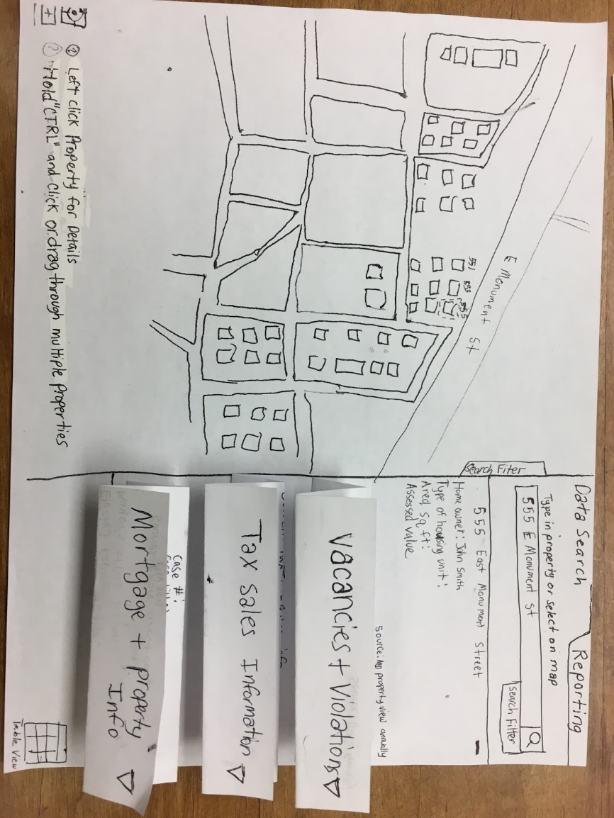
Fig 9. Paper prototype version 2

Test taking procedures

Participants this round were instructed to complete a test consisting of a series of 12 tasks. Within an hour the participant was required to use the map view to locate “555 East Monument Street” on the map and identify its data involving: service calls, homestead information, and adoptable lot information. Once completed, the user then had to go to the table view to: add vacancy information in a column, add another address to the table, and save/print the changes to the table view. Next, the user had to go back to the map view, drag and select multiple properties on the map (this was simulated by pressing and dragging their index finger through the paper prototype). Once the participant selected multiple properties, the user homed in on “555 East Monument Street” then selected the reporting tab. Lastly, the user had to use the dropdown menu to select vacancies, add a description of the issue, and submit an image of the property.
The participants were required to place posted notes with descriptions of their recommendations on the areas that needed modification. If they had no input on the design, they were asked to move on to the next page of the prototype. After all of the posted notes were placed and tasks were complete, I required the user to explain their recommendations in detail so I could implement them in the technical prototype.

Recommendations

Participants 1 and 2 wanted me to “Add Pictures to the Data Table View page”. Participant 1 wanted to know if we could implement a system where users could search for user generated vacancy reports that haven’t been specifically logged by the public reporting systems, “Is there a way to search for user generated vacancy and other reports even if the city hasn’t reported it vacant?”. In the technical prototype, I added user generated notes system that populates the map with user defined reports. Participant 2 stated, “A help section/ number for people who can’t figure out how to navigate the site.”. I added a help button on the technical prototype’s bottom left corner that stays visible on every screen.

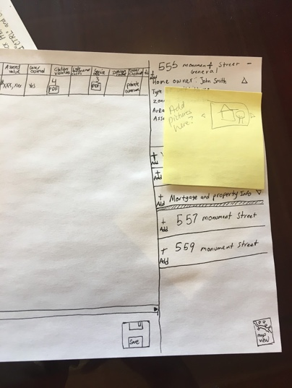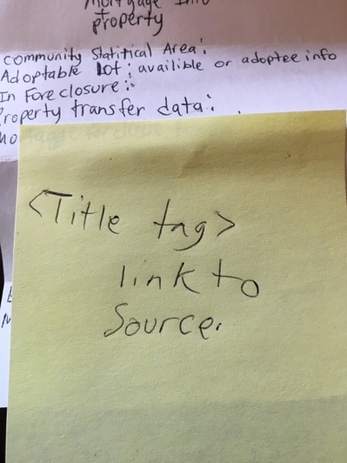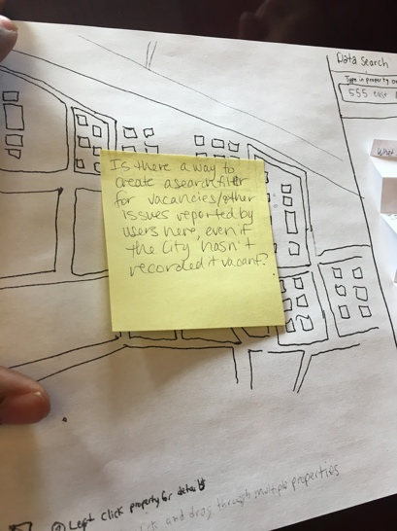
Fig 10. Participant 1 and 2 suggestions

Participant 3 wanted me to find a way filter or search for only public reporting system information on the map, no custom user generated content. He also wanted the map to “Have a targeted tagging system, finds nearby houses that are reported with an issue (311 calls vacancies etc.) and have those results auto populate secondary and tertiary options”. Participant 4 recommended that when reporting, allow the user to “insert custom comments (ones) that don’t currently have public reporting system call information associated with them”. For example, chipping paint (which could lead to lead issues) currently doesn’t have a 311-directory attached to it, allow a user to type that in and display that.

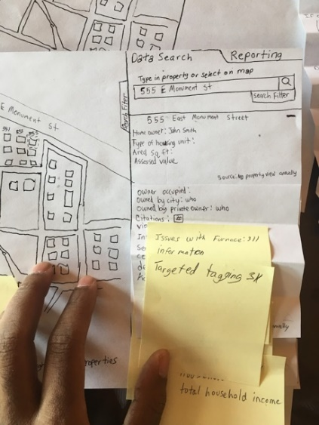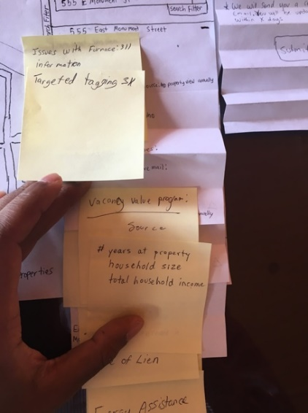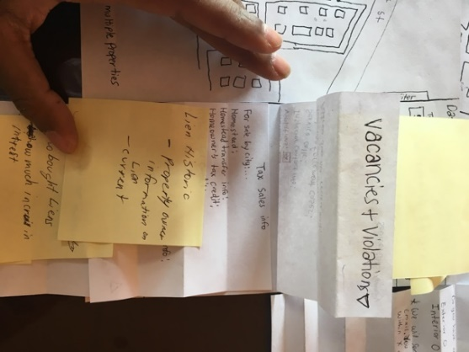

Fig 11. Participants 3, 4, and 5 suggestions

Participant 5 wanted me to change “Do you have any attachments?’ on reporting tab to “Attachments” and replace “Add More” with “View More” when adding another property to view in the table. She then suggested to “Send reporting verification through email and in pdf or excel view”. Lastly, she recommended to remove the table view icon from the map into the top right corner, above the data search and reporting links.

Design

Prior to testing the prototype created in Axure, as previously stated, initial testing rounds of testing were conducted using a paper prototype version of the application. The testing rounds were exploratory, so the task required the user to freely navigate through the prototype and to locate inaccuracies in content directories. Without the vacancy reporting functionality initially added in this round of testing, participants were asked how they would report a vacancy if this mapping system included one. 3 out of 3 participants recommended a separate section where the user could add pictures or other forms of multimedia to indicate property damages or vacancies. One participant suggested a mobile application to capture images solely for the purposes of reporting vacancies.
For data organization suggestions, a small closed card sorting session was conducted. Participants were asked to place several data labels into three categories: “Vacancies and Violations”, “Tax Sales Information”, and “Mortgage and Property”. Upon collecting that information, I managed to construct 3 dropdown lists with the aforementioned category titles containing the labels each participant placed in said containers.

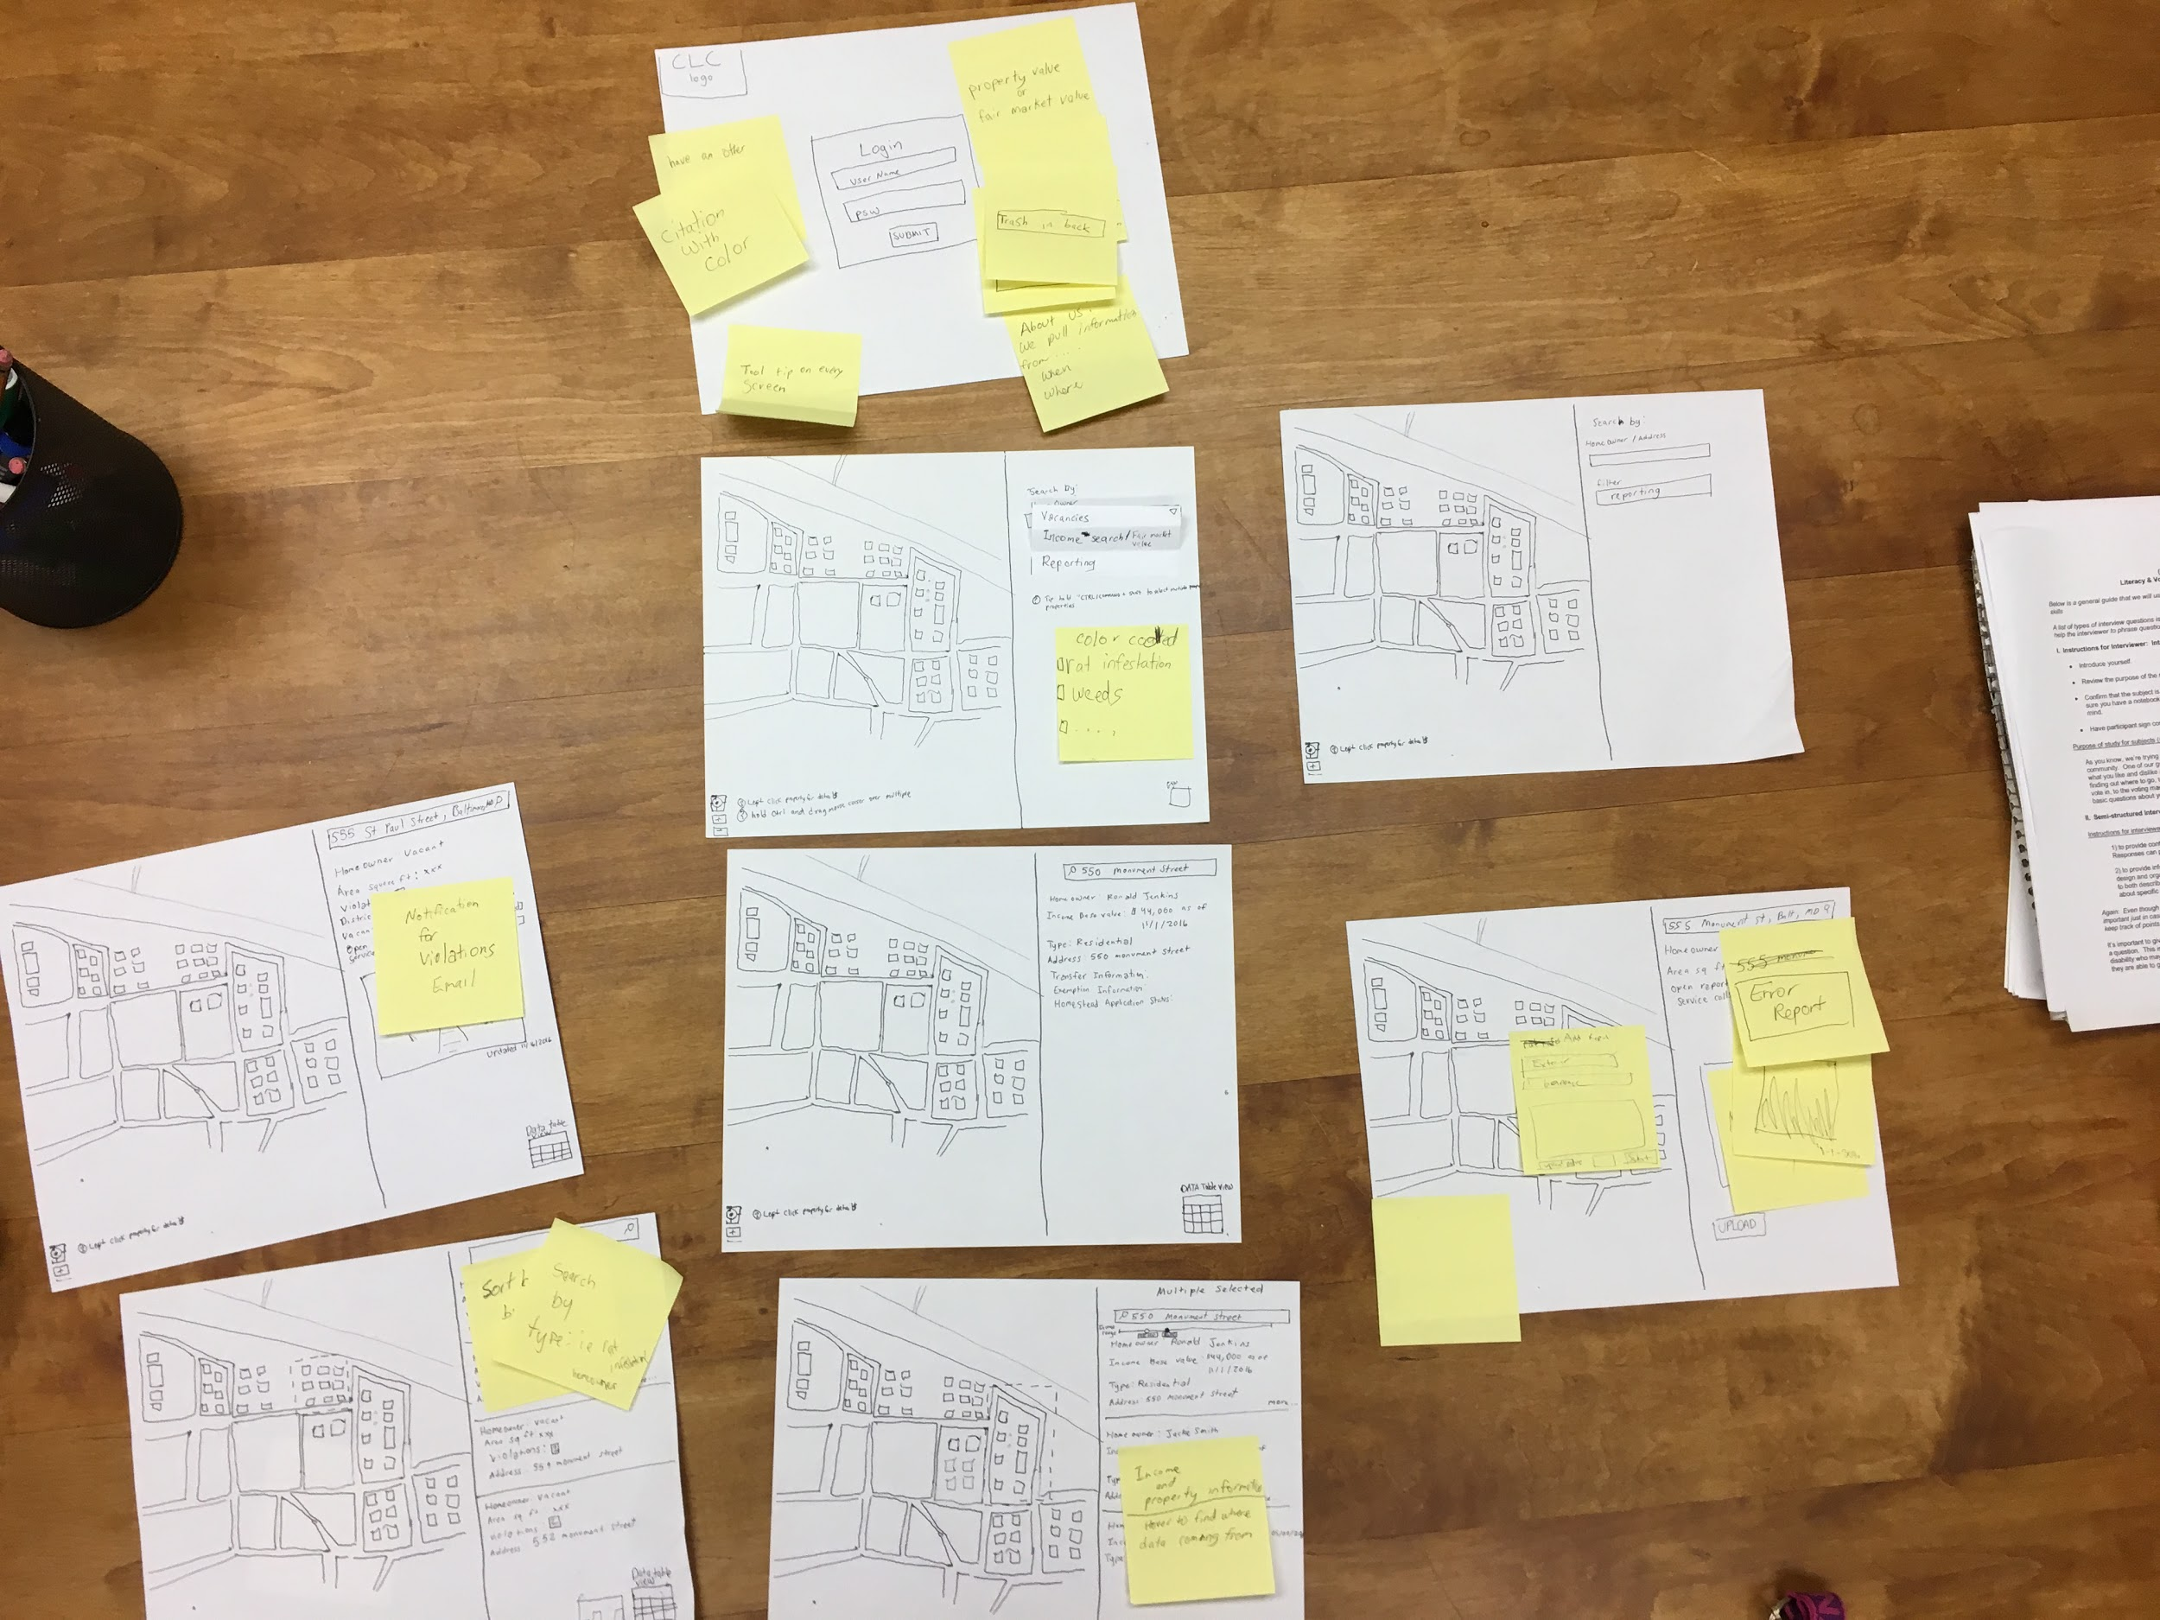
Fig 12. Final Paper Prototypes

Once the preliminary rounds of paper prototypes concluded, construction of the high-fidelity prototypes commenced. Utilizing vector and raster images, the prototype visually displayed vacancies within a section of Baltimore City. The user can select a property on the map, and on the right sidebar, details information about that property displays. General information is always front facing, such as: homeowner name, type of housing unit, area square feet, and potentially, contact information. Just one drop down menu down contains property vacancy information. From there, the user can see citations, violations, and service calls at a glance to see if the property has open cases or complaints.
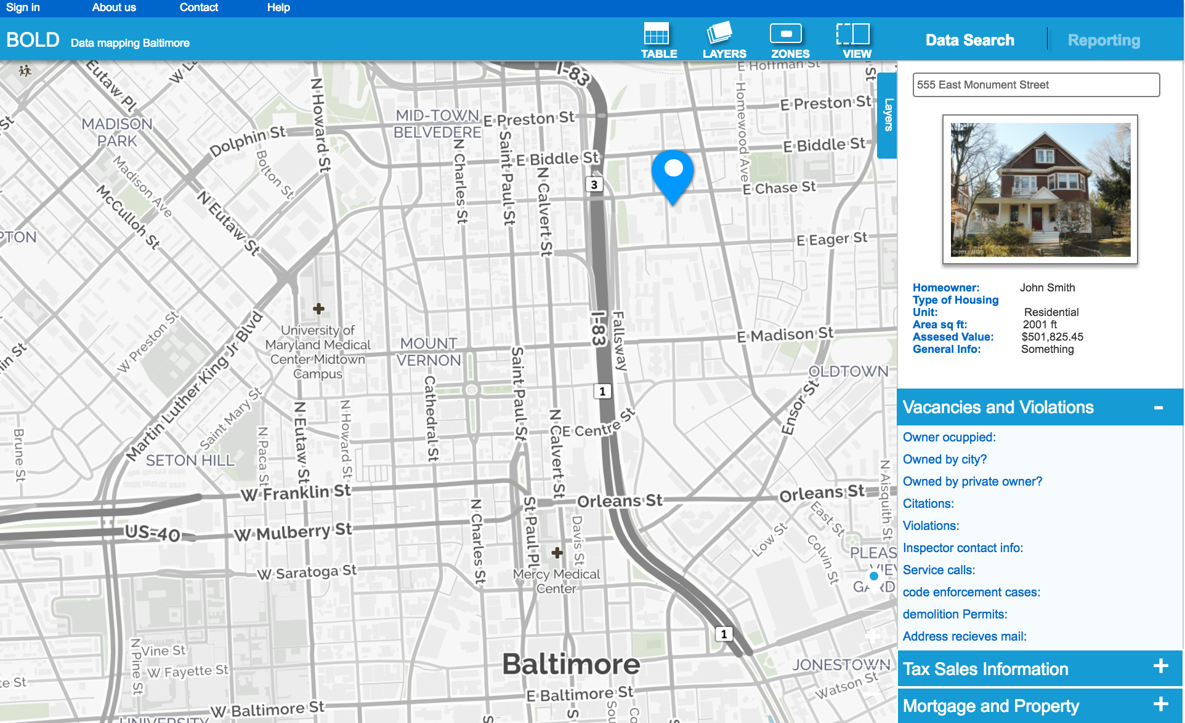
Fig 13. Technical prototype Vacancies

Once the user has the property selected, and has viewed the vacancies and violation information, he can click the “Reporting” tab to report an issue. The user can now select an issue from a list of options in the drop-down menu; selections such as: high grass and weeds, rats, boarded up windows, trash, etc. Once the user selects his option, the map will populate with other blocks that have similar open reports. The user can now enter a title for the vacant property and compose a message about the property’s condition. The user can also submit an image or other media validate the report’s claims. Once the user submits, the dataset owner will contact the user and the appropriate public reporting system directories. Until the issue is resolved, the white “reporting” icon will remain on the map.

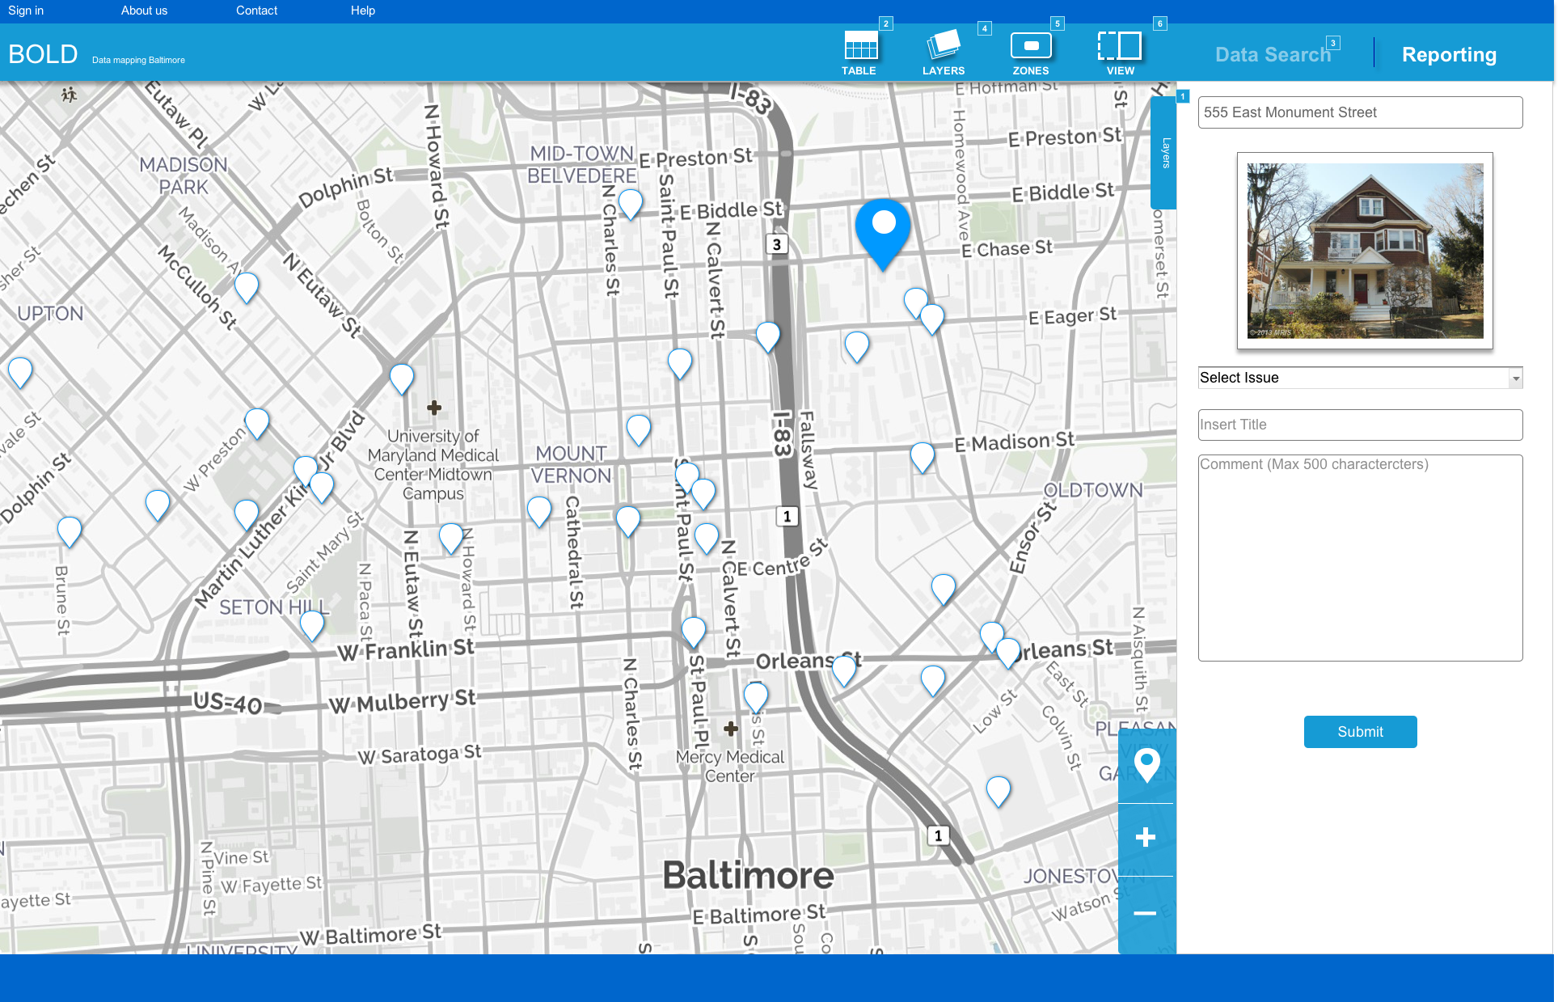
Fig 14. Vacancy reporting

The mapping system should be displayed via a raster image to get a photorealistic view of the land. This is important for users that can’t locate their property by address, but can visually aid them to find it on the map. Users will be able to zoom in and inspect the home close up to see if they are selecting the correct home to report vacancies. This view can help decrease the margin of error for improper vacancy reporting. Both views will be accessible in the data search screen and the reporting screen.
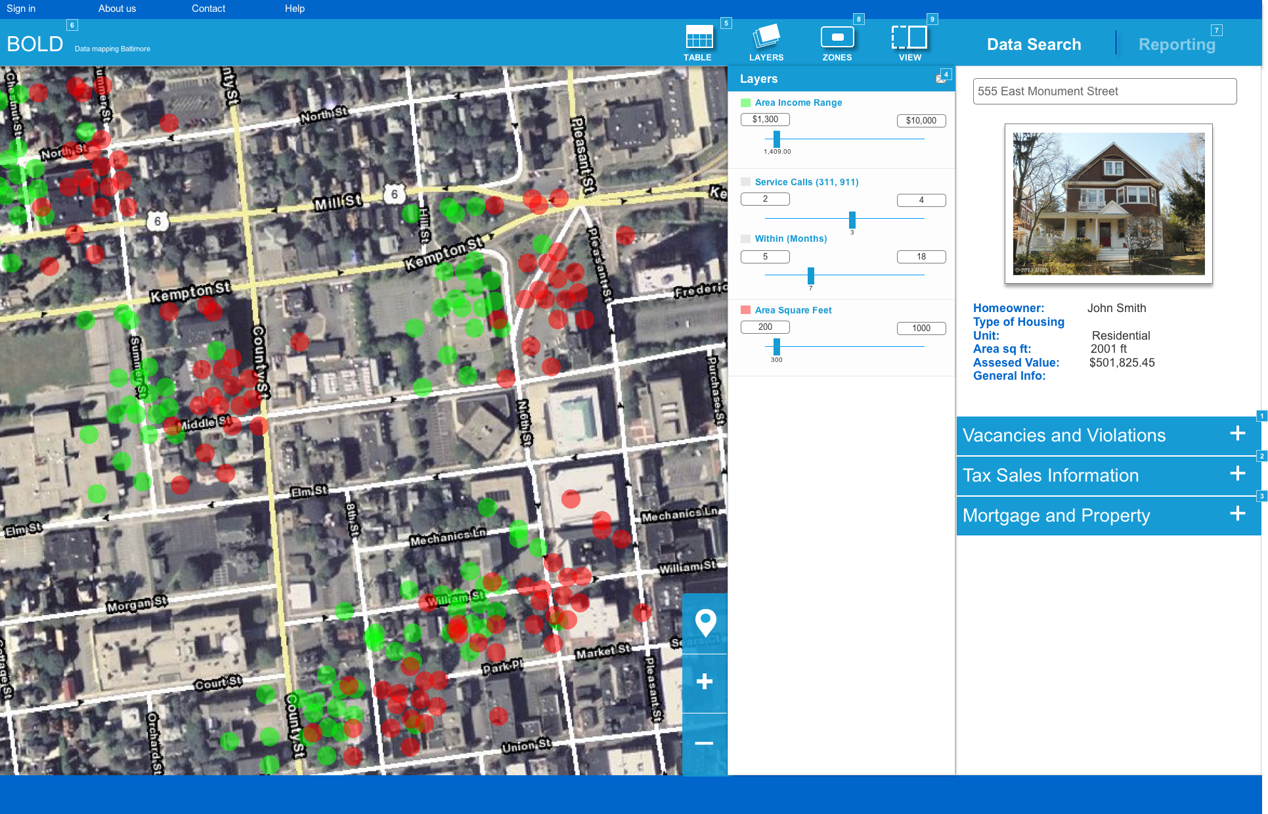
Fig 15. Rasterized prototype

Technical prototype

Participants

The goal of the technical prototype testing sessions was to use 18 participants ranging from age and expertise in their field of community involvement, community organization, and non-profit organization affiliation. Participants had to be over the age of 21 and will have to have worked in one of the 3 fields mentioned for a minimum of 1 year. The data captured was split into two categories: quantitative and qualitative. 3 participants will be required to commute to the user research lab to test quantitatively via lab usability software and the other 15 will be required to use their desktop or laptop computer to test. The latter half of testing will be done remotely, so the participant can test in whatever environment they choose provided they have a stable internet connection for the duration of the study.
The first 3 participants had to have the role of community nonprofit organization affiliate or community law firm associate. They had to have worked in that field for 2 or more years and be intermediate or expert in that field. The data captured was in lab and quantitative, so it’s crucial to test with participants that have used programs prior to testing day that displays content similar to the prototype used. Their tasks will be oriented toward capturing data with their expertise in the field in mind.
The last 15 participants consisted of community leaders and community enhancement oriented individuals. They had to have attended community organization meetings, been involved in community growth projects, or have been overall an active member or their society for over one year. It was important to gather their vocal and nonverbal opinion on the prototype as opposed to the statistical data from the quantitative data sets.

Materials

I used Axure to create high end prototypes for each user to test. They replicated the results from a paper based testing prototype used prior to this study. The GIS mapping prototype consisted of two parent locations which the users will test: the property vacancy address lookup and the user submitted reporting functionality. In both locations, users were given a series of tasks to see if these areas contain the correct: flow, data requirements, terminologies, and information they need. It's important to test with prototypes because it replicates the final product, but can be easily modified or restructured if needed.
To attain the most accurate quantitative data for the prototype’s design, the implementation of Morae usability software was utilized. This program was used to record and timestamp each task the participant completed throughout the study. Users were required to travel to the University of Baltimore User Research Lab to complete the full session of testing. They had to have agree with sharing their voice and video in the consent, since they used the laboratory's webcam microphone, and screen recorder technologies. This was stated in the IRB presented before testing.

After the completion of the in-lab testing sessions, the following 15 participants tested with qualitative data capture as the central focus. Each session was conducted both remotely and together using a think aloud method of testing. With the think aloud testing, I did not require eye tracking software, but the program Zoom to be installed on the moderator’s and the participant’s computer to share and record the user’s screen as well as webcam during the session’s duration. The user was required to have a functional webcam, microphone, and headset or computer speakers to participate in the quantitative portion of testing.
Each participant used the Firefox browser to view the prototype and Axure Share’s browser based prototyping application to view the prototype. Specifically, each participant was required to use the version 3.4.8 of Firefox due to Tobii Studio’s inability to use any version other than that. Even for the qualitative study, each participant had to downgrade their Firefox browsers to that version specifically to keep the consistency of the prototype intact. We did not test with any other browser during the duration of the study and we used Windows 10 as the primary operating system for testing.
The University of Baltimore provided applicable usability hardware to facilitate any potential accessibility needs of the participants. The User Research Lab provided large text keyboards and a wheel chair ready desk to take the test on. There was also have magnification software; however, the eye tracking software prohibited the use of it and decreased any and all browser zoom settings to its default size. Participants that wear bifocals were initially subject to rejection from the quantitative (eye tracking) study due to Tobii’s limitations with their (bifocal lenses) light reflection against its eye tracking sensor. I provided reading glasses to prevent that from happening, but users had to first agree to wearing them.

Test taking procedures

The first 3 participants were required to take the test via the University of Baltimore User Research Lab and the next following 15 took the test remotely; however, tasks and completion times will remain identical to each other. Tasks were presented in the following order each with set completion times associated to them: exploratory search, property vacancy search, property vacancy reporting, confidence interval. The sessions took approximately 45 - 60 minutes to complete, with a 10-minute post discussion included as the final task.

Exploratory search - 10 minutes

Users were first asked to log in and freely explore all sections of the prototype for 10 minutes. They were told to think aloud and comment on anything they find interesting or concerning during this section. They started at the login page and then taken to the landing page featuring the GIS map and search menu occupying the display. Comments concerns and other suggestions were taken either here or in the post discussion section of testing for eye tracking. For remote testing, the users were encouraged to comment and express concern throughout the testing duration.

Property vacancy search - 20 minutes

Property vacancy search consisted of 3 step by step tasks for the user to complete within 20 minutes. Each step required the user to either utilize the map, search bar, and menu to locate property vacancies in Baltimore. The first task required the user to use the search bar to locate a vacant property at “555 East monument street”. From there the user needed to find previous homeowner information such as homeowner name and open/ closed public reporting system calls to this address. Once completed I asked the participant to navigate back to the home page and proceed to step 2. Step 2 required the user to search for the same information, but this time the participant needed to find the same address using the map displayed on the landing page. With that property selected, the user was tasked to view the data in table mode utilizing the table view button on the bottom of the map. Step 3 the user was tasked to use the search tools pop out menu to find the same location “555 E Monument street”.

Vacancy reporting - 10 minutes

With 555 East Monument street selected from the previous task, the participant was asked to role play as if they were reporting a vacant property at that address. The participant will be asked to navigate to the reporting section of the prototype. From there, they were tasked with submitting a picture, which I provided on the desktop, and to write a description of the vacant property. They had to then submit the report and locate that report on the map.

Exploration
Property Vacancy
Search
Vacancy Reporting
Follow-up questions

Post discussion/ confidence interval - (10)

The final step in the test was a post discussion of the participant’s experiences using the prototypes. Here they explained what worked or didn’t and suggestions to the designer to make the prototype feasible in their line of work. Following the discussion, three questions were asked to quantitatively capture data regarding their experiences using the prototypes. A final question at the end was used to qualitatively capture the user’s experience using the prototype. A Likert scale was used raging from scores 1 - 5, one being least desirable and 5 being most desirable. The first question was, “Was it easy to locate the property vacancy given”. The second, “What was the easiest method of locating a property and how easy was it?”. The last question, “How confident were you completing each task on this app?”. The quantitative question was, “If there are any suggestions you’d make to this application that we could tell the designer, what would they be?”. For the remainder of the testing, there was an open discussion on things that either the moderator or the participant noticed during the session. Lastly, the question “Would you use an application like this to located and note property vacancies in Baltimore” was asked to see if a data mapping solution would be an ideal was to locate vacancies. A binary yes or no answer was collected for analysis.

Table 1: Follow-up questions
 | Suggestions |  | Was it easy to locate the property given? | How confident were you completing tasks | Would you use this application?
Participant #1 | Establish if property is individually owned or owned by the business |  | 5 | 5 | yes
Participant #2 | Display sources on hover |  | 4 | 5 | yes
First two participant responses to follow-up questions

Analyzation

The data was captured in an excel sheet format. Each header contains: task completion success/failure, task completion times, quotes and observations, and general comments. The success and failure column contains a binary success or failure metric whereas the quotes and observations column stores remarks by the participant relevant to the task they are completing. Frustrations, positive reactions, and other noteworthy nonverbal gestures were also recorded in this section. The comments column was used to transcribe participant quotes into design problems. When there is a consistent trend of identical problematic observations (by more than 3 participants), design recommendations will be taken into consideration and eventually addressed. The test will not be modified once the first session has started.
Additionally, there was a feedback tab that recorded follow up question results. This contains user satisfaction and confidence interval data sets; data metrics of 1 to 5 (5 in favor and 1 not in favor). On the bottom of each column, there’s a total cell that calculates the average of all the participant's scores. This was useful to see if the results of the satisfaction/ confidence intervals correlated with the success or failure of task completion rates.

Results

Out of the 18 participants that tested the functional website, 6 reacted positively to the reporting system provided on this application. One participant responded negatively due to the separation of the reporting section from the property/data search area.

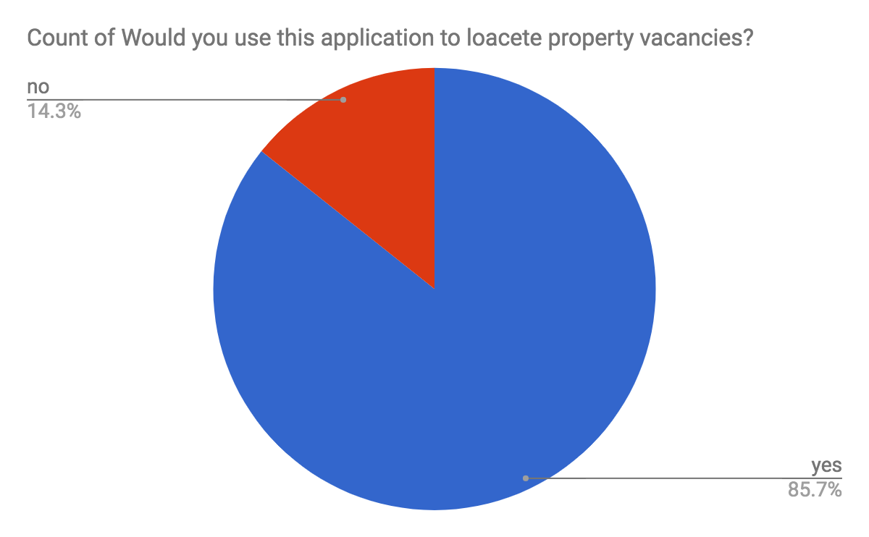

Fig 16. Application usage

Out of the same group of participants, each were asked “Was it easy to locate the property given?” and “How confident were you completing the tasks in this session?”. Participants had an average of 4.5 out of 5 claiming yes, it was easy to locate the property tasked to them and 4.14 or 83% was the task confidence interval average. Overall users found it relatively easy to locate and report using the prototype.

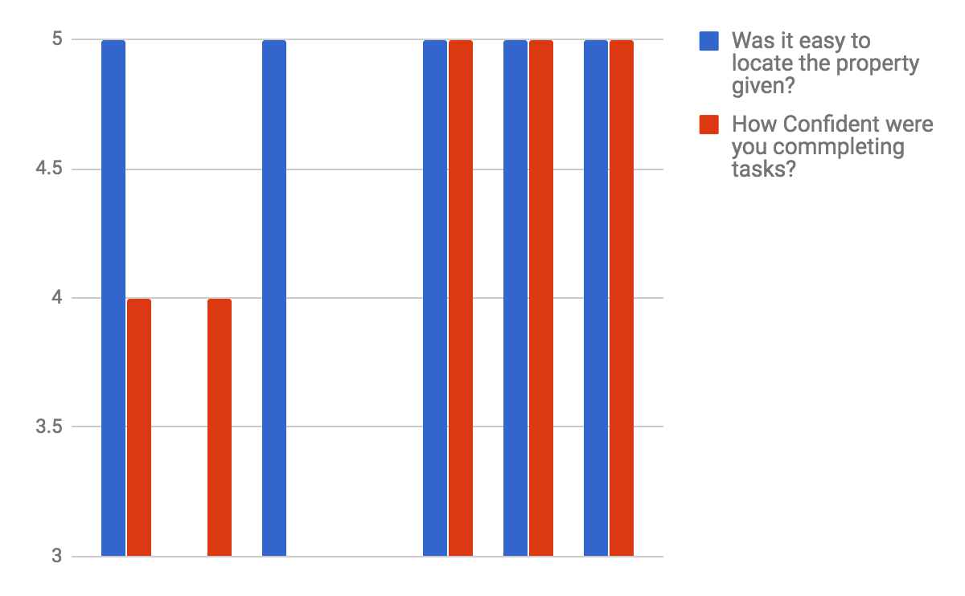
Fig 17. Confidence interval

All participants apart from one, were able to successfully locate and report the property “555 E. Monument street”. The average time it took participants to locate the property was 3:28:43 and to submit a report about that property, it took an average of 3:35:00 (three minutes and thirty-five seconds). General exploration took an average of 8:43:24 until the participant wanted to move on to the next task.

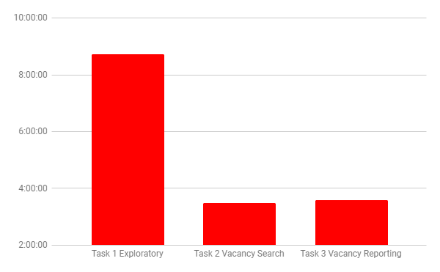
Fig 18. Task completion times

Final Recommendations

For systems that solely rely on a search system to query a database, consider a map system integration. One user recommended visual feedback for search results if the option was there. Also, if a search option is integrated, make sure that the search bar doesn’t obtrusively occlude the map. Allow the search box to be collapsed, moved, and reformatted to the size that the user finds visually comfortable. When displaying data filters that you want to populate the map, allow for each option to have a relevant parent container that houses similar data types. Since there are numerous filters that can be applied, allow for the section labels to be collapsed via an accordion menu or dropdown menu to avoid visual clutter.

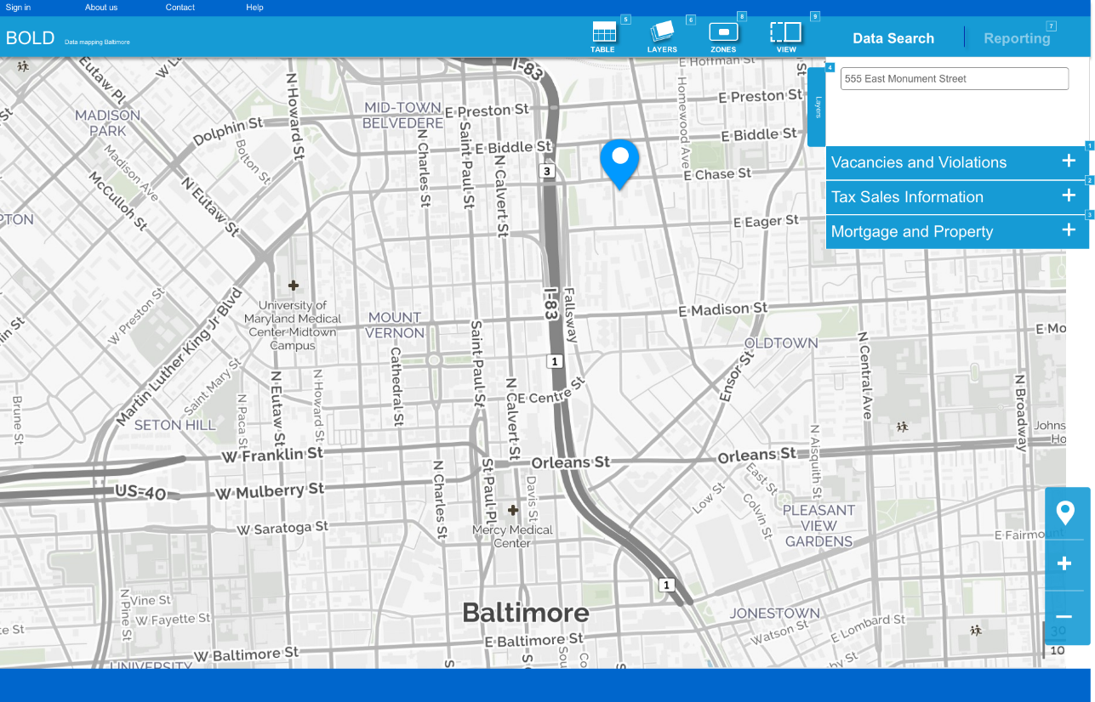
Fig 19. Prototype collapsed

If API access to public reporting system information can be utilized, allow for that data to display on the mapping system. Vacancies and other 311 open/ closed information would allow the user to easily locate the property vacancy on the map, which could potentially remove the burden of remembering or writing down property addresses they’d like to report. It would allow the user to immediately recognize the solution rather than recalling information. In addition to calling the 311 API to display vacant properties on the map, users expressed interest in submitting reports and media (pictures, videos, etc.) to 311 if given the ability to. If the public reporting systems don’t comply uploading through an external database, allow the user to submit and display their content on the map via a local uploading system. That will enable authorized users to submit and edit notes that will populate the map, so unauthorized users can view content without the use of a public reporting system. A tiered log in system will ensure that only authorized users can post notes and media to the database. Users granted an authorized status would be able to report vacancies and non-authorized users (general public) would be able to search and locate vacant properties. Both user groups (authorized and unauthorized) will have the privilege to export their findings in the format they desire.
Where “Authorized” status allows the user to report as well as data search, a participant wanted to have that feature also save preferences. If a volunteer lawyer generally uses the database to generate statistics of vacant homes with rat infestations, allow for the system to automatically start her search with that filter selected the next time they login rather than starting from a blank slate. This preference system could also remember the layout of the system when a user last logged in, for example, the table view was last enabled when the user logged off, so that’s the first screen the user sees when they log in. The use of cookies could also be applied to remember the user’s preferences and search history to enable autocompletion of text strings in the search box or possibly predict what relevant filters should be selected, generated from user search behavior.

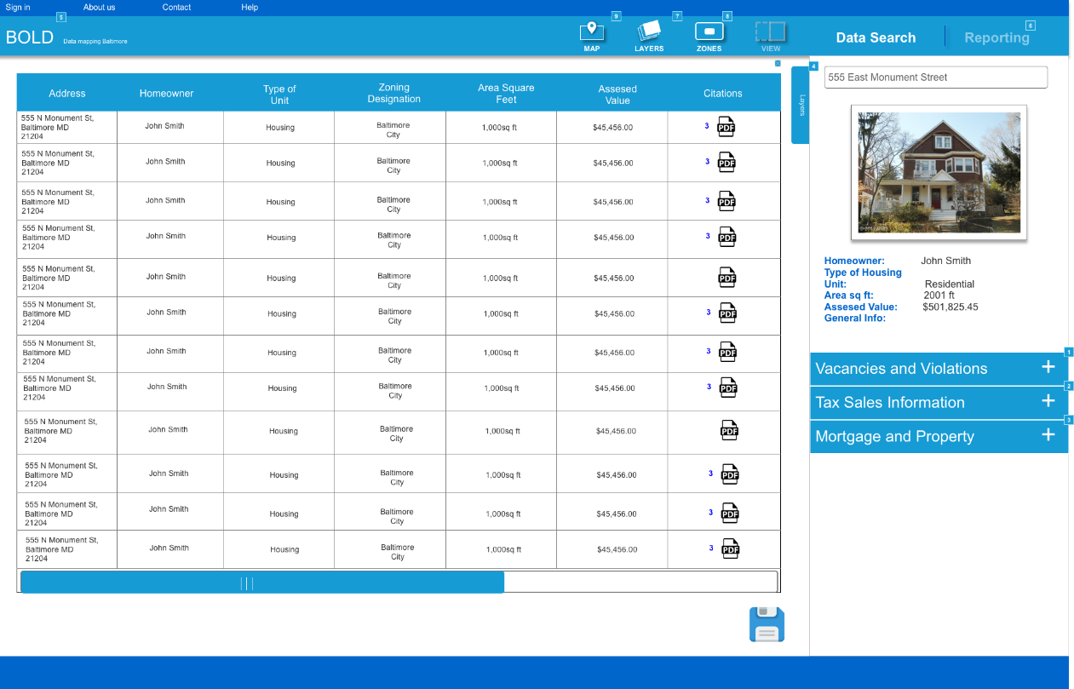
Fig 20. Table view

For non-technical users, include a help button that’s visible on every page of your site. Allow the user to know exactly where the sources come from and when they were last updated. This information should be displayed in a nonintrusive manner like on a hover state popup, or in small text next to the data type. Font should remain large and the map should be fully responsive.
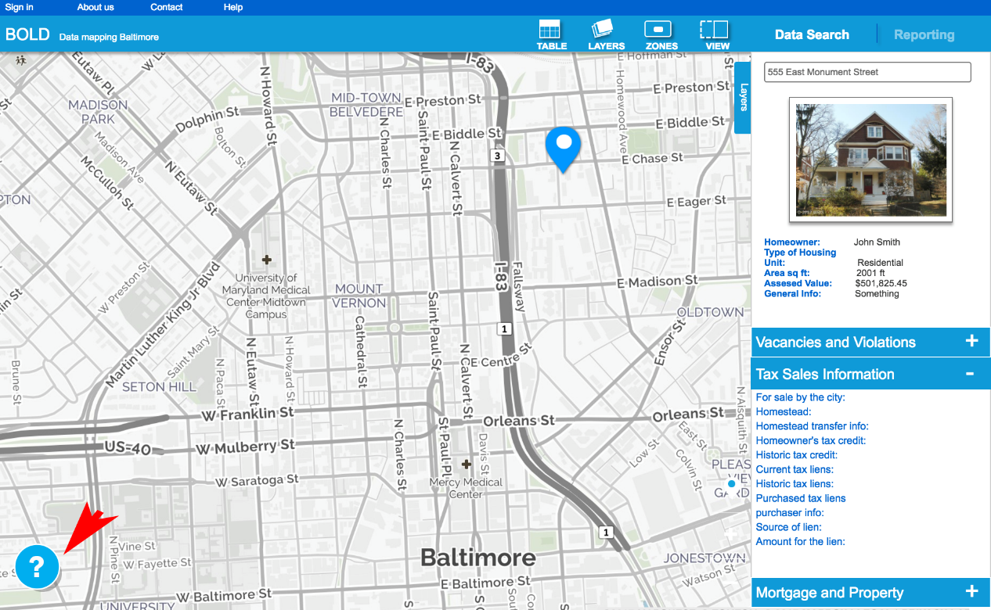

Fig 21. Help menu

Conclusion

A GIS mapping system is a great way to not only locate, but to report vacancies in the Baltimore area. From community officials to community leaders, locating and reporting vacant properties with a map visually aids users to expeditiously find the exact property and communicate with officials without the use of current public reporting systems. I learned that community leaders find the process of calling public reporting system operators and having to recall service codes arduous, and would rather have a system with a dropdown menu containing services listed for ease of reporting. I also learned that when creating a database searching system and a map, make every screen collapsible so users can view content without information being occluded by other windows. Community law officials, lawyers, and leaders all use database lookups differently, so let the user save preferences (last search, most used query) and have said preferences display immediately when the user returns to the application. Lastly, lawyers found it important for the application to display the sources of where the data comes from and the dates of when the data was last updated, it gives them confidence in using a reporting application. While Technologies such as GIS mapping systems are currently in use by organizations in Baltimore today, a front facing reporting system is desired by community law officials and leaders alike.

References

Accordino, J. and Johnson, G. T. (2000), Addressing the Vacant and Abandoned Property
Problem. Journal of Urban Affairs, 22: 301–315. doi:10.1111/0735-2166.00058

ArcGIS Desktop Help 9.3 - Discrete and continuous data. (n.d.). Retrieved March 14, 2017, from http://webhelp.esri.com/arcgisdesktop/9.3/index.cfm?TopicName=Discrete_and_continuous_data
BNIA – Baltimore Neighborhood Indicators Alliance. (n.d.). About BNIA-JFI. Retrieved July 14, 2017, from http://bniajfi.org/about_bnia/
Dempsey, C. (2013, July 18). GIS Data Explored - Vector and Raster Data ~ GIS Lounge. Retrieved March 12, 2017, from https://www.gislounge.com/geodatabases-explored-vector-and-raster-data/

Eric, V., & Monica, K. (2016). New resources for smart food retail mapping a GIS and the open source perspective. Journal Of Spatial And Organizational Dynamics, Vol IV, Iss 4, Pp 304-312 (2016), (4), 304.

Geospatial Innovation Facility (GIF) - UC Berkeley GIS & Remote Sensing. (n.d.). Retrieved March 08, 2017, from http://gif.berkeley.edu/

GIS Spatial Data Types: Vector vs Raster. (2017, January 22). Retrieved March 11, 2017, from http://gisgeography.com/spatial-data-types-vector-raster/

Google Maps. (n.d.). Retrieved February 27, 2017, from https://www.google.com/maps/@39.3961425,-76.4362095,4737m/data=!3m1!1e3

Hai-Min, L., Guo-Fu, W., Jack Shuilong, S., Lin-Hai, L., & Guo-Quan, W. (2016). Analysis and GIS Mapping of Flooding Hazards on 10 May 2016, Guangzhou, China. Water (20734441), 8(10), 1-17. doi:10.3390/w8100447

Larocca, A., Visconti, R. M., & Marconi, M. (2016). Malaria diagnosis and mapping with m-Health and geographic information systems (GIS): evidence from Uganda. Malaria Journal, 151-12. doi:10.1186/s12936-016-1546-5

MASHAYEKHAN, ARMIN, MOHAMD REZA POURMAJIDIAN, HAMID JALILVAND, MOHAMAD REZA GHOLAMI, and MOJGAN SABET TEIMOURI. 2016. "Economic importance and GIS mapping of medicinal plants in Iran: A Case study of Darkesh." Journal Of Applied Sciences & Environmental Management 20, no. 3: 646-650. Environment Complete, EBSCOhost (accessed April 1, 2017).

MHealth. (2016, December 29). Retrieved March 16, 2017, from http://www.himss.org/library/mhealth

Mobile Health Technology. (2016, December 29). Retrieved March 20, 2017, from http://www.himss.org/mobile-health-technology

President’s Malaria Initiative. Fighting malaria and saving lives(2015). https://www.pmi.gov/docs/default-source/default-document-library/ country-profiles/uganda_profile.pdf?sfvrsn=16. Accessed 14 February 2017

S. (n.d.). Real Property Data Search. Retrieved September 25, 2017, from https://sdat.dat.maryland.gov/RealProperty/Pages/default.aspx

The Vacant Dead: The 50 US Cities With The Most "Zombie" Foreclosures. (2015, June 10). Retrieved October 07, 2017, from http://www.zerohedge.com/news/2015-06-11/vacant-dead-50-us-cities-most-zombie-foreclosures
Uganda Communications Commission. http://www.ucc.co.ug/data/
qmenu/3/Facts-and-Figures.html. Accessed 20 March 2017
What is GIS? (n.d.). Retrieved March 21, 2017, from http://www.esri.com/what-is-gis

