Conspiracies: A look into the Denver International Airport and Beyond

Jack Barry

Emily Sharkey

Paige Twilley

Fisher Jones

Author Notes:

CMAT 297 Communication Research Course
Salisbury University
Dr. Chrys Egan, Advisor
Fall 2018
Contact: Jbarry4@gulls.salisbury.edu

Abstract
There are many ideas that surround some of the most important events and places that shape the culture of not only America, but the world. In the case of this study, we investigated one of the most intriguing conspiracies in the United States of America: The Denver International Airport (DIA). While some people may not know the theories behind this large transport center, there are also many believers that have research to support some terrifying scenarios that are supported by objects and images scattered throughout DIA. In order to gather information on this topic, the researchers gave out and collected written surveys with a series of questions based on the belief of theories and their impact on the country. The surveys were held on the campus of Salisbury University in Salisbury, Maryland on the date of November 16, 2018. The data collected showed that about half of those surveyed believed in conspiracy theories. The importance of this will help better understand the general campus population’s opinions on these theories.

Keywords: Conspiracy, Denver International Airport

Introduction
Background
For many years, conspiracy theories have been apart of the cultural society that we live in. They have been passed around through social media, the news, and even by word of mouth. Conspiracy theories can be exciting for some people because they pose a mystery as to whether or not they are actually true. Some conspiracy theories may even scare people because they create a distrust of the government.
There are many different conspiracy theories that have been passed around in our society today. For example there is the conspiracy that 9/11 was an inside job, that JFK was assassinated by the mafia, and even that the Denver airport was created to house world leaders. Some conspiracy theories may seem too crazy and impossible to be true, but some really do cause people to question whether or not they are real.
Rationale
It is important to look at how conspiracy theories affect people today in our society. For our study, we will be looking to see if people have a general idea of some conspiracy theories involving the government. These conspiracy theories, especially about the Denver Airport, can cause a distrust between society and the government. This study acknowledges how likely people are to believe in conspiracy theories.
Review of Literature
Trust in each other and the government is an important lesson taught to every American citizen, but what if others are planting lies or covering the truth on a massive scale? Do American citizens really know what is going on around them? Research shows that all you need is a mention of conspiracy to make people distrust each other. These can spread in awareness and acceptance to reach such incredible heights. Most Americans can name a few conspiracies off the top of their head. Further research must be done into the impact of conspiracies, but plenty of data already exists to help understand the phenomenon.
A two-stage randomized experiment at Indiana University determined the impact of media promoting government conspiracies and people’s faith in the government. The results indicate that just the mention of such conspiracies can cause distrust among individuals (Minchul & Xiaoxia, 2016). Messages promoting conspiracy create distrust and can lead to skepticism over a long term period (Minchul & Xiaoxia). This distrust builds until eventually people start making their own conspiracies to justify their cynicism. If they aren’t already inclined to one of many popular conspiracy theories, they will make up their own (Minchul & Xiaoxia).
Conspiracy theories can spread like a wildfire. A Gallup poll found that 61% of Americans believe that someone other than Lee Harvey Oswald assassinated John F. Kennedy (Waxman, 2013). More compelling is that most people surveyed did not have an answer to who or what organization caused his death, and more people believe it isn*’t Lee Harvey Oswald now than they ever have (Waxman, 2013).
Who believes in conspiracy theories, and what sources of information contribute to the beliefs of conspiracy theories? A telephone survey was conducted of 1,010 randomly selected adults who were asked about their media use and whether they believed in three different conspiracy theories about the 9/11 attacks (Stempel, 2007). The results showed that there was a positive correlation between the belief in conspiracy theories and having a higher consumption of non-mainstream media (Stempel).
Research has shown that reinforcement of conspiracy media has existed for decades. The death of John F. Kennedy has many theories that surround it from aliens to our own government instead of the man accused Lee Harvey Oswald. Conspiracy theorists have drawn their own conclusions to the assassination of Kennedy since that day in 1969 to try and prove Oswald was either not alone or was working for someone other than himself. Unfortunately Oswald was assassinated before his trial which only has proven to make certain theories like the involvement of the mafia more popular. Another popular theory that has persisted from the 1960s is the belief that human beings never landed on the moon in 1969, but that it was all an elaborate movie set meant to trick the world (Bates, 2014). People justify this belief by replicating the footage using special effects work from the time of release and supposed “issues” with certain footage that conspiracists say prove beyond a doubt that the moon landing was a hoax.
If people are willing to accept without a doubt humanity landing on the moon from their own couch, a closed and controlled environment such as an airport will be able to make you consume any media you are presented with. People are willing to change their media preferences with a change of environment,. the airport setting offers an abundance of reading materials usually considered to be taboo from celebrity gossip to in flight publications. It was found that because the airport provides gossip magazines and other filler material to pass time on flights, people find it justifiable to consume these kinds of media where they usually wouldn’t (McDonnell,2015).
Research Question/Hypothesis
Research Question: How do media messages in modern culture shape college students ideas about conspiracy theories and what level of awareness do college students have of historic conspiracy theories?
The previous research on exposure to media has shown that conspiracy can easily be introduced into mainstream culture. Mentions of distrust in government through media has shaped people’s behavior into one of skepticism. Previous research has also shown that in a controlled environment people will resort to consuming any media around them, even if it is devoid of meaningful content. The researchers hypothesize that most college students will believe in at least one conspiracy theory. The researchers also believe that media messages have been contributing to the spread in belief of multiple historic conspiracy theories.
Methods
Participants
On November 9, 2018 at 1pm in the afternoon, the researchers gathered to red square where they set up a table where students could come and take the survey. The participant requirements included being over the age of 18 and currently enrolled as a student at Salisbury University. A total of 50 students completed the survey. 34% were male and 66% were female. 18% of participants were 24 years or older, 10% were 23 years old,, 30% were 21 years old, 24% were 20 years old, 8% were 19 years old, and 10% were 18 years old.
Procedures
The researchers created a survey using word documents consisting of seven multiple choice questions that were about conspiracy theories and whether or not people believed in them. The survey consisted of multiple choice and open ended questions. The incentive to participate in the survey was candy which was offered by the researchers. On November 9, 2018 at 1pm, a table was set up by researchers in Red Square at Salisbury University where the participants could come and take the survey (Appendix A). The participants voluntarily completed the survey. The survey was set up so that the participants could remain anonymous. Once the surveys were completed, the researchers collected the data and analyzed it.
Measurements
The study consisted of both qualitative and quantitative research. Researchers used the data that was obtained from the surveys to evaluate the different beliefs of conspiracy theories. While researchers evaluated each survey, they counted each time a question was answered, and made a tally for the various responses. The researchers then compiled all of the findings from the results into different graphs such as a pie chart, bar graphs, column charts, and scatter charts to gain a better understanding of the outcome from the survey.

Results
- Age
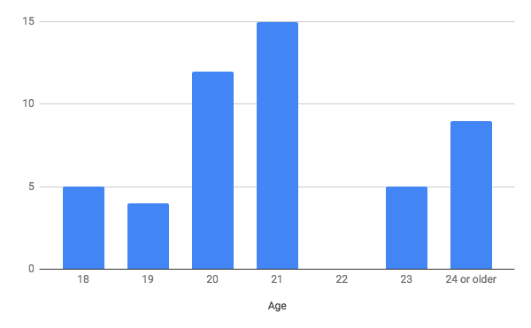
2.
Gender
Male | 34%
Female | 66%

3. Do you believe in any Conspiracy Theories?
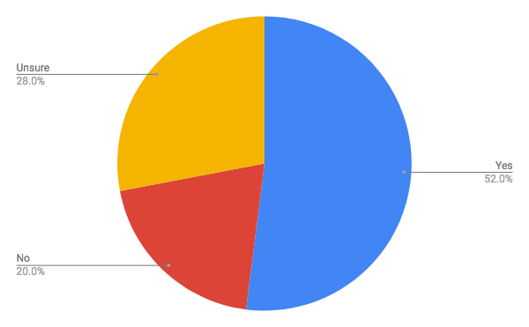

4.
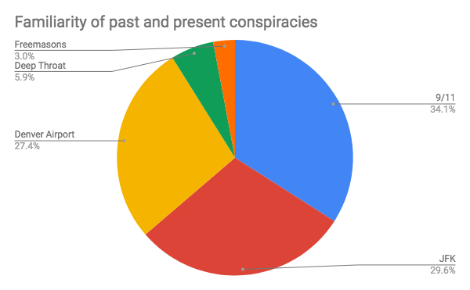
5.
Do you believe in the DIA conspiracy?
Yes | 30%
No | 47.5%
Unsure | 22.5%

6. Do you find it suspicious that the Denver Airport budget went $2 billion over original budget before completion?
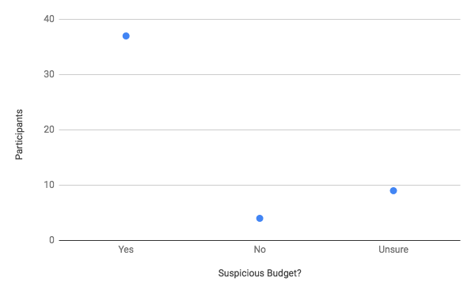
7.

If you do not believe in the DIA (Denver International Airport) conspiracy, what would it take you to believe?
See Evidence | 41.9%
For Yourself
Watch Evidence | 27.9%
Online
Never Will | 30.2%
Believe

Discussion
Significance
When asked if they believed in any conspiracy theories, 52% of respondents said yes, 20% said no, and 28% were unsure. The one statistical category that was the most consistent and noticeable about the study was that 52% of the subjects did believe in some form of conspiracy theory. This proved the hypothesis, not only are the student population aware of conspiracy theories but had belief in these theories. When they were asked what it would take to believe in the Denver Airport conspiracy, 41.9% said they would have to see the evidence themselves, 27.9% said they would have to watch the evidence online, 30.2% said they will never believe in the conspiracy theory. The researchers had more than one participant who was enthusiastic about starting a conversation around the topic or introducing conspiracies present in their lives. The three most popular theories that subjects were familiar with were 9/11, the JFK assassination, and the Denver Airport. When the respondents were asked if they believed that the Denver Airport was the home of the Illuminati, 30% of respondents said yes, 47.5% said no, and 22.5% were unsure. We had predicted these results as well because of the media's constant portrayal of these theories through many mediums. The last interesting statistic researchers found was that less than half of the subjects used had never heard of the denver airport conspiracy theory, which we chose partially because of its popularity within the US public. 74% of respondents found it suspicious that the Denver Airport went over budget, 8% of respondents did not find it suspicious, and 18% were unsure. The researchers found that this data was particularly interesting because the surplus of budget was the most concrete evidence found to support claims of the DIA Conspiracy. The researchers concluded that the majority of the Salisbury University students surveyed believe in some sort of conspiracy theory.
Limitations
Some of the limitations of this research was the inclimate weather outside, which prohibited the survey station from functioning as planned, also leading to a less populated red square area. As the researchers traveled around campus they were able to find more willing participants. The survey sample size was only 50 participants and therefore can not be accepted as representative of the whole university population. The questions are based on United States government conspiracies and therefore students who are not familiar with United States pop culture may not be able you give honest or accurate feedback.

Future Research
Future research into this matter might be done in Colorado at the airport or in the area surrounding the airport. The proximity to the airport would increase awareness of controversy of the conspiracy theories and first hand accounts with the production problems that create the evidence of the conspiracy, which could then be properly investigated first hand. In future research the data collection method should be conducted in a method that is cautious of inclement weather and time of day and week.

References
Bates, D. (2014). From JFK to Moon landings, why we fall for conspiracy theories. Daily Mail,, p. 25, 14 ago. 2015. Retrieved From: <http://proxy-su.researchport.umd.edu/login?url=http://search.ebscohost.com/login.aspx?direct=true&db=bwh&AN=108900860&site=ehost-live>. Acesso em: 30 nov. 2018.

McDonnell, A. M. (2015). Stars in Space: Celebrity Gossip Magazines, Guilt, and the Liminoid Airport, Critical Studies in Media Communication, 32(4), 287–301. https://doi-org.proxy-su.researchport.umd.edu/10.1080/15295036.2015.1033730

Minchul Kim, & Xiaoxia Cao. (2016). The Impact of Exposure to Media Messages Promoting Government Conspiracy Theories on Distrust in the Government: Evidence from a Two-Stage Randomized Experiment. International Journal of Communication (19328036), 10, 3808–3827. Retrieved from http://proxy-su.researchport.umd.edu/login?url=http://search.ebscohost.com/login.aspx?direct=true&db=ssa&AN=127361793&site=ehost-live

Stempel, C., Hargrove, T., & Stempel III, G. H. (2007). Media Use, Social Structure, and Belief in 9/11 Conspiracy Theories, Journalism & Mass Communication Quarterly, 84(2), 353–372. Retrieved from: http://proxy-su.researchport.umd.edu/login?url=http://search.ebscohost.com/login.aspx?direct=true&db=ufh&AN=26650948&site=ehost-live

Waxman, O. B. (2013). JFK Conspiracy Theories Are Alive and Well, According to Gallup Poll. Time.Com, 1. Retrieved from http://proxy-su.researchport.umd.edu/login?url=http://search.ebscohost.com/login.aspx?direct=true&db=a9h&AN=92039605&site=ehost-live

Appendix A
SURVEY

1. What is your age: _______. If you’re not at least 18, please do not take this survey since we will not be able to use your feedback.
2. What is your gender? Male Female Non-Binary Other

3. A conspiracy theory is a secret plan by a group to do something unlawful or harmful. Do you believe in any conspiracy theories?
❏ yes
❏ no
Unsure

4. Check all conspiracies listed below in which you are familiar.

❏ 9/11 was an inside job
❏ JFK assassinated by the mafia
❏ The Denver Airport and the Illuminati
- Deep Throat

Freemasons
- The Gunpowder Plot
- The July 20 Plot

5. Do you believe the Denver Airport is home of the Illuminati or New World Order with bunkers underground to house the world elite in the case of a global crisis?
- Yes
- No
- Unsure

6. Do you find it suspicious that the Denver Airport budget went $2 billion over original budget before completion?
- Yes
- No
- Unsure
7. If you do not believe in the DIA (Denver International Airport) conspiracy, what would it take you to believe?
- See the evidence yourself
- Watch evidence online
- Never will believe the theory

Appendix B
Human Subjects Letter
