Supplementary Material

Table A1. Dependencies among AERONET aerosol properties. Linear regression slope (Slp) and intercept (Y0), their uncertainties as ± standard error (se) and r² for N = 9,352.
Pair | Slp | se | Y0 | se | r²
AOD(0.44)-SSA(0.44) | -1.2 10⁻³ | 0.012 | 0.923 | 4.1 10⁻³ | 10⁻³
AOD(0.44)-SSA(0.87) | 0.128 | 0.016 | 0.872 | 5.8 10⁻³ | 6 10⁻³
AOD(0.44)-g(0.44) | 0.166 | 9 10⁻³ | 0.660 | 3.4 10⁻³ | 3 10⁻²
AOD(0.44)-g(0.87) | 0.103 | 0.019 | 0.601 | 6.8 10⁻³ | 3 10⁻³
AOD(0.44)- AE_{e} | -1.179 | 0.136 | 1.602 | 0.049 | 7 10⁻³
AOD(0.44)- AE_{a} | 0.813 | 0.186 | 1.122 | 0.066 | 2 10⁻³
SSA(0.44)-SSA(0.87) | 0.790 | 0.012 | 0.189 | 0.011 | 0.31
SSA(0.44)-g(0.44) | -0.044 | 8 10⁻³ | 0.760 | 8 10⁻³ | 3 10⁻³
SSA(0.44)-g(0.87) | -0.468 | 0.016 | 1.068 | 0.015 | 8 10⁻²
SSA(0.44)- AE_{e} | 4.030 | 0.116 | -2.530 | 0.107 | 0.11
SSA(0.44)- AE_{a} | -3.228 | 0.164 | 4.388 | 0.152 | 4 10⁻²
SSA(0.87)-g(0.44) | 0.302 | 5 10⁻³ | 0.442 | 5 10⁻³ | 0.27
SSA(0.87)-g(0.87) | 0.491 | 0.011 | 0.186 | 0.010 | 0.18
SSA(0.87)- AE_{e} | -3.453 | 0.079 | 4.352 | 0.073 | 0.17
SSA(0.87)- AE_{a} | 5.373 | 0.104 | -3.519 | 0.096 | 0.22
g(0.44)-g(0.87) | 1.464 | 0.014 | -0.416 | 0.010 | 0.55
g(0.44)- AE_{e} | -10.69 | 0.098 | 8.872 | 0.071 | 0.56
g(0.44)- AE_{a} | 8.026 | 0.184 | -4.359 | 0.132 | 0.17
g(0.87)- AE_{e} | -6.767 | 0.026 | 5.495 | 0.017 | 0.88
g(0.87)- AE_{a} | 4.628 | 0.089 | -1.538 | 0.058 | 0.22
AE_{e}- AE_{a} | -0.765 | 0.012 | 2.316 | 0.015 | 0.32

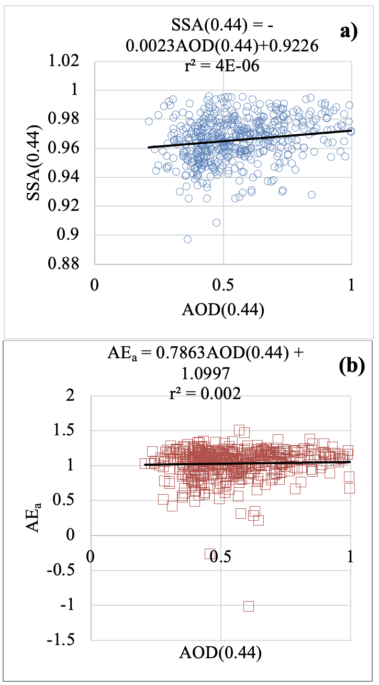

Fig. A1. Dependencies between absorption-related aerosol properties and atmospheric turbidity at GSFC. A) SSA(0.44) vs AOD(0.44), b)AEa vs AOD(0.44). N = 539, equations are linear regressions.

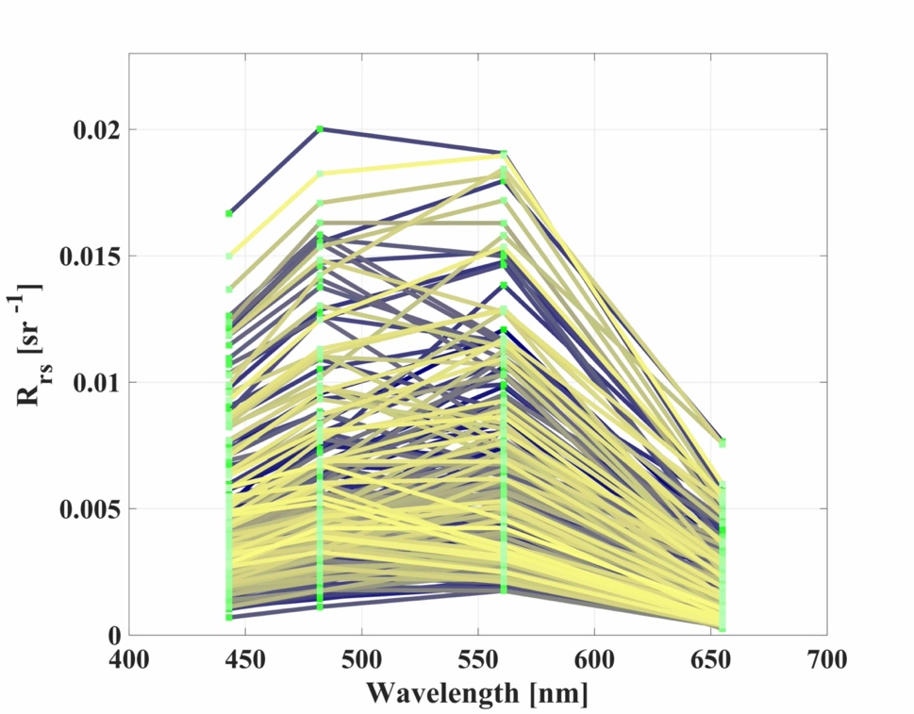
Fig. A2. R_{rs} spectra used as input to the RT code for simulating $ρ_{t}$ (Section II.F)

Table A2. AERONET sites with the largest number of observations including SSA and AE_{a} inversions as well as AOD(0.44) < 0.44.
Site name | Site id | # Records
ATHENS-NOA | 37 | 69
Banizoumbou | 53 | 94
Barcelona | 56 | 59
Beijing | 62 | 63
Belsk | 65 | 51
BONDVILLE | 80 | 66
Burjassot | 100 | 50
Chiang_Mai_Met_Sta | 139 | 52
CLUJ_UBB | 146 | 84
COVE | 153 | 72
CUT-TEPAK | 158 | 132
Dakar | 160 | 91
Dhadnah | 167 | 73
Dushanbe | 297 | 61
Eilat | 304 | 56
Evora | 316 | 80
Granada | 342 | 92
GSFC | 345 | 170
IER_Cinzana | 386 | 80
IMS-METU-ERDEMLI | 393 | 82
Ispra | 400 | 85
Jaipur | 406 | 106
KAUST_Campus | 418 | 73
SEDE_BOKER | 653 | 73
Solar_Village | 679 | 107

Table A3. Proposed aerosol types and sources in the literature.
Aerosol type | AERONET site | Method | Reference
DU | Banizoumbou¹, Ouagadougou, Cape Verde⁴, Solar Village, Bahrain, Kanpur⁴, Dahkla, Sede Boker⁴, Nes Ziona, Maricopa⁴, Ascension Island⁴, La Paguera⁴, and Yulin | Clustering | (Omar et al. 2005)
DU | Banizoumbou, Cape Verde,Dakar, Ouagadougou  XiangHe, Shirahama⁴ | Airborne and ground measurements | (Eck et al. 2005; Reid et al. 2003; Tanré et al. 2003)
DU | Solar Village | Clustering | (Giles et al. 2012)
DU | Solar Village, CapeVerde, Tamanrasset, Dakar, Banizoumbou, Beijing, Cairo, Bahrain | Clustering | (Russell et al. 2014)
MAR | Lanai, Tahiti, Arica⁴, La Parguera, Dry Tortugas, Ascension Island, La Jolla⁴ | Clustering | (Omar et al. 2005; Sayer et al. 2012a; Smirnov et al. 2003a)
MAR | Lanai | Clustering | (Russell et al. 2014; Sayer et al. 2012a; Smirnov et al. 2003a)
MAR | COVE⁴,Wallops Island, SERC⁴, Lanai, Cape Verde, Tahiti, Kaashidho, Darwin,Bermuda⁴, Ascension Island, Midway Island  Bermuda⁴,Lanai,Midway, Kaashidhoo, Ascension Island,Tahiti,Amsterdam Island,Crozet Island, Guam,Nauru, Graciosa,Coconut, Azores, Rottnest | Ground measurements  Ground measurements | (Ahmad et al. 2010; Smirnov et al. 2003a)⁵  (Sayer et al. 2012a; Sayer et al. 2012b; Smirnov et al. 2003a; Smirnov et al. 2003b)
MIX | Mauna Loa, Railroad Valley, Saturn Island, Sevilleta, Rogers Dry Lake, Bonanza Creek⁴, Rimrock, Maricopa⁴, H. J. Andrews, Howland, Konza EDC, Bethlehem, San Nicolas | Clustering | (Omar et al. 2005)²
MIX | XiangHe, Sede_Boker⁴,Kanpur⁴,Ilorin | Airborne and ground measurements | (Derimian et al. 2006; Dey et al. 2004; Eck et al. 2010; Giles et al. 2011; Singh et al. 2004; Yang et al. 2009)
BB³ | Skukuza⁴, IMS Metu Erdemli, Abracos Hill⁴, Mongu, Cuiaba, Los Fieros⁴, Yulin, CEILAP-BA | Clustering | (Omar et al. 2005)
BB³ | Abracos Hill, Alta Floresta⁴, Bonanza Creek⁴, Lake Argyle, Mongu⁴ | Airborne and ground measurements | (Eck et al. 2003; Eck et al. 2009; Mitchell et al. 2006; Schafer et al. 2008)
U/I | Walker Branch, Venise, ISDGM CNR, Moscow, MSU, MD Science Center, Columbia, GSFC, Wallops, SERC, Avignon, UCLA, Cart Site, Mexico City, Toulouse, Anmyon, Lille, Moldova, Stennis, Rome Tor Vergat, Konza EDC, Rio Branco, Nes Ziona, Ispra, Shirahama⁴, La Jolla⁴, Bondville, COVE, Dry Tortugas, Alta Floresta⁴, Arica, Fresno, GISS, Sao Paulo, Gotland, Bethlehem, Abracos Hill⁴, Bahrain⁴, Sioux Falls, Los Fieros⁴, Corcoran, Sede Boker⁴, Kaashidhoo, El Arenosillo, Bermuda, Bordeaux, Mongu⁴, Waskesiu,Egbert, Skukuza⁴, Etosha Pan, Belterra, IMS Metu Erdeml, and Dalanzadgad | Clustering | (Omar et al. 2005)
U/I | Moldova, Ispra, GSFC, Mexico City, Shirahama⁴ | Airborne and ground measurements | (Holben et al. 2001; Mélin and Zibordi 2005)
U/I | GSFC,GISS, Créteil, Aire Adour, Lille, Anmyon, Bandung, Chen-Kung | Clustering | (Russell et al. 2014)
¹Sites chosen by multiple studies in italics, ²MIX is defined as rural/background or continental clean,³also defined as smoke in Giles et al. (2012),⁴this site has been assigned to more than one aerosol type,⁵includes two aerosol types, coastal and open ocean.
Table A4. Examples of PAM-derived aerosol types at AERONET sites.
Aerosol type | Location name (latitude¹, longitude¹)
DU | Dhabi (24.481N, 54.383E), Cairo_EMA (30.081N, 31.290E), Saada (31.626N, 8.156W), Dakar (14.394N, 16.959W), Dhadnah (25.513N, 56.325E),  Dushanbe (38.553N, 68.858E),  Eilat (29.503N, 34.917E),  Granada (37.164N, 3.605W),  IER_Cinzana (13.278N, 5.934W,  Sede_Boker (30.855N, 34.782E), Ilorin (8.484N, 4.675E)  ,
MAR  BB¹  BB²  MIX  U/I | La Jolla (32.868N,117.251W), Chao_Jou (22.513N,120.529E),  Tremiti (42.118N, 15.490E), Sevastopol (37.458N,126.951E), Midway Island (28.22N, 177.35W)  Bonanza Creek (21.826S, 19.590E), Alta Floresta (9.871S, 56.104W), Bratts Lake (50.204N,104.713W), Pimai (15.182N,102.564E),  Barcelona (41.389N, 2.112E),ARM_Darwin (12.425S,130.891E), Moscow (55.707N, 37.522E), ATHENS-NOA (37.972N, 23.718E) , Belsk (51.837N, 20.792E), Burjassot (39.507N, 0.420W), Chiang_Mai_Met_Sta (18.771N, 98.972E), CLUJ_UBB ( 46.768N, 23.551E), Taihu (31.421N,120.215E),Skukuza (24.992S, 31.587E)  Osaka (34.651N,135.591E),  Chiba_University (35.625N,140.104E), Cartel (45.380N, 71.931W)  UCLA ( 34.070N,118.443W), Bondville (40.053N, 88.372W),COVE (36.900N, 75.710W),Beijing (39.977N,116.381E), Konza_EDC (39.102N, 96.610W)
¹coordinates in decimal degree

Table A5. Aerosol properties for A2010 models and PAM-derived cluster 10; model^{match} and RH^{match} (%) correspond to synthetic models matching PAM-derived MAR type, respectively.
 |  | R_{n}^{fine} | σ_{n}^{fine} | r_{n}^{coarse} | σ_{n}^{coarse} | n_{r}(0.44) | n_{r}(0.87) | n_{i}(0.44) | n_{i}(0.87)
A2010 | range¹ | 0.085-0.138 | 0.437 | 0.567-1.288 | 0.672 | 1.379-1.528 | 1.371-1.518 | 0.002-0.010 | 0.002-0.009
A2010 | model^{match} | 40-50 |  | 30-40 |  | 39-41 | 29-31 | 29-31 | 29-31
A2010 | RH^{match} | 75-80 |  | 70-75 |  | 75-80 | 70-75 | 70-75 | 70-75
PAM | Range | 0.048-0.158 | 0.318-0.585 | 0.342-1.835 | 0.517-0.794 | 1.330-1.600 | 1.365-1.600 | 0.0023-0.0139 | 0.0005-0.024
PAM | Mean | 0.095 | 0.461 | 0.760 | 0.653 | 1.466 | 1.468 | 0.0075 | 0.0075
¹These values are based on 80 theoretical aerosol mixtures with 10 models augmented by 8 levels (30, 50, 70, 75, 80, 85, 90, 95%) of RH (e.g., indices 1 – 10 and 31 – 40 correspond to RH=30% and 75%, respectively).

References
Ahmad, Z., Franz, B.A., McClain, C.R., Kwiatkowska, E.J., Werdell, J., Shettle, E.P., & Holben, B.N. (2010). New aerosol models for the retrieval of aerosol optical thickness and normalized water-leaving radiances from the SeaWiFS and MODIS sensors over coastal regions and open oceans. Applied Optics, 49, 5545-5560
Derimian, Y., Karnieli, A., Kaufman, Y.J., Andreae, M.O., Andreae, T.W., Dubovik, O., Maenhaut, W., Koren, I., & Holben, B.N. (2006). Dust and pollution aerosols over the Negev desert, Israel: Properties, transport, and radiative effect. Journal of Geophysical Research: Atmospheres, 111
Dey, S., Tripathi, S.N., Singh, R.P., & Holben, B. (2004). Influence of dust storms on the aerosol optical properties over the Indo‐Gangetic basin. Journal of Geophysical Research: Atmospheres, 109
Eck, T., Holben, B., Dubovik, O., Smirnov, A., Goloub, P., Chen, H., Chatenet, B., Gomes, L., Zhang, X.Y., & Tsay, S.C. (2005). Columnar aerosol optical properties at AERONET sites in central eastern Asia and aerosol transport to the tropical mid‐Pacific. Journal of Geophysical Research: Atmospheres, 110
Eck, T., Holben, B., Reid, J., O'neill, N., Schafer, J., Dubovik, O., Smirnov, A., Yamasoe, M., & Artaxo, P. (2003). High aerosol optical depth biomass burning events: A comparison of optical properties for different source regions. Geophysical Research Letters, 30
Eck, T., Holben, B., Reid, J., Sinyuk, A., Hyer, E., O'Neill, N., Shaw, G., Vande Castle, J., Chapin, F., & Dubovik, O. (2009). Optical properties of boreal region biomass burning aerosols in central Alaska and seasonal variation of aerosol optical depth at an Arctic coastal site. Journal of Geophysical Research: Atmospheres, 114
Eck, T.F., Holben, B., Sinyuk, A., Pinker, R., Goloub, P., Chen, H., Chatenet, B., Li, Z., Singh, R.P., & Tripathi, S.N. (2010). Climatological aspects of the optical properties of fine/coarse mode aerosol mixtures. Journal of Geophysical Research: Atmospheres, 115
Giles, D.M., Holben, B.N., Eck, T.F., Sinyuk, A., Smirnov, A., Slutsker, I., Dickerson, R., Thompson, A., & Schafer, J. (2012). An analysis of AERONET aerosol absorption properties and classifications representative of aerosol source regions. Journal of Geophysical Research: Atmospheres, 117
Giles, D.M., Holben, B.N., Tripathi, S.N., Eck, T.F., Newcomb, W.W., Slutsker, I., Dickerson, R.R., Thompson, A.M., Mattoo, S., & Wang, S.H. (2011). Aerosol properties over the Indo‐Gangetic Plain: A mesoscale perspective from the TIGERZ experiment. Journal of Geophysical Research: Atmospheres, 116
Holben, B.N., Tanre, D., Smirnov, A., Eck, T., Slutsker, I., Abuhassan, N., Newcomb, W., Schafer, J., Chatenet, B., & Lavenu, F. (2001). An emerging ground‐based aerosol climatology: Aerosol optical depth from AERONET. Journal of Geophysical Research: Atmospheres, 106, 12067-12097
Mélin, F., & Zibordi, G. (2005). Aerosol variability in the Po Valley analyzed from automated optical measurements. Geophysical Research Letters, 32
Mitchell, R., O'Brien, D., & Campbell, S. (2006). Characteristics and radiative impact of the aerosol generated by the Canberra firestorm of January 2003. Journal of Geophysical Research: Atmospheres, 111
Omar, A.H., Won, J.G., Winker, D.M., Yoon, S.C., Dubovik, O., & McCormick, M.P. (2005). Development of global aerosol models using cluster analysis of Aerosol Robotic Network (AERONET) measurements. Journal of Geophysical Research: Atmospheres, 110
Reid, J.S., Kinney, J.E., Westphal, D.L., Holben, B.N., Welton, E.J., Tsay, S.C., Eleuterio, D.P., Campbell, J.R., Christopher, S.A., & Colarco, P. (2003). Analysis of measurements of Saharan dust by airborne and ground‐based remote sensing methods during the Puerto Rico Dust Experiment (PRIDE). Journal of Geophysical Research: Atmospheres, 108
Russell, P.B., Kacenelenbogen, M., Livingston, J.M., Hasekamp, O.P., Burton, S.P., Schuster, G.L., Johnson, M.S., Knobelspiesse, K.D., Redemann, J., & Ramachandran, S. (2014). A multiparameter aerosol classification method and its application to retrievals from spaceborne polarimetry. Journal of Geophysical Research: Atmospheres, 119, 9838-9863
Sayer, A., Hsu, N., Bettenhausen, C., Ahmad, Z., Holben, B., Smirnov, A., Thomas, G., & Zhang, J. (2012a). SeaWiFS Ocean Aerosol Retrieval (SOAR): Algorithm, validation, and comparison with other data sets. Journal of Geophysical Research: Atmospheres, 117
Sayer, A., Smirnov, A., Hsu, N., & Holben, B. (2012b). A pure marine aerosol model, for use in remote sensing applications. Journal of Geophysical Research: Atmospheres, 117
Schafer, J., Eck, T., Holben, B., Artaxo, P., & Duarte, A. (2008). Characterization of the optical properties of atmospheric aerosols in Amazonia from long‐term AERONET monitoring (1993–1995 and 1999–2006). Journal of Geophysical Research: Atmospheres, 113
Singh, R., Dey, S., Tripathi, S., Tare, V., & Holben, B. (2004). Variability of aerosol parameters over Kanpur, northern India. Journal of Geophysical Research: Atmospheres, 109
Smirnov, A., Holben, B., Dubovik, O., Frouin, R., Eck, T., & Slutsker, I. (2003a). Maritime component in aerosol optical models derived from Aerosol Robotic Network data. Journal of Geophysical Research: Atmospheres, 108, AAC 14-11-AAC 14-11
Smirnov, A., Holben, B., Eck, T., Dubovik, O., & Slutsker, I. (2003b). Effect of wind speed on columnar aerosol optical properties at Midway Island. Journal of Geophysical Research: Atmospheres, 108
Tanré, D., Haywood, J., Pelon, J., Léon, J., Chatenet, B., Formenti, P., Francis, P., Goloub, P., Highwood, E., & Myhre, G. (2003). Measurement and modeling of the Saharan dust radiative impact: Overview of the Saharan Dust Experiment (SHADE). Journal of Geophysical Research: Atmospheres, 108
Yang, M., Howell, S., Zhuang, J., & Huebert, B. (2009). Attribution of aerosol light absorption to black carbon, brown carbon, and dust in China–interpretations of atmospheric measurements during EAST-AIRE. Atmospheric Chemistry and Physics, 9, 2035-2050

