Supplementary Materials
Supplementary Text
Figs. S1 to S5
Table S1

Supplementary Materials for

Title: The Effectiveness of Global Protected Areas for Climate Change Mitigation
Authors: L. Duncanson¹*, M. Liang¹, V. Leitold¹, J. Armston¹, S. M. Krishna Moorthy¹, R. Dubayah¹, S. Costedoat², B. J. Enquist³, L. Fatoyinbo⁴, S. Goetz⁵, M. Gonzalez-Roglich⁶, C. Merow⁷, P. R. Roehrdanz², K. Tabor^{2,4,8}, A. Zvoleff²
Correspondence to: lduncans@umd.edu

This PDF file includes:

Supplementary Text
Figs. S1 to S5
Table S1

Supplementary Text
Comparison of year 2000 AGBD
To test whether our results simply reflect preferential PA establishment in areas of higher AGB, we analyzed a year 2000 AGBD product and assessed whether year 2000 AGBD differed between PAs and matched unprotected areas (insofar as can be gleaned from the only available global year 2000 AGBD product ⁴). The results found that the PA age (or time since establishment) heavily influenced the difference in 2000 AGBD levels. Although we observed a statistically significant difference F(1, 159,920) = [361], p <0.05) with regards to the year 2000 AGBD between the PAs and unprotected matches for PAs designated in and after 2000 (recently established PAs), this difference was significantly smaller (52.7%) than that for PAs designated before the year 2000 (older PAs). By analyzing the relationship between PA age and additionally preserved AGB in year 2000 (our baseline year), it was inferred that PAs’ ability to preserve additional AGB generally increased over time (Fig S3). These results indicate that at least since the year 2000, PAs have not been preferentially established in higher AGBD sites (i.e. matched unprotected areas are balanced with respect to AGBD). Indeed, higher year 2000 AGBD in older PAs reinforces our finding that PAs are effective at protecting AGB, and that this effect increases over time as discrepancies between protected and unprotected areas increase.

Comparison of forest cover loss within and outside of PAs
To test the hypothesis that PAs reduce deforestation or forest loss, we compared the area of forest loss within PAs and their matched unprotected areas at a country-, biome-, continent- and global-level. We first summarized tree cover loss for all forested regions of the globe between years 2000 - 2019 from a Global Forest Change (GFC) data product (v.1.7; ²⁵). The GFC dataset was divided into 10x10 degree tiles with approximately 30-meter pixel resolution at the equator. We used the GFC “lossyear” data layer to generate a forest cover loss mask layer with values 0 indicating no change in forest cover and values of 1 indicating forest cover loss between 2000-2019 at the 30m pixel resolution. We then calculated the forest cover loss area within every protected area polygon and matched unprotected pixel. We estimated the fraction of forest cover loss (30 m pixels with value 1) falling within each PA and matched unprotected 1 km pixel. We aggregated these values for all the 1 km PA pixels and their corresponding matched unprotected areas to estimate the total forest cover loss differences at the country, biome, continent and global scale. Our results indicate that for most of the countries (69%), areas outside PAs have lost more forest cover than those within PAs. This signal is especially strong in the tropical moist biomes of South America and Southeast Asian forests and Savanna biomes of South American forests, and the temperate and boreal forests of North America.

For the subset of PAs that had matched unprotected areas, we classify the PA into five classes based on differences between PA and unprotected AGB and forest cover loss. Where PAs have higher (>5 Mg/ha) AGBD (positive ‘carbon effectiveness’) than matches, their effectiveness is attributed either to avoided emissions from forest loss outside of PAs (where there is a higher rate of observed 2000-2000 forest cover loss in matches than PAs, 30.4% of PAs), or to enhanced stocks (either avoided degradation or enhanced growth, 18.4%) when there is either no difference in forest cover loss between PAs and matches, or more forest cover loss within PAs. The forest cover loss product is based on Landsat data which saturates with respect to forest cover, height, and biomass, and thus may not be able to detect subtle losses. Where there was little difference in PA and unprotected AGBD (0 +/- 5 Mg/ha, 25.8%), PAs are classified as having no additionality in AGBD, regardless of any perceived difference in forest loss rate. Finally, where PAs had lower AGBD than matches, this is explained either by encroachment into PAs that is visible as forest cover loss within PAs (8.3%) or degradation in PAs when there is no higher perceived forest cover loss (16%). This analysis was repeated at a continental scale (Fig S5).

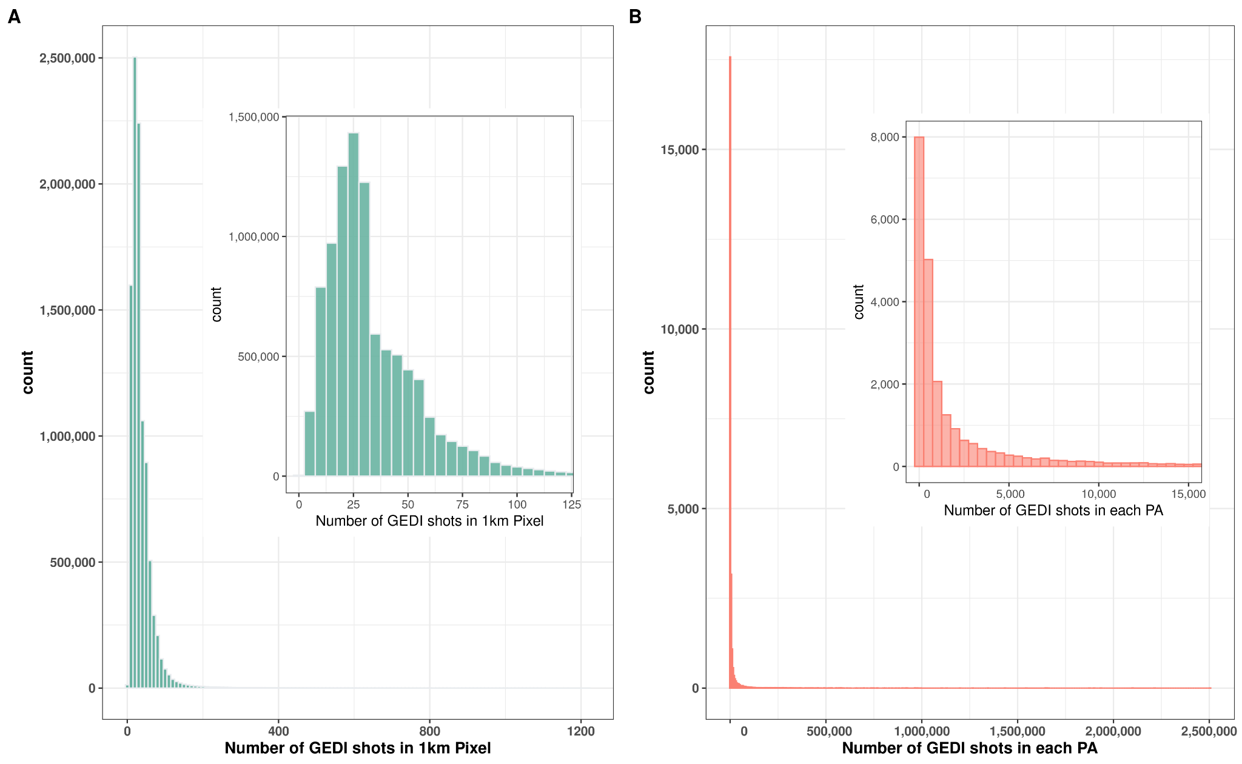

Fig. S1. GEDI enables a richer analysis of forest structure than has previously been possible, as demonstrated by the distribution of GEDI shots in each matched 1 km pixel (A) and PA (B). The largest PA in this analysis had >2 million GEDI samples (Shot in cell has median of 28, and shot in PA median is 639).
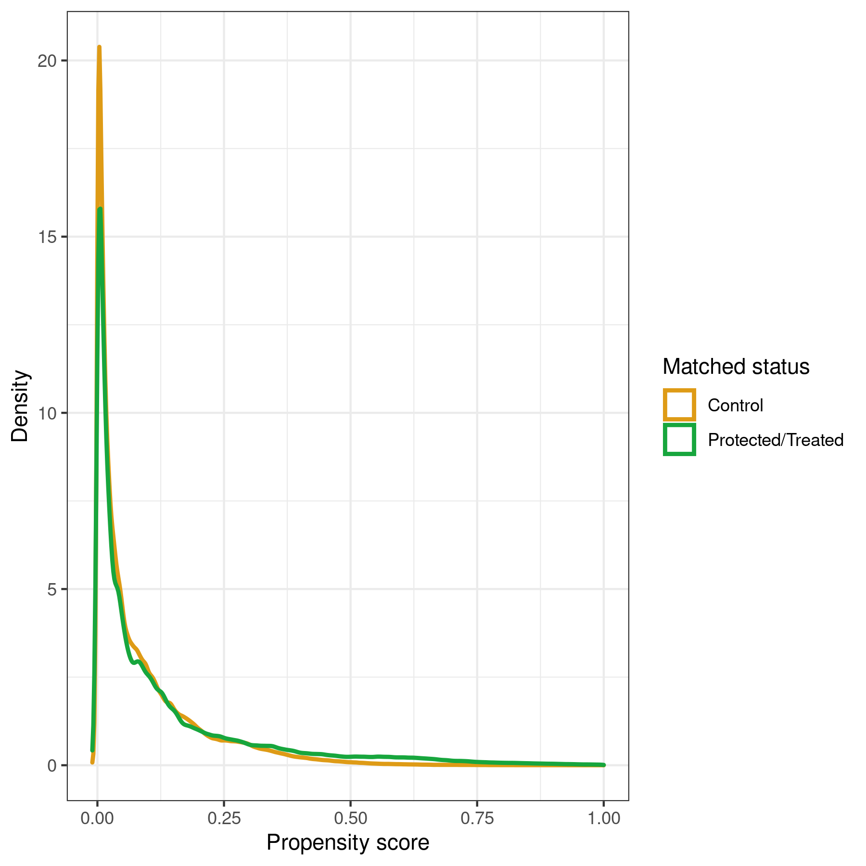
Fig. S2. The distribution of propensity scores of the matched protected area pixels and unprotected matched pixels for all matched PAs.
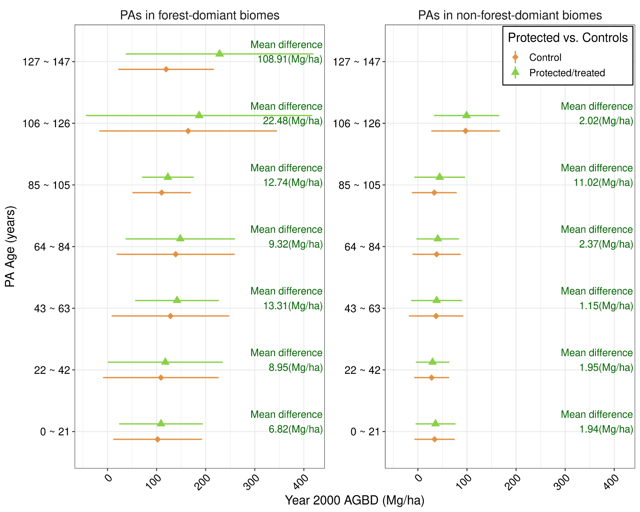
Fig. S3. Relationship between PA ages and the mean difference in PA and matched unprotected sites with respect to the year 2000 AGBD. Recently established PAs are represented as PA ages (0~21) and these PAs have the lowest mean difference between matched PA sites and control sites, indicating lower capacity to preserve AGBD.
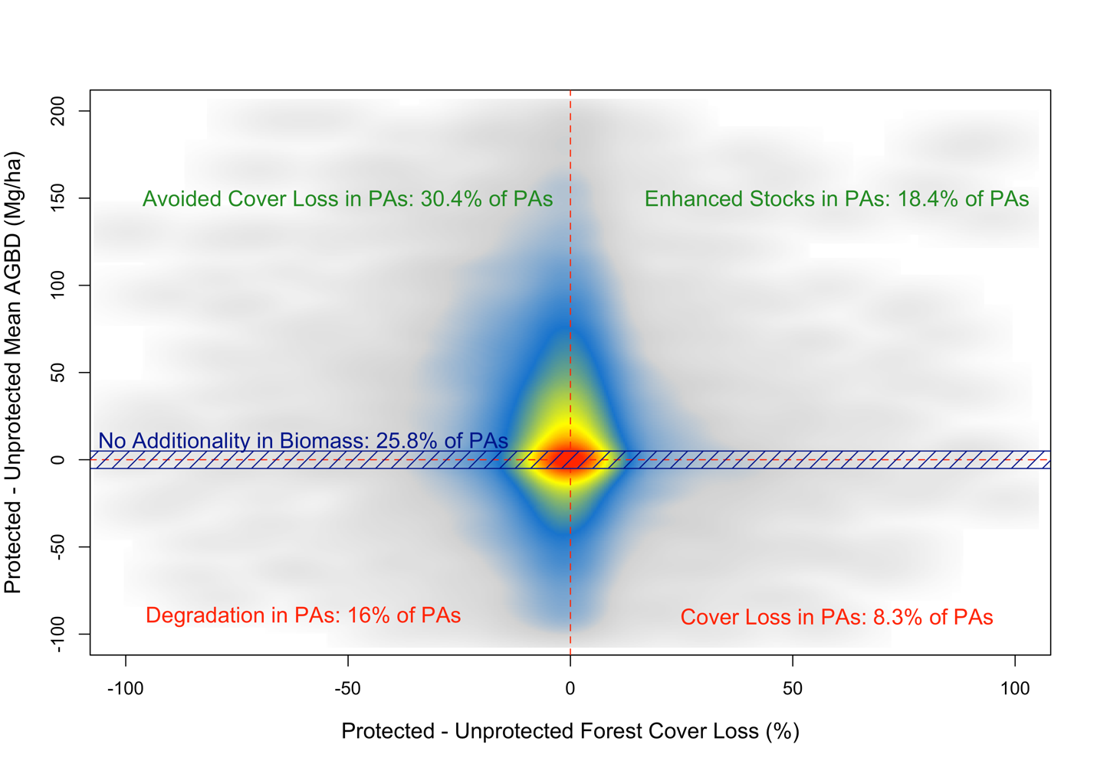
Fig. S4. More than half of the analyzed PAs had more than 5 Mg/ha average higher AGBD than unprotected matches, around a quarter exhibited no difference in AGBD, and about a quarter had increased deforestation or degradation within the PAs.
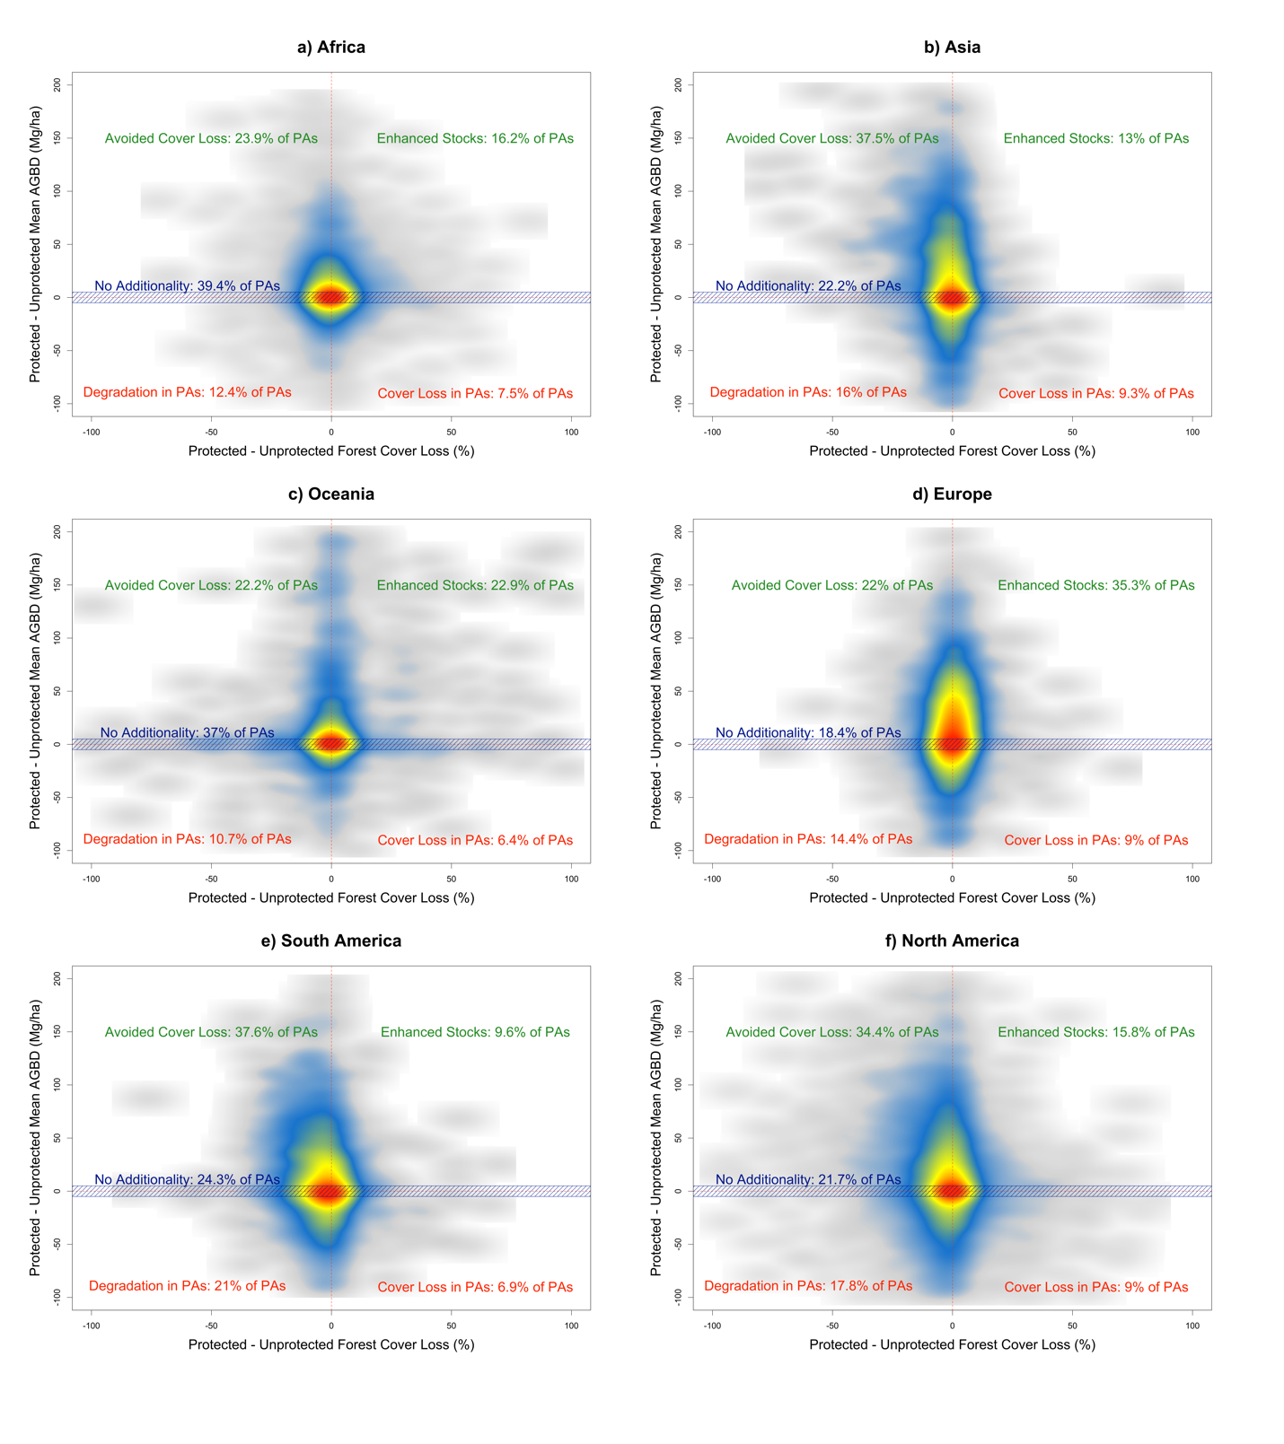Fig. S5. The attribution of AGB results to either carbon effectiveness (through avoided deforestation, degradation and regrowth) varied by continent. Notably, South America and Asia had the highest rates of avoided emissions from forest loss, Africa and Oceania had the largest proportions of PAs with no additionality in AGB, and rates of degradation and forest loss within PAs were relatively consistent across continents. These density plots are colored with respect to data density, ranging from grey (least data) to red (most data).
Table S1. Datasets used in this study, and covariates used for matching in year 2000 baseline conditions.
