Supporting Information
The role of hunting on Sapajus xanthosternos’ landscape of fear in the Atlantic Forest, Brazil
Priscila Suscke, Andréa Presotto, Patrícia Izar

Figure S1. Moran’s I Spatial Autocorrelation detect in the response variable intensity of space use
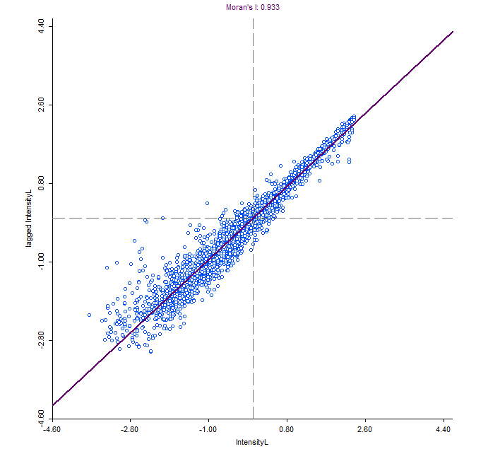

Figure S2. Distribution of the spatial autocorrelation across the study group’s home range
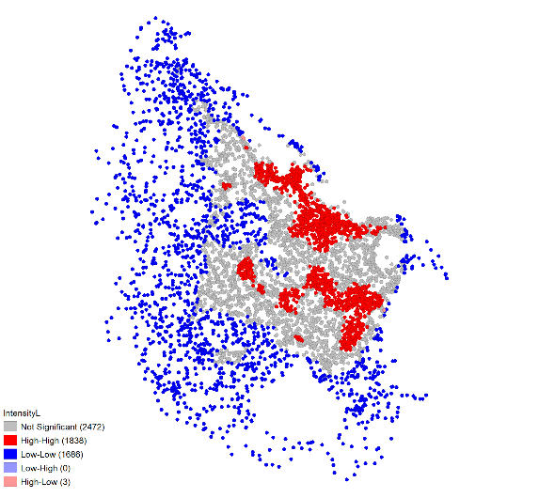

Table S1. Distribution of fixes within the capuchin’s home range per forest type
Forest type | Fixes | Percentage of use
Cabruca | 420 | 6.64
Mature | 2546 | 40.27
Secondary | 3356 | 53.08

