

JGR-biogeosciences journal
Supporting Information for
Imaging Spectroscopy for Enhancing Regional Coastal Wetlands Extent Monitoring
Pati Thakali¹, Anthony Campbell^{2, 3}, Elhadi Adam¹,
¹School of Geography, Archaeology and Environmental Studies, University of the Witwatersrand, Johannesburg 2050, South Africa.
²NASA Goddard Space Flight Center, NASA, Maryland, USA.
³Goddard Earth Sciences Technology and Research (GESTAR) II, University of Maryland, Baltimore County, Maryland, USA.

Contents of this file

- Text S1 to S2:

Text S1 describes the model accuracy assessment, and Text S2 explains the limitations observed in our analysis.

- Figures S1 to S4:

Figure S1 includes the water level data for Swartvlei, Figure S2 includes the area by estuary type, Figure S3 includes the Swartvlei estuary for full spectral bands, and Figure S4 includes the Knysna estuary for full spectral bands.

- Table S1

Table S1 includes the twenty most important spectral bands by habitat for the 8 January 2024 model.

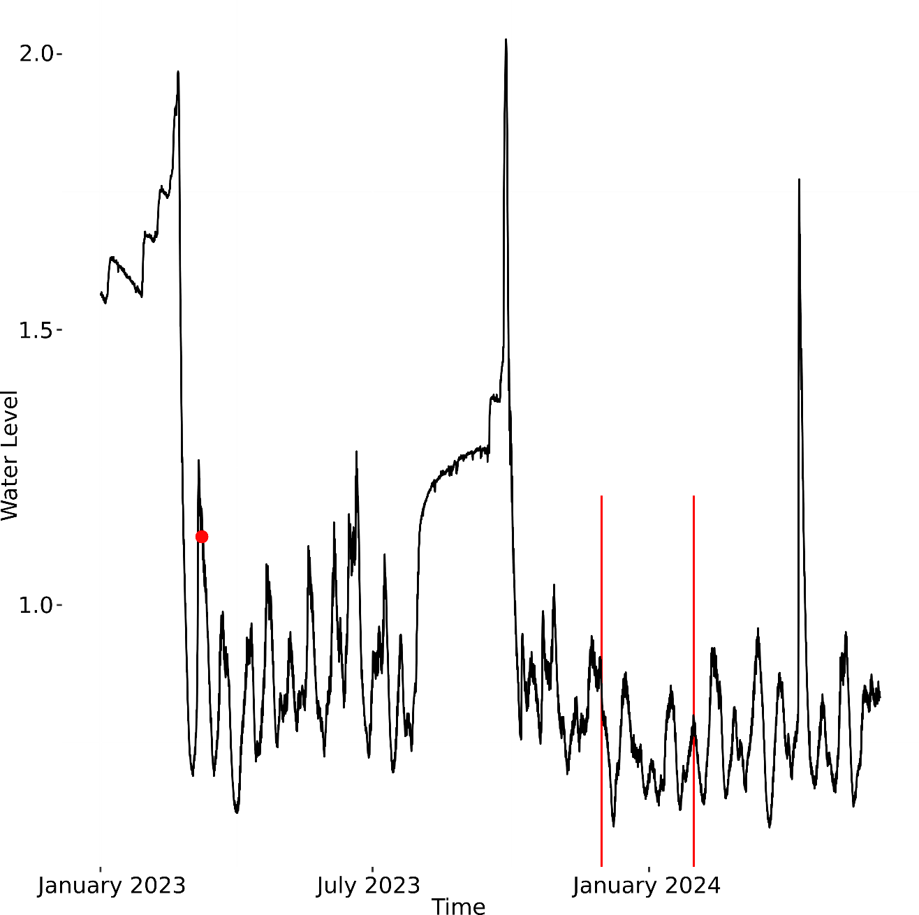
Figure S1. Water levels for the Swartvlei lake gauge across the study period. The time period of the training data is denoted by the two red lines, and EMIT acquisition is identified by the red point.

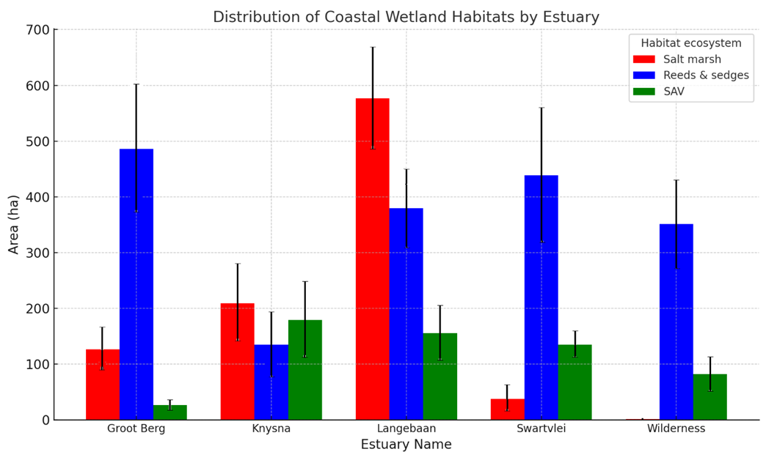 Figure S2. Distribution of coastal wetland habitat extent (ha) across all estuaries by three habitat ecosystems (salt marsh, reeds and sedges, and SAV).

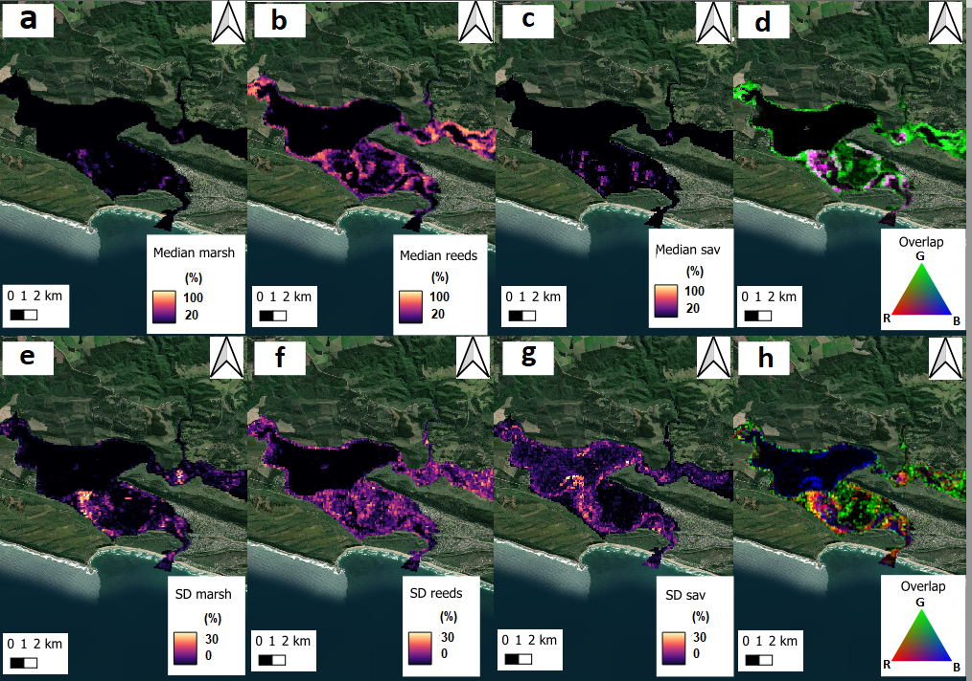
Figure S3. Swartvlei estuary (9 March 2023) in the eight panels (a-h) for full spectral bands. Panels a = salt marsh (%), b = reeds and sedges (%), c = SAV (%), d = (extent overlap in RGB; R (red) represents salt marsh, G (green) represents reeds and sedges, and B (blue) represents SAV. Panels e = salt marsh extent standard deviation (%), f = reeds and sedges extent standard deviation (%), g = SAV extent standard deviation (%), h = (standard deviation overlap in RGB): R (red) represents salt marsh, G (green) represents reeds and sedges, and B (blue) represents SAV.

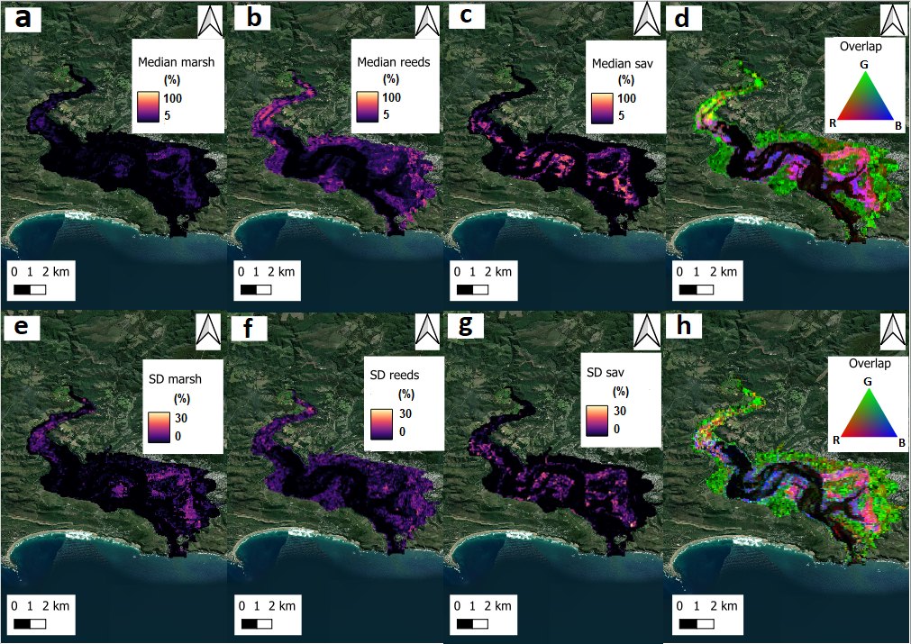
Figure S4. Knysna estuary (9 March 2023) in the eight panels (a-b) for full spectral bands. Panels a = salt marsh (%), b = reeds and sedges (%), c = SAV (%), d = (extent overlap in RGB; R (red) represents salt marsh, G (green) represents reeds and sedges, and B (blue) represents SAV. Panels e = salt marsh extent standard deviation (%), f = reeds and sedges extent standard deviation (%), g = SAV extent standard deviation (%), h = (standard deviation overlap in RGB; R (red) represents salt marsh, G (green) represents reeds and sedges, and B (blue) represents SAV.

- Tables S1:
Table S1. Twenty most important bands by habitat for the 8 January 2024 model.
Habitats
Reeds and sedges | Salt marsh | SAV
425 nm | 425 nm | 917 nm
484 nm | 1439 nm | 2485 nm
1320 nm | 723 nm | 1439 nm
381 nm | 381 nm | 381 nm
388 nm | 396 nm | 544 nm
418 nm | 418 nm | 671 nm
492 nm | 484 nm | 678 nm
499 nm | 671 nm | 693 nm
633 nm | 700 nm | 700 nm
663 nm | 708 nm | 715 nm
671 nm | 715 nm | 723 nm
686 nm | 730 nm | 887 nm
693 nm | 738 nm | 902 nm
700 nm | 753 nm | 909 nm
708 nm | 790 nm | 924 nm
1439 nm | 947 nm | 932 nm
1461 nm | 1320 nm | 1446 nm
1469 nm | 1439 nm | 1461 nm
1632 nm | 1446 nm | 1469 nm
1766 nm | 1469 nm | 2492 nm

Introduction
This supplementary information contains detailed data and figures to support the analysis of coastal wetland habitats across the three study sites: Langebaan, Knysna, and Swartvlei estuaries. It includes the following:
- Figures S1 to S4: show the spatial distribution of wetland habitats, explain why different spectral bands are required, and water levels in Swartvlei Lake.
- Table S1: which lists the 20 most important bands by habitat for the 8 January 2024 model.
- The model accuracy and limitations of the study are outlined in Text S1 and Text S2. The processes employed during data processing of the images used to derive the various figures and tables above are described, as well as known distortions such as difficulties in determining water levels and fringing vegetation are mentioned
Supporting Text (Example)
- Text S1:
Accuracy Assessment and Variable Importance
In this section, details of the models’ accuracy assessment are outlined, including the comparison of the full-band and top-20-band models.
Example Citation:
“The highest performance was the salt marsh extent model for the 8 January 2024 (low tidal stage) model in Groot Berg with a RMSE of 7.8%. In contrast, the reeds and sedges on 8 November 2023 (High tidal stage) model performed well in the hold-out validation but poorly when applied to Groot Berg”.

- Text S2:
Limitations of Wetland Extent Estimation
This section explains the challenges faced in estimating wetland extent, particularly for the Swartvlei and Wilderness Lakes, due to varying water levels and narrow fringing vegetation.
Example Citation: "The limitations of this approach were evident in Swartvlei and Wilderness Lakes, where a combination of low water levels during our training data classification, high water levels during the EMIT image acquisition, and the narrow bands of fringing vegetation along the lakes resulted in low estimates of wetland extent compared to our training data (Figure S1)."

