Supplementary Information

Identifying the chemical gel point of epoxy-fumed silica composites using optimally windowed chirp measurements
Stian K. Romberg, Sarah Lehrman, Jonathan Seppala, Anthony P. Kotula*
Materials Science and Engineering Division, National Institute of Standards and Technology Gaithersburg, MD 20899, United States of America
*Email of corresponding author: anthony.kotula@nist.gov

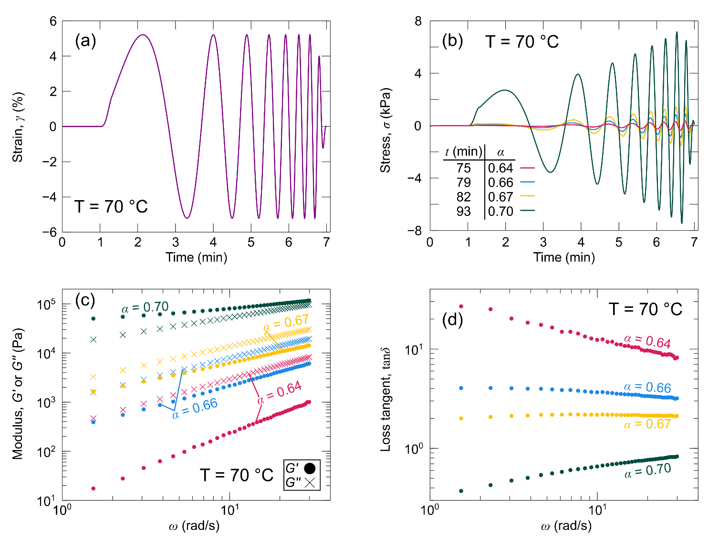
Fig. S1: OWCh data at selected times for the resin with 0 % fumed silica cured at 70 °C. (a) Applied OWCh waveform. (b) Resulting stress response. (c) Resulting linear viscoelastic moduli. (d) Resulting loss tangent.
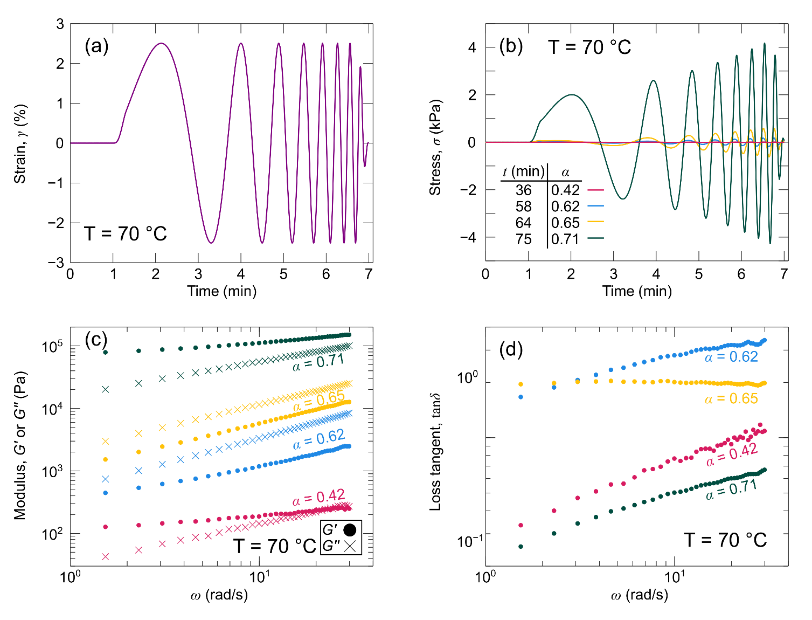
Fig. S2: OWCh data at selected times for the resin with 2.5 % fumed silica cured at 70 °C. (a) Applied OWCh waveform. (b) Resulting stress response. (c) Resulting linear viscoelastic moduli. (d) Resulting loss tangent.
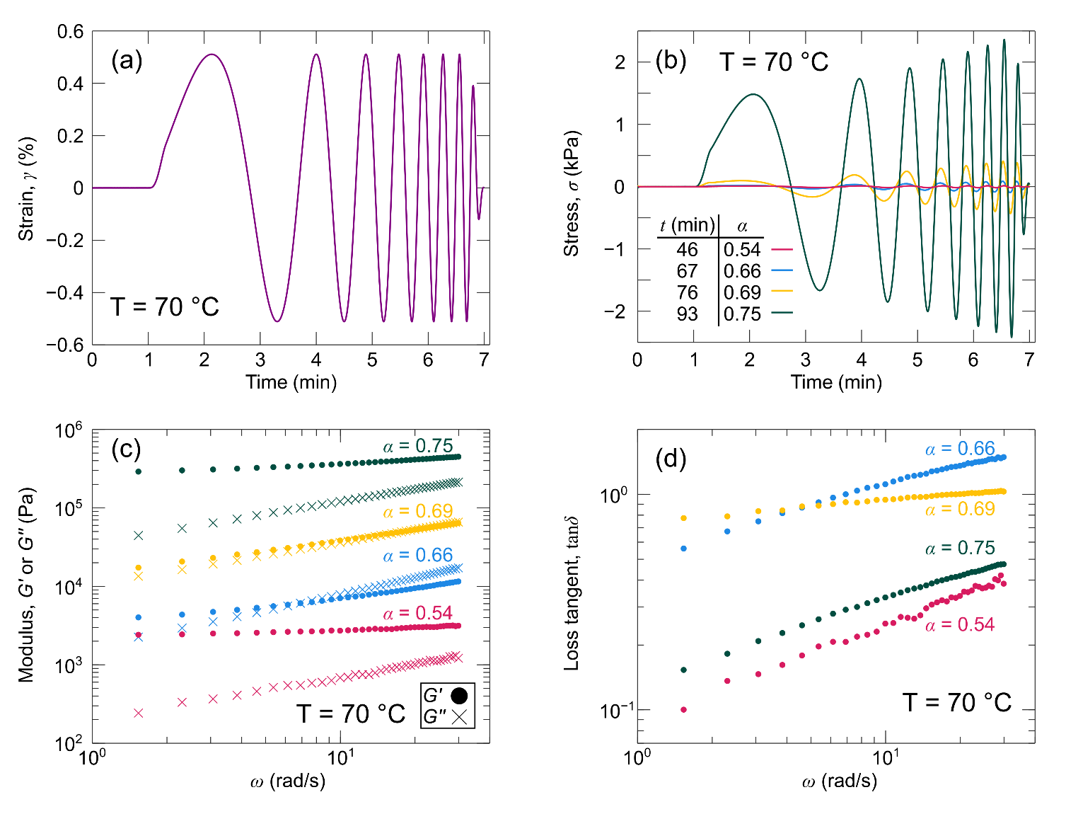
Fig. S3: OWCh data at selected times for the resin with 5 % fumed silica cured at 70 °C. (a) Applied OWCh waveform. (b) Resulting stress response. (c) Resulting linear viscoelastic moduli. (d) Resulting loss tangent.
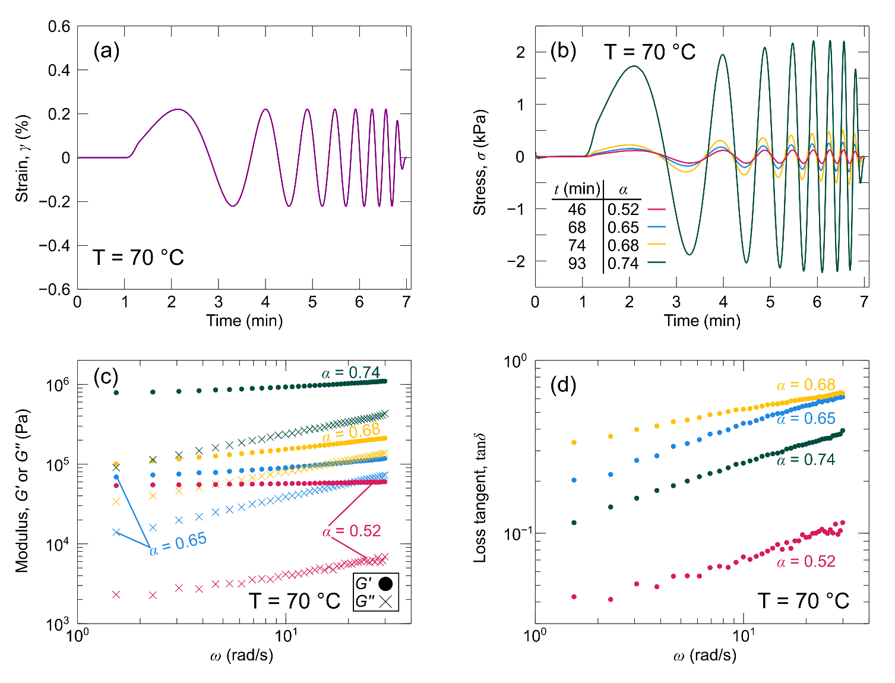
Fig. S4: OWCh data at selected times for the resin with 10 % fumed silica cured at 70 °C. (a) Applied OWCh waveform. (b) Resulting stress response. (c) Resulting linear viscoelastic moduli. (d) Resulting loss tangent.

Optimally windowed chirp (OWCh) measurements are attractive because they can be conducted quickly, so it is important to verify that the measurement period of these chirps is short enough to provide reliable measurements. This can be done by evaluating the mutation number (Equation S1), which compares the measurement period to the rate of change of a rheological property of interest g.
$$λ_{mu}=\frac{t_{meas}}{t_{mu}}=\frac{t_{meas}}{{\left(\frac{d[\ln{g}]}{dt}\right)}^{-1}}$$ | (S1)
In Equation S1, λ_{mu} is the mutation number, t_{meas} is the measurement period of the OWCh, and t_{mu} is the mutation time. Mutation numbers below 0.15 indicate measurements that avoid significant error due to non-linear effects [1, 2]. Since every single OWCh measurement generates multiple measurements of the complex modulus and loss tangent, we have a range of mutation numbers for each OWCh measurement. In other words, the rheological properties at each frequency evolve at different rates. To improve visibility, Fig. S5 shows a shaded region between the minimum and maximum mutation number for each chirp. The range of mutation numbers for each composite resin is below 0.15. These results indicate that the reported OWCh measurements provide time-resolved data with little error due to non-linear effects.
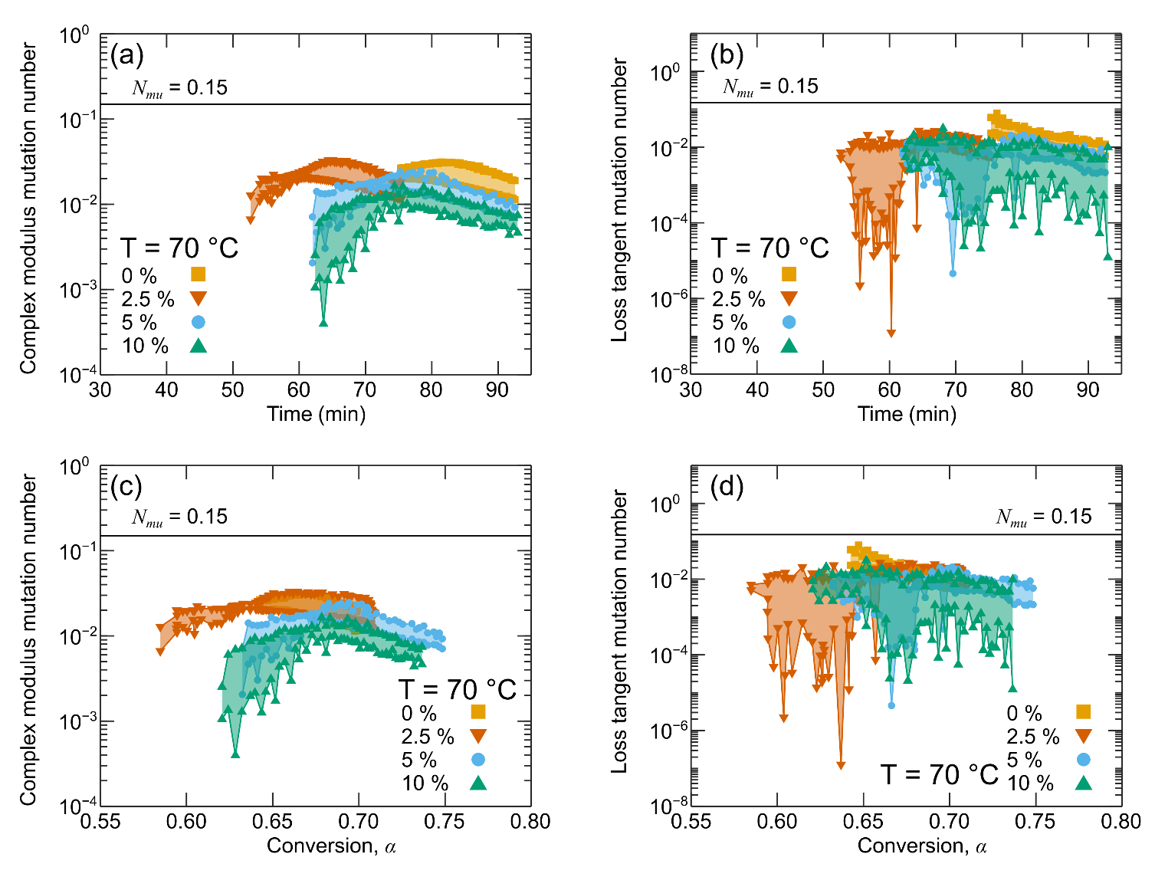Fig. S5: Evolution of the mutation number for the resins cured at 70 °C. Mutation number associated with the (a) magnitude of the complex modulus versus time ($g=\left|G^{*}\right|$), (b) loss tangent versus time ($g=\tan{δ}$), (c) magnitude of the complex modulus versus conversion, and (d) loss tangent versus conversion.
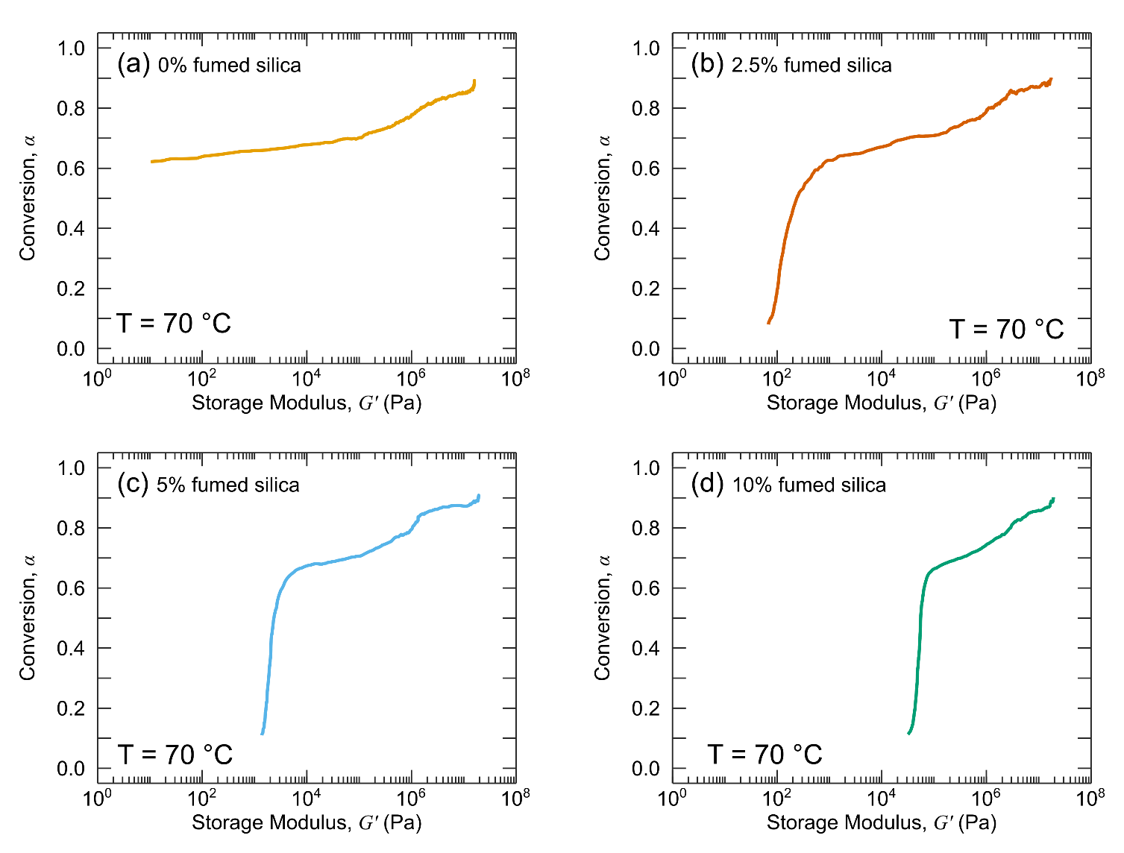
Fig. S6: Conversion-storage modulus relationship of the resins cured at 70 °C obtained from the rheo-Raman instrument (at a frequency of 6.28 rad/s). (a) Resin with 0 % fumed silica. (b) Resin with 2.5 % fumed silica. (c) Resin with 5 % fumed silica. (d) Resin with 10 % fumed silica.
Fig. S6 shows the conversion-storage modulus relationship (which was measured at a frequency of 6.28 rad/s). Data shown in Fig. S6a,c,d were generated in previous work [3, 4], whereas those shown in Fig. S6b were generated during this work. Conversion is assigned to the OWCh measurements by interpolating this map at the storage modulus provided by the OWCh results (which were also interpolated at a frequency of 6.28 rad/s).

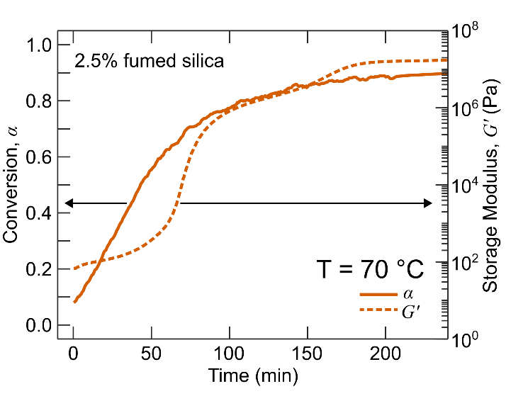
Fig. S7: Rheo-Raman measurements of conversion and storage modulus plotted as a function of time for the resin with 2.5 % fumed silica cured at 70 °C. Storage modulus was measured at a frequency of 6.28 rad/s.
Fig. S7 shows the simultaneous measurements of conversion and storage modulus obtained from the rheo-Raman instrument for the resin with 2.5 % fumed silica. These time-dependent curves were manipulated to achieve the conversion-storage modulus relationship shown in Fig. S6b.

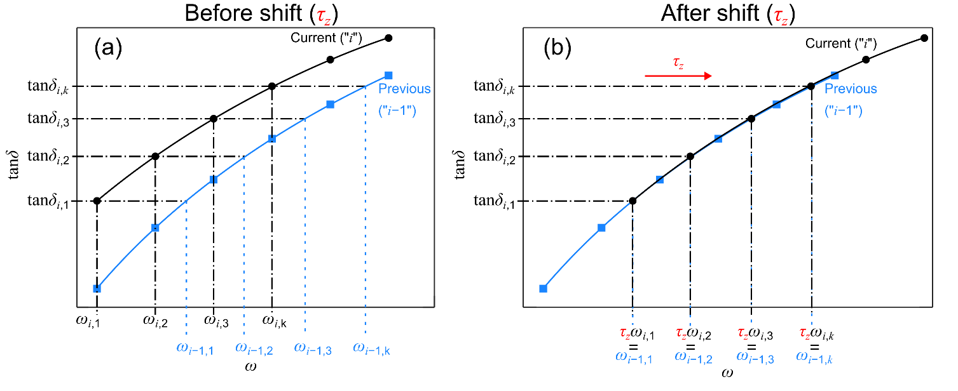
Fig. S8: Graphical explanation of the method used to determine the horizontal shift factor for each loss tangent response. (a) Before the current response is shifted onto the previous response. (b) After the current response is shifted onto the previous response.
Fig. S8a illustrates how the horizontal shift factor ($τ_{z}$) was determined for each response. The first step requires a frequency from the previous response to be paired with each frequency of the current response. This is accomplished by drawing a horizontal line corresponding to the loss tangent at each frequency of the current response ($ω_{i,k}$) and finding its intersection with the previous response using MATLAB’s “fzero” function. A 4th order b-spline is applied to the previous response, so that the loss tangent can be interpolated between measured frequencies rather than using the nearest measured frequency to approximate the “intersection frequency” ($ω_{i-1,k}$). Then, in Fig. S8b, the current response was multiplied by the shift factor to superimpose it onto the previous response. In the ideal case shown in Fig. S8 (i.e., when the shapes of the curves match perfectly and there is no noise or fluctuations), the shift factor can be calculated by dividing the frequency associated with the previous response by the current frequency (i.e., $τ_{z}= \frac{ω_{i-1,k}}{ω_{i,k}}$), and every instance ($k$) of this equation would result in the same value of shift factor. Of course, for each overlapping frequency (indicated by the index “$k$”), the ratio of $\frac{ω_{i-1,k}}{ω_{i,k}}$ may be different due to the fluctuations shown in Fig. 2 of the main text. Therefore, some additional complexity must be incorporated into the shifting algorithm. Gergesova et al. [5] developed a closed form solution to determine the horizontal shift factor by finding the value that would eliminate the net area between the current and previous response, balancing the error. We implement this approach by slightly modifying the equation shown on the x-axis of Fig. S8b to assume some amount of error ($ε_{k}$).
$$τ_{z}ω_{i,k}= ω_{i-1,k}+ ε_{k}$$ | (S1)
We eliminate the error between the shifted current response and the previous response by solving for $ε_{k}$, summing over every term, and then setting that sum equal to 0.
$$\sum_{j=1}^{k}{ε_{j}}= \sum_{j=1}^{k}{\left(τ_{z}ω_{i,j}- ω_{i-1,j}\right)}=0$$ | (S2)
The shift factor $τ_{z}$ can be factored out of the frequency term and then isolated, providing a closed-form solution that depends on the overlapping frequencies of the current ($ω_{i,k}$) and previous ($ω_{i-1,k}$) responses.
$$τ_{z}= \frac{\sum_{j=1}^{k}{ω_{i-1,j}}}{\sum_{j=1}^{k}{ω_{i,j}}}$$ | (S3)
The data we obtained exhibits three features that complicate determination of the horizontal shift factor. First, the data may not exhibit an “overlapping” region. In these cases, we approximated the horizontal shift factor by dividing the maximum frequency of the previous response by the minimum frequency of the current response. This is not a perfect solution, but the following results show that this provides a good approximation when the minimum loss tangent of the current response is close to the maximum loss tangent of the previous response. The best solution to this issue for future experimentation is to obtain data more frequently or increase the range of frequencies tested. Second, noisy data can intersect the loss tangent more than once. In these cases, the “intersection frequency” was approximated by averaging all the frequencies where the loss tangent line intersected with the previous response. Finally, the loss tangent can exhibit frequency independence (if the loss tangent varied less than 10 % for all the frequencies within a given chirp, it was assumed to be frequency independent). Once frequency independence is achieved the horizontal shift factor becomes infinite, as no horizontal movement will overlay frequency independent curves at different loss tangent values. In these cases, the horizontal shift factor from the previous measurement was assumed as the current shift factor to prevent the scale of our figures from diverging.
Some horizontal shifts (Fig. 6 of the main text) produce visibly poor superposition that we associate with the gel point. To identify these shifts, the residual error between each shift and its immediate predecessor was calculated. This error was normalized, then averaged for each response. We expected to see a spike in this error around the time we observed poor superposition, but did not observe such behavior. We noticed that the magnitude of the noise in the measurement (which may be improved by increasing the time-bandwidth constants of the OWCh signals [2, 6]) was on the same order of magnitude as the error observed in the curves that did not superimpose properly.
To magnify the error caused by poor superposition, we modified the error calculation outlined above. Instead of comparing each response to its immediate predecessor, we compared each response to the response prior to its immediate predecessor. In short, we compared each response (represented by “i”) to response “i-2” instead of response “i-1.” This error metric provided the spike we were expecting, allowing us to set an error threshold above which “invalid shifts” could be identified. Fig. S9 depicts the results of the error calculation as a function of time for each resin. On each plot, a horizontal line represents the threshold used to categorize invalid shifts for that resin. The error threshold was different for each resin, because the inherent level of noise in the loss tangent measurement varies for each resin. Fig. S10 highlights these invalid shifts (in royal blue) on the time-cure superposition results.
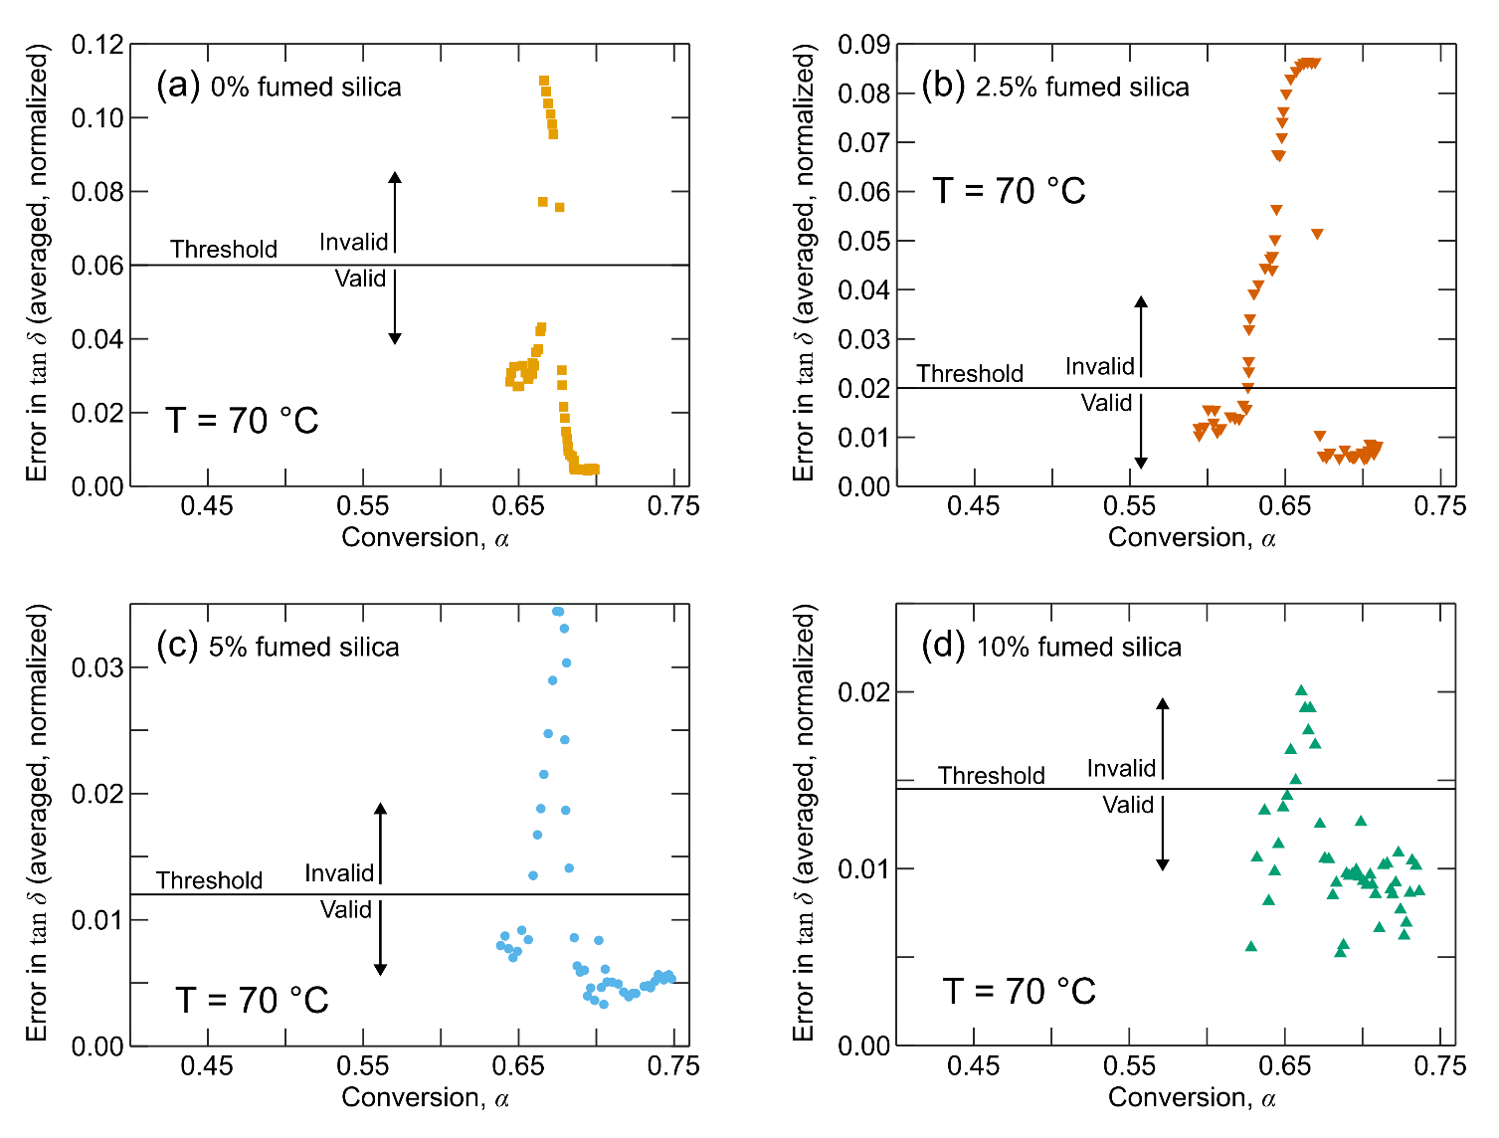Fig. S9: Normalized and averaged error in the loss tangent after applying time-cure superposition shifts for the resins cured at 70 °C. (a) Resin with 0 % fumed silica. (b) Resin with 2.5 % fumed silica. (c) Resin with 5 % fumed silica. (d) Resin with 10 % fumed silica.
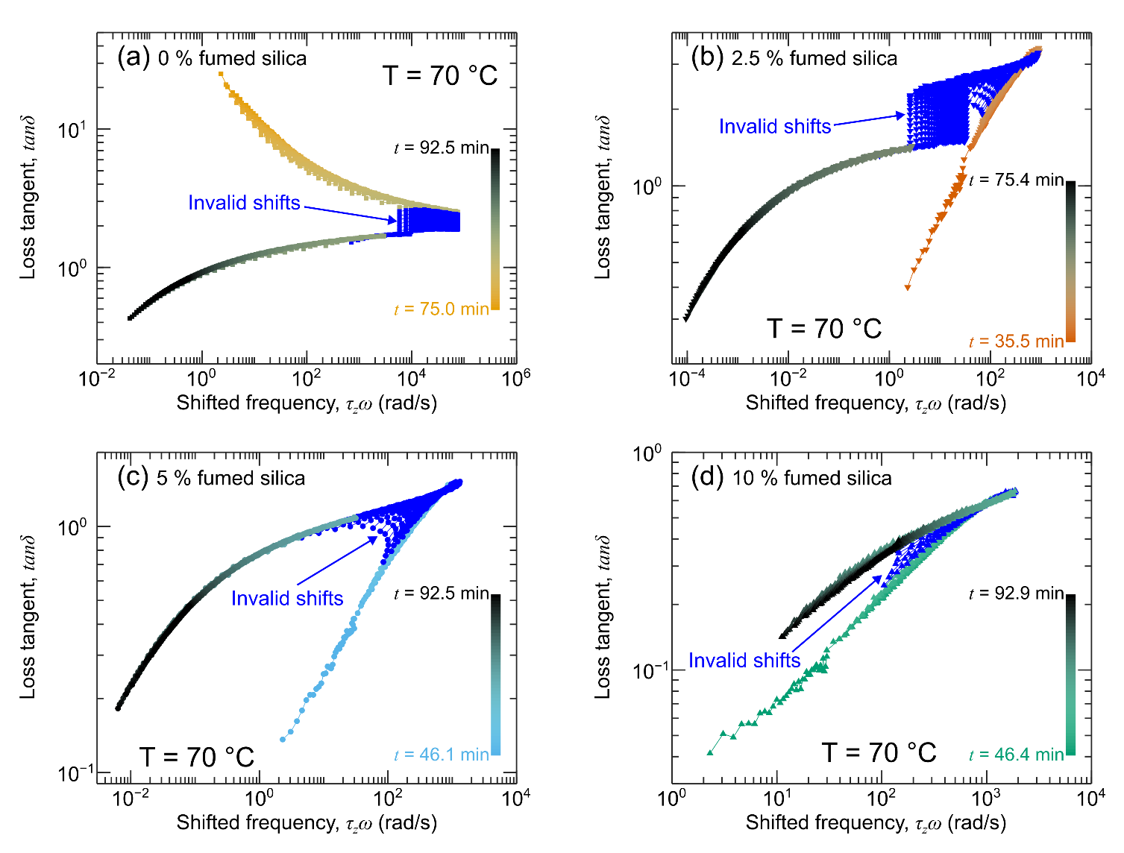
Fig. S10: Time-cure superposition of the loss tangent for the resins cured at 70 °C. The invalid shifts are highlighted in royal blue. (a) Resin with 0 % fumed silica. (b) Resin with 2.5 % fumed silica. (c) Resin with 5 % fumed silica. (d) Resin with 10 % fumed silica.

References
[1] Mours, M., Winter, H. H., Time-resolved rheometry, Rheol. Acta 33(5) (1994) 385-397. https://doi.org/10.1007/BF00366581.
[2] Geri, M., Keshavarz, B., Divoux, T., Clasen, C., Curtis, D., McKinley, G. H., 2018. Time-Resolved Mechanical Spectroscopy of Soft Materials via Optimally Windowed Chirps, Phys. Rev. X 8(4), 041042. https://doi.org/10.1103/PhysRevX.8.041042.
[3] Romberg, S., Kotula, A., 2023. Simultaneous rheology and cure kinetics dictate thermal post-curing of thermoset composite resins for material extrusion, Addit. Manuf. 71, 103589. https://doi.org/10.1016/j.addma.2023.103589.
[4] Romberg, S., Kotula, A., Simultaneous rheology and cure kinetics dictate thermal post-curing of thermoset composite resins for material extrusion, in: N.P.D. Repository (Ed.) 2023. https://doi.org/10.18434/mds2-2918.
[5] Gergesova, M., Zupančič, B., Saprunov, I., Emri, I., The closed form t-T-P shifting (CFS) algorithm, J. Rheol. 55(1) (2011) 1-16. https://doi.org/10.1122/1.3503529.
[6] Athanasiou, T., Geri, M., Roose, P., McKinley, G. H., Petekidis, G., High-frequency optimally windowed chirp rheometry for rapidly evolving viscoelastic materials: Application to a crosslinking thermoset, J. Rheol. 68(3) (2024) 445-462. https://doi.org/10.1122/8.0000793.

