Supplementary Information

Model | Organization | Reference
ACCESS-CM2 | Commonwealth Scientific and Industrial Research Organization (CSIRO), Australia | Bi et al., 2020⁷⁶
ACCESS-ESM1-5 | Commonwealth Scientific and Industrial Research Organization (CSIRO), Australia | Ziehn et al., 2020⁷⁷
CESM2 | National Center for Atmospheric Research (NCAR), USA | Danabasoglu et al., 2020⁷⁸
CESM2-WACCM | National Center for Atmospheric Research (NCAR), USA | Gettelman et al., 2019⁷⁹
CMCC-CM2-SR5 | Fondazione Centro Euro-Mediterrano sui Cambiamentin Climatici, Lecce, Italy | Cherchi et al., 2018⁸⁰
CMCC-ESM2 | Fondazione Centro Euro-Mediterrano sui Cambiamentin Climatici, Lecce, Italy | Lovato et al., 2022⁸¹
CNRM-CM6.1 | Centre National de Recherches Meteorologiques, Toulouse, France | Voldoire et al., 2019⁸²
CNRM-ESM2-1 | Centre National de Recherches Meteorologiques, Toulouse, France | Séférian et al., 2019⁸³
EC-Earth3 | EC-Earth-Consortium, Europe | Döscher et al., 2022⁸⁴
FGOALS-g3 | Chinese Academy of Sciences, China | Li et al., 2020⁸⁵
GFDL-CM4 | Geophysical Fluid Dynamics Laboratory (GFDL), USA | Held et al., 2019⁸⁶
GFDL-CM4_gr2 | Geophysical Fluid Dynamics Laboratory (GFDL), USA | Held et al., 2019⁸⁶
GFDL-ESM4 | Geophysical Fluid Dynamics Laboratory (GFDL), USA | Dunne et al., 2020⁸⁷
GISS-E2-1-G | Goddard Institute for Space Studies (GISS), USA | Kelley et al., 2020⁸⁸
IITM-ESM | Centre for Climate Change Research, Indian Institute of Tropical Meteorology, India | Swapna et al., 2015⁸⁹
INM-CM4-8 | Marchuk Institute of Numerical Mathematics of the Russian Academy of Science, Russia | Volodin et al., 2021⁹⁰
INM-CM5-0 | Marchuk Institute of Numerical Mathematics of the Russian Academy of Science, Russia | Volodin et al., 2017⁹¹
KACE-1-0-G | National Institute of Meteorological Sciences Korea Meteorological Administration, Republic of Korea | Young-Hwa et al., 2019⁹²
MIROC-ES2L | Japan Agency for Marine-Earth Science and Technology (JAMSTEC), University of Tokyo (UT), National Institute for Environmental Studies (NIES), and RIKEN Center for Computational Studies (RCCS), Japan | Hajima et al., 2020⁹³
MPI-ESM1-2-HR | Max Planck Institute for Meteorology, Germany | Gutjahr et al., 2019⁹⁴
MPI-ESM1-2-LR | Max Planck Institute for Meteorology, Germany | Mauritsen et al., 2019
MRI-ESM2-0 | Meteorological Research Institute, Japan | Yukimoto et al., 2019⁹⁶
NorESM2-LM | NorESM Climate Modeling Consortium (NCC), Norway | Seland et al., 2020⁹⁷
NorESM2-MM | NorESM Climate Modeling Consortium (NCC), Norway | Seland et al., 2020⁹⁷
TaiESM1 | Research Center for Environmental Changes, China | Wang et al., 2021
Supplementary Table 1: The 25 Global Circulation Models employed in Coupled Model Intercomparison Project Phase 6 (CMIP6).

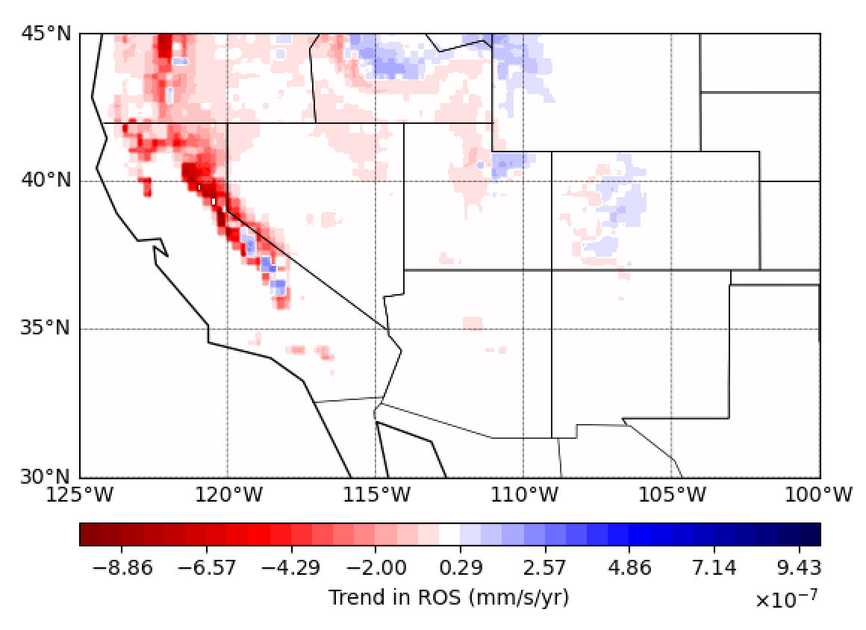
Supplementary Figure 1: Contrasting Trends in Rain-on-Snow Events Across Elevation Zones in the Western USA. Spatial distributions of the trends in under historical conditions (1950-2014) over the Western United States
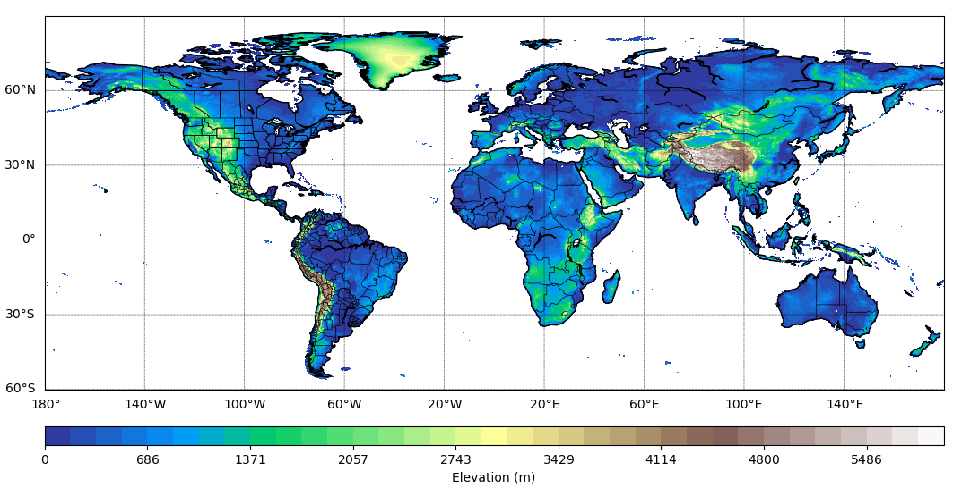
Supplementary Figure 2: Global Elevation Map. The elevation data shown in this figure has been used to interpret the changes in rain-on-snow.

Supplementary Figure 3: Changes in Rain-on-Snow and Its Contribution to Runoff Across Historical and Future Climate Scenarios. Differences in the ratio of rain-on-snow (ROS) to precipitation (P) between (a) historical and SSP245, (b) historical and SSP585, and (c) SSP585 and SSP245, and in the ratio of snowmelt following ROS (QSM_{ROS}) to total runoff (Runoff_{WA}: liquid precipitation + snowmelt) between (d) historical and SSP245, (e) historical and SSP585, and (f) SSP585 and SSP245. Red areas indicate historical values lower than future projections, while blue areas show future projections lower than historical conditions.
Supplementary Figure 4: Seasonal (October–December) Evolution of Rain-on-Snow and Its Contribution to Runoff Under Historical and Future Climate Scenarios Across Key Regions. Yearly averages of rain-on-snow (ROS) and the ratio of snowmelt following ROS (QSM_{ROS}) to total runoff (Runoff_{WA}: liquid precipitation + snowmelt) from October to December under historical conditions and future projections for regions in Figure 1j: (a, b) Western US, (c, d) Eastern US, (e, f) Eastern Europe, (g, h) Western Europe, (i, j) Andes, and (k,l) Rockies.

Supplementary Figure 5: Seasonal (October–December) Averages of Rain-on-Snow and Its Contribution to Runoff Under Historical and Future Climate Projections for High-Latitude and Mountainous Regions. Yearly averages of rain-on-snow (ROS) and the ratio of snowmelt following ROS (QSM_{ROS}) to total runoff (Runoff_{WA}: liquid precipitation + snowmelt) from October to December under historical conditions and future projections for regions in Figure 1j: (a, b) High-Latitude North America, (c, d) European Alps, (e, f) Northern Eurasia, and (g, h) High Mountain Asia.

Supplementary Figure 6: Seasonal trends in precipitation, rainfall, and snowfall for historical conditions and future projections under SSP245 and SSP585. Seasons are defined as DJF (December–February), MAM (March–May), JJA (June–August), and SON (September–November).
Supplementary Figure 7: Comparison of Trend Signs for Precipitation, Snow Depth, and Air Temperature Between Our Historical Simulations and ERA5-Land, MERRA-2, and IMERG. Comparison of trend signs for (a) precipitation, (b) snow depth, and (c) air temperature between our historical condition simulations and those from ERA5-Land (subscript 1), MERRA-2 (subscript 2), and IMERG (subscript 3). The tables showing the percentage of positive and negative trends captured by our simulations, as well as the total percentage of negative and positive cells in the domain relative to ERA5-Land, MERRA-2, and IMERG are presented in (a4) for precipitation, (b3) for snow depth, and (c2) for air temperature.

Supplementary Figure 8: Percentage of Ensemble Members Exhibiting the Same Trend Sign as the Average for Precipitation and Snowfall. Percentage of individual ensemble members exhibiting the same trend sign as the average for (a) precipitation and (b) snowfall. Negative percentage values indicate that the average trend sign is negative, while positive percentage values indicate a positive trend sign. Note that areas in white do not have statistically significant trends.

76. Bi, D. et al. Configuration and spin-up of ACCESS-CM2, the new generation Australian Community Climate and Earth System Simulator Coupled Model. J. South. Hemisphere Earth Syst. Sci. 70, 225–251 (2020).
77. Ziehn, T. et al. The Australian Earth System Model: ACCESS-ESM1.5. J. South. Hemisphere Earth Syst. Sci. 70, 193–214 (2020).
78. Danabasoglu, G. et al. The Community Earth System Model Version 2 (CESM2). J. Adv. Model. Earth Syst. 12, e2019MS001916 (2020).
79. Gettelman, A. et al. The Whole Atmosphere Community Climate Model Version 6 (WACCM6). J. Geophys. Res. Atmospheres 124, 12380–12403 (2019).
80. Cherchi, A. et al. Global Mean Climate and Main Patterns of Variability in the CMCC-CM2 Coupled Model. J. Adv. Model. Earth Syst. 11, 185–209 (2019).
81. Lovato, T. et al. CMIP6 Simulations With the CMCC Earth System Model (CMCC-ESM2). J. Adv. Model. Earth Syst. 14, e2021MS002814 (2022).
82. Voldoire, A. et al. Evaluation of CMIP6 DECK Experiments With CNRM-CM6-1. J. Adv. Model. Earth Syst. 11, 2177–2213 (2019).
83. Séférian, R. et al. Evaluation of CNRM Earth System Model, CNRM-ESM2-1: Role of Earth System Processes in Present-Day and Future Climate. J. Adv. Model. Earth Syst. 11, 4182–4227 (2019).
84. Döscher, R. et al. The EC-Earth3 Earth system model for the Coupled Model Intercomparison Project 6. Geosci. Model Dev. 15, 2973–3020 (2022).
85. Li, L. et al. The Flexible Global Ocean-Atmosphere-Land System Model Grid-Point Version 3 (FGOALS-g3): Description and Evaluation. J. Adv. Model. Earth Syst. 12, e2019MS002012 (2020).
86. Held, I. M. et al. Structure and Performance of GFDL’s CM4.0 Climate Model. J. Adv. Model. Earth Syst. 11, 3691–3727 (2019).
87. Dunne, J. P. et al. The GFDL Earth System Model Version 4.1 (GFDL-ESM 4.1): Overall Coupled Model Description and Simulation Characteristics. J. Adv. Model. Earth Syst. 12, e2019MS002015 (2020).
88. Kelley, M. et al. GISS-E2.1: Configurations and Climatology. J. Adv. Model. Earth Syst. 12, e2019MS002025 (2020).
89. Swapna, P. et al. The IITM Earth System Model: Transformation of a Seasonal Prediction Model to a Long-Term Climate Model. (2015) doi:10.1175/BAMS-D-13-00276.1.
90. Volodin, E. The Mechanisms of Cloudiness Evolution Responsible for Equilibrium Climate Sensitivity in Climate Model INM-CM4-8. Geophys. Res. Lett. 48, e2021GL096204 (2021).
91. Volodin, E. M. et al. Simulation of the present-day climate with the climate model INMCM5. Clim. Dyn. 49, 3715–3734 (2017).
92. Byun, Y.-H. et al. NIMS-KMA KACE1.0-G model output prepared for CMIP6 CMIP. Earth System Grid Federation https://doi.org/10.22033/ESGF/CMIP6.2241 (2019).
93. Hajima, T. et al. Development of the MIROC-ES2L Earth system model and the evaluation of biogeochemical processes and feedbacks. Geosci. Model Dev. 13, 2197–2244 (2020).
94. Gutjahr, O. et al. Max Planck Institute Earth System Model (MPI-ESM1.2) for the High-Resolution Model Intercomparison Project (HighResMIP). Geosci. Model Dev. 12, 3241–3281 (2019).
95. Mauritsen, T. et al. Developments in the MPI-M Earth System Model version 1.2 (MPI-ESM1.2) and Its Response to Increasing CO2. J. Adv. Model. Earth Syst. 11, 998–1038 (2019).
96. Yukimoto, S. et al. The Meteorological Research Institute Earth System Model Version 2.0, MRI-ESM2.0: Description and Basic Evaluation of the Physical Component. J. Meteorol. Soc. Jpn. Ser II 97, 931–965 (2019).
97. Seland, Ø. et al. Overview of the Norwegian Earth System Model (NorESM2) and key climate response of CMIP6 DECK, historical, and scenario simulations. Geosci. Model Dev. 13, 6165–6200 (2020).
98. Wang, Y.-C. et al. Performance of the Taiwan Earth System Model in Simulating Climate Variability Compared With Observations and CMIP6 Model Simulations. J. Adv. Model. Earth Syst. 13, e2020MS002353 (2021).

76. Bi, D. et al. Configuration and spin-up of ACCESS-CM2, the new generation Australian Community Climate and Earth System Simulator Coupled Model. J. South. Hemisphere Earth Syst. Sci. 70, 225–251 (2020).
77. Ziehn, T. et al. The Australian Earth System Model: ACCESS-ESM1.5. J. South. Hemisphere Earth Syst. Sci. 70, 193–214 (2020).
78. Danabasoglu, G. et al. The Community Earth System Model Version 2 (CESM2). J. Adv. Model. Earth Syst. 12, e2019MS001916 (2020).
79. Gettelman, A. et al. The Whole Atmosphere Community Climate Model Version 6 (WACCM6). J. Geophys. Res. Atmospheres 124, 12380–12403 (2019).
80. Cherchi, A. et al. Global Mean Climate and Main Patterns of Variability in the CMCC-CM2 Coupled Model. J. Adv. Model. Earth Syst. 11, 185–209 (2019).
81. Lovato, T. et al. CMIP6 Simulations With the CMCC Earth System Model (CMCC-ESM2). J. Adv. Model. Earth Syst. 14, e2021MS002814 (2022).
82. Voldoire, A. et al. Evaluation of CMIP6 DECK Experiments With CNRM-CM6-1. J. Adv. Model. Earth Syst. 11, 2177–2213 (2019).
83. Séférian, R. et al. Evaluation of CNRM Earth System Model, CNRM-ESM2-1: Role of Earth System Processes in Present-Day and Future Climate. J. Adv. Model. Earth Syst. 11, 4182–4227 (2019).
84. Döscher, R. et al. The EC-Earth3 Earth system model for the Coupled Model Intercomparison Project 6. Geosci. Model Dev. 15, 2973–3020 (2022).
85. Li, L. et al. The Flexible Global Ocean-Atmosphere-Land System Model Grid-Point Version 3 (FGOALS-g3): Description and Evaluation. J. Adv. Model. Earth Syst. 12, e2019MS002012 (2020).
86. Held, I. M. et al. Structure and Performance of GFDL’s CM4.0 Climate Model. J. Adv. Model. Earth Syst. 11, 3691–3727 (2019).
87. Dunne, J. P. et al. The GFDL Earth System Model Version 4.1 (GFDL-ESM 4.1): Overall Coupled Model Description and Simulation Characteristics. J. Adv. Model. Earth Syst. 12, e2019MS002015 (2020).
88. Kelley, M. et al. GISS-E2.1: Configurations and Climatology. J. Adv. Model. Earth Syst. 12, e2019MS002025 (2020).
89. Swapna, P. et al. The IITM Earth System Model: Transformation of a Seasonal Prediction Model to a Long-Term Climate Model. (2015) doi:10.1175/BAMS-D-13-00276.1.
90. Volodin, E. The Mechanisms of Cloudiness Evolution Responsible for Equilibrium Climate Sensitivity in Climate Model INM-CM4-8. Geophys. Res. Lett. 48, e2021GL096204 (2021).
91. Volodin, E. M. et al. Simulation of the present-day climate with the climate model INMCM5. Clim. Dyn. 49, 3715–3734 (2017).
92. Byun, Y.-H. et al. NIMS-KMA KACE1.0-G model output prepared for CMIP6 CMIP. Earth System Grid Federation https://doi.org/10.22033/ESGF/CMIP6.2241 (2019).
93. Hajima, T. et al. Development of the MIROC-ES2L Earth system model and the evaluation of biogeochemical processes and feedbacks. Geosci. Model Dev. 13, 2197–2244 (2020).
94. Gutjahr, O. et al. Max Planck Institute Earth System Model (MPI-ESM1.2) for the High-Resolution Model Intercomparison Project (HighResMIP). Geosci. Model Dev. 12, 3241–3281 (2019).
95. Mauritsen, T. et al. Developments in the MPI-M Earth System Model version 1.2 (MPI-ESM1.2) and Its Response to Increasing CO2. J. Adv. Model. Earth Syst. 11, 998–1038 (2019).
96. Yukimoto, S. et al. The Meteorological Research Institute Earth System Model Version 2.0, MRI-ESM2.0: Description and Basic Evaluation of the Physical Component. J. Meteorol. Soc. Jpn. Ser II 97, 931–965 (2019).
97. Seland, Ø. et al. Overview of the Norwegian Earth System Model (NorESM2) and key climate response of CMIP6 DECK, historical, and scenario simulations. Geosci. Model Dev. 13, 6165–6200 (2020).
98. Wang, Y.-C. et al. Performance of the Taiwan Earth System Model in Simulating Climate Variability Compared With Observations and CMIP6 Model Simulations. J. Adv. Model. Earth Syst. 13, e2020MS002353 (2021).

