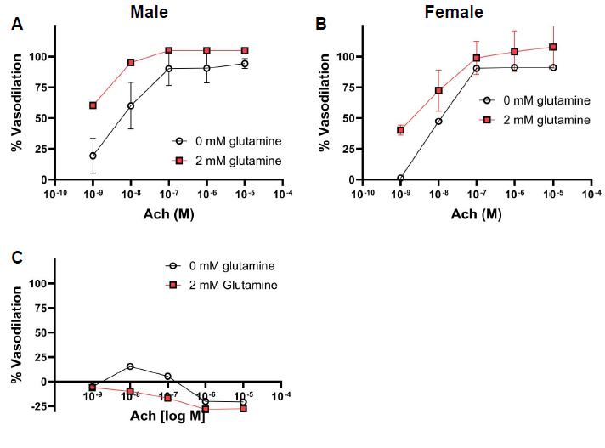
Figure S1. Glutamine increased vasodilation in male and female arteries and in an NO-dependent manner. Mouse carotid artery vasodilation in response to acetylcholine with an intact endothelium. Isolated male (A) and female (B) mouse carotid arteries were incubated at 4°C overnight in physiological saline containing either 0 or 2 mM glutamine. For male mice, 0 mM glutamine: n = 4 arteries; 2 mM glutamine: n = 1 artery. For female mice, 0 mM glutamine: n = 1 artery; 2 mM glutamine: n = 4 arteries. Vasodilation was measured the following day by pressure myography. C) Mouse carotid artery vasodilation in response to acetylcholine after eNOS was inhibited using 10⁻⁵ M L-NAME, as measured by pressure myography. n = 1 artery per condition.

