Supplemental Material
[if accepted, Data and R Code for replication]

Table S1. Descriptive statistics for input data, unabridged.
Characteristic | Overall  N = 201,879¹ | Morning  N = 39,426¹ | midday  N = 69,394¹ | Afternoon  N = 30,731¹ | Evening  N = 35,556¹ | Night  N = 26,772¹
Temperature Anomaly | 0.64 (-0.20, 1.41) | 0.86 (0.19, 1.50) | 0.62 (-0.09, 1.28) | -0.33 (-2.06, 0.60) | 0.35 (-0.57, 1.19) | 1.75 (0.95, 2.41)
Tree Cover (%, 10m) | 17 (2, 47) | 13 (2, 40) | 20 (4, 49) | 19 (1, 59) | 16 (1, 47) | 13 (1, 40)
Tree Cover (%, 30m) | 23 (10, 40) | 18 (9, 31) | 26 (11, 41) | 26 (11, 49) | 23 (10, 41) | 20 (10, 36)
Tree Cover (%, 60m) | 22 (13, 38) | 18 (13, 30) | 24 (14, 38) | 25 (13, 46) | 23 (13, 42) | 22 (13, 34)
Tree Cover (%, 90m) | 23 (13, 36) | 15 (13, 29) | 24 (13, 37) | 25 (14, 46) | 24 (14, 39) | 22 (14, 33)
Impervious Surface (%, 10m) | 59 (27, 82) | 61 (34, 81) | 54 (23, 75) | 56 (20, 82) | 65 (35, 87) | 67 (44, 87)
Impervious Surface (%, 30m) | 54 (34, 71) | 59 (45, 71) | 52 (27, 68) | 50 (28, 69) | 58 (33, 76) | 62 (43, 75)
Impervious Surface (%, 60m) | 54 (33, 67) | 56 (46, 67) | 47 (30, 63) | 51 (27, 65) | 57 (31, 73) | 59 (40, 72)
Impervious Surface (%, 90m) | 53 (32, 67) | 55 (46, 67) | 47 (30, 63) | 50 (25, 64) | 56 (29, 71) | 58 (40, 71)
Cloud Condition
clear | 72,740 (38%) | 9,152 (25%) | 31,394 (49%) | 6,616 (22%) | 12,211 (34%) | 13,367 (50%)
cloudy | 120,626 (62%) | 28,076 (75%) | 32,437 (51%) | 23,363 (78%) | 23,345 (66%) | 13,405 (50%)
Unknown | 8,513 | 2,198 | 5,563 | 752 | 0 | 0
Year
2019 | 66,903 (33%) | 21,291 (54%) | 32,757 (47%) | 6,770 (22%) | 6,085 (17%) | 0 (0%)
2020 | 122,052 (60%) | 17,878 (45%) | 32,547 (47%) | 19,536 (64%) | 28,541 (80%) | 23,550 (88%)
2021 | 12,924 (6.4%) | 257 (0.7%) | 4,090 (5.9%) | 4,425 (14%) | 930 (2.6%) | 3,222 (12%)
Elevation | 41 (27, 60) | 44 (28, 61) | 42 (26, 60) | 42 (28, 99) | 41 (28, 46) | 37 (26, 44)
Wind Speed | 0.85 (0.16, 1.77) | 1.21 (0.50, 1.77) | 1.24 (0.68, 2.28) | 0.60 (0.25, 1.10) | 0.27 (0.00, 0.96) | 0.00 (0.00, 1.40)
Wind Direction
East | 23,930 (12%) | 7,527 (20%) | 7,165 (10%) | 3,678 (12%) | 2,459 (7.1%) | 3,101 (12%)
NE | 3,195 (1.6%) | 1,306 (3.5%) | 1,597 (2.3%) | 255 (0.9%) | 0 (0%) | 37 (0.1%)
North | 6,306 (3.2%) | 2,790 (7.4%) | 2,389 (3.5%) | 932 (3.2%) | 0 (0%) | 195 (0.8%)
NW | 2,791 (1.4%) | 438 (1.2%) | 2,054 (3.0%) | 0 (0%) | 299 (0.9%) | 0 (0%)
SE | 28,175 (14%) | 3,466 (9.2%) | 3,826 (5.6%) | 6,115 (21%) | 8,851 (26%) | 5,917 (23%)
South | 93,517 (48%) | 9,945 (26%) | 30,564 (44%) | 16,680 (57%) | 20,550 (60%) | 15,778 (62%)
SW | 33,682 (17%) | 11,990 (32%) | 17,647 (26%) | 1,479 (5.0%) | 2,278 (6.6%) | 288 (1.1%)
West | 4,262 (2.2%) | 235 (0.6%) | 3,678 (5.3%) | 300 (1.0%) | 49 (0.1%) | 0 (0%)
Unknown | 6,021 | 1,729 | 474 | 1,292 | 1,070 | 1,456
¹ Median (IQR); n (%)

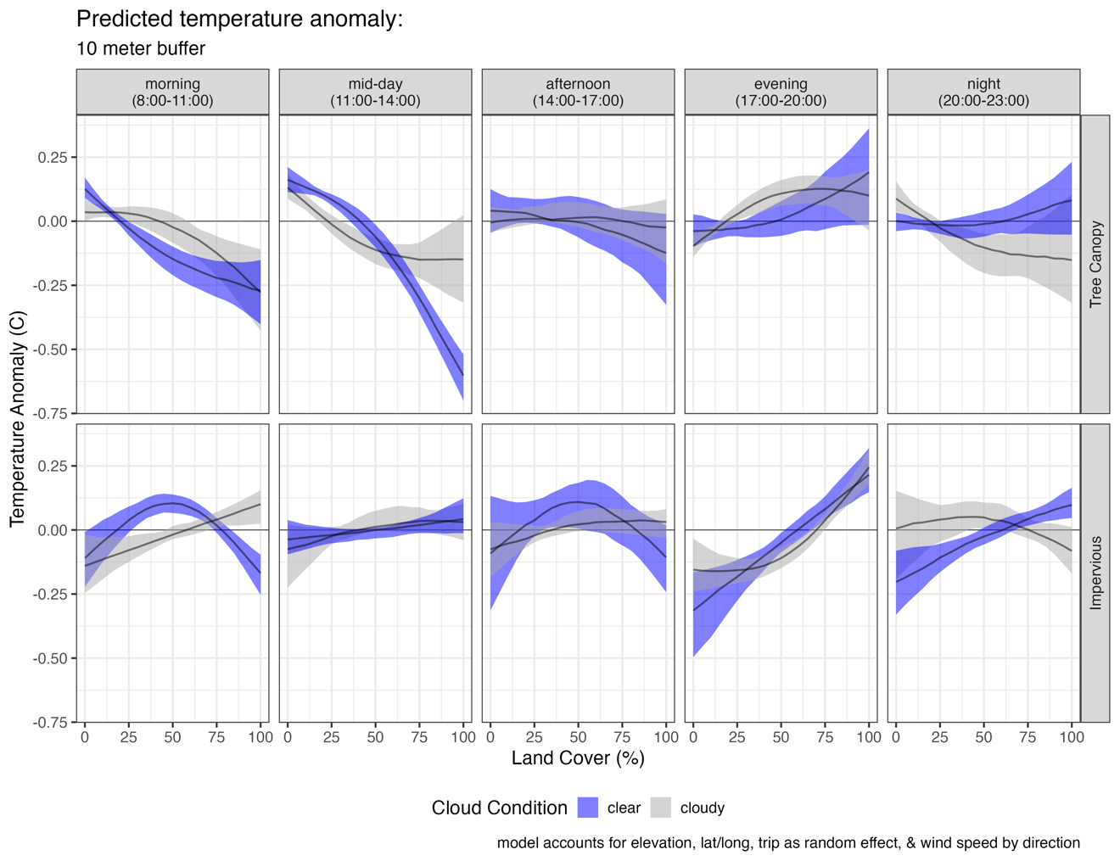
Figure S1. Estimated temperature anomaly (bike temperature minus reference station) from tree canopy (top) and impervious surface (bottom) in 10m buffers by cloud condition from resampled generalized additive mixed models controlling for elevation, location, trip, and wind speed per direction.
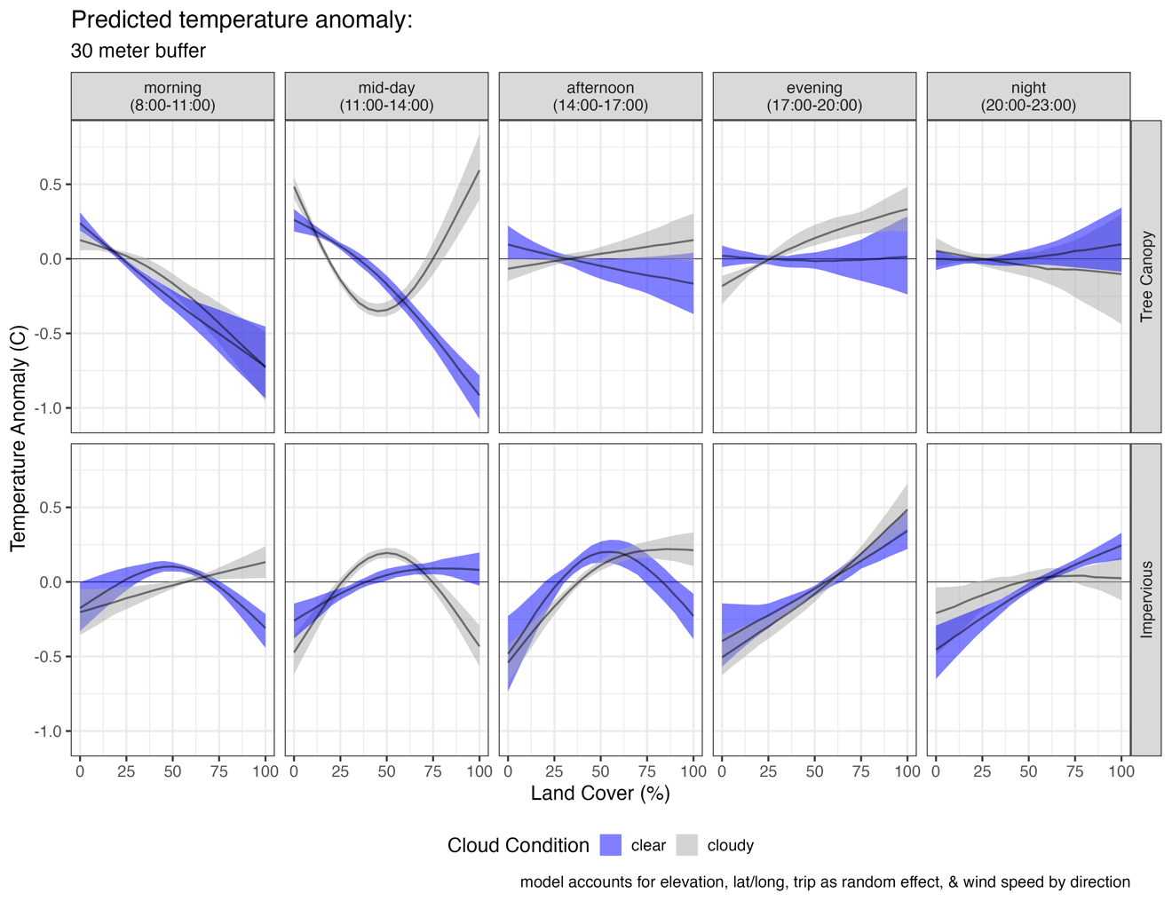
Figure S2. Estimated temperature anomaly (bike temperature minus reference station) from tree canopy (top) and impervious surface (bottom) in 30m buffers by cloud condition from resampled generalized additive mixed models controlling for elevation, location, trip, and wind speed per direction.
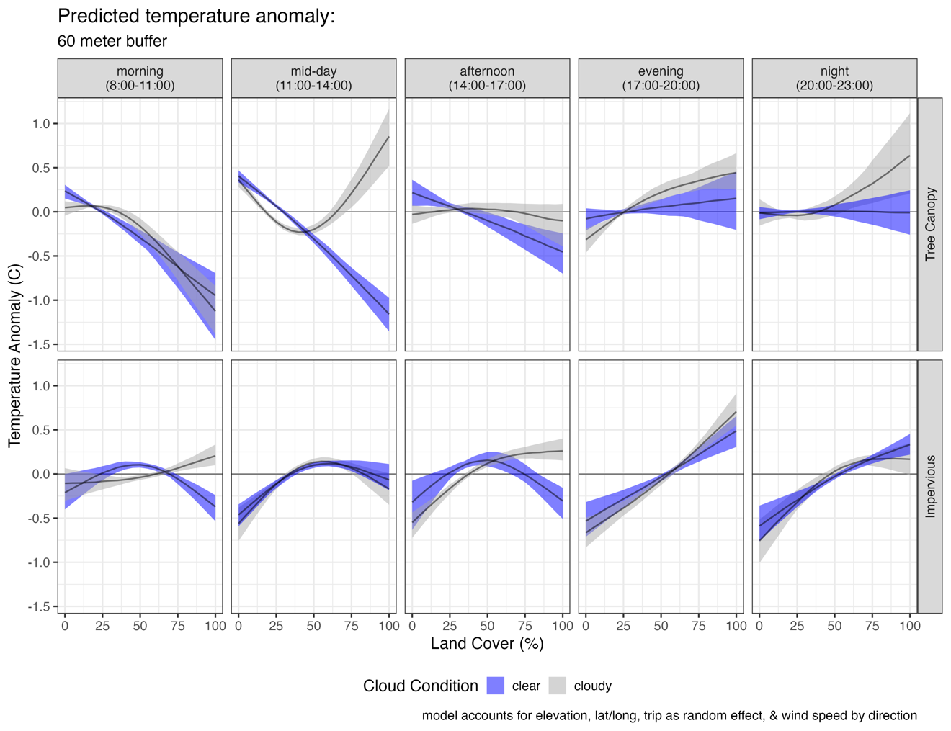
Figure S3. Estimated temperature anomaly (bike temperature minus reference station) from tree canopy (top) and impervious surface (bottom) in 60m buffers by cloud condition from resampled generalized additive mixed models controlling for elevation, location, trip, and wind speed per direction.

Table S2. Overall effect sizes from GAMMs created by subtracting the prediction at 100% cover from 0% cover.
 | Tree canopy |  |  |  | Impervious surface
 | Clear |  | Cloudy |  | Clear |  | Cloudy
Time of Day | estimate | 95% CI | estimate | 95% CI | estimate | 95% CI | estimate | 95% CI
morning | -1.15 | (-1.18, -1.12) | -0.92 | (-0.94, -0.89) | 0.13 | (0.14, 0.12) | 1.03 | (1.04, 1.03)
midday | -1.62 | (-1.63, -1.61) | 0.53 | (0.5, 0.56) | 0.46 | (0.46, 0.46) | 0.52 | (0.52, 0.51)
afternoon | -1.19 | (-1.21, -1.18) | -0.51 | (-0.53, -0.5) | -0.3 | (-0.29, -0.31) | 0.64 | (0.64, 0.64)
evening | 0.54 | (0.51, 0.57) | 0.47 | (0.46, 0.48) | 1.11 | (1.11, 1.11) | 1.1 | (1.1, 1.1)
night | -0.12 | (-0.14, -0.1) | 1.43 | (1.39, 1.46) | 0.95 | (0.96, 0.94) | 1.03 | (1.04, 1.03)
morning-shift | 0.07 | (0.04, 0.09) | 0.29 | (0.26, 0.31) | 0.29 | (0.3, 0.28) | 0.31 | (0.32, 0.3)
midday-shift | -1.43 | (-1.43, -1.42) | -0.28 | (-0.3, -0.25) | 0.22 | (0.21, 0.22) | 0.97 | (0.97, 0.97)
afternoon-shift | -1.12 | (-1.13, -1.1) | -1.17 | (-1.19, -1.16) | 0.31 | (0.31, 0.3) | 0.51 | (0.51, 0.51)
evening-shift | -1.09 | (-1.15, -1.03) | 0.41 | (0.39, 0.42) | 0.35 | (0.35, 0.35) | 0.66 | (0.66, 0.66)
night-shift | 0.72 | (0.7, 0.75) | 0.41 | (0.36, 0.45) | 1.44 | (1.45, 1.43) | 1.4 | (1.41, 1.4)
morning-hottest | -0.38 | (-0.38, -0.38) | -1 | (-1.01, -1) | 0.46 | (0.42, 0.5) | 0.43 | (0.4, 0.47)
midday-hottest | -1.12 | (-1.12, -1.11) | -1.17 | (-1.19, -1.15) | 0.72 | (0.72, 0.73) | -0.32 | (-0.33, -0.32)
afternoon-hottest | -1.78 | (-1.78, -1.78) | 2.69 | (2.55, 2.83) | -0.48 | (-0.48, -0.49) | 0.69 | (0.7, 0.68)
evening-hottest | -0.84 | (-0.86, -0.82) | -0.34 | (-0.37, -0.31) | -1.55 | (-1.59, -1.52) | 2.07 | (2.05, 2.09)

Table S3. Descriptive statistics shifted analyses.
Characteristic | Overall  N = 181,148¹ | morning-shift  N = 9,898¹ | midday-shift  N = 91,584¹ | afternoon-shift  N = 22,401¹ | evening-shift  N = 36,610¹ | night-shift  N = 20,655¹
Temperature Anomaly | 0.55 (-0.30, 1.28) | 0.82 (0.32, 1.33) | 0.72 (0.00, 1.38) | -0.14 (-1.76, 0.71) | -0.24 (-1.24, 0.67) | 1.31 (0.58, 1.79)
Tree Cover (%, 10m) | 17 (2, 47) | 8 (0, 32) | 20 (4, 49) | 19 (1, 57) | 16 (0, 50) | 14 (2, 39)
Tree Cover (%, 30m) | 23 (10, 40) | 15 (5, 31) | 25 (10, 40) | 24 (10, 47) | 24 (10, 42) | 19 (11, 35)
Tree Cover (%, 60m) | 22 (14, 38) | 15 (6, 29) | 22 (15, 37) | 23 (14, 43) | 25 (14, 45) | 22 (13, 33)
Tree Cover (%, 90m) | 23 (13, 37) | 15 (7, 26) | 23 (13, 36) | 23 (14, 41) | 26 (14, 45) | 22 (14, 33)
Impervious Surface (%, 10m) | 58 (26, 81) | 71 (39, 94) | 55 (24, 74) | 60 (21, 85) | 61 (29, 84) | 67 (45, 87)
Impervious Surface (%, 30m) | 53 (33, 70) | 65 (48, 84) | 52 (30, 67) | 55 (29, 74) | 51 (31, 70) | 64 (45, 77)
Impervious Surface (%, 60m) | 54 (32, 66) | 65 (50, 83) | 51 (32, 62) | 55 (28, 68) | 51 (28, 66) | 60 (43, 74)
Impervious Surface (%, 90m) | 53 (31, 66) | 65 (51, 81) | 51 (31, 61) | 53 (28, 66) | 50 (26, 66) | 59 (43, 73)
Cloud Condition
clear | 89,696 (50%) | 2,942 (30%) | 52,165 (58%) | 9,638 (45%) | 12,609 (34%) | 12,342 (60%)
cloudy | 89,327 (50%) | 6,956 (70%) | 38,046 (42%) | 12,011 (55%) | 24,001 (66%) | 8,313 (40%)
Unknown | 2,125 | 0 | 1,373 | 752 | 0 | 0
Year
2019 | 66,903 (37%) | 7,057 (71%) | 40,964 (45%) | 9,556 (43%) | 7,268 (20%) | 2,058 (10.0%)
2020 | 104,315 (58%) | 2,841 (29%) | 47,513 (52%) | 8,451 (38%) | 27,141 (74%) | 18,369 (89%)
2021 | 9,930 (5.5%) | 0 (0%) | 3,107 (3.4%) | 4,394 (20%) | 2,201 (6.0%) | 228 (1.1%)
Elevation | 42 (27, 62) | 37 (27, 53) | 45 (27, 62) | 42 (26, 71) | 42 (30, 112) | 37 (26, 44)
Wind Speed | 0.93 (0.29, 1.87) | 0.66 (0.10, 1.75) | 1.32 (0.72, 2.08) | 0.50 (0.04, 1.60) | 0.73 (0.28, 1.36) | 0.06 (0.00, 0.75)
Wind Direction
East | 21,057 (12%) | 2,689 (28%) | 11,736 (13%) | 2,656 (12%) | 2,902 (8.2%) | 1,074 (5.4%)
NE | 3,158 (1.8%) | 471 (4.8%) | 2,432 (2.7%) | 255 (1.2%) | 0 (0%) | 0 (0%)
North | 6,111 (3.5%) | 1,733 (18%) | 3,446 (3.8%) | 0 (0%) | 932 (2.6%) | 0 (0%)
NW | 2,791 (1.6%) | 284 (2.9%) | 2,208 (2.5%) | 0 (0%) | 299 (0.8%) | 0 (0%)
SE | 22,440 (13%) | 1,542 (16%) | 5,750 (6.4%) | 4,237 (19%) | 8,164 (23%) | 2,747 (14%)
South | 83,113 (47%) | 858 (8.8%) | 34,598 (39%) | 11,959 (55%) | 19,453 (55%) | 16,245 (81%)
SW | 33,394 (19%) | 2,194 (22%) | 25,425 (28%) | 2,349 (11%) | 3,426 (9.7%) | 0 (0%)
West | 4,262 (2.4%) | 0 (0%) | 3,913 (4.4%) | 300 (1.4%) | 49 (0.1%) | 0 (0%)
Unknown | 4,822 | 127 | 2,076 | 645 | 1,385 | 589
¹ Median (IQR); n (%)

# end January 18, 2023

