Supplementary Material

Table S1. List of measurements, symbols, instruments and units used on the T2 and T3.
Parameter | Symbol | Instrument | Unit
Carbon Monoxide  dry air mole fraction | CO | Los Gatos ICOS N2O/CO-23D  (LGR) | ppb
Sulfur Dioxide  dry air mole fraction | SO₂ | 43i-TLE*  (Thermo) | ppb
Concentration of  Organic Aerosols | OA | ACSM*  HR-ToF-AMS**  (Aerodyne Research Inc.) | ngm⁻³
Concentration of  Sulfate | SO₄ | ACSM*  HR-ToF-AMS**  (Aerodyne Research Inc.) | ngm⁻³
Concentration of  Nitrate | NO₃ | ACSM*  HR-ToF-AMS**  (Aerodyne Research Inc.) | ngm⁻³
Concentration of  Ammonium | NH₄ | ACSM*  HR-ToF-AMS**  (Aerodyne Research Inc.) | ngm⁻³
Concentration of  particles | CN | CPC 3772, 3010*, WCPC*  (TSI) | cm⁻³
Diameter of  particles | Dp | SMPS 3082, 3081  (TSI) | µm
Light Scattering  Coefficient | SCAT | Nephelometer A3000*, 3563**  (Ecotech, TSI) | Mm⁻¹
Light Absorption  Coefficient | ABS | MAAP 5012* (Thermo)  AE33*, AE31** (Magge) | Mm⁻¹
Air Relative  Humidity | RH | HOBO U30  WXT520 (Vaisala)** | %
Air  Temperature | - | HOBO U30  WXT520 (Vaisala)** | °C
Air  Pressure | - | HOBO U30  WXT520 (Vaisala)** | hPa
Wind  Direction | WDir | LUFFT WS800-UMB*  SODAR** | deg
Wind  Speed | WSpd | LUFFT WS800-UMB*  SODAR** | m s⁻¹
*Available only at the T2, **Available only at the T3

Chemical  Species | T2  Concentration at departure |  | T3  Concentration at arrival |  | T3/T2  Relative Factor
- | IOP 1 | IOP 2 | IOP 1 | IOP 2 | IOP 1 | IOP 2
$OA$ - $μgm^{-3}$
Median | 1.9 | 7.0 | 1.9 | 8.9 | 1.0 | 1.3
Average | 2.1 | 7.3 | 1.9 | 9.5 | 0.9 | 1.3
Std. Deviation ($±$) | 1.0 | 1.9 | 0.9 | 3.2 | - | -
$SO4$- $μgm^{-3}$
Median | 0.3 | 1.4 | 0.2 | 1.9 | 0.5 | 1.4
Average | 0.4 | 1.6 | 0.2 | 2.1 | 0.5 | 1.4
Std. Deviation ($±$) | 0.2 | 0.5 | 0.1 | 1.0 | - | -
$NO3$- $μgm^{-3}$
Median | 0.1 | 0.3 | 0.0 | 0.2 | 0.4 | 0.6
Average | 0.1 | 0.3 | 0.0 | 0.2 | 0.4 | 0.6
Std. Deviation ($±$) | 0.0 | 0.1 | 0.0 | 0.1 | - | -
$NH4$- $μgm^{-3}$
Median | 0.1 | 0.5 | 0.1 | 0.5 | 0.8 | 1.1
Average | 0.1 | 0.5 | 0.1 | 0.6 | 0.7 | 1.2
Std. Deviation ($±$) | 0.1 | 0.2 | 0.0 | 0.2 | - | -
Table S2. Changes on the concentration of aerosol chemical components resulting from evolution of the Manaus plume between the sampling sites (T2 and T3) during IOP 1 (1 February to 31 March 2014, wet season) and IOP 2 (15 September to 15 October 2014, dry season). Concentrations are shown at departure and arrival times of air masses leaving the T2 site and reaching the T3 site.

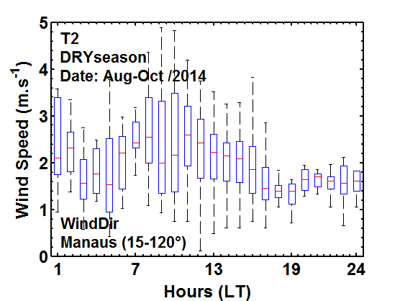
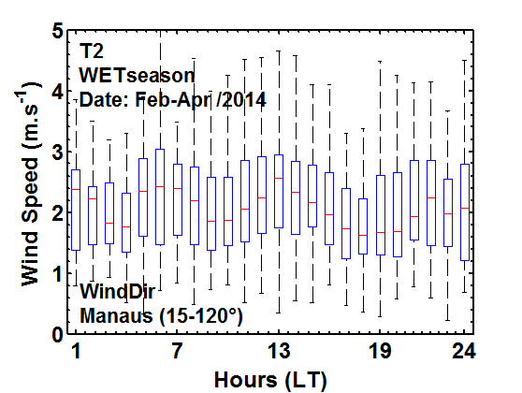
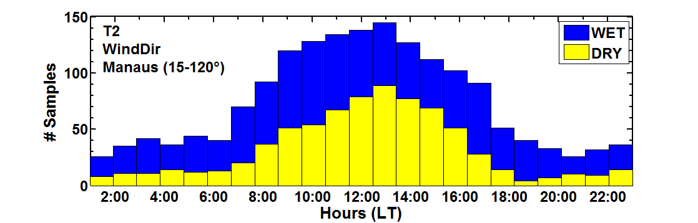
(a)

(a)
(b)

(b)
(c)

(c)

Figure S1. Diel trend of wind speed for air masses coming from Manaus (wind direction in the range 15-120°) at T2 (8 km downwind) during the wet season (IOP 1, panel a) and dry season (IOP 2, panel b). Boxes represent the percentiles 25 and 75, and red lines represent median values. On the bottom, frequency of winds coming from the Manaus direction as function of local time.

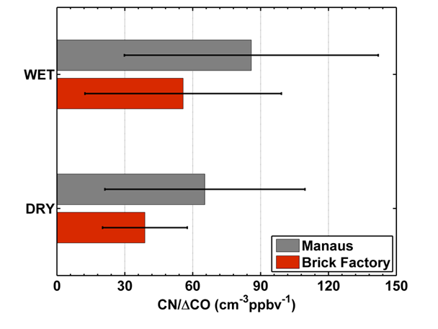
Figure S2. CN/ΔCO average ratios for Manaus emissions and brick factories as identified at the T2 (8 km downwind) site during the year (February-November, 2014). The black bars represent the standard deviation.

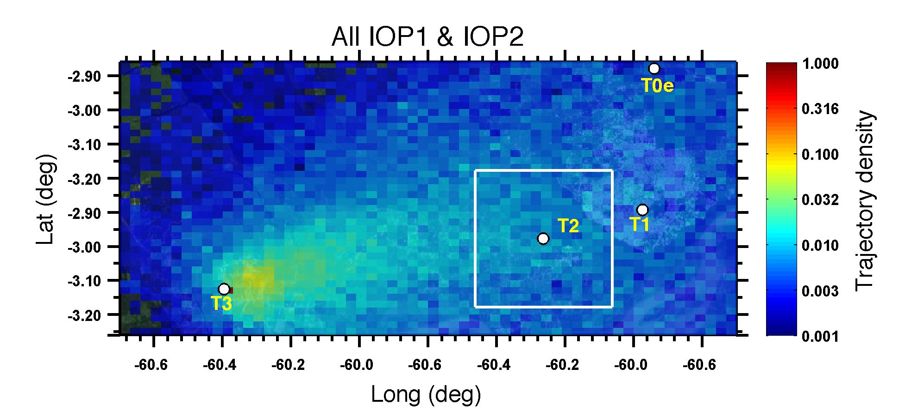
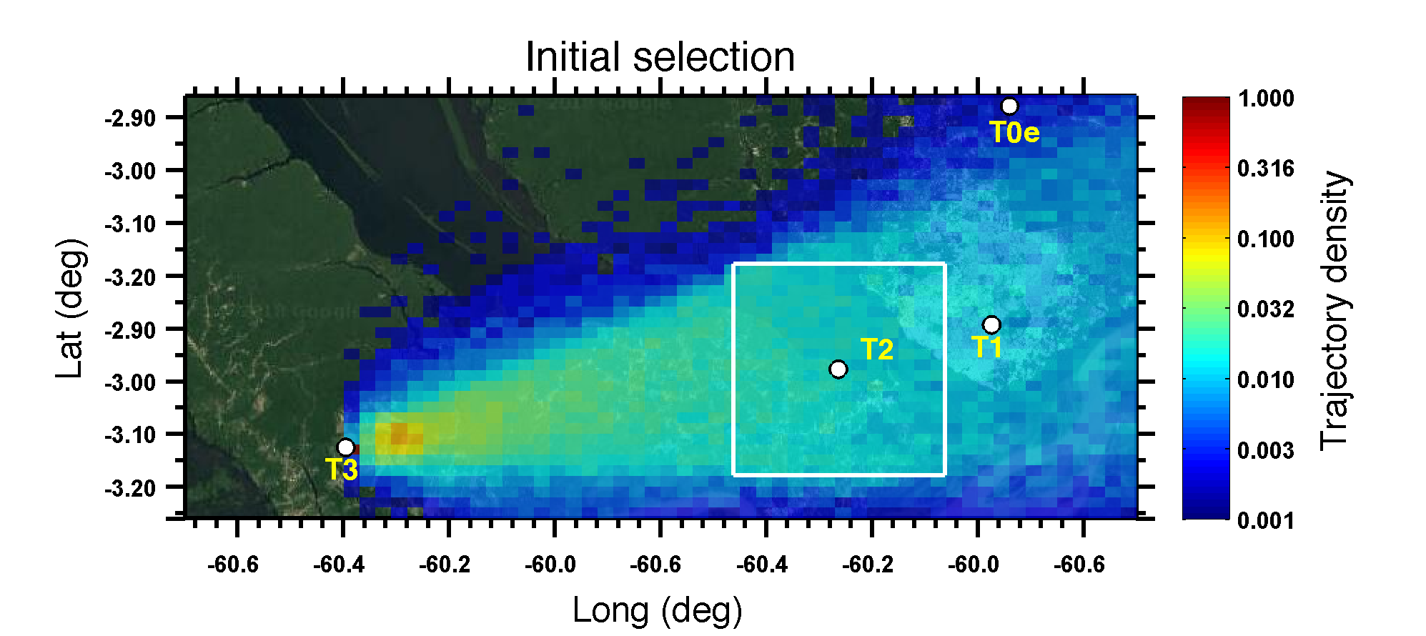
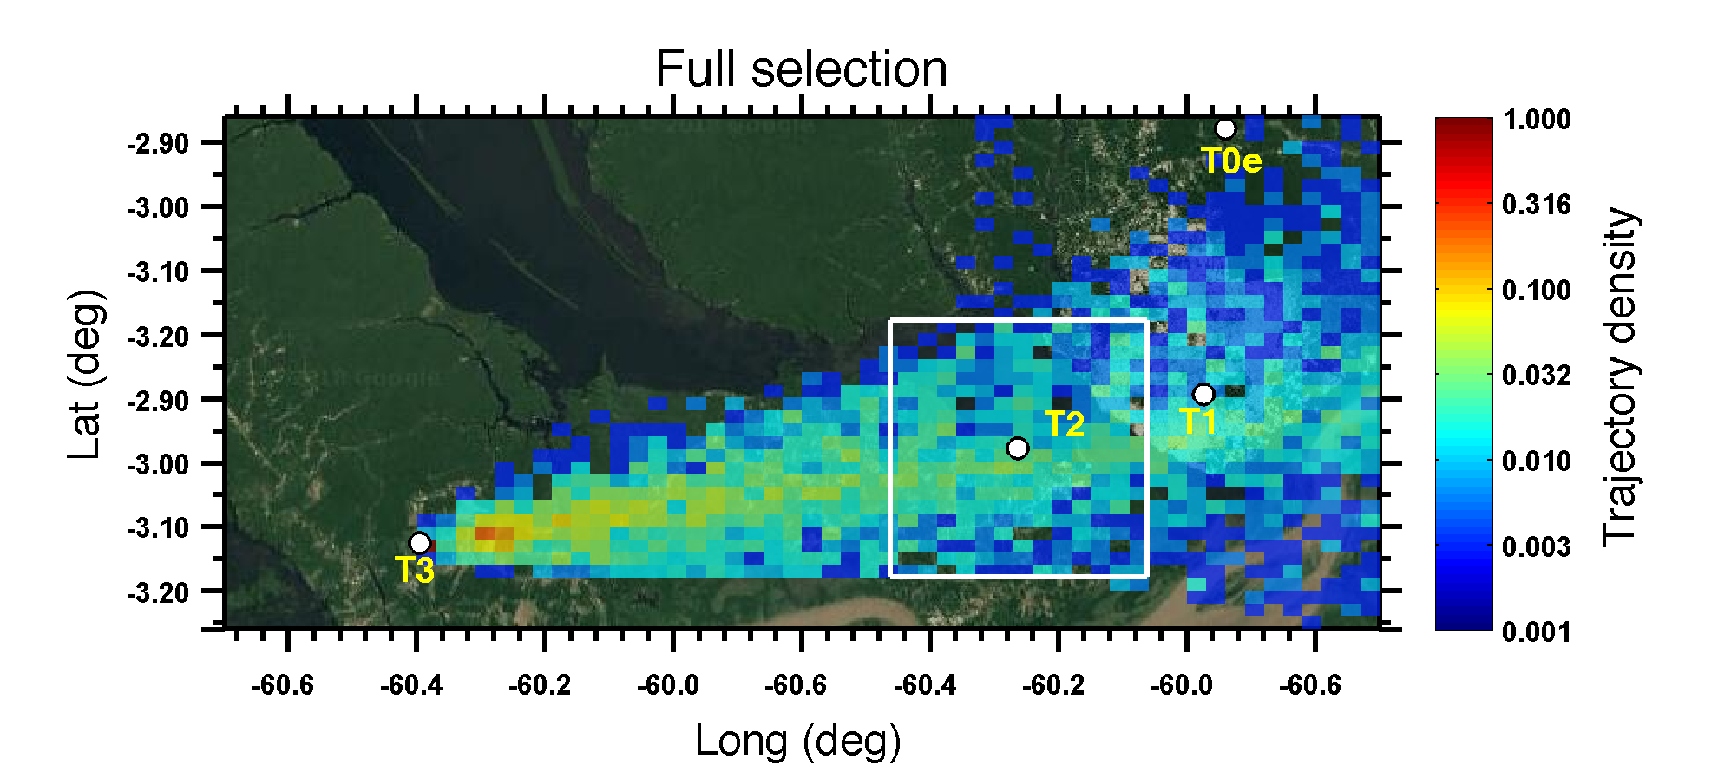
Figure S3. Trajectories density with the coverage areas for all simulated back trajectories over sites. On the top panel show total simulated cases during IOP1 and IOP2 (100% of 5712 data points). The middle panel shows the selected cases to the periods only to back-trajectories going over T2 (at 20 km×20 km box), within the BL (below 1000m) and no precipitation along the transect during the IOPs (~ 30% of 5712 data points). The bottom panel, finally, shows trajectories without the influence of fresh local biomass burning emissions (f60 < 0.35), after criteria mentioned above (~ 25% of 5712 data points).
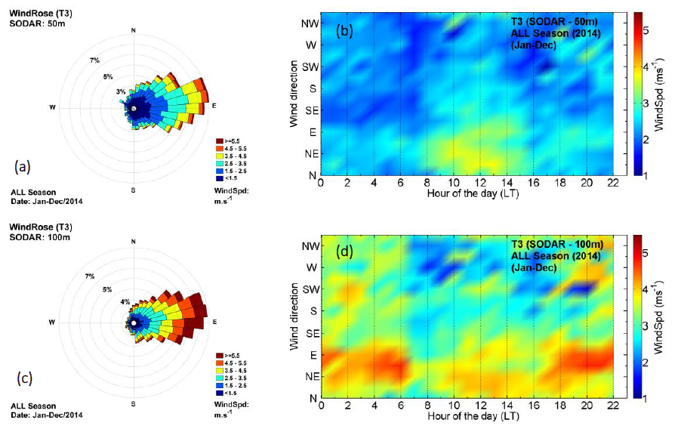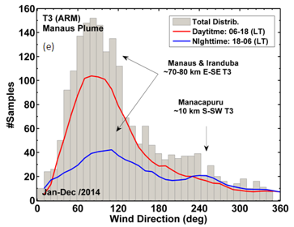
Figure S4. The trend of prevailing wind at different heights, from January to December 2014 at the T3 (70 km downwind). The wind roses (on the left) show the direction and speed wind at 50 m (a) and 100 m (c) of height. The diurnal cycle of wind (- 4 UTC) for all directions is presented at 50 m (b) and 100 m (d) of height (on the right). The time instants used in (a), (b), (c) and (d) are the same ones in which the HYSPLIT simulated back trajectories passing over T2 (8 km downwind) and T3. On the bottom panel (e) is shown the distribution of the direction of the wind as observed at T3 (vertical grey bar), as well as for the daytime and nighttime (red and blue lines, respectively). These results were found taking account the total distribution of the wind. No data filtering was used in this result.
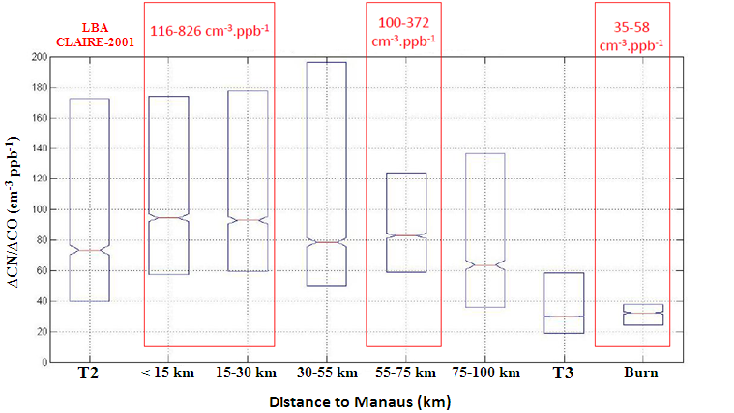

Figure S5. ∆CN/∆CO calculated point by point at heights lower than 700 m considering all G1 flights from the GoAmazon2014/5 experiment. The ∆CN/∆CO median reduction of 94 cm⁻³ ppb⁻¹ (< 15 km) to 63 cm⁻³ ppb⁻¹ (> 75 km) corresponds to the decreasing by 33%.

Figure S6. The original mean distributions as observed at T2 (8 km downwind) and T3 (70 km downwind) and the fitted initial distribution used in the simulation T2 during the IOP 2.

