The Effects of Restorative Practices on
Negative Student Behavior and Disciplinary Action

By Andrew Barrett

Submitted in Full Fulfillment of the Requirements for the
Degree of Master of Education

July 2020
Graduate Programs in Education
Goucher College
Table of Contents
List of Tables i
List of Graphs ii
Abstract iii
I. Introduction 1
Statement of Problem 2
Statement of Research Hypothesis 2
Operational Definitions 3
II. Review of Literature 4
History of Discipline in Schools and Need for Change 4
Dealing with Discipline as Outlined by the Federal Government 4
Punitive Approach and the School to Prison Pipeline 5
Encouraging positive behavior-PBIS 6
Needs of a high school student: Student perceptions of discipline 7
Restorative Practices: Theory and Practice 8
Conclusions 9
III. Methods 11
Design 11
Participants 11
Instrument 12
Procedure 13
IV. Results 16
V. Discussion 31
Implication of the Results 31
Theoretical Consequences 33
Threats to Validity 33
Connections to Literature 34
Implications for Further Research 35
Conclusion 35
References 37
List of Tables
1. Test of Hypothesis 1
2. Test of Hypothesis 2
3. Test of Hypothesis 3
4. Marking Period 1 Referrals
5. Marking Period 2 Referrals

List of Figures
1. Negative Behaviors
2. Consequences of Negative Behaviors
3. Referrals for Negative Behaviors
4. Events by Marking Period
5. Test of Hypothesis 1
6. Test of Hypothesis 2
7. Test of Hypothesis 3
8. Test of Hypothesis 4
9. Test of Hypothesis 5
10. Test of Hypothesis 6
11. Test of Hypothesis 7
12. Test of Hypothesis 8

Abstract
The purpose of this study was to determine if a novel, school-wide initiative known as Restorative Practices would influence student misbehavior. The measurement tool was the Office Disciplinary Referral written by a staff member when a student’s negative behavior is so egregious, it requires a consequence from an administrator. This study involved comparison of data from before implementation (SY2018) to information gleaned post implementation of Restorative Practices. Although there were fewer referrals, the study showed no significant statistical change between study groups. A number of mitigating factors may be attributable to the results. Further study addressing the long-term impact of Restorative Practices as well as research into the impracticality of traditional student discipline methods are warranted by this study.
CHAPTER I
INTRODUCTION
Overview
One of the problems many school districts face is dealing with discipline-related issues. Disruptive behavior in the classroom traditionally results in a referral to the administrator’s office. This results in a disconnect between teacher and student. Student learning experiences are diminished when teachers don’t work to build positive relationships with their students. Meaningful conflict resolution helps students learn acceptable means of social interaction. Simply removing a student form a classroom environment because of their disruptive behavior may solve an immediate issue, but it does little to repair the harm that has been committed by the offender, nor does it help the offender learn how they have affected others. Administrators are left with little option then to employ a punishment that removes the student from the school environment. This further ostracizes the student from their peers, while also further diminishing the progression of academic success. More often than not, administrators are employing punitive measures, rather than restorative.
Restorative Practice involves empowering the teacher to prevent negative behaviors before they escalate into an office referral. Office referrals lead to an increase in school-wide suspensions. Suspensions progress into expulsion and can lower a school’s graduation rate. State and federal incentives can be dependent on lowering expulsions and increasing graduation. Furthermore, a high school dropout is more likely to progress into the prison reform system (Skiba, Arredondo, & Williams, 2014).
Restorative Practices are a combination of methods that highlight the importance of building connections with students before teaching them content. The thought is that students will be less likely to misbehave while more likely to engage in the content. The researcher’s interest in the topic stems from accepting the opportunity within the study high school to become one of 15 trained Restorative Practice Champions throughout the 2019-2020 school year. Part of the school-wide initiative involves the champions teaching methods to fellow colleagues throughout the year. The goal is to teach staff certain strategies effective for handling student issues before they result in office referrals. At the same time, students may act out less should they feel a stronger connection with the teacher and their classmates.
Statement of Problem
The purpose of this study is to reduce disciplinary action, in the form of punishment, within a high school. Specifically, this study will examine the effect Restorative Practices have on negative behavior. This study will examine the effectiveness of the polices on decreasing disciplinary action.
Hypothesis
Restorative Practices will have no effect on student negative behavior.
Operational Definitions
What follows are the relevant variables and concepts in terms of their operations or processes:
Independent Variable (IV) – The implementation of Restorative Practices. This involves the use of methods intended to build and sustain a healthy community where all members feel better connected and valued. Affective language and Restorative Circles are utilized both to dispel conflict and build relationships.
Dependent Variable (DV) – Student behavior that will be measured by the number of disciplinary referrals. These referrals are uploaded into Power Teacher Administrator (PTA). This is a web-based system of collecting data on student disciplinary action. Office disciplinary referrals, types of infractions, and suspensions are collected and stored.

CHAPTER II
REVIEW OF THE LITERATURE
This review of the literature examines the need for transitioning schools from a traditional discipline approach to more modern methods. This review will initially focus on the history of discipline in schools and why change is warranted. To conclude, this review will compare and contrast the punitive approach to discipline with the Restorative Practice model.
History of Discipline in Schools and Need for Change
A major, recent study conducted by the American Institutes for Research found that minority students are disproportionality disciplined and thereby withheld from school in comparison to their counterparts. These disciplines include suspensions, expulsions, and legal conflict. The U.S. Department of Education’s Office for Civil Rights finds that, “compared to white students, black students were twice as likely to face corporal punishment; 2.5 times as likely to be suspended in or out of school or arrested in a school-related incident; three times as likely to be expelled, and four times as likely to face out-of-school suspension multiple times” (Sparks, 2013, p. 5).
This inequality can have far reaching consequences, as the less time students spend in the classroom, the more time they spend on the streets. Students can get swept into a life crime and wrongdoing because they weren’t given the reparative help they needed at pivotal time period. This study indicates that minorities are being unfairly targeted while already being socioeconomically disadvantaged.
Dealing with Discipline as Outlined by the Federal Government
Shortly after this report, the U.S. Department of Education collaborated with the U.S. Department of Justice and released a guidance package providing resources assisting school in development of practices and strategies meant to create safe and positive school climates. “The initiative aims to support school discipline practices that foster safe, inclusive and positive learning environments while keeping students in school” (Washington, 2014, p. 1). The aim is to keep more kids in the classroom while also limiting the discipline inequality that exists among minority populations.
Grants and resources have been provided to school systems so that they can implement restorative practices. Restorative practices are a framework that allows us to respond to negative behavior in a way that restores relationships between those that cause harm and their community. This method offers healing to those who were injured, and leads to lasting behavior change (Muhammed, 2019).
Punitive Approach and the School to Prison Pipeline
Historically, disciplinary practices within schools have been largely punitive. Negative behavior results in punishment. As this behavior intensifies, the severity of the punishment increases. Eventually, corporal punishment is the only option. The school to prison pipeline is the notion that student who misbehave in school will be the same adults are engaged in criminal activity and caught up within the legal system. The punitive approach does not fix the root cause of the issue, rather it deals with the immediate problem.
Resources and interventions for at-risk students have been few and far between in the past. These are reasons why the federal government has integrated guiding principles into the resources that states, districts and schools receive. “The first guiding principle is to focus on creating positive school climate and prevention efforts. The second is to establish discipline policies with clear, appropriate, and consistently applied expectations and consequences. The final principle is to ensure fairness, equity, and continuous improvement by building staff capacity and evaluating the school's discipline policies and practices in an effort to improve achievement for all students” (Klotz, 2014, p. 27).
Encouraging Positive Behavior-PBIS
Managing negative behaviors before students become repeat offenders is a logical approach to academic success. One system-wide method of not only managing, but also shaping behavior, is PBIS. Stemming from its introduction in the reauthorization of the Individuals with Disabilities Act, is School-Wide Positive Behavior Intervention and Support (SWPBIS), and it has been active in schools for over a decade (Busler, 2014). “Conventional management models that are restrictive and punitive have not been effective in bringing about improved student conduct. Research has shown management strategies that improve student behavior, centers on developing and implementing a comprehensive, school-wide approach to support positive behavior and academic performance for all students” (Busler, 2014, p. 4). This platform operates mostly from a reward system for the students that do well, while also providing interventions for students who are identified as at-risk. These interventions provide at-risk students an alternate path toward discipline. One that does not solely center around punishment. This, in turn, has the ability to empower the student (Busler, 2014).
While PBIS rewards the exemplary traits of students, it does very little for the students who don’t succeed academically or behaviorally. These students are largely ignored. The thought is that these students are looking for attention, and by giving them none, their actions will begin to change. Restorative practices’ philosophy is that these particular students are committing wrongdoing for a reason and it is necessary to have an open dialogue with all parties involved to bring about repair and lasting change (Muhammed, 2019).

Needs of a High School Student: Student Perceptions of Discipline
A recent study by Gorden and Fefer (2019) found evidence suggesting that discipline infractions students received are important predictors of perceptions surrounding school climate. Prior research has linked positive behavior, academic, and social outcomes to positive school climate perceptions, but little research has been done in determining the aspects that influence school climate opinions. As it turns out, particularly among high school students, punitive punishment practices and racial disparity have a major effect on positive school climate perception. The study found that, “the number of times that a student reported being sent to the office and the total student-reported discipline history (measured by the number of times a student was sent to the office, the number of times the student received a detention, and the number of days the student was suspended) were significant predictors of perception of school climate” (Gorden & Fefer, 2019, p.16). This suggests that the traditional ramifications and consequences applied to negative student behavior, needs to be reevaluated. Shaping student behavior requires a systematic, holistic approach.
Another study by Koka and Hagger (2015) found evidence of psychologically damaging effects from controlling teaching behaviors. Students who admitted to feeling intimidated by their teachers were more likely to exhibit anger and bullying. Students who perceived their teachers as positive and unintimidating were more likely to engage in the content. More importantly, their emotional mental capacity was healthier. These students reported far less anger and bullying. This study shows that the constraints imposed by a teacher have a significant impact on a student’s emotional well-being. The actions of a teacher have a direct impact on a student’s ability to process emotion and manage behaviors.

Restorative Practices: Theory and Practice
In The Restorative Journey by Malik Muhammad, the author explains how the punitive model can do more harm than good, while also detailing the theory and application of restorative practices. One flaw of the punitive model is that it doesn’t allow for reflection on the harm caused by the infringement. Another flaw is that it assumes that the punishment will rectify the offender’s behavior, while also gratifying the needs of those harmed by the infringement. “A 2005 study by the National Bureau of Justice Statistics found that three-quarters of offenders released from prison were re-arrested within five years” (Muhammed, 2019, p. 31). The punitive approach often damages relationships beyond repair rather than strengthening them. In the classroom this can lead to a social disconnect where students are not supported through their growth. Lastly, the punitive approach results in harsher penalties for groups of people who are already marginalized. “According to a 2018 report by the Government Accountability Office, Black children, American Indian/Alaska Native children, and children with disabilities receive disproportionate rates of suspension and expulsion in the K-12 schools;” (p. 32) furthermore, “A 2017 report from the United States Sentencing Commission found that when Black men and White men commit similar crimes, Black men receive sentences that are on average 19 percent longer” (Muhammed, 2019, p. 33).
The restorative model is a stark comparison to the punitive approach in its alternative response to wrongdoing. This approach puts a greater emphasis on who was harmed and how were they harmed. This is an inclusive method of repairing harm by examining the impact of the infraction on all parties involved. This provides curative behavior change on the part of individual responsible for harm. According to Muhammad (2019), “The restorative model…can help meet the needs of both people who cause harm and people who are harmed, can lead to real behavior change in the part of wrongdoers, and can heal and strengthen relationships” (p. 36). The author notes that implementing restorative practices aren’t without challenges. The harm done by an offender doesn’t go away overnight. It often can take a long time for restorative practices to change behaviors. The restorative model relies upon commitment from those in charge and a belief that people can change given the appropriate individualized approach. The author recommends using restorative circles to build a sense of community in the classroom. These circles can be proactive, in that, they work to strengthen relationships and build personal connections. These circles can also be reactive, where they attempt to mitigate and repair harm that has been committed by certain community member(s) before it evolves into a greater dilemma.
Conclusions
The punitive approach and the restorative practice approach are both methods for dealing with problem behaviors. While the punitive approach offers a quick fix in the form of punishment, it doesn’t necessarily address the underlying issues provoking the offender, nor does it seek to repair the damage done to a community. A study conducted by Cole (2013) examined the effect of high schools utilizing alternatives to punitive discipline practices in order to see if restorative practices were a viable approach. The research indicated that there was a positive response to the use of restorative practices. Data indicated that suspensions were lowered, while overall student’s attendance rates increased. Compared to the rest of the district, academic success was above the norm. The researcher indicates a strengthening of the relationship between students and peers, and students and teachers. Over time, restorative practices transcended the school boundaries and became fundamental in many aspects of the community. “Restorative practices were successfully used as an alternative to punitive discipline approaches” (Cole, 2013, p. 10).
Restorative practices are not a “one-size-fits-all” method for effectively dealing with misbehavior. Discipline is a necessary component to maintain safety and security (DeAntonio, 2015). One of the challenges is the role that shame, guilt, and remorse can play in the restorative practice approach. One study found that harmed parties must be fully invested in the restorative process. Oftentimes, preconceived notions hinder the experience and restoration process of harmed parties (Mathews, 2014). This study indicates the importance of only trained facilitators and open-minded, willing participants be a part of the restorative process. This study also demonstrates how learning experience of a particular content can be limited for certain individuals who may not have a need for the restorative process but are still members of the classroom community. Many students express disinterest or nervousness in the process of participating in a community building circle.
A recent study found no difference in school climate between schools that tried restorative practices and those that didn’t (Acosta, 2019). The same study also acknowledged how hard of a process it is for school to implement school-wide restorative practices. This presents the notion that restorative practices costs may exceed their benefits. In order to be an effective school-wide initiative, there has to be a high degree of student and teacher buy-in. Exchanging grievances face-to-face with classroom adversaries, or exposing your vulnerabilities to your entire class may pose uncomfortable situations that not every individual wants to be involved in.

CHAPTER III
METHODS
Design
A quasi-experimental design is utilized in this study to examine the effect of restorative practices on student discipline. An office disciplinary referral (ODR) is written by a teacher or an administrator if disciplinary action in the form of punishment is needed. Students receive a referral if their behavior is a disruption to the learning environment. Instances that may result in a referral include chronic tardiness, violence, insubordination, or vandalism. The data collected on the offenses and the disciplinary action taken is uploaded and stored into a database that school administrators access.
In this study, the independent variable is the implementation of school-wide restorative practices. This is operationally defined by two groups that represent before and after treatment. Discipline data from marking periods 1 and 2 in the 2018-2019 school year will be compared to discipline data from marking periods 1 and 2 in the 2019-2020 school year. The dependent variable in this study is the number of office disciplinary referrals. Restorative practices are a new school wide initiative within the 2019-2020 school year. The researcher will examine discipline data from the two groups, before and after implementation of restorative practices, in order to draw conclusions on their effectiveness to reduce disciplinary action.
Participants
The participants in this study include the entire population of high school students from a public high school in Cecil County, Maryland. The population of the control group during the 2018-2019 school year consists of 1,098 students spread across Grades 9, 10, 11, and 12. In this sample, 529 students are female, and 569 students are male. Demographically, 80 students are African American, 11 are Asian, 40 are Hispanic, 915 are White, and 51 students are two or more races. Out of the entire population of 1,098 students, 12.5% are students with disabilities, and 36% are students who receive free and reduced meals.
The population of the focal group includes the entire 1,029 students that make up grades 9-12 in the 2019-2020 school year. In this group, 68 are African American, 14 are Asian, 51 are Hispanic, 849 are White, and 43 students are two or more races. Out of the entire population of 1,029 students, 14.5% are students with disabilities, and 34.5% are students who receive free and reduced meals. Restorative practices have been implemented during the 2019-2020 school year. The students from the 2018-2019 school year received no such treatment.
Instrument
In this study, the amount of office referrals written for the control group is being compared to the focal group. The office referrals get logged into an electronic system used to collect and store data. Office discipline referrals are written by a staff member. They include the date, time, location, problem behavior(s), previous interventions, a description of the incident, motivation, and action taken. Problem behaviors include academic dishonesty/cheating, arson/fire, bullying, chronic minor infractions, class cutting/leaving school property, disrespect, disruption, false alarm/bomb threat, fighting, harassment, inciting/participating in a disturbance, insubordination, theft, threat, unsafe behavior, use/possession of explosives/combustibles, vandalism/destruction of property, or violation of a county wide policy regarding dress code, drugs and alcohol, portable electronic devices, tobacco, or weapons. Action taken represents the punishment assigned by an administrator. These include: detention, parent/guardian contact, conference with student, in school suspension, or out of school suspension.
Procedure
In the current 2019-2020 school year, Cecil County Public Schools has begun a partnership with an organization called Akoben. This organization is committed to providing, “trainings, consulting and keynotes to transform individuals, organizations, and communities” (Akoben webpage, 2020). The purpose of the school system working with this organization is to provide teachers with a skillset to prevent and mitigate misbehavior that would otherwise result in missed instructional time for the student. At the beginning of the school year, each principal within the county identified 15 restorative practice “champions.” These champions received professional development, trainings, and one-on-one consultation with a coordinator throughout the school year. These champions provided testimony and resources to their fellow colleagues. It was an expectation that teachers use restorative practices in the form of a community circle at least once a week.
A community circle is designed to promote engagement, inclusion, trust/connection, and leadership. Members of the circle take turns asking questions and listening to answers. Students are not forced to participate and can choose to “pass” if they do not feel comfortable engaging. A “talking piece” is used to signify that that attention should be on the speaker. It was recommended that these circles be used at least once a week for the first ten minutes of a class. Circles can be used to exchange dialogue meant to build connection, or to reiterate concepts learned in the classroom. Students can be trained to use smaller group circles or the entire class can sit in a circle. During the sessions, 80% of the time the circles are meant to be proactive, meaning they work to develop a connection between community members. On the other hand, 20% of the time, these circles can be used in a responsive fashion, where they work to repair conflict that has arisen within the learning environment.
Champions have been trained to use affective language as a way to deescalate conflict before it may result in disciplinary action. Affective language is the aptitude to express one’s full range of emotion verbally. A vital trait of restorative practices is being an effective communicator. Affective language is meant to be taught, encouraged, and refined. An affective statement is an “I” statement that expresses emotion connected to a behavior. They are meant to let the recipient know how their behavior has impacted others. Teachers have been trained and encouraged to use the following questions to deescalate conflict: What happened? This helps to create a narrative. What were you thinking at the time? This provides an antecedent to the issue. Who has been affected/impacted and how? This allows an individual to feel remorseful for their action. What needs to happen to make things right/better? This provides a resolution without the need for punishment. Using this method as a form of conflict resolution helps to build community. It shows that an infraction causes harm, which creates needs requiring repair and restoration.
The last component of restorative practices implemented this school year is a student support room. This is a safe space within the school that all students have access to should they have a need. They can voluntarily ask permission to go to the room, or a school staff member can refer them to the room. The room has two trained behavior technicians that help students manage whatever issues that may face. Interventions provided within the student support room include a work zone, a reflection zone, and a Zen zone. The work zone is for students who may have difficulty focusing, or for students who need to be separated from a peer group, or for students who may experience anxiety with testing. The reflection zone is mostly an assessment stage. It provides a non-threatening environment free of consequences. This is utilized to build rapport with reluctant students. Methods include the use of communication therapy, active listening and teaching of active listening, meditation, mindfulness, and breathing exercises. Lastly, the Zen zone provides students with space in a calming environment. Yoga and relaxation are encouraged.

CHAPTER IV
RESULTS
The purpose of this study was to examine the effect Restorative Practices have on negative student behavior. Office referrals are used when disciplinary action is required for misbehavior. This study examined the number of office referrals recorded before and after implementation of Restorative Practices. The high school population from marking periods 1 and 2 of the 2018 school year was compared to the 2019 school year. Additionally, information on the type of negative behavior displayed by students and the consequences for negative behavior for the 2019 school year was derived and analyzed. The Student Support Center was a large part of the Restorative Practice initiative of the 2019 school year. Data on the number of students who accessed the room, along with the source of referral is included for interpretation.
The following bar charts represent the frequency of occurrence for the variables being tested.
Figure 1
Negative Behaviors
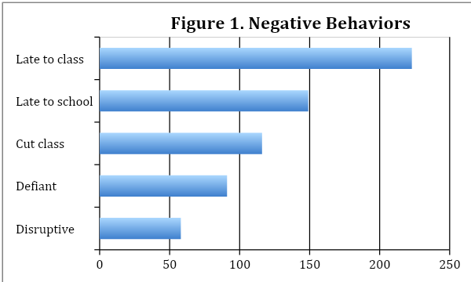
Figure 1 shows the top five negative behaviors documented on office referrals during marking periods 1 and 2 of the 2019 school year. Minor infractions occur at a higher frequency and decrease precipitously with severity.
Figure 2
Consequences of Negative Behaviors
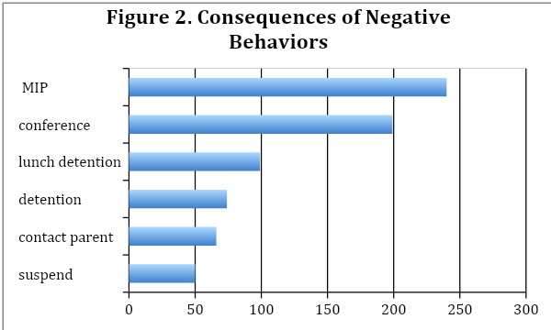
Figure 2 shows the top six consequences documented on office referrals during marking periods 1 and 2 of the 2019 school year. Severe consequences occur at a low incidence rate, while minor consequences occur at a higher incidence rate.

Figure 3
Referrals for Negative Behaviors

Figure 3 shows the frequency with which an individual refers students to the Student Support Room during marking periods 1 and 2 of the 2019 school year. Teachers refer more students to the Student Support Center than all other categories combined.
Figure 4
Events by Marking Period
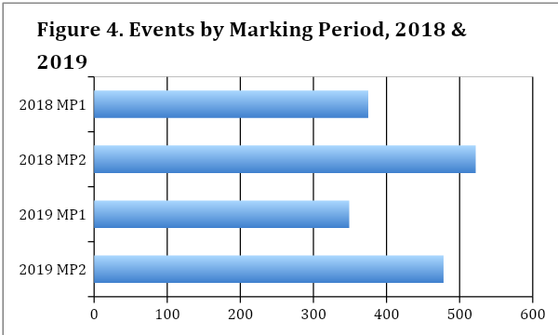
Figure 4 shows the total number of office referrals written by staff members during marking periods 1 and 2 of the 2018 and 2019 school year. There is a 38% average increase in office referrals between the marking periods 1 and 2.
The first hypothesis test is whether the uniform distribution fits the observed counts of behavior data. Null hypothesis: All categories of negative behaviors will occur with equal frequencies.
Table 1
Test of Hypothesis 1
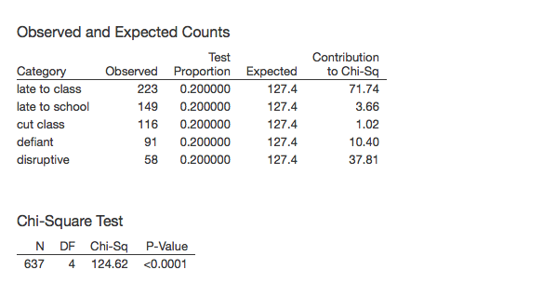

Figure 5
Test of Hypothesis 1
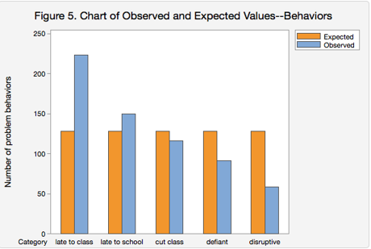
The null assumes that each occurrence of negative behavior will be 20% of the total. Since there are 637 total behaviors and five categories, the expected total for each behavior is 127.4. The Pearson Chi-square was used to measure the inconsistency between the observed and expected incidences. The p-value was determined to be less than the set alpha level of 0.05. For this reason, the uniform curve does not fit the data. The null is rejected. Late to class and disruptive behavior are the primary reasons for the incongruences.
The second test is whether the uniform distribution fits the data on consequences. Null hypothesis: All categories of consequences will occur with equal frequencies.

Table 2
Test of Hypothesis 2
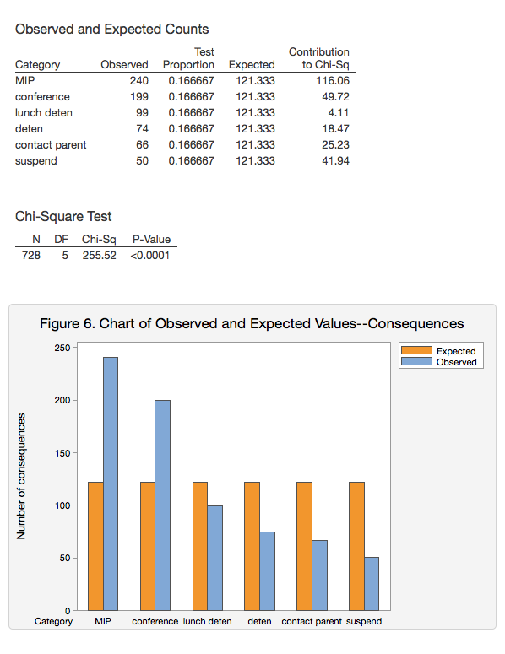
Figure 6
Test of Hypothesis 2

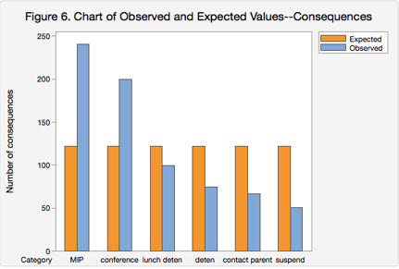
The null assumes that each occurrence of consequence will be 16.67% of the total. Since there are 728 total incidences and six categories, the expected total for each category is 121.33. The Pearson Chi-square was used to measure the inconsistency between the observed and expected incidences. The p-value was determined to be less than the set alpha level of 0.05. For this reason, the uniform curve does not fit the data. The null is rejected. MIP (in-school suspension) had the highest observed frequency, while suspension had the lowest.
The third test was conducted to determine whether the uniform distribution fits referrals to the Student Support Center. Null hypothesis: All categories of individuals responsible for referrals will occur with equal frequencies.
Table 3
Test of Hypothesis 3
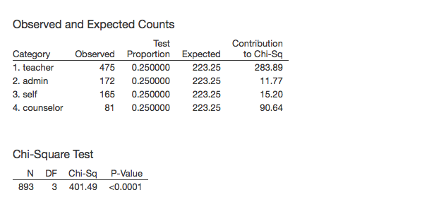
Figure 7
Test of Hypothesis 3
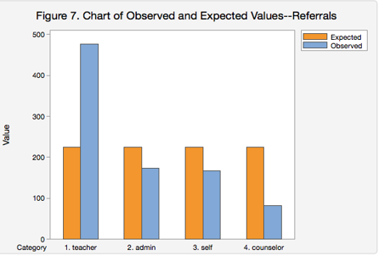
The null assumes that there will be equal distribution of occurrences among the four categories. Since there are 893 total referrals to the Student Support Center, the expected total for each category is 223.25. The Pearson Chi-square was used to measure the inconsistency between the observed and expected incidences. The p-value was determined to be less than the set alpha level of 0.05. For this reason, the uniform curve does not fit the data. The null is rejected. A comparatively high number of teacher referrals and a low number of counselor referrals are the primary reason the uniform distribution failed to fit.
The uniform theoretical distribution failed to fit the observed data trends for problem behaviors, types of consequences, and sources of referrals. Rather, the trends of data within the graphs display disproportionateness with a dominant category of frequency. Furthermore, there is successive decreasing in the frequency of occurrence for the succeeding categories. This indicates that an exponential (multiplicative) population distribution may be a better fit.
The fourth test is the exponential distribution fit test for the data on behavior. Null hypothesis: All categories of negative behaviors will decline at an exponential frequency.
Figure 8
Test of Hypothesis 4
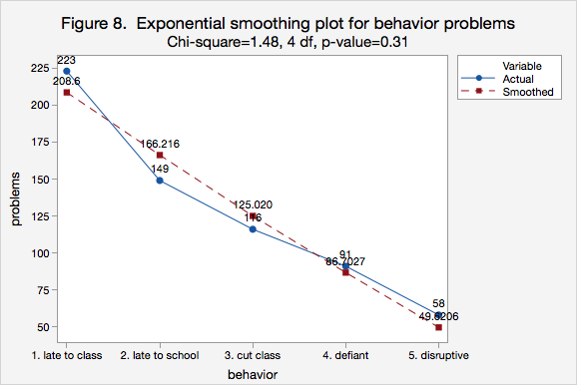
The null assumes a rate of decline at Y=300*0.73^{X}. This fits the observed frequencies since the p-value is higher than the threshold of 0.05. Therefore, the exponential theoretical curve fits to explain the distribution of negative behaviors.
The fifth test is the exponential distribution fit test for the data on types of consequences. Null hypothesis: All categories of consequences will decline at an exponential frequency.
Figure 9
Test of Hypothesis 5
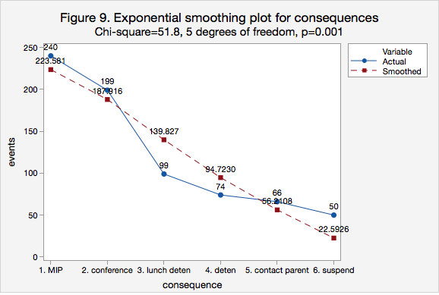
The null assumes a rate of decline at Y=322*0.72^{X}. This is rejected as not fitting the data since the p-value is lower than the threshold of 0.05. Therefore, this exponential theoretical curve does not fit as the distribution of consequences for negative behaviors. This is due, in part, to higher number of suspensions when compared to the expected number of the null. Additionally, the number of lunch detentions is less and differs from what is expected under the null in the exponential model. The exponential curve, however, fits the data better than the uniform.
The sixth test is the exponential distribution fit test for the data on referrals to the Student Support Center. Null hypothesis: All categories of referrals will decrease at an exponential rate.
Figure 10
Test of Hypothesis 6
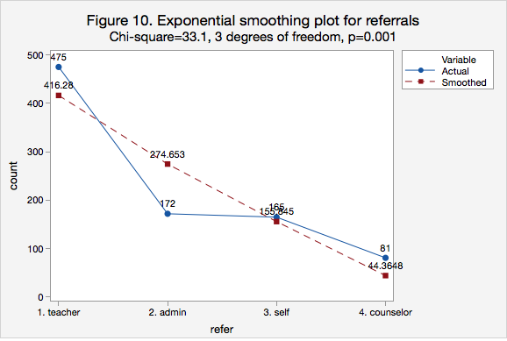
The null assumes a rate of decline at Y=692x0.586^{X}. This is rejected as not fitting the data since the P-value is lower than the threshold of 0.05. Therefore, this exponential theoretical curve does not fit the distribution of sources of referrals to the Student Support Room. This is largely because teachers have a very high number of referrals when compared to the expected numbers under the exponential model, while administration has a very low combative number of occurrences.
The exponential theoretical family of distributions fit the trends in data better than the uniform model. The exponential curve was found to fit the observed data for negative behavior. The exponential curve failed to fit the observed data well enough to be accepted for consequences and referrals, though it was a much-improved fit over the uniform model.
The seventh test is a uniform distribution fit test for the number of referrals over the course of two years. These years represent before and after school-wide introduction of Restorative Practices. Null hypothesis: there will be an even distribution of incidences across the two years that data was collected. Below is a breakdown of the observed and expected values under the uniform distribution fit test.
Table 4
Marking Period 1 Referrals
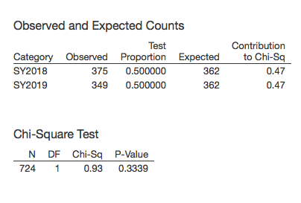
Figure 11
Test of Hypothesis 7
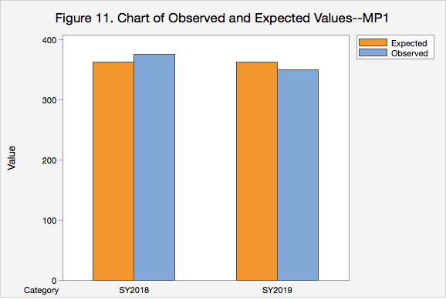
Table 5
Marking Period 2 Referrals
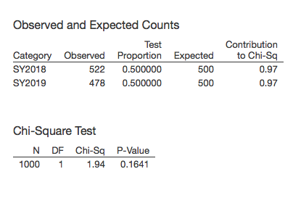
Figure 12
Test of Hypothesis 8
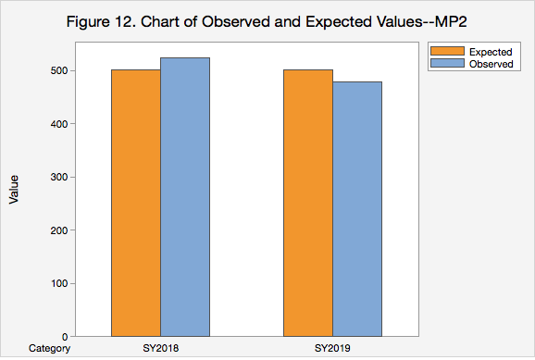
The uniform theoretical population cannot be rejected as fitting the data because the actual number of events during marking periods 1 and 2 did not differ significantly from the expected counts. According the Chi-square test, there was not a significant statistical change from school year 2018 to school year 2019 during marking periods 1 or 2.

CHAPTER V
DISCUSSION
The purpose of this study was to determine whether the use of Restorative Practices lowers the amount of office disciplinary referrals. The null hypothesis for this study is that there will not be a significant change in the number of disciplinary referrals after the implementation of Restorative Practices. Staff members participated in various school-wide professional development on methods to utilize Restorative Practices in the classroom. This includes community circles and the use of affective language to mitigate conflict. Students also have access to a Support Room where they can work with behavior technicians. These changes were newly implemented during the 2019-20 school year. Discipline data from the 2018 school year was compared to analyze the effect of these changes.
This study used a Chi-Square test to determine whether there is a significant statistical difference in the discipline data between school years. The results of this study support the null hypothesis that there will be no significant change in the number of disciplinary referrals received by students after the implementation of Restorative Practices. Although the number of behavior related instances decreased in the first half of the 2019 school year compared to the prior school year, the differences were not statistically significant according to the Chi-Square test.
Implications of the Results
The results of this study show that the number of disciplinary referrals decreased between the 2018 and 2019 school years. Marking periods 1 and 2 were examined and compared. The length of time and the population size were considered for control variables. In the 2018 school year, marking periods 1 and 2 had a combined number of 897 disciplinary referrals. In the 2019 school year, marking periods 1 and 2 had a combined number of 827 disciplinary referrals. The difference of 70 was found not to be statistically significant in accordance with the Chi-Square test.
Data also shows that there was a 39% increase in the amount of office referrals written between marking periods 1 and 2 for the 2018 school year. In the 2019 school year, this increase went down to 37%. This suggests that Restorative Practices may have an impact on student behavior and discipline. The data also shows that staff and students are utilizing the Student Support Center a means to prevent the need for disciplinary action. A total of 180 different students accessed the Student Support Center for a combined total of 893 times during marking periods 1 and 2 of the 2019 school year. Teachers are by far the predominant referrer of students to the Student Support Center, with counselors being the least likely to refer students. Finding a balance while getting all members of the school community involved in the Restorative circle is critical to the success of the program.
Lastly, the data shows that only 16% of office referrals were a result of negative behavior, such as defiance and disruption, in the classroom. The vast majority of referrals were the result of students cutting class or showing up late to school or class. This suggests that students are more likely to get in trouble for reasons other than negative behaviors in the classroom. Restorative Practices promotes community connection within the classroom as an effort to increase a more positive school climate. Disciplinary referrals are largely written for reasons not directly addressed by the school-wide Restorative Practice initiative. The findings support the idea that different types of negative behaviors do not occur with equal frequency. Less serious infractions occur more often than the disruptive, defiant behaviors that Restorative Practices are meant to address. While this is true, suspensions still occur at higher rate compared to other consequences under the exponential model.
Theoretical Consequences
Though the statistical difference in the number of office referrals was not significant enough to reject the null hypothesis, the data trends support the theory that students benefit from a connection with their classmates and teachers. Community circles and the use of affective language can curb disciplinary-related issues. Students may be less likely to act out in the future if they learn how their actions impact others. Students also benefit from having a support room to help them navigate through issues that could otherwise result in disciplinary action.
Threats to Validity
There are a number of factors that may have influenced the validity of this study. First, not all teachers received equal amount of training on the topic of Restorative Practices. Some teachers received far more, and others received far less. Additionally, using Restorative Practices in the classroom was not a requirement, only an expectation. Teachers were not instructed to incorporate community circles into their lesson plans; instead, it was merely a suggestion.
Additionally, the state-mandated closure of schools resulted in insufficient data for marking periods three and four. Without this data, it is difficult to draw conclusions on the impact of Restorative Practices on discipline as the initiative was still in its infancy before the closure. Training of teachers was ongoing, while more were gaining confidence in using these methods in the classroom.
The last threat to the validity of this study is students not being aware of the Student Support Center. Although the room had been accessed 893 times, there were only 180 individual students who used the room, roughly only 17% of the entire school population. The Student Support Center is meant partly to prevent the escalation in behaviors that could typically result in an office referral. Perhaps if more students were made aware of the services it offers, there would be fewer instances resulting in an office referral.
Connections to Previous Literature
Restorative practices work to keep absentee kids in the classroom by constructing a relationship among classmates and their teacher. Once the relationships and connections are built, the student may feel more inclined to come to class. As mentioned earlier, studies have shown that students who receive a higher instance rate of suspension have a negative perception of their teachers, their classmates, and school as a whole. Restorative practices work to build a positive school climate. Perhaps it is time that we rethink the way that we discipline students. Punishing a student by keeping them out of school may do more harm than good.
As noted earlier, Restorative Practices are not a “one-size-fits-all” approach. Discretion has to be used to cater to the individual needs of the student. This study has shown that there is a wide range of behaviors exhibited by students. Students are mostly getting in trouble for not coming to school or cutting class. Comparatively, few students are getting referrals for defiant and disruptive behavior, yet a disproportionate amount of students are getting suspended. Students are mostly getting in trouble for skipping school while receiving consequences that result in them missing more school. If Restorative Practices are not a uniform approach to addressing negative behavior, perhaps it is time to revamp the referral process in an effort that gives more discretion to individual cases.
Implications for Future Research
In future research, being able to include additional marking periods is vital for determining the impact of Restorative Practices. Restorative Practices were a new concept at the beginning of the school year. Throughout the school year, staff and students were getting more comfortable with the process. It would have been beneficial to see the data trends in the second half of the school year.
Additionally, a comparison of other schools in county would be useful to determine whether the behavior and consequences align from years past. This school could be a control group as the experimental group will be the one implementing Restorative Practices. Since the predominant chronic infractions resulting in office referral involved being tardy or truant, perhaps we need a separate system for these types of seemingly, trivial behaviors. Each case may be different, and, in this way, we can allow for the punishment to fit the crime.
Lastly, it is clear from this study that schools need a better system for dealing with discipline. If there was a way to link the type of behavior to the type of consequence that students received, then schools could do a better job determining the impact of Restorative Practices. If restorative practices are going to be paramount for addressing misbehavior in the classroom, they should be involved more in the office referral process.
Conclusion
With the mandated school closure, vital information from succeeding marking periods is missing. A conclusion as to the extent of the effect Restorative Practices has had on the disciplinary system is impossible to determine. However, this study did uncover surprising data trends.
While this study assumed the majority of office referrals were the result of negative behavior exhibited by the student in the classroom, it was learned that the vast majority of office referrals are a result of tardiness and truancy. Perhaps school-wide initiatives to address this issue would result in a decline in office referrals with statistical significance.
First marking period has significantly fewer office referrals. Perhaps lessons innately contain more Restorative Practice methods. After all, the beginning of the school year is when “get to know you” activities take place in attempts to build connection. Teachers often abandon this as content becomes paramount, however. Perhaps a healthy balance of both, through the use of regular community circles and other Restorative Practices, could stymy the surge in office referrals from first to second marking period.

References

Acosta, J., Chinman, M., Ebener, P. et al. Evaluation of a Whole-School Change Intervention: Findings from a Two-Year Cluster-Randomized Trial of the Restorative Practices Intervention. J Youth Adolescence 48, 876–890 (2019). https://doi.org/10.1007/s10964-019-01013-2
Busler, L. J. (2016). Positive behavior intervention support (PBIS): A statewide study of outcomes of schools implementing PBIS in washington state (Order No. 10006522). Available from Education Database. (1762588738). Retrieved from https://goucher.idm.oclc.org/login?url=https://search-proquest-com.goucher.idm.oclc.org/docview/1762588738?accountid=11164
Cole, K. Y. (2013). Implementing restorative practices: A case study of how one urban high school approached alternatives to punitive discipline practices (Order No. 3587926). Available from Education Database. (1427375566). Retrieved from https://goucher.idm.oclc.org/login?url=https://search-proquest-com.goucher.idm.oclc.org/docview/1427375566?accountid=11164
DeAntonio, Michael G. "A Comparative Study of Restorative Practices in Public Schools." Order No. 3734773 Alvernia University, 2015.
González, T. (2012). Keeping kids in schools: Restorative justice, punitive discipline, and the school to prison pipeline. Journal of Law and Education, 41(2), 281-335. Retrieved from https://goucher.idm.oclc.org/login?url=https://search-proquest-com.goucher.idm.oclc.org/docview/1008167526?accountid=11164
Gordon, K., & Fefer, S. (2019). Discipline history and demographics: Which factors relate to school climate perceptions among high school students? School Psychology Forum, Research in Practice, 13(1), 16-28. Retrieved from https://goucher.idm.oclc.org/login?url=https://search-proquest-com.goucher.idm.oclc.org/docview/2230713498?accountid=11164
Hein, V., Koka, A., & Hagger, M. S. (2015). Relationships between perceived teachers' controlling behaviour, psychological need thwarting, anger and bullying behaviour in high-school students. Journal of Adolescence, 42, 103. doi:http://dx.doi.org.goucher.idm.oclc.org/10.1016/j.adolescence.201
Klotz, M. B. (2014). Federal guidance on school discipline practices: Halting the school-to-prison pipeline. Bethesda: National Association of School Psychologists. Retrieved from https://goucher.idm.oclc.org/login?url=https://search-proquest-com.goucher.idm.oclc.org/docview/1539321919?accountid=11164
Mathews, Spencer Friel. "Does Restorative Justice Repair Damage? the Experience of Harmed Parties at Two American Public Universities." Order No. 3640284 University of South Dakota, 2014. Ann Arbor: ProQuest.
Muhammad, Malik Ed.D. (2019). The Restorative Journey. Book One: The Theory and Application of Restorative Practices. Akoben LLC.
Skiba, R. J., Arredondo, M. I., & Williams, N. T. (2014). More than a metaphor: The contribution of exclusionary discipline to a school-to-prison pipeline. Equity & Excellence in education, 47(4), 546–564. https://doi-org.goucher.idm.oclc.org/10.1080/10665684.2014.958965
Sparks, S. D. (2013). Report tallies up inequities in school discipline policies: "Meaningful measures: School discipline that improves outcomes." Education Week, 33(11), 5. Retrieved from https://goucher.idm.oclc.org/login?url=https://search-proquest-com.goucher.idm.oclc.org/docview/1459189771?accountid=11164
U.S. departments of education and justice release school discipline guidance package to enhance school climate and improve school discipline Policies/Practices. (2014). (). Washington: Federal Information & News Dispatch, Inc. Retrieved from Education Database Retrieved from https://goucher.idm.oclc.org/login?url=https://search-proquest-com.goucher.idm.oclc.org/docview/1475206344?accountid=11164

