
Geophysical Research Letters
Supporting Information for
A generalized aerosol algorithm for multi-spectral satellite measurement with physics-informed deep learning method

Jianfang Jiang¹, Minghui Tao^{1*}，Xiaoguang Xu², Zhe Jiang³, Wenjing Man¹, Jun Wang², Lunche Wang¹, Yi Wang¹, Yalin Zheng¹, Jinhua Tao⁵, Liangfu Chen⁵

¹Key Laboratory of Regional Ecology and Environmental Change, School of Geography and Information Engineering, China University of Geosciences, Wuhan 430074, China
²Goddard Earth Sciences Technology and Research (GESTAR) II, and Earth and Space Institute, University of Maryland Baltimore County, Baltimore, Maryland 21250, USA
³Carbon Neutrality Research Center, Institute of Atmospheric Physics, Chinese Academy of Sciences, Beijing 100029, China
⁴Dept. of Chemical & Environmental Engineering, University of Iowa, Iowa City 52242-1503, USA
⁵State Key Laboratory of Remote Sensing Science, Aerospace Information Research Institute, Chinese Academy of Sciences, Beijing 100101, China

Contents of this file

Figures S1 to S7

Figure S1. Studying area and geographic location of AERONET sites.
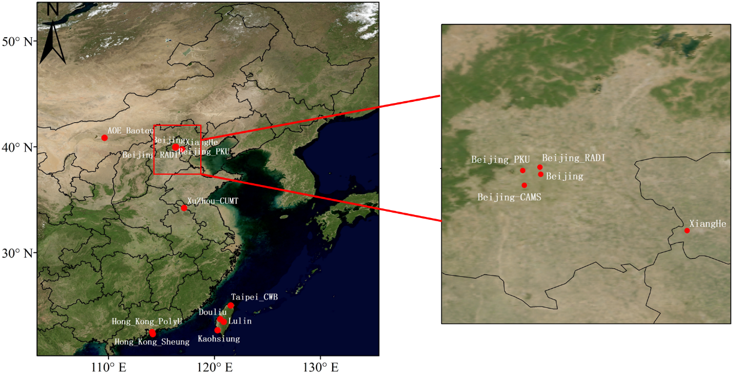

Figure S2. Statistical histograms of AOD, fine AOD, coarse AOD, effective radius (μm) and effective variance of fine and coarse mode aerosols, and median radius and standard deviation for volume of coarse particles used in RT calculations in Beijing site during 2015-2021. The optical/microphysical parameters are retrieved from sun photometers for fine and coarse particles separately.
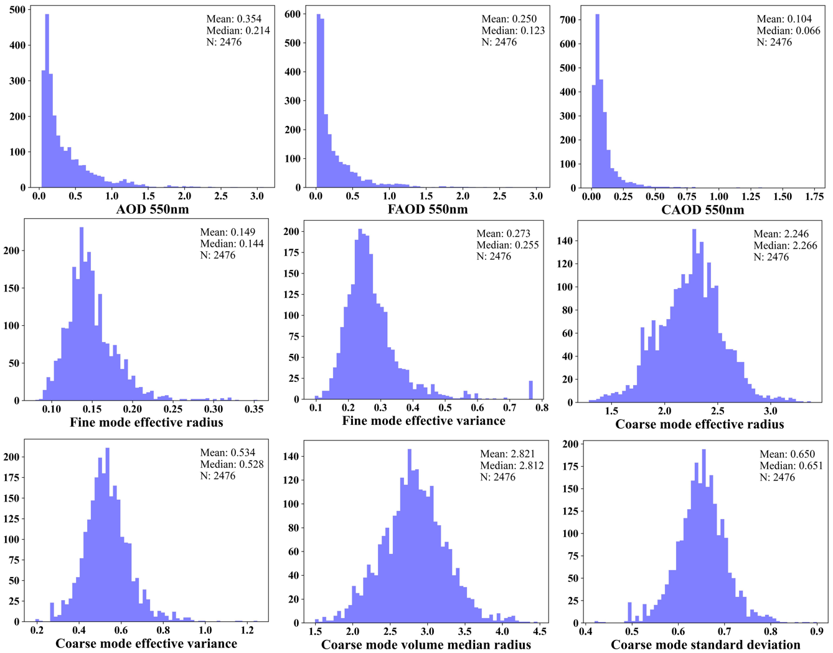

Figure S3. Statistical histograms of spectral SSA used in RT calculations in Beijing site during 2015-2021.
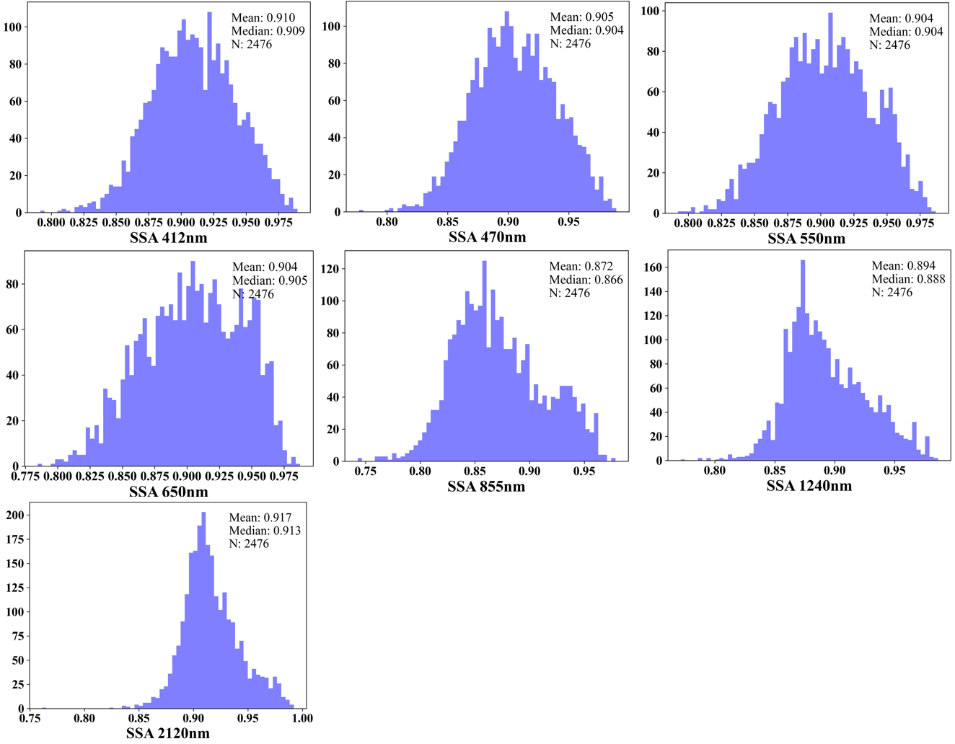

Figure S4. Statistical histograms of MODIS isotropic surface reflectance in eastern China during 2021.
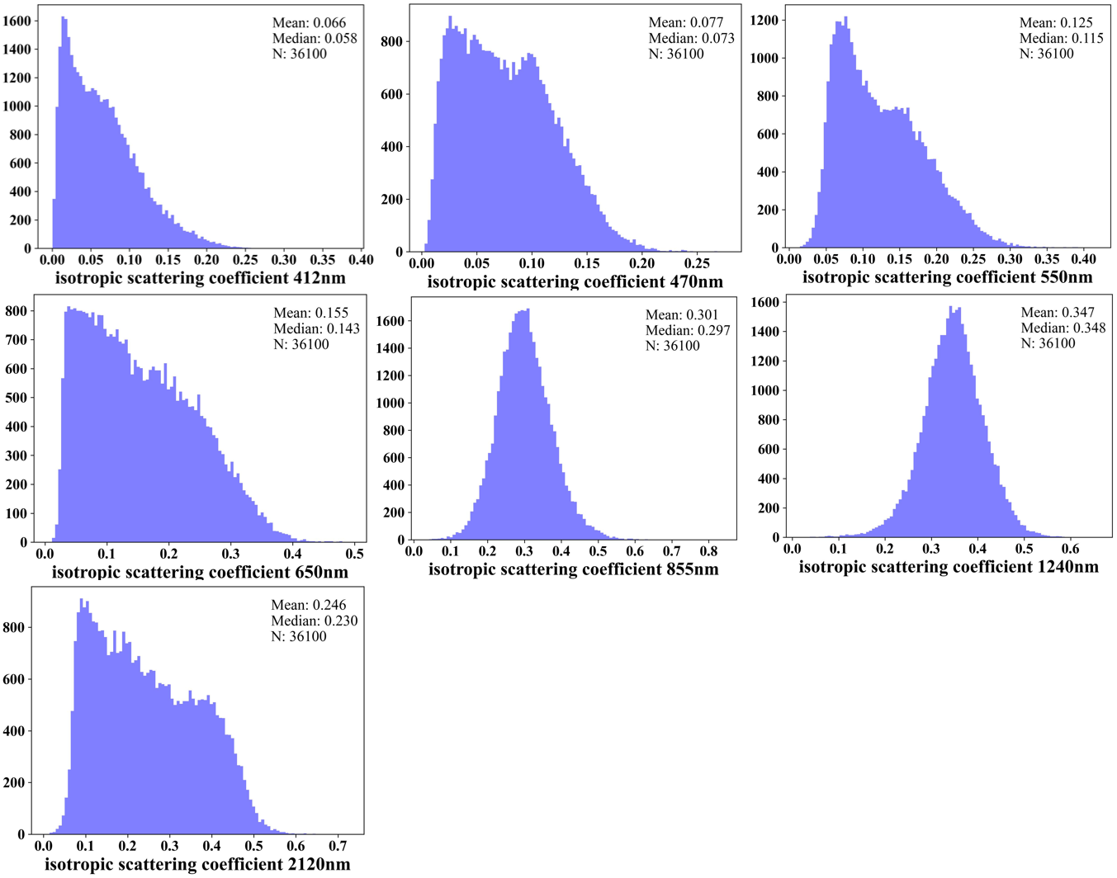

Figure S5. Comparison of RT simulations with collocated AERONET observations and MODIS BRDF as inputs with corresponding single-pixel MODIS TOA spectral reflectance over Beijing site. The red and dashed lines are fitting and 1:1 line. Correlation coefficient (R), Root Mean Square Error (RMSE), and number (N) of simulation-measurement matchups are also shown.
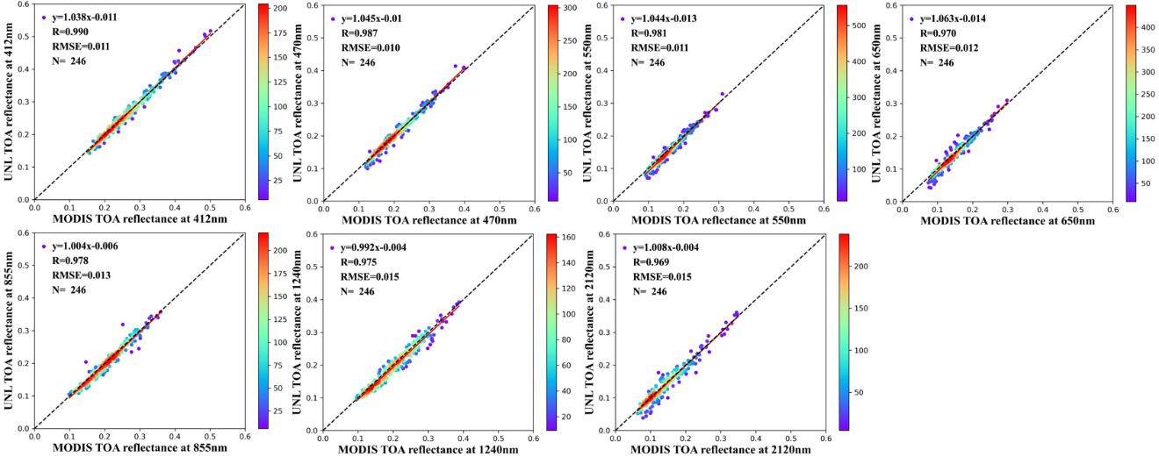

Figure S6. Statistical histograms of bias of UNL-VRTM calculated TOA spectral reflectance compared with MODIS measurements in Figure S5.
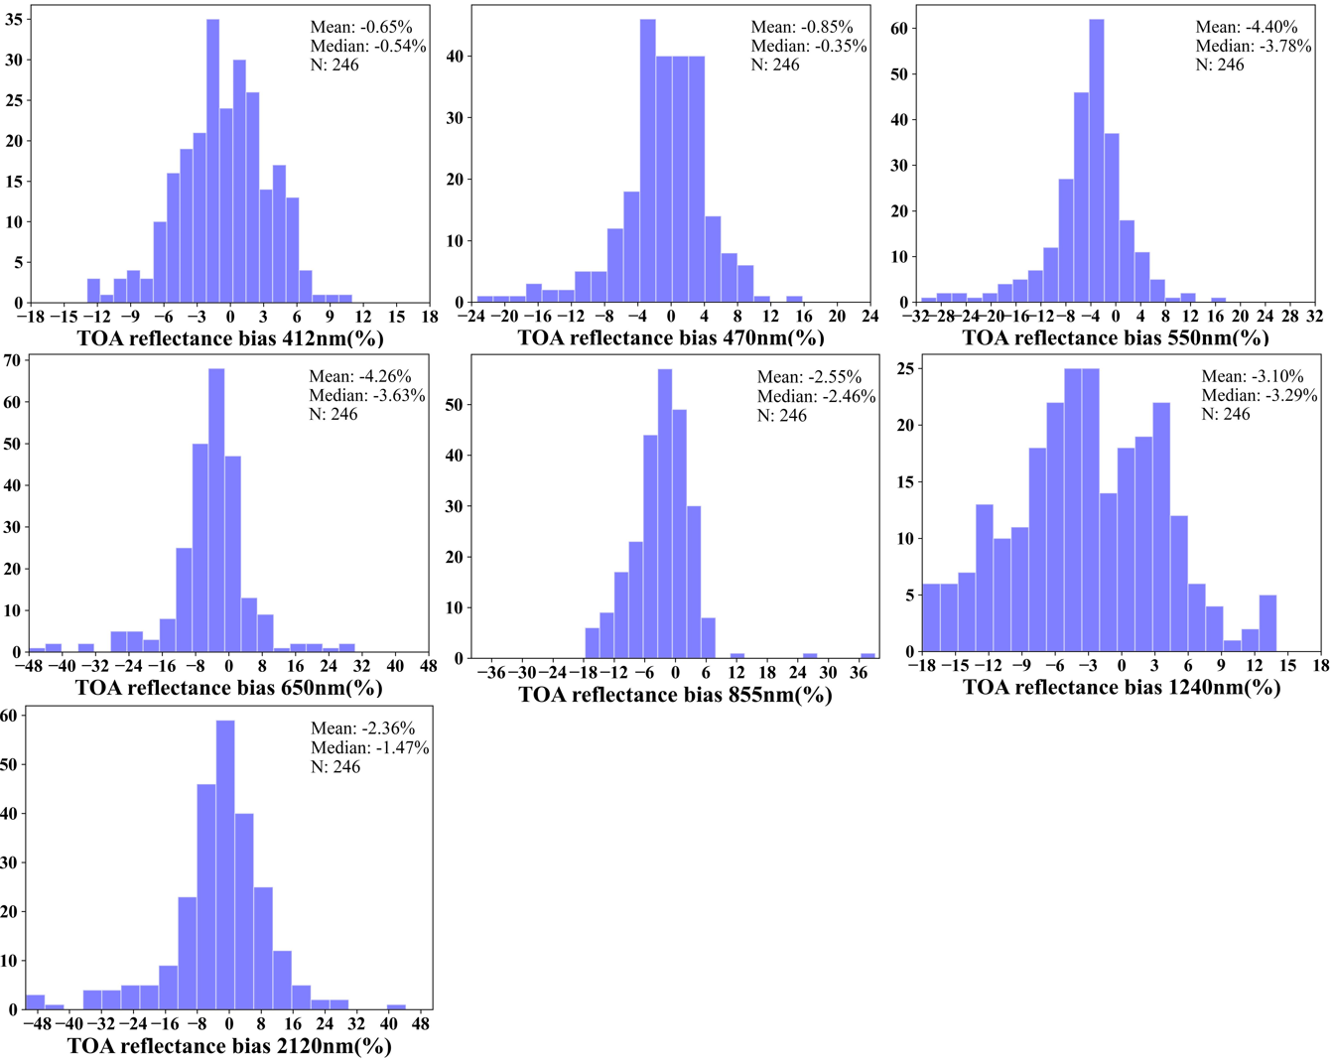

Figure S7. MODIS MAIAC and DB AOD, and PDL AOD, FAOD, and CAOD at 550 nm, and PDL SSA at 650 nm in eastern China on November 13, 2020.
