IDENTIFYING LOCATIONS IN THE GREATER WASHINGTON D.C. AREA MOST AT RISK FROM FUTURE DEVELOPMENT

by

Kelly Cunningham

Independent Project

Submitted in partial satisfaction of the requirements for the degree of

MASTER OF SCIENCE

in

ENVIRONMENTAL BIOLOGY

in the

GRADUATE SCHOOL

of

HOOD COLLEGE

MAY 2018

Accepted:

_________________________ _________________________
Eric C. Kindahl, Ph.D. Susan L. Carney, Ph. D.
Research Project Advisor Director, Environmental Biology Program

_________________________ _________________________
Eliza Cava, M.S. April Boulton, Ph.D.
Director of Conservation, Dean of the Graduate School
Audubon Naturalist Society

STATEMENT OF USE AND COPYRIGHT WAIVER

I authorize Hood College to lend this project, or reproductions
of it, in total or in part, at the request of other institutions or
individuals for the purpose of scholarly research.

TABLE OF CONTENTS
 | Page
ABSTRACT  ACKNOWLEDGMENTS  LIST OF TABLES  LIST OF FIGURES  INTRODUCTION  BACKGROUND  MATERIALS AND METHODS  RESULTS  - Brandywine  - Clarksburg  - White Oak  DISCUSSION  - Brandywine  - Clarksburg  - White Oak  REFERENCES  APPENDIX A: GIS Maps | iv  v  vi  vii  1  2  7  11  11  12  14  16  16  19  21  25  28

ABSTRACT
The purpose of this project was to identify locations in the greater Washington, D.C. area most at risk from future development. In order to determine these areas, research was conducted using master plans, databases, primary literature, mainstream publications and local government resources. A set of parameters was established which included projected population, housing and employment growth, as well as existing stream quality. Locations were also considered based on proposed development activity and local bodies of water that might be impacted by development. Nine locations were identified as “at-risk”. Brandywine, Clarksburg, and White Oak, MD are of primary focus in this report. These locations were selected as they are projected to sustain significant increases in population and development in the foreseeable future.

ACKNOWLEDGMENTS
I would like to acknowledge the following individuals who helped make this independent project possible: Eliza Cava, Director of Conservation at Audubon Naturalist Society for serving as my external advisor, Dr. Eric Kindahl, professor of biology at Hood College, for serving as my internal advisor, Dan Somers, Program Planning Specialist with the Watershed Management Division of Montgomery County Department of Environmental Protection for assisting me in obtaining relevant information from DEP, and Kevin Stanfield, Graduate Research Assistant at Hood College, for assisting me in developing the GIS component of this project.

LIST OF TABLES
Table |  | Page
1  2  3  4  5  6  7  8  9 | Materials used to formulate this report.  Parameters of interest in this study.  Sample calculations of total score for Clarksburg and Olney, MD.  Location scores.  Quantifiable parameters of nine locations of interest.  Value ratings.  Existing, vacant, and anticipated changes in jobs and housing.  Existing and approved changes in jobs and housing, White Oak, MD.  Proposed development, Villages of Timothy Branch and Stephen’s Crossing, Brandywine, MD. | 7  9  10  10  13  15  14  15  17

LIST OF FIGURES
Figure |  | Page
1  2  3  4  5  6  7 | Impacts of impervious surfaces on stormwater runoff.  Aerial view, Stephen’s Crossing.  Aerial view, Villages of Timothy Branch.  Aerial view of COMSAT facility.  Existing condition of proposed in Viva White Oak area.  FDA proposed development areas.  FDA development strategies.  Map A: Population Change 2000-2010  Map B: Projected Population Change From 2010  Map C: Projected Change in Housing Units From 2010  Map D: Projected Change in Employment From 2010 | 4  18  18  20  22  22  23  28  29  30  31

INTRODUCTION

The health of the Chesapeake Bay remains at risk due to intensified stormwater runoff in the Chesapeake Bay watershed. Runoff occurs when natural vegetation is replaced with surfaces that are incapable of absorbing rainwater. Failure to absorb rainwater results in the flow of water atop these surfaces that often carries pollution into local waterways. These surfaces, identified as impervious surfaces or cover, increase with residential and commercial development as well as the development of infrastructure. As the human population of the watershed continues to increase it has become imperative to implement development that reduces or mitigates the effects of stormwater runoff.
The Audubon Naturalist Society (ANS) located in Chevy Chase, Maryland is guided by a mission to “inspire residents of the greater Washington, DC region to appreciate, understand, and protect their natural environment through outdoor experiences, education, and advocacy.” In keeping with this mission, ANS has expressed interest in identifying areas in the greater Washington, D.C. region where high quality habitat is most at risk from potential future development in the next ten years and on which ANS should consider focusing advocacy efforts. These advocacy efforts will aid in reducing and mitigating the effects of stormwater runoff associated with future development.

BACKGROUND
The Chesapeake Bay serves as a key economic resource for those living within the 64,000-square mile watershed. The National Oceanic and Atmospheric Administration estimated that the commercial seafood industry in Maryland and Virginia contributed $3.39 billion in sales, $890 million in income, and almost 34,000 jobs to the local economy.¹ Tourism and recreational use also provide a major source of income for the six states encompassing the watershed. For instance, the 2009 report, Economic Impact of Maryland Boating, estimated that nearly $2.3 billion is generated each year in Maryland due to the recreational boating industry.² As an added benefit, the surrounding wetlands provide ecosystem services such as flood control, water purification, food supply and aesthetic and recreational value. The monetary value of these ecosystem services provided by the watershed was estimated at $107.2 billion in 2016. In addition to the Bay’s human related benefits, it also provides essential habitat for approximately 3,600 different species such as migratory birds, shellfish, fish, and plants.³
The Chesapeake Bay suffers from poor water quality primarily due to excessive sediment and nutrient pollution, specifically from phosphorus and nitrogen. When present in excess, phosphorus and nitrogen can cause eutrophication within the Bay that creates dead zones, habitat that is no longer suitable for plants and animals due to lack of dissolved oxygen. Major sources of these excess nutrients include animal manure and fertilizer from agricultural lands, failing sewer and septic systems, by-products of burning fossil fuels, stormwater runoff and residential contributions such as fertilizers and pet wastes.⁴ According to the Chesapeake Bay Program, stormwater runoff is the fastest growing source of pollution in the Bay and continues to be of paramount concern to water quality.⁵
Stormwater runoff has increased as a result of intensified development within the watershed. With development comes an increase in impervious surfaces. As demonstrated through Figure 1, an increase in impervious surface translates to an increase in surface runoff and decrease in infiltration.⁶ Examples of common impervious surfaces include roads, driveways, rooftops, parking lots, patios and sidewalks. Urbanization remains the primary contributor to increased stormwater runoff that would otherwise be retained by vegetation.⁷ In addition to impacts on water quality, excessive stormwater runoff can influence local hydrology, physical landscape, and biological diversity. A comprehensive literature review compiled by the Center for Watershed Protection highlighted the negative impacts sustained by each of these factors. According to the report, as impervious cover increases, surface runoff occurs more quickly, thus increasing peak flow.⁸
A hallmark of excessive runoff is the appearance of highly eroded banks, particularly among streams and narrow rivers. This erosion alters channels, generally making them wider over time due to the loss of soil and vegetation. This activity also carries with it large amounts of sediment (among other contaminants) which acts as a pollutant in the Chesapeake Bay when suspended in the water column. Evidence also suggests a correlation between increased impervious surface and increases in water temperature.⁸

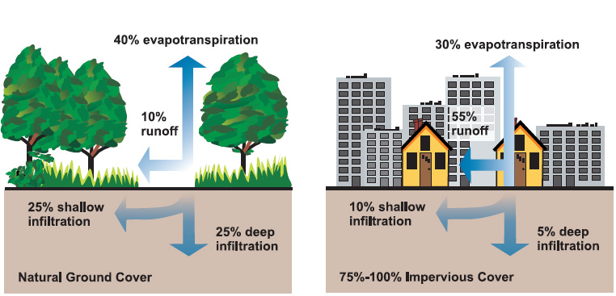
Figure 1. Impacts of impervious surfaces on stormwater runoff.
Source: U.S. Environmental Protection Agency, “Protecting Water Quality from Urban Runoff”. Document No. EPA 841-F-03-003.

These changes in hydrology, the physical landscape, and water quality ultimately impact biological diversity. Analogous to a domino effect, these factors contribute to a decrease in available, high quality habitat. As a result, we can see a decline in species sensitive to change. Alteration, particularly to the base of the food chain, subsequently impacts the remaining food web. In 1979, Richard Klein proposed that stream water quality became impaired when impervious cover reached 12% and that it became severely impaired at 30% coverage.⁹ Thirty-eight years later, significant evidence supports Klein’s initial concerns that increased impervious cover compromises habitat, thus affecting species abundance and richness. ⁸
The increase in impervious cover is directly related to population growth. The human population of the Chesapeake Bay watershed has grown significantly over the last 60 years. The Chesapeake Bay Program determined that the population increased from 8.4 million in 1950 to 18.1 million in 2016, a 115% increase.⁵ The increase in population has warranted the need for development and infrastructure that can support the population which in turn increases impervious surface cover. A study conducted by Xian and colleagues estimated changes in impervious surface coverage using Landsat imagery for the contiguous US states between 2001 and 2006. The results indicated that Maryland had increased its impervious surface coverage from 110 km² in 2001 to 151 km² in 2006 or, approximately 37% in only five years.¹⁰
Although development is inevitable it is possible to reduce or mitigate the quantity of stormwater runoff associated with increased impervious surface thus preserving local water quality. Practices can be implemented among small scale projects, such as those of an individual homeowner as well as large scale projects such as the construction of a new housing development or public transitway. Examples of small scale practices that could be applied to small and large-scale projects include installing permeable pavers, green roofs, rain barrels and conservation-minded landscapes such as raingardens and native plant gardens. Larger scale projects can consider the construction of stormwater ponds and regenerative wetlands as well as increasing plantings of canopy cover.
ANS has played a role in helping to advocate for the integration of these practices into development plans. For instance, ANS was integral in helping to shape the stormwater management plans for the Tyson’s Corner Redevelopment Project in Fairfax, Virginia. The plan, Urban Stormwater Concepts of Tyson’s Corner, addressed methods for on-site stormwater infiltration, use of green roofs, and reuse of rainwater. Another project in which ANS is advocating for proper practices is the EMBARK Richmond Highway Plan in northern Virginia. This proposed multimodal transitway plan aims to develop a stormwater management plan modeled after that of the Tyson’s Corner Redevelopment Project.
The purpose of this study is to investigate locations proximate to ANS, and in the greater Washington D.C. area, that anticipate significant growth in population. It is expected that this growth in population will warrant the need for improvement to, or construction of, infrastructure that could potentially lead to increased impervious surface coverage. As a result, it is expected that these areas will necessitate the implementation or enhancement of stormwater management practices that will reduce negative impacts to the environment.

MATERIALS AND METHODS
Materials for this project included databases, primary literature, mainstream publications, local government resources and ArcGIS³¹. Table 1 outlines pertinent resources and materials used in compiling this report.
Table 1. Materials used to formulate this report.
Source | Source Classification | Purpose
U.S. Census Bureau | Federal Government | To obtain numerical data on past and current population numbers, housing units and employment numbers
Montgomery County Department of Environmental Protection | County Government | Stream Conditions and  GIS Assistance
Master Plans | Local Government | To determine population, housing units, and employment number projections.
The Maryland-National Capital Park and Planning Commission | State Government | Master Plans
Google Earth | Online Program | Determine coordinates of places of interest.
ArcGIS | Geographic Information Systems | To create GIS maps to accompany this report.
Local news publications | Media | To obtain information on upcoming development plans.
Audubon Naturalist Society | Non-Profit | Guidance

The methodology incorporated modeled that of a previous study by Thekdi and Lambert that assessed and prioritized land areas at risk for development. To determine areas at highest risk Thekdi and Lambert took into account 25 variables. Each variable was analyzed with the most influential factors on land development found to be population, population forecast, employment centers, land values, and undervalued land. The model was then applied to the Virginia Statewide Mobility System Roadways to determine areas at low, medium, and high risk for development. In addition, locations were prioritized based on how quickly development would occur (e.g. within 0-5 years, 5-10 years or 10+ years).¹¹ For this study the quantifiable parameters examined are explained in Table 2. Available information was a limiting factor in this study and therefore not all of the parameters listed above were considered.
These parameters were assembled into a comprehensive rubric that identified past, present, and projected data on population, housing units, and employment (Table 5 in Results). In addition, stream water quality and distance from ANS were obtained. Nine locations were identified as eligible candidates for further investigation. After identifying these locations, master plans and news outlets were researched to determine potential plans for development. Information gained from this research was shared with ANS who ranked interest in each location on a scale of high, medium, and low. All parameters received individual value ratings on a scale of 0-3 (See Table 6 in Results).
Value ratings were then added to determine the sum of all parameter value ratings. The final sum was classified as the overall “score” for the location (Table 3). Locations were assembled in descending order according to overall score (Table 4).

Parameter of Interest | Method of Determination
Percent Change in Population from  2000-2010 | Obtained from 2010 U.S. Census Bureau
Percent Change in Population from  2000-2010 Ranking | Obtained from the 2010 U.S. Census Bureau.
Projected Population Number | Obtained by examining the most up to date master plans.
Percent Change in Population from  2010-2020+ | Calculated using percent change equation with numerical data from the 2010 U.S. Census Bureau and applicable master plans.
Percent Change in Housing Units from 2010-2020+ | Calculated using percent change equation with numerical data from the 2010 U.S. Census Bureau and applicable town master plans.
Percent Change in Employment from 2010-2020+ | Calculated using percent change equation with numerical data from the 2010 U.S. Census Bureau and applicable master plans.
Stream Quality Assessment | Obtained from local government organizations.
Table 2. Parameters of interest in this study.
Locations with the three highest scores, including Clarksburg, Brandywine, and White Oak, MD (Table 4), were selected as focal locations. These locations exhibited a combination of parameters indicative of locations most at risk from future development such as high rates of population growth, development, and employment. To complement the findings of this study GIS maps (Appendix A) were created to visually represent Population Change 2000-2010 (Map A), Projected Population Change From 2010 (Map B), Projected Change in Housing Units From 2010 (Map C), and Projected Change in Employment From 2010 (Map D).
 | Projected Population % Change from 2010 | Projected Housing Units % Change from 2010 | Projected Employment % Change from 2010 | Stream Quality Rating | ANS Interest | Total  Score
Clarksburg Values | 3 | 3 | 3 | 2 | 3 | 14
Olney Values | 1 | 2 | 0 | 2 | 1 | 6

Table 3. Sample calculations of total score for Clarksburg and Olney, MD.

Table 4. Location Scores.
Score  Table 4. Location scores. | Town/City | County
14 | Clarksburg | Montgomery
14 | White Oak | Montgomery
12 | Brandywine | Prince George's
11 | Gaithersburg | Montgomery
10 | Accokeek | Prince George's
9 | Waldorf | Charles
7 | Germantown | Montgomery
6 | Cloverly | Montgomery
6 | Olney | Montgomery

RESULTS
Three locations, including Brandywine, Clarksburg and White Oak, MD were chosen as focal locations. As seen on the GIS map layers found in Appendix A, each location exhibited a combination of relevant parameters including high rates of population growth, housing development, and employment. Additional research suggested that these locations are either improving existing infrastructure or implementing new development currently, or in the near future.
- Brandywine, MD
Brandywine is located in the southern portion of Prince George’s County approximately 38 miles from ANS in Chevy Chase, MD. In 2000, the population of Brandywine was estimated at 1,420 individuals. In 2010, the population was estimated at 6,719, a 377% increase.¹² The Maryland-National Capital Park and Planning Commission’s (M-NCPPC) Subregion 5 Master Plan published in July 2013 estimates the town will reach a population of 16,119 by 2030, a 140% increase from 2010. In addition, dwelling units are projected to increase to 6,400 units, a 168% increase from 2010.¹³ Although it is anticipated that there will be a significant increase in housing it is expected that there will be little change to the already relatively small number of jobs in the area.
Mattawoman Creek watershed is identified by the Subregion 5 Master Plan as the watershed of greatest concern in Brandywine. M-NCPPC conducted a ten-year study assessing habitat quality and stream degradation in the watersheds and subwatersheds of Prince George's County. In that time M-NCPPC concluded that Mattawoman Creek’s stream quality had decreased by 19.4%. Likewise, Benthic-Index of Biotic Integrity (B- IBI) and Visual-Based Physical Habitat Quality were assessed. B-IBI measured type and frequency of benthic insects within Mattawoman Creek rated the quality as “Fair”. The stream’s ability to sustain healthy flora and fauna was classified as “Supporting”.¹⁴ Although ratings of “Fair” and “Supporting” were not explicitly defined in the report the Montgomery County Department of Environmental Protection uses a similar scale in which “Fair” indicates streams exposed to significant stress due to anthropogenic factors such as development and agriculture. Organisms found here are generally tolerant of difficult conditions however there are those that are sensitive to pollution. “Supporting” indicates a stream in which stressors have impacted the area, however the area itself is still capable of supporting a viable community.¹⁶
- Clarksburg, MD

Clarksburg is located in the northwestern portion of Montgomery County approximately 22 miles from ANS. In 2000, the population of Clarksburg was estimated at 1,834 individuals. In 2010, the population was estimated at 13,766, a 650% increase.¹² The Clarksburg master plan of 1994 estimates the town of Clarksburg could grow to 43,000, however, it should be noted that no anticipated date was associated with this estimate. The report also examined existing employment numbers and housing units. When combined with what was categorized as “Vacant Land Potential” planners estimated that anticipated development could result in a total of 32,360 jobs and 14,940 total housing units (Table 7). According to the most recent census data, employment was recorded at 12,879 and housing units at 4,352. This would mean a 151% and 243% increase, respectively, in the foreseeable future. ¹⁵

Town/City | County | Population % Change ranking since 2000 Census | Population % Change 2000-2010* | Population 2010 | Projected Population† | Projected Population % Change from 2010* | # of Housing Units 2010 | Projected Housing Units† | Projected Housing Units % Change from 2010* | Employment 2010 | Projected Employment† | Projected Employment % Change from 2010 | Stream Quality Rating | ANS Interest*** | Score
Clarksburg | Montgomery | 1 | 650.60% | 13,766 | 43,000 | 212.36% | 4,352 | 14,940 | 243.29% | 12,879 | 32,360 | 151.26% | Fair | High | 14
White Oak | Montgomery | 72 | -17.02% | 17,403 | 32,000 | 83.88% | 6,865 | 15,688 | 128.52% | 14,274 | 36,374 | 154.83% | Fair | High | 14
Brandywine | Prince George's | 2 | 376.52% | 6,719 | 16,119 | 139.90% | 2,386 | 6,400 | 168.23% | 7,095 | 7,518 | 5.96% | Fair | High | 12
Gaithersburg | Montgomery | 89 | 18.90% | 59,993 | 73,354 | 22.27% | 2,337 | 9,637 | 312.37% | 50,025 | 68,625 | 37.18% | Fair | High | 11
Accokeek | Prince George's | 32 | 43.90% | 10,573 | 17,508 | 65.59% | 3,816 | 6,300 | 65.09% | 2,294 | 3,136 | 36.70% | Fair | Medium | 10
Waldorf | Charles | 3 | 203.66% | 67,752 | 106,318 | 56.92% | 25,496 | 41,799 | 63.94% | 54,462 | 45,429 | -16.59% | Fair | Medium | 9
Germantown | Montgomery | 21 | 55.89% | 86,395 | 92,000 | 6.49% | 31,807 | 37,000 | 16.33% | 68,049 | 77,909 | 14.49% | Fair | Medium | 7
Cloverly | Montgomery | 9 | 93.00% | 15,126 | 18,200 | 20.32% | 4,996 | 6,620 | 32.51% | 12,468 | NA | NA | Good | Medium | 6
Olney | Montgomery | 119 | 7.70% | 33,844 | 37,100 | 9.62% | 11,879 | 16,000 | 34.69% | 28,002 | NA | NA | Fair | Low | 6
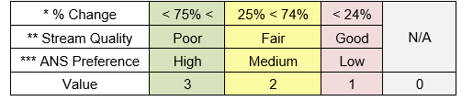
†year at which population, housing units, and employment
will reach the projected value varies from 2020-2045.

Focal location rows in bold.
Table 6. Value Ratings.
Table 5. Quantifiable parameters of nine locations of interest.

The 1994 plan identified three watersheds of concern including Ten Mile Creek (area of greatest concern), Little Seneca Creek, and Cabin Branch. According to the Montgomery County Department of Environmental Protection’s Stream Conditions Index, Clarksburg’s stream quality rates as “Fair”.
Table 7. Existing, vacant, and anticipated changes in
jobs and housing, Clarksburg, MD.
Source: Clarksburg Master Plan, 1994.

 | Existing and Approved | Vacant Land Potential | Anticipated Development
 | A | B | A&B
Total Jobs | 5,830 | 16,780 | 32,360
Total Housing Units | 800 | 14,600 | 14,940
J/H Ratio | 7.3 | 1.1 | 2.1

In 2014, the Ten Mile Creek Limited Amendment was added to the Clarksburg master plan of 1994. This amendment included a complete assessment of environmentally sensitive areas in addition to modeling that determined how to move forward with development while simultaneously protecting water quality. The amendment was the result of a multiyear effort headed by ANS that entailed extensive collaboration among local community and government organizations.
3. White Oak
White Oak is located in the southeast corner of Montgomery County, MD and is within closest proximity (7 miles) to ANS. Between 2000 and 2010 White Oak experienced a 17% decrease in population¹²; however, the White Oak Master Plan of 1997 envisioned a community of up to 32,000 persons, which would be an 84% increase. The 1997 plan also projected a scenario that would accommodate 7,598 dwelling units.¹⁷ It should be noted that projections in this plan did not identify a year is which these numbers would be reached. Although this would mean a small increase in housing (~10%) the White Oak Science Gateway Plan approved in 2014 projected a potential increase to 15,688 units, a 129% increase from 2010.¹⁸ Likewise, both the plan of 1997 and the White Oak Science Gateway plan anticipate a significant increase in jobs (Table 8).
The plan area incorporates portions of three watersheds of the Anacostia River – Northwest Branch, Paint Branch, and Little Paint Branch. In terms of water quality, the Montgomery County DEP rates stream quality in this area as “Fair”¹⁶; however, a small portion of the Galway Tributary of the Little Paint Branch watershed is considered “Poor”, exhibiting heavily altered biological communities. The plan area is estimated to be approximately 50 percent impervious surface coverage. ¹⁸
Table 8. Existing and approved changes in jobs and housing, White Oak, MD.
Source: White Oak Science Gateway Master Plan
 | Existing | Existing and Approved | 1997 Master Plan Scenario** | 2012 Master Plan Scenario*
Commercial (SF) | 11,187,298 | 12,000,000 | 15,854,064 | 25,434,851
Single-Family dus | 2,260 | 2,260 | 2,404 | 2,785
Multi-Family dus | 4,858 | 4,858 | 5,194 | 12,903
Total Dwelling Units | 7,118 | 7,118 | 7,598 | 15,688
Jobs | 27,688 | 31,168 | 40,063 | 70,312
Plan Area J/H ratio | 3.8/1 | 4.3/1 | 5.2/1 | 4.4/1
* Reflects densities from February 2012 Traffic modeling; does not reflect the maximum potential densities allowed by the plans full recommended zoning except for the Percontee/Site 2 properties, where maximum densities are assumed.
**Estimated build out of the 1997 Master plans, based on an adjusted 2040 COG forecast; assumes existing centers will not

DISCUSSION
After analysis of population, housing, and employment growth, further research was conducted to determine relevant plans for improvement and/or implementation of new development. This additional information was meant to provide ANS with an overview of the anticipated plans for development for each location. Furthermore, specific development projects were identified so that ANS might consider where to focus advocacy efforts that promote sustainable practices to help mitigate the impacts of stormwater runoff.
- Brandywine
The Subregion 5 plan approved in 2013 and the Brandywine Revitalization Study of 2011 both anticipate significant future development in Brandywine. The plan envisions a community of high density with a combination of commercial and mixed-use development. Plans are also in place to preserve historic portions of the area.¹³
The Subregion 5 plan proposes major improvements to transportation systems in order to accommodate anticipated growth. Although there are many roadway projects underway and proposed, one of significance is the MD 5 (Branch Ave.) at Brandywine Rd. and MD 373 (Accokeek Rd.) Improvement Project. This project aims to alleviate congestion plaguing the area by removing signalized intersections as well as constructing a new overpass, service roads, roundabout, and a park and ride facility. The project, which was started in 2016, is projected to complete in 2019. The most recent State Highway Administration update stated the $55.7 million project was 44% complete and on time for completion in the spring of 2019. ^{19, 20} According to the Subregion 5 plan, the area of growth in Brandywine is “roughly” centered around this roadway project.
The proposed focal point of development is identified as the Brandywine Community Center. The core of the community center is comprised of a 120-acre area of transit-oriented, mixed-use development that contains moderate to high density, residential and commercial development. Public facilities such as parks, schools, and transit station would account for 10-20% of this development.¹³
The outskirts of the community center are meant to be within reasonable distance (⅓- ¾ miles) of a proposed, centralized transit station. Two communities, including Stephen’s Crossing and the Villages of Timothy Branch have been proposed for this area. The 325- acre lot, Villages of Timothy Branch, is currently for sale and managed by Friend Commercial Real Estate. According to the “sale notes” posted on the listing, a development plan has already been approved for this site (Table 9)²¹. Likewise, a conceptual site plan for Stephen’s Crossing, a 169-acre lot, has also been approved. This lot is for sale and was accepting offers until March 1, 2018.²² Both lots are currently heavily forested (Figure 2 and 3).
Table 9. Proposed Development, Villages of Timothy Branch and Stephen’s Crossing, Brandywine, MD.

 | Villages of Timothy Branch | Stephen’s Crossing
Lot Size (acres) | 325 | 169
Approved Residential Units | 1,200 | 1,245-1,390
Approved Retail/Commercial (sq. ft.) | 305,000 | 200,000-300,000
Real Estate Company | Friend Commercial Real Estate | The Hogan Companies

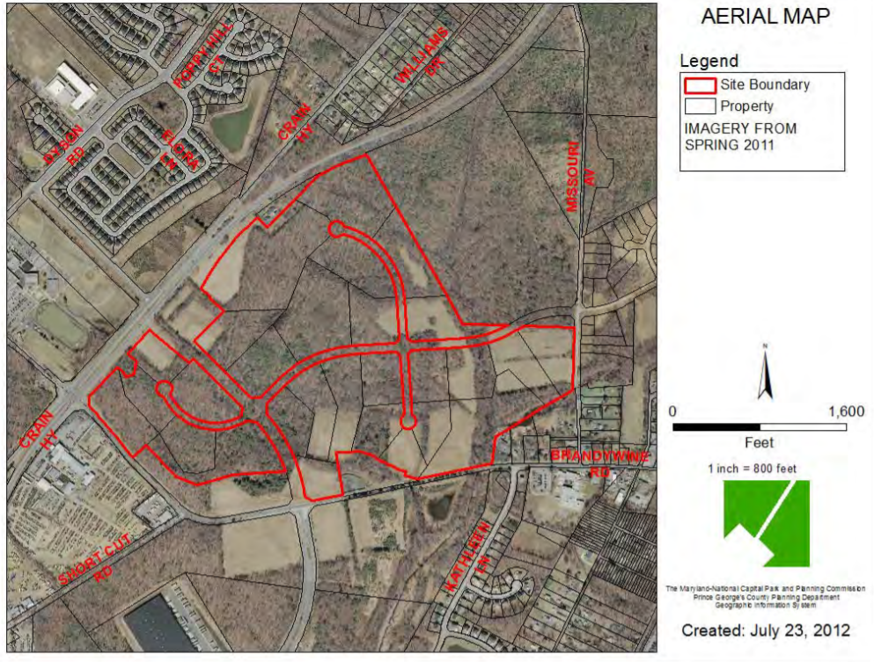
Figure 2. Aerial view, Stephen’s Crossing.
Used with permission by M-NCPPC. ²³

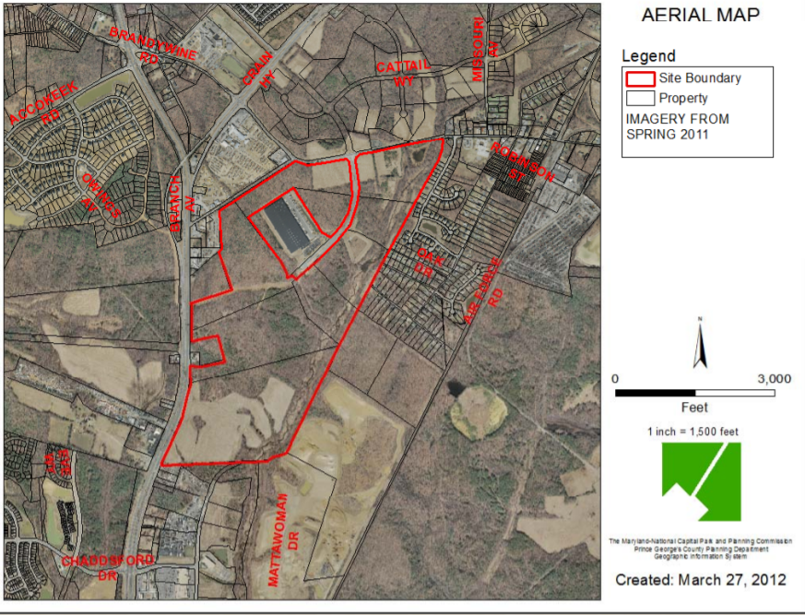
Figure 3. Aerial view, Villages of Timothy Branch.
Used with permission by M-NCPPC.²⁴

- Clarksburg
Clarksburg continues to experience rapid population growth. In recent years several large-scale developments have been constructed including Clarksburg Village, Clarksburg Town Center, and Cabin Branch to accommodate the growing population. A proposed transit corridor and recent sale of a 204-acre lot could translate into increased development in the foreseeable future.
The Corridor Cities Transitway (CCT) is a 15-mile, high quality bus rapid transit system extending from the Metropolitan Grove MARC station in Gaithersburg to the COMSAT facility in Clarksburg. The CCT is meant to provide an efficient method of travel for both local and long-distance commuters. Phase I of the project aims to develop a Bus Rapid Transit (BRT) line operating from the Metropolitan Grove MARC station to the Shady Grove Metrorail. Phase II aims to extend the CCT to the COMSAT facility in Clarksburg.²⁵ Phase I of the project is underway. In January 2018 an environmental assessment was published that detailed the environmental impacts of a “Build” and “No-Build” alternative. The “No Build” alternative would not induce any adverse effects to local ecosystems. The assessment claims that the “Build” alternative would not result in any adverse effects; however, the executive summary quantifies acres of resources that could be impacted by the “Build” alternative. Examples of affected resources include, 36.2 acres of wildlife habitat, over 1,500 street trees, 4.9 acres of parkland, and 2,102 linear feet of stream/waterways. Due to a shortage of funds, the final design and construction, including right-of-way acquisition for the CCT, has been deferred until 2023. ²⁶ Although there are no definitive start dates for the construction and incorporation of Clarksburg, projected increases in population and housing favor this transitway.
The CCT may play an important role in the future development of the COMSAT facility (Figure 4). Previously, the 496,000 square foot building served as a research facility, however it was sold to Lantian Development in 2015.²⁷ Although there are no formal plans for the property, a May 2017 interview with Bob Elliott, a Lantian representative, shed some light on the potential future of this 204- acre lot. According to Elliott, market studies are underway to determine potential use of the property. Elliott theoretically estimates that upwards of 5 million square feet could be developed, however he doubts it would be developed to that extent. He also mentions that the CCT could “allow for a future mixed-use component that might be a little different than what you could build today.” Its proximity to I-270 mixed with the growth experienced by the surrounding communities leads Elliott and Lantian to view this as a “great, stabilized, long-term land play.”²⁸
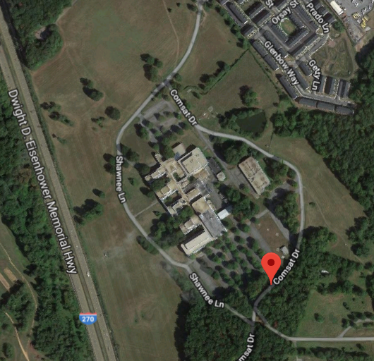
Figure 4. Aerial view of COMSAT facility.
Source: Google Maps.

- White Oak
Although White Oak has already been heavily developed, the approval of the White Oak Science Gateway Plan provides an opportunity to improve and/or implement new stormwater management practices that could help to reduce any negative impacts associated with redevelopment. The plan is ambitious and addresses topics such as land use and zoning, transportation, environmental protection, historical points of interest, and community centers. The Plan’s vision is to redevelop the three major centers of White Oak (Hillandale, White Oak, and Life Sciences/ Food and Drug Administration). These locations would transition from “conventional, auto-dependent suburban shopping centers, business parks, and light industrial areas into vibrant, mixed-use, transit-served nodes.”¹⁸
In the summer of 2017, Percontee Inc. based in Silver Spring, MD shared with the public its plans to begin developing a new community named Viva White Oak (Figure 5). Viva White Oak is a joint venture between Percontee Inc., Global LifeSci Development Corporation and Montgomery County. The plan aims to develop 12 million square feet of mixed use development on a 300-acre site. Although the plan has been in the works for over a decade, Percontee Inc. recently received approval for the entire sketch plan by the Montgomery County Planning Board. It is anticipated that an approval for phase 1 of the project is forthcoming.²⁹
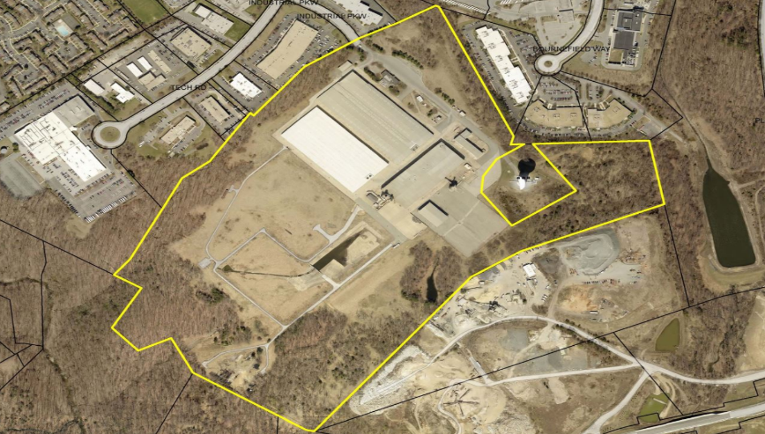
In addition to the potential Viva White Oak community, the Food and Drug Administration (FDA) is in the midst of consolidating its facilities in Montgomery and Prince George’s counties (Figure 6). Currently four plans have been proposed, one of which is a “no build plan”. Each plan (with exception of the no build plan) would add 1.6 million gross square feet of new building and office space in addition to 7,050 parking spaces.

Figure 5. Existing condition of proposed Viva White Oak area.
Used with permission from Montgomery County Office of Planning and Development.²⁹

As seen in Figure 7, Strategy A was identified as the option that would result in the most impervious surface coverage while Strategy B and C result in an equal amount of coverage. According to the timeline set forth by the National Capital Planning Commission, preparation of a final master plan and an environmental impact statement is to occur over the summer of 2018 with final decisions made in the fall/winter of 2018.³⁰
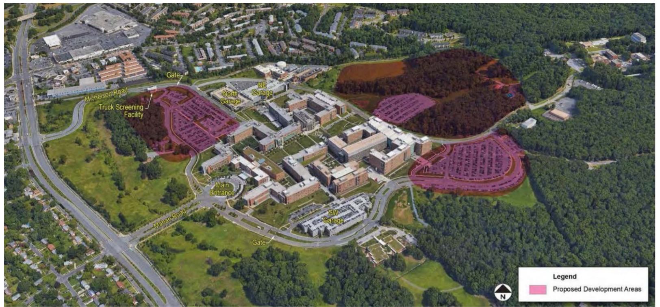
Figure 6. FDA proposed development areas. National Capital Planning Commission.³⁰

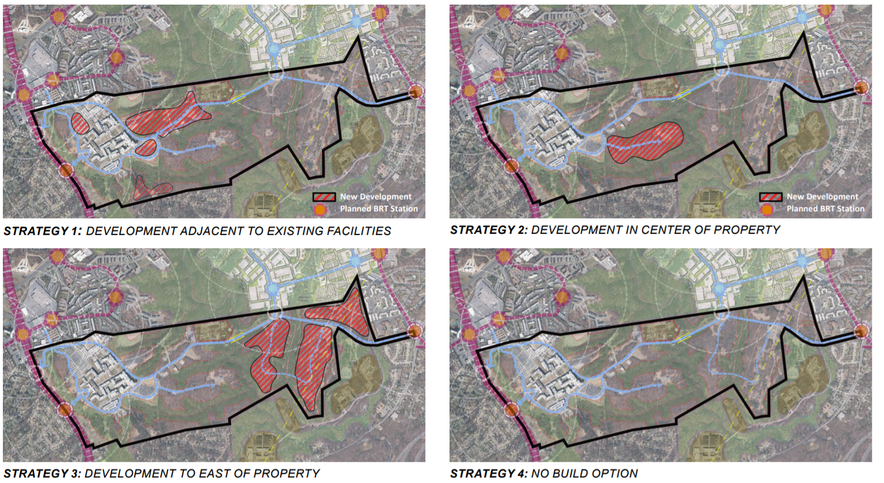
Figure 7. FDA development strategies. National Capital Planning Commission.³⁰

One of the main obstacles facing the White Oak community for decades has been adequate transportation. The White Oak Science Gateway Plan recognizes the need for large infrastructure projects such as the proposed Bus Rapid Transit (BRT) system that would help improve access to major centers such as the FDA campus and Viva White Oak without increasing congestion beyond a reasonable level. In addition, a network of bikeways and pedestrian pathways has been proposed.
It appears inevitable that development and/or redevelopment is in the future for Brandywine, Clarksburg and White Oak, MD. Negative impacts to natural resources are somewhat unavoidable when it comes to new construction. Conversion of natural areas threatens resident wildlife, increases opportunities for stormwater runoff, and thus water quality, however, sustainable development practices can be implemented that could exceed the compulsory expectations to which developers might adhere. With these impending development changes comes an opportunity to implement, restore, or enhance practices that will help better preserve natural resources. Many of the plans evaluated during this process explicitly state recognition of the need to conserve natural resources and minimize negative environmental impacts. As a result, ANS may consider focusing their advocacy efforts in these locations by educating city planners, developers, and the local community on the most effective practices.

REFERENCES
- CBF. The Economic Importance of the Bay. Chesapeake Bay Foundation.
Retrieved March 4, 2018 from http://www.cbf.org/issues/what-we-have-to-lose/economic-importance-of-the-bay/index.html.

- Lipton, D. 2009. Economic Impact of Maryland Boating in 2007. University of Maryland Sea Grant Program. Retrieved March 4, 2018 http://www.mdsg.umd.edu/sites/default/files/files/rec_boat09.pdf.

- Phillips, S., & McGee, B. 2016. Ecosystem Service Benefits of a Cleaner Chesapeake Bay. Coastal Management, 44(3), 241-258.

- EPA. 2016a. Nutrient Pollution, Sources and Solutions. Environmental Protection Agency. Retrieved June 21, 2017 from https://www.epa.gov/nutrientpollution/sources-and-solutions

- CBP. 2016. Chesapeake Bay Watershed Population. Chesapeake Bay Program. Retrieved June 23, 2017 from http://www.chesapeakebay.net/indicators/indicator/chesapeake_bay_watershed_population

- EPA. 2016b. Stormwater Runoff and Impervious Surface. Environmental Protection Agency. Retrieved June 21, 2017 from https://www3.epa.gov/caddis/ssr_urb_is1.html

- Alliance for the Chesapeake Bay. 2017. Impervious Surface. Alliance for the Chesapeake Bay. Retrieved June 23, 2017 from http://www.stormwater.allianceforthebay.org/about

- CWP. 2003. Impacts of Impervious Cover on Aquatic Ecosystems. Center for Watershed Protection.

- Klein, R. D. 1979. Urbanization and stream quality impairment. JAWRA Journal of the American Water Resources Association, 15(4), 948-963.

- Xian, G., Homer, C., Dewitz, J., Fry, J., Hossain, N., & Wickham, J., 2011. The change of impervious surface area between 2001 and 2006 in the conterminous United States. Photogrammetric Engineering and Remote Sensing, Vol. 77(8): 758-762.

- Thekdi, S. A., & Lambert, J. H. 2012. Decision analysis and risk models for land development affecting infrastructure systems. Risk Analysis, 32(7), 1253-1269.

- USDC. 2012. Maryland: 2010 Census of Population and Housing. United States Department of Commerce. Retrieved March 4, 2018 from https://www.census.gov/prod/cen2010/cph-2-22.pdf

- M-NCPPC. 2013. Subregion 5 Approved Master Plan and Sectional Amendment. 2013. Maryland-National Capital Park and Planning Commission. Retrieved March 4, 2018 from http://www.mncppcapps.org/planning/Publications/PDFs/317/Sub_region5.pdf

- Lammers, CJ & Martinez, A. Summary of Water Quality Biological Assessment Studies Conducted in Prince George’s County, Maryland. Maryland-National Capital Park and Planning Commission. Retrieved March 4, 2018 from http://mncppcapps.org/planning/RCPLytebox/media/WQAssessment.pdf

- M-NCPPC. 1994. Clarksburg Master Plan. Maryland-National Capital Park and Planning Commission. Retrieved March 4, 2018 from http://montgomeryplanning.org/wp-content/uploads/2016/10/ClarksburgMasterPlanHyattstownSpecialStudyArea1994ocr300.pdf

- MCDEP. 2015. Montgomery County Stream Condition 2011-2015. Montgomery County Department of Environmental Protection. Retrieved March 4, 2018 from https://www.montgomerycountymd.gov/water/streams/watershed-health.html

- M-NCPPC. 1997. White Oak Master Plan. Maryland-National Capital Park and Planning Commission. Retrieved March 4, 2018 from http://montgomeryplanning.org/wp-content/uploads/2016/09/WhiteOakMasterPlan1997ocr300.pdf

- M-NCPPC. 2014. White Oak Science Gateway Master Plan. 2014. Maryland-National Capital Park and Planning Commission. Retrieved March 4, 2018 from http://www.montgomeryplanning.org/community/wosg/documents/approved_and_adopted_final.pdf

- SHA. 2018. MD 0005 Branch Ave. at Brandywine Rd. (MD 373/MD 381) States Highway Administration. Retrieved March 4, 2018 from http://apps.roads.maryland.gov/webprojectlifecycle/ProjectSchedule.aspx?projectno=PG1755116

- MDOT. 2017. Hogan Highlights Progress on Maryland Route 5 in Brandywine. TheBaynet.com. Maryland Department of Transportation. Retrieved March 4, 2018 from http://www.thebaynet.com/articles/0617/hogan-highlights-progress-on-maryland-route-5-in-brandywine.html

- FCRE. 2018. Brandywine Rd. Listing. Friend Commercial Real Estate. Retrieved March 4, 2018 from http://www.loopnet.com/Listing/Brandywine-Rd-Brandywine-MD/5775055/

- The Hogan Companies. Stephen’s Crossing. Retrieved March 4, 2018 from http://www.hogancompanies.com/resources/Stephen's_Crossing_OM.pdf

- M-NCPPC. 2018. M-NCPPC. 6. 4-09003 the Villages of Timothy Branch. Maryland-National Capital Park and Planning Commission. Retrieved March 4, 2018 from http://mncppc.iqm2.com/Citizens/Detail_LegiFile.aspx?Frame=&ID=1137&CssClass=

- M-NCPPC. 2018. M-NCPPC. 9. CSP-09003 Stephen’s Crossing at Brandywine. Maryland-National Capital Park and Planning Commission. Retrieved March 4, 2018 from http://mncppc.iqm2.com/Citizens/Detail_LegiFile.aspx?Frame=&ID=1137&CssClass=

- M-NCPPC. 2011. Clarksburg Master Plan & Hyattstown Special Study Area. Maryland-National Capital Park and Planning Commission. Retrieved March 4, 2018 from http://www.montgomeryplanning.org/community/plan_areas/I270_corridor/clarksburg/documents/CLMPApprovedandAdopted2011.pdf

- DOT MTA. 2017. CCT Environmental Assessment. Department of Transportation Maryland Transportation Authority. Retrieved March 4, 2018 from http://www.cctmaryland.com/environmental-studies

- Gunts, Ed. 2016. Where’s my Comsat? The Architects Newspaper. Retrieved March 4, 2018 from https://archpaper.com/2016/02/where-my-comsat/

- Banister, John. 2017. Developer Q&A: Lantian Development CEO Bob Elliott . Bisnow. Retrieved March 4, 2018 from https://www.bisnow.com/washington-dc/news/neighborhood/developer-qa-lantian-development-ceo-bob-elliott-74423?utm_medium=email_share&utm_source=website

- MCG. 2018. Viva White Oak. Montgomery County Government Office of Planning and Development. Retrieved March 4, 2018 https://www.montgomerycountymd.gov/DGS/OPD/WhiteOakScienceGateway.html

- NCPC. 2018. United States Food and Drug Administration (FDA) Headquarters Consolidation at the Federal Research Center, White Oak - Master Plan Information Presentation. National Capital Planning Commission. Retrieved March 4, 2018 https://www.ncpc.gov/docs/MP201_Info_combined_NCPC_GSA.pdf

- Environmental Systems Research Institute (ESRI). (2012). ArcGIS Release 10.1. Redlands, CA.
APPENDIX A: GIS Map Layers

