Do Sleeping Patterns Have an Effect on Athletic Performance?

By Kayla Yost

Submitted in Partial Fulfillment of the Requirements for the
Degree of Master of Education

December 2019

Graduate Programs in Education
Goucher College

Table of Contents
List of Tables | i
Abstract | ii
I. Introduction | 1
Overview | 1
Statement of Problem | 2
Operational Definitions | 2
II. Review of the Literature | 4
Why is sleep important? | 4
Factors related to sleep loss | 5
Sleep and Athletic Performance | 7
Accuracy and Reaction time | 8
Learning and Executive Function | 8
Injury and Illness | 9
How can we promote sleep in athletes? | 10
III. Methods | 12
Design | 12
Participants | 12
Instrument | 12
Procedure | 13
IV. Results | 14
Results | 14
V. Discussion | 17
Implications | 17
Theoretical Consequences | 17
Threats of the Validity | 18
Connections to previous studies/existing literature | 18
Implications for Future Research | 18
Conclusion | 19
References | 20

List of Tables/Figures
- Figure 1. Player A case study data 15
- Figure 2. Player B case study data 15
- Table 1. Player A and B data results with statistical averages 16

Abstract
The purpose of this study was to analyze the benefits of sleep with regard to athletic performance by observing the sleep patterns of two women collegiate basketball players in season. Sleeping patterns were recorded using an Apple watch and an IPhone over a seven-week period. Current research shows many benefits from sleep, with athletic performance figuring prominently. Studies have shown a higher success rate within teams who recorded high sleep quality and longer duration of sleep when compared to teams with low quality and short durations. Although the previous research supports sleep affect athletic performance, due to limitations, this study did not support those findings. Research in this area should continue to help researchers collect more significant data to make a more concise generalization on the relationship between sleep and athletic performance.

CHAPTER I
INTRODUCTION
Overview

Living the life of a college student-athlete can be fairly demanding. Not only are coaches asking their athletes to improve on their athletic abilities, professors are asking them to perform to their highest academic abilities as well. When you think about a student-athletes’ schedule, they are balancing practices, games, weight-lifting sessions, classes, and trying to find time to study and complete homework. Being a student-athlete, they are typically coached within a formalized environment meaning evening practices and games are very common. When there is an away game, the commute is often long resulting in returning to campus late at night followed by early educational start times the next day (Taylor, Chrismas, Dascombe, Chamari, & Fowler, 2016). When looking at their busy schedules, one might question, when do student-athletes find time to sleep?
In this study, the researcher will attempt to analyze the impact sleep has on athletic performance. Sleep plays an important role in our bodily function and our mental function. For athletes to perform to the best of their abilities, they need a functioning body and they need to be mentally focused. Being a college athlete demands a lot of energy and time from players on and off the court. Most collegiate athletes were recruited by their coaches to play a sport and the expectation is they are going to perform to their best ability every time they step foot on the court. What triggered interest in this study was the researchers’ experience living the life of a sleep deprived college basketball player and then transitioning into coaching at the collegiate level.

Statement of Problem
Sleep is something that helps refuel our bodies and our minds. It is said that humans are supposed to get a certain number of hours of sleep a night, which varies from age to age. Getting the correct amount of sleep is crucial to our body and mind’s growth. Without it, we cannot function, and our bodies start to shut down. We gain many different benefits from sleep which are necessities for our everyday living. The purpose of this study is to analyze how beneficial sleep is when it comes to athletic performance by looking at the sleeping patterns of two women, who are also collegiate basketball players, while they are in season. The following research proposes the answer to the following question: What is the observed relationship between sleep and athletic performance?
Operational Definitions
Due to using a case study design, this study only has two variables of interest; sleep and athletic performance.
Sleep
Sleep is a biological function that plays major roles in energy conservation, recovery and survival (Mukherjee et al., 2015).
Athletic performance
Athletic performance is determined by multiple different statistical measurements from games. Although there are many different statistical categories within a basketball game, this study only takes a look at a handful of them. These statistical categories were chosen because they require more mental focus than some others. The first statistical measurement is shooting percentage. To find a player’s shooting percentage, you divide the total number of shots they made by the total number of shots they attempted within that game. The second statistical measurement is free throw percentage. Free throw percentage is also found by dividing the total number of free throws they made by the total number of free throws attempted within that game. The third statistical measurement is rebounds. Rebounds are measured by how many rebounds they got within that game. The last statistical measurement are minutes played, which simply records how many minutes each player played within that game.

CHAPTER II
REVIEW OF THE LITERATURE
In this review of literature, the researcher will attempt to analyze sleeping patterns within women basketball players to see if they affect their athletic performance. Sleep is a vital part of our everyday lives and is crucial for survival, especially in athletes. Studies have found a relationship between sleep and athletic performance which showed the benefits of athletes getting increased sleep duration and quality. The researcher will focus on the importance of sleep and will focus on analyzing statics from athletic competitions. The researcher will then compare the two to see if there is a relationship between the duration and quality of sleep impact athletic performance.
Why is sleep important?
When it comes to promoting health within ourselves, sleep plays a critical role (Irwin, 2015). Sleep is a biological function that plays major roles in energy conservation, recovery and survival (Mukherjee et al., 2015). Sleep is also very important when it comes to vital functions such as “neural development, learning, memory, emotional regulation, cardiovascular and metabolic function, and cellular toxic removal”. Getting good-quality sleep is important to one’s health and their overall quality of life. Good quality sleep means that an individual is getting the right amount of sleep they need, which varies based on age, and it means they are sleeping without any disturbances that could reduce the quality. For young adults, like these young college athletes, the National Sleep Foundation for healthy sleep recommends seven to nine hours of sleep per night, which they consider a “normal” night of sleep. However, some researchers say athletes require more sleep and should get nine to ten hours of sleep per night. Unfortunately, studies have shown athletes do not get the recommended hours of sleep they need. 890 athletes from South Africa were surveyed about their sleep behaviors. The survey showed that 75% of athletes slept on average six to eight hours per night on weekdays and of that 75% of athletes, 11% of them reported sleeping less than six hours on weekends. Chronic sleep loss can lead to health-related problems such as depression, increased obesity risk, higher rates of drowsy driving accidents and other cardio-metabolic abnormalities (Irwin, 2015; Kaur & Singh Bhoday, 2017; Owens, 2014).
Sleep is important to athletes because it helps with “memory consolidation especially motor learning” (Owens, 2014, p.2). Past research has shown many improvements within an athlete’s motor tasks after a “normal” night of sleep compared to athletes who experienced multiple periods of being awake throughout the night. Studies have also shown sleep loss increases the risk of injury, which for athletes is an obstacle they want to avoid so they do not miss training. College athletes put their bodies under a lot of stress due to intense training and competitions which means their bodies need to recover. Sleep is an important role in the recovery phase, which again stresses the importance of quality sleep.
Factors Related to Sleep Loss
There are many different factors that play into the sleeping patterns of adolescences in general. According to Kaur and Singh Bhoday, some of these factors include academic demands, sports which includes travel for sports, social interactions, the internet, phone usage during bed time, television and possibly even a job (2017). Due to these factors, adolescents are averaging around seven hours of sleep during school days, which is a reduced amount of sleep compared to their childhood days. A study that involved 1,125 students from an urban Midwestern university who ranged from the ages of 17 to 24 years, participated in a cross-sectional online survey about their sleeping habits (Lund, Reider, Whiting, Prichard & Prichard, 2010). The results showed that 60% of these students were categorized as poor-quality sleepers. Poor-quality sleepers were also found to have significantly more problems with physical and psychological health when compared to students with good-quality sleep. Some factors that where found that impacted their sleep was emotional and academic stress.
Travel is one factor that might result in a lack of sleep within the athletic population. It is typical for a team to travel anywhere from one to three hours to reach the place of competition. Bigger colleges at times play games within a different state forcing them to fly to their game. These travel conditions leave athletes in cramped conditions for long periods of time. It is common for athletes to have late start times during the week resulting in a late return time to campus followed by early start times for class the next morning (Venter, 2012).
Having a poor sleeping environment can also result in a lack of sleep within athletes. Most athletes live on campus which means they usually have a roommate. Some issues athletes, or any college student for that matter, could run into might be different sleep schedules, noises causing awakening, or light. At times these are conditions that might be out of their control but unfortunately still impact their quality of sleep (Venter, 2012)
Alcohol or caffeine ingestion can also effect sleeping patterns. Depending on the amount of alcohol or caffeine ingested sleep can be increased or decreased. Too much alcohol consumption can lead to a decrease in REM-sleep, which is one of the most important stages of sleep (Venter, 2012). A study that looked at the effects of alcohol and caffeine was conducted to see the relationship to sleep. Researchers found that students who were rating their sleep as “poor” quality drank more alcohol daily compared to those students who rated their sleep as “good” quality. This was an area of concern for researchers because collegiate athletes tend to have “significantly higher proportions of risky lifestyle behavior patterns when compared with non-athletes” (Lund et al., 2010, p. 125). College athletes tend to participate in heavy drinking which is why they are looked at as an “at risk” group of risky lifestyle behavior.
Sleep and Athletic Performance
Past studies have shown that sport teams who get increased sleep duration and quality have more success than teams who do not. A study with 576 elite male and female Brazilian athletes were asked to document and describe their quality of sleep and mood before competition. Most athletes rated their sleep quality as being “good” or “normal”. However, those athletes who rated their sleep quality as “poor”, studies found a correlation between poor sleeping quality and losing in competition (Brandt, Bevilacqua & Andrade, 2017).
Another study which included 42 netball athletes tracked their sleep with either a journal or some sort of watch which tracked their duration for sleep. This study focused on evaluating the relationship between sleep and success in competition during a national tournament. Researchers found that the two teams with the highest placement within the tournament had reported significantly greater sleep durations and also rated their sleep quality very high. When looking at the two lowest placed teams in the tournament, they were the complete opposite. They reported low sleep durations and poor sleep quality (Juliff, Halson, Hebert, Forsyth, & Peiffer, 2018). These two studies suggest that improved sleep duration and quality are correlated with having success within competitions however, they focus on the team as a whole rather than individual players.
Although it has been found that performance is affected by sleep loss, research indicates that some physical and gross performances will be maintained, however sport-specific performance will be lower due to the physiological effects from sleep loss (Fullagar et al., 2014). In simpler terms, this means that even with sleep loss, athletes are going to be able to run, jump, and play physical but when it comes to making decisions out on the court or dribbling a basketball, they might not perform as well.
Accuracy and Reaction Time
Athletes who do not get enough sleep or who get poor quality of sleep have demonstrated less accuracy in athletic performances and a decrease in reaction time. Findings were the opposite for athletes receiving enough sleep and good quality sleep. They were found to improve in accuracy and reaction time (Watson, 2017). A study with a men’s college basketball team measured their sleeping behaviors and compared their accuracy and reaction time. As a team, over a five-week period, their average sleep per night increased from 6.6 hours to 8.5 hours (Mah, Mah, Kezirian, & Dement, 2011). As a result, their free throw accuracy went up 9% and their three-point percentage increased by 9.2%. A study within a college tennis team also measured their sleeping behaviors. As a team, they increased their average sleep duration per night by 1.6 hours. As a result, their serving accuracy increased by 36%. These studies suggest that sleep deprivation can impact athletes’ accuracy and reaction time but it also suggests improvements with sleep extension.
Learning and Executive Function
As mentioned before, sleep plays a critical role in memory consolidation. The learning process, which includes memory, is essential for athlete in order for them to continue individual player development and to improve their performance. Cognitive lapses have been found to be correlated with sleep deprivations or sleep loss which can have significant effects on tasks that require flexible or critical thinking. Sleep deprivation or sleep loss has been found to have negative effects on inhibitory control as well (Watson, 2017). “Inhibition or inhibitory control is the ability to inhibit or control impulsive (or automatic) responses by using attention and reasoning” (CogniFit, 2016, p. 1). During competition, this could affect decision making within athletes. Being mentally focused is very important for athletes to be able to perform at their best. One of the most critical effects seen from sleep deprivation or sleep loss is impairments in neurocognitive performance, which effects athletes especially if they are involved in a fast-paced game that requires quick decision making. If they are unable to do so, they are more likely to poorly perform (Watson, 2017).
Injury and Illness
Injury and illness tend to be one of the biggest obstacles athletes face when it comes to being able to participate in training and competition. Sleep deprivation and sleep loss have been connected to increased risks of injury and illness within athletes. Researchers believe the relationship between sleep loss and injury comes down to reaction time and cognitive function. As mentioned before, a lack of sleep affects reaction time and cognitive function. Due to a lack of sleep, athletes are not moving how they are used to when they received a full night of sleep and they are not thinking about their actions as much as they might when they are rested. This results in athletes suffering from an acute injury such as an ankle sprain. Sleep deprivation and sleep loss also contributes to muscle fatigue. When muscles are fatigued, athletes run a risk of injury as well (Watson, 2017).
Previous researchers conducted a study focused on young athletes from middle and high school. Athletes that reported sleeping less than an average of eight hours a night were “70% more likely to report an injury than those who slept more than eight hours” (Milewski et al., 2014). Researchers also found that as training load increased, sleep duration decreased. Athletes making a transition from high school sports to college sports are going to see the training load increase even more, which is one of the reasons why college coaches and trainers stress the importance of sleep to their athletes. College athletes often times have a lifting session and a practice in the same day. On days where they do not have a lifting session or practice, they are usually competing in a game, giving them limited days where they are not training in same time of way.
Getting the proper amount of sleep each night is also critical for an athlete’s immune system. A lack of sleep has been found to be “immunosuppressive and increases susceptibility to upper respiratory infections in particular” (Cohen, Doyle, Alper, Janicki-Deverts & Turner, 2009, p. 27). Over a 14-day period, a study was conducted with 154 men and women. The first 14 days participants monitored their sleep duration and efficiency. Nasal drops containing rhinovirus were then administered to participants after the 14-day period was over. Researchers found that when participants who slept less than seven hours per night were compared to those who slept eight hours or more, they were three times as likely to develop an infection (Cohen et al., 2009).
How Can We Promote Sleep In Athletes?
Sleep plays a role in many different things within the human body and is important when it comes to survival. College athletes are experiencing a busy time within their lives between academics and sports, therefore promoting healthy sleeping habits could benefit athletes in many different ways. Athletes first need to be aware of how much sleep they are getting on average per night to be able to determine if they are getting the proper amount of sleep their bodies need (Watson, 2017). Then, getting on a regular sleeping schedule will reassure them they are receiving the amount they need. The human bodies’ internal biological clock will be disrupted by following an irregular sleeping schedule. Research suggest once an individual is on a regular sleep schedule, should they want to adjust their schedule to an earlier or even later sleep time, they should stick to a thirty-minute window in both directions. It’s important to “establish consistent sleep and wake-up times” (Waston, 2017, p.1) therefore, athletes should wake up around the same time every morning even if they receive a “poor” quality of sleep the night before. This keeps the human biological clock on track (Venter, 2012).
Having a proper sleeping environment is important as well. Making sure the room in which the athlete is sleeping in is comfortable, cool, dark, without noise or electronics provides them a space to promote healthy sleeping. Today’s world runs on different electronic devices; however, researchers have found the use of electronic devices before bed suppresses natural melatonin, which delays the onset of sleep. It is recommended to stop using electronic devices about an hour before bed (Venter, 2012).
Some other ways to promote healthy sleeping patterns within athletes are to encourage them to start a “winding down routine”. It’s important that this routine includes something that is going to calm the body down and acts as a clue for the body and mind that it’s time to get ready for sleep. An activity that promotes muscle relaxation such as different breathing and relaxation techniques will help the onset of sleep. Music tends to create a calm, relaxing environment for individuals as well. This could be added into the “winding down routine”; however, it’s important the tempo of the music includes something that is slower than the individuals heart beat to help the calming and relaxation process (Venter, 2012; Watson, 2017).

CHAPTER III
METHODS
Design
This study was conducted as a case study. There were only two variables of interest within this study. Those variables were sleep and athletic performance. Sleep data was collected for five weeks total. Data collection started two weeks before athletic competition to get an average base line of sleep. For the following three weeks, sleep data was collected while athletes were competing. Once the five weeks were over, sleeping patterns were compared to athletic performance to determine the relationship between the two.
Participants
The participants within this study were two female collegiate athletes who played basketball on the women’s basketball team at Goucher College in Maryland. One female athlete was 18 years old and the other was 20 years old. Participants were chosen due to the convenience of the researcher.
Instrument
The instrument used in this study was an apple watch and the “sleep watch” app on the athlete’s IPhone. An apple watch comes with an accelerometer, gyroscope and heart rate sensors to help track an individual’s sleeping patterns. To track sleeping patterns, the watch must be worn while sleeping, it cannot be placed next to an individual. The instrument was not tested for reliability or validity.

Procedure
Both athletes owned their own apple watch, which they used to track their sleep. First, the researcher helped them download the “sleep watch” app which is an extension of the “watch” app, which comes pre-downloaded onto an iPhone. Once each participant had the app downloaded, the researcher instructed them to wear their apple watch to bed every night for the next 5 weeks. At the end of every week, each participant electronically logged their hours of sleep each night of the week on a spread sheet that was shared to them in Google drive by the researcher.
Throughout the five weeks that the participants were tracking their sleep, the researcher was collecting data on their athletic performance. Throughout the five weeks, the two participants performed in seven basketball games. At the end of each game, the researcher documented four different statistical categories for each participant. The four statistical categories included shooting percentage, free throw percentage, rebounds, and minutes played during that game. All statistical categories were recorded in the spread sheet.

CHAPTER IV

RESULTS

The purpose of this study was to determine the relationship between sleep and athletic performance. This study was based on a case study design with two athletes, player A and player B. It measured the amount of sleep they got over a seven-week period which was then compared to different statistical categories from game performances. Figure 1 and 2 shows the relationship between sleep and athletic performance.

As seen in table 1, over the course of seven weeks, on average player A was getting 379.86 minutes of sleep per week which means player A was getting roughly 6.3 hours of sleep per night. On average, player A had a shooting percentage of 37.71 over the course of seven weeks, a free throw percentage of 53.57 and 8 rebounds per game. Player A was playing an average of 28.14 minutes per game.

Table 1 also shows over the course of seven weeks, on average player B was getting 373.50 minutes of sleep per week which means player B was getting roughly 6.2 hours of sleep per night. On average, player B had a shooting percentage of 44.29 over the course of seven weeks, a free throw percentage of 67.14 and 4.43 rebounds per game. Player B was playing an average of 30.86 minutes per game.

The data collected shows there is no discernable pattern between sleep and each statistical category therefore, resulting in there being no relationship between sleep and athletic performance.

Figure 1.

Player A case study data.

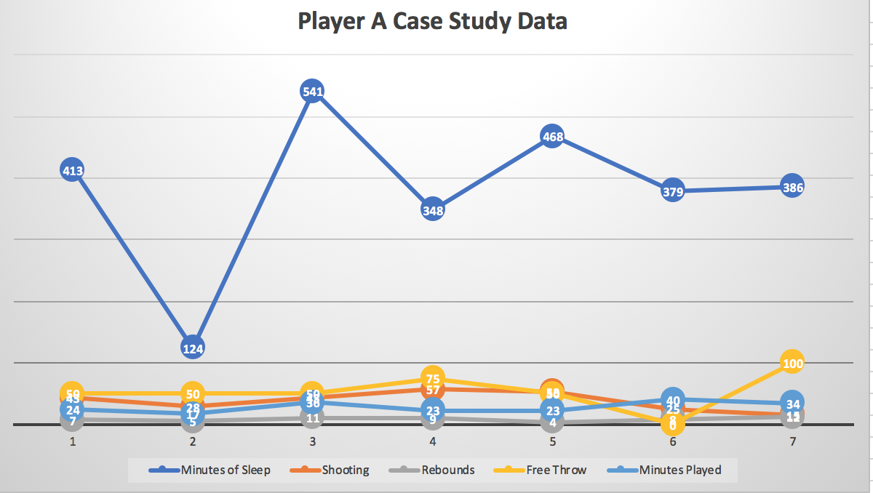

Figure 2.

Player B case study data.

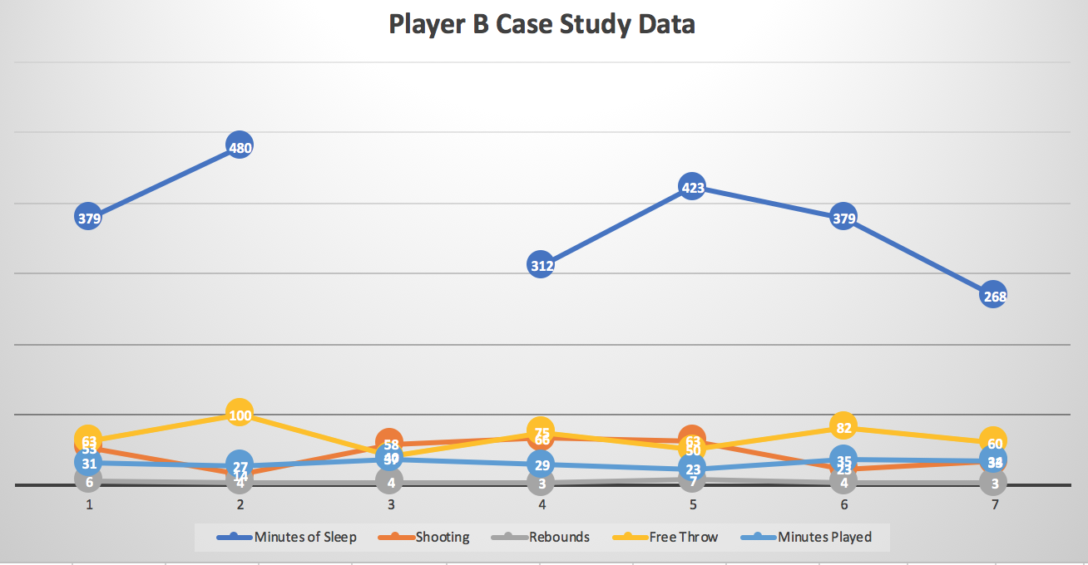

Table 1.

Player A and player B data results with statistical averages.

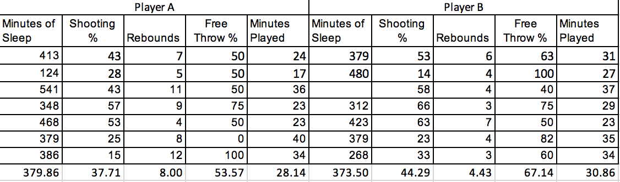

CHAPTER V
DISCUSSION
Player A and player B were selected to participate in this case study experiment based on the convenience of the researcher. These two athletes were chosen because they had access to an Apple watch and the “sleep watch” application. Over a seven-week period, the amount of sleep that each athlete was getting was recorded as well as statistical categories from game performances. The purpose of this study was to answer the following question: What is the observed relationship between sleep and athletic performance?
Implications
The results showed that there is not a discernable pattern between sleep and athletic performance. As shown in figure 1, the minutes of sleep for player A varies. Although the amount of sleep varies each week, the statistics from games remain consistent each week. Figure 2 shows similar results. Player B’s sleep varies from week to week. Due to missing data, there is even a break in the amount of sleep player B is getting. Although the minutes of sleep varies, again, the statistics from games remain consistent from week to week.
Theoretical Consequences
The theoretical consequences are not supported in this study. Research implies that sleep is beneficial to our bodies in many ways with athletic performance being one of them. In chapter 2, it was discussed that teams who get an increased amount of sleep duration and quality have more success than team who do not.
However, this study did not support the research due to the case study design. A case study design adds limitations to a study. There are no statistical tests that can be ran to on the data presented to support research. Based on the results, sleep duration has no effect on athletic performance.
Threats of the Validity
There are a few threats to the validity of this study. As mentioned, the case study design was a limitation. The design limited the generalizations that could be made. Another threat would be the instruments, which would be the Apple watches and IPhones used in this study. In order to collect data, both of these devices had to be charged daily in order for them to have full charge through the night while participants were sleeping. The sample size is also a threat. With a case study design only using two participants, this could make it difficult to make a generalization to a larger population. Also, the gender of the subjects could be a threat. Both participants were female athletes. No data was collected on male athletes which also makes it difficult to make a generalization to a larger population. This study also does not include all varsity teams at the college; both participants are a part of the women’s basketball team.
Connections to Previous Studies/Existing Literature
Existing literature and previous studies support the importance of sleep within athletes due to the benefits it has on athletic performance. The literature also supports increased sleep duration lowers the risk of injury and illness within athletes. This holds true within this study. Through the duration of the study, both participants stayed injury free and were free from major illnesses.
Implications for Future Research
Future research should be done with a larger population mixed with both male and female subjects. More participants will validate the generalizations that can be made from the data. Also, when conducting future research, the researcher should allow multiple teams other than just women’s basketball to participate in the study. The researcher might even consider allowing multiple colleges to participate in the study. This will help eliminate any bias that can be made when conducting the research. Different colleges have different schedules which will help the researcher get a better understanding about the relationship between sleep and athletic performance. Also, different sports have different demands on a body which can cause individuals to perform differently. This could will also help validate the generalization that can be made from the data. Future research should possibly think about changing the design of the study. Using an experimental or a quasi-experimental design could help to validate previous research.
Conclusion
A collegiate student athlete’s life can be fairly demanding. While trying to balance demands from coaches and professors, practices, games, weight-lifting sessions, trying to find time to study and time to complete homework while also trying to have a social life, sleep can be put on the back burner. Literature has proven there are many different benefits to sleep. Sleep plays a role in energy conservation, recovery and survival (Mukherjee et al., 2015). This study showed that athletes are receiving a reduced amount of sleep per week averaging somewhere around six to six and a half hours of sleep. Literature has also showed the importance of sleep when it comes to athletic performance. Although the data from this study cannot support the literature due to its limitations, future research could do so. Further research will help researchers collect more significant data to make a more concise generalization on the relationship between sleep and athletic performance.

References

Brandt, R., Bevilacqua, G. G., & Andrade, A. (2017). Perceived sleep quality, mood states, and their relationship with performance among Brazilian elite athletes during a competitive period. Journal of Strength and Conditioning Research, 31(4), 1033-1039. doi:10.1519/jsc.0000000000001551
CogniFit. (2016, June 08). Retrieved May 15, 2019, from https://www.cognifit.com/science/cognitive-skills/inhibition
Cohen, S., Doyle, W. J., Alper, C. M., Janicki-Deverts, D., & Turner, R. B. (2009). Sleep Habits and Susceptibility to the Common Cold. Archives of Internal Medicine, 169(1), 62. doi:10.1001/archinternmed.2008.505
Fullagar, H. H., Skorski, S., Duffield, R., Hammes, D., Coutts, A. J., & Meyer, T. (2014). Sleep and athletic performance: The effects of sleep loss on exercise performance, and physiological and cognitive responses to exercise. Sports Medicine, 45(2), 161-186. doi:10.1007/s40279-014-0260-0
Irwin, M. R. (2015, January 03). Why Sleep Is Important for Health: A Psychoneuroimmunology Perspective. Retrieved October 30, 2018, from https://www.ncbi.nlm.nih.gov/pmc/articles/PMC4961463/
Juliff, L. E., Halson, S. L., Hebert, J. J., Forsyth, P. L., & Peiffer, J. J. (2018). Longer sleep durations are positively associated with finishing place during a national multiday netball competition. Journal of Strength and Conditioning Research, 32(1), 189-194. doi:10.1519/jsc.0000000000001793
Kaur, H., & Singh Bhoday, H. (2017). Changing adolescent sleep patterns: Factors affecting them and the related problems. Journal of The Association of Physicians of India, 65, 73-77. doi:10.1017/cbo9780511499999.005
Lund, H.; Reider, B.D.; Whiting, A.B.; Prichard, R.N. & Prichard, J.R. (2010). Sleep patterns and predictors of disturbed sleep in a large population of college students. Journal of Adolescent Health, 46: 124-132
Milewski, M. D., Skaggs, D. L., Bishop, G. A., Pace, J. L., Ibrahim, D. A., Wren, T. A., & Barzdukas, A. (2014). Chronic lack of sleep is associated with increased sports injuries in adolescent athletes. Journal of Pediatric Orthopaedics, 34(2), 129-133. doi:10.1097/bpo.0000000000000151
Mukherjee, S., Patel, S. R., Kales, S. N., Ayas, N. T., Strohl, K. P., Gozal, D., & Malhotra, A. (2015). An official American thoracic society statement: The importance of healthy sleep. recommendations and future priorities. American Journal of Respiratory and Critical Care Medicine, 191(12), 1450-1458. doi:10.1164/rccm.201504-0767st
Owens, J. (2014, September 01). Insufficient Sleep in Adolescents and Young Adults: An Update on Causes and Consequences. Retrieved October 30, 2018, from http://pediatrics.aappublications.org/content/early/2014/08/19/peds.2014-1696
Venter, R. E. (2012). Role of sleep in performance and recovery of athletes: A review article. South African Journal for Research in Sport, Physical Education and Recreation, 34(1), 167-184. Retrieved May 15, 2019.
Watson, A. M. (2017). Sleep and Athletic Performance. Current Sports Medicine Reports, 16(6), 413-418. doi:10.1249/jsr.0000000000000418

