White Baltimore's Perceptions of Digital Neighborhood Watch

by
Bryan McDonough
July 2020

Presented to the
Division of Science, Information Arts, and Technologies
University of Baltimore

In Partial Fulfillment
of the Requirements for the Degree of
Master of Science



Kathryn Summers (Jul 7, 2020 16:10 EDT)
Approved by: ________________________________
Kathryn Summers, IDIA M.S. Program Director

________________________________
Greg Walsh
Abstract
Baltimore City has a national reputation as a dangerous city, and statistically, it’s true. Baltimore has higher than average rates of violent and property crime. In an effort to increase the safety of their homes and neighborhoods, many residents have purchased Wi-Fi-enabled home or doorbell security cameras to deter criminal activity and to assist in criminal identification if and when a crime does occur. Neighborhood communities have formed online groups on platforms such as Facebook and Nextdoor where these incidents are discussed, and video footage is shared, serving as a digital neighborhood watch. As technology continues to advance and new crime alert apps enter the market, questions have emerged as to how this increase in awareness of criminal activity may be impacting residents’ perceptions of safety, privacy, and security. Ultimately, understanding the impact of this technology on individuals will inform a discussion on whether or not digital neighborhood watch groups and technologies in their various forms are having a positive impact on the perception of neighborhood safety and how this may impact resident growth, retention, and overall neighborhood health.
This study utilized two rounds of research, focusing on two areas of inquiry; (1) the usage and sharing of public-facing home security camera footage and (2) the usage of online social platforms and mobile apps that residents have used to facilitate digital neighborhood watch groups. The first round of research was comprised of an online survey that reached 289 Baltimore City residents and the second being 12 individual in-depth interviews targeting four Baltimore City neighborhoods; Canton, Federal Hill, Hampden, and Mt. Washington. The results of this research show that (1) residents feel safer when home security cameras are present in their neighborhood (2) residents’ value security over privacy and are willing to forgo privacy in public spaces to increase their safety (3) residents are willing to share their home security camera footage with their neighbors and the police in order to assist in criminal investigations, as long as the footage is being shared and not accessed freely in the form of a live video feed. However, there was no consistency to how people felt about and interacted with neighborhood watch groups and crime alert apps. The notifications were found to cause anxiety and negatively impact perception of safety in some, yet comforted others by helping them to feel better informed.

Table of Contents

List of Tables iv

List of Figures v

Chapter 1: Introduction 1

Chapter 2: Literature Review 4
Baltimore City 4
A City of Neighborhoods 4
Baltimore Crime 5
Long-term Residence 7
Public Surveillance 10
Effectiveness of Public Surveillance and CCTV 10
Baltimore City “CitiWatch” Program 11
United Kingdom Mass Surveillance 12
Neighborhood Watch Programs 13
2013 Boston Marathon 13
Neighborhood Watch and Police Partnerships 14
Home Security Cameras 15
Evolution of Technology 15
Competitive Landscape 17
Rights & Privacy 18
Content & Data Sharing 18
Online Social Platforms and Crime Alert Apps 20
An Overview 20
Facebook Groups 20
Nextdoor 25
Ring Neighbors 28
Citizen App 34

Chapter 3: Research Methodology 36
Online Survey: Baltimore Neighborhood Security & Privacy 36
The Purpose of this Survey 37
Tools Used and Survey Structure 37
Distribution and Data Collection 38
Neighborhood Demographic Breakdown 40
In-depth Interviews: Baltimore Resident’s First-hand Experience 41
The Purpose of the In-depth Interviews 41
Participant Recruitment and Tools Used 41
Interview Structure 42

Chapter 4: Findings 44
Online Survey: Baltimore Neighborhood Security 44
Participation Results 44
Demographic Breakdown 45
Security Cameras and Content Sharing Questions 48
Open-ended Responses 54
In-depth Interviews: Results & Analysis 59
Participant Results 59
Group A 64
Group B 65
Group C 65
Group D 66
Additional Findings 67
Comparison to Survey’s Open-ended Response Themes 69
Crime Data Tracking, Notifications, Perception and Safety 70

Chapter 5: Conclusion 74
General Discussion 74
Research Limitations 76
Online Survey 77
In-depth Interviews 77
Significance and Future Research 78
Extension of the Current Study 78
Future Research 79

References 80

Appendix A: Online Survey, Baltimore Neighborhood Security & Privacy 85

Appendix B: Confidence Interval Workbook 99

Appendix C: Open Text Survey Responses 102

List of Tables
Table 1 Baltimore City Neighborhood Crime 6
Table 2 Total Number of Households 8
Table 3 Households with Children Under 18 9
Table 4 Significant Changes in Crime, Downtown Baltimore 11
Table 5 Popular Camera Brand Models Competitive Analysis 17
Table 6 2017 Data from Community Statistical Area Profile 40
Table 7 Baltimore Neighborhood Security & Privacy Survey: Your Baltimore City Neighborhood 44
Table 8 Baltimore Neighborhood Security & Privacy Survey: Demographics 45
Table 9 Baltimore Neighborhood Security & Privacy Survey: Home Security 48
Table 10 Baltimore Neighborhood Security & Privacy Survey: Home Security Camera Video 51
Table 11 Baltimore Neighborhood Security & Privacy Survey: Privacy or Security 54
Table 12 Baltimore Neighborhood Security & Privacy Survey: Response Mapping 55
Table 13 In-depth Interviews: Baltimore Resident’s First-hand Experience: Demographics 59
Table 14 In-depth Interviews: Baltimore Resident’s First-hand Experience: Summary 60

List of Figures
Figure 1. Canton Neighbors Facebook Post Example 1 23
Figure 2. Canton Neighbors Facebook Post Example 2 24
Figure 3. Canton Neighbors Facebook Post Example 3 25
Figure 4. Nextdoor Urgent Alert Post Modal 26
Figure 5. Nextdoor Safety Subchannel Post Modal 27
Figure 6. Ring Neighbors Activity Feed 29
Figure 7. Ring Neighbors Post Step 1 30
Figure 8. Ring Neighbors Post Step 2 31
Figure 9. Ring Neighbors Post Step 3 32
Figure 10. Ring Neighbors Weekly Safety Report 33
Figure 11. Citizen App Website 35
Figure 12. Citizen App Notification 71
Figure 13. Citizen App Map View User Interface 72
Figure 14. Citizen App Comments 72

Chapter 1: Introduction
Baltimore City has a national reputation as a dangerous place. It has been called “Body-more Murder Land” and “The City that Bleeds" among other disparaging nicknames. This is a direct result of its high rates of poverty, crime, and murder, but it’s also in part due to its leading role in HBO’s The Wire, which showcased the city’s drug trade and corrupt leadership from 2002 through 2008. In 2015, Baltimore was once again in the national spotlight when the city broke out in riots following the death of Freddie Gray, a 25-year-old man who sustained fatal injuries while in police custody. This event further publicized the mistrust between city residents and the police department, showcasing Baltimore as a less than desirable place to call home.
Residents of Baltimore City are not unaware of this reputation. Those who live in the city know where they should and should not go at any given time. There are invisible boundaries that divide neighborhoods and even streets within neighborhoods. However, even in the areas that are considered safe, residents often experience a heightened sense of caution. This can be attributed in part to Baltimore’s reputation but may also be exacerbated by the real-time crime alerts and discussions that have been enabled by the Internet of Things (IOT) and propagated through online social communities.
In recent years, the home security industry has grown significantly due to advances in technology and the introduction of new products in the form of WiFi-enabled home security and doorbell cameras. Through public investments and acquisitions by large tech companies and well-funded marketing campaigns, the popularity of these cameras in the smart home ecosystem has grown exponentially. Home security cameras were typically marketed to do one thing; provide live surveillance and video recordings in case of a crime. However, these new devices are being leveraged in new ways. For example, doorbell cameras allow the homeowner to see who is at their door, even if they are not home, allowing them to converse and accept packages remotely. In addition, they serve their traditional purpose exceptionally well due to their high resolution, night-vision, live streaming, and cloud storage capabilities.
In addition, online social platforms have become ubiquitous and increasingly flexible, enabling online neighborhood groups to capture, share, and comment on video surveillance footage of criminal and non-criminal activity in their neighborhoods. This has taken the traditional concept of a neighborhood watch group and made it more easily accessible, far reaching, and potentially intrusive as notifications interrupt daily life. We are calling this concept the digital neighborhood watch.
The purpose of this study is to understand how this rise in popularity of home security cameras and more specifically, the sharing of home security camera footage on digital neighborhood watch platforms has impacted individual residents' perception of privacy, security, and safety as well as the impact it may be having on the strength of the overall neighborhood community. More specifically, the research will address the following questions:
(1) do residents feel safer when home security cameras are present in their neighborhood?
(2) which do residents value more, privacy or security?
(3) are residents willing to share their public-facing home security camera footage?
(4) how have digital neighborhood watch programs, crime notifications, and crime alert apps affected residents' perception of safety in their neighborhood?
The subjects of this study all reside in Baltimore City or have recently moved out of Baltimore City within the past year. This study targeted four of Baltimore’s more affluent neighborhoods that are early adopters of this technology and have active online communities. Unfortunately, income, race, and neighborhood tend to correlate in Baltimore, which meant that the majority of the respondents were white. Thus, this became an exploration of the experiences and attitudes of white Baltimoreans.
The study was conducted in two parts. The first step was an online survey distributed through the neighborhood’s online neighborhood communities/digital neighborhood watch platforms to understand quantitatively how people are using this technology. This was followed by a series of 12 in-depth interviews which explored individual experiences related to the use of home security cameras, digital neighborhood watch platforms, and crime alert apps. The 12 subjects were divided into four groups, each represented by three interviewees; (Group A) owners of cameras who actively participate in digital neighborhood watch groups (Group B) owners of cameras who do not actively participate in digital neighborhood watch groups (Group C) individuals who do not own cameras who actively participate in digital neighborhood watch groups (Group D) individuals who do not own cameras and who do not actively participate in digital neighborhood watch groups.
In the Chapters to follow, this paper will discuss the importance of Baltimore City and the selected neighborhoods as the subject of this study, the evolution of home security camera technology, rights and privacy concerns, the ubiquity of online social networks, and the role they play in evolving the concept of a digital neighborhood watch. It will also outline the research methodologies and results and discuss the significance of this research and the need for further investigation.

Chapter 2: Literature Review

Baltimore City

A City of Neighborhoods
Baltimore is a city of very distinct neighborhoods. So much so that many neighborhoods have their own identity that is known and celebrated by its residents. However, Baltimore’s neighborhoods are highly segregated. They have boundaries that can be represented by major roads, train tracks, bodies of water, or parks. In many cases, some of the city's most affluent neighborhoods share boundaries with some of the most poverty-stricken. The reasons for Baltimore’s poverty go beyond the scope of this research, but they are many and include topics such as red-lining, subprime lending, the crack epidemic, lack of industrial jobs, mass incarceration, gentrification, etc.
According to 2018 US Census data, Baltimore City’s median household income of $50,501 was below the national average of $61,937. However, the state of Maryland overall is well above the national average at $83,076. Similarly, 18.9% of Baltimore City residents live in poverty compared to only 9.1% of Marylanders. The national average of those who live in poverty is 13.1%. Unfortunately, these figures do not illustrate the full story. Due to the segregated nature of Baltimore neighborhoods, the wealth is not evenly distributed. For example, the affluent Baltimore City neighborhood of Canton has a median household income of $111,891, more than double the average for Baltimore City (Alliance, 2020).
Canton, as well as Federal Hill, Hampden, and Mt. Washington, will serve as the focus of this research for the following reasons: (1) These neighborhoods are overwhelmingly white and represent wealthier Baltimore City neighborhoods, (2) These neighborhoods have higher rates of juvenile and property crime (the types of crime mostly targeted by homeowner security cameras) and lower rates of violent crime as compared to the average figures across all Baltimore City neighborhoods, and (3) These communities have active neighborhood social networking groups.

Baltimore Crime
Baltimore City has the highest homicide rate of any US major city. In 2019, Baltimore City ended the year with 348 homicides (Baltimore Sun, 2020). In contrast, some of the more affluent neighborhoods in Baltimore City rarely see homicides. Instead, the majority of incidents are drug-related theft, whether by car break-in, package theft, home invasion, or mugging. Many of these crimes are committed by juveniles who are checking car door handles or walking through alleys looking for opportunities to steal. In order to further understand how the four selected neighborhoods, compared to Baltimore City neighborhoods reported crime-rates overall, Baltimore City Police Department data is being presented across the following categories:
Part 1 Crime: The Part 1 crime rate captures incidents of homicide, rape, aggravated assault, robbery, burglary, larceny, and auto theft that are reported to the Police Department. (Alliance, 2020)
Violent Crime: The violent crime rate measures the number of Part 1 crimes identified as being violent (homicide, rape, aggravated assault, and robbery) that are reported to the Police Department. (Alliance, 2020)
Property Crime: The property crime rate measures the number of Part 1 crimes identified as being property-based (burglary and auto theft) that are reported to the Police Department. (Alliance, 2020)
Juvenile Arrests: The number of persons aged 10 to 17 arrested per 1,000 juveniles that live in an area. This indicator is calculated by where the arrested juvenile was arrested and not by where the crime is committed. Arrests are used instead of crimes committed since not all juveniles that are arrested are charged with committing a crime. This indicator also excludes offenders who are later charged as adults for their crime(s). (Alliance, 2020)
Table 1
Baltimore City Neighborhood Crime

Neighborhood | Part 1 Crime |  |  | Violent Crime |  |  | Property Crime |  |  | Juvenile Arrest
 | 2016 | 2017 | 2018 | 2016 | 2017 | 2018 | 2016 | 2017 | 2018 | 2013 | 2014 | 2015
Baltimore | 67.92 | 71.11 | 67.25 | 19.05 | 21.25 | 20.01 | 47.83 | 48.67 | 47.24 | 75.63 | 62.74 | 43.79
Canton | 45.56 | 43.95 | 58.64 | 8.27 | 10.37 | 9.14 | 37.16 | 33.46 | 49.50 | 81.48 | 59.26 | 29.63
Inner Harbor/Federal Hill | 69.16 | 61.69 | 69.39 | 14.47 | 16.49 | 14.08 | 54.45 | 44.42 | 55.31 | 259.62 | 233.97 | 185.90
Medfield/Hampden/  Woodberry/Remington | 48.30 | 47.33 | 51.18 | 8.86 | 10.87 | 10.64 | 39.05 | 36.06 | 40.55 | 69.48 | 45.56 | 51.25
Mt. Washington/Coldspring | 35.99 | 46.83 | 36.38 | 8.90 | 10.26 | 5.22 | 27.09 | 35.60 | 31.15 | 17.54 | 5.01 | 10.02

Note. Baltimore City crime data was aggregated by the Baltimore Neighborhood Indicators Alliance and was originally sourced from the Baltimore City Police Department (Alliance, B. 2020).
As shown in Table 1, Baltimore City neighborhoods averaged 20 violent crime incidents per 1,000 residents in 2018 (the most recent aggregated data available at the time of this writing). The neighborhoods that are being targeted for this research all have significantly lower reported rates of violent crimes than the Baltimore City neighborhoods’ average. It is worth noting that the data is reported in neighborhood groups. For example, many residents would not associate the Inner Harbor with Federal Hill from a neighborhood boundaries perspective, however the data is aggregated to include both neighborhoods. This data is merely used for reference since it is possible that the Inner Harbor could have more violent crime incidents than Federal Hill or vice versa, creating a skewed representation of the neighborhood's overall safety. This specific example is relevant since the Inner Harbor/Federal Hill have the second highest reported violent crime numbers, though still less than the Baltimore City neighborhood average.
Part 1 crimes may be the single-best indicator of neighborhood crime because they are an aggregate of both violent and property-based crimes. Based on this, Mt. Washington/Coldspring have the least amount of reported crime, followed by Medfield/Hampden/Woodberry/Remington. and then Canton, whereas the Inner Harbor/Federal Hill have the most reported Part 1 crimes, surpassing the Baltimore City neighborhood average in 2018. However, if we determine neighborhood safety on the basis of the number of violent crimes committed per 1,000 residents, then the Inner Harbor/Federal Hill neighborhoods are safer than the Baltimore City neighborhood average. Mt. Washington/Coldspring are the safest, followed again by Medfield/Hampden/Woodberry/Remington and then Canton.
The neighborhood order follows a similar pattern when looking at property crime, though these numbers have less of a separation. Both Canton and the Inner Harbor/Federal Hill both surpass the Baltimore City neighborhood average in terms of property crime committed per 1,000 residents. Medfield/Hampden/Woodberry/Remington and Washington/Coldspring fall below the average, but not much below. This is interesting because it shows a lower overall crime and specifically violent crime rate, but in some cases a higher property or non-violent crime rate. Since these neighborhoods are wealthier, it appears that criminals may be coming to these neighborhoods to committee burglaries and auto-thefts.
Juvenile arrests decreased from 2013 to 2015. However, the percentages of juvenile arrests associated with each neighborhood remained consistent. The Inner Harbor/Federal Hill had the highest number of juvenile arrests year-over-year, far surpassing the Baltimore City neighborhood average. However, this is likely due to the fact that the Inner Harbor is less residential and is a hangout for many juveniles in Baltimore City (Weil, M., 2019.) Therefore, this is not an accurate depiction of Federal Hill’s juvenile crime. Interestingly though, Medfield/Hampden/Woodberry/Remington has consistently high juvenile arrest figures when compared to the overall crime figures for Part 1 crimes, both violent and property related. Assumedly, in this neighborhood, many of the crimes reported are being committed by juveniles.

Long-term Residence
Many young families in Baltimore City’s surrounding counties once lived in Baltimore City. However, not all young couples remain in Baltimore City once they decide to begin families. This has downstream effects on the economy and culture, such as decreased long-term home ownership and under-funded, pseudo-segregated schools. Although several inconveniences contribute to a family's reasons for moving to the suburbs, such as a lack of parking, rush-hour traffic, small homes, the cost of childcare, and high taxes, crime is usually a contributing factor, especially in Baltimore City. Feeling unsafe pushes individuals and families to move out of the city sooner than they may have otherwise planned (O'Connell, 2015.)
However, this trend for young families is not unique to Baltimore City. Since much of the knowledge regarding young families moving out of Baltimore City is anecdotal and we are not able to locate specific statistics related to this topic, we’ll instead analyze the Baltimore City neighborhood’s change in number of households between 2010 and 2018 since Baltimore is also facing reduced numbers of households, overall.
“Since July 2010, Baltimore has lost more than 18,500 residents, or 3% of its population, while its neighbors have seen population gains. From July 1, 2017 to July 1, 2018, all counties in the Baltimore region experienced upticks in population, with the exception of Baltimore County, whose year-over-year numbers remained flat.” (Baltimore Sun, 2020).
Table 2
Total Number of Households
Neighborhood | 2010 | 2018 | Value Change | Percent Change
Baltimore | 249,903 | 238,436 | -11,467 | - 4.6%
Canton | 4,310 | 3,865 | -445 | -10.3%
Inner Harbor/Federal Hill | 6,724.0 | 6,481.0 | -243 | -3.6%
Medfield/Hampden/ | 8,289 | 7,740 | -549 | -6.6%
Woodberry/Remington
Mt. Washington/Coldspring | 2,466 | 2,316 | -150 | -6.1%

Note. From United States Census
In addition to the decrease in Baltimore City’s total population, the United States Census reports that from 2010 to 2018, Baltimore City's total number of households dropped by 11,467 or 4.6%. This same pattern is reflected in each of the neighborhoods we are focused on. As seen in Table 2, Canton has had the largest decrease in total number of households with a 10.3% reduction. Interestingly, the Inner Harbor/Federal Hill have less of a reduction, at only 3.6%, which is less than Baltimore City overall.
Table 3
Households with Children Under 18
Neighborhood | 2010 | 2018 | Percent Change
Baltimore | 28.4% | 25.5% | -2.9%
Canton | 8.8% | 11.4% | 2.6%
Inner Harbor/Federal Hill | 11.4% | 12.5% | 1.1%
Medfield/Hampden/ | 17.6% | 15.9% | -1.7%
Woodberry/Remington
Mt. Washington/Coldspring | 23% | 24.7% | 1.7%

Note. From United States Census
However, the anecdotal evidence for young couples moving out of the city when they decide to have children (or shortly thereafter) is not supported by Census data. The closest measurement available is the percentage of households with children under the age of 5 and under the age of 18. As seen in Table 3, these households with children under the age of 18 reduced between 2010 and 2018 for Baltimore City. Interestingly though, in the neighborhoods of Canton, the Inner Harbor/Federal Hill, and Mt. Washington/Coldspring the percentage of households with children has actually increased slightly. Similar patterns can be seen when viewing the number of households with children under the age of 5, where the percentage in Canton and Mt. Washington went up slightly. Canton increased from 4.1% to 5.6% and Mt. Washington increased from 6.3% to 9%. Federal Hill and Hampden remained relatively flat.
According to greatschools.org, there is also a very dramatic difference in the school ratings in the neighborhoods cited, versus many other Baltimore City neighborhoods. For example, Hampstead Hill Academy, located in Canton, is rated a 7 out of 10, whereas most surrounding Elementary schools are rated between 1 and 4 out of 10. A similar pattern can be seen in Federal Hill, with Thomas Johnson Elementary School being rated a 7 out of 10. Summit Park Elementary School is rated an 8 out of 10. Out of 128 Elementary Schools in Baltimore City. Only 14 scored above a 4 out of 10. Most of these schools are situated in the wealthier and mostly white neighborhoods in Baltimore City (GreatSchools, 2020.)
This could imply that these neighborhoods are becoming increasingly family friendly. However, when compared to the overall drop in total number of households, it is also possible that the percentage of households with children has gone up marginally because many of the households that no longer exist, did not house children under the age of 18, or that families who already had children moved into the neighborhoods. Unfortunately, granular housing turnover statistics are not available. It is important to note that these Census figures are estimates and comparisons are being made for reference only as they are based on separate sample sets.
Overall, there is a clear year-over-year reduction in population in each of the four neighborhoods, which is consistent with the patterns that can be seen across Baltimore City. In an effort to curb the crime epidemic in Baltimore City, residents, local government, police, and private groups have used surveillance cameras as a means to deter crime and identify criminals when crimes do occur.

Public Surveillance

Effectiveness of Public Surveillance and CCTV
Closed Circuit Television (CCTV) is not new technology. It has been used since the 1940s. However, VCR recording in the 1970s and multiplexing (combining the video feeds from multiple cameras into one frame) in the 1990s made this technology more popular for business owners, security firms, and police departments.
Police departments in particular have tried to adopt public surveillance as part of a larger strategy to combat crime, though CCTV was originally intended to surveil private places. Unfortunately, CCTV has had mixed results in terms of its effectiveness in reducing crime. Studies have demonstrated effectiveness in the reduction of property crime, specifically car theft. However, other studies have shown limited, if any support for the effectiveness of CCTV in reducing property or violent crime. For example, a large-scale study performed in Cincinnati, Ohio, found minimal evidence overall that crime was reduced as a result of CCTV; however, in residential areas there was reduction in certain types of crime, specifically during nighttime and weekend hours. In downtown areas, greater effects were experienced during daytime hours. It was also found that the size of the reduction was related to the base rate of crime that existed in that area prior to the study. Unfortunately, if an area already had higher rates of assault, robbery, and burglary, the presence of CCTV cameras made less difference than it did in areas with a lower base rate of crime (Lim & Wilcox, 2017).
It has also been argued that there are more effective ways to reduce crime either in place of or in addition to CCTV. For example, increased street lighting has been proven to be more effective and more cost effective in reducing crime in certain situations, since lights encourage increased street usage, which in turn increases the number of individuals who can potentially intervene to prevent crime (Welsh, Farrington, Taheri, 2020) (Cohen & Felson 1979).

Baltimore City “CitiWatch” Program
Inspired by a trip to London in 2004, the Mayor of Baltimore City, Martin O'Malley, began a pilot program to use surveillance cameras to combat violent crime in Baltimore City with technology. The program was referred to as CitiWatch. It began with five cameras and quickly expanded to over 500 cameras that were being monitored 24 hours per day at a facility known as CitiWatch. The majority of cameras were positioned within a 50-block radius in Baltimore’s downtown business district where the majority of crimes (65%) were larceny. The program later expanded into high-crime neighborhoods but to a lesser degree (La Vigne, 2011).
Table 4
Significant Changes in Crime, Downtown Baltimore
Crime | Time for Installation | Pre-Shift Mean | Post-Shift Mean | % Change
Larceny Inside | 3 months | 36.79 | 25.03 | -31.97%
Larceny Outside | 11 months | 41.47 | 27.13 | -34.58%
Violent | 6 months | 21.17 | 16.36 | -22.72%
Total | 4 months | 119.05 | 89.47 | -24.85%
1000-ft Buffer | 5 months | 2,316 | -150 | -6.1%
Source: The Urban Institute (La Vigne, 2011).
* First set of cameras were installed in early May 2005; therefore, the intervention point was determined to be May 2005. The downtown extension cameras were not included in this analysis.
Significant at p<.05.

As seen in Table 4, The CitiWatch program was effective in reducing crime within the pilot program’s 50-block radius (La Vigne, 2011). However, the program presented new challenges. For example, due to the success of the program and the perception of the public, prosecutors began citing the “CSI effect.” This is where juries assume that there will be camera footage of the crime, or similar advanced forensic and/or technological evidence tied to all crimes. If there is not, they will fail to deliver a verdict. Other issues with the program were due to technology limitations. For example, the cameras were programmed to pan and therefore may not capture an event when needed if it took place outside of the frame. Additionally, inclement weather, night vision quality and basic image quality limited the effectiveness of the cameras. This led to investigators viewing camera surveillance as one more step in a list of actions they needed to take without assurance that it would be usable (La Vigne, 2011).
This is not the only time Baltimore has attempted to use surveillance to combat violent crime. Baltimore is once again piloting a new controversial technology at the time of this writing. Recently launched in May of 2020, three planes will be circling Baltimore City capturing footage, covering 90% of the city, that can be used to identify criminals following an incident. The 6-month pilot program is currently being privately funded but has already met resistance from civil liberties groups (cbsnews.com, 2019).

United Kingdom Mass Surveillance
Since the 1980’s The United Kingdom has installed an estimated 1 CCTV camera for every 11-14 people, making it the most heavily surveilled country in the world with the exception of China. It is estimated that the average person in the UK is caught on CCTV over 70 times per day. This has caused the country to be heavily criticized and subject to debates and legal battles pertaining to privacy and human rights. Most recently, London officials have made the decision to implement a facial recognition camera system. This has ignited a new controversy pertaining to the UK's mass surveillance system. Opponents claim that an independent trial conducted on the facial recognition technology produced an 81% failure rate, posing a threat to freedom and privacy. Alternatively, In the United States, facial recognition was banned in San Francisco in May of 2019, over privacy concerns (time.com, 2020).

Neighborhood Watch Programs
Surveillance is not always initiated by governments. The idea is for a community to self-organize in an effort to stop or reduce criminal activity. An example of this could be through a homeowner’s association (HOA), wherein a process is created for notifying neighbors of suspicious activity and reporting it to the police. This can also exist on a larger scale and be promoted by a government or organization as a call to action. An example of this would be the “If you see something, say something” campaign, initiated by the Department of Homeland Security with the goal of fighting terrorism by calling citizens to report strange behavior (Homeland Security. n.d.)
The problem with these types of neighborhood watch programs is that they can induce feelings of paranoia and normalize suspicion towards strangers (Larsson, 2016). Even worse, these types of programs can increase racial targeting, which is common in primarily white neighborhoods (Lowe, Stroud, Nguyen, 2017).

2013 Boston Marathon
A neighborhood watch can be much broader when the concept of a neighborhood is replaced with an online community, which is not tied to a physical space. When two bombs were detonated at the 2013 Boston Marathon, people were receiving minute by minute updates via the internet. On a popular website called Reddit, individuals were able to contribute to the discussion in real-time, sharing data, content, and opinions that shaped the narrative for what took place and who they believed to be the suspect (Lally, 2016).
However, this type of crowdsourcing for information with limited access to facts can have larger consequences. Since information can be shared so easily on the internet and spread so fast, any assumption or false claim can be mistaken for truth. Even worse, in the case of the 2013 Boston Marathon, media outlets began reporting on the updates from Redditers as if they were a confirmed source. This scenario resulted in little more than a witch hunt, as mentioned by one of the participants (Lally, 2016). There is no governing body separating fact from fiction, aside from the untrained anonymous moderator.
What is also unique about the online community is that the digital application itself, in this case Reddit, has its own rules and constraints which can influence the interactions of the participants. For example, Reddit is driven by the concept of upvoting which utilizes an algorithm to elevate popular posts to the forefront. This in turn promotes a herd mentality, or like thinking (Lally, 2016).
However, the internet’s far reach and real-time nature do present real opportunities for law enforcement.

Neighborhood Watch and Police Partnerships
City governments such as Baltimore’s have also recognized the potential of crowdsourcing surveillance footage from resident’s private home security cameras. Since the CitiWatch Program maintenance costs alone were over $600k per year, having a large network of cameras available at the police department’s disposal, if and when they need it, is an appealing proposition.
In March of 2020, The Baltimore County Council voted for a bipartisan bill that would allow the police to create a voluntary private security camera registry. According to the Baltimore Sun, in order to incentivize participation, the county is waiving fees related to permitting new alarm system installations and waiving one “false alarm” call per year (Baltimore Sun, 2020). However, this does not appear to be an actual incentive for Baltimore City residents as the fees related to alarm system installation do not apply to homeowners, only contractors and monitors, and the first “false alarm” fee is waived, regardless of enrollment in the CitiWatch program.
According to the Disclaimer and Terms of Use, by registering you agree to provide video footage to the police, if contacted, and if you have footage that relates to possible criminal activity. This could then be used as evidence during a criminal proceeding. Registration does not allow the police to access footage/feeds directly from the camera without the owner’s knowledge. As will be shown in the survey feedback, allowing the police access to real-time video feeds would reduce participation as this proves to be too intrusive for residents.

Home Security Cameras
The Internet of Things (IoT) is generally thought of as connecting things to the Internet and using that connection to provide some kind of useful remote monitoring or control of those things (Chase, 2013.) In today’s world, it is possible to warm up your car, check your refrigerator to see if you have milk, turn on your lawn sprinkler, and adjust your thermostat, all while sitting in the waiting room of your doctor’s office.
However, IOT is not just about being able to control your various devices when, where, and how you want to. It’s also about interconnectedness. Through a coordination of sensors, cameras, and settings, devices can now actively engage with the user based on an event or trigger. For example, today’s home security cameras are able to sense movement in a yard, begin recording directly to a cloud, and notify the homeowner via a push notification on their smartphone. Once notified, the homeowner can then view the live video feed from anywhere in the world on their phone, and even speak into their phone and project that audio via a speaker built into the security camera.
This has opened up a whole new segment of buyers for these devices due to increased functionality, affordable pricing, and marketing. Homeowners are now using these devices for more than security. For example, if the homeowner is not able to come to the door, or not home, they can still see and communicate with a delivery person who may be dropping off a package.

Evolution of Technology
As technology has evolved, the adoption and usage of security cameras has also grown. The first closed circuit television camera was invented in Germany in 1942 and was used commercially for monitoring V-2 rockets and later promoted by the American government. At this time, the single camera had to be watched live at all times. The next technological advancement came in the form of reel to reel recordings. These were problematic as they had to be changed manually and were a costly and unreliable solution (Longdin, 2020).
It wasn’t until video cassette recordings (VCRs) were invented in 1951 that the user was able to walk away from the camera and review footage at a later time. They were not readily available until the 1970s. The invention of video recording made CCTV a popular option for business owners who could now leave a camera recording during business hours and review the recording only if an incident occurred. However, the tapes still needed to be changed or overwritten, which was a manual process for the owner/operator (Longdin, 2020).
The next significant advancement in CCTV technology was the introduction of multiplexing in the 1990s. This allowed the user to view the footage of multiple cameras on one screen. For example, a business owner could now set up cameras around a perimeter of their building or monitor interior and exterior cameras at the same time (Longdin, 2020).
VCRs have now been replaced with digital recordings and utilize local or cloud-based storage. There is no longer a manual process. Systems can be configured to overwrite, erase, or store footage indefinitely, assuming the storage space is available. Traditional CCTV systems can now take advantage of networked video recorders, allowing the footage from multiple locations to be streamed and viewed remotely (Longdin, 2020).
In the residential space, the majority of homeowners are now purchasing Internet Protocol (IP) cameras, which removes the need for a local recording device entirely. An example of this would be a Nest camera, which connects to the homeowners WiFi and uploads directly to the cloud. Many current camera features include motion detection, 2-way audio, enhanced resolution, focusing, night vision. The devices are paired with mobile apps that allow the user to control the device settings, view the live video feed or recorded footage, and enable push notifications.
According to Business Wire, the North American home security system market is forecasted to reach a value of $14.1 billion by 2024. The latest estimates show that as of 2018, the industry had already reached $4.8 billion. Business Wire cites a North American rise in crime rates, the evolution of new and improved system technologies, and increased research and development as paving the way for the internet of things, remote monitoring, and home automation. Although this research is primarily focused on home security cameras, it is important to note that these cameras are designed to be integrated into a system, resulting in a “smart” home. Google acquired Nest Cameras for $3.2 billion on January 13, 2014. Similarly, Amazon purchased Ring Cameras for an estimated $1 billion in 2018, proving that big tech companies are investing in this space.

Competitive Landscape
In Table 5, we compare the high-level features of four of the most popular home security camera brands.
Table 5
Popular Camera Brand Models Competitive Analysis
Top Brands  (model) | WIFI Enabled | Motion Detection | Cloud storage | Live Video Feed | 2-way Audio | Night Vision | Real-time notifications | Smart Assistant Integration | Crime & Safety Alerts | Price
Nest  (Hello Video Doorbell) | Yes | Yes | Yes | Yes | Yes | Yes | Yes | Yes | No | $229
Samsung (SmartThings Cam) | Yes | Yes | Yes | Yes | Yes | Yes | Yes | Yes (with additional fee) | No | $89.99
Ring  (Video Doorbell 3) | Yes | Yes | Yes | Yes | Yes | Yes | Yes | Yes | Yes | $199
Arlo  (Video Doorbell) | Yes | Yes | Yes | Yes | Yes | Yes | Yes | Yes | No | $149.99

Note. Sourced from (https://store.google.com/us/product/nest_hello_doorbell?hl=en-US) (https://www.samsung.com/us/smart-home/) (https://shop.ring.com/products/video-doorbell-3) (https://www.arlo.com/en-us/products/arlo-video-doorbell/default.aspx#buying_options)

It is clear from the inclusion of features that these brands and models are highly competitive. Of the four brands, only Samsung does not offer a doorbell-specific model. However, this is not a requirement for use in the city. Indoor cameras can be placed in a window and outdoor-specific cameras can be mounted on the exterior of the home or building. Of the remaining, Arlo’s Video Doorbell is the most cost-effective option. However, Nest is natively integrated with Google suite of Smart Home products and Ring is natively integrated with Alexa, Alexa’s smart home assistant. In summary, these brands are highly competitive, creating an environment that is ripe for innovation. Today they offer only minor distinguishing features, with the exception of Ring’s crime & safety alerts.
No matter which brand a consumer purchases, the ability to record and share video footage with others is inherent to the products’ core offering. Since this has the potential to impede on another individual’s right to privacy, the topic of rights and privacy need to be discussed as this study is specifically focused on the sharing of content.

Rights & Privacy

Content & Data Sharing
The topic of content and data sharing issues involves one primary question. Who owns the video footage? Is it the owner of the camera, the service provider or camera company, or the individual(s) who is captured in the video? The answer in this case is the owner of the camera. However, that does not mean that the owner of the camera is necessarily the only person who may have access to the video footage. For example, in Nest’s Privacy Policy it says:
“For external processing: We have vendors, service providers, and technicians who help with some of our processing and storage, including helping to answer your questions. They may also assist with monitoring our servers for technical problems. These technicians (as well as Nest employees) can access certain information about you or your account in line with this work but these technicians are not allowed to use this data for non-Nest purposes. We also have strict policies and technical barriers in place to prevent unauthorized employee access to video data.” (Nest Privacy Statement, 2020)
The Nest Privacy Statement goes on to describe how content can be saved and shared but explicitly states that it is the user’s responsibility to comply with all applicable laws.
“Saved and Shared Content: Nest Cam enables you to determine the purpose and the means for which you save and share content. You may save and may choose to share certain content like video clips, live video streams, images, captions, and comments for other people to access using the Services. (Nest Privacy Statement, 2020)
Ring, owned by Amazon, collects similar information and also posts a similar disclaimer, voiding any responsibility for privacy law adherence.
Privacy and video surveillance laws in your jurisdiction may apply to your use of our products and services. You are solely responsible for ensuring that you comply with applicable law when you use our products or services. For example, you may need to display a notice that alerts visitors to your home that you are using our products or services. Capturing, recording or sharing video or audio content that involves other people, or capturing other peoples’ facial feature information, may affect their privacy rights. (Ring Team, 2020)
There is less of an expectation of privacy on public streets than there is within a private space, such as a home. For example, it is entirely possible to be captured on an aerial image being captured by Google maps without your consent. However, since you are outside and there is no presumption of privacy, no explicit consent is required. Maryland does not regulate a homeowner’s right to record security camera footage or its use thereafter, so long as the camera is not hidden from view (MD Crim Law Code § 3-901, 2013.) Instead, privacy laws are directed at areas where an individual has an expectation of privacy, such as bathrooms, hotel rooms, etc. Audio recordings of conversations are regulated and require explicit consent.
One concern related to sharing content does come from the police themselves, citing that if footage is shared on social media before they’ve had a chance to investigate, it can taint their ability to identify unbiased witnesses–which is counterproductive to the original intent of the surveillance.

Online Social Platforms and Crime Alert Apps

An Overview
At their core, social networking sites enable a user to set up a profile, engage with a network of their peers, share content, and engage in discussions. The most well-known of these platforms is Facebook, which has a reported 2.6 billion monthly active users as of 2020. These platforms have changed the way we interact with our friends and family, as well as our communities and institutions. On the same platform, a user can send a private message to their close friend, shop for a product via a chatbot, submit a customer complaint for their recent shopping order, sign an online petition, and see what events are happening in their neighborhood that weekend. They are extremely versatile and omnipresent in the lives of those who choose to sign up.

Facebook Groups
Facebook Groups is a feature within Facebook that allows a user to set up a community or page that is focused on a specific topic of interest. When a user sets up a new group, they have the option to make the group public or private. If the group is public, anyone can see who has joined the group and what they post. If the group is private, only invited or accepted members can see the posted content. Groups are also controlled by users who have been provided administrator rights. They are called group moderators. They are able to delete posts, disable comments, etc., to ensure that the guidelines of conduct are being followed. For example, if a group is targeting motorcycle enthusiasts but someone is posting advertisements for selling used cars, the moderator could delete those posts and remove that user from the group. Moderators have several options for allowing new members to join a private group. They can have applicants complete a questionnaire, accept them automatically based on their membership in another group, have them accepted by a current member, or require that the moderator accept them explicitly. These settings as well as many others are configurable within Facebook.
Facebook Groups has become a popular platform for neighborhood communities to organize. Sites such as Facebook are not only being used by residents. Police are also able to share data, photos and videos about a wide variety of crimes (The Observer, 2020.) Although there have not been any studies on the effectiveness of Facebook Groups serving as neighborhood watch platforms, there have been published case studies which showcase the need for community engagement and the usage of Facebook as a platform for connecting community members. One such group formed in Victoria, Texas after a series of robberies and vandalism took place. The community created a Facebook Group and began alerting one another of suspicious activity. According to Officer Lt. Chris Guerra in Victoria, "If you have the type of neighborhood that looks out for one another and calls the police every time you see anyone suspicious around. ... Criminals don't like that." "They avoid those areas and target the neighborhoods they know people don't want to get involved at." In addition to the neighborhood groups in Baltimore, there are Facebook Groups that are specifically intended to share security camera footage. Though in this study, we will be discussing the broader community groups where users do share criminal footage but that is not the sole intended purpose of the group.
Most community members are already on the platform, making it extremely accessible. Instead of a community group or organizer having to seek out participation from the neighbors, the neighbors are able to seek out the group. This means that when new neighbors move into the neighborhood, they are able to do a simple search within Facebook to see if a neighborhood group exists. If it does exist, they can request to join the group. If it does not, they can easily create one and begin recruiting their neighbors in hopes that it will grow organically thereafter. When a neighbor moves out of the neighborhood, they can choose to leave the group or not.
Once a member of a group, the user is able to post to the group wall or activity board. A post can be a simple message or question, or it can contain media content such as photos, video, GIFs, emojis, or stickers. Members can also set up events, check-in to share their location, poll other members, ask for recommendations, stream live video, etc. In short, it is a very powerful content sharing tool. In addition to sharing content, members can configure notifications to stay up to date with any posts or ongoing discussions that take place within the group.
Since its creation March 21, 2012, the Canton Neighbors Group on Facebook has grown to 22,172 members, as of May 2020. Similarly, Federal Hill Neighborhood Association (FHNA) Group has 8,512 members since its creation on March 1, 2012. Hampden Neighbors Group has 5,811 members since its creation on July 15, 2014. Mt. Washington however is less active on Facebook with only 389 members since its creation on June 3, 2014.
Facebook Neighborhood Groups’ content covers many topics, including but not limited to items for sale, events in the neighborhood, recommendations for services, political discussions, crime alerts, and general complaints or inquiries. It is also common for neighbors to share video footage from their home security cameras. This can be done to share general information as well as information regarding a crime. In some cases, these posts are asking for help identifying a criminal. In other cases, they are providing a public service announcement. Other times, the footage does not pertain to a crime but is used for public shaming. A common example of this would be if someone parks inconsiderately or if they do not pick up after their pet on a walk.

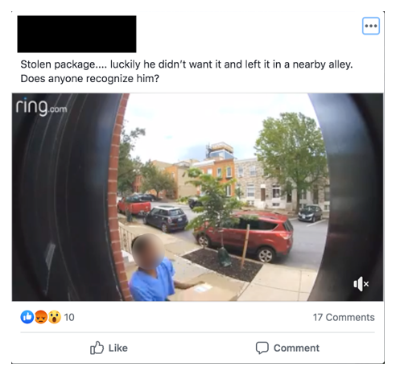
Figure 1. Canton Neighbors Facebook Post Example 1
In Figure 2, a man can be seen stealing a package from the front porch of a house with a Ring doorbell camera. The resident has posted a video of the accused stealing the package and asks the group members if anyone recognizes the individual.

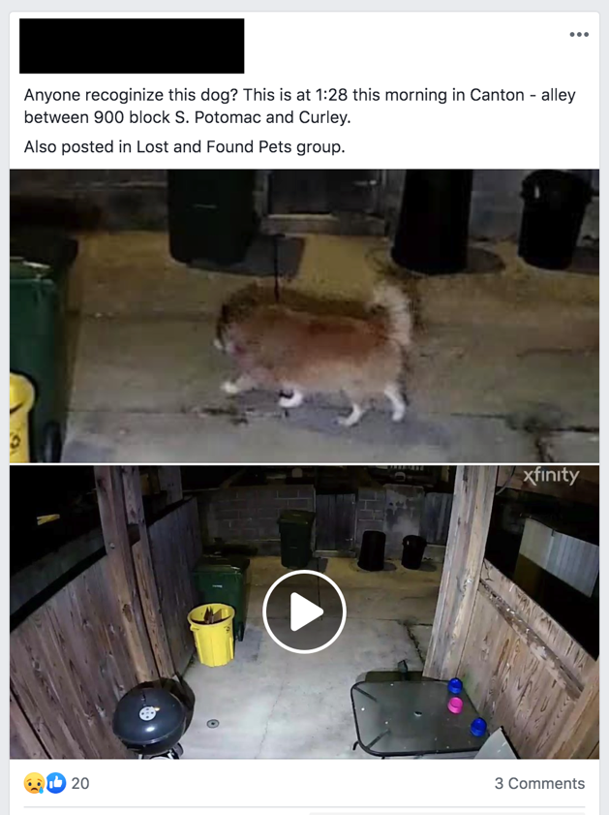
Figure 2. Canton Neighbors Facebook Post Example 2
In Figure 3, a resident posts video from their Xfinity security camera of a dog that is wandering in their alley. The resident is asking the group if anyone recognizes the dog so that it can be returned to its home.
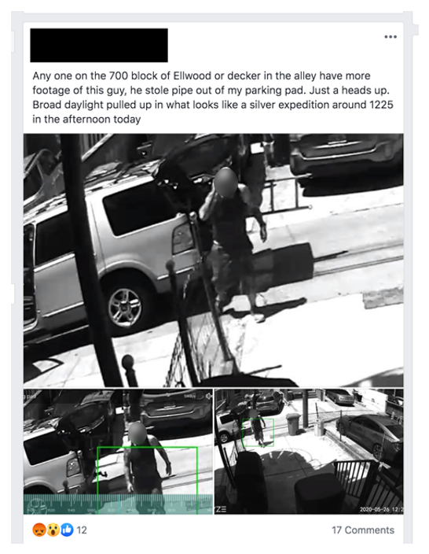
Figure 3. Canton Neighbors Facebook Post Example 3
In Figure 4, the resident has posted a series of still frame shots from a video camera and posted them to the neighborhood group in an attempt to identify the thief as well as alert neighbors and make them aware of the vehicle used in the crime.

Nextdoor
Nextdoor is another platform, similar to Facebook but differentiated by its model of organizing groups by default, based on the location of their residence (nextdoor.com, 2020). By comparison, Facebook groups are very broadly defined, Nextdoor is very specific to geographic location. When a new user signs up for Nextdoor, the first field they are required to fill in is their street address. It’s based on this street address, that the user is placed into the appropriate neighborhood, as defined by Nextdoor. Nextdoor then maintains directories for Public Agencies, Pets, and Neighbors. Unfortunately, since Nextdoor neighborhood groups are private to residents only, we do not have access to data regarding the number of members in each neighborhood.
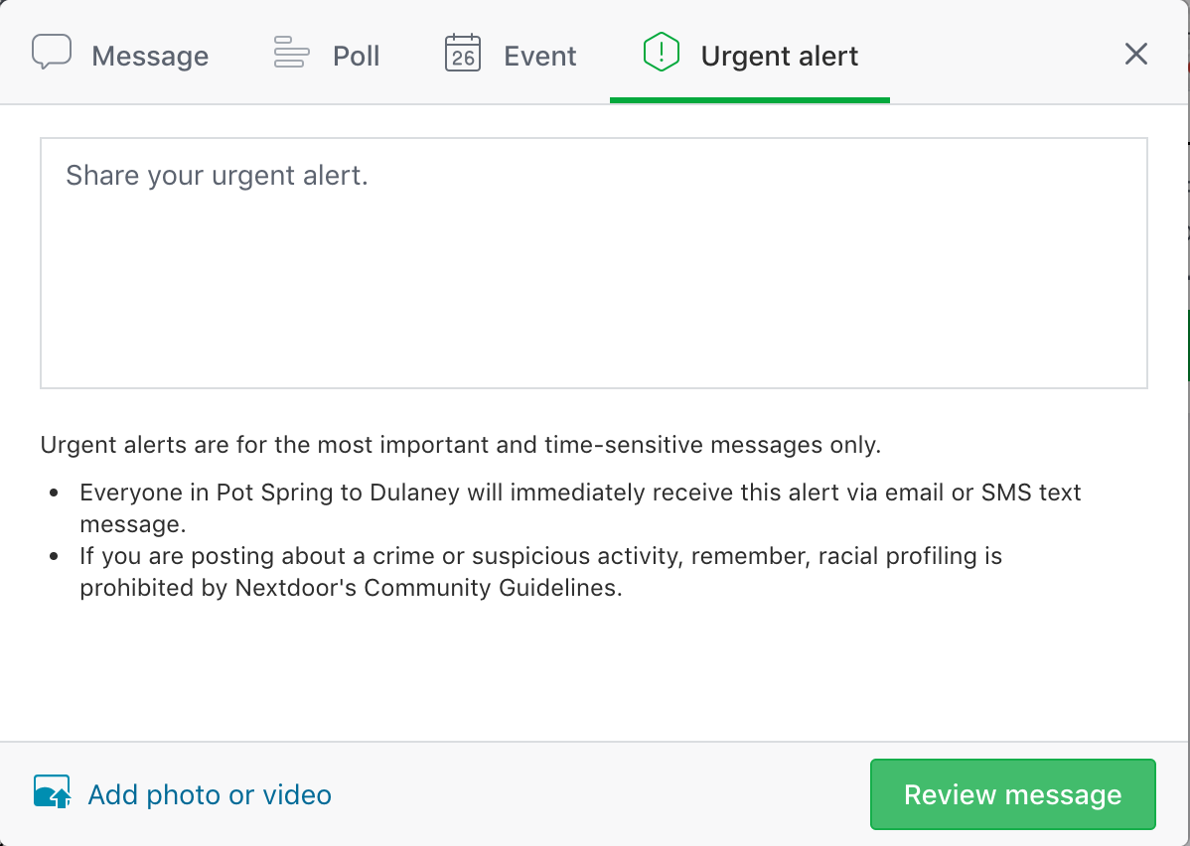
Figure 4. Nextdoor Urgent Alert Post Modal
Once a user is placed in their neighborhood, the interface is very similar to a Facebook Group. The user is also able to post to a board of recent activity and has many of the same rich content capabilities, such as uploading photos, video, events, or polls. However, there are key differences in these two platforms. As seen in Figure 5, Nextdoor allows users to notify their neighbors of an urgent alert via text message. Those who have enabled this form of notification will be notified in real time. Significantly, Nextdoor posts a disclaimer with this function that says, “If you are posting about a crime or suspicious activity, remember, racial profiling is prohibited by Nextdoor's Community Guidelines.” This disclaimer seems to reflect a recognition that neighborhoods may be segregated, and that segregation can lead to racial profiling.
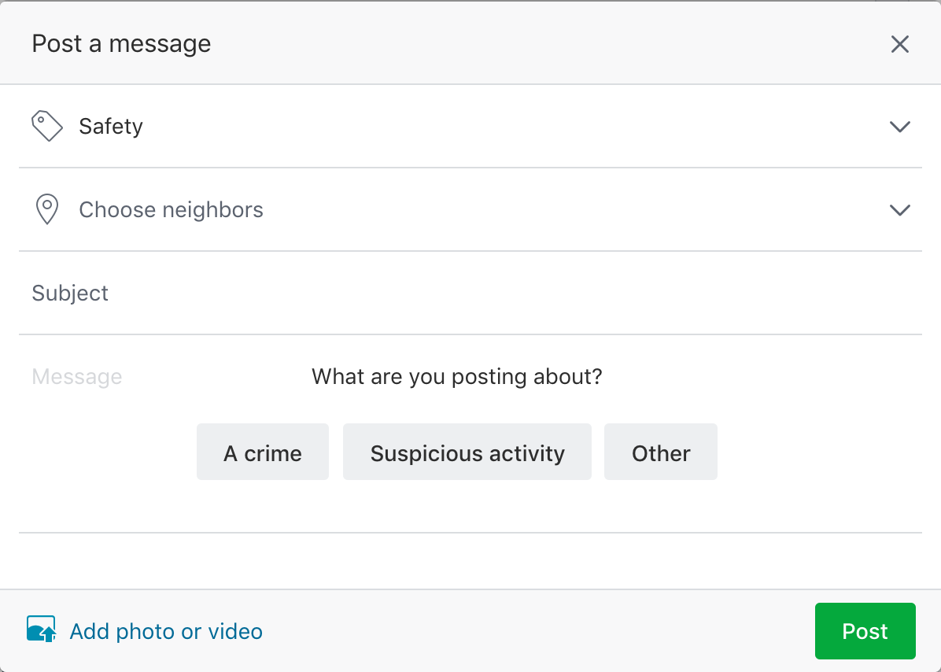
Figure 5. Nextdoor Safety Subchannel Post Modal
In addition, Nextdoor has a sidebar menu of subchannel or topics that a user can select. These include but are not limited to, Businesses, For Sale & Free, Local Deals, Events, Real Estate, Safety, Lost & Found, etc. This allows users to place their post in the appropriate subchannel, specific to their interest. Since crime and safety topics have their own subchannel, the user is not confronted with these items at first glance as they are in the Facebook Groups. Nextdoor also creates additional context in these subchannels for the posted content. For example, as seen in Figure 6, when posting in the Safety subchannel, the user must select whether the post is regarding a crime, suspicious activity, or other. Nextdoor takes more action in regulating the type of content and systematically moderating acceptable content versus allowing self-appointed moderators to police the channel as Facebook does.
Nextdoor has been criticized for its role in enabling racial profiling. However, in 2017 Nextdoor began taking steps to curb its users’ biases, forcing them to answer questions such as "is what I saw actually suspicious, especially if I take race or ethnicity out of the equation?" (Lambright, 2019.)

Ring Neighbors
Ring Neighbors is the newest platform of the three and is unique because it is a feature built into the app used to control and monitor Ring cameras. It is not limited to Ring camera owners, as there is a standalone public app available as well for individuals who do not own a Ring camera. Conceptually, it is built around the idea of sharing Ring camera footage and crime alerts amongst neighbors. Upon opening the Ring app, users will see a card/button at the top left corner of the app that is labeled, “Nearby Incidents.” Once clicked, the user is presented with a stream of recent activity, similar to those on Facebook or Nextdoor. However, each post is tied to a Ring Camera video clip from a neighbor’s home with a corresponding label.
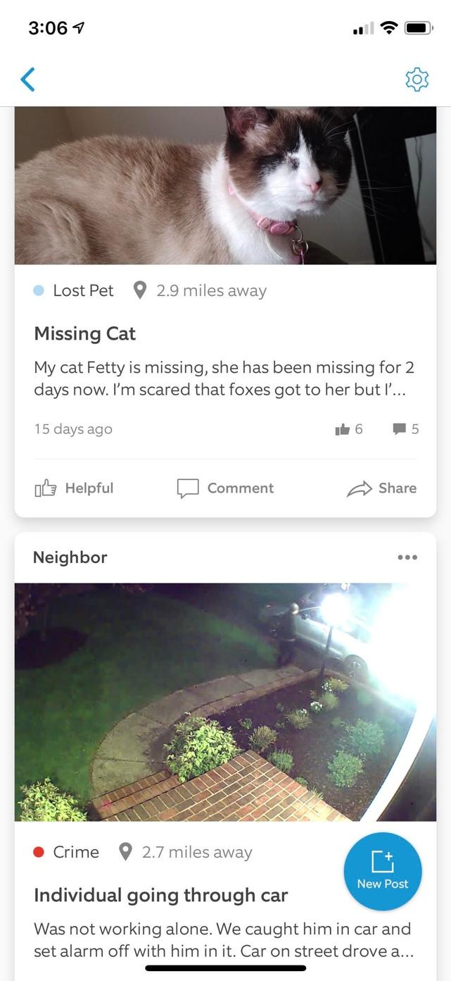
Figure 6. Ring Neighbors Activity Feed
As seen in Figure 7, the posts are anonymous but the location from your home is not. For example, the bottom post shows a crime that occurred 2.7 miles away (from the user’s home).
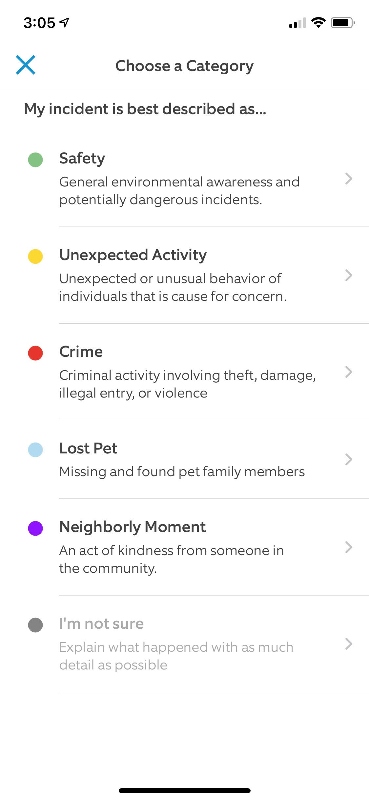
Figure 7. Ring Neighbors Post Step 1
As seen in Figure 8, users of Ring Neighbors App are able to post incidents with a category label of, Safety, Unexpected Activity, Crime, Lost Pet, Neighborly Moment, or I’m Not Sure.
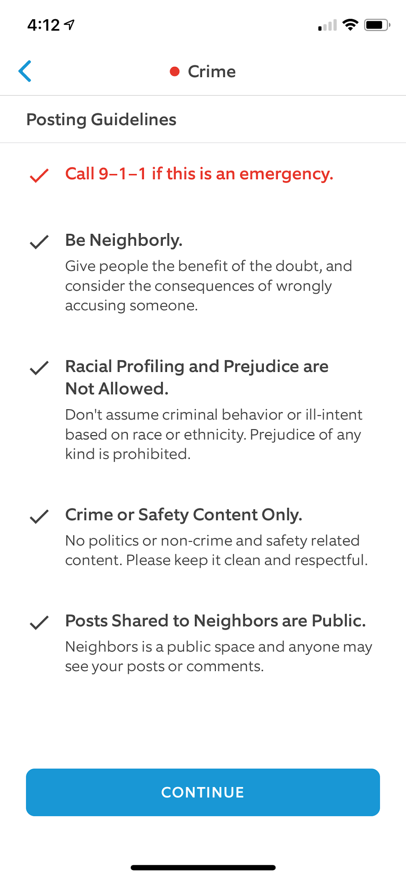
Figure 8. Ring Neighbors Post Step 2
As seen in Figure 9, once the Crime category is selected, the user is presented a series of Posting Guidelines. However, it is not clear how this is monitored and enforced.
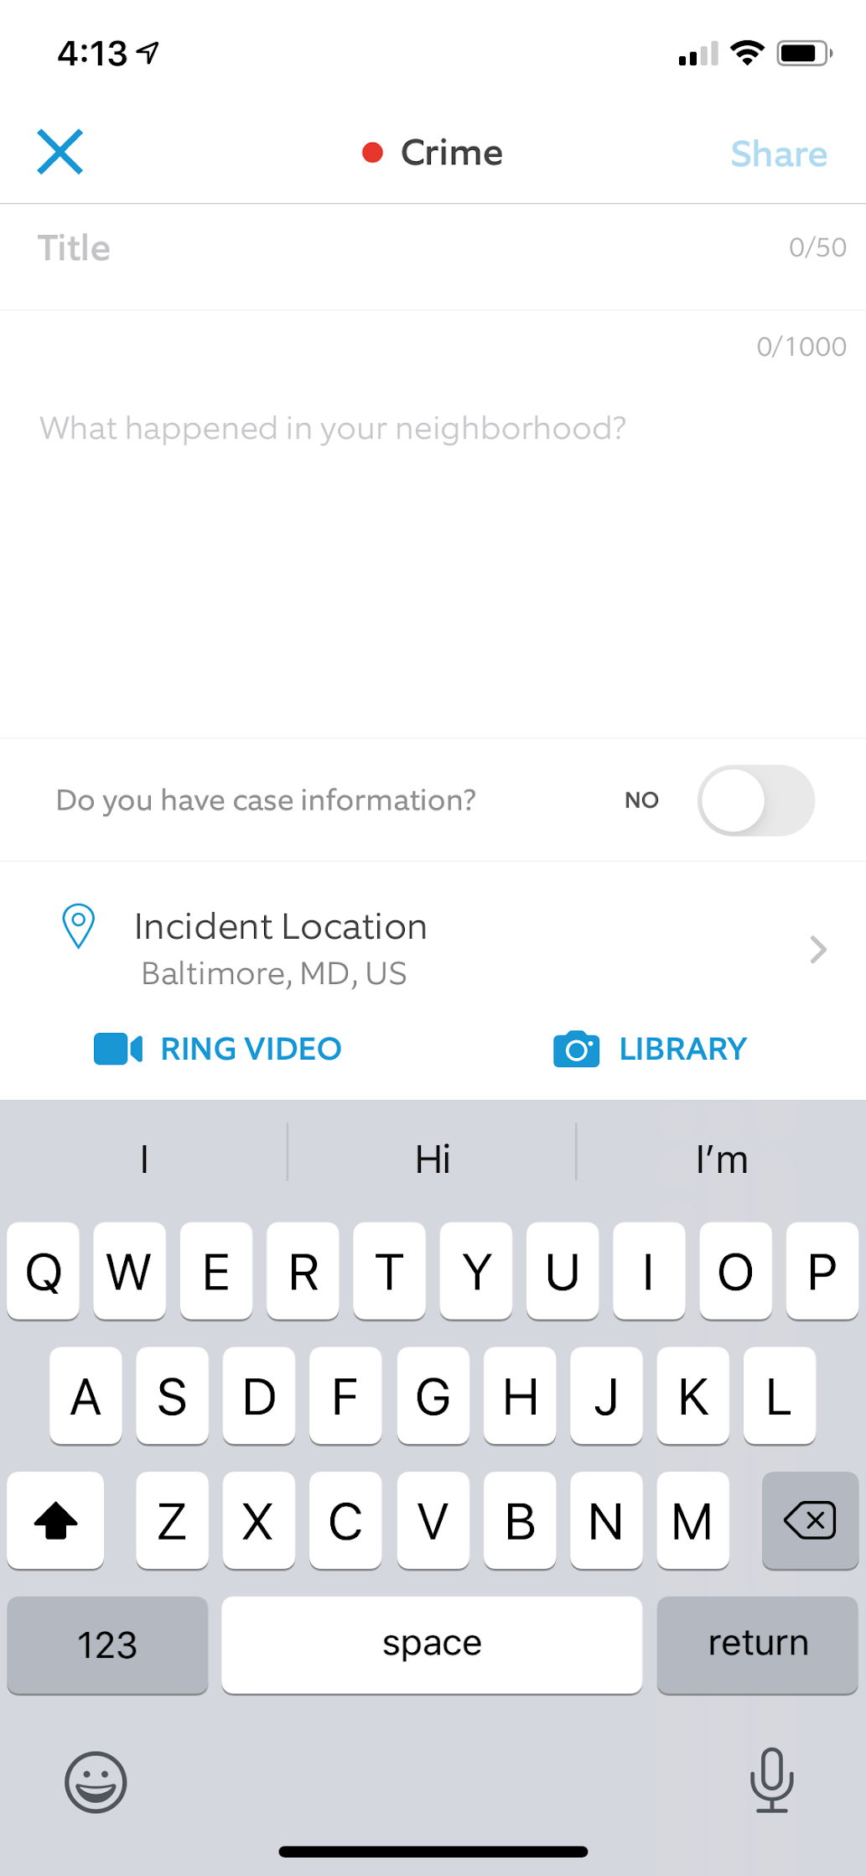
Figure 9. Ring Neighbors Post Step 3
As seen in Figure 10, once the user proceeds to the next step of the flow, they are asked to provide the location of the incident and have the opportunity to also upload supporting content such as Ring video footage or an image or video from the user’s device library.
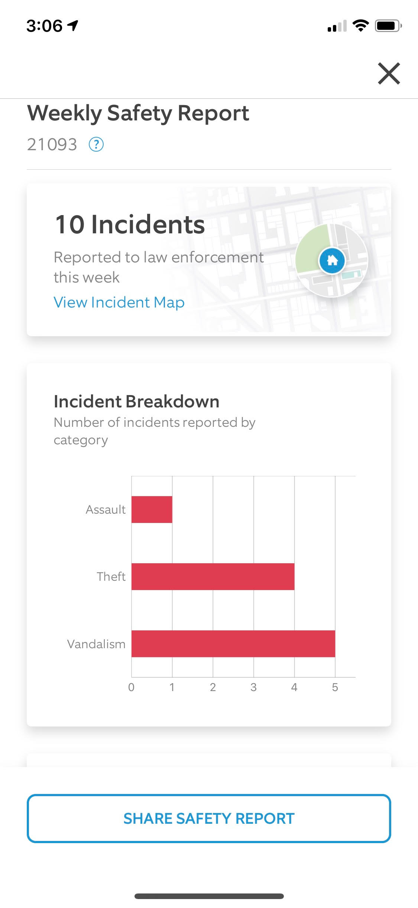
Figure 10. Ring Neighbors Weekly Safety Report
As seen in Figure 11, Ring Neighbors also displays a Weekly Safety Report. This allows the user to see a summary of all of the reported incidents in their area over the course of the prior week. It also states that these incidents were reported to law enforcement. The idea that residents are able to use their private home security camera footage to aid the police in investigating crimes, proactively introduces a new variable in the Digital Neighborhood Watch Platform concept. This also may create a skewed picture of the actual neighborhood safety as Ring Neighbors is only presenting the incidents that were reported through the app, which means this is entirely dependent on the neighborhood’s participation.
According to the Washington Post as of August 2019, Ring (owned by Amazon) has partnered with over 400 police forces, allowing them to request access to video footage to aid in criminal investigations.
“The partnerships let police request the video recorded by homeowners’ cameras within a specific time and area, helping officers see footage from the company’s millions of Internet-connected cameras installed nationwide, the company said. Officers don’t receive ongoing or live-video access, and homeowners can decline the requests, which Ring sends via email thanking them for ‘making your neighborhood a safer place.’” (Washington Post, 2019)

Citizen App
Citizen is an entirely different type of app. Its model makes 911 data available to citizens via notifications and near real-time crime mapping. According to their website, “Citizen is the only safety app that gives you instant access to verified 911 information. Know what’s happening as it’s happening, from fires and robberies to missing pets and natural disasters.”
According to the New York Times, “Under the hood, Citizen is essentially a transcription service for emergency radio. The company employs teams of people to listen to police, fire and emergency radio transmissions and to submit certain categories of incident for including in the app. (“Citizen has a detailed editorial guide about what goes into the app and why,” Mr. Donald said. “Citizen does not include, for example, suicides inside a private residence, suspicious people, or vague suspect descriptions.”)

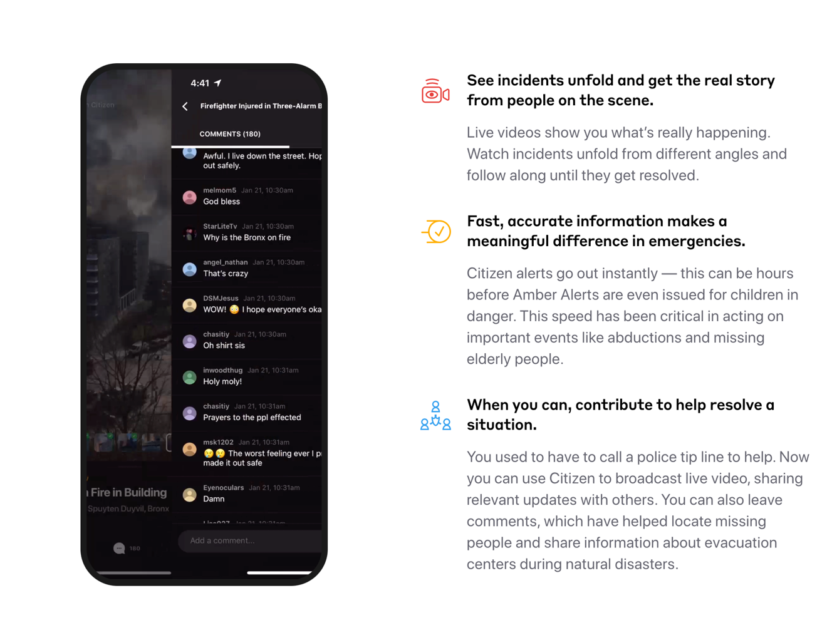
Figure 11. Citizen App Website
Formerly named Vigilante, Apple quickly banned the predecessor app due to safety concerns. The name Vigilante has since been changed as well as the focus of the apps Marketing, towards awareness and safety. However, as seen in Figure 12, Citizen still calls on users to actively participate in resolving emergencies where possible.
Since Citizen just recently became available in Baltimore, there is not enough reported on how this is being used and what the effects may be on the crime rate and neighborhood safety and perception, overall.

Chapter 3: Research Methodology
This study was comprised of two stages of research. The first was in the form of an online survey and the second was a series of in-depth interviews, targeting four specific personas. The online survey was intended to understand quantitatively, how WiFi-enabled home security cameras and their footage are being used and shared amongst neighborhood residents. The in-depth interviews took a deeper look at specific patterns that emerged in the survey as well as explored how this technology is affecting individuals, both in terms of their sense of safety and their overall well-being. Specifically, the research aimed to answer the following questions:
(1) do residents feel safer when home security cameras are present in their neighborhood?
(2) which do residents value more, privacy or security?
(3) are residents willing to share their public-facing home security camera footage?
(4) how have digital neighborhood watch programs, crime notifications, and crime alert apps affected resident’s perception of safety in their neighborhood?

Online Survey: Baltimore Neighborhood Security & Privacy
Social networking platforms have changed the way we engage with our communities. In the past an individual may have had to attend an organized community event or send information via a community newsletter or email thread if they wanted to connect with their neighbors. Due to platforms such as Facebook and Nextdoor, that’s no longer the case. Now all they need to do is sign-up, self-report their residence, and join the conversation. Once they've been accepted into a moderated group, they’re able to send posts, which may include various types of media, such as event invitations, images, video, and surveys.
Due to the digital focus of this research topic, it seemed appropriate to use the same social networking platforms that are enabling the digital neighborhood watch concept, to distribute this survey. In the sections to follow, the survey methodology, target audience, structure, results, and analysis will be discussed in detail. However, it is worth noting that this survey does not represent a cross-section of Baltimore’s population. Particularly, the neighborhoods which exhibit the highest rates of crime and poverty are not represented. Rather, the survey focuses on the neighborhoods which have active communities on social media platforms, and these communities skewed towards higher income and reduced racial diversity. Neighborhoods with different crime statistics, demographic, and socioeconomic makeup may yield different responses.

The Purpose of this Survey
The goal of this study was to understand how Baltimore City neighborhood residents felt about sharing their public-facing home security camera footage with their neighbors or with the police. It was also designed to explore the relationship between perceived privacy and perceived security in the context of public-facing home security camera surveillance.
In order to understand the general sentiment of a larger community, in this case a neighborhood, it was important to conduct a study that could reach a large group of participants at once and present a low barrier to entry. Therefore, the survey was distributed online and utilized a more quantitative approach to data collection. While the survey cast a wide net in terms of participants and questions, it was limiting in terms of the depth of questioning. This resulted in the need for a more qualitative study to confirm assumptions and seek additional details. A series of in-depth interviews were conducted in order to gain a deeper understanding of the residents’ views. This will be covered in later pages.

Tools Used and Survey Structure
There are several web-based tools available to create and distribute online surveys. Some of them are free, while others offer free and paid versions. For this survey Google Forms was used, which allowed for conditional branching and the coding of open text responses to identify patterns, which later informed the screening and interview guide in the in-depth interviews.
The survey, shown in Appendix A, consisted of several sections. The first section contained an introduction page and consent form. All responses were anonymous and therefore, no names or email addresses were collected.
The second section was designed to collect demographic and household information independently.
The third section focused on the participant’s history of owning and using a home security camera. The first question asked if they had in fact owned a home security camera. If not, participants continued to the next section. If they had, then they were asked additional questions about the specific brand and whether or not it was WiFi-enabled. Lastly, participants were asked questions about if and how their home security camera made them feel safe. The next section focused on video sharing and asked questions such as “Do you think if a crime occurred, your home security footage (exterior) could help the police?” Similar questions were asked about sharing video content with neighbors. The questions consisted of multiple-choice questions as well as open-ended text areas for additional comments and examples.
The next section focused not on the participants’ cameras, but the cameras their neighbors owned. The purpose of this section was to determine if the participant felt safer knowing that their neighbors were recording public spaces. Additionally, the participant was asked if they ever needed to use the video footage from their neighbors’ camera for any reason.
The last question asked in very general terms, what is more important to you, privacy or security? Available responses were in the form of radio buttons and included, Privacy, Security, or It depends. The participant was asked to further explain their response in an open text area.
The phrasing of each question was designed to minimize any biased language that could persuade a participant to select one answer over another.

Distribution and Data Collection
Since it was important to understand individual views as well as receive enough responses to understand the neighborhood-based patterns of thought, targeting neighborhoods with high engagement on social platforms was key. Canton, as well as Federal Hill, Hampden, and Mt. Washington, served as the focus of this research for the following reasons: (1) These neighborhoods have higher rates of juvenile and property crime and lower rates of violent crime as compared to the average figures across all Baltimore City neighborhoods, and (2) These communities have active neighborhood social networking groups.
Two social community platforms were used to distribute the survey, Facebook and Nextdoor. These two platforms are different but share many of the same attributes, including being web-based, free to sign up, widely used, and they enable private communities and notifications. Facebook allows communities to self-organize and create closed networks for their neighborhoods. These neighborhood Groups are typically managed by one or more moderators who establish guidelines for content, language, and conduct. In order to join a group, the individual may have to ask to join, provide their address, or answer a quick questionnaire to prove that they are in fact a neighborhood resident or at least someone who has ties to the neighborhood. This varies by group and is set up by the Group creator. Once they are a member of the Group, they are free to post to the Group’s page and engage in discussions. In order to post this survey, I had to first join the Groups for the neighborhoods that were targeted and explain the goals of my research to the group’s moderator so that it was not removed. Nextdoor is set up differently than Facebook. Nextdoor was created specifically for neighbors to communicate with those in their immediate communities. Because of this, when an individual register, they are required to provide their home address. Based on their address, they are placed in a community. Nextdoor provides channels within their community related to specific topics, such as Local Deals, Events, and Crime & Safety. The challenge with Nextdoor is that in order to distribute a survey to a specific community, you need to reside in that community. Since I do not live in all four neighborhoods that were being targeted, I had neighborhood residents distribute them on my behalf.

Neighborhood Demographic Breakdown
Canton, Federal Hill, Hampden, and Mount Washington are all separate and distinctly different neighborhood communities within Baltimore. Each has their own cultural identity. Geographically, they span from the southern to northern regions of Baltimore City. However, economically and racially, they are not as diverse as Baltimore City overall and do not represent a stratified sampling of Baltimore City. Instead, they represent white Baltimore. They have a higher than average median household income and higher than average home sale price. They also have lower than average crime rates, which was discussed in Chapter 1. These residents can typically afford to purchase home security cameras and are accustomed to paying a premium in terms of Baltimore City housing costs in order to live in a desirable neighborhood. Each of these factors will be considered and reiterated as this group does not represent Baltimore City’s residential population holistically.
Table 6
2017 Data from Community Statistical Area Profile

 | Median Household Income | Median Price of Homes Sold | Households Living Below Poverty Line | Racial Diversity Index | Violent Crime per 1,000 Residents | Non-Violent Crime per 1,000 Residents
Baltimore City (Overall) | $46,641 | $150,000 | 17.2% | 55.9 | 21.25 | 48.67
Canton | $111,891 | $306,500 | 4% | 26.3 | 10.37 | 33.46
Federal Hill | $98,763 | $300,000 | 2.3% | 45.4 | 16.49 | 44.42
Hampden | $65,099 | $210,000 | 6% | 39 | 10.87 | 36.06
Mount Washington | $79,993 | $298,500 | 2% | 52.3 | 10.26 | 35.60

Note. From, Baltimore Neighborhood Indicators Alliance

In-depth Interviews: Baltimore Resident’s First-hand Experience

The Purpose of the In-depth Interviews
The initial survey was successful in gathering a wide net of responses from the four selected Baltimore City neighborhoods to get an overall understanding of how people viewed their privacy and security as it relates to public-facing home security cameras and their impact on crime. However, the survey was quantitative in nature and therefore focused more on the “what” than the “why." Although the survey allowed participants to provide open-ended responses, it did not allow for unstructured conversation to explore associated concepts or emotions beyond what the participant was motivated to provide on their own. It also did not ask questions about online neighborhood platforms, which can serve as a digital neighborhood watch or apps that specifically serve up crime alerts. Since the subject matter can be personal and the participant’s worldview can be shaped by their past experiences, it is important to understand how their usage of this technology or their experiences with crime may be influencing their perception.
In addition, since the initial survey was conducted, there have been technological and experiential enhancements in the private home security industry that have changed how people are able to engage with their devices and their communities. Conducting in-depth interviews allowed for a deeper understanding of how these enhancements are being used, either actively or passively. An objective was also to explore how the use of this technology may be affecting the participants’ perception of safety as well as what additional or supplemental affect it may be having, physically or emotionally.

Participant Recruitment and Tools Used
At the time this research was conducted, the State of Maryland was under Stay at Home Orders to prevent the spread of the Coronavirus, Covid-19. Due to this unprecedented state of emergency, in-person recruitment and interviews were not possible. In lieu of this, I utilized my own personal and professional network to recruit twelve Baltimore City residents and former residents who moved out of Baltimore City within the last year. The 12 subjects were divided into four groups, each represented by three interviewees; (Group A) owners of cameras who actively participate in digital neighborhood watch groups (Group B) owners of cameras who do not actively participate in digital neighborhood watch groups (Group C) individuals who do not own cameras who actively participate in digital neighborhood watch groups (Group D) individuals who do not own cameras who do not actively participate in digital neighborhood watch groups. Their Baltimore City home also had to be located in one of the previously targeted neighborhoods; Canton, Federal Hill, Hampden, or Mt. Washington.
Participants were interviewed using Zoom so that the interviews could be conducted remotely. The interviewees were required to use a device with a camera so that expressions and body language could be observed. Participants were also asked to share their screen, if applicable. These interviews were also recorded for further analysis. Although the interviews are confidential, and no images of participants are used in reports of this research, de-identified screenshots are used to illustrate examples of neighborhood apps that the interviewee presented on camera during the interview.

Interview Structure
At the beginning of each interview, the participant was introduced to the research topic, notified that the interview would be conducted confidentially, and asked for verbal consent to continue. Once the interview began, the participant was asked to provide the same demographic information as those who participated in the initial survey.
The interviewee was then asked to explain if they own a public-facing security camera. If yes, they were asked a series of questions, such as; why they initially purchased it, what features they were looking for, how it’s used, etc. As with the nature of semi-structured interviews, the conversations shifted depending on the information that was offered up by the interviewee.
The next series of questions focused on their experience with online social communities, specific to their neighborhood’s crime and safety. This set of questions was relevant, even if the interviewee did not own a camera. Example questions included; how do they engage with their neighborhood communities in a digital format, do they receive notifications or updates in real-time or any other cadence (e.g., weekly email), do the online communities ever share or request video footage, and how does this impact their perceptions of privacy and security?
Although the in-depth interviews were conducted using a similar structure or interview guide, discussions were fluid and went in different directions based on the experiences or opinions shared by the interviewee.

Chapter 4: Findings

Online Survey: Baltimore Neighborhood Security

Participation Results
The online survey was distributed on October 31, 2018 and remained active through November 30, 2018. However, the majority of responses were received in the first two weeks, ending on November 15th. In that time period, 289 Baltimore City residents responded to the survey. Of those that responded, 76.5% were homeowners and 22.5% were renters.
Table 7
Baltimore Neighborhood Security & Privacy Survey: Your Baltimore City Neighborhood

Neighborhood |  | Number of Respondents | Percentage of Respondents
Canton | 58 |  | 20.1%
Federal Hill | 68 |  | 23.5%
Hampden | 55 |  | 19%
Mt. Washington | 34 |  | 11.8%
Roland Park | 6 |  | 2.1%
Locust Point | 4 |  | 1.4%
Hoes Heights | 3 |  | 1%
Fells Point | 3 |  | 1%
Upper Fells Point | 3 |  | 1%
Patterson Park | 3 |  | 1%
Fells point | 3 |  | 1%
Upper Fells | 3 |  | 1%
Other (37) | 46 |  | 16.1%

Note. From, Baltimore Neighborhood Security & Privacy Survey
As seen in Table 7, there was fair distribution across the targeted neighborhoods with 23.5% of respondents residing in Federal Hill, 20.1% in Canton, 19% in Hampden, and 11.8% in Mount Washington. In total, there were 49 neighborhoods, but none of the 45 additional self-reported neighborhoods represented more than 2% of respondents. Furthermore, these self-reported neighborhoods were in many cases, considered to be part of the larger neighborhood that was being targeted. Those that were not, shared a border with the primary-targeted neighborhood. Lastly, since the respondents were all actively participating in the online neighborhood groups where the surveys were distributed, their responses will remain as part of the data set.

Demographic Breakdown
Table 8
Baltimore Neighborhood Security & Privacy Survey: Demographics

Category | Groups | Count |  | Percentage
Gender | Female |  | 186 | 64.4%
Gender | Male |  | 97 | 33.6%
Gender | Prefer Not to Say |  | 5 | 1.7%
Gender | Gender Non-Conforming (GNC) |  | 1 | 0.3%
Age | 18 – 20 |  | 0 | 0%
Age | 21 – 29 |  | 55 | 19%
Age | 30 – 39 |  | 92 | 31.8%
Age | 40 – 49 |  | 41 | 14.2%
Age | 50 – 59 |  | 47 | 16.3%
Age | 60 or Older |  | 54 | 18.7%
Race/Ethnicity | American Indian or Alaskan Native |  | 0 | 0%
Race/Ethnicity | Asian / Pacific Islander |  | 8 | 2.8%
Race/Ethnicity | Black or African American |  | 3 | 1%
Race/Ethnicity | White / Caucasian |  | 264 | 91.3%
Race/Ethnicity | Multiple ethnicity |  | 9 | 3.1%
Race/Ethnicity | Hispanic |  | 2 | 0.7%
Race/Ethnicity | Undisclosed |  | 3 | 1%
Relationship Status | Married |  | 141 | 48.8%
Relationship Status | Widowed |  | 8 | 2.8%
Relationship Status | Divorced |  | 25 | 8.7%
Relationship Status | Separated |  | 1 | 0.3%
Relationship Status | In a domestic partnership or civil union |  | 9 | 3.1%
Relationship Status | Single, but cohabitating with a significant other |  | 45 | 15.6%
Relationship Status | Single, never married |  | 60 | 20.8%
Education Level | Primary school |  | 1 | 0.3%
Education Level | Some high school, but no diploma |  | 1 | 0.3%
Education Level | High school diploma (or GED) |  | 6 | 2.1%
Education Level | Some college, but no degree |  | 22 | 7.6%
Education Level | 2-year college degree |  | 13 | 4.5%
Education Level | 4-year college degree |  | 111 | 38.4%
Education Level | Graduate-level degree |  | 135 | 46.7%
Employment Status  (Select all that apply) | Employed full-time |  | 211 | 73%
Employment Status  (Select all that apply) | Employed part-time |  | 28 | 9.7%
Employment Status  (Select all that apply) | Retired |  | 34 | 11.8%
Employment Status  (Select all that apply) | Student full-time |  | 8 | 2.8%
Employment Status  (Select all that apply) | Student part-time |  | 8 | 2.8%
Employment Status  (Select all that apply) | Self employed |  | 2 | 0.7%
Employment Status  (Select all that apply) | Unemployed |  | 2 | 0.7%
Employment Status  (Select all that apply) | Other |  | 8 | 2.8%
Personal Income | Less than $20,000 |  | 9 | 3.1%
Personal Income | $20,000 - $34,999 |  | 17 | 5.9%
Personal Income | $35,000 - $49,000 |  | 34 | 11.8%
Personal Income | $50,000 – $74,999 |  | 73 | 25.3%
Personal Income | $75,000 - $99,999 |  | 68 | 23.5%
Personal Income | $100,000 - $149,999 |  | 49 | 17%
Personal Income | $150,000 or more |  | 39 | 13.5%

Note. From, Baltimore Neighborhood Security & Privacy Survey
As shown in Table 8, the majority of respondents were women at 64.4%. However, age ranges were fairly evenly distributed. Ages 30-39 represented the largest group of respondents at 31.8%, followed by 21-29 at 19%, 60 or older at 18.7%, 50-59 at 16.3%, and 40-49 at 14.2%. One demographic category that was not evenly distributed was race and ethnicity. Of the 289 respondents, 91.3% reported being white/Caucasian. Although the majority of residents in the neighborhoods targeted for this survey are white/Caucasian, the survey respondents skewed even farther white (nine out of ten). For example, as of 2017, according to the Baltimore Neighborhood Indicators Alliance, Canton was 85.6% white/Caucasian, Hampden was 77.1%, Federal Hill was 71.9%, and Mount Washington was 64.7%. Also, half of respondents were married at 48.8%. The majority of respondents held college degrees, 38.4% had undergraduate degrees, while 46.7% had graduate degrees, totaling 85.1% of participants with a bachelor’s degree or higher. According to the Baltimore Neighborhood Indicators Alliance, as of 2017, 70.2% of Canton residents, 55.8% of Hampden residents, 70.4% of Federal Hill residents, and 70.4% of Mount Washington residents had a bachelor’s degree or higher. In summary, the participants do not represent a cross section of the neighborhood demographics, as there is a higher than average representation of white/Caucasian participants, women, and participants with higher than average education levels (Alliance, 2020.)

Security Cameras and Content Sharing Questions
Table 9
Baltimore Neighborhood Security & Privacy Survey: Home Security
Question | Responses | Count |  | Percentage | 95% Confidence Interval
Do you own an exterior home security camera?  289 responses | Yes |  | 92 | 31.8% | -
Do you own an exterior home security camera?  289 responses | No |  | 197 | 68.2% | -
Why do you not own one?  If the answer was “no” -  197 responses | I don’t think I need one |  | 25 | 12.7% | 8% - 17%
 | I don’t think they help with crime |  | 15 | 7.6% | 4% - 11%
 | I think they are too expensive |  | 6 | 3% | 1% - 5%
 | I may get one in the future |  | 93 | 47.2% | 40% - 54%
 | I’m concerned about privacy |  | 4 | 2% | 0% - 4%
 | I never really thought about it |  | 24 | 12.2% | 8% - 17%
 | Other |  | 30 | 15.2% | 10% - 20%
Which brand do you own?  If the answer was “yes” -  92 responses | Nest |  | 22 | 23.9% | -
 | Samsung |  | 5 | 5.4% | -
 | Ring |  | 19 | 20.7% | -
 | Arlo |  | 16 | 17.4% | -
 | Other |  | 30 | 32.6% | -
Is your camera connected to WiFi?  92 responses | Yes |  | 79 | 85.9% | -
Is your camera connected to WiFi?  92 responses | No |  | 9 | 9.8% | -
Is your camera connected to WiFi?  92 responses | Not sure |  | 4 | 4.3% | -
If so, are you concerned about privacy?  92 responses | Yes, always |  | 10 | 10.9% | 4% - 17%
If so, are you concerned about privacy?  92 responses | Yes, sometimes |  | 17 | 18.5% | 10% - 27%
If so, are you concerned about privacy?  92 responses | No, not really |  | 44 | 47.8% | 37% - 58%
If so, are you concerned about privacy?  92 responses | I never think about it |  | 13 | 14.1% | 7% - 21%
If so, are you concerned about privacy?  92 responses | My camera is not connected to WiFi |  | 8 | 8.7% | 3% - 15%
Does your home security camera make you feel safer while in your home?  92 responses | Yes, always |  | 30 | 32.6% | 23% - 42%
 | Yes, sometimes |  | 28 | 30.4% | 21% - 40%
 | No, not really |  | 22 | 23.9% | 15% - 33%
 | I never think about it |  | 9 | 9.8% | 4% - 16%
 | They aren’t working |  | 1 | 1.1% | 0% - 3%
 | Other |  | 2 | 2.2% | 0% - 5%
Does your home security camera make you feel safer while you are not home?  92 responses | Yes, always |  | 36 | 39.1% | 29% - 49%
 | Yes, sometimes |  | 34 | 37% | 27% - 47%
 | No, not really |  | 19 | 20.7% | 12% - 29%
 | I never think about it |  | 2 | 2.2% | 0% - 5%
 | They aren’t working |  | 1 | 1.1% | 0% - 3%

Note. From, Baltimore Neighborhood Security & Privacy Survey
Results shown in Table 8 can be viewed numerically or as a percentage. Additionally, confidence intervals have been calculated, where applicable. This can be read as; we are 95% confident that between 8% and 17% of individuals do not own a home security camera because they don’t think they need one. For this particular question, 12.7% of our 197 respondents selected this answer. In the sections to follow, I will refer to the survey results only. However, confidence intervals can be viewed in the associated table.
Out of the 289 total respondents, only 31.8% owned their own home security camera. This equates to 92 participants who were able to provide first-hand experience on owning and sharing their own cameras and footage. Of the remaining 197 individuals who did not own a home security camera, the most common response (47.2%) when asked, why do you not own one? was I may get one in the future. The second most common response at 12.2% was I never really thought about it. Only 2% or 4 individuals reported being concerned about privacy. However, 7.6% or 15 individuals reported that they do not think they help with crime. Additional responses were provided in an open-ended response where several respondents reported living in a condo building or citing another reason why owning and operating a camera was not feasible. Based on the responses, most respondents were willing to purchase a camera in the future if they didn’t own one already. Only a small percentage of respondents expressed concerns with cost or privacy issues, leading us to believe that an individual’s reason for owning or not owning a camera has more to do with perceived effectiveness, feasibility, and convenience.
Out of the 92 individuals who reported owning a private home security camera, the most common brand was Nest at 23.9% of cameras, followed by Ring at 20.7%, then Arlo at 17.4%. The last notable brand was Samsung at 5.4%. In total, 30 different brands were reported but none of the remaining were owned by more than 2.2% of the respondents. This is not surprising, as Nest and Ring are heavily marketed, being owned by Google (Nest) and Amazon (Ring).
Of the 92 respondents who reported owning private home security cameras, 85.9% of them reported having their cameras connected to WiFi. When asked if they were concerned about privacy, 18.5% reported being concerned about privacy sometimes, and another 10.9% reported that they are always concerned about privacy. As seen in Table 9, the majority of camera owners do not think about or believe privacy to be an issue. However, only 2% (4) of respondents who do not own cameras cited privacy as an issue. Therefore, it may be inferred that around 20% of respondents may have developed privacy concerns after he or she owned a camera and began using it.
When asked if the cameras made them feel safer while in their home, 32.6% responded Yes, always, 30.4% responded Yes, sometimes - meaning the majority of respondents who owned cameras did feel safer while in their homes. Of the remaining respondents, 23.9% reported No, not really, and 9.8% reported I never think about it. Interestingly, respondents reported more strongly that their cameras made them feel safe when they were not home. People seem to think about their cameras less when they are home but when they are away from the home, the cameras make them feel safer.
Table 10
Baltimore Neighborhood Security & Privacy Survey: Home Security Camera Video
Question | Responses | Count |  | Percentage | 95% Confidence
Has any neighbor ever needed to view your security footage for any reason?  92 responses | Yes |  | 46 | 50% | 40% - 60%
 | No |  | 46 | 50% | 40% - 60%
Have the police ever needed to view your security footage for any reason?  92 responses | Yes |  | 29 | 31.5% | 22% - 41%
 | No |  | 63 | 68.5% | 59% - 78%
Do you think if a crime occurred, your home security footage (exterior) could help the police?  92 responses | Yes |  | 85 | 92.4% | 87% - 98%
 | No |  | 7 | 7.6% | 2% - 13%
Do you pay for a monthly subscription for your home security footage?  92 responses | Yes |  | 35 | 38% | -
 | No |  | 57 | 62% | -
If so, how much do you pay per month?  92 responses | Less than $5 |  | 11 | 12% | -
If so, how much do you pay per month?  92 responses | $6 - $9 |  | 6 | 6.5% | -
If so, how much do you pay per month?  92 responses | $10 - $19 |  | 10 | 10.9% | -
If so, how much do you pay per month?  92 responses | $20 - $39 |  | 5 | 5.4% | -
If so, how much do you pay per month?  92 responses | $40 - $59 |  | 0 | 0% | -
If so, how much do you pay per month?  92 responses | $60 or more |  | 2 | 2.2% | -
 | I do not pay for a subscription |  | 58 | 63% | -
Would you ever share your exterior (street or alley facing) security camera footage with your neighbors?  92 responses | Yes |  | 79 | 85.9% | 79% - 93%
 | No |  | 1 | 1.1% | 0% - 3%
 | It depends |  | 12 | 13% | 6% - 20%
Would you ever share your exterior (street or alley facing) security camera footage with the police?  92 responses | Yes |  | 83 | 90.2% | 84% - 96%
 | No |  | 0 | 0% | -
 | It depends |  | 9 | 9.8% | 4% - 16%
Do your neighbor’s home security cameras make you feel safer while walking?  289 responses | Yes, always |  | 50 | 17.3% | 13% - 22%
 | Yes, sometimes |  | 66 | 22.8% | 18% - 28%
 | No, not really |  | 81 | 28% | 23% - 33%
 | I never think about it |  | 80 | 27.7% | 22% - 33%
 | Not at all |  | 1 | 0.3% | 0% - 1%
 | Other |  | 11 | 3.8% | 2% - 6%
Do your neighbor’s home security cameras make you feel safer while you’re not home?  289 responses | Yes, always |  | 43 | 14.9% | 11% - 19%
 | Yes, sometimes |  | 63 | 21.8% | 17% - 27%
 | No, not really |  | 85 | 29.4% | 24% - 35%
 | I never think about it |  | 89 | 30.8% | 25% - 36%
 | Not at all |  | 1 | 0.3% | 0% - 1%
 | Other |  | 8 | 2.8% | 1% - 5%
Have you ever needed to view a neighbor’s security camera footage for any reason?  289 responses | Yes |  | 39 | 13.5% | 9% - 18%
 | No |  | 250 | 86.5% | 82% - 91%

Note. From, Baltimore Neighborhood Security & Privacy Survey

As seen in Table 10, half of the respondents reported having needed to share their camera footage with a neighbor. In addition, 31.5% reported having to share their security footage with the police. This is important to note since it implies that 1 out of 3 respondents potentially captured a crime on their home security camera. It also confirms that the police are actively seeking out this footage for use in their investigations. When asked if they believed their footage could help the police if a crime occurred, 92.4% said yes. This leads us to believe that the camera footage being shared amongst neighbors is not always crime related, or that it was capturing an incident that was not necessarily shared with the police.
Of the 92 respondents who own a home security camera, 38% of them reported paying for a monthly subscription. For context, many camera brands offer free and paid subscriptions that in many cases can be the difference between live video access versus paid storage and additional features. Although the subscription costs vary, 79% reported paying less than $20 a month, and 50% reported paying under $10 a month.
When asked “Would you ever share your exterior (street or alley facing) security camera footage with your neighbors?” 85% responded with yes, 13% responded with “It depends,” while only 1% responded with no. One respondent wrote, “While I don't know or necessarily trust everyone in the neighborhood, the risk versus reward usually dictates sharing footage of crime with neighbors for awareness, deterrence, and to help resolve incidents.” Another respondent expressed potential privacy and equity concerns by stating,
“Unclear whether this would be (a) On request or (b) Always through a feed that they have access to. If (a) then then it would depend on circumstances. If (b), then at least for personal privacy and security. But also, my neighbors who would also be recorded. If the wrong person gets access e.g. racist calls cops on PoC for no real reason.”
This person is implying that if a video feed was accessible by others, this could introduce privacy issues and explicitly mentions not wanting this to be misused by the police. When asked the same question about sharing with police directly, none responded with no and only 9.8% responded with It depends. The open-ended responses explaining their selection were mostly consistent and centered around solving crime. However, one respondent did specify that they would be willing to share a video clip, not a live feed.
Participants were also asked if their neighbor’s home security cameras make them feel safer when walking. Of the full 289 respondents, 17.3% responded with “Yes, always.” Another 22.8% responded with “Yes, sometimes.” Thus, a total of 116 out of 289 people felt safer when walking in the presence of their neighbor’s home security cameras. However, there were a variety of open-ended responses that ranged from “I don’t think about it” to “Cameras don’t prevent crime.” This is a topic that will be explored in more detail as part of the in-depth interviews section. When asked, “Do your neighbor’s home security cameras make you feel safer while you’re not home?” 21.8% responded “Yes, always,” and 29.4% responded “Yes, sometimes,” meaning that about half of the people who responded to this survey felt that having home security cameras present in their neighborhoods made them feel safer when they were walking as well as when they were not home.

Open-ended Responses
The survey included several opportunities for the participants to add additional context to their answers via an open-ended response text area, some of which were referenced above. In the last question of the survey, the participants were asked “What is more important to you, privacy or security?” This question was intentionally vague as the goal was to illicit written responses. This was successful as 96 individuals provided a written explanation of their selection.
Table 11
Baltimore Neighborhood Security & Privacy Survey: Privacy or Security
Question | Responses |  | Count | Percentage |  | 95% Confidence Interval
What is more important to you, privacy or security?  289 responses | Privacy | 33 |  |  | 11.4% | 8% - 15%
 | Security | 182 |  |  | 63% | 57% - 69%
 | It depends | 74 |  |  | 25.6% | 20% - 31%

Note. From, Baltimore Neighborhood Indicators Alliance
As seen in Table 11, all 289 participants who began the survey, completed the last question. Only 11.4% or 33 individuals selected privacy as being more important than security. An overwhelming majority of 63% or 182 individuals selected security as being more important than privacy. For the 25.6% or 74 individuals who selected “It depends,” it appeared that neither privacy nor security were definitively more important than the other in all situations. The open-ended responses were key in understanding which circumstances would push these individuals to prioritize privacy over security, and vice versa, or if this could be done at all in some cases.
The 96 responses were coded and then grouped into relevant themes using an affinity mapping exercise. Once completed, the responses formed 13 themes that were further grouped in to five categories. Some responses expressed the themes of more than one category and therefore counted more than once.
Table 12
Baltimore Neighborhood Security & Privacy Survey: Response Mapping
Response Theme | Count |  | Percentage
Category 1: Tension between privacy and security
There must be a balance of privacy and security |  | 16 | 16.7%
Bad question, the answer is neither |  | 6 | 6.3%
Total security is not achievable |  | 1 | 1.0%
Category 2: Safety is more important than privacy
In Baltimore City, safety must come first |  | 17 | 17.7%
Cameras serve as a deterrent and help solve crimes |  | 7 | 7.3%
You need security to have privacy |  | 8 | 8.3%
Category 3: Privacy is not important
I have nothing to hide |  | 17 | 17.7%
Category 4: Privacy is important
Cameras should not target private areas |  | 11 | 11.46%
I trust individuals, not institutions and how they may use my data |  | 6 | 6.3%
Privacy above all |  | 3 | 3.1%
Category 5: Negative sentiment towards cameras
Cameras are not effective |  | 7 | 7.3%
Cameras cause suspicion |  | 2 | 2.1%
Other |  | 4 | 4.17%
* Bold text signifies that this theme was expressed by more than 10% of responses
Note. From, Baltimore Neighborhood Security & Privacy Survey
Category 1 responses each expressed a tension between privacy and security. Collectively, these responses represented a quarter of all responses at 24%. The largest group to emerge was Category 2. This group contains themes that all express support for security cameras, prioritizing safety over privacy. Arguably, Category 3 may also be merged with Category 2, since the sentiment of having nothing to hide is indirectly in support of increased security measures by being less concerned with privacy. Together, Category’s 2 and 3 represented half of the responses at 51%. Category 4 expressed a priority of privacy over security in some way and represented 20.9% of responses. Lastly, Category 5 responses expressed negative sentiments toward cameras and represented 9.4% of the comments.
The strongest themes to emerge will be discussed in more detail and are styled as bold within Table 12. Each of these received more than 10 similar comments or 10% of the overall comments. These include the following themes;
(1) In Baltimore City, safety must come first
(2) I have nothing to hide
(3) There must be a balance of privacy and security
(4) Cameras should not target private areas
Taking a closer look at the theme of There must be a balance of privacy and security, several responses argue that both privacy and security are equally important and can be mutually exclusive. For example, one respondent stated “I value both equally. While I feel I have nothing to hide, and thus would say security, I wouldn’t want any entity taking advantage of that and risking my privacy.” Similarly, another respondent wrote “It is a compromise. Both are important. I wouldn’t mind if everyone had cameras, but I don’t want them all linked up and searchable, that would cross a line for me.” In both responses, it is clear that while security is important, there is a boundary where privacy takes precedent. For many, the line seems to be providing access to live video streams or video on demand. In earlier survey questions, it was also clear that most individuals were comfortable with the idea of sharing their video footage with neighbors or the police as long as it was in support of solving a crime and on their terms.
In Baltimore City, safety must come first. This theme was consistently and passionately communicated by several participants. For example, one respondent wrote “In Baltimore City? Security, hands down.” Another respondent wrote, “The crime in this city is beyond absurd, and I've lived in some pretty sketchy neighborhoods in Detroit, St. Louis, New Orleans, Washington DC, and Birmingham. I've never, ever, ever experienced crime like the crime I've experienced on a regular basis in Baltimore.” A third respondent wrote " I used to be anti-security camera but as crime increased in my neighborhood, I reluctantly got a camera several years ago. As more neighbors got cameras, we've been able to get good "actionable" footage of criminals. It also helps to see how much crime actually goes on - it's been eye opening.” In each of these comments, the theme is that Baltimore, specifically, exacerbates the need to prioritize security due to its prevalence of crime. It’s especially telling that one of the respondents began as “anti-security camera” and was then converted by their experiences. A few respondents went so far as to suggest that additional surveillance measures should be taken in Baltimore, beyond home security cameras. For example, one respondent wrote “I prefer safety; I would like to bring the helicopters that surveilled the city.” Clearly white residents value safety over privacy, with some limits.
For some, even with additional security measures, the crime in Baltimore has made them feel too unsafe to continue living in the city. For example, one respondent wrote “I just moved to Baltimore in June and loved the community but now I do not feel safe anymore. I’m not sure if I will continue my lease or not.”
The third theme to emerge in the open-ended responses was I have nothing to hide. This statement was used verbatim in some cases when describing why privacy was not a concern. For example, one respondent wrote “I am not concerned about my privacy - I have nothing to hide.” Another respondent mentioned having nothing to hide but then continued to describe better approaches to public safety than implementing cameras. “I don’t feel like I have anything to hide, especially in terms of being recorded outside my house in my neighborhood, but I don’t particularly like the idea of potentially being recorded anywhere. I feel that a community of neighbors who know each other and pay attention to what’s happening on their street and spend time outside is a better solution to neighborhood crime and socially healthier than installing cameras, which I feel only heightens an environment of mistrust and suspicion.” In this way, the statement almost protects the individual from sharing their actual opinion. In several of these comments, the respondents also mention that concept of there being no privacy expectations when on the public street – therefore, I have nothing to hide expresses their acceptance of surveillance as part of life when in public. This is also a statement of privilege that may not be reflected in the views of all Baltimore residents.
The fourth major theme to emerge was Cameras should not target private areas. For example, one respondent wrote “I don't want neighbors cameras aimed into a house window.” Similarly, another respondent wrote “When I'm outside in a common area, it's public space and I don't have an expectation of privacy. However, if cameras are filming inside my home or within my privacy fence then I would feel that was an invasion of my privacy and would be very unhappy about it.” Another respondent wrote “With regards to cameras, I don't believe they should point towards another person’s private property.” This is interesting given that most homes in Baltimore City are row homes and therefore are positioned very close together. It’s almost guaranteed that cameras positioned towards public streets such as streets or allows would contain at least some glimpse into a private space such as the front window of the home across the street, or the parking pad of the neighbor’s property, incidentally. In fact, in many cases neighbors share camera footage with one another for this reason.
These themes were explored in more detail in the in-depth interviews. Many of the same sentiments were expressed.

In-depth Interviews: Results & Analysis

Participant Results
In total, 12 interviews were conducted in May of 2020. Each interview lasted 20 - 30 minutes in duration. Although the interviews were conducted anonymously, basic demographic information can be viewed in Table 13.
Table 13
In-depth Interviews: Baltimore Resident’s First-hand Experience: Demographics
Participant | Gender | Age Group | Race | Marital Status | Neighborhood
Interviewee 1 | Female | 30 - 39 | Caucasian | Married | Mt. Washington/Federal Hill
Interviewee 2 | Female | 30 - 39 | Caucasian | Single | Canton
Interviewee 3 | Male | 30 - 39 | Caucasian | Married | Perry Hall/Federal Hill
Interviewee 4 | Male | 30 - 39 | Caucasian | Single | Canton
Interviewee 5 | Male | 30 - 39 | Caucasian | Single | Canton
Interviewee 6 | Male | 30 - 39 | Caucasian | Single | Canton
Interviewee 7 | Male | 30 - 39 | Caucasian | Single | Canton
Interviewee 8 | Female | 30 - 39 | Caucasian | Married | Mt. Washington/Hampden
Interviewee 9 | Male | 30 - 39 | Caucasian | Single | Fells Point/Canton
Interviewee 10 | Female | 30 - 39 | Caucasian | Married | Pikesville/Canton
Interviewee 11 | Female | 30 - 39 | Caucasian | Married | Canton
Interviewee 12 | Male | 30 - 39 | Caucasian | Married | Canton

Note. From, In-depth Interviews: Baltimore Resident’s First-hand Experience
Since the interviewees were recruited from my personal and professional network, they over-represent the 30-39 age bracket, and all participants are Caucasian. In comparison, the survey represented a more diverse sample of participants, in all aspects except race and ethnicity.
Table 14
In-depth Interviews: Baltimore Resident’s First-hand Experience: Summary
Interviewee | Owns Camera | Actively Participate in Neighborhood Group and/or Crime App | Summary
Participant Group A
Interviewee 7 | Yes | Yes | - Owns a camera in his back-patio area connected to his ADT system but plans to buy a Ring camera for the front of his house in the future  - Receives notifications from Citizen App  - Participates in Facebook neighborhood group  - Overall, does not believe people should have access to anyone else's footage unless shared willingly
Interviewee 10 | Yes | Yes | - Had a ring camera when she still lived in the city but doesn't feel the need to use one now that she is in the county  - She and her husband participated in online neighborhood networks but also had several crime incidents happen to them personally, which was a major driver in them moving out of the city  - She believes the cameras are a good thing and appreciates that they are accessible to most people
Interviewee 11 | Yes | Yes | - Has a camera but it is not working because the battery is drained too quickly from the street traffic  - Participates on Facebook neighborhood groups and wishes her camera was charged so that she could be of more help to the neighborhood  - Has had to use neighbor’s camera footage when a crime occurred in her parking pad because she only has a front camera
Participant Group B
Interviewee 5 | Yes | No | - He owns two cameras but does not have notifications turned, nor does he use any neighborhood watch features  - He believes that aerial footage paired with street level surveillance are powerful tools.  - He believes that when you leave your home, personal privacy if forfeited
Interviewee 9 | Yes | No | - Has a camera but it is not turned on  - It's used as a visual deterrent  - Strongly believes that the community sharing creates a negative perception of the city and local government  - He also believes that the apps such as Citizen cause anxiety and are not a good thing  - He has disabled all notifications  - He thinks that any sharing of crime video should go through the police
Interviewee 12 | Yes | No | - He has a Ring doorbell camera in the front of his house  - Does not participate in Facebook neighborhood groups or crime alert apps  - Believes that cameras are good in moderation but does not want them to be used by the police as proactive surveillance
Participant Group C
Interviewee 3 | No | Yes | - Did not own a camera but is leaving the city due to crime  - He participates in online community forums  - He would like to get a camera in the future, but it is more of a want than a need  - He believes that cameras bring crime to the surface and makes people more aware, which he believes is a good thing
Interviewee 4 | No | Yes | - Does not own a camera but did talk about how he believes they are a good thing  - When he sees the reports on Facebook, he doesn't feel great about his decision to buy a home in the area  - He has notifications turned off
Interviewee 6 | No | Yes | - Does not own a camera but uses Citizen App and a few neighborhood community apps  - Cameras don't bother him but did not like when his car appeared in a video (invasion of privacy)  - He does not feel the need to buy one himself  - He disables all notifications because they annoy him  - He has changed his behavior based on crime reports - the example he gave was the path he takes walking to work
Participant Group D
Interviewee 1 | No | No | - Does not own a camera because she lives in a condo building  - Discussed 4 criminal incidents that were captured on camera  - Thinks cameras make more sense in higher crime neighborhoods/not needed in the county  - Current neighborhood does not offer an online neighborhood group on Facebook  - Is not aware of Nextdoor App
Interviewee 2 | No | No | - Does not own a camera but feels that overall, the cameras in her neighborhood are a good thing and make her feel safer  - Believes they could be used in a way that could cause suspicion and that not all cameras were working anyway  - She is considering getting a camera now that she has internet (had to setup internet to work from home during pandemic)  - Is a member of Canton Neighbors group but not an active participant – disables notifications  - Mentions that she tracks her packages using Amazon
Interviewee 8 | No | No | - Does not own a camera  - Would prefer less cameras and would rely more on in-person communication and trust.  - Did move from Hampden to Mt. Washington so that her children would not become accustomed to seeing and living with crime and poverty as she has  - Not setup on her new address for Nextdoor App – does receive a neighborhood newsletter

Note. From, In-depth Interviews: Baltimore Resident’s First-hand Experience

Out of the twelve interviewees, six owned their own home security cameras. Nevertheless, each had strong opinions about the cameras in their neighborhood and was willing to share stories about their usage and their participation in online neighborhood groups and/or crime alert apps. The interviewees represented opinions at each end of the spectrum, from wanting there to be less cameras and more trust in people to thoughts that we should be utilizing aerial surveillance in conjunction with street level surveillance to create a smarter city. Similarly, opinions related to neighborhood groups and crime tracking apps were wildly different. On one end of the spectrum, one interviewee would proactively check crime apps before leaving the house and would modify their walking route to work based on recent crime activity. Whereas another person deleted his crime tracking app because he felt it fueled feelings of anxiety, unnecessarily.
The 12 subjects were divided into four groups, each represented by three interviewees; (Group A) owners of cameras who actively participate in digital neighborhood watch groups, (Group B) owners of cameras who do not actively participate in digital neighborhood watch groups, (Group C) individuals who do not own cameras who actively participate in digital neighborhood watch groups, and (Group D) individuals who do not own cameras and who do not actively participate in digital neighborhood watch groups.

Group A
(Owners of cameras who actively participate in digital neighborhood watch groups)
Three interviewees owned cameras and also were active participants in digital neighborhood watch groups. Of the three, one expressed that their camera is no longer working, another expressed that she had a camera in the city but recently moved to the county and no longer has one, and the third has partial coverage of his property and intends to buy an additional camera.
Each of the interviewees is willing to share their camera footage with their neighbors. The interviewee whose camera was not working expressed that she felt badly that is was not operational because she wanted to support the neighborhood’s safety efforts. None of the three expressed any issue with video footage being shared on digital neighborhood watch platforms. One did mention that footage should only be shared with the police upon request and upon the discretion of the owner.
The general sentiment of this group is that bringing awareness to neighbors was a good thing and that a problem cannot be addressed unless it is acknowledged. Camera footage and platforms that allow for the sharing of that content helped to bring the issues to light.

Group B
(owners of cameras who do not actively participate in digital neighborhood watch groups)
Feelings amongst Group B interviewees were not entirely consistent but also did not necessarily contradict one another. For example, one interviewee believed that aerial footage paired with street level surveillance are powerful safety tools. Whereas another felt that crime alert apps caused anxiety in individuals and posed a risk to the overall health of the neighborhood. The third interviewee expressed that he did not want the police to use surveillance proactively by monitoring citizen activity before a crime occurs. He mentions that this would move the city further towards a “big brother” surveillance state.
As a general sentiment, this group of white residents believes that public safety should be managed by the police and that surveillance can be a powerful tool to help them in ensuring public safety. However, this technology should not be used to surveil the public before a crime occurs, as this would be a breach of privacy.

Group C
(Individuals who do not own cameras who actively participate in digital neighborhood watch groups)
This group of interviewees did not own cameras but did not express any negative sentiments towards them. One interviewee commented that they are a good thing. Each of these interviewees was active on digital neighborhood watch groups and/or crime alert apps. Incidentally, one of the interviewees has since moved out of the city, citing crime as a major driver in that decision. Another interviewee has modified his behavior based on crime alerts, checking the app and changing his walking route to work. The third interviewee expressed regret in purchasing a home in the city when he sees the reports of crime.
In summary, the individuals who own cameras and participate in digital neighborhood watch groups seem to feel more in control of the situation and as though they are part of the solution. Whereas individuals who do not own cameras and are actively monitoring or participating in digital neighborhood watch groups seem to have a reduced sense of control. They believe that cameras are a good thing for the neighborhood but seem more reactionary to the information being presented to them. As a result, their lack of camera ownership may be driving additional usage of digital neighborhood watch platforms and an increased sense of vulnerability.

Group D
(Individuals who do not own cameras who do not actively participate in digital neighborhood watch groups)
The last group did not own cameras and did not participate in digital neighborhood watch groups or crime alert apps. Of the three, one did not own a camera because she lived in a condo building, one did not own a camera but did express that they were a good thing to have, whereas the third did not own a camera but did not believe they were a good thing because they promoted a surveillance mindset and neighborhood safety should come from in-person communication and trust.
Interviewee 1 does mention being a member of the Federal Hill Neighborhood Group on Facebook but did not actively participate. In her new county neighborhood, there is no group. She was also not familiar with any other platforms, such as Nextdoor. The second interviewee does describe being a member of the Canton Neighborhood Group on Facebook but self-describes herself as a “very passive reader.” She goes on to say that there used to be a lot of package thief videos but that has gone down significantly during the Stay-at-home Order, presumably because more people are at home and monitoring their package deliveries more closely. She uses Amazon tracking for her packages and disables all notifications from the Facebook group, saying that it’s “just too much,” referring to the frequency of notifications. Interviewee 8 had not registered her new address in Nextdoor App. However, she does mention receiving a neighborhood newsletter, though it mostly focuses on things like organizing running groups.
This group was the least consistent in their thinking and no real patterns can be extracted from the discussions.

Additional Findings
Of the individuals who do own cameras, none participated in or received any notifications of crime activity in their neighborhoods from the camera company’s platform directly. None of the interviewees were currently using Ring’s Neighbors app platform nor were they aware of the capability.
All twelve interviewees expressed that they were members of an online neighborhood group but only six expressed that they were active participants or received notifications from one or more online neighborhood networks, most referencing a Facebook neighbors’ group specific to their neighborhood, e.g. Canton Neighbors Facebook Group. These Facebook Groups are very active. The most active of those referenced by interviewees are associated with the Canton and Federal Hill neighborhoods. For example, Canton has roughly 10,000 residents in total and over 22,000 members of the Canton Neighbors Facebook Group. Since members are not removed from the group if they move out of the neighborhood, there is no way to tell how accurate the membership is in relation to Canton’s current residents.
When asked about the type of content shared on the neighborhood group sites, the interviewees referenced various topics such as items for sale, dog poop not being picked up, events, etc., but all mentioned crime in some capacity. For example, package thefts, auto break-ins, and kids checking door handles were all mentioned. It was also mentioned that more serious crimes were shared on these sites as well, including shootings and muggings, though much less commonly. All agreed that video footage is shared frequently on these sites as well as still images from cameras. When asked if notifications were enabled for these types of Facebook neighborhood posts, all said no, some citing that the constant barrage of updates is annoying. Instead, most of the interviewees mentioned that the neighborhood group updates would appear within their Facebook newsfeed. The newsfeed is only visible when the user opens Facebook, as opposed to a notification that could alert the user of activity even when the app was closed. Notifications were not specifically referenced in regard to Nextdoor’s platform.
Another interesting point to that came out of the interviews is that not all cameras were reported to be functioning. One interviewee said that her camera worked for a few days because it was not hard wired, and all of the city street traffic made the battery die too quickly. After a few days, they just stopped charging it. Another interviewee admitted that his camera hasn’t worked in years and that it’s in place as a decoy. This is also reflected in open-ended survey responses. Since we know from the survey that white residents feel safer when they see cameras in their neighborhood, this may provide a false sense of security.
Out of the 12 total interviewees, three have moved in the past year and one is moving this year. Out of the four, two have relocated to Mt. Washington and two have moved to surrounding county neighborhoods. Interviewee 1 moved from Federal Hill to Mt. Washington. Although she mentioned that crime was part of the reason for moving, the primary reason was that her and her husband felt it was time to purchase a home and wanted to settle down in a neighborhood that was safer for a young family. Interviewee 8 has two young children and recently moved from Hampden to Mt. Washington. Her reasons for moving were driven by the need to provide a home with more space but also discussed feeling accustomed to living around poverty and crime in Hampden and not wanting her children to grow up thinking that was normal or right. Although the racial diversity and crime rates look similar in Table 6 for Hampden and Mt. Washington, the level of juvenile crime is markedly lower (see Table 1).
Interviewee 3 is moving from Federal Hill to Perry Hall (a Baltimore Country suburb) in 2020. His reasons for moving are crime related. His wife was recently mugged on her way home from work, expediting their decision to move out of the city. Lastly, Interviewee 10 recently moved from Canton to Pikesville (a Baltimore County suburb). Her reasons for moving were to purchase a home and stop renting since she was married and expecting a child. However, she also cited several incidents of crime that again affected their decision to leave the city. For example, she was mugged walking home from a bar one evening and her husband’s motorcycle was stolen from the street in front of their house. Living on an alley street, it was not uncommon for their security camera to pick up footage of drunks and drug addicts.

Comparison to Survey’s Open-ended Response Themes
Since the interviewees were not asked to make a direct comparison to the importance of security versus privacy, the responses cannot be treated as a direct comparison. However, the general sentiments of the interviewees did mostly mirror those recorded in the open-ended response themes from the initial survey. For reference, the survey’s open-ended response themes were as follows;
(1) In Baltimore City, safety must come first
(2) I have nothing to hide
(3) There must be a balance of privacy and security
(4) Cameras should not target private areas
The first theme, In Baltimore City, safety must come first, was clearly in line with most of the interviewees thought processes. Several of the individuals discussed in detail, their own experiences with crime in Baltimore and how for four of the interviewees the crime was a driving force in their decision to move out of their neighborhood. Those who did not decide to relocate still referenced several criminal incidents that took place in their neighborhoods and expressed concern with the level of safety in Baltimore. It was also communicated by most that cameras and the sharing of camera footage were thought to be a good thing overall for Baltimore because the problems cannot be addressed if they are not surfaced. However, there were differing opinions on the application of this topic. Although a minority, one individual expressed that this type of footage should not be handed over to the police since sharing amongst community members can have damaging effects on individuals, such as increased anxiety, and cause negative perceptions of the neighborhood and local government agencies.
The phrase I have nothing to hide was not referenced explicitly but it was mentioned by one interviewee that “when you leave your home, personal privacy is forfeited.” These ideas are related in the sense that these white residents accept a level of surveillance while in public.
The theme, there must be a balance of privacy and security, was expressed in many of the comments as a tension between security and privacy, where there is not always a clear delineation. Similar tensions surfaced in the interviews but not always citing the same reasons. However, some were aligned, such as not wanting police to have too much access to surveillance capabilities. In both the survey responses and the interviews (Interviewees 7 and 9), it was communicated that police or neighbors should be provided video footage by the camera owner, at the discretion of the camera owner and not through proactive surveillance monitoring. Interviewee 6 expressed tension between the concepts of security and privacy in a way that was not communicated in the survey open-ended responses. He claimed to be supportive of cameras and has no issue with the criminal footage being shared to help support criminal investigations. However, when his car, which was parked on a nearby street, showed up in video footage that was posted online, he felt as though his privacy was invaded.
The last theme, cameras should not target private areas, was not specifically addressed in the in-depth interview’s line of questioning, although it should have been explored. This topic also did not come up organically in conversation. Instead, Interviewee 11 referenced having to ask her neighbors to share footage because their camera was able to capture incidents that happened on her parking pad, which some would consider private. However, there was no reference to privacy issues related to cameras facing the interiors of other neighbor’s homes.
A prominent topic to emerge in the interviews only was the usage of crime alert apps, specifically Citizen App. This was not so much of a theme as it was a topic of debate as there were strong opposing views related to the usage of this app. Similar sentiments were not explicitly expressed by the open-ended survey responses since the survey did not specifically ask any questions about crime alert apps and Citizen app was not available in Baltimore City at the time of the survey distribution.

Crime Data Tracking, Notifications, Perception and Safety
Most of the discussions in this paper thus far have focused on the sharing of video footage through online neighborhood groups. We’ve been referring to this concept as the Digital Neighborhood Watch. However, several of the interviewees mentioned the usage of a new mobile app called Citizen which displays crime alerts in real-time, transcribed from emergency radio channels used by first responders. Interviewee 5 mentioned using the app from time to time but was not willing to enable location tracking, which caused frequent requests from the app, which he described as annoying. When asked why he didn’t want to enable location tracking, he mentioned privacy issues as well as battery life. When asked how he felt when he received notice of a crime in his area, he said that in most cases, he feels isolated from the incident because they are typically not in his immediate neighborhood – since he lives on the “safe” side of Patterson Park.
Interviewee 6 also did not have location services enabled while the app was not in use. He did have notifications enabled and actually received a notification during the interview. When showing examples of the notification (Figure 2) and the app interface (Figure 3) he mentioned that the comments section was mostly people complaining about Baltimore City’s inability to control the crime (Figure 4). As a new homeowner in Baltimore, this gets on his nerves and therefore, he does not participate in the conversations. He does look at the app before leaving his house to see if there is any recent crime activity in his route and will modify his route accordingly to avoid a potential incident.
Figure 12: Citizen App Notification
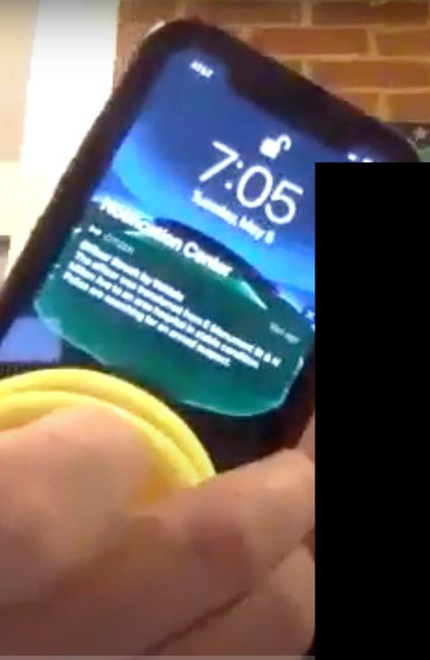
Figure 13: Citizen App Map View User Interface
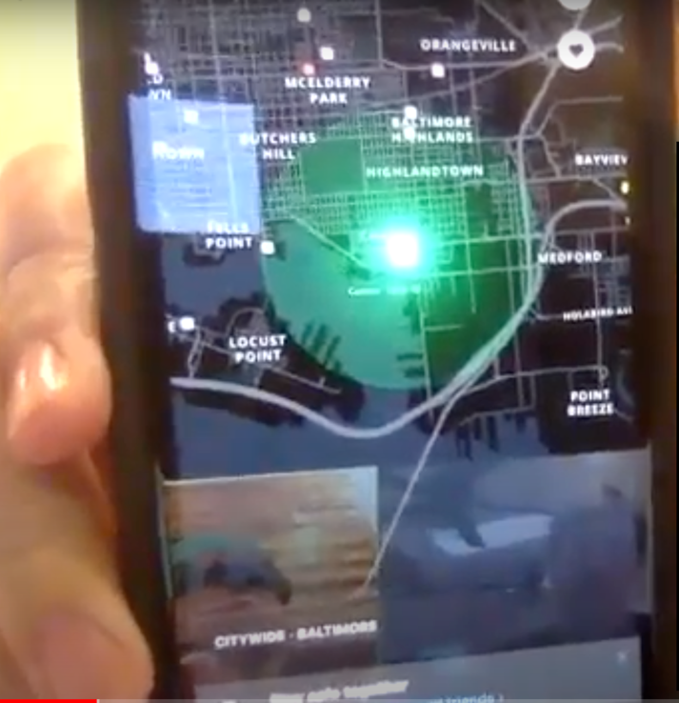
Figure 14: Citizen App Comments
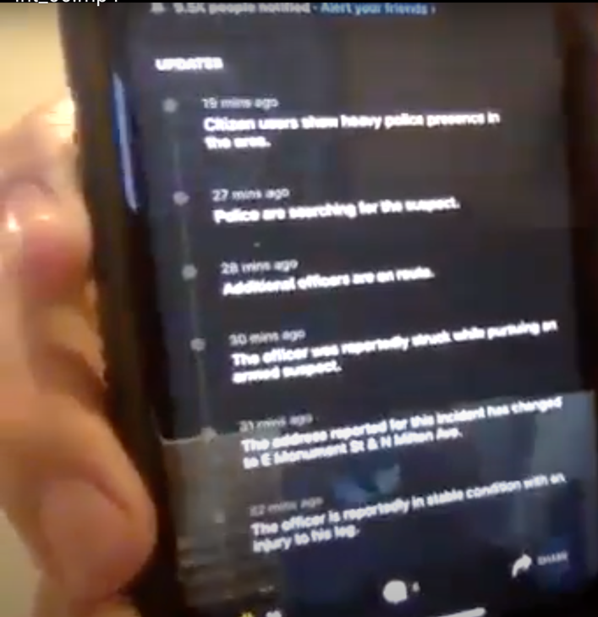
Interviewee 9 had a very different perspective on crime apps such as Citizen. He does not use the app because he believes it causes anxiety and promotes fear. He is also a member of the Patterson Park Neighbors Group and the Canton Neighbors Group on Facebook but has hid all of the notification. When asked why, he said that all of the posts and comments got crazy and cited examples of negative discussions related to the city and local government. He also stated that his overall philosophy is that “… being informed about events in the neighborhood isn’t going to keep me safe, it’s just going to spike my anxiety and cause fear.” Instead he tries to be aware of his surroundings, walks in well-lit areas, etc. It is worth noting that throughout the course of the interview he mentioned fear and anxiety several times, stating “the anxiety isn’t paralyzing, it just puts it in your head, and I don’t need that, similar to the news.” In regard to the Citizen app, he said, “I know people who are obsessed with Citizen.” He’s had to tell friends that he doesn’t want to know about the crime and to stop talking to him about it. He thinks it’s bad for the city and bad for the neighborhood. He also said, “It becomes a very negative conversation that doesn’t bring forward solutions. The most constructive things people are doing now are safety task force meetings.” The task force meetings are monthly in-person meetings that bring together local government leaders, the police, and residents to discuss city issues and actions that are being taken. These meetings were not discussed by any of the other interviewees.

Chapter 5: Conclusion

General Discussion
In both the survey results and the in-depth interviews, there were consistent patterns that emerged as well as groups of differing viewpoints. In the survey, it was apparent that the majority of Caucasian individuals who own private home security cameras do not have an issue with sharing the footage with their neighbors, or the police upon request. Although only roughly a third of survey respondents own a home security camera, most individuals agree that cameras are a good thing and that the presence of cameras in their neighborhood does make them feel safer. Also, out of the two thirds of individuals who do not own cameras, half of them plan to buy one in the future. Therefore, it can be assumed that the presence of cameras in mostly white neighborhoods will continue to grow and the cities’ CitiWatch program for registering home security cameras for police awareness, is likely to grow as well.
Concerns related to privacy did emerge. However, the concerns had very little to do with hacking into camera footage and more to do with where the cameras were positioned and who had access to the live stream. So long as the owner of the camera was in control of the footage and respectfully pointed the camera at public spaces or their own private property, there was very little concern expressed. Interestingly though, one interviewed individual did express feeling like his privacy was violated when he saw his car on a video that was shared on an online neighborhood group that was reporting a crime.
When conducting the in-depth interviews, a few additional points came up related to the cameras, specifically. Firstly, there is a common opinion that these cameras are more important to have in the city or neighborhoods with higher rates of crime. When people moved out of the city or discussed future plans to move out of the city, they also mentioned that cameras are less important in the county. Secondly, not all cameras were reported to be functioning. One interviewee said that her camera worked for a few days because it was not hard wired, and all of the city street traffic made the battery die too quickly. After a few days, they just stopped charging it. Another interviewee admitted that his camera hasn’t worked in years and that it’s in place as a decoy. Thirdly, people expressed the concept of being fatigued with too many notifications. This is a problem, especially for a device that is supposed to alert the owner to a potential crime at their residence, because the interviewees stated that they simply stopped looking at the notifications or disabled them altogether.
When the topic of digital neighborhood watch groups or online neighborhood groups were discussed, all interviewees stated that they were a member of a Facebook neighborhood group. However, most were passive members at best, disabling notifications and just seeing updates when posts appeared in their newsfeed. Nextdoor was much less popular as many of the interviewees were not aware of it.
Although the sample size was very small, one pattern began to emerge between individuals who owned cameras and those who did not when both received crime alerts and participated in digital neighborhood watch platforms. People who own cameras felt more engaged and able to help the neighborhood by deterring crime, sharing suspicious activity with their neighbors, and helping the police by providing footage if a crime does occur to support their investigation. They seemed to speak about the topic in a more positive light and seemed hopeful that their efforts were helping the community. However, those who do not own a camera and instead received notifications and crime alerts from others only, seemed to speak about the topic differently. They made more comments about being concerned about crime and their property values.
The most polarizing topic was Citizen App. This was not intended to be part of the initial study but was brought up in multiple interviewees. The model of Citizen App is to provide real-time police and emergency response information to the community and allow people to engage with that content in ways that have never been done before. Two of the interviewees mentioned that they did use the app and found it valuable and even interesting. Whereas another felt very strongly that it was bad for the community and caused him a lot of anxiety.
In conclusion, the initial survey and the in-depth interviews demonstrated that the primarily Caucasian Baltimore City residents who live in the neighborhoods of Canton, Federal Hill, Hampden, and Mt. Washington:
(1) feel safer when home security cameras are present in their neighborhood
(2) value security over privacy and are willing to forgo privacy in public spaces to increase their safety
(3) are willing to share their home security camera footage with their neighbors and the police in order to assist in an investigation, as long as the footage is being shared and not accessed freely in the form of a live video feed.
Anecdotally, these home security cameras and digital neighborhood watch groups are considered to be a positive for the community. They make neighbors feel connected and give them the opportunity to “join the conversation” and feel as though they are contributing to a solution. They are also providing additional tools for the police to conduct their investigations and reduce crime – although there is no data to support the effectiveness of this.
However, these cameras and digital neighborhood watch groups may also be negatively impacting the community. Notifications annoy people and crime notifications specifically can cause anxiety, making an individual feel less safe and increasing incidents of racial targeting and paranoia. In the future, ubiquitous networks of private home security cameras could, in theory, track an individual’s activity from place to place by pairing with aerial surveillance and facial recognition. This could have the potential to threaten individual privacy on a massive scale. As seen in this research, not all Caucasian individuals have the same expectation of privacy on public streets, many sharing the sentiment that “they have nothing to hide,” and do not have an issue forfeiting their privacy when in public.

Research Limitations
The survey and in-depth interviews were both conducted with smaller, less-diverse samples than we would have liked. Ideally, the sample would have included additional neighborhoods, representing more racial and economic diversity, both in Baltimore City as well as the surrounding counties for comparison. It is reasonable to assume that race and ethnicity have a strong impact on residents’ experiences with cameras, surveillance, and police.
In addition, the online survey was distributed a year and a half before the in-depth interviews, which may have impacted the two groups of participants’ perceptions of neighborhood safety in Baltimore as well as the available technology at the time of engagement.

Online Survey
Although the survey was effective in providing insights for the topics that were being targeted, there were flaws in the way some of the questions were phrased. For example, some questions were vaguely stated and asked if the participant would be willing to share their video footage with the police. Several respondents commented that it was unclear if this meant a single video clip shared for the purposes of identifying a criminal or if this meant access to a live video feed, for example. This misinterpretation may have caused certain responses to be skewed.
This survey did not explore the topic of digital neighborhood watch networks and how people are using the internet to connect with their neighbors and share this type of home security camera footage. In addition, the survey did not explore how seeing incidents of crime in their neighborhoods, either on their own cameras or through another channel makes them feel and/or impacts their perception of safety.
The survey also did not ask any questions about crime alert apps, such as Citizen App. Furthermore, since Citizen App was not available to Baltimore City residents at the time of the survey, respondents did not have any experience using the app that could affect another response, such as an open-ended response regarding privacy versus security.

In-depth Interviews
The in-depth interviews were conducted in the midst of an unprecedented Stay-at-home order as a result of the worldwide Covid-19 pandemic. As a result, the interviews were conducted remotely, limiting the environmental context, and with a less diverse sample than would have been preferred. Ideally, the in-depth interview participants would have represented a more balanced slice of the larger online survey participants, demographically and economically, but instead were limited to Caucasian individuals in their 30’s who were all in similar income brackets.

Significance and Future Research
In Baltimore City, crime continues to limit the growth and potential of neighborhoods. As new technology becomes available it enables local government, police, and residents to combat crime in new ways. With this new technology, also comes a risk that it can be misused. This research explored several topics related to the use of private home security cameras and online platforms that have enabled digital neighborhood watch groups to form. This research can and should influence how digital neighborhood watch groups are monitored by administrators and how local governments and police departments partner with residents and private companies to form networks of private cameras for the use of criminal investigations.
While some of the research questions were answered conclusively, through the survey results and validated with in-depth interviews, additional questions remain unanswered and new topics were uncovered.

Extension of the Current Study
Additional research should specifically investigate how much privacy loss in the name of security would be too much for Caucasian Baltimore City residents to accept? In this study, the overwhelming majority of participants expressed their willingness to forgo privacy for an increase in security in Baltimore City. Some individuals did touch on where those privacy limits are for them, such as facing cameras in what they believe to be private spaces and allowing police access to live camera feeds. However, it is not clear if these same boundaries are shared by all residents of these neighborhoods.
Additionally, it is also not clear if these same sentiments are shared across neighborhoods with different socio-economic makeup. For example, how would the results of this research vary in less privileged Baltimore city neighborhoods and county neighborhoods, both of lesser and greater privileged status? Is privacy more important in the county? Is security even more important in less-privileged neighborhoods? Is there a direct correlation between the amount of crime that exists in a neighborhood and the willingness of those residents to forgo privacy? What is the impact of race and ethnicity on feelings about privacy and security?

Future Research
This study also uncovered additional insights that should be explored in future research. For example, does owning a camera make an individual feel like they have more control over their security and therefore increase their perception of safety, even when they are receiving crime alerts or updates of criminal activity in their neighborhoods on online neighborhood watch platforms? In comparison, does not owning a camera make an individual actually feel more vulnerable when they are receiving crime alerts or updates of criminal activity in their neighborhoods on online neighborhood watch platforms?
Similarly, what is the psychological toll of receiving crime alerts and updates of criminal activity in their neighborhoods on online neighborhood watch platforms? How does the potential increase in security compare to the potential increase in anxiety and ultimately, what affect is this having on neighborhood health?

References
MD Crim Law Code § 3-901 (2013)
Alliance, B. (2020). BNIA – Baltimore Neighborhood Indicators Alliance | Providing reliable, actionable quality of life indicators for Baltimore’s neighborhoods. Bniajfi.org.
Afzalan, N., & Evans-Cowley, J. (2015). Planning and Social Media: Facebook for Planning at the Neighbourhood Scale. Planning Practice & Research, 30(3), 270–285. https://doi-org.proxy-ub.researchport.umd.edu/10.1080/02697459.2015.1052943
Baltimore Sun -Baltimore County Council approves private security camera registry aimed at giving police more crime footage. (2020). Baltimoresun.com. Retrieved 10 May 2020, from https://www.baltimoresun.com/maryland/baltimore-county/bs-md-co-camera-registry-20200303-qrf6qn6w3naytmuzhd2zb37vzi-story.html
Baltimore Sun Media Group. (2020). Baltimore Homicides. https://homicides.news.baltimoresun.com/#nt=interstitial-manual.
Baltimore Sun - This Baltimore neighborhood has built an informal home camera network to fight crime. Police say it’s working. (2020). Retrieved 29 June 2020, from https://www.baltimoresun.com/news/crime/bs-md-ci-cr-patterson-park-cameras-20191021-wng33b54ffe55ikbxt2arrxmka-story.html
Baltimore to become first city monitored by police surveillance planes. (2019). Cbsnews.com. Retrieved 10 May 2020, from https://www.cbsnews.com/news/baltimore-maryland-to-become-first-city-monitored-by-police-surveillance-planes/
Bertoni, S. (2020). How Safety Startup Citizen Surpassed Twitter To Become Apple’s Top News App Amid The George Floyd Protests. Forbes.Com, N.PAG.
Brandon C. Welsh, David P. Farrington, and Sema A. Taheri (2020). Annualreviews.org. Retrieved 16 March 2020, from https://www.annualreviews.org/doi/pdf/10.1146/annurev-lawsocsci-120814-121649
Bouchillon, B. C. (2019). Patching the Melting Pot: Sociability in Facebook Groups for Engagement, Trust, and Perceptions of Difference. Social Science Computer Review, 37(5), 611–630. https://doi-org.proxy-ub.researchport.umd.edu/10.1177/0894439318791241Bureau, U. (2020). Small Area Income & Poverty Estimates. Census.gov.
Chase, J. (2013). The evolution of the internet of things. Texas Instruments, 1, 1-7.
Deepti Doshi, & Nicole Schneidman. (2018). From resilient cities to resilient citizens: the use of Facebook groups during disasters. Field Actions Science Reports, 64–69.
Elementary Schools in Baltimore City Public Schools, 1-25 - Baltimore, MD | GreatSchools. (2020). Retrieved 29 June 2020, from https://www.greatschools.org/maryland/baltimore/baltimore-city-public-schools/schools/?gradeLevels%5B%5D=e
Facebook builds community involvement with neighborhood watch group. (2014). Victoria Advocate (Victoria, TX).
Harwell, D. (2019). Doorbell-Camera Firm Ring Has Partnered with 400 Police Forces, Extending Surveillance Concerns. Washington Post, August, 28.
Herrman, John. All the Crime, All the Time: How Citizen Works. (2020). Nytimes.com. Retrieved 31 May 2020, from https://www.nytimes.com/2019/03/17/style/citizen-neighborhood-crime-app.html
Homeland Security. n.d. About The Campaign. [online] Available at: <https://www.dhs.gov/see-something-say-something/about-campaign> [Accessed 29 June 2020].
Hyungjin Lim & Pamela Wilcox (2017) Crime-Reduction Effects of Open-street CCTV: Conditionality Considerations, Justice Quarterly, 34:4, 597-626, DOI: 10.1080/07418825.2016.1194449
Kelly, A., & Finlayson, A. (2015). Can Facebook Save Neighborhood Watch. Police Journal, 88(1), 65–77.
La Vigne, N. G. (2011). Evaluating the use of public surveillance cameras for crime control and prevention. [electronic resource]. COPS.
Lally, Nick. 2017. Crowdsourced surveillance and networked data. Security Dialogue. Retrieved from https://journals.sagepub.com/doi/abs/10.1177/0967010616664459
Lambright Katie. (2019). Digital Redlining: The Nextdoor App and the Neighborhood of Make-Believe. Cultural Critique, 103, 84. https://doi-org.proxy-ub.researchport.umd.edu/10.5749/culturalcritique.103.2019.0084
Larsson, Sebastian. 2016. A First Line of Defence? Vigilant Surveillance, Participatory Policing, and the Reporting of “Suspicious” Activity. Surveillance & Society 15(1): 94-107. http://library.queensu.ca/ojs/index.php/surveillance-and-society/index|
Lawrence E. Cohen, & Marcus Felson. (1979). Social Change and Crime Rate Trends: A Routine Activity Approach. American Sociological Review, 44(4), 588.
London Police to Deploy Facial Recognition Cameras. (2020). Time. Retrieved 10 May 2020, from https://time.com/5770976/london-facial-recognition-police/
Longdin, Anna. (2020). The history of CCTV – from 1942 to present - PCR. PCR. Retrieved 10 May 2020, from https://www.pcr-online.biz/2014/09/02/the-history-of-cctv-from-1942-to-present/
Maria R. Lowe, Angela Stroud, Alice Nguyen, 2017. Who Looks Suspicious? Racialized Surveillance in a Predominantly White Neighborhood. Social Currents. Retrieved from https://journals.sagepub.com/doi/10.1177/2329496516651638
Mosconi, G., Korn, M., Reuter, C., Tolmie, P., Teli, M., & Pipek, V. (2017). From Facebook to the neighbourhood: Infrastructuring of hybrid community engagement. Computer Supported Cooperative Work (CSCW), 26(4–6), 959–1003. https://doi-org.proxy-ub.researchport.umd.edu/10.1007/s10606-017-9291-z
New app helps to build a circle of trust in your area. (2016, September 18). Mail on Sunday, 97.
New neighborhood watch helping people cope with crisis. (2020). The Observer (La Grande, OR).
Nextdoor is the neighbourhood hub for trusted connections and the exchange of helpful information, goods, and services. Join your neighbourhood. (2020). Retrieved 29 June 2020, from https://nextdoor.com/#neighbors
O'Connell, J., 2015. The Real Challenge For Cities: What Happens When Millennials Have Babies And The Suburbs Beckon?. [online] The Washington Post. Available at: <https://www.washingtonpost.com/news/digger/wp/2015/05/08/millennials-moved-to-the-city-whether-they-stay-might-depend-on-what-happens-to-the-kids/> [Accessed 29 June 2020].
Personal Privacy vs. Public Security. (2020). Techcrunch.com. Retrieved 10 May 2020, from https://techcrunch.com/2018/05/06/personal-privacy-vs-public-security-fight/
Privacy Notice. (2020). Ring Team. Retrieved 10 May 2020, from https://shop.ring.com/pages/privacy-notice
Privacy Statement for Nest Products and Services. (2020). Nest. Retrieved 10 May 2020, from https://nest.com/legal/privacy-statement-for-nest-products-and-services/
Reel, M. (2016). Baltimore police will continue aerial surveillance program. Bloomberg.Com, N.PAG.
Thompson, D. (2019). The Future of the City Is Childless. Retrieved 29 June 2020, from https://www.theatlantic.com/ideas/archive/2019/07/where-have-all-the-children-gone/594133/
UK mass surveillance programme violates human rights, European court rules. (2018). The Independent. Retrieved 10 May 2020, from https://www.independent.co.uk/news/uk/politics/uk-mass-surveillance-gchq-eu-human-rights-echr-edward-snowden-a8535571.html
Weil, M. (2019). Fights erupt as youths gather at Baltimore’s Inner Harbor, police say. Washingtonpost.Com.

Welsh, B. C., Farrington, D. P., & Taheri, S. A. (2015). Effectiveness and Social Costs of Public Area Surveillance for Crime Prevention. Annual Review of Law & Social Science, 11, 111–130. https://doi-org.proxy-ub.researchport.umd.edu/10.1146/annurev-lawsocsci-120814-121649
WIRE, B. (2019). North America Home Security System Market Expected to Reach a Value of US$ 14.1 Billion by 2024 - ResearchAndMarkets.com. Businesswire.com. Retrieved 10 May 2020, from https://www.businesswire.com/news/home/20190709005374/en/North-America-Home-Security-System-Market-Expected

Appendix A: Online Survey, Baltimore Neighborhood Security & Privacy
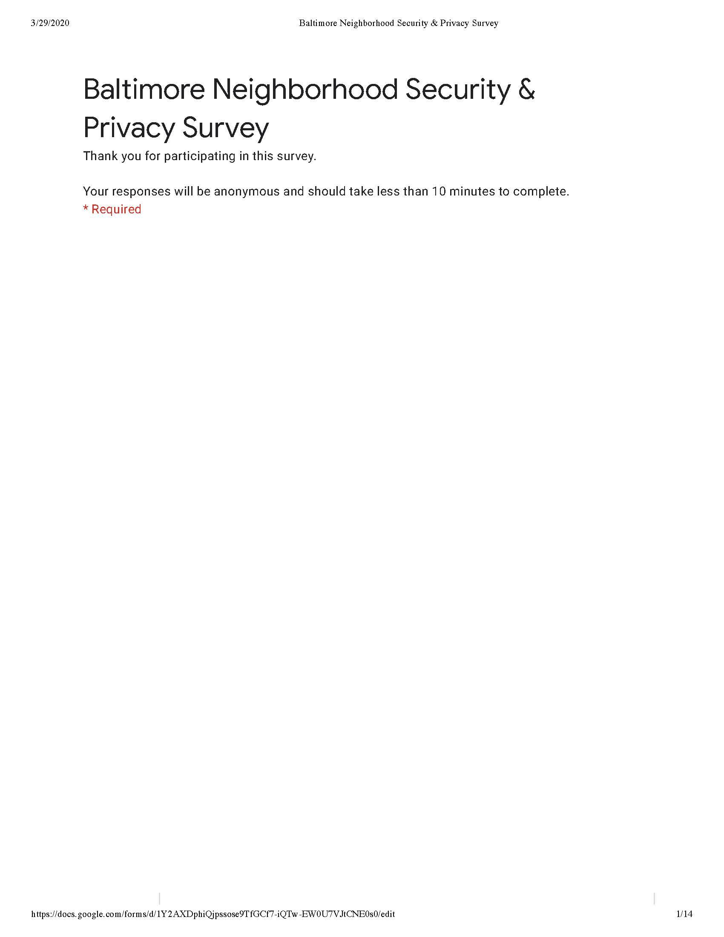
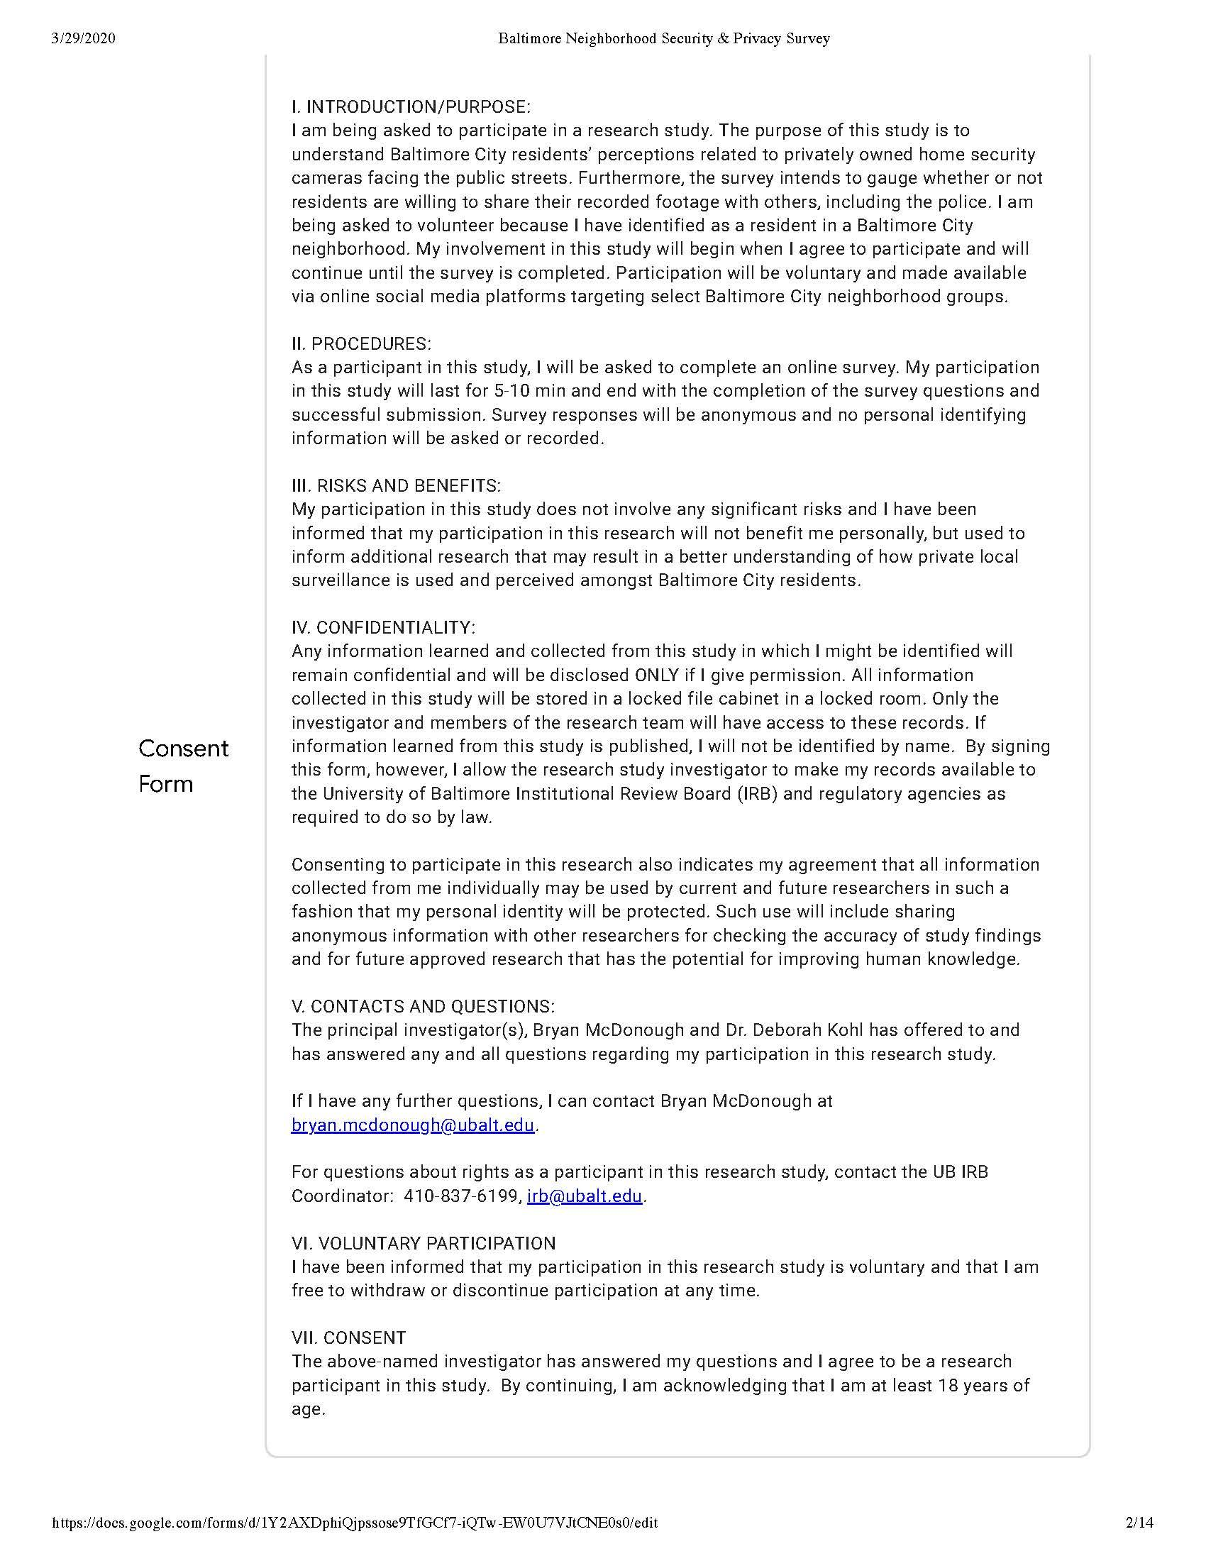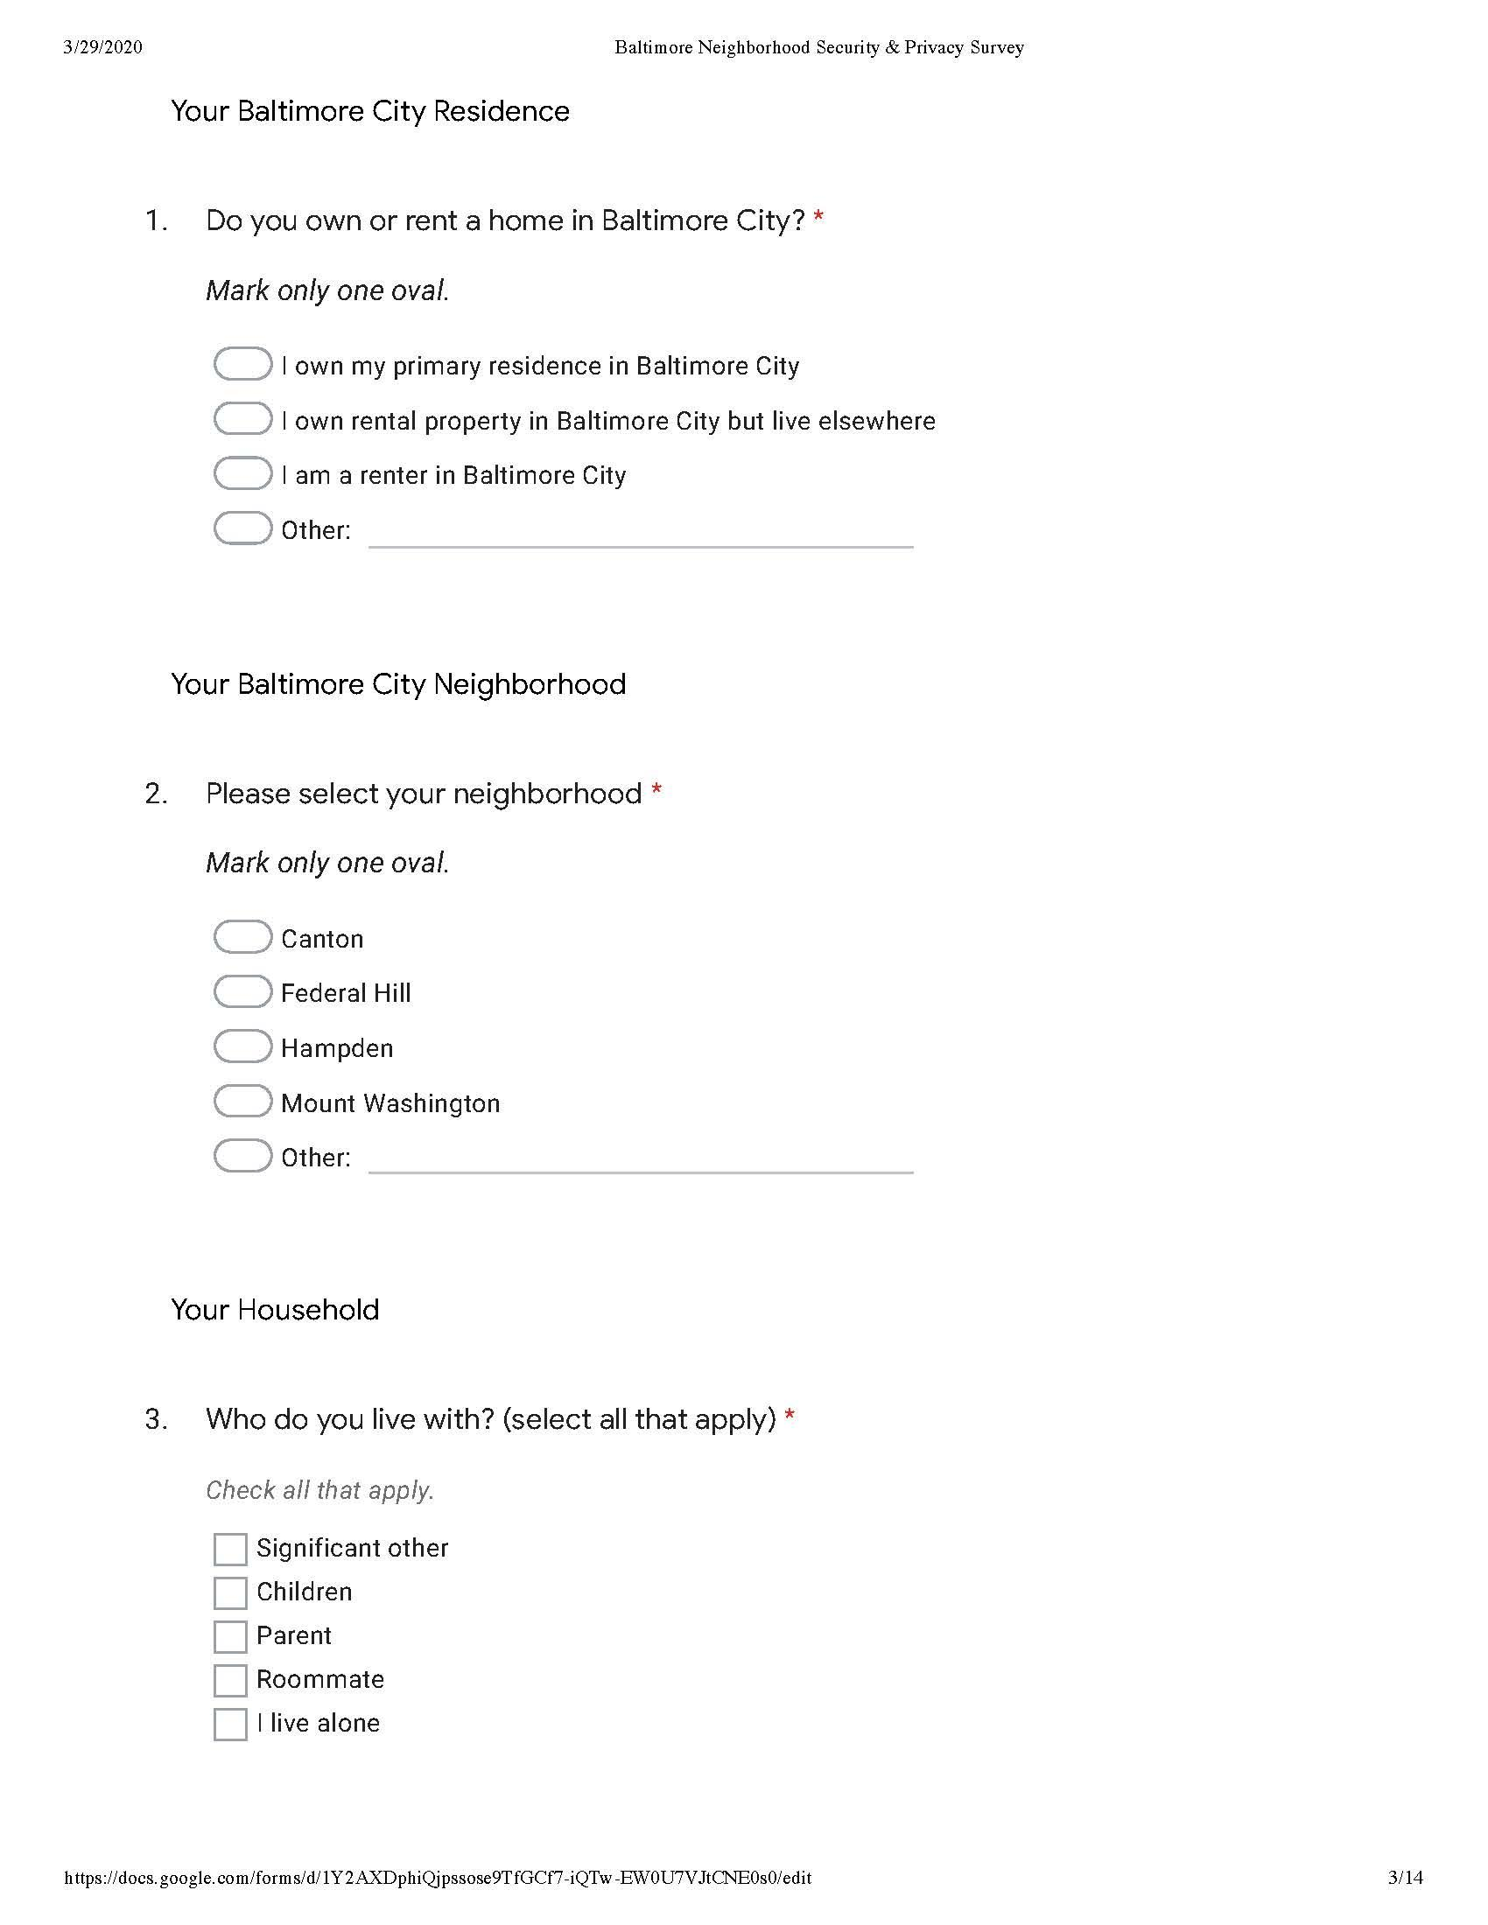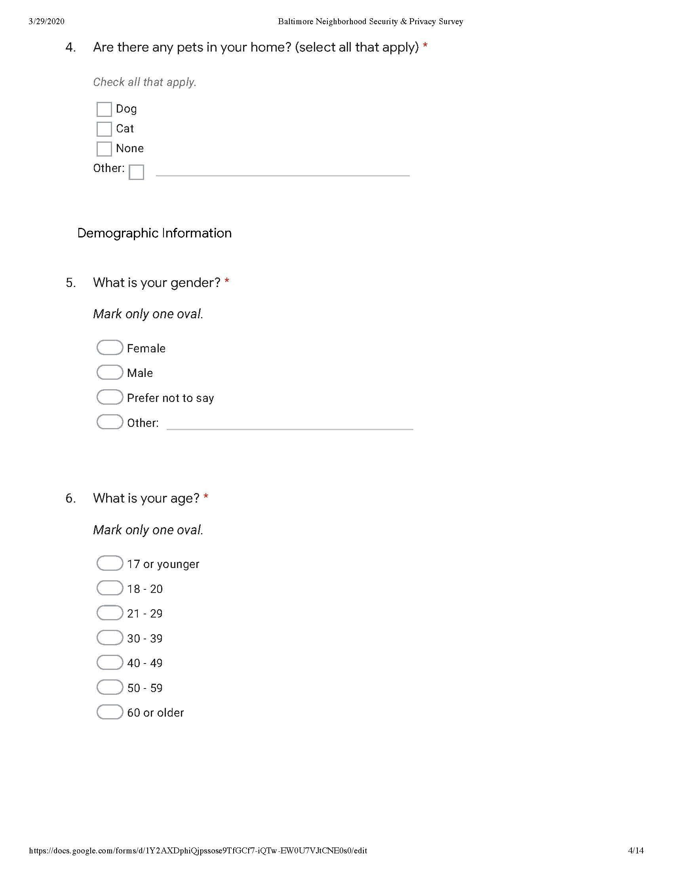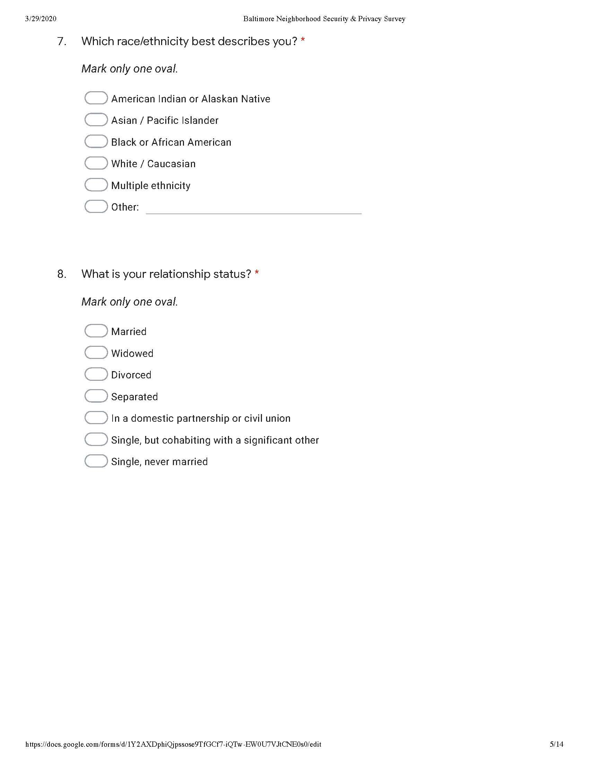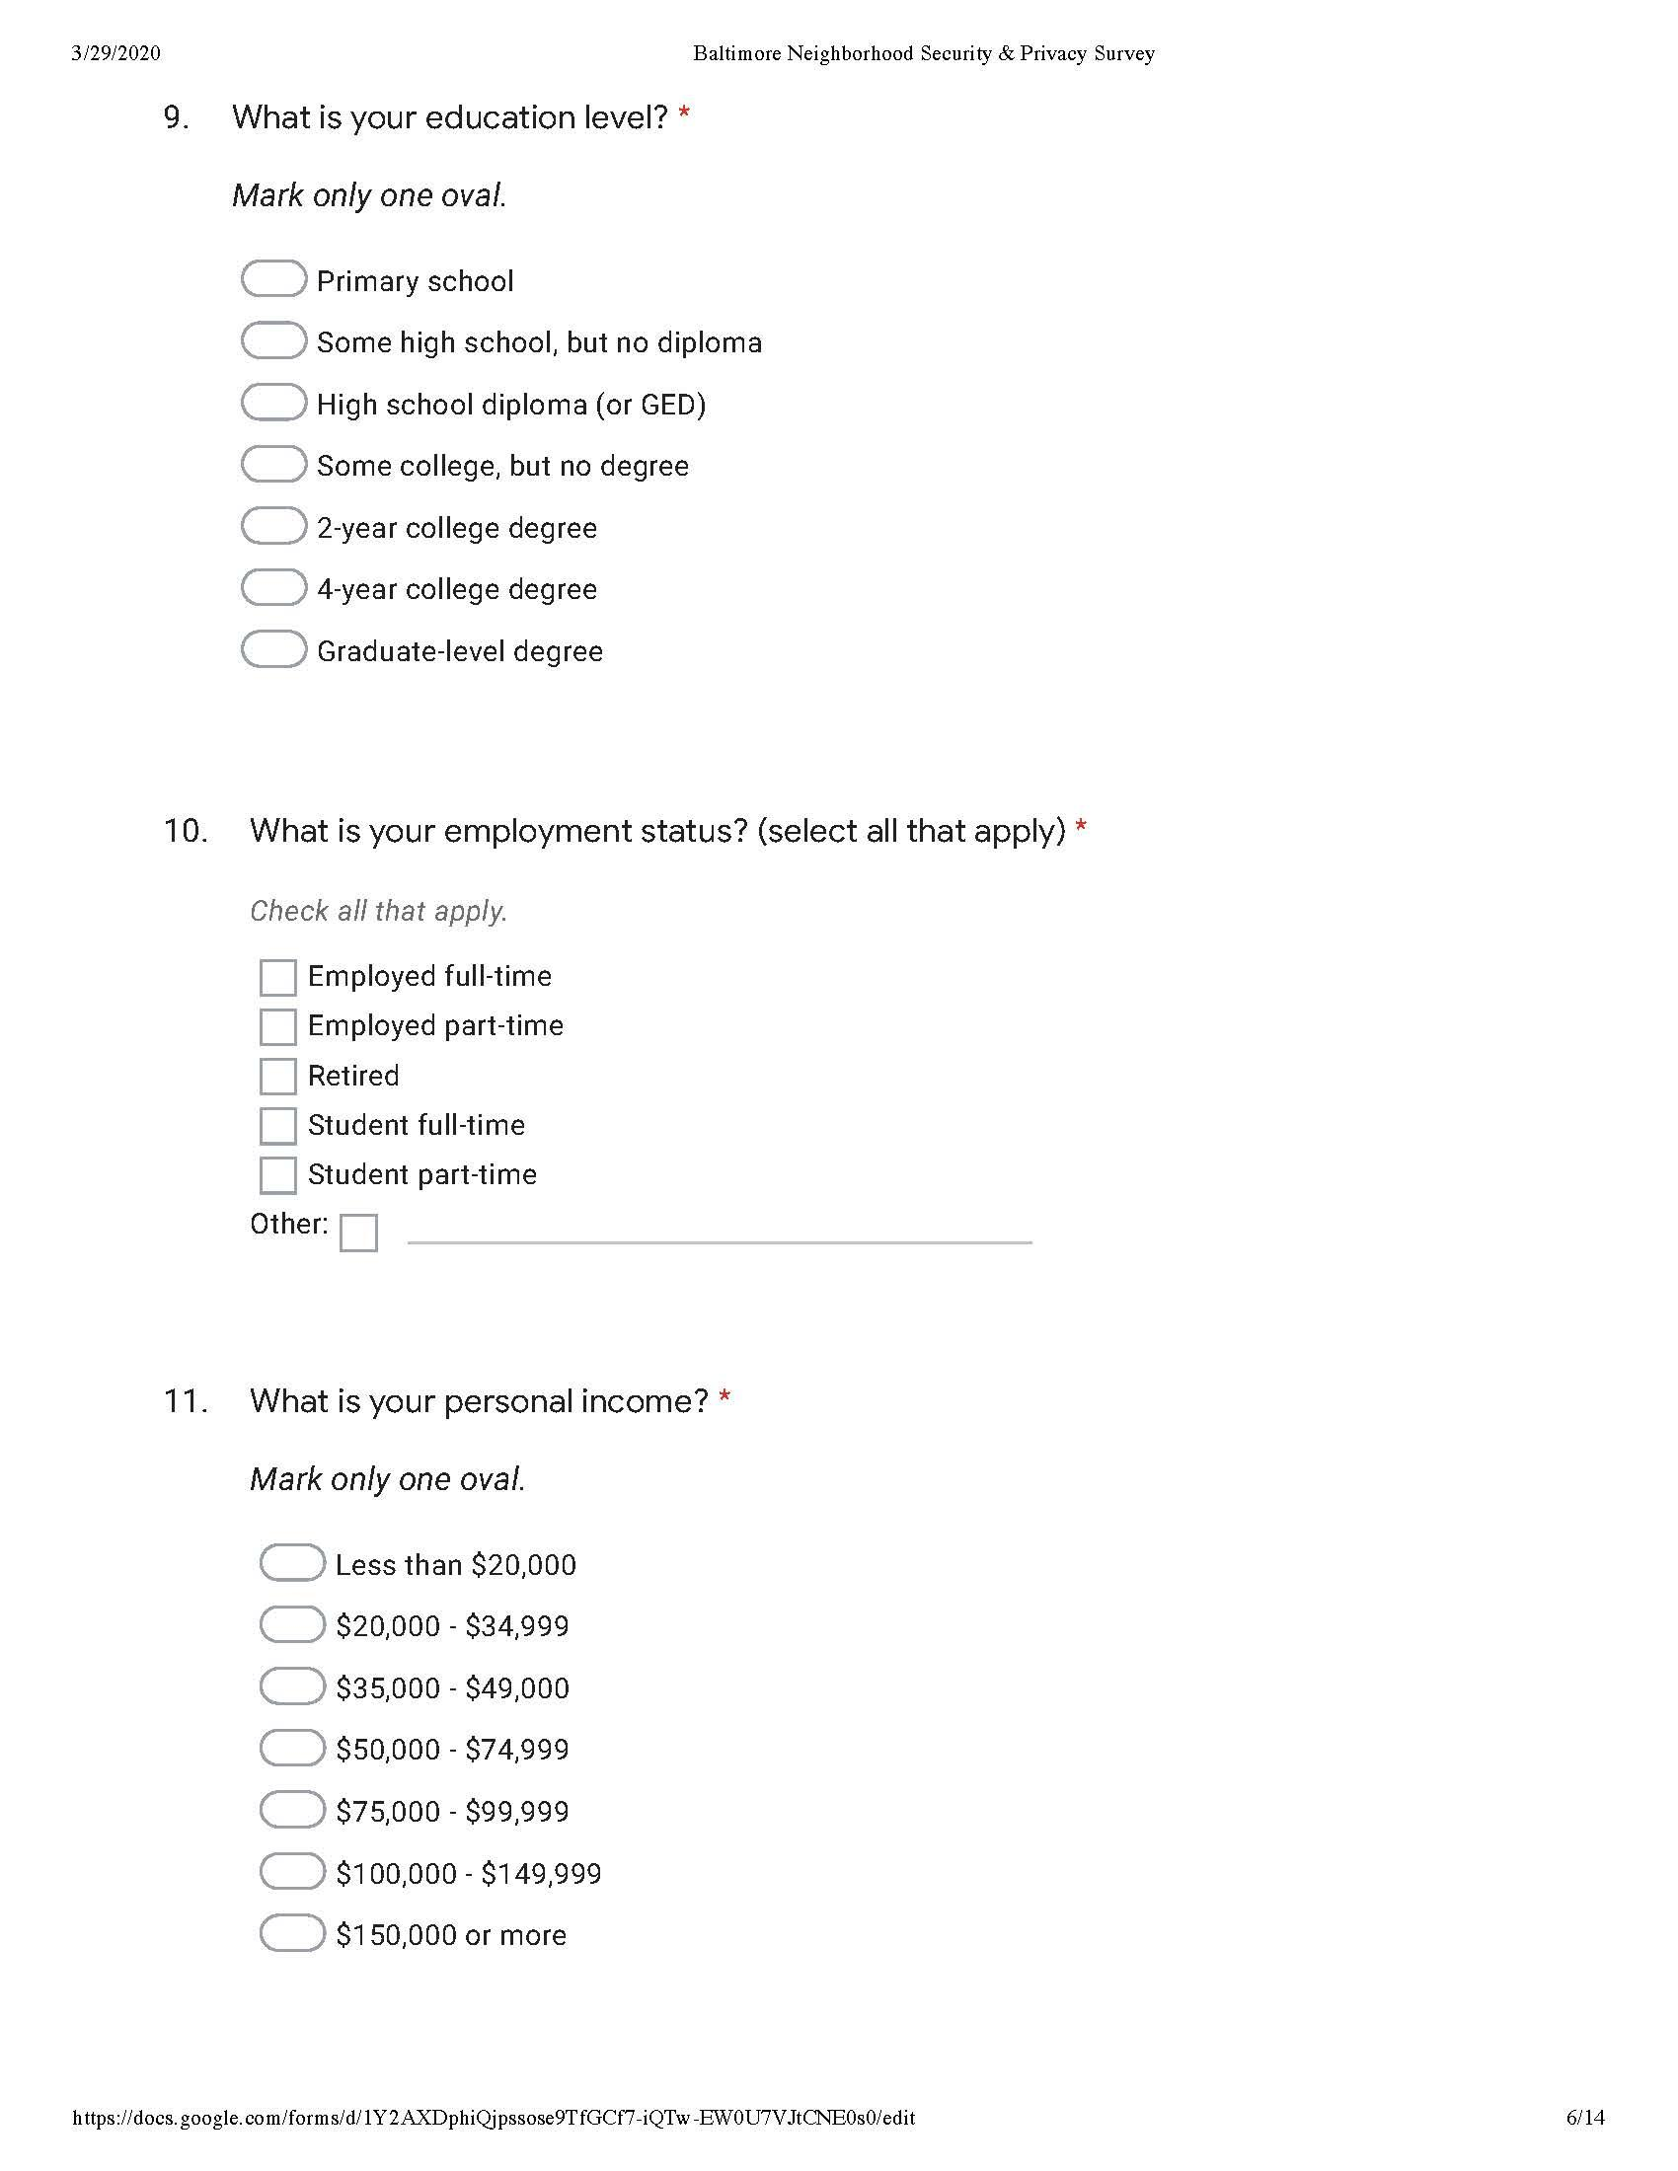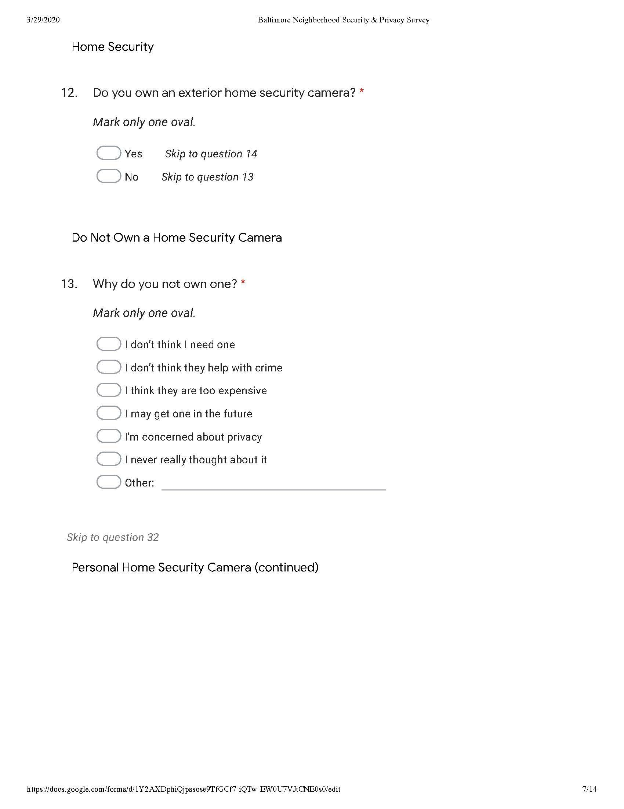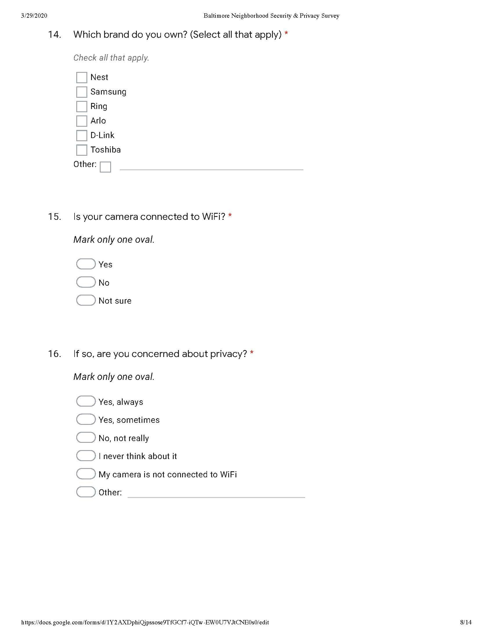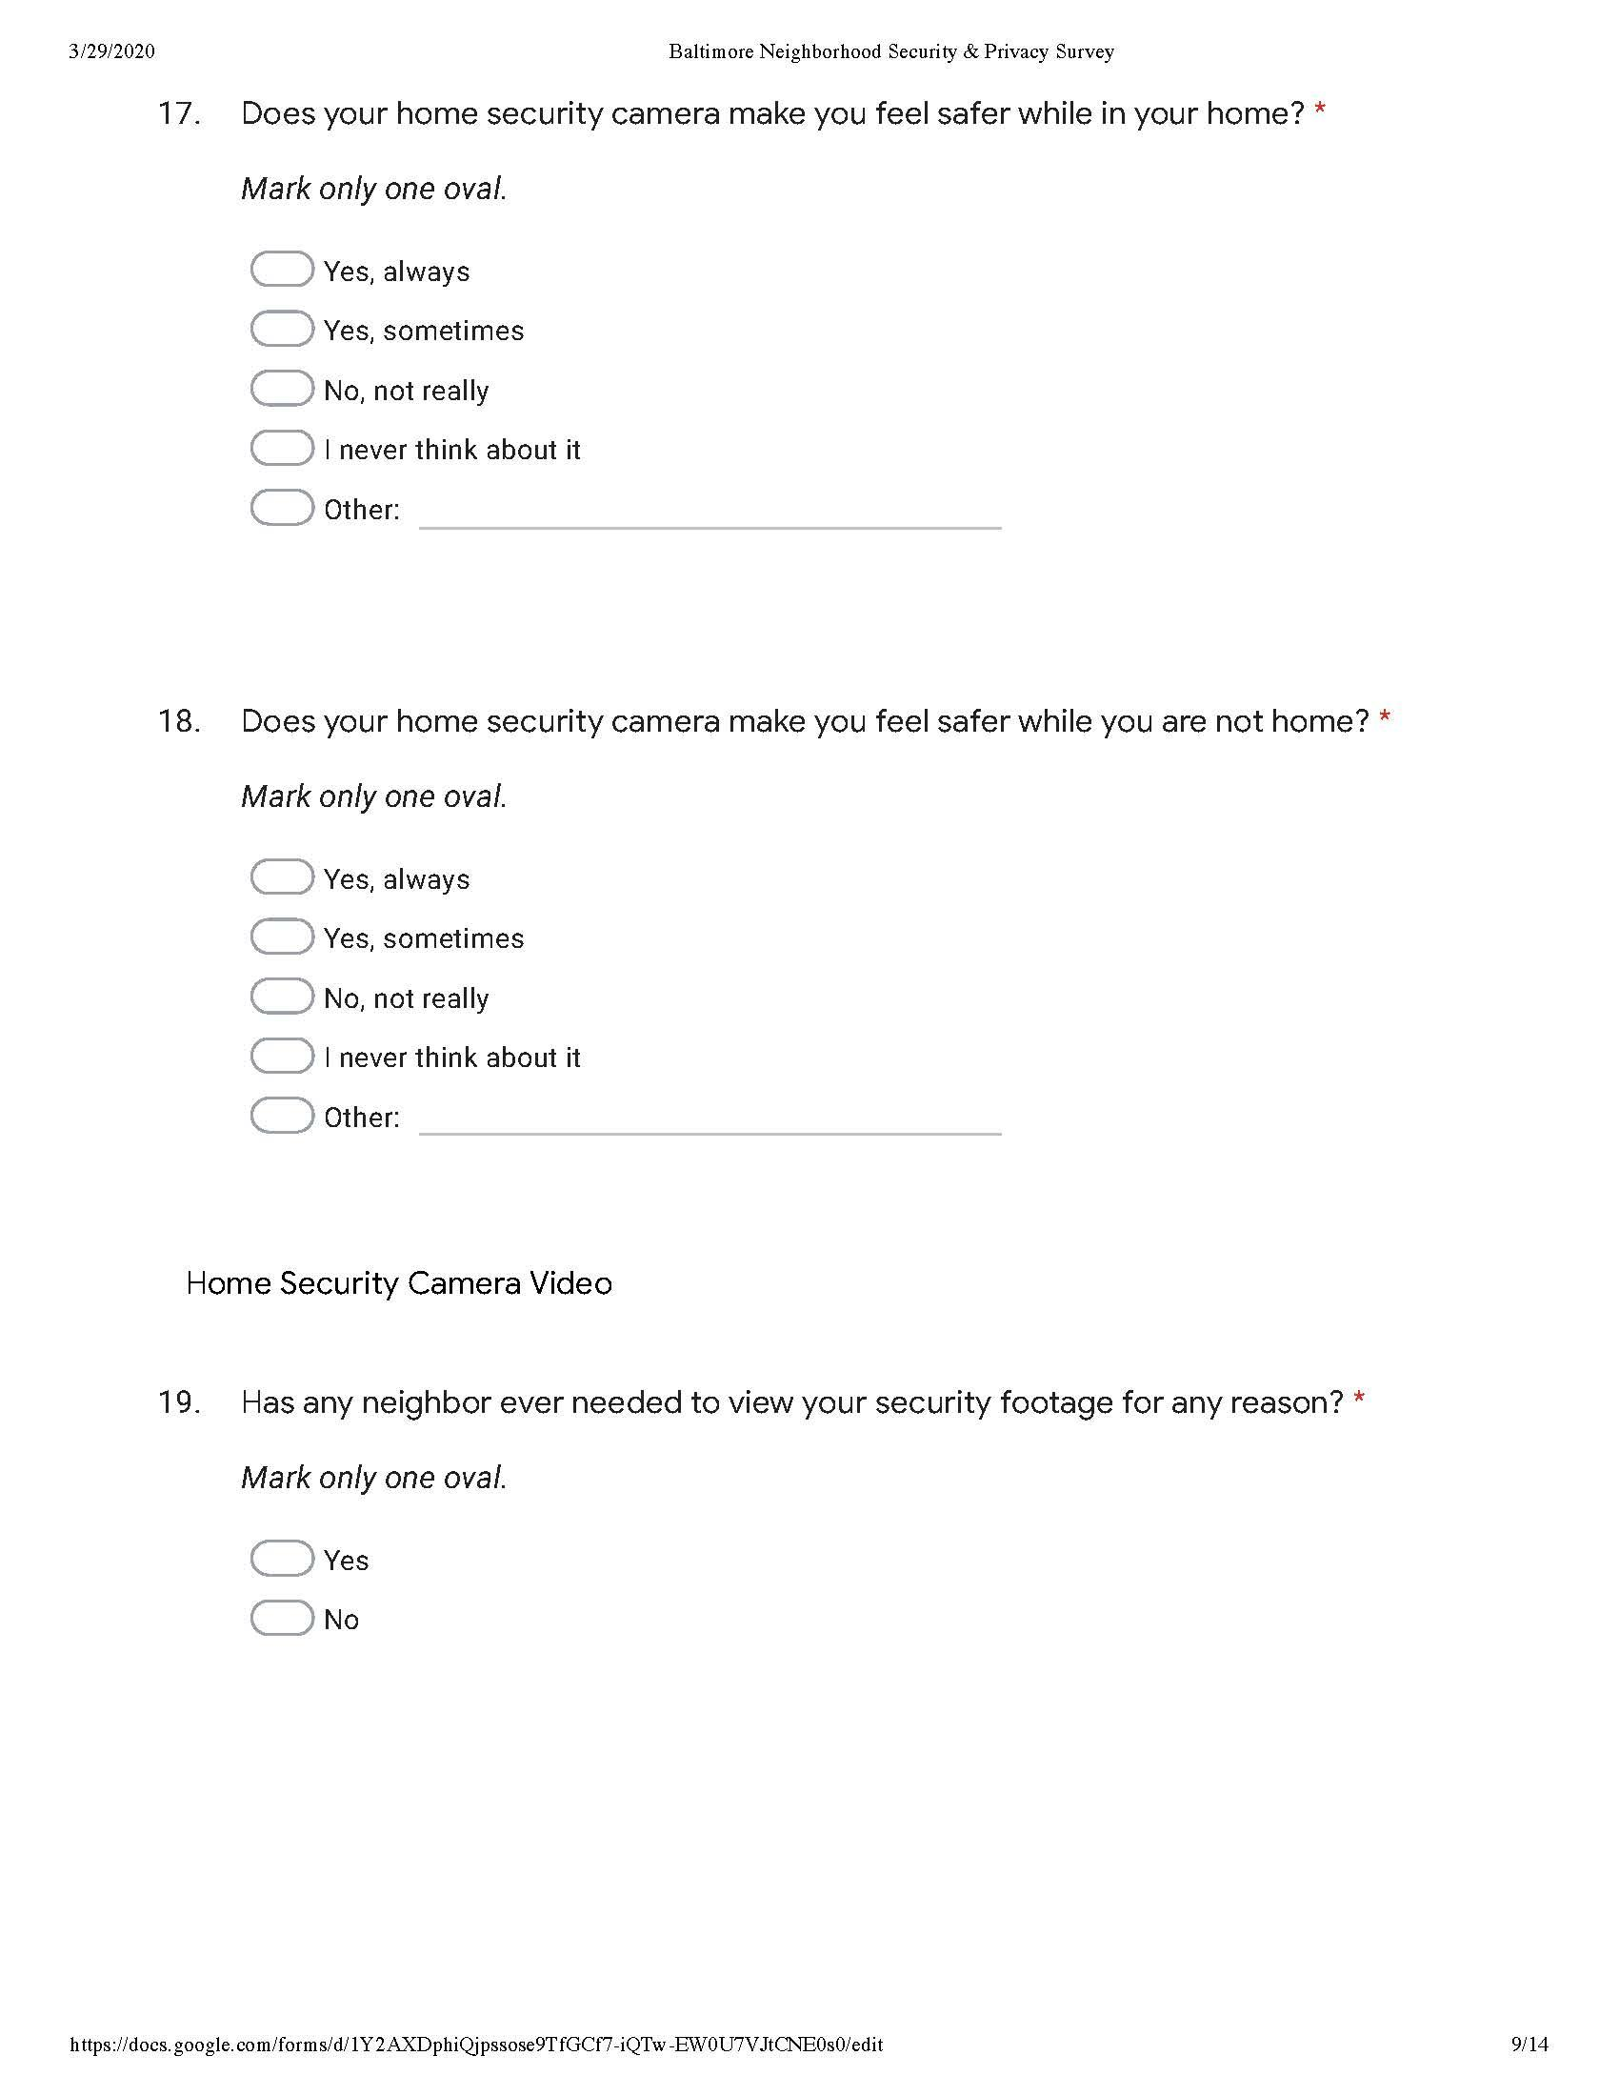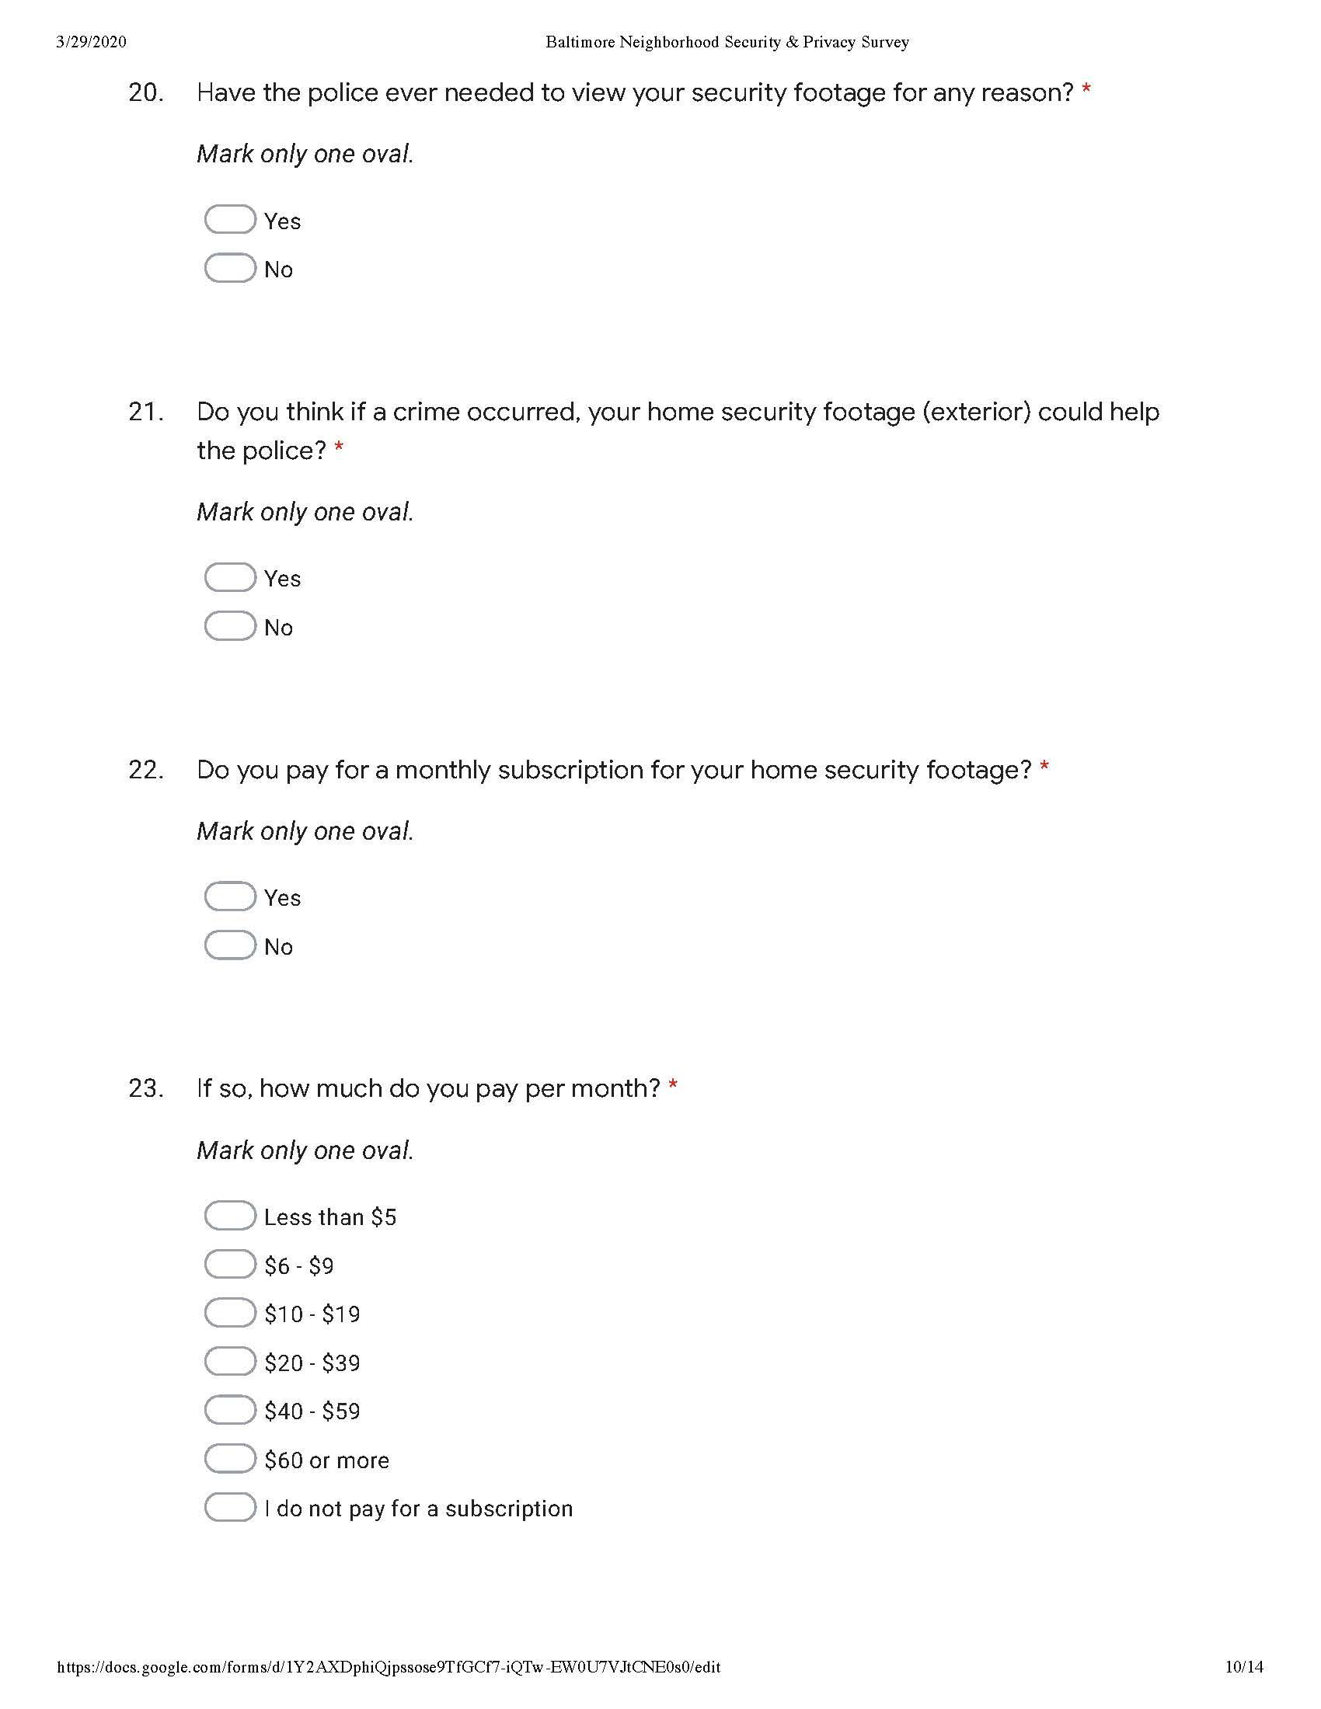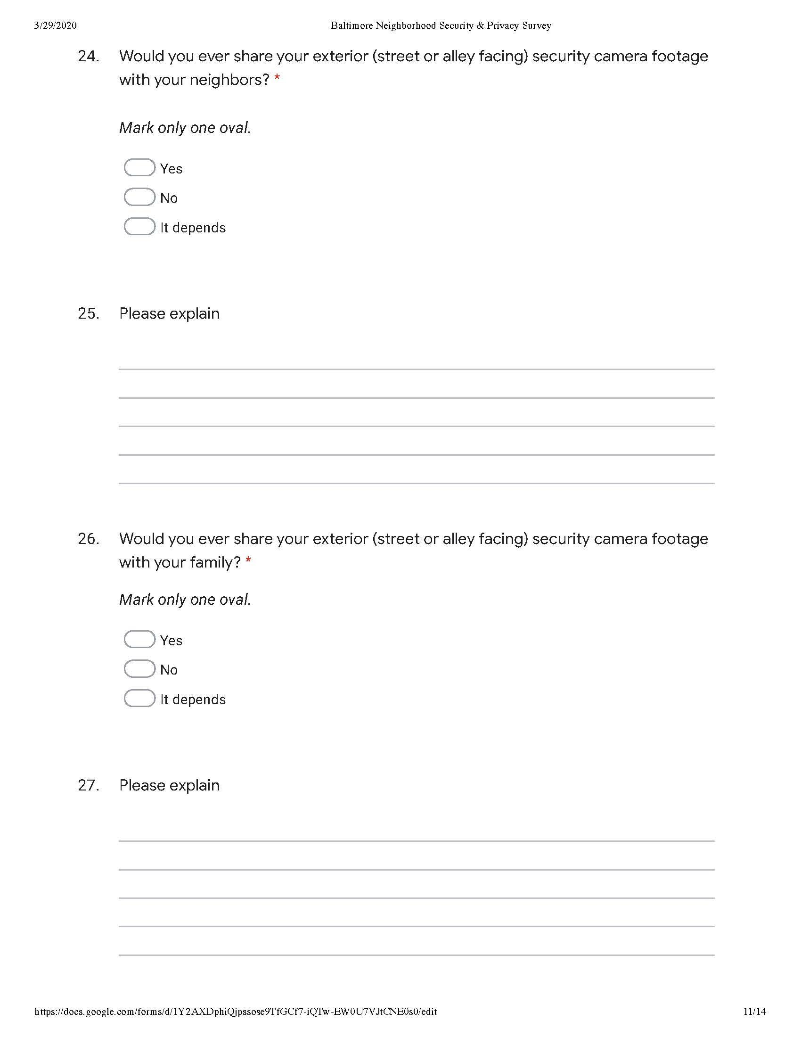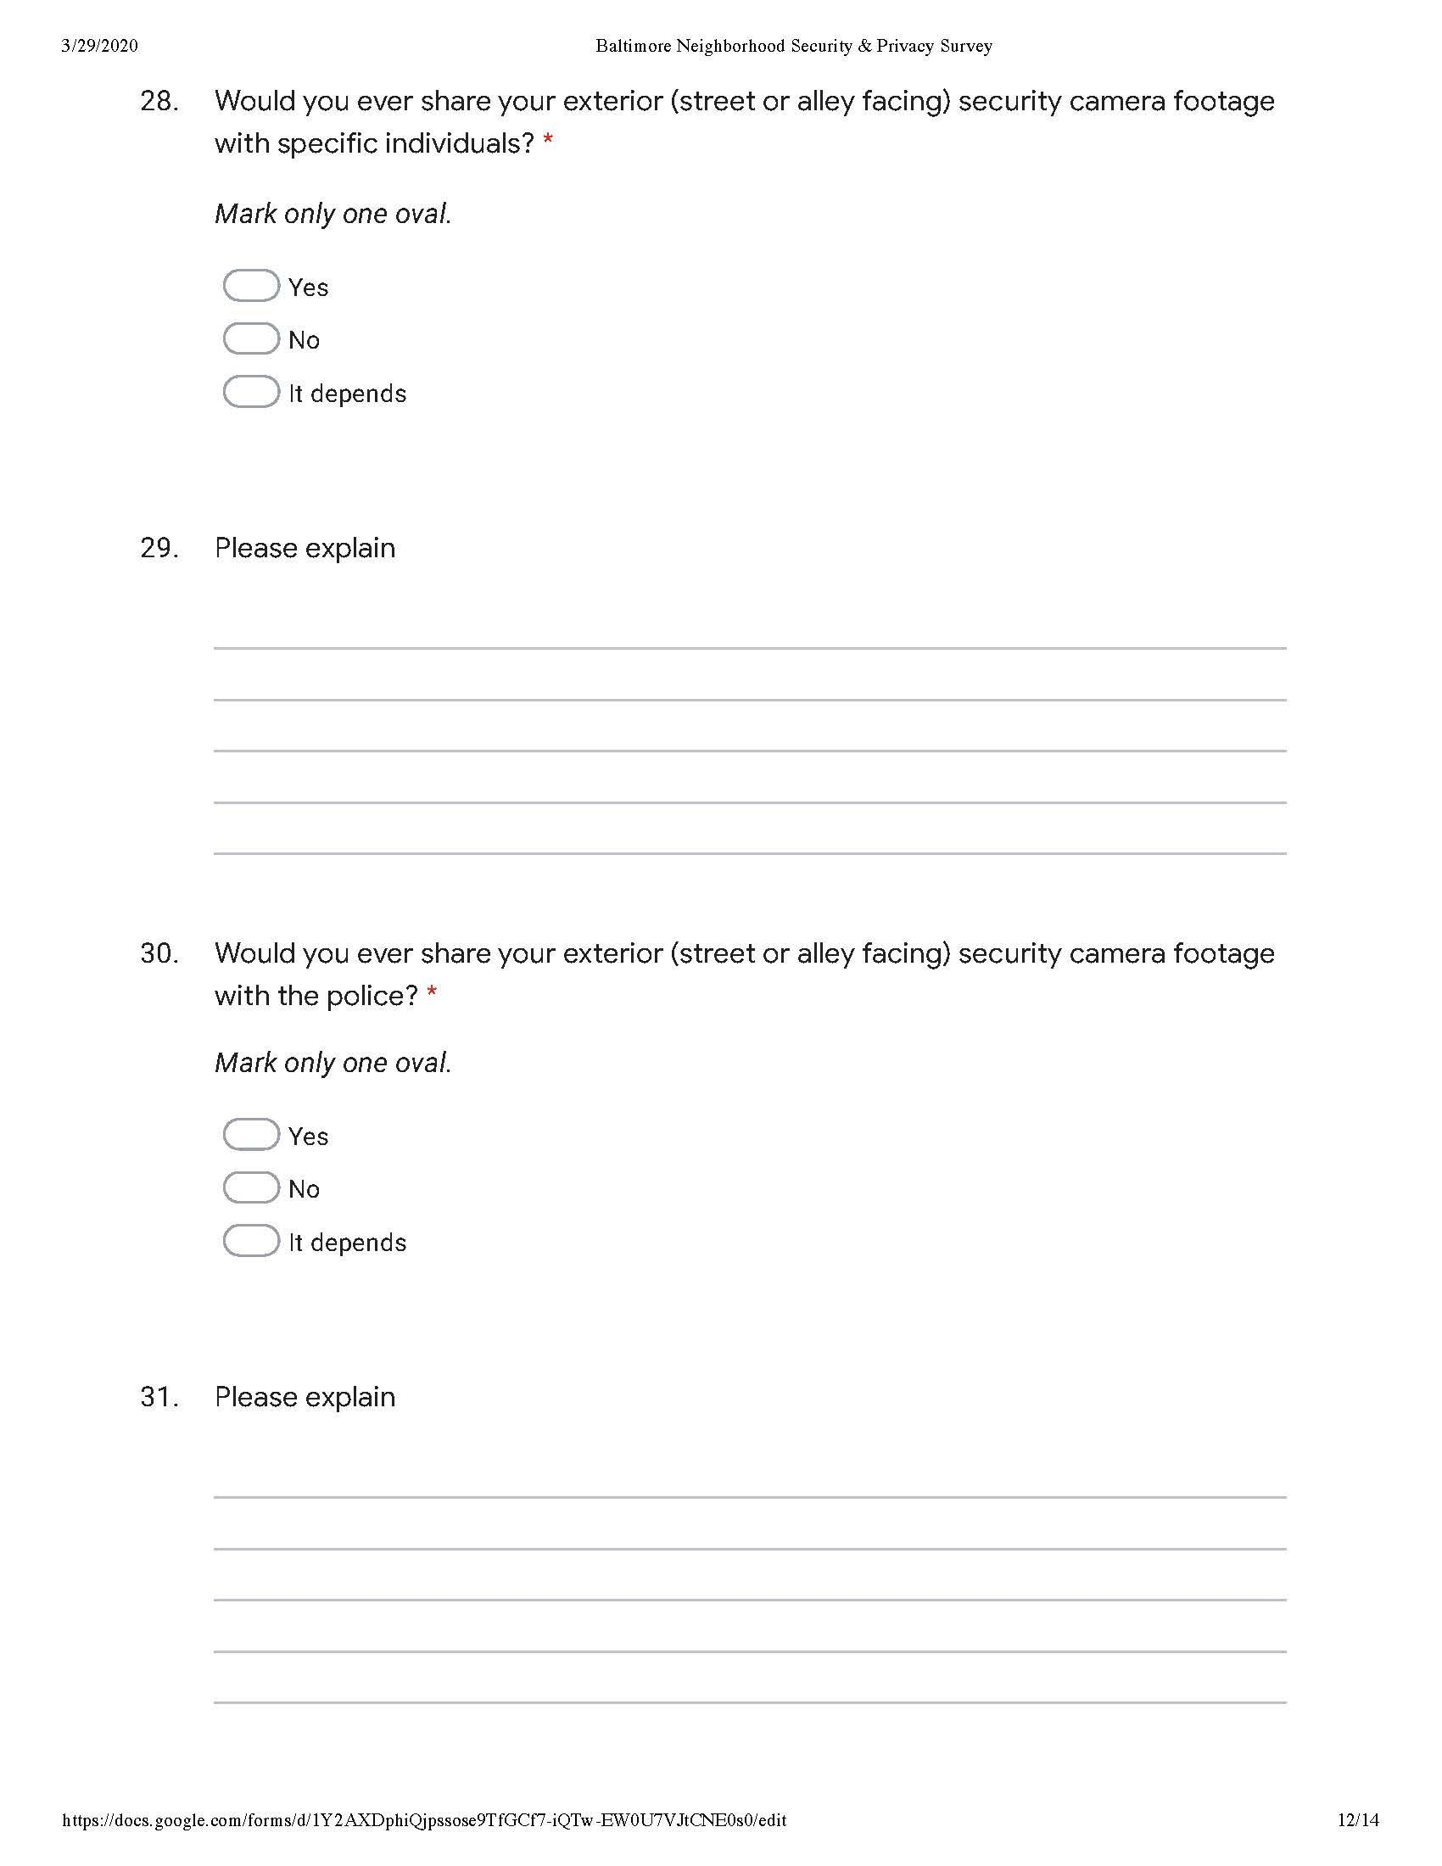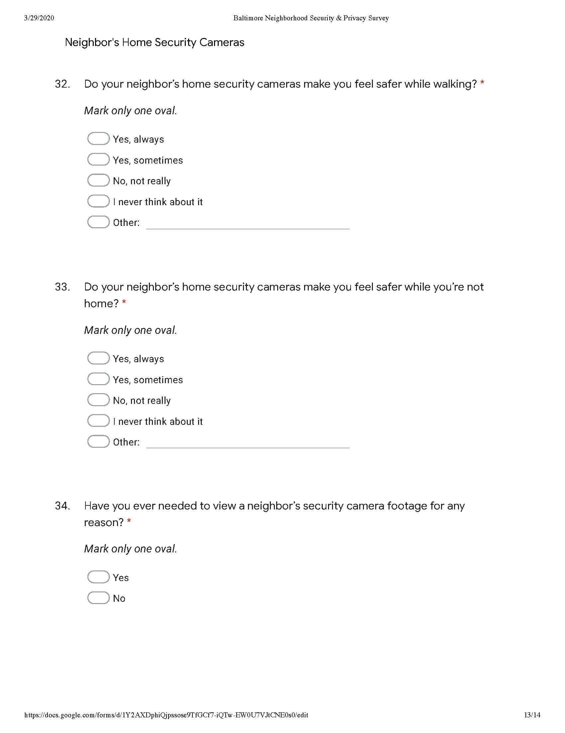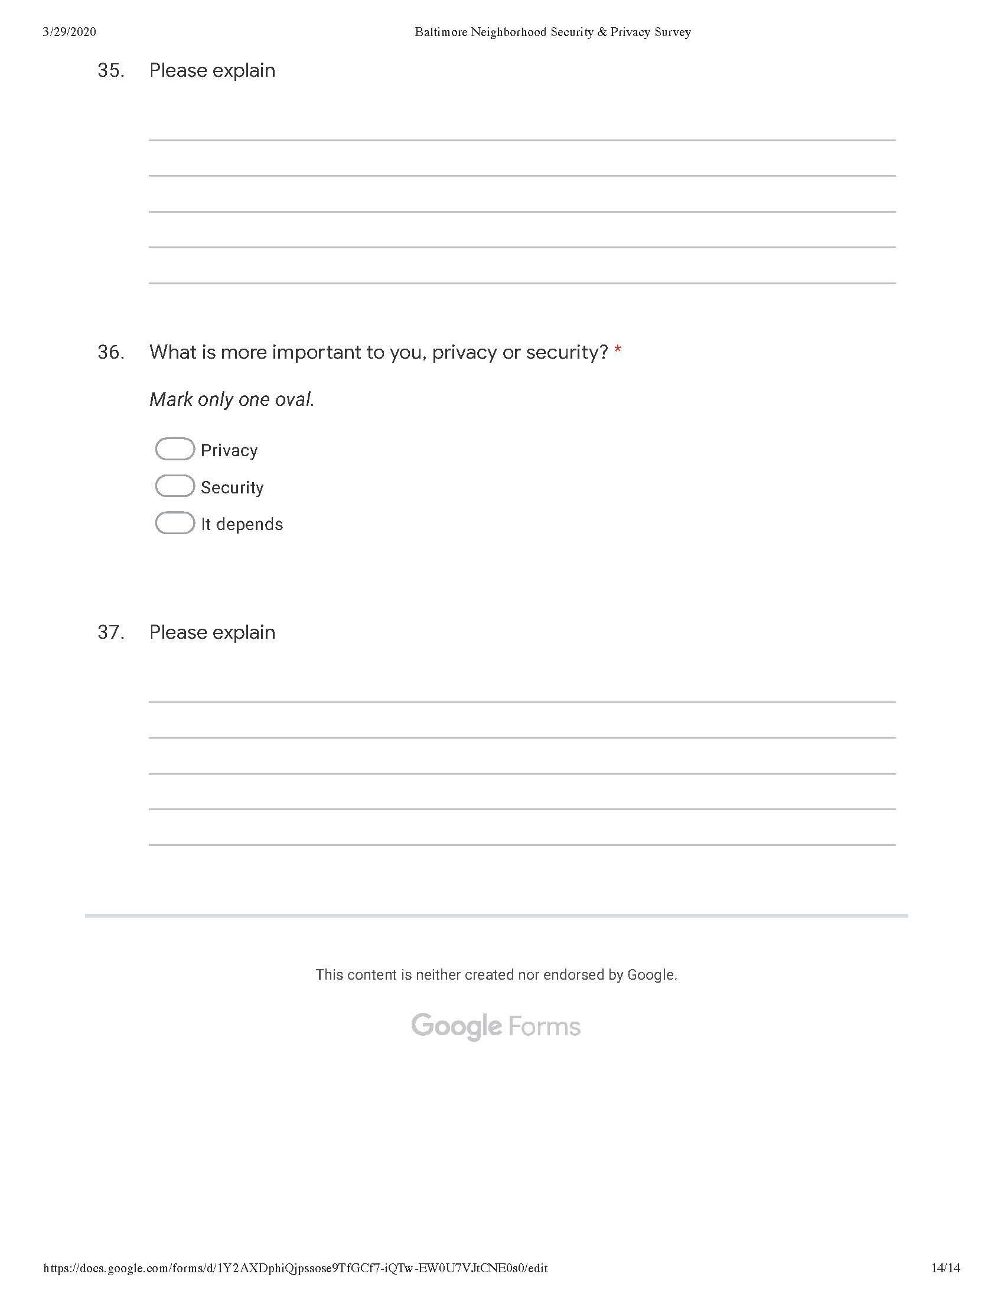

Appendix B: Confidence Interval Workbook
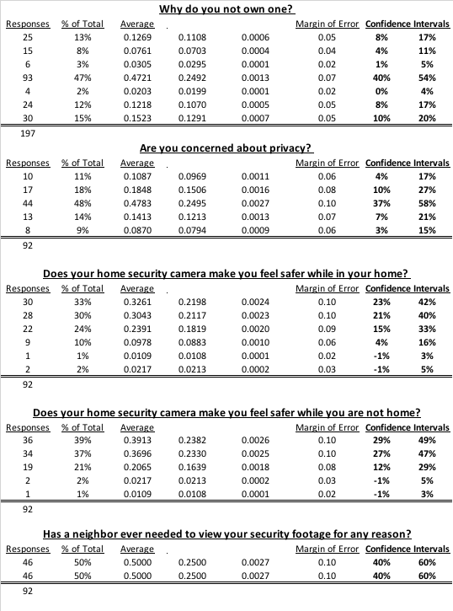

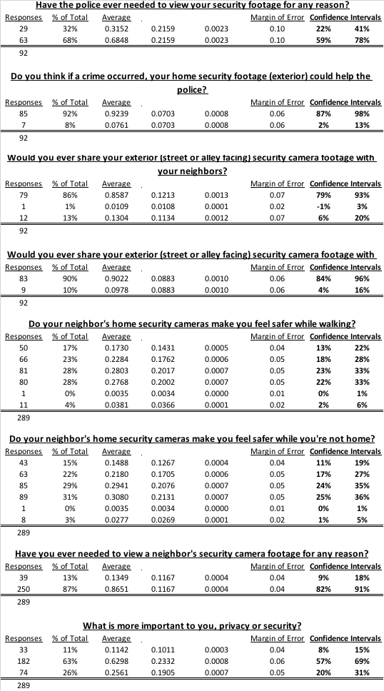

Appendix C: Open Text Survey Responses
