Examining the Total Physical Response Storytelling Method and Traditional Grammar-Based Instruction to Identify Overall Effectiveness Relating to Vocabulary Recall

By Christine DeLucry

Submitted in Partial Fulfillment of the Requirements for the
Degree of Master of Education

December 2020

Graduate Programs in Education
Goucher College

Table of Contents
Abstract | ii
I. Introduction | 1
Statement of Problem | 2
Hypothesis | 2
Operational Definitions | 2
II. Review of the Literature | 3
Common Barriers Regarding Second Language Acquisition | 3
Grammar-based Instruction and Practice | 4
Stephen Krashen and The Monitor Hypothesis | 5
Accuracy Versus Fluency in Language Acquisition Classrooms | 6
Total Physical Response Storytelling and Classroom Implications | 6
Comparison Between Total Physical Response Storytelling and Grammar-based  Instruction | 8
Conclusion | 9
III. Methods | 10
Design | 10
Participants | 10
Instrument | 10
Procedure | 11
IV. Results | 12
Question 1 | 12
Question 2 | 12
Question 3 | 13
Question 4 | 14
Question 5 | 15
Question 6 | 15
Question 7 | 16
Question 8 | 16
Question 9 | 17
Question 10 | 17
Question 11 | 18
Summary | 19
V. Discussion | 20
Threats to Validity | 20
Connections to Existing Literature | 21
Implications for Future Research | 22
Conclusion | 22
References | 23

List of Tables
1. Appendix A | 25

Abstract
The field of second language acquisition has undergone a dramatic shift over the past several decades, shifting from grammar-based instruction, memorization, and written dictation to a more organic approach of language acquisition that encourages use of realia and teaching vocabulary in-context. Assessments have shifted from multiple choice and spelling exams to hands-on, project-based assessments showing how students can use the material. The purpose of this study is to ascertain which method holds the most promise for second language acquisition- Traditional Grammar-based Instruction or Total Physical Response Storytelling.

CHAPTER I
INTRODUCTION
Two of the most used methods for second language acquisition are the Total Physical Response Storytelling method and the grammar-based instructional method. Both methods show promise with language retention; however, there is marked divide regarding the pedagogy surrounding second language acquisition. Several prominent language theorists, including Dr. Stephen Krashen (1987), argue that to successfully retain new language vocabulary, one must be exposed to repeated contextual output in the target language prior to being able to produce output in the target language. Krashen also states that “[l]earning comes into play only to make changes in the form of our utterance, after it has been "produced" by the acquired system. This can happen before we speak or write, or after.” (p. 18) Dr. James Asher (1966) developed a method which incorporates movement within acquisition, which shows promise in the accuracy of vocabulary recall.
Some theorists argue that one does not learn a second language organically. Theorists such as Ediger (2018) argue that one must be taught correct syntax in second language acquisition to become proficient writers in the second language. The use of realia is encouraged to reinforce learning; however, there is a greater focus placed upon correct usage of the language. Theorists who promote a grammar-based approach to language acquisition argue that by providing meaningful vocabulary within a formal grammar-based instructional setting, instructors can facilitate learners’ utilization of skills acquired during their formative language development years to ascertain meaning in second language learning.
There has been a dramatic shift over the past five years in the public school system regarding how second language learning is presented. For example, Baltimore County Public Schools followed a grammar-based instructional model prior to 2016; in 2016, Baltimore County Public Schools introduced a more organic approach to language acquisition. There has been a great deal of discussion among educators as to the efficacy of the Total Physical Response Storytelling and Comprehensible Input strategies. Due to the dearth of research on vocabulary instruction and second language acquisition, this study will focus on this issue
Statement of Problem
This study sets out to determine which method of second language acquisition holds greater potential for student retention and recall, as perceived and reported by foreign language teachers, Total Physical Response Storytelling or traditional grammar-based instruction.
Hypothesis
This study will use a survey, and, in this instance, the descriptive study will not posit a hypothesis.
Operational Definitions
Total Physical Response Storytelling- A method of second language acquisition focused on
incorporating movement to facilitate comprehension of new learning.
Grammar-based instruction- A method of second language acquisition focused on proper syntax, spelling, and usage.
Comprehensible Input- A method of second language acquisition that uses realia, props, and
other tools to help students navigate meaning. Students are not expected to understand all
words presented, students circumnavigate meaning within context.
Second Language Acquisition- Methodology used to learn second and multiple languages.

CHAPTER II
REVIEW OF THE LITERATURE
There are several methods that are used to assist learners in acquiring another language. Two of the most popular methods that are used are the Total Physical Response Storytelling method and traditional grammar-based instruction. This chapter will identify the research behind the barriers faced in learning a second language and compare the unique strengths and weaknesses that each model possesses.
Section one will focus on barriers to second language acquisition. Section two will focus on grammar-based instruction and its implications. Section three will focus on Stephen Krashen (1987) and the Monitor Hypothesis. Section four will focus on accuracy versus fluency in language acquisition classrooms. Section five will focus on the Total Physical Response Storytelling method and its implications. Section six will focus on the comparison between Total Physical Response Storytelling and grammar-based instruction, and section seven will provide a summary.
Common Barriers Regarding Second Language Acquisition
Second language acquisition poses unique struggles to learners looking to adapt to a new language and culture. It is not uncommon, as Ahmed (2019) states, for second language learners to “suffer from anxiety and a lack of self-confidence” (p. 2) when prompted to produce output in the second language. Second language learners are tasked with processing the new language, and this can pose comprehension challenges due to cultural differences.
Anxiety, Ahmed (2019) states, is one of the “most common predictors of language success or failure” (p. 3). In addition, anxiety can be both a positive and a negative motivator regarding language acquisition. Per Ahmed (2019), “Anxiety is deeply rooted in fear which arouses negative human emotions. Anxiety emerging from fear breaks down fundamental progress of language development” (p. 3).
Listening comprehension is often the first skill to develop when learning a new language. That does not mean it does not present its own unique set of challenges to a new language learner. Chen (2005) lists seven common listening comprehension problems faced by new language learners: “the rate of speech of the speaker, the inability to have items repeated, the limited vocabulary base of the learner, failure to recognize symbols, problems of interpretation, inability to concentrate, and established learning habits” (p. 2) of the language learner.
Grammar-Based Instruction and Practice
Grammar-Based instruction, according to Ediger (2018), “include[s] word placement or syntax in communication” (p. 145). This method of second language acquisition, SLA, focuses on teaching the parts of speech and their proper usage from an early age. It is believed that this allows the learner to learn the rules to English language and apply them correctly in context. Ediger states, “students [will] subsequently become better writers [and will] improve communication endeavors” (p. 145). Teaching parts of speech may involve realia, such as props or photographs depicting certain items, such as nouns. As students progress with vocabulary acquisition, verbs are introduced in tandem with the objects studied. This provides students with the opportunity to form relationships between various actions and the subjects that may perform said action.
Azad (2013) reiterates the need for grammar instruction, stating that “some formal instruction on grammar is necessary in L2 classrooms” (p. 111). Formal grammar instruction, when paired with meaningful vocabulary introduction, helps students retain more language than by teaching isolated words alone. Recent research indicates that while one picks up their native language in an organic manner, second language acquisition often happens later in one’s development. Thus, second language learners often bring a wealth of linguistic knowledge that directly benefits second language acquisition.
Gao (2001) claims that adult learners cannot acquire a second language in the same method as when acquiring their primary language. Gao’s belief follows that of several other researchers, such as Azad (2013), in that while one picks up a first language in a culturally rich context, it is difficult to do so as an adult. This is believed to be a result of exposure to grammar context and explicit rules governing usage, as stated by Zhonggang (2001): “[t]he reason second language learners need to resort to learning grammar is that it provides some general and systematic guidance on the structure and syntax” (p. 327).
Stephen Krashen and The Monitor Hypothesis
Krashen (1987), an expert in linguistics pedagogy and acquisition, states in his Theory of Second Language Acquisition that input is directly attributed to how one acquires language. Krashen suggests that one acquires a language subconsciously by one’s motivation, whereas learning is viewed as a separate entity that requires a conscious effort to obtain (Nagle, 1986). Verbal language and language comprehension are viewed as two separate items that develop at different times.
Krashen (1987) believes that input is essential in one’s language acquisition and that by receiving comprehensible input that is relevant to the learner, acquisition occurs naturally. Comprehensible input is an essential component of language acquisition where learners can understand the material heard but are not expected to understand every word spoken. Krashen’s theory focuses on receiving input that is one level above the learner’s current level, referred to as i+1. Listening comprehension is encouraged to develop as the learner navigates meaning and context of the language being spoken without being pressured to immediately produce output in the second language, referred to as L2. Encouraging the learner to simply experience the language and infer meaning based on what they hear results in a learning environment that is less stressful and more conducive to language acquisition.
Accuracy versus Fluency in Language Acquisition Classrooms
Carridan (2009) describes how when young children are learning their native language, “[they] make associations between the sounds they hear and the actions and movements they see” (p. 57). When learning to speak, it is expected for there to be mistakes in verb tenses and syntax as one learns to associate meaning with words. It is believed by several theorists such as Krashen (1982) that language acquisition develops organically, and one must be exposed to continual input before output in the language can occur.
Lightbown and Pienemann (1993), however, point out several issues that are evident with Stephen Krashen’s Monitor Theory. The authors state that Krashen (1993) “reiterates...the only role for formal instruction is to permit learners to ‘monitor’ their L2 production.” (p. 717) As such, comprehensible input, and methods such as Total Physical Response Storytelling (TPRS) do not prepare students for meaningful L2 acquisition. Lightbown and Pienemann believe that “...while comprehensible input is an essential part of the learning environment, it will not always be sufficient to bring about developmental change or increased accuracy, even when learners are in supportive environments” (p. 718).
Total Physical Response Storytelling and Classroom Implications
The Total Physical Response method devised by Asher (1966) encourages an association between physical movement and language. This method has shown promise in retaining language, as demonstrated in a Japanese language study conducted by Asher. Students were instructed to listen to a term and then mimic the movement produced by the teacher. After a brief period, students could recall the word and associated movement with almost perfect accuracy (Asher, 1966). Khorasgani and Khanehgir (2017) validate the efficiency of the TPRS method saying, “[E]xperimental studies that focused on the efficiency of teaching a FL using the TPR method indicated that TPR can lead to a significant increase in the vocabulary acquisition and listening comprehension skills of FL learners when compared with the control groups” (p. 151).
When Total Physical Response Storytelling (TPRS) is implemented in a classroom setting, the instructor uses storybooks and creates fictional stories based on students’ interests and lives so that students are invested in the learning. Students learn vocabulary through context and are tasked with listening, reading, and retelling the story via writing. Comprehension is observed by using the circling technique. If a comprehension is not achieved, the instructor will reteach areas of opportunity.
The TPRS method follows a three-step process: establishing meaning, asking a story, and reading. According to Kara and Eveyik-Aydin (2019), establishing meaning involves “pre teaching of the basic vocabulary items and structures before the storytelling activity…using high-frequency words…and incorporating L1 translation and gestures to aid in comprehension” (p. 137) The second step, asking a story, involves repetition of terms in a creative setting that incorporates students acting out the story. The instructor will ask several questions to check for comprehension, such as yes/no, either/or, who/what/when/where. Reteaching will occur at this step, if needed. Kara and Eveyik-Aydin state that the last step, reading, involves students rereading the story and incorporating activities such as writing a different end for the story.
Comparison between Total Physical Response Storytelling and Grammar-based Instruction
While both methods show promise in second language acquisition, both models possess disadvantages that may pose problematic to instructors and learners alike. Grammar-based instruction may be beneficial to older students who have a solid grasp of grammar rules and context; however, students often have trouble recalling vocabulary and structures learned. Total Physical Response Storytelling (TPRS) shows promise in language acquisition for younger students, but it may not be practical for adult learners. Grammar-based instruction is extremely teacher-centered, focusing on the teacher speaking in the target language for most of the class as students listen to correct pronunciation and accents. TPRS actively involves both the educator and learners in the creation and retelling of the story, which can be exhausting to the educator who must constantly adapt and react to student learning.
Busch and Kariyuki conducted a study in 2008 detailing the effects of the Total Physical Response Storytelling method versus traditional grammar-based instruction. Their study concluded that the experimental group using TPRS showed promising results in comparison to the control group, which focused on traditional grammar instruction. Busch and Kariyuki (2008) stated that there are specific roles for both teacher and students in a TPRS classroom setting. Classes are conducted in a method where students have creative license in the creation of stories and illustrations, which help to cement ideas and concepts that the educator is presenting. In a traditional grammar-based classroom, instead of collaborative creation of learning between students and teachers, students are passive learners in a teacher-centered environment which may or may not provide learning opportunities that pique the interest of students. Busch and Kariyuki state that writing is often the last skill introduced in a grammar-based classroom, which does a disservice to kinesthetic and visual learners.
Conclusion
The research conducted suggests that there is a division regarding the efficacy of grammar-based instruction versus the Total Physical Response Storytelling method, as evidenced in the five sections outlined in this chapter. In the first section, commonalities exist between the two methods regarding language acquisition and apprehension. In the second section, grammar-based instruction was introduced as a method of second language acquisition. The third section examined Stephen Krashen’s Monitor Theory of second language acquisition as the precursor to the Total Physical Response Storytelling Method. The next section detailed perceived issues regarding the effectiveness of Krashen’s theory and language development, which is followed by an examination of the overall effectiveness of the Total Physical Response Storytelling method. Finally, differences were examined between the two methods, which shows a divide between the perceived effectiveness of each method.

CHAPTER III
METHODS
This study sets out to determine which method of second language acquisition holds greater potential for student retention and recall, Total Physical Response Storytelling or traditional grammar-based instruction; as perceived and reported by Foreign Language Teachers.
Design
This is a descriptive study using survey methodology. The study is impacted by the SARS-COVID 19 global pandemic and will be conducted via on-line survey technique.
Participants
Research participants were randomly selected based on their roles as world languages educators currently teaching remotely at the secondary level. Participants were asked to partake in an online survey detailing their familiarity with two second language acquisition models. Participants taught at the secondary level ranging from 6th to 12th grade. In addition to English, there were several other languages spoken at home, including Arabic, Spanish, Chinese, and Urdu. Students come from a wide array of cultural and socioeconomic backgrounds, as documented via Montgomery County Public Schools Annual Community Report and the School Data Dashboard provided by Baltimore County Public Schools.
Instrument
The instrument selected for this research was a survey inquiring about pedagogical practices and theories regarding second language acquisition and instruction. Participant data was collected via a survey provided via Google Forms. The survey consisted of ten multiple choice questions relating to language and level taught, familiarity with Total Physical Response and ragmmar-based instruction, location of school, vocabulary requirements, and one open-ended question where educators provided their professional opinion as to which of the two methods studied is best-suited for second language acquisition. The questions used in the survey are provided in Appendix A at the end of this paper.
Procedure
The survey instrument was administered over the course of two weeks via Google Forms. Participants submitted their responses anonymously based on their individual responses. Participants were limited to submitting one response to ensure testing validity. One hundred surveys were sent within the two-week timespan. Participants were given the same instructions for completion of the survey and encouraged to provide thoughtful feedback regarding which method of language acquisition holds greater promise, based on their professional experience with each model. A summary of the results will be provided in Chapter IV.
CHAPTER IV
RESULTS
Of the 100 surveys sent to prospective middle school respondents, 11 surveys were completed. The survey took place during school closures due to the COVID-19 global pandemic. Teachers were working on-line with students and dealing with many situations. The researcher would have preferred to have more respondents but after two weeks, the faculty adviser to the researcher recommended using the data that were available.
Table 1
Survey Results- Question One
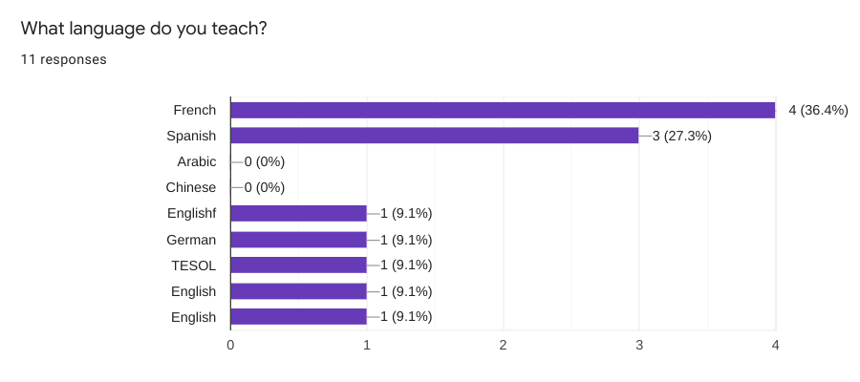
The first question asked teachers to identify the language taught via multiple choice. Respondents had the option to choose from French, Spanish, Arabic, Chinese, or Other. Responses varied, with four respondents (36.4%) selecting French, three respondents (27.3%) selecting Spanish, three respondents (27.3%) selecting other- English, one respondent (9.1%) selecting other- German, and one respondent (9.1%) selecting other- Teaching English to Speakers of Other Languages.

Table 2
Survey Results- Question Two
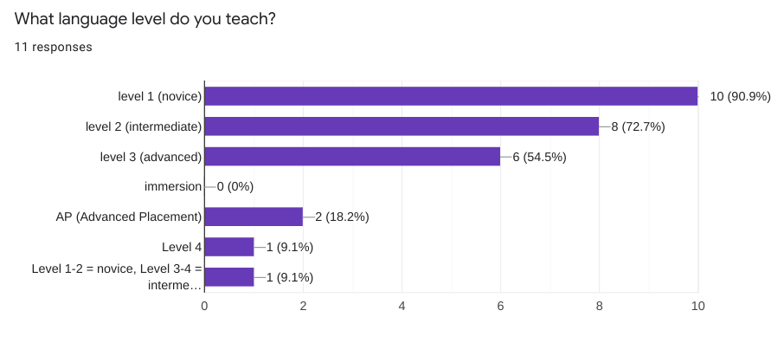
The second question asked teachers to identify the language level taught, as identified by the American Council for Teaching of Foreign Languages. This question provided information regarding student acquisition levels. Options provided included level 1/novice (student with no prior language study), level 2/intermediate (first and second year of language study), level 3/advanced (third year of language study), immersion (instruction completely in target language in a school setting), level 4 (fourth year of language study), and Advanced Placement. Ten respondents indicated that they taught level 1/novice, eight respondents who selected level 2, six respondents selected level 3, zero respondents selected immersion, two respondents selected Advanced Placement, one respondent selected level 4, and one respondent indicated they taught levels 1-2 and level 3-4. Respondents were able to select more than on level based on their classes currently being taught.

Table 3
Survey Results- Question Three
The third question asks respondents to identify the location of their school by selecting from a rural, urban, suburban, or other setting. Respondents were able to select more than one option. Six respondents (54.5%) selected suburban, five respondents (45.5%) selected urban, one respondent (9.1%) selected other- virtual in China, and zero respondents selected rural settings.
Table 4
Survey Results- Question Four
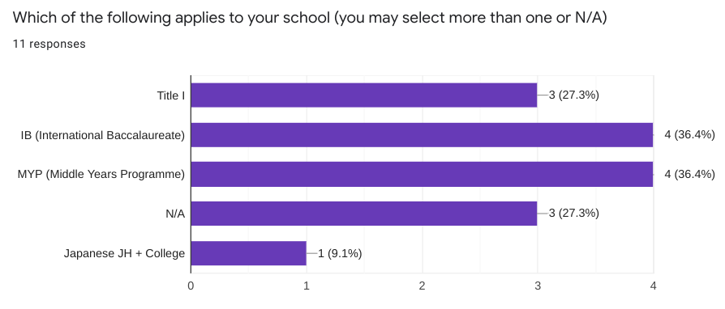
Question four asked respondents to select one of the following special considerations related to their school. Options included Title I, International Baccalaureate, Middle Years Programme, N/A, or Other. Four respondents (36.4%) selected International Baccalaureate and four respondents (36.4%) selected Middle Years Programme. Three respondents (27.3%) selected Title I and three respondents (27.3%) selected N/A. One respondent (9.1%) selected Other and indicated their institution was a Japanese High School/College.
Table 5
Survey Results- Question Five
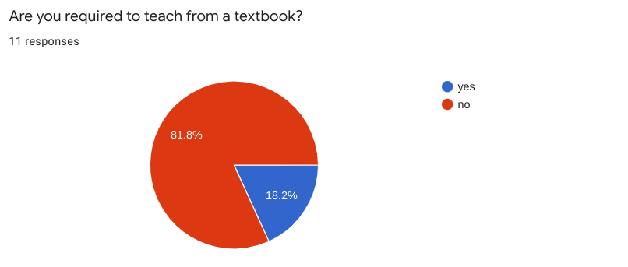
Question five asked respondents to indicate if they are required to teach from a textbook. An overwhelming majority of respondents, 81.8%, indicated that they are not required to teach from a textbook. 18.2% of respondents indicated that they are required to teach from a textbook.
Table 6
Survey Results- Question Six
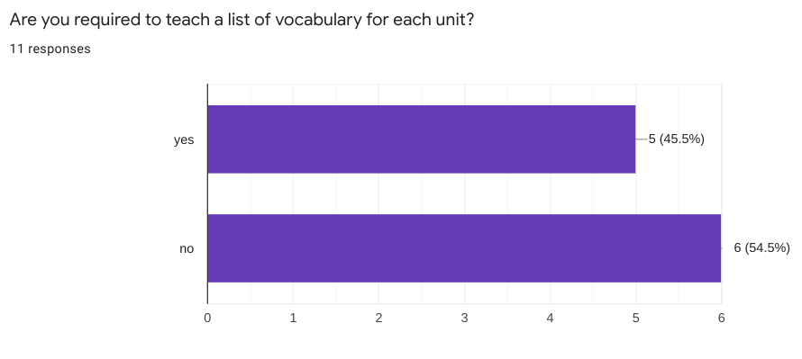
Question six asked respondents to identify if they were required to teach a mandated list of vocabulary for each unit of study. Six respondents (54.5%) indicated that they were not required to teach a list of vocabulary, whereas five respondents (45.5%) indicated that they were required to teach a set list of vocabulary.
Table 7
Survey Results- Question Seven
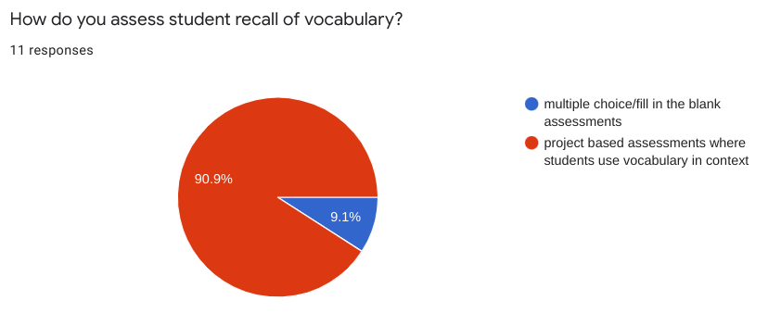
Question seven asked respondents to indicate how student vocabulary recall was assessed. Respondents were provided with two options: multiple choice/fill in the blank assessments and project-based assessments where students use vocabulary in context. 90.9% of respondents indicated that they utilize project-based assessments where students use vocabulary in context. 9.1% of respondents indicated that they utilize multiple choice/fill in the blank assessments to assess student vocabulary recall.
Table 8
Survey Results- Question Eight
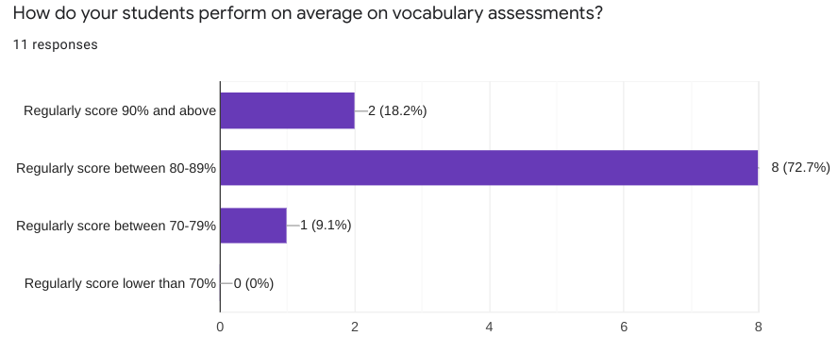
Question eight asked respondents to provide an average on student assessment. Four options were provided: regularly score 90% and above, regularly score between 80-89%, regularly score between 70-79%, and regularly score lower than 70%. Eight respondents (72.7%) indicated that students regularly score between 80-89% on assessments. Two respondents (18.2%) indicated that students regularly score 90% and above. One respondent (9.1%) indicated that students regularly score between 70-79%. Zero respondents indicated that students regularly score lower than 70%.
Table 9
Survey Results- Question Nine
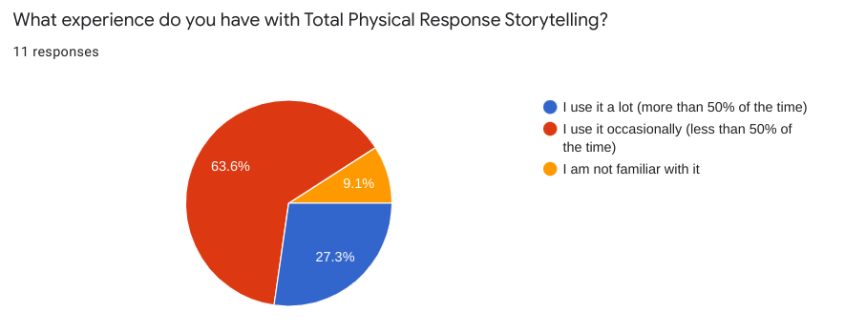
Question nine asks respondents about their experience related with Total Physical Response Storytelling. Respondents selected from one of the provided options: I use it a lot (more than 50% of the time), I use it occasionally (less than 50% of the time), and I am not familiar with it. 63.6% of respondents indicated they use it occasionally. 27.3% of respondents indicated that they use it a lot. 9.1% of respondents indicated that they were not familiar with the method.
Table 10
Survey Results- Question Ten
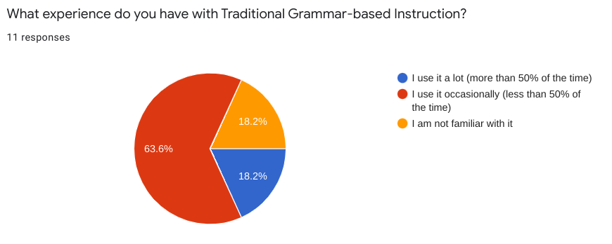
Question ten asks respondents about their experience related to Traditional Grammar-based instruction. Respondents selected from one of the provided options: I use it a lot (more than 50% of the time), I use it occasionally (less than 50% of the time), and I am not familiar with it. 63.6% of respondents indicated that they use it occasionally (less than 50% of the time). 18.2% of respondents indicated that they use it a lot and 18.2% of respondents indicated that they are not familiar with the method.
Table 11
Survey Results- Question Eleven
Question eleven asked respondents to submit an open-ended response to the prompt ¨In your personal and professional opinion: what method of teaching second language instruction works best for student learning?” Responses varied based on the individual experiences of each respondent. Respondents suggested immersing students in the language, providing hands-on learning with acting out and use of realia. One respondent indicated that they believe that TPRS/CI holds more promise for second language acquisition and that using language in-context provides students with the opportunity to use the language in an authentic setting. Memorization/grammar-based instruction, in one respondent’s submission, does not help students retain information. One respondent indicated that the natural approach to language acquisition held more promise. Additionally, one respondent indicated that they believe there needs to be a mixture of traditional grammar-based instruction and more modern exploratory methods, such as Total Physical Response Storytelling/Comprehensible Input. It was noted that this educator feels that their students will often give up and become frustrated if grammar and vocabulary are not explicitly taught, as it helps them to find patterns that are prevalent in language learning.
Summary of Results
Survey results showed mixed professional opinions regarding methods of second language acquisition. It is interesting to note that most respondents feel that utilizing a combination of grammar-based instruction and Total Physical Response Storytelling/Comprehensible Input strategies showed more promise in developing their students’ vocabulary recall. 63.6% of respondents indicated that they use Total Physical Response Storytelling occasionally (less than 50% of the time) and an equal percentage of respondents indicated they use Traditional Grammar-based instruction in their language instruction. The researcher found it particularly interesting that an equal percentage of respondents used both methods described in the study, yet 90.9% of respondents indicated they utilized project-based assessments to demonstrate student proficiency in vocabulary. Based on the survey results, it is unclear as to whether traditional grammar-based or Total Physical Response Storytelling holds greater promise of promoting vocabulary proficiency among students.

CHAPTER V
DISCUSSION
This study sets out to determine which method of second language acquisition holds greater potential for student retention and recall, Total Physical Response Storytelling or Traditional Grammar-based Instruction as perceived and reported by Foreign Language Teachers. The study was significantly impacted by the small number of respondents to the survey. The continuing degree to which school closure due to the COVID-19 virus will impact student learning and language acquisition is hard to determine.
Threats to Validity
All research studies in all fields of inquiry and science suffer from threats to validity. The threats fall under two general categories: external threats to validity and internal threats to validity. In this case of a descriptive research study, the threats are overlapping and deal with sampling strategy and return rate of the participants.
The COVID-19 global pandemic implicated both external and internal threats to the validity of this study. An internal threat to the validity of the study would be the small sample size. The researcher was tasked with sending out an anonymous survey to 100 secondary level language teachers with whom the researcher did not have a working relationship. Out of the 100 surveys distributed, the researcher received 11 responses.
The study was purposive, which placed limitations on how far the researcher was able to generalize the returns. Due to the small sample size and the anonymity of the returns, generalization is exceedingly difficult.

Connections to Existing Literature
The researcher set out to determine which method of second language instruction- Traditional Grammar-based instruction or Total Physical Response Storytelling- held greater promise regarding student vocabulary mastery and recall. As mentioned in Chapter II, the research conducted suggests that there is a division regarding the efficacy of Grammar-based instruction versus the Total Physical Response Storytelling method. This divide is not apparent based on the sample responses provided via the Google Forms survey that was conducted.
In the written response, there were varying opinions as to the efficacy of one method over the other. One respondent indicated that there should be a mixture of Traditional Grammar-based instruction and Total Physical Response Storytelling; another indicated that the use of realia in addition to acting out in the target language and providing hands-on learning shows more promise for language acquisition. This mirrors research presented in Chapter II, where it was indicated that classes [that] are conducted in a method where students have creative license in the creation of stories and illustrations, which help to cement ideas and concepts that the educator is presenting.
In Chapter II, it was noted that grammar-based instruction may be beneficial to older students who have a solid grasp of grammar rules and context; however, students often have trouble recalling vocabulary and structures learned. While there were no written responses indicating the sole usage of Traditional Grammar-based instruction, it was noted that there is a benefit in explicitly teaching grammar and vocabulary as opposed to teaching them in-context. This method helps to prevent students from disengaging in their learning by affording students the opportunity to discover patterns in the language that may not be readily apparent when using the Total Physical Response Storytelling method.
Implications for Future Research
Due to the COVID-19 global pandemic and subsequent closure of all public schools in the state of Maryland, the researcher was unable to conduct the study as originally intended. As a result, potential future research could include conducting a study utilizing quasi-experimental pre- and posttests to measure vocabulary recall based on Total Physical Response Storytelling and Traditional Grammar-based instruction in a classroom setting. Additional future research could include the usage of Zoom or Google Meets and the implementation of both Total Physical Response Storytelling and Traditional Grammar-based instruction in an online classroom environment.
Conclusion
This study set out to identify which method of language acquisition held more promise regarding student vocabulary mastery- Total Physical Response Storytelling or Traditional Grammar-based Instruction. Each method studied has shown promise regarding second language acquisition and vocabulary recall. Educators do not exclusively use one methodology; instead, preferring a combination of the two models studied. Further research is needed to determine the efficacy of Total Physical Response Storytelling and Traditional Grammar-based instruction due to the complications presented due to the COVID-19 pandemic.

References
Ahmed, M.K. (2019). Psychological barriers in the acquisition of second language: A non-native perspective. E-BANGI Journal, 16(7), 1-9.
Asher, J.J. (1966). The learning strategy of the total physical response: A review*. The Modern Language Journal, 50(2), 79-84. doi:10.1111/j.1540-4781.1966.tb03573.x
Azad, M.A.K. (2013). Grammar teaching in EFL classrooms: Teachers’ attitudes and beliefs. ASA University Review, 7(2), 111-126.
Carrigan, R.P. (2009). Implementing language acquisition in classrooms. Education Digest, 75(4), 57-61.
Chen, Y. (2005). Barriers to acquiring listening strategies for EFL learners and their pedagogical implications. TESL-EJ, 8(4).
Ediger, M. (2018). Teaching grammar as communication in the curriculum. Reading Improvement, 55(4), 145-147.
Kara, K., & Eveyik-Aydin, E. (2019). Effects of TPRS on very young learners’ vocabulary acquisition. Advances in Language and Literary Studies, 10(1), 135-146.
Kariuki, P.N.K, & Bush, E.D. (2008). The effects of total physical response by storytelling and the traditional teaching styles of a foreign language in a selected high school. Online Submission.
Khorasgani, A.T., & Khanehgir, M. (2017). Teaching new vocabulary to young learners: Using two methods of total physical response and keyword method. International Journal of Evaluation and Research in Education, 6(2), 150-156.
Krashen, S.D. (1987). Principles and Practice in Second Language Acquisition. (pp. 18-19). New York, London, Toronto: Prentice-Hall International.
Lightbown, P., & Others (1993). Comments on Stephen D. Krashen’s “Teaching issues: formal grammar instruction.” TESOL Quarterly 27(4), 717-725. doi: 10.2307/3587404
Nagle, S., & Sanders, S. (1986). Comprehension theory and second language pedagogy. TESOL Quarterly, 20(1), 9-26. doi: 10.2307/3586386.
Zhonggangao, D.C. (2001). Second language learning and the teaching of grammar [1]. Education, 122(2), 326. doi: 10.2307/3587404.

Appendix A

