Supplementary Material A
Standard of Care (SOC) was a condition in which the health-care provider gave instructions about how to take antiretroviral therapy (ART) medication and described the importance of adhering to the ART regimen; enhanced Standard of Care (eSOC) was a condition like Standard of Care, but with additional support such as adherence counselling or short education sessions; Telephone (TELE) was a condition that used telephone calls (arranged at various timepoints) to remind or support patients; Short Message Service (SMS) was a condition in which text messages were sent to patients’ mobile phones at various timepoints; Behavioral Skills Training or Medication Adherence Training (BST/MAT) was a condition that provided educational training on how to adhere to ART, including interventions that involved module-based learning as well as those designed to improve life skills, behaviors, knowledge, and attitudes; Multimedia (MULTI) was a condition that involved materials available online or through use of a computer or tablet; Cognitive Behavioral Therapy (CBT) was a condition that included CBT, cognitive behavioral stress management, or interventions that involved counselling with individuals with trained professionals and included interventions that used motivational interviewing; Supporter (SUPP) was a condition in which an individual supported the patient’s treatment adherence with peer-based support, home visits, treatment assistants, medication managers, directly-observed therapy, or modified directly-observed therapy; Incentives (INCENT) was a condition that involved conditional or unconditional cash transfers, financial incentives, or the use of vouchers to support adherence; and Device Reminders (DEV) was a condition that involved the use of calendars, alarms, pagers, or disease management assistance system devices.

Supplementary Materials B
Interventions that passed initial screening but were excluded at the data-extraction stage.
First Author Year | Control | Treatment | Reason for exclusion
Abdulrahman 2017 | SOC | SMS | Insufficient measurement of undetectable HIV viral load: Results of some assessed participants not reported. Assessments of undetectable viral load included only participants with “good” adherence.
Alsan 2016 | SOC | INCENT | Insufficient measurement of undetectable HIV viral load: No measurement of undetectable viral load reported. Abstract only.
¹Alsan 2017 | SOC | INCENT | Not a randomized controlled trial. Participants in the control group were not assigned at random.
²Alsan 2017 | SOC | INCENT | Not a randomized controlled trial. Participants in the control group were not assigned at random.
Amanyire 2016 | SOC | eSOC | Insufficient measurement of undetectable HIV viral load: No measurement of undetectable viral load. Abstract only.
Belzer 2015 | SOC | SMS | Insufficient measurement of undetectable HIV viral load: No measurement of undetectable viral load. Viral load not measured after start of treatment.
Blank 2014 | SOC | SUPP | Insufficient measurement of undetectable HIV viral load: No measurement of undetectable viral load.
Blashill 2017 | eSOC | CBT | Insufficient measurement of undetectable HIV viral load: Viral load measured at intake, but not measured after start of treatment.
Chang 2017 | SOC | DEV, SUPP | Insufficient measurement of undetectable HIV viral load: No results were reported.
Collier 2005 | SOC | SUPP | Insufficient measurement of undetectable HIV viral load: This study did not provide the information required to determine differences in undetectable viral load between the groups.
Cunningham 2018 | SOC | SUPP | Insufficient measurement of undetectable HIV viral load: Ambiguous description of results, could not determine the number of participants assessed per group. Criterion for undetectable viral load was not reported. Number of participants assessed per group not reported.
Cuong 2016 | SOC | SUPP | Insufficient measurement of undetectable HIV viral load: Ambiguous description of results. Virologic failure (inverse of undetectable viral load) was defined as either >1000 copies/mL for a specified period or a measure of < 200 copies/mL followed by a measure of >1000 copies/mL.
¹Drake 2017 | SOC | SMS | Insufficient measurement of undetectable HIV viral load: No results were reported.
²Drake 2017 | SOC | INCENT, SMS | Insufficient measurement of undetectable HIV viral load: No results were reported.
El-Sadr 2017 | SOC | INCENT | Insufficient measurement of undetectable HIV viral load: Ambiguous description of results, could not determine the number of participants assessed per group.
¹Fox 2018 | SOC | SUPP | Insufficient measurement of undetectable HIV viral load: No measurement of undetectable viral load.
²Fox 2018 |  |  | Insufficient measurement of undetectable HIV viral load: No results were reported. No Standard of Care Control Group.
Gamble 2017 |  |  | Not a randomized controlled trial: No experiment was conducted.
Geldseltzer 2017 |  |  | Not a randomized controlled trial: No experiment was conducted.
Greene 2017 |  |  | Not a randomized controlled trial: No experiment was conducted.
¹Gross 2015 | SOC | SUPP | Insufficient measurement of undetectable HIV viral load: Ambiguous description of results, no measurement of undetectable viral load.
²Gross 2015 |  |  | Insufficient measurement of undetectable HIV viral load: No measurement of undetectable viral load.
Gross 2009 |  |  | Insufficient measurement of undetectable HIV viral load: No measurement of undetectable viral load.
¹Haberer 2016 | SOC | SMS | Not a randomized controlled trial. No measurement of undetectable viral load.
²Haberer 2016 | SOC | SMS | Not a randomized controlled trial. No measurement of undetectable viral load.
Hersch 2013 | SOC | MULTI | Insufficient measurement of undetectable HIV viral load: No measurement of undetectable viral load.
Huhn et al 2017 | SOC | OTHER DRUG REGIMEN | No intervention to promote ART adherence or viral suppression: Study was a medication change.
Joseph-Davey 2016 | SOC | eSOC | Insufficient measurement of undetectable HIV viral load: No measurement of undetectable viral load.
Konkle-Parker 2012 | SOC | BST/MAT | Insufficient measurement of undetectable HIV viral load: No measurement of undetectable viral load.
Kurth 2016 | SOC | eSOC | Insufficient measurement of undetectable HIV viral load: Ambiguous description of results, could not determine the number of participants assessed per group.
Kwarisiima 2017 |  |  | Not a randomized controlled trial. There was no randomized group assignment. There were no groups.
Magidson 2015 | SOC | BST | Not a randomized controlled trial.
Magidson 2016 | SOC | BST | Insufficient measurement of undetectable HIV viral load: Viral load not measured after start of treatment.
Mimiaga 2018 |  |  | Insufficient measurement of undetectable HIV viral load: No results were reported.
Moore 2018 |  |  | Insufficient measurement of undetectable HIV viral load: No results were reported.
Orrell 2015 | eSOC | SMS | Insufficient measurement of undetectable HIV viral load: This study did not provide the information required to determine differences in undetectable viral load between the groups.
Parsons 2007 | SOC | BST/MAT | Insufficient measurement of undetectable HIV viral load: No measurement of undetectable viral load
Pasternak 2015 |  |  | Not a randomized controlled trial: No experiment was conducted
Pellowski 2016 |  |  | Not a randomized controlled trial: No experiment was conducted. Secondary analysis.
Reynolds 2008 |  |  | Insufficient measurement of undetectable HIV viral load: No measurement of undetectable viral load
Robbins 2016 | SOC | SUPP | Insufficient measurement of undetectable HIV viral load: Ambiguous description of results, could not determine the number of participants assessed per group. Study was interrupted before all results were collected at week 48. 9 of 14 samples assessed at week 48 were undetectable, but the number from each per group was not reported.
Rodrigues 2015 | SOC | SMS, TELE | Insufficient measurement of undetectable HIV viral load: No measurement of undetectable viral load.
Ruiz 2011 | SUPP | SUPP | No standard of care control group.
Safren 2012 | eSOC | CBT | Insufficient measurement of undetectable HIV viral load: No measurement of undetectable viral load.
Shet 2014 | SOC | TELE | Insufficient measurement of undetectable HIV viral load: No measurement of undetectable viral load.
¹Simoni 2009 | SOC | DEV | Insufficient measurement of undetectable HIV viral load: Results aggregated over multiple assessments. Not possible to separate results for any specific timepoint.
²Simoni 2009 | SOC | SUPP | Insufficient measurement of undetectable HIV viral load: Results aggregated over multiple assessments. Not possible to separate results for any specific timepoint.
³Simoni 2009 | SOC | DEV, SUPP | Insufficient measurement of undetectable HIV viral load: Results aggregated over multiple assessments. Not possible to separate results for any specific timepoint.
Thirumurphy 2018 | SOC | INCENT | Insufficient measurement of undetectable HIV viral load: This study did not provide the information required to determine differences in undetectable viral load between the groups.
van Servellen 2005 | SOC | eSOC | Insufficient measurement of undetectable HIV viral load: Ambiguous description of results – Criterion for undetectable viral load inconsistent throughout paper.
Weissman 2016 | SOC | SOC Different measurement time | No intervention to promote ART adherence: Intervention was manipulation to timing of viral load measurements.

Supplementary Material C
Results of Cochrane Collaboration Tool for Interventions (n=51) included in the main analysis.
Author Year | Intervention Type | UDL Criterion  (copies/mL) | Sequence Generation | Allocation Concealment | Blinding | Incomplete outcome data | Selective outcome reporting | Other sources of bias | Comments
Altice 2007 | SUPP | <400 | Unclear | Low | Unclear | Low | Low | Unclear
Andrade 2005 | DEV | <50 | Unclear | Low | Unclear | Low | Low | Low
¹Barnabus 2016 | eSOC | <50 | Low | Low | Unclear | Low | Low | Low
²Barnabus 2016 | eSOC, SUPP | <50 | Low | Low | Unclear | Low | Low | Low
Belzer 2014 | TELE | ≤400 | Low | Low | Unclear | Low | Low | High | Very small sample size
Berg 2011 | SUPP | <75 | Low | Low | Unclear | Low | Low | Low
Berger 2008 | BST/MAT | <50 | Low | Low | High | Low | Low | High | Method of training may have affected intervention
Berrien 2004 | BST/MAT | <2.6 log10 | Low | Low | Low | Low | Low | High | Very small sample size
Chawana 2017 | SUPP | <1000 | Unclear | Unclear | Unclear | Low | Low | Low
Cunningham 2018 | SUPP | <75 | Low | Low | Low | Low | Low | Low | Note, More people were virally suppressed at baseline in each group (88 in treat 49%, 91 in control 52%)
de Bruin 2010 | CBT | ≤50 | Low | Low | High | Low | Low | Low
DiIorio 2008 | CBT | <0.4 log10 | Unclear | Low | High | Low | Low | High | Very strict criteria for undetectable viral load (<0.4log = <3 copies/mL).
Garcia 2005 | CBT | <400 | Unclear | Low | Unclear | Unclear | Low | Low
Garofalo 2016 | SMS | ≤75 | Low | Low | High | Low | Low | Low
Geldsetzer 2018 | SUPP | <1000 | Low | Low | High | Low | Low | Low
Giordano 2016 | SUPP | <400 | Low | Low | Low | Low | Low | Low
¹Goggin 2013 | CBT | <400 | Unclear | Low | Unclear | Low | Low | Low
²Goggin 2013 | CBT, SUPP | <400 | Unclear | Low | Unclear | Low | Low | Low
Gross 2013 | TELE | <75 | Low | Low | High | Low | Low | Low
Ingersoll 2011 | MULTI | <49 | Unclear | Low | High | Low | Low | Low
Javanbakht 2006 | INCENT | <400 | Low | Low | Low | Low | Low | Low
¹Kalichman 2016 | CBT | <100 | Low | Low | Low | Low | Low | Low
²Kalichman 2016 | SMS | <100 | Low | Low | Low | Low | Low | Low
³Kalichman 2016 | CBT, SMS | <100 | Low | Low | Low | Low | Low | Low
Kiweewa 2013 | SUPP | <400 | Low | Low | High | Low | Low | Low
Kuo 2019 | eSOC, SMS | <200 | High | Unclear | Unclear | Low | Low | Low
Lester 2010 | SMS | ≤400 | Low | Low | High | Low | Low | Low
Lucas 2013 | SUPP | <50 | Low | Low | Low | Low | Low | Low
Macalino 2007 | SUPP | <50 | Unclear | Low | High | Unclear | Low | Low
McLaughlin 2018 | SUPP | <400 | High | Low | Unclear | Low | Low | Low | Not true random assignment, cluster analysis.
¹Metsch 2016 | SUPP | <200 | Low | Low | Unclear | Low | Low | Low
²Metsch 2016 | SUPP, INCENT | <200 | Low | Low | Unclear | Low | Low | Low
Myers 2018 | SUPP | <50 | Low | Low | Unclear | Low | Low | Low
Naar-King 2013 | BST/MAT | NR | Unclear | Low | Low | Low | Low | Low
Nachega 2010 | SUPP | <400 | Low | Low | High | Low | Low | Low | Typo in consort flowchart makes attrition look higher than it actually was (606% vs 6.6%)
Orrell 2015 | DEV, SMS | <40 | Unclear | Low | High | Low | Low | Low
Pence 2015 | SUPP | <50 | Low | Low | Low | Low | Low | Low
Pradier 2003 | BST/MAT | <40 | Unclear | Low | Unclear | Low | Low | Low
Ramirez-Garcia 2012 | eSOC | <50 | Unclear | Low | High | Low | Low | Low | Small sample size. Inaccurate caption for Figure 2.
Rathbun 2005 | BST/MAT | <400 | Low | Low | High | Low | Low | Low
Sabin 2015 | SMS | <50 | Low | Unclear | High | Low | Low | Low | Conflicting reports of number assessed in Method and Table 2. Used 55 assessed as reported in Table 2.
Silveira 2014 | BST/MAT | <50 | Low | Unclear | High | Low | Low | Low
Silverman 2019 | INCENT | <200 | Low | Low | High | Low | Low | Low
Taiwo 2010 | SUPP | <400 | Low | Low | Low | Unclear | Low | High | Possible that individual differences in treatment partners could affect treatment. Procedural adherence of treatment partners was not reported. Distance between home and clinic predicted likelihood of medication pick-up
van Loggerenberg 2015 | CBT | <400 | Low | Low | High | Low | Low | Low
Wagner 2013 | BST/MAT | <50 | Unclear | Low | High | Low | Low | Low
White 2015 | SUPP | ≤400 | Low | Unclear | Unclear | Low | Low | Low
Williams 2014 | SUPP | <400 | Low | Low | High | Low | Low | Low
¹Wohl 2006 | SUPP | <400 | Low | Low | Low | Low | Low | Low
²Wohl 2006 | SUPP | <400 | Low | Low | Low | Low | Low | Low
Yotebieng 2016 | INCENT | <40 | Unclear | Unclear | Unclear | Low | Low | Low
Note. We assessed Risk of Bias from Incomplete Data using a cutoff that required at least 70% of enrolled participants to have been assessed at the primary timepoint for the intervention to be considered for evaluation as low risk of bias.

Supplementary Material D
Results of Cochrane Collaboration Tool for Interventions (n=15) excluded from the main analysis.
Author Year | Intervention Type | UDL Criterion  (copies/mL) | Sequence Generation | Allocation Concealment | Blinding | Incomplete outcome data | Selective outcome reporting | Other sources of bias | Comments
Abas 2018 | eSOC | <200 | Low | Low | Low | High | Low | Low | BL: Partially blinded by providing extra counseling sessions. IOD: <half control group reported for follow up for VL, but most participants completed other parts of follow-up.
Bhargava 2018 | SUPP¹ | <25 | Unclear | Unclear | Unclear | High | High | Low
Bhargava 2018 | SUPP² | <25 | Unclear | Unclear | Unclear | High | High | Low
Chang et al. 2010 | SUPP | ≤400 | Low | Low | High | High | Low | High | High attrition. Large difference in number assigned to intervention and control groups.
Cowan 2018 | SUPP | <1000 | High | Low | High | High | Low | Low
Fox 2018 | SUPP | <400 | Low | Unclear | Unclear | High | Low | Low
Hosseinipour 2017 | SUPP | <1000 | Unclear | Unclear | Unclear | High | Low | Low | High attrition in both groups.
Hosseinipour 2017 | SUPP | <1000 | Unclear | Unclear | Unclear | High | Low | Low | High attrition in both groups.
McNairy 2017 | eSOC, SMS, INCENT | <1000 | High | Low | Unclear | High | High | Low | Cluster analysis
Rawlings et al. 2003 | BST/MAT | <40
Rosen et al. 2007 | INCENT | <400 | Unclear | Low | High | High | Low | Unclear
Smith et al. 2003 | BST/MAT | <400 | Unclear | Low | High | High | Low | High | Possibility of bias from individual differences in identification of self-incentives and in compliance with directives for self-management intervention, which was not directly assessed in most cases
Tuldra et al. 2000 | eSOC | <400 | Unclear | Low | High | High | Low | Unclear
Wamalwa et al. 2009 | eSOC | <100 | Low | Low | High | High | Low | Unclear
Wohl 2017 | CBT, SMS | <50 | Low | Unclear | Unclear | High | Low | Low

Supplementary Materials E

Analysis of interventions included in the main analysis (N=51) as judged by the Missing-Missing analysis.

 |  | UDL |  | n Assigned |  | n Assessed |  | n UDL |  | % UDL
 | Treatment | Criterion | Primary | Cont | Treat | Cont | Treat | Cont | Treat | Cont | Treat
First Author Year | Type | copies/mL | Measurement | -rol | -ment | -rol | -ment | -rol | -ment | -rol | -ment | RR | 95% CI
Altice 2007 | SUPP | <400 | Month 6 | 53 | 88 | 52 | 83 | 26 | 49 | 50 | 59 | 1.18 | 0.85 | 1.64
Andrade 2005 | DEV | <50 | Week 12 | 32 | 32 | 29 | 29 | 4 | 11 | 14 | 38 | 2.75 | 0.99 | 7.64
¹Barnabus 2016 | eSOC | <50 | Month 9 | 439 | 437 | 422 | 419 | 214 | 219 | 51 | 52 | 1.03 | 0.90 | 1.18
²Barnabus 2016 | eSOC, SUPP | <50 | Month 9 | 439 | 449 | 422 | 431 | 214 | 202 | 51 | 47 | 0.92 | 0.81 | 1.06
Belzer 2014 | TELE | ≤400 | Week 24 | 18 | 19 | 16 | 15 | 2 | 8 | 13 | 53 | 4.27 | 1.07 | 16.96
Berg 2011 | SUPP | <75 | Week 24 | 38 | 39 | 32 | 31 | 14 | 22 | 44 | 71 | 1.62 | 1.03 | 2.55
Berger 2008 | BST/MAT | <50 | Month 12 | 51 | 53 | 51 | 53 | 38 | 43 | 75 | 81 | 1.09 | 0.89 | 1.34
Berrien 2004 | BST/MAT | <2.6log | Month 4-6 | 17 | 20 | 17 | 20 | 4 | 9 | 24 | 45 | 1.91 | 0.71 | 5.12
Chawana 2017 | SUPP | <1000 | Follow-up | 27 | 23 | 27 | 23 | 8 | 12 | 30 | 52 | 1.76 | 0.87 | 3.55
Cunningham 2018 | SUPP | <75 | Follow-up Month 3 | 176 | 180 | 158 | 157 | 63 | 82 | 40 | 52 | 1.31 | 1.03 | 1.67
de Bruin 2010 | CBT | ≤50 | Months 4-5 | 67 | 66 | 63 | 64 | 50 | 58 | 79 | 91 | 1.14 | 0.98 | 1.32
DiIorio 2008 | CBT | <0.4log | Month 3 | 122 | 125 | 103 | 105 | 62 | 62 | 60 | 59 | 0.98 | 0.78 | 1.23
Garcia 2005 | CBT | <400 | Month 6 | 41 | 35 | 39 | 28 | 28 | 18 | 72 | 64 | 0.90 | 0.64 | 1.26
Garofalo 2016 | SMS | ≤75 | Month 6 | 54 | 55 | 49 | 43 | 13 | 16 | 27 | 37 | 1.40 | 0.76 | 2.57
Geldsetzer 2018 | SUPP | <1000 | Month 6 | 1009 | 1163 | 872 | 943 | 777 | 852 | 89 | 90 | 1.01 | 0.98 | 1.05
Giordano 2016 | SUPP | <400 | Month 6 | 235 | 225 | 215 | 202 | 84 | 92 | 39 | 46 | 1.17 | 0.93 | 1.46
¹Goggin 2013 | CBT | <400 | Week 24 | 65 | 70 | 63 | 62 | 45 | 44 | 71 | 71 | 0.99 | 0.79 | 1.24
²Goggin 2013 | CBT, SUPP | <400 | Week 24 | 65 | 69 | 63 | 65 | 45 | 50 | 71 | 77 | 1.08 | 0.88 | 1.32
Gross 2013 | TELE | <75 | Quarter 4 | 89 | 91 | 76 | 72 | 45 | 54 | 59 | 75 | 1.23 | 1.01 | 1.59
Ingersoll 2011 | MULTI | <49 | Months 5-6 | 27 | 26 | 19 | 23 | 14 | 13 | 74 | 57 | 0.77 | 0.49 | 1.20
Javanbakht 2006 | INCENT | <400 | Week 48 | 43 | 47 | 40 | 47 | 10 | 14 | 25 | 30 | 1.19 | 0.60 | 2.38
¹Kalichman 2016 | CBT | <100 | Month 12 | 151 | 149 | 134 | 134 | 98 | 108 | 73 | 81 | 1.10 | 0.97 | 1.26
²Kalichman 2016 | SMS | <100 | Month 12 | 151 | 150 | 134 | 144 | 98 | 110 | 73 | 76 | 1.04 | 0.91 | 1.20
³Kalichman 2016 | CBT, SMS | <100 | Month 12 | 151 | 150 | 134 | 131 | 98 | 104 | 73 | 79 | 1.09 | 0.95 | 1.24
Kiweewa 2013 | SUPP | <400 | Month 6 | 44 | 48 | 32 | 43 | 29 | 38 | 91 | 88 | 0.98 | 0.83 | 1.14
Kuo 2019 | eSOC, SMS | <200 | Month 6 | 55 | 57 | 50 | 50 | 28 | 28 | 56 | 56 | 1.00 | 0.71 | 1.42
Lester 2010 | SMS | ≤400 | Month 12 | 265 | 273 | 194 | 208 | 127 | 155 | 65 | 75 | 1.14 | 1.00 | 1.30
Lucas 2013 | SUPP | <50 | Month 12 | 52 | 52 | 46 | 48 | 14 | 21 | 30 | 44 | 1.44 | 0.81 | 2.47
Macalino 2007 | SUPP | <50 | Month 1 | 43 | 44 | 37 | 37 | 11 | 9 | 30 | 24 | 0.82 | 0.38 | 1.74
McLaughlin 2018 | SUPP | <400 | Month 12 | 156 | 200 | 138 | 180 | 108 | 152 | 78 | 84 | 1.08 | 0.97 | 1.20
¹Metsch 2016 | SUPP | <200 | Month 6 | 264 | 266 | 233 | 225 | 89 | 97 | 38 | 43 | 1.13 | 0.90 | 1.41
²Metsch 2016 | SUPP, INCENT | <200 | Month 6 | 264 | 271 | 233 | 238 | 89 | 120 | 38 | 50 | 1.32 | 1.07 | 1.62
Myer 2018 | SUPP | <50 | Month 12 | 238 | 233 | 209 | 202 | 117 | 155 | 56 | 77 | 1.37 | 1.19 | 1.58
Naar-King 2013 | BST/MAT | NR | Month 3 | 40 | 36 | 38 | 32 | 6 | 6 | 16 | 19 | 0.84 | 0.30 | 2.36
Nachega 2010 | SUPP | <400 | Month 12 | 136 | 136 | 103 | 110 | 93 | 99 | 90 | 90 | 1.00 | 0.91 | 1.09
Orrell 2015 | DEV, SMS | <40 | Week 48 | 115 | 115 | 96 | 86 | 80 | 75 | 83 | 87 | 1.05 | 0.93 | 1.18
Pence 2015 | SUPP | <50 | Month 6 | 155 | 149 | 113 | 113 | 98 | 79 | 87 | 70 | 0.81 | 0.70 | 0.93
Pradier 2003 | BST/MAT | <40 | Month 6 | 121 | 123 | 121 | 123 | 58 | 58 | 48 | 47 | 0.98 | 0.76 | 1.28
Ramirez-Garcia 2012 | eSOC | <50 | Week 12 | 23 | 28 | 23 | 28 | 8 | 22 | 35 | 79 | 2.26 | 1.25 | 4.08
Rathbun 2005 | BST/MAT | <400 | Week 28 | 17 | 16 | 17 | 16 | 11 | 15 | 65 | 94 | 1.45 | 1.00 | 2.10
Sabin 2015 | SMS | <50 | Month 9 | 56 | 63 | 55 | 62 | 54 | 58 | 98 | 94 | 0.95 | 0.88 | 1.03
Silveira 2014 | BST/MAT | <50 | Follow-up Month 12 | 166 | 166 | 158 | 161 | 78 | 81 | 49 | 50 | 1.02 | 0.82 | 1.27
Silverman 2019 | INCENT | <200 | Month 12 | 50 | 52 | 47 | 49 | 22 | 37 | 47 | 76 | 1.61 | 1.14 | 2.28
Taiwo 2010 | SUPP | <400 | Week 24 | 251 | 248 | 217 | 234 | 149 | 162 | 69 | 69 | 1.01 | 0.89 | 1.14
van Loggerenberg 2015 | CBT | <400 | Month 9 | 150 | 147 | 127 | 123 | 115 | 109 | 91 | 89 | 0.98 | 0.90 | 1.07
Wagner 2013 | BST/MAT | <50 | Week 24 | 30 | 24 | 23 | 20 | 13 | 15 | 57 | 75 | 1.33 | 0.86 | 2.06
White 2015 | SUPP | ≤400 | Week 24 | 23 | 20 | 18 | 14 | 6 | 7 | 33 | 50 | 1.50 | 0.65 | 3.47
Williams 2014 | SUPP | <400 | Month 6 | 55 | 55 | 46 | 53 | 24 | 31 | 52 | 58 | 1.12 | 0.78 | 1.60
¹Wohl 2006 | SUPP | <400 | Month 6 | 84 | 84 | 84 | 84 | 45 | 50 | 54 | 60 | 1.11 | 0.85 | 1.45
²Wohl 2006 | SUPP | <400 | Month 6 | 84 | 82 | 84 | 82 | 45 | 44 | 54 | 54 | 1.00 | 0.75 | 1.33
Yotebieng 2016 | INCENT | <40 | Week 6 After Childbirth | 217 | 216 | 155 | 171 | 108 | 113 | 70 | 66 | 0.95 | 0.82 | 1.10

Note. For all interventions, the control condition was either Standard of Care (SOC) or enhanced Standard of Care (eSOC). Treatment type is based on classifications in Supplementary Materials A. UDL=Undetectable Viral Load. Missing-Missing Analysis = Analysis without imputation of missing samples. Significant statistical results at the p<.05 level are shown in bold. Superscript numbers (^{1, 2, or 3}) designate the first, second, or third intervention evaluated within a single study and correspond with the superscript numbers in Figure 2.

Supplementary Material F

Analysis of evaluated interventions with a high risk of bias from incomplete data (N=15).

 |  |  |  |  |  |  |  |  |  | Missing-Detectable Analysis |  |  |  |  | Missing-Missing Analysis
 |  | UDL |  | n Assigned |  | n Assessed |  | n UDL |  | % UDL |  |  |  |  | % UDL
 | Treatment | Criterion | Primary | Cont | Treat | Cont | Treat | Cont | Treat | Cont | Treat |  |  |  | Cont | Treat
First Author Year | Type | copies/mL | Timepoint | -rol | -ment | -rol | -ment | -rol | -ment | -rol | -ment | RR | 95% CI |  | -rol | -ment | RR | 95% CI
Abas 2018 | eSOC | <200 | Month 6 | 18 | 14 | 8 | 12 | 4 | 9 | 50 | 75 | 1.50 | 0.70 | 3.23 | 22 | 64 | 2.89 | 1.12 | 7.47
¹Bhargava 2018 | SUPP | <25 | Round 3 | 215 | 214 | 131 | 135 | 43 | 45 | 33 | 33 | 1.02 | 0.72 | 1.43 | 20 | 21 | 1.05 | 0.72 | 1.33
²Bhargava 2018 | SUPP | <25 | Round 3 | 215 | 214 | 131 | 127 | 43 | 36 | 33 | 28 | 0.86 | 0.60 | 1.25 | 20 | 17 | 0.84 | 0.56 | 1.26
Chang 2010 | SUPP | ≤400 | Week 192 | 366 | 970 | 27 | 85 | 22 | 84 | 81 | 99 | 1.21 | 1.01 | 1.45 | 6 | 9 | 1.44 | 0.92 | 2.27
Cowan 2018 | SUPP | <1000 | End of Assessment Period | 3612 | 4619 | 869 | 828 | 590 | 588 | 68 | 71 | 1.05 | 0.98 | 1.11 | 16 | 13 | 0.78 | 0.70 | 0.87
Fox 2018 | SUPP | <400 | Month 3 | 505 | 358 | 68 | 71 | 24 | 11 | 35 | 15 | 0.44 | 0.23 | 0.83 | 5 | 3 | 0.65 | 0.32 | 1.30
¹Hosseinipour 2017 | SUPP | <1000 | Month 6 | 447 | 394 | 247 | 274 | 208 | 237 | 84 | 86 | 1.03 | 0.96 | 1.10 | 47 | 60 | 1.29 | 1.14 | 1.47
²Hosseinipour 2017 | SUPP | <1000 | Month 6 | 447 | 428 | 247 | 312 | 208 | 254 | 84 | 81 | 0.97 | 0.90 | 1.04 | 47 | 59 | 1.28 | 1.12 | 1.45
McNairy 2017 | SMS, INCENT | <1000 | Month 12 | 1101 | 1100 | 458 | 493 | 406 | 419 | 89 | 85 | 0.96 | 0.91 | 1.01 | 37 | 38 | 1.03 | 0.93 | 1.15
Rawlings 2003 | BST  /MAT | <40 | Week 24 | 99 | 96 | 69 | 55 | 55 | 45 | 80 | 82 | 1.03 | 0.86 | 1.22 | 56 | 47 | 0.84 | 0.64 | 1.11
Rosen 2007 | DEV, INCENT | <400 | Week 16 | 28 | 28 | 21 | 18 | 10 | 13 | 48 | 72 | 1.52 | 0.89 | 2.58 | 36 | 46 | 1.30 | 0.69 | 2.46
Smith 2003 | BST  /MAT | <400 | Within 1 year | 21 | 22 | 13 | 11 | 5 | 7 | 38 | 64 | 1.65 | 0.73 | 3.76 | 24 | 32 | 1.34 | 0.50 | 3.56
Tuldra 2000 | eSOC | <400 | Week 48 | 61 | 55 | 38 | 36 | 25 | 32 | 66 | 89 | 1.35 | 1.05 | 1.75 | 41 | 58 | 1.42 | 0.98 | 2.07
Wamalwa 2009 | eSOC | <100 | Month 9 | 46 | 53 | 14 | 14 | 5 | 7 | 36 | 50 | 1.40 | 0.58 | 3.36 | 11 | 13 | 1.22 | 0.41 | 3.57
Wohl 2017 | CBT, SMS | <50 | Week 24 | 199 | 206 | 125 | 128 | 63 | 62 | 50 | 48 | 0.96 | 0.75 | 1.23 | 32 | 30 | 0.95 | 0.71 | 1.27
Note. For all interventions, the control condition was either Standard of Care (SOC) or Enhanced Standard of Care (eSOC). Treatment type is based on classifications in Supplementary Materials A. UDL=Undetectable Viral Load. Missing-Detectable Analysis = Analysis with missing samples imputed as detectable. Missing-Missing Analysis = Analysis without imputation of missing samples. Significant statistical results at the p<.05 level are shown in bold. Superscript numbers (^{1 or 2}) designate the first or second intervention evaluated within a single study.

Supplementary Material G
Characteristics of interventions included in the Main Analysis (N=51).
 | Count of Interventions
 |  | Significant Treatment Effects on %UDL
 |  | Missing-Detectable |  | Missing-Missing
 | Total | Increased | Decreased | Increased | Decreased
Treatment Type
BST/MAT | 7
CBT | 6
CBT, SMS | 1
CBT, SUPP | 1
DEV | 1
DEV, SMS | 1
eSOC | 2 | 1 |  | 1
eSOC, SMS | 1
eSOC, SUPP | 1
INCENT | 3 | 1 |  | 1
MULTI | 1
SMS | 4 | 1 |  | 1
SUPP | 19 | 1 | 1 | 3 | 1
SUPP, INCENT | 1 | 1 |  | 1
TELE | 2 |  |  | 2
UDL Criterion (copies/mL)
3 | 1
40 | 3
49 | 1
50 | 13 | 2 |  | 2 | 1
75 | 4 |  |  | 3
100 | 3
200 | 4 | 2 |  | 2
400 | 19 | 1 |  | 2
1000 | 2 |  | 1
Not Reported | 1
Country/Countries
Amsterdam | 1
Brazil | 2
Canada | 1 | 1 |  | 1
China | 2
Democratic Republic of Congo | 1
France | 1
Kenya | 1 | 1 |  | 1
Nigeria | 1
Peru | 1
South Africa | 4 | 1 |  | 1
South Africa, Uganda | 2
Switzerland | 1
Tanzania | 1 |  | 1
Uganda | 1
USA | 30 | 2 |  | 6 | 1
Zimbabwe | 1
Note. UDL: Undetectable Viral Load; 0s are represented by blanks.

Supplementary Materials H
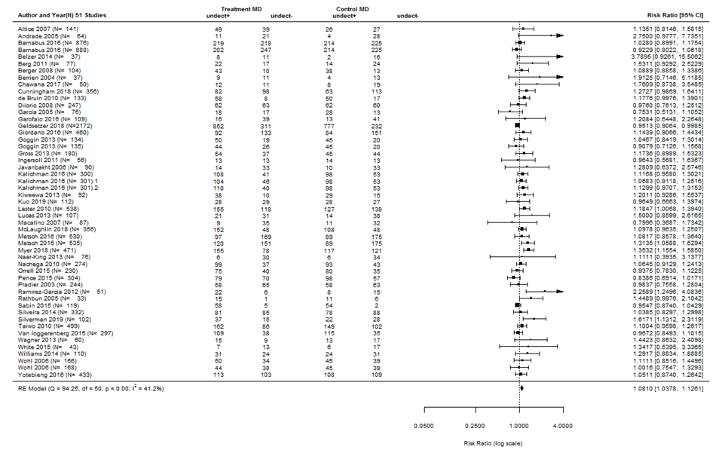
Figure H. Missing-Detectable Forest Plot for Main Analysis (N=51).

Supplementary Material I
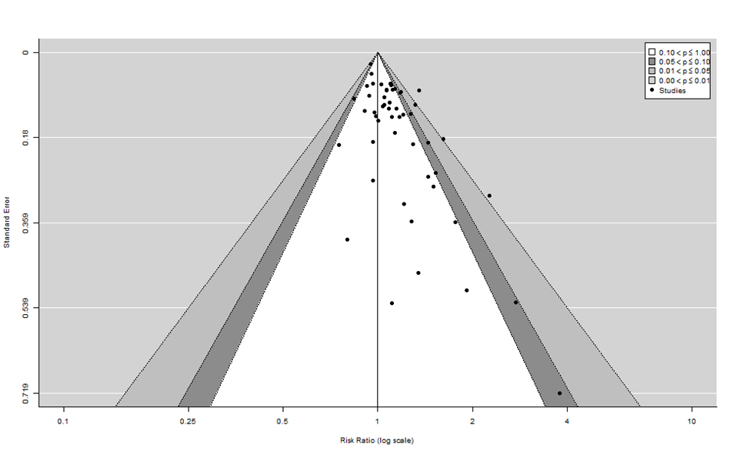
Figure I. Missing-Detectable Funnel Plot for Publication Bias in Main Analysis (N=51).
Supplementary Material J
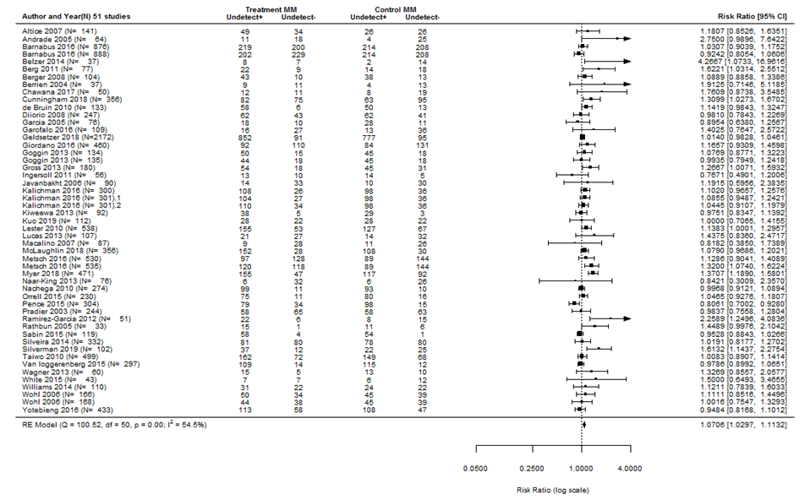
Figure J. Missing-Missing Forest Plot for Main Analysis (N=51).

Supplementary Material K
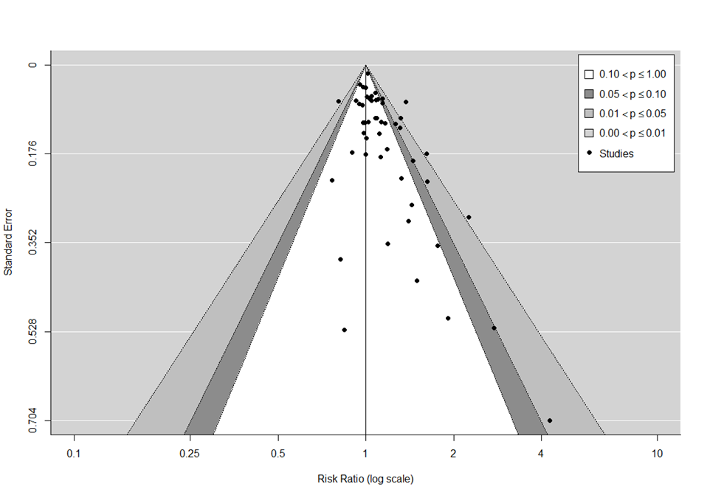
Figure K. Missing-Missing Funnel Plot for Publication Bias in Main Analysis (N=51).

Supplementary Material L
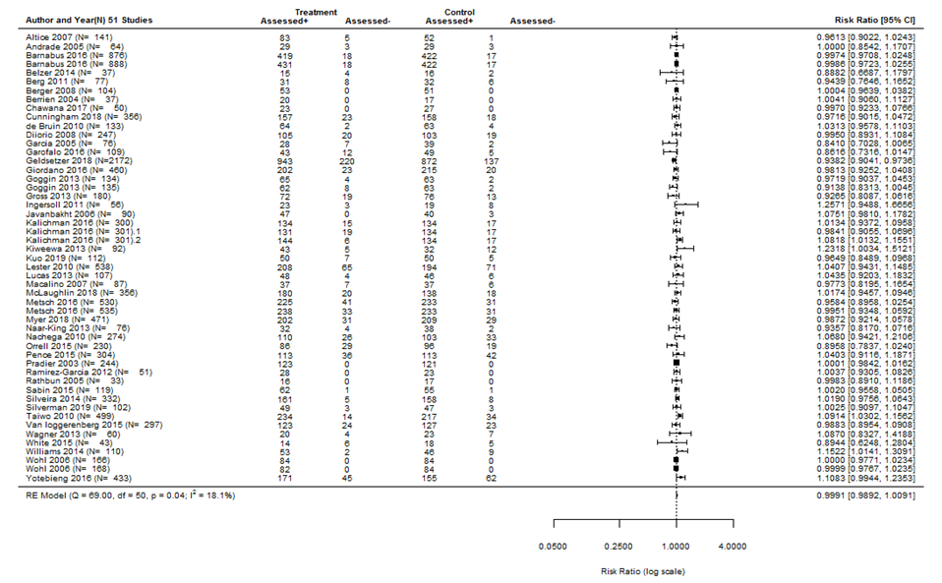
Figure L. Forest Plot for Binary Outcome Adherence (Assessed or not) for Main Analysis (N=51).
Supplementary Material M
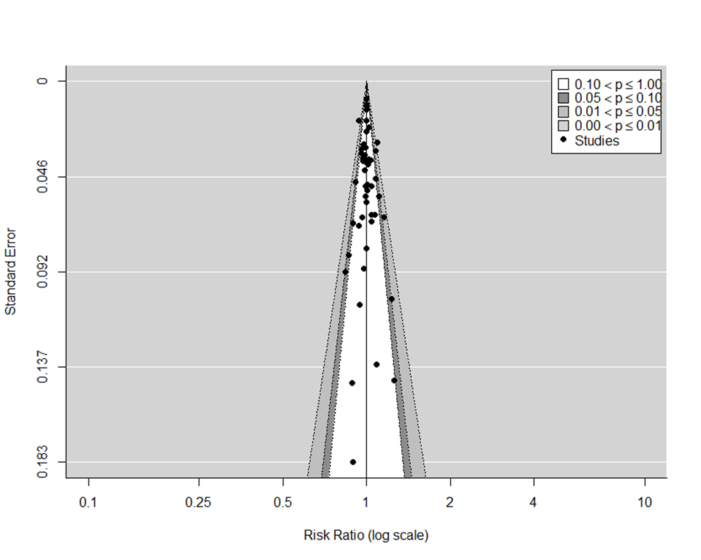
Figure M. Funnel Plot Checking for Publishing Bias for Binary Outcome Adherence (Assessed or not) for Main Analysis (N=51).

Supplementary Material N
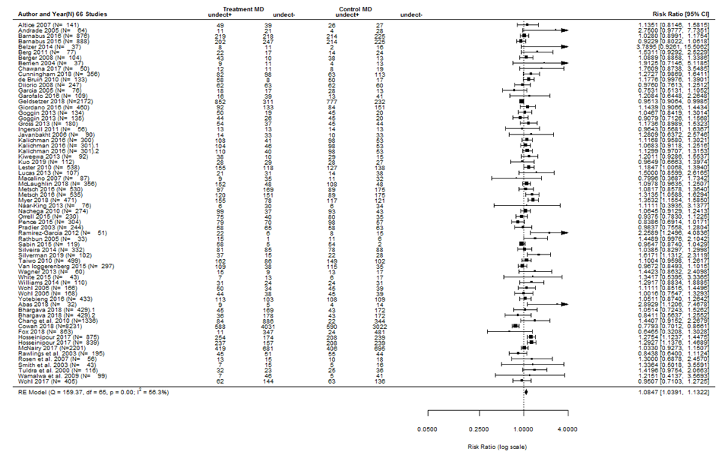
Figure N. Missing-Detectable Forest Plot for All Analyzed Interventions (N=66).

Supplementary Material O
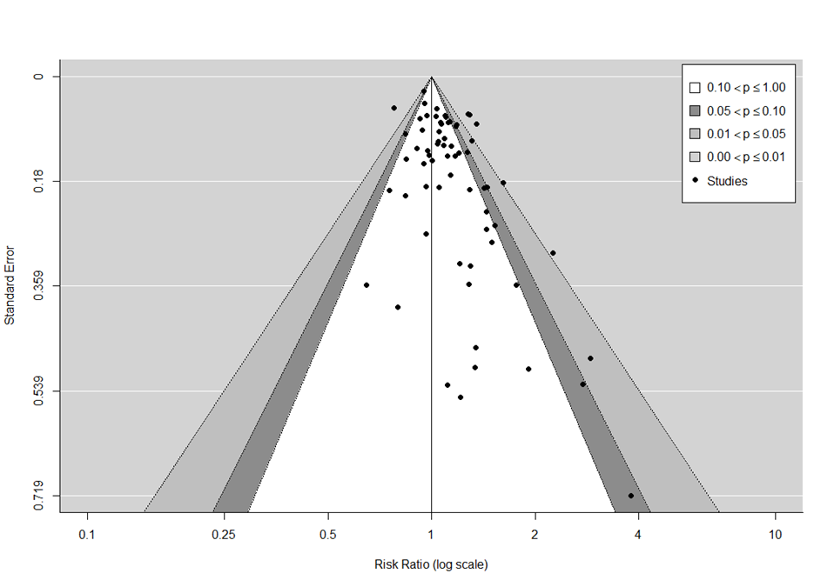
Figure O. Missing-Detectable Funnel Plot for Publication Bias for all analyzed interventions (N=66).

Supplementary Material P
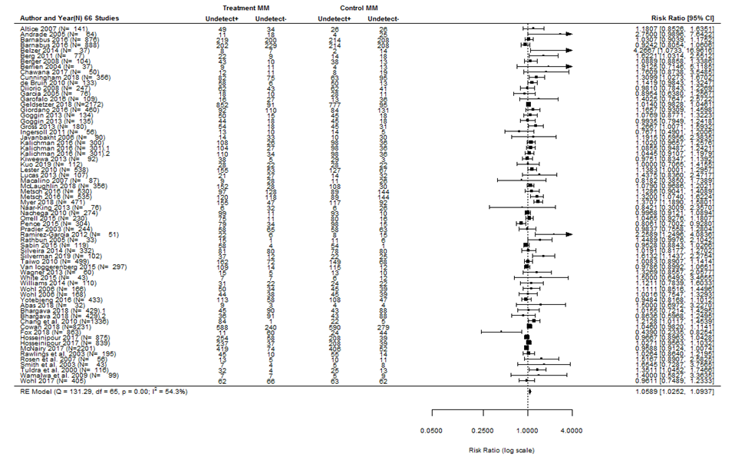
Figure P. Missing-Missing Forest Plot for all analyzed interventions (N=66).

Supplementary Materials Q
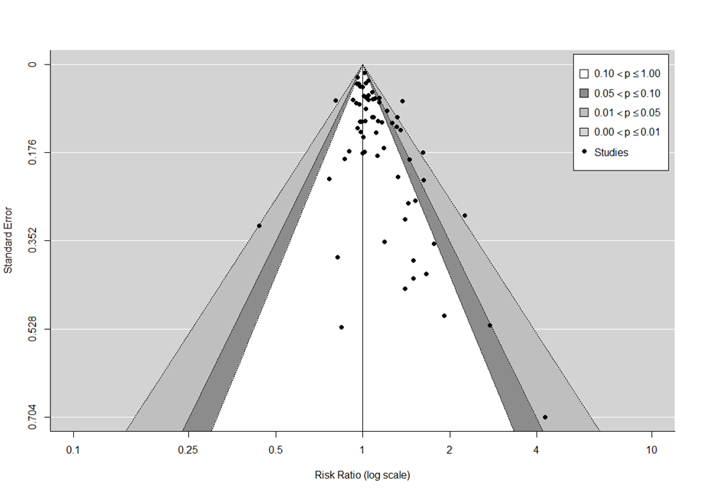
Figure Q. Missing-Missing Funnel Plot for Publication Bias for all analyzed interventions (N=66).
Supplementary Material R
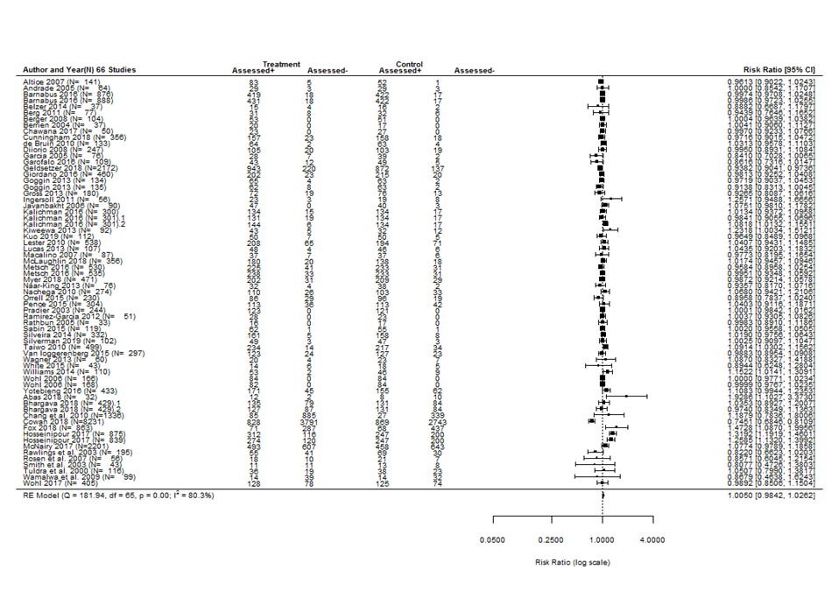
Figure R. Forest Plot for Binary Outcome Adherence (Assessed or not) for all analyzed interventions (N=66).

Supplementary Material S
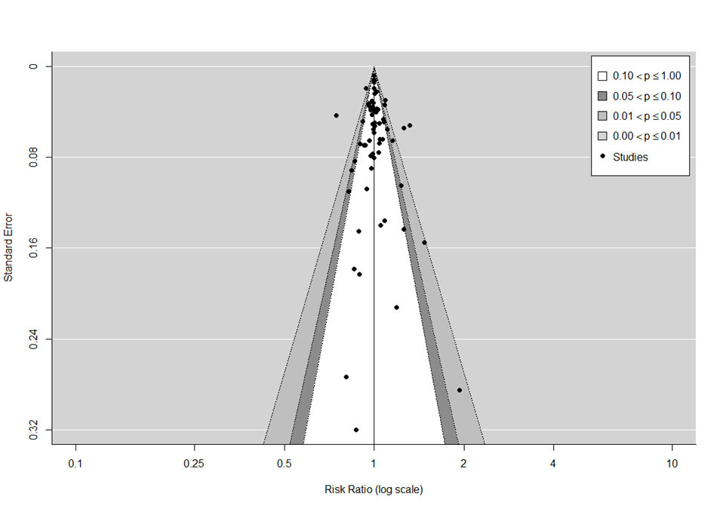
Figure S. Funnel Plot Checking for Publishing Bias for Binary Outcome Adherence (Assessed or not) for all analyzed interventions (N=66).

