Evaluating the Presence and Socio-Economic Impact of Microplastics in the Tidal Marshes of Otter Point Creek

By

Nicholas P. Dawson

Goucher College

Capstone

Abstract
Microfibers are a type of microplastic that are <5um in size. They originate from degraded plastic waste, as well as from synthetic textiles. They are a significant problem in marine and freshwater ecosystems. To investigate the extent of the problem in Otter Point Creek, I collected sediment and water samples to examine for the presence of microfibers during the month of June 2019. Microplastics were found in all samples that were collected at Otter Point Creek. In addition, I created a project on Ancedata in order to gauge the awareness of the local communities' knowledge regarding microplastic pollution at Otter Point Creek as well as determining the socio-economic impact use the trade-cost-method. Participants were able to survey their activities, the level of knowledge regarding plastic pollution in the estuary and answer questions relating to their current socio-economic situation. As this is the first comprehensive study to examine the presence of microplastics in the tidal marshes of Otter Point Creek, this study will further the understanding of the consequences of anthropogenic litter that unknowingly enters freshwater systems.

Key Words: Microplastics; Sediment; Toxicology; Water Quality; Synthetic Textiles; Socioeconomics; Travel-Cost-Method

Hypotheses
- Microplastics are present in the sediments of the Otter Point Creek Tidal Marsh
- Microplastics are present in the water column of Otter Point Creek Tidal Marsh
- Microplastics affect the socio-economic awareness of the community present at OPC

- Introduction

Plastic was first identified as a threat to the health of the ocean in the 1970s (Dris et al. 2015). Studies have centered on the entanglement of marine mammals and other species in net fragment litter and other large fragments of plastic waste (Laist 1997). In fact, approximately 267 marine species around the world have been recorded as being impacted by plastic debris (Erikson et al 2013). Gyres found in the Pacific have been documented as plastic debris hotspots. In addition, the constant radiation emitted by the sun and the force created by waves break apart the plastic into smaller pieces within the gyres. The most recent concern of plastic debris is the appearance of much smaller pieces of plastic litter, which includes those not visible to the naked eye, known as microplastics. Fragments no bigger than 1 um in diameter are now known to bioaccumulate within the water column and food web of aquatic ecosystems (Free et al. 2014).

Primary microplastics are plastics that are specifically manufactured to be microscopic in size. Primary microplastics, which include commercial facial cleansers and synthetic fibers found in clothing, have been detected in a few freshwater studies (Eerkes et al. 2015). In contrast, secondary microplastics are plastic fragments that have been derived from the breakdown of larger plastic debris. The most prevalent type of microplastic in aquatic systems are microfibers, in fact, a single garment could produce up to 1900 fibers per wash (Hernandez et al. 2017). The overuse of detergent is seen to directly affect the number of microfibers that are removed from clothing during washing process (Hernandez et al. 2017). A key understanding of synthetic textiles is that they are constantly emitted throughout the lifetime of each garment.

Additionally, microbial films can develop on microplastics changing their physicochemical properties (i.e., surface hydrophobicity and buoyancy) (Cole et al. 2011). Once these fragments sink due to the change in buoyancy, organisms in the benthos as well as within the sediment can become repositories for these plastics (Barnes et al 2009). Toxic hydrophobic pollutants, which are labeled persistent, bioaccumulate, may attach to micro-litter in aquatic environments; thus, microplastics are a cause of concern for both human and environmental health (Thompson et al. 2009).

Small plastic pieces are readily available to organisms at lower levels of the food web. For instance, studies have documented that plankton and several groups of marine invertebrates and vertebrates can ingest and accumulate micro-litter (Wagner et al. 2014). Factors such as size, density, and color affect the bioavailability of microplastics in aquatic environments (Zhang 2017).

Otter Point Creek is one of the largest remaining freshwater tidal marshes in the Chesapeake Bay. OPC is in a tidal zone and is closely linked with the terrestrial environment. These tidal marshes provide habitats and ecological conditions that make them ideal for supporting many diverse fish and invertebrate species at various stages of their life cycles. Otter Point Creek consists of two terrestrial areas (Leigh Park and Melvin G. Bosley Conservancy) that is connected by 261 acres of open water.

Leigh park consists of 93 acres of forest; whereas, Bosley Conservancy is over 350 acres of tidal marshes and wooded wetlands. Within the estuary wild rice is found to attract and feed large amounts of wildlife. Through partnerships with Harford County and the Chesapeake Bay National Estuarine Research Reserve, Otter Point Creek has been open to various recreational activities such as canoeing/kayaking, research, and various private and public educational programs.

OPC is one such area in which the presence of microplastics could impair ecosystem services. The accumulation of microplastics in benthic and tidal marsh sediments has the probability of imposing certain physiological and toxicological risks on the organisms' present. When plastic pollution encounters a marsh, it can be entrapped and stowed away deep within the marsh (Viehman et al. 2011). If there are such effects, it is likely that microplastic pollution of freshwater marshes like OPC would translate into some impacts on human health and well-being.

While microplastics have been extensively documented in marine environments, very little is known about microplastics in estuarine areas such as the Chesapeake Bay. The Chesapeake Bay is the largest estuary in the United States. There’s been only one study to date that studied four estuarine tributaries in the Bay. This study confirmed the correlation between high microplastic quantities in the rivers that were in significant proximity to densely populated communities (Yonkos et al. 2014). In addition, Yonkos et al. (2014) found that meteorological events speed up microplastic transfer from terrestrial to aquatic systems. Using this study as a basis, I plan to explore the presence and distribution of microplastic pollution in Otter Point Creek Estuary and to gauge the awareness of the local community regarding microplastics through a citizen science project on anecdata.

- Materials & Methods

Sampling areas were reached by kayak. Surface water and sediment samples were collected in the estuary in the month of June 2019. Sampling site locations are described below. Water temperature, dissolved oxygen concentration and pH measurements were collected from the ‘Bush River Otter Creek Point’ current-near real time station. This data was extrapolated and graphed from the website provided below.

2.1 Sample Site Description

This sample area is about 13.70 acres of estuarine and marine wetland habitat that has been classified as a E2ABM under the USFW wetland mapper server. The area consists of Wood Duck Cove and Snake Island. The (E) lists the wetland as having deep-water tidal habitats and adjacent tidal wetlands. The wetlands are semi-enclosed by land; however, they have an opening that leads into oceanic water. The salinity in this area increases due to evaporation but periodically becomes diluted due to freshwater runoff. The (2) classifies this area as an intertidal subsystem, with areas periodically flooded and exposed by tides. (AB) shows that this area is dominated by plants that grow on or below the surface of the water. (M) demonstrates that this area within Otter Point Creek is exposed irregularly.

2.2 Sampling Site

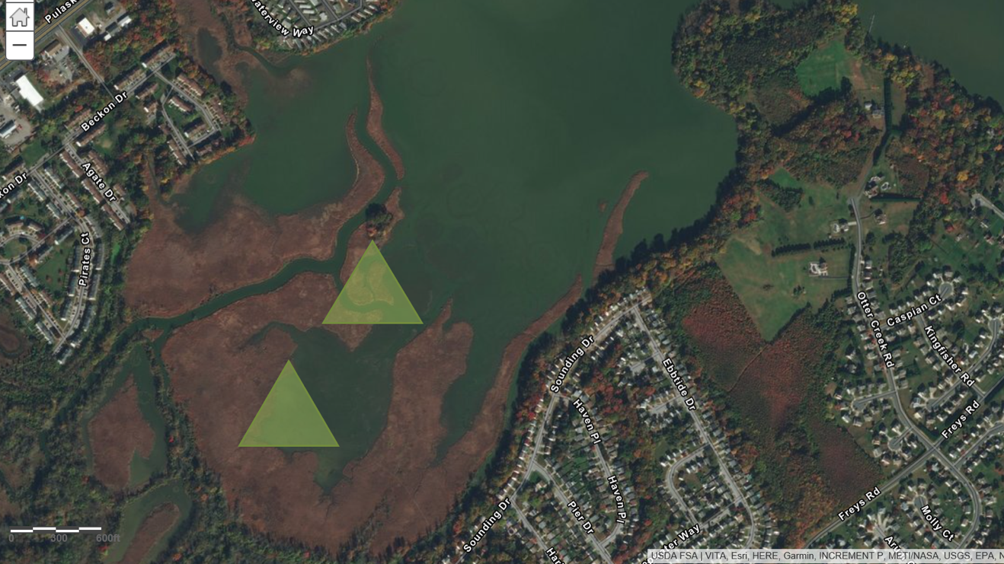
Sampling Area 1 (39.440894, -76.278266) (Snake Island)
Sampling Area 2 (39.436791, -76283571) (Wood Duck Cove)

These areas were found using ArcGIS and are near Anita C. Leight Estuary Center.

2.3 Surface Water Sampling

Surface water samples were collected using glass mason jars (473 ml) at a depth of 0.3 - 0.6 meters depth in the water column (Eriksen 2013). The first water sample was collected 2 meters from the bank closest to the urban population. Sample 2 was at 3 meters, sample 3 at 4 meters, and sample 4 at 5 meters from the bank. Jars were labeled with the coordinates, time and date of collection. Collected water samples were placed in the refrigerator at a temperature of 1.6 degrees Celsius.

2.4 Surface Water Microplastic Separation

Nile red was added to each sample using a micropipette in order to achieve a final concentration of 5 ug ml 1. The samples were then placed in a dark room for 30 minutes. Petri dishes were rinsed with filtered water and methanol to ensure no contamination. They were left upside in order to air dry and lessen the exposure to plastic pollution permeating from the air. Samples were filtered through 0.45𝞵μm mixed cellulose ester membrane filters (Advantec: www.advantecmfs.com), and the filters were then placed into petri dishes. Samples were viewed using a cyan Night Sea Filter set (www.nightsea.com). Microplastics found were counted and classified as either “other” which included granules, particles, films, etc. or “fibers”.

Plastic-free water ‘blanks’ for both water and sediment analysis were created for this experiment. Blanks for the water and sediment samples were created using 200 mL of NaCl and 200 microliters of nile red. Blanks were created to ensure that there was no contamination within our samples.

2.5 Sediment Sampling

Sediment was collected using a PVC pipe with labeled centimeter marks. In addition, these sediments were collected during low tide period. Times for low tide were extrapolated from the website ‘Eyes on the Bay’. Six sediment samples were collected with 5 cm cores to a depth of 15 cm below the surface of the water. Sediment samples were retained in Nasco@ whirl-paks. Whirl-paks were labeled with time and date of collection. They were frozen at -16º Celsius for later sediment analyses. All materials were rinsed with plastic-free water to ensure there was no contamination in the collected samples.

2.6 Sediment Micro-plastic Separation

The process by which microplastics were separated from the sediment was done through density separation using sodium chloride (NaCl 1.2 g cm⁻³), as documented by (Thompson et al 2004). Sodium chloride was dissolved in 1 Liter ultrapure water to acquire a density range between 1.2- 1.8g cm⁻³ (Coppock et al. 2017). 600 mL beakers were rinsed with filtered water and methanol to ensure no contamination from the air was present. They were placed upside to dry in order to limit the exposure to possible microplastic pollution coming from the air.

Sediment samples were placed in labeled beakers and 200 ml of NaCl was added to each beaker. The use of the sodium chloride solution allows low-density plastics to be separated via flotation. The beakers were placed on a platform shaker for 20 minutes allowing the sediments to mix at 110 rpm. The sediment samples were then allowed to settle for 40 minutes. The sediments were then filtered through 1mm and then 500 um mesh to ensure removal of excessive debris. The mesh was rinsed after each sample to ensure no cross contamination.

Nile red was added to each sample to achieve a final concentration of 5 ug/ml. These samples were incubated in the dark room for a maximum of 30 mins. One hundred milliliters of each filtered sample were then placed in two labeled sterile plastic tubes and centrifuged at 1700 rpm for 5 minutes. It should be noted that one tube holds 50 mL therefore two tubes were used per sample in order to acquire 100ml. Sediment samples were viewed the same way as the water samples.

3. Results

The graphs below depict the pH, temperature, dissolved oxygen and salinity of OPC on Friday, June 7th. The averages for each were, 8.16 for pH, 10.04 mg/L for DO, 19.46 ntu for turbidity, 0.1ppt for salinity and 78.8 degrees Fahrenheit. This graph was taken directly from central database on Eyes on the Bay (www.eyesonbay.dnr.maryland.gov). Water quality is measured every 15 minutes throughout the Chesapeake Bay, specifically OPC.

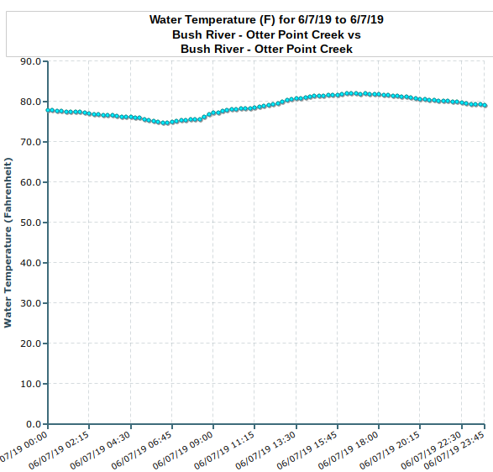
Figure 1. Shows the average water temperature throughout the day in Otter Point Creek
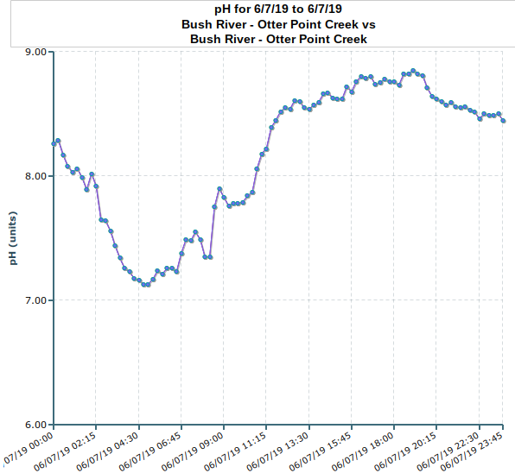
Figure 2. Average Ph monitored within Otter Point Creek

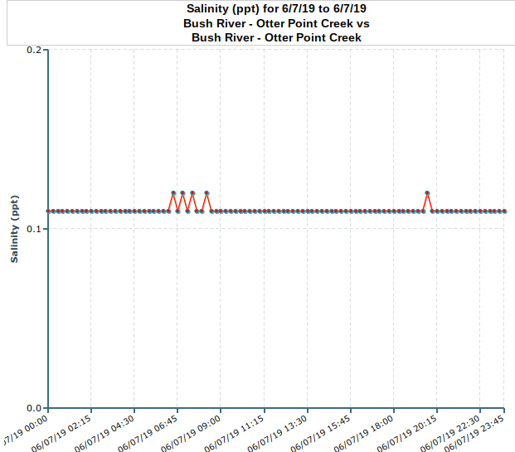
Figure 3. Average salinity monitored in Otter Point Creek

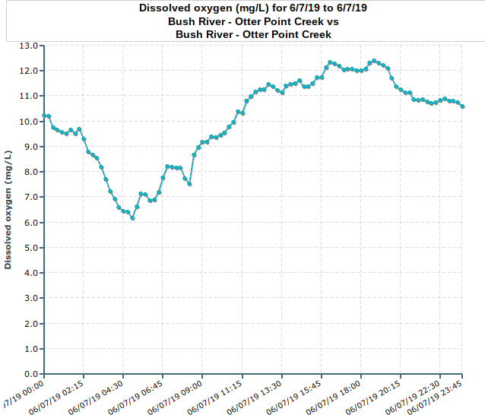
Figure 4. Average dissolved oxygen level monitored in Otter Point Creek

3.1 Surface Water Results

All surface water samples taken from Wood Duck Cove and Snake Island within Otter Point Creek were present with microplastic contamination. ‘Others’ were the dominant form of microplastic that was present within all these samples (Figure 5). Fibers were not as present within each sample, however. The average amount of fibers found within Snake Island was 0.037 mL of water for ‘Other’ and 0.007 mL of water for ‘Fibers’. Moreover, when looking at Wood Duck Cove the averages for ‘Other’ was 0.25ml and 0.001 mL for ‘Fiber’ respectively.

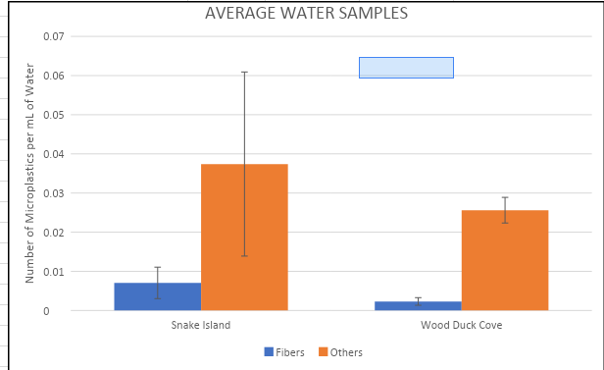
Figure 5. The error bars in the graph represent the standard error of the mean. In addition, this graph represents the average number of microplastics that were found in 0.07 mL collected from Snake Island and Wood duck Cove surface water.

3.2 Sediment Results

Micro-plastic contamination was present within all sediment samples collected from Snake Island and Wood Duck Cove. As with the water samples, ‘Other’ was the dominant microplastic found when viewed through the microscope. The average number of ‘fibers’ found was 0.004 mL of sediment, whereas ‘other’ was found to have an average of 0.31 mL of sediment found in Snake Island. In Wood Duck Cove, the average number of microplastics for ‘fibers’ was 0.05mL per sediment; whereas ‘other’ 0.2 mL per sediment.

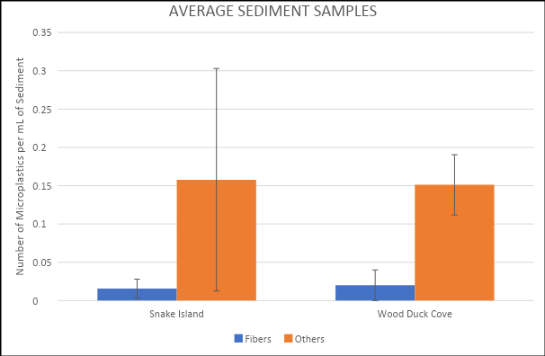
Figure 6. The error bars in the graph represent the standard error of the mean. In addition, this graph represents the average number of microplastics that were found in 0.35 mL collected from Snake Island and Wood duck Cove surface water.

4. Using Citizen Science to Understand the Socio-Economic Impacts in Otter Point Creek


For Otter Point Creek, economic impacts of plastic pollution, specifically that of macro-plastics, such as water bottles, plastic bags and other forms of macro-plastic, can lead to the decrease in revenue directly provided from tourism. Anita C. Leight Estuary Center is seen as the center of research and education for Otter Point Creek and seeks to increase the awareness and respect of estuaries (http://www.otterpointcreek.org/about-us/). Since the local communities surrounding Otter Point Creek are provided recreational services; I would like to know how the presence of plastic pollution affects these socio-economic values, thus I decided to start my citizen science project here.

This project was created on https://www.anecdata.org/projects/view/595, and will be used to bring more awareness to the issues of plastic pollution in OPC. The survey will collect valuable economic and experiential data. This data would be suitable for future researches to design and conduct experiments to fully understand the economic impacts that could be occurring at OPC. Moreover, by working with local citizens to help monitor any macro-plastic pollution entering the system, they will also be able to research the amount of possible microplastic exposure within OPC. Through this method, I will be able to not only increase participation in monitoring the estuary but educate the community in the economic problems that occur when plastic pollution is present in this ecosystem. In addition, this survey is also specifically designed to record socio-economic information of the participants.

By placing socio-economic questions on the survey, I will be able to extrapolate data to use in the travel-cost-method or TCM. This method is used in order to accurately calculate the economic value of environmental goods that we use. Moreover, this method is mainly used for determining what value economics has regarding recreational sites, such as OPC. For example, TCM can be used to calculate part of the economic benefits that stem from recreational activities such as kayaking, swimming, camping, hunting etc. which is conducted at OPC. Information such as distance traveled, mode of transportation, income, number in the party, area in which the participant lives and duration of the visit will be collected from the survey to give reliable data for the TCM.

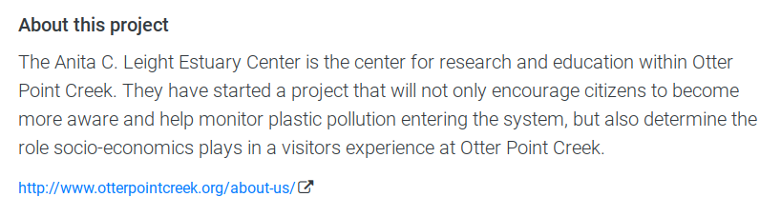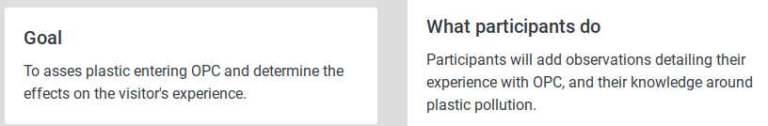
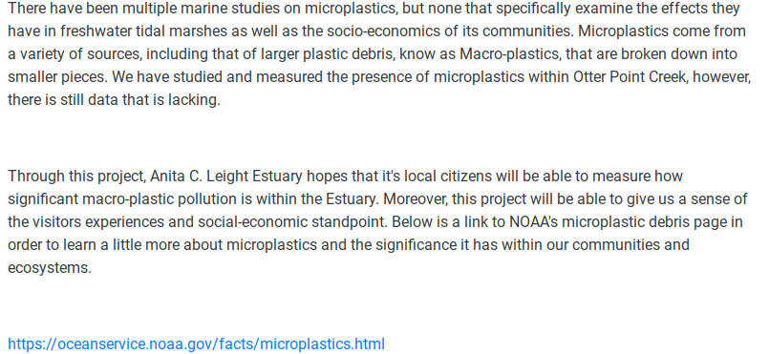
Figure 7: The front-page participants will see when looking up the project on anecdata.org. They will understand the breakdown of macroplastics into microplastics and understand the overall goal of the project.

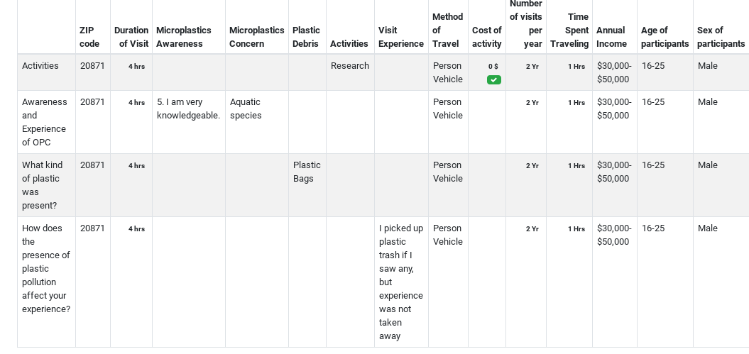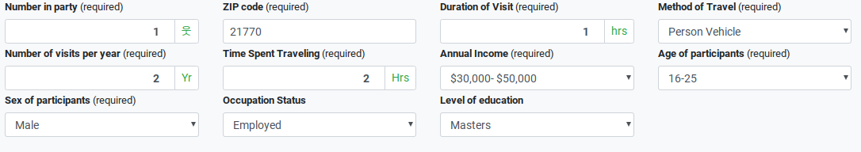
Figure 8: This shows what a completed observation looks like on anecdata. The observation details the activities, their knowledge regarding plastic pollution and the price of each activity. Moreover, it details socio-economic based data as well.

The project is open to all people who are interested in being part of a citizen science project that will bring more attention to impacts of plastic pollution; specifically, the impact microplastics have on freshwater ecosystems and the services they provided to the local community. When arriving at Otter Point Creek, participants will be able to sign in through the anecdata app and access points using the QR code, however, they will be able to use a laptop or other device that will give them access to the website.

The participants will be able to choose between various activities, such as kayaking/canoeing, swimming, camping etc. Moreover, they will be able to choose the level of their awareness regarding microplastic pollution and the type of topics/concerns relating to plastic. Finally, these participants will be able to add entries regarding any type of plastic debris they have come across during visit and their overall experience with OPC.

The survey data that will be collected could be used by Anita C. Leight Estuary and other researches to create new and innovative protocols to prevent increased exposure to plastic pollution within OPC. Moreover, the types of plastic are is recorded could provide an indication of the point source for the pollution. The data that is collected from anecdata.org and the travel-cost-method can be used by environmental economists and other parties to determine how the presence of plastic pollution, such as microplastics, takes away from the revenue produced by OPC. The zonal travel cost method would be best for this project.

The zonal travel cost method is a non-market based procedure and is used to estimate the economic costs and benefits that is a direct result from a person's current access to a recreational park or various changes in environmental quality at recreational site (Fleming & Cook, 2008). Specifically, looking at the costs of consuming recreational amenities that Otter Point Creek has. With this method, zones are defined using the collected zip codes from the survey. From there one would be able to calculate the round-trip distance and cost it would take to reach and leave OPC; or in other words gain the total consumer surplus to visits to Otter Point Creek.

Moreover, the purpose of this survey is to not only create an increase of community awareness and support in keeping OPC clean and plastic free, but get an idea of how OPC amenities are used and how often the estuary is visited.
Since there are significant knowledge gaps when it comes to freshwater microplastics, this project will be one of many that will not only test various experiments in OPC regarding plastic pollution, but also contribute to finding plastic product alternatives.

5. Discussion and Critical Reflection

As demonstrated in the data above, ‘others’ was the most dominant type of microplastic found in both sediment and water samples collected from Otter Point Creek, specifically the Snake Island and Wood Duck Cove locations. This was rather surprising to see in such a small sample size, as fibers are usually dominant and spread homogeneously throughout the environment (Liebezeit et al. 2012). Moreover, what was more interesting is the sheer lack of microplastics found in my two sample areas.

Although, Yonkos et al. (2014) and I both sampled in the Chesapeake Bay, we had vastly different outcomes in results. Yonkos et al. (2014), sampled in watersheds that were closer to urban populations; whereas I sampled farther away from any communities. Therefore, I was not able to make any direct correlations between microplastic concentrations and urban population density. I believe that if I had sampled further down the river near the boating communities, I would have different results.

Yonkos et al. 2014 determined that the amount of rainfall impacted the amount of microplastics found throughout their study sites. They stated that the greatest concentrations of microplastic pollution had occurred following a raining event. As a result, I looked up the rainfall events that occurred prior to my study date and saw that the following week there was about .22 inches of rainfall that only occurred on Thursday, May 30th. However, after that the weather conditions over Otter Point Creek were sunny with instances of mild clouds. Therefore, I do not believe that amount of rainfall impacted the abundance of microplastics found in my two locations.

Both Snake Island and Wood Duck Cover were covered in Spatterdock (Nuphar luteum), American Eelgrass (Vallisneria americana) and Eurasian Watermilfoil (Eurasian Watermilfoil). These plants are extremely common in the shallow waters of Otter Point Creek and usually bloom between May and Spring. In addition, I believe that another reason for the lack of microplastic pollution in these two areas maybe thanks to the presence of flora capturing microplastics on their leaves, thus stopping them from entering into the surrounding waters. However, this is a working hypothesis that should be tested for a later date.

When comparing the average of number of microplastics for both sediment and surface water, Snake Island had more prevalent contamination. I believe this was due to snake island being closer to the opening of Bush River as compared to Wood Duck Cove, which is further into the spadderdock concentrated area. Looking at the abundance of microplastics found within my sample areas, the sediment collected from Snake Island and Wood Duck Cove possessed the highest concentrations of plastic.

Microplastics are known to be a favorable site when it comes to the accumulation of biofilm and other microbes; thus, changing the density of microplastics within the water column (Dai, et al. 2018). As a result of changing density, these plastics would have settled to the bottom and taken in by the surrounding sediment. Dia, et al. (2018), suggested that the surface water was not an accurate interpretation of the amount of microplastic in a body of water. Nonetheless, more research needs to be conducted on the density changes of microplastics and sampling method of surface waters.

Although there is substantial data on marine microplastics, there is a lack of awareness when it comes to freshwater ecosystems. Otter Point Creek is one such area in which the urban population does not fully understand the effects of plastic pollution in the area. In order to fill the gaps in knowledge regarding microplastic pollution in freshwater ecosystems, citizen science projects, such as the one I created on anecdata.org, will bring together the local community to tackle the plastic debris problem. The project will allow participants to survey their experience at Otter Point Creek and their awareness regarding plastic pollution.

Moreover, this project will allow me to use zonal TCM in order to get accurate socio-economic data. Since there is no direct cost associated with OPC, being that it is a free recreational estuary, the travel-cost-method applies value to the consumption of amenities provided by park. Specifically, I would use Zonal TCM for this project, as I am having the participants include the zip code in which they are traveling from. Moreover, if I have the distance traveled and the amount of time that elapsed until the participants arrived, I would be able to calculate the value of OPC assets.

For example, within Australia, Lake McKenzie is the biggest recreational tourist attraction on Frasier Island boasting over 2000 individual visits per day. The management team that oversees Lake McKenzie views this as highly unsustainable and looks for ways to reduce the number of visits through alternate management practices. For instance, Fleming & Cook, (2008) used the zonal travel cost method to determine the recreational value of Lake McKenzie in Australia. Sampling was done in April and August, in which they collected socio-economic information for visitors through the use of surveys. Factors such as age, income, and educational status were collected during the sampling period. Fleming & Cook, (2008), found that the yearly recreational value for Frasier Island was between $115- 270 million; whereas Lake McKenzie was between $19- $44 million a year. Furthermore, in order to gain an understanding of satisfaction with the recreational area, visitors were asked to give a total proportion of their enjoyment was due to to their time at Lake McKenzie.

However, this method is not without its limitations. We assume that populations located in each zip code or zone are the same, therefore, they will share the same travel cost. Yet, we know this not to be the case. Another limitation to this method is determining if the individual is paying to access the park and its entirety, or certain parts like the boat ramp or a hiking trail (Randal 1994). If that is the case, then we would be only giving value to specific aspects of OPC, instead of viewing it. Furthermore, individuals can find value in the actual voyage to OPC rather than valuing any of the amenities that they have access to. As such, there is no way within Zonal TCM to accurately account for this limitation.

I hope that this project will set a foundation for future research projects within OPC. Work locally but think globally is how I want this project to be viewed. Starting at the community level and bringing more awareness will lead to changes further up the chain. By monitoring the presence of MP and investigating the sources, we would be able to implement various protocols to mitigate the exposure that plastics have on freshwater environments as well as on urban populations.

Incorporating both science and human-dimension aspects into this capstone was not an easy feat. In addition, there were aspects of this capstone that I did not take into consideration. For instance, understanding that microplastics are taken in by species at different levels. Corbicula Fluminea, the freshwater invasive Asian clam, like all bivalves can filter particulates at varying sizes. During my studies in the Raritan River, NJ, I found that these clams can take in and absorb microplastics into their tissues. In addition, Wetz (2015) documented that Mercenaria mercenaria, or the hard shelled clam, was found to incorporate plastics into their system as well. This is significant as this species of clam can be found in OPC.

With the presence of plastic already proven within OPC, one can suggest that plastics are being taken in by benthic organisms, and more importantly being passed through the food web. Furthermore, I believe if I had sampled closer to urban communities within OPC, I would have yielded different results. As this was the first study conducted at OPC, there is still room for improvement. As new and innovative sampling methods are released, more research can be done to examine the effects of plastic pollution within OPC. I hope that this study will be one of many that will close the knowledge gap between microplastics and the effects it has on the environment and urban communities.

6. Literature Cited

Barnes, D. K., Galgani, F., Thompson, R. C., & Barlaz, M. 2009. Accumulation and fragmentation of plastic debris in global environments. Philosophical Transactions of the Royal Society of London B: Biological Sciences, 364(1526), 1985-1998.

Cole, M., Lindeque, P., Halsband, C., & Galloway, T. S. 2011. Microplastics as contaminants in the marine environment: a review. Marine pollution bulletin, 62(12), 2588-2597.

Coppock, R. L., Cole, M., Lindeque, P. K., Queirós, A. M., & Galloway, T. S. 2017. A small-scale, portable method for extracting microplastics from marine sediments. Environmental Pollution, 230, 829-837.

Dris, R., Imhof, H., Sanchez, W., Gasperi, J., Galgani, F., Tassin, B., & Laforsch, C. 2015. Beyond the ocean: contamination of freshwater ecosystems with (micro-) plastic particles. Environmental Chemistry, 12(5), 539-550.

Dai, Z., Zhang, H., Zhou, Q., Tian, Y., Chen, T., Tu, C., ... & Luo, Y. 2018. Occurrence of microplastics in the water column and sediment in an inland sea affected by intensive anthropogenic activities. Environmental pollution, 242, 1557-1565.

Eerkes-Medrano, D., Thompson, R. C., & Aldridge, D. C. 2015. Microplastics in freshwater systems: a review of the emerging threats, identification of knowledge gaps and prioritization of research needs. Water research, 75, 63-82.

Eriksen, M., Mason, S., Wilson, S., Box, C., Zellers, A., Edwards, W., ... & Amato, S. 2013. Microplastic pollution in the surface waters of the Laurentian Great Lakes. Marine pollution bulletin, 77(1), 177-182.

Fleming, C. M., & Cook, A. 2008. The recreational value of Lake McKenzie, Fraser Island: An application of the travel cost method. Tourism Management, 29(6), 1197-1205.

Free, C. M., Jensen, O. P., Mason, S. A., Eriksen, M., Williamson, N. J., & Boldgiv, B. 2014. High levels of microplastic pollution in a large, remote, mountain lake. Marine pollution bulletin, 85(1), 156-163.

Gall, S. C., & Thompson, R. C. 2015. The impact of debris on marine life. Marine pollution bulletin, 92(1), 170-179.

Hernandez, E., Nowack, B., & Mitrano, D. M. 2017. Polyester textiles as a source of microplastics from households: a mechanistic study to understand microfiber release during washing. Environmental science & technology, 51(12), 7036-7046.

Liebezeit, Gerd, and Fatehi Dubaish. 2012. Microplastics in beaches of the East Frisian islands Spiekeroog and Kachelotplate. Bulletin of Environmental Contamination and Toxicology 89.1, 213-217.

Randall, A. 1994. A difficulty with the travel cost method. Land economics, 88-96.

Thompson, R. C., Moore, C. J., Vom Saal, F. S., & Swan, S. H. 2009. Plastics, the environment and human health: current consensus and future trends. Philosophical Transactions of the Royal Society of London B: Biological Sciences, 364(1526), 2153-2166.

Viehman, S., Vander Pluym, J. L., & Schellinger, J. 2011. Characterization of marine debris in North Carolina salt marshes. Marine pollution bulletin, 62(12), 2771-2779.

Wagner, M., Scherer, C., Alvarez-Muñoz, D., Brennholt, N., Bourrain, X., Buchinger, S., ... & Rodriguez-Mozaz, S. 2014. Microplastics in freshwater ecosystems: what we know and what we need to know. Environmental Sciences Europe, 26(1), 12.

Yonkos, L. T., Friedel, E. A., Perez-Reyes, A. C., Ghosal, S., & Arthur, C. D. 2014. Microplastics in four estuarine rivers in the Chesapeake Bay, USA. Environmental science & technology, 48(24), 14195-14202.

Zhang, Hua. 2017. Transport of microplastics in coastal seas. Estuarine, Coastal and Shelf Science 199: 74-86.

