The Impact of Explicit Phonemic Awareness Instruction on

Instructional Reading Levels in Kindergarten

by

Amy E. Fowler

Submitted in Partial Fulfillment of the Requirements for the

Degree of Master of Education

May 2019

Goucher College
Graduate Programs in Education

Table of Contents
List of Tables i
Abstract ii
I. Introduction 1
Overview 1
Statement of the Problem 2
Hypothesis 2
Operational Definitions 2
II. Literature Review 3
Introduction 3
Phonological/Phonemic Awareness and the Reading Process 3
The Relationship Between Phonological/Phonemic Awareness
and Reading Achievement 5
The Role of Phonological/Phonemic Awareness Instruction in the
Kindergarten Classroom 6
Phonological/Phonemic Awareness and Guided Reading 8
Summary 9
III. Methods 10
Design 10
Participants 10
Instrument 11
Procedure 11
IV. Results 13
V. Discussion 17
Implications of the Results 17
Theoretical Consequences 18
Threats to Validity 19
Connections to Previous Studies/Existing Literature 19
Implications for Future Research 20
Conclusion/Summary 21
References 22

List of Tables
- Null Hypothesis Test of Sample Mean Changes for F&P-IL 14
- Null Hypothesis Test of Sample Mean Changes for Accuracy 15
- Null Hypothesis Test of Sample Mean Changes for Fluency 15
- Null Hypothesis Test of Sample Mean Changes for Within 15
- Null Hypothesis Test of Sample Mean Changes for Beyond 16

i
Abstract
The purpose of this study was to examine the impact of explicit phonemic awareness instruction during small group instruction on kindergarten students’ instructional reading levels. The measurement tool used was Fountas and Pinnell’s (2017) Benchmark Assessment System and the treatment utilized “Phonemic Awareness: The Skills That They Need To Help Them Succeed!” by Michael Heggerty. A one-group pre/post design was used to determine the impact of six weeks of explicit phonemic awareness instruction in small group on instructional reading levels. Pre-to-post gains were statistically and practically significant in the areas of instructional reading level, overall accuracy and comprehension, and fluency.

ii

CHAPTER I
INTRODUCTION
Overview
Each year, kindergarten classrooms are filled with curious, energetic, and impressionable five-year old children. Some of these children are embarking on their school careers for the very first time, while others have been in daycares and early learning centers before they could talk or walk. Meeting the social-emotional and academic needs of all kindergarten students can be challenging. Despite the varying levels and little to no information about the students before they arrive on the first day of school, teachers are tasked with ensuring all students leave kindergarten reading on grade level. No curriculum could possibly address the varying needs found within a kindergarten classroom; therefore, kindergarten teachers must be skilled in using data to design customized instruction to meet student need. It is important for teachers to have a sound understanding of the most effective instructional practices to ensure all students leave kindergarten reading on grade level.
Learning to read is a complex task. The brain is wired for sound and unlike spoken language, reading is not natural; rather a process that must be learned (Berg & Stegelman, 2003). The Report of the National Reading Panel identified five critical components necessary for the development of independent reading: phonemic awareness, phonics, fluency, vocabulary, and comprehension (Konza, 2014). Phonemic awareness is a subset of phonological awareness and is used as a predictor for later reading success. Phonemic awareness among prereaders is a better predictor of future success in reading and spelling than IQ, mental age, or perceptual ability (Snider, 1997). Children who are poor readers in early childhood often stay poor readers and rarely catch up. It is critical that teachers are knowledgeable in the areas of collecting and analyzing data, implementing best practices, and utilizing instructional resources that provide children with the skills and strategies needed to be emergent readers by the end of kindergarten.
Statement of Problem
The purpose of this study was to examine the impact of explicit phonemic awareness instruction during small group instruction on kindergarten students’ instructional reading levels.
Hypothesis
There will be no difference in students’ mean instructional reading levels as measured by Fountas and Pinnell’s (2017) Benchmark Assessment System between pre and post phonemic awareness instruction using “Phonemic Awareness: The Skills That They Need To Help Them Succeed!” by Michael Heggerty.
Operational Definitions
The independent variable is daily phonemic awareness instruction. This is operationally defined as explicit instruction using “Phonemic Awareness: The Skills That They Need To Help Them Succeed!” by Michael Heggerty. This is a scripted program. The dependent variable is instructional reading levels as measured by Fountas and Pinnell (2017) Benchmark Assessment System given pre and post instruction. This is operationally defined as an alphabetic level A-Z. Instructional reading levels are acquired using the Benchmark Assessment System. Each student is individually assessed to determine his/her instructional reading level. For this study, students’ levels were assessed mid-year to determine a baseline and assessed again after receiving explicit phonemic awareness instruction in small groups for six weeks.

CHAPTER II
A REVIEW OF THE LITERATURE
Introduction
This literature review seeks to explore the topic of explicit phonological awareness instruction and reading achievement in kindergarten students. Section one provides an overview of the reading process, defines phonological and phonemic awareness, explains the acquisition of phonological awareness skills, and details where phonological awareness fits within the complex process of learning to read. Next, section two highlights research that determines relationships between phonological and phonemic awareness and reading success while also discussing the role of phonological and phonemic awareness as an early predictor for reading difficulties. Then, section three details the use of scaffolding during phonemic awareness instruction in kindergarten and discusses outcomes of phonological and phonemic awareness instruction for kindergarten students. Finally, section four discusses phonological and phonemic awareness skills and guided reading levels.
Phonological/Phonemic Awareness and the Reading Process
Learning to read is a complex task. The brain is wired for sound and unlike spoken language, reading is not natural; rather a process that must be learned (Berg & Stegelman, 2003). As children are immersed in the language they hear around them, they learn to speak that language and become tuned in to the rhythm, patterns of intonation, and individual phonemes that make up words (Konza, 2014). To read, children must understand what a ‘sound’ is in relation to spoken language; thus, when children cannot hear the separate sounds in words, they are unable to make the link between speech and print symbols and greatly struggle with reading and writing (Konza, 2014).
Over a decade ago, the Report of the National Reading Panel identified five critical components necessary for the development of independent reading: phonemic awareness, phonics, fluency, vocabulary, and comprehension (Konza, 2014). Phonemic awareness is a subset of phonological awareness and is used as a predictor for later reading success. Phonological awareness is the ability to identify and manipulate units of oral language that include words, syllables, onsets, and rimes (Tracey, 2017). Phonemic awareness is the ability to identify and manipulate individual sounds within words (Tracey, 2017). Strong phonological awareness allows children to link phonemes to graphemes which supports decoding and subsequent reading comprehension (Carson, Gillon, Boustead, Nippold, & Troia, 2013).
Reading and writing are far more complex than oral language and are developed through direct instruction (Berg & Stegelman, 2003). The act of reading takes place in four processors of the brain: Orthographic Processor, Phonological Processor, Meaning Processor, and Context Processor (Tracey, 2017). These processors are organized as interconnected neural networks with the reading process beginning in the Orthographic Processor where print is perceived and processed (Tracey, 2017). The phonological processor processes sound during the reading experience and as phonemic and phonological processing improves, so does reading ability (Tracey, 2017).
Acquisition of Phonemic Awareness
Acquiring phonemic awareness begins with acquisition of the larger construct of phonological awareness. Phonological awareness develops on a continuum that moves from large to increasingly smaller units of sound within words and ends with the identification of phonemes; the smallest unit of sound (Paige, Rupley, Smith, Olinger, & Leslie, 2018). Cassady, Smith, and Putman (2008) stated sufficient evidence supports the fact that reading skill development progresses from basic phonological processing to phonemic awareness and eventually to independence in decoding. The more sensitive children are to the sound structure of spoken words, the more likely they will become strong readers despite other factors such as socioeconomic status, intelligence, and receptive vocabulary (Carson et al., 2013).
The Relationship Between Phonological/Phonemic Awareness and Reading Achievement
Phonological awareness serves as a foundation and bridge for reading achievement. Because learning to read does not come naturally like learning to speak, the ability to process phonological components of language is a critical precursor to understanding letter-sound relationships (Berg & Stegelman, 2003). Oral language provides the platform for the development of phonological skills and the longitudinal research of Maclean, Bryant and Bradley (1987) revealed that knowledge of nursery rhymes was strongly related to the development of phonological skills such as rhyme and awareness of the first phoneme (Konza, 2014). The National Early Literacy Panel also found a strong predictive value of phonological awareness and alphabet knowledge leading to later literacy achievement (Konza, 2014). Early success in phonological awareness predicts success in phonemic awareness, which serves as an intermediate step toward successful reading (Cassady et al., 2008). Phonemic awareness among prereaders is a better predictor of future success in reading and spelling than IQ, mental age, or perceptual ability (Snider, 1997). Konza (2014) also found that the phonemic awareness of preschool children is the single best predictor of future reading ability, better than either socio-economic status or intelligence.
Phonological Awareness as an Early Predictor for Reading Difficulties

Children who are poor readers in early childhood often stay poor readers and rarely catch up. A poor reader in first grade almost invariably continues to the be a poor reader in later grades as getting off to a slow start in reading has consequences for decoding and comprehension far down the line (Berg & Stegelman, 2003). Weaknesses in the Phonological Processor are a widespread cause of reading difficulty and many now consider significant deficits in the Phonological Processor as the hallmark of dyslexia (Tracey, 2017). The poor phonological processing that underlies weak phonemic awareness leads to inaccurate decoding and trouble with fluency and comprehension (Ashby, Dix, Bontrager, Dey, & Archer, 2013). Challenges with fluency present because of phonological deficits as children read slowly because they are slower to recognize familiar words and are slower to identify unfamiliar words (Ashby et al., 2013).
The Role of Phonological/Phonemic Awareness Instruction in the Kindergarten Classroom
Appropriate early reading instruction has a critical impact on later reading success and makes the first three years of school the most important in a child’s life (Berg & Stegelman, 2003). Kindergarten programming plays a key role in the acquisition of phonological skills. Knowing and understanding that reading will not unfold naturally places great responsibility on teachers to know the key principles of effective reading instruction and to impart that knowledge skillfully and effectively through direct instruction of phonemic awareness (Berg & Stegelman, 2003). It is critical that teachers understand the link between oral language and subsequent reading development so that the oral skills of all students, particularly those whose skills are not as advanced as their peers, are developed (Konza, 2014). Ignoring or failing to understand the role of oral language creates the risk of limiting a child’s chance of becoming an independent reader (Konza, 2014). Raising reading achievement and reducing inequality in reading statistics begins with ensuring key predictors of early literacy success are taught effectively and efficiently in the kindergarten classroom (Carson et al., 2013).
Barriers to effective phonological or phonemic awareness instruction is that the curricula used does not provide teachers with techniques for providing feedback to children when they fail to adequately perform a task (McGee & Ukrainetz, 2009). The instructional practice of scaffolding is a means of supporting skill acquisition through modeling, prompting, and emphasizing skills within tasks (McGee & Ukrainetz, 2009). When teachers provide varying levels of support to teach phonemic awareness in preschool and kindergarten, most children, regardless of skill level, make progress in acquiring even complex levels of phonemic awareness (McGee & Ukrainetz, 2009).
Outcomes of Phonological Awareness for Kindergarten Students
While less is known about the optimal duration and intensity of phonemic awareness instruction in heterogeneous classrooms, frequent and intensive sessions are considered an important component of effective phonemic awareness instruction (Carson et al., 2013). Phonological awareness instruction has positive outcomes on reading success when instruction is provided in a time-efficient framework by teachers as part of the beginning literary curriculum (Carson et al., 2013). Early identification of children who are at risk for future reading failure has positive outcomes if those students receive timely, explicit training in phonemic tasks (Snider, 1997). Tracey (2017), also supports the fact that weaknesses in the Phonological Processor are often very responsive to intervention when they are identified at an early age. To identify student deficits, teachers must collect and analyze relevant data needed to drive phonological awareness instruction. Intervention should be directed at the students’ correct level of phonological processing and be provided in order of challenge to provide the best outcomes for student skill acquisition (Tracey, 2017).

Phonological/Phonemic Awareness and Guided Reading
Guided reading is an instructional practice that is used to bring readers from where they are to as far as intentional teaching can take them in a given school year (Fountas & Pinnell, 2012). Guided reading is intended to provide teachers with the opportunity to observe and provide timely and relevant feedback to children about specific reading behaviors. Guided reading uses a text level gradient that provides teachers with a guideline for selecting different texts for different groups of children (Fountas & Pinnell, 2012). Text levels are used to describe books, not children. Guided reading lessons include reading and writing as well as assessment. The assessment of students’ reading levels and the responsive teaching that ensues goes beyond accurate word reading and addresses comprehension and fluency (Fountas & Pinnell, 2012).
Phonological Awareness in a Guided Reading Lesson
The opportunity to successfully and meaningfully engage with text is based on the foundation of solid phonological awareness skills. Guided reading provides the opportunity for teachers to support deficit skills while also bridging the natural skill of language and the learned skill of reading. A guided reading lesson is not merely sitting with a small group of students listening to each child go around and read but rather a carefully planned instructional sequence aimed at providing customized feedback based on student need (Abbott, Dornbush, Giddings, & Thomas, 2012). Guided reading instruction supports all areas of the reading process including phonological awareness through oral language and phonemic awareness tasks. The goal of a guided reading lesson is not for students to just read “this book” or even to understand a single text, but to build reading power through strategic activities that operate simultaneously in the reader’s head (Fountas & Pinnell, 2012). These strategic actions are supported by the foundation of phonological awareness. A proficient reader develops a network like a computer, only a thousand times faster and more complex, that allows the brain to constantly make new connections as reading is far more than looking at individual words and saying them (Fountas & Pinnell, 2012).
Summary
The review of literature suggests that explicit phonological awareness instruction in early childhood impacts later reading success. Phonological awareness is the critical foundation to becoming a skilled reader. Early assessment of and instruction for phonological awareness skills provides children with the basis for letter-sound relationships. Research has shown that explicit phonological awareness instruction improves skill development thus creating greater outcomes for literacy success.

CHAPTER III
METHODS
The purpose of this research was to determine the impact of explicit phonemic awareness instruction during small group instruction on kindergarten students’ instructional reading levels.
Design
A one-group pre-post design was used to determine the impact of explicit phonemic awareness instruction on instructional reading levels. The independent variable was the phonemic awareness instruction. The dependent variable was the students’ instructional reading level. Pretest and posttest data were collected in January and March. This data was collected using the Benchmark Assessment System. All students received daily explicit phonemic awareness instruction during small group instruction with the teacher. The teacher utilized the resource, “Phonemic Awareness: The Skills That They Need To Help Them Succeed!” by Michael Heggerty, to provide two to three minutes of explicit instruction. The phonemic awareness instruction during small group was in addition to phonemic awareness instruction that occurred as part of the core word work curriculum.
Participants
This research was conducted in a kindergarten classroom at a Title I school in Baltimore County. The sample was convenience. There were fifteen students who participated in the study; seven boys and eight girls. The class demographic was comprised of various races and ethnicities; nine students identified as Caucasian, two students identified as Hispanic, three students identified as African American, and one student identified as multi-race. Within this group of students, the January Benchmark Assessment indicated five students performing below grade level, eight students performing on grade level, and two students performing above grade level. One student has an IEP for speech services and one student is currently going through the student support team process for speech concerns.
Instrument
There were two instruments used in this study. The first instrument was the Fountas and Pinnell (2017) Benchmark Assessment System. This assessment system is used to determine student’s independent and instructional reading levels. Through a running record and comprehension conversation, teachers observe student reading behaviors and determine various levels of student understanding to make informed instructional decisions. Data was collected in January for a baseline and then again in March, at the end of the study. The data collected indicated the students’ instructional reading level according to the Fountas and Pinnell (2017) text level gradient.
The second instrument used in this study was “Phonemic Awareness: The Skills That They Need To Help Them Succeed!” by Michael Heggerty. This instrument is a 35-week curriculum of daily phonemic awareness lesson plans that have been developed on a systematic scope and sequence of skills with explicit modeling. The teacher reads from the given script while students manipulate sounds and word parts. The teacher provides corrective feedback as needed.
Procedure
Baseline data was collected in January to determine students’ current instructional reading levels. This data was collected using the Fountas and Pinnell (2017) Benchmark Assessment System. The data was analyzed to create small reading groups within the classroom. Over the course of six weeks, students received explicit phonemic awareness instruction at the beginning of each small group session. This instruction was in addition to the phonemic awareness instruction that occurred in whole group word work. At the end of the six weeks, data was collected once again using the Fountas and Pinnell (2017) Benchmark Assessment System. This data was used to record growth of students’ instructional reading levels.
Analysis Plan: the change from pre-to-post assessment scores from the sample students was tested for statistical significance using the t-test. In addition, because of the small sample size, Cohen’s Delta effect size was calculated. Effect size measures the amount of change in scores independent of the sample size. Unlike the t-test, however, effect size is descriptive rather than inferential. For small-sample action research studies, effect size may be more informative than significance testing.

CHAPTER IV
RESULTS
The purpose of this study was to determine the impact of explicit phonemic awareness instruction during small group instruction on kindergarten students’ instructional reading levels. The Fountas and Pinnell (2017) Benchmark Assessment System was used to measure students’ instructional reading levels (F&P- IL) before and after six weeks of explicit phonemic awareness instruction in small group. The participants in the study were one class of fifteen kindergarten students at a Title I elementary school in Baltimore County Maryland. All students received the treatment, and pre and post data was collected. Data relative to the students’ instructional reading level growth is displayed in the figures below. The data represents pre to post reading growth.
Findings
- There were 15 students tested pre and post treatment.
- The null hypothesis for each dependent variable stated that there was no change from pre-to-post treatment in the population mean value of the dependent variable. The alternative hypothesis stated that there was a change from pre-to-post in the mean value of the dependent variable. The customary p-value of 0.05 was used as the threshold for rejecting the null hypothesis. Using the 0.05 value essentially meant that the researcher was willing to tolerate at most a 5% chance that rejecting the null was actually a false positive.
- The paired t-test was used to determine whether the pre-to-post mean change was statistically significant at the 0.05 p-value. Statistically significant indicates that the null may be rejected, while not statistically significant indicates there is insufficient evidence to reject the null at this time.
- Summary results for testing the null hypotheses for each dependent variable
  - F&P-IL: sample mean change = 2.1, t = 7.3, p = 0.00, reject null.
  - Accuracy/Comprehension: sample mean change = 12.6, t = 4.0, p = 0.001, reject null.
  - Fluency: sample mean change = 1.1, t = 5.9, p = 0.00, reject null.
  - Within: sample mean change = 0.4, t = 1.03, p = 0.32, do not reject null.
  - Beyond: sample mean change = 0.6, t = 1.6, p = 0.13, do not reject null.
  - Cohen’s delta effect size was calculated for each dependent variable. Effect size measures the standardized amount of change in scores from pre-to-post regardless of sample size. For small sample studies, effect size can spotlight the practical import of a treatment. For F&P the effect size of the treatment was in the category of very large on a scale of very small to huge. For Accuracy the effect size was large; for Fluency the effect size was very large; and for Within and Beyond, the effect sizes were small.
Table 1
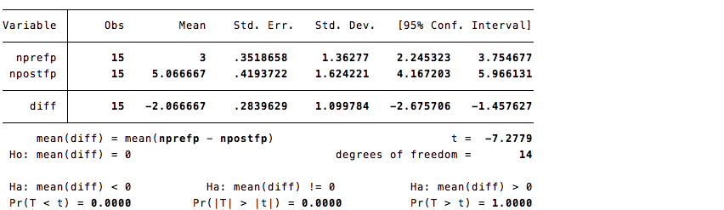
Null Hypothesis Test of Sample Mean Changes for F&P-IL

Table 2
Null Hypothesis Test of Sample Mean Changes for Accuracy
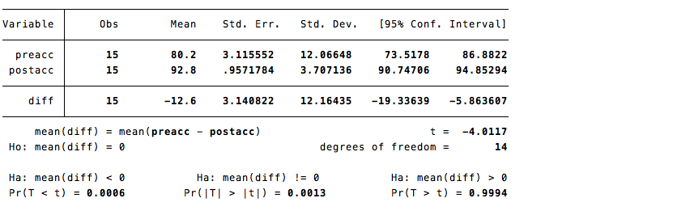

Table 3
Null Hypothesis Test of Sample Mean Changes for Fluency
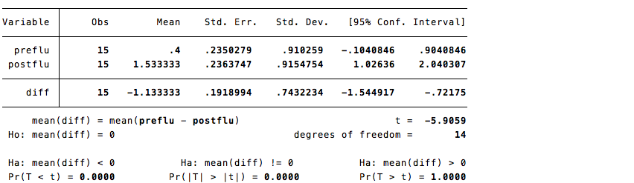

Table 4
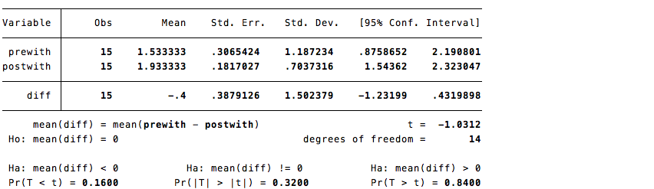
Null Hypothesis Test of Sample Mean Changes for Within

Table 5
Null Hypothesis Test of Sample Mean Changes for Beyond
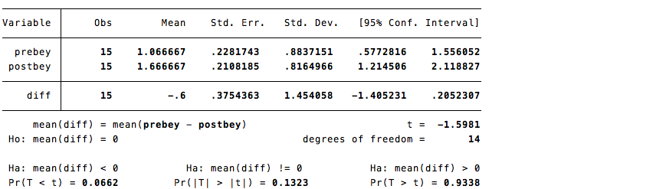

Summary
For the dependent variables Fountas and Pinnell (2017) Benchmark Assessment System instructional reading levels, Accuracy/Comprehension, and Fluency, the mean gains from pre-to-post treatment were statistically significant at the customary p-value of 0.05. In addition, the explicit phonemic small-group instruction also had large or very large effect sizes for those outcomes. The other two outcomes, Within and Beyond, failed to reach the customary level of statistical significance, and attained only small effect sizes. Therefore, for Within and Beyond, the lack of statistical significance was not only due to small sample sizes but to small treatment effects. Note that the design was a one-group pre and post. Thus, there were no data on the growth of the outcomes without the instructional treatment. The pre-to-post gains were significant, both statistically and practically when the treatment was applied. We cannot say, however, what would occur in the absence of the treatment.

CHAPTER V
DISCUSSION
This study examined the impact of explicit phonemic awareness instruction during small group instruction on kindergarten students’ instructional reading levels. Results of the statistical analysis reported in Chapter IV indicated areas in which the null hypothesis was rejected as well as areas where the null hypothesis could not be rejected at customary levels of significance. Data collected indicates a statistical significance in which the null was rejected in the areas of instructional reading level, overall accuracy and comprehension, and fluency. Moreover, the three areas with statistically significant gains also had large or very large effect sizes. Therefore, the pre-to-post gains were statistically and practically significant. The null is retained in the areas of within and beyond the text comprehension and the effect sizes were small, indicating that small sample sizes were not the main cause of retaining the null.
Implications of the Results
The data implies that explicit phonemic awareness instruction in small group may have had an impact on students’ instructional reading levels. This implication can be supported by the post-test data result that 100% of students gained at least one instructional reading level. Five out of 15 students progressed one reading level based on Fountas and Pinnell’s (2017) grade level goals, six out of 15 students progressed two reading levels, three out of 15 students progressed three reading levels, and one out of 15 students progressed five reading levels. The pretest indicated that five out of 15 students were not meeting grade level expectations as defined by Fountas and Pinnell’s (2017) Instructional Level Expectations for Reading, eight out of 15 students were meeting expectations, and two out of 15 students were exceeding expectations. The posttest concluded that after treatment, two out of 15 students were meeting expectations and 13 out of 15 students were exceeding expectations.
Treatment was provided over six weeks. The use of Michael Heggerty’s resource “Phonemic Awareness: The Skills That They Need To Help Them Succeed!” was used to provide explicit phonemic awareness instruction to small groups of students. This resource, which provides a script for explicit phonemic awareness instruction in conjunction with other research and evidence based instructional practices, contributed to the students’ acquisition of early literacy skills. This enabled students to become more fluent readers, thus increasing the instructional level of texts students could read and comprehend. Systematic and explicit phonemic awareness and phonics instruction combined with modeled, shared, interactive, guided, and independent reading and writing allowed students the opportunity to make neurological connections that support strong decoding and comprehension. The data implies that explicit phonemic awareness instruction coupled with additional best practices occurring within the kindergarten classroom yielded improvement in instructional reading levels. There is no evidence that only using the phonemic awareness resource would yield similar results.
Theoretical Consequences
Multiple comprehensive curricular components are needed to ensure students are making the necessary connections to be able to successfully decode and comprehend text. A balanced approach is needed to ensure students have the basic early literacy skills and understandings needed to be literate. Interactive read-aloud and literature discussion, shared and performance reading, writing about reading, writing, oral, visual, and technological communication, phonics, spelling, and word study, and guided reading contributes substantially in complementary ways to children’s development of reading, writing, and language processes (Fountas & Pinnell, 2011). An increase in phonemic awareness instruction alone would not directly impact reading ability.
Threats to Validity
Possible threats to validity exist within this study. Threats to internal validity include the quality of instruction and length of instructional time. The instruction was not observed or measured by the researcher. While the phonemic awareness instruction was provided by the same teacher to all the participating students, the researcher did not observe the daily instruction that was provided by the classroom teacher. The participating teacher was instructed to use the Heggerty script to provide explicit phonemic awareness instruction at the beginning of small group guided reading lessons.
The length of instructional time was also not measured by the researcher. The participating teacher used her judgement to determine the amount of instruction needed for each group of students based on their needs and level. Length of explicit instruction ranged from three to five minutes in a small group setting.
Threats to external validity include the small sample size and the one-group pre-post design. This study included 15 kindergarten students from one classroom. All 15 students received the treatment, so the study did not conduct a comparison between a treatment and non-treatment group. While the students represented a wide range of ability, results may be different with a larger sample of students.
Connections to Previous Studies/Existing Literature
This study focused on the impact of explicit phonemic awareness instruction on instructional reading levels. For decades, early childhood research has identified phonological awareness as a critical skill needed for later reading success. Over a decade ago, the Report of the National Reading Panel identified five critical components necessary for the development of independent reading: phonemic awareness, phonics, fluency, vocabulary, and comprehension (Konza, 2014). Phonemic awareness is a subset of phonological awareness and is used as a predictor for later reading success.
Previous studies have found that the more sensitive children are to the sound structure of spoken words, the more likely they will become strong readers despite other factors such as socioeconomic status, intelligence, and receptive vocabulary (Carson et al., 2013). Phonemic awareness instruction in kindergarten is imperative as weaknesses in the Phonological Processor are often very responsive to intervention when they are identified at an early age (Tracey, 2017). This study investigated the use of explicit phonemic awareness instruction in a small group setting so that the teacher could carefully monitor student responses and provide immediate feedback.
Implications for Future Research
Future research should continue to investigate the impact of explicit phonemic awareness instruction on reading success; especially in pre-kindergarten and kindergarten classrooms. Based on the results of this study, phonemic awareness, among other best practices, provides kindergarten students with the foundational skills needed to acquire the basic early literacy skills needed to be able to decode and comprehend text. The use of explicit phonemic awareness curricula and teacher to student feedback should be further studied.
Future studies should also consider a larger group of participants and a non-treatment group to gain additional information. This study was limited to one kindergarten class, but a larger sample would provide better information about which students would most benefit from explicit phonemic awareness instruction in small group. Additionally, future studies may want to manipulate the length of the explicit instruction to determine if there is a relationship between the amount of instructional time and student achievement.
Conclusions/Summary
This study focused on the impact of explicit phonemic awareness instruction during small group instruction on students’ instructional guided reading levels. All participants gained at least one instructional reading level from the pre to posttest. Based on the literature review and study findings, explicit phonemic awareness instruction is a critical component of kindergarten programming. This study emphasized explicit instruction occurring during small group instruction which allowed the teacher to customize what the group of students needed beyond what was provided during core word work instruction. It also gave the teacher the opportunity to provide on the spot feedback to students as a means of clarifying errors and misconceptions. Learning to read is a complex task and explicit phonological awareness instruction in early childhood impacts later reading success as phonological awareness is the critical foundation to becoming a skilled reader.

References
Abbott, L., Dornbush, A., Giddings, A., & Thomas, J. (2012). Implementing guided reading strategies with kindergarten and first grade students. Retrieved from ProQuest Dissertations & Theses from https://goucher.idm.oclc.org/login?url=http://search.ebscohost.com/login.aspx?direct=true&db=eric&AN=ED531180&site=ehost-live&scope=site
Ashby, J., Dix, H., Bontrager, M., Dey, R., & Archer, A. (2013). Phonemic awareness contributes to text reading fluency: Evidence from eye movements. School Psychology Review, 42(2), 157-170. Retrieved from https://goucher.idm.oclc.org/login?url=http://search.ebscohost.com/login.aspx?direct=true&db=a9h&AN=88362324&site=ehost-live&scope=site
Berg, M., & Stegelman, T. (2003). The critical role of phonological and phonemic awareness in reading success: A model for early literacy in rural schools. Rural Special Education Quarterly, 22(4), 47-54. Retrieved from https://goucher.idm.oclc.org/login?url=http://search.ebscohost.com/login.aspx?direct=true&db=a9h&AN=12059529&site=ehost-live&scope=site
Carson, K. L., Gillon, G. T., Boustead, T. M., Nippold, M., & Troia, G. (2013). Classroom phonological awareness instruction and literacy outcomes in the first year of school. Language, Speech & Hearing Services in Schools, 44(2), 147-160. doi:10.1044/0161-1461(2012/11-0061)
Cassady, J. C., Smith, L. L., & Putman, S. M. (2008). Phonological awareness development as a discrete process: Evidence for an integrative model. Reading Psychology, 29(6), 508-533. doi:10.1080/02702710802271966
Fountas, I. C., & Pinnell, G.S. (2017). Fountas & Pinnell benchmark assessment system 1. grades k-2, levels a-n. Portsmouth, NH: Heinemann.
Fountas, I. C., & Pinnell, G. S. (2012). Guided reading: The romance and the reality. Reading Teacher, 66(4), 268-284. doi:10.1002/TRTR.01123
Fountas, I. C., & Pinnell, G.S. (2011). The continuum of literacy learning: Grades prek-2.
Portsmouth, NH: Heinemann.
Konza, D. (2014). Teaching reading: Why the "fab five" should be the "big six." Australian Journal of Teacher Education, 39(12) 154-169. Retrieved from https://goucher.idm.oclc.org/login?url=http://search.ebscohost.com/login.aspx?direct=true&db=eric&AN=EJ1047077&site=ehost-live&scope=site
McGee, L. M., & Ukrainetz, T. A. (2009). Using scaffolding to teach phonemic awareness in preschool and kindergarten. Reading Teacher, 62(7), 599-603. Retrieved from https://goucher.idm.oclc.org/login?url=http://search.ebscohost.com/login.aspx?direct=true&db=eric&AN=EJ835933&site=ehost-live&scope=sitehttp://dx.doi.org/10.1598/RT.62.7.6
Paige, D. D., Rupley, W. H., Smith, G. S., Olinger, C., & Leslie, M. (2018). Acquisition of letter naming knowledge, phonological awareness, and spelling knowledge of kindergarten children at risk for learning to read. Child Development Research, 2018, 1-10. doi:10.1155/2018/2142894
Snider, V. E. (1997). The relationship between phonemic awareness and later reading achievement. Journal of Educational Research, 90(4), 203. Retrieved from https://goucher.idm.oclc.org/login?url=http://search.ebscohost.com/login.aspx?direct=true&db=a9h&AN=9704143073&site=ehost-live&scope=site
Tracey, D. H. (2017). Understanding the reading process: One path to strengthening classroom instruction. Education and Urban Society, 49(9), 814-831. Retrieved from https://goucher.idm.oclc.org/login?url=http://search.ebscohost.com/login.aspx?direct=true&db=eric&AN=EJ1160555&site=ehost-live&scope=sitehttp://dx.doi.org/10.1177/0013124516659526

