[Graphical Passwords and Young Learners]

by
[Jasper John Cole]
[June] 2016

Presented to the
Division of Science, Information Arts, and Technologies
University of Baltimore

In Partial Fulfillment
of the Requirements for the Degree of
Master of Science

Approved by: ________________________________
[name, Thesis Advisor]

________________________________
[name, Committee Member]

________________________________
[name, Committee Member]
Abstract
Computer security is becoming an increasingly important and common part of our daily lives. We cannot use computers safely or securely without effective login systems. This challenge is especially problematic for children. Whether accessing their family computer, a school account, or a game online – children also need secure access to their personal information. Previous studies have shown that children struggle to remember and type textual passwords.

This paper outlines a study into graphic passwords. After designing a system for graphical passwords, a study was conducted with 13 children between the ages of six and twelve years old. These students created their own accounts for fictional websites. Each participant created their own usernames, textual, and graphical passwords. After two weeks, participants returned and attempted to recall the usernames and passwords that they created. Results were compared to determine the effectiveness and ease of use for different password methods.

This study showed that graphical passwords had a lower success rate and participants were less likely to access their accounts when using graphical passwords. It is not clear if this could be resolved through modifying the system or if the graphical systems are inherently too challenging for children. Whether using graphical or textual passwords, children succeeded with generalities, but struggled with specifics. With textual passwords, they would remember the phrase or word, but could not recall capitalization or numbers that they included. With graphical passwords they remembered the picture they chose but struggled to select the same points accurately and in the correct order.

This study shows that graphical passwords are an interesting subject and provide many possibilities for children. They warrant further research, but it seems clear that they do not alleviate all of the difficulties presented by password systems. Other alternative methods may provide similar functionality in a more approachable method.
Acknowledgments
Thanks to my advisor, Greg Walsh, and all of the participants who participated in the study. I’d also like to thank Ashley, Joel, and Zach who worked with me on this study. Finally, thank you to my family and friends who have supported me throughout my academic career. I hope to make you all proud.
Table of Contents

List of Tables v

List of Figures vi

Chapter 1: Concept and Preliminary Research 1
Introduction 1
Initial Concept 2
Research 3
IRB Approval 3
Formal Concept 4
Further Work 5

Chapter 2: Prototype Design and Testing 6
Design Iteration and Paper Prototyping 6
Initial Prototype Concept 7
First Prototype 7
Storing Data and Developer Mode 9
Initial Testing 11
KidsTeam 11
First Visit to KidsTeam on October 10th 12
Changes 21
Second Visit to KidsTeam on November the 5th 24
Designing the Final Testing System 25
Recording 29
Other Ideas 29

Chapter 3: Formal Testing 31
Overview 31
Methodology 32
The First Session 32
The Second Session 34

Chapter 4: Results and Discussion 36
Results
Number of tests and order of study 36
Success Rate 38
Unsuccessful Attempts 39
Qualitative Results 41
Case Study – Esther 46
Case Study – Kyle 53
Other Observations 59
General Understanding of Passwords 59
Basic Literacy 60
Basic Computer Literacy 60
Lack of Security 61
Lack of Systems of Memory 61
Choosing specific points 63
Results related to Hypotheses 63
Children will prefer using picture password systems. 63
Children will be able to remember the picture that they chose with high accuracy. 64
Children will be able to remember their picture passwords more easily than their text-based passwords. 65
Children will create more unique passwords when using picture passwords. 66
Discussion 66
General difficulties with generality/specificity 66
Conclusion 67
Limitations and Difficulties 67
Technical difficulties – Inaccurate saving of data 67
Recommendations 68
Further Research 68
More Data 68
Other Picture Passwords 69
A Password System Based on this Research - Relic Passwords 69

References 71

Appendix A: Annotated Bibliography 72

Appendix B: Bibliography 84

Appendix C: IRB Application 87

Appendix D: Consent Form 94

Appendix E: Assent Form 98

Appendix F: Changelog after first KidsTeam 99

Appendix G: Session 1 Testing Script 100

Appendix H: Session 2 Testing Script 103

List of Tables
Table 1 Number of Textual and Graphical Passwords Created In the First Session 37
Table 2 Number of Textual and Graphical Passwords Created In the Second Session 37
Table 3 Success Rate of Passwords 38
Table 4 Unsuccessful Login Attempts 39
Table 5 Number of Different Images Selected on Each Page 41
Table 6 Points Selected for Mia’s First Graphical Password 42
Table 7 Points Selected for Mia’s Second Graphical Password 43
Table 8 Points Selected for Mia’s Third Graphical Password 44
Table 9 Points Reordered on Mia’s Third Graphical Password 45
Table 10 Points Selected for Esther’s First Graphical Password 46
Table 11 Points Reordered for Esther’s First Graphical Password 48
Table 12 Points Selected for Esther’s Second Graphical Password 49
Table 13 Points Selected for Kyle’s First Graphical Password 54
Table 14 Points Reordered for Kyle’s First Graphical Password 55
Table 15 Points Selected for Kyle’s Second Graphical Password 57
Table 16 Points Selected for Kyle’s Third Graphical Password 58
Table 17 Points Selected for Xena’s First Graphical Password 62

List of Figures
Figure 1. The “Enter your Username” screen in the original prototype. 9
Figure 2. The developer mode in the final prototype 11
Figure 3. The group at KidsTeam 14
Figure 4. Children pointing to a position on the screen 15
Figure 5. Children using the computers to access their accounts 16
Figure 6. Jasper Cole observes KidsTeam. 17
Figure 7. Greg helps a student access her account 18
Figure 8. The notes that participants filled out 19
Figure 9. The results of the children’s design ideas 20
Figure 10. The results of all of the children’s dislikes 20
Figure 11. The results of all of the children’s likes 21
Figure 12. The username screen in the second prototype 23
Figure 13. The graphical password screen in the second prototype 23
Figure 14. The username screen on the “Animals Site” testing page 26
Figure 15. The username screen on the “Game Site” testing page 27
Figure 16. The password screen on the “Environmental Site” textual testing page 27
Figure 17. The image selection screen on the “Old Movies Database” site 28
Figure 18. The graphical password screen on the “Old Movies Database” site 28
Figure 19. A participant using the password system to log in 36
Figure 20. Esther’s password on the “Aquarium Site” page 47
Figure 21. The car where Esther chose a point for her second graphical password 49
Figure 22. Esther’s password on the “Game Site” page 51
Figure 23. Esther is entering her password for the “Game Site” page 53
Figure 24. Kyle’s password on the “Game Site” page 56
Figure 25. The number “2” on Kyle’s final graphical password 59
Figure 26. A participant is smiling while entering a graphical password 64
Figure 27. A participant looks frustrated and confused 65

Chapter 1: Concept and Preliminary Research

Introduction
In their article Designing Textual Password Systems for Children, authors Janet Read & Brendan Cassidy write “studies on how children create and use passwords are rare” (2012 p. 200) These authors suggest requiring text passwords that do not require 8 letters and do not require a mixture of numbers, letters, and symbols, but they do not discuss any alternatives methods. Despite this, they write that “textual passwords can be especially problematic for children” (p. 200). Therefore, it is worthwhile to examine some other systems of authentication and their accessibility, memorability, and favorability among children. Alternative passwords may be better for children, providing safer, easier, and more secure access to their private information.
Graphical passwords are a popular alternative among adults and have been the subject of many studies. One of the most discussed system is PassPoints – where users select several distinct points on an image and then recall these positions accurately in order to access their account. This system has been studied extensively and many authors have written about it. For example, Wiedenbeck, Waters, Birget, Brodskiy & Memon examine tolerance and image choice and Dirik & Birget model and predict user choice (2005; 2007). These studies are built around the potential viability of graphical passwords among adults.
However, a study has not yet been performed on children and graphical passwords. This leaves many questions unanswered. Are children able to create graphical passwords? Are they able to remember and reenter these passwords accurately at a later date? Is this a fun and appropriate method for children? This study examines these questions.

Initial Concept
This study began with an interest in passwords and login systems. This subject was covered throughout University of Baltimore’s Graduate program in Information Architecture and Interaction Design, and researchers wanted to explore alternative methods for securing information. As well, this was an opportunity to examine passwords from a new angle. Jasper Cole, the primary researcher, also works at the Johns Hopkins Center for Talented Youth (CTY) and has experience working with children. In CTY’s online program, courses are accessed with a username and a password, and many young children struggle to access their accounts – often receiving help from parents and other family members. All of these experiences, combined with a general interest in the relationship between children and computers, lead researchers to this subject.
It was quickly apparent that some research had been done on children and passwords already. For example, Mendori & Okada wrote a paper in 2002 positing an alternative method for children to access their secure information. They recommended a system similar to other graphical password systems – reliant upon the “discernment of icons” (para. 4). This type of matching password systems seems logical, but the authors did not compare the usability or memorability of this system against more traditional textual password. Despite a long history of research about children’s struggles with passwords, and many viable alternatives, there are very few studies that compare alternative password systems to more conventional textual systems.
This lapse is the focus of this study - examining graphical passwords and comparing them against textual passwords. Textual passwords are the dominant form of password in most systems and graphical passwords are the most commonly discussed alternative. Researchers wanted to see how children responded to these systems and whether or not graphical passwords made it easier for children to use and remember their password. The original thesis proposal explained the goal as follows:
I propose designing and testing alternative methods for logging in, which would allow a wider audience to access secure material without requiring such difficult memorization. […] First, I would like to expand research into login mechanisms and the way they apply to young learners. I hope provide more insight into the difficulties and problems that exist with current password systems. Second, I intend to create an alternative system for login and user verification. This should further expose alternative methods that may pave the way for improved login methods in the future.

Although there was no specific outline for the research, the main objects were clear. These have been no deviations from that general goal over the past two semesters.

Research
Research was conducted primarily through Google Scholar and University of Baltimore’s Langsdale Library’s online system. Some articles were retrieved through the Interlibrary Loan system when they were not available online. Articles were grouped into one of three categories. Articles that covered Passwords, Login systems, and research on children. This research uncovered a lot of data about PassPoints and other Graphical password systems.
Please see Appendix A for a full annotated bibliography which outlines all of the research. See also Appendix B for a bibliography without annotations.

IRB Approval
A formal application was submitted to the Institutional Review Board (IRB) on September 3, 2015. Researchers were asked to follow up with a sample survey and interview questionnaire and other minor changes. Another proposal was sent on September 18, 2015. IRB representatives felt that “the youngest children proposed as part of this study, even the most talented 1st grader may not understand the instructions or the questionnaire.” As well the consent form was not clearly directly towards the participant’s parents and required revision. Reviewers were also concerned about some of the specific details of the study, such as benefits to participants, storage of data, and confidentially.
The application was revised based on their concerns, and two more applications were submitted. The final application was submitted on October 30, 2015. This was approved on November the 6, 2015, and the study moved forward.
In the final proposal the consent form clearly addresses the participant’s parents instead of the participant, and children sign an assent form. This meant that parents and/or guardians provided written consent. Afterwards the minors signed forms indicating that they understood that the study was voluntary and they could stop at any time. Participants also received $5 Amazon gift cards. The gift cards were given to participants for each session and some participants received two. Jasper Cole purchased some of these gift cards and Greg Walsh provided others.
The final application as well as the consent and assent form are attached as Appendices C, D, and E.

Formal Concept
A formalized research concept was written on December 10th. It explains the research and the testing prototype.
[Participants will use an] interface [that] requires participants to choose one of 12 images. They then select five points on the image. They can create a hint and are required to confirm their password twice – with the assistance of circles that show where to click. Participants will then log into the system. Upon successful completion they will then take a break for twenty minutes. During this time we will work on layered elaboration about password systems. This may show good ideas for password systems for children and will be a productive use of time. Also it will distract the participant so that they will not be thinking about their password.
After twenty minutes they will return to the password system. They will again attempt to login. Upon completion of the activity, they will be asked several questions.
The fundamental pieces of this idea remained consistent throughout the study, but the specifics of the methodology changed when participants were recruited for testing. For example, sessions already took in excess of an hour and the distraction task was limited to approximately five minutes. If participants took more time between login attempts, it is possible that it would have affected the results, but it is also possible that requiring children to remain focused for more than an hour and a half would have detrimentally affected the study as well.

Further Work
With the final concept for the project formalized, work began on the testing system. The goal was to create a unique graphical password prototype system that could be easily altered and adapted for children. The concept of the system was based on PassPoints as described in the paper by Chiasson, Stobert & Oorschot, as well as Creese et al., Dirik et al., and Wiedenbeck et al. among others (2007; 2015; 2007; 2005). The system would require the user to create a username, select an image, and then choose five points on that image. They would then need to recall their username, their image, and the same five points, in order to gain access their account.

Chapter 2: Prototype Design and Testing

Design Iteration and Paper Prototyping
Researchers experimented with several different prototypes, creating as many ideas as possible and iterating on the best ideas. This resulted in the concept of a graphical system based on the PassPoints system. The clearest description of this system came from Chiasson, Stobert, Oorschot & Biddle’s paper “Multiple Password Interference in Text Passwords and Click-Based Graphical Passwords.” This paper describes PassPoints passwords as follows:
In PassPoints, users are presented with an image, and a password consists of 5 click-points on the image (see Figure 1). To log in, users must select the same 5 click-points in the same order. The system allows for a tolerance area around each click-point so that approximately correct login attempts are accepted (2009 p.501).

The prototype created for this study was modeled closely on this description. Users create a text username then select one of several images from a menu of images. They then select five points on that image as their password. To access their account they choose the same image and then select the same five points in the same order. If they select points that are close enough to their original selections they will successfully their account.
After completing informal paper prototyping to understand, clarify, and refine the idea, work began on the digital prototype. The decision to use a digital prototype was logical as interviews and paper prototyping would not have returned the same results. It would have been challenging to compare points as accurately with a paper prototype, measuring the exact distance between the original points and the points selected during the login attempt. More importantly, paper prototyping would not have uncovered the difficulties that young children have with computer interfaces. Children use a keyboard and mouse at different levels of proficiency, and many of the difficulties they face when using a computer could not be accurately reproduced with a paper prototype – even if many of the systems were otherwise similar.

Initial Prototype Coding
The prototype was created with HTML, CSS, and Javascript. Researchers had familiarity with these languages, and they were chosen due to their high level of functionality, portability, compatibility, and versatility. As well, these languages are a practical application for a password system. Websites are one of the main places where we use passwords, and it seems logical that a password system should be coded in HTML and JavaScript for easy online implementation.

First Prototype
The first prototype was written on October 15, 2016. This version was very simple, containing 273 lines of code including 40 lines of HTML, 105 lines of CSS, and 128 lines of JavaScript. A circle image was created in Photoshop and six stock photos were taken from istockphotos.com. These photos were chosen because of other PassPoints research that recommended using photos that contain multiple salient points.
The prototype starts by loading all of the resources, but uses the “display: none;” property to hide most of the page content. The user is presented with simple instructions “Enter Your Username,” a form for input, and two buttons “I already have an account” and “I am making a new account.” This type of account creation was based on Amazon’s login system that encourages users to enter their username before asking if they already have an account. That avoids the problem where a user enters their username on the “Login” page only to realize that they need to reenter their username on a different form to create a new account.
The user enters a username, and if they do not have an account, they select “I am making a new account.” There are very few requirements for username creation. They can be any length up to 10 characters and they cannot contain any spaces. Otherwise, all names are accepted. Once the user selects “I am making a new account” they are prompted with a list of the six photos. They can see them all on one screen and by hovering the cursor over a photo, it expands slightly. This allows them to see the image at a larger size, and it accentuates their current selection. This was accomplished CSS animations, so the picture enlarges smoothly and slowly – which avoids a jarring effect.
Once the user select an image, the other images disappear. The selected image expands to the size of the canvas element – 800 pixels wide and 600 pixels tall. All of the images were cropped and resized in Photoshop to fit to these dimensions appropriately. The canvas is appears centered on the screen and the other images disappear. The user then clicks on the canvas. Each click is confirmed by an on screen visual of a black dot that appears on the canvas and grows in size before disappearing. This gives the user clear visual feedback of the location that they selected. Once the user clicks on five points, a JavaScript alert appears indicating that the password is saved. The canvas disappears and there are no further instructions. Researchers then instruct participants to then refresh the page and log in to their account.
After entering their username a second time, they could choose the option “I already have an account.” If they pressed this button before, they got a JavaScript alert indicating that the “Username does not exist!” If they press “I am making a new account” they are prompted to create a new password and it overwrites their previous password. This is helpful if a user created a password that they cannot remember, but still wants to continue the test by trying again.
Once they enter their username and select “I already have an account,” they are again given the same six pictures in the same order. They have to select the same image and choose the same six points. If the points they choose are more than 10 pixels, either vertically or horizontally, from the original point that they chose, the password is incorrect. Once they enter all five points they receive a message “Wrong Password!” For security purposes it is not clear to the user which point was incorrect.
If all five points are accurate to the password they created previously, they receive a JavaScript alert that says “Correct Password.” The page is cleared using the “display: none;” property and they are left with a blank with a screen. This completes the test.
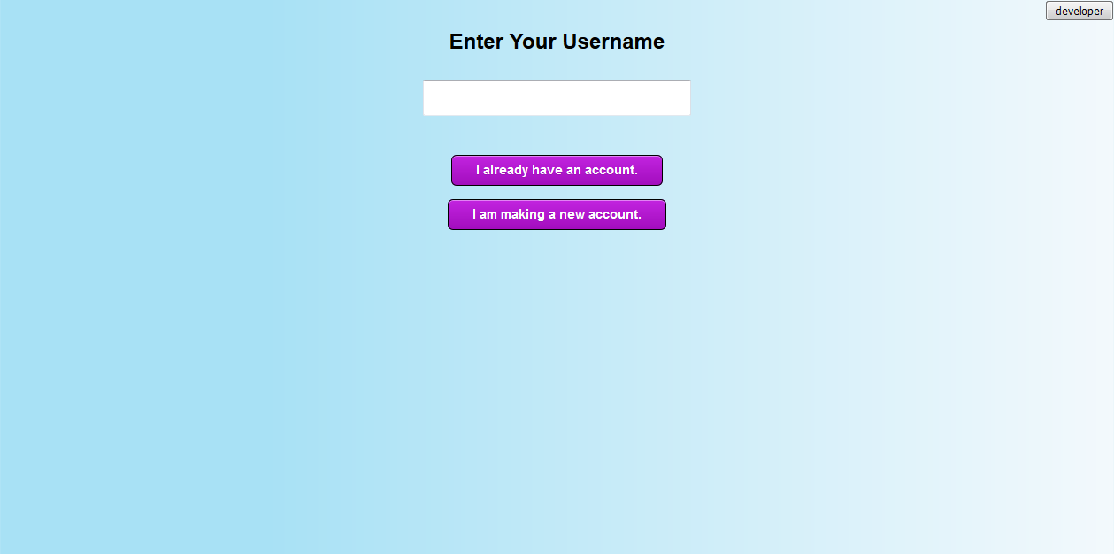
Figure 1. The “Enter your Username” screen in the original prototype. The developer button is visible in the upper-right corner.

Storing Data and Developer Mode
Data is stored in the browser using the Javascript “localStorage” object. This information can be viewed through browsers, recalled from temporary data, or viewed through the “Developer” button. In early versions of the prototype this was visible in the upper-right corner of the screen, but in later versions it was hidden using the “display: none;” property. It becomes visible with the CSS “:hover” selector. This means that it only appears if the user puts their cursor in the upper-right corner of the screen. No participants found the button during testing. Developer mode recalls information from the localStorage object, and creates numbers on the canvas based on the locations that the user selected. This can be used to view and visually interpret the password that a user created. This is much faster and easier than reading the password information in text format. Passwords are stored as a JSON string and look like this:
["140.452","676.461","399.339","204.328","401.272"]

The system was also unique in that it did not save users passwords with the image that the user selected. Passwords are completely independent of the user’s image and can hypothetically be entered on alternate image – or theoretically a blank page. Requiring the user to select the correct image could be an additional layer of security, as there is more information that a third party would have to enter. But associating passwords with a specific image has been shown by Creese, Goldsmith & Nurse to be somewhat predictable by a machine (2015). By identifying certain regions of contrast, hackers can guess passwords. However, if the user’s password may be associated with any one of eight images, identifying salient points on a specific image will be largely futile – unless the third party has correctly identified the user’s password image.
As well, it is important to acknowledge that this is a prototype for usability testing only. This prototype is not a genuine authentication system and could not safely secure any data. Data is not encrypted in any way and is accessible to anyone who understands how to view browser data. If this system was actually implemented it would need to be altered from a testing system to an encrypted security system.

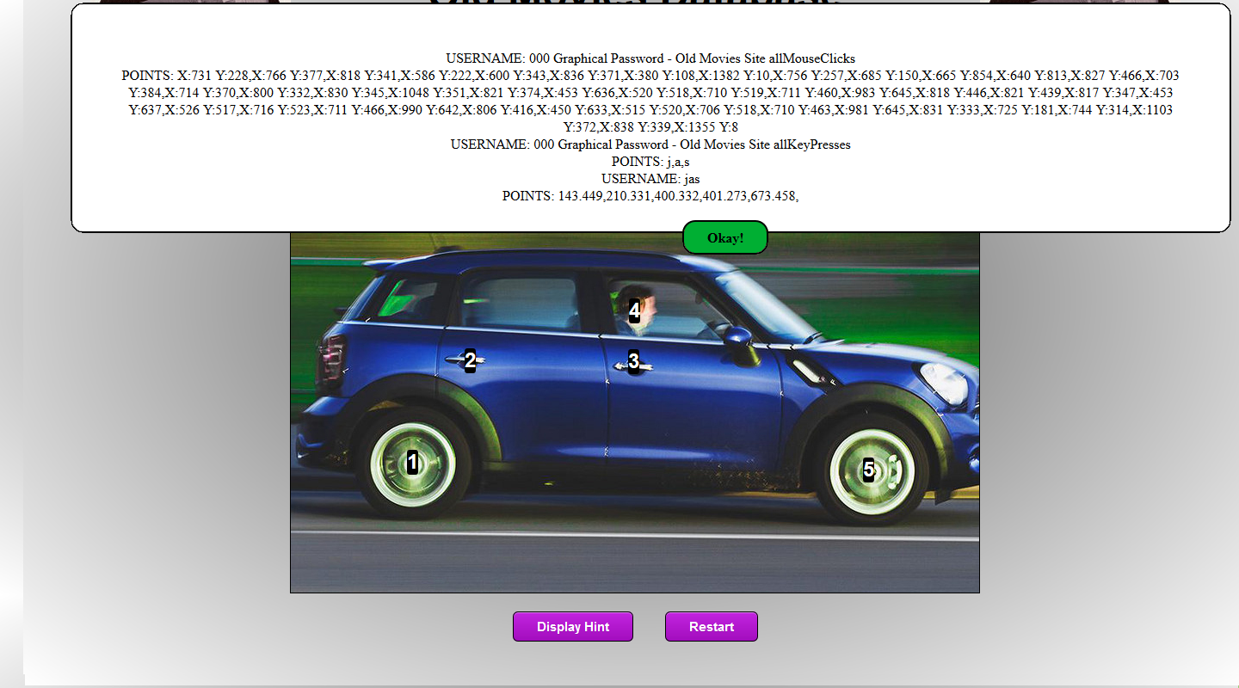
Figure 2. The developer mode in the final prototype. The text prompt shows all of the positions of mouse clicks, all of the keys pressed, as well as the usernames, hints, and passwords that are stored. The positions that the user selected are overlaid on the picture.

Initial Testing
After initial design and personal testing, researchers tested the system informally with friends and coworkers. After a short explanation of the system, participants created usernames and graphical passwords with the system. They then returned to the login screen and successfully entered the password that they had created. Overall they seemed to like the system and were able to use it without any trouble. They did not encounter any of the bugs or problems that researchers later discovered with child participants. After these successful tests, it was necessary to continue testing with children before preparing the prototype for the official study.

KidsTeam
Researchers contacted Greg Walsh, who runs KidsTeam, a team of children and adult designers who collaborate and design new technology. Professor Walsh defines it on his website as “intergenerational design team at the University of Baltimore” that “work *together* in the design of new children's technologies.” KidsTeam meets twice a week and usually has six to ten children who made perfect participants for this study. One of the most important things about KidsTeam is collaborative design. The children are partners in design rather than passive subjects in testing and approval. Researchers coopted this approach, and while this study did not include children from its inception, it did rely on their opinions, feedback, and recommendations to design a system that suited their wants and needs. As well, researchers collected their feedback throughout the whole study, taking their ideas as serious and valid recommendations.

First Visit to KidsTeam on October 10th
Jasper Cole first visited KidsTeam on October 10, 2015, bringing the current version of the testing prototype on a USB drive. This session of KidsTeam took place in The Whimsy Lab, a computer lab at University of Baltimore. Researchers received help and guidance from the KidsTeam assistants Zachary Pease and Ashley Chisholm. Researchers prepared for the testing by adding the testing prototype to all of the computers in the Whimsy Lab so multiple participants could use the system at a time.
When the participants arrived, they went through their usual warm-up and team building exercises, and were then given access to the computers. They created accounts with any username that they wanted, designed a password, and then tried to log into their account. Zachary writes regular summaries of events at KidsTeam and provided a brief synopsis of the events as follows:
“In today’s session we partnered with Jasper to do a Likes, Dislikes, and Design Ideas on his “pass-points” based graphical authentication system. We had full attendance and a junior researcher. Overall, while the kids enjoyed the pictures selected for the pass-points system, they found replicating their passwords to be difficult, and extremely time consuming relative to traditional alpha-numeric systems. The level of precision necessary proved problematic for a number of the design partners, and they also requested some sort of hint system to help recover forgotten passwords. They also expressed interest in customization, the ability to upload their own photos for use with the system. They also expressed desire for some sort of multi-media reward upon successful replication of the passcode.”
The experience was very educational, but it was definitely a mixed success. Users expected the testing prototype to be a game or a multimedia experience and were somewhat disappointed by the dull experience of logging in and finding no reward. As well, the test was extremely challenging. Very few participants logged in successfully and it took many attempts before they got in at all. Some participants never successfully logged in. The level of precision was too high, and users did not remember their passwords. As well, there were some bugs that caused the points to appear in different locations from the place where the user clicked if they scrolled too far down the page.
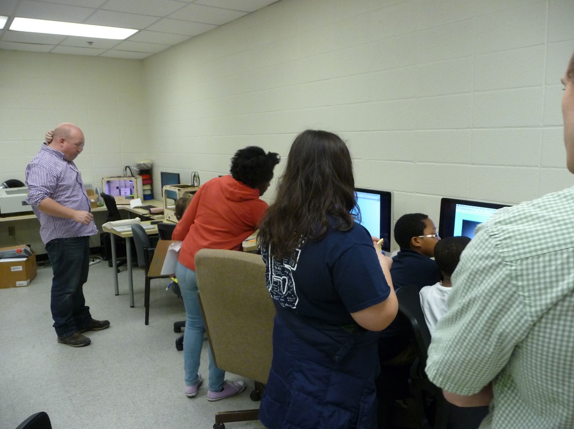
Figure 3. The group at KidsTeam. The children are at the computers, using the system. Jasper is visible in the foreground and Greg Walsh is standing in the background helping students with the system.

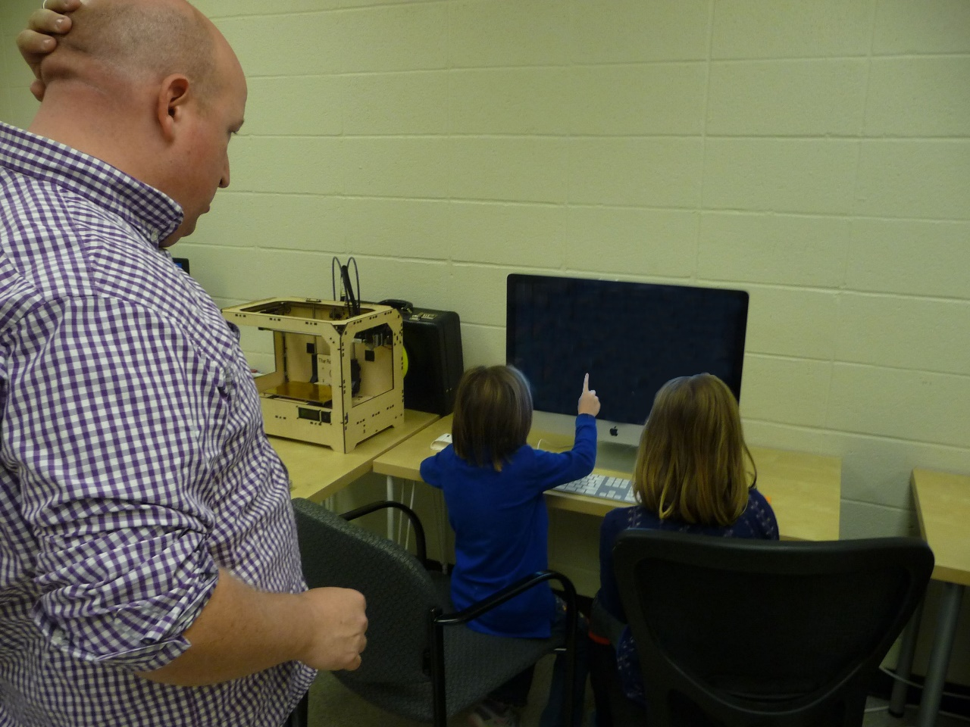
Figure 4. Children pointing to a position on the screen, trying to identify and remember the positions that they selected. The picture was edited to remove any images on the monitor. Greg Walsh is looking on to help the children.
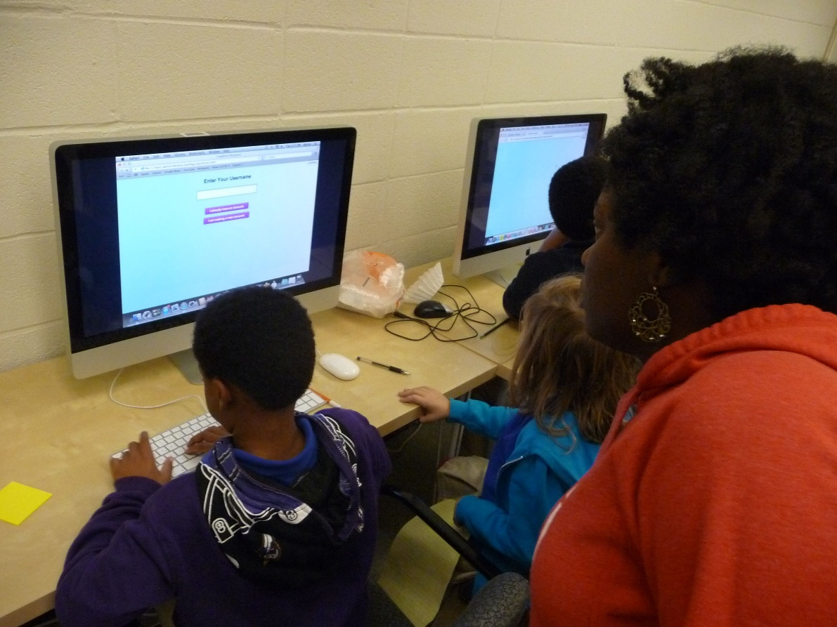
Figure 5. Children using the computers to access their accounts. Ashely Chisholm is helping them enter their usernames.
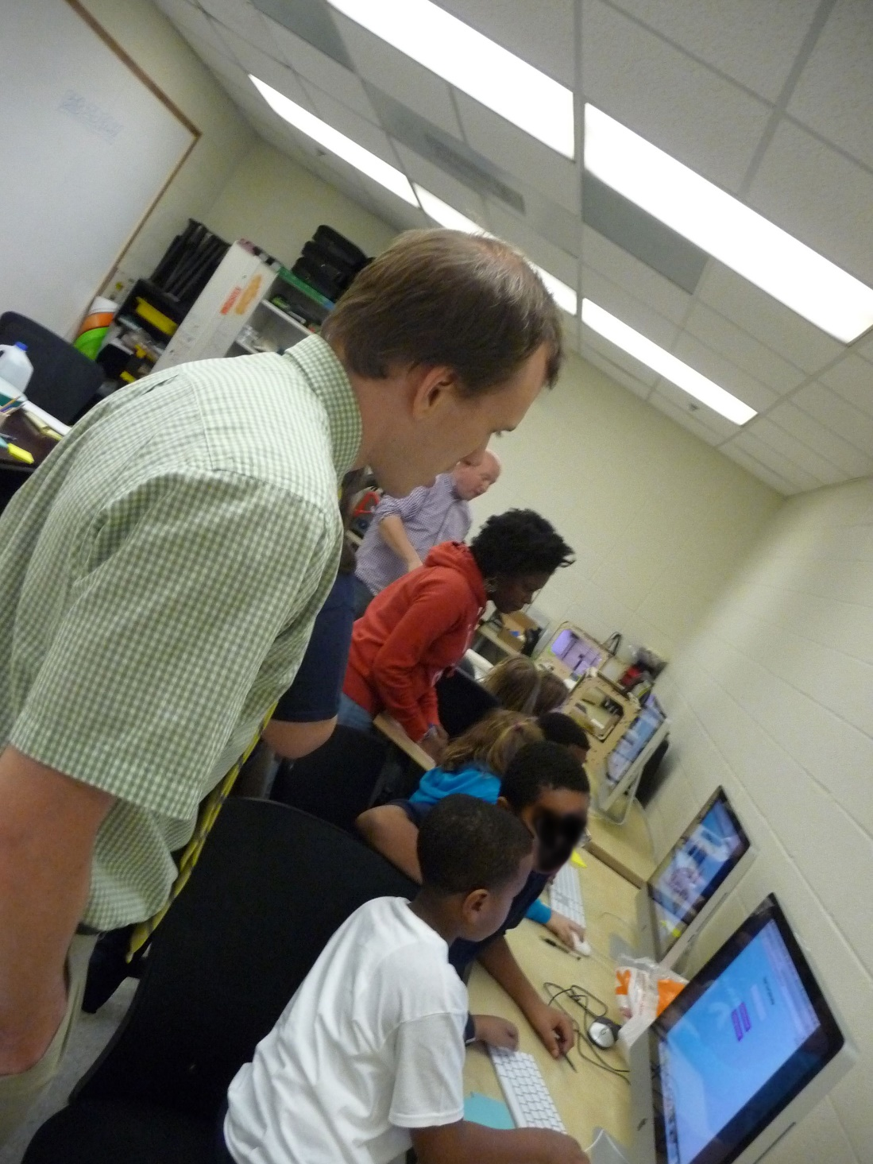
Figure 6. Jasper Cole observes KidsTeam. The picture was modified to remove participants’ identifiable characteristics.

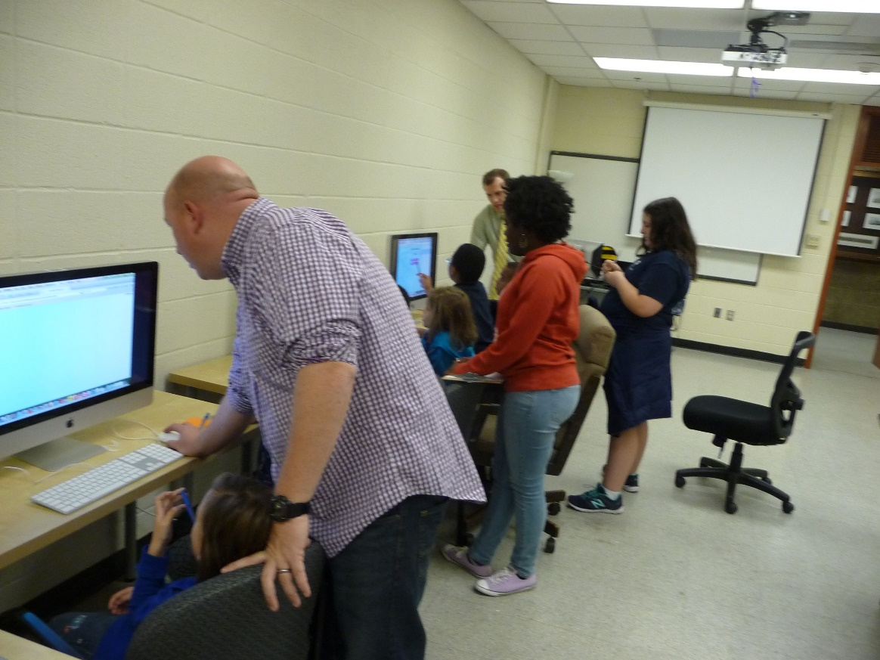
Figure 7. Greg Walsh helps a student access her account. She is sitting back in her chair and appears to have stopped trying for the moment.

After participants completed their test, they brainstormed likes and dislikes. They included these as notes that were put on the whiteboard and categorized into larger overall points. The dislikes fell into four main categories:
- Too hard
- Too many things to choose from
- Overall dislike of the concept
- Having to put the points in order
Researchers took all of these suggestions into consideration, but some were not possible. For example, researchers did not want to allow points in any order, at least for this study, as it may compromise security too greatly. Likes came in two main categories, including:
- The concept of clicking an image for a password
- Freedom to create passwords of your choice
The children also provided a list of suggestions to improve the system in the future. These included:
- Allowing for more Customization
- Giving clues or hint
- Putting a game afterwards.
The recommendation to “put a game afterwards” showed that children viewed this as a multimedia experience and they thought it was boring that logging in did not provide access to any other content. This showed that they did not enjoy the system entirely on its own merits, but it also implied that they associated this kind of system with something fun; the system seemed to be a part of an entertaining media experience instead of a dull or routine task.
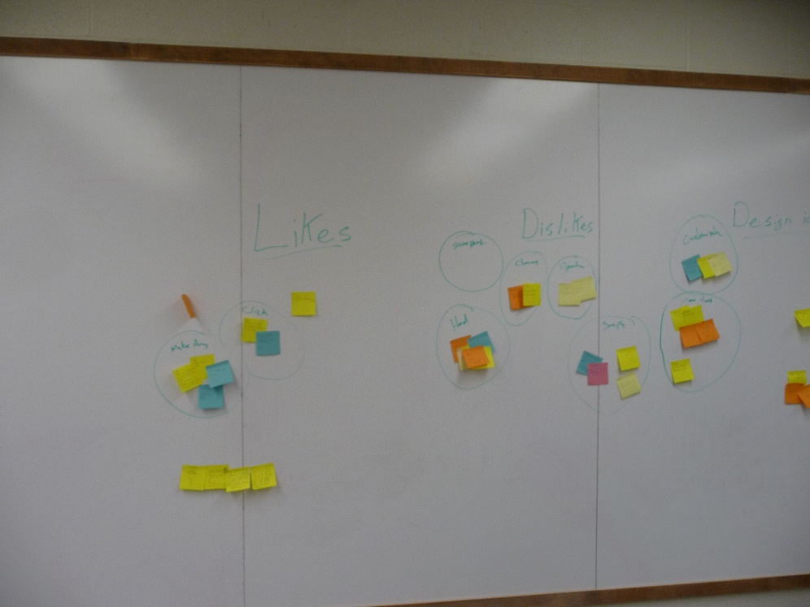

Figure 8. The notes that participants filled out. There are three major categories: likes, dislikes, and design ideas.
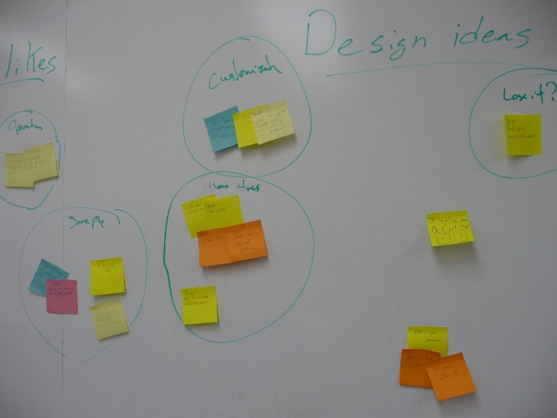
Figure 9. The results of all of the children’s design ideas.
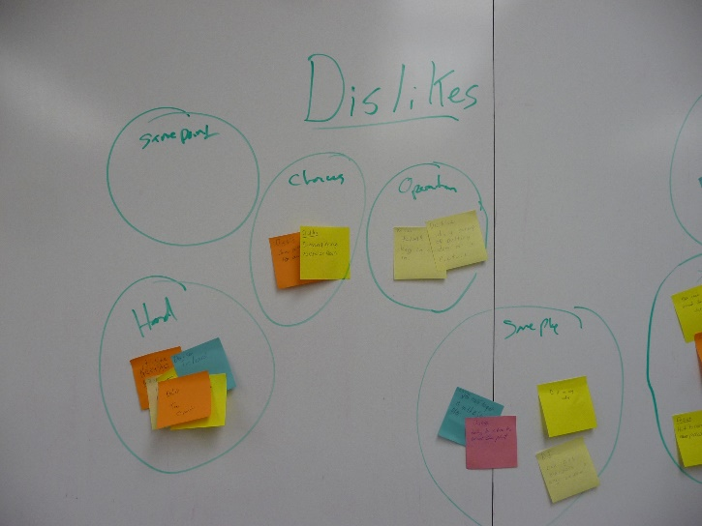
Figure 10 The results of all of the children’s dislikes.

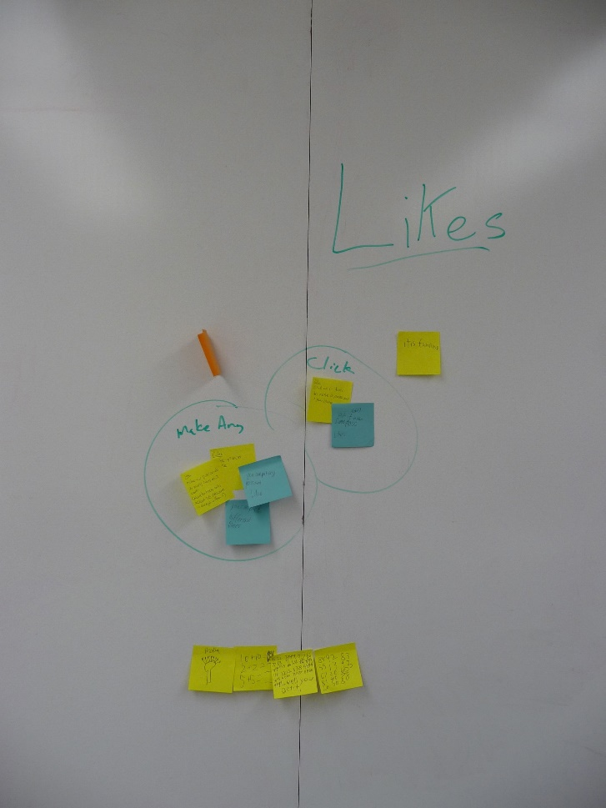
Figure 11. The results of all of the children’s likes. There are far fewer notes in this category.

While the children did not have overwhelming success with the system, it was clear that the system had some potential. The session was very productive and a lot was learned from their interactions as well as their feedback.

Changes
After the first test, the testing prototype was updated. Researchers scheduled another meeting with KidsTeam a month later and worked on modifying and updating the system. In less than a month the project ballooned to 724 lines of code including 61 lines of HTML, 361 lines of Javascript and 302 lines of CSS. The new prototype used images from Creative Commons and Public Domain Licenses. This allowed for screenshots and recordings of the test to be documented and recorded.
As many changes were made over this time, please see Appendix F for a full list of changes performed at the first test at KidsTeam. The principal changes included: fixing glitches, instructions with custom alerts (rather than the default JavaScript alerts), clear error messages, limiting usernames to 10 characters without spaces or special characters, and creating password hints. A reset button was also added. This allows users to return to the start of the test without requiring a page refresh.
There were several fundamental changes to the graphical password creation process. While users create their passwords, numbers appear on the image, showing users the points they previously selected. That way they receive a long-lasting visual cue indicating their selection. As well the points are numbered to encourage users to understand and memorize the sequence of the points that they selected. Also, after completing a password, they are required to confirm it two times. During the confirmation process circles appear around the points that they selected. Only one circle appears at a time, showing them where they selected and how accurate they need to be when entering the point again. Most notably, when logging in, the user now has a 20 pixels tolerance instead of a 10 pixel tolerance. This means they do not have to be nearly as accurate.

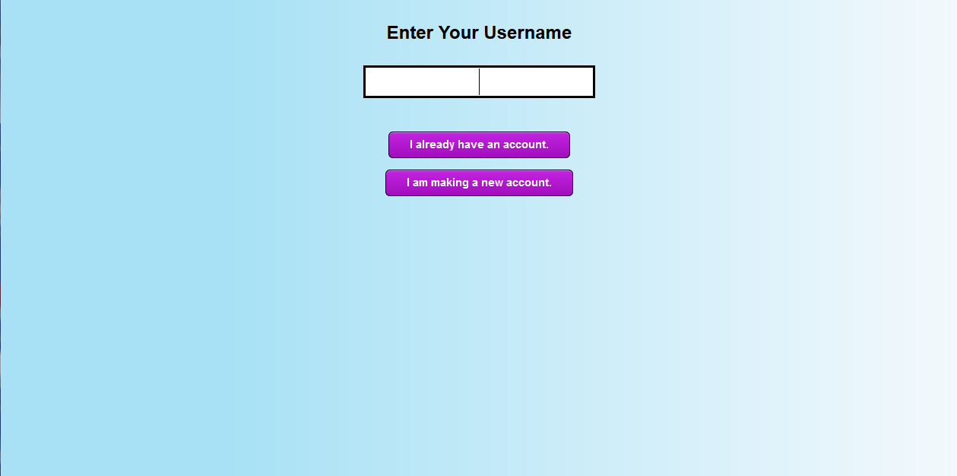
Figure 12. The username screen in the second prototype. This picture looks almost identical to the username screen in the first prototype.

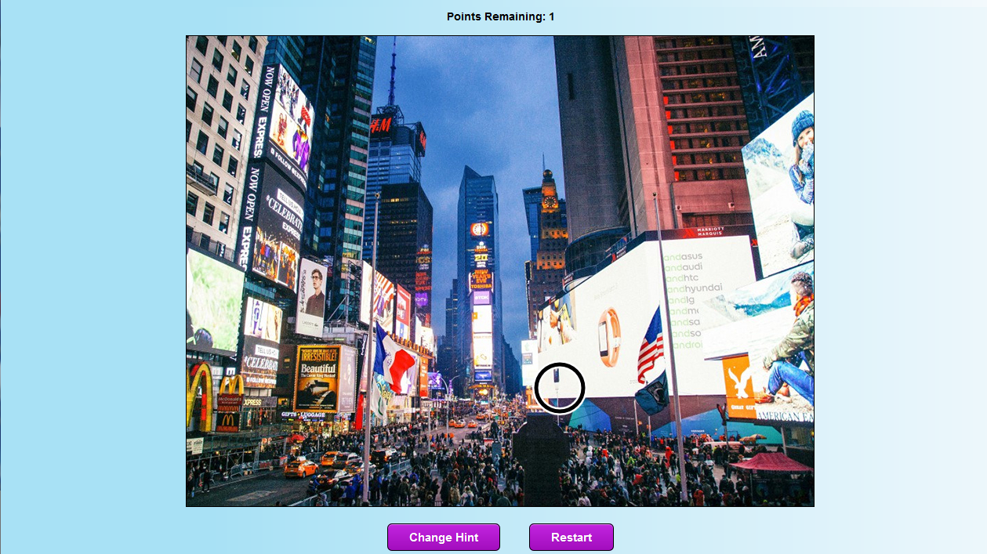
Figure 13. The graphical password screen in the second prototype. Many of the new features are visible here. There’s a circle displayed on the picture. This is the confirmation sequence and the circle is guiding the user to select the correct password. As well there’s a “change hint” button that allows the user to write a textual hint, as suggested by the design partners from KidsTeam.

Second Visit to KidsTeam
The second visit to KidsTeam occurred on November the 5th. This test went similarly to the previous one. After the testing system was uploaded to all of the computers in the Whimsy Lab, the participants arrived and started with their standard team-building and focusing exercises. Afterwards they used the new testing prototype to create new accounts. They then attempted to access the accounts that they created. This time the session was less formal and they did not write down their response or design ideas.
Greg Walsh, Ashley Chisom, and Zachary Pease again attended. While the participants were using the system, researchers recorded their progress and monitored their activity. Zachary summarized the event as follows:
“Today we did another session with Jasper to evaluate his revisions to his pass-points based password system, incorporating changes suggested by the co-designers in the previous meeting. I would also like to say that this session was incredibly productive. It was remarkable the difference in satisfaction and competency expressed by the design partners after the changes were implemented. While the co-designers had previously bemoaned the difficulty of recreating their passwords, changes to the granularity of point selection resulted in nearly all members being able to recreate their passwords on the first attempt. The greater variety of pictures available for selection was also met with enthusiasm. Jasper expressed satisfaction with the way the co-designers reacted to the changes. Additionally, the implementation of a reward screen upon successful login, an animated GIF of fireworks, elicited a number of oohs and ahhs. The design partners seemed more focused than they had in the previous session, and the group dynamic was more cohesive than in earlier sessions. The session ended with a discussion with Jasper for possible next steps in the development and evaluation of the system.”
As Zachary explained in his report, the testing went much better during this second attempt. Users seemed to feel that their recommendations were taken seriously, and they were very happy with the changes implemented. The biggest improvement came from the introduction of password confirmation when users first created their password. This seemed to help users remember their password. As well it seemed to help users understand the required accuracy of their clicks. Strangely, none of the children seemed interested in the hint feature that they had requested at the previous session. Many participants did not write a hint at all, and it seemed clear that while they wanted help remembering their password, a text-based hint was too much trouble – at least in the short term.

Designing the Final Testing System
The second test seemed very successful and the system was not changed significantly before the final testing. Several bugs were fixed and system was altered to back up data. There were also a few minor visual changes.
A textual password interface was then created. This version of the site works exactly the same as the picture passwords. The user creates a username and selects the “I am making a new account” button. They then type in a password and confirm it two times. They are prompted to create a hint which they can change at any point during the password confirmation process. Afterwards they are taken back to the homepage and they log in to their account by entering their username, selecting “I already have an account” and entering their password.
Work then began on the final testing structure. Five fictional websites were created. Each site has its own color scheme, a unique title, and its own logo or picture. They were easily identifiable. They were “Animals Site,” “Aquarium Site,” “Environmental Site,” “Game Zone,” and “Old Movies Database.” These subjects were chosen because they would be somewhat interesting for children, while also being very distinct from one another. Each site has eight pictures for the graphical password, and each set of pictures is entirely different from the pictures in all of the other sites.
There were two versions of each site – a graphical password version and a textual password version. From the homepage it is not clear which version of the site you are viewing. Once you enter a username you are taken to one of two places – either the form where you select your image, or the form where you enter your textual password.
Graphical password sites had over 760 lines of code, while textual password sites had approximately 620 lines of code. Most of this code was reused but it was still time-consuming to create so many different sites. As well, it largely prevented further alterations the pages, as any change would need to be replicated on all ten sites.
Researchers created 17 introductory pages. These pages all look the same – a blank page with a simple “Begin” button. Each of these introductory pages creates an array of hyperlinks. When a participant completes each page (by successfully logging in to their account), the test automatically moves to the next page based on the values stored in the array. That way, each participant could move through the pages in their own order – alternating randomly between graphical and textual pages.
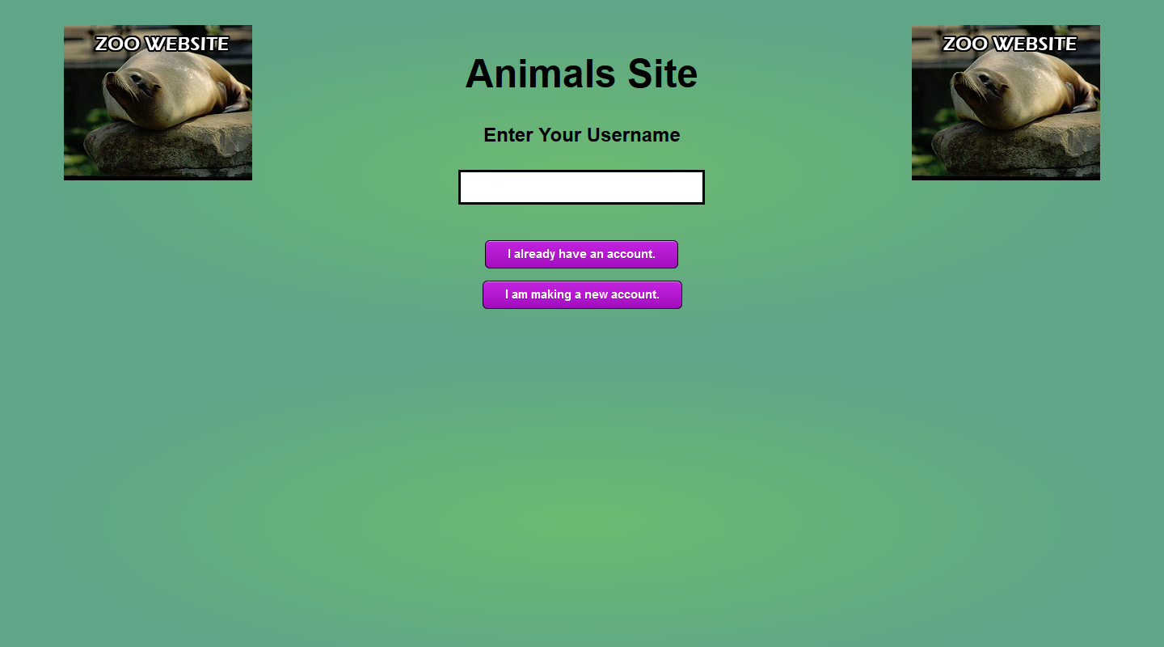
Figure 14. The username screen on the “Animals Site” testing page. This shows the unique title, color, and image that were displayed to help the user differentiate this page. Other than these differences, this page looks very similar to the page in the second prototype.

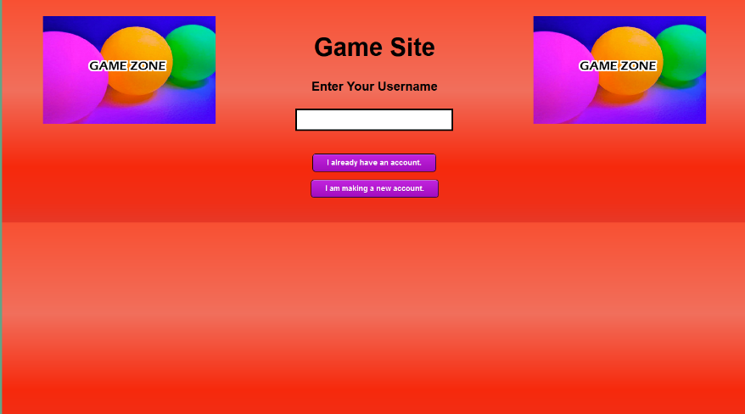
Figure 15. The username screen on the “Game Site” testing page. There is a strong contrast with the “Animals Site” page as the background, images, and title are all noticeably different.

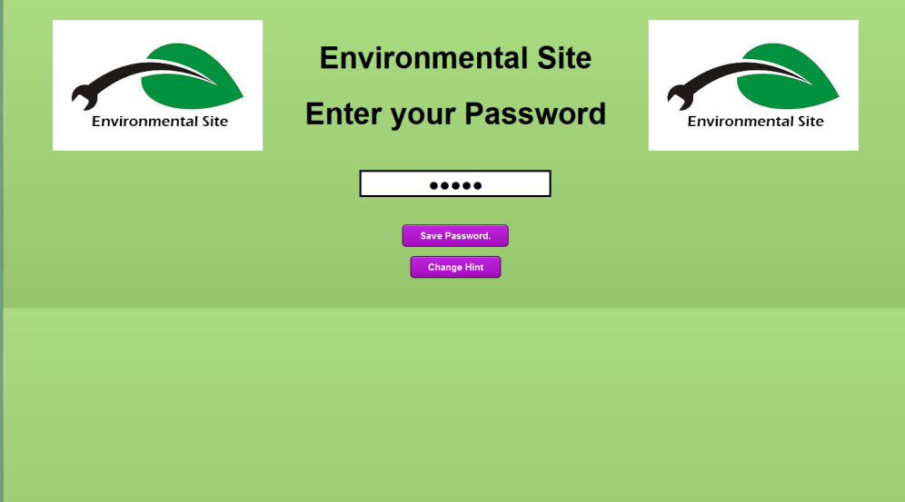
Figure 16. The password screen on the “Environmental Site” textual testing page. There’s a field where the user can enter their password. There are two buttons. One to save their password and another to change their hint. All textual testing pages follow this basic format, but participants can identify the page through the image, title, and background color at all times throughout the testing process.

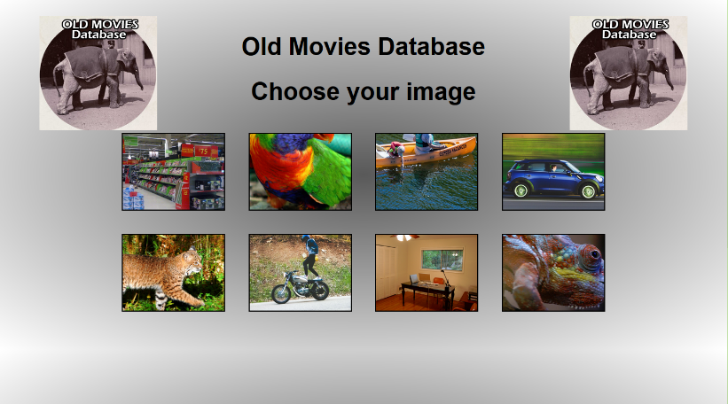
Figure 17. The image selection screen on the “Old Movies Database” site graphical testing page. This screenshot shows all eight images. As the user moves their mouse across the images they expand. Once they click an image they are taken to the next screen. All graphical testing pages follow this basic format, but participants can identify the page through the image, title, and background color.

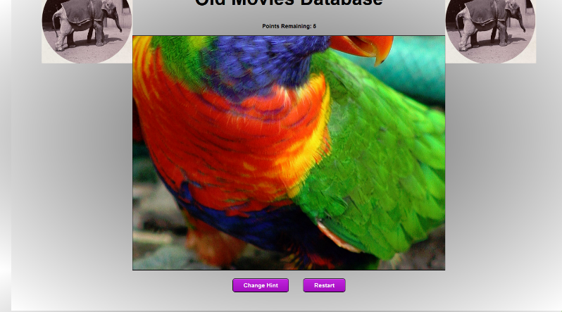
Figure 18. The graphical password screen on the “Old Movies Database” site. This screenshot shows the selected image. As the user clicks the image, a block dot expands to help them identify the position that they selected. All graphical testing pages follow this basic format, but participants can identify the page through the image, title, and background color.

Recording
All sessions were recorded using the available software. When working with KidsTeam researchers recorded users with Microsoft’s LifeCam software. This is Microsoft’s default webcam software and it was extremely problematic. Several times it created recordings and displayed that it was recording, but it then saved blank mp4 files that were 0 kilobytes and could not be opened or viewed. The screen was recorded with Camtasia Recorder, but this was also faulty. After one session where the screen recorder crashed before saving data, researchers switched to using VLC player which recorded the screen very well and was both fast and easy.
In the Usability Lab the screen was recorded and the webcam was logged using Morae. This made videos that automatically synchronized webcam and screen capture. Morae also tracked the movement of the mouse cursor, adding trails to help identify its position. However, it did not effectively log and timestamp key presses or the location and time mouse clicks. For some reason it recorded these while users were accessing other websites, but not while using the locally stored testing system. This was very frustrating and it seemed like none of the recording software was wholly sufficient.

Other Ideas
While the final system worked well overall, it would have been useful if more time was spent in the early stages of development. The system was functional, but also incomplete. In retrospect it would have been better to create a single site and use JavaScript to fill in the page title, change the background and dynamically load the images. This would have allowed researchers to change the pages more easily. Because there were ten different sites, it was not possible to alter them. If one page was changed, that change would then have to be replicated in all nine duplicates. This meant that researchers could not easily implement new features as they had more ideas.
For example, participants frequently selected other parts of the page and began typing. Researchers constantly had to remind them to click into the text field to select the appropriate input element before typing their username. It would have been ideal if the page automatically selected the form when the user pressed “Okay” after incorrectly entering their password. However this change could not be easily implemented without altering all webpages.
The methods of storing and recording data were also insufficient. The system recorded every single mouse click and button press. This was a good idea, but it became difficult to separate the useful information from other data. Despite using Morae and other professional level screen recording software, this data was never logged consistently and with enough precision to be reusable. The data logged by this password prototype was more consistent and precise than any other data available. It should have been more organized and more easily comparable to the user’s original password input. With a few minor changes it could have created easily consumable representations that showed the user’s original points alongside the points they entered during a password attempt. This would have made easily manageable and visual data. Unfortunately that is not easily changed with the data storage that was implemented.
In summary, the testing system would have been improved by the following recommendations. Create only one page that altered its appearance using JavaScript, instead of using multiple pages. Change that page so that forms were automatically selected. Change the way data was stored so it was organized and appropriately timestamped. All mouse-clicks could still be recorded, but clicks on the canvas during login attempts would be organized into distinct categories that could be easily compared to other attempts and to the saved password. Lastly, the system would display any key presses in the corner of the page. That way, the recording software would automatically record key-presses in the screen capture.

Chapter 3: Formal Testing

Overview
This study was performed with the hypothesis that properly designed graphical passwords will be easier for children to create and remember than textual password systems. As well, researchers hoped that a graphical password system would be more enjoyable too. By encouraging participants to memorize multiple passwords, researchers sought to compare their rates of recall while also getting qualitative data about their preferences, understanding, and knowledge relating to password systems. The study’s hypotheses were as follows:
- Children will prefer using picture password systems.
- Children will be able to remember the picture that they chose with high accuracy.
- Children will be able to remember their picture passwords more easily than their text-based passwords
- Children will create more unique passwords when using picture passwords.
The study was completed with 13 participants between the ages of 6 and 12 years old. The study had an inside-subjects design where all participants created textual and graphical passwords. Participants were randomly assigned to different orders; some created textual passwords first while others created graphical passwords first. All participants had some experience with passwords and login systems, but because of their young age most did not have extensive experience or as many different passwords as many adults. Participants all used computer systems at University of Baltimore and the pages were displayed within the Google Chrome browser. The browser was full screen and participants completed the study with researchers directly available to assist them. When they needed help navigating the system, researchers provided guidance to keep children on track. As much as possible, participants were left to navigate the system on their own, and were encouraged to speak their thoughts aloud. When they asked questions, researchers responded with “What do you think?” or “What should you do next?” whenever possible.

Methodology
The study consisted of two lab-based session. The first session took approximately one hour and was completed by all 13 participants. In this session they created accounts for five webpage prototypes, using a mix of textual and graphical passwords. They were then distracted by a game for approximately five minutes. They then returned to the password system and logged into all five webpage prototypes in the same order. The second session took approximately thirty minutes. They used the same computer system and tried to recall the passwords that they had previously created. This occurred after two weeks and was completed by 10 of the 13 participants. One participant voluntarily chose not complete the second session, saying that she simply did not want to participate in the study and would rather play outside. Two other participants completed only the first session because their parents did not respond to request to schedule a second appointment. These participants appeared to enjoy the study and it seems possible that these were problems with scheduling rather than the participants’ feelings.

The First Session
The first session consisted of several different parts. After parents signed consent forms, the child participant signed an assent form and they had the study explained to them. It was made clear that they could stop at any time, and that they were not being personally tested or evaluated in any way. The session then began with a short interview. They were asked questions about themselves, their age, and their interests. They were also asked questions directly relevant to the subject – such as how many passwords they had, and if they had ever forgotten a password before.
They then began the session, creating passwords for each of the five pages. They received a random order of graphical and textual passwords. Some participants created three graphical passwords and two textual passwords and other participants created three textual passwords and two graphical passwords. All participants completed all five passwords. Each site was distinct and was identified by different colors, a different title, and a different logo image. When participants created graphical passwords, they were given a choice of eight different images and each page had a different selection of images. In total 65 passwords were created - 34 picture passwords and 31 text passwords.
Once participants created their password, they confirmed it twice within the creation process. They were given an opportunity to create a hint – although they could leave the form blank and it allowed them to proceed. Afterwards they were taken back to the homepage and they logged in with their account. Their username was still saved in the form, but they had to enter their password. With picture passwords, the confirmation process provided some guidance and this was the first time they had to enter the password without assistance.
After creating five accounts, participants were given approximately five minutes to play a game online. The games varied, but researchers made sure all participants played games that were not entirely familiar. This functioned as a distraction task. As compared to tasks with adults, researchers did not want to bore or frustrate the children with a standard math based distraction task. As well, the game interested children, renewing their attention and allowing them to stay focused on the task during a long testing process.
After completing the game, they went back to confirm their passwords. They started the test from the beginning and chose “I already have an account” for each page. For the first time they were asked to recall their username. As well they entered their passwords for the fifth time. They already entered it once during creation, twice for confirmation, and once to log in immediately after creating the account. After logging in they were taken to the next page automatically. If they failed to log in, they were given up to five attempts, but many children gave up after several unsuccessful attempts. They were encouraged to continue, but if they would not, they were given their password and advanced to the next page.
Once they attempted to log in to all five accounts, they were congratulated for their focus and hard work. They then answered a few questions about the process. These questions included questions about preference such as “What was easier to remember?” and “What did you prefer?” as well as questions about security in general, such as “Which of these would protect you better?” The full testing script for the first session is available as appendix G.

The Second Session
Ten participants returned to the lab 11 to 16 days after they completed their first session. These participants tried to recall the passwords that they created previously.
This session started with a brief explanation to children and their parents. Afterwards the children were taken aside and were shown the same introductory page from their first session. They were again reminded that they were not being personally evaluated or tested in any way. They were informed that they could stop at any time, and the study was explained.
Researchers then observed as children moved through the process. If they clicked to create a new account, researchers intervened and moved them back to the “I already have an account” button on the homepage. They first attempted to recall their username. Next they attempted to enter their password. They could press the hint button if they wanted. They had unlimited attempts, but researchers usually moved them on after five unsuccessful attempts. Some students stopped earlier and they were encouraged to keep trying. If they were sure that they could not remember, they were prompted to try one more password before researchers entered the password for them.
After logging into the first page they then logged into the same five website prototypes in the same order from the first session. If they could not log into a page, researchers provided the password for them and moved them to the next page. Once they completed the task, researchers asked them several questions about the experience. For example, they were asked if they felt their hints were useful, and if they felt graphical or textual passwords were more secure. The full testing script for the second session is available as appendix H.

Chapter 4: Results and Discussion

Results

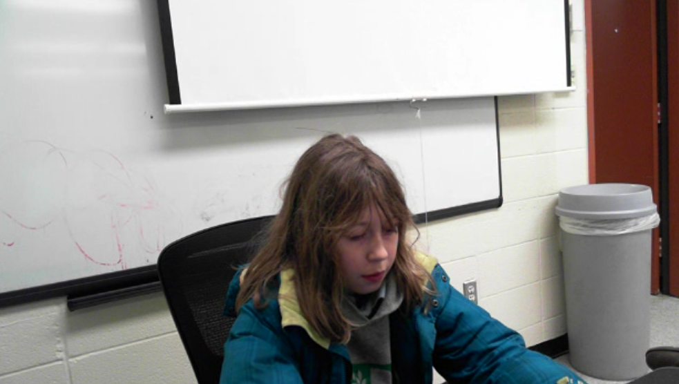
Figure 19. A participant using the password system to log in. She is looking down at the keyboard instead of straight ahead at the screen.

Number of tests and order of study
In total each participant created 5 accounts. They then logged into each account twice during the first test and once more if they returned for the second test. In total that means that every user logged in three times for a total of fifteen attempts.
In the first website prototype, seven participants had to enter textual passwords and six participants had to enter graphical passwords. The following table shows the number of text and graphical pages that were used in the test.
Table 1
Number of Textual and Graphical Passwords Created In the First Session
 | 1st test | 2nd test | 3rd test | 4th test | 5th test | Total
Text password required | 7 | 7 | 7 | 3 | 7 | 31
Graphical password required | 6 | 6 | 6 | 10 | 6 | 34

In total 31 textual passwords were created and 34 graphical passwords were created. All of these were tested at least twice, during the first and second attempt of the first session. The group that returned for the second session was smaller and in total the numbers were as follows.
Table 2
Number of Textual and Graphical Passwords Created In the Second Session
 | 1st test | 2nd test | 3rd test | 4th test | 5th test | Total
Text password required | 6 | 5 | 6 | 1 | 5 | 23
Graphical password required | 4 | 5 | 4 | 9 | 5 | 27

Textual and graphical passwords appeared in similar numbers in both tests. Researchers intended to have them appear in equal numbers, but several participants canceled. If two more participants been in the study, the numbers would have been roughly equal at 37 textual passwords and 38 graphical passwords.

Success Rate
The success rate is the number of successfully entered passwords divided by the total number of attempts. The following table shows the number of times participants attempted to access their account and the number of successfully entered passwords. A single attempt in this table can include multiple password entries, as long as the user continued to work on accessing their account.
Table 3
Success Rate of Passwords
 |  | Attempts at entering password | Successfully entered passwords | Success Rate
Graphical passwords | Immediately following account Creation | 34 | 29 | 0.852941
 | After distraction task | 34 | 26 | 0.764706
 | After two weeks | 27 | 10 | 0.37037
 | Total | 95 | 65 | 0.684211
Textual passwords | Immediately following account Creation | 31 | 30 | 0.967742
 | After distraction task | 31 | 25 | 0.806452
 | After two weeks | 23 | 16 | 0.695652
 | Total | 85 | 71 | 0.835294

It’s clear from this table that participants did best during their first login. As soon as they were distracted for five minutes, they were much less successful at logging into their account. The success rate of graphical passwords dropped from approximately 85% to approximately 76%. The success rate of textual passwords dropped from approximately 96% to approximately 80%. This implies that users forgot textual passwords more quickly, as the distraction task caused a greater difference with textual passwords than graphical passwords (16% versus 9%). This implies that graphical passwords may be more memorable in the short term. But they were also more difficult for participants, as participants were able to access their accounts more consistently when using textual passwords.
After two weeks, image passwords performed dismally. They were only entered successfully approximately 37% of the time. This is a drop of 39% and shows that time radically affected children’s ability to successfully enter their graphical password. Textual passwords did much better, providing successful access approximately 69% of the time. This is a drop of only 11% and shows that retention was decent even after a long period of time.

Unsuccessful Attempts
The chart on the following page shows the number of unsuccessful login attempts. These are organized by the webpage where the child was unable to access their account and what type of password the child was using.

Table 4
Unsuccessful Login Attempts
 | Attempts at entering password | 1st webpage | 2nd webpage | 3rd webpage | 4th webpage | 5th webpage | Cumulative
First password attempt | Number of students who could not access their account because of their password | 0 | 1 | 2 | 2 | 1 | 6
… | Number that used text passwords | 0 | 1 | 0 | 0 | 0 | 1
… | Number that used image passwords | 0 | 0 | 2 | 2 | 1 | 5
Username attempt after distraction task | Number of students who could not access their account because of their username | 3 | 4 | 4 | 2 | 4 | 17
Password attempt after distraction task | Number of students who could not access their account because of their password | 1 | 2 | 5 | 4 | 2 | 14
… | Number that used text passwords | 1 | 1 | 3 | 0 | 1 | 6
… | Number that used image passwords | 0 | 1 | 2 | 4 | 1 | 8
Username attempt after two weeks | Number of students who could not access their account because of their username | 3 | 6 | 3 | 5 | 3 | 20
Password attempt after distraction task | Number of students who could not access their account because of their password | 4 | 5 | 5 | 5 | 5 | 24
… | Number that used text passwords | 1 | 1 | 3 | 0 | 2 | 7
… | Number that used image passwords | 3 | 4 | 2 | 5 | 3 | 17

This table explains how many students successfully accessed their accounts on each page of the testing prototype. For example, on the first page all participants recalled their password and logged in successfully immediately after password creation. This is true for both graphical and textual passwords. After the distraction task, participants got their username wrong on 3 attempts – or correct on only 10/13 attempts. This is a success rate of approximately .76.

Differences in Images Selected
The following table shows the number of graphical passwords created and the number of different pictures that were chosen. For example, in the first test six graphical passwords were created and three different pictures were used out of eight possible choices. That means that three users repeated images chosen by other users.

Table 5
Number of Different Images Selected on Each Page

 | 1st test | 2nd test | 3rd test | 4th test | 5th test | Total
number of pictures chosen | 3 | 5 | 6 | 5 | 6 | 25
number of graphical passwords created | 6 | 6 | 6 | 10 | 6 | 34

This shows that children were attracted to some images more than others, but the results were not entirely consistent. Even on pages where one image was particularly popular, it was not selected by all of the users. Furthermore, on some pages, like the 3rd and 5th tests, all users selected different images. This implies that children are not attracted consistently to the same image, which means that graphical or item-based passwords are not entirely predictable and potentially viable.

Qualitative Results
Case Study – Mia
After two weeks Mia failed to access all three of her graphical password accounts. These results seem to imply she completely forgot her graphical passwords, and this was a very unmemorable password system for her. However, it was clear from close observation that she remembered the general arrangement of her passwords, despite being unable to enter them with sufficient accuracy. This case study examines why she was unable to access her account and what would have made it possible.
The following table shows the pixel positions of her original password as well as the pixel positions that she chose during her three attempts to log in. All of her attempts were extremely close to her original password. In at least one of the attempts, she got every point to within 20 pixels, the necessary threshold, except for the horizontal position of the third point. This point was never accurately chosen to within the necessary threshold, but it was selected to within 30 pixels. A threshold that allowed for thirty pixels instead of twenty pixels, would have allowed Mia to access this account, without radically altering the security of the system.

Table 6
Points Selected for Mia’s First Graphical Password
 | First point Horizontal Position | First point Vertical Position | Second point Horizontal Position | Second point Vertical Position | Third point Horizontal Position | Third point Vertical Position | Fourth point Horizontal Position | Fourth point Vertical Position | Fifth point Horizontal Position | Fifth point Vertical Position
Password | 706 | 425 | 600 | 398 | 575 | 455 | 157 | 457 | 276 | 437
First Attempt | 701 | 417 | 590 | 377 | 603 | 464 | 157 | 423 | 257 | 415
Difference | 5 | 8 | 10 | 21 | 28 | 29 | 0 | 34 | 19 | 22
Second Attempt | 696 | 422 | 596 | 367 | 599 | 446 | 179 | 458 | 264 | 426
Difference | 10 | 3 | 4 | 31 | 24 | 9 | 22 | 1 | 12 | 11
Third Attempt | 699 | 422 | 591 | 382 | 602 | 448 | 169 | 427 | 253 | 395
Difference | 7 | 3 | 9 | 16 | 27 | 7 | 12 | 30 | 23 | 42

For her second account Mia came very close to successfully logging into the system. For the first four points, she input her answers extremely accurately. She was off by less than six pixels horizontally and vertically for every point on the image. In total she was off by only 25 pixels – remarkably close. She only missed the fifth point, and even this was in the right general area – being only 67 pixels off horizontally and 71 pixels off vertically. Her second attempt was very similar, again scoring very close on the first, second, and fourth points. Realizing that something was wrong, she chose a different point for her third point and this proved to be disastrous. A clear pattern emerged after she failed her first attempt. As she became frustrated, rather than attempting to increase the accuracy of her selections, she started choosing points more broadly, in seemingly random attempts to select the correct position.
Table 7
Points Selected for Mia’s Second Graphical Password
 | First point Horizontal Position | First point Vertical Position | Second point Horizontal Position | Second point Vertical Position | Third point Horizontal Position | Third point Vertical Position | Fourth point Horizontal Position | Fourth point Vertical Position | Fifth point Horizontal Position | Fifth point Vertical Position
Password | 222 | 523 | 235 | 476 | 495 | 435 | 720 | 289 | 533 | 228
First Attempt | 223 | 521 | 235 | 472 | 498 | 430 | 726 | 285 | 466 | 157
Difference | 1 | 2 | 0 | 4 | 3 | 5 | 6 | 4 | 67 | 71
Second Attempt | 219 | 524 | 240 | 481 | 306 | 512 | 720 | 294 | 451 | 174
Difference | 3 | 1 | 5 | 5 | 189 | 77 | 0 | 5 | 82 | 54
Third Attempt | 464 | 484 | 212 | 513 | 231 | 481 | 586 | 95 | 714 | 287
Difference | 242 | 39 | 23 | 37 | 264 | 46 | 134 | 194 | 181 | 59
Fourth Attempt | 217 | 513 | 237 | 476 | 724 | 300 | 253 | 208 | 462 | 165
Difference | 5 | 10 | 2 | 0 | 229 | 135 | 467 | 81 | 71 | 63

For her third graphical password, Mia’s points appear to be very inaccurate. Many of her points are off target by hundreds of pixels.
Table 8
Points Selected for Mia’s Third Graphical Password
 | First point Horizontal Position | First point Vertical Position | Second point Horizontal Position | Second point Vertical Position | Third point Horizontal Position | Third point Vertical Position | Fourth point Horizontal Position | Fourth point Vertical Position | Fifth point Horizontal Position | Fifth point Vertical Position
Password | 523 | 285 | 789 | 585 | 6 | 2 | 786 | 3 | 5 | 587
First Attempt | 795 | 1 | 791 | 588 | 6 | 585 | 7 | 7 | 524 | 286
Difference | 272 | 284 | 2 | 3 | 0 | 583 | 779 | 4 | 519 | 301
Second Attempt | 796 | 587 | 792 | 0 | 791 | 4 | 17 | 7 | 4 | 584
Difference | 273 | 302 | 3 | 585 | 785 | 2 | 769 | 4 | 1 | 3
Third Attempt | 3 | 589 | 793 | 0 | 794 | 594 | 6 | 2 | 528 | 282
Difference | 520 | 304 | 4 | 585 | 788 | 592 | 780 | 1 | 523 | 305
Fourth Attempt | 7 | 3 | 12 | 577 | 791 | 588 | 795 | 3 | 526 | 283
Difference | 516 | 282 | 777 | 8 | 785 | 586 | 9 | 0 | 521 | 304
In actuality, Mia came very close to the correct positions. In her first attempt she chose the points in the wrong order, but none of them were far from the correct locations. If the positions are reordered, it is apparent that she never selected a position more than ten pixels from the correct location. Ignoring order, this shows a remarkable accuracy.

Table 9
Points Reordered on Mia’s Third Graphical Password
 | First point Horizontal Position | First point Vertical Position | Second point Horizontal Position | Second point Vertical Position | Third point Horizontal Position | Third point Vertical Position | Fourth point Horizontal Position | Fourth point Vertical Position | Fifth point Horizontal Position | Fifth point Vertical Position
Password | 523 | 285 | 789 | 585 | 6 | 2 | 786 | 3 | 5 | 587
First Attempt Reordered | 524 | 286 | 791 | 588 | 7 | 7 | 795 | 1 | 6 | 585
Difference | 1 | 1 | 2 | 3 | 1 | 5 | 9 | 2 | 1 | 2
As she continued to guess, she chose some of the same points but in different orders. This implies that she might have guessed her password eventually, but after four attempts, she still had not guessed the correct password. She could have accessed her account if the prototype page accepted points out of order.
Overall Mia is a very interesting participant because she clearly understood the processes well and had a strong memory for the passwords that she created. She was able to recall them, and in many cases was remarkably accurate in the positions that she originally chose. However, due to minor mistakes she was never able to use graphical passwords to access her account. She exemplified the same troubles that a lot of children had with their passwords; they could remember generally what they chose – remarkably well after long breaks, but they were not always able to remember the exact locations that they selected. This caused the success rate to be very low, but it does not mean that graphical passwords are entirely untenable.

Case Study – Esther
After two weeks Esther accessed one graphical password account successfully while failing to access her other two graphical password accounts. This case study examines what was different about her successful attempt as compared to her two unsuccessful attempts.
Her first graphical password occurred on the second page – the aquarium website. She chose the correct picture and attempted to enter her password.

Table 10
Points Selected for Esther’s First Graphical Password
 | First point Horizontal Position | First point Vertical Position | Second point Horizontal Position | Second point Vertical Position | Third point Horizontal Position | Third point Vertical Position | Fourth point Horizontal Position | Fourth point Vertical Position | Fifth point Horizontal Position | Fifth point Vertical Position
Password | 150 | 46 | 526 | 101 | 233 | 146 | 568 | 261 | 398 | 205
First Attempt | 168 | 34 | 522 | 81 | 259 | 119 | 494 | 176 | 400 | 190
difference | 18 | 12 | 4 | 20 | 26 | 27 | 74 | 85 | 2 | 15
Second Attempt | 167 | 24 | 540 | 79 | 243 | 123 | 493 | 232 | 397 | 206
difference | 17 | 22 | 14 | 22 | 10 | 23 | 75 | 29 | 1 | 1
Third Attempt | 174 | 25 | 499 | 79 | 288 | 157 | 478 | 252 | 407 | 192
difference | 24 | 21 | 27 | 22 | 55 | 11 | 90 | 9 | 9 | 13

It is clear that she remembered most of her points with an acceptable degree of accuracy. Most of her positions were around 20 points off and a bit more flexibility would have made a difference. She struggled with the fourth point, consistently putting this point too far up the page and too far to the left. This may have been caused because the point was not chosen at a clearly identifiable location; it was easily confused with other similar locations in the image. In her original password she selected a plain white petal to the right of the image’s center. When she recalled the password, she chose another plain white petal in the same general area. She had no trouble remembering the position that she chose on the bumble bee, which is the fifth point that she selected. This is likely because the bee is a more distinct point that is not easily conflated with other locations in the image.
Her hint also mislead her. She wrote “top to botum bee last.” She meant that she should enter the top position first, and then work vertically down the page and the last point will be on the bumble bee. However, her fourth point is actually lower than the bumble bee. Because she followed her hint, she tried to choose a similar position that was still higher than the bumble bee and this caused her to choose the wrong petal. If these petals had stronger distinguishing features, she may have been able to tell them apart more easily, remembering the location of her fourth point.
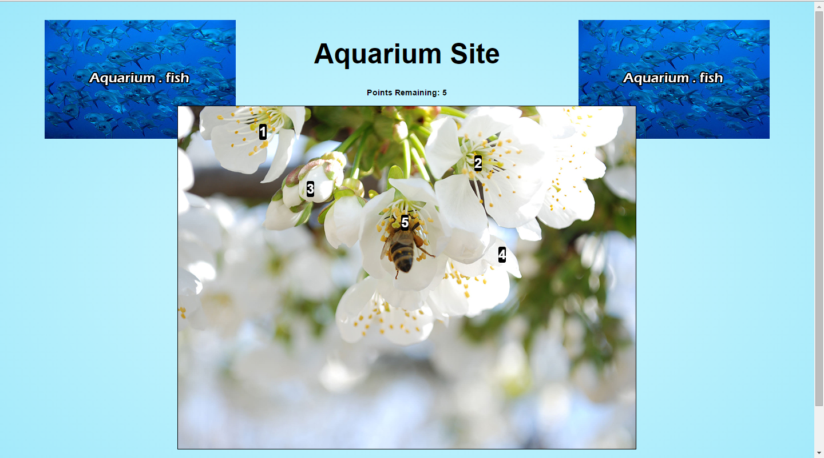
Figure 20. Esther’s password on the “Aquarium Site” page. The fourth point is located on a plain petal without other identifiable characteristics. It’s located further down the page than the bee.
Esther’s next graphical password was on the environmental page. She first selected the wrong image as there were two landscape images. As she looked at the image more closely she noticed that this was wrong and reset the process, selecting the correct image. Here she was extremely accurate in the points that she selected.

Table 11
Points Reordered for Esther’s First Graphical Password
 | First point Horizontal Position | First point Vertical Position | Second point Horizontal Position | Second point Vertical Position | Third point Horizontal Position | Third point Vertical Position | Fourth point Horizontal Position | Fourth point Vertical Position | Fifth point Horizontal Position | Fifth point Vertical Position
Password | 595 | 446 | 734 | 415 | 145 | 66 | 244 | 550 | 368 | 441
First Attempt | 593 | 443 | 730 | 416 | 146 | 67 | 241 | 553 | 359 | 426
difference | 2 | 3 | 4 | 1 | 1 | 1 | 3 | 3 | 9 | 15

She never selected anything that was more than 15 pixels off and successfully logged into her account on her first attempt. After two weeks this is a remarkable level of accuracy. The difference here had to do with the image itself. The landscape featured lots of small and distinct positions. Her hint “kill the car and explor” shows that she was thinking in terms of the objects that she chose. Because these objects were small and distinct positions, they were easily selected with high accuracy. The car in this picture is extremely small, only about 25 pixels wide at its widest point and 18 pixels tall at its tallest point. As well it has a very clear and distinct center that makes choosing the center of the car very easy. She was able to select the car to within 5 pixels without any trouble. If the car was larger, or a less distinct shape, it is likely she would not have been able to choose the point as accurately. As well, if she simply selected a position in the road, instead of the car she probably could not recall that arbitrary position as easily. Of course this is also a security risk, as images with distinct locations that form strong contrasts can be easily guessed and even replicated by computers as shown in the article, by Creese, Goldsmith & Nurse, “Predicting Graphical Passwords.”
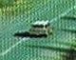
Figure 21. The car where Esther chose a point for her second graphical password. It is scarcely larger than 20 pixels wide and 20 pixels tall.
For her third graphical password, Esther made three attempts before deciding that she could not log into her account. On her first attempt she came close to the correct locations but was unable to select the correct positions because her first point was inaccurate. She started again and chose three points before realizing that she was selecting the wrong positions. She abandoned this attempt without choosing a fourth or fifth position. She started one last time and made many of the same mistakes that she made on her first attempt. She came very close on all of the positions except for the first position.
Table 12
Points Selected for Esther’s Second Graphical Password
 | First point Horizontal Position | First point Vertical Position | Second point Horizontal Position | Second point Vertical Position | Third point Horizontal Position | Third point Vertical Position | Fourth point Horizontal Position | Fourth point Vertical Position | Fifth point Horizontal Position | Fifth point Vertical Position
Password | 307 | 201 | 471 | 305 | 47 | 383 | 166 | 527 | 722 | 466
First Attempt | 285 | 137 | 465 | 314 | 57 | 363 | 150 | 527 | 735 | 458
difference | 22 | 64 | 6 | 9 | 10 | 20 | 16 | 0 | 13 | 8
Second Attempt | 60 | 370 | 170 | 538 | 722 | 452 | n/a | n/a | n/a | n/a
difference | 247 | 169 | 301 | 233 | 675 | 69 | n/a | n/a | n/a | n/a
Third Attempt | 339 | 122 | 466 | 307 | 41 | 379 | 162 | 535 | 725 | 446
difference | 32 | 79 | 5 | 2 | 6 | 4 | 4 | 8 | 3 | 20

The yarn image was very popular. Out of the 10 participants who created graphical passwords, 4 chose this image. Only one participant successfully logged in after the distraction exercise. This same participant also managed to log into the account after two weeks. No other participants managed to do this during either test.
The question is, why did participants consistently have so much trouble with this image? Many of the focal points of the image were large indistinct areas that were easily confused with one another. It would be difficult for a computer to anticipate what point someone would choose, as each ball of yarn is a large area without any distinct points within it. As such, any point is likely. That means that it would be a very secure image, but it also made it difficult for participants to choose the correct position. Many participants seemed to remember what ball they chose, but did not consider the position of their point beyond this.
Esther remembered her point on the needle and the scissors just fine, but struggled the most with her first selection, as this selection was off-center on a ball of yarn and it was challenging for her to recall what position she selected.
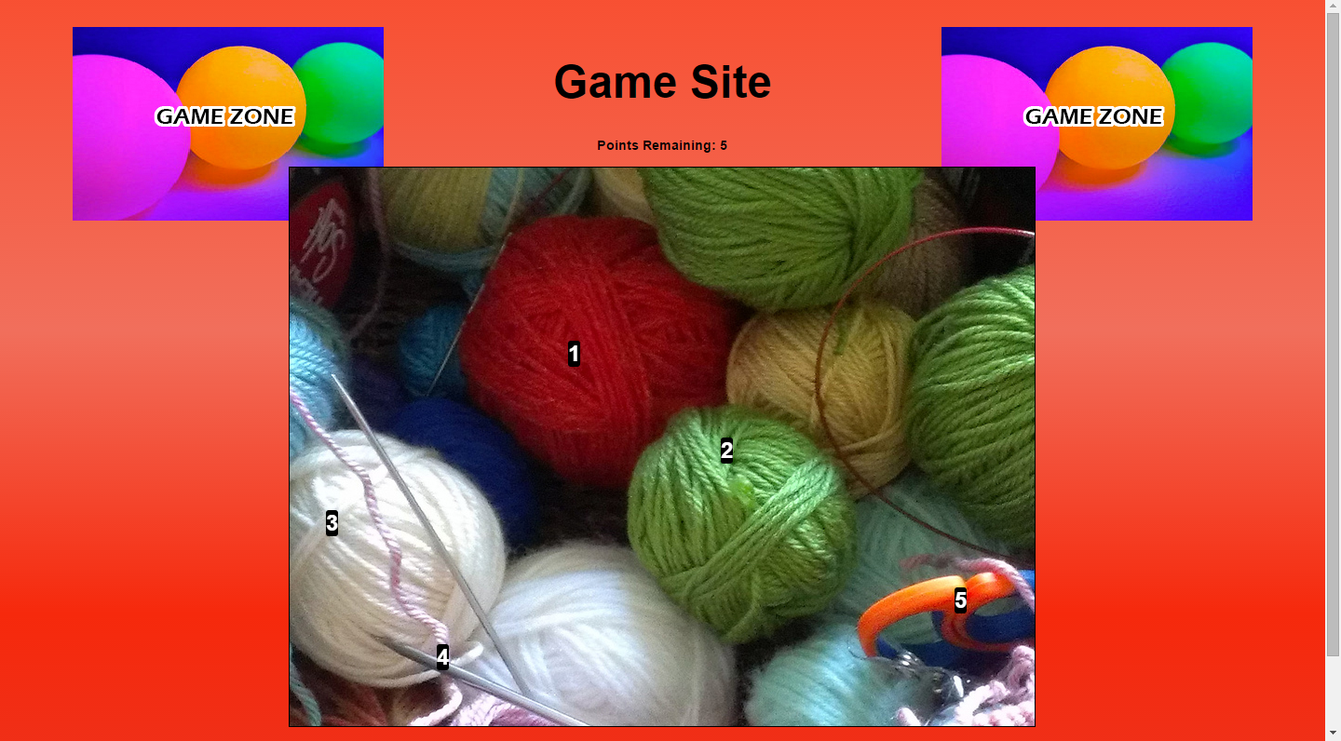
Figure 22. Esther’s password on the “Game Site” page. Several of the points she chose are off-center on balls of yarn and do not appear at obvious edges or distinct focal points.

As well her hint is very telling here. She wrote “wor pees sheep faets.” She meant “war, peace, sheep, fates”. She explained this hint to me as follows. Her first point was located on the red yarn and so she described it was “war.” Her next point was located on a green ball of yarn, which is a more peaceful color and she described this as “pees.” Her third position was located on a white ball of yard – like a “sheep.” “Fates” represented the last two points, located on the needle and the scissors. She explained that she was thinking about the Fates in Greek mythology. These characters operate a loom that controls people’s destiny and can cut thread to end their life.
This hints are, in many ways, great and show that children can create hints that are both useful and secure. They make sense and they would remind her of the positions she chose, but at the same time they are not too obvious to a third party, as they do not correspond to immediately obvious positions in the image.
However, they also show her flawed planning. She is thinking of her first point through its location on the red ball of yarn. It seems that this is not only a problem with her hint, but also with the way she memorized her password. The red ball of yarn is much too large to choose an accurate point repeatedly. If she had in mind that her position was on a particular thread or edge of the ball of yarn, she likely would have been able to choose the specific point accurately. It is clear in her attempts that she could not recall its specific location, despite remembering that it was located on the red ball of yarn. Her guesses were always located on this ball of yarn, but it is a large object in the image and her guesses reflected this. The actual point was at the horizontal position 307, and her first attempt was at 285 and her third attempt was at 339. While both of these were within 35 pixels of her original position, the entire range was very broad – over fifty pixels. She showed in previous passwords that she was capable of choosing the same position when she remembered its location, and she did not choose the same incorrect position repeatedly. It is clear that she was not misremembering the location of the specific point that she chose. Instead she had a very vague concept of where the point was located, and repeatedly chose positions in that general area, rather than focusing on a specific location.
This can be compared against the hint “Kill the car.” In some ways this hint is much less secure, as the car is a single distinct point, and a third party could probably guess her point accurately based on this hint – even if they didn’t have any other knowledge of her password. However, the car is a very small distinct position, and remembering that she chose the car allowed her to pick a small and distinct point repeatedly and accurately.
Esther perfectly exemplifies a problem that many participants struggled with. Children remembered objects that they chose, more than distinct locations. It seems that the difficulty came from having images that featured large areas that did not feature many small distinct objects. To some extent this could be remedied with better image selection.
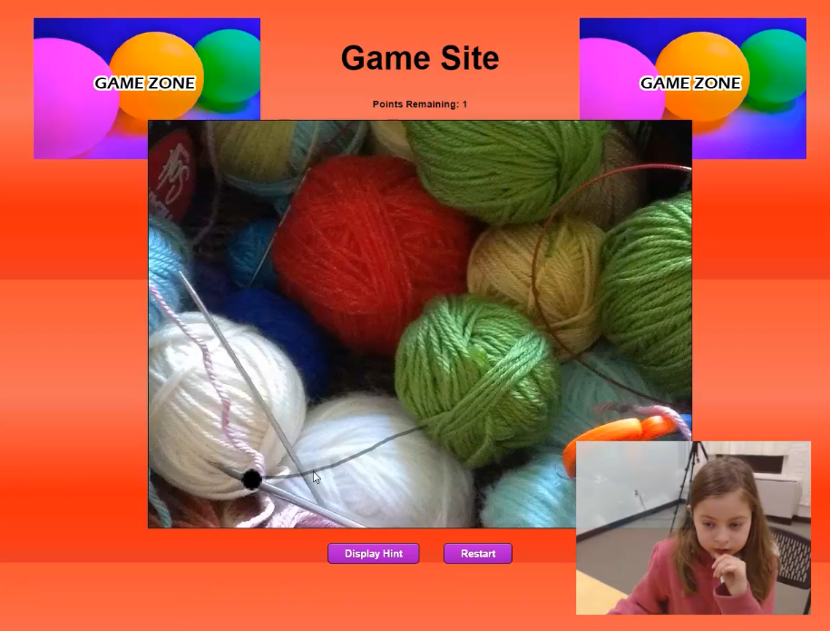
Figure 23. Esther is entering her password for the “Game Site” page. She is focusing intently on the screen and has correctly selected a point where a thread crosses a needle.

Case Study – Kyle
Kyle remembered his first username and his fifth username (after three attempts), but he did not recall any of his other three usernames and he did not recall any of his passwords – textual or graphical. He was 9 years old and had experience with alternate passwords through his experiences at KidsTeam and by using smartphones. Overall this shows how challenging this test could be. Despite being older than the average participant, and despite his experience, he still struggled to remember so many usernames and passwords. However, his guesses were not far off. Many of his graphical password attempts were very close to successful inputs. This case study examines why he was not able to enter his graphical passwords accurately.
His first graphical password occurred on the second page – the aquarium website. He chose the correct picture – a bike’s handlebars – but he could not enter the correct password. The following table shows the location of his original passwords and the points that he selected during his login attempts.

Table 13
Points Selected for Kyle’s First Graphical Password
 | First point Horizontal Position | First point Vertical Position | Second point Horizontal Position | Second point Vertical Position | Third point Horizontal Position | Third point Vertical Position | Fourth point Horizontal Position | Fourth point Vertical Position | Fifth point Horizontal Position | Fifth point Vertical Position
Password | 430 | 218 | 411 | 53 | 423 | 129 | 336 | 136 | 339 | 136
First Attempt | 409 | 52 | 426 | 219 | 423 | 128 | 339 | 131 | 493 | 126
Difference | 21 | 166 | 15 | 166 | 0 | 1 | 3 | 5 | 154 | 10
Second Attempt | 421 | 139 | 404 | 55 | 433 | 226 | 347 | 129 | 493 | 132
Difference | 9 | 79 | 7 | 2 | 10 | 97 | 11 | 7 | 154 | 4
Third Attempt | 413 | 56 | 411 | 145 | 432 | 214 | 360 | 138 | 497 | 133
Difference | 17 | 162 | 0 | 92 | 9 | 85 | 24 | 2 | 158 | 3
Fourth Attempt | 339 | 127 | 501 | 127 | 421 | 136 | 410 | 50 | 415 | 214
Difference | 91 | 91 | 90 | 74 | 2 | 7 | 74 | 86 | 76 | 78

One of the unusual aspects about Kyle’s password is that the fourth and fifth points are almost identical. He chose a point at the top of the bike’s handlebars, a point at the bottom of the bike’s handlebars, a point directly in the middle, and then two points to the left of the handlebars. He clearly misremembered this and tried to choose five different points – one in the middle, one above, one below, one to the left, and one to the right. This is a logical arrangement of points, but it is not the arrangement that he created. He tried this in several different orders and was unable to access his account. However, he was never far off. If his first attempt is reordered, and the point to the right is replaced with another point to the left of the handlebars, all of his points were remarkably accurate.

Table 14
Points Reordered for Kyle’s First Graphical Password
 | First point Horizontal Position | First point Vertical Position | Second point Horizontal Position | Second point Vertical Position | Third point Horizontal Position | Third point Vertical Position | Fourth point Horizontal Position | Fourth point Vertical Position | Fifth point Horizontal Position | Fifth point Vertical Position
Password | 430 | 218 | 411 | 53 | 423 | 129 | 336 | 136 | 339 | 136
First Attempt Reordered | 426 | 219 | 409 | 52 | 423 | 128 | 339 | 131 | 339 | 131
difference | 4 | 1 | 2 | 1 | 0 | 1 | 3 | 5 | 0 | 5

None of these positions were more than five pixels from the correct location. Just like with Mia, if the passwords were not order sensitive, Kyle may have been able to access his account.
On the next graphical password page, Kyle chose the picture of yarn. He struggled to accurately reproduce the positions he chose. He remembered his first few points generally, but completely forgot where his fifth point was positioned. As well, he remembered his second point most accurately as it appeared adjacent to a piece of wire. His other points appeared within the balls of yarn. In the following image most of these points appeared roughly near, but not at, the center of the balls.
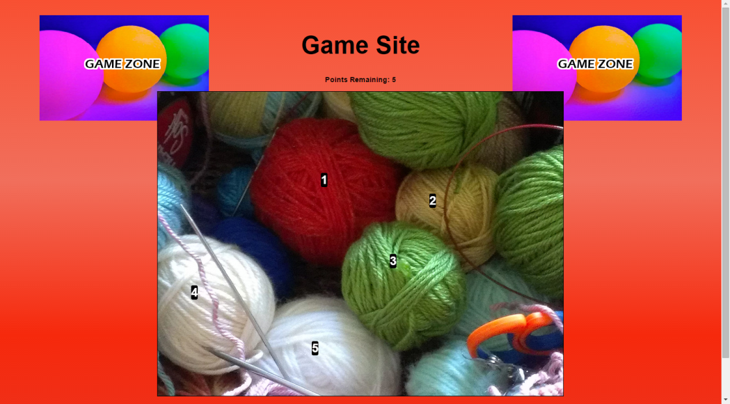
Figure 24. Kyle’s password on the “Game Site” page. Many of the points that he chose are on the balls of yarn and are not at the very center or near easily identifiable exact locations.

The points that he selected are not at distinct locations on the yarn. As well his hint was simply the word “yarn,” which might help him remember the picture, but certainly would not help him remember his points with any specificity. In general hints of this nature were much more common than hints that corresponded with specific locations.

Table 15
Points Selected for Kyle’s Second Graphical Password
 | First point Horizontal Position | First point Vertical Position | Second point Horizontal Position | Second point Vertical Position | Third point Horizontal Position | Third point Vertical Position | Fourth point Horizontal Position | Fourth point Vertical Position | Fifth point Horizontal Position | Fifth point Vertical Position
Password | 330 | 175 | 544 | 216 | 466 | 335 | 74 | 397 | 312 | 507
First Attempt | 331 | 154 | 553 | 216 | 485 | 385 | 77 | 404
Difference | 1 | 21 | 9 | 0 | 19 | 50 | 3 | 7
Second Attempt | 340 | 146 | 549 | 200 | 477 | 373 | 313 | 493 | 68 | 401
Difference | 10 | 29 | 5 | 16 | 11 | 38 | 239 | 96 | 244 | 106
Third Attempt | 324 | 156 | 546 | 203 | 510 | 384 | 340 | 528 | 84 | 405
Difference | 6 | 19 | 2 | 13 | 44 | 49 | 266 | 131 | 228 | 102

Kyle entered a graphical password for the final page of the test. These are some of the most disappointing results as they clearly show that Kyle remember his password accurately.

Table 16
Points Selected for Kyle’s Third Graphical Password

 | First point Horizontal Position | First point Vertical Position | Second point Horizontal Position | Second point Vertical Position | Third point Horizontal Position | Third point Vertical Position | Fourth point Horizontal Position | Fourth point Vertical Position | Fifth point Horizontal Position | Fifth point Vertical Position
Password | 605 | 131 | 631 | 128 | 663 | 141 | 505 | 354 | 503 | 479
First Attempt | 634 | 131 | 649 | 125 | 511 | 342 | 505 | 460 | 604 | 131
difference | 29 | 0 | 18 | 3 | 152 | 201 | 0 | 106 | 101 | 348
Second Attempt | 605 | 128 | 632 | 125 | 652 | 127 | 505 | 339 | 503 | 458
difference | 0 | 3 | 1 | 3 | 11 | 14 | 0 | 15 | 0 | 21
Third Attempt | 636 | 124 | 655 | 125 | 511 | 340 | 499 | 457 | 608 | 132
difference | 31 | 7 | 24 | 3 | 152 | 199 | 6 | 103 | 105 | 347
Fourth Attempt | 613 | 129 | 640 | 122 | 659 | 118 | 510 | 337 | 504 | 462
difference | 8 | 2 | 9 | 6 | 4 | 23 | 5 | 17 | 1 | 17

In his fourth attempt he missed logging in by only three pixels on the third point. In his second attempt he did even better, missing his fifth point by only one pixel. If the page tolerated a single additional pixel offset, he would have accessed his account. His image showed a supermarket and all of his points were on numbers on the price-tags. It was easy for him to remember their approximate locations, although not always in the correct order. His final point was offset by a frustratingly close 21 pixels, one pixel beyond the allowed tolerance. The object he selected, a number “2” was about 26 pixels tall and is shown in the following image. It is surprising that he could not reproduce this point accurately, but it is likely that if the number was displayed just a bit smaller, he would have logged in successfully.
Figure 25. The number “2” on Kyle’s final graphical password. It’s about 26 pixels tall, but he could not select the same location accurately.

This shows that even when using pictures with distinct points that are easily identifiable and memorable, children can still struggle to select the exact points that they selected.
Kyle was an interesting participant. In many ways his results were similar to the other two case studies. He was frequently accurate and clearly could have benefitted from more tolerance or a system that ignored the order of the positions selected. However, he also failed to access his accounts even when choosing small and distinct objects. It is possible that this system is a poor fit for some children and picture selection would not alter this.

Other Observations

General Understanding of Passwords
Children have many misunderstandings and a lot of trouble with passwords. Participants were asked several questions about passwords in general and they revealed many of their misunderstandings. Many participants tried to give researchers their passwords, and sometimes even the passwords of their parents and family members. This information was never asked for, and children were stopped whenever they started revealing personal information. However, this is a great example of why children struggle with password systems. They cannot create secure passwords, if they do not understand why passwords need to be kept private, or what makes a password secure. Children do not yet have the experience to understand why their passwords must be kept private. Furthermore, they do not have the skills to understand that they shouldn’t volunteer personal information to a person in authority.

Basic Literacy
One of the challenges for many participants when creating usernames and passwords was misspellings. Many users, especially young children, struggle to spell. Here are some of the misspellings that children wrote in their passwords, usernames, and hints:
- Fenix - Phoenix
- Firklo – Fire claw
- Mifatcat – My fat cat
- AWSOME – Awesome
- Firflowr – Fire flower
- Wor - War
- Pees – Peace
- Faets – Fate
This relates to the difficulty that children when recalling the specifics of their password. A young learner may remember that their password contained a specific word, but if they cannot reproduce their spelling of the word, they will not be able to access their account. Several users remember their passwords generally but failed to reproduce their spelling. This kept them from accessing their accounts successfully.

Basic Computer Literacy
Children also struggle with many of the basic computer skills that many adults take for granted. Like adults, children have a wide variety of experience with computers, but this is compounded by their general lack motor skills. Keyboards and mice can be time-consuming and frustrating to use. One user, Trevor, had a lot of trouble selecting specific positions on the screen. He held down the mouse button and dragged the cursor to the location that he wanted to choose. Only then did he release the mouse the button. He was asked about this, but he could not articulate his intentions. It is unclear if he preferred to click this way, or if he thought he was drawing lines instead of selecting positions on the image.

Lack of Security
Many children also clearly did not understand the importance or purpose of security. As mentioned previously some participants even tried to volunteer their personal passwords from other accounts. Although they repeated some lines such as one particpant’s statement that “it is not smart to tell people your passwords,” they did not seem to understand security well. At the end of their second session researchers asked all participants what would protect them better and why, and none of them articulated clearly what makes a password secure or difficult to guess. Archer best exemplified this confusion. When he was asked if the system seemed secure and trustworthy, he said it seemed safe because it was appropriate for children and there was “nothing to hurt you.” He seemed to think only of appropriateness and overt danger. He did not seem to consider the security of the system, or its data collection whatsoever.

Lack of Planning and Systems of Memorization
Participants were all informed that they could use the same username for all of their accounts in the study. However, very few participants used the same username or password between pages. Only one user used the same username for every page. Xena took one of the simplest and most repetitive approaches, using the same username and password for every page except for the last one. Her username was “yadayadayada” and her textual password was always “blahblahblah.” She explained that she chose these because she was bored during the explanation of the activity, while researchers were explaining the instructions. This shows how much difficulty children had staying focused and engaging with the activity – as it sometimes seemed dull and boring to them. She could not remember these after two weeks, despite remembering her password phonetically. She spelled her password “blablabla” and could not access her account until she was reminded of her original spelling.
Still she made many choices that allowed her to recall her passwords. For example with graphical passwords, she chose approximately the same point for all five points. The following table shows the points that she selected on her first graphical password page. There’s only a seven pixel difference in the horizontal positions of her leftmost and rightmost points.

Table 17
Points Selected for Xena’s First Graphical Password
 | First point Horizontal Position | First point Vertical Position | Second point Horizontal Position | Second point Vertical Position | Third point Horizontal Position | Third point Vertical Position | Fourth point Horizontal Position | Fourth point Vertical Position | Fifth point Horizontal Position | Fifth point Vertical Position
Password | 107 | 168 | 107 | 168 | 113 | 172 | 106 | 168 | 112 | 174

Because of these choices, she had an easy time logging into her accounts. Once she recalled her username and the spelling of her password, she logged into all of her accounts successfully, quickly, and on her first attempt.
Users could have easily manipulated the system. For example, they could have typed a single letter for their username and password. For graphical passwords they could have selected all five of their points in the upper-left corner or the exact center of every image. Participants had very few restrictions placed on them and there was nothing that stopped them from creating simple, obvious, or insecure passwords. It is possible that they felt pressure not to do this, because they were being observed. Still, it is strange that only one user used the same username for all of their accounts. Even users who complained that the process was dull, repetitive, or too challenging still created passwords that were long, complex, and unmemorable.

Choosing specific points
As shown through Esther’s experience with the ball of yarn image, choosing images that had large objects confused many children. They remembered the objects that they chose more than the specific points. This implies that images with many small distinct locations would allow for better memorization. Unfortunately there was some evidence that this could also be problematic. For example, Mia was unable to access her account on the aquarium website when she chose the bug picture. The picture shows more than fifty bugs and each one is a salient point surrounded by whitespace. There were so many similar objects that she conflated them and could not remember which bugs she chose. Considering this, the most memorable password image would have many very small distinct objects that were all very different from one another.

Results related to Hypotheses

Children will prefer using picture password systems.
Mostly True. Researchers asked participants at the end of the first session if they preferred textual or graphical passwords. Five participants said they preferred the text passwords and the other eight said they preferred graphical passwords. As well, some participants said other things throughout the test that implied that they preferred graphical passwords. Eric responded to the question “Was this fun?” with “The fun part was the pictures, but I didn’t like writing all the words.” Xena responded to the same question with “Eh. Sort of. The pictures were fun because they’re visual.”
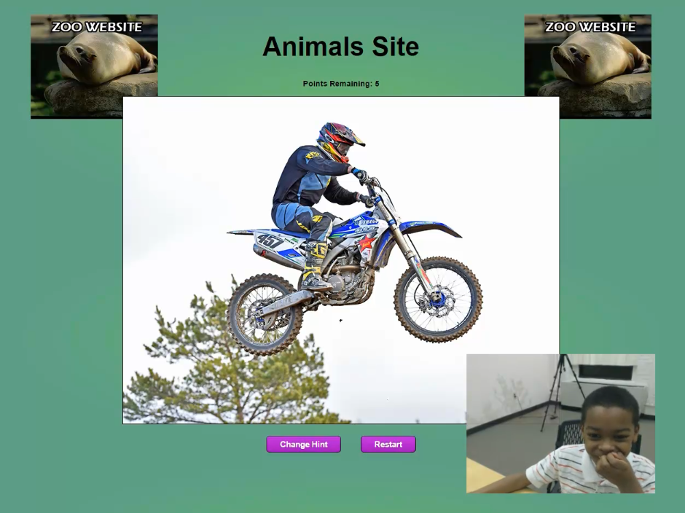
Figure 26. A participant is smiling while entering a graphical password on a picture of a motorbike.

Children will be able to remember the picture that they chose with high accuracy.
True. This study demonstrated that children are capable of remembering which picture they chose very accurately. Every participant succeeded in selecting the correct image. In one instance a user selected the wrong image but upon looking at it closer, they then returned to the image select screen and selected the correct image. In another instance a user selected another image and realized part of the way through the process that they were using the wrong image. Both of these mistakes seemed absent minded, and the users claimed to be more confident in their second attempt. Because this was accomplished with much greater accuracy than selecting points on an image, further research should be done in this area. Graphical identification seems like it could be part of a system that was both secure and usable.

Children will be able to remember their picture passwords more easily than their text-based passwords.
Mostly untrue. This hypothesis was not proven. It is clear that young children were able to enter their textual passwords more accurately than their graphical passwords. The success rate for textual passwords was consistently higher in every stage of testing. Users entered their graphical passwords with less accuracy immediately following creation, after a distraction activity, and after two weeks. After two weeks they did significantly worse. Most students did enter passwords that approximated their original password, even after two weeks, but it was too challenging to enter these passwords with sufficient accuracy. While accepting points in any order and greater tolerances many help children use graphical passwords more easily, this will inevitably decrease the security of the system. Finding a successful medium may be possible, but it was not shown successfully in this study.
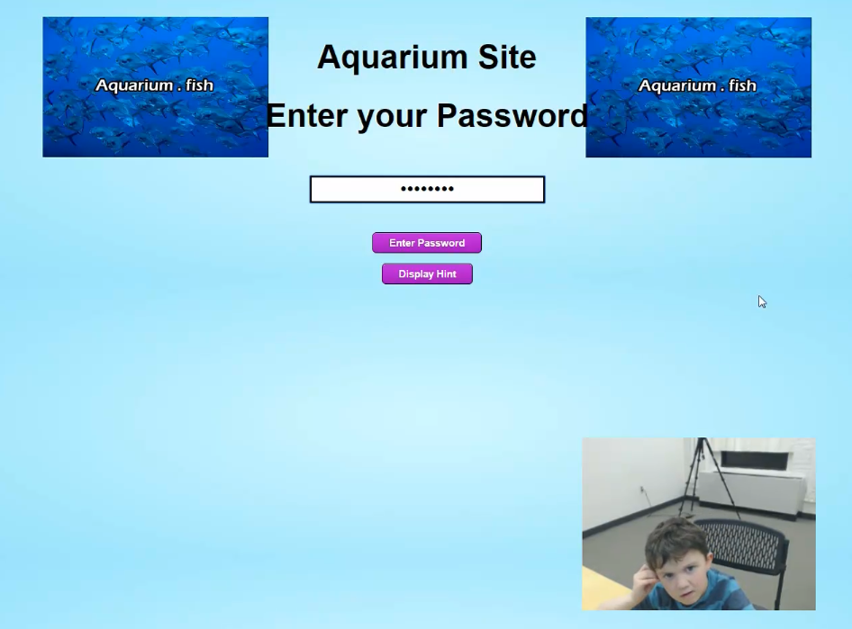
Figure 27. A participant looks frustrated and confused while trying to enter a textual password.

Children will create more unique passwords when using picture passwords.
Uncertain. It is clear that some users repeated usernames and passwords. As well several participants created passwords that were similar to their username, and one participant used the exact same username and password. This problem was decreased with graphical passwords. However, it may not be necessary as children were inspired by the material that they saw in front of them. For example, on the page for the “environmental site,” usernames included “treesaver,” “Leafshelpus.com,” and “Leaf2.” Surprisingly few children used the same passwords or usernames regardless of the page. It may be true that graphical passwords avoid some of these pitfalls, but repetitious passwords were not as problematic as anticipated. No children created passwords that were only one character long. Furthermore, children were drawn to certain points on images and selected certain images more commonly than others. For example, the Game Zone site had eight images and 10 participants created graphical passwords for this site. The yarn image was chosen four times – almost fifty percent. Meanwhile the woman holding flowers and the psychedelic shape were chosen twice each. The other two participants chose the grapes and the roads. No partipcants chose the flower close up, the farm, or the glass with a lime. A more comprehensive test could study this and it may be able to determine whether textual or graphical passwords are more comprehensively different.

Discussion

General difficulties with generality/specificity
Even after two weeks most children did remember the generalities of their password. Most passwords were approximated, even when children couldn’t access their accounts. They remembered what kinds of usernames and passwords they created, what picture they chose, and generally where the points were located on the image. Their troubles came from selecting specific locations, maintaining accuracy and order, and recalling the exact spelling, capitalization, and symbols following their passwords and usernames. This implies that both graphical and textual passwords are potentially viable, but concessions must be made to facilitate children. An alternative system may be able to capitalize on this knowledge to create a secure system that does not require the same specificity.

Conclusion
Most users did remember generalities and further testing should be performed on graphical and textual passwords. By changing the requirements of password creation and the accuracy required by the system, many different results are possible. This study shows that graphical passwords are potentially viable and certainly worth exploring further. However, it also shows that the requirements of this testing prototype were too challenging and graphical password systems for children need further examination. For the time being, implementing graphical password systems will yield uncertain results as there are no guidelines for structuring an ideal system.

Limitations and Difficulties

Technical difficulties – Inaccurate saving of data
Having a custom built prototype was liberating but also caused several problems. It provided a lot of flexibility and allowed researchers to adapt the system to the needs of children. This autonomy could not be replicated by a commercial product as there is no preexisting graphical password system for children. However, it was not as robust as professional software and did not log data in an organized fashion. All data was stored locally and had to be backed-up manually. At one point a participant, Alice, accidentally pressed the “Clear all data” button during a test and deleted all local data. Fortunately researchers kept backups, but her data had to be reentered and the data was lost from her work on the first two graphical passwords.

Recommendations
This study showed that PassPoints graphical password systems are not easier for children to use than textual passwords. At this point there is no evidence that they should be employed. Alternative designs may improve this system’s functionality, but it may be difficult to fine the ideal equilibrium between security and usability. However, these results did not imply that textual passwords were a model alternative. Textual passwords were recalled at less than 70% after two weeks. As well, these numbers may be lower in practice, as most sites have more restrictions to passwords than what this study required from participants.
The highest rate of success came from children selecting the appropriate images – which was at 100% for all participants in both sessions, regardless of how long they spent between sessions. These results show that the best password system for children would likely involve choosing objects, symbols, or images – rather than choosing points.
One of the problematic features of image identification passwords is that it can be time consuming to enter a series of pictures. However, this may not be a problem for children. If the password provides access to a game or another form of entertainment, allowing fast access is not a priority like it may be for a work application. As well, children tend enter their passwords slowly anyway. Some participants took minutes to slowly enter their username, typing with a single finger while looking at the keyboard. Therefore, the idea that textual passwords can be quickly entered, is more accurate for adults than for children.

Further Research

More Data
Having only ten participants return for the second session was a disappointment. More participants were scheduled, but several canceled or forgot to show up to their second session. This data is an excellent starting part, but further research could help strengthen the arguments of this paper.

Other Picture Passwords
It would be good to see more research on alternative graphical or picture password designs. This study showed that multipoint graphical passwords like PassPoints are problematic, but it also showed that children were able to remember objects and pictures with a great deal of accuracy. It would be interesting to study this further to discover the strengths and weakness of this capacity. It is likely that fertile new technologies could take advantage of this to create password systems that are both secure and child friendly.

A Password System Based on this Research - Relic Passwords
This study uncovered many interesting things, and it would be interesting to design and test a system that took advantage of these discoveries. Researchers found that children had trouble with specific points and point order, but remembered visual cues and objects very clearly. This information could be applied in a new password system. One such system proposed here is called Relic Passwords.
This was partially inspired by methods for identifying the reincarnation of Tulku Lama in Tibetan Buddhism. In Tibetan Buddhism, the Tulku Lama’s reincarnation has been tested by putting children in a room with many objects (or relics). If the child chooses the objects that belonged to the Tulku Lama in a previous life, it is believed that they are the reincarnation of the Tulku Lama. This system is perfect for an online password system, as it relies on object identification and is designed around children and their capacities.
The Relic Password system would work in a similar way. Children would choose their objects when creating an account. When logging into their account, the system would use JavaScript to randomly fill the canvas with many different objects of different shapes and sizes. Some of these objects would change each time, and their locations (and possibly their rotation and/or coloration) would vary. Children would click on the objects they chose doing their account creation and this would highlight them. If they clicked the object again, they could deselect it. Once five objects were selected, they could press a button to “enter password.” If they chose the correct five objects, the password would be confirmed. If they chose the wrong five objects, they would be informed that it was incorrect.
This system would avoid the difficulties children have identifying highly specific locations and recalling order and sequence. Furthermore while children were searching for their objects, the process would help ingrain them in their memory and would provide a fun and game-oriented aspect that would fulfill children’s desires for fun computer systems. In this way it could be similar to a Where’s Waldo or I Spy book. Of course, it would be much easier to locate the correct objects, as the purpose would never be to obscure the password, but children may find it fun nevertheless.
This systems would hopefully be faster than clicking through a series of images as all of the content is displayed at the same time and it may be viable for adults as well. It would be great to see further research and development done on this system.

References
Chiasson, S., Biddle, R., & van Oorschot, P. C. (2007, July). A second look at the usability of click-based graphical passwords. In Proceedings of the 3rd symposium on Usable privacy and security (pp. 1-12). ACM.
Chiasson, S., Forget, A., Stobert, E., van Oorschot, P. C., & Biddle, R. (2009, November). Multiple password interference in text passwords and click-based graphical passwords. In Proceedings of the 16th ACM conference on Computer and communications security (pp. 500-511). ACM.

Creese, S., Goldsmith, M., & Nurse, J. (2015). Predicting Graphical Passwords.
Dirik, A. E., Memon, N., & Birget, J. C. (2007, July). Modeling user choice in the PassPoints graphical password scheme. In Proceedings of the 3rd symposium on Usable privacy and security (pp. 20-28). ACM.
Mendori, T., Kubouchi, M., Okada, M., & Shimizu, A. (2002, December). Password input interface suitable for primary school children. In Computers in Education, 2002. Proceedings. International Conference on (pp. 765-766). IEEE.

Read, J. C., & Cassidy, B. (2012, June). Designing textual password systems for children. In Proceedings of the 11th International Conference on Interaction Design and Children (pp. 200-203). ACM.

Walsh, G. (n.d.). KidsteamUB. Retrieved April 04, 2016, from https://home.ubalt.edu/gwalsh/kidsteam.html
Wiedenbeck, S., Waters, J., Birget, J. C., Brodskiy, A., & Memon, N. (2005, July). Authentication using graphical passwords: Effects of tolerance and image choice. In Proceedings of the 2005 symposium on Usable privacy and security (pp. 1-12). ACM.
Wiedenbeck, S., Waters, J., Birget, J. C., Brodskiy, A., & Memon, N. (2005). PassPoints: Design and longitudinal evaluation of a graphical password system. International Journal of Human-Computer Studies, 63(1), 102-127.

Appendix A: Annotated Bibliography

Computers and Young Children: Social Benefit or Social Problem?
Attewell, P., Battle, J., & Suazo-Garcia, B. (2003). Computers and young children: Social benefit or social problem?. Social forces, 82(1), 277-296.
This article examines the potential benefits and problems of young children using computers. In a study of school-aged children (4-14), parents filled out a time diary that recorded the child’s computer use. These results were compared to a variety of tests (vocabulary, math, comprehension, memory) and the authors looked for correlations. The authors found that children who used computers for less than 8 hours a week did not sacrifice time spent doing other important activities such as reading and playing sports. As well, students who used computers at home for less than 8 hours per week had higher scores on letter-word recognition, reading, comprehension, and mathematics. However, there were risks involved with using the computer for more than 8 hours per week. For example, obesity rates are higher.
http://sf.oxfordjournals.org/content/82/1/277.short

A Second Look at the Usability of Click-Based Graphical Passwords
Chiasson, S., Biddle, R., & van Oorschot, P. C. (2007, July). A second look at the usability of click-based graphical passwords. In Proceedings of the 3rd symposium on Usable privacy and security (pp. 1-12). ACM.

This article describes two studies about graphical passwords. The first study tested usability in a single session and the second study tested success over the period of a college semester. In the first study, 43 college-aged participants created graphical passwords, gave their opinion on the system and then completed several puzzles in the “Mental Rotations Test.” They then logged into the system using their previously created password. The authors also had a long term test where 376 students accessed their instructor’s class material by using a graphical passwords. The authors argue that the lab study was much more successful than the field study. They call for further research and investigation into real world applications of graphical passwords.

http://dl.acm.org/citation.cfm?id=1280682

Multiple Password Interference in Text Passwords and Click-based Graphical Passwords
Chiasson, S., Forget, A., Stobert, E., van Oorschot, P. C., & Biddle, R. (2009, November). Multiple password interference in text passwords and click-based graphical passwords. In Proceedings of the 16th ACM conference on Computer and communications security (pp. 500-511). ACM.

This article examines graphical passwords. If a user has multiple graphical passwords, does it prevent them from recalling other passwords? Will they be likely to confuse the passwords? The authors performed a study where each participant spent an hour learning to use PassPoints, creating multiple passwords, and trying to recall them. They found that users had trouble recalling multiple textual passwords and less trouble recalling multiple graphical passwords in the short term. After two weeks users had equal difficulty and it was not easy for them to remember either graphical or textual passwords. However, the authors still thought that there were benefits to graphical passwords, such as built in cueing based on the picture that the user sees.
http://dl.acm.org/citation.cfm?id=1653722

Implications of What Children Know About Computer Passwords
Coggins III, P. E. (2013). Implications of What Children Know About Computer Passwords. Computers in the Schools, 30(3), 282-293.

This article examines 9-12 year olds and their knowledge of computer passwords. It begins by acknowledging that password systems are flawed but still minimize risk. Furthermore, it states that encouraging children to use computers will develop computer skills and promote safe and secure computer habits. 74 children completed a survey, answering questions about computers, if they used passwords, and providing an example of easy (weak) and hard (strong) passwords. Examples were evaluated based on the number of letters, inclusion of special characters, and whether the password used dictionary words. The authors then say that password security should be a formal topic covered in classes, as students will learn about it “on the street” and may develop unsafe practices if they are not guided.

www.tandfonline.com/doi/abs/10.1080/07380569.2013.807719

A Pedagogical Example of Second-Order Arithmetic Sequences Applied to the Construction of Computer Passwords by Upper Elementary Grade Students
Coggins III, P. E. (2015). A pedagogical example of second-order arithmetic sequences applied to the construction of computer passwords by upper elementary grade students. International Journal of Mathematical Education in Science and Technology, 46(3), 441-450.

This article starts by acknowledging the threats of cybersecurity breaches. It says that few efforts have been made toward educating children about password creation. The authors argue that there is an opportunity to teach children about safe password construction while also creating a fun classroom activity. The authors propose creating passwords using mathematical operations called “digital root sums” as this will create secure passwords. In a classroom activity students followed a procedure to create complicated numerical passwords which appear random. The study showed that children can create complex passwords. However this study does not evaluate their attitudes, interests, or memory in any way.
http://www.tandfonline.com/doi/abs/10.1080/0020739X.2014.982730

Predicting Graphical Passwords
Creese, S., Goldsmith, M., & Nurse, J. (2015). Predicting Graphical Passwords.

This article claims that many of the problems with textual passwords come from humans’ inability to remember them and use them effectively. The authors acknowledge that graphical password systems are more memorable. The paper then focuses on a study of “PassPoints” which is a graphical password system. It examines whether or not users with demographic information will reliably choose similar positions in an image. The authors found that user’s decisions were not based on a single attribute. In other words, women did not all choose the same points. However, people who responded to many different questions in similar ways, did tend to choose similar points. The authors concluded that knowledge of a user’s attributes is not likely to be a security risk, however users should be given information about the strength of their password. This would be based on their password’s comparison to heat maps of common selections.

http://www.cs.ox.ac.uk/publications/publication9348-abstract.html

Modeling User Choice in the PassPoints Graphical Password Scheme
Dirik, A. E., Memon, N., & Birget, J. C. (2007, July). Modeling user choice in the PassPoints graphical password scheme. In Proceedings of the 3rd symposium on Usable privacy and security (pp. 20-28). ACM.

This paper outlines an attempt to model predictable positions in images and whether it will be a secure image for use in a PassPoints system. The authors explain – in detail – the purpose and functionality of a PassPoints system. The authors created models using luminosity contrast, color contrast, and foreground recognition. Using these were able to accurately predict points that humans would likely choose. They verified this accuracy by having users test images. They then compared the human’s selections with their computer’s predictions. They accurately predicted 70-80% of user click positions. This is a mixed blessing, as it allows site creators to choose photos that will protect users, but it also means that the authors have proven that automated hacking of PassPoints systems are possible.

https://cups.cs.cmu.edu/soups/2007/proceedings/p20_dirik.pdf

Methods and Techniques for Involving Children in the Design of New Technology for Children

Fails, J. A., Guha, M. L., & Druin, A. (2012). Methods and techniques for involving children in the design of new technology for children. Human–Computer Interaction, 6(2), 85-166.

This article examines the ways that children have participated in designing technologies and the methods that will help them to participate in further designs later. The authors explain how ubiquitous computing technologies are, and how commonly children use them. Children become better design partners between 7 and 10 years old, which falls within Piaget’s concrete operational stage. Because these learners struggle with abstract thinking, the authors recommend having concrete objects help to bridge their thinking. The article examines the origins of participatory technology and proposes that children be involved in the process from an earlier stage, as informants or even design-partners. The article then proposes many different methods for designing with children.

http://www.nowpublishers.com/articles/foundations-and-trends-in-humancomputer-interaction/HCI-018

Persuasion as Education for Computer Security
Forget, A., Chiasson, S., & Biddle, R. (2007, October). Persuasion as education for computer security. In World Conference on E-Learning in Corporate, Government, Healthcare, and Higher Education (Vol. 2007, No. 1, pp. 822-829).

The authors of this study outline methods for persuading users to behave more securely and how to teach users about more secure passwords. The authors outline many of the limits of human memory as well as the disinterest of many users. They acknowledge that to many users, security appears to be a secondary tasks that only impedes their ability to complete their primary tasks. The also propose many methods for encouraging better password creation – such as adding symbols and unusual characters automatically into users’ passwords, or recommending that user select points within a certain range when using PassPoints graphical passwords.

http://www.editlib.org/p/26432/

Getting Past Passwords
Furnell, S. (2013). Getting past passwords. Computer Fraud & Security, 2013(4), 8-13.

This article argues that no single password method will function as a silver bullet to the problem of passwords. All alternative password methods combined together provide a wider means for users to access their private information securely. The article has a table that shows that most websites do not prevent common passwords such as the user’s surname or the user’s ID. The authors show Android’s “pattern unlock” as a popular alternative method for authentication. This method involves the user drawing a pattern between different points on the screen. Making more systems with unusual passwords (such as Androids “pattern unlock”) will make each system more secure because users will be unable to repeat passwords when using many dissimilar systems.

http://www.sciencedirect.com/science/article/pii/S136137231370037X

Click Passwords under Investigation
Gołofit, K. (2007). Click passwords under investigation. In Computer Security–ESORICS 2007 (pp. 343-358). Springer Berlin Heidelberg.

This article examines graphical password systems, their advantages and their weaknesses. There are three main systems: Passlogix, Pass-Points, and Click Passwords. All of them are based on the idea of choosing points in a picture. They also look at picture passwords, where users identify a sequence of pictures from a gird that lead them to their password. In a study participants created seven points on a picture and these points were compared. As expected, they found that participants chose many of the same locations. Still they feel that graphical passwords have both advantages and disadvantages.

http://link.springer.com/chapter/10.1007/978-3-540-74835-9_23#page-1

Attitudes and practices of students towards password security
Hart, D. (2008). Attitudes and practices of students towards password security. Journal of Computing Sciences in Colleges, 23(5), 169-174.

This article outlines the responses to a survey about computer security. University students at Plattsburgh University in New York are given two passwords and expected to remember them to access their personal information while in college. The department of Computer Science sent out a survey in order to identify the students’ information. The survey also included an educational component which was given out at different parts of the survey process. Ultimately it seemed that students did not learn from the process of educational handouts. This shows that password education is not cannot be taught from a single flyer.

http://dl.acm.org/citation.cfm?id=1352653

The Domino Effect of Password Reuse
Ives, B., Walsh, K. R., & Schneider, H. (2004). The domino effect of password reuse. Communications of the ACM, 47(4), 75-78.

This article examines some of the weakness of passwords. Primarily the authors focus on password reuse. If a hacker gains access to someone’s password, it is likely they may use the same password on other – possibly more sensitive – systems. The authors have a list of password recommendations which include creating password guidelines that force users to use passwords that are not the same as passwords from other systems.

http://dl.acm.org/citation.cfm?id=975820

The Design and Analysis of Graphical Passwords
Jermyn, I., Mayer, A. J., Monrose, F., Reiter, M. K., & Rubin, A. D. (1999, August). The Design and Analysis of Graphical Passwords. In Usenix Security.

This article discusses the drawbacks of standard password systems, and proposes the use of graphical passwords. Graphical passwords consist of handwritten designs and drawings. The authors propose a method called “draw a secret” where the user draws a design on a grid.

https://www.usenix.org/legacy/events/sec99/full_papers/jermyn/jermyn.pdf

Human Selection of Mnemonic Phrase-Based Passwords
Kuo, C., Romanosky, S., & Cranor, L. F. (2006, July). Human selection of mnemonic phrase-based passwords. In Proceedings of the second symposium on Usable privacy and security (pp. 67-78). ACM.

This article discusses phrase based passwords, which it argues are memorable and harder to forget. A phrase based password may be something like “4s&7yaoF” standing for “Four score and seven years ago, our Fathers.” Because the password is based on a memorable phrase, it’s easy for the user to remember this otherwise complicated password. In a study, participants generated passwords in an online survey. One group created passwords of their liking, while another group was instructed to use mnemonic phrase-based passwords. As expected mnemonic passwords were somewhat harder to crack mainly due to the fact that most memorable phrases are readily available online. Should hackers develop a database of mnemonic phrases, these passwords would not be hard to crack.

Password input interface suitable for primary school children
Mendori, T., Kubouchi, M., Okada, M., & Shimizu, A. (2002, December). Password input interface suitable for primary school children. In Computers in Education, 2002. Proceedings. International Conference on (pp. 765-766). IEEE.

This paper explains that textual passwords are not always appropriate for children and attempts to explain an alternate password interface. In this system, users created and remembered passwords based on a series of symbols instead of letters. This is a more visual method and may be better for children. The authors found that it was accurate but didn’t compare it against textual password recall.

http://ieeexplore.ieee.org/stamp/stamp.jsp?tp=&arnumber=1186069

Designing textual password systems for children

Read, J. C., & Cassidy, B. (2012, June). Designing textual password systems for children. In Proceedings of the 11th International Conference on Interaction Design and Children (pp. 200-203). ACM.

This article begins with a survey about passwords. A study concluded that children do not know what makes a password secure or why it is important. More children saw passwords as barriers to access rather than gateways to secure areas. The authors then had children create textual passwords, learning from what they created. Lastly, the authors examined the design implications, concluding that children’s passwords should not have to be too long, and should not require the use of characters or symbols. The authors recommend adding in additional security questions to offset this loss of security.

http://dl.acm.org/citation.cfm?id=2307125

Transforming the ‘Weakest Link’ — a Human/Computer Interaction Approach to Usable and Effective Security
Sasse, M. A., Brostoff, S., & Weirich, D. (2001). Transforming the ‘weakest link’—a human/computer interaction approach to usable and effective security. BT technology journal, 19(3), 122-131.

This article says that humans are not the weakest link in passwords. This line of thinking blames humans for the problems that the system presents rather than looking for alternative systems that are easy for humans to understand and interact with. The authors propose using single sign-on systems. This is a system where the person only has to remember one password, but it does increase risk if a password is compromised. A study of password-resets and IT calls discovered that most users have trouble remembering their passwords and a lot of password resets are caused by administrative problems rather than user problems. The authors recommend knowledge-based systems and mnemonic phrase based systems. Ultimately they feel that company practices need to be revised rather than changing password systems altogether.
http://link.springer.com/article/10.1023/A:1011902718709

A Comparison of Posture and Muscle Activity during Tablet Computer, Desktop Computer and Paper Use by Young Children
Straker, L. M., Coleman, J., Skoss, R., Maslen, B. A., Burgess-Limerick, R., & Pollock, C. M. (2008). A comparison of posture and muscle activity during tablet computer, desktop computer and paper use by young children. Ergonomics, 51(4), 540-555.

This article examines children’s posture and muscle activity while using different types of computers. It surveys a group of Australian students participating in a mandatory laptop program. These students use computers for an average of 16.9 hours a week (up to 80 hours a week). In previous studies 80% of children reported discomfort while using computers. In a study, researchers divided children into groups that used tablets, desktop computers, and paper information technology, and examined posture and muscle activity using multi-camera infrared motion systems. Participants completed a coloring activity. The authors found that paper and tablet use is more likely to cause stress and negative ergonomic positions. However, they also acknowledge that desktops have more static positions and other mediums have greater variation of posture and muscle activity.

http://www.tandfonline.com/doi/pdf/10.1080/00140130701711000

Password Policy: The Good, The Bad, and The Ugly
Summers, W. C., & Bosworth, E. (2004, January). Password policy: the good, the bad, and the ugly. In Proceedings of the winter international synposium on Information and communication technologies (pp. 1-6). Trinity College Dublin.

This article looks at many of the risks and benefits associated with computer passwords. According to a study of 3000 IT professionals, more than 24% have more than eight user names and passwords. Because of the increase of “nonwords” and combinations of numbers and letters, more users are forgetting passwords or writing them down in non-secure methods. Many users’ passwords are easily guessed and are not hard to crack with automated systems. The authors recommend that passwords should not be the only method of security. They recommend additional layers of security that include “What you have,” (smart cards and tokens), “who you are,” (fingerprints and iris scans) and “what you produce” (voice and signature patterns).
http://dl.acm.org/citation.cfm?id=984724

Layered Elaboration: a New Technique for Co-design with Children.
Walsh, G., Druin, A., Guha, M. L., Foss, E., Golub, E., Hatley, L., ... & Franckel, S. (2010, April). Layered elaboration: a new technique for co-design with children. In Proceedings of the SIGCHI Conference on Human Factors in Computing Systems (pp. 1237-1240). ACM.

This article examines the method of cooperative inquiry, which involves many techniques that facilitate cooperation between designers and children. It also discusses Layered Elaboration which is a method where users layer transparent pieces of paper on top of each other, and each participant elaborates on the ideas that the previous users began. The authors describe some of the results of layered elaboration as well as the lessons learned from the process. They find that it is helpful, and fun for participants, while also having low costs and high portability. They also acknowledge that transparent paper has its own limitations and that presentations are not always effective with children as they may not always pay attention.
http://www.researchgate.net/profile/Elizabeth_Foss/publication/221513906_Layered_elaboration_a_new_technique_for_co-design_with_children/links/00b49527d4f2568554000000.pdf

Authentication using graphical passwords: Effects of tolerance and image choice
Wiedenbeck, S., Waters, J., Birget, J. C., Brodskiy, A., & Memon, N. (2005, July). Authentication using graphical passwords: Effects of tolerance and image choice. In Proceedings of the 2005 symposium on Usable privacy and security (pp. 1-12). ACM.
This article examines the effects of graphical passwords. After citing many difficulties and security risks surrounding standard passwords, they discuss graphical passwords where the user clicks on a series of images. One such method has a user selecting the correct face four times from a lineup of 9 faces (including 8 decoys). Empirical evidence has shown this method to be more memorable. This system does have its own drawbacks as users tend to choose similar faces for their passwords. Also having to choose multiple faces over and over again makes login slow and tedious. The authors of the article create a new method that relies on users choosing multiple locations on one image. The authors had thirty two undergraduate students use the system to create a password and log in. They found that each point should have a tolerance of 14*14 pixels as smaller boxes had a large margin for error. Another study found that many different types of pictures were valid, but they should be memorable and further research needs to be done to determine the hotspots that attract many individuals to the same area.
http://dl.acm.org/citation.cfm?id=1073002

Passpoints: Design and Longitudinal Evaluation Of A Graphical Password System
Wiedenbeck, S., Waters, J., Birget, J. C., Brodskiy, A., & Memon, N. (2005). PassPoints: Design and longitudinal evaluation of a graphical password system. International Journal of Human-Computer Studies, 63(1), 102-127.

This article examines graphical passwords and compares them to textual passwords. After examining the general difficulties with text passwords and the possible advantages of graphical passwords, the authors explain their study. They had 40 participants. 20 created text passwords, and 20 created graphical passwords. They then compared how quickly and accurately participants made and recalled their passwords. Finally they had them answer some questions about whether they thought entering the password was “easy” or “fast” and whether the interface was “pleasant to use.” Ultimately they found mixed results. They decide that users had more difficulty learning graphical passwords and had similar perceptions related to ease, speed of input, and favorability.
http://clam.rutgers.edu/~birget/grPssw/susan1.pdf*

Appendix B: Bibliography
Attewell, P., Battle, J., & Suazo-Garcia, B. (2003). Computers and young children: Social benefit or social problem?. Social forces, 82(1), 277-296.
Chiasson, S., Biddle, R., & van Oorschot, P. C. (2007, July). A second look at the usability of click-based graphical passwords. In Proceedings of the 3rd symposium on Usable privacy and security (pp. 1-12). ACM.
Chiasson, S., Forget, A., Stobert, E., van Oorschot, P. C., & Biddle, R. (2009, November). Multiple password interference in text passwords and click-based graphical passwords. In Proceedings of the 16th ACM conference on Computer and communications security (pp. 500-511). ACM.
Coggins III, P. E. (2013). Implications of What Children Know About Computer Passwords. Computers in the Schools, 30(3), 282-293.
Coggins III, P. E. (2015). A pedagogical example of second-order arithmetic sequences applied to the construction of computer passwords by upper elementary grade students. International Journal of Mathematical Education in Science and Technology, 46(3), 441-450.
Creese, S., Goldsmith, M., & Nurse, J. (2015). Predicting Graphical Passwords.
Dirik, A. E., Memon, N., & Birget, J. C. (2007, July). Modeling user choice in the PassPoints graphical password scheme. In Proceedings of the 3rd symposium on Usable privacy and security (pp. 20-28). ACM.
Fails, J. A., Guha, M. L., & Druin, A. (2012). Methods and techniques for involving children in the design of new technology for children. Human–Computer Interaction, 6(2), 85-166.
Forget, A., Chiasson, S., & Biddle, R. (2007, October). Persuasion as education for computer security. In World Conference on E-Learning in Corporate, Government, Healthcare, and Higher Education (Vol. 2007, No. 1, pp. 822-829).
Furnell, S. (2013). Getting past passwords. Computer Fraud & Security, 2013(4), 8-13.
Gołofit, K. (2007). Click passwords under investigation. In Computer Security–ESORICS 2007 (pp. 343-358). Springer Berlin Heidelberg.
Hart, D. (2008). Attitudes and practices of students towards password security. Journal of Computing Sciences in Colleges, 23(5), 169-174.
Ives, B., Walsh, K. R., & Schneider, H. (2004). The domino effect of password reuse. Communications of the ACM, 47(4), 75-78.
Jermyn, I., Mayer, A. J., Monrose, F., Reiter, M. K., & Rubin, A. D. (1999, August). The Design and Analysis of Graphical Passwords. In Usenix Security.
Kuo, C., Romanosky, S., & Cranor, L. F. (2006, July). Human selection of mnemonic phrase-based passwords. In Proceedings of the second symposium on Usable privacy and security (pp. 67-78). ACM.
Mendori, T., Kubouchi, M., Okada, M., & Shimizu, A. (2002, December). Password input interface suitable for primary school children. In Computers in Education, 2002. Proceedings. International Conference on (pp. 765-766). IEEE.

Read, J. C., & Cassidy, B. (2012, June). Designing textual password systems for children. In Proceedings of the 11th International Conference on Interaction Design and Children (pp. 200-203). ACM.

Sasse, M. A., Brostoff, S., & Weirich, D. (2001). Transforming the ‘weakest link’—a human/computer interaction approach to usable and effective security. BT technology journal, 19(3), 122-131.
Straker, L. M., Coleman, J., Skoss, R., Maslen, B. A., Burgess-Limerick, R., & Pollock, C. M. (2008). A comparison of posture and muscle activity during tablet computer, desktop computer and paper use by young children. Ergonomics, 51(4), 540-555.
Summers, W. C., & Bosworth, E. (2004, January). Password policy: the good, the bad, and the ugly. In Proceedings of the winter international synposium on Information and communication technologies (pp. 1-6). Trinity College Dublin.

Walsh, G. (n.d.). KidsteamUB. Retrieved April 04, 2016, from https://home.ubalt.edu/gwalsh/kidsteam.html
Walsh, G., Druin, A., Guha, M. L., Foss, E., Golub, E., Hatley, L., ... & Franckel, S. (2010, April). Layered elaboration: a new technique for co-design with children. In Proceedings of the SIGCHI Conference on Human Factors in Computing Systems (pp. 1237-1240). ACM.
Wiedenbeck, S., Waters, J., Birget, J. C., Brodskiy, A., & Memon, N. (2005, July). Authentication using graphical passwords: Effects of tolerance and image choice. In Proceedings of the 2005 symposium on Usable privacy and security (pp. 1-12). ACM.
Wiedenbeck, S., Waters, J., Birget, J. C., Brodskiy, A., & Memon, N. (2005). PassPoints: Design and longitudinal evaluation of a graphical password system. International Journal of Human-Computer Studies, 63(1), 102-127.

Appendix C: IRB Application

UNIVERSITY OF BALTIMORE
Application for Approval of Research Involving Human Subjects
This form is to be completed by the investigator who will submit it to the Institutional Review Board (IRB) for review and approval. Answer all the questions completely and spell out any acronyms. Include a copy of any applicable survey instruments, consent documents, and training certificates with your application. When the IRB has approved the application, the investigator will be notified in writing. Any changes to an approved protocol must be re-submitted for review and approval. Changes should be highlighted or typed in a different text color.
 | Researcher 1 |  |  | Researcher 2
Name | Jasper Cole
UB ID # | 3000017
Department | Interaction Design and Information Architecture
Address for Approval Letter | 6146 Parkway Drive  Baltimore MD 21212
Phone # | 443-386-7259
Email | Jasper.cole@ubalt.edu
Status  (Faculty/Staff/Student) | Student
If student, faculty sponsor name & email | Greg Walsh  gwalsh@ubalt.edu
Check if this is: | Student master’s thesis Doctoral dissertation research  Class Project (Faculty should contact the IRB Coordinator before students submit applications for class projects.)
Project Title | Alternative Login Designs for Children
Agency Sponsor
(if applicable)
PeopleSoft Project #
(if applicable)
Project Duration | Estimated Start Date | August 2015 | Estimated End Date |  | May 2016
Submission Date | 8/25/15
Application Type
Please select ONE application type only.
(Complete checklists in Parts A & B below before making your selection.)
Exempt
In order to be exempt, you must answer the questions and satisfy the criteria in Parts A and B below.
Expedited Review
Expedited review is possible only in one of two circumstances:
1. There is minimal risk to the participants and the researcher is not requesting the IRB to waive the normally required informed consent procedures.
or
2. The IRB review is to evaluate minor changes in previously approved research.
Full Board Review

It is possible that your research is exempt from IRB review. Please complete Parts A and B below, regardless of whether you believe your research is exempt.
Part A – Please check Yes or No for each item, To be considered exempt, all answers must be No.
Yes | No | Item
 | x | 1 | Does the research involve as subjects prisoners, fetuses, pregnant women, the seriously ill, or mentally or cognitively compromised adults.
 | x | 2 | Does the research involve the collection or recording of behavior which, if known outside the research, could reasonably place subjects at risk of criminal or civil liability or be damaging to the subjects’ financial standing, employability, or reputation.
 | x | 3 | Does the research involve the collection of information regarding sensitive aspects of subjects’ behavior (e.g., drug or alcohol use, illegal conduct, sexual behavior)?
x |  | 4 | Does the research involve subjects under the age of 18 (except as they are participating in projects that fall under categories 1, 3, 4, and/or 5 in Part B)? Category B 2 studies that include minors should be submitted for expedited review.
 | x | 5 | Does the research involve deception? (see question C.5.)
 | x | 6 | Do the research procedures generate any evident or foreseeable risk to the subjects?

Part B – Exemption Categories
Please mark Yes or No for each item below, regardless of whether you believe your research is exempt. To be considered exempt, at least one must be marked yes.
Yes | No | Item
x |  | 1 | Will the research be conducted in established or commonly accepted educational settings and involve normal educational practices (e.g., research on regular and special education instructional strategies, research on the effectiveness of or comparison among instructional techniques, curricula, or classroom management methods)?  (Please note: The fact that the research is taking place in an educational setting [i.e. at a University by a student] is not a sufficient reason in and of itself to apply for this exemption.)
x |  | 2 | Will the research involve the use of educational tests (cognitive, diagnostic, aptitude, achievement), survey procedures, interview procedures or observation of public behavior? If not, mark “No.” If so, mark “Yes” unless:  (i) information obtained is recorded in such a manner that human subjects can be identified, directly or through identifiers linked to the subjects;  and  (ii) any disclosure of the human subjects' responses outside the research could reasonably place the subjects at risk of criminal or civil liability or be damaging to the subjects' financial standing, employability, or reputation.  If both (i) and (ii) are true, then mark “No.”
 | x | 3 | Will the research involve the use of educational tests (cognitive, diagnostic, aptitude, achievement), survey procedures, interview procedures, or observation of public behavior that is not exempt under question 2? If not, mark “No.” If so, mark “Yes”, if:  (i) the human subjects are elected or appointed public officials or candidates for public office;  or  (ii) federal statute(s) require(s) without exception that the confidentiality of the personally identifiable information will be maintained throughout the research and thereafter. (This is an unusual circumstance and documentation is required.)
x |  | 4 | If the research involves the collection or study of existing data, documents, records, pathological specimens, or diagnostic specimens then are these sources either  a.) publicly available  or  b.) is the information being collected and recorded anonymously (i.e., in such a manner that subjects cannot be identified, directly or through identifiers linked to the subject)?
 | x | 5 | Is the research (including demonstration projects) being conducted by or subject to the approval of federal department or agency heads and is it designed to study, evaluate, or otherwise examine one or more of the following: (i) public benefit or service programs (e.g., social security, welfare, etc.); (ii) procedures for obtaining benefits or services under those programs; (iii) possible changes in or alternatives to those programs or procedures; or (iv) possible changes in methods or levels of payment for benefits or services under those programs?
 | x | 6 | Does the research involve taste or food quality evaluations or consumer acceptance studies and are the tested products wholesome foods without additives, or foods which contain additives at or below levels found to be safe by the EPA of the Food Safety and Inspection Service of the U.S. Department of Agriculture?

Is Your Research Exempt?

If your answers to Part A above are all No and at least one of your answers in Part B is yes, then please select “Exempt” as the application type before continuing on.

Even if you believe you satisfy the criteria for exemption, the Institutional Review Board needs to review your proposal to confirm that.

Therefore, whether or not you have indicated that you are seeking exempt status, please CONTINUE ON to answer the questions in Part C.

Part C: About the Proposed Research – please answer all the questions in this section. Please be clear and concise, but provide enough detail so the Board can make an informed determination.

1. Describe the purpose of the proposed research and your research protocol. Avoid using acronyms or technical jargon, unless they are defined. Attach additional pages when necessary.
I propose researching how young users login to online systems and remember passwords. I also intend to test alternative methods for logging in, which would allow a wider audience to access secure material without requiring such difficult memorization.
2. Describe the human subject population (size, age, gender, and racial distribution) and how participants will be selected for inclusion in the research. If you are limiting your study to certain specific groups, please justify why.

I will study young students between the ages of 6 and 18. Participants will not be over the age of 18. They will be of different genders and racial distributions, but they will all be familiar with the basics of computer use.

What is your relationship to the subject population (fellow student, co-worker, supervisor, government agent, law enforcement)?
I am a grade-school instructor at Johns Hopkins Center for Talented Youth and a student at University of Baltimore. I will recruit the participants from these populations. I will focus on recruiting children from the university of Baltimore’s kidsteam and other students in the area. I may also recruit students from The Johns Hopkins Center for Talented Youth. The study will performed at the University of Baltimore. There are already mechanisms of safety in place for participants of the kidsteam project, and I will rely on these to ensure the safety of participants. Furthermore kids will remain under constant supervision, preferably by at least two adults at a time.

Yes | No
x |  | a. Does the research involve protected subjects including prisoners, pregnant women, minors?
 | x | b. Does the research involve UB Students as subjects/participants?
 | x | c. Does the research involve UB Faculty or Staff as subjects/participants?
 | x | d. Will the human subject population be limited to participants 18 years of age or older? (Studies involving minors will require consent from parents/legal guardians.)
3. Describe the type of data you will be collecting and how it will be collected, e.g., survey, interview, focus group, record review, etc. (Attach a copy of the questionnaire, interview guide, stimulus materials, or other collection instruments.)
I will be collecting information about how young students login to secure sites and severs. This may be done with a survey, interviews, and contextual inquiries – which is a recorded observation of users using computers in natural/common environments. I may also observe users while they engage in paper prototyping – testing prototypes of login systems using paper cutouts. I may film users’ hands and the screens. Other personally identifiable details may be caught on film, but I will not film these intentionally. Tapes will be stored digitally on a password protected computer and will be deleted once the paper is complete. Some screenshots and clips may appear in the final paper but will not include any personally identifiable information.

4. Does the research involve potential discomfiture or harassment to human subjects beyond levels encountered in daily life? Describe the potential discomfiture to the human subjects as the research is carried out.
This research does not.
5. If your answer to Part A, Question 5 was yes, then please describe the nature of the deception.

6. Describe the potential benefits of the research.
My research may lead to better login systems for young learners and for all users who need to access confidential or private material.

7. Describe any applicable payments, inducements or incentives that will be offered to research participants. (i.e. gift cards, course extra credit, lotteries, etc.)
I do not expect to provide incentives, but I may revise this if I cannot find willing participants.

8. Informed Consent Procedures
Yes | No
 | x | Is the researcher requesting that the IRB grant a waiver of the required informed consent procedures?
Describe here the informed consent procedures and attach the consent form(s) and script(s) (if applicable):
Please find attached an informed consent form that outlines the details and requirements of the study. It also has contact information for me and for Greg Walsh. It has space for the parent to write their name, their child’s name, and their signature.
Please also find attached an assent form for the minors. It has a space for the minor to write their name and sign their signature. If they do not yet have a signature, they can write their name twice.
9. Might the disclosure of the subjects’ responses reasonably be expected to cause the subjects to feel embarrassed or that their privacy has been violated? Might disclosure place the subjects at risk of criminal or civil liability or potentially damage the subjects’ financial standing, employability, or reputation?
The subject’s responses should not be embarrassing or violate their privacy in any way.

If so, describe the procedures in place for protecting, privacy and prevent breach of confidentiality as well as the rights of the human subjects generally.

10. What are the potential risks if an individual is identified with participating in the study? Explain how you are mitigating that risk.
There are no potential risks.

11. Describe how and where the data (original documents and electronic databases) will be stored and protected.
Any paper notes will be stored in a locked room. I will store any digital data on my desktop computer which is password protected.
12. Describe who will have access to the data.
Me and my advisor, Greg Walsh. I may also get help from other graduate students at University of Baltimore but they will use anonymized versions of any data that they have access to.

Note: Any future additions or changes in procedures involving human subjects after the proposal has been approved must be brought to the attention of the IRB Chair and/or IRB Coordinator.

I agree to provide proper surveillance of this project to ensure that the rights and welfare of the human subjects are properly protected and to notify the IRB Chair and/or IRB Coordinator immediately of any adverse events involving participants.

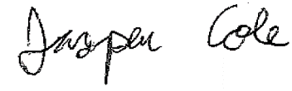 8/25/15
Signed, Researcher 1 (Date) | Signed Researcher 2 (Date)
Signed, Faculty Advisor* (Date)
(If Applicable)
* I have read and reviewed this proposal and certify that it is ready for review by the IRB. I have worked with the student to prepare this research protocol. I agree to mentor the student during the research project.

Appendix D: Consent Form
Whom to Contact about this study:
Principal Investigator: Jasper Cole
Department: Information Architecture and Interaction Design
Telephone number: 443-386-7259

CONSENT FORM FOR PARTICIPATION IN RESEARCH ACTIVITIES

- INTRODUCTION/PURPOSE:
My child, ___________________________________, is being asked to participate in a research study at the University of Baltimore. The purpose of this study is to design better login and password systems for young learners. My child is being asked to volunteer because they are a young learner who uses password-protected systems. Their involvement in this study will begin after I have given consent and when they agree to participate and will continue for up to an hour. About 20 persons will be invited to participate.

- PROCEDURES:
As a participant in this study, my child will be asked to answer some questions about their current login systems and test prototypes for new login systems. They will be asked to come to the University of Baltimore. Their participation in this study will last for the duration of the study – approximately an hour. They may be recorded, but other personally identifiable information will not be included with results or response.

- RISKS AND BENEFITS:
My child’s participation in this study does not involve any significant risks and I have been informed that their participation in this research will not benefit them personally, but the outcome of study will benefit others.

- CONFIDENTIALITY:
Any information learned and collected from this study in which my child might be identified will remain confidential. All information collected in this study will be stored in a locked room. Digital data will remain on a password protected computer. Only the investigator and members of the research team will have access to these records. If information learned from this study is published, neither my child nor I will be identified by name. By signing this form, however, I allow the research study investigator to make my records available to the University of Baltimore Institutional Review Board (IRB) and regulatory agencies as required to do so by law.

Consenting to participate in this research also indicates my agreement that all information collected from me individually may be used by current and future researchers in such a fashion that my personal identity will be protected. Such use will include sharing anonymous information with other researchers for checking the accuracy of study findings and for future approved research that has the potential for improving human knowledge.

Check if images or video are recorded during the research study:

Yes, I give permission to use my child’s image in scientific publications or presentations.

No, I do not give permission to use my child’s image in scientific publications or presentations

Check if voice recordings are used during the research study:

Yes, I give permission to use my child’s voice in scientific publications or presentations.

No, I do not give permission to use my child’s voice in scientific publications or presentations

Although your confidentiality in this study is protected, confidentiality may not be absolute or perfect. There are some circumstances where research staff might be required by law to share information my child or I have provided. For example, if an interviewer has reason to believe a child is being abused (or has been abused), the interviewer is required by Maryland state law to file a report with the appropriate agencies. Similarly, if my child reports that they have been abused in the past, the interviewer may also have to file a report. In addition, if my child is threatening serious harm, it may be necessary for the interviewer to warn an intended victim, notify the police, or take the steps to seek hospital based treatment.

- COMPENSATION/COSTS:
My participation in this study will involve no cost to me.

- CONTACTS AND QUESTIONS:
The principal investigator, Jasper Cole, has offered to and has answered any and all questions regarding my participation in this research study. If I have any further questions, I can contact (Greg Walsh) at (410-837-5473).

For questions about rights as a participant in this research study, contact the UB IRB Coordinator: 410-837-6199, irb@ubalt.edu.

- VOLUNTARY PARTICIPATION
I have been informed that my child’s participation in this research study is voluntary and that I on my child’s behalf or my child at his/her own choice am/is free to withdraw or discontinue participation at any time.

I will be given a copy of this consent form to keep.

- SIGNATURE FOR CONSENT
The above-named investigator has answered my questions and I agree to allow my child/person under my guardianship to be a research participant in this study.

Parent/Legal Guardian’s Signature: _____________________________ Date: _____________

Investigator's Signature: _____________________________ Date: __________________________

Appendix E: Assent Form

I, __________ understand that my mom, dad, caregiver, or guardian has said it is okay for me to take part in this study. I will help design new things that may help other children.
I am taking part because I want to. I have been told that I can stop at any time I want to. Nothing will happen to me if I want to stop.

Signature

Appendix F: Changelog after first KidsTeam

Graphical Passwords for Kids

Changes for 11/5/2015
- Usernames must be less than 10 characters without spaces or special characters
- Added in error messages that tell the user to create appropriate usernames
- Added in error message that tell the user when a username does not exist
- Images replaced with Creative Commons Public Domain images
- Increased to twelve images (previously 6)
- Added in custom alerts that explain the process of creating an account
- Allowed the user to create password hints
- Added in a button that allows them to change hint during password creation and view their hint during login.
- Added in a reset button that lets the user restart creation/logging in
- Added in a button that returns the user to the homepage when they complete account creation
- Added in a button that returns the user to the homepage when they fail log in
- Added in a button that allows the user to attempt again when they fail log in
- Added in fireworks multimedia when the user successfully logs in
- Made click area wider – they must be within 40 pixels horizontally and 40 pixels vertically (20 previously)
- Fixed glitch that caused points to appear off center when the page is scrolled down
- Added in numbers when the user is creating a password so they can see previous clicks
- Added in review-mode where the user has to repeat their password by clicking within circles
- Hid developer button
- Allowed developer to see password hints

Appendix G: Session 1 Testing Script
Master Thesis (Login Systems for Young Learners) - Usability Sample Survey / Interview Questionnaire
Introduction 3-5 minutes
[Greet participant. Direct participant to a seat/computer]

First, I’ll show you this form. It’s called an assent form and you fill it out to let me know that you want to participate in this activity. We can stop at any time and nothing bad will happen if we do. If you don’t want to answer any question, please just say so. Okay?

(explain key points – anonymity & recording) <parents should have already signed consent form>

<Have participant sign assent form>
<explain process>
We are testing a new computer login system, which will make it easier for children to use their computer and protect their private files. You will do several tasks using a version of this system. We want to learn how you use the system so that we can make it better. We are testing the app design and not you or your ability. There is no right or wrong way to complete any of these tasks. If you can’t complete something. It isn’t your fault. We want the system to work for you!

If you find a problem, just let us know and we’re happy to help you with it.

We ask that as you move through each task that you think aloud, or say what you are thinking at the time. For example, if I were to ask you to press a button, you might say “I’m looking for a button that is a square, or in a special location.” When you find it you might say “this is not where I thought this would be” or “I don’t know what to do here.” You can tell us whatever you want, okay?
Do you have any questions before we begin?

Preliminary questions 3-5 minutes
We will begin with a few questions for some demographic and background information
- <Determine gender>
- <Determine ethnicity>
- How old are you? And what grade are you in?
- Do you consider where you live to be urban, rural, or suburban? <may ask parents>
- What online classes do you take?
- What online systems do you log in to?
- Do you have any passwords? <If so,> How many passwords do you have? <try to get them to talk about the number of passwords and login systems they use>
- Do you have different password for each system? <Or do you use the same password for many different systems?>
- Do you ever forget a password?
- What do you do if you forget a password?
- Do you use any other login systems that are different? Have you used any login systems that are interesting?

Activity approximately 30 minutes

Now let’s look at the system. Remember that it isn’t finished, and we are testing the system, not you. Here is the system you will use.

You’re going to visit five websites and you’re going to create an account for each website. You’ll create a username and then you’ll make a password. Once you confirm your password, you’ll log into the account. Afterwards you’ll play a game for a few minutes and then you’ll try to remember your username and password. You’ll try to remember these passwords in two weeks as well.

<show participant the system>

Go ahead and try thinking aloud on the first task, and let me know as soon as you feel that you are finished with each task.

You can create any username that you want. You can use the same username for all the websites, but you don’t have to.

<Let participant create and access accounts for all websites>
<Play game online for five minutes>
<Have participant log into their accounts a second time>

Follow-Up
<if have any q’s> I was interested in why you did ________
<if have any q’s> I noticed you ________. Can you tell me a bit more about that?

General Information

- Did you like the way the system looked?
- What did you like about the system?
- What did you dislike about the system?
- Which did you prefer? The text passwords or the picture passwords?
- What would you like to change on the system?
- Would you consider this trustworthy? Does it seem safe to use?

Wrap Up 3 minutes
Is there anything else that we haven’t talked about? Did you want to say anything else?

<Ask parents for comments or follow up. Remind participant that I’ll see them in two weeks>
<Provide incentive>

Appendix H: Session 2 Testing Script
Master Thesis (Login Systems for Young Learners) - Usability Sample Survey / Interview Questionnaire
Introduction 3-5 minutes
[Greet participant. Direct participant to a seat/computer]

First, I’ll show you this form. I want to remind you that you already signed the assent form. We can stop at any time and nothing bad will happen if we do. If you don’t want to answer any question, please just say so. Okay?

(explain key points – anonymity & recording)

<explain process>
As you already know, we are testing a new computer login system, which will make it easier for children to use their computer and protect their private files. We want to learn how you use the system so that we can make it better. We are testing the app design and not you or your ability. There is no right or wrong way to complete any of these tasks. If you can’t complete something. It isn’t your fault. We want the system to work for you!

If you find a problem, just let us know and we’re happy to help you with it.

We ask that as you move through each task that you think aloud, or say what you are thinking at the time. For example, if I were to ask you to press a button, you might say “I’m looking for a button that is a square, or in a special location.” When you find it you might say “this is not where I thought this would be” or “I don’t know what to do here.” You can tell us whatever you want, okay?
Do you have any questions before we begin?

Preliminary questions 1-2 minutes
- Do you feel like you remember your passwords?

Activity 10-15 minutes

Now let’s look at the system. Remember that it isn’t finished, and we are testing the system, not you. Here is the system you will use.

<show participant the system>

You’re going to log into your account using the usernames and passwords that you created two weeks ago. If you can’t remember your username or password try a few guesses and if you still can’t get in, let me know and I’ll help you access your account.

<Let participant log into all five systems>

That completes that tasks that we have for you.

Follow-Up
<if have any q’s> I was interested in why you did ________
<if have any q’s> I noticed you ________. Can you tell me a bit more about that?

General Information

- What was easier the text passwords or the picture passwords?
- What was the hardest part of this test?
- Did your hints help you?
- Was this fun?
- Was it easy to remember which picture you chose? Why or why not?
- Was it easy to remember the points that you chose on your image? Why or why not?
- What will protect you and your information better? Text passwords or picture passwords?

Wrap Up 3 minutes
Is there anything else that we haven’t talked about? Did you want to say anything else?

<Ask parents for comments or follow up>
<Provide incentive>

