SUPPLEMENTARY MATERIAL

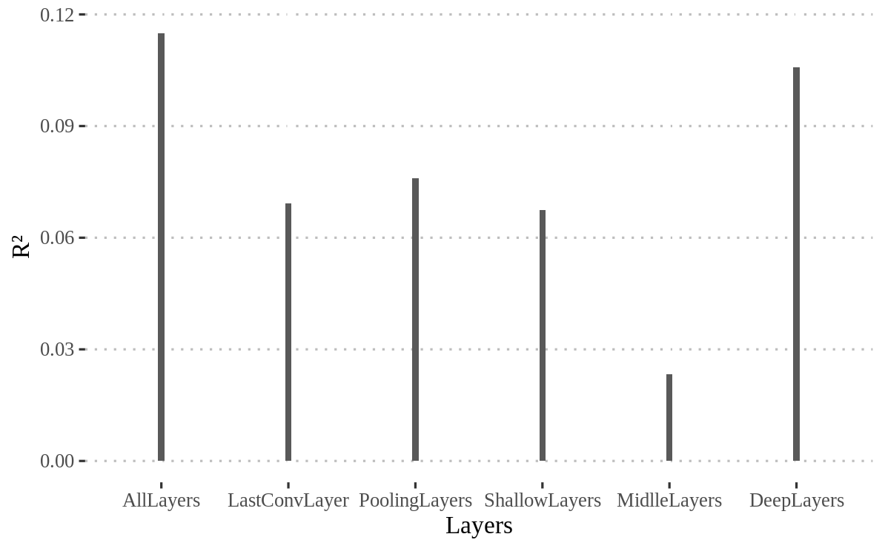
Fig.S1 Comparison of explained variance of attractiveness (R²) using subsets of layers of VGGFace. AllLayers: all available layers of VGGFace. LastConvLayer: layers block1_conv2, block2_conv2, block3_conv3, block4_conv3, and block5_conv3. PoolingLayers: layers block1_pool, block2_pool, block3_pool, block4_pool, and block5_pool. ShallowLayers: layers input_1, block1_conv1, block1_conv2, block1_pool, block2_conv1, block2_conv2, and block2_pool. MiddleLayers: Layers block3_conv1, block3_conv2, block3_conv3, block3_pool, block4_conv1, block4_conv2, block4_conv3, and block4_pool. DeepLayers: layers block5_conv1, block5_conv2, block5_conv3, block5_pool, fc6, fc7, fc8, and flatten.
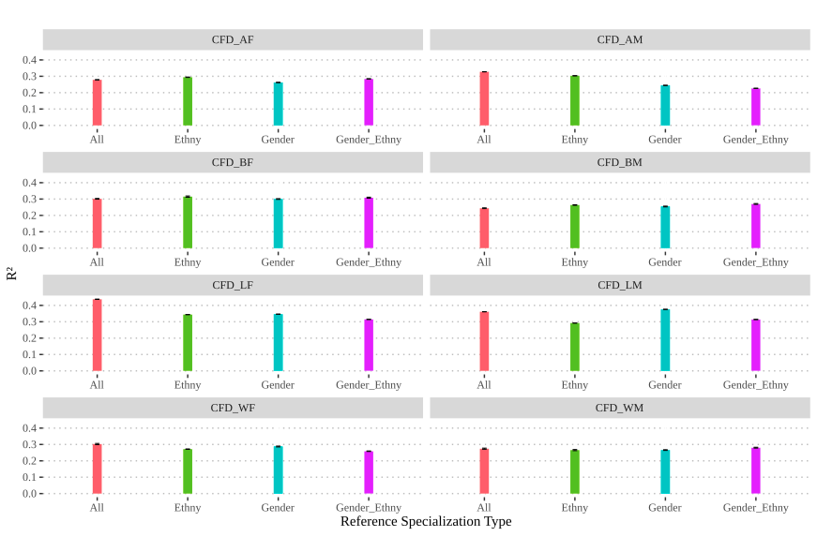
Fig.S2 Explained variance of attractiveness (R²) for the 8 Categories_“ethnicity x gender” from CFD images (CFD_AF, CFD_AM, CFD_BF, CFD_BM, CFD_LF, CFD_LM, CFD_WF and CFD_WM) by reference specialization type – ‘All’ (red), ‘ethnicity'(green) , ‘gender' (blue), and ‘ethnicity x Gender' (pink).

