La Comunità:
Programming for Italian-Americans in Providence, Rhode Island

By
Jamie Asciolla

Submitted in partial fulfillment of the requirements for
Degree of Master of Arts in Cultural Sustainability
Goucher College, Baltimore, Maryland

7/2/2017

CAPSTONE COMMITTEE
Robert Forloney MA, Advisor
Melissa McLoud PhD, Reader
Rory Turner PhD, Reader

Acknowledgement

I would like to sincerely thank my entire committee – Robert Forloney, Melissa McLoud, and Rory Turner for their endless help and guidance with my Capstone project over the last year.

A special thanks to Amy Skillman, Director of the Cultural Sustainability program for her thoughtful insights and advice on the Capstone process.

I would also like to thank the many people who I was able to interview, for without whom there would be no content for this project: Vinny, Anna, and Ralph Gianfransesco, Alba Goode, Irene Rado, Kelly and Kara DeAngelis, Marlena Martino, Mike Iafrate, Joe Tufano, Robert and Jessica Asciolla, Cheryl DiRobbio, and Lia Bellini
Table of Contents
- Acknowledgement …………………………………………………………………..… 2
- Table of Contents …………………………………………………………………...… 3
- Introduction …………………………………………………………………………….. 4
- Literature Review …………………………………………………………….....…… 13
- Reflection ……………………………………………………………………...……… 21
  - Initial research …………………………………………………….…...……. 21
  - Program changes …………………………………………………......……. 24
  - How capstone fits into MACS …………………………………………..…. 35
  - What I learned about project/process ………………………………….…. 39
  - What I learned about myself ………………………………………..……... 41
- Program Outlines …………………………………………………………….……... 44
  - Ciao Italian! A Beginner Italian Language Class ……………………...… 44
  - Musica D’Italia: A Festival …………………………………………….....… 50
  - Cooking on the Hill ………………………………………………………….. 56
- Conclusion ……………………………………………………………………….…… 63
- Appendix ……………………………………………………………………………… 64
  - Field Notes ………………………………………………………………….. 64
  - Transcripts …………………………………………………….…………….. 67
    - Group 1: Gianfransesco Family ………………………….……….. 67
    - Group 2: Friends …………………………………………...…….… 76
    - Vinny Interview …………………………………………………...… 90
    - Family Interview ……………………………………………......….. 96
    - Lia Interview ………………………………………………….……. 100
  - Consent Forms …………………………………………...………...………114
    - Blank Consent Form …………………………………………...…..115
    - Completed Consent Forms ………………………………………..116
- References ……………………………………………………………………….… 130

Introduction
For my Capstone, I researched and developed in dialogue with community members a series of public programs that focus on the Italian-American community in the Providence, Rhode Island area. With the lack of well-marketed and accessible programming for community members in Rhode Island that interprets Italian-American heritage, my project will serve as a model for the various ways that such programs can both serve the community while educating general audiences unfamiliar with this heritage. This is important because culture and traditions are generally kept by individual groups and when that culture is shared, partnerships and networks are formed that continuously keep interest in it alive and thriving. The programs will focus on a variety of topics that were identified through conversations with community members. They will provide educational and engaging opportunities allowing those involved to sustain their culture. The programs have been designed to engage the community in conversations about their identity and representations as well as provide opportunities for community members to share their personal stories with each other as well as to appreciate different aspects of their culture. The goal is that these initial programs will foster increased interest and dialogue within the community. One outcome would be a committee of community members that would convene to plan continued programming and seek resources for such programs and cultural dialogue to continue. These programs would be designed and implemented in the same dialogic fashion as this model Capstone project – a process that will continuously draw inspiration from within the community and help to foster and sustain the Italian-American traditions that the community identify as important and necessary.
Growing up I had a fascination with my Italian heritage despite it not being the most prominent culture represented in my household. My father’s side of the family, had mostly Italian traditions with some French traditions as well. However, since my mother’s family was very large and we celebrated almost every holiday with them, almost all of the traditions I celebrated had an English influence to them. I grew up with a very Italian last name, in a very culturally Italian town, and even looking very Italian. From the time I was in middle school I began to study the language, even turning it into one of my majors for my undergraduate degree at the University of Rhode Island. Even when entering Goucher, I could not shake the immediate claim that I was an Italian-American. People have always assumed that all my relatives are Italian, that I am Catholic, and that I fit into the stereotypical mold of being an Italian-American from Rhode Island. While I do not fit that mold precisely, everyone I know has some Italian in them. There is so much history of Italians in Rhode Island and we are known for having our own “Little Italy” on Federal Hill.
Federal Hill is the center of all things Italian in Rhode Island. The best-known Italian restaurants are there. It is the place where many Italian-Americans got their start prior to moving to the neighboring suburbs. It is where many Catholic churches are located. These churches still hold mass in Italian and have large feasts that honor various saints throughout the year. Many families also got their start in America by living on the Hill and eventually being able to afford to move to the neighboring towns of Johnston, Cranston, and North Providence, where a significant portion of the population identify as being Italian-American. Italian-Americans lived in tenant housing and worked as masons, factory workers, farmers, and other jobs that were not as appealing to other Americans. The Italian families were able to form a close-knit community full of their own traditions. For example, going to church was a significant part of life, not just because of the religious aspects but also due to the social aspects of feasts, dances, and singing. The families also shopped at the outside food vendors that served traditional Italian meats and cheeses. In the last forty years, there has been a shift in the demographics of the residents, from a neighborhood of immigrant families to a neighborhood with various college tenants and upper middle class families. Similar to other immigrant neighborhoods, the area has experienced gentrification over the years with families who have lived there for over fifty years being forced to move because the cost of living is too high. While there are significant efforts to give Federal Hill its reputation as being “Little Italy,” there is also a clear mix of the different cultures that remain. For example there are Mexican, Japanese, and American restaurants that are interlaced between the many Italian restaurants on the Hill.
Despite the rich history and traditions of the area, as well as its current reputation, there is a lack of accessible community programs in the area. Community programs are important because they allow for the process of planning and executing of a program to be for and by community members. They allow for community members to have some involvement, either in planning or participation that keeps the cycle of interest present and thriving. “Community-First Program Design” is a way to bring programs to a community that are designed by the wants and needs of a community from extensive conversations and partnerships with different community members. By having community members involved from the beginning and having them an active part of the partnership, interest in the programs will most likely be genuine and abundant because we are all working together for a common goal. This idea of personalizing the programs is an effective way to reach many people who all have slightly different levels of interest. There are church events and feasts a few times a year but there is nothing that is constant in the area that caters to or is about the Italian-American community.
For the purposes of my project, “community” is a term used for people who identify as Italian-American in the Greater Providence Area. Since not all the people I interviewed live in Federal Hill, but many in the nearby suburbs, I could not limit the definition of community to those who have lived or currently live in the Federal Hill area. I also am not limiting it to those who identify solely as Italian or Italian-American since many people celebrate multiple cultures in their lives. It is interesting to note there is a difference in how people perceive Italian culture and Italian-American culture. Generally Italian culture stems from those who are from Italy directly while Italian-American culture stems from a blend of Italian culture from previous generations and the American culture. Personally, I identify as an Italian-American because my great-grandparents emigrated from Italy to America; because I am not from Italy myself, I would not say I am Italian. However, I interviewed many different kinds of Italian-American community members for this project including those who emigrated from Italy to America - Anna and Ralph Gianfransesco, Irene Rado, and Alba Goode; first-generation Italian-Americans - Vinny Gianfransesco, Marlena Martino, Cheryl DiRobbio, and Lia Bellini; and second, third, and fourth generation Italian-Americans - Kelly, DeAngelis, Kara DeAngelis, Joe Tufano, Mike Iafrate, Jessica Asciolla, and Robert Asciolla. During my interviews, there were many times when they would state something about “being Italian” despite my mentioning of being “Italian-American” or the “Italian culture” that was in the area. Jessica Asciolla also mentioned that she does not like to tell people she is Italian because of her experience going to Italy and realizing the differences between Italian and Italian-American culture.
I first began to research the area of Federal Hill and the Italian community that came to live in Rhode Island to get a general understanding of their background. I also looked into different programming such as lectures, film nights, cooking classes, festivals, feasts, etc. from different colleges and universities, Italian-American and non-Italian-American social clubs about other ethnic communities in the area, as well as other programming for Italian-Americans elsewhere in the country. Some local organizations such as the many Italian-American social clubs in the area had details about events they have previously done. However, there was little information available online about any events that might have happened in the past or planned future events. I tried numerous times to contact them via email and telephone but received no response. I also know from firsthand experience about the different feasts and parades throughout the year but they are the same every year and there are only a few a year. I was hoping to find information about different events other than feasts and festivals revolving around churches and saints. Through my research I began reaching out to different organizations that was not as effective as I had hoped. My emails and phone messages went unanswered despite reaching out at different times and by different methods. Looking back, it may have been the wrong time of year or they may have had no interest into helping with graduate research. In hindsight, I would have sounded less academic in my emails and maybe attempted to visit in person during business hours. I therefore turned to people I knew in the community for help, which proved to be successful.
For my first interview, I contacted my friend Vinny Gianfransesco because he comes from a large Italian-American family, and asked if I could speak with some of his relatives about their culture. I was able to speak with Vinny, his wife Kelly, his parents Anna and Ralph, his maternal aunt Alba Goode, and his paternal aunt Irene Rado. From this interview, it was evident that there were some aspects of the Italian culture that were very important to them: language, food, and music. Using the knowledge gained from the first interview about those valued topics, I developed and designed three programs that were subsequently redesigned and structured based on the four following interviews with different community members. My hope is that these three programs will be the basis for other programs that are developed in partnership with the community and various other organizations in the area. The overarching goal of the programs will focus on sparking a dialogue about representation and ethnic identity between different target audiences, and to build upon the aspects of their culture of which they are proud. These programs will be marketed to include many different people in the community such as children, students, adults, educators, seniors, first-generation Italian-Americans, recent immigrants, and even non-Italian-Americans or non-community members.
I did not want each program’s intended audience to be so limiting that only a handful of people could participate. I really wanted for all community members to feel that the programs were something that they could do and feel comfortable doing. Therefore the programs are geared towards multiple kinds of people. The details of each program were added from each interview that I had with different people in the community. During each interview, I had introduced the programs, explained how they were going to run, the goals of the program, and how they had been changed from the previous interviews. While we talked, certain details were focused on, questioned, added, or taken out. From there I would restructure what I had drafted from before to include those edits and repeat the process with others until I felt confident that the programs were representative of what the community was aspiring. I also interviewed my family, some of my friends, some of Vinny’s friends, Vinny, and my friend Lia Bellini who owns a restaurant on Federal Hill. With a multitude of different types of community members, I aimed to get a sampling of the kinds of people in the community.
My goal is that these programs, if implemented, would bring the community together to celebrate the Italian culture and with additional programming, be able to foster a dialogue about Italian-American representation and identity. The field of Cultural Sustainability works to help communities work together to sustain their culture and with these programs I want to create a space and sense of community that will grow and continue beyond these programs, to truly promote the strengths of the community and help them sustain their traditions. With the programs designed based on conversations with community members, there will be an interest among those who participate to want more and diverse programming about other aspects of the Italian-American culture. The city of Providence is a diverse place, containing a lot of history and notoriety of Italian-American culture, but these are not currently accessible to the public through interpretive opportunities. The programs I designed in conjunction with some members of the community will hopefully provide a basis for future programming based on community collaboration.
One of the questions that frames the field of Cultural Sustainability is “How can we work with communities in identifying and nurturing traditions of knowledge and practice that are meaningful and valued by those communities? In other words, how can we help to sustain culture?” This question truly guided me through all of my work for this project from interviewing different community members to incorporating their feedback and ideas through each program redesign. Despite being a member of the community myself, I frequently had to ensure that I was constantly thinking about their feedback and working to make sure that their ideas and voices had a part in each program. As an Italian-American, I have my own ideas about what is missing and what I find important about the culture but I had to remind myself that not everyone has the same viewpoint that I do nor the same ideas. I also consider myself to be an outsider because I am not fully Italian-American, I was not raised predominantly in the Italian-American culture, and I do not live on Federal Hill. From the initial research that I conducted on the Italian-American community and the area of Federal Hill, I was able to pinpoint key components of what was important in the culture. These selected components were further identified in my conversations with community members because they are what is important to sustain in the culture. I believe that these programs will work in part to open a partnership with the community that will further produce programs that specifically focus on identity and representation within the Italian-American community in Rhode Island.
Literature Review
Bojer, Marianne Mille, Heiko Roehl and Marianne Knuth. Mapping Dialogue: Essential Tools for Social Change. Chagrin Falls, OH: Taos Institute Publications, 2008.

This book was an excellent resource to learn the different ways of facilitating dialogues and the different techniques to do so. Prior to reading this book, I was aware of that there are multiple ways of facilitating a dialogue but learning about their strengths and weaknesses along with multiple other ways was a great insight for my work. While I did not implement any specific dialogue type, I did use the tools for formulating appropriate questions, creating the space, and facilitating the flow of the conversation. This book was used for CSP 628 Principles of Cultural Mediation and was a great tool for learning how to facilitate and participate in dialogues with different groups of people. I think it is a great building block for jump starting dialogues within communities both small and large.

Borrup, Tom. Creative Community Builder’s Handbook: How to Transform Communities Using Local Assets, Arts and Culture. Saint Paul, MN: Fieldstone Alliance, 2006.

This book was such a great tool when taking CSP 615 Cultural Partnerships because it laid out formats on how to approach creating a partnership within the community. There are so many aspects of a culture that people adapt and make into their own, that when planning an event for the community, it is important to know what they value as important. The book details methodologies of how to approach partnerships and execute them in a way that is beneficial to the community. There are multiple worksheets throughout the book that really helped me to make sure I was as transparent as I could be and building upon the strengths that the community has. A significant portion of successful dialogic programming comes from the ability to form strong partnerships and this book has the necessary information to begin to form those partnerships.

Carbone, Stanislao. "The Dialogic Museum and Ethnocultural Diversity." Canadian Ethnic Studies 37, no. 1 (January 2005): 127-136. https://goucher.idm.oclc.org/login?url=http://search.ebscohost.com/login.aspx?direct=true&db=a9h&AN=18678588&site=ehost-live&scope=site

From other sources and classes I have taken, dialogue is such a strong component in culture and community relations. Carbone really emphasizes that having a dialogue between the community and the museum will really enrich the experience of the museum goer. To ensure authenticity, community members must be involved in critically thinking about what is important to them and what cultural aspects make them different from other communities. Despite not being partnered with a museum to fully incorporate these programs, the importance of give the community a voice is stressed in this piece. As an individual conducting the interviews, I must set aside my preconceived notions about the community and really listen to what the others are expressing concern for, and really take their words into consideration. The idea of “professionalism”, that I have a better understanding of what the community needs was something I did struggle with a few times, and I really had to take a step back and listen to what the community members were sharing with me.

Chew, Ron. “Five Keys to Growing a Healthy Community-Connected Museum.” Community Arts Network, Reading Room, 2005.

Despite the piece being geared towards growing community involvement in museums, I still found the content very relevant to my project. The five keys: stretch the boundaries, make the institution’s programs relevant to today’s issues and needs, grow your diversity, allow young people to rise to leadership, and five, invest in long-term relationships, all related to some aspect of my work. When I first began talking with community members about the programs I had been thinking of, I quickly realized the audience of some of my programs may be a bit narrowed. From these conversations, it also brought to light how, if done, the programs would be modified based on input from more community members. From the work done at the Wing Luke Asian Museum, it is clear that community involvement really provided and went beyond the success they were hoping to achieve. Having young people interested in learning about culture and wanting to participate, and then including them in doing so, built a foundation for growth and success and gave them an edge that has allowed them to become a model for how to grow. My hope is that this example will serve as a model for the programs and while dialogic program is not an exact science and there are multiple variables, the basic ideas presented will help guide the partnerships that are formed and help carry other programs that are built from those partnerships.

Federal Hill Providence. http://federalhillprov.com/

The website for the businesses of Federal Hill was a great introductory source to help me understand what businesses are located there and an overview on exploring the community. On the site, there are recommendations for what hotel to stay in, where to eat, where to shop, what to visit, that all pertain to some aspect of Federal Hill and its significance to the Italian history of the area. The information about the different events that the Federal Hill Commerce Association (FHCA) hosts also bettered my understanding of what types of events the community already has. For example, their biggest event of the year is the Columbus Day Festival which is hosted over the entire weekend consists of live music from local artists and authentic food from the local Italian restaurants. It was helpful to know exactly what is already done for the community and be able to alter my ideas to be different, instead of just repeating an event that is already done. However, there could be more that is added to different sections such as becoming a member despite not being a business or about how the current programs they have were developed. They seem to present information about attending and how to join as a business partner but not as a volunteer or something similar. I tried to contact them for more information about what they do and did not hear back. When I mentioned this to Lia Bellini who’s restaurant is a member, she mentioned that they are not the nicest people to deal with.

Fuoco, Joe. Images of America: Federal Hill. Charleston, SC: Arcadia, 2004.

The collection of photographs presented in the book provided an insightful look at the history of Federal Hill and the Italian-Americans that lived there in the early to mid-20th century. The photographs highlight the daily lives of Italian-Americans, as well as special events such as weddings, holidays, and church activities. It provided a good look into the past and really helped me to better visualize what life was like for Italian-Americans. It was interesting to see how certain aspects of the culture have changed and how some have stayed the same. For example, the large family gatherings that occurred during times of celebration still happen today. However, buying food from street vendors is not a common practice on Federal Hill anymore, and instead they have specialty stores to do so. These images can serve as talking points for community members to express where their interests lie. I used this book in my interview with Lia Bellini to inspire the conversation.

Graves, Bau. Cultural Democracy: The Arts, Community and the Public Purpose. Urbana and Chicago: University of Illinois Press, 2005.

Until I read this book, I was unaware of how impactful a community can be on a project and vice versa. Thoughtful collaborations and partnerships help to provide a well-rounded product for all to be involved in. I knew from the start that what the community members I interviewed said, would influence the programming I was looking to design, but the topics and questions I was bringing up also sparked some curiosity in them to better understand what it means to be Italian-American. While I became aware of what aspects of culture they were looking for more of, they also began to think about their own identities and what was missing for them on that cultural level. Graves keeps a focus on delving into “neighborhood culture” which I found really relates to my work because many of the Italian-Americans I interviewed and some I know personally, all have some connection to the neighborhood of Federal Hill and it has shaped their identity, however small, as an Italian-American. In chapter 3 “Presentation and Participation” Graves writes that the ideas of presentation and participation coincide in a cycle with each other. During a performance, an audience member views the presentation while the performer participates in it and their takeaway from the performance is different from the other. There is a frame for the performance which allows for the experience to be reflexive because one “must cut out a piece of itself for inspection (and retrospection)” (83).

Hein, George E. Learning in the Museum. New York, Routledge, 1998.

While the book mainly concentrates on museums being a tool for learning, I still found the later chapters to be very informative. Chapter 7: Evidence for learning in the museum and Chapter 8: The Constructivist Museum both had sections that could be restructured to fit programming instead of exhibits. There are different types of visitors to a museum and keeping this idea in mind of those who attend programs, it made me conscious when thinking about my designs for programs because they would have to be something that everyone could enjoy, instead of a select few. By keeping it open and available to all, more people would be able to come, learn, and enjoy themselves to the point that they would attend again. I particularly like the section in Chapter 8 that discussed associations with place and how a person views a building can determine their experience. Finding a place for the programming would be a critical component because of the history and importance of different places in and around Providence.

Iannuccilli, Ed. What Ever Happened to Sunday Dinner? And Other Stories. Lexington, KY: CreateSpace, 2012.

Family is an important part of Italian culture and being able to spend time with one’s family, particularly around food, is a traditional Italian custom. Iannuccilli recounts personal stories of what life was like growing up in an Italian household in the 1940s and 1950s in Rhode Island. Since it was very personal stories, there was little about the community and programming. However, some of the stories presented are similar to experiences that I have had and some that others have had. For example the sense of community that is recounted is similar to the interviews I did. Being a part of an Italian-American neighborhood meant that everyone was familiar and similar to each other. It was when people moved away from these clusters that they realized their differences and they tried to assimilate and change. This kind of book would be a great way to jumpstart others talking about their family traditions and what they value as important.

Karp, Ivan and Christine Kreamer. Museums and Communities: The Politics of Public Culture. Washington: Smithsonian Institution Press, 1992.

Similar to the other sources regarding museums and communities, the themes of dialogue and understanding are key to successful museum exhibits, programs, and experiences. Many of the essays discuss examples and techniques on involving the community in the planning process and it was interesting to see the wide variety of the types of museums and communities that worked together. I was reminded of many of the components of the essays throughout the process and tried to keep an open mind when it came to hearing criticism from the community members. It was a great learning tool for me to be able to critically think with them about what was important about their culture that would be celebrated by all the others who I could not speak to. John Tchen’s article discusses the process that the Chinatown History Museum underwent to create a dialogic exhibit that focus on the telling of the history of Chinatown through its community members. Staff at the museum made it their mission to go out into the community to have conversations with community members about what was important to them about Chinatown’s history, lifestyle, and culture. By speaking with the community, the museum was giving them a voice. This is very similar to what I have done regarding the programs I have designed in collaboration with community members. Guillerno Gómez-Peña’s article “The Other Vanguard” discusses the complexity of border culture for Mexican-Americans along the U.S.-Mexican border. Their culture is a mix of the two worlds in which they come from and this is the same with the Italian-American culture in Providence. For so long, Federal Hill was home to Italian immigrants who established cultural practices that were from their homeland but they also had to adapt to becoming Americanized. There is a hybrid of American customs with certain Italian customs which have been altered from being completely regional customs to being identified as a whole, solely Italian. Gómez-Peña discusses how border culture must be a blend of many aspects, an all-encompassing culture that must be multiple facets at one time, being unique but conforming to the ideals around you, despite there being two or three or more. This ideal was a constant in my mind and I tried to separate the different regional qualities that people might have but found it overwhelming and time consuming.

Muratore, Joseph. Images of America: Italian-Americans in Rhode Island Volume II. Charleston, SC: Arcadia, 2000.

Like Fuoco’s Images of America, this book also uses photographs to visually narrate what life was like for Italian-Americans throughout the 20th century. Unlike its companion book, the captions of the photographs in Muratore’s work are substantially more descriptive. The photos highlight the life for early immigrants, the importance of family, music, dance, church, clubs and organizations, veterans, and the contributions of Italian-Americans to the state of Rhode Island. The whole book shares the theme of keeping deeply rooted traditions alive and prosperous. Once again, compared with the conversations with community members, I can see how important it is to keep traditions alive, at the same time that people struggle to hold onto old ways as the world changes around them. For example, the importance of church is stressed, not only for the religion but for the social aspects of it. In today’s day and age, many young people struggle to find a connection to religion or even the time to go to church.

Raben, Jonathon. Italian-Americans and Federal Hill: Rhode Island’s Little Italy. Providence, RI: Seven Fishes Productions, 2006.

Written to accompany the film, Italian-Americans and Federal Hill, the book gives a brief history of Federal Hill, the immigrants that came, the language and culture, and how life has changed over the years for the Italian-Americans that have since moved away from Federal Hill. It also includes maps and advertisements of the different businesses and people that financially contributed to the making of the film. It was interesting to see the scope of the people that wanted to be involved in the making of this work and how the community came together to make this project. While I did not see the film, the book provided a strong historical background that once again showcased the importance of traditions and the pride that the community has over their Italian heritage. I would have liked to see quotes from the local community members who they interviewed for the film, instead of just picturing them. This book definitely served as a tool for understanding more of the background of Federal Hill and explained the changes that have happened to the community within the last thirty or so years.

Santoro, Carmela E. The Italians in Rhode Island: The Age of Exploration to the Present, 1524-1989. Providence: Published jointly by the Rhode Island Heritage Commission and the Rhode Island Publications Society, 1990.

This book certainly helped with background research for Federal Hill and Italian-Americans in Rhode Island. It specifically points out various places and people that hold a significance in the identity of Italian-Americans. For example, during my first interview, it was mentioned that Ralph and Anna Gianfransesco had been active church goers of St. Ann’s and Holy Ghost Church, respectively, which was detailed in the book as being two of the more prominent Italian churches of Providence. It also detailed the hardships and struggles that early Italian-Americans faced and how the state’s demographics have shifted over the years to being predominantly Italian-American. While I knew some of the history of the community, it was interesting to see numerical data and specific examples of change.

Sciorra, Joseph. Built with Faith: Italian-American Imagination and Catholic Material Culture in New York City. Knoxville: University of Tennessee Press, 2015.

Religion is such a large part of Italian culture but with the ever changing flow of daily life, younger generations have spoken about turning away from the Catholic Church simply because it does not embody who they are as a person. Sciorra’s work which was done over a period of time from the 1970s to 2010s has used accounts from local Italian-American Catholics in New York City. He conducted these conversations from formal interviews to quick conversations on the sidewalk. One of the first points that Sciorra makes is how hard it was to make the distinction between “conversation” and “interview” since the flow of topics can and did change quickly over the short period of time (xxxvi). This stayed with me throughout most of my work because I wanted to feeling on the interviews to be informal and flow like a conversation, so that the interviewees would feel more comfortable and honest.

Simon, Nina. The Art of Relevance. Santa Cruz: Museum 2.0, 2016.

Relevance is a tricky subject because one item, idea, concept, person, can have a different meaning depending on who you are speaking too. This was very clear when I was conducting my interviews. For example when it came to wanting to learn Italian, the interviewees who were closer to my age all expressed some interest in wanting to learn, whereas when I interviewed my father, he had no interest in learning Italian. Simon does an excellent job in differentiating between the “needs” and “wants” of a community which really helped me in designing programming based of on the conversations I had with different community members. I was able to understand what parts of their culture they were proud of or missed or were impartial to, and think about how the community would feel if certain events were done or not done. Obviously not everyone holds aspects of culture to the same relevance, and it must be taken into consideration that not everyone would enjoy the programming and not everyone will take away exactly what I hope they would take away from a program. This book was such a great reference because she stresses the importance of “Community-First Program Design” and how the programs that are designed must be done so by the community and something that can be personal for many people at the same time (99).

“2015-2016/2016-2017 Events.” Montclair State University. The College of Humanities and Social Sciences: The Italian Program. 23 March 2017. http://www.montclair.edu/chss/inserra-chair/events/

This is a list of programs that MSU has put together in correlation with the Italian program. The programs all have to do with some aspect of literature, language, and culture. The programs have speakers and presenters that are experts in their chosen fields. Some events are part of a series such as “Critical Made in Italy” which was designed by the Chair of the program to explore various aspects of the culture. The program pages lay out the agenda of the event, biographies of the speakers, the inspiration, and the resources for the event. Some of the programs allow for students to participate prior to the event and even at the event. Based upon my inspection of the program, the events seem to correlate with what the students are learning. These programs have served as a good example of a format on how to present the programs that I have designed in correlation with conversations with members of the community.

While each source is excellent on its own, the combination was a tremendous help to learn more about the community, dialogic programming, community-based program development, and how together, they can impact Cultural Sustainability. I was able to pull from many different sources and make connections between them to learn how to design dialogic programming as well as its importance. Being able to create and access dialogic programming allows community members to be directly involved in the process and the ability to become of reflective of their own identity and culture. Through the process of sharing our own identity with others, people are able to make connections that strengthen the culture of the community of which they are a part. This is particularly important for the field of Cultural Sustainability because it allows for community members to become an active part of the cycle of keeping their culture thriving, either by being involved in the planning and designing of a program or by participating in it. Community members are not required to be completely invested in every program or even attend every program, but by having that awareness that these kinds of programs exist, it increases the impact of sustaining their culture and traditions.
Reflection
A. Initial research
The original idea for my capstone was very different. I wanted to write a research paper that compared the differences and similarities of community engagement between for-profit and non-profit museums. With the advice of my advisor and committee members that idea was put aside and I adopted a new idea. At first I could not think of another topic. Then I spoke with Amy Skillman, the Director of the Cultural Sustainability program. She reminded me that in the class Introduction to Cultural Sustainability, I wrote a paper about the cultural practices of Italian-Americans in Boston, Massachusetts. The Italian-American culture is very prominent in Boston’s North End and would have been an excellent choice to speak with community members. However, I feel more of an outsider than insider in relation to that community. I was more comfortable changing the location to Providence, Rhode Island because it is closer to home and already a part of my identity. With help from my advisor Rob Forloney, I was able to form a basis for a new proposal that focused my Capstone on designing public programming for the Italian-American community of Providence, Rhode Island through conversations with different community members. I was able to secure Melissa McLoud and Rory Turner as my two readers. With the initial parts in place, I began to work on my project starting with background research of the area and Italian-Americans in Rhode Island.
Many of the books that I found through the public libraries of Rhode Island were general information about Italian immigrants in Rhode Island in the early 1900s when they began arriving in the area. The Images of America books provided good background knowledge accompanied by photographs, most of which I had prior knowledge. The books all contained similar aspects of the culture such as language, food, marriage customs, traditions, daily life, farmer’s markets, street vendors, jobs, social clubs, etc. Through these sources I was able to get a good basis for what life was like for Italian immigrants as well as first and second generation Italian-Americans in the Providence region. All of the books touched upon the area of Federal Hill, which is Rhode Island’s “Little Italy” and how the area had its origins in the Italian culture as well as how it continues to be the epicenter of Italian culture in the state. It was very interesting to learn more about the local history because so much has changed over the years such as the architecture and the demographics of the population. Most notable are the farmers markets and pushcart vendors that used to be how Italian-Americans would get their food. The area is now a place where many cultures are mixed together but the Italian culture still predominately shines through. From personal experience, it is a place where anyone can go to celebrate the Italian-American culture and feel completely welcomed. Many people frequent the Italian restaurants because they feel that the food and atmosphere are authentically Italian.
During my research on Federal Hill, I could not find any information about events that are currently active. I found a few pages online that discuss the few events that happen every year such as the summer feast, the Columbus Day feast, and the parade for St. Joseph but there was hardly anything else. Many of the larger social clubs and societies, such as the Italo-American Club of Rhode Island and the Italian-American Historical Society of Rhode Island, had event pages on their websites but no events posted, either previous or upcoming. It was evident from the beginning that there was a lack of programming for the community. Since there were no programs in the area to use as examples, I began researching other community programs elsewhere in the country. At first I searched for programs that involved other cultures but found the results overwhelming, so I narrowed the focus to just programs involving Italian-Americans.
I was able to find programming that was based mainly on colleges and universities. This is probably because many schools offer degrees in Italian and support events that will help the students have real world experience with the Italian language and culture. There were different lectures, guest speakers, workshops, and other programs that were more academically based. While I was attending the University of Rhode Island, the Italian department would have different events each semester such as movie nights, food nights, Italian authors speaking, panels of Italian scholars, etc. which meant to promote learning outside the classroom. The community programs that I found were events such as feasts and parades for different saints, which are similar to the events that happen around Federal Hill. I wanted to have programs that were unique to the area but still similar so that people would not be afraid to try them. However, it seemed that any program that was designed would be unique because there were hardly any existing programs.
When it came time for the first interview with different community members, I wanted to ask questions that were broad in order to leave room for a wide range of possibilities for ideas of programs. The questions mainly focused on how and why each member identified as being Italian-American and what was important to them culturally. As the interviews progressed, there was more focus on the programs that had been designed and what aspects could be changed or were thought to work well. It was during the second interview, where I first introduced the programs that were inspired by the previous group interview.
B. Program changes
From my initial research into the different programs that were offered in the area, it was very clear that there were many exclusively available to the Italian social clubs throughout the area. The events that they hosted, that for some were very few each year, were really for the members of the clubs and their families. The few events in Federal Hill and the surrounding towns that were for the general public were feasts celebrating different Catholic saints. There was really nothing else offered. This made me think about what the community was missing and what they were looking for in programming. The programs were designed from interviews with various community members and altered as each interview happened to include the feedback from the previous interviews. In all I interviewed a diverse range of people that I feel is a suitable sampling of the community. I was able to interview four older people who came from Italy as children, Anna and Ralph Gianfransesco, Alba Goode, and Irene Rado. I was also able to interview second and third generation individuals who were around the same age as the first four, Cheryl DiRobbio and Robert Asciolla. Despite being similar ages, there were differences in the generations as well as similarities. The others that I interviewed fell between the ages of 23 and 27 but were different generations of Italian-American. It was interesting to learn that they did not prioritize the same aspects of the culture. For example, my sister thought that the food program was a great idea because food is such an important tradition for her while Kara DeAngelis who is a fourth generation as well, expressed that she had a lot of interest in continuing to learn the language. I was initially worried that I was not going to have enough information from the interviews to develop well rounded programming, but the conversations were all meaningful and the community members had a lot to share. After five interviews with the different people who all identified as Italian-American, I was able to incorporate what was deemed as “missing” or “lacking” in the community as well as how the programs might be received by other people in the community.
For each interview, I wanted to get a better understanding of what being Italian-American meant to different community members. With some of the community members being from Italy and some being born in the United States, I was aware of the differences of being Italian vs. Italian-American. However, whenever there was mention of the culture, it was almost always referred to as “Italian” rather than “Italian-American”. For some of those who were being interviewed there was no distinction between the two while for others there was a clear separation. For the first interview, this understanding was especially important because what was said became the foundation of the programs. While I did not record the interview, I did take detailed notes about the conversation. During this first interview I kept the conversation around the questions I had written prior to starting, but as the conversation flowed, I let us drift off topic a few times simply because the stories they were telling were intriguing and even amusing. The conversation ranged from a variety of topics such as their different upbringing from Italy to America, what school was like, learning English, the different customs and traditions that they had growing up and that they did while raising their families, how they keep those traditions alive through cooking, being a part of a social club, celebrating with family, etc.
With so many topics to choose from, I decided to focus the programs around language, music, and food as those three really stuck out to me due to the fact that they were referenced in my research and mentioned at some point during each interview prior to discussing the program ideas. It would have been interesting to design a program that focused on social clubs and maybe have more interaction between them, other than a bocce tournament, but I was unsure how to contact other clubs, as well as dealing with some clubs that are male only such as the Fontegreca Club among others. I also did not focus on social clubs because not everyone who identifies as Italian-American belongs to a social club and planning an event that focuses solely on members was not as inclusive as I would have liked.
At first I wanted the programs to be more academically-based, having a focus on having a conversation around a certain subject such as representation in film and media, or a lecture on the history or Italian-Americans in Rhode Island. However, if I had chosen to focus on a more formal and academic setting, I would be narrowing my target audience. This was brought up in my second group interview when I asked if having an academic type of event would be a good idea to which Kara and Vinny commented that it would be harder to get people to be interested in an academic event. Vinny mentioned that younger generations might see it as more school, while Kara mentioned that the older generations that she knows do not have an academic background so getting people to come might prove harder than another kind of activity. This took a lecture or similar type of event off the list for possible programs for the Capstone. I am not ruling it completely out because while I was in school, I went to as many academically related lectures about the Italian culture for the sake of learning. I attended panel discussions about Italian women authors, I went to an Italian comedy show, movie nights where we discussed the representation or history of Italians in the film, conversation hours, and sometimes informal game nights that tested how quickly I could think in Italian.
During the first interview, Anna Gianfransesco mentioned that she wished she had somewhere or someone with which to speak Italian. She wanted the chance to relearn how to say certain things which she forgotten as she has been in the United States for over 40 years now. When raising her sons, she and her husband Ralph decided to not teach them Italian and only spoke English at home. While their sons did pick on some words, Vinny expressed that he would have loved to learn the language growing up and thinks of it as a “missed opportunity.” This was also something that I personally connected with because growing up I would hear stories about how my dad learned some Italian from his grandparents but never enough to be fluent or teach me. This was what inspired me to study Italian in high school and eventually in college.
In my second interview, the group all expressed that they would like to have a chance to learn the language because they either never learned it or studied it in high school many years ago and have not used it since. When I told Lia Bellini about the idea for this class she was very excited because she only speaks dialect and does not know proper Italian grammar or words and would like to learn it. She also expressed that she knows people in the community who have hired private tutors to achieve this goal but it is very expensive and not a luxury that many people cannot afford. When I researched how much a private tutor cost, the average for an hour session was between $50 and $100. There were many options to choose from such as one-on-one in person, on the phone, or video chat, as well as small group options online. Having weekly lessons can be expensive but learning it for free on your own is very challenging, especially if you have no one with which to practice or to correct you. Even just taking one language class at the Community College of Rhode Island can cost someone close to $1000 in tuition and fees and one must organize their schedule on when the class is being offered which is mostly likely during the day when many people work.
After the first interview, as I thought about how to incorporate language into a program, I was inspired to design an Italian language class. I initially designed it to be an hour long, once a week class that lasted for 3-6 months and was targeted towards those who did not know any Italian. When I presented this idea during my second group interview, it was very well received because learning the language was something in which they expressed interest. I really wanted the class to be a place where people could come together to learn a language in a space that was both affordable as well as convenient for them. We did discuss adding a bit of Italian history into the class as well which could be incorporated when learning vocabulary and verb conjugation. We also discussed how comfortable people would be paying a fee of $100 and they agreed that if the price was reasonable that others would see the value of taking the class. The length of the class was also changed because Vinny mentioned that an hour might be too short and if it was longer, people could get more work done and stay more committed to learning the language.
When I presented the restructured idea, a longer class time with some focus on Italian history, in the interview with my family, my sister thought it was a good setup because many adults do not want to sit in on a college class, or even pay for a college class. My dad discussed the challenge of dialects, which was also mentioned in the second group interview. It was a valid point to bring up and I explained to him that many dialects are similar because when I studied in Italy, despite not speaking a dialect, I was still able to communicate with those who did because of how similar the words are and by the context of what is being said. I can understand that this may be a challenge for those who take the class who already speak dialect and would have to be addressed with the instructor of the class in the moment. Italy has many dialects but with the words being similar, I do not see it as that much of an obstacle.
Lia Bellini also mentioned this when I interviewed her because she speaks dialect Italian but does not know how to speak the national Italian. However she expressed interest in learning as she wished for her daughter to be able to learn from her. Many people she knows speak some form a dialect but have expressed an interest in learning the national Italian. Lia also mentioned that her cousin has an Italian tutor who teaches the national Italian but since it is so expensive, not many people can afford it. When I presented the program idea and mentioned that it would probably be between $300 and $400, she thought that was an affordable price for the amount of time being spent in a class. She also mentioned that there would be a lot of interest for a class like that because people she knows have expressed that interest. This made me think about how to compensate for a large interest in the program should it ever be implemented and I honestly could not think of anything other than offering a second class at a different date and time. However, that would only have to be discussed should there be an excessive demand. Lia also mentioned that there are many places around the neighborhood that have space to host the class. Upon my internet search I could not find anything that might be offered free of charge which led me to budget for expenses to rent a space in the Providence area. If ever implemented, research would have to be done to locate a low-to-no budget space, so that the cost of the program could be lowered or these funds used to cover more supplies.
In the first interview music was also mentioned as being part of the different traditional parties and events as it was its role in dictating how they behaved and lived. They had to dress a certain way, speak a certain way, act a certain way depending on where they were such as church or at home, etc. There was also mention of how important it was to pass on traditions to future generations that got me thinking about having a musical event that was targeted towards children. Anna and her sister had mentioned that a lot of what they had learned was from their older relatives as children. I thought about how children today might learn traditional Italian folk songs and stories. I designed an event that focused on having story and music time for children as a summer activity. By getting different storytellers and musicians to come for an hour or two, have some time set aside during the day for parents to bring their children and experience traditional Italian music and stories. Then I presented the idea to the second group interview, how it should be a summer activity so that parents could enjoy it was well as opposed to a school vacation activity. Joe mentioned that that would be something his grandfather would have a lot of interest in since he is an Italian musician. We also discussed if it should be a weekly event or a monthly event and Vinny suggested that it could be a weeklong festival with food vendors and such.
I really liked the idea of a festival because festivals are very popular among different cultural groups in RI, particularly for Italian-Americans. It is a chance for people of all ages to come together to have a good time and experience the food and music that is being offered. We talked about how older generations would be more interested than the children because they love traditional Italian music. This was confirmed yet again in my interview with Lia when she said that anytime there is a musical performance in the area, all the older people put their chairs out in front way before a show starts to get a good seat to see the show. When I spoke with Lia about the festival I had mentioned the changes this particular program had already undergone and she really liked the new ideas. She not only talked about how music is popular with the older generations but to have a day-long festival that was really about the music and nothing else, would be very popular and attract a lot of people. Lia knows many different Italian-American musicians who love to play at festivals for the different crowds and mentioned that it could be held at Holy Ghost Church or in one of the parks nearby on the Hill. While it does make sense to have the festival in the church where there is an available stage, places to sit, and a dry, cool place if the weather is bad, some people might not come if the event is affiliated with the church. In the second group interview, it was stated that most of the participants were not religious and do not have interest in church related events because of the disconnect they feel with religion. On the other hand, religion is a large part of Italian culture, which Lia mentioned so I was really torn on where the ideal location should be for a festival. In the end, I decided a park would be a good neutral space because the church choir could come perform and people who are not religious could feel comfortable at the same time.
The third program that I designed is about the most well-known attribute of Italian culture, the food. Food is a significant cultural feature and plays a large role not only in my cultural identity, but also in those I interviewed. In the first interview Anna talked about how she learned to cook from her mother and grandmother, and she continues to teach her nieces, sons, daughter-in-law, and hopes one day to teach her grandchildren. In the second group interview, food was mentioned countless times as being such an integral part of any Italian-American gathering. For my family, food was a bonding experience because most of what I know how to cook comes from helping my dad in the kitchen, who in turn learned from helping his grandmother in the kitchen. Many of the stories that my dad has shared of his grandmother all involve her being in the kitchen and helping her cook when he came home from school. Growing up, both of my parents welcomed us into the kitchen to learn how to make different dishes and discussed what those dishes meant to them. The best example that comes to mind is how each Christmas Eve, my dad would make pizzelles, a traditional Italian waffle cookie and we had to trim the excess off the sides once they were done cooking. This was always fun and was a time where I felt particularly connected to my Italian heritage. Lia went to Johnson and Wales for culinary studies and now owns an Italian restaurant in which she is the chef. Initially, the concept was to have a few different restaurants be involved in hosting a cooking class that was centered on a certain traditional dish or type of food, such as a pasta or pizza making classes. At first the classes were designed as standalone classes in which someone could buy a ticket for one class or, alternatively, a package could be purchased that would include all the classes being offered at a discounted price.
When I presented this idea in the second group interview, I suggested that there be a history component explaining where the dish originated and how it has evolved since coming to America. I also originally intended for it to be a once a month event with the focus on a different Italian restaurant on Federal Hill each month. We also talked about how the classes could become more complex, for example, having the class solely in Italian instead of English. At first I really liked the idea but it could become too complicated especially if a restaurant did not have a chef that was fluent in Italian. This would also exclude some restaurants from participating in more classes because they do not have an Italian speaking chef and it would also mean that those who are signing up to take the class would need to be able to communicate extremely well in Italian. I decided to not include this aspect in the design but I have kept the idea in mind for the language class, as having a field trip of sorts, to practice the language in a different environment.
When I spoke with Cheryl, my dad, and Jessica about it, they were all interested in the idea and really believed that, if a restaurant on the Hill was involved, many people would sign up to take the class. Jess also mentioned that it would give people the chance that didn’t learn from a relative, a chance to learn traditional recipes. There would also have to be various classes offered that are targeted towards different age groups because not every restaurant is “kid friendly” and cooking involves using sharp tools as well as hot surfaces that might not be appropriate for children. I was very excited to present this idea to Lia because she owns her own restaurant. When I introduced the idea, she said that there are some places that do this but it is along the lines of making your own pizza which is kid friendly.
She did suggest that it should be a package that included all the restaurants because more restaurants would be willing to partner with others with which they were close. This did alter how I was thinking about the package setup because instead of offering a package where one could buy passes to 4 cooking classes of their choice, now one would buy a package where all the classes are linked and there is not an option choosing select ones. For example, there could be a package of classes that relate to pasta and sauces and then another package of classes that relate to meats or desserts. Depending on how popular the program is, there could one day be an option to choose your own package that may be slightly more expensive than the others. To get a sense of appropriate pricing, I researched other cooking classes in the area, most notably those offered by Chef Walter at his cooking school in Federal Hill. His classes are priced by the hour and depending on what is being taught and how many people can attend, can range from $100 to $500. For many people that is far too expensive so having an affordable series of classes would teach people how to cook and while helping restaurants and community members build different, more complex relationships.
C. How capstone fits into MACS
One of the questions that frames the field of Cultural Sustainability is “How can we work with communities in identifying and nurturing traditions of knowledge and practice that are meaningful and valued by those communities? In other words, how can we help to sustain culture?” When thinking about my Capstone, I tried to keep this question in mind and I feel that my project was truly guided by this question. One of the ideas that was constant through my classes was the idea of being an “insider/outsider” to a community. When it comes to the Italian-American community, I feel that I identify as both because I do have a family history and still have some influences of Italian-American culture in my daily life, but at the same time, I feel that since it is a small part of who I am in the grand scheme of life, I tend to be an outsider. With my background of studying anthropology and now with Cultural Sustainability, I feel that I am set even further outside of the community because I am able to apply what I have learned from my studies. However, because I am an insider/outsider with these circumstances, I must always remember to listen to what the community is saying and hear multiple voices.
When I began this process I kept having to remind myself that I had to keep my opinions, previous knowledge, and preconceived notions to a minimum and really listen to what the community members were saying. With the insider/outsider outlook I had on the community, I had to keep in mind that while I thought I knew what the community needed, I did not know for certain until I had those conversations. It was an interesting experience to learn what the community values as its most important aspects of the culture, compared to what was stated as important in the initial research that I did. In most of the books, there was always a chapter on the importance of the church. It was mentioned by Anna and Ralph how big of a role the church played in their lives. Lia also mentioned that church is a big part of her identity as an Italian-American. She told me that “Holy Ghost Church, me and my husband got married in the church, my daughter is now baptized in the church, we go to church every Sunday together. The Italian mass is still very strong, solely in Italian, there is no English spoken.” Many of the things that were identified in the books and in the conversations are elements of the culture that are universally recognized, such as the language, food, and music.
These aspects of the culture are also known and shared with people that are not a part of the cultural group. Because of the popularity of Italian food in particular, many foodways and traditions have been passed down through generations and have spread over a great area of the world. Due to the popularity of Italian cuisine, this aspect of the culture has been sustained at a greater extent than certain Italian crafts. However, not everyone is able to experience or learn how to cook Italian food in their own home. Therefore they are only able to experience it through the hands of another at a restaurant or with a friend. By creating a program that allows for community members to have the chance to learn how to cook, people will have the ability to participate in those foodways.
The language program also allows for the community to help sustain the culture because it gives members of the community the chance to learn Italian. It was clear that many those interviewed wished that they had been taught Italian when they were children. For example, when Vinny was a child, his parents did not teach him Italian because they wanted him to be American and speak English. During the first interview Vinny kept joking with his parents that he was mad at them but in the second group interview expressed that he did wish he was taught Italian as a child. Knowing more than one language can certainly be beneficial in different career choices, when traveling abroad, and even having the ability to learn at a different pace than others. It also helps to pass on the culture with different phrases and expressions that have special meaning to different families and groups. By giving the community the chance to learn, the language will continue to grow and thrive.
Music was also identified as being an important part of the culture. Italian music is very popular among Italian-Americans as well as non-Italian-Americans especially when it is linked to popular musicians like Frank Sinatra and Dean Martin. However with the ever-changing musical styles of today, there are not many popular places or artists that perform culturally Italian music. Having local musicians who play this style of music would both allow for older generations to feel nostalgia and introduce it to younger generations. It was mentioned in the interviews that it can be hard to connect with older generations but that connection could be made through music. Joe Tufano, who I interviewed, plays guitar and sings and he is able to talk about music with his grandfather who also played guitar. By sharing that interest, they would be able to connect further by attending an Italian music festival. When I asked if he would pass the musical traditions to his children, Joe joked that he would “have to have kids first.” Music is multigenerational and through shared experiences continues to thrive in the community.

D. What I learned about project/process
I initially went into this process thinking that I would design programs that would start a conversation about identity and representation within the Italian-American community. I thought that I would speak with community members and from there develop programs that held strong roots in an academic setting. I quickly learned that most people do not want to sit in a lecture or attend events that feel like a school setting simply because people already do spend a lot of time in similar settings. Through the interviews that I did with the community members it became clear that there were some parts of their culture that they thought were missing in their lives or were set aside for other things. These topics became the basis for the programs that were designed and from each conversation, it became easier to see that these programs could be fully developed one day.
This project also taught me that not everyone is open to talking about culture and programs. I reached out to many different social clubs and Italian-American organizations in order to talk to people about their culture and heritage but hardly anyone answered my emails or returned my phone calls. This was very frustrating because Italian-Americans are very proud of their culture and I thought that they would embrace an opportunity like this. I realize now that they may not have chosen to work with me because I might have sounded too academic in my emails. If I could redo the project, I would be more careful in how I expressed my interest in meeting with them and maybe they would have chosen to work with me. It is very hard to talk to strangers about the kind of work that I was conducting for this project because they have no understanding of who I am nor the work that I am doing. In Cultural Partnerships class, one of the topics discussed was about how time consuming it is to reach out to a community and begin to form trust, that partnerships often occur long before any actually project work is getting done.
When I realized that that amount of work could not be done in the time it would take for me to develop my Capstone, I turned to people I knew. However, this was difficult at times because my family members did not open up as much as I wanted them too and were reluctant to be interviewed in the first place. I was able to learn more about people I knew and learn about strangers as well. I would have liked to interviewed people the community that I had no prior connection because their conversations would have added a different element to the project. I thought that having Vinny belong to a social club would help me with access but I was disappointed when the social club was for men only and even if I went, my presence would shift the atmosphere which would have made the interview not as authentic as it could have been. Thankfully in the end, it worked out for the best because I was able to talk with people I knew or were already connected, and closely examine what and why they identify as Italian-American as well as really defining the details of the programs. I also learned that a lot of work goes into designing community based programming. There is probably triple the work that needs to be done in order actually to implement each program. Projects such as this one take a lot of time to research and plan and now that I have a basic understanding of how it works, I feel confident that if given the chance to do something similar, I will be better prepared.

E. What I learned about myself
Going into the Cultural Sustainability program at Goucher College, I knew that I would be challenged in many different ways. Not only was the content of the material more complex than anything I did for undergraduate work, but the amount was also greater. Additionally, there was the challenge of balancing regular life commitments with online classes and all the work that went along with them. Never before had I taken an online class and without discipline and focus, it was easy to fall behind. I always managed to finish on time and to the best of my ability but it was in the preparation for my Capstone that I became more aware of myself and my work habits.
During April of 2016 as I was preparing my Capstone Proposal, life became crazy when I discovered I had to have surgery to remove two herniated discs in my lower spine. While recovery took less time than anticipated, I could not do any school work and was very behind in my classes. By the time I was able to do school work again and finally catch up, the semester was over. I spent most of my summer preparing my Capstone proposal and after finding a third reader, submitted it for review. The comparative paper I proposed was a lot of work and more along the lines of a dissertation, so I was told that I should consider a different topic which turned into my current Capstone topic.
At first I was unsure about the topic of my project but I am glad that I chose it because it is something for which I have a lot of interest, both the topic of Italian-American culture as well as designing public programming. Throughout middle and high school, I took Italian classes and in college, continued to do so with a minor in Italian. However once I started taking classes, I quickly added Italian as another major alongside anthropology. I was hoping by doing this, I would be able to one day work in an Italian museum or Italian department at a non-Italian museum. I was also initially interested specifically in curatorial work but the more classes I took at Goucher and throughout this process, I can now see myself working in programming or education departments of museums. Due to the way I set up the first schedule for my project, I kept the majority of the work to be completed at the start of 2017. As the semester went on, I did not really do much work aside from gathering sources and reading them. Because my efforts to reach out to different Italian-American social clubs were unsuccessful, my work began to fall behind. I did not think it would be so difficult to connect with organizations. I assumed that they would be very interested and willing to help out. I can see now that effective and long-lasting partnerships take time to establish. Life just kept getting in the way and soon it was January 2017 and I had only one semester left of school.
I had spent time avoiding my Capstone but in January I became more invested. However, it seemed that life was against me because I did not hear back from those whom I had reached out to for interviews. In March I asked my friend Vinny if I could interview some of his family since he comes from a large Italian-American family. They were able to help and from that point on, I began to work more aggressively on my project. It was still difficult to balance life, work, and school but I was able to conduct five interviews and have significant feedback on the programs that were designed to really continue forward. Interviewing was an interesting process because I am introverted and was anxious that I would not ask the right questions or I was not going to be clear enough in what I was asking. However, that was not the case because in my interviews, aside from the one with my family, the conversations flowed naturally and we were able to cover many topics, examine the programs that I presented, and discuss what about the programs would or would not work. I now feel more confident interviewing others, and I am more aware of what questions to ask to have more natural and free-flowing conversations instead of strictly questions and answers.
This boost of confidence was followed up with the many conversations that I had with Rob who was more than encouraging and helpful. After every phone call, email, WebEx, etc. I always felt good about what I did and what I had to do. I was able to complete the small milestones I set for myself and despite needing the five week extension, I was able to do an extraordinary amount of work in a short time frame. My committee was helpful with feedback on the work I gave to them and it really pushed me along to want things to get done quickly and to the best of my ability. Despite all the challenges I faced over the last year, their encouragement and help was the driving force that pushed me to stop procrastinating and finish.
Program Outlines

1. Name: Ciao Italian! A Beginner Italian Language Class

Overview: With the Italian culture so prominent in the Providence, RI area, particularly in Federal Hill, it would be a great opportunity for community members to be able to learn to speak, read and write Italian. Many people I know who identify as being Italian-American did not get a chance to learn the language growing up or even take it while in an academic setting, either because their parents did not want to teach them Italian or it was not offered in their school. With the business of everyday life, it can also be difficult to enroll in a college course or hire a private tutor.

Goals: The goals of the language class are as follows:
- To have a basic and thorough understanding of written and oral Italian
- To learn about the different cultural aspects of Italians in Italy
- To learn the history of the language and Italy
- To give local community members the chance to learn a new language
- To make connections with other community members who have similar interests
- To offer affordable classes to those restricted by finances and full-time day work

Timeline: The class would run for 28 weeks beginning the first week of September through the end of March the following year. The class would meet once a week for a two hour window in the evenings on a weekday either a Wednesday or Thursday depending on the availability of the people who sign up. The class would not meet on or around major holidays such as Thanksgiving, Christmas, and New Year’s Eve.

Budget: The cost to rent a meeting space varies between locations, but from calling around to a few places, the average cost to rent a small space that would hold twenty-one people would be between $50 and $100 an hour. So for a two hour class, the cost per week to rent a space could range from $100 to $200 a week. The cost of books also depends on what the person teaching prefers to use that could be up to an additional $100 per person. There is also the possibility of paying for an instructor for the time that they are teaching the class, which could be up to $1000 if they work at about $15.00 an hour. With twenty people signed up to take the class, the class fee would have to be $400 a person in order to cover all costs. However, the costs could be lowered if there is no charge to have a space for one evening a week, in a local business or church. Also whoever is teaching might just want to volunteer their time to teach the class and take no payment, which would lower the cost of the class between $300 and $350 per student.

Project Format: The structure of the class would be a classroom style learning environment for the first three classes of the month and the fourth class would serve as a reflection and conversation time for what was taught the previous classes before moving on. This would ensure that the material that is covered is understood and practiced several times until the students are confident in their ability. By getting different members of the community together, students will be able to relate to others in the class because the lives they lead do not allow for them to learn the language elsewhere. Not only is taking a college class or hiring a tutor expensive and time consuming but learning the language on your own can be lonely and lacking in the chance to learn from and with others at the same level as you. Taking a class with other beginners will help to ease the fear of potential failure and keep people on the right track so they do not fall behind in their learning.

Project Team: The team would consist of myself, the staff of the meeting place, the instructor, and the participants. For myself, I would be planning out the details of where and when the class would be, advertising, facilitating the sign ups and being the link of communication for the students and the instructor with any questions or concerns for the program. The staff of the meeting place would be there at the time of the class to ensure the space is ready to use and for the cleanup. The instructor would be someone who is fluent in Italian, both written and oral, and have experience teaching the language. The instructor would preferably come from an academic institution nearby and is someone who would be able to meet the needs of the students since they would non-traditional students, those who are learning the language for the want to learn the language. The students would be members of the community who have that want to learn the language and do not necessarily have to identify as Italian-American but are interested in learning about the language and culture.

Intended Audience: The students who sign up for the class need not meet any requirements other than that they want to learn the language, can afford the cost of the class, and make the commitment to be there and learn. The students do not necessarily have to be Italian-American but have that interest to learn Italian. The class would be geared to individuals in the community that did not have the opportunity or means to take an Italian language class before. Having some knowledge of the language such as knowing a dialect of Italian would not hinder the chances of taking the class nor would having no experience at all. The intended audience would be people whose everyday lives cannot afford them the chance to take a language class at an academic institution, to hire a private tutor, or learn the language on their own.

Scope of Work:
- Begin reaching out to different venues about securing a small meeting space to fit about 20 people
- Contact Italian language teachers and professors at local schools, both high school and college to see if they would be willing to teach
- Create publicity to advertise around the area: posters, social media, print ads
- Create email account for signups and inquiries
- Establish a way to receive payment from students
- Once location and instructor are secured, calculate cost per student, begin advertising, purchase text books, have sign ups
- Give 2-3 weeks for sign ups before class starts
- Classes start
- Update any social media accounts with progress of students – potential to have another class
- Survey students and consider this input
Assessment: There will be two types of assessment for the program. The first is in-class exams that test the knowledge of the Italian language and culture the students have gained at various parts of the curriculum. This will help the instructor know where students are struggling and excelling. The other assessment would be about the program itself. A survey about the structure of the class itself will be given at various points throughout the program to ensure that the students’ input of how the program is functioning are taken into consideration. The survey will question if the students are satisfied with the length, the material, the instructor, their outcomes and goals, the program’s goals, etc. This feedback will be used to modify the class accordingly and ensure that future classes are changed to reflect it as well.
Publicity Plan: Thousands of people pass through the neighborhood of Federal Hill daily. By making posters and flyers to hang up on street poles, community bulletin boards, in restaurants, churches, recreational centers, and other businesses many people would see those. Also by creating social media accounts, mainly a Facebook page and then being able to share the link via personal social media such as Facebook, Twitter, and Instagram. Also reaching out to the different Italian-American clubs that are in the area would spread the word to more people than just in the immediate Providence area. Depending on the costs of the space and the instructor, it would be possible to put ads into the local newspapers such as the Providence Journal and the Valley Breeze.
The most effective method would probably be on the grassroots level through word of mouth or social media posts. Many people I know personally, talk about new and interesting things that are happening in the area or the world with multiple people. Also by getting the word out to multiple groups of people, there could be the potential to have more than one class going at a time, or having a larger class for more study group opportunities. With the potential success of one rotation, interest could grow and there could be multiple classes for different levels of expertise.

Inspiration: The inspiration for this program was because of Anna Gianfransesco, an Italian-American who emigrated from a small farming village in Italy as a child. Anna is the mother of my friend, Vinny Gianfransesco. In the interview, she mentioned that she wished she had somewhere or someone to speak Italian with. She wanted the chance to learn how to say certain things that she forgot since she has been in America for over 40 years now. When raising her sons, she and her husband Ralph decided not to teach them Italian and only spoke English at home because they wanted them to be as American as possible. While their sons did pick on some words, Vinny expressed that he would have loved to learn the language growing up and thinks of it as a “missed opportunity” for himself. Anna and Ralph expressed some regret in not teaching their children Italian but stood by their decision. In my second interview with Vinny, Kara DeAngelis, Joe Tufano, Marlena Martino, and Mike Iafrate, the group all expressed that they would like to have a chance to learn the language because they either never learned it or studied it in high school many years ago and have not used it since. When I told Lia Bellini, a former classmate of mine who lives and owns an Italian restaurant on Federal Hill, about the idea for this class she was very excited about it because she only speaks a dialect of Italian but did not specify which one and does not know proper Italian grammar or words and would like to learn it. She also expressed that she knows people in the community who hire private tutors to achieve this goal but it is very expensive and not a luxury that many people can afford.

2. Name: Musica D’Italia: A Festival

Overview: Music is such a large part of life and it is a defining characteristic of culture. Italian culture is known for having a rich catalogue of musical genres that range from classical operatic pieces to traditional folk music. Having a day-long festival that focuses on Italian music that is performed by local artists would be a great way to showcase the musical traditions of Italian-American culture. The free event would allow for community members to come and enjoy the music and generate interest among those unfamiliar with either Italian music or the artists.

Goals: The goals of the music festival are as follows:
- To have local musicians be able to play traditional Italian music
- To showcase local Italian-American musicians
- To show an appreciation for classic Italian music as well as original pieces that were inspired by the Italian music tradition
- To provide the community with a chance to see and hear Italian music performed live
- To provide the community with a relaxing afternoon filled with music, food, and a sense of community
- To provide business to the different vendors present

Timeline: While the festival would only be one Sunday afternoon, for example, the planning of the day would take between 2-3 months of planning. The first step would be to try to partner with a few local organizations such as the Rhode Island State Council on the Arts to form a partnership to ensure the festival is as authentic as it can be. After a partnership and funding is ready the next step is to secure a location, preferably an outdoor park on or near Federal Hill. After the location, date, and time are secured, the next step would be to contact the musicians and any businesses in the area to see if they would be willing to donate their time and services to the event. With the planning all complete, the actual event would run between 4-6 hours depending on the time the event is scheduled for and how long the musicians will play. During the course of the festival, people would be free to watch the performances and have time at their leisure to eat, drink, and converse with others. After the event is over, I would suggest between 1-2 hours of cleanup of the area, if outside services are not requested beforehand.

Budget: Since it is not possible to have all involved donate their time, some money would be needed to pay for certain amenities. I am unsure, if we partner with the Federal Hill Commerce Association, if they would contribute financially to the festival or if money would need to be raised prior to planning. Most likely, there needs to be money to pay for any outside services that we would require such as a stage and sound equipment, as well as to pay for the musicians who will play. From previous festivals I have gone to in the area, a festival goer usually pays for any food and drink bought, tickets for rides and games, and any retail shopping they may do. There is usually no fee to go nor is there any fee to watch the musical performances. In order to raise earned income, some money would have to be given from those involved with intent to be compensated from any further fundraising. There is also the opportunity to apply for different grants if we can plan far enough ahead and know how much each musician charges, if they do at all. There is also the possibility of partnering with the Rhode Island State Council on the Arts (RISCA) and applying to the different grants that they provide.

Project Format: For the process of planning the festival see below (Scope of Work). The schedule for the day of the festival would be similar to the following, again it is dependent on the resources that will be available to us. Ideally the festival would take place on a Sunday afternoon, in warm weather and would run between 3pm and 9pm. The day-of-setup would begin the morning of the event around 9am or so to ensure that everything is in place prior to people arriving. The setup would include setting up the stage, directing vendors to their assigned locations, directing the musicians to where they can wait and when they will be on stage, adding decorations and schedule of performances. Hopefully people will begin to arrive no earlier than 2pm or so, in which they will be limited to waiting for the festival to start and walking around the neighborhood. Vendors would open at 3pm and the first act would take the stage around 3:30pm and playing about an hour or so long set. Ideally there would be 5 performances that would all play 30-45 minutes onstage with an interlude of 20-40 minutes between acts. This would have the musical performances end around 8:30pm and give people time to hang around for a bit after. For the cleanup of the event, 1-2 hours would be set aside to make sure that the area is clean of all garbage and the vendors and musicians have everything they brought with them. Again, depending on how many volunteers there are for cleanup, the time could be shortened to around an hour but would not be definite until the event is about to take place.

Project Team: The project team would consist of myself, Lia Bellini (who expressed interest in planning this event) and anyone else that she or I think would be a good fit to help plan. There is the possibility of partnering with RISCA or the FHCA among potential organizations. We would need the cooperation of the City of Providence with the permits, other businesses in the area with donating goods and services, the local musicians, about 3-5, who would be playing during the festival, and between 5-20 volunteers depending on how many musicians and businesses there will be. Depending on the location (DePasquale Square or Garibaldi Park) the size of the area will determine how many vendors there will be, how big the stage is, and how many people can be close to the stage. The planning would be done by Lia and me, and the volunteers would be needed the day of the event to assist with setting up, helping during the festival, and cleaning up from the event.

Intended Audience: The event is not restricted to solely Italian-American community members but to anyone in the area who has an interest in music, particularly Italian music and the local musicians that play it. The event is intended for all ages and is not geared specifically towards either children or adults but is meant to be all-inclusive. From my interviews with some community members, it was evident that the older generations would be very interested in this kind of event.

Scope of Work:
- Contact Lia Bellini, determine her interest, what she will contribute to planning, and have her contact others that she knows are interested in this type of events and those who may be interested
- Determine a date and location and submit permits to the City of Providence and the Federal Hill Commerce Association for approval
- Determine how many musical acts there will be and contact them about playing
- Begin to ask other businesses about donations of food, drink, and services (particularly sound equipment)
- Plan schedule of events for the day (the order of acts, where vendors are located, where stage is setup, etc.)
- Create flyers, posters, and social media for the event and start advertising
- Ask for volunteers for the day of the event
- Finalize details for vendors and musicians
- Day-of set up 3-4: set stage, set vendors, check musicians in, etc.
- Event runs between 4-6 hours
- Post-event cleanup 2-3 hours
Assessment: Prior to the event starting, an online and print survey would be put together and advertised during the event. The survey would gauge how satisfied people were with the event, any changes they would suggest, if they felt that the festival was representative of Italian-American music and culture, if there was any technical issues such as parking and ability to hear, if they felt a connection to the music, others in the community, and even the area itself, etc. The survey would be available to fill out at the event and advertised to take online as well. The musicians would also be given the chance to give their feedback about the festival and any suggestions they might have for another one. This feedback will help to shape future festivals of a similar nature.
Publicity Plan: With partnering with different musicians and businesses, I would hope that they would be most influential in promoting this event, either in person or on their social media accounts. With the different social media sights that musicians and businesses have accounts with, it would be possible to reach thousands of people over Facebook, Twitter, Instagram, etc. Another way to advertise would to be putting an advertisement in the Providence Journal or Valley Breeze newspapers since they are able to target older generations who may not have social media accounts. The biggest and most effective way of advertising would be by word of mouth, through the different churches and social clubs in the area particularly because festivals are such an iconic tradition in the community to showcase different aspects of the culture that they are representing. With how popular other festivals are in the area, word of mouth would really help boost attendance within and outside the community.

Inspiration: In my first interview that I did with community members, music was mentioned as being part of the different parties and events that they did because it was “the Italian way” of doing things. There was also mention of how important it was to pass on traditions to future generations that got me thinking about having a musical event that was geared towards children. From my second group interview, we discussed how older generations would be more interested than the children because they love traditional Italian music. This was confirmed yet again in my interview with Lia when she said that anytime there is a musical performance in the area, all the older people put their chairs out in front way before a show starts to get a good seat to see the show.

3. Name: Cooking on the Hill

Overview: One of the most prominent features of Italian culture is the food and Federal Hill is known for having some of the best Italian restaurants in Rhode Island. When it comes to Italian cooking, many techniques and recipes are passed down through the generations and that is what different chefs on the restaurant base their menus on, family recipes. However, not everyone is fortunate enough to have an experience of learning how to cook traditional Italian cuisine from their parents or grandparents. By having a series of cooking classes, participants can learn to cook different dishes by chefs from the local Italian restaurants.

Goals: The goals of the program are as follows:
- To foster an understanding and appreciation for Italian cooking
- To teach different culinary skills and techniques to community members interested in learning to cook
- For restaurants to establish a personal connection with community members through the process of teaching
- To give the opportunity to learn from a professional chef who specializes in Italian cooking
- To bring community members together to learn and share their culture and ideas

Timeline: The series would consist of 4 different classes that take place once a week over the course of a month. Each week would feature a different restaurant and chef who is leading the class and each class focuses on a different dish. Each class would be about 2-3 hours depending on the availability of the restaurant and the dish that is being taught. During each class there would be an introductory section of the background of the restaurant, the chef, and the dish that is being made. Participants would be encouraged to share any experiences they have had either with the specific dish or with cooking in general. The participants would follow along as the chef led them through the preparation, cooking, presentation, and eating of the food.

Budget: In order to cover the cost of supplies and using the kitchen space in each restaurant during non-business hours, there would be a fee for the program. Depending on how many restaurants agree, certain packages could be selected but are all priced similarly. For example the average cost for one person to do 4 classes over a month would be between $100 and $150. Divided into four ways, $25 - $37.50 per restaurant, which is the average cost of a meal. Classes that include specialty ingredients or have unique requirements for participants would be about $25-$50 more per person. The price is a little lower than other cooking classes in the area in order to ensure that it is affordable to more people and it really relies on the cooperation of the restaurants to keep the prices low. The money that is made from each person would be divided into equal portions for each restaurant for their time and supplies.

Project Format: With at least 4 restaurants participating, people would be able to purchase packages that would differ depending on what each restaurant specializes in. For example, there could be a package that focuses on different types of pasta and sauce dishes, a package on pizza making, or a package on desserts. Depending on how many restaurants agree to participate and how much space they have to offer, the class sizes would be relatively small between 5-10 people per class. The restaurants would determine what days and times work for them to have the classes and participants would have to commit to those dates and times. There will be one class a week for about 4 weeks. Once feedback obtained from surveys, which would be given out after each class, is received from one or two classes, more planning can be done to add more packages. If multiple types of packages are being offered, there can be multiple classes a week with different people in each group.

Project Team: The project team would consist of myself in partnership with different Italian restaurants on Federal Hill. Working around their availability and what they have to offer, we would make a schedule and determine how many spaces are available per session. If the first round is successful, then more packages and dates would be added. Coordinating with the restaurants’ management and chefs will be the challenge because dates and times cannot overlap and the programs must follow a similar flow between them. For the first few classes, other chefs and I could be present to see the flow of the class and how the group is, so that we will have a better idea of how each session could go.

Intended Audience: The program is open to those who have an interest in cooking. At first, the packages will only be offered to those 18 and older but with expansion there is a possibility of adding classes designed towards teenagers and even children. No prior experience is required but a want to learn and have new experiences is. While the focus is on Italian food, participants do not have to identify as Italian-American. Participants should note that there is a possibility of working with raw foods, sharp objects, open flames, and high temperatures so being careful is important. Classes for those under 18 would be modified to ensure that everyone is being aware and safe.
Scope of Work:
- Contact restaurants about their involvement
- Once at least 4 restaurants are interested, plan meeting to bring everyone to the table – have restaurants bring list of what they would be interested in teaching
- At the meeting, discuss the goals of the program and coordinate what interests match with others
- Determine schedule of classes
- Set up accounts (email and banking) to be able to sign people up and receive payment
- Begin advertising to the public via social media (make social media for programs)
- Have 2-3 week period for signups –close once packages are all sold out
- Begin program with 1 class per week for about a month
- After 2 classes, ask for feedback and make adjustments as needed
- Begin planning other package offers that can run simultaneously
- After each package is over, offer space for feedback and make adjustments accordingly
- Begin cycle of planning, advertising, signups, and facilitating as needed
Assessment: For this program, there would be two different types of feedback, those from the participants and those from the restaurants. While there would be logistical questions about the setup and running of the event, there would also be open questions that focus on how those involved felt the program connected them to the Italian-American culture, both their own and the others around them. As well as, their mindset prior to and after the classes have shifted, if any. For example, if prior to the classes, the participant did not like cooking but after the classes was able to have an appreciation for cooking because it reminded them of their grandmother. The assessment process would be given after the first two classes and after the last two classes for comparison. The feedback given will help to shape future classes so that participants are able to get the most out of their experience.
Publicity Plan: By being in partnership with the restaurants on Federal Hill, advertising would be mostly done in the restaurants that are participating and on their social media accounts (Facebook, Twitter, Instagram, etc.). Social media accounts would be created for the program itself that could be share via the restaurants’ accounts and possible the personal accounts of those who work in the restaurants. Fliers could also be made and hung around the neighborhood, in churches in the area, and in the Italian social clubs. Advertising would start 1-2 weeks before signups begin in order to garner interest and advertising would continue even if the classes sell out to keep interest alive.
Inspiration: Food is such a significant cultural feature and plays a large role in my cultural identity. Through my interviews, it was also discussed how for example, Anna Gianfransesco learned to cook from her mother and grandmother, and she continues to teach her nieces, sons, daughter-in-law, and hopefully one day her grandchildren. While the classes would revolve around following the recipes that the chefs provide, participants would be encouraged to add inspiration from their traditions and family recipes and share them with the group. However, not everyone is as skilled in the kitchen as others or has had the opportunity to learn the family recipes yet, if there are any to learn of. Initially, the classes were standalone classes and a package could be purchased that would include all the classes being offered at a discounted price. However, from my interview with Lia Bellini, she suggested that it should be a package that included all the restaurants because more restaurants would be willing to partner up with others that they were close with.
Conclusion
The changes that my project went through from beginning to end are reflective of the way that the programs underwent their respective changes. By this I mean that I originally started out with one pathway in mind in regards to how the overall process was going to work and, instead, through conversations with my committee, my project evolved into something else entirely. But something that I took pride in and a project that went beyond who I am as a person; much like the programs are an embodiment of myself as well as those who I interviewed. I originally thought that there was a lack of programming in the community but it was not until I spoke with community members did I realize that there are programs available but they are not as accessible as they should be. My hope is that the programs that were designed in collaboration through the community conversations, could one day be implemented and serve as the start for more programming that brings the community together to celebrate the Italian culture and foster a dialogue about Italian-American representation and identity. While the three programs presented do not necessarily provoke intense reflection on identity and representation, they can serve as a catalyst for partnerships what will continue to design and implement programs that do.
The evolution of the program ideas from more academic to those that are inspired by elements that community members found important to the Italian-American culture, has allowed me to learn more about how community based programming works and the possible changes that can happen in order to ensure success. I am optimistic that these programs presented along with additional offering, will be implemented for the community and inspire a self-aware community engagement.
Appendix

Capstone Journal Notes/Overview:

September 2016: Due to the issues with my back and having surgery in the springtime, I was given the chance to really finish my proposal and add the necessary details to make it complete. I was very grateful for the chance that was given to me. I also searched to finalize the bibliography for my proposal. This proved challenging for me since I did not know where to look. I had laid out a well-structured timeline in the proposal that I quickly became behind on and was well aware. I also thought that I could make up the time elsewhere.

October 2016: I spent my time this month reading the sources that I had to better establish my background knowledge of Italian-Americans in general, as well as in Rhode Island.

November 2016: I took some time to write up the consent form that participants would sign to be interviewed. I had to look back on my notes from Cultural Documentation Field Lab to get a better understanding of what I had to include in the form. I also had a few people read it so that it was easily understood what participants would be signing.

December 2016: This month was one of the hardest of my life with the passing of my grandmother. Having her get sick and then losing her really took a toll on my life and my project was neglected as such. It did not help that the holidays were so close and my entire family took time off to be together. I tried to work on bits of research here and there but it was hard to concentrate and retain information. Overall it was not a good month for my project and I got little done to help me advanced.

January 2017: A chunk of January was spent at my last residency. I was able to meet with Rob while at residency and we discussed the setbacks that I have had and came up with a plan and timeline to make sure that I would finish in May. Rory also gave me words of encouragement to get my work done. With the new timeline and inspiration, I was able to get more sources and find programs that were of a similar nature. I also reached out to Joseph Sciorra and Joan Saverino who deal with different Italian-American communities. Unfortunately, our schedules never did make it so that either one could talk further than a few passing emails.

February 2017: I spent some of my time reaching out to different Italian-American organizations in the Providence area. I emailed the Italo-American Club of Rhode Island, the Italian-American Historical Society of Rhode Island, and the Rhode Island Italian-American Hall of Fame. I continued to gather sources and read up on those for more background information. After a couple of weeks of not hearing back from the organizations, I emailed again with no luck.

March 2017: Since I did not hear back from any of the organizations I turned to those I knew personally. I was able to set up an interview with my friend Vinny Gianfransesco and his family. When I mentioned it to Vinny, he was more than welcoming to help and promised to get his cousins and other friends to come. The day of the interview, Vinny called me to confirm that I wanted to speak with his family who came over from Italy, since his wife thought that was what I was looking for. I told him that I just wanted any Italian-American and that they did not have to be born in Italy, but it was too late to get others to come. This was fine because when I met with him, his parents, and his aunts, we talked for over two hours. I got a good base for how to begin planning the programs based on what was discussed. One of the first points that was brought up was when Anna said she wished she could speak Italian again, like she used too. From that I began planning an Italian language class that was affordable and local for the community. Cooking is such a large part of Italian culture and Anna and Kelly talked about how they each love to cook and to learn family recipes that are essential to their identities as being Italian-American. This inspired me to plan a cooking class and possibly partner with a local Italian restaurant in order to do so. Another facet of the conversation focused on music which led me to think about having an event for children that involved learning about traditional Italian music and stories.

April 2017: Since my interview with the Gianfransesco family went well, I decided to interview some of my friends. I also asked Vinny to bring some other people he knew, that were not family, to be a part of it. Instead of focusing my questions mainly on their background and history, I used the majority of my time to discuss the programs that were designed based on the previous conversation. I presented the program ideas that had stemmed from the previous interview and opened the conversation up for feedback. The feedback that was given was very helpful and really shaped the programs into something more cohesive and concrete. I also was able to interview Vinny one-on-one about the importance of being involved in the social club because it is such an important part of Italian-American culture and his life. Unfortunately I am not able to go to a meeting because it is a men’s club with only a few events a year for family members to be involved. This was very informative because I was able to get a better understanding of how the Fontegreca Club functions and the importance they have to the community that they serve. This month I also began typing up my Literature Review to send to my committee.

May 2017: From my conversation with Rob who expressed the committee’s concerns, I scheduled another interview with a friend of mine from high school who now owns an Italian restaurant on Federal Hill. Rob also suggested talking to some family members. While having dinner at my dad’s house, I was able to interview him, his girlfriend, and my sister about what makes them Italian-American and going over the programs. While it was nice to learn more about that side of my family, it was frustrating to get them to give me feedback that I found helpful. It was a great insight into the idea that not everyone will be on board or as interested as others in the programs that are being developed. This month I also finished my first draft of my Literature Review and got excellent feedback from my committee that put me in a better place with my academic sources for the project.
My interview with Lia went better than I expected. Not only did we talk about her heritage but we discussed her role in the community as a restaurant owner, resident, and Italian-American in Federal Hill. Every year she and others, get together to help put on different community events in Federal Hill. She was really receptive of the ideas that I had and was interested in collaborating, should I ever want to go ahead and implement them. From this interview, I was able to further refine the program ideas and designed a template for each program which included the potential budget, target audience, possible location, staffing, etc. I also went back and analyzed each of the interviews. I looked at what kinds of questions I asked, if they were relevant, the answers I received, what I learned from each person, how the interviews shaped the programs, among other things, to really help later when I finalize all the pieces.

June 2017: The bulk of this month was spent writing all the aspects of the project. I started with the program outlines which were based on examples sent by Rob. In each program outline, I thoroughly detailed different aspects such as the goals of the program, the project budget, the intended audience, the scope of the work, the publicity plan, and the inspiration among others. It took me some time to fill all three in but once those were solidified, I could easily turn my focus onto the other sections of the paper. To make the work I had to do less daunting, I divided the reflection paper into different sections. I wrote the introduction to the project which also gave me a better platform to write the other pieces. For the reflection sections, I wrote them out of order simply because some were easier to write than others. I thought that each section would only be a few pages but when it came to actually writing them, they all varied in length. The Program Changes section was the longest because that was where the bulk of my work happened. While writing each section individually did help me, as I began to put them together I noticed how often I was repeating myself. This was because I wrote each section individually, not thinking about them as a whole during the process. I also set up a Google Drive for my documents that was shared with my committee which made sending my documents and receiving comments much easier and faster. With all the comments and conversations with my committee, I am in the process of finalizing the first draft of my capstone for review. We will all have a Webex on June 28th to discuss what I have completed and then after some edits submit another draft before my Defense which is scheduled for July 2nd. Hopefully there will not be significant changes to my paper and I will have no issues submitting it before July 14th, the final date to submit Capstones.

Transcripts/Interview Notes

Group 1: Gianfransesco Family

Researcher: Jamie Asciolla
Project Name Capstone

Date Logged: 03/11/2017

File Name Group 1 Interview
File 1 of 1

Date (YYYY-MM-DD): 2017-03-10 Location: Home of Anna and Ralph Gianfransesco North Providence, RI

Length: about 2 hours

Interviewee/Event: Vincenzo Gianfransesco, Kelly DeAngelis, Ralph Gianfransesco, Anna Gianfransesco, Irene Rado, Alba Goode

Interviewer(s): Jamie Asciolla

Subject: Italian immigrants talk about their heritage both in Italy and after their move to American, and life since. As well as discussing potential program ideas for the community.

Copyright Owner: Jamie Asciolla Restricted? • No, Yes, details:

Key words, names, & places:
- Italian-American
- Family
- Programming
- Culture
- Generation
- Life

Summary:

The original location was to have it at my friend, Vinny Gianfransesco’s house in Smithfield but because his aunts were coming, he asked his parents to have it at their home instead. His cousins and some of his friends were also supposed to come but could not make it. They immediately welcomed me into their home and offered me food, as they were finishing eating dinner. I thanked them for having me over and speaking with me for my project, which they were more than happy to help with. I wanted to keep the meeting as informal as possible to make sure that everyone involved was comfortable and conversation was able to keep flowing. I had typed up some questions that I wanted the conversation to focus around but was hoping that things they said would spark other questions for me to ask. I was planning on recording the meeting but quickly realized that any chance of transcribing the recording would be an impossible task with so many people talking over each other. I decided to take diligent notes, as best as I could, and if I needed any help recalling what was talked about, asked if it would be possible to have a second meeting, which they were glad to help with if needed.
The small group included Vinny, his wife Kelly, his parents Anna and Ralph, his mom’s sister Alba, and his dad’s sister Irene. With the exception of Kelly and Vinny, the other four were all born in Italy and came to America when they were children and teenagers. I explained what my project was and asked if they were willing to sign consent forms, which they were, and passed out the list of questions I wanted to touch upon. I brought a notebook and pen and reminded them about keeping it informal and anything that might be said that they did not want written about I would not write down. Everyone was in agreement, so we began.
The first question was “Do you identify as an Italian-American? Why?” Immediately I was bombarded with four voices at once. They all answered that they were because they were Italians, born in Italy, who came to America with their parents and grew up to eventually raise their own families. Anna said that they were influenced by their parents’ generation who were not tied down to the land, so they had the ability to move to another country for a different kind of life. Since their parents did not farm, but worked in factories, it was possible for them to save money so they could make the move to America.
It was interesting as they started to talk about other things, I was intently listening to the discussion happening, when Vinny took command and directed everyone’s attention back to the questions to continue on. The second question, “Do you have any personal connections to Federal Hill?” was met with some confused faces. I then explained that I meant if they have ever lived on Federal Hill, knew people who do or did, or even frequented it often. At first Anna said no until Alba disagreed with her saying that the apartment they first lived in when coming to America was on Atwells Ave, while no longer considered part of Federal Hill, did once belong to the neighborhood. Ralph said that his cousins married into the family that owns Venda Ravioli, a restaurant that also specializes in making pasta for sale. Alba said that as kids they used to ride their bikes up the hill to go shopping for their family, especially on weekends. Vinny made the joke that whatever cheese they bought would be gone by the time they got back home. Ralph laughed and joked that the same thing used to happen at his home but his sisters would always get in trouble and not him. Irene got offended and said that was because he was the only boy so he got away with everything. Kelly interjected with how Anna and Ralph got married on Federal Hill. Anna told me that the biggest church Italian families went to was Holy Ghost and that was where her and Ralph got married, along with many of their siblings. Anna began telling me about how as teenagers, the church had many different kinds of activities to do, because going to church was similar to having a social hour. It was where they met up with everyone to have mass, then enjoy a meal together. There would be music and the teenagers would do traditional Italian dances to Italian music.
While she was telling me this, Vinny once again interrupted to say that she was answering the next question and to not skip ahead. I assured them that it was okay since I wanted to have a flow of conversation and if we talked about things I was going to ask later, it was really okay. The question was “Have you ever done and events/programs there or about Italian-Americans ever?” They went back to talking about how everything revolved around the church because of how important religion was to the community. Every event had music and food because that was “the Italian way” of doing things. They kind of struggled to think of current events that they do, and the first that came to mind was the Columbus Day Parade every year, that has floats dedicated to Italian saints, street vendors, and they see people they only see once or twice a year. Ralph joked that they try to avoid people they used to be acquainted with simply because they now have nothing in common anymore. Anna tried to say that wasn’t true but even Vinny backed his father up with the reason that since everyone moved away from Federal Hill to different towns and churches, it was hard to stay in touch with the busy lives they all led.
This was a great segue into my next question, “What is it like being part of an Italian-American club?” Ralph said that clubs are a great meeting place because of how informal they are. They belong to the Fontegreca Club, which only allows members to come from Fontegreca, Italy or the surrounding area. Ralph, Irene, and their family are from Fontegreca while Anna, Alba, and their family are from a small town about twenty minutes away. Coincidentally, where my family is from in Italy in the same province of Caserta, is about an hour away from Fontegreca. Since the towns in this area are so tiny and close knit compared to cities and towns in America, according to Ralph, the clubs are a great way to bond with people with similar experiences as them. In their club, they meet weekly and most play card games, both Italian and American. For some members, there are three generations that play together. They mostly speak Italian with some English for the younger members that do not know a lot of Italian. Vinny and his family are an example of this because he plays with his father and paternal grandfather who were both born in Italy and know the language but Vinny, while he can understand most of it, cannot speak it fluently.
Vinny likes being a member of the club so that he can connect with the older generations. The weekly gatherings are a set time in his schedule where he can see family and friends that he otherwise might not see if it weren’t for the club. The club started over twenty years ago when some of the parishioners of St. Ann’s Church in Providence began noticing that their families came from the same area in Italy. They decided to get together outside of church for a social hour once a week. This evolved into meeting to play card games in the winter and bocce games in the warmer weather. The membership of the club is limited to only men which means membership has ranged between 20 – 30 members over the years. Anna said that they used to award a “Woman of the Year” which was given to the oldest lady living at the time but since many of the older generation has passed away, they have stopped doing it. Alba noted that she wished things like that would come back because it was always a fun party. Ralph said that they still party every year at the family cookout and at the bocce games. The bocce games are also a great time to connect with other Italian-American club members because each club that has a bocce team competes in the Rhode Island Bocce League. This allows for different clubs to interact while doing the same activity. They become part of the larger social group which reflect Italian culture and customs.
While I was listening intently to the older four, Vinny interrupted to try to move onto the next question of “What kinds of events/programs would you want to see and/or experience?” Yet again I reminded the group that we did not have to stick to just strictly answering the questions and that the whole conversation was informal. The kinds of events they would like to see are something like monthly events and seasonal parties. While the club does have events like this such as bocce tournaments and family dinners in the summertime, it's not as extensive as it once was or it could be. A lot of the old programming that they used to do correlated with religious affiliations but since a lot of the younger generations don't attend church anymore or not as frequently as they once did, the nucleus of the group is gone. Without the common ground of going to church they don't have those connections anymore to get together as often as they once did. Anna suggested having events that teach the language or to learn about the heritage of Italy because that was something she wishes she was able to teach her children growing up. As a child living in America, she assimilated as quickly as possible to the American culture losing a lot of who she was as an Italian. When she and her siblings were having children, they all decided that it was best to Americanize them thoroughly as well, so they left out aspects of the Italian culture, language in particular. Irene suggested something like bowling but Ralph questioned that because that is a very Americanized activity.
Other suggestions from the group were having more events surrounding Christmas and holidays. Christmas in Italy is a largely celebrated holiday, not just about doing a gift exchange because that's more of an Americanized version of the holiday, but really bringing back the traditions that revolved around the religious aspects. Food, religion, and family are so intertwined with holidays especially, and Irene would love to see people getting together in a more traditional setting and really bringing it back to the religious side of things. It was interesting to see Vinny and Kelly interject that they do not agree with bring religion back into things and Ralph said that Irene meant the social aspects of church, not so much the religion itself.
When I was making the questions, I had assumed that my audience would be second or third generation Italian-American, so I wrote “Have you ever been to Italy? How does it compare to American?” Throughout the night, each one would tell stories of what it was like to make the transition from life in Italy to live in America. Anna and Alba talked about how hard it was for their entire family of eight (two parents and six children) to all be crammed into a two bedroom apartment in Providence. Only their father and oldest brother knew English and on their second day in America, they had to attend school where they only knew each other and were helpless to understand what was happening. They quickly realized that they needed to learn English as soon as possible and really bonded with their peers to help each other out and to learn the language. Ralph mentioned that learning English today is a lot easier for foreign students because there are more resources available to them. When they were children growing up in the states, there were no English as a second language classes, there were no tutors after school, and everything had to be done on their own. Today there are so many resources for children and adults to learn that English, that it is not an impossible task. Anna had talked about how shocking it was to come to America because it was such a stark difference from Italy. In Italy there's a more laid-back lifestyle, it's very basic, especially in the farming town they came from. They were self-sufficient and their family in particular was a little better-off than the other families because they owned a hotel. However the town have the same routine every day. There was an unspoken schedule to maintain which was more or less dictated by traditions and not being dictated by the clock. Whereas in America everything tends move faster and follow a tight schedule. Growing up Anna’s cousins were more educated than her because they were wealthier and so they had a better appreciation for different topics such as history and art which Anna had envied. So when she was raising her children she wanted to make sure that they knew all about history and culture and were able to really embrace the world for what it was and what it had to offer.
The next question was “Are there differences depending on what generation is come to Italy and is it different to be a first generation versus a third-generation Italian-American?” This brought about similar answers as the previous question especially when it came to schooling. As it was mentioned before, children today have a much easier entryway into assimilating in the school system as opposed to what they had thirty, forty, and fifty years ago. With everything that has changed, particularly with the advancement of technology becoming Americanized is a lot easier and faster than it was when everyone had to do it on their own. Kelly was very quick to answer that there are most certainly differences because back when her grandparents came, the neighbors didn't really welcome them, and they were not as accepted as they would have hoped. There was really a kind of fear of not being accepted and feeling inferior. As opposed to today where Americans are more likely to embrace the differences and because of the system that is in place people are able to make those connections.
Ralph and Anna also talked a little bit about the fear of a not being accepted and really trying to blend in. For example, when Ralph came to America, his name was Raphael but because it sounded too foreign he decided to just shorten it to Ralph. In Italy there's a pride as to what region you come from but when you come to America no one really understands the importance of regions so all Italians just got grouped together as one unit. This really helped to establish connections between Italians because they were just one group in America and had to bond together to have relationships. The size of Italy versus the size of America was such a shock to Irene, and the way that we treat states here in America is how they treat other countries in Europe. For example, it takes hours and hours to end up in another country where in America you can drive for hours and hours and just be in a different state but the same country. Moving to Rhode Island especially, had such an influence on their mentality about distance and driving because of how small the state was in comparison with how big the country was. When they were in Italy, it was such an adventure to drive a few hours and end up in a completely foreign country that it was shocking it did not happen that way in America. They have now become such Rhode Islanders that driving an hour and ending up in a different state is just too much.
This led into the next questions of “How is the Italian-American culture a blend of the two for you personally?” and “Do you see a loss of culture of the years go on? How do you keep the tradition alive?” For the women it was an easy answer of the preservation of food, family, language, and for the men it was activities such as gardening, playing sports, cards. It really varies by families and individuals according to them. For Vinny being part of the club is keeping in touch with the older generation and then for Anna it’s passing on traditions such as cooking and baking. The recipes that she learned from her mother and grandmother she wants to pass on to her daughter-in-law, her nieces, and future grandchildren. She said that there is a noticeable loss of togetherness because in America it is much busier. There's hardly a connection to religion and traditional family values because life is so career oriented. Anna talked about how it was hard for her to watch Vinny and her other son struggle to go to school, how much work they had to do, and how everything they did was to really gain a career. There is so much that goes into having a career and it no longer means just working on the weekdays but having to work on weekends as well. There's really no time for other things to do because of how focused people have to be now to succeed in life. Since education and saving money takes a longer time now, they can’t move out right at eighteen, get a job right away, can't get married and have kids at a younger age. The timetable is really pushed back from when they were children themselves. For example, Irene's daughter Clarissa just recently moved out of her home and is now living on her own despite being in her mid-20s. As opposed to when Irene was her age, she was already married with a child. When they were still in Italy and their family there now, are considered “poor” they are more focused on raising children and having time to really pass down the traditions. Alba stressed that the traditions are learned so they need someone to show you how to do something, it’s not just something that you're immediately born with, and they take time to manifest. Traditions are really appreciated because of the great memories that are associated with them. There is also less marrying “within the family” as Ralph jokingly put it, which means that their children are not just strictly marrying into another Italian family. There is now a blending of different cultures within one family and the extended family is becoming much greater.
The final question I had prepared was “How would you remedy the changes you see?” Anna immediately threw out more church which Vinny and Kellie promptly said no to. Anna laughed it off and seriously said that she would have liked to see interest in cooking and baking because that something she loves to do. Ralph said just making sure the passion and love for certain things stays there and is really showcased and taught to others. The others agreed that is very important for them as well.
One thing that had been on my mind since we had started discussing everything, was how they came to America. With Alba and Anna’s family and even Ralph and Irene’s family, were sponsored by other family members to come which meant that someone had to come before hand to secure a living arrangement and a job. They also had to learn English and have saved some money to send to Italy. In Anna and Alba’s family, their grandfather had come to America in his youth and lived there for some time, and became an American citizen but since he wanted to raise his own children in his own traditions, he moved back to Italy. Their father and his siblings were all born in Italy which is where he met and married their mother and had children. However, they wanted a different life for themselves so they decided to move to America. For Ralph and Irene's family it was really just that America presented a better opportunity for them, so as a family unit they had moved.
I also asked if there was anything else they would like to see in programming and the suggestions of music and traditional folk songs came up. As well as really the language and really just explain various things and stories because they've been lost in translation over the years and they would really like to learn the roots of where those came from. It also came in to discussion kind of what the cultural implications in raising American kids were like, and it was really just came down to the issues of curfews, escorts, talking back, obeying, staying in the home until marriage, starting at an older age, the fashion trends, shaving, hairstyles, etc. All those issues had such strict rules for the four of them growing up versus when they were raising their children. They realized early on that their children kind of demanded this freedom that was unknown to them as kids because that was really the American way of life. Particularly for Anna and Ralph's household, it kind of became the place where their sons’ friends would come and really have a place to hang out, stay late, and be safe.
Overall my whole experience was definitely a good one. It was such a welcoming environment altogether which is a regular quality of Italian culture and Italian home life. They were more than helpful and if I needed anything else for this project or even just to hang out in general, they were more than happy to help again, which I was very fortunate to experience

Group 2: Friends

Researcher: Jamie Asciolla
Project Name Capstone

Date Logged: 04/23/2017

File Name Group Interview 2
File 1 of 1

Format:
Digital file type: BWF WAV MP3 • Other: AAC audio file
Bit Depth: 16 24 • Other: 64kbps
Sample Rate: • 44.1kHz 48kHz 96kHz Other:
Sound field: • Mono Stereo Multitrack (# of Tracks= )
Bit Rate (MP3 Only): 320kbps 192kbps 128kbps 96kbps Other:
Bit Rate Encoding (MP3 Only): Constant (CBR) Variable (VBR)

Length of recording: Hour(s): 00 Minutes: 32 Seconds: 20

Date Recorded (YYYY-MM-DD): 2017-04-22 Location: Eliot Ave, North Providence, RI

Interviewee/Event: Kara DeAngelis, Joe Tufano, Michael Iafrate, Marlena Martino, Vinny Gianfransesco

Interviewer(s): Jamie Asciolla

Subject: Their Italian heritage and they responses and feedback to different cultural programming ideas

Copyright Owner: Jamie Asciolla Restricted? • No, Yes, details:

Summary: The group and I discussed their Italian heritages: what it means to be Italian, customs they partake in, loss of culture. As well as a discussion of the different program ideas that I have drafted based on previous conversations with other community members.

Key words, names, & places:
- Italian-American
- Family
- Music
- Programming
- Culture
- Children
- Generation
- Life

File Name Group Interview 2
File 1 of 1
Sound Quality: broadcast • good fair poor unintelligible
TIME CODE CONTENT DESCRIPTION
(HH:MM:SS)
00.00:00

[Previous to this I had started another recording but the interviewees didn't seem to get a firm grasp that what I wanted and had just blurted out answers that were inappropriate so I had to start over again]

Me: Okay, it's recording again [laughing] so just go around and introduce yourself and just tell me a little bit about who you are and how you identify as an Italian-American

[Silence]

00.00:19

Kara: Hi I am Kara and my maternal and paternal grandparents are from Italy. Except my grandfather's parents came from France but we are never really learned anything about the French culture and we always celebrated Italian culture.

Mike: Hi I’m Mike [clears throat] and my father's parents are Italian, first generation of American, their parents are from Italy. My maternal grandmother, same, she's a first generation American. Her parents are from Italy.

Joe: My name is Joe, both my grandparents are from Italy.

Vinny: My name is Vinny, I'm a first-generation American. Both my parents were actually in born small farming towns and came over when they were kids. So I identify myself with the Italian culture because that's how I was raised.

Marlena: My father is Italian and I was born and raised in North Providence which is predominantly Italian town.

00.1:33

Me: Okay so, um, being all Italian-Americans have you guys done any events or programming about Italian-Americans in the region such as Federal Hill or anything like that?

Vinny: Yes. We actually have relatives that own restaurants on Federal Hill and we often visit there and we tend to go to the festival such as Columbus Day festival. And around Christmas time around the federal hill fountain we end up always finding ourselves getting some, you know, holiday desserts.

Kara: I say we frequent a lot of the Federal Hill restaurants and festivals. Whenever there's something big going on around there. A lot of the times they have music on a Friday night and we go there.

00.2:40

Me: Do you guys do any cultural programming like aside from just going out to experience the food, do you go see art shows or lectures that feature Italians at Brown or RISD or different things like that?

[Shuffling]

Guys come on don’t worry

00.3:17

Vinny: yes

[Water pouring]

00.3:20

Joe: So my uncle is a president of a Sons of Italy lodge in North Providence and they always have Italian speakers and stuff at all the meetings so…

Me: Are they Italian-Americans or straight up Italians?

Joe: A lot of them are Italian straight from Italy that are already here so, Italian.

00.3:55

Me: Have you guys done any Italian related things in school: college, university, high school, elementary school, anything like that

Marlena: Well in high school during the cultural day, myself and a couple of other friends who are Italian would make a group. And like so basically what the thing was, like, was a culture day so we would have a table [trails off]

Me: For some reason everyone just keeps laughing and I'm just unsure…

Joe: Too much wine.

Marlena: And we would just have different types of foods and talk about our families, talk about Italy itself. So that's kind of the only real thing our high school did and it wasn't a big thing but it was something done once a year that we would do for the school.

Vinny: My high school offered Italian classes as well and we spent a lot of the time, not only learning the language but trying learning the customs and the holidays as well. We spent our times, well we actually spent our times going to senior centers which are predominately full of Italians which is where I went to high school. And not only did we listen to their stories but we did presentations and some plays in the native language so it was a nice interaction there.

Kara: I also took Italian classes at my high school and the teacher tried to incorporate a lot of things like making a traditional Italian meal or creating a cooking video based on that. And we had to talk about our dream house and speak about them in Italian and watch traditional Italian films and critique them in Italian and that kind of stuff.

Marlena: Which is nice because I was never taught Italian growing up, so learning about it and how to speak it and where the language comes from. It was really nice because it was good to understand exactly where you're from. It helps.

Joe: I remember on those field trips like how important it was for the older generation to hear the younger generation speaking Italian, like knowing a lot of Italian things.

Mike: Also back to the previous question about Federal Hill. I remember when Italy won the World Cup in 2006 like Vinny and his family and his cousins went down there and had a big celebration and yeah…

Me: Did you do anything to celebrate it?

Mike: I rooted for them I didn't do anything to celebrate it.

00.6:53

Me: Um so I know we talked a little bit about the generations stuff. Do you notice a huge gap in generations that are older versus younger and kind of how, I don't want to say loss of culture, but essentially it is a loss of culture, that varies between the generations and how you would remedy that? What are some things?

Vinny: I think a lot of the loss of culture goes back to the loss of popularity in religion. That a lot of Italian families, especially when they are this country together, bond over religious activity and churches and kind of go together. That way, I don't know, that's how my parents met. I know that's a lot of how my aunts and uncles met each other. Just kind of celebrating over religious feasts or just at church and things like that. And now it's not as popular with the younger generations, to promote religious activities. So a lot of the culture is lost just in kind of loss of religion that we kind of see around here.

Joe: It's incredibly different to grow up from what like our grandparents grew up from and to what we grew up in. Whereas you know my grandparents were born on a farm in a small town and didn't have like electricity really or like any good, you know, commodities like we have today. So it's just, it’s so different. The values that we have are different than what they had.

Marlena: I think a lot of times, at least my dad really assimilated to American culture and kind of completely forgot about his background and so a lot of the things I indulged in were secondhand from friends. So that’s how I experienced a lot of cultural events within that, just because the American culture completely engulfed my life at home rather than any of the Italian.

Vinny: I think that's important for a lot of Italians who come into this country to try to assimilate quickly. I kind of agree with exactly with what she is saying because it is something that I know. When my family came over they learned English as quickly as possible. We were growing up they didn't speak any Italian really unless we were pretty much in trouble and they return to their native language to yell at us

[Everyone chuckles]

Marlena: Ditto

[Laughs some more]

00.9:44

Me: Do you kind of wish you were all taught Italian as children”

[More or less at the same time]
Kara: Yes, absolutely.
Vinny: Yes.
Joe: Yes.
Mike: Of course.
Marlena: Yes.

Me: So that kind of is a good segue into my next point because one of the programs, from my previous conversations with Italian-Americans, is to propose an Italian language class which would be a weekly event, about an hour long, in a small location, with a smaller group of people, that will probably last between 3 to 6 months. That we teach a basic understanding of Italian in both oral and written. So maybe to have a native language speaker or to pull from academic institutions like CCRI or RIC, for example, to come in and just kind of teach it to a small group. And have it be a, not a more formal setting but definitely like this is the class try to make it as best as you can. It's the same core people who come every week and you try to help each other and it's not anything that you're being graded on it's just there for the love of learning. What are your thoughts on something like that?

Marlena: Could we go to Italy?

Me: I mean that could be an idea that spawn off of it or towards another program entirely, where you just raise funds to go to Italy after learning about Italy for a certain time.

Vinny: I like the structure of it. I feel like when you try to learn the language on your own you kind of get lost in your own daily life. Therefore if you had a scheduled time that you were going to be doing every week, it might be nice and you could probably stick to it more than you would if you were just trying to pick up something on your own. So yeah I do like that.

Kara: I also have been in cohort classes before and it's the same model: the same core group of people that doesn't really change, nobody gets added or shifted around. And I feel that is a really great way to learn because you kind of build relationships with those people and help each other out, study together, can you have your own built-in buddy system. So I do think that would be a great way to learn the language.

Joe: You need to hear it. Like you wouldn't be able to get the same effect if you took it online or something like that. And you need to be able to hear people speak it to hear exactly how the annunciate things and the way that they're saying it, the tone, and everything like that.

Vinny: Or their lack of annunciation at the end of words.

Joe: Yeah.

[Marlena Laughs]

Mike: To have someone speaking it, actually to explain different dialects, the way different areas of the country say different things because that can be a big barrier as well. You're learning the language and trying to speak it.

Kara: On that note, I was learning textbook Italian in high school, my grandma, there was something she would ask me to say and I would tell her how to say it, how I learned and it would totally be different from how she would say it. If you look back even though the root was the same, she didn't know what I was talking about because it was textbook Italian and her dialect was all she ever spoke with. So I think that's really good if you know a little bit about the dialects and stuff.

00.13:16

Me: So instead of it just being a strict language class, kind of make it more like a history class? Something like a culture class essentially?

Joe: I think it's more beneficial to learn the language and the culture too.

Me: To coincide with each other?

Joe: Yeah.

Vinny: I think the history aspect would be nice. You know Italians are very proud of their history, their heritage and all of the greats, not only art, but all of what makes them a great civilization.

00.13:56

Me: Do you think that if it couldn't be free, that that’s something that people would pay a small fee for, or a one-time fee of $100 or something for three months’ worth of lessons?

Joe: I don’t see why not.

Vinny: I think people would understand the value of it

Me: I don't mean a monetary value in the way that, like, if I was designing it I would, say profit. It's more of a fee to rent the space and hirer the teacher if they needed to be paid and couldn't do it for free kind of thing.

Kara: Absolutely. People pay for language courses all the time and especially if it was local and in their community, they could be together with people that they know. To be able to bring family friends, things like that, that they would be willing to pay for that.

Marlena: Especially if it was going to support something that was going to, you know, keep the culture alive and like you said within the community.

14:55

Me: What, do you have any feedback or suggestions for the length of the program: both while you're there, will an hour suffice or should be more or less or the length should be a three month long class, a one month class, a six-month class?

Vinny: I kind of think an hour maybe a little bit too short. Kind of feel that the less homework people have to do, you know what I mean or the more work that they can get done in class and not have it interfere with their life daily lives, the more people would be interested in keeping up with it. So if they could get an hour and a half or so, two hours and in doing less work at home, that be something they would have a lot of interest in.

Me: So you would be willing to set aside two hours every week to do this?

Marlena: I mean yeah, I feel like especially if there’s going to be a fee you’re going to do the commitment.

Vinny: And if there a fee, there’s probably going to be food so…

[Everyone laughs]

Kara: That's true. Most college classes, actually all college classes, are more than an hour, so two hours isn't too much to ask.

00.16:12

Me: Okay, and kind of one of my other ideas for a program, is to have an Italian cooking class. So to hire a chef who specializes in Italian food teach locals how to make Italian dishes. And kind of well, and also bring someone else in to teach them the history of Italian food. My idea for that would to be have a local restaurant donate space and volunteer a chef and kind of just be able to have that time, maybe just three hours, like a onetime thing. And if there was a series done, they would have no connection between them, kind of just being like: this month we're going to learn how to make pasta, and then this month the cooking series on how to do meats, and this one will be on how to do cheeses. Since they kind of have nothing to do with each other, you could do one or you could do them all, it doesn't make a difference. What are your thoughts on that?

Joe: If you're going to do it, this is probably the most perfect state to do it in. There’s so many Italian chefs and Italian restaurants in Rhode Island that would probably be very easy. There are probably a lot of restaurants who would be on board with doing this or something like this.

Vinny: I wonder if the longer you do this, the more and more that you go on, they would become more progressively Italian-only speaking with instructions and everything like that.

Marlena: Could you connect it with the Italian language class? Well also you could probably reach out to people on Federal Hill and be like, “hey do you want to teach a class this week?” You know what I mean? Like teach how to cook an appetizer. There's a lot of pride on Federal Hill so I'm sure if you said it's for the Italian community, they would be willing to do that even if it's volunteer or with a fee of $50 or something like that.

Me: So you think this is something the community would be interested in doing?

Kara: Absolutely.

Marlena: You would probably have to do a little advertising, opening up to younger folks to maybe even having an age gap. If you could have a class where maybe parents could bring little kids to make a little easy things like pasta and things like that.

Kara: I kind of like the idea of it being a family event, bring a grandparent or bring somebody in your family. That way it's a cross generation opportunity for them. Well, even though they're there to learn but they also know some of the things already.

Marlena: Open it up to other communities as well to kind of spread the knowledge of the Italian culture.

Me: Keep it open to anyone. You don't have to be an Italian-American, it's not a requirement.

Marlena: Like sharing.

00.19:20

Me: Could you just this, might be a difficult question or an easy question for some of you, why do you think food is such a big part of it all and culture?

Marlena: It brings people together. Family is very important.

Joe: Yeah pretty much.

Kara: I think that's the thing we kept the most. I don't know much of the language except for what I learned in high school and I've been to Italy once, but not to the villages where my family grew up, but we kept a lot of the food traditions. And I learned how to make some of the food traditions and that's how it keeps Easter, Easter and Christmas, Christmas. Like we do traditional Italian meals and things like that are passed down and that's the connection between the generations now.

Vinny: I think that's what keeps us closer to the older generations. We may not have much in common with them otherwise, but food kind of transcends generations.

Marlena: Yeah let's be honest, grandma is always the proudest when we’re eating her meal

[Everyone laughs]

00.20:35

Me: Okay, so my other idea, because I kind of came up with three various ideas for programming for the community, my last one would be geared more towards children. So kind of having it being more of a summer activity or even just a vacation thing, having music and story time for kids with traditional folk stories and music. So maybe having a local musician, local storyteller come to the space, such as the library, or an open air park, or things like that kind of, just deciding like during vacation, oh, just come to the park and hear traditional folk music Italian folk music. What are your thoughts on that?

Kara: Yeah that's a big part of the culture that I am attuned with but that would definitely be something interesting to hear Italian folk music. I don't have kids yet but I have a niece and I would like to bring her to that.

Marlena: So I'm the opposite. I'm not attuned to that. So I would like to hear it and be exposed to it.

Vinny: I actually think there would be a lot of older generations that would be excited about it because music was a big part of their lives. I know my grandfather himself played in the traveling band. So even though he lived on a farm, kind of another source of income. I believe he played the clarinet. So I think a lot of them would not only volunteer but kind of relish the moment to share their previous skills.

Joe: Yeah I mean my grandfather used to play the guitar. And I've never actually heard him play the guitar because you know it's just something that he grew out of, but I've seen lots of pictures of him playing it. But I know he would love to hear all that stuff.

Mike: I can remember a relative, well really a friend of the family that used to play the accordion. A lot of folksy music from, you know, the Italy basically.

Joe: My grandfather still has his accordion, I've seen it. [Laughs]

Mike: So it's pretty interesting because that not something you get to see every day, you don't see people playing on the streets. It's pretty impressive

Me: So the timeframe for that, like do you think that would be strictly a vacation thing or should that be a summer activity a weekend activity?

Vinny: I think I have to be a weekend or summer or vacation thing just because kid’s lives are so busy, that it's one thing for adult to spare an hour or two, but with school it would probably be a little tough.

Kara: I agree I think summer would be a great time slot for that because you know when they're in school, they are usually involved in something else, some kind of club baseball or softball, whatever is happening. But then in the summer they have a lot more free time and it would be nice to have something cultural related to bring them to.

Me: Do you think it should be a weekly event? Like every Thursday morning we do this or should It be a once a month event?

Joe: The more you can expose it, the more it will stick and the better you can do with it.

Vinny: Maybe we could make it like a festival do a weeklong thing. Every day for a week or something like that to really immerse yourself. Have our own little Italian Woodstock.

[Everyone laughs]

Me: That’s a good idea actually

Joe: El Woodstock

Vinny: Il Woodstock, but yes

[Everyone laughs]

00.24:36

Me: So do you guys have any other suggestions for different programming you'd like to see or other programs you've experienced, maybe from a different culture you would like to see done for the Italian-Americans of Rhode Island?

Marlena: Maybe like dancing.

Me: Dancing? Why dancing?

Marlena: Well I have a friend who's Portuguese and I always see her at Portuguese club doings traditional dances and stuff like that in actual Portuguese garb. So like I think that would be pretty cool to almost kind of like transition that if possible.

Me: Do you think that should be a part of, if we were to organize a festival?

Marlena: Yeah they could always do performances from like groups from the community, to put on a dancer, singer, or instrumentals, poems, that type of thing skits, all that Italian culture.

Vinny: I was in New York recently and they had a festival for a type of marinated chicken that lasted for days. So I don't understand why we can't do that with Italian culture. It was really good chicken but still.

00.26:01

Me: I know when I was at URI and I was studying Italian as my major we would always have different speakers come, like different authors, and poets, and lectures, and storytellers and even a comedian came one time. Do you think doing an academic type of event would be beneficial to the community? Like a speaker series? What do you think that something the community, like people such as yourself, things that would not interest them?

Vinny: I think sometimes getting people involved might interest them a little more than just listening to someone. Not that I don't think it's valuable, but I think a lot of the younger generations don't want to feel like you're going to school.

Kara: Right, I agree with that. I think that it's harder to get people to come to a lecture rather than a cooking class or to see music or a dance, it's a little bit tougher. And I think a lot more of the older generation, well at least my older generation, has less of an academic background and I don't know if they would be apt to go to something like that. Like the type of flyer versus a festival or cooking class it's very different and I don't know if it would draw many people.

Marlena: You could probably do a lecture at a local college and maybe if you wanted to organize it that way and then work with them to offer extra credit for students, just to get something like that out there. But like she said, I don't know if that would work for like the community at large.

00.27:57

Me: Do you think that you would pass on any tell your traditions to your children once you have them or your grandchildren? Kind of a loaded question.

Vinny: Yeah.

Joe: I would have to have kids first

Me: Yes I understand you have to have kids. No one in this room has children yet

Vinny: Yeah I think you normally kind of raise your kids in the setting that you were raised in and so I think that's kind of how heritage plays down generations.

Kara: There are aspects that I hold onto. Like I said the food and some music and some things that I listened to growing up but like Vinny had mentioned earlier, like the religious part of it, I'm not as into. So that is not something I will pass down to my kids because it's not something I feel strongly about. So they're definitely pieces I would pass down.

Me: Would you encourage your kids to learn another language but that doesn't have to be Italian, at a younger age?

Mike: I think that even if it's just not Italian I think having a child exposed to other languages or even going as far to try to teach them another language while they're learning their native language, is a good thing. I think it's just, it opens their mind up. It's really good going forward. I'm sure if you looked up studies of people who learned more than one language probably do better on standardized testing and so on and so forth. So I think it's a good thing.

00.30:11

Me: Does anyone else have any other thoughts or ideas or comments, concerns, anything there today or else they want to add?

Kara: I think you have some great ideas. I would love to see some of these things come to fruition

[Someone pours a glass of water from the fish pitcher which makes a gurgling noise]

Me: The fish pitcher [laughs]

Marlena: You have a lot of really great ideas

Me: Thank you. Do you actually think these are feasible?

Vinny: Yeah, why not?

Marlena: I mean if you work with the community and do fundraising, you could start the funds and gauge interest and things like that.

Vinny: It's all about knowing a guy who knows a guy.

Me: That’s true.

Kara: And I think a lot of this, these are each big events to plan and I think you need a little committee in order to do so but they are definitely manageable.

Joe: There are a lot of clubs and stuff that you could probably talk to and have it happen. Where you as an individual may not have all the resources they have.

Mike: I think around here, like when he [Joe] was saying, Vinny and Joe alluded to it, there's so much Italian culture around here so many people that are interested. And even if you went to a place that's not necessarily Italian club, like a Knights of Columbus or something like that, I'm sure there are people that may not be like first-generation Italian but grew up in an Italian household that would be willing to do something like that. Or even the senior center, something like that, there are so many places around here that are open to the public that that would have the right interest.

Me: Cool anything else?

[Silence]

Well thank you guys

[Collective thank-yous]

Analysis:

Being able to interview people I already knew, both acquaintance and friend, was an interesting experience. I was able to learn more about their backgrounds and also had them think about what they were interested in seeing in the community for programming. It was in this conversation that I was able to really break down the programs with people and talk more in depth about different aspects of the programs that I had initially designed after my first interview. From this interview I was able to revise the programs that I already had and give them more careful consideration. With the input of other voices, I felt that the programs were starting to take shape and grow into something that was not just me but had parts of others as well.
Going into this interview, I was afraid that they would passively agree with what I was suggesting but the conversation was really thoughtful. They really expressed that they believe there is an interest in the community for programs such as these. I do think that these programs could be done either on Federal Hill or in North Providence since that is where they come from. There is a potential to have these programs done in different parts of the state too, if there is interest such as here shown. Obviously that would take talking to people in that area of the state, but I feel that I am not limited to solely one area.
I mentioned it before, but being able to really break down how the programs would work and the different aspects that would go into make them really allowed to expand my thinking. By this I mean that I was able to understand all the components that would go into planning them and I was able to get a better understanding of why these things should be done. I know many of the things that they said will be incorporated into the design of the programs. Especially the music program because that idea was really altered from my original way of thinking from this conversation. The level of interest that was expressed for it from the adult perspective was shocking to me. Originally I had intended the event to be focused on children but it was revealed that older generations would like it even more, actually shocked me. I also learned from another interview I did, that the older generations center their schedules around Italian musicians that perform in the area. So it was nice to see that the idea of including more of the older generation is seen from more than one point of view.

Vinny Interview

Researcher: Jamie Asciolla
Project Name Capstone

Date Logged: 04/30/2017

File Name Vinny Interview
File 1 of 1

Format:
Digital file type: BWF WAV MP3 • Other: AAC audio file
Bit Depth: 16 24 • Other: 64kbps
Sample Rate: • 44.1kHz 48kHz 96kHz Other:
Sound field: • Mono Stereo Multitrack (# of Tracks= )
Bit Rate (MP3 Only): 320kbps 192kbps 128kbps 96kbps Other:
Bit Rate Encoding (MP3 Only): Constant (CBR) Variable (VBR)

Length of recording: Hour(s): 00 Minutes: 9 Seconds: 39

Date Recorded (YYYY-MM-DD): 2017-04-22 Location: Eliot Ave, North Providence, RI

Interviewee/Event: Vinny Gianfransesco

Interviewer(s): Jamie Asciolla

Subject: His Italian heritage and what it is like to be a member of an all-male Italian-American club.

Copyright Owner: Jamie Asciolla Restricted? • No, Yes, details:

Summary: Vinny and I sat down for a one-on-one interview discussing the happenings of the Fontegreca Club, the Italian-American club that he and his family are members of. Since it is a male only club and women are only allowed for certain events, Vinny felt that if I were to go, the men would not behave as they normally would and we agreed the experience would not be as authentic as it could be.

Key words, names, & places:
- Italian-American
- Family
- Heritage
- Programming
- Culture
- Club
- Generation
- Life

File Name Vinny Interview
File 1 of 1
Sound Quality: broadcast • good fair poor unintelligible

TIME CODE CONTENT DESCRIPTION
(HH:MM:SS)
00.00:00

Me: So I know a little about the Italian-American club you’re a part of, but tell me a little about it.

Vinny: So it’s the Fontegreca Club in Providence, Rhode Island on Douglas Ave. It’s a male only social club with all of its members being from or around Fontegreca, Italy which is a small farming village in Southern Italy. A lot of the members are people from my family and there’s a lot of generations. So I’m a member, my dad is, my uncles, my cousins, my grandfather, other guys his age, people like that.

Me: Are there people you’re not related to?

Vinny: [laughs] Yeah there are some but most of the guys that aren’t actually family, are like family because they have all known each other so long.

Me: How many members do you think there are currently? And has that number changed over the years?

Vinny: Yeah, so there are about 20-25 guys right now but there has been as low as twenty-ish to as large as, I would say like, 35 or so. I know it doesn’t seem like a lot but the space is a little small so it feels full when the majority of guys are there. Like Kelly’s dad is an honorary member just because he’s now a part of the family but his family didn’t even come from the same region as mine but he’s good company. [laughs]

Me: Do all the members come every week? It is mandatory to go?

Vinny: No it’s not mandatory and not everyone goes. Like, life can get in the way and there are other obligations and stuff that happen that people skip, which is fine. But we usually have at least 15 or so every week.

00.01:51

Me: I know your dad mentioned that it was started when the guys of St. Ann’s Church wanted to meet not at church, is that still how the members share a connection or have you added guys who have no relation to the church?

Vinny: Uh, so we’ve had some other friends come join and not all of my family went to St. Ann’s or even Holy Ghost like my mom’s family did. Even though it’s the Fontegreca Club, one doesn’t have to be exclusively from Fontegreca. Like my mother’s brothers and my cousins from that side are members but they’re from a village about half an hour away, so it’s like, kinda from there but not really.

Me: Like saying you’re from Providence when you’re really from Cranston?

Vinny: Yeah like that.

Me: Gotcha. But would you allow someone not from the area, kinda like Kelly’s dad but someone else you knew like that?

Vinny: Probably not, there are a bunch of other Italian-American clubs that are for different regions of Italy, like Chris [his brother-in-law], he belongs to the Prata (sp?) Club but wouldn’t probably come to play at mine just because his family comes from a different region of Italy and he’s already a member somewhere else.

Me: Gotcha. But can you belong to multiple clubs?

Vinny: Well most likely no. I know a few people who belong to a club like for a region and then they’re a member of the Italian-American club for Rhode Island or something like that.

Me: Okay.

Vinny: Yeah, it’s a, uh, a crazy group of guys as it is. The older ones all mostly speak in Italian, dialect Italian, and they smoke cigars, and we drink, play cards, it can get a little unsuitable for women sometimes. Like that’s why I thought it wouldn’t be good for you.

Me: No that’s understandable, I would have liked them to be authentic and if my presence affected that, then I wouldn’t get the results I was hoping for. I don’t want people to feel guarded and not themselves.

Vinny: Yeah, it’s like a time to be “away from the women” as some of the other guys say. But it’s really a time to spend time with people we don’t normally see. A set time to catch up and relax.

00.04.36

Me: So what kinds of things do you do?

Vinny: We play different card games, sometimes Italian card games, like Scopa, depending on the night but mostly like Hi Lo Jack, poker, things like that. When it gets warmer we play bocce. We are actually part of a bocce league for Rhode Island that other Italian clubs are a part of too. In the summer we’ll have different tournaments and stuff to win money and prizes. Like I said, it’s mostly in Italian and even though I don’t speak it, I can still understand a lot of what is happening.

Me: I know your mom mentioned that they used to do things for the women from time to time, like the oldest women contest and stuff like that. Do you do anything to include anyone else?

Vinny: Yeah, we actually have a picnic type/cookout thing in the summer, like an Italian barbeque where any family member of a member can come and enjoy the day. People bring different foods, all Italian obviously, and we play bocce and cards, and just relax, that sort of thing. It’s a good summer activity and lets us see everyone’s family and interact with them since we don’t always see them and stuff. I don’t remember any of the women contest things that was before my time but it was for the oldest woman of the year, but a lot of that generation is gone now and the wives and stuff don’t really do that.

Me: Would you like to see it brought back?

Vinny: Maybe, I know my mom talks about it often, so maybe she would bring it back or something.

Me: Maybe, she seemed like she really enjoyed it when it happened. [laughs]

00.07:55

Me: What does it mean for you to be a member?

Vinny: Like I said, it connects me to guys I wouldn’t normally see and it’s a weekly reminder of my heritage and culture. It connects me to my Italian roots and it’s kinda the only connection I have to the older generations because I’m not that religious so I don’t go to church. And the generations are so far apart nowadays with technology that it’s a time to take a step away for an hour or two a week. It’s definitely a difference being a first generation Italian-American than coming from Italy to America. You can notice the differences. Especially when we’re all together sometimes.

Me: Would you encourage your sons, if you ever had any, to join?

Vinny: Yeah of course. I mean, I don’t know what kinds of changes will happen but I hope that they would be happy to join and appreciate those who came before them and the culture they are a part of. I sometimes wished I was fluent in Italian and I know I could learn now, but it would’ve been easier as a child. I want my children to know where they come from so I’m gonna expose them to as much culture as possible and hope they appreciate it.

Me: Yeah I feel the same. It’s good to know where you come from and have a pride in that.

Analysis:

I have known Vinny for a long time now and when I started this project and first interviewed him and his family, I had a better understanding of where he comes from and who he is. I always knew that his family was important to him and part of that is how big the Italian culture is to him. I was able to learn how important the social club is to him because it is a direct connection to his heritage. He is able to meet with family members he would not see on a daily basis, and be able to partake in “being Italian” with others. Since I was unfortunately not able to attend a meeting at the social club since it was only for men, I felt that I had missed an opportunity. I never got to experience what the atmosphere was like first-hand but I was able to get a one-on-one insight with Vinny’s experiences. It was easy to see the passion he has about it and while experiencing it in person would have been nice, it also would not have been as authentic as if I was not there. Since women are not typically allowed to go, unless it is a family event, my presence would have definitely altered how the men would have acted in some way.
The more people I speak with about Italian culture and being Italian-American, it is evident that there is so much love and pride in being part of something like this “extended family.” By this I mean that there are people in the community that you have some connection to and they have connections to others, and it becomes this giant network of “six degrees of separation” which I can assume is a part of any culture group, but particularly prominent in this community. There are multiple generations making connections and people from different families coming together simply because they share a point of origin. From speaking with his family before, I learned that they know people who are a part of multiple clubs. Ralph and Anna are also a part of a larger Italian-American club for the state and through that they know so many other people.
It was interesting to note the changes that have happened to the club over the years. For example, there used to be an event for the women each year but that has since stopped. While the generations are coming together, there is still a disconnect, which Vinny has said is with religion. I know many people my age that do not go to church or are partial to the idea of organized religion but there are still some do like it. I know from other times that a few of Vinny’s cousins are religious and still go to church because that is what they were raised to do. While we did not talk about it here, I should have asked whether or not church is still a significant part of life for the other members. I was really hoping to be able to interview a small group of members but our schedules did not allow us too. I feel that I have some unanswered questions, particularly about religion and the role that it plays in the “Italian Identity” because it did not have a large role in those I have interviewed with.

Family Interview

Researcher: Jamie Asciolla
Project Name Capstone

Date Logged: 05/11/2017

File Name Family Interview
File 1 of 1

Format:
Digital file type: BWF WAV MP3 • Other: AAC audio file
Bit Depth: 16 24 • Other: 64kbps
Sample Rate: • 44.1kHz 48kHz 96kHz Other:
Sound field: • Mono Stereo Multitrack (# of Tracks= )
Bit Rate (MP3 Only): 320kbps 192kbps 128kbps 96kbps Other:
Bit Rate Encoding (MP3 Only): Constant (CBR) Variable (VBR)

Length of recording: Hour(s): 00 Minutes: 20 Seconds: 55

Date Recorded (YYYY-MM-DD): 2017-05-07 Location: Chiswick Rd, Greenville, RI

Interviewee/Event: Robert “Bob” Asciolla, Cheryl DiRobbio, Jessica Asciolla

Interviewer(s): Jamie Asciolla

Subject: My father, his girlfriend, and my sister sat down to discuss our Italian heritage and to go over what other community members and I have talked about in terms of programming, and gave their feedback on the ideas.

Copyright Owner: Jamie Asciolla Restricted? • No, Yes, details:

Summary: After having dinner together, I had my family sit down to talk about my project, our Italian heritage, and the program idea. I really wanted their feedback because my dad and his girlfriend, in particular, were both raised in Italian households and had strong connections to their grandparents who emigrated from Italy.

Key words, names, & places:
- Italian-American
- Family
- Programming
- Culture
- Grandparents
- Generation
- Life

File Name Family Interview
File 1 of 1
Sound Quality: broadcast • good fair poor unintelligible
TIME CODE CONTENT DESCRIPTION
(HH:MM:SS)
00.00:00 I introduced those around me, my dad Bob, his girlfriend Cheryl, and my sister Jessica. I explained that I just wanted to ask them questions about their Italian heritage and culture and to get their insight on the programming that has started to develop as a result of other interviews that I have done. Cheryl expressed some hesitations that she did not want to speak when she realized that I would be recording, but Jessica and I explained that only I would hear the recording and she agreed to continue.

00.01:02 Cheryl explains that her grandparents were where she got all of her customs from because they came from Italy. When I asked if she spoke any Italian, she said that her parents did and so did her brothers and sisters. Since she was the youngest and her mother passed away when she was 12, she was never taught any Italian and never had a desire to learn. While she knows some words, she is content on not being fluent but expressed that if she ever visited Italy she would like to know more.

00.01:53 Dad explains that his grandparents came from Sessa Arrunca, Italy as children. His grandmother was the oldest child and the only one out of her siblings that was born in Italy. There was an 8 year age difference between her and her next sibling, her sister Adeline. Two of her brothers died in 1918 as small children due to the influenza, which left 8 other siblings. His grandfather has a sister who lived in Providence, who my dad visited frequently because she was widowed at a young age, which was hardly ever spoken about. My dad’s grandfather’s sister Etta, died at 81, a few years after his grandfather. He was the youngest sibling so when he died at 73, his nephew Domenic, or “Mimmy”, was only 65 and because they were so close in age, they were really good friends, my dad remembers. Dad then relates it to how my grandpa and his Uncle William were close in the same regard, which was something we witnessed growing up.

00.04:01 I asked if the traditions they had growing up were mostly Italian. Dad said that the holidays were always Italian, the fishes on Christmas, weekly family dinners, learning to make pasta, desserts, Italian dishes, etc.

00.04:29 I asked if they were raised Catholic and if religion was an important part of their lives growing up. Dad said that growing up he went to a Catholic school, was an altar boy, did all the milestones of growing up Catholic, was in the CYO (Church Youth Group) but was never too into it.

00.05:15 I tried to get my sister to share but she just shrugged it off and explained that since she studied abroad and spent a week in Rome, that what she had always thought of as being “Italian” was really “Italian-American” so now she says that she is American with some Italian influence. Jessica said that once she met actually Italians she was a little ashamed to say she was Italian, when we don’t really participate frequently in the customs and culture of “traditional” Italians. Jessica noticed that the lifestyles are very different than Americans, like religion is a large part of their daily lives and the food is a lot better.

00.05:46 I brought up the topic of programs and if they ever participated in programming for Italian-Americas, like in school or the community. Cheryl said that celebrating St. Joseph’s Day was a big tradition in school. She would wear red, white, and green, and eat zeppole. Dad joked that he wished everyday was St. Joseph’s Day because zeppole are his favorite Italian pastry and not all bakeries make them year round.

00.06.52 I turned the conversation to the programs that I have designed based on conversations with some community members. I explained the premise of the Italian Language class, it’s inspiration from others saying that they wished they learned the language and asked for their feedback. Jessica thought that it would be a good idea because some adults don’t want to sit in a college class room or learn on their own. Dad seemed impartial to the idea because he felt that growing up, English was emphasized so much that was really all he knew. However, because of the relationship he had with his grandfather, he could understand enough Italian to connect with him but he was never fluent. His grandmother strived to speak English but inserted Italian words into her speech so he learned to understand from the context. Dad also brought up the differences in dialects and thought that that would be a huge barrier but I explained that there was a national Italian that almost everyone in Italy can understand.

00.11:12 The second program idea of the cooking class was introduced. Dad and Cheryl thought it was a fun idea. Jessica said that she thinks it would be a success because not everyone has the opportunity to learn traditional cooking from their grandparents or parents like our dad did and they would want to learn. Cheryl said that if it were to be done in Federal Hill, the turnout would probably be overwhelming because they have some of the best Italian restaurants around. I also mentioned that maybe it could turn into an event where people share stories about the memories associated with the food. Dad said that is how recipe sharing is done, you hear how someone switched an amount of something, added something unexpected, took something away, etc. and that makes recipes even better. Dad also said that this idea should be something I try to actually do because it would be cool to see happen.

00.13:34 We talk about how I would really like to see these programs happen one day and the implications of putting them together. Cheryl said the cost of the language class might turn people away and I explained that it would most likely be cheaper than taking a college class where you have to go 2/3 times a week and pay close to $1,000 for one semesters worth of work. I said that while there would be a fee, there are grants that would probably cover most of the cost of a space and a teacher. Donating space and services is also a route to explore.

00.14:46 The third program about traditional Italian music was laid out for them and I really emphasized that this idea was really molded from the conversations that I have had. Dad said that he didn’t have an opinion on it despite being very musically inclined. Then they all stated singing different English inspired Italian songs. To get them thinking, I brought up how this music event could become a music festival that does not take place at a church and getting Italian musicians to come. Cheryl thinks this would be a better idea because it has every fun aspect of Italian culture in one event. Jessica also agreed because people are always looking for fun things to do in the summer, especially families. Also getting a chance to expose their children to authentic Italian culture would be educational.

00.18:22 I also asked them if these events should be limited to only people who identify as Italian-American. Cheryl said no, that it should be open to all because it would be fun things to do. Jessica said that going to different cultural festivals growing up, are some great memories for her. As kids, we would always go to the different Greek festivals around, despite us not being Greek.

00.19:31 I asked for any ideas of other programs idea and dad said that he wants more zeppole. Cheryl said that a wine tasting would be fun and Jessica agreed and added that there should be cheese. Dad joked that that is a restaurant in North Providence, Wine and Cheese, and it is really good. Jessica, Cheryl, and I talked about how we have never been but love wine and cheese. The talking continued and I turned off the recording.

Analysis:

Until Rob had mentioned it, I never thought to interview my family members, those who have Italian ancestry, and talk about programming for the community. It was an interesting experience because I got to learn more about the Italian side of my family which is very small. I also got to learn more about my dad’s girlfriend, Cheryl, and how her Italian heritage shaped her life. However, it was challenging to ask them probing questions because they did not seem like they that interested in it, other than for my sake, which made me frustrated. For example, when I asked if they thought any other community members would have an interest in certain programs or topics, my dad said that I should ask them since he didn’t know other people. This was extra frustrating to me since many of his friends and coworkers all have some Italian heritage and publicize it on social media, which I can see. My sister, Jessica, was also challenging since she does not consider herself to be Italian-American at all because we did not grow up as ingrained in it as others that we know.
With all the frustrations and terrible dad jokes, they were very encouraging in the hopes that I finish my project and the direction of some aspects of the program ideas. I really wish that I had more Italian family members that were alive or that we kept in contact with, so that I could have had a bigger sampling. Part of the reason I have such an interest in Italian culture is that it was a part of my life that was never really explored growing up. We occasionally did the “customary” Italian things, like making different foods, watching certain movies, listening to certain songs, etc. but they were few and far between which always made me want it even more. Being able to go to school to learn the language and culture gave me more confidence in that part of my identity. But it is moments like this, that really make me doubt because there is this hesitation and an almost unwillingness to recognize that part of our family because it does have some not so pleasant memories attached. Although the hesitations that are present here, could also be reflected among other people with similar situations like my family. Overall, it is good to know that not everyone will have an interest or share in the enthusiasm of different programs that others may have. Figuring out a way to balance that would be an interesting challenge should the time ever come to make these programs a reality.

Lia Interview

Researcher: Jamie Asciolla
Project Name Capstone

Date Logged: 05/20/2017

File Name Lia Interview
File 1 of 1

Format:
Digital file type: BWF WAV MP3 • Other: AAC audio file
Bit Depth: 16 24 • Other: 64kbps
Sample Rate: • 44.1kHz 48kHz 96kHz Other:
Sound field: • Mono Stereo Multitrack (# of Tracks= )
Bit Rate (MP3 Only): 320kbps 192kbps 128kbps 96kbps Other:
Bit Rate Encoding (MP3 Only): Constant (CBR) Variable (VBR)

Length of recording: Hour(s): 00 Minutes: 30 Seconds: 32

Date Recorded (YYYY-MM-DD): 2017-05-16
Location: Enoteca Umberto, Atwells Ave, Providence, RI

Interviewee/Event: Lia Bellini

Interviewer(s): Jamie Asciolla

Subject: Lia and I discuss her Italian heritage, her Italian restaurant, and the programs that I’ve designed with other community members

Copyright Owner: Jamie Asciolla Restricted? • No, Yes, details:

Summary: Lia and I meet in her restaurant in the early afternoon, before they open for the evening. I met her husband who was cleaning up and their baby girl, Nicolina. We had gone to high school together and remained in touch over social media these last 7 years. I messaged her to talk about her Italian heritage, what it is like owning an Italian restaurant on Federal Hill, the area itself, and for her to give me feedback on the kinds of programming I am putting together.

Key words, names, & places:
- Italian-American
- Family
- Music
- Programming
- Culture
- Food
- Restaurant
- Federal Hill
- Reputation
- Children
- Generation
- Life

File Name: Lia Interview
File 1 of 1
Sound Quality: broadcast • good fair poor unintelligible
TIME CODE CONTENT DESCRIPTION
(HH:MM:SS)
00.00:00

Me: So just kind of talk about what makes you Italian-American.

Lia: Okay, so I am actually first generation Italian-American. My mother was born in Italy and my Nonna, grandmother, is the only one there in the states so we do go back a lot. We're very proud of our culture and we try to stick to the traditional as much as we can and I think that showcasing being Italian and having a pride for it is really what being Italian-American is all about. This restaurant is really done for the neighborhood and to show our pride for our culture and to be able to share our culture, our traditions, our recipes, with other people. So that is something I kind of do on a daily basis. I try to instill it in my daughter and then we're going to, well she's gonna try to be bilingual. She understands a lot already that we do speak to her Italian. I am fortunate enough to speak Italian but dialect, but we do speak it still at home, we speak it with my mother, with my grandmother. And I think now being a mother I see how much more important it is because I want her to be able to grow up. And we still jar our own tomatoes, we make our own sausage, we make our own wine, we implement Sunday dinners and eating as a family every week. It's something we do every week and it’s something that we still do no matter who is married, who has kids, who has baseball, and who has this, and still work around it to meet each other every week and I think that all of those things are what you expect to be Italian-American so.

00.02:04

Me: You kind of touched up on some of my other questions so let's just talk about your restaurant and kind of the inspiration I know you touched upon some of that before.

Lia: Yeah so we something that we, we were boyfriend and girlfriend when we opened this and then he proposed to me in here and we’re married and I have a baby. So [this] is definitely a growth process all away, something that we would talk about late at night.

[The baby, Nicolina, starts making noises, we laugh]

Lia: It's our culture and what we really wanted to do with this, I know something we talked about all the time having a restaurant and being able to share our family recipes. And it was April 2014, my husband went to Italy and he was inspired by one of these enotecas that was there. They're different than what we have due to the laws and stuff there but still inspired by the idea, inspired by the atmosphere there. So he had talked about it with me when he came home and it just so happened that in May [2015] this building was available and we were contacted about it. My husband had a clothing store here in the 90s so he, it was very Italian-American. He sold Italian memorabilia, Italian CDs, he had, back in the day, fedoras, Valore suits, things like that, that whole time. So the landlord would always contact him, it just so happened that we were ready at the time when he did. So really in the beginning we didn't have a menu so that when we first opened I would write on the mirror, you know different recipes. It was the summertime it was just stuff I grew up eating at my house and now we’re able to share so many of our families’ recipes, the main staples. The pastacheci was my late mother in law’s recipe which is something that my husband grew up on all the time, he ate almost 4 times a week. It was peasant food it was something that she could provide him so that he would be full but now that it is something that we just got rated number one pasta by MSN in RI. So what those are, all the things we grow up eating and were such a simplistic, such minimal things, that now these people get to enjoy. Friesele, which is a twice baked bread, which is something I grew up eating with my Nonna, again peasant dish. They would make it so that they could keep it on the shelf for months at a time ‘cause it wouldn't go bad. So we would rehydrate it when it's time to eat and then we would eat that all summer long. We would eat it with fresh tomatoes on top something, again I serve here. We're lucky enough to sell my husband’s family's cheese that we get imported from Italy and so we have their mozzarella that we serve every day. So definitely southern Italian focus, definitely family recipe focused. Do I put my spin on things? Of course but we really try to stick to tradition even throughout. We try to make fish on Fridays and we try to kind of follow, as well as religious beliefs, what we choose to cook on certain days of the week and certain times of the year. So those are all things we try to instill in the restaurant.

00.05:15

Me: About this particular location, like being on Federal Hill, like how important was that for you to, did you ever think about owning a restaurant before and like did you always want it on Federal Hill?

Lia: I didn't particularly say okay I want my restaurant here or there I think that this is my family's neighborhood. This is where my grandparents grew up, this is where they had their first home, this is where my family, uncles, were born and as well as my husband’s family. They had the first six tenement house on Kenyan street and they had their families grow up here and his father grew up on Spruce Street which is now, where he used to live but now it's the highway so it's not even there anymore. It's very much home to our families and even for us we still live in the neighborhood. We live right off of Broadway [Street].

Me: Oh nice.

Lia: As much as people say that's the West End. It is Federal Hill. So that's where we live so to have it here I think I love it I'm proud to be on Federal Hill. For my husband I think it means even more because he grew up here, he came up from not the greatest background that he had to struggle through and now he has a successful restaurant and all the people that have watched him grow up get to see that as well. I think it's great to have a place that you know you have Italians coming into now and saying ‘I won't eat anywhere else, this is my favorite place to eat because I won't eat Italian here or there, this Italian’. It's nice to hear that they can come in and get something and say ‘I haven't eaten this since my grandmother made it 20 years ago’ or ‘I haven't’, it's very comforting in that sense the Hill is up-and-coming. I think I think that it is on its way back up just like any other neighborhood, there's gentrification, there's change everywhere, even in Italy the same thing. They’re called hamburgerias now making hamburgers everywhere. Things change but I think that there still a lot of culture, there still a lot of pride in the culture in this neighborhood and that it's coming out more, more now. We're lucky enough to be opening a second location two doors down and again Italian-American we're gonna do a little more casual, little more street style of eating but still kind of bringing that aspect back to the Hill. That's what we're focusing on right now.

Me: So you really kind of planned your restaurants around what's missing from the area?

Lia: Yeah

Me: So um, my advisor, so I've used this book as one of my references he said bring it and show people the changes and have them comment on them.

Lia: Okay! [Takes book and opens to random page and looks through]

Me: So you're more than welcome to flip through and just comment on what you think has changed and I know, ‘cause he's actually from Cranston but he now lives in Maryland so he always knows what I’m talking about.

Lia: So when I happened to open it up it was to Holy Ghost Church. So Holy Ghost Church, me and my husband got married in the church, my daughter is now baptized in the church, we go to church every Sunday together. The Italian mass is still very strong, solely in Italian, there is no English spoken. We have a lot of the older community that still does go to the church and I think it is a great thing they all get very excited when we come in with the baby because they're happy that younger generations are doing the same. Let's see what else we got here unfortunately Holy Ghost school is not here anymore.

[Nicolina starts hitting the book with her bread, we laugh]

Lia: I think that things like that, the many empty school buildings and play areas for the kids are definitely something in the community should be brought back, should have a new life set into them. Myself actually and Alicia from Constantinos, Alicia Ama (sp?), we started an organization called Eventi. We wanted to bring family friendly events back to the Hill. So we started two Christmases ago with Festa di Natale which is a Christmas festival that we had we set up in the Piazza. We had Santa come, we had hot chocolate, we had snacks for the kids, we had arts and crafts, cookie decorating, we had vendors coming in and selling their stuff, and carolers coming and singing from Bayview. So we just had our second year of that which went great. Last spring, which is what we're gonna be coming up on now, a little bit later actually because we had two little babies, they’re about a month apart, last spring we had a spring writing contest with the local school. And they were inspired to write about how, to create a drawing and explain to us how if they could grow anything in the world what were they grow. And we had so many different things: I would grow a money tree, I would grow this tree, I would grow that tree. And the little girl that won, she grew a tree that grew books so that everyone could learn because education is very important, she grew a blueberry tree for the hungry so that they could always have healthy foods available to eat, she grew a, I think she did girl money tree but she said it would be for homeless so that they could have money as well.

Me: Oh nice

Lia: And then we gifted her an iPad. So we kind of promoted education to these kids as well and we have plans of other events that we would like to do. We would like to have a bocce tournament with all the other restaurants. There is a public bocce court right here over on Spruce Street that is for the neighborhood. So we wanted to do that and as the girls, the babies get older, it will be a little bit easier for us to pick back up where we left off. But we created it to create family-friendly atmosphere especially after all of the kind of not family-friendly advertising that the area has been getting. So that is something we are pretty passionate out and we hope to continue with in the years to come especially for girls because even though Alicia doesn't live in the neighborhood anymore, she works here, the baby’s here every day, as Nicolina, it's something that means a lot to us. I personally don't ever plan on, we love the neighborhood me, myself and my husband, and we don't plan on leaving. We want to eventually put an addition on the house or whatever but we want her to grow up in the neighborhood that my husband grew up in and our families both grew up in. So creating a family friendly neighborhood, creating more or bringing back the culture that once was here is very important to us because it’s something that will be our daughters someday.

00.11:55

Me: I like those ideas of programming

Lia: Thank you.

[Nicolina makes noises and we laugh]

Me: I know one of those chapters talks about food carts and stuff.

Lia: That's awesome! That’s something that I wish I was here for. Like that's something that as many times as I get told about the stories, it just gets better and better for me, like I love to hear about them.

[Laughs]

Lia: We really, I really wish we could get a little bit more of that back. Part of the Eventi we wanted to schedule to do some type of farmers market up here. To have it be whatever it is once a month or somewhere around here where we get some local farms to come in and kind of have the neighborhood people kind of shop.

Me: Yeah.

Lia: Something that we are looking into as well for the future to kind of bring back again at least for now. I feel bad because a lot of people kind of just turn their head now when you say Federal Hill. They're like” oh we don't go up there because I think it's scary’ and things like that but we try to instill that is still a great place for people. It's still, we believe it's one of the best Italian-American communities in the country.

Me: Yeah.

Lia: And I've been to a lot of them so.

Me: It's, almost all of my research, it talks about the North End of Boston and Federal Hill and I'm like oh, okay.

Lia: Yeah, we go to, we love Arthur Avenue in the Bronx. We go there a lot. Again, gentrification is there, there’s Chinese restaurants, there’s Jamaican restaurants, there's this, there's that. They have one large farmers market that they're known for and still very, very authentic and we love it. We go all the time. We've been to the little Italy in San Diego, which is great. Again, it's a mixture of hipster places in this place, in that place, and it's everywhere. So I try to, when someone does say something about the area that's not so positive, I try to like say “look this is everywhere, every place changes, every place grows, nothings ever going to stay the same. People try to better their lives, like the people that live here that do you have a decent amount of true Federal Hillians that still live in the neighborhood but a lot of people moved out because that showed that they were growing, that they were bettering their families, and they left tenements. They left the apartment buildings and they live in Cranston, they live in Johnston, live in North Providence because that to them was that they made it by doing that you know.

Me: Yeah.

Lia: So there's nothing against that but I think that um some family staying and some families continuing to raise children here I think will only bring back what it once was.

Me: I noticed a lot too, when I was talking to other people about the community and how, um, Vinny Gianfransesco, I interviewed his parents and his aunts and they talked a lot about how as soon as they could when they moved out, they immediately started raising their children as being completely American. So Vinny kind of felt that he was gypped.

Lia: Yeah that definitely happens. You look at, so see my mom’s situation is different. My mom said that they never came to the Hill, they came later, in the later years so they moved to Johnston and they had very strong Italian community there as well. And it’s my papa and his sisters, three sisters they all moved here. It was kind of their own little clique here. But they had to get sponsored to come here and it was a lot to come here. And then you have people like my husband’s family, or say his grandparents were born in Italy and they came here and they had to make a life for themselves and they were made fun of and they were bullied and because they didn't speak American speak English. They were un-American and you see the difference because say for instance his father, and his aunts, and his uncles, they were told not to speak Italian, you didn't speak Italian to their children and they wanted them like you said to be Americanized and to be normal because they didn't want them to be made fun of or not to be liked. As much as there is a lot of racism in the world with other ethnicities, there was a lot of racism against Italians and they’re were almost, I think the lowest on the pay scale that there was. There was African-Americans, there was Chinese, then there was Italians. And they had them do all of the hard work as well. That's why a lot of the Italian men are masonries and they were working with their hands, and people worked in textile factories, and things like that, who worked on farms, who picked tomatoes and even when they moved here they those are the jobs they did.

Me: Yeah.

Lia: So there is, there is a big difference of first generation to second-generation Italians. And then I think you got a third generation, where somebody like my husband who is so much more passionate about it because he was raised by his grandparents. when at the time it was okay now to be proud to be Italian again. So they spoke Italian to him and they instilled a culture in him where it missed his parents because they wanted them to be so normal.

Me: Yeah.

Lia: So there’s stories of my late mother in law that, they’re Sicilian so they're from Sicily, and she went out one time with her girlfriends and she got so tan and her mother was like screaming “What did you do? What did you do? They're going to make fun of you! They're going to do this, they're going to do that!” And like literally put her in the tub and was scrubbing her tan off of her.

Me: Oh my God.

Lia: Because she didn’t want her to be bullied.

Me: Yeah that’s crazy.

Lia: Yeah but that’s how they thought.

Me: Yeah.

Lia: They wanted their kids to be liked they wanted them to be accepted they wanted them to be quote unquote American. So I'm lucky enough to be from both aspects of it. My dad's parents were second-generation, well first generation here but they, so my dad side is more Italian-American but my mom side is more…

Me: Italian?

Lia: Yeah, Italian and I have appreciation for both sides. Do I think that my grandparents on my dad's side are any less Italian then my Nonna? Absolutely not but there's two totally different styles you know? Like when we would be at my Nonna’s and my Papa’s, it was like we were in Italy. We had to, we had to speak Italian with them, and we had to say our prayers in Italian when we slept there, we had to help her to go in the garden and do this and do that and I love that. As opposed to my grandmother when she was making us fried meatballs, meatball sandwiches on toast on Sunday mornings, things like that that my Nonna wouldn’t do for us. So I definitely feel that I'm lucky to have both aspects of it. And now I feel like I'm lucky that I get to, that the baby gets to have that. She's lucky enough to have three of her, my grandparents living, so she has three great grandparents and she gets to learn from as well as my parents and my husband's father as well.

00.19:04

Me: It's kind of a good segue to talk about the programs because I just want your feedback on the ideas and stuff that I have to see if they would be feasible in the community. So the first one I have is an Italian language class. So it kind of focusing on a small group of people, probably at most 15 or so, and it kind of just being like a night program like an hour and a half to two hours for like six months at a time. Someone to come in from CCRI or RIC or somewhere and just teach the basic oral and written in Italian to those who want to learn. And they kind of just being like, probably $300, $400 for the six month time period instead of like a college class so.

Lia: I definitely am, definitely think that's a great idea. That something that was a lot more popular a couple years back and I know that my husband took Italian classes, my uncle Steve, my aunts husband, was married into the family, to took Italian classes. I know that my little cousin now takes them. My uncle has a man and who come straight to the house. It's private, it's very expensive, it's about like $75 for one session, [he] comes to the house. That’s something that's a little bit less affordable but I think it should be. I definitely think it's something that is, is important, that should be done. I know it's something that I'm gonna have the baby do eventually.

Me: Mhm hm.

Lia: Because I do want her to be able to speak it and to read it. It's different than what we can speak to her. I don't speak proper Italian so I would love for her to learn that and be able to. My husband’s dream is that she's going to go to the University of Rome and that's where she's going to go to school you know? So we love her to be able to do that. I think it's a great idea. I was actually talking to one of my cousins recently about it. She is an Italian major, she's a teacher at the St. Rocco’s school right now but she does have her Italian major and we were speaking the other day and she's just like “I wish there was more for us like the younger Italians to do” you know?

Me: Yeah.

Lia: Something like daytrips there so that you know you go with bunch of Italians

Me: Yeah.

Lia: Do things like that or dinners and stuff like that. So it's definitely something that's wanted by the community, by the younger generation, even as much as the older generations you know?

Me: Yeah I was gonna say because the reason I thought of it, it was because it was something Vinny's mom had mentioned about she just wish she could like take a class where she would just speak Italian because it's been so long since she just spoke fluent Italian to anyone other than her sisters or brothers or husband.

Lia: Exactly.

Me: And she would love to just redo it.

Lia: Yeah. I definitely, I definitely agree with that. It's something that I think is a great idea. So we are, my family, my Papa, my mom's father, so when he came from Italy, they created a society called Santa Maria di Prata in Cranston. So it's where my mom is from an Italy and they created their own society in Cranston. So there's a lot of members now, my husband just became a member and they have their own club you know? The culture in the older generation is very, very strong.

Me: Yeah.

Lia: Not last Sunday, but the Sunday before there was a blessing of the Madonna, the mother, and we went with my, I went with the baby and my husband went to, my mother was there, we surprised her, we told her we were not going to be there. And it was an hour and we sat there and we prayed and all the older women they sang and some of the older men were there too. It was great and the other kids, the little ones, there's an indoor bocce court, they were running to the bocce court to play and like so involved in it. And there's nobody like our age that was there and that was… After when I spoke to my husband about it you know, I have to sign up and be a member of the woman's society, which my cousin already is, my aunts are. So I'm gonna do that this year because I feel like our generation should be doing it and should be starting to set up, step up and do it because my Nonna is 79 these women are 60s, 70s how much more they going to be able to do?

Me: Exactly.

Lia: It's definitely something that that hopefully will be doing because there's feasts, there's all these different things they do throughout the year. And they, um, there's eventually going to be a time when they don't do it and then if we're not there to do it it's not gonna get done. So I definitely see the want for it, it's just if people are actually going to step up to do it is the question.

Me: Yeah.

Lia: I definitely think that's awesome with the Italian language class

00.23:39

Me: Yeah and then my other one, the second one is more of like, I really started thinking about a music time for kids and traditional Italian folks songs. And then after speaking to some other people kind of thinking maybe turning into a music festival. And I know like the St. Anthony’s feast, they have bands and stuff come in, it's pretty popular but just kind of focusing more just solely on music as opposed to a church event or a feast.

Lia: Right, not a feast. Now in June 23rd, 24th, and 25th there's going to be a summer festival over here. But again it's still based, there's going to be a procession of Saint Joseph and it's going to be more you know food-based and things like that.

Me: Yeah.

Lia: I think it's an awesome idea to have a music festival. I know actually a lot of Italian musicians that would probably be interested in it, both Italian-American and Italian born and that's a great idea.

Me: Because I wanted it to be just a time where parents could bring their kids like in the summertime for like an hour or two. Someone was like “oh no my grandfather would love to go to that” and I was like oh okay. I didn't think that older generation would want to sit there.

Lia: Oh they love it. The society I was just talking about, they do a feast on Labor Day weekend and the older people come and put the chairs out, right out in front of the little stage and they're there before the band even get there to get their seats because they want to hear the music.

[Laughs]

Lia: So I really think that's a wonderful, wonderful idea. Like one day to see what, I mean like a Sunday from, even if it's a five hour event, I think that's a great idea.

00.25:11

Me: And then my last one, which would probably be most interesting to you, is to have like an Italian cooking class. So pair up with different restaurants on the Hill, kind of just like a one or two hour thing on just an afternoon, and just bring a small group of people in and learn how to make a specific dish or like this how you make pasta for the day.

Lia: Yup I really think that's a great idea. I know that’s something some of the other local restaurateurs do things like that.

Me: Oh they do?

Lia: I know that there is Walter, he has his cooking classes. Chef Walter, which is now, which is now just a cooking class and if you walked by it at all, it's right by the bank, so you walk in and he has it all set up for cooking classes. He does it for children, he has Italian-American kind of like museum in there as well where he does have a lot of old Federal Hill memorabilia and things like that. He does I believe that, I want to say, maybe it's like Pane e Vino, where they do pizza, they give people a lesson making pizza

[Keys are rattling since Nicolina is playing with them]

Me: Oh nice.

Lia: I know it's not food but like Marc Gasbarro (sp?) does a winetasting and then is like that with Italian base which is really nice. But I do think that is a great idea to do it with as like a rotation with, potentially you could buy some type of a package that then would integrate all them working with say six of the restaurants in the area which would be really cool.

Me: That was kind of my main intention, was to design something like a package type between many different restaurants.

Lia: Yeah you know that so many people are interested in things like that. And you see all the people that come, come for the Federal Hill Stroll where they're popping in and the different restaurants just to get a little sample. For however much they're paying for it and they're paying for tours of the Hill and they're getting the historical information out what it was and saying “Okay here, DiPasquale Avenue was never Dipasquale Avenue it was Babbo (sp?) Avenue” and this is where they had the pushcarts, and this, that. And so people are interested in that, very interested in it. So I think that it was brought in the right way that it would definitely be something that people would be interested in. It seems to be more of the older generation, not older but I would say like 50s and 60s are the people that really seem to be into it when I do see the tours going around. It seems to be that age group that's doing it but I don't think, I think that, if there is something available to children, um, then a lot of people would take their kids because it’s something different for them do, it’s something hands-on. It’s something fun and different that you know doesn't feel like arts and crafts or whatever. So I think that that's a good idea.

00.27:59

Me: So that was kind of it. I don't know if you have any other suggestions of program types or things that are lacking in the community?

Lia: That's really just it, it just needs more positive, um, positive advertising and any of those things would be great ideas to bring to the neighborhood. You know, like there's a Federal Hill Association which is kind of in charge of the feasts that we have or, um, any type of promotional things that we do that or Federal Hill Stroll things like that.

Me: I sent them an email and they never got back to me so…

Lia: Yeah they’re (mouths stronzi which is Italian for “asshole”) but even in future times working with myself and Alicia with Eventi, we’ll be more than happy to do any of those types of events with you if you like to.

Me: Yeah.

Lia: The Music one is something that is really, really great. We're fairly friendly with the Ambruzziani (sp?) which is an Italian band that played at my wedding. They play at, they’re part of the church choir at Holy Ghost and they're usually very involved in the neighborhood and especially with the church. So even if I know that they're so focused on and driven to bring back a lot of what the church is missing. And I know that even some people that aren’t Italian say that “we would love to come see Italian mass because the music’s great” you know? They come just to hear that, so I think something incorporate with the church would be awesome, like a music festival or music concert or they would come downstairs, the stage in there you know? You pay admission and people come in and they get to enjoy it and then some type of proceeds goes to the church and help the church better themselves would be awesome. Something in the summertime now, in the Piazza or there's two parks here on this avenue that no one uses which would be great to have a music festival there. You have a schedule, even if you have three different bands, have so many Italian-American musicians there's a band every night of the week in the piazza, not all of them Italian but there's a good amount.

Me: Yeah.

Lia: People that would just come and play the organ and we would love it, so I think that's a good idea.

Me: Okay I really don't have anything else thank you.

Lia: You’re welcome.

Analysis:

My interview with Lia was to me, the most successful of all. From my previous interviews I was able to get an understanding of what the community was wanting to see more of and through my various other interviews really refine the designs into something that reflected what the community thought. It wasn’t until this interview that I was able to feel more secure in the ideas and the progression of the programs. Out of all the people I interviewed, Lia is most involved on the Hill, not only having a successful Italian restaurant, but living there and raising her family there. She really delved into what the community was about and what was there to offer to people and what was not. She saw the need for the types of programs I was bringing forth. From this interview I was also able to tweak more of the details and really refine what it is the programs would hope to accomplish and kind of how to go about running them as well.
After I stopped recording we did chat a bit more about working together to bring those ideas to life. She wants to get more events with Eventi but said it was hard with having a baby, and if I was involved, they could get more things done. I told her that if she was inspired by what I had to just do it, but she didn’t want to steal my ideas and would love for me to be involved as well, which is something I’m looking forward to in the future. Her insights into how the community is seem from people not closely linked with Federal Hill were a little surprising to me simply because I did not know people around my age feared the older reputation that it had. Hopefully community involved programming would bring forth a new and more positive light onto the area. I was really inspired by the things that Lia said and was glad that many of the things that the others who I interviewed said really did connect together and there is a noticeable lack of somethings for the community.

Capstone Consent Forms

Blank Consent Form

Consent Form for Participation in Capstone Project

I, _____________________________ volunteer to participate in a research project (Capstone) conducted by Jamie Asciolla, graduate student from Goucher College. I understand that the Capstone is to gather information about the Italian-American community in Providence, RI and use the information gathered to develop and design cultural programming.

- My participation in the Capstone is voluntary and at any point if I feel uncomfortable, I have the right to leave and have my information removed from the Capstone with no penalties.
- I understand that other participants will have different concerns and ideas than me and if I feel uncomfortable, I have the right to not answer and questions or remove myself completely from the process.
- Participation involves interviews and informal conversations with Jamie Asciolla and may be in person, over the phone, or by email.
- I understand that these interviews will be recorded ad documented through video or audio recordings, and through field notes and journal entries. The documentation will be viewed by Jamie Asciolla and her Goucher College faculty Capstone committee and may be submitted with the final Capstone work.
- I understand that Jamie Asciolla and the Capstone committee will have access to all information but upon submittal of the final Capstone, any and all names will be formatted as first name and last name initial with the town and state followed. Example – Jamie A. from North Providence, RI.
- I understand that the information obtained will be used to develop and design potential programming for the Italian-American community in Providence, RI. The purpose of the Capstone is to understand what the community would like to have if it was possible to have.
- I have read and understand what is to be expected of me and this Capstone. I have had all my questions answered to my satisfaction and agree to participate. I have also received a copy of this consent form.

_____________________________ _______________________
Signature Date

___________________________ _____________________________
Printed Name Jamie Asciolla

Contact information:
Jamie Asciolla
Student at Goucher College, MA Cultural Sustainability
Jaasc001@mail.gouher.edu
401-741-4427
Completed Consent Forms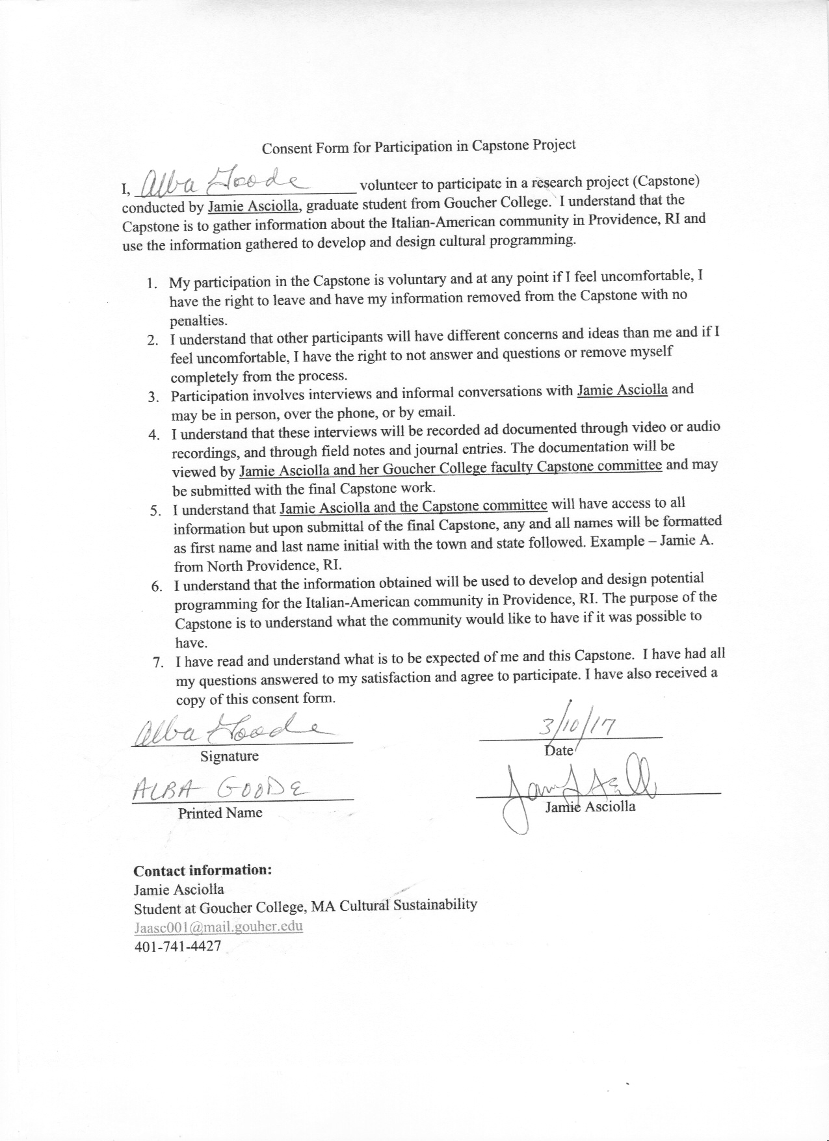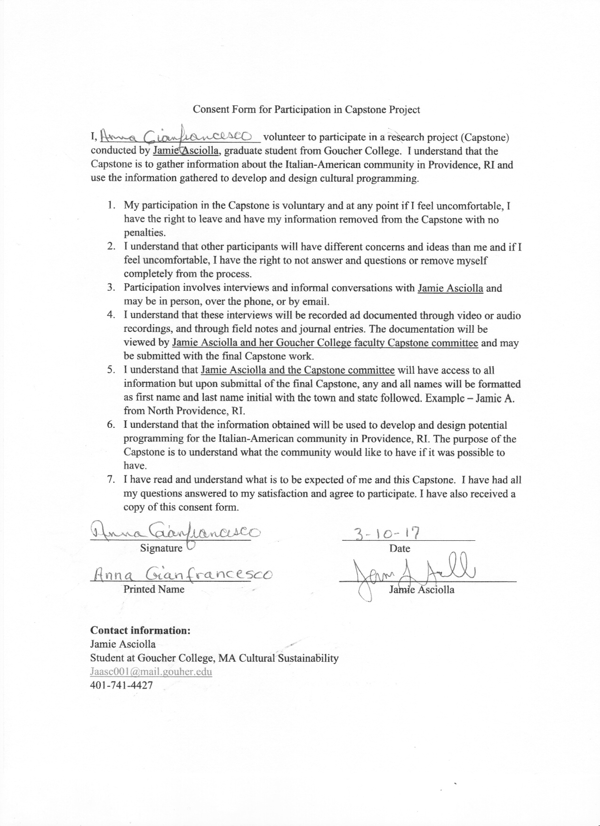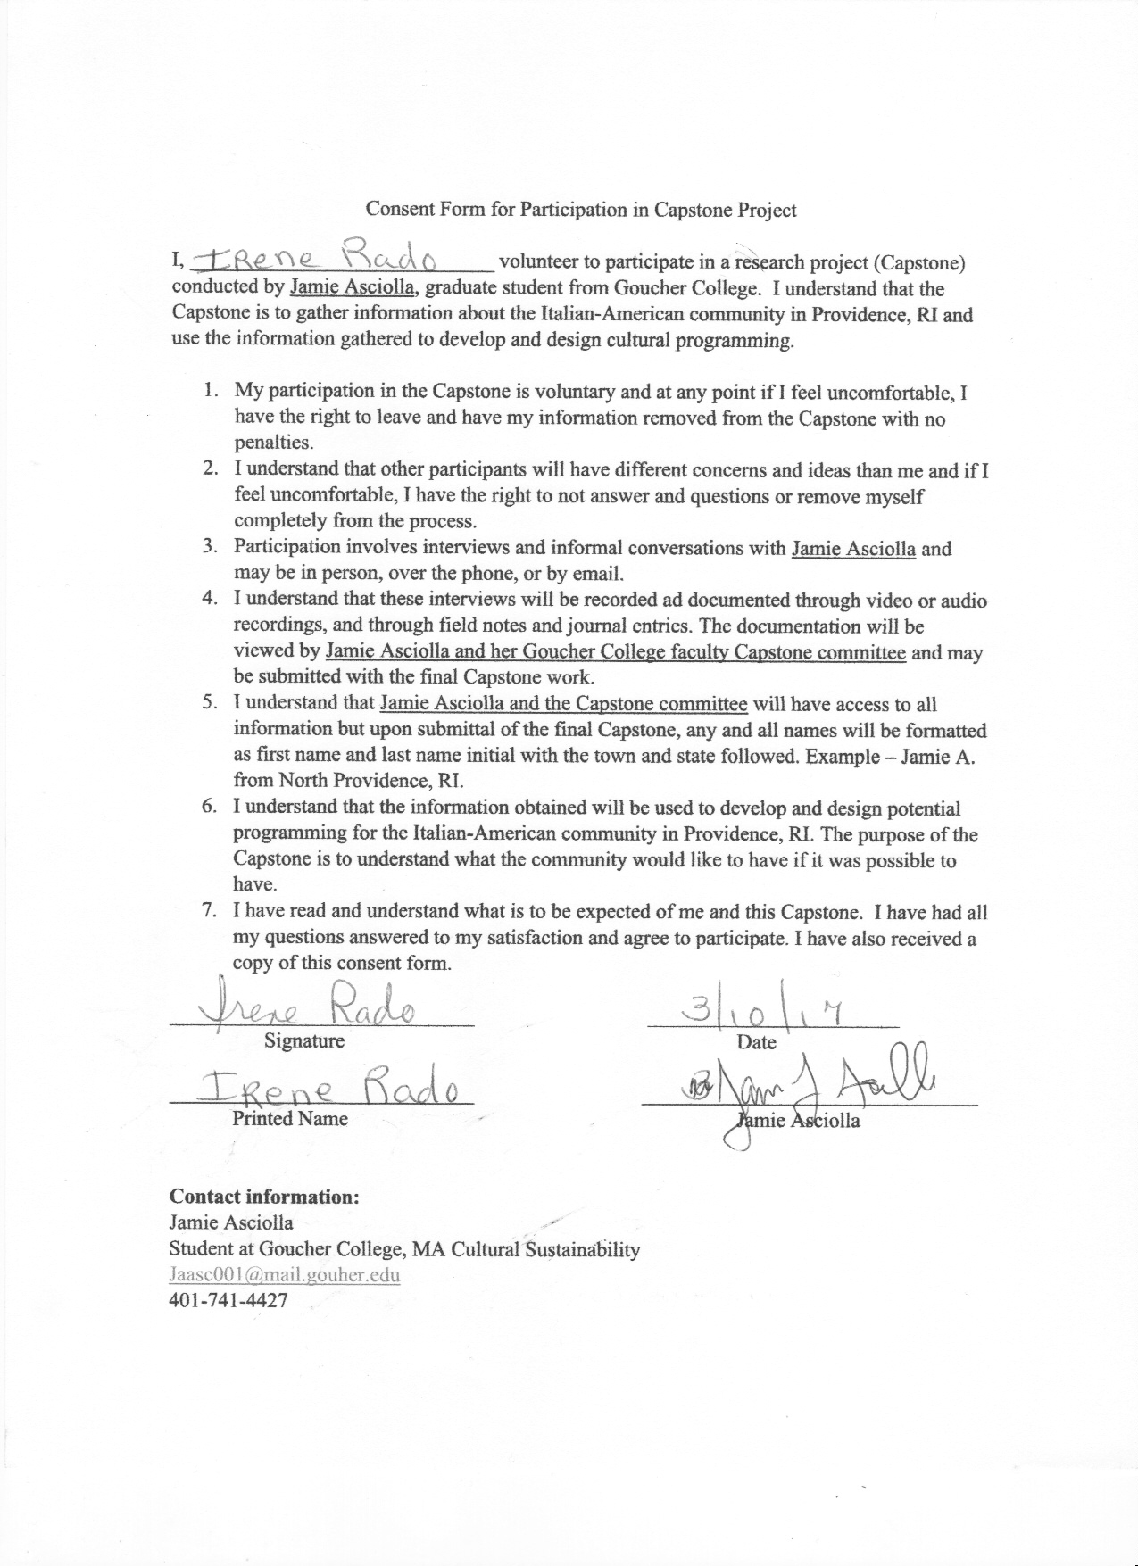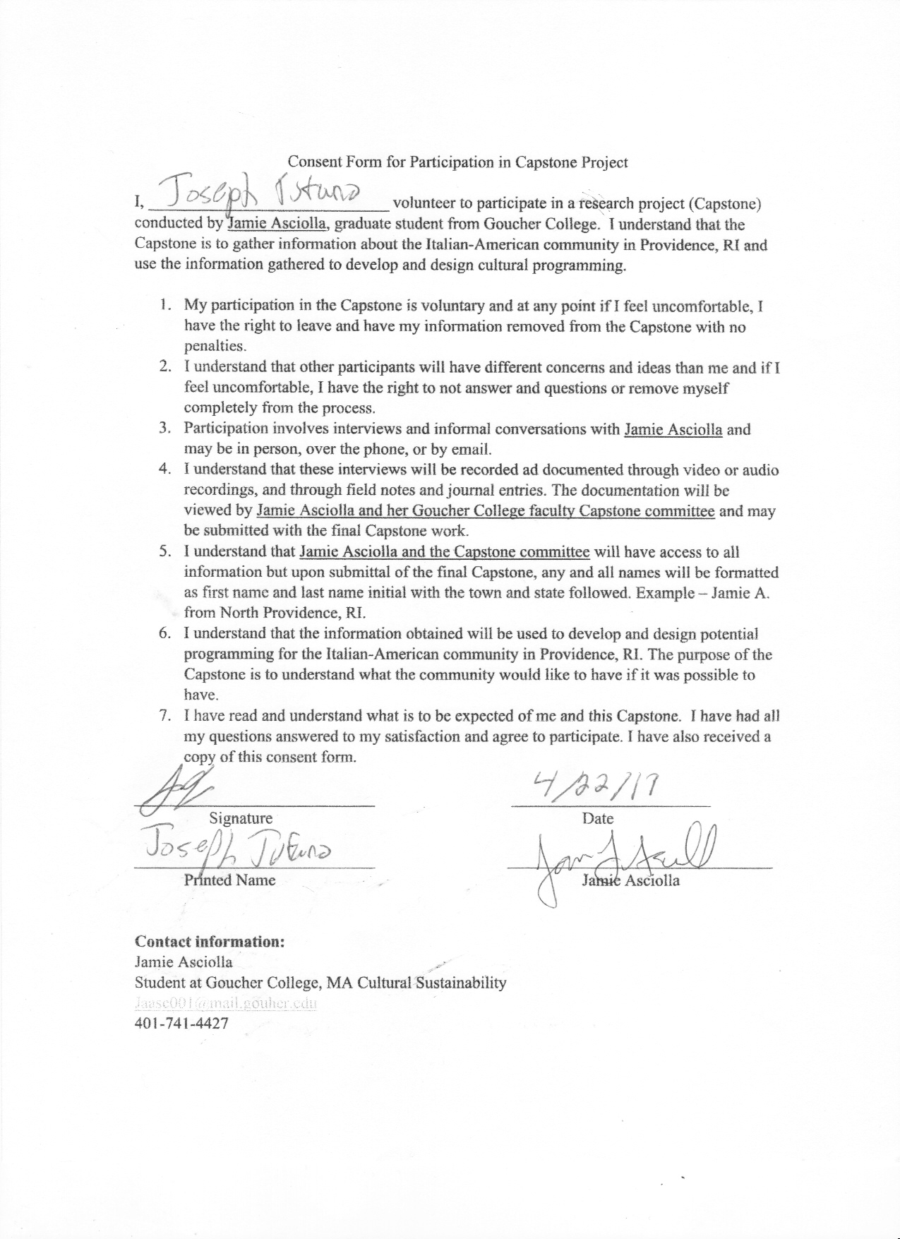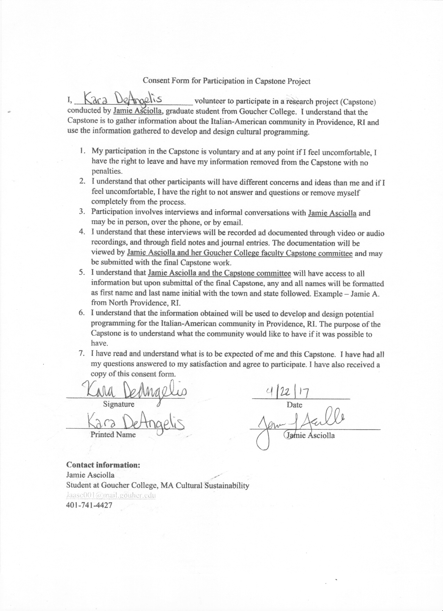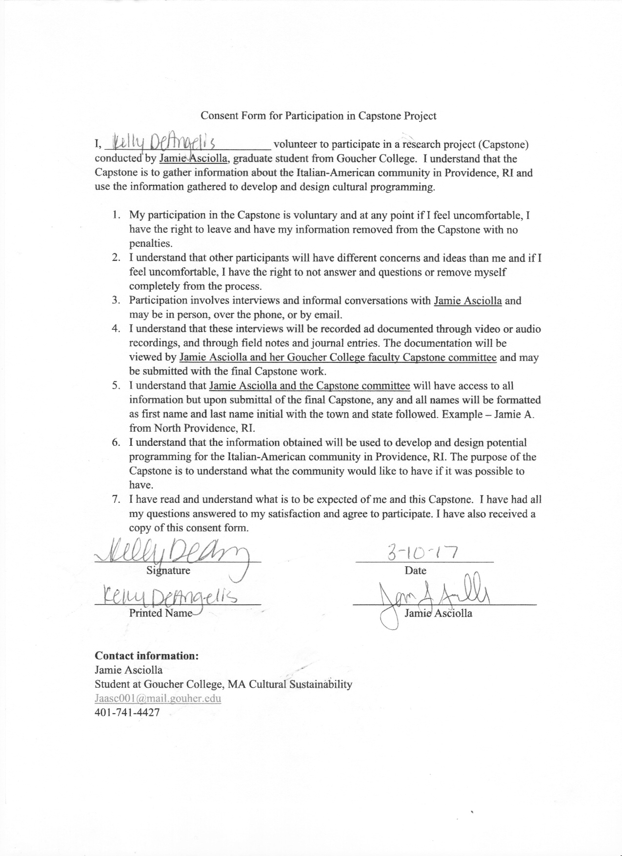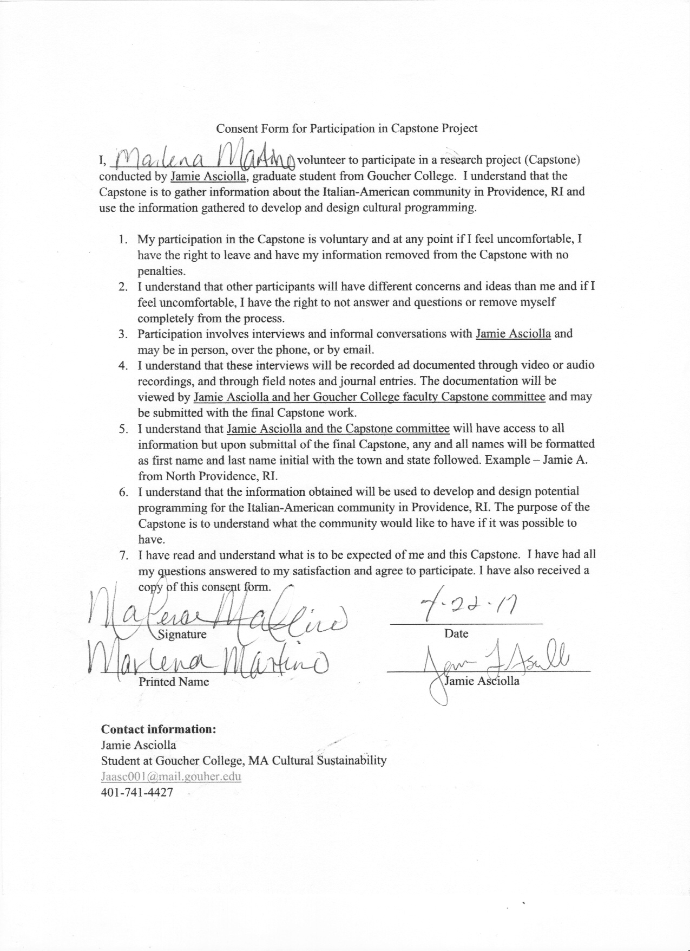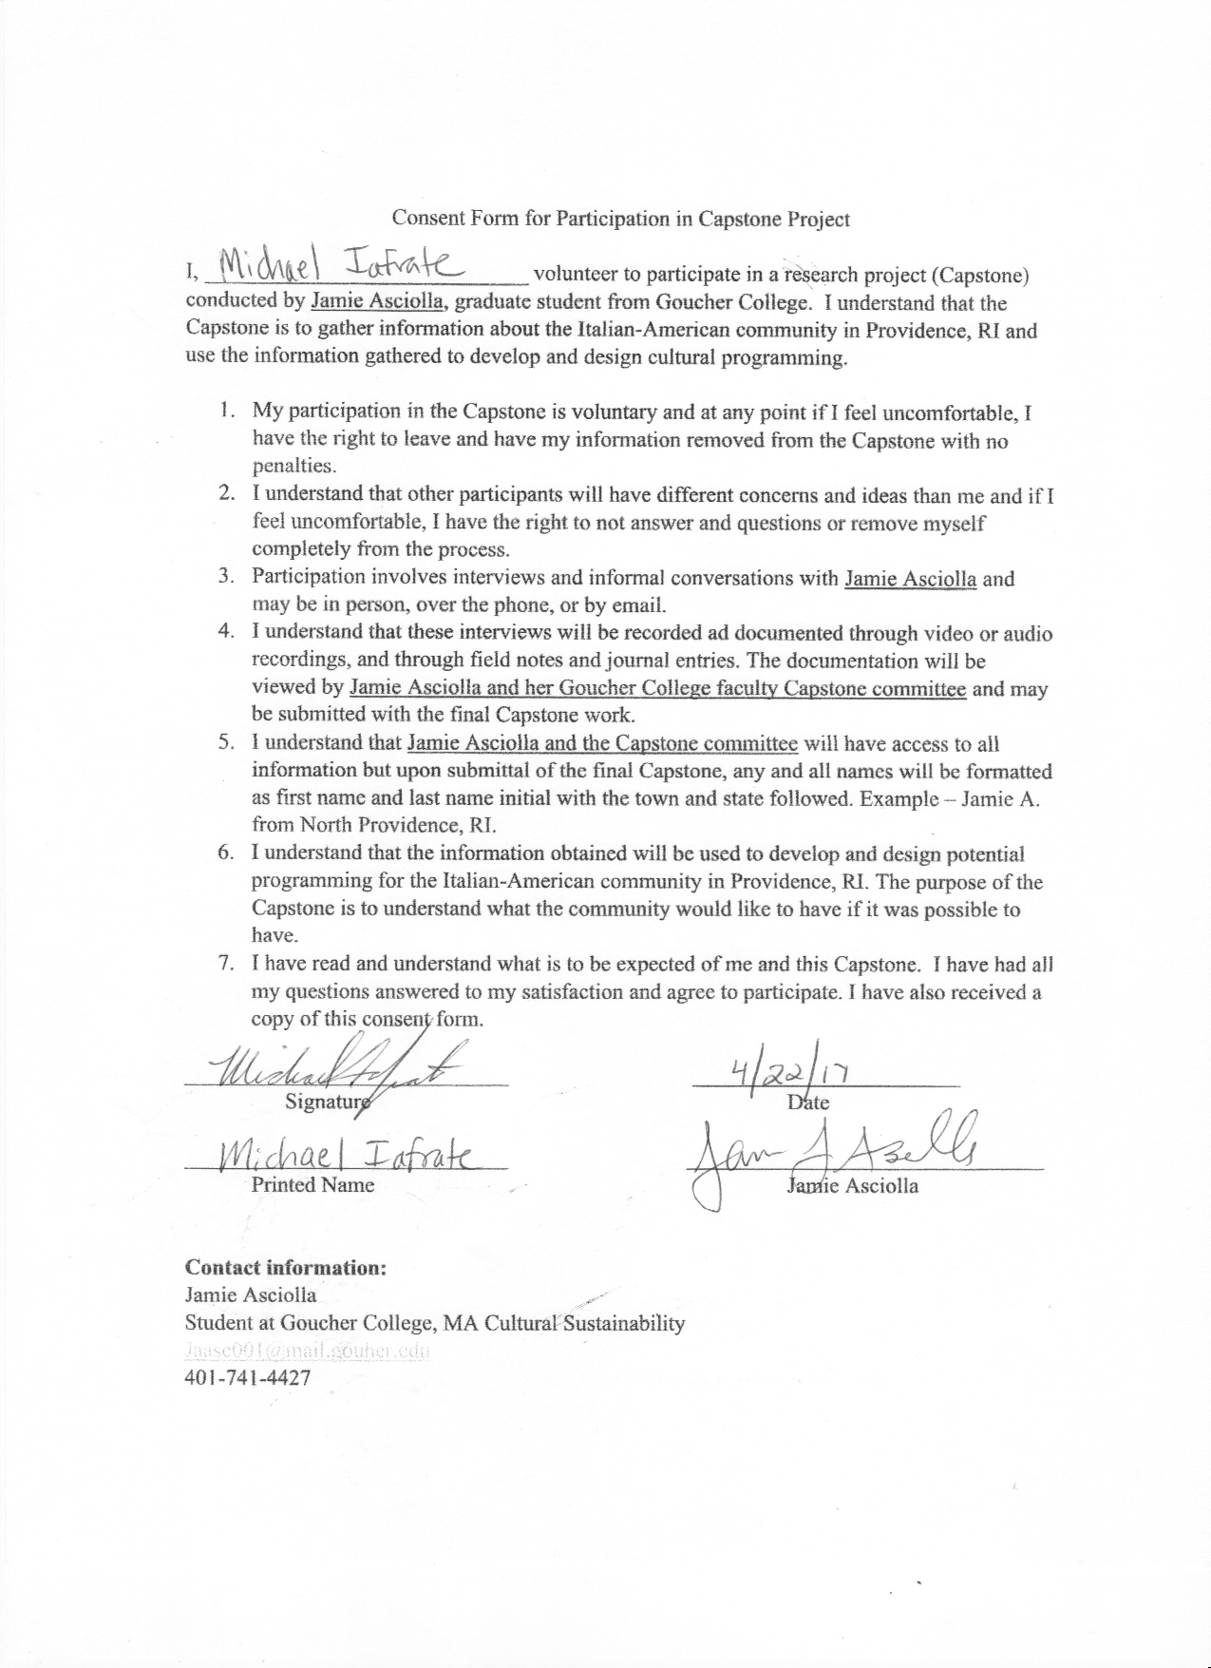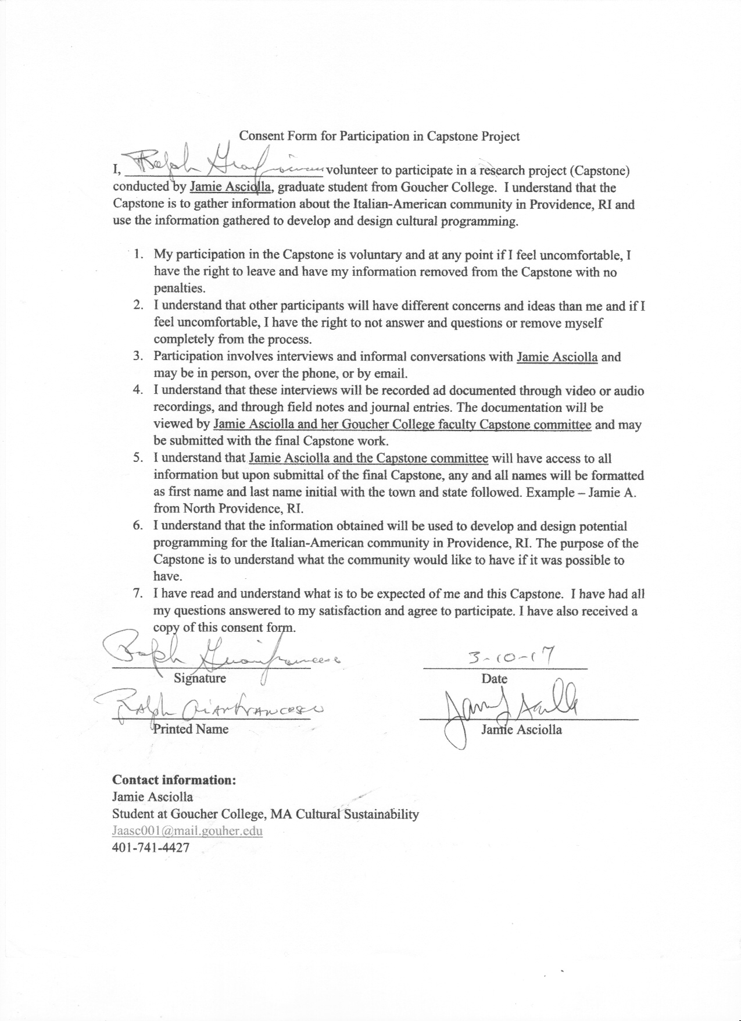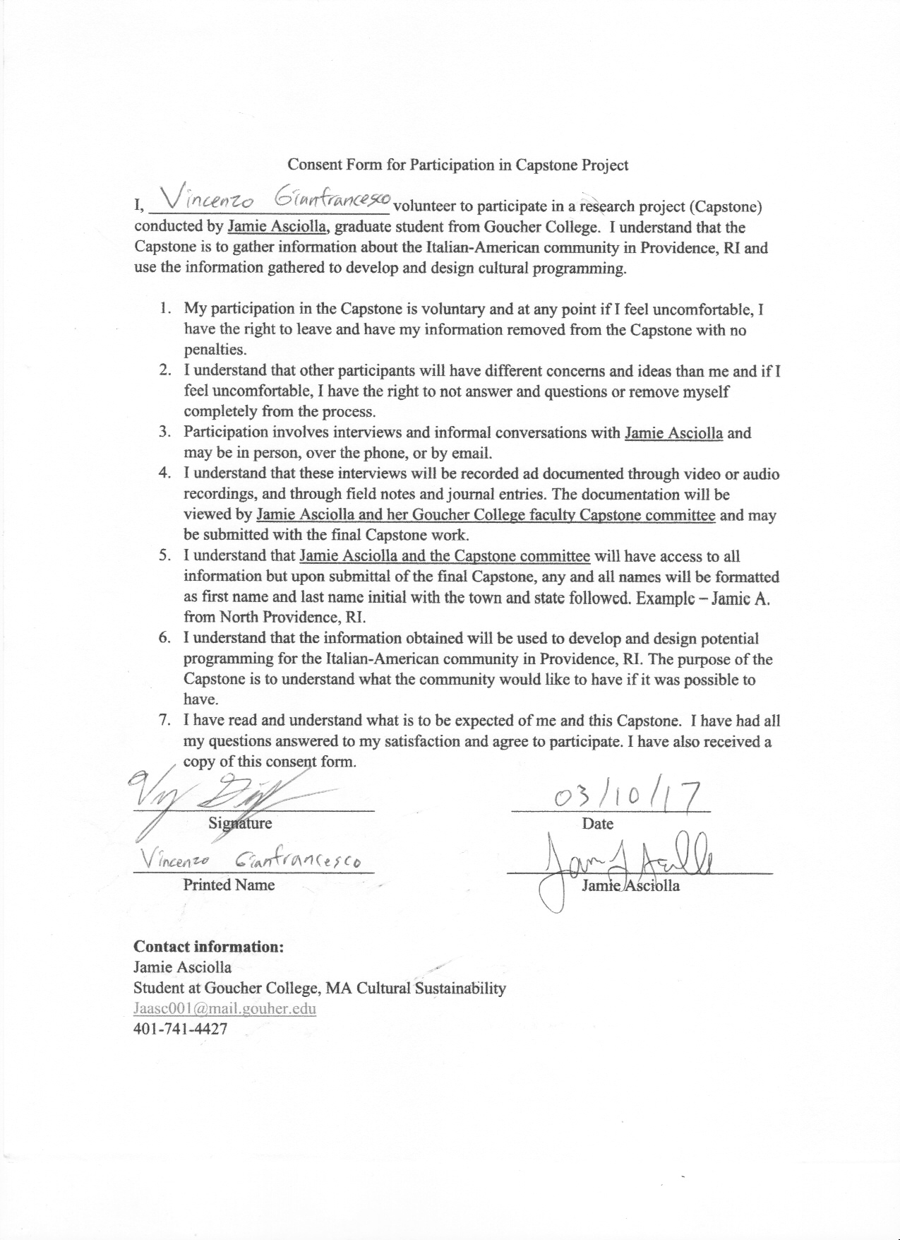
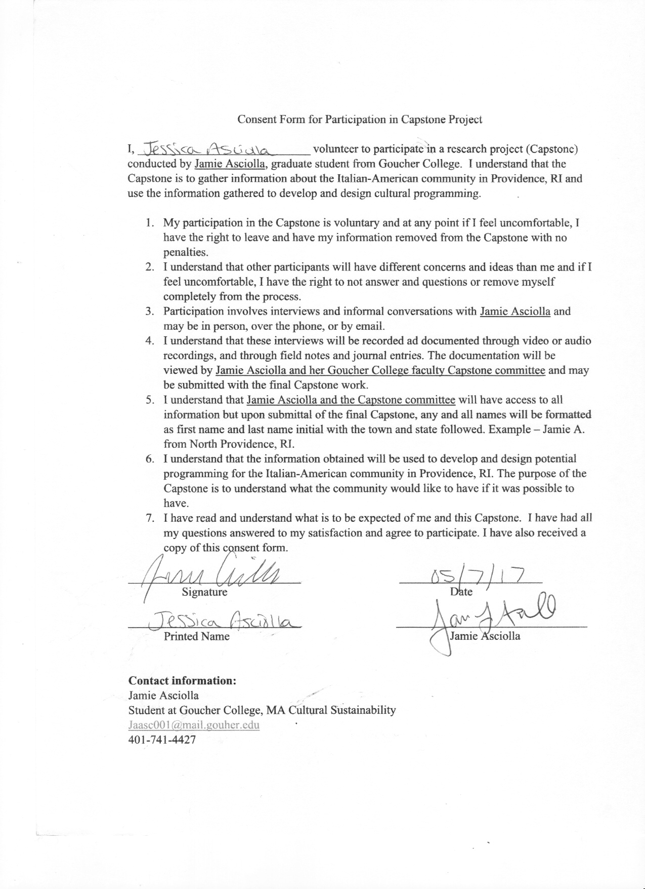
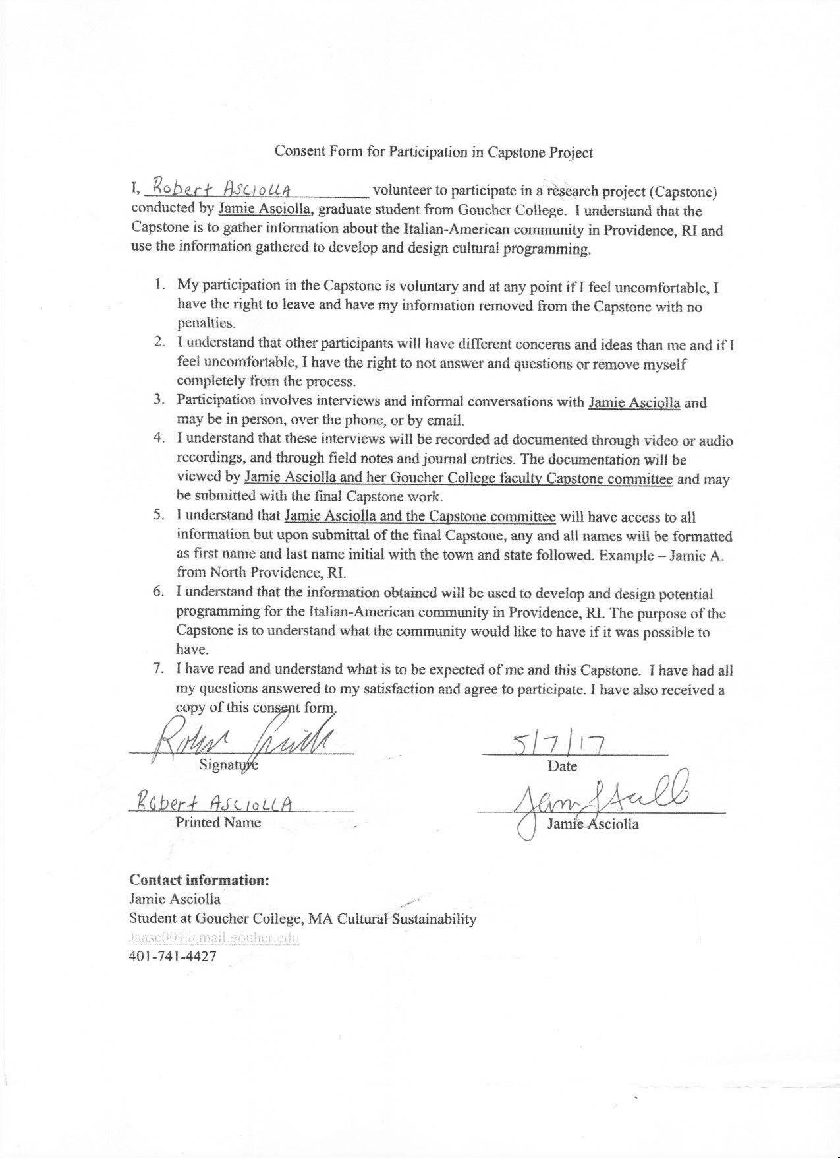
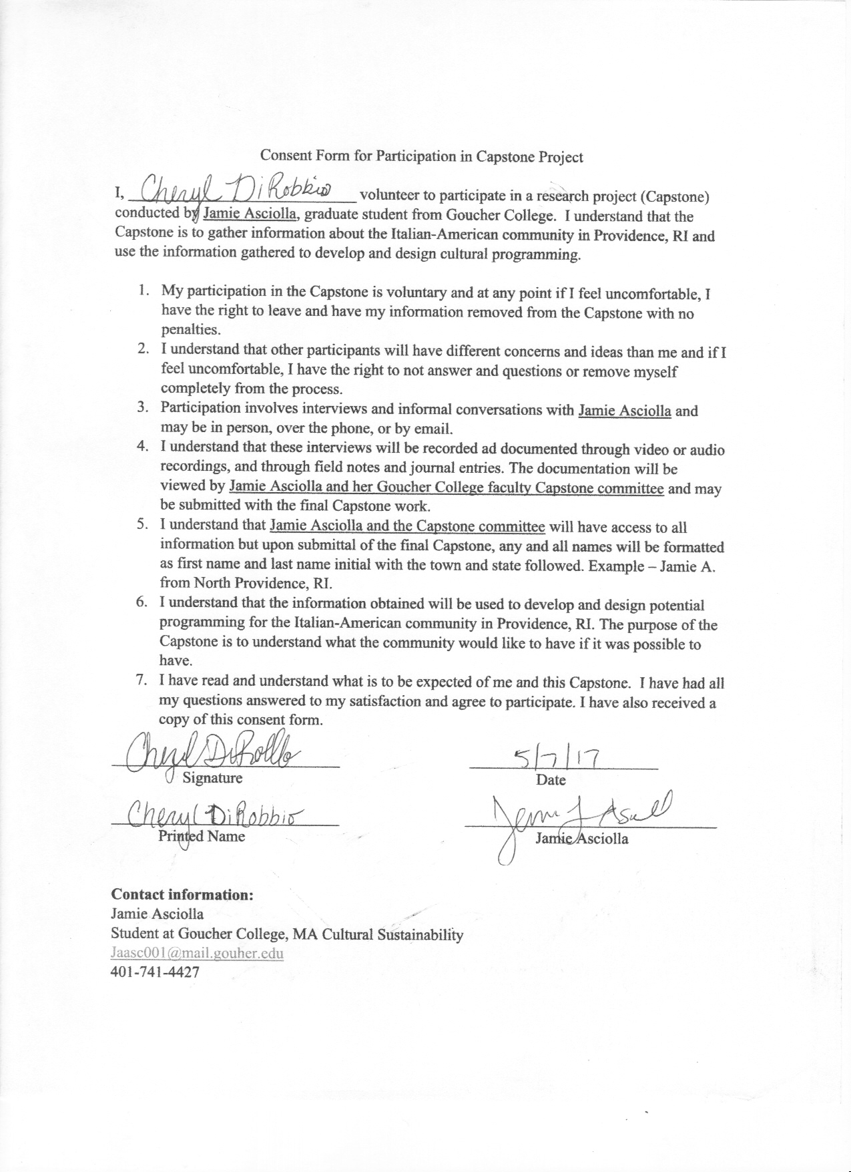
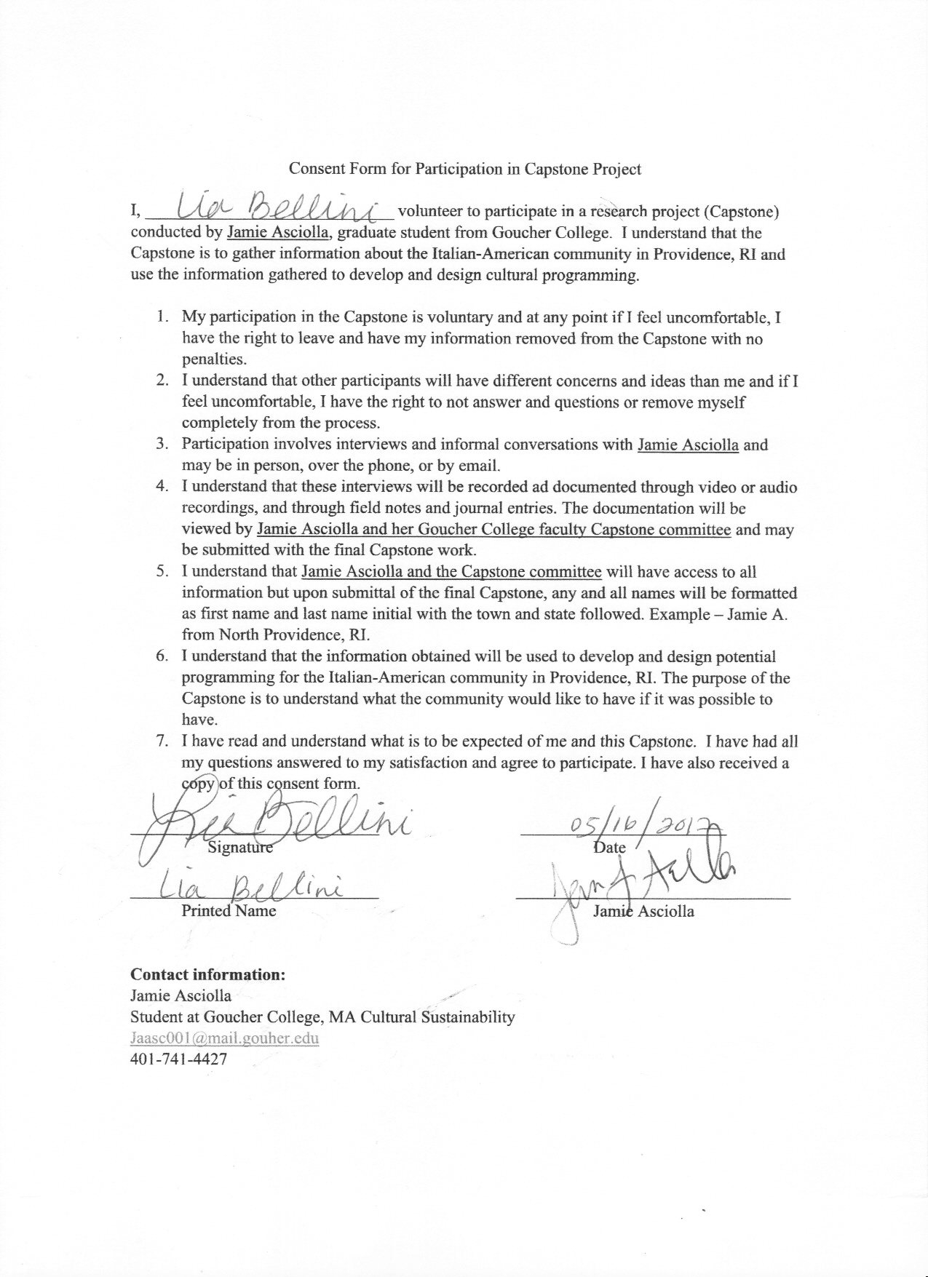
References
Bojer, Marianne Mille, Heiko Roehl and Marianne Knuth. Mapping Dialogue: Essential Tools for Social Change. Chagrin Falls, OH: Taos Institute Publications, 2008.
Borrup, Tom. Creative Community Builder’s Handbook: How to Transform Communities Using Local Assets, Arts and Culture. Saint Paul, MN: Fieldstone Alliance, 2006.
Carbone, Stanislao. "The Dialogic Museum and Ethnocultural Diversity." Canadian Ethnic Studies 37, no. 1 (January 2005): 127-136. https://goucher.idm.oclc.org/login?url=http://search.ebscohost.com/login.aspx?direct=true&db=a9h&AN=18678588&site=ehost-live&scope=site
Chew, Ron. “Five Keys to Growing a Healthy Community-Connected Museum.”
Community Arts Network, Reading Room, 2005.
Community College of Rhode Island. “Fall 2017 Tuition” Accessed 19 June 2017.
https://www.ccri.edu/bursar/tuitionfees/fall-tuition-fees.html
Federal Hill Providence. Accessed 1 September 2016. http://federalhillprov.com/.
Fuoco, Joe. Images of America: Federal Hill. Charleston, SC: Arcadia, 2004.
Graves, Bau. Cultural Democracy: The Arts, Community and the Public Purpose. Urbana and Chicago: University of Illinois Press, 2005.
Hein, George E. Learning in the Museum. New York, Routledge, 1998
Iannuccilli, Ed. What Ever Happened to Sunday Dinner? And Other Stories. Lexington, KY: CreateSpace, 2012.
Karp, Ivan and Christine Kreamer. Museums and Communities: The Politics of Public Culture. Washington: Smithsonian Institution Press, 1992.
The Italian-American Historical Society of Rhode Island. Accessed 1 September 2017. http://www.iahsofri.org/events.html.
The Italo-American Club of Rhode Island. Accessed 1 September 2017.
http://italoamericanclubofri.com/news/.
Muratore, Joseph. Images of America: Italian-Americans in Rhode Island Volume II. Charleston, SC: Arcadia, 2000.
Raben, Jonathon. Italian-Americans and Federal Hill: Rhode Island’s Little Italy. Providence, RI: Seven Fishes Productions, 2006.
The Rhode Island Italian-American Hall of Fame. Accessed 1 September 2017.
https://www.rocjo.com/riiahf/.
Santoro, Carmela E. The Italians in Rhode Island: The Age of Exploration to the Present, 1524-1989. Providence: Published jointly by the Rhode Island Heritage Commission and the Rhode Island Publications Society, 1990.
Sciorra, Joseph. Built with Faith: Italian-American Imagination and Catholic Material Culture in New York City. Knoxville: University of Tennessee Press, 2015.
Simon, Nina. The Art of Relevance. Santa Cruz: Museum 2.0, 2016.
Take Lessons. “Italian Language Tutor Near Pawtucket, RI” Accessed 19 June 2017.
https://takelessons.com/search?service=Italian&vertical=Language&max_distanc
e=30&limit=20&page=1&sort=sort_best_match&location%5Blocation%5D=&location%5Blatitude%5D=41.868499755859&location%5Blongitude%5D=-71.392799377441&location%5Bzip_code%5D=02860&location%5Baccuracy%5D=ip&bounding_box=
“2015-2016/2016-2017 Events.” Montclair State University. The College of Humanities
and Social Sciences: The Italian Program. 23 March 2017. http://www.montclair.edu/chss/inserra-chair/events/

Santoro, Carmela E. The Italians in Rhode Island: The Age of Exploration to the Present, 1524-1989. Providence: Published jointly by the Rhode Island Heritage Commission and the Rhode Island Publications Society, 1990. 6.
See Appendix Lia Interview 105.
Santoro 14.
See Appendix: Lia Interview 105.
See Appendix: Gianfransesco Family 70.
See Appendix: Lia Interview 105.
Simon, Nina. The Art of Relevance. 99
Simon 107-109.
See Appendix Group 2: Friends 90.
See Appendix Family Interview 99.
“2015-2016/2016-2017 Events.” Montclair State University. The College of Humanities and Social Sciences: The Italian Program. 23 March 2017. http://www.montclair.edu/chss/inserra-chair/events/
I checked on the websites of the Italo-American Club of Rhode Island (http://italoamericanclubofri.com/news/), the Rhode Island Italian-American Hall of Fame (https://www.rocjo.com/riiahf/), and the Italian-American Historical Society of Rhode Island (http://www.iahsofri.org/events.html) which had no current events listed.
See Appendix Lia Interview 114.
See Appendix Lia Interview 105.
Muratore, Joseph. Images of America: Italian-Americans in Rhode Island Volume II. South Carolina. 2000. and Fuoco, Joe. Images of America: Federal Hill. 2004.
Muratore 81 has photographs of the pushcarts. It was also mentioned by Lia Bellini See Appendix Lia Interview 113.
Santoro 7.
See Appendix Family Interview 100.
I checked on the websites of the Italo-American Club of Rhode Island (http://italoamericanclubofri.com/news/), the Rhode Island Italian-American Hall of Fame (https://www.rocjo.com/riiahf/), and the Italian-American Historical Society of Rhode Island (http://www.iahsofri.org/events.html) which had no current events listed.
“Federal Hill Providence”. http://federalhillprov.com/
“2015-2016/2016-2017 Events.” Montclair State University.
“Federal Hill Providence”.
See Appendix Group 2: Friends 77.
Anna and Ralph discussed how they wanted their children to be American so they did not teach them Italian, while my dad saw no need to learn Italian because he was American.
See Appendix Family Interview 99.
See Appendix Group 2: Friends 83.
During the two group interviews, instead of saying “Italian-American culture,” the interviewees said “Italian culture” despite me making a distinction in the question. See Appendix Group 1: Gianfransesco Family and Group 2: Friends.
When I interviewed my family, my sister Jessica made it very clear that the two culture were in fact separate. Lia Bellini also noted the difference between the two cultures when describing her family and her life growing up. See Appendix Family Interview and Lia Interview.
Jonathon Raben’s Italian-Americans and Federal Hill contains chapters on Italian dialect, assimilation, and includes sheet music for “My Home on Federal Hill” (25, 51, 161).
Joe Fuoco’s Images of America: Federal Hill has pictures of Italian-American musicians (42-46).
Joseph Muratore’s Italian-Americans in Rhode Island has a chapter featuring photographs of the many Italian-American musicians that played on Federal Hill (109-116).
Ed Iannuccilli’s Whatever Happened to Sunday Dinner? is full of stories about food and cooking with his mother.
See Appendix –Group 2 Interview 88.
Take Lessons. “Italian Language Tutor Near Pawtucket, RI” https://takelessons.com/search?service=Italian&vertical=Language&max_distance=30&limit=20&page=1&sort=sort_best_match&location%5Blocation%5D=&location%5Blatitude%5D=41.868499755859&location%5Blongitude%5D=-71.392799377441&location%5Bzip_code%5D=02860&location%5Baccuracy%5D=ip&bounding_box=
Lia Bellini also mentioned that her uncle pays her cousin’s Italian tutor about $75 per lesson. See Appendix Lia Interview 110.
Community College of Rhode Island. “Fall 2017 Tuition” https://www.ccri.edu/bursar/tuitionfees/fall-tuition-fees.html
See Appendix Group 1: Gianfransesco Family 70.
In the first two group interviews, Vinny in particular mentioned that he did not like church or religion too fondly and tried to stay away from it. Kara also mentioned that she was not as religious as her parents because it was something she did not have an interest in. See Appendix Group 1: Gianfransesco Family 72 and Group 2: Friends 89.
Santoro 14; Muratore 65; Fuoco 69.
See Appendix Group 1: Gianfransesco Family 72.
See Appendix Lia Interview 107.
See Appendix Group 2: Friends 82.
See Appendix Group 2: Friends 89.
See Appendix Group 1: Gianfransesco Family 72.
See Appendix Group 1: Gianfransesco Family 72.
There are many types of Italian dialect but from my understanding of Lia’s background, it would probably be Sicilian.
In my interview with Lia Bellini, she mentioned that she and her fellow chef Alicia, have begun programming to connect with the Federal Hill Community. She also mentioned that the interest is there for other restaurants to get involved, they just have not done so yet.

