Immunity and ecological factors mediate parasitic co-infection in sea fan octocorals

Allison M. Tracy^{1*}, Ernesto Weil², Colleen A. Burge³

Frontiers in Immunology

Appendix S1

Fig. S1: Experimental design: (A) Eight samples were collected for each of 10 colonies in the field (4 healthy and 4 copepod-infected samples) for use in the laboratory experiment. (B) For each colony, two healthy samples and two copepod-infected samples were inoculated with Aspergillus, creating 4 treatments: control, copepod-infected (denoted by circle), Aspergillus-inoculated (denoted by asterisk), and copepod-infected + Aspergillus-inoculated (with both circle and asterisk). Eight samples were used for each colony to have two time points (6 hours and 48 hours) for each colony in each treatment.

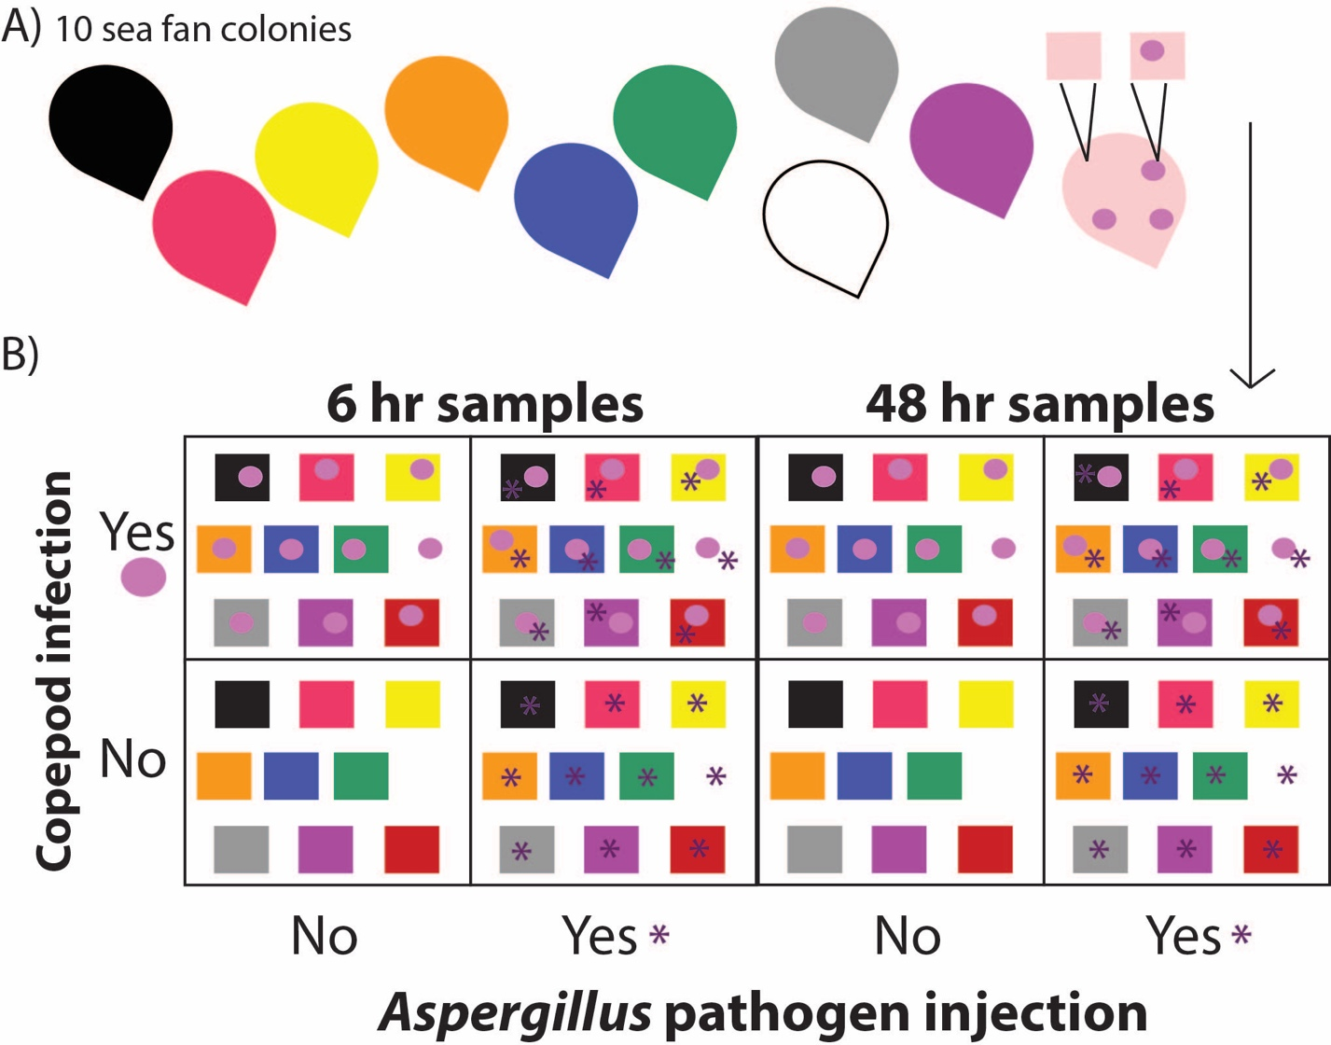

Table S1: Candidate immune genes identities and primers. (GenBank accession numbers pending).
Name | Swiss Prot ID | G. ventalina transcriptome ID | Direction | Primer sequence | Length
EF1  Elongation Factor 1 | A5D989 | 75614 | Forward | ACCGCTGCTAGTTTGGATGT | 20
EF1  Elongation Factor 1 | A5D989 | 75614 | Reverse | TGATGAAACCGACATGGCTA | 20
T5A  Tachylectin 5A | Q9U8W8 | 42227 | Forward | ATTTCGGTTTTCCTCAACGA | 20
T5A  Tachylectin 5A | Q9U8W8 | 42227 | Reverse | CCTGGTGGTATGCTGCTTG | 19
MMP  Matrix metalloproteinase | Q5RES1 | 81521 | Forward | ACCGTATTTCTGGACGTTGG | 20
MMP  Matrix metalloproteinase | Q5RES1 | 81521 | Reverse | CGGTTTTTCCATCTCGTCTT | 20
IκB  NF-κB Inhibitor cactus | In sub-mission to GenBank | N/A | Forward | TCGAAGCATTGAGGTGTTGGA | 21
IκB  NF-κB Inhibitor cactus | In sub-mission to GenBank | N/A | Reverse | GACGTGCGATATTTGCTGGC | 20

Table S2: Nanodrop quality and quantity data for all samples
Sample | Timepoint of nanodrop | Concentration (ng/uL) | 260/280 | 260/230
A10L | pre DNAse | 1696.5 | 2.04 | 2.55
 | post DNAse | 321.1 | 2.03 | 2.43
A9L | pre DNAse | 1465.1 | 2.08 | 2.25
 | post DNAse | 302.3 | 2.27 | 2.11
N6L | pre DNAse | 2148.1 | 2.07 | 2.44
 | post DNAse | 364.4 | 2.05 | 2.26
M6E | pre DNAse | 3655.1 | 2.12 | 2.36
 | post DNAse | 341.1 | 2.03 | 2.52
M9E | pre DNAse | 1744 | 2.13 | 2.55
 | post DNAse | 494.4 | 2.07 | 2.49
N2L | pre DNAse | 2623.3 | 2.11 | 2.37
 | post DNAse | 369.3 | 2.05 | 2.4
M2E | pre DNAse | 2092.7 | 2.07 | 2.53
 | post DNAse | 370.4 | 2.08 | 2.13
A1E | pre DNAse | 2312.1 | 2.11 | 2.52
 | post DNAse | 379.2 | 2.22 | 2.13
MA6E | pre DNAse | 1520.7 | 2.07 | 1.88
 | post DNAse | 395.5 | 2.12 | 1.6
MA1E | pre DNAse | 2668 | 2.08 | 2.45
 | post DNAse | 343.3 | 2.16 | 2.2
M2L | pre DNAse | 1112.8 | 2.04 | 2.49
 | post DNAse | 395.6 | 2.23 | 2.13
N10L | pre DNAse | 2489.7 | 2.1 | 2.36
 | post DNAse | 367.8 | 2.19 | 2
A9E | pre DNAse | 1220 | N/A | N/A
 | post DNAse | 932.9 | 2.03 | 1.89
N9L | pre DNAse | 1280 | N/A | N/A
 | post DNAse | 1103.6 | 2.03 | 2.25
A2L | pre DNAse | 1140 | N/A | N/A
 | post DNAse | 973.2 | 2.02 | 2.22
A1L | pre DNAse | 560 | N/A | N/A
 | post DNAse | 564.9 | 2.14 | 1.94
N10E | pre DNAse | 680 | N/A | N/A
 | post DNAse | 728.9 | 1.97 | 2.14
MA2E | pre DNAse | 886 | N/A | N/A
 | post DNAse | 737.1 | 1.98 | 2.06
MA9L | pre DNAse | 3209.3 | 2.09 | 2.36
 | post DNAse | 356.5
MA10L | pre DNAse | 3145.2 | 2.08 | 2.28
 | post DNAse | 337
MA6L | pre DNAse | 2308.3 | 2.12 | 1.74
 | post DNAse | 374.1
M6L | pre DNAse | 3306.4 | 2.07 | 2.43
 | post DNAse | 335
M9L | pre DNAse | 1726.6 | 2.08 | 2.33
 | post DNAse | 346.3
M10L | pre DNAse | 1783.8 | 2.09 | 2.49
 | post DNAse | 396.9
N9E | pre DNAse | 1067 | 2.06 | 2.51
 | post DNAse | 405 | 2.01 | 2.26
N6E | pre DNAse | 1926.4 | 2.1 | 2.46
 | post DNAse | 360.9 | 2.05 | 2.24
M1L | pre DNAse | 2370.4 | 2.13 | 2.32
 | post DNAse | 343 | 1.99 | 2.19
MA1L | pre DNAse | 3112.8 | 2.08 | 2.2
 | post DNAse | 403.5 | 2.01 | 2.03
A6E | pre DNAse | 2584.7 | 2.09 | 2.29
 | post DNAse | 353.4 | 2.15 | 1.99
A10E | pre DNAse | 2212.9 | 2.08 | 2.34
 | post DNAse | 370.1 | 2.08 | 1.93
N2E | pre DNAse | 3810.7 | 2.07 | 2.36
 | post DNAse | 314.2 | 2.06 | 2.13
MA10E | pre DNAse | 2740.9 | 2.09 | 2.45
 | post DNAse | 327 | 2.11 | 2.09
A2E | pre DNAse | 2722.8 | 2.07 | 2.39
 | post DNAse | 366 | 1.96 | 2.06
MA9E | pre DNAse | 3185.4 | 2.08 | 2.34
 | post DNAse | 348.9 | 2.12 | 2.09
N1E | pre DNAse | 2694.7 | 2.09 | 2.39
 | post DNAse | 393.3 | 2.14 | 2.1
M1E | pre DNAse | 3441.5 | 2.09 | 2.33
 | post DNAse | 408 | 2.17 | 2.19
A6L | pre DNAse | 3680.7 | 2.08 | 2.28
 | post DNAse | 358.5 | 2.08 | 1.99
N1L | pre DNAse | 2493.7 | 2.17 | 2.37
 | post DNAse | 357.6 | 2.15 | 1.99
M10E | pre DNAse | 3686.8 | 2.1 | 2.27
 | post DNAse | 511.7 | 2.12 | 1.96
MA2L | pre DNAse | 3758.4 | 2.08 | 2.42
 | post DNAse | 415.2 | 2.02 | 1.98
MA4E | pre DNAse | 3291.4 | 2.08 | 2.4
 | post DNAse | 375.9 | 2.1 | 2.14
A3L | pre DNAse | 3631.5 | 2.09 | 2.34
 | post DNAse | 359.8 | 2.18 | 2.13
M7L | pre DNAse | 2382.7 | 2.11 | 2.49
 | post DNAse | 350.1 | 2.13 | 2.14
M8L | pre DNAse | 1765.9 | 2.1 | 2.56
 | post DNAse | 371.7 | 2.11 | 2.34
M5E | pre DNAse | 2208.9 | 2.08 | 2.51
 | post DNAse | 410.5 | 2.14 | 2.21
A4E | pre DNAse | 2834.3 | 2.11 | 2.47
 | post DNAse | 393.2 | 2.09 | 2.16
N8L | pre DNAse | 2186 | 2.13 | 2.45
 | post DNAse | 385.3 | 2.11 | 2.14
A5L | pre DNAse | 2676.5 | 2.09 | 2.44
 | post DNAse | 401.9 | 2.02 | 2.16
MA8L | pre DNAse | 2013.1 | 2.13 | 2.41
 | post DNAse | 378 | 2.01 | 2.03
MA8E | pre DNAse | 1617.7 | 2.17 | 2.41
 | post DNAse | 379.5 | 1.97 | 2.07
M4E | pre DNAse | 1828.5 | 2.15 | 2.46
 | post DNAse | 374.8 | 2.05 | 2.28
N4E | pre DNAse | 2830.8 | 2.13 | 2.22
 | post DNAse | 371.4 | 2.03 | 1.94
A8L | pre DNAse | 2314.7 | 2.15 | 2.46
 | post DNAse | 340.5 | 2.13 | 2.24
MA5L | pre DNAse | 2239.8 | 2.15 | 2.35
 | post DNAse | 405 | 2.11 | 2.14
MA7L | pre DNAse | 2102.1 | 2.17 | 2.45
 | post DNAse | 335.6 | 2.24 | 2.29
A8E | pre DNAse | 2015.1 | 2.17 | 2.45
 | post DNAse | 404 | 2.01 | 2.29
M3E | pre DNAse | 2203.1 | 2.16 | 2.38
 | post DNAse | 365.8 | 2.11 | 2.15
MA5E | pre DNAse | 2777.2 | 2.16 | 2.47
 | post DNAse | 374.5 | 2.04 | 2.14
M3L | pre DNAse | 2988.1 | 2.09 | 2.45
 | post DNAse | 308.9 | 2.07 | 2.02
M5L | pre DNAse | 2751.2 | 2.09 | 2.37
 | post DNAse | 382.6 | 2.14 | 2
A7L | pre DNAse | 3005.6 | 2.11 | 2.39
 | post DNAse | 337.3 | 1.95 | 2.04
A7E | pre DNAse | 2740 | 2.1 | 2.49
 | post DNAse | 323.3 | 2.07 | 2.14
M8E | pre DNAse | 1843.8 | 2.1 | 2.46
 | post DNAse | 357.6 | 2 | 2.13
MA3E | pre DNAse | 2161.3 | 2.12 | 2.47
 | post DNAse | 306.5 | 2.13 | 2.09
N3L | pre DNAse | 2493.6 | 2.12 | 2.46
 | post DNAse | 335 | 2.12 | 2.08
MA4L | pre DNAse | 1913.8 | 2.11 | 2.5
 | post DNAse | 328.8 | 2.15 | 2.09
N7L | pre DNAse | 2152.8 | 2.08 | 2.4
 | post DNAse | 363.4 | 2.05 | 2.2
N3E | pre DNAse | 2404.1 | 2.11 | 2.35
 | post DNAse | 362.3 | 2.13 | 2.06
MA7E | pre DNAse | 2689.3 | 2.1 | 2.24
 | post DNAse | 373.4 | 2.02 | 2.04
M7E | pre DNAse | 2240.1 | 2.11 | 2.25
 | post DNAse | 337.1 | 2.09 | 1.91
N8E | pre DNAse | 1095.4 | 2.14 | 2.44
 | post DNAse | 356.3 | 2.05 | 2.24
N7E | pre DNAse | 1812.6 | 2.1 | 2.43
 | post DNAse | 364.8 | 2.17 | 2.26
A5E | pre DNAse | 3025.4 | 2.08 | 2.43
 | post DNAse | 396 | 2.1 | 2.3
M4L | pre DNAse | 2391.9 | 2.09 | 2.41
 | post DNAse | 321.8 | 2.08 | 2.11
A4L | pre DNAse | 2814.4 | 2.1 | 2.33
 | post DNAse | 362.2 | 2.03 | 2.25
MA3L | pre DNAse | 2638.1 | 2.09 | 2.27
 | post DNAse | 388.6 | 2.12 | 2.21
N4L | pre DNAse | 3368.6 | 2.06 | 2.26
 | post DNAse | 398.3 | 2.03 | 1.95
N5L | pre DNAse | 1846.9 | 2.06 | 2.04
 | post DNAse | 407.7 | 2.1 | 1.82
N5E | pre DNAse | 1196.6 | 2.03 | 2.39
 | post DNAse | 392.9 | 2.07 | 2.15
A3E | pre DNAse | 1547.5 | 2.06 | 2.35
 | post DNAse | 368.2 | 2.12 | 1.86

Table S3: Efficiencies of genes from PCR Miner, averaged across Miner runs
Gene | Efficiency
EF1 | 0.882
T5A | 0.803
IκB | 0.860
MMP | 0.853

Fig. S2: Map of survey sites in The Natural Reserve of La Parguera and in Guánica, on the southwest coast of Puerto Rico.

Table S4: GPS coordinates of sites in La Parguera and Guánica, Puerto Rico with the abbreviation, temperature logger type and copper concentration (Pait et al. 2007).
Reef site name and # | Latitude | Longitude | Temperature Logger | Copper sediment concentration range
Turrumotico (#1) “TC” | 17° 55.743' | 66° 58.487'' | Use Turrumote | 0.0-0.9 μg/g
Turrumote (#2) “TM” | 17° 56.097' | 67° 01.130'' | HOBO | 1.0-1.9 μg/g (Indicator Kriging, Pait et al. 2007)
Laurel Patch (#3) “L” | 17° 56.537' | 67° 04.057' | Use Media Luna | 0.0-0.9 μg/g
Media Luna (#4) “ML” | 17° 56.096' | 67° 02.911' | HOBO | 2.0-4.1 μg/g
Pelotas  (#5) “P” | 17° 57.446'' | 67° 04.183' | HOBO | 2.0-4.1 μg/g
Caballo Blanco  (#6) “CB” | 17° 57.831' | 67° 02.940' | iButton | 2.0-4.1 μg/g
Enrique  (#7) “E” | 17° 57.294' | 67° 02.608' | HOBO | 4.2-80.6 μg/g
Corral Channel  (#8) “CH” | 17° 56.959' | 66° 59.938'' | iButton | 4.2-80.6 μg/g
Fosfo Bay  (#9) “F” | 17° 57.544' | 67° 00.826' | Use Channel | 4.2-80.6 μg/g
Mario reef  (#10) “M” | 17° 57.170' | 67° 03 387' | HOBO | 4.2-80.6 μg/g
Buoy  (#11) “B” | 17° 53.291'' | 66° 59.884' | HOBO | 0.0-0.9 μg/g (Indicator Kriging, Pait et al. 2007)
Romero  (#12) “R” | 17° 56.830' | 66° 59.431' | iButton | 4.2-80.6 μg/g (Indicator Kriging, Pait et al. 2007)
San Cristobal  (#13) “SC” | 17° 56.497' | 67° 04.497' | Use Pelotas | 1.0-1.9 μg/g (Indicator Kriging, Pait et al. 2007)
Guánica 1  (#14) “G1” | 17° 56.862' | 66° 54.087' | iButton | 1.0-1.9 μg/g (Indicator Kriging, Pait et al. 2007)
Guánica 2  (#15) “G2” | 17° 56.529' | 66° 54.855' | Use Guánica 1 | 1.0-1.9 μg/g

Table S5: None of the infection terms, time or interactions predicted EF1 expression for any of the subsets (NS = not significant; DF = degrees of freedom; LRT = likelihood ratio test). Models include colony as a random intercept. No random slopes were supported by model comparison.
EF1 (T5A samples) |  |  | EF1 (IκB samples) |  |  | EF1 (MMP samples)
Model | DF | Delta AIC | Model | DF | Delta AIC | Model | DF | Delta AIC
Parasite*time [NS predictors] | 6 | 0 | Parasite*time [NS predictors] | 6 | 0 | Aspergillus*time [not better than null by LRT] | 6 | 0
Null | 3 | 2.01 | Parasite_single*time [NS predictors] | 8 | 0.79 | Aspergillus*time+copepod [not better than null by LRT] | 7 | 1.5
Aspergillus*time | 6 | 2.4 | Aspergillus*time [NS predictors] | 6 | 3.05 | Null | 3 | 1.7
Copepod | 4 | 2.4 | Copepod*Asperigllus*time [NS predictors] | 10 | 4.61 | Parasite*time | 6 | 2.33
Parasite | 4 | 2.6 | Aspergillus*time+copepod [NS predictors] | 7 | 5.01 | Parasite | 4 | 3.07
Aspergillus*time+copepod | 7 | 2.63 | Copepod*time [NS predictors] | 6 | 5.59 | Copepod | 4 | 3.26
Parasite_single*time | 8 | 3.58 | Parasite+time [NS predictors] | 5 | 6.25 | Aspergillus | 4 | 3.55
Aspergillus | 4 | 4.01 | Copepod+time [NS predictors] | 5 | 7.2 | Parasite+time | 5 | 4.09
Copepod+time | 5 | 4.06 | Aspergillus+time [NS predictors] | 5 | 7.21 | Copepod+time | 5 | 4.28
Parasite+time | 5 | 4.26 | Parasite_single+time [NS predictors] | 6 | 7.38 | Aspergillus+time | 5 | 4.57
Copepod+Aspergillus | 5 | 4.39 | Copepod*time+Aspergillus [NS predictors] | 7 | 7.55 | Parasite_single | 5 | 5.04
Parasite_single | 5 | 4.55 | Null | 3 | 8.07 | Copepod+Aspergillus | 5 | 5.1
Copepod*time | 6 | 5.03 | Parasite | 4 | 9.15 | Parasite_single*time | 8 | 5.43
Copepod*Aspergillus | 6 | 5.61 | Copepod+Aspergillus+time | 6 | 9.17 | Parasite_single+time | 6 | 6.06
Copepod*Asperigllus*time | 10 | 5.6 | Copepod*Aspergillus+time | 7 | 9.38 | Copepod*time | 6 | 6.09
Aspergillus+time | 5 | 5.68 | Copepod | 4 | 10 | Copepod+Aspergillus+time | 6 | 6.12
Copepod+Aspergillus+time | 6 | 6.05 | Aspergillus | 4 | 10 | Copepod*Aspergillus | 6 | 7
Parasite_single+time | 6 | 6.21 | Parasite_single | 5 | 10.3 | Copepod*Asperigllus*time | 10 | 7.03
Copepod*time+Aspergillus | 7 | 7.02 | Copepod+Aspergillus | 5 | 12 | Copepod*time+Aspergillus | 7 | 7.94
Copepod*Aspergillus+time | 7 | 7.27 | Copepod*Aspergillus | 6 | 12.3 | Copepod*Aspergillus+time | 7 | 8.02

Table S6: Models tested for immune-related metrics in the laboratory experiment: Only models with the “parasite” term were tested for IκB because random slope analyses supported the use of the “parasite” term as a random slope.
Metric | Treatment models | Parasite models | Parasite single models
Amoebocyte density | - Aspergillus  - Aspergillus + time  - Aspergillus * time  - Copepod  - Copepod + time  - Copepod * time  - Aspergillus * Copepod  - Aspergillus * Copepod + time  - Aspergillus * Copepod * time  - Aspergillus + Copepod  - Aspergillus + Copepod + time  - Aspergillus * time + Copepod  - Copepod * time + Aspergillus | - Parasite  - Parasite + time  - Parasite * time | - Parasite_single  - Parasite_single + time  - Parasite_single * time
MMP (no random slope) |  | - Parasite  - Parasite + time  - Parasite * time
IκB (random slope = parasite) | None | - Parasite  - Parasite + time  - Parasite * time
T5A (random slope = time) | - Aspergillus + time  - Aspergillus * time  - Copepod + time  - Copepod * time  - Aspergillus * Copepod + time  - Aspergillus * Copepod * time  - Aspergillus + Copepod + time  - Aspergillus * time + Copepod  - Copepod * time + Aspergillus | - Parasite + time  - Parasite * time | - Parasite_single + time  - Parasite_single * time

Table S7: Best fit random effects structures for candidate genes
Gene | Random slope | Random intercept
T5A | Time | Colony
IκB | ParasiteYN | Colony
MMP | None | Colony

Table S8: AIC Table of models for amoebocyte density in the laboratory experiment (random effects = 1|colony:sample) with the best model highlighted. The model with copepod alone is better than the null by the LRT (Chi Sq. = 3.99, P= 0.0457).
Model | Degrees of freedom (K) | Delta AIC | AIC Weight
Copepod | 5 | 0 | 0.21
Copepod + Aspergillus | 6 | 1.24 | 0.12
Parasite_single | 6 | 1.74 | 0.09
Parasite | 5 | 1.91 | 0.08
Copepod + time | 6 | 1.95 | 0.08
Null | 4 | 1.99 | 0.08
Copepod * Aspergillus | 7 | 3.08 | 0.05
Copepod + Aspergillus + time | 7 | 3.18 | 0.04
Aspergillus | 5 | 3.21 | 0.04
Parasite_single + time | 7 | 3.68 | 0.03
Parasite + time | 6 | 3.84 | 0.03
Copepod * time | 7 | 3.93 | 0.03
Copepod+Aspergillus*time | 8 | 4.09 | 0.03
Copepod * Aspergillus + time | 8 | 5.03 | 0.02
Copepod * time + Aspergillus | 8 | 5.15 | 0.02
Aspergillus + time | 6 | 5.15 | 0.02
Parasite *time | 7 | 5.65 | 0.01
Aspergillus * time | 7 | 6.22 | 0.01
Parasite_single *time | 9 | 6.75 | 0.01
Copepod*Aspergillus*time | 11 | 9.75 | 0

Table S9: The best model of laboratory amoebocyte density includes the copepod as a predictor.
Random effects:
 | Groups | Name | Variance | Standard deviation
 | sample | Intercept | 0.113 | 0.336
 | colony | Intercept | 0.120 | 0.346
 | Residual |  | 0.424 | 0.651
Fixed effects:
 | Estimate | Standard  Error | Degrees of freedom | t value | Pr(>|t|) | 95% CI
Intercept | 4.54 | 0.127 | 8.08 | 35.9 | 3.40E-10 | 4.29-4.79
Copepod | 0.105 | 0.0525 | 64.8 | 2.01 | 0.049 | 0.00242-0.208

Fig. S3: (a) Amoebocyte density is best predicted by copepod infection across all 9 colonies included in the analyses. (b) Amoebocyte density across all treatments (error bars are 1SE).

a)

b)
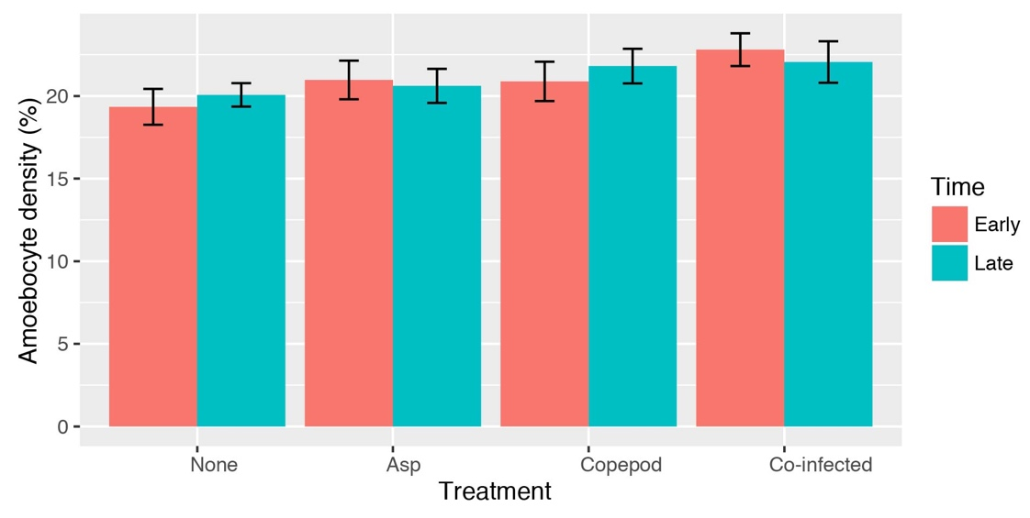

Table S10: AIC Table of models for T5A expression in the laboratory experiment (random effect: time| colony) with the best model highlighted. No models were tested without time because it was the best random slope. The highlighted model is better than the null model (Chi Sq.= 14.108, P= 8.64E-04) and the Parasite*time model by the LRT (Chi Sq.= 2.01, P= 0.156).
Model | Degrees of freedom | Delta AIC
Parasite*time | 8 | 0
Parasite+time | 7 | 0.0112
Parasite_single+time | 8 | 0.673
Parasite_single*time | 10 | 2.18
Copepod*Aspergillus+time | 9 | 2.65
Copepod*Aspergillus*time | 12 | 5.20
Copepod*time+Aspergillus | 9 | 9.17
Copepod*time | 8 | 9.49
Copepod+Aspergillus+time | 8 | 9.84
Copepod+time | 7 | 10.0
Null | 5 | 10.1
Aspergillus+time | 7 | 10.6
Copepod+Aspergillus+time | 9 | 11.7
Aspergillus*time | 8 | 12.5

Table S11: The best model of Tachylectin 5A (T5A) included the general Parasite term (Parasite) and time.
Random effects:
 | Groups | Name | Variance | Std.Dev. | Corr
 | colony | (Intercept) | 0.0244 | 0.156
 |  | time1 | 6.65E-03 | 0.0815 | 0.3
 | Residual |  | 0.00523 | 0.0723
Fixed effects:
 | Estimate | Std. error | df | t value | Pr(>|t|) | 95% CI
(Intercept) | 0.401 | 0.0530 | 8.14 | 7.56 | 6.0E-05 | 0.297-0.505
Parasite | 0.0369 | 0.00984 | 53 | 3.75 | 4.4E-04 | 0.0176-0.0562
Time | 0.0330 | 0.0285 | 8 | 1.16 | 0.280 | -0.0228-0.0888

Fig. S4: T5A expression across all treatments and time points (error bars are 1SE).

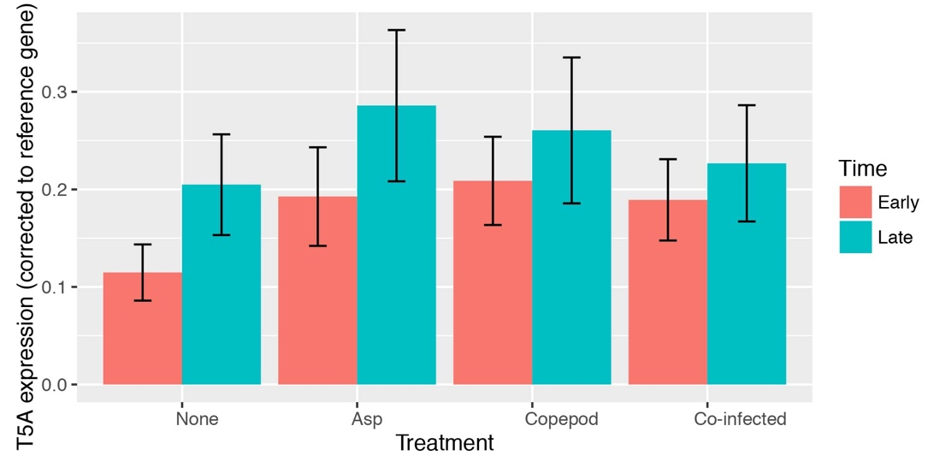

Table S12: AIC tables of models for IκB expression in the laboratory experiment. Two sets of models were tested with different random effects because Parasite and Parasite_single were both supported as random slopes. (a) Models with the random effect: Parasite| colony: Parasite*time is the best model by AIC, but the null model is best by the LRT (Chi Sq. = 2.01, P= 0.156). (b) Models with the random effect: Parasite_single | colony: the null model is the best model by AIC and parsimony.

(a)
Model | Degrees of freedom | Delta AIC
Parasite * time | 8 | 0
Null | 5 | 1.06
Parasite | 6 | 1.69
Parasite + time | 7 | 1.76

(b)
Model | Degrees of freedom | Delta AIC
Null | 8 | 0
Parasite_single *time | 13 | 1.20
Parasite_single | 10 | 2.63
Parasite_single +time | 11 | 2.70

Table S13: The best model of IκB gene expression by AIC (parasite *time with Parasite as random slope), supports a trend for increasing expression in the presence of a parasite during the early time point only, though the null is the best model by the LRT (P=0.07).
 | Estimate | Std. error | Degrees of freedom | t value | Pr(>|t|)
(Intercept) | 0.261 | 0.0201 | 8 | 13.0 | 0.0000
Parasite | 0.0178 | 0.0155 | 8 | 1.15 | 0.285
Time | -0.0153 | 0.00696 | 52 | -2.20 | 0.0322
Parasite:time | 0.0135 | 0.00696 | 52 | 1.94 | 0.0583

Fig. S5: IκB expression across all treatments and time points (error bars are 1SE).

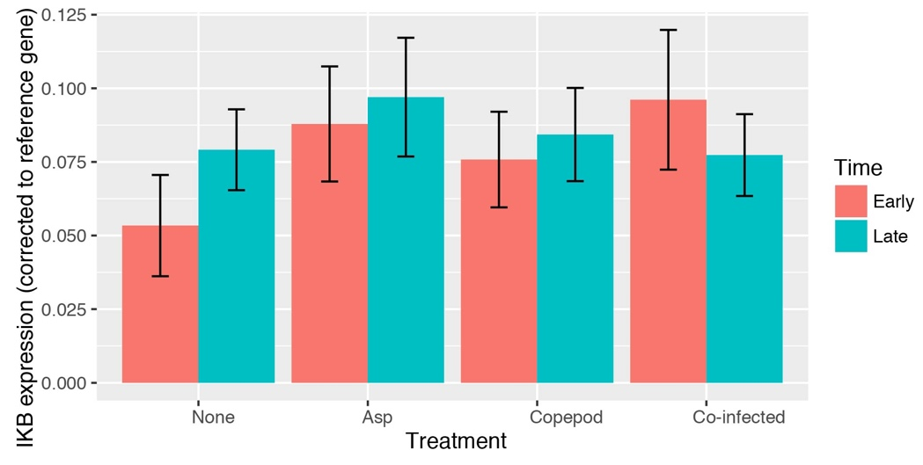

Table S14: AIC Table of models for MMP expression in the laboratory experiment (random effect: 1| colony) with the best model highlighted.
Model | Degrees of freedom | Delta AIC
Null | 3 | 0
Copepod | 4 | 1.021
Copepod * time | 6 | 1.1756
Parasite * time | 6 | 1.3558
Parasite | 4 | 1.5652
Aspergillus | 4 | 1.90
Copepod + time | 5 | 2.25
Parasite + time | 5 | 2.80
Copepod + Aspergillus | 5 | 2.92
Copepod * time + Aspergillus | 7 | 3.07
Aspergillus + time | 5 | 3.14
Copepod + time + Aspergillus | 6 | 4.15
Aspergillus * time | 6 | 5.14
Copepod + Aspergillus * time | 7 | 6.15
Copepod * Aspergillus * time | 10 | 6.67

Fig. S6: MMP expression across all treatments and time points (error bars are 1SE).
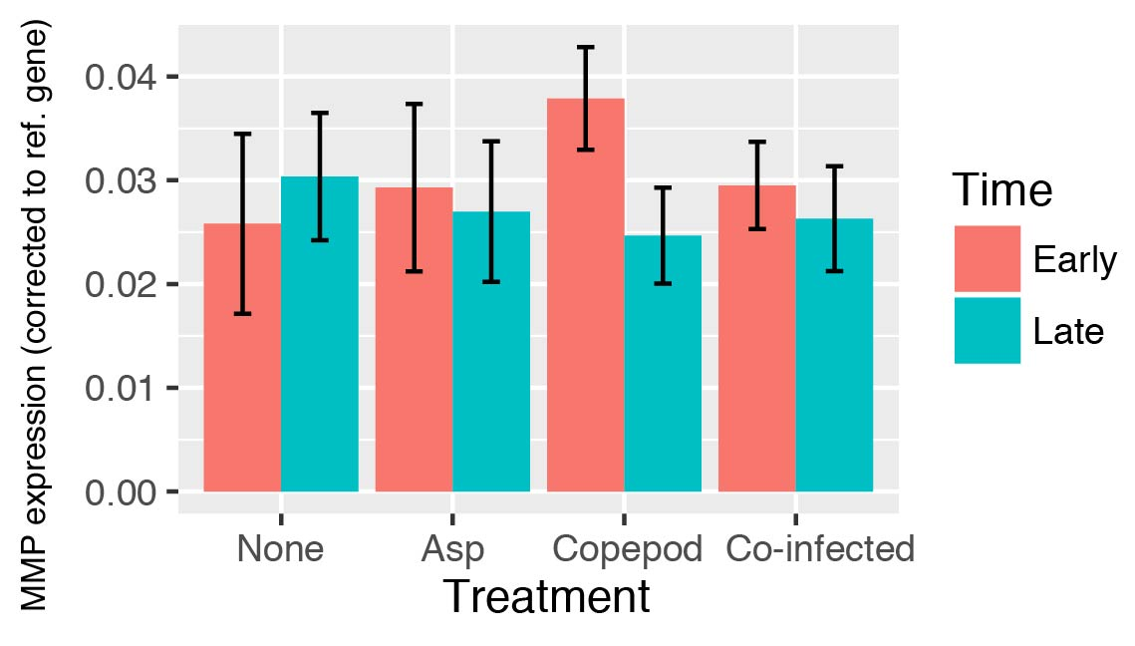

Table S15: Spearman’s rho correlations with Holm’s Bonferroni corrections for pairwise correlations between amoebocyte density, T5A, IκB, and MMP.
 | Amoebocyte density | T5A | MMP | IκB

Amoebocyte density
T5A | rho=0.411, p=0.00228
MMP | rho=0.315, p=0.0289 | rho=0.394, p=0.00335
IκB | NS  rho=0.0321, p=1.00 | NS  rho=-0.0542, p=1.00 | NS  rho=0.0583, p=1.00

Table S16: Copepod severity in the laboratory experiment is not predicted by time, co-infection, or their interaction.
 | Degrees of Freedom | Delta AIC | AIC Weight | Cumulative Weight
Null | 3 | 0 | 0.64 | 0.64
Co-infection | 4 | 1.5 | 0.3 | 0.95
2Coinfect*Time | 6 | 5.01 | 0.05 | 1

Fig. S7: The copepod and fungal hyphae randomly co-occur in the field. Colored bars represent observed parasite frequencies, whereas black bars represent expected frequencies under the null model for the Chi square test. 44 of the colonies had neither parasite (48.9%), 4 had only the fungus (4.44%), 34 had only the copepod (37.8%), and 8 were co-infected (8.89%).
Table S17: The AIC Table for amoebocyte density in the field with the best model highlighted.
Model | Degrees of freedom | Delta AIC
Copepod + site + reproductive status + coral cover | 20 | 0
Fungus*copepod+ sea fan density +site +temperature +coral cover +sex | 23 | 4.38
Null | 2 | 132.53

Table S18: Summary of the best model of field amoebocyte density
 | Estimate | Std. error | z value | Pr(>|z|) | Confidence interval
(Intercept) | 10.0 | 0.0498 | 202 | <2.00E-16 | 9.94, 10.1
Copepod infection | 0.0870 | 0.0139 | 6.28 | 3.47E-10 | 0.0597, 0.114
siteCB | -0.307 | 0.0745 | -4.13 | 3.67E-05 | -0.454, -0.160
siteCH | -0.277 | 0.0782 | -3.54 | 0.000407 | -0.431, -0.122
siteE | -0.441 | 0.0677 | -6.51 | 7.56E-11 | -0.575, -0.307
siteF | -0.107 | 0.0778 | -1.37 | 0.170 | -0.259, 0.0456
siteG1 | 0.153 | 0.0747 | 2.05 | 0.0407 | 0.0055, 0.300
siteG2 | -0.264 | 0.0704 | -3.75 | 0.000179 | -0.402, -0.125
siteL | -0.157 | 0.0874 | -1.80 | 0.0720 | -0.329, 0.0153
siteM | 0.0435 | 0.0746 | 0.583 | 0.560 | -0.101, 0.188
siteML | -0.323 | 0.0724 | -4.46 | 8.17E-06 | -0.466, -0.18
siteP | -0.419 | 0.0667 | -6.29 | 3.28E-10 | -0.55, -0.288
siteR | -0.430 | 0.0692 | -6.22 | 5.02E-10 | -0.566, -0.295
siteSC | -0.269 | 0.0706 | -3.81 | 0.000141 | -0.408, -0.129
siteTC | -0.226 | 0.0752 | -3.00 | 0.00269 | -0.374, -0.0765
siteTM | -0.357 | 0.0685 | -5.21 | 1.89E-07 | -0.491, -0.223
Coral cover | 0.178 | 0.0448 | 3.97 | 7.18E-05 | 0.0891, 0.267
Reproductive status: M vs. F | 0.00802 | 0.0175 | 0.457 | 0.647 | -0.0265, 0.0426
Reproductive status: reproductive vs. not | 0.0507 | 0.0106 | 4.77 | 1.84E-06 | 0.0298, 0.0715

Table S19: The best model of amoebocyte density in a subset of the data without the deepest site supports the same predictors, but depth is not significant.
 | Estimate | Std. error | z value | Pr(>|z|)
(Intercept) | 9.94 | 0.145 | 68.7 | <2.00E-16
Copepod infection | 0.0842 | 0.0146 | 5.77 | 7.88E-09
siteCH | 0.0378 | 0.0733 | 0.516 | 0.606
siteE | -0.445 | 0.200 | -2.23 | 0.0256
siteF | -0.00531 | 0.158 | -0.034 | 0.973
siteG1 | 0.344 | 0.103 | 3.35 | 0.000813
siteG2 | -0.273 | 0.200 | -1.37 | 0.171
siteL | 0.0680 | 0.102 | 0.666 | 0.505
siteM | 0.227 | 0.116 | 1.95 | 0.0512
siteML | -0.472 | 0.279 | -1.69 | 0.0912
siteP | -0.341 | 0.155 | -2.19 | 0.0284
siteR | -0.430 | 0.198 | -2.17 | 0.0298
siteSC | -0.279 | 0.199 | -1.40 | 0.161
siteTC | -0.242 | 0.202 | -1.19 | 0.233
siteTM | -0.347 | 0.197 | -1.76 | 0.0791
Coral cover | 0.190 | 0.0463 | 4.11 | 3.97E-05
Depth | 0.260 | 0.150 | 1.73 | 0.0839
Reproductive status: M vs. F | -0.000141 | 0.0188 | -0.007 | 0.994
Reproductive status: reproductive vs. not | 0.0663 | 0.0112 | 5.91 | 3.49E-09

Table S20: The AIC Table for MFPS prevalence with the best model highlighted.
 | Degrees of freedom | Delta AIC | AIC Weight
Size² + temperature + coral cover | 6 | 0 | 1
Coral cover + depth + temperature + size | 6 | 75.2 | 0
null | 2 | 164.32 | 0

Table S21: The best model of MFPS prevalence includes size² as a predictor.
Random effects
 | Groups | Name | Variance |  | Std.Dev
 | site | (Intercept) | 0.290 |  | 0.538
Fixed effects: |  |  |  |  |  | 95% CI
 | Estimate | Std. error | z value | Pr(>|z|) |  | Left | Right
(Intercept) | -0.683 | 0.156 | -4.38 | 1.21E-05 |  | -0.978 | -0.377
size | 2.46 | 0.209 | 11.8 | <2.00E-16 |  | 2.05 | 2.87
I(size^2) | -1.13 | 0.154 | -7.38 | 1.57E-13 |  | -1.43 | -0.833
Temper-ature | -0.647 | 0.292 | -2.216 | 0.0267 |  | -1.22 | -0.0747
Coral cover | -0.396 | 0.235 | -1.69 | 0.0911 |  | -0.856 | 0.0634

Table S22: The AIC Table for MFPS severity with the best model highlighted. Site was tested separately with each predictor due to convergence errors.
Model | DF | Delta AIC
Size²+site | 18 | 0
Size+site | 17 | 4.41
Size²+temperature | 8 | 17.7
Size+temperature+copper | 7 | 20.4
Size²+coral cover | 8 | 21.7
Size+coral cover+copper | 7 | 24.6
Coral cover+site | 17 | 32.3
Site | 16 | 35.1
Null | 2 | 57.0

Table S23: The summary of the best model for MFPS severity includes size² and site (Table S2) as predictors.
 | Estimate | Std Error | t value | Pr(>t) | 95% CI
(Intercept) | 2.52 | 0.295 | 8.54 | <2.00E-16 | 1.95, 3.10
Size | 0.834 | 0.148 | 5.63 | 1.83E-08 | 0.543, 1.12
Size² | -0.256 | 0.121 | -2.11 | 0.0346 | -0.493, -0.0185
SiteCB | -0.511 | 0.358 | -1.428 | 0.153 | -1.21, 0.191
SiteCH | 0.015 | 0.334 | 0.043 | 0.965 | -0.641, 0.670
SiteE | -0.709 | 0.349 | -2.03 | 0.0424 | -1.39, -0.0242
SiteF | -0.767 | 0.322 | -2.38 | 0.0172 | -1.40, -0.136
SiteG1 | -0.0572 | 0.344 | -0.166 | 0.868 | -0.732, 0.617
SiteG2 | -0.834 | 0.390 | -2.14 | 0.0326 | -1.60, -0.069
SiteL | 0.0319 | 0.307 | 0.104 | 0.917 | -0.570, 0.634
SiteM | -0.708 | 0.321 | -2.21 | 0.0273 | -1.34, -0.0793
SiteML | -0.615 | 0.337 | -1.83 | 0.068 | -1.27, 0.046
SiteP | -0.077 | 0.358 | -0.214 | 0.830 | -0.778, 0.625
SiteR | -0.299 | 0.355 | -0.841 | 0.400 | -0.994, 0.397
SiteSC | -0.907 | 0.379 | -2.39 | 0.0168 | -1.65, -0.163
SiteTC | -0.739 | 0.396 | -1.86 | 0.0625 | -1.52, 0.0385
SiteTM | -1.05 | 0.351 | -2.99 | 0.0028 | -1.74, -0.361
logSigma | -0.0008 | 0.0413 | -0.0190 | 0.985 | -0.0817, 0.0802

Fig. S8: Variability in MMP gene expression across colonies (9 colors, one colony omitted for heavy infection) across the four experimental treatments.

