Ethical Considerations and Methodology for
Documenting Deaf Cultural Data

Kathleen L. Brockway

May 3, 2022
Capstone Defense
Goucher College

Co-Advisors
Susan Eleuterio
Heather Gerhart

Reader
Dr. Melanie McKay-Cody

TABLE OF CONTENTS
- Acknowledgments 3
- Abstract 4
- Introduction 5
- Methodology 9
- Analysis and Plan 15
- Literature Review 23
- Challenges 26
- Recommendations 30
- Conclusion 30
- References 33
- Appendix
- Course Preparation Outline and Syllabus 37
- Booklet: The Lost Shared Signing Community of Lantz Mills 44
- Letter of Intent 77
- Initial Signed Narrative Interview Questions 78
- IRB Approval Letter 79
- IRB Approval Consent Form 80
- IRB Certification 81
- William Barber Consent Form 82
- Denise Drake Consent Form 83
- Charity Warigon Consent Form 84
- Denise Drake Interview, Transcription (AS-IS) 85
- William Barber Interview, Transcription (AS-IS) 132
- Printed Audio-Recording Transcription of Joe Miller Interview 151
- Log Files: Video and Photo Logging Files 211
- Log Files: Video and Photo Logging Files 215

Acknowledgments

I want to acknowledge my daughters, Ashley and Maureen, who were the most prominent supporters throughout my studies since joining the Goucher College program. I genuinely appreciate the Goucher College instructors and staff for their open-mindedness in working to meet the success of this project. I would not have done this without the consented participants, William Barber, Denise Drake, and Charity Warigon willing to be part of the interviews. I also want to note Elissa Free has been a great communicator with me in regards to her transcripts and the answered questions I needed for my research project. There are many more names to name and I am grateful for their assistance and patience. Lastly, I am grateful for my committee, including co-advisors Susan Eleuterio, Heather Gerhart, and Reader Dr. Melanie McKay-Cody. They went through with me and helped me reach the finish line!

Abstract

For years, documentary research methods have focused on hearing-world-centric techniques. There has been very little research up till now on identifying problematic and in some cases, unethical practices in documenting deaf culture by researchers who lack knowledge of deaf culture. This paper makes the case for developing culturally responsive methods for documenting deaf culture, and seeks to break new ground by developing a deaf-world centric course that reflects the ethical considerations for documenting deaf culture and using appropriate interview technology. This paper primarily focuses on documenting name signs through signed narratives, and uses Lantz Mills deaf village as a case study for using a multi-sited ethnographic approach to responsible data collection. it includes a syllabus and a sample module for an online course which will introduce researchers to appropriate methodologies
Introduction

The scope of this capstone is to discuss ethical considerations and a methodology for documenting deaf cultural data. It focuses on a step-by-step process I have used to develop an online course on adequately documenting deaf culture, primarily focusing on name signs and identifying proper interview technology when researching deaf communities. Name signs – or the use of a signed name using American Sign Language (ASL) – is a naming custom in deaf culture and is part of an established deaf cultural tradition and history in the deaf world. Below I explain their significance in greater detail as deaf communities' name signs are important heritage and membership identifiers.

My research objectives were: 1) To identify the significance of documenting name signs in historical research on deaf communities, 2) To identify proper interview methodology with the deaf participants, and 3) To describe the significance of using specific accessibility features/tools such as sign language interpreters. The course syllabus will be discussed in this paper before I create a website for delivering the content.

My inspiration for this project came about as the result of study I conducted in Lantz Mills, Virginia. I first learned about the Lantz Mills community when writing the "The Lost Shared Signing Community In Lantz Mills, Shenandoah County, Virginia” (Brockway, 2022). My published study of the community describes a village where deaf and hearing people communicated using a shared sign language, including the two-handed manual alphabet, the single-handed manual alphabet, the name signs of deaf participants, and the dying regional sign language. Because this story has been untold for years, I have named it a “lost shared signing community.” You could also say that the hearing people were bilingual in both spoken English and spoken German, along with knowing the regional sign language plus the regional manual alphabet.

I note this because there was a lack of information and even awareness about this type of deaf cultural community except for the Martha’s Vineyard deaf village. I have been studying the Lantz Mills deaf village and other stories, including Martha's Vineyard's deaf village. As a deaf researcher and documentarian myself, I made sure the deaf culture was documented correctly compared to the other deaf historical stories written by non-deaf researchers or anthropologists. The most striking part they missed were the use of the name signs by deaf participants. I did not fully grasp the significance of name signs until I took courses at Goucher College including Cultural Documentation, Introduction to Cultural Sustainability, Cultural Documentation Field Work, Cultural Partnerships, and more, which defined these signs for me.

As I conducted research into Lantz Mills, I noticed many name signs used by residents during their unstructured conversations, and not once were they documented. My recent publication identifies some of the Lantz Mills name signs. This is the first time they have been documented in the 250 years of history of this Shenandoah County community.

Martha’s Vineyard Deaf Village
There has been very little research up till now on identifying problematic and in some cases, unethical practices in documenting deaf culture by researchers who lack knowledge of deaf culture. Melanie McKay-Cody, a deaf researcher of Disability and Psychoeducational Studies at the University of Arizona and author of Memory Comes Before Knowledge. North American Indigenous Deaf: Socio-cultural Study of Rock/Picture Writing, Community, Sign Languages, and Kinship (2019), has written that “shared signing communities define gatherings where both deaf and hearing neighbors communicate through signed and gestural languages.” Martha’s Vineyard provides one well-known example of a shared signing community.

Many researchers have focused on the famous story of Martha's Vineyard's historically deaf community. Nora Groce, a non-deaf author, published the adapted story from her original anthropological dissertation, Everyone Here Spoke Sign Language: Hereditary Deafness on Martha's Vineyard (1985). Groce is an anthropologist specializing in medical disability and is currently Leonard Cheshire Chair of Disability and Inclusive Development at University College London.

However understanding the deaf culture concept is different from understanding the general disability concept, and her book missed opportunities to document important aspects of deaf traditions such as the name signs, identified regional signs, and other details of deaf culture. There is a possibility she did not fully understand how to document the deaf culture because she may not have experienced sign language all her life, nor did she have the personal experience of social life in a deaf community. Understanding the deaf culture concept is different from the general disability concept. Groce coined "Martha's Vineyard Sign Language (MVSL)." How did she identify this island sign language terms without knowledge of sign language all her life? Is that appropriate? These questions, among other personal experiences, inspired me to create and teach a course on properly documenting deaf culture.

Similar to Martha’s Vineyard, the Lantz Mills townspeople organically communicated in sign language with each other. I reviewed a series of signed narratives and was struck by how vital name signs are to the community’s history. This capstone reflects the ethical considerations for documenting deaf culture and using appropriate interview technology and includes a proposed course for teaching researchers the proper techniques, in addition to properly documenting deaf culture. Using proper technology is essential to this documentation.

Ethical Considerations
What are Name Signs?
As described above, name signs are a large aspect of deaf culture. Sometimes name signs are a combination of initialized and descriptive types. As a deaf person, please note that I use the term "name signs" in deaf culture conversations. "Signed names" is the equivalent in written English.

Traditional deaf culture typically involves name signs, and people are not addressed as “Mr., Mrs., or Miss.” Maher (1996) explains that “it is common for deaf people to create name signs to avoid the time-consuming process of fingerspelling. Often, the name sign reflects a significant characteristic of the person.” Name signs have been one of the most valued practices in the deaf community for years. Using them displays proper interview practices for members of the deaf community and cultural competence and respect for deaf cultural practices.

Name signs are not commonly given at birth since most Deaf children have hearing parents. They are given an English name that is put on their birth certificate but typically, it is only later when the child is among other Deaf people that they are given a name sign – usually by their peers in the Deaf community (Supalla, 1992). It is vital to recognize the deaf heritage, the values, and the traditions behind giving and receiving name signs. It is not common for hearing people to use name signs, although we now see more hearing people being accepted into and recognized as part of the deaf community and possibly receiving name signs.

The accurate identification and documentation of name signs depends on the use of a qualified ASL interpreter. Non-deaf interviewers have been interviewing deaf interviewees for years, often relying on interpreters to communicate with their interviewees. Unfortunately, not all interpreters are equally qualified. This is something that’s difficult for non-deaf individuals to assess, and they may hire based on cheaper fees. Certified interpreters typically have a higher fee based on their experience and skill level. Certified interpreters are more likely to get training to capture the name signs that a non-deaf interviewer might miss. In addition to hiring a qualified interpreter, the non-deaf researcher also needs to attend to- and document - the kinesthetic aspect of ASL that includes information that is communicated visually.

According to the Oral History Association on Archiving Oral History, "It is important for oral historians and archivists to understand the responsibility for ensuring the long-term preservation of an oral history interview. Oral history as a field of practice prioritizes preserving the original recording of the interview and related documentation” (Oralhistory.org, 2022). The standard practice for oral historians interviewing deaf participants relies on them listening to sign language interpreters' audio or voice(s).

In contrast, the interpreters receive visual signing from the deaf interviewees. This focus on the interpreter's voice results in missed opportunities that include documenting physical aspects such as the name signs or signed narratives describing something from memory. Who is responsible for capturing the name signs? The interviewer is responsible.

For example, in an interview with Denise (Appendix K), I caught her signing the “train” sign and did not recognize that visual sign. At that time, I did not ask the interpreter to describe through the audio recording. In the CART transcription, the visual sign language is not described. The audio translated through the interpreter is shown here from the Appendix K, lines 3-6. Shown here is the audio transcript without editing:

“ 3 there was a train that the time for him to travel to school. So

4 my grandfather told me he used a different old fashion sign for

5 train because it was a slow train you know where the wheels chug

6 chug a long so he used a very old fashion sign for train.”

In this case, for the interpreter who voiced, I should have been responsible for interrupting the interpreter and describing what Denise actually signed when she used the visual sign for “train.” This can be addressed in a separate Module that addresses the responsibility of an interviewer as well as how we can use interpreters as allies in the interview process.

Based on a "general" organization or community (Oralhistory.org, 2022), I respectfully disagree when it comes to the practice of many researchers of using only a non-deaf methodology regardless of disability or non-disability. In researching deaf culture through history, including values and traditions, the vital part is recognizing signs that researchers should be required to document, such as identified name signs that are part of each interviewee's identity in deaf culture.

In Margaret Kovach’s book, Indigenous Methodologies, she emphasized respecting indigenous culture when it comes to research within tribal communities. Kovach may not have known that there are some deaf indigenous members within the tribal community. A major number of researchers like Kovach are only using non-deaf methodology versus using deaf and non-deaf methodologies. I discuss this issue below under the literature review by comparing the difference between Dr. Melanie McKay-Cody and Margaret Kovach’s objectives in the indigenous methodologies.

Methodology

To create a course and a process for researching and documenting deaf culture, I used methods I learned in the Cultural Documentation Course, such as:

Participant observation - Capturing name signs and other signs (town and regional old signs) through video interviews. Observed dialogues through audio-only recording transcriptions;

Research - Reviewing video interviews, documentations, literature review, and photographs;

Multi-sited ethnography - Interviewing individuals from multiple locations, not just one location. Deaf individuals are scattered across the nation;

Data Collection - Observing deaf cultural information through the transcriptions and other documentations such as photographs and videos.

A study of culture, concerns, ethical considerations, and traditions is one of the strategies I will discuss step by step developing a course syllabus. I also will share my challenges, reflections, and speculations. I created a course syllabus (see Appendix A, pages 36) and developed some signed narratives for use in the course modules.
Signed Narratives using the Methods
I selected three key people to interview: William Barber (fig. 1), Denise James Drake (fig. 2), and Charity Warigon (fig. 3). They were invited because they have ancestors from Lantz Mills, Shenandoah County, Virginia, and knew several name signs in the families passed down through the generations. The importance of having them in a visual language demonstration is because they knew several name signs the deaf community has not heard of in many years.

Screenshots of interviews I had with Barber, Warigon, and Drake are shown here. Barber attended the interview on the Goucher Campus, while both Warigon and Drake had their personal interviews in their homes using the online zoom link set up through Goucher College on the Web.

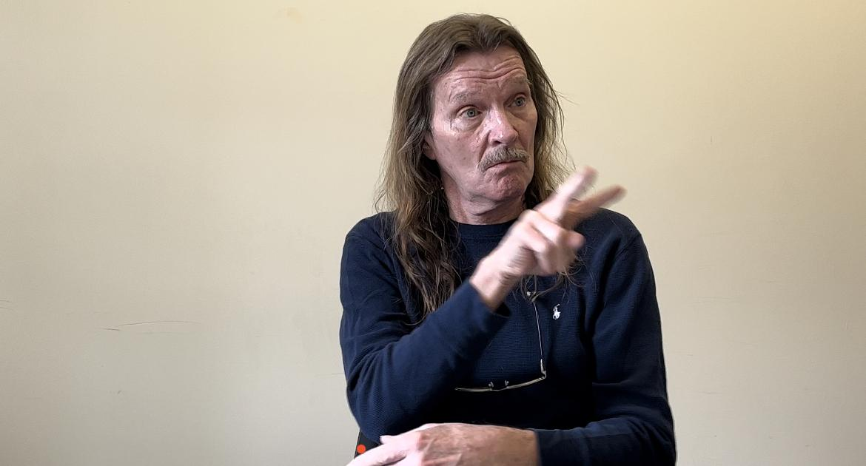
Fig. 1, a screenshot of interviewee William Barber, who is signing. The interviewee sat in a room on the Goucher College Campus in the Julia Rogers building. Transcript is available, attached to the Appendix L . (PC: Kathleen L. Brockway).

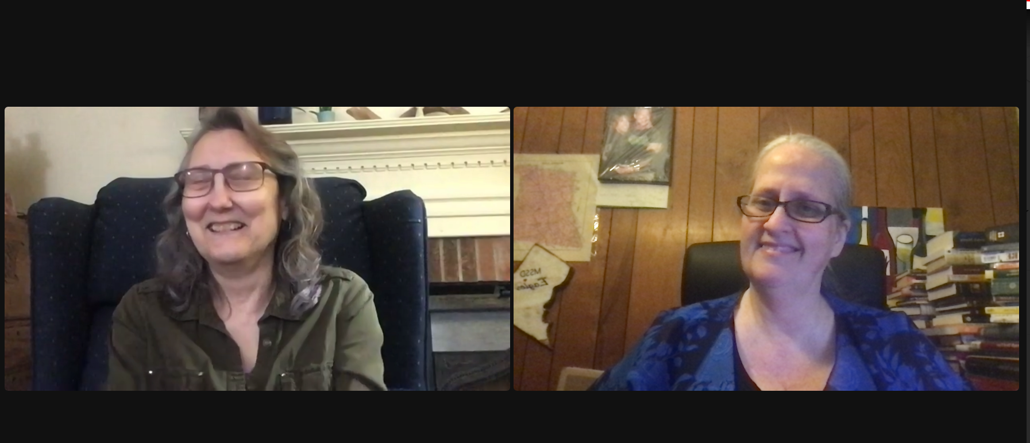
Fig. 2, a screenshot of interviewee Denise Drake (left) and interviewer Kathleen on right. Both appeared in an online zoom meeting using dual screens. Both interviewee and interviewer are smiling. Transcript is available, attached to the Appendix K. (PC: Kathleen L. Brockway)
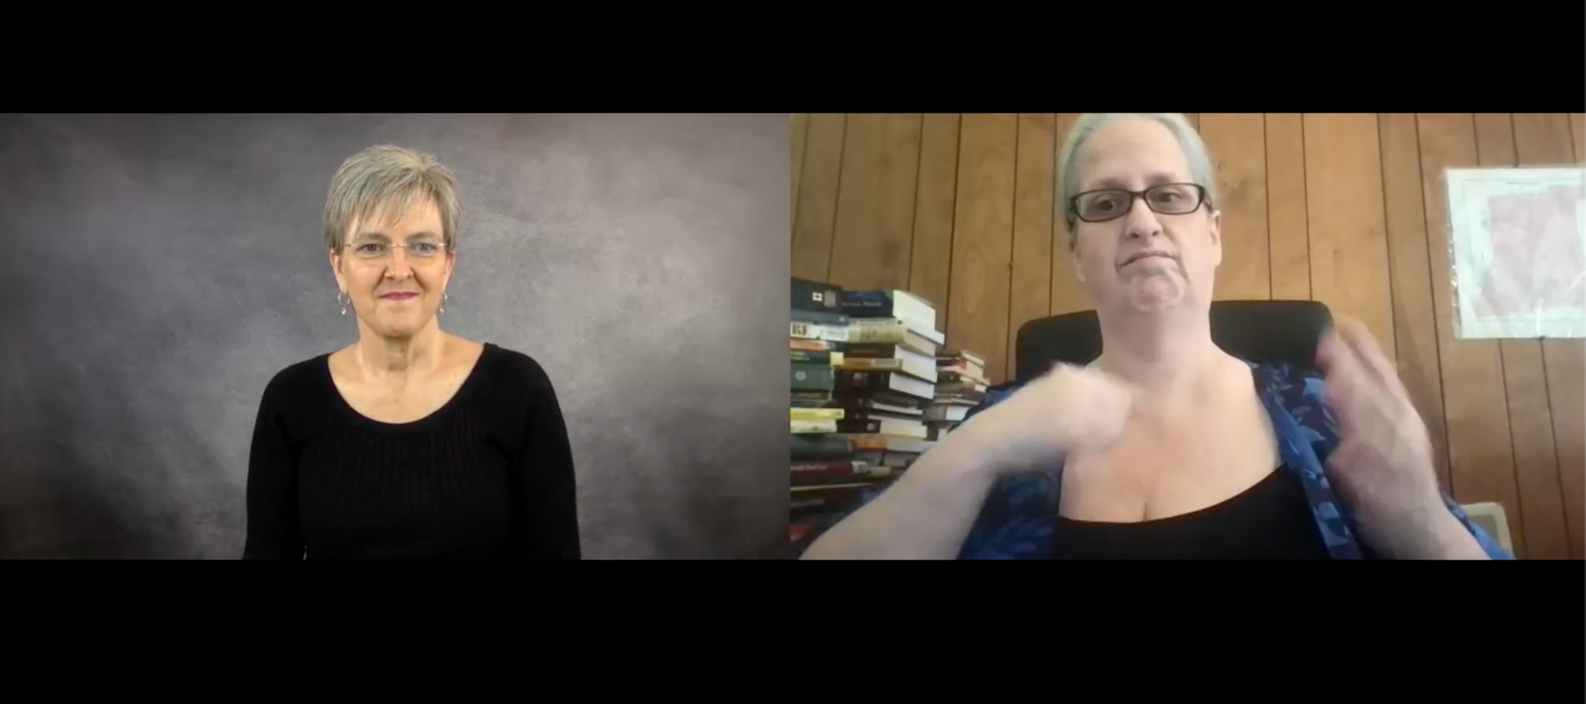
Fig. 3, a screenshot of interviewee Charity Warigon (left) and interviewer Kathleen on right. Both appeared in an online zoom meeting using dual screens. Interviewer is signing while Interviewee looks on. Audio-only and Transcript recordings are unavailable; however, a summary is logged under Appendix O, Video Worksheet 3. Time ran out with the scheduled voice interpreter to complete the transcription. (PC: Kathleen L Brockway)

Before the interviews, I started to build relationships with the named people and continued to have unstructured interviews with them before this project’s formal interviews. They are familiar with my research; however, I did not share my initial interview questions for this particular interview. My goal was to capture the deaf culture's name signs in natural action through visual language and expressions. The visual action is also significant to document with the name signs. As I stated before, the interviewer is supposed to be responsible for doing the participant observation by documenting the visual signs accurately while the interpreter voices the description.

The original arrangement was to set up interviews on Friday, April 1, 2022, between 2 PM and 4 PM on the Goucher College campus in the Van Meter Hall building adjacent to the Julia Rogers building. Because of the interpreters' availability, the date and time were changed to April 12 from 12 noon to 3 PM. One interviewee could not make it after the date/time change; however, we were able to conduct the interview virtually using the online platform Zoom, arranged for April 11; I provided the pre-recorded interview on the 12th for interpreters and the Communication Access Real- Time Translation (CART) service to translate the voice and type up into the written ”as is” English words.

For the in-person interview, I chose a room that is less noisy and quieter in a setting where the audio would not be garbled from the ambient noise in order to allow the captioner to hear the full details in typed real-time captioning. The real-time captioning becomes the written transcript. I manually edit the written transcript if necessary, for instance, to correct misspelling and/or "garbled" words; however, I do not adjust the whole signed narrative because it allows the interviewees' voice to tell the story. Il also add the name signs through visual language from the signed narratives into described name signs. The description writing is called the ASL Gloss. In other words, the commonly known general terminology is the writing gloss system. A writing gloss system helps to understand the words, not translate the words. The initial interview questions are shown in Appendix D, page 77.

An example of ASL Gloss based on a visual image:

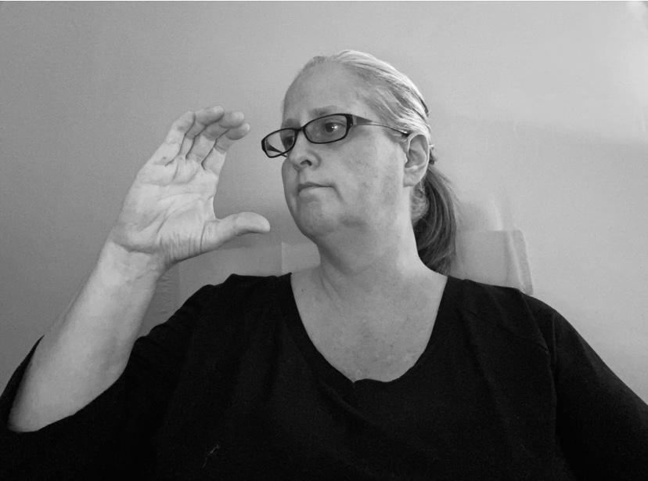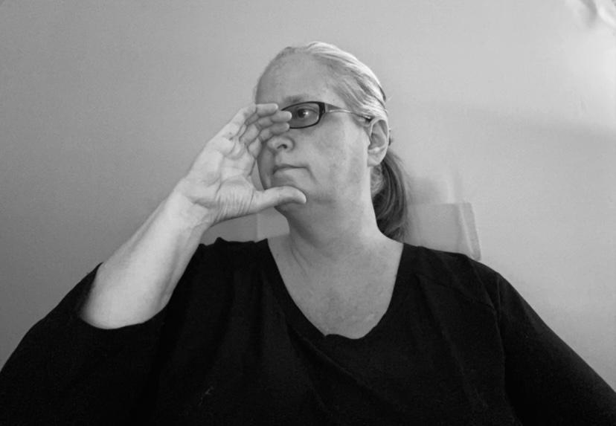
On the left, shows a hand-shape C away from the face. On the right, shows a hand-shape C touching onto the nose on the face. Then repeat to make it a name sign for “Christian.” (PC: Kathleen Brockway)

Analysis and Plan for the Capstone Project

Course Development
Taking Goucher’s Designing and Delivering a Learning Experience Course gave me the idea to create an online course for researchers working with deaf participants. This course aims to have adult learners (specifically researchers studying deaf culture) identify and adequately document deaf culture, particularly name signs. The course will be designed and adapted for relevant audiences, including anthropologists, historians, curators, deaf studies majors, or cultural sustainability graduate students. An additional goal is for participants to identify proper interview technology; describe the significance of specific accessibility features such as captions, and learn how to hire experienced interpreters. Finally, my goal is to develop this as a self-paced course to utilize the online format effectively. Developing a course is significant because there is a need for researchers of historically deaf communities who are not deaf to learn about aspects of deaf culture and subsequently use the proper accessibility tools to properly document deaf culture.

Without attending the courses throughout the MACS program, I would not have concluded where I am in developing my project. For instance, courses called Cultural Documentation and Cultural Documentation Field Work opened my eyes to the ethical considerations of documenting deaf cultural data. Readings from these courses, including When They Blew the Levee: Race, Politics, and Community in Pinhook, Missouri, by Lawrence and Lawless, introduced me to processes I could use for documenting Lantz Mills, Virginia, such as field journaling, photo journaling, and the interview videos.

The MACS Course, Introduction to Cultural Sustainability, was a fundamental course that influenced my thoughts on documenting and using the proper methodology for the deaf cultural community. In particular, Margaret Kovach’s book, Indigenous Methodologies: Characteristics, Conversations, and Context, discusses the concept of a “single tribe” defined as a community that grew up in the same area. This provided a jumping-off point for my own research that focuses on the deaf community who are often scattered all over the nation but share a deaf identity. To find deaf descendants or former residents, researchers must do a wider search outside of the local community (or a single tribe). For this reason, I chose a multi-sited ethnographic approach for my research methodology.

I may be an experienced cultural researcher, but I overlooked several things. Thanks to the experts I learned from at Goucher College, I was able to see what was missing. For example, photo journaling is significant for observing and describing, not assuming what the person is saying in the photo as I have explained in the next paragraph below (please see fig. 4 image).

Another example was through the Cultural Policy Course which required doing interviews with two different state school employees through deaf educational programs. I consumed a lot of information collected through those interviews. For example, I learned that both schools were affected by the COVID pandemic changes in the deaf education system. Not only that, I saw how excited my Professor was according to the ASL interpreter who heard the Professor's voice in a different tone when I gave a presentation on this topic. He encouraged me to do a thesis on this subject. His thinking greatly influenced me to recognize the importance of having multiple interviews to examine the answers and different perspectives. I combined his thoughts onto a different subject I chose to focus on.

In Another Course, Cultural Documentation, I learned more methods to use in the process of documenting correctly. Especially doing photo-journaling (see fig. 4), I understood how to document deaf culture through the Field Work class properly. My instructor told me that she was not interested in photo-journaling deaf history but needed more information about deaf culture. I did not understand at first, then realized what I was doing was inappropriate. Originally, I showed an opened map-book on the table without any visual gestures from an individual; Fig. 4 shows an example of properly documenting deaf culture:

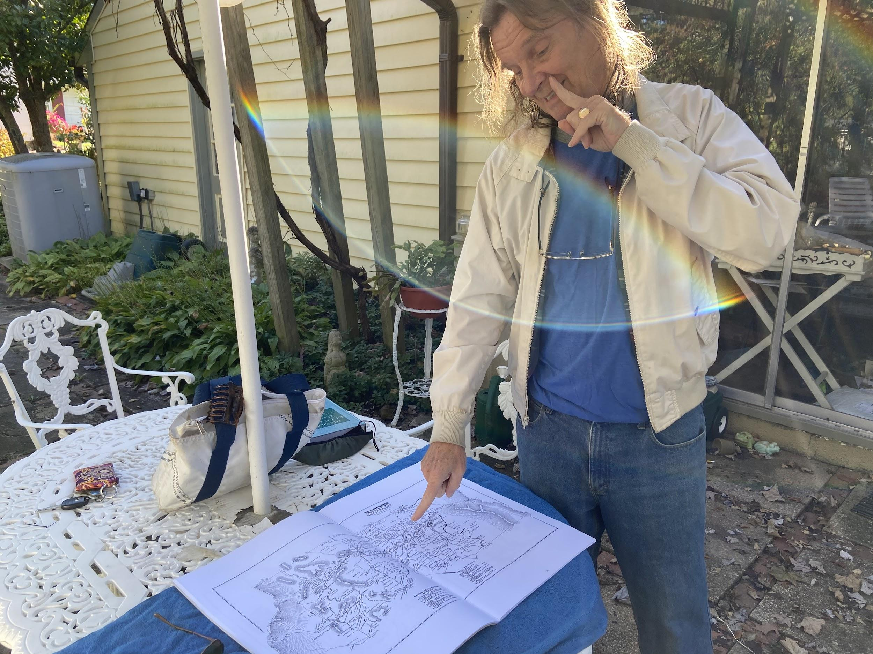
Fig. 4, William Barber is standing by a table with an old map book on the table. He is pointing to a location where many deaf residents lived. He also is signing the word “deaf” with an index finger on his cheek.
Logistics and Materials
I designed this course using a variety of media and techniques for teaching and learning through a variety of media including video, captioning, and questionnaires (all kinds for feedback, multiple choices, and pre/post-test quizzes) formats. Also, I use an iPhone (smartphone) to record videos and take photos in either a still photo, moving video, or other effects coming with a tripod. Lastly, I plan to put the course modules onto a website as a self-paced course. Materials will include the attachments that are listed as readings in either active links or attachments in PDF formats and relevant chapters from some of my reference books. The materials will be relevant to which topics are used for course development, including why name signs are significant, discussions including the comparison of auto-generated and manual captions, and the significance of accessibility in the research methodologies or curatorship. I may provide different topics that are relevant to the participant's job or experience.

Evaluation Plan
Feedback from participants is a vital part of course development. After the course ends, I will create and use survey data to evaluate the course based on responses from participants including their opinions - some will be blank text fields to allow the takers to type in their opinions and perspective. Some questions will ask how the course has impacted participants and analyze their thinking about inclusivity or accessibility. I will then use the results to implement changes based on the outcome measures. Those results include taking the post-test quizzes to deliver the results of how much learners have learned. After gathering data, the measurements of the results and statistics, including feedback, are the key to improving the course. One idea I have is to post these outcomes in statistics format on social media platforms or the online course website to inform people that this course is having an impact in their workplaces or research strategies.
Signed Modules
I will deliver lectures via signed modules that discuss the assigned readings. The modules will include audio, captioning, and signing all in one video designed to be accessible for all kinds of takers. I will also be sure to make the modules accessible for other audiences such as deaf-blind or blind takers. My aim is to ensure compatibility with the Americans with Disabilities Act (ADA), by engaging participants and providing all viewers with an experience of inclusivity.

Syllabus Development
Developing a syllabus was an essential part of creating guidelines for success for this course. It includes an introduction, a guide to time management, workload, attendance, participation and communication, technical issues, how the class will communicate, including email (no phone calls), and grades posted every post-test results. The first module begins with a welcome video with a brief background about myself. Then I explain what the course offers and what is included in this online course. I address some key terminology in advance, including deaf culture, and American Sign Language (ASL), Name signs, and a reminder that errors are not the takers' fault because they are possibly unfamiliar with an experience of deaf culture. For the Name Signs module, I explain the custom of deaf individuals giving name signs. The other modules will provide a course introduction, cover key terminology, and focus on accessibility tools and how important that is to the deaf community, including all kinds of deafness like deaf-blind, oral-deaf, and late-deafened. The required readings may be the most fun of all in the syllabus! I hope this course will impact the broader audience on ethical considerations and methodology to properly document deaf cultural data.

Sample Module: Name Signs
This module’s goals are for participants to think through and identify why it is essential to capture the actual signing process of name signs and document it in their research. Also, it provides a guide to understanding step-by-step from seeing the signing of a name sign, then understanding how to write and use proper technology in documenting the name signs and other deaf cultural materials.

Website
Once pilot tested and developed, the course will be posted on a website in an online format. A pilot will be tested with a small focus group to see if the course is successful for a launch. Possibly, I will host an online zoom meeting to hear their feedback and discussion. That may help improve the outcome of course development. Once I am ready for a launch, I will promote the course over social media platforms using a video with audio and captioning to address why this course would be useful in terms of learning about ethical considerations and methodology for documenting deaf cultural data. My target audience in the focus group would be the curators of some museums, anthropologists selected from a higher educational program, and Professors who teach methodologies classes. For the first focus group, I will recruit non-deaf participants to give me a better idea of what they learn from the pilot version of the course.

Literature Review
This literature review addresses the significance of documenting deaf culture data, including ethical considerations of definitions, keywords, and methodologies in the interviews. I have also addressed how these works helped me to develop a course on properly documenting deaf culture, along with works which are important to my work on ethical considerations and methodology. It should be noted that there are very few texts which focus on ethical considerations and methodology toward deaf culture and deaf people. Dr. Melanie McKay-Cody’s publication was the closest I could find which included these considerations. The term “multi-sited ethnography” first resonated with me and I became determined to include ethical considerations and methodology in properly documenting the deaf culture. Other than reading about the terminology, the interviews led me to think about ethical considerations when I collected many name signs in the interviews. I learned from others’ work and through my personal experience and perspective on deaf culture.

The Lost Shared Signing Community of Lantz Mills and Shenandoah County, Virginia
This capstone project is designed to create strategies to include ethical considerations when documenting deaf culture data. Lantz Mills has served as my case study by allowing me to create samples of a variety of deaf cultural documentation including photo journaling, signed ethnographic narratives, and sign language archaeology. I have also analyzed the villagers’ behavior and traditions including a study of ethical considerations on definitions and keywords.

Before I attended Goucher College, I was fascinated by what I learned from deaf individuals about stories of Lantz Mills, Virginia. I was not familiar with the area and began to do a deep study, then asked more questions. The more I studied, the more I started to realize how important this community’s story is, and I firmly believe this story should be more widely shared. I was especially influenced by taking courses through the MACS program. This community instantly reminded me of the Martha’s Vineyard’s shared signing community story which is described in the text, Everyone Here Spoke Sign Language by Nora Groce.

After taking classes through the Masters of Cultural Sustainability program, I began to examine through a closer lens the Lantz Mills community based on my learning experience from the classes I took, especially based on the Cultural Documentation and Cultural Documentation Field Work courses. Collecting more information impacted and improved my thinking in planning this course.

Publishing this work as a booklet (Appendix B, pages 42-74) also shifted my assumptions. I had assumed a lack of information reflected a lack of knowledge. In fact, several townspeople in Shenandoah County, Virginia did know the stories, but did not think to share them publicly. They also may not have known that information was important or valuable to others. As I gained their confidence, townspeople began openly sharing information to help support the deaf culture. My recent publication through the Shenandoah County Historical Society (March 26, 2022) includes these contributions from the community.

When They Blew the Levee: Race, Politics, and Community in Pinhook, Missouri
For one of my courses, we read When They Blew the Levee: Race, Politics, and Community in Pinhook, Missouri by Todd Lawrence and Elaine Lawless. This book helped me think about the research process, because the field workers, Lawrence and Lawless, used a process that I wanted to employ for the Lantz Mills community telling their story through the deaf cultural data.

Both authors of Pinhook were field workers who saw beyond the facts to the politics of what happened in Pinhook, Missouri. The tight-knit community was a small group that many overlooked when the levee was blown with the intention to save another town of Cairo, Illinois. The story had a huge impact on the documentation of music, culture, and the community of Pinhook, Missouri and therefore, on their culture. I learned of this book through the Cultural Documentation Lab Class and that story brought me closer to focus on the town of Lantz Mills and its existence as a shared signing community. The fieldworkers (authors) did a systematic process in ethnographic documenting and listening to the individuals who saw that the negligent treatment of this town, Pinhook, was based on race and politics. I began to think about the politics of how deaf individuals are treated. In the next couple of paragraphs, I will explain the reason.

The Pinhook authors posted videos from their field work including a documentary on the website www.rebuildpinhook.org. This kind of teamwork gave me a heightened motivation to do a project using both print text and a future website to demonstrate my research and the impact of cultural documentation work. The Pinhook documentary focused on race and politics.

Before I collected information based on what I learned through the Pinhook story and the MACS Field Work course, my vision was to create the Lantz Mills documentary not intended to be focused on race, but rather focused on politics. My goal was to research why Shenandoah County did not recognize this shared signing community for 250 years. There were questions hammering in my head: Were county administrators unaware of this community? Or were they lacking knowledge of how to portray deaf individuals without causing embarrassment? Those were the questions I was searching for as I began to develop a course syllabus.

After interviewing community members, publishing a booklet (see Appendix B, page 43) for the Shenandoah County 250th Anniversary Commemoration, and sharing the story through an interview on the front page through Northern Virginia Daily news, I was determined to teach a course in order to draw more attention to the proper documentation of deaf culture. I realized that this course needs to be taught so individuals could learn how to be more inclusive in documenting overlooked communities similar to those in Pinhook.

The History of Shenandoah County
John W. Wayland was a famous author and historian who published a book in 1927 called A History of Shenandoah County. This book lacked any mention of deaf culture or the history of Lantz Mills as a shared signing community. However, Wayland made a reference to one person - Arthur Belew Christian - that was particularly exciting to me and to local residents. Wayland mentioned that his was possibly the most prominent military funeral ever held in Shenandoah County on March 1, 1919. Arthur died on November 13, 1918, in France during the war. The family fought to bring his body home after being buried in France. His body was brought in a casket from France to the USA, entering the tiny community of Lantz Mills in Shenandoah County. His family then buried his body there. The author did not know that Arthur was deaf with slight hearing loss. His hearing loss may have been hidden since he could speak well. If the author knew he was deaf, would his story be published in the book? The assumption was based on the other prominent deaf villagers not mentioned in his book.

I raise this because Wayland did not mention the Christian family included six brothers (five were deaf out of six) and two deaf parents. They were very significant to the Shenandoah County community because they ran a cabinetry business and as undertakers creating the wood caskets for bodies buried at the cemetery in Lantz Mills and other cemeteries. The business was called William Christian and Sons and this business was promoted through local newspapers. This business ran between 1877 and 1915 for 38 years before 82-year-old William Christian succumbed to his injuries after being hit by a horse and a carriage going down the hill while Christian was walking down the road between the shop and his house.

I wanted to explore why Wayland did not include significant people like the deaf individuals in the Lantz Mills community. The historical argument is whether the authors or writers intentionally withheld information on the deaf community because they did not want to show embarrassment? Perhaps the author did not know what to address about the deaf village, so he left it out? Wayland published two books, with the last book published posthumously.

Wayland’s book, among others, resulted in me deciding to develop the course for researchers. I hope to provide students who take this course more confidence and knowledge in collecting more inclusive information, including deaf cultural stories. Zach Hottel, the Librarian of Shenandoah Public Library, set up archives on deaf cultural research in the Edinburg, Virginia area. This course can additionally benefit researchers by augmenting their knowledge in deaf culture.

Indigenous Methodologies: Characteristics, Conversations, and Context
Kovach’s book presents her outline of indigenous research methodologies with a perspective from both Western systems research and her own approach which demonstrates how that the Western system disrespects indigenous culture. Kovach presents a depth of new approaches focused on the sensitivity of intersectionality and designed to gain respect for her and other indigenous people’s culture. This book showed me new potential research methodologies for different minority cultures.

However, the critical missing information in Kovach’s research is the deaf indigenous community within her tribe on methodological research. As Kovach said, “My critical perspective on the world was solidified through academia” (Kovach, 1988). She mentioned that research textbooks did not offer Indigenous frameworks as a methodological option. She then inquired into the intersection between Indigenous knowledge and research (Kovach, 1988).

My argument is that Kovach misses an entire aspect of Indigenous knowledge and research by excluding deaf culture. Hence, the course I am planning to teach will include deaf culture as an aspect of conducting multi-sited ethnography. Scholars like Kovach or Groce may have missed the opportunity to include or access more thoroughly the deaf community using the methodology of “multi-sited ethnography.” I am hoping to teach students to understand how to get more information, not just in one place but from multiple places.

Memory Comes Before Knowledge - North American Indigenous Deaf: Socio-cultural Study of Rock/Picture Writing, Community, Sign Languages, and Kinship
In Melanie McKay-Cody’s dissertation, Memory Comes Before Knowledge. North American Indigenous Deaf: Socio-cultural Study of Rock/Picture Writing, Community, Sign Languages, and Kinship, she raises important keywords that I will use in the research for this project, especially such as “multi-sited ethnography,” a term coined by George Marcus. Before I read McKay-Cody’s dissertation, I read Margaret Kovach’s book, Indigenous Methodologies: Characteristics, Conversations, and Context, during my Introduction to Cultural Sustainability class, and that book impacted my thinking to research whether there are any similar appropriate methodologies to use with the Deaf Studies. That was in 2018. McKay-Cody’s dissertation was published in 2019 and is considered the best methodology for documenting deaf culture.

Though McKay-Cody did not mention the discussion of name signs in her dissertation, she has verbally acknowledged there are name signs among Indigenous deaf communities. During recent interviews with McKay-Cody, she noted some perspectives discussed below related to my realizations about Kovach’s work in terms of deaf culture.

According to Dr. Melanie McKay-Cody, a deaf Indigenous researcher, usually gets the following three pieces of information from her interviewees: name sign in American Sign Language, Indigenous name sign, and the full Indigenous name assigned by the tribal community. Name signs are crucially adding to Indigenous knowledge and research documentation because it is an Indigenous deaf culture.

This material along with Samuel J. Supalla’s work, The Arbitrary Name Sign System in American Sign Language. Sign Language Studies provided valuable information for my module on name signs. Although there are several references to name signs in other work, non-deaf scholars have not focused on name signs when they have interviewed deaf interviewees or researched deaf culture and history. This has underlined how important documenting name signs are as part of researching deaf cultural communities.

Disability Oral History Toolkit
The scholars Fady Shanouda, MA and Karen K. Yoshida Ph.D developed a toolkit for The Centre for Independent Living in Toronto (CILT) Inc. with the Department of Physical Therapy at the University of Toronto. The Disability oral history toolkit presents a resource for the general disabled community. Part B provides vital information to understand how to capture everything in the interview, such as name signs, stories, and understanding of the visual language if scholars want to interview deaf interviewees.

For example, these four core principles are discussed:

• Shared authority and collaborative process;
• Ways of speaking about disability and learning how to recognize different perspectives.
• Appropriate responses to emotional moments; and,
• The incorporation of personal objects into a life narrative.

To have an open-minded dialogue, scholars and others can help understand and work through the reading. My lecture, especially the deaf interviewees' responses using the four core principles, is significant. I intend to apply the four principles towards properly documenting deaf culture aspects, including visual language, regional sign language, name signs, and other stories. In the future, I hope to develop an appropriate toolkit specifically for the linguistic minority community.

In section C of the article mentioned above, transcriptions are discussed. Often, many who do the audio-only recordings do not provide transcripts right away because a widespread understanding is a time-consuming process. However, to be more inclusive, my course will teach users to utilize the ready-made transcription before posting the audio-only recording such as a podcast for the public. This toolkit and these principles can give participants a general understanding before I provide my lecture on how this is relevant to deaf culture and inclusivity.

Collection Analysis: Signed Testimony of Simon Carmel
When I studied the collection analysis in a MACS Class, Cultural Documentation Field Work, I requested to analyze Holocaust Museum on the Web’s collection about Deaf Holocaust Survivors. The 2006 signed narratives were posted there with identifying collection descriptions. Before in the past, the posted videos of Simon Carmel, the interviewee, was identified as signing "American Sign Language." The curator's error has been corrected and changed to "International Sign Language." In the beginning, the curator made the error assumption based on not enough knowledge of identifying sign language.

I will add this collection analysis to one of the modules to help participants look for potential errors in other collections. I will provide a narrative on this collection analysis report from my Cultural Documentation course so participants can review the provided link to understand why I am sharing this information. The accuracy of cataloging collections such as this is crucial in properly documenting deaf culture.

“According to the digitized catalogue online, the language was identified as ASL…My speculation is that the Museum staff did not identify specific kinds of visual languages other than ASL. From a deaf person’s perspective, identifying specific visual languages is significant. In thousands of oral history videos, I assumed that the non-deaf interviewees’ voices were identified in specific accents or languages, so why not the deaf interviewees?” I was analyzing the Jewish deaf collection through the United States Holocaust Memorial Museum’s website that contains the signed videos of Dr. Siimon J. Carmel, a notable American deaf folklorist… Overall, the review in this Jewish deaf collection was unexpected, as reported in my paper through the Cultural Documentation Field Lab course, Review of Jewish Deaf Collection (Brockway, 2020).

This vital example provided in the reading resources will help participants understand when I give my lecture on using proper accessibility tools, especially hiring a sign language interpreter if that curator does not know any visual languages. In addition, I will point to a related resource that I helped to develop when I was on the Gallaudet University team partnering with the Apple Maps team to document the world's sign languages and upload them onto the Apple Maps. This Apple Map Guide is designed to connect the deaf community to the global signing ecosystem and can also help curators and researchers to understand there is not just one but many sign languages to identify from, especially there are over 250 world sign languages.

8 Killer Tips for Audio Transcription and Recording to Transform Your Work
This article provides tips for doing a successful transcription from the audio recordings. The tips are recommended to make recordings smoother before typing into a typed-English transcript.

However, in my developed course, I will discuss the real-time captioning (CART) and do a comparison between the audio transcription and a converted transcription from the ASL interview into written English. The accessibility is more complicated than just doing the audio transcription and recording.

Interviewing Techniques and Strategies
A reading through my Oral History Class through the MACS program, Interviewing Techniques and Strategies by Valerie Yow provided a useful checklist for critiquing interview skills, which helped me prepare my critical thinking before and after the interview. She also mentioned using probing and follow-up questions (Yow, 2015, Chp. 11) for clarification which helped me gain confidence to conduct the interviews about signed narratives. Whoever takes the course will learn to distinguish proper methods for documenting the signed narratives. For example, identifying and capturing name signs in ASL gloss.

The Signs of Language Revisited and Understanding Deaf Culture
The book edited by Harlan Lane and Karen Emmorey greatly impacted me, which prompted me to lead the research on the Lantz Mills deaf village. In Chapter 14, written by Loew, Akamastsu, and Lanaville discussed A Two-Handed Manual Alphabet in the United States, they addressed the old signs mentioned and compared them to Lantz Mills’ two-handed manual alphabet. The reconstruction of culture is another point of discussion that informs my research. Applying to do a reconstruction of culture with the stories of Lantz Mills, drawn from the reading of Understanding Deaf Culture by Dr. Paddy Ladd, explains why reconstruction is important when addressing cultural appropriations. Ladd notes that cultural reconstruction defines a need for creating deaf history archives and cultural museums, a resource to benefit both Deaf and hearing Nations wishing to learn about their languages and cultures. This perspective impacted my thinking in regards to reconstructing how to document deaf culture data for both hearing and deaf audiences.

American Deaf Culture Course
I liked the American Deaf Culture course created by Terrell Brittain, ASLI Assistant Professor of University of Houston for a curriculum. His six-week course provides a historical overview of the American Deaf community and its evolving culture (Britain, 2022) and serves as a model for my own approach, with modules including the written texts and signing videos. With the feedback through Brittain’s course, that will help me to modify for improvement and better methods. Feedback is vital in improving the course to allow the audience to understand me completely. The content and format for my course will not be the same as Brittain’s. My course focuses on documenting the deaf cultural data in the field of Cultural Sustainability.

Critical Ethnography: Methods, Ethics, and Performance
I will use some of the methods from D. Soyini Madison’s Critical Ethnography: Methods, Ethics, and Performance which was used in several of my courses. For instance, I discuss Madison’s perspective and compare it with my perspective using the methods. I also will compare the perspective with Kusters & et al. book, Innovations in Deaf Studies. Although I did not emphasize Madison’s method in my current work, I plan to discuss and compare in a course. The emphasis is why some methods are not considered not fit to document the deaf cultural data. For instance, many methods focus on just the Western system, not inclusive in some groups like BIPOC, Indigenous, or deaf communities.
Challenges in Creating Sample Modules for the Course
A challenge in creating the first modules for this course is that, as a deaf interviewer, I need interpreters and CART services to effectively conduct interviews. It is a challenge arranging for qualified interpreters, whereas hearing individuals can plan and conduct interviews anytime that works for their interviewee and get audio recordings. This caused a lot of pressure, because I needed to reschedule the interpreters and CART services close to my scheduled defense date.
For example, a non-deaf interviewee (who lived locally all his life) mentioned detailed information about the caskets the deaf-owned business sold. He specifically said “walnut coffins” or “rough box coffins.” A deaf person (normally a descendant who was not raised in the local area) usually would say something basic, just “coffin” or a “box” in visual language. Usually, the local descendant or resident would specifically describe more details according to Dr. Melanie McKay-Cody through a personal interview. That was based on her experience doing the local descendants through her case study. A two-way street interview is significant with both non-deaf and deaf interviewees. You just cannot interview only non-deaf individuals if you want to research on deaf culture and/or history topics. Both sides will tell different perspectives of a bigger story. The interviewer can ask the deaf person what type of wood, if needed to be more specific and compare notes with the hearing descendant(s).

Several years ago, Ann Cottrell Free, link [Link text: Wikipedia, 2022] who was a journalist in Virginia, interviewed some from the Lantz Mills area, but did not provide any transcriptions right away. Ann’s daughter, Elissa, noticed some stories were about the deaf village after she got some transcriptions completed. Fig. 5 is shown here:

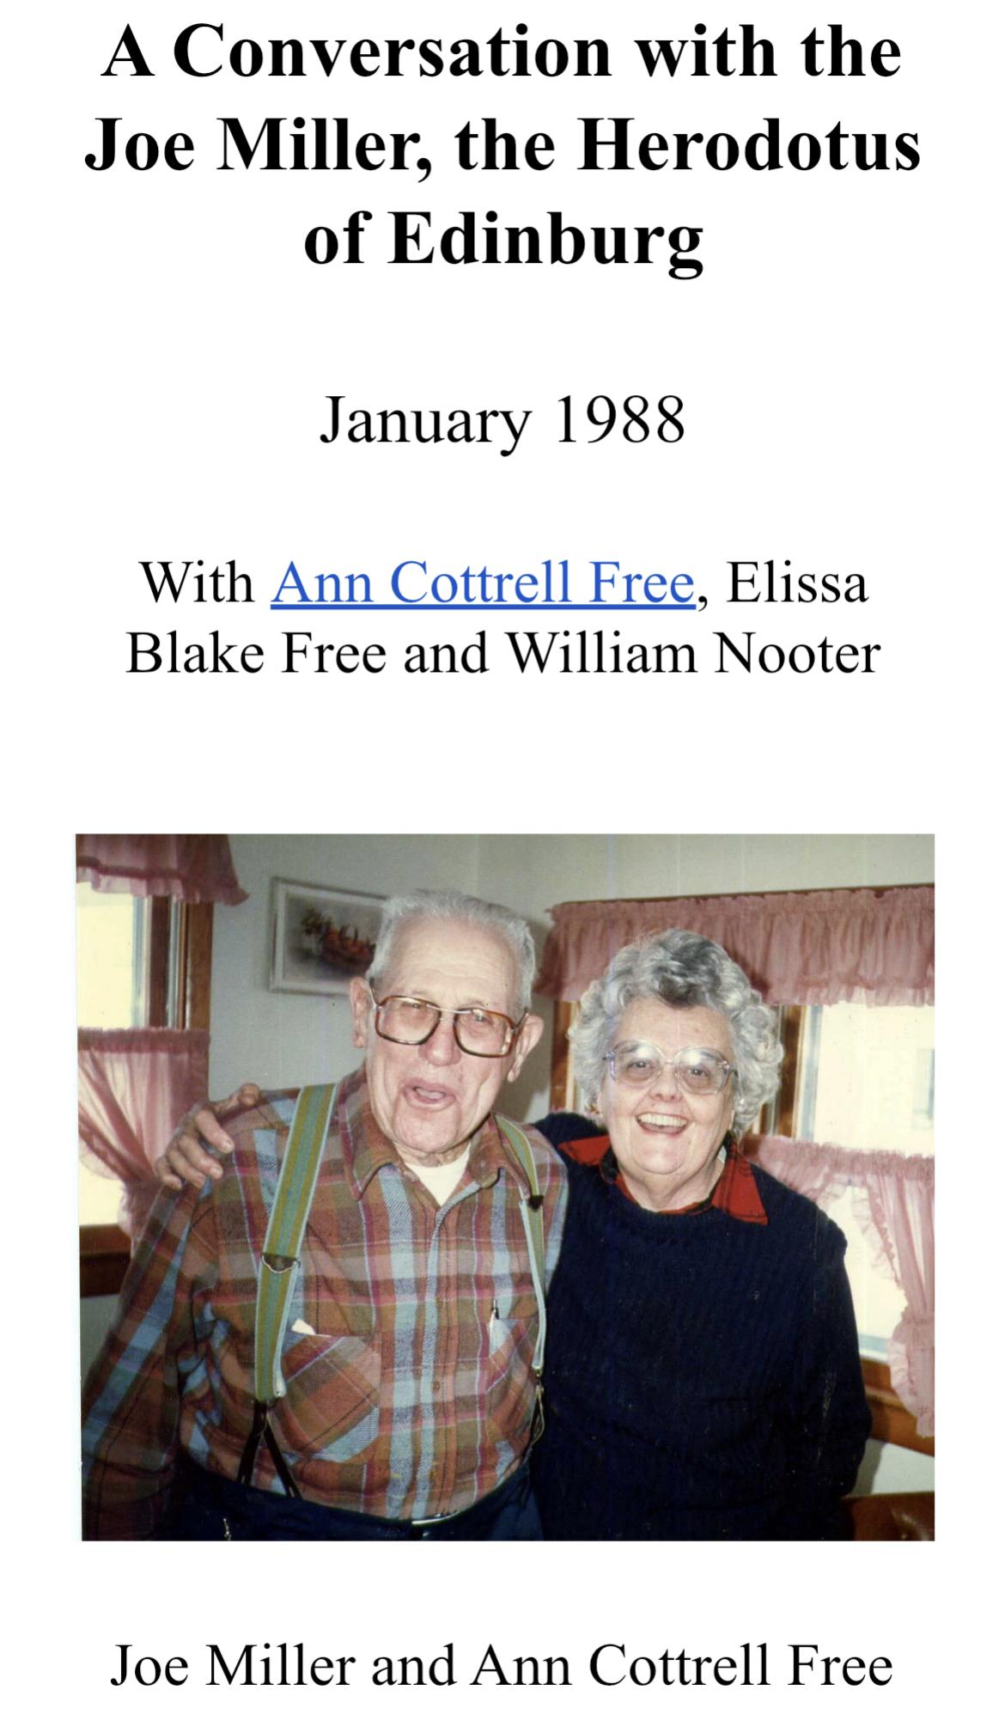
Fig. 5, a screenshot of a audio-recording transcription titled “A Conversation with Joe Miller, the Herodotus of Edinburg” January 1988 created by Elissa Free, daughter of Ann Cottrell Free. Image shows on the left, Joe Miller, interviewee, with Ann Cottrell Free on the right as one of the interviewers. This interview given by Ann Cotttrell Free, Elissa Blake Free, and William Nooter was an unstructured interview in casual conversations recorded on audio-only recording. Elissa Free hired someone to type the transcription of the conversations. (PC: Kathleen L. Brockway)

See a portion of the typed interview below in fig. 6, between Elissa Free (EF) and Joe Miller (JM) in January 1988, Full transcription is shown in Appendix M, page 149:

“JM: “Now that is still standing. Let me tell you about that. That’s not the original. Now the original building…old man Bill Christian made walnut coffins and rough boxes to bury their people in and —
EF: Did he sell them too?
JM: I just remember him and that’s all … (Free, 1988)”

Fig. 6, Retrieved from a full transcription of the Interview between Joe Miller and Elissa Free in January 1988.

When I saw the transcriptions recently, that put me in more of a cultural shock because for years, deaf researchers like me have had no idea of those richly detailed stories. Without those transcriptions, we would have no documentation of the stories except for the signed narratives. Do you really call it documenting if it is only the audio recordings?

Examples of Problems with Non-Deaf Research
Previously, I stated I had a solo interview with the reporter, Charles Paullin, for the Northern Virginia Daily. The reporter did not send the article to me for a review before posting it. He rushed to send the article, which led to several errors. The sign language interpreter over the relay service may have not been a certified interpreter or may not have been familiar enough with Shenandoah County, Virginia to absorb my detailed information in visual language. Some interpreters may misunderstand unfamiliar words, archaic or historical information.

Local area interpreters referred to as “community interpreters” (deaf or hearing) are more likely to gather the familiar words in any interview. That is because of their local knowledge of the subjects shared within the community. It is the same principle with Indigenous/Native interpreters who are familiar with tribal knowledge and can translate information effectively, when the interviewer is on tribal land (McKay-Cody, personal communication, 2022). Another example is an area where there is a black community, the highly recommended community interpreter should be BIPOC who is familiar with Black ASL (BASL). Community interpreters have communal knowledge of the community and terminology that the local people use. That is different from certified interpreters who received their training from colleges, workshops and professional development.

For example, shown below in fig. 7, the reporter wrote, “...a community of 52 deaf people who lived in Shenandoah County.” The interpreter over the phone missed a vital distinction. I stated that once in 1880, there were at least 52 deaf people living in Shenandoah County. The reporter updated the correction later through the online news; unfortunately, the errors are still in the print version.

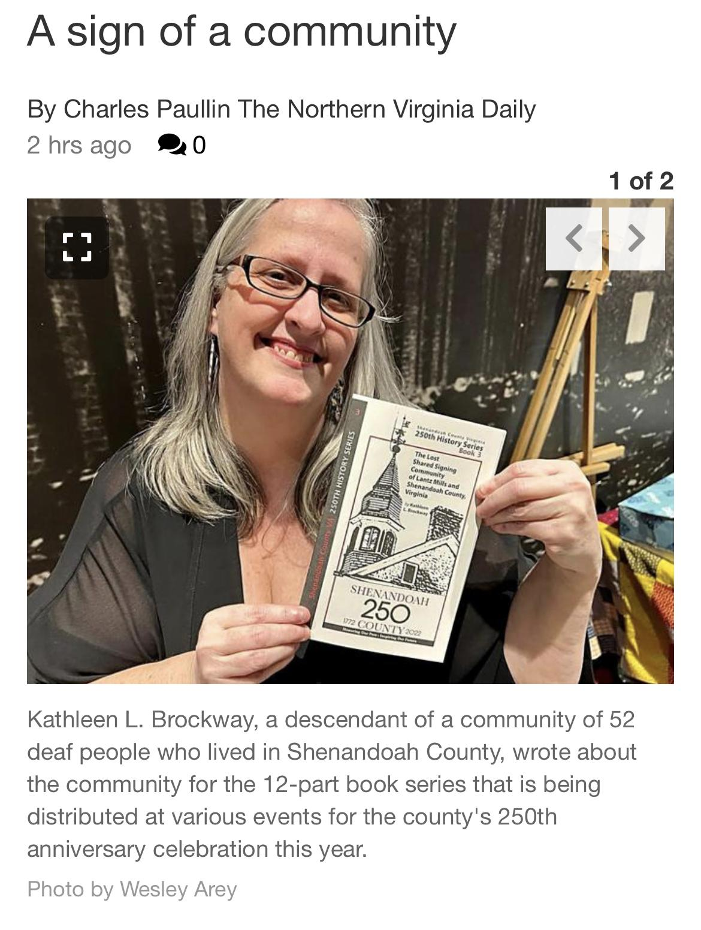
Fig. 7, a screenshot of online Northern Virginia Daily news with a title, “A Sign of A Community” and image of Kathleen L. Brockway holding the booklet (Appendix B), titled “The Lost Shared Signing Community of Lantz Mills and Shenandoah County, Virginia.” The statement under the image stated, “Kathleen L. Brockway, a descendant of a community of 52 deaf people who lived in Shenandoah County, wrote about the community for the 12-part book series that is being distributed at various events for the county’s 250th anniversary celebration this year.” (PC: Kathleen L. Brockway)

Recommendations for Researchers in Terms of Inclusivity
Always use inclusion recognition among the diversity, equity and inclusivity. The recognition of inclusion will help strengthen the understanding within and among cultural groups and encourage cultural health and equity. To teach about inclusivity is by design with appropriate research methods identifying and nurturing traditions of knowledge and practice that are meaningful by the deaf communities, especially the deaf cultural researchers.

Many historical research papers and books such as those cited in the paper are focused heavily on diversity and equity but often do not include inclusivity. The absence of hiring interpreters and providing the transcriptions to the oral history and podcasts recordings are the common issues we need to address. Margaret Kovach with Indigenous Methodologies focused on one tribe, but not the inclusivity of the tribe. McKay-Cody, with her dissertation, focused on gathering research on the existing Indigenous deaf tribal communities. She provided the inclusivity of what has been missing for years within the Indigenous knowledge and research. The exception is missing the signed names and other deaf cultural stories compared between the non-deaf and deaf signed narratives.

Lastly, in the future, I plan to continue working on the completion of the course syllabus with signed videos and written English for both deaf and non-deaf participants. My aim is to identify and demonstrate a range of professional skills that contribute to sustainability and collaboration in teamwork like two-way street practice instead of one-way street practice. It is not completed without any transcriptions. The best practices should be more inclusive toward everybody in the community. My goal is to finish the signed modules of every lecture and provide examples. I also plan out all on a website to make it accessible and friendly for everybody to see.

Over the years, the common saying about the audio-only recordings is accessible. Note the online summary I found, “Audio-only content should include a transcript. Evaluate accessibility of video and audio materials made by others; don’t share inaccessible materials (University of Minnesota, 2022).” With the transcriptions, the audio-only recordings are accessible.

As I discussed in the Challenges section above, Elissa Free was deeply moved by my recent work and was inspired to donate more transcriptions of her own old audio recordings of her mother’s. Recently, I read some of her typed transcriptions she sent me. Those transcriptions are a huge influence showing a big difference between the non-deaf and deaf interviewees’ dialogue.

Recently, I gave a presentation through the Virginia Humanities Conference [March 2022, link [Link text: VHC, 2022] on the issue of recordings not being provided with the transcriptions right away. Without the transcriptions, how can I access the old audio recordings to discover the stories? That question resonated with the audience, who asked what I recommend on this issue and tweeted about my presentation afterwards.

Alternative Ways for Collecting Deaf Cultural Material
When there is a lack of deaf culture research or stories, I use alternate ways to collect information by posting public short stories over social media platforms such as, Facebook, Instagram, Twitter, or LinkedIn. Unfortunately, a limited number of followers view my posts and most of the followers are from the deaf community. Though, I did post under “Edinburg Memories” on Facebook, and this group has a high number of local Edinburg followers. The result was I got essential information from that group.

Another alternative is to publish a booklet (Appendix B) through a non-deaf historical nonprofit organization, as I did recently during the Shenandoah County 250th Commemorative celebration on March 26, 2022. The booklet called The Lost Shared Signing Community of Lantz Mills and Shenandoah County, Virginia led me to some information during my solo phone interview with Charles Paullin, the reporter for the Northern Virginia Daily.

The newspaper article with my story on the front page resonated with the local residents of Edinburg, Virginia! More information emerged by sharing under a Facebook group, Edinburg Memories. This reminded me that it is helpful to reach out to those who respond to social media posts so I can collect more deaf culture stories, especially using the initial interview questions in the unstructured interviews. The detailed information is crucial since, in the deaf community, we convey less detailed information through the signed narratives.

Thanks to my newspaper interview, it sparked interest among the local non-deaf community of Edinburg, Virginia to share more information with. Just recently, I met a local non-deaf resident through Facebook from Edinburg who had a cabinet with pencil-scribbling inside, “J J Christian & Sons.” This vital information verified the fact that the deaf-owned business ran into the next two more generations. This was the most remarkable finding that produced evidence of a 2nd deaf generation carried on the business after William Christian’s, his father, death in 1915. “J J Christian” is known as John Jacob Christian and he mentioned “sons,” which shows that his children were in a wood-working business with him. Then John’s own deaf son, Horace Christian, became the 3rd deaf generation running the business. Altogether, the business was run and owned by a deaf family for about 91 years, instead of the supposed 38 years (1877 - 1915). Thanks to my newspaper interview, it sparked interest among the local non-deaf community of Edinburg, Virginia to share more information with the deaf researcher.

A Living Experience
On April 12, 2022, the live signed narrative interview at Goucher College, an experienced interpreter #1 was present in the room. See an example in fig. 8 below. However, with the deaf interviewer #3 and deaf interviewee #2 sitting opposite of each other, this interpreter had to look at me and then move her head to look at the other person, sometimes back and forth multiple times. The interpreter had to interrupt us several times to catch everything that we said.

The most significant focus is hiring experienced interpreters who understand that deaf people sign well. I would recommend local deaf interpreters who can work with them to capture more. Other significant details during interviews with the interpreters, they should not interrupt the interviewer or interviewee unless it is really necessary. If there is an interruption at any time, the question or response needs to be repeated for accuracy purposes in the recording.

That requires a few seconds of hesitating in between questions and answers between the interviewer and the interviewee. Perhaps if there were two interpreters, the conversation would be sped up.

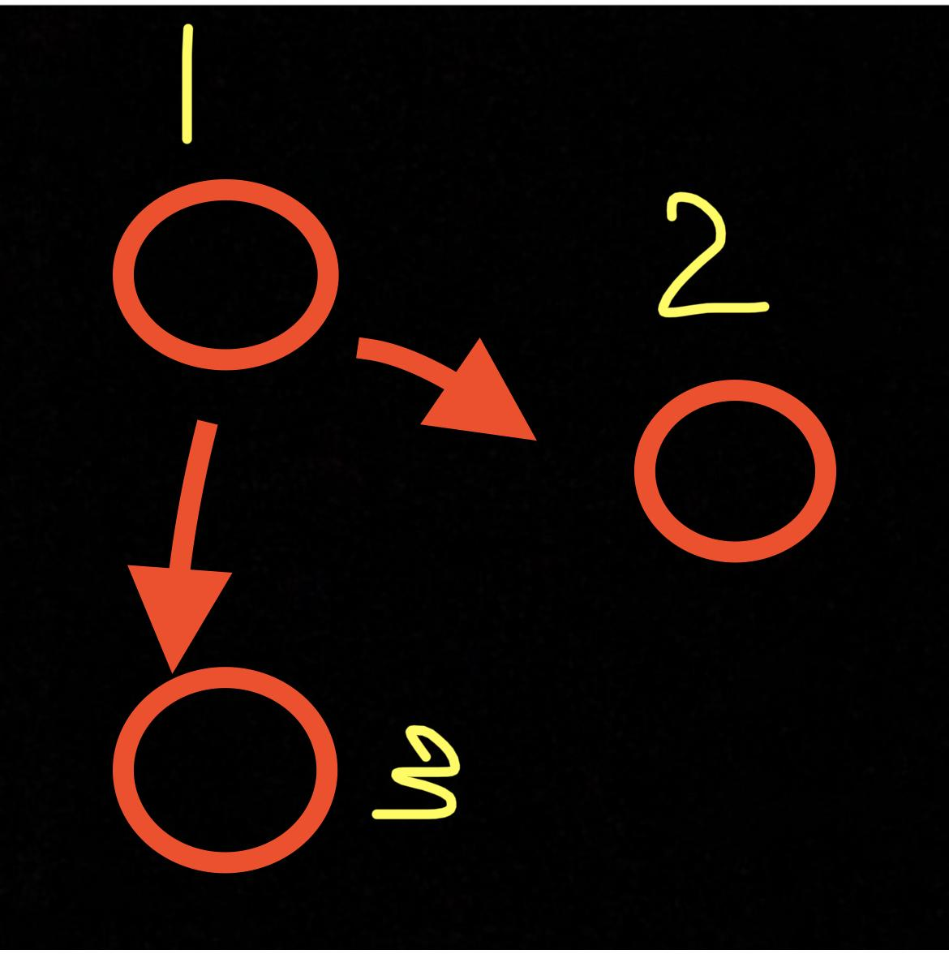
Fig. 8, A figure of drawing shows #1, interpreter, #2, interviewee, and #3, interviewer, sitting in a social setting distant from each other at a big table. See two red arrows from where #1 interpreter is sitting had to look at both #2 and #3 individuals.

Compared to this experience, the experience I had in the other interview was during the Oral History class. That time, there were two different interpreters. One voiced for me, and the other one voiced for the interviewee. This setup, along with the audio and the CART tools, allowed the interview to go smoothly. This comparison encourages having at least two interpreters on the next signed narrative project.

More Challenges
The most challenging part of this final project was getting all interviewees arranged for the same-day interviews, plus arranging sign language interpreters for their available schedule. At first, I arranged for a specific day, but the coordinator said that the interpreter was not available for that day. That jeopardized my plan with the interviewees. When I showed up, the coordinator of the interpreting services came, not the scheduled interpreter I expected. I would have stuck with the originally scheduled day if I had known of this.

As a deaf person, I had to go through the accessibility service with an accessibility coordinator at my school. There is a real impact to an individual when the required services are not frequently utilized at a school with less than 1% of students being deaf. If an accessibility officer had been familiar with how it works on the services for the deaf with the interviews and schedule arrangement, this situation might not have happened. Unfortunately, I could not explain to the coordinator with a “memorandum of understanding” how it works in a short time frame. The timing was high pressure, and it was too much hassle to discuss this through. I had experienced several setbacks through the accessibility services at my college.

I hope in the future, some people at Goucher College can understand how it is a challenge for a deaf person like me to make specific arrangements in my way. The most significant goal is a satisfactory service to complete the assignments quickly. With the change of dates, I had two earlier interviews through zoom meetings and then a live interview on Goucher’s Campus. The third interview was not completed for audio and CART purposes with a limited time frame of 3 hours. The plausible reason was that there was only one interpreter available.

Conclusion and Further Research

Below is a summary of what is significant in contributing to the field of cultural sustainability by linking to the four Cultural Sustainability principles of the MACS program. Before I share my final thoughts, I want to thank my committee and the supporters for encouragement in completing my Capstone Defense.

By sharing deaf cultural data, I hope to bridge the understanding between the hearing and deaf audiences by showing that authentic deaf culture should count in academic research and is necessary to accurately conduct culturally sensitive and accurate documentation of deaf cultural data. That is the reason why I am developing a course in order to support cultural sustainability. For example, asking deaf participants to contribute information to academic or local publications and/or developing a toolkit with deaf stakeholders would make a difference in conceptualizing and implementing actions that foster sustainable cultural discourses, practices, and processes. Educating about ethical considerations may increase inclusivity among cultural groups.

To generate a greater understanding among deaf cultural groups, I recommend providing a presentation, creating a plan for a conference that is affiliated with the Oral History Association or a local History Association, or hosting a workshop sharing tips, ideas, and stories. That way, we can contribute to peace and social justice, work effectively with communities to address the conflict, and foster cultural health and equity. That way, this educational presentation or workshop can identify the essential components of deaf culture.

My biggest goal is to work with the local community as stakeholders by sharing their stories and contributing their memories to historical research. The content of the stories will include the value of traditions, culture, and traits that are meaningful to those who share the stories. This course development will demonstrate how to include these in the documentation of deaf communities. For example, they could be included in a plan for an exhibition partnering with a big organization like the Library of Virginia or preparing a cultural tour partnering with a local town. Those implementing actions can help empower community efforts in cultural documentation, preservation, revitalization, and social equity.

Identifying and demonstrating skills that contribute to organizational sustainability, I have used my challenging experiences of inaccessibility to devise, implement, and evaluate actions supporting cultural sustainability and understanding, such as the educational course I have developed.

This course also seeks to share best practices for documenting deaf communities. These best practices include: 1) making documentation accessible to deaf audiences (including transcriptions); 2) interviewing both deaf and non-deaf community members to collect multiple, detailed perspectives; and 3) hiring experienced (and community-based) interpreters when researching deaf communities.

Examples of implementing, understanding and contributing to the field of Cultural Sustainability are:

- Contribute Cultural Sustainability
  - Publications which document deaf culture
  - Develop an inclusive toolkit
  - Develop and teach a course to both deaf and non-deaf participants
- Generate Greater Understanding
  - Provide a presentation on methodology for documenting deaf culture
  - Present papers presented at conferences on Oral History and Historical research about deaf culture and the appropriate types of methodology for conducting research
  - Provide a workshop on topics included in my on-line course
- Work with the stakeholders to share stories
  - Plan an exhibition about deaf culture at a center, library, or a museum
  - Provide a cultural tour for both deaf and non-deaf tourists

For the future, I plan to finish the course development by completing the signing modules as outlined in the syllabus and developing quizzes and surveys using a questionnaire format. I also will finish the captioning and transcriptions for each module. After finishing the course development, I plan to create a pilot of a course sharing it with a small focus group to gather feedback before launching the on-line course onto a public website. I also hope to continue comparing Oral History and Signed Narratives and presenting the difference between them in this online course or through future workshops. That way, people can note and understand what a signed narrative is and how it is different from an oral history interview.

Since I have realized that so much historical deaf culture has been missed in the past, I hope this work will inspire other researchers, both hearing and deaf, to employ the strategies I am offering to capture this rich historical and significant material more fully.

Bibliography

Personal correspondence
Through signed and oral interviews, several local descendants provided valuable assistance and data to this work. Special thanks to William Barber, Denise James Drake, Dr. Melanie McKay-Cody, and Charity Reedy Warigon.

Barber, W. (2022). In-person interview. [Transcription, Appendix L]
Drake, D. J. (2022). Zoom online interview. [Transcription, Appendix K]
McKay-Cody, M. (2022). Videophone interview. [Pages 14 and 23]
Warigon, C. R. (2022). Zoom online interview. [Appendix 0, Video Log Worksheet 3]
References
Andrews, J., et al. (2018). Deaf Culture Exploring Deaf Communities in the United States. Plural Publishing, Inc.
Brittain, Terrell. 2021. American Deaf Culture. Accessed by Kathleen L. Brockway on the University of Houston website: https://www.coursera.org/learn/deaf-culture#about.

Brockway, K. (2014). Baltimore’s Deaf Heritage. Accessed to the website on April 27, 2022: https://www.arcadiapublishing.com/Products/9781467121934.
Brockway, K. & Detroit Association of the Deaf. (2016). Detroit’s Deaf Heritage. Accessed to Arcadia Publishing Inc. on the Web on April 27, 2022: https://www.arcadiapublishing.com/Products/9781467116015.
Brockway, K. (2020). Review of Jewish Deaf Collection. Through the Cultural Documentation Field Lab course, MACS Program, Goucher College.
Brockway, K. (2022). The Lost Shared Signing Community: Lantz Mills and Shenandoah County. Shenandoah County Historical Society: Virginia, accessed: https://www.nvdaily.com/nvdaily/a-sign-of-a-community/article_fb48e08b-42dc-5c3b-8914-6e4a4469cf89.html. Inserted in Appendix J, pages 48-80.

Callis, L. (2017). Name Signs, What’s That About? Accessed to the website on April 27, 2022 through Huff-Post on the Web: https://www.huffpost.com/entry/name-signs-whats-that-abo_b_7301910.

Carter, J. 2nd ed. (2001). A Sense of Place: An Interpretive Planning Handbook. Publication: Scottish National Heritage, retrieved through Interpretive Planning class readings.

Chiseri-Strater, E. & Sunstein, B. (2012). FieldWorking: Reading and Writing Research. Bedford/St. Martin’s: New York. Fourth Edition.

Dornfeld, B. & Rankin, T. & Titon, J. (1989). Powerhouse for God. Retrieved from on the Web: https://www.folkstreams.net/films/powerhouse-for-god.

Educational Technology. (2018). Kirkpatrick Model: Four Levels of Learning Evaluation. Accessed April 27, 2022 on the Web: https://educationaltechnology.net/kirkpatrick-model-four-levels-learning-evaluation/#:~:text=The%20Kirkpatrick%20Model%20is%20probably%20the%20best%20known,how%20participants%20react%20to%20the%20training%20%28e.g.%2C%20satisfaction%3F%29.

Elliott, E. & Jacobs, A. (2013). Facial Expressions, Emotions, and Sign Languages. Accessed to the website on February 23, 2022: https://www.ncbi.nlm.nih.gov/pmc/articles/PMC3593340/.

Ethnography. (1995). Annual Review of Anthropology, 24:95-117.

Free, E. (1988). Audio-Recording Transcription of Interview between Joe Miller and Ann Cottrell Free, Elissa Free, and William Nooter. Edinburg, Virginia: Shenandoah County Public Library.

Gilman, L. and Fenn, J. (2019). Participant Observation. Retrieved from the Handbook for Folklore and Ethnomusicology Fieldwork. Indiana University Press, 118-139.

Groce, N. (1985). Everyone Here Spoke Sign Language: Hereditary Deafness on Martha’s Vineyard. Harvard University Press: Cambridge.
Holocaust Museum. (2022). Signed testimony of Simon Carmel. Accessed April 28, 2022 on the Web: https://collections.ushmm.org/search/catalog/irn39659.
Kovach, M. (2010). Indigenous Methodologies: Characteristics, Conversations, and Contexts. Toronto, Canada: University of Toronto Press.
Kusters, A. & et al. (2017). Innovations in Deaf Studies. Oxford University Press.
Ladd, P. (2003). Understanding Deaf Culture. Multilingual Matters, Ltd. United Kingdom: p. 444.
Lane, H. & Emmorey, K. (2014). The Signs of Language Revisited. Psychology Press.
Lawrence, D. T. & Lawless, E. J. (2018). When They Blew the Levee: Race, Politics, and Community in Pinhook, Missouri. University Press of Mississippi.
Loew, R., Akamatsu, C. T., & Lanaville, M. (2000). A Two-Handed Manual Alphabet in the United States. Retrieved through The Signs of Language Revisited, Eds. Emmorey, K. and Lane, H. Psychology Press.
Madison, D. Soyini. 2012. “Methods.” In Critical Ethnography: Methods, Ethics, and Performance. 2nd ed. Thousand Oaks, 19-50. California: SAGE: 2012. 27-43.
Maher, J. (1996). Seeing language in sign: The work of William C. Stokoe. Gallaudet University Press: Washington D.C.
Marcus, George E. (1995). Ethnography in/of the World System: The Emergence of “Multi-Sited Ethnography.” Annual Review of Anthropology, 24:95-117.
McKay-Cody, M. (2019). Memory comes before knowledge — North American indigenous Deaf: Socio-cultural study of rock/picture writing, community, sign languages, and kinship. PhD diss.,University of Oklahoma.
Mind Tools. SMART Goals: How to Make Your Goals Achievable. Accessed on the Web, January 25, 2020: https://www.mindtools.com/pages/article/smart-goals.htm.
One Million Muffins, (2022). Name Signs in the Deaf Community. Accessed April 27, 2022 on the Web: https://onemillionmuffins.com/aslkb/namesigns.html.
Oral History Association nonprofit organization, 2022 on the web, https://www.oralhistory.org/archives-principles-and-best-practices-overview/.

Paullin, C. (2022). A Sign of a Community: Rarely Documented Deaf Village in Edinburg Detailed in Book. Accessed on the web, April 6, 2022: https://www.nvdaily.com/nvdaily/a-sign-of-a-community/article_fb48e08b-42dc-5c3b-8914-6e4a4469cf89.html.

Rev (2019). 8 Killer Tips for Audio Transcription and Recording to Transform Your Work. Accessed on the web, April 28, 2022: https://www.rev.com/blog/8-killer-tips-for-audio-transcription-and-recording.

Shanouda, F. & Yoshida, K. (2014). Disability Oral History Toolkit. Accessed April 27, 2022 on the Centre for Independent Living in Toronto, Inc. on the Web: http://www.cilt.ca/Documents%20of%20the%20CILT%20Website/Disability%20Oral%20History%20Toolkit.pdf.

Shorthand. (2020). Accessible Visual Storytelliing. Accessed April 27, 2022 on the Web: https://shorthand.com/the-craft/accessible-visual-storytelling/.

Supalla, Samuel J. The Arbitrary Name Sign System in American Sign Language. Accessed April 27, 2022 on the Project Muse on the Web: https://muse.jhu.edu/article/507092.

Supalla, Samuel J. (1992). The Book of Name Signs: Naming in American Sign Language. San Diego, CA: DawnSignPress
Virginia Humanities Conference. (2022). Accessed on April 27, 2022 on the Web: https://vahumanitiesconference.org/
Washington.Edu. (2021). How are the terms deaf, deafened, hard of hearing, and hearing impaired typically used? Accessed April 27, 2022 on the Web: https://www.washington.edu/doit/how-are-terms-deaf-deafened-hard-hearing-and-hearing-impaired-typically-used.
Wayland, John W. (1927). A History of Shenandoah County. Shenandoah Publishing House: Virginia.

Weinstock, Robert (2021). Gallaudet University Launches New Guides in Apple Maps; New Guides Connect the Deaf Community to the Global Signing Ecosystem. Accessed on the Web: https://www.gallaudet.edu/news/gallaudet-university-launches-new-guides-in-apple-maps/.

Wikipedia. (2022). Ann Cottrell Free. Accessed April 27, 2022 on the Web: https://en.m.wikipedia.org/wiki/Ann_Cottrell_Free.

Yow, V. (2015). Interviewing Techniques and Strategies. Chp. 11 retrieved from The Oral History Reader, 3rd Ed. by Perks & Thomason, 2015. London: Routledge.
APPENDIX A: COURSE PREPARATION OUTLINE
Logistics and Materials
Media
- Video format - demonstrate the action throughout the course with interviews and signed narratives.
- Captioning format - demonstrate the action throughout the course comparing auto-generated and manual captions.
- Questionnaire software - use for feedback, multiple choices, and pre-test and post-test quizzes.
- Website - self-paced course used in an online format.
- Camera and tripod - make videos for demonstrations and signing modules.
- iPhone, smartphone - used for recording videos and taking photos in either still, moving, or other effects.

Materials
- Provide the attachments that are the readings in PDF formats or active links and/or blogs, provided for the topics:
  - Why are the name signs significant?
  - Discussion of the auto-generated and manual captions.
  - Discussion of the accessibility in the research methodologies or curatorship.
  - Other topics that are relevant to this teaching course.

Evaluation Plan
A form of measuring quality of the learning experience collecting the reaction and learning experience.

Surveys
- Collect the surveys after the course ends, to evaluate how the course-takers react with their feelings - some will be the blank features to allow them to type in their feelings and perspective. Some of the questions include below:
  - Has the course impacted them?
  - Has this course changed their thinking on inclusivity or accessibility?
- Results implement the outcome measures collecting the behavioral evaluation of the aftermath of taking the course.
  - Post-test quizzes deliver the results of how much learners have learned. The gathering data of the results and feedback forms are important to evaluate each student. Measurements of the results and statistics are the key in improving the course.
- Outcome on the social media platforms
  - Hint the course-takers to follow or tag the account to see their own programs or information. Tagging is a way of informing people that they are putting in an effort for a change.
- Questionnaires
  - Send out questionnaire surveys to the course-takers and see how the course improved them or not. Something to ponder about like:
    - Will this course make a difference in the course-takers’ lives?
    - Are the results effective in the policy change?
    - Are the planning and designing accessibility tools more inclusive?

Sample Modules
Doing the sample modules, the purpose of inclusivity including:
- My aim is to exhibit the dynamic experience for an interview experience with inclusivity.
- Teaching includes the ensure of compatibility with the American with Disabilities Act (ADA) engaging members and visitors with inclusivity.
- With the proper documentation of name signs and use proper technology, those module samples gain a visitor and viewer experience of inclusivity.

A Syllabus in Process
The process of developing a syllabus is based on the learning experience deliverables I have outlined in my capstone paper. My literature reviews support the readings I have provided in the syllabus. Through the lectures and the course, I may repeat some information because of the majority of course-takers are likely to not be familiar with deaf culture and I would have to repeat and explain to allow them to thoroughly understand.

PREPARATION about the course
Faculty Bio - Kathleen L. Brockway
[Photo will be attached later.]

Kathleen L. Brockway is a deaf cultural worker from Washington, D.C. She is the author of Baltimore’s Deaf Heritage (2014) and Detroit’s Deaf Heritage (2016) through Arcadia Publishing, Inc. She has contributed multiple articles and chapters to a variety of community histories and publications, including the Little Papers of the Virginia School for the Deaf Alumni Newsletter, 2017–2018, and Evolution of Deaf Collective Resistance: The Deaf Grassroots Movement as a Case Study with Don A. Grushkin in 2021. In March 2022. She released a booklet through the Shenandoah County Historical Society, titled A Lost Shared Signing Community of Lantz Mills and Shenandoah County, Virginia. She has maintained social media platforms including Twitter, LinkedIn, Facebook, and Instagram, as a content creator to share short stories of deaf culture and history.

Guidelines for Success
Introduction
Introduction will be both in text and signed narrative on a video.
Text: I’m Kathleen Brockway, your instructor for this course. My goal for teaching this course is to share best practices on how to properly document deaf culture. I wear multiple hats including as a historian, cultural worker, and researcher. This course is presented from a deaf person’s perspective and based on my extensive experience in the deaf culture field. The specific learning objectives can be found in the syllabus.
Time Management and Workload
This course requires pre- and post-tests to help evaluate how much you know before and after. This course also requires some reading and watching videos with subtitles and audio. This course is self-paced; however, I highly recommend you go with the flow and not fall behind. You are welcome to contact me if you have any issues.
Attendance
There is no attendance requirement.
Participation and Communication
The online class is designated as a self-paced course. There will be no class meetings; however, if you have questions or want to discuss material, you are free to contact me.
Technical Issues
In order to participate in this course, you must have access to a computer and the internet. However, if there is a technical issue with the course itself, please contact me as soon as possible.
How We Will Communicate
- Email to
- No Phone Calls
- Grades will be posted after every post-test results.
Overall Reading List (all modules)
No books are required to purchase, all PDF and links to readings will be attached.
You may also be interested in the following publications by Kathleen Brockway that further explore deaf culture:
“Baltimore’s Deaf Heritage,” 2014 - link. [Link text: Brockway, 2014]
“Detroit’s Deaf Heritage,” 2016 - link. [Link text: Brockway & Detroit Association of the Deaf, 2016]
“A Lost Shared Signing Community of Lantz Mills and Shenandoah County, Virginia,” 2022 (see Appendix B, pages 42-74 for this PDF)

Module 1: Course Overview and Introduction

Welcome video
- A brief background on Kathleen Brockway
  - Talking about the instructor's books, why I have a passion for the deaf culture.
    - Books instructor published: “Baltimore’s Deaf Heritage,” “Detroit’s Deaf Heritage,” co-contributed a Chapter in “Deaf Empowerment,” and just this year - “The Lost Shared Signing Community of Lantz Mills and Shenandoah County, Virginia.”
  - Attending Goucher College was a game-changer for the instructor.
- Why offer this course?
  - - Realization that researchers have misunderstood or been unaware and not known how to properly document aspects of culture such as name signs Goal is to offer examples of proper methods for researching deaf culture
  - From a deaf experienced cultural worker’s perspective
  - Respecting the culture of deaf research subjects
- Explanation of what will be included in the course (pre-quizzes and post-quizzes).
  - Terminology
    - Deaf Culture
    - American Sign Language - ASL
    - Name Signs
    - Errors - explaining it is not your fault, because you were not raised with experience of deaf culture.
  - Name signs
    - Explanation of deaf culture “rules” on the name signs
      - Deaf individual must give a name sign to a hearing person
      - It can be quick from birth to later in the adult years.
    - How name signs are used
      - Typically, use the common classifiers of hand-shapes like V-bend, C-shaped, Index finger, A-shaped, Cocked-hand, Open-hand, Closed-hand, etc.
      - Some are a combination of initialized and descriptive types.
  - Accessibility tools
    - Explanation why accessibility tools are important in the deaf community
      - Visual language is culturally deaf individual’s first language
      - Sign language picks up the understanding of the subject faster
      - All kind of deafness have different accessible tools
        - Deaf-blind, provides a written transcription
        - Hard of hearing, provides captions/subtitles
        - Culturally deaf, provides visual language
          - Option of certified deaf interpreter/sign language interpreter
    - Collection analysis on comparing between the audio-recording and real-time captioning transcriptions
  - Why do I need to do all three, since they are relevant for the achievement of understanding the significance of name signs.
- Explanation on the requirement of passing grade 80% or above going to each section.
  - Explanation why a pre-test quiz is necessary. No grades on it.
  - Can take the post-test quiz repeatedly until that taker passes.
- Takers take a pro-test Quiz after complete viewing of the video to grasp the understanding basics of this course.

Module 2: Terminology
Terminology shares the appropriate keywords and identifying terms to use throughout the professional work including interpretive panels, artist biographies, writing materials, and verbal narratives. This introduction of terminology applies to many things in general.

Required Reading.

Terminology discussion link. [Link text: Washington.edu, 2021]

Read, Page 4-6 and Chapter 6; Multi-Sited Ethnography discussion link. [Link text: McKay-Cody, 2019]

Analyze the collection through Holocaust Museum on the Web, link. [Link text: Holocaust Museum, 2022]

Give a pre-test terminology quiz before the next lectures.
View Terminology Lecture videos
- Preparing words and definitions.
  - Deaf versus hearing impaired
  - Deaf versus mute
  - “Speech difficulties”
  - Deaf culture
  - Multi-sited ethnography
  - Identifying Sign Languages
- Share the sources where you learn the terminology from, using the literature review sources.
- Provide readings to read (attached under the “required readings.”) Discuss in my lecture with relevance to the readings.
- Discuss the errors including the Holocaust Museum’s video and cataloguing on identifying the sign language.
- Takers take a pro-test quiz after complete viewing of lectures.

Module 3: Name Signs

Name signs are by deaf culture rules using communication through visual language.

Required Readings.

Article Link Signed Names. [Link text: Callis, 2017]

Supalla, S.J. (1990). The Arbitrary Name Sign System in American Sign Language. Sign Language Studies 67, 99-126. doi:10.1353/sls.1990.0006. Link. [Link text: Supalla, 1990]

Article Link: 3 categories. [Link text: One Million Muffins, 2022]

Give a pre-test significant focus quiz before the next lectures.
View Significant Focus on the Course Lecture videos
- Name Signs
  - Discuss why they are important and how they are different in our deaf culture?
  - Share sources, using literature review sources with quotes.
  - Present some interview techniques as samples showing still shots to capture the name signs during the interview, for hearing interviewers to see while having a voice ASL interpreter. Discuss how to document the name signs.
  - If deaf interviewer, discuss how to capture the name signs during the interview and document them.
- Provide readings to read articles on the name signs (attached under the
required readings.”) Discuss in my lecture on each article I provide.
- Takers take the post-test quiz after complete viewing of the lectures.

Module 4: Accessibility Tools
Accessibility tools are important in recognizing the crucial tools for the target audience: deaf viewers. This can apply to the non-deaf users who need to know the appropriate tools.

Required Readings.

Article Accessibility tools. [Link text: Shorthand, 2020]

Read section B in this reading Oral History with tools. [Link text: Shanouda & Yoshida, 2014]

Read section C in this reading above, Oral History with Tools by Shanouda and Yoshida, 2014.

Article Audio-Recording Transcript Tips [Link text: Rev, 2019]

Give a pre-test accessibility tools quiz before the next lectures.
View Accessibility Tools Lecture videos
- Ethical Considerations discussion, the difference between the auto-generated and manual captions.
  - Provide screen samples and discuss the significance of each sample.
- Discuss the four core principles from the Oral History Toolkit and how they are relevant to deaf culture.
- Discuss the significance of written transcriptions after every audio-recording podcast or interview.
  - Provide readings on written transcriptions
    - Deafblind individuals
    - Deaf individuals
    - Prepare the written transcriptions ready before, not after posting the podcasts or interviews.
    - Compare between the CART Transcription and audio-recording transcription.

APPENDIX B: Booklet on The Lost Shared Signing Community of Lantz Mills and Shenandoah County, Virginia
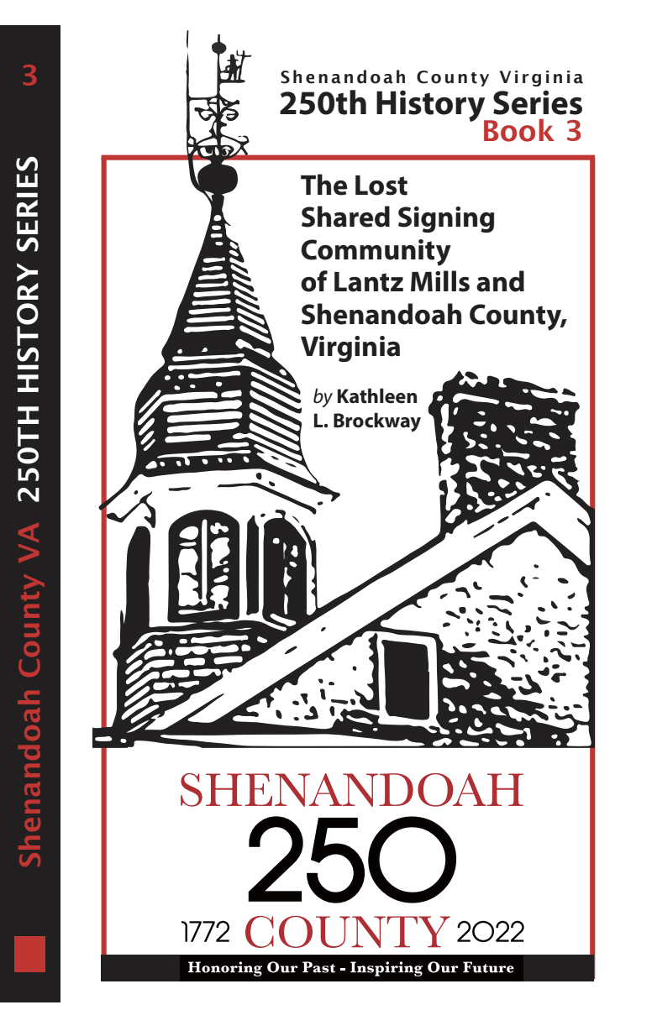
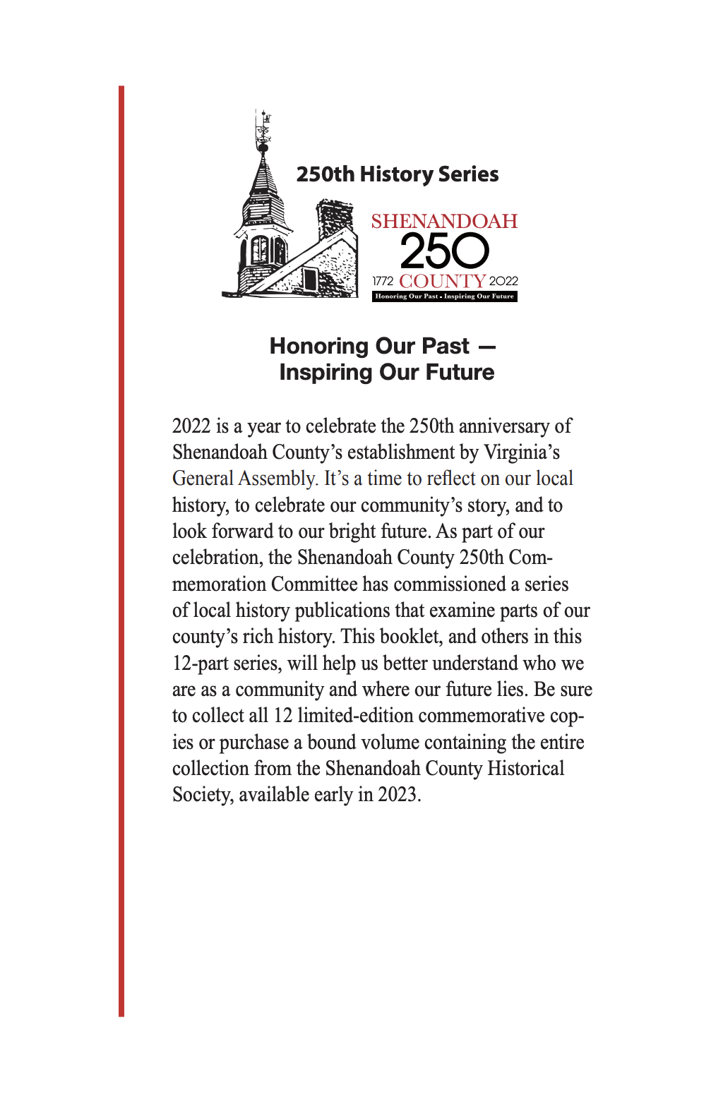
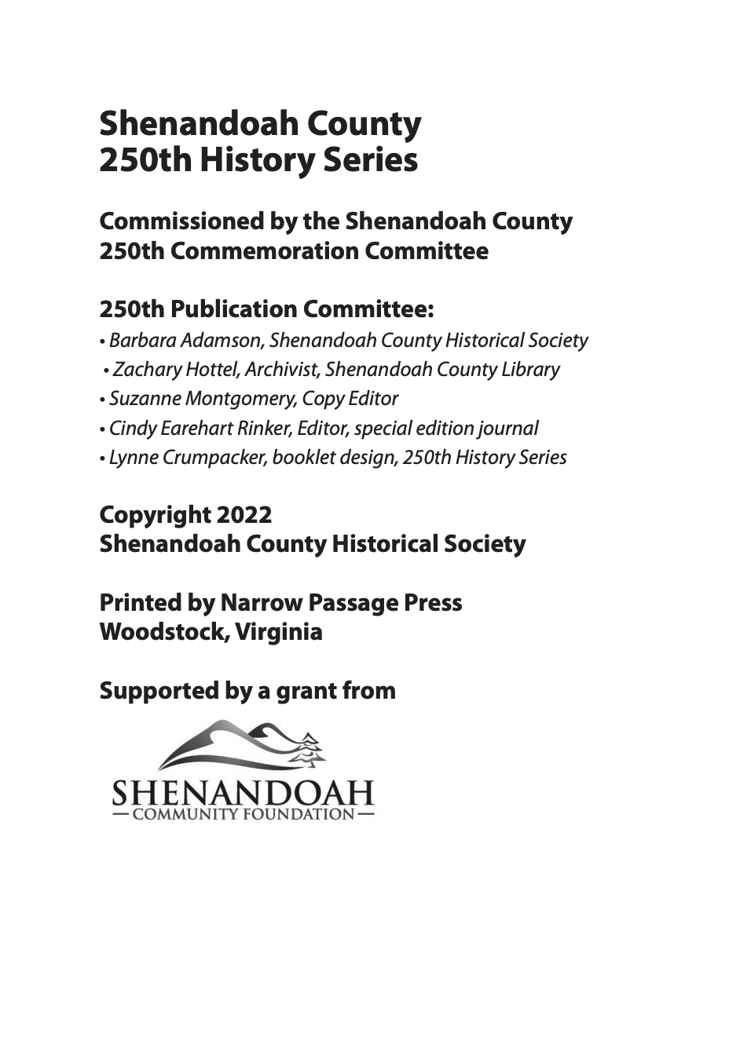
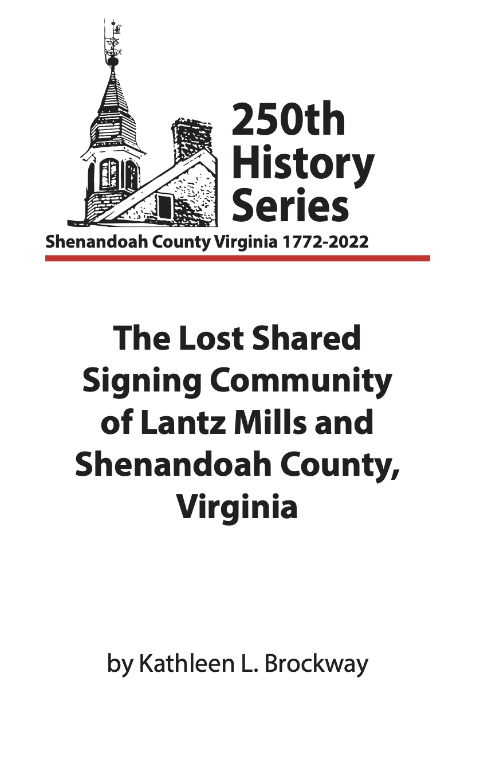
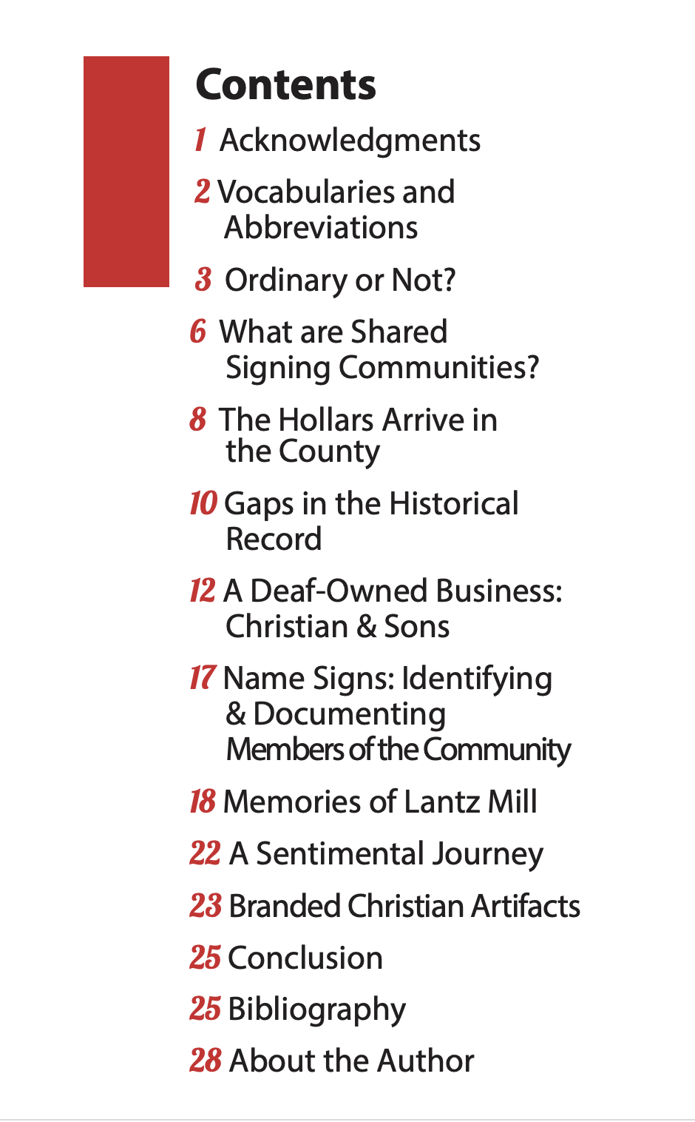
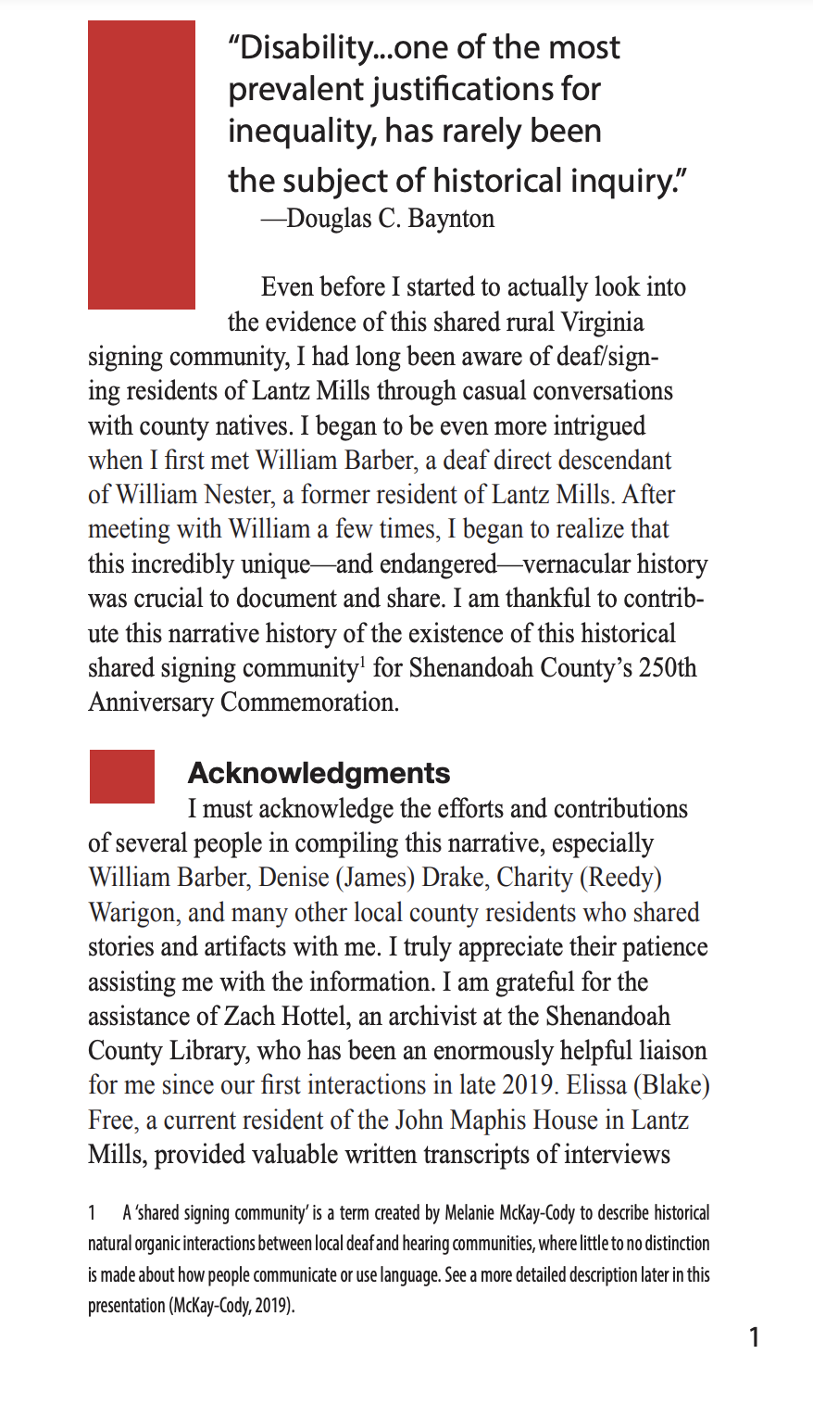
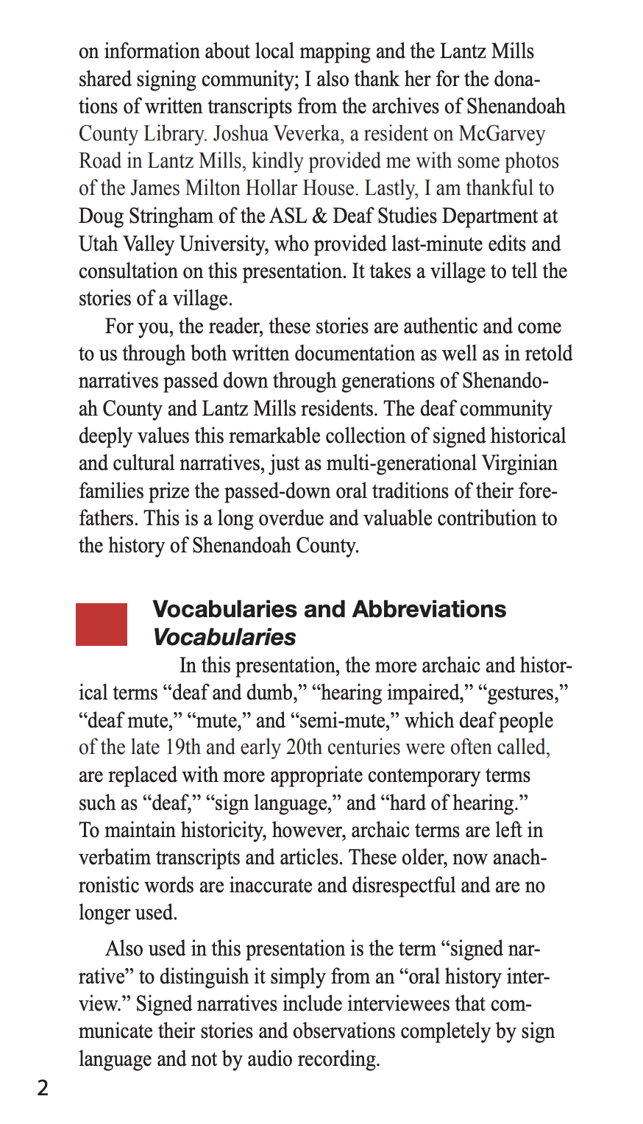
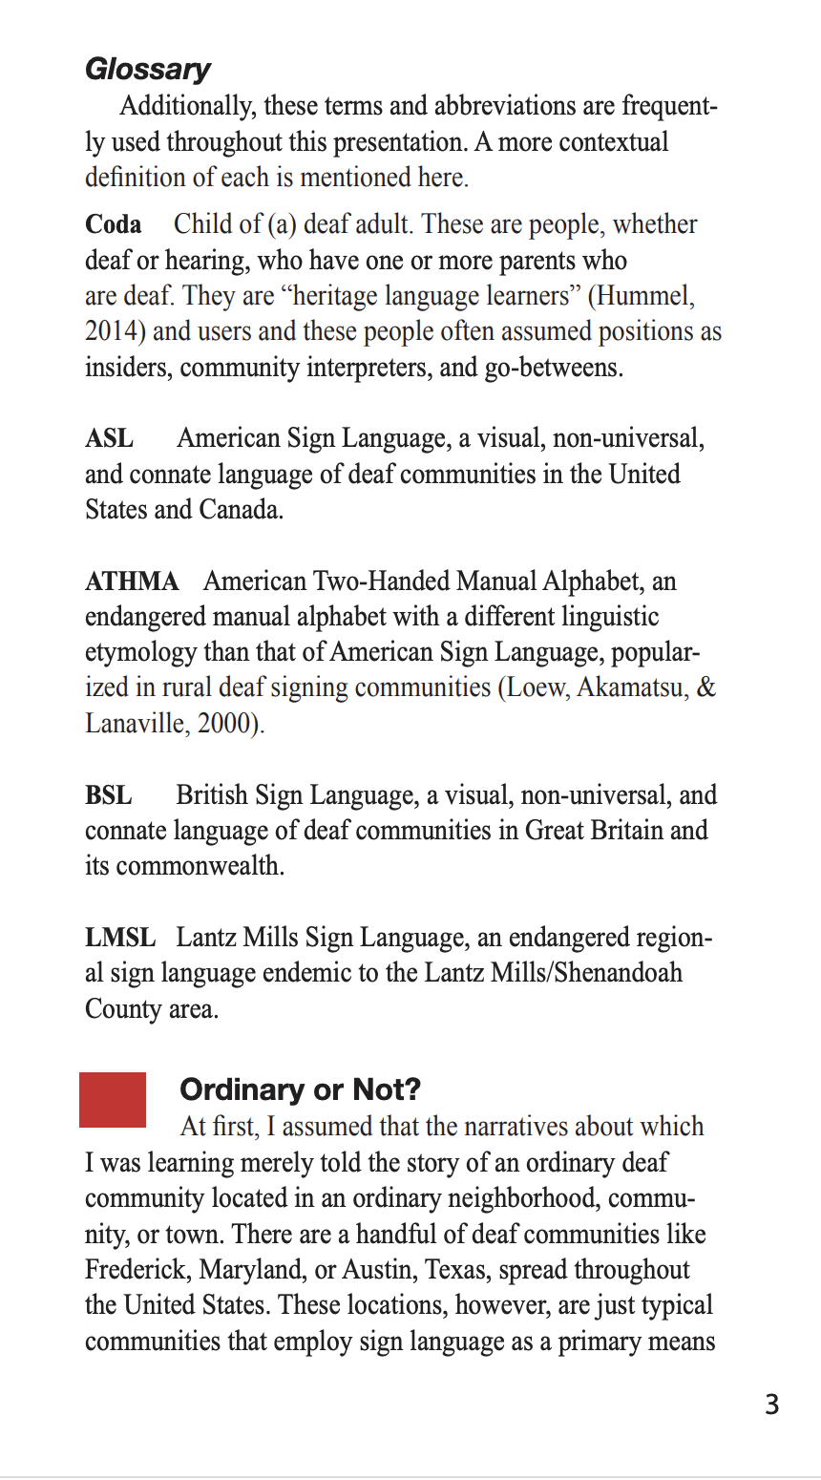
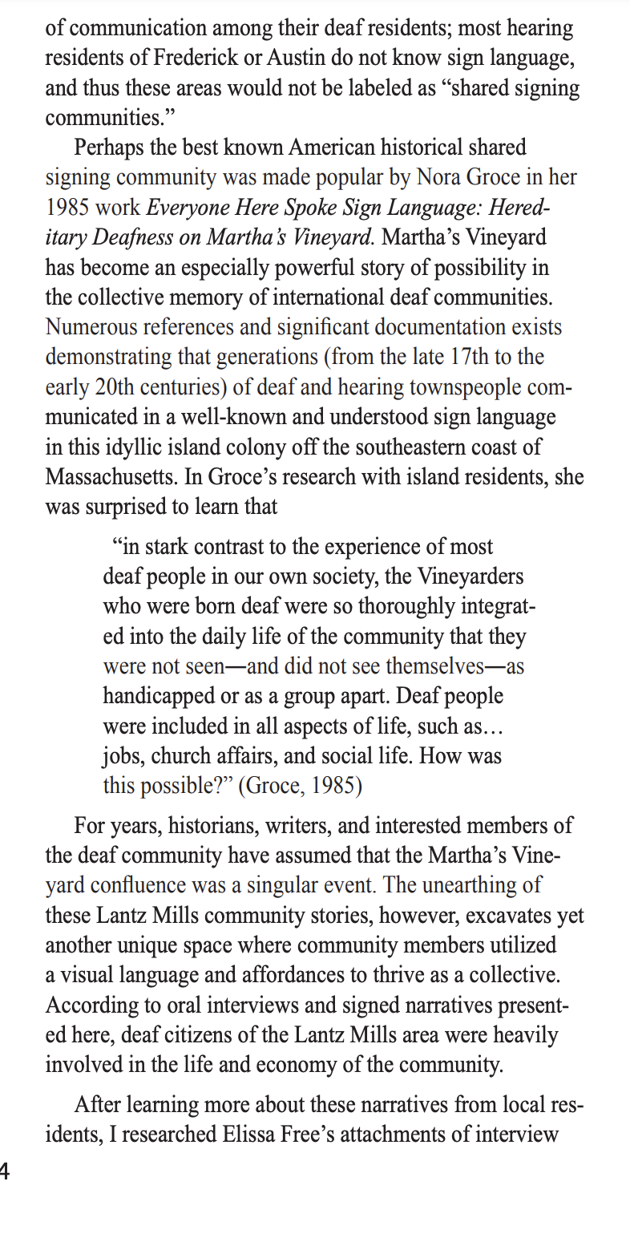
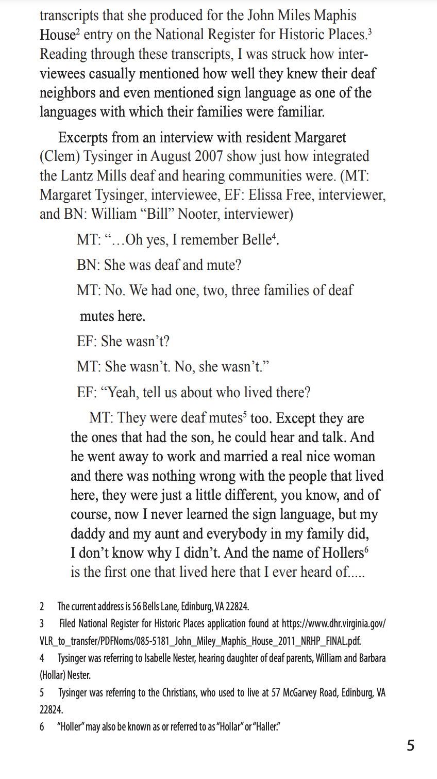
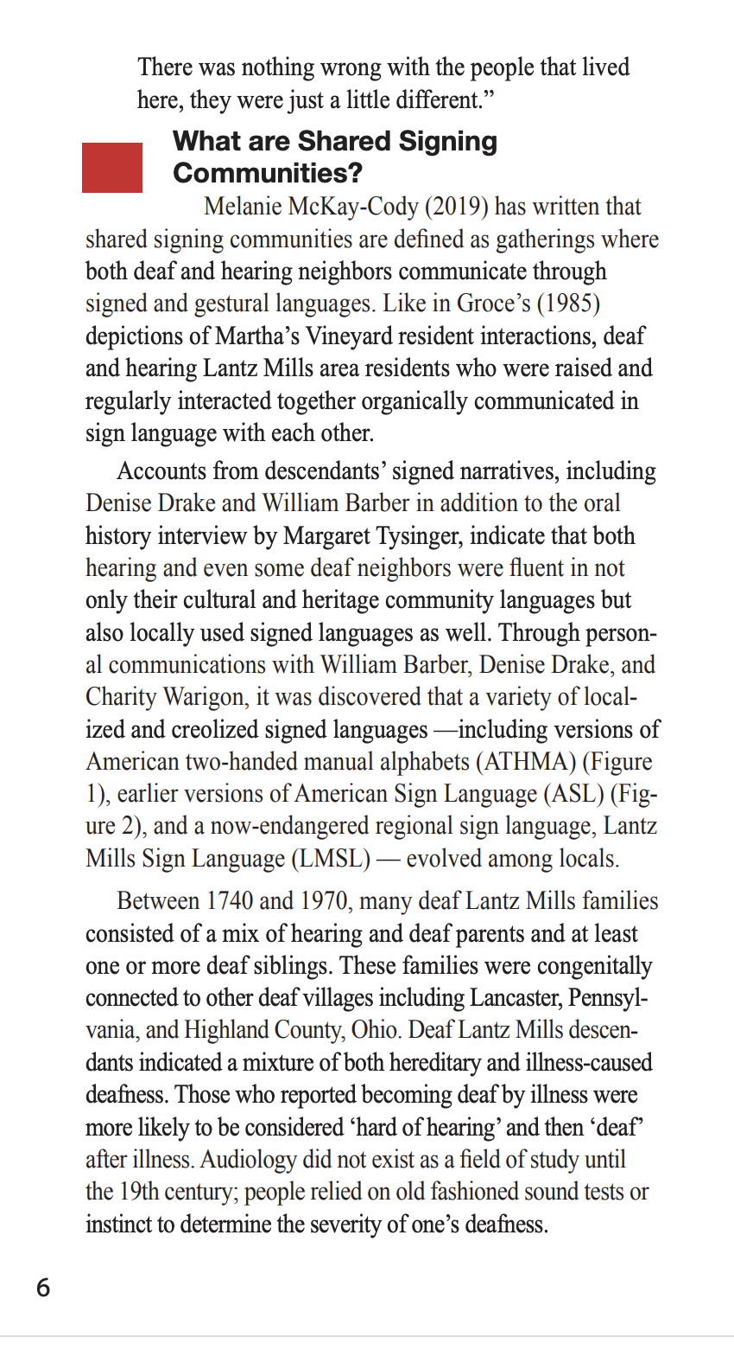
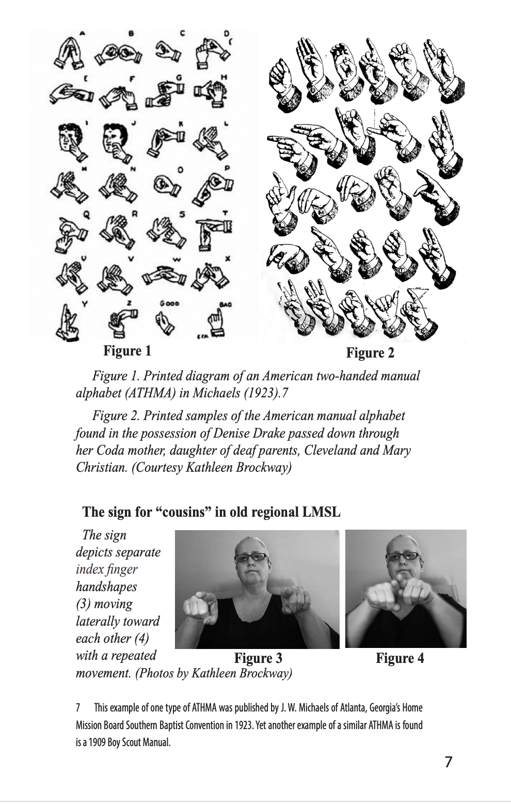
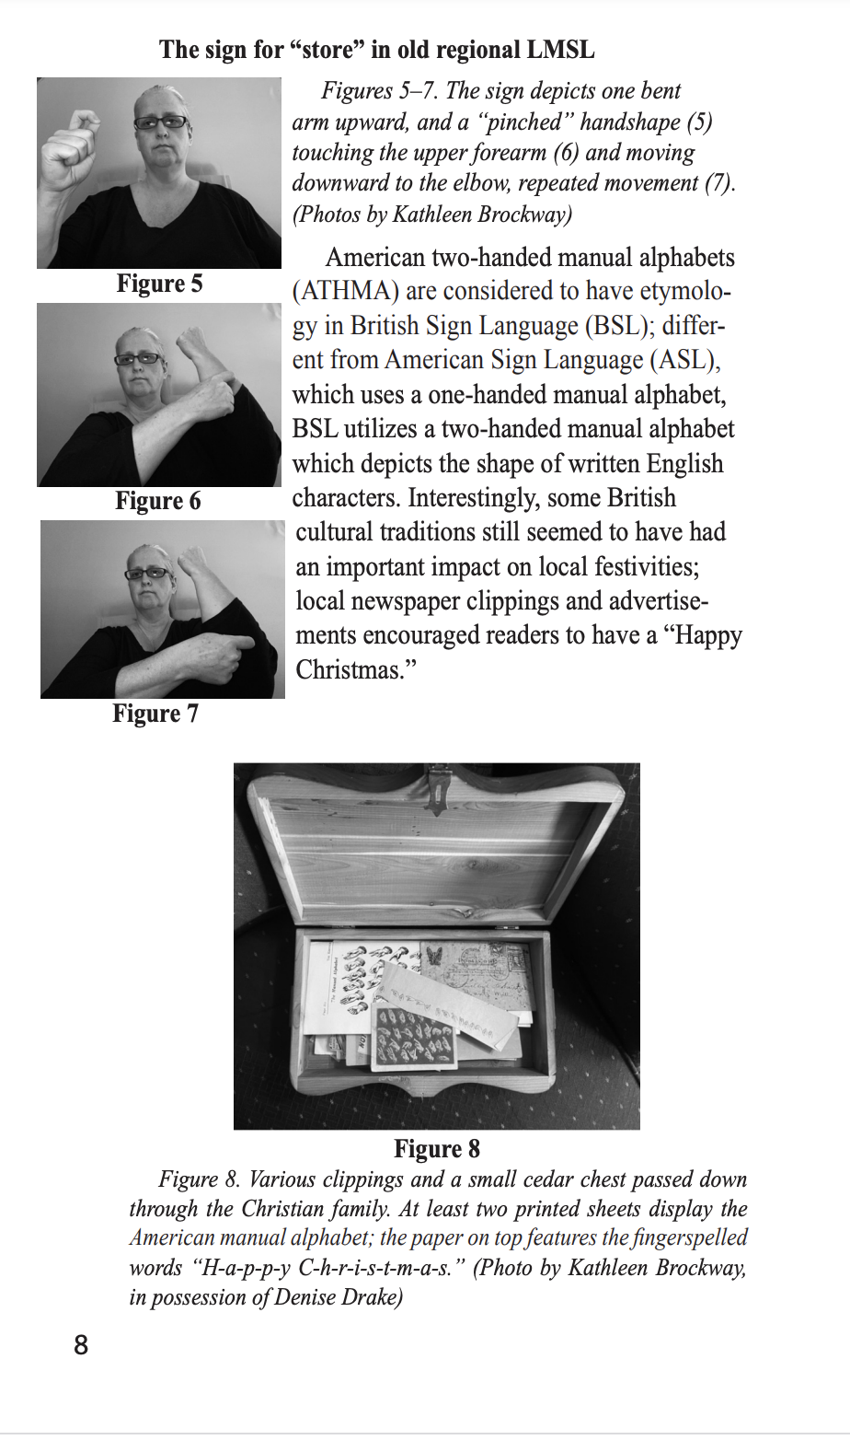
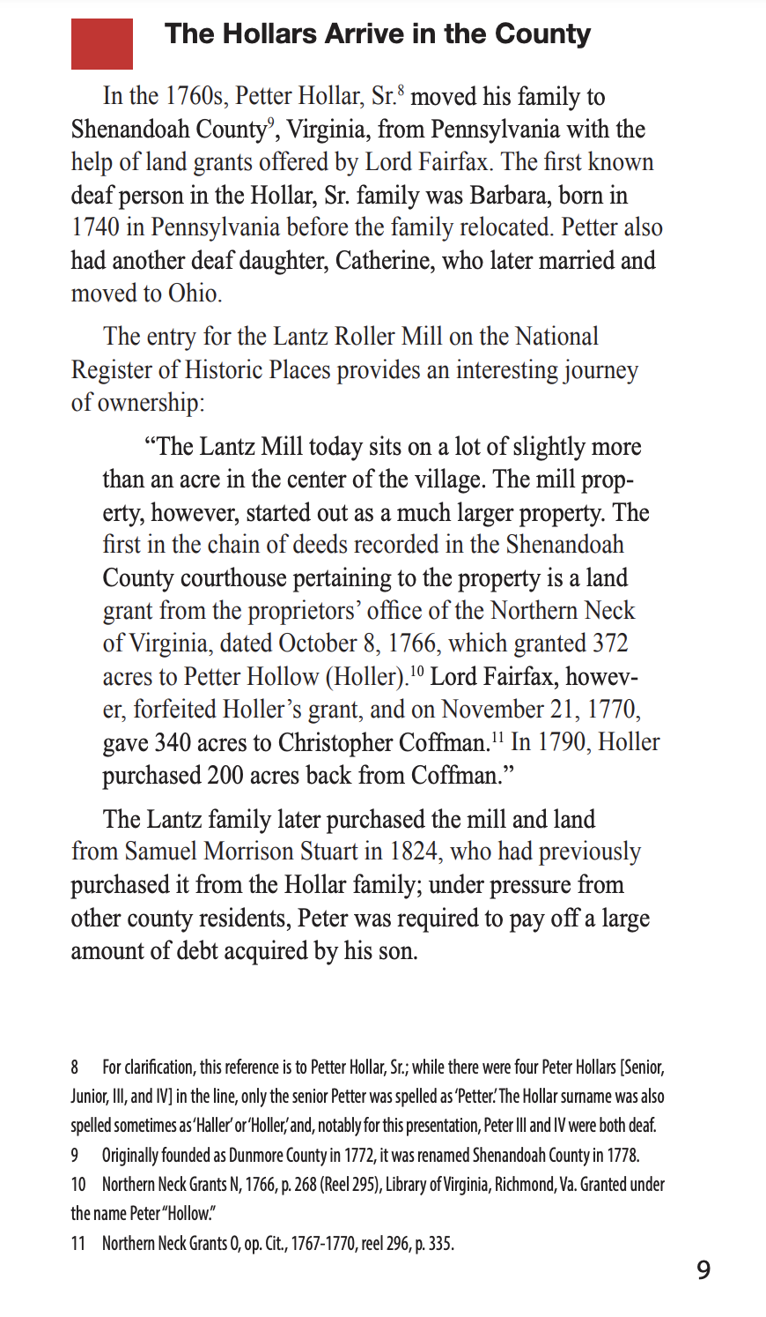
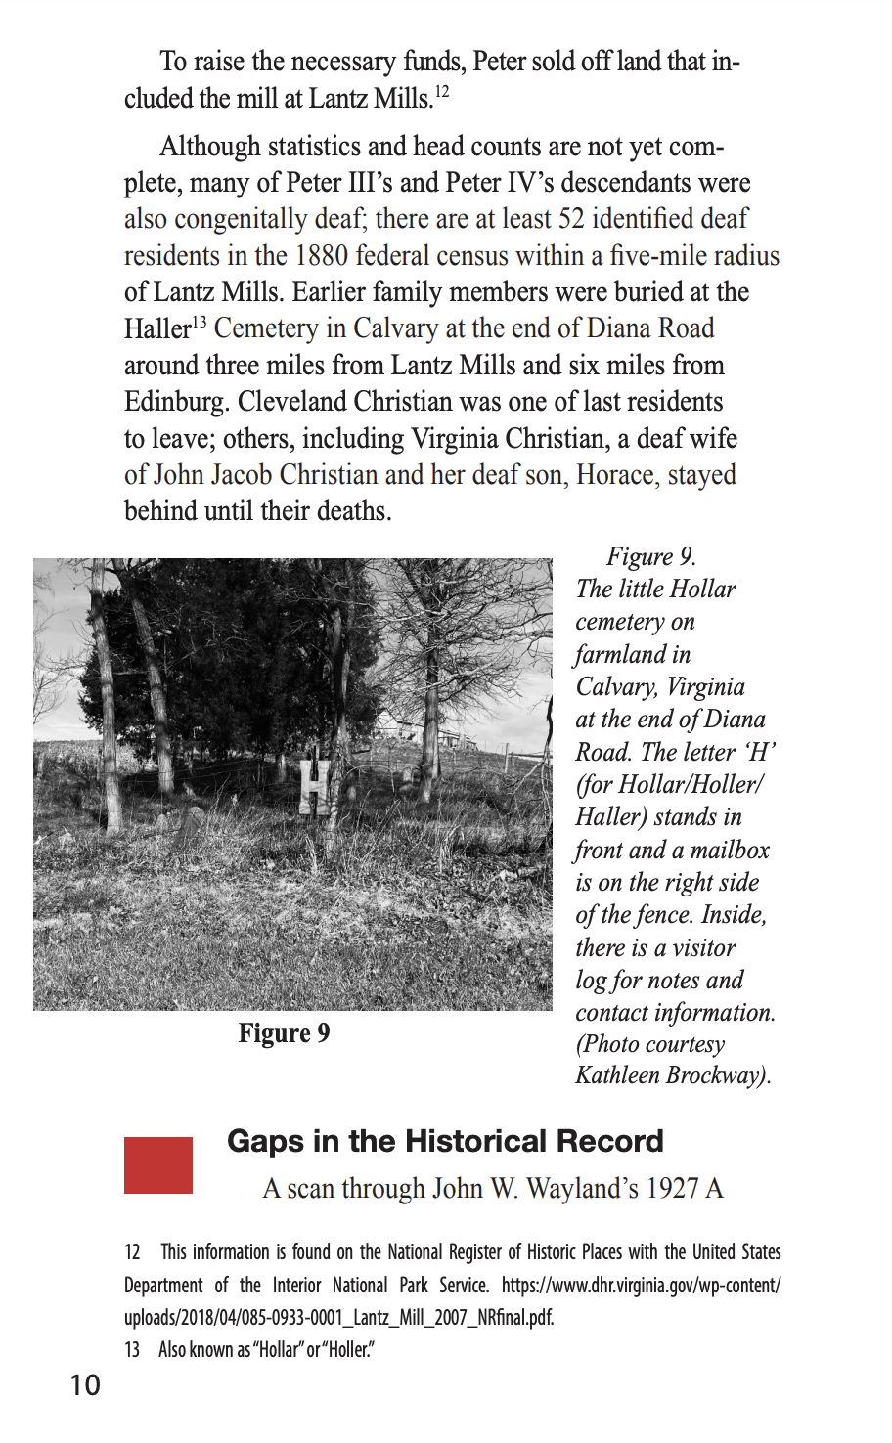
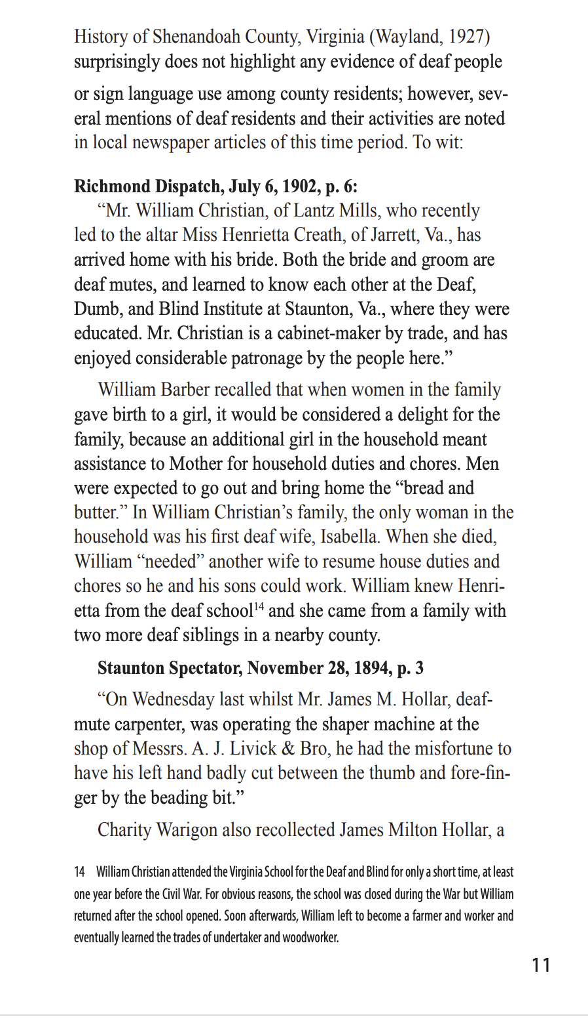
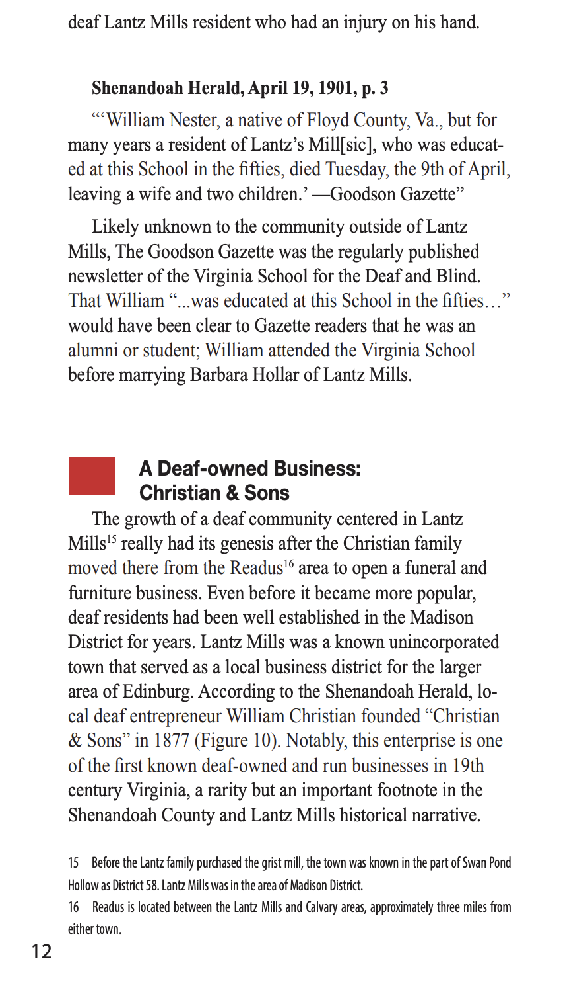
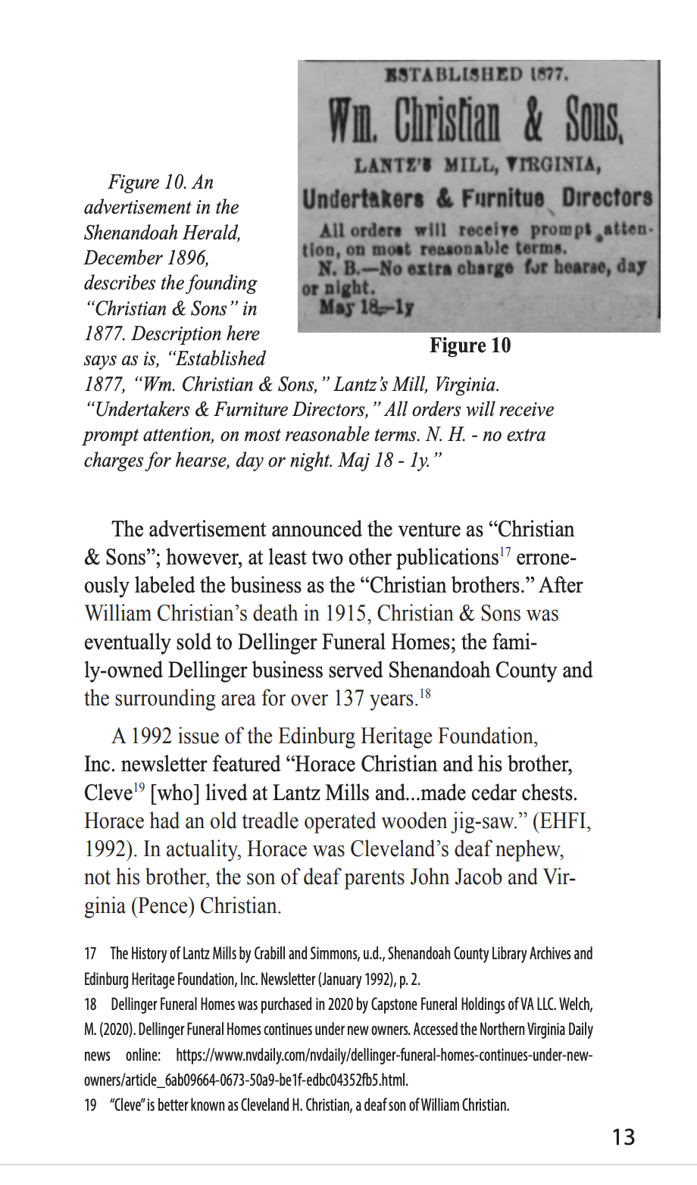
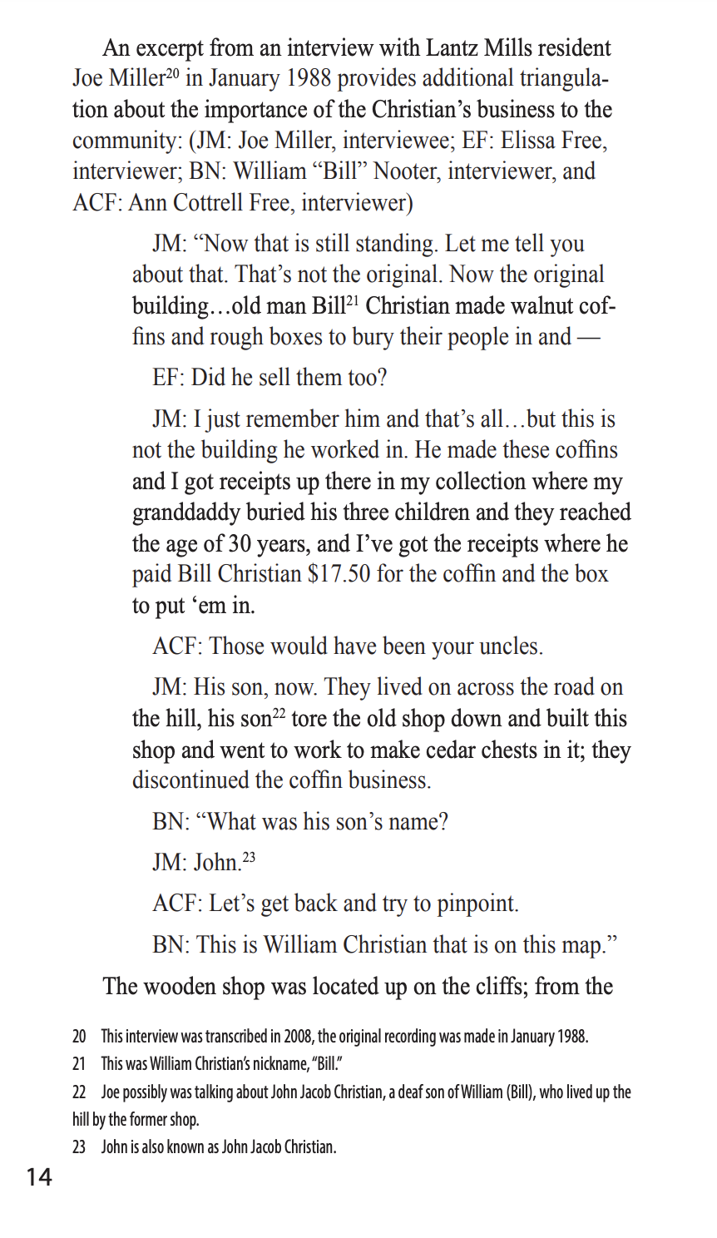
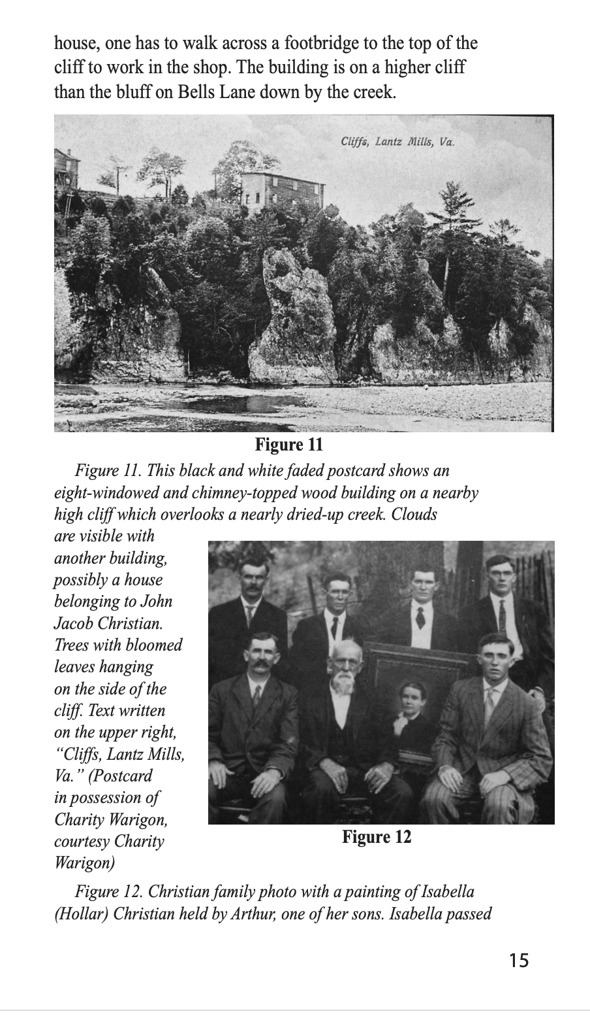
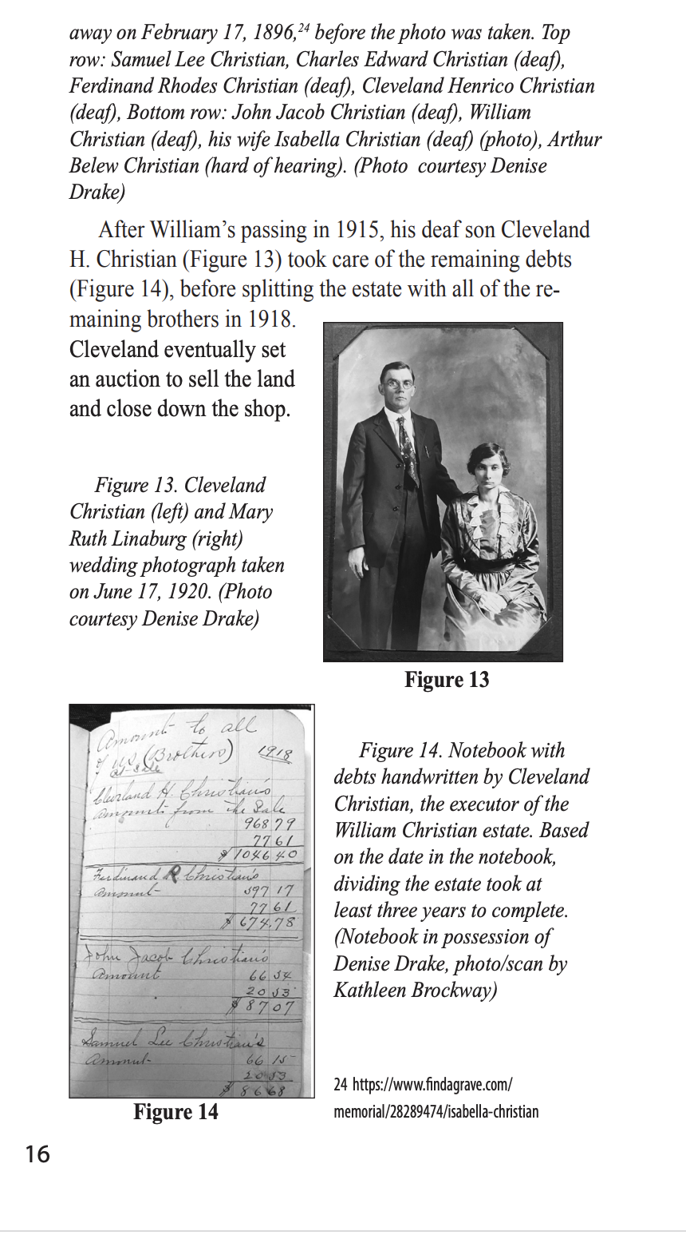
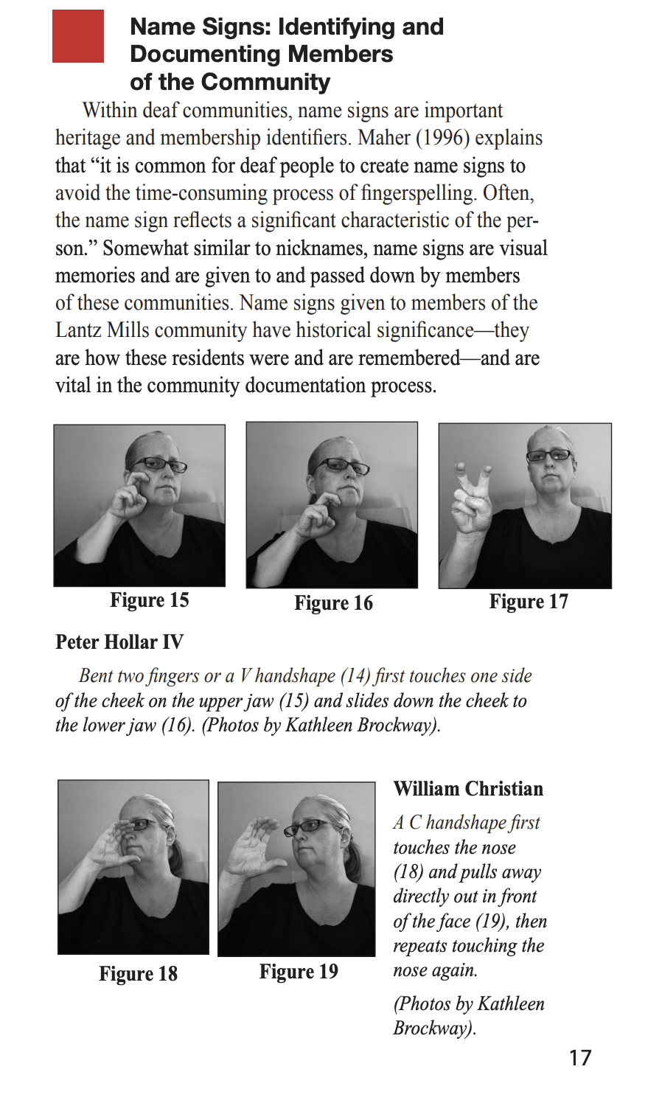
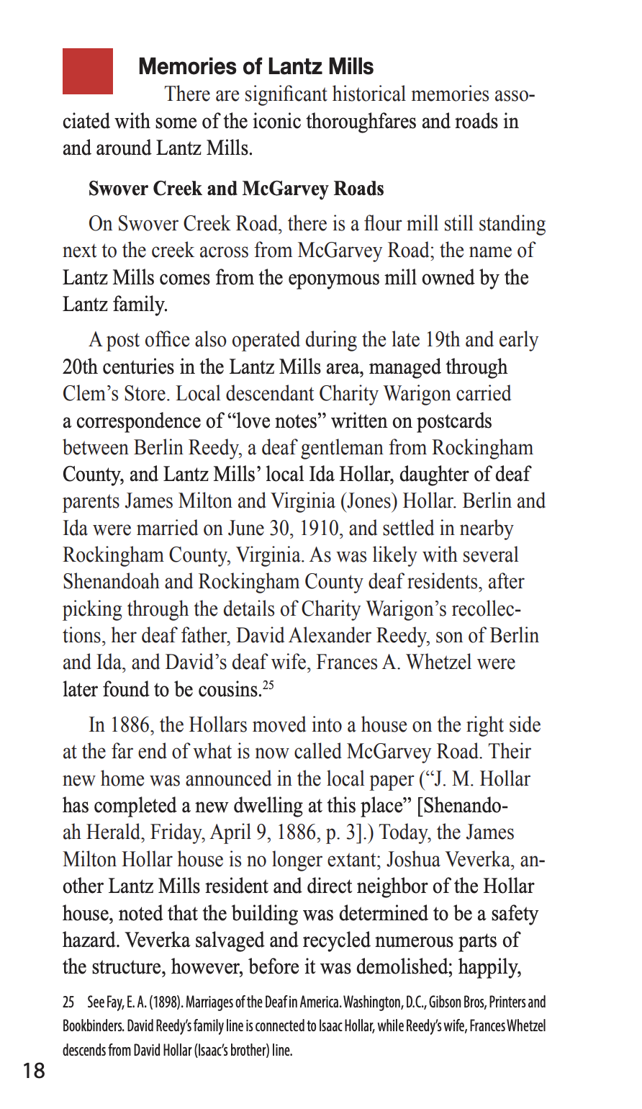
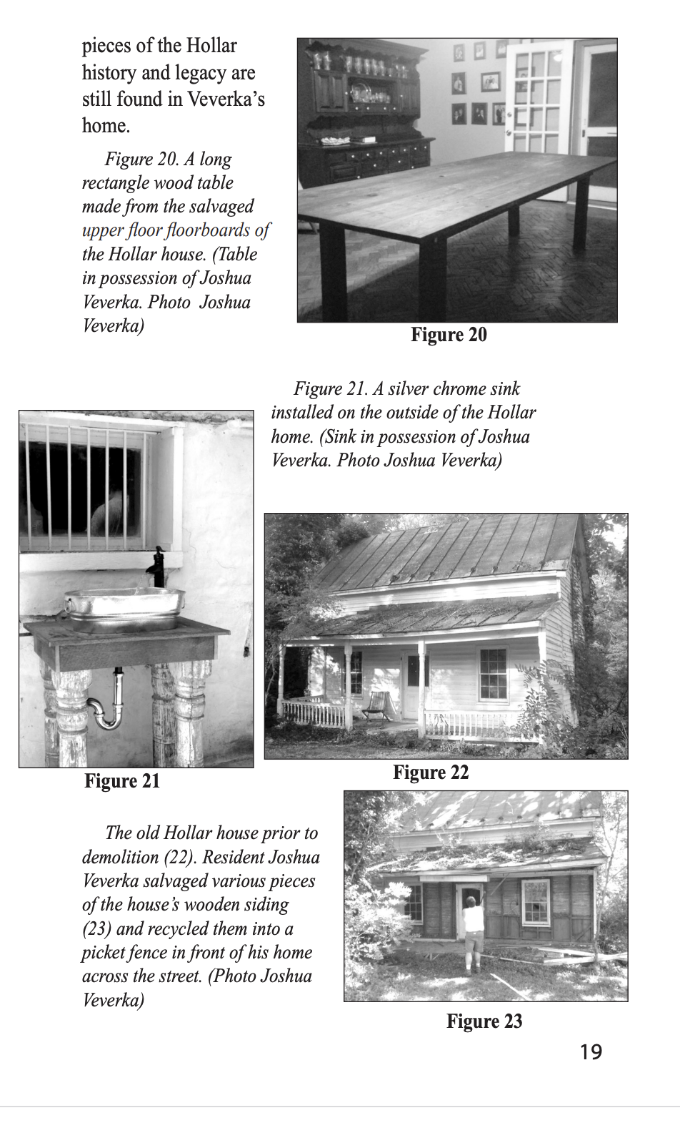
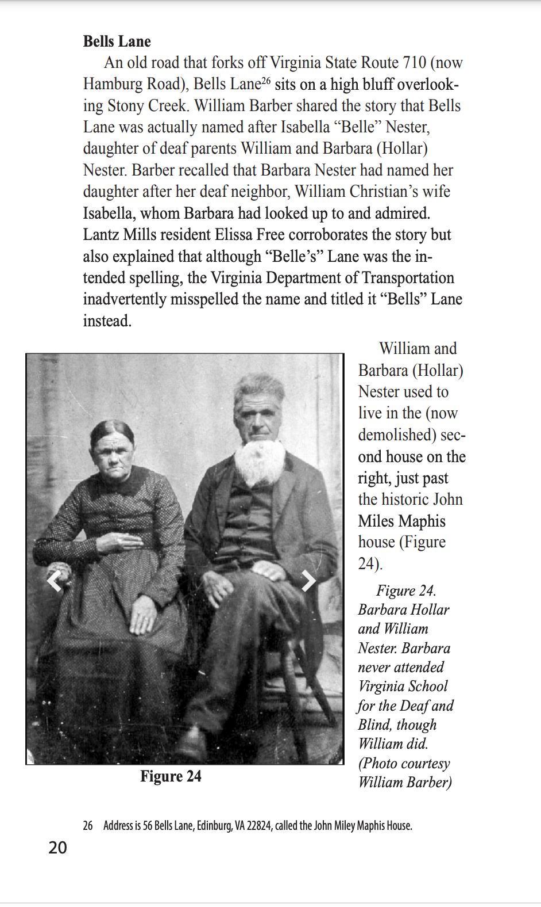
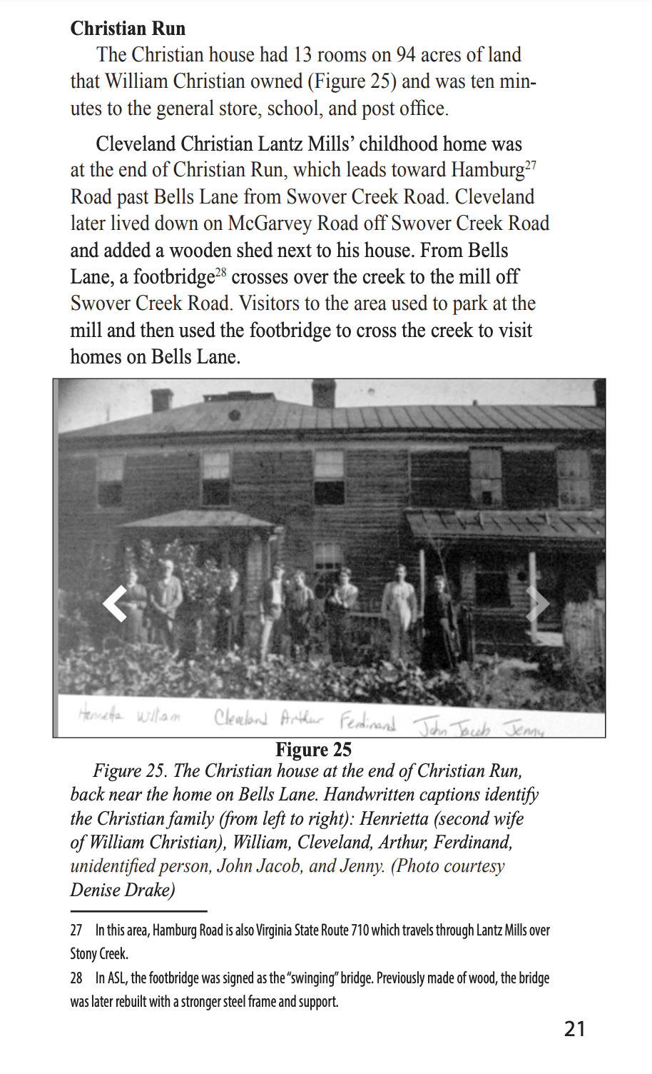
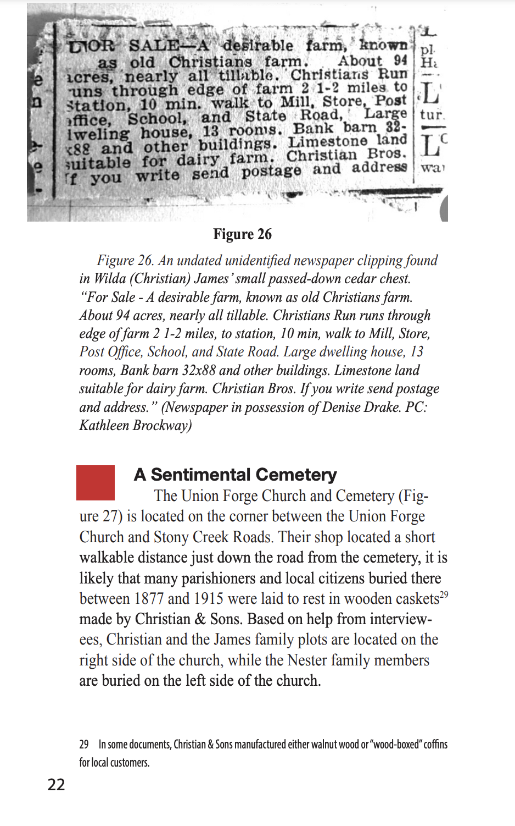
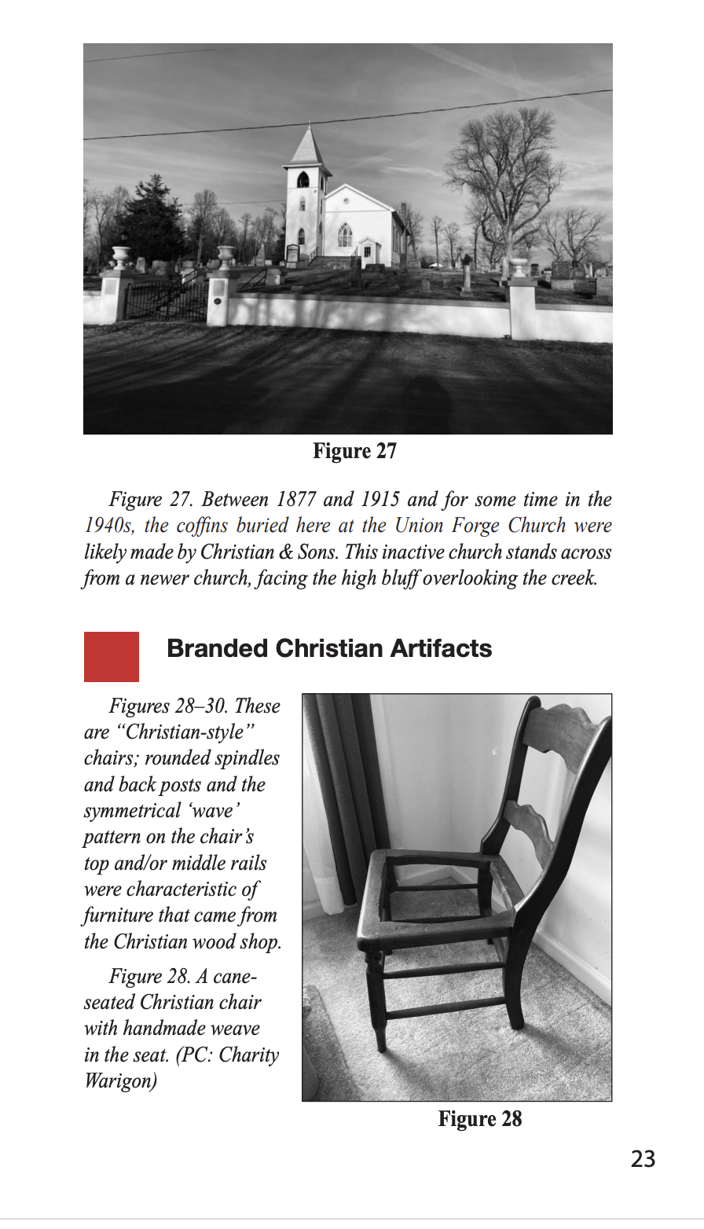
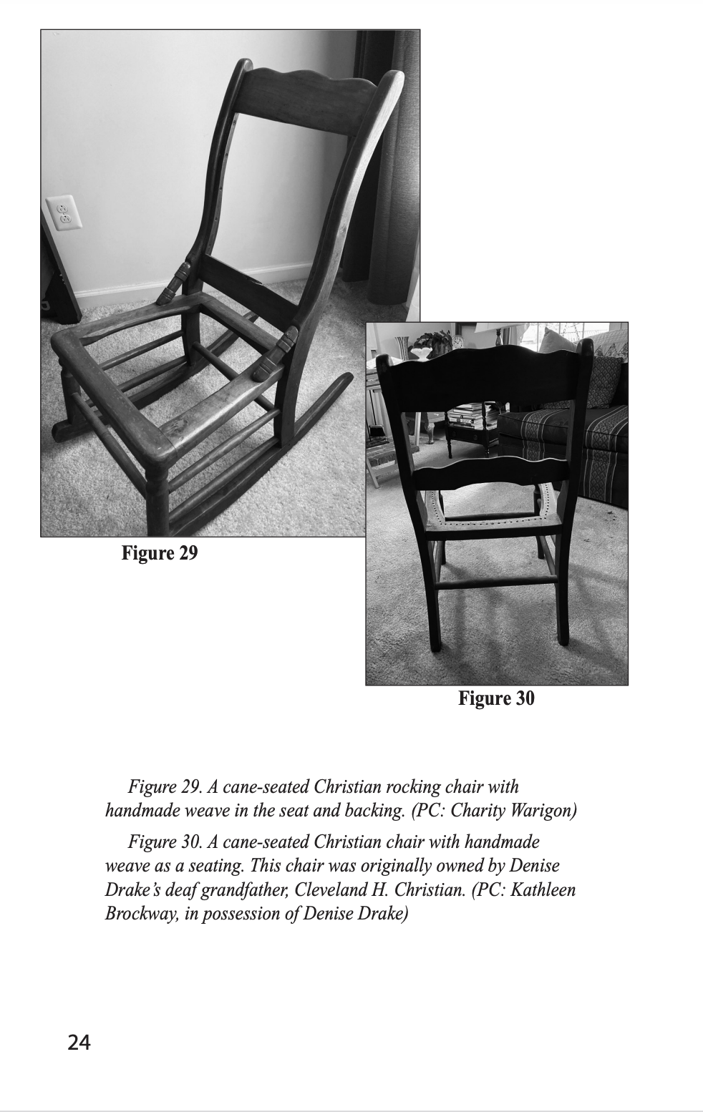
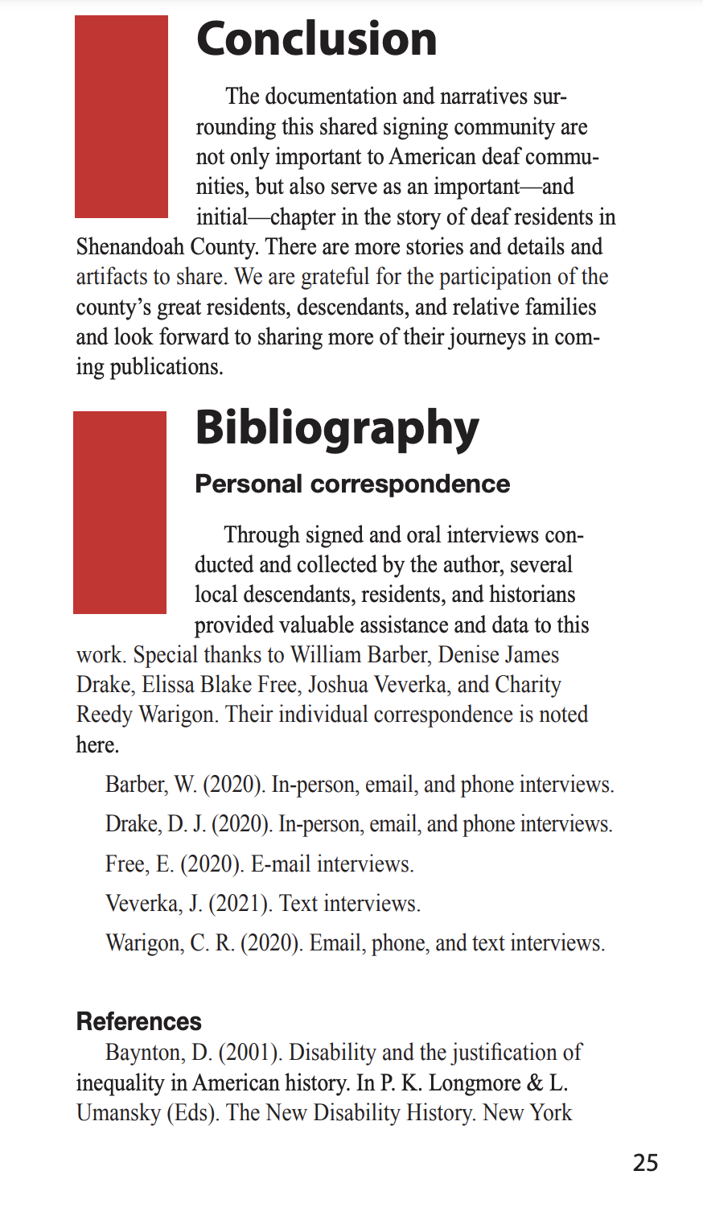
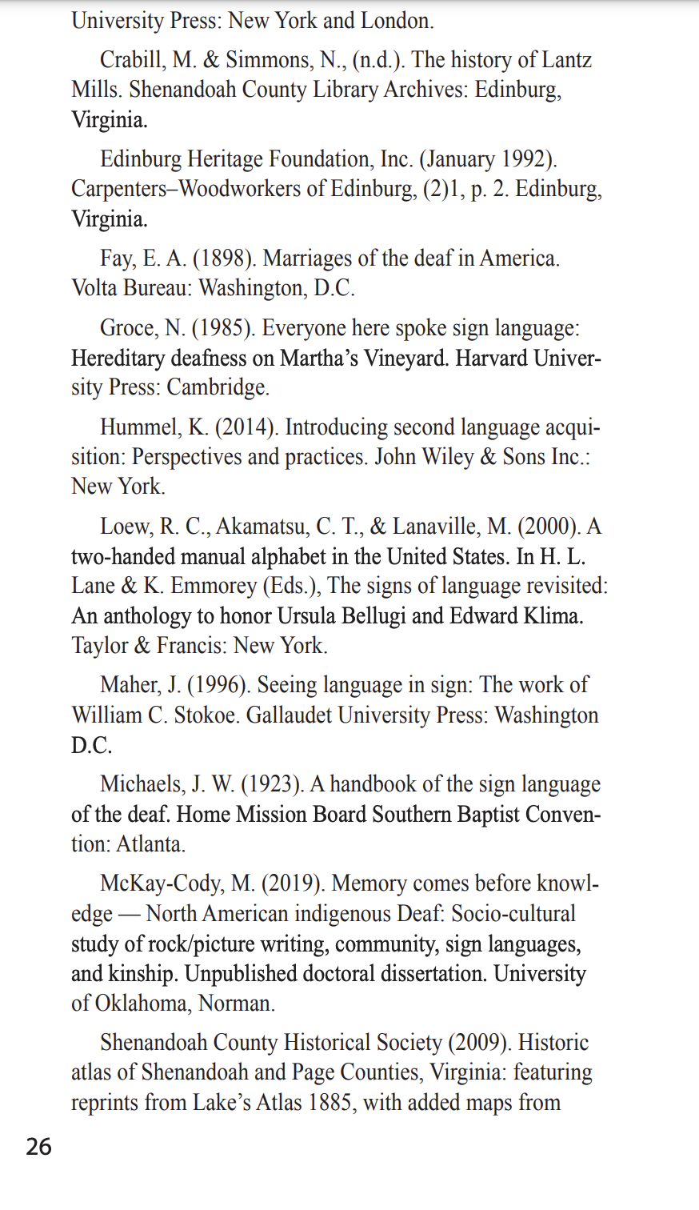
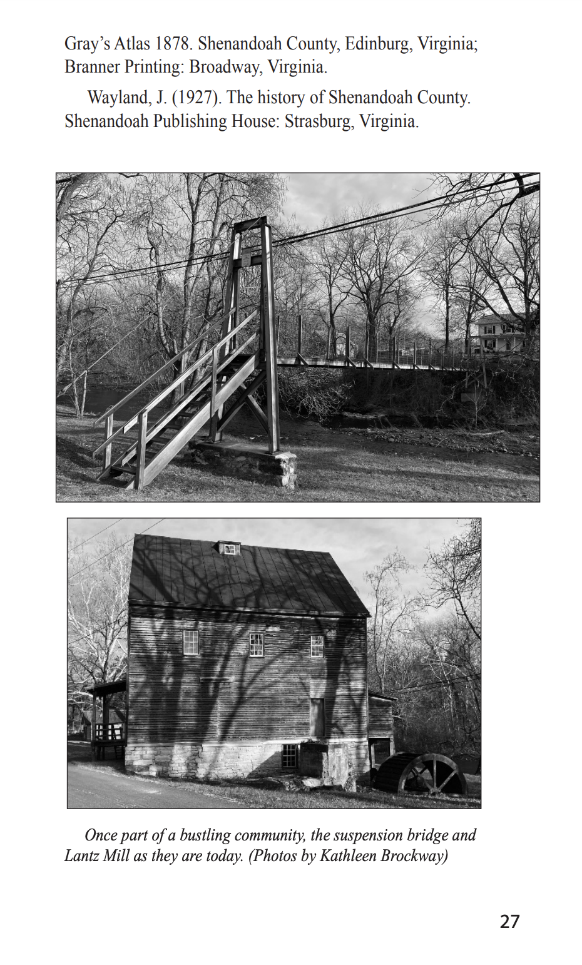
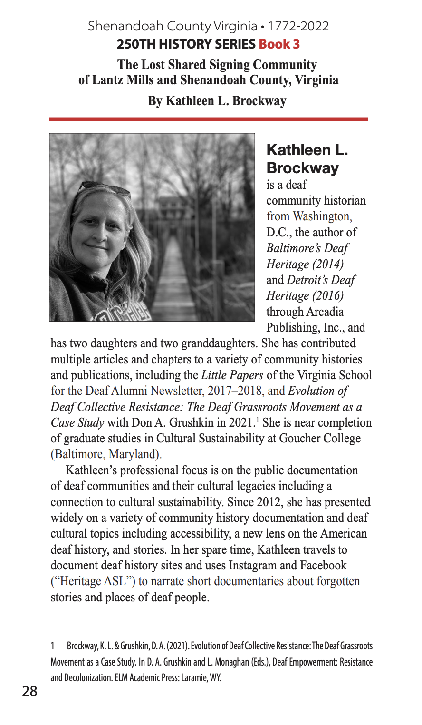
APPENDIX C: Letter of Intent Front Page
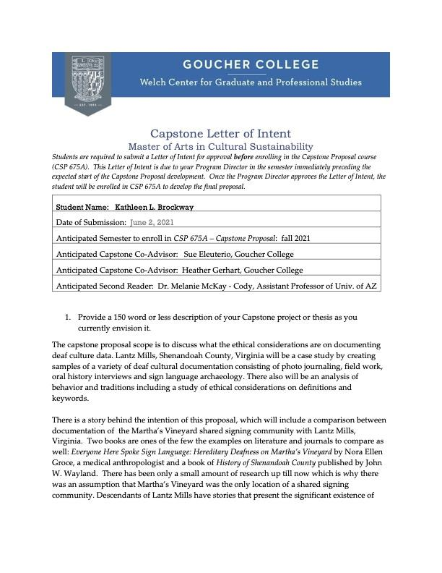

APPENDIX D: Initial Signed Narrative Interview Questions
Deaf Interviewees
- I am sharing the written release form (explaining word to word (i.e., explaining why I am doing this project, what is my role, and what I intend to use information for, and mentions that I have interpreters and a captioner in the room with us) from form in sign language). Do you want to remain anonymous or share your name in public if the story is being told after my final paper?
- What is your name and your name sign, please?
- How did your name sign come up? Follow-up question - do you know who gave you the name sign?
- Can you tell me more about why the name signs are important to you?
- Can you tell me more about the names of the other deaf ancestors in your family? Follow-up question - Can you tell me what their name signs are? (only if they did not sign the names).
- Can you explain how (name) came up with the name sign?
- Follow-up questions, if necessary. (will add here after completing the signed narrative interviews).
APPENDIX E: IRB APPROVED LETTER
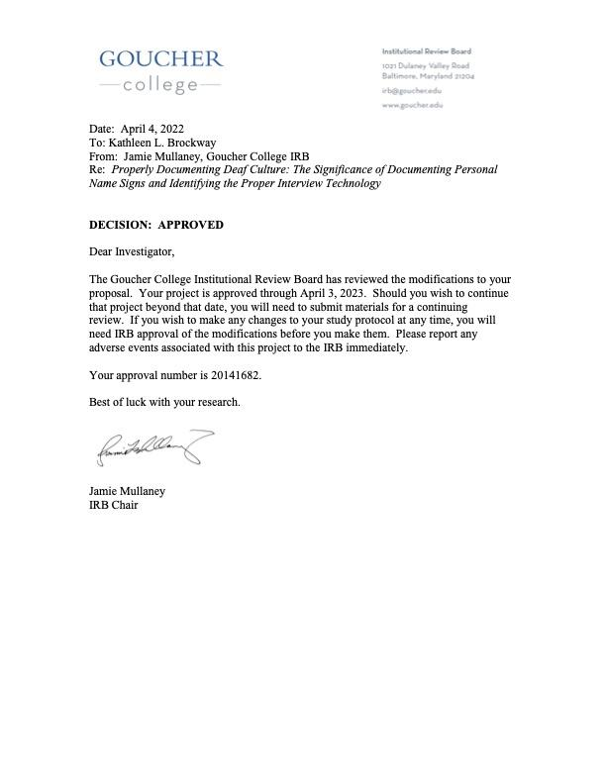
APPENDIX F: IRB APPROVAL CONSENT FORM
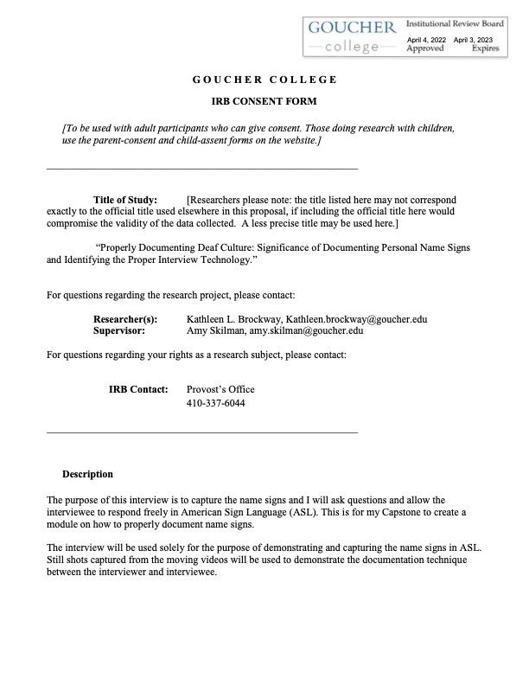
APPENDIX G: IRB CERTIFICATION
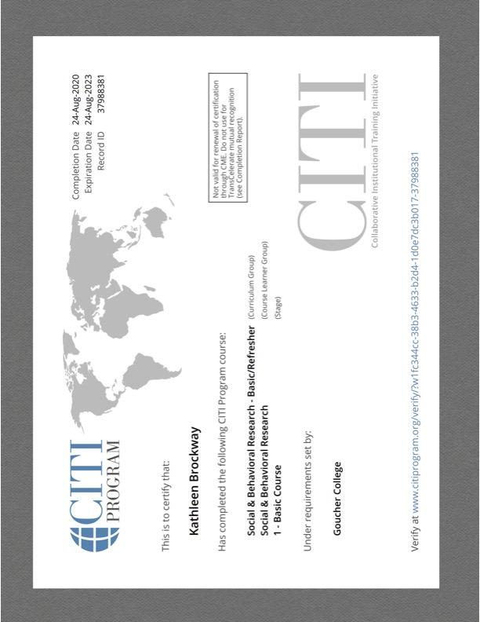
APPENDIX H: WILLIAM BARBER CONSENT FORM
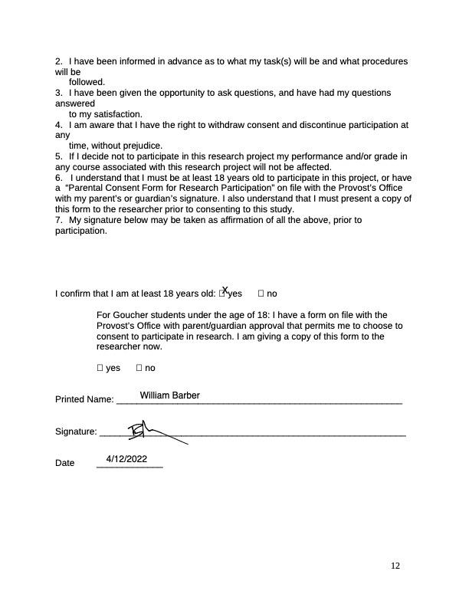

APPENDIX I: DENISE DRAKE CONSENT FORM
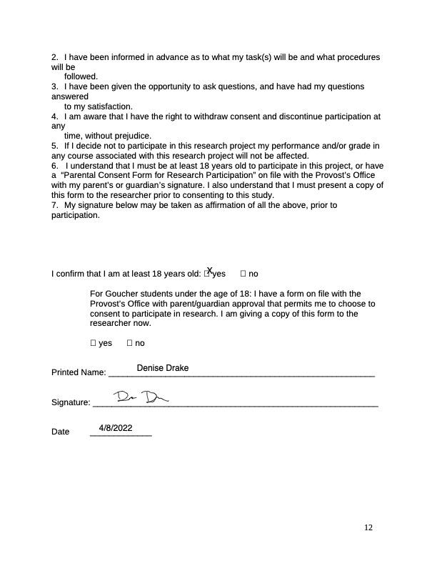

APPENDIX J: CHARITY WARIGON CONSENT FORM
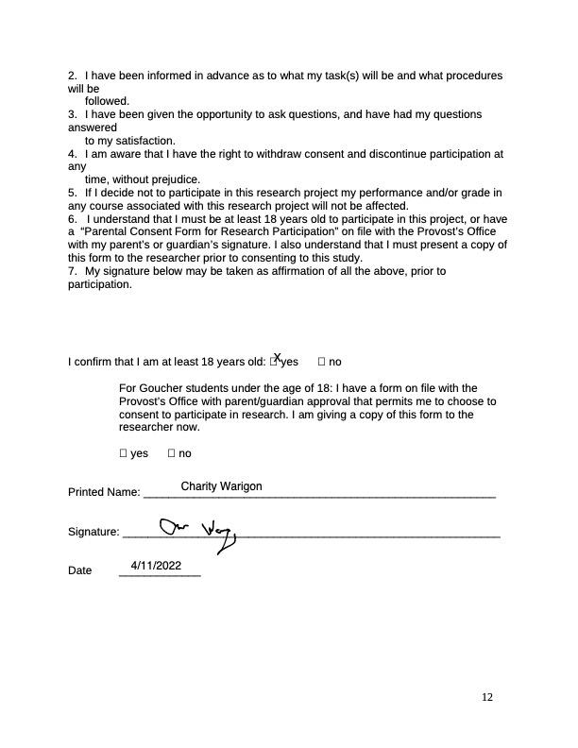

APPENDIX K: DENISE DRAKE Interview, TRANSCRIPTION THROUGH REAL-TIME CAPTIONING [AS-IS]
1 SCHOOL: Goucher College

2 STUDENT: Kathleen Brockway
PARTICIPANT: Denise Drake

3 CLASS: Capstone - Denise Interview

4 TIME: 1:30-3:00

5 DATE OF CLASS: 041222

6

7 Karasch & Associates

8 Captioned by: Terri

9

10 "This text is being provided in a rough draft format.

11 Communication Access Realtime Translation (CART) is provided in

12 order to facilitate communication accessibility and may not be a

13 totally verbatim record of the proceedings."

14

15 KAT: Hello, Denise. My name is Kathleen Brockway, and I'm

16 here with Goucher college and I am majoring in cultural data --

17 Back up let's start off.

18 Hi Denise. I'm Kathleen Brockway and I'm here with the

19 Goucher college. My major is cultural sustainability and that is my

20 major and it's research the connection between name signs and my focus

21 is going to be asking you questions. So the reason I'm studying this

22 is analyze and to use it for my presentation for my course on how to

23 catch name signs and importance it's for research and to really teach

24 other people the importance of name signs. So I will use your blog

25 and people will watch you and I will watch you and I will document and
2

1 use that to teach other people and to show them the importance of what

2 H you say related to name signs and name signs are different than

3 voice names you can't really vocalize a name sign so that is what I'm

4 doing for my research purposes. Do you agree to volunteer to

5 participate in this study or this research and for the purposes of I

6 mentioned.

7 PARTICIPANT: Yes, I do.

8 KAT: Do you agree I can use it after I graduate for

9 different exhibits to show pictures of this interview and also

10 for teaching courses and explaining do you agree to that?

11 PARTICIPANT: Yes, I do.

12 KAT: Okay. Thank you so much. All right now if you read

13 did for my questions here we go for this interview I'm going to

14 use Zoom which is different than doing a video in a class room.

15 You and I are in our own homes. And the backgrounds are clear

16 for your to understand right you can see me and understand me

17 okay?

18 PARTICIPANT: Yes, I can.

19 KAT: Okay, good. Okay. Can you tell me your name please.

20 PARTICIPANT: My name is Denise Drake. And this is my sign

21 name. So before you were married you are married correct.

22 A.Yes I am.

23 KAT: What was your name before you were married?

24 PARTICIPANT: James.

25 KAT: I'm curious. Your name sign was it's same before you
3

1 were married.

2 PARTICIPANT: Yeah, yeah didn't change.

3 KAT: So as a child that was always your name sign.

4 PARTICIPANT: Yes. It was my entire live that was my name

5 sign.

6 KAT: So how did you get that name sign I'm curious?

7 PARTICIPANT: Okay I went to roads island school for the

8 deaf and my bangs were straight across and my hair was vague

9 across at ear level and people always used that way to label me

10 to show the length of my hair so that became my name sign.

11 KAT: So that is your name sign with bend hand because of

12 your short straight hair.

13 PARTICIPANT: Yes, yes that was my name sign it was my name

14 sign my whole life then I got married and my church group said

15 your married your first name is Denise what is last name Drake

16 okay so they gave me a new name sign DD. So later on I when ore

17 union at RI school for deaf and they said hi and they used my old

18 name sign and I was so inspired and I thought that is my real

19 name sign and I haded to go back to my real original name sign to

20 show my hair.

21 KAT: Sorry to interrupt you. So that name sign that was

22 given to you from a deaf student.

23 PARTICIPANT: Yes, from a deaf student. And they were oral

24 students we were not allowed to sign.

25 KAT: So where was this?
4

1 PARTICIPANT: It was in Rhode Island it was in Rhode Island

2 in New England you know you know where Rhode Island is and it's

3 just below Massachusetts and that was the name sign they gave me

4 and I accepted it. And I went back to that sign name.

5 KAT: Okay. Hold up. Your camera froze for a moment.

6 >>Interrupt interrupt. I'm going to continue this interview. I

7 apologize for the freezing. I want to be sure the internet is

8 working well. Can you continue please?

9 PARTICIPANT: Sure. Sure so I went back here to Virginia

10 from Rhode Island and my friends that were calling me DD I said

11 no, no we are going back to my old original sign name and they

12 were shocked and they didn't know who I was using that new name

13 sign but I said you're going to have to use my old name sign and

14 stop using the DD name sign.

15 KAT: So the DD name sign that was given to you by deaf

16 people or hearing people.

17 PARTICIPANT: Deaf people. Deaf people but they were strong

18 English users some of them were oral half of them were oral they

19 had very strong English skills.

20 KAT: And that was in Virginia; is that correct?

21 PARTICIPANT: Yes. At my church in Virginia and I was

22 American sign language user but the church studied the bibb and

23 all of that around they used more English and they wanted to

24 learn so I was fine interacting with those people and taking

25 advantage of the learning there.
5

1 KAT: So owing up you used that old name sign and you had

2 been using that because you use it your whole life I get that so

3 I'm curious your grandfather use that name sign?

4 PARTICIPANT: Yes, yes he did he did. So do you want me to

5 tell story of why that happened.

6 KAT: Yes. Go ahead.

7 PARTICIPANT: So I started asking migrate father this was my

8 mom had information from my father so I said to my mom I said so

9 why was that dad my grandfather name sign and so I asked her a

10 bunch of question and my mom said why was that your

11 congratulations father name sign and I said okay my grandfather

12 was born on March 10 during president Cleveland's inauguration.

13 And he was born in March, maybe not exactly on that date but his

14 deaf family discussed it and they decided that his name sign was

15 going to be president his name sign was the sign for president so

16 that was his sign for every more until he was buried. It never

17 changed that was grandfather same name.

18 KAT: Your mom had a name sign.

19 PARTICIPANT: You know what she never told me. So I visited

20 my cousins and Elizabeth okay so Elizabeth had a name sign and so

21 there was a another name sign with the W and my mothers sister

22 more name was VELMA and she had a name sign. So V twisted and

23 the other one was a W twisted. So when I was a little girl, I

24 lived in Maryland and my aunt came to visit and she was teaching

25 me the name for vell what that is name sign that is your aunt.
6

1 And I said okay. Aunt Velma, she was heavy smoker so I thought

2 the V was being a smoker. I was a little girl and that was my

3 observation as a kid later on I found out --

4 KAT: Wow! interesting so I'm curious so you nigh all of

5 your grandfather family.

6 PARTICIPANT: Well yes but not exactly I didn't know all of

7 their names I forgot a lot because I didn't socialize with them

8 much. But I do know my grand parents is closest brother was

9 author that was his name sign and he was hard of hearing Yes, yes

10 my grandfather always signed author author author. So that was

11 his name sign and they told me that my grandfather family his

12 brother tended to sign just the first letter just a C.

13 KAT: Who is SF?

14 PARTICIPANT: Frank, his name was Frank I'm motivation sure

15 how to spell it I'm pretty sure it was Frank -- so I think I

16 guess his name was Frank so that was a name sign and there was

17 another one with a J. There was a JACOB and third 11 author so

18 there is 41st starting with S, Sam so no, no no Kat this name

19 sign for Sam this was Sam's name sign.

20 KAT: Okay. So was somebody hearing was one of them

21 hearing? Was the hearing ones were the shaken ones the V and the

22 W did that identify them as hearing people?

23 PARTICIPANT: So I learned from somebody who was deaf that

24 if you have a strong hereditary deafness or genetic deafness I'm

25 your family the signs are up at your far head some out to the
7

1 side. So you kind of classify them.

2 KAT: So how explain that again expand on that what do you

3 mean by strong genetic deafness what do you mean?

4 PARTICIPANT: I mean lots of deaf people with lot of the

5 deaf name signs.

6 KAT: So if KODA a hearing family member so if you born as

7 the hearing you still have a name sign and then so there is deaf

8 name signs and quodded name signs but there are different

9 locations on your body so might be on the left shoulder for one

10 group and who is that group on your left shoulder?

11 PARTICIPANT: I don't know Mark was one of my family Mark so

12 yeah so I don't no China are on the left shoulder I really don't

13 know maybe I don't know maybe somebody gave them that sign where

14 he went I don't really know okay so I heard about your

15 grandfather went to club with his brother hold up interrupt

16 interrupt.

17 KAT: So about your grandfather going to VDB so VDB invited

18 new students and they got new name sign tell me explain a little

19 bit about that?

20 PARTICIPANT: Okay so my mom told me a story what she

21 learned from her father and he said hey went to VDB and they took

22 a tour and my grandfather looked at everybody and he had a very

23 strong personality he was a very strong person. And took a

24 stance on anything and he spoke out he spoke out. So he went

25 there and they looked around and saw the name sign for Cleveland
8

1 and they said you know that is my name sign he said what is my

2 name sign and people wanted to change it to a different name sign

3 and I said no that is my name sign. And that needs stay that way

4 so they wanted to change the name sign to a different name sign

5 and he said that was my name he did not want to change the name

6 to a different name sign he said this is my name sign it has

7 always been and he got angry so the students gave him what he

8 wanted and they left his name sign the way that it was. So my

9 mom said that some of the students that were there not sure or I

10 think two or three of the deaf brothers when to VDB and they were

11 given different name signs however that came home they used his

12 real name sign so.

13 KAT: You mean they had name sign home signs and.

14 >> They just spelled out the name.

15 KAT: So when they were at their home they used the other

16 name signs and?

17 PARTICIPANT: I don't remember what hey were I don't

18 remember what they were.

19 KAT: Okay so VDB Virginia school for the deaf and blind

20 that is what you referring to.

21 A.Yes.

22 KAT: Where is what school?

23 PARTICIPANT: It's in Stanton, Virginia.

24 KAT: Is that where the school is?

25 PARTICIPANT: How did he get there I think he said he took a
9

1 train from his home to the Virginia school for the deaf and blind

2 I think he road the train so I don't know. So when he first went

3 there was a train that the time for him to travel to school. So

4 my grandfather told me he used a different old fashion sign for

5 train because it was a slow train you know where the wheels chug

6 chug a long so he used a very old fashion sign for train.

7 KAT: I love that sign what is so cool I like that sign you

8 told me that another family member a distant cousin David Reedy

9 had a horse at VDB is that right did he still take the train and

10 also he went by a horse?

11 PARTICIPANT: Yes he did have a horse and buggy yes. So he.

12 KAT: So me took the train and horse and buggy.

13 PARTICIPANT: You know that school the train would only take

14 you to a certain location and then it stopped and then Stanton

15 Virginia was not right there you had to go up a very steep hill

16 it was not far but you had today go up a very steep hill so the

17 horse and carriage would bring him up there so you know he would

18 put all his things in the trunk I guess or whatever you call it

19 in his trunk it would be put into the carriage and then all the

20 kids that were in this wagon this carriage put all their stuff in

21 this and the horse and the wagon would take them up to the

22 Virgina School for Deaf and Blind.

23 KAT: That kind of maybes me think of hayride with everybody

24 insides of hair ride.

25 PARTICIPANT: Yeah. That is what it was like that's what I
10

1 was like.

2 KAT: Have you seen a picture of that horse and wagon have

3 you every seen that?

4 PARTICIPANT: Let me think.

5 KAT: It's okay if you have not it's okay. I was just

6 curious the see something you know picture of what it looked

7 like. Can you tell me about Lancemills, Virginia so your GB is

8 there there right Cleveland so remember you went to Lancemills?

9 PARTICIPANT: Yes, yes. Very recently.

10 KAT: So what age did you go there do you remember how old

11 you were?

12 PARTICIPANT: I think I was about 13 or 14 years-old that.

13 KAT: Was your first visit there?

14 PARTICIPANT: Yes, I was the first time.

15 KAT: Do you remember what it was like can you describe what

16 it looked like?

17 PARTICIPANT: Yeah so we drove around we saw Cleveland's

18 burial spot his grave. We looked around we saw family it was a

19 little bit awkward. At first I went there for my grandmother

20 funeral we flew there because I was in Rhode Island we drove from

21 Rhode Island to Virginia and when to funeral, and I remember

22 Cleveland's grandparents said there was a bridge and I remember

23 they had talked about that bridge and then we went to wood stock

24 and I looked around and I was like that's Woodstock. That's the

25 sign for Woodstock.
11

1 KAT: Okay. All right. That's the sign for Woodstock so

2 that was the name of town so you were wear of that name sign?

3 PARTICIPANT: Yes, I was and there was a lot in Woodstock

4 and so my father's brother he worked in a wood shop as carpenter

5 and worked with grass and hay and that's what would was needed

6 they needed to bring that in the wagon. It was piled high. So

7 they were put it all in the wagon a horse would pull it and they

8 would bring it to the town of Woodstock. And deliver it all the

9 wood the hay and grass everything I just hay and the wood and the

10 wood shop they would use to fun churn I guess and when hey were

11 done they chop what they needed and put it back in the wagon and

12 go home to Lancemills.

13 KAT: So I'm curious, you had not visited there before you

14 were age 13.

15 PARTICIPANT: No, no I never visited there before wait a

16 minute when my grandfather died I was 13 I had not visited there

17 until my grandfather died and I flew and then we drove from

18 Virginia to the funeral.

19 KAT: Okay let me clarify your grandfather they flew the

20 body back and then you drove.

21 PARTICIPANT: Yes, yes my family drove to the funeral in

22 Virginia we slept in a hotel. And then we traveled around

23 Woodstock and I saw fire trucks and my dad said my gosh the fire

24 trucks were beautiful the trees were -- I just -- I had no idea

25 about that and I saw all of the fire trucks in Woodstock were
12

1 read and I said wow! dad they are white fire trucks that is what

2 grandfather Cleveland told me about.

3 KAT: Wait a minute they were white few trucks.

4 PARTICIPANT: Yes.

5 KAT: And you were 13 at this time right.

6 PARTICIPANT: I was I was and he told me about that and we

7 got there and I looked all around and Woodstock was really a cool

8 town.

9 KAT: Can you tell me more about Lancemills though you saw

10 your grandfather house there?

11 PARTICIPANT: Yes, I did I saw his house. We could not go

12 in it of course but we saw the outside. And we went to funeral

13 and then we decided my mom wanted to drive just to two of us

14 alone and so we drove and we looked around more in Lancemills and

15 my mom said I was born there. In that house right there and aunt

16 V her sister was born in that house as well. And she said there

17 was a big garden and this was the sign a different sign for

18 garden because you brushing dirt off your hand and.

19 KAT: That is my sign for picnic.

20 PARTICIPANT: This is my sign for picnic?

21 KAT: So this is my sign for garden brushing the dirt off

22 your hands and this is my sign picnic.

23 PARTICIPANT: She showed me there was a big garden and just

24 grass there now no longer a garden and then my mom said wait what

25 is that? And so we looked at that and the bridge so it was a
13

1 bridge that was there it was a wood bridge with slats across it

2 like a hanging bridge either it used be a rail on it.

3 KAT: Did it look different back then from today?

4 KAT: Yes, yes it was different.

5 KAT: So explain more about the difference.

6 PARTICIPANT: So there was they added on the bottom they a

7 floor to bridge before it was just a hanging bridge with rails.

8 There was no fence or anything on the side it was just like

9 little strings with ropes on side very scary back then.

10 KAT: So you seen those in movies where trying to walk

11 across on the wood slats across before something caught you on

12 the other side you know woman and men would try to escape from a

13 bad group of people and they were try to walk on these wood slats

14 and not fall into the water so I you would already dreamt that

15 you seen that?

16 PARTICIPANT: Y already seen a bridge like that.

17 KAT: Like as a particular back?

18 PARTICIPANT: Yes. So you know you can see the bridge

19 breaking but I saw that bridge but we were able to walk across it

20 but I had the really focus I had to focus you know I was so

21 terrified walking across that bridge and we made it across to the

22 other side and I asked my mom I said you were not afraid to cross

23 that bridge and I don't know that sign you used yeah that is sign

24 for afraid that my mom used. My mom said no I wasn't afraid. I

25 wouldn't believe it that is how she grew up groin across that
14

1 bridge they did have roads there righten Yes, yes hey did have

2 roads on the other side of bridge.

3 KAT: So explain where were you knocking you said you

4 knocked on a door so you went to --

5 >>Interrupt interrupt.

6 PARTICIPANT: So we knocked and Earl's home on his door and

7 then we were not sure so that is where my mom wanted to go he

8 shocked on Earl's door and he opened it.

9 KAT: So you don't remember Earl yourself? You saw a young

10 boy at the time you don't remember him or you do?

11 PARTICIPANT: He was young he was a young man.

12 KAT: Do you remember him at all?

13 PARTICIPANT: No.

14 KAT: You don't remember I'm I was just curious can you

15 elaborate more about that visit please.

16 PARTICIPANT: Yes so they served us water. And there was

17 ice tea and juice nothing nothing just plane water. Nothing else

18 and I was used to signing and I you know so they were signing but

19 I just was like hurry up.

20 KAT: So were you in house at this time and?

21 PARTICIPANT: Nope, nope I didn't.

22 KAT: Was there a crest there?

23 PARTICIPANT: No, no, no. So I thought in the homes they

24 did have that.

25 KAT: So when you mentioned that before I tried to any back?
15

1 PARTICIPANT: Nope. I didn't see any maybe in the upstairs

2 bedroom there was I don't know but I didn't go upstairs maybe it

3 was upstairs.

4 KAT: Do you remember the other houses that were near by?

5 PARTICIPANT: I do. I do. Yeah. There were other houses

6 near by.

7 KAT: Do you remember a brick house was there a brick house

8 or there were other kinds of houses there do you remember or now

9 it's changed right?

10 PARTICIPANT: Yeah, it has changed.

11 KAT: Does it look the same?

12 PARTICIPANT: Well it looks the same to me I'm not really

13 sure.

14 KAT: And the road looks the same to you.

15 PARTICIPANT: Yep, yep the road looks the same.

16 KAT: So do you remember the road's name?

17 PARTICIPANT: I don't really know no I don't roads name

18 sorry.

19 KAT: So the water, you looked and you remember what the

20 water looked like right.

21 PARTICIPANT: Yes.

22 KAT: Was the water low or just a little bit of water was it

23 the same today as it was back then?

24 PARTICIPANT: It was about the same it was about the same.

25 KAT: So because I had heard there had been floods can you
16

1 tell me more about that.

2 PARTICIPANT: So my mom had said when there was just a

3 pouring rain my grandfather signed this to show that there was

4 torrential rain like a just poured down like in buckets, buckets

5 of water. Then people had to get rid of the water because it

6 would flood so they had to go and get the water they had to

7 shovel the water away so houses wouldn't flood I'm not sure how

8 it worked how hey get rid of water but my grandfather said it

9 poured bucket as and would be fluids and they had to push and

10 shovel the water away and they told me this over and over again

11 and when my father passed away I asked my mom why did grandfather

12 buy that house if there was such a flooding issue you know you

13 know they have stay up all night when it was raining so they

14 collegiate rid of water so the house didn't flood why didn't he

15 move and my mom said well that was what he could afford so buy at

16 that time that house was cheaper.

17 KAT: So did you grandfather live on the high bluff from the

18 bridge is that where he lived?

19 PARTICIPANT: No. Actually it was little bit be who.

20 KAT: No, no. No. I mean when he grew up across the bridge

21 right well wait where did he grow up?

22 PARTICIPANT: So he grew up on a farm behind that house

23 there was a horse farm behind the house it was distance after he

24 bought this house the farm was behind it.

25 KAT: No, no no, no wait a minute wait a minute so you mean
17

1 that Fred used live on the high bluff okay so you recently

2 mentioned that Frank used live there before?

3 PARTICIPANT: You know what I am not really sure.

4 KAT: So who was it who was the person that you told us

5 recently about moving to the house?

6 PARTICIPANT: So when my grandfather was growing up right

7 behind those houses there is kind of like a island and behind it

8 was a barn and it was up high enough so after my grandfather

9 passed away they sold it.

10 KAT: So they sold the house.

11 PARTICIPANT: Yes, yes they sold the house so the sign I'm

12 using that is my old sign I can't change it to the new scienter

13 sell people say what is that sign but what is sign I use for sell

14 but it's just hard. It a almost the sign as the real sign but

15 anyway they sold his house and they bought this other house it

16 was a cheaper house and that was the house they would flood and I

17 didn't understand why.

18 KAT: So you're telling me that the high bluff was more

19 extensive?

20 PARTICIPANT: That is what I think because no water was

21 going down in it.

22 KAT: So when you were 13 did your home signs mention where

23 you grandfather Cleveland grew up.

24 PARTICIPANT: No, no, she didn't.

25 KAT: So when did you become familiar when did you learn
18

1 where he grew up?

2 PARTICIPANT: Recently.

3 KAT: For real?

4 PARTICIPANT: Yes. Bill Barber and DOROTHY they lived

5 behind there and I got so excited to find out where.

6 KAT: Wait wait so do you remember Earl stories about him

7 you met Earl so you do remember the stories about this?

8 PARTICIPANT: Well, I found out recently.

9 KAT: So do you remember tell me what he said?

10 PARTICIPANT: No you told me what he said.

11 KAT: Okay. All right.

12 PARTICIPANT: So right across the way so what Earl explained

13 he said that he could walk across and around one way but he had

14 to go all the way around but Earl said nope no that wasn't true

15 you could walk instruct around from his property you could go

16 straight to backyard to your grandfather's house.

17 KAT: So that creek that went behind the house?

18 PARTICIPANT: So there was a bridge there over the creek but

19 I had not asked Earl about that.

20 KAT: So now I'm curious, did your mom every take you to

21 that uphill cliff can you tell me more if you remember did you

22 drive up there to the cemetery up there in that area do you

23 remember going up that hill?

24 PARTICIPANT: Which cemetery?

25 KAT: Yes, the cemetery where you grandfather was buried?
19

1 PARTICIPANT: No, no no, no.

2 KAT: Where Cleveland is buried do you remember going up

3 that road up that hill? Do you remember that? Did you ever look

4 around at the houses there the wood shop those houses do you

5 remember that?

6 PARTICIPANT: The wood shop yeah that was fun that was fun.

7 So my cousin I don't know if I spell it right forest this is his

8 name sign HORACE.

9 KAT: Did you meet him did you meet her race?

10 PARTICIPANT: No. I never did but my grandfather told me

11 that Horace moved. He used horseshoes. He would decorate

12 horseshoes and he went a way to the devil --

13 KAT: Wait a minute. You mean like witchcraft is that

14 you're talking about.

15 PARTICIPANT: Yes, yes. People would call it that so he

16 would put up horseshoe to ward evil so my grandfather would say

17 Horace put up those silly things there he would sign silly at his

18 head instead of his nose like we do but my mom and I drove and we

19 saw the wood shop and the horseshoe they are still there.

20 KAT: Do you remember the wood shop?

21 PARTICIPANT: Yes we saw the wood shop and it there were two

22 woodchops two buildings side by side.

23 KAT: Okay. So tell more about the wood shop it's two

24 floors or one floor?

25 PARTICIPANT: It was one floor. But there were two
20

1 buildings side by side. And you could go back and forth between

2 two of them and there would be a wagon and the horse so you could

3 go from one to the other so.

4 KAT: So you were 13 years-old and horses were still there.

5 PARTICIPANT: No, no no. That was in the past but I could

6 see the design and the horseshoe was still there I was so

7 impressed.

8 KAT: Was it outside?

9 PARTICIPANT: Yes. It was outside on front of wood shop.

10 KAT: So can you tell me why that was Horace's name sign?

11 Do you know?

12 PARTICIPANT: Nope, I have no idea.

13 KAT: Did your grandfather tell you that name sign that was

14 his name sign?

15 PARTICIPANT: Yeah he did.

16 KAT: So when it was close to the time he passed away you

17 know I saw my grandfather Cleveland and he pointed over and said

18 there is Horace over there. And there was a chair where he was

19 pointing but nobody was there in the chair and I said to my mom I

20 said he is pointing at this chair and doing this sign and my mom

21 said my goodness, that's you know he working to in the wood shop

22 because Horace owned the business and your grandfather would help

23 him and they worked together and when Horace had no patients at

24 the wood shop in fixing things he would give it to my grandfather

25 because my grandfather was very patient and handy. Horace was a
21

1 really good worker at the wood shop but he had no patient he

2 became frustrated easy but my grandfather would do the work for

3 him that he could not handle so my grandfather told me that

4 Horace was over there and having a chat with Horace who is not in

5 the chair. My grandfather had Alzheimer's so he was having a

6 conversation with Horace?

7 PARTICIPANT: Yeah, he was.

8 KAT: So there was one -- I saw article about both brothers

9 that explains why they were very close is why they both where are

10 so close?

11 PARTICIPANT: That makes sense. That makes sense.

12 KAT: So that made me think wow! the newspaper said about

13 his brother was they were really uncle and nephew? So when you

14 looked at that wood shop do you remember looking at the other

15 side of it do you remember a house on the other side across from

16 the wood shop across the wood shop?

17 PARTICIPANT: Yeah so so it was flat to one side of the wood

18 shop and Horace's house was across from the wood shop. So it was

19 across from there and across there was flat field and that was

20 where Horace's house was on that flat field.

21 KAT: So when you went recently was that house across on the

22 left correct is that right? So if you stand and look at the wood

23 shop towards your left and you turn to your right and you look is

24 that where Horace's home was am I right?

25 PARTICIPANT: Yes, it was little bit closer in.
22

1 KAT: So you mean it was on the right or the left?

2 PARTICIPANT: So Horace's house would have been to the right

3 side.

4 KAT: Not on the left, correct?

5 PARTICIPANT: No, no, no. It was not on the left. It would

6 have been on the right.

7 KAT: So Horace's house in his family for generations is

8 that correct?

9 PARTICIPANT: Horace's house, I don't know.

10 KAT: That's fine so on house left was not your family's

11 home.

12 PARTICIPANT: Correct it wasn't.

13 KAT: The one on the right was I see I see thank you for

14 clarify. So do you know about the land that was across from the

15 wood shop can you tell me about that land do you remember just

16 the vacant land that was there?

17 PARTICIPANT: I really have no idea what that was.

18 KAT: Your mom didn't tell you anything about the

19 surrounding land nothing? Your mom did tell you abhor races home

20 right?

21 PARTICIPANT: Elizabeth told me. She told me about Horace's

22 house.

23 KAT: So Elizabeth was there.

24 PARTICIPANT: Yeah, yeah I visited her.

25 KAT: So you did see Elizabeth you saw her.
23

1 PARTICIPANT: Yes. I did see Elizabeth and she would come

2 to check on the his on Horace. Horace is not.

3 KAT: Horace's sister or mother.

4 PARTICIPANT: Neither no, no there was no relationship?

5 KAT: So who she to Horace how is she related to Horace?

6 PARTICIPANT: So Elizabeth's husband was related to Horace.

7 KAT: Okay. So like step mom.

8 PARTICIPANT: Maybe step mom yeah, yeah yeah step mom.

9 KAT: So Elizabeth is how much older than Horace or older or

10 younger.

11 PARTICIPANT: Elizabeth was younger than Horace.

12 KAT: Okay. Okay. I see.

13 PARTICIPANT: Because she would go and stay and take care of

14 Horace's house close to his death. So she had to have been

15 younger. Horace decided to fill out papers like a will for that

16 house and Horace's house and the wood shop and gave both of them

17 to Elizabeth in the will.

18 KAT: So do you know when Elizabeth died?

19 PARTICIPANT: I really don't have a good memory what year it

20 was.

21 KAT: That's fine that's fine. So did you go to Elizabeth's

22 funeral?

23 PARTICIPANT: No, no I didn't go to her funeral.

24 KAT: I'm curious.

25 PARTICIPANT: I really can't remember if I did or not.
24

1 KAT: So you went to Cleveland's. You went to the cemetery

2 where he is can you tell me -- do you remember across from the

3 cemetery to the other area was the house was there a house there?

4 PARTICIPANT: Okay. So say is that again?

5 KAT: So Cleveland if you were at the cemetery, at the

6 church if you looked across the way was there a church or house

7 or building across from the cemetery do you remember was there a

8 billing there?

9 PARTICIPANT: No.

10 KAT: You don't remember.

11 PARTICIPANT: No, I don't remember I'm trying to any. Bill

12 Barber might know. His family lived there I think in that house.

13 KAT: So there was a house you think or a church at that

14 time?

15 PARTICIPANT: I'm thinking a house.

16 KAT: You think there was a house there.

17 PARTICIPANT: I think so I think so so we had a funeral at

18 the church there.

19 KAT: Was old church there as well?

20 PARTICIPANT: Yeah there was a beautiful old church.

21 KAT: Can you tell me about the inside of church?

22 PARTICIPANT: It was very plane it was old church. Kind of

23 looked like a house it had a cross like a wood cross real wood.

24 My grandfather had open casket.

25 KAT: So the funeral was in that church the service was in
25

1 the church.

2 PARTICIPANT: Yes, yes the service was in the church. The

3 casket was open it was beautiful.

4 KAT: Do you remember were there lots of deaf people there?

5 PARTICIPANT: Yes there were there were lots of people there

6 were so many deaf people so much signing going on. And you know

7 so there were so many Cleveland's granddaughter was and so.

8 KAT: That's is sign you use for granddaughter?

9 PARTICIPANT: Yes.

10 KAT: Okay that is your sign for granddaughter okay so that

11 means one granddaughter one time so if you do a couple sign girl

12 a couple timings or you do girl born born that's two

13 granddaughters one okay one is daughter if you do it twice it's

14 granddaughter?

15 PARTICIPANT: Yes, yes that is how I sign it.

16 KAT: So you have grandfather so remember the name signs of

17 those people do you remember the name signs of people you met

18 there?

19 PARTICIPANT: Well I know one name Cleveland never few.

20 KAT: Wait. Wait. Spell it again sorry, the Charlie.

21 PARTICIPANT: Charlie, Charles that his name sign.

22 KAT: So is that Frank's son?

23 PARTICIPANT: I think so. I think so.

24 KAT: So he had his own business a repair business watch

25 repair was he deaf.
26

1 PARTICIPANT: I think he was deaf. But he had his own

2 business and I was like what I was so surprised.

3 KAT: He told you about that.

4 PARTICIPANT: Yeah I was so surprised to fine that out.

5 KAT: So who is Bill who is bilge my fourth cousin what is

6 who told me about the watch repair William Barber he know as lot

7 about my family.

8 KAT: So do you know his sign name?

9 PARTICIPANT: I don't. I know author. I just know Author's

10 name sign.

11 KAT: But you don't know Bill's name sign?

12 PARTICIPANT: I don't. I spell Bill. Bill Barber, spell it

13 BILL that is what I use for his name sign.

14 KAT: So did you every meet his mom or his grandmother?

15 A.Never, never did.

16 KAT: So the first time you came and met was that time.

17 PARTICIPANT: Yes so Bill told me that he never knew that

18 they were his relatives they were his family his cousins. when

19 they would come to visit him from Virginia to Maryland. Bill

20 Barber he was a little boy. And he lived in Maryland. Deaf

21 people would come and visit and chat and Bill enjoyed watching

22 their conversation. Their old signs.

23 KAT: You don't remember Bill?

24 PARTICIPANT: Nope. I never met him but he enjoyed it so

25 much and they that were his cousins.
27

1 KAT: So when he was older and fin I niched college at

2 Gallaudet and graduated and he start to do some research for his

3 family tree and then he met my husband and the two of them used

4 be roommates for one summer at Gallaudet.

5 KAT: So your husband, what is his name sign?

6 PARTICIPANT: Tom. That used be his sign name but me

7 prefers just to spell out Tom since it's so quick and easy.

8 KAT: So they were roommates during the summer.

9 PARTICIPANT: They hung out together and then later on at

10 homecoming they bumped into each other and started talking and

11 Bill said wait a minute you know I went to this town called

12 Lancemills and at this cemetery then my husband was like my

13 goodness I know what he's talking about and they talked about the

14 street and there was water there and there was a bridge and they

15 were both shocked and amazed. My wife's mother she was born

16 there. And there was like what what? And they said yeah her

17 maiden name was Kristin, so then they started exchanged phone

18 numbers and they never new it. And then again they never got in

19 touch with each other and they exchanged numbers again and they

20 said this time we need the call each other so one Sunday

21 afternoon my husband Tom he said your cousins on the phone I'm

22 like what what and the lights flashing that the phone is ringing

23 and I was busy and I said what what I said click the phone on

24 your cousin is on the phone I'm like what and Bill is there

25 looking at me.
28

1 KAT: How long ago was that?

2 PARTICIPANT: I think five years ago.

3 KAT: Only five years ago really?

4 PARTICIPANT: Maybe seven years ago.

5 KAT: I met him two years ago so hold up it's interesting

6 because he said I'm your cousin and could not believe it he said

7 my name is Bill Barber. And I looked at him and he said I know

8 your grandfather. His name was Cleveland. And I said yes I

9 still could not believe it. And said your grandfather name sign

10 was the same as president and that was it I could not be

11 skeptical any more after he said my what grandfather sign name

12 was I was in shock I was shocked you know because no one no one

13 he was the only one that had that name sign. Nobody else just my

14 grandfather. So we started talking and he started sharing with

15 me who our family's were and all of that and our old Lancemills

16 sign and Virginia school for deaf and blind and that became our

17 secrete communication our husband's were lost they mad no clue

18 what we were talking about at this point.

19 KAT: Wow!. So I'm curious, do you know previous

20 generations of the family can you tell me more about the past

21 generations did you hear anything about past generations?

22 PARTICIPANT: Well my grandfather told me a lot of different

23 stories.

24 KAT: Do you remember your grandfather mentioning a name

25 sign from a long time ago?
29

1 PARTICIPANT: A name sign of a person? Yes.

2 KAT: Any recollection from name signs from the past from

3 previous generations.

4 PARTICIPANT: This one was a young boy starting with a RI

5 think Richard Elizabeth um -- someone with an E.

6 KAT: Who is E --

7 PARTICIPANT: Someone's wife was 90 years-old when he she

8 pass away that is name sign but my mom signed this but her speech

9 said rose because I had a lot of hearing so maybe that was her

10 name before she was married. This no maybe that was her last

11 name Edison maybe that was her last name I don't know maybe

12 before she was married I don't know. That is interesting

13 Edmondson maybe but.

14 KAT: So this was a name sign who is who person kind of like

15 a F at the nose wait a minute. Who is Dorothy who is that?

16 PARTICIPANT: That's Mark's mom.

17 KAT: I mean is that any relation to you.

18 PARTICIPANT: My cousin. My cousin.

19 KAT: So she said that this person is fox that's the sign

20 for fox FOX I don't know so who told you the E at your nose.

21 Your grandfather told you that?

22 PARTICIPANT: Yes, yes.

23 KAT: So your mom said that your mom told you about that

24 name sign.

25 PARTICIPANT: Yes so resource from -- they stayed from
30

1 Elizabeth Christian at her house and they visited together every

2 year they would come for a visit from Ohio.

3 KAT: Ohio?

4 PARTICIPANT: Yes, yes.

5 KAT: Akron, Ohio?

6 PARTICIPANT: I'm not sure of the place they lived in Ohio.

7 I don't know. But Mark, he drove to visit Richard just before he

8 passed away in Ohio. So when he came then Rose did visit us at

9 my home in Rhode Island. When I was a little girl with Richard

10 and his wife and rose. So I kind of feel that right sign name.

11 But the speech name is Rose like the flower but the name sign is

12 with an E until Dorothy said no, no that's not right and my mom

13 was like my grandfather told me that.

14 KAT: So your mom told you that after your grandfather died

15 so the name Kristin was that a name was there a name sign for

16 that Christine that was the name sign why is C at the nose?

17 PARTICIPANT: I don't really know why they just decided on

18 that.

19 KAT: So did Cleveland use that name sign for them?

20 PARTICIPANT: Yes my mom too.

21 KAT: And your dad or was that the last name for the family.

22 PARTICIPANT: I don't know my mom told me you know it was

23 Kristin.

24 KAT: So that is the last name, correct so there is no first

25 name for the Kristins right there is no first name?
31

1 PARTICIPANT: No, no.

2 KAT: So basically what is from the leader?

3 PARTICIPANT: William Kristin.

4 KAT: So you think that is his name and Cleveland mentioned

5 that name sign?

6 PARTICIPANT: No, he would just say grandfather.

7 KAT: He never used a name sign.

8 PARTICIPANT: Nope.

9 KAT: But he did mention Kristin like how did he mention

10 that.

11 PARTICIPANT: My mom used use that name sign my whole life

12 but Cleveland didn't use that you never saw him use that name

13 sign. I don't know. Maybe he used that name sign but my mommy

14 grandfather maybe when they chatted back and forth but I just

15 ignored it. I didn't know who they were talking about anyway you

16 don't understand what the adults are talking about and that I

17 mean sign you ignore it but when my grandfather died my mom would

18 sign that and I said wait wait a minute that is Kristin is that

19 and she spell identify it back to me yeah what is that family the

20 Kristin family I said that name sign was.

21 KAT: Are you related to Hollou? Can you tell me any name

22 signs from the Hollou family?

23 PARTICIPANT: Well, there is this one does it start at your

24 cheek to your chin.

25 KAT: Why is that is name sign?
32

1 PARTICIPANT: I have no idea. I learned that from Dorothy

2 and Mark they showed me that name sign and I said what the that.

3 KAT: So that name sign for molar is what the last name so

4 there are two last names right Kristin and Hollou. They have

5 name signs for the last names.

6 PARTICIPANT: Yes. They had strong her red deafness and

7 they tended to use the last name of name sign.

8 KAT: What about NESTOR?

9 PARTICIPANT: Nope, I don't know.

10 KAT: Do you know anyone that Cleveland mentioned in the

11 Hollou family?

12 PARTICIPANT: Nope Cleveland never mentioned that he never

13 talked about that however, when he would speak this name I

14 thought that name sign was the Hollou from looking at his lips.

15 KAT: You would try to read his lips.

16 PARTICIPANT: Yes. I would try to speech read and later on

17 Dorothy said no it's different this name sign is Horace and the

18 other name sign on your cheek is Hollou. I didn't know I was

19 younger than all of them.

20 KAT: So did Cleveland ever explain anyone who lived on the

21 street with him in the past?

22 PARTICIPANT: My mother mentioned it she said that my

23 grandfather house Cleveland's house where my mom and Velma lived

24 there at that house the Christians well Richard was one of that

25 family lived next door and my mom said there were a lot of deaf
33

1 people so the Kristin family was deaf that house was deaf there

2 were a lot of deaf people on that.

3 KAT: But she didn't name who they were.

4 PARTICIPANT: I only know Richard next door.

5 KAT: So that was Frank house at the end of street.

6 PARTICIPANT: So across the street were the Hollou's.

7 KAT: So wait a minute so you said there is Cleveland's

8 house and across the street there were other houses and those

9 were Hollou houses so you mean there was more than one house for

10 the Hollou family?

11 PARTICIPANT: Yeah, yeah.

12 KAT: Do you know who they were which Hollou they were?

13 PARTICIPANT: No. No they didn't tell me they just said

14 Hollou's house so that's why so many deaf people when they

15 spelled their name and did their name sign hearing people you

16 know that learned the signs and spelled there there were a lot of

17 people who signed there.

18 KAT: So hearing people naturally signed because there were

19 deaf people.

20 PARTICIPANT: Yes. Even my grandfather Cleveland told me

21 that there were hearing people who learned sign language and

22 learned how the finger spell because it became normal for them

23 because all the neighbors were deaf so they learned it growing up

24 they saw sign language. The hearing people so so many people

25 signing they just learned it as a way of life.
34

1 KAT: So did Cleveland mention any businesses near your

2 home?

3 PARTICIPANT: Well one huge house that burnt down.

4 KAT: What was they name of the store?

5 PARTICIPANT: I don't know. It was a huge house. It had a

6 fire. And I was reading one article on newspaper and it caught

7 my eye and my grandfather's brother worked there.

8 KAT: Really?

9 PARTICIPANT: Yes. It was a large house so I can share with

10 you picture so it disappeared I don't know. So I will share that

11 Earl has a picture with Cleveland standing at the end of picture

12 at that store.

13 KAT: Really?

14 PARTICIPANT: Yes, yes Cleveland worked there before.

15 KAT: I'm not surprised. So Cleveland mentioned working in

16 that area.

17 PARTICIPANT: Yes he said several deaf people worked there.

18 KAT: I heard that because yes there were several people

19 that worked at that store.

20 PARTICIPANT: And Bill Barber, I think, has one article

21 there were two deaf woman willow that worked there. So they were

22 asked n they wanted to earn some money a they would teach them

23 how to make baskets to weaver baskets.

24 KAT: So who was going the teach them?

25 PARTICIPANT: William was going the teach them and they were
35

1 two deaf woman he would teach them how the weave baskets.

2 KAT: So how do you know this?

3 PARTICIPANT: Bill Barber told me.

4 KAT: I see.

5 PARTICIPANT: So William was going the teach them how the

6 weaver the baskets and they would money.

7 KAT: Tell me about the mill did Cleveland mention the mill.

8 PARTICIPANT: Nope. No he didn't no, no.

9 KAT: So can you tell me anything more than you remember

10 about Cleveland's home do you remember looking around the house

11 like what else did you see?

12 PARTICIPANT: A brown like a shed a shelter like a shed.

13 Kind of like a garage.

14 KAT: It's still there.

15 PARTICIPANT: Yep. It was still there and I told my brother

16 he went to my grandfather Cleveland when he was a baby and little

17 and growing up he went there more often and I told my brother

18 last year two years ago I think it was about two years ago I said

19 there was a brown shed and he said what. My brother was still

20 totally shocked he said it was so ugly and brown and it's still

21 there and I it's. He could not believe it. He thought for sure

22 it was going the collapse but two years ago it was there still

23 had not collapses and my brother could not believe it. I

24 remember when I went it was still there. And it was still there.

25 I was like wow! it was so inspirational to see that house was
36

1 still standing.

2 KAT: So I'm curious, you said your mom mentioned the Hollou

3 houses there were several of them?

4 PARTICIPANT: Yes.

5 KAT: Did the say anything more about them Cleveland say

6 more about them?

7 PARTICIPANT: Most of stores that Cleveland told me I think

8 he was kind of a quiet man. He didn't talk so much.

9 KAT: All right so I'm curious, your brother had a name sign

10 was he given one?

11 PARTICIPANT: My brother? Um, no. No. So my mom always

12 signed your brother. Brother, brother that ask what she used and

13 that meant my brother that was his name sign your brother and

14 point to him.

15 KAT: Did she sign your brother or without brother?

16 PARTICIPANT: She would just sign brother brother because he

17 was hearing. My parents were hearing. So my grandfather didn't

18 say anything he said you know the rule or you didn't know the

19 rule nope.

20 KAT: You just noticed that deaf people had name sign answer

21 hearing people doesn't.

22 PARTICIPANT: Right. My brother used sign language to me

23 when we would fight we would argue and fight and he would start

24 signing to me he would talk in a loud voice and I could talk in a

25 loud voice we had awful fights.
37

1 KAT: Your brother could sign?

2 PARTICIPANT: Yes, yes.

3 KAT: He could chat with your grandfather.

4 PARTICIPANT: Yep he did and my grandfather told me he was

5 so excited to sign to him and when he brother got older he would

6 be at his friend's house and he lost his sign skills and my

7 grandfather said what's up he can't sign anymore what is up with

8 that he was disappointed that my brother could not sign anymore.

9 KAT: Do you remember Cleveland mentioning any different

10 name signs of anybody else any name signs?

11 PARTICIPANT: No.

12 KAT: That's okay. So I think we're done that so much I

13 really appreciate your time to do this interview because it's so

14 important name signs are so important would you agree name signs

15 are so important in the deaf community am I right?

16 PARTICIPANT: They are. I do know my grandfather

17 volunteered to mow grass at the family cemetery as well.?

18 KAT: Really he did? Only the family?

19 PARTICIPANT: Yes that part of church by the church he did

20 the whole cemetery the whole church.

21 KAT: He mowed the whole thing.

22 PARTICIPANT: He did, and it was not even motorized.

23 KAT: And your grandfather told you that.

24 PARTICIPANT: And someone took a picture of him it's

25 upstairs mowing the grass.
38

1 KAT: When he died do you know who mowed the grass after

2 that?

3 PARTICIPANT: When it was time for him to move out of

4 Lancemills because there was nobody else deaf who was there?

5 KAT: Why is that why nobody deaf left there?

6 PARTICIPANT: Well, because after the big fire burnt the

7 store down there were no jobs and the deaf people didn't have

8 jobs so they found good jobs in Ohio so they all kind of moved on

9 the Ohio.

10 KAT: So that fire pretty much closed doing all the job.

11 PARTICIPANT: Yes there were no more jobs for people that

12 were deaf in the community and one factory that was in Ohio had

13 all different kind of jobs Richard who lived next door to my

14 mother he decided to take his whole family and they moved out the

15 Ohio.

16 KAT: So you mean Frank moved to Ohio.

17 PARTICIPANT: Yes, yes. He moved to Ohio.

18 KAT: I see. I see.

19 PARTICIPANT: So he took all of his family and my mom

20 graduated high school and she moved to silver spring and moved in

21 with her hearing cousin and my aunt Velma, she moved to Maryland

22 after she graduated she moved around to differ jobs so my mom

23 worked for bell telephone. She did that and so she lived in

24 silver spring.

25 KAT: So I'm curious before we wrap up do you have anything
39

1 else you want to say that's special?

2 PARTICIPANT: The last thing is that my grandfather

3 Cleveland wrote letters to my parents asking them if he could

4 move in with them and my dad said why not sure come on. Sure.

5 Bring all your furniture. He wanted him to feel like he was at

6 home and he was comfortable so my parents went my brother was

7 there as well and he told me and so they picked which furniture

8 my mom wanted and my grandfather wanted and they sold the rest of

9 it at auction.

10 KAT: Do you remember when that was?

11 PARTICIPANT: I wasn't there. So I remember well my brother

12 was there so I don't know maybe he was I don't know nine or ten

13 years old I but hey sold it as auction and then the house became

14 a rental so that the family had some income. But they didn't get

15 regular payments for it so they decided to just go ahead and sell

16 the house. And move on. So he was supposed to live with another

17 daughter my aunt but he ended up staying with us. We really

18 enjoyed having him there and watching his stories I learned so

19 much and he gave me so much education.

20 KAT: Tell me Cleveland's full name.

21 PARTICIPANT: It was Cleveland and he was named after the

22 president.

23 KAT: We're ending at 9:38 p.m. April 8, Friday. Thank you

24 for your time, Denise. And I look forward to talking later on.

END
APPENDIX L: William Barber Interview, TRANSCRIPTION THROUGH REAL-TIME CAPTIONING [AS-IS]
1 SCHOOL: Goucher

2 STUDENT: Kat

3 CLASS: Capstone - Billy Interview

4 TIME: 12-1:30

5 DATE OF CLASS: 041222

6

7 Karasch & Associates

8 Captioned by: Terri

9

10 "This text is being provided in a rough draft format.

11 Communication Access Realtime Translation (CART) is provided in

12 order to facilitate communication accessibility and may not be a

13 totally verbatim record of the proceedings."

14

15 KAT: Look at me when I ask you a question you look at

16 camera to answer you look at me for the question and on the

17 answer you look at the camera got that? So should I see to you

18 and so I look at you when you sign and then sign my answer to the

19 camera and it may help I am worried about the interpreter for

20 vision and with the interpreter not easy job for the interpreter

21 to do and sometime there is information that might be helpful to

22 give (indiscernible) Kat already knows the question and does she

23 know my answers. Trust her. Trust her she will be with you.

24 PROFESSOR: I am going to leave. I'm going to go to lunch.

25 Okay. You have my phone if you have questions. All right. She
2

1 is telling William hold up you type what I say this is just for

2 practice so when I see this is Kat talking whether I stop and

3 then William when you sign look at the camera and sign to the

4 camera. And if I look over to camera still look at the camera

5 because I'm just checking to be sure you are in -- don't you turn

6 your head you focus on the camera and he is saying okay. So if

7 the interpreter doesn't understand you then she will stop you for

8 a second so you need to stop for a second and then

9 (indiscernible) the important thing is to continue with the

10 camera. I keep looking at the camera but (indiscernible) I'm

11 making sure the interpreter can see you clearly. If you can't

12 see me then --

13 KAT: My name is Kathleen Brockway. What is your name?

14 PARTICIPANT: My name is Billy --

15 KAT: And we're here the interpreter who is going to vice

16 interpret and the interpret is next to you right. Yes, I do.

17 Okay so -- let's make sure -- okay. Good. I'm really glad that

18 you are here because I'm here at Goucher college. And the reason

19 I'm here at Goucher is to explain to you the reasons when you

20 take my class for my final project for the graduate program we

21 have to focus on documenting deaf culture. So in deaf culture

22 it's important to catch different aspects of deaf culture from my

23 course through teaching and developing this course. So I'm

24 curious can you give me -- one second. Your permission to

25 record? Yes. Okay so you give me your permission to record?
3

1 PARTICIPANT: Yes, I do.

2 KAT: So what is your full name please.

3 PARTICIPANT: William (indiscernible).

4 KAT: Where are you from?

5 PARTICIPANT: Lower Maryland.

6 KAT: So today is April 12, 2022 and it's 12:30 that we are

7 starting your interview so understand I plan to continue

8 recording this interview and I will use it after I graduate for

9 the purpose of publishing do you give me permission to use it for

10 that purpose?

11 PARTICIPANT: Yes, I do.

12 KAT: So I have permission for both for my graduate paper

13 and also after graduation publication and future use of the

14 interview for analytical purposes. So now I have some questions

15 for you. The question I are not perfect but try your best to

16 answer as best you can. It's okay if you don't know the answer.

17 That's just fine I just want to pick your brain and learn more

18 about you through your descendents of mill scray Virginia. You

19 grew up where?

20 PARTICIPANT: I was born in Harrisonburg Virginia and moved

21 to DC and moved to Maryland and I'm still here in Maryland.

22 KAT: Who is your family, what are their names, your parents?

23 PARTICIPANT: My father's name is Francis Barber from DC and

24 my mom is Jesse Virginia Joseph and she was from Harrisonburg

25 Virginia.
4

1 KAT: So both of your parents -- hold up one second.

2 >> Continue typing. are you still typing Terri? Yes. I want to be

3 sure that includes reflection paper this is one of challenges

4 that occurred that we needed time lag for interpreter to look

5 from one person to the other. Okay.

6 KAT: Are your parents deaf?

7 PARTICIPANT: Yes, both of my parents are deaf.

8 KAT: I see. Do you have more deaf in your family?

9 PARTICIPANT: Yes, I do. I am six generation deaf in my

10 families.

11 KAT: So how many generations back do you have deaf family?

12 PARTICIPANT: So wait my third great grandparents were deaf

13 Peter -- and his wife was Magdalene and they were both cousins.

14 KAT: So do you know name signs for any of family members

15 that you can share with me?

16 PARTICIPANT: Yes there is several name signs including my

17 own. I got signing when I was eight years old and everybody was

18 orally even though my parents were deaf. I transferred to

19 Maryland school and I finally got my signing. Somebody all right

20 taking one that people use before so my parents had their own

21 signings I don't know where that was from but my dad's signing

22 was Francis Barber and Jesse Joseph and then the next generation

23 my grandmother was blanch Joseph. And her maiden name was

24 (indiscernible) and that was her name sign I think she got it

25 from deaf school that she went to. She was a very strong girl.
5

1 And my grandfather who is also deaf I think his sign name was

2 this Joseph. And then the next generation (indiscernible) I

3 don't know what that name sign was I don't know.

4 KAT: That is fascinating. So before the deaf school, your

5 family assigned you a name sign before you went to the deaf

6 school?

7 PARTICIPANT: No. My parents did not give me a name sign

8 they were not encouraged to give me one I was supposed to get one

9 from the deaf school. So did they call you Bill or William

10 growing up.

11 PARTICIPANT: I really don't remember. But I do remember

12 the first day at deaf school I was shocked to see so many deaf

13 people signing and looking back and forth and they were signing

14 quickly and I don't remember what he called me at first but in

15 trying to find a sign for me and they gave me Billy Barber that

16 name sign.

17 KAT: I see so you went to the Virginia school for the deaf?

18 PARTICIPANT: No, no. I didn't go to Virginia school I went

19 to -- and then transferred to Maryland school and transferred to

20 MSSD.

21 KAT: Okay so you mean Kendall.

22 PARTICIPANT: Yes Kendall school for the deaf in DC and that

23 is on Gallaudet.

24 >> You are both signing at the same time.

25 KAT: Gallaudet University campus?
6

1 PARTICIPANT: Correct.

2 KAT: So do you know any other family members like cousins,

3 aunts, uncles that were deaf in your family?

4 PARTICIPANT: Not many. I do know of one deaf cousin that

5 was my mother's second cousin what is only one I know of really

6 nobody else.

7 KAT: Do you know of the name sign in the form of that

8 people?

9 PARTICIPANT: So you mean my deaf cousin's sign name? Yes.

10 PARTICIPANT: The name was Ralph but I don't know the name

11 sign.

12 KAT: Okay. So your family was from Lancemills{ph}; is that

13 correct.

14 PARTICIPANT: Well, a little bit my family life I really

15 don't know that much I mean I really don't know about the deaf

16 communities and I really didn't recognize all of that.

17 KAT: So how did you find out about the deaf community?

18 PARTICIPANT: When I started doing some generation work in

19 one 990 (indiscernible) I found so many and I was so shocked.

20 KAT: I see. So that was when you met your mother deaf

21 cousins and you learned more name signs. Is that correct?

22 PARTICIPANT: Yes, yes.

23 KAT: About HOLLAR?

24 PARTICIPANT: I did some work way back I tried to collect

25 some stories about my family from the old local newspaper and the
7

1 newspaper.com is where I looked and I found one of them one story

2 about Peter HOLLAR and he was in a sled accident. And you know

3 disconnected from a horse it was a slay and he hit the conner of

4 the fence and he destroyed one side of his face his jaw, jaw was

5 severely damaged on the right side of his face and the doctor

6 found that that injury was frightful so the date was January 18,

7 22 and he was aged 60 and I when to check my family records and I

8 found out he was deaf and he was the oldest brother of my second

9 great grandmother so I was shocked and then later on I met

10 another cousin and we were talk about the sign name for

11 Christiana and I said really what about the HOLLAR and that was

12 the name sign. It was two hooked fingers on side of your face

13 and I said why I said it is sex no, no no it's two signs right

14 there and then later on I made the connection when I found out

15 about HOLLAR and his accident his jaw was damaged so I made that

16 connection the name sign fit the person himself it was perfect

17 matches.

18 KAT: I see an interesting story. I'm curious Peter what

19 year old, did you know?

20 PARTICIPANT: I don't have the exact date but it was about

21 1820 and he died like 18 -- he was United States citizen and

22 showed up in so he died when he was over 80 so after that his

23 names didn't show up anymore.

24 KAT: So you mean that Peter -- so he was the third

25 generation is that what you're saying?
8

1 PARTICIPANT: Well, his name was passed on through the

2 generation there was one PETTER who was the first and the next

3 one PETTER the second and the third generation dropped the second

4 and the fourth generation with one T was the deaf one. He wasn't

5 married had no children is last two Peters with 1T --

6 KAT: So the last two were deaf and had 1T in their names.

7 So you mean so four generations of Peters but the last two of

8 Those generations were deaf?

9 PARTICIPANT: Yes. I don't know about the first two I have

10 no idea if they were deaf or not but I do know the last two were

11 deaf.

12 KAT: I see. So you believe that the name sign with the two

13 hooked fingers was that the fourth generation Peter?

14 PARTICIPANT: Yes I think it was the last one because the

15 time frame and he was aged 60 in 1879 so the aged seemed to match

16 that person.

17 KAT: I see. You mean that slay accident he fell and hit

18 the fence so he was 60 years old when that happened?

19 PARTICIPANT: Yes. Yes. That's what the publication said

20 he was around 60 and it happened from unmanageable horse it was

21 out of control. And it through his body against the fence and he

22 hit the corner.

23 KAT: So I'm curious where he lives.

24 PARTICIPANT: I'm not sure where he lived but the census

25 showed he lived in Lancemills.
9

1 KAT: So you feel the horse accident was in Lancemills.

2 PARTICIPANT: So the newspaper said it happened in singer --

3 I think that was several towns away from Lancemills it was in

4 Rockingham, Virginia.

5 KAT: So you mean Rockingham County.

6 PARTICIPANT: Yes.

7 KAT: I see. So that's next to Shenandoah County?

8 PARTICIPANT: Yes, it is.

9 KAT: I see. I see. Yeah. So your grandmother what was

10 her name?

11 PARTICIPANT: Blanche with E at the end (indiscernible) her

12 married name was COFFELT and her married last name was Joseph.

13 KAT: Do you know her name sign?

14 PARTICIPANT: Yes it's C putting up the arm.

15 KAT: So she grew up where exactly do you know where her

16 house was.

17 PARTICIPANT: Wow! I got information from a grandmother and

18 my mommy mom said she was born in Lancemills and her family house

19 burnt down to the ground and family moved out of Lancemills to

20 forge that is one town away. And they moved to a shall house

21 like a schoolhouse. And she grew up there the rest of her time

22 before she got married and moved out.

23 KAT: I see. So you mean forge was on the cliff is that

24 correct.

25 PARTICIPANT: It was, yes.
10

1 KAT: And right across from the church cemetery?

2 PARTICIPANT: Yes, it was.

3 KAT: Wow!. That road union forge church roads I think so

4 you said that the house burnt down. It was on the low land is

5 that correct and so was low land?

6 PARTICIPANT: Yes it was yes it was Lancemills. Yes.

7 KAT: So you're saying that union forge road was not part of

8 Lancemills is that what you're saying?

9 PARTICIPANT: Well really it was really two different

10 locations the lower part was Lancemills and the upper clip was

11 another town called union forge. So that location's name was

12 different.

13 KAT: I see. I'm curious do you know that deaf people tend

14 to get you understand how deaf people get name signs so did you

15 tend to learn get your name signs from deaf people or hearing

16 people?

17 PARTICIPANT: (indiscernible).

18 KAT: I see. So when you started to learn the name signs

19 like Blanche's name sign and you learned your name sign or you --

20 you very were assigned that name sign but hearing people didn't

21 have -- like deaf people had name signs and hearing people did

22 not?

23 PARTICIPANT: No. I didn't think about I didn't figure it

24 out I just accepted it. This is my new sign name. It's easer.

25 KAT: Did you ever notice that hearing people didn't have
11

1 name signs?

2 PARTICIPANT: At the Maryland school where I got my signed

3 name the hearing teachers had name signs one teacher had

4 (indiscernible) I don't know where they got that name.

5 KAT: So your hearing family did they have name signs.

6 PARTICIPANT: Good question. My uncle was the only hearing

7 person in my mother's family and we just called him JR junior.

8 KAT: So that uncle does he sign.

9 PARTICIPANT: Yeah, he signs pretty well, yeah.

10 KAT: And did you wonder about other deaf name signs?

11 PARTICIPANT: Did he socialize with other deaf people? He

12 didn't really socialize with other deaf people, just family.

13 KAT: So when you first learned about this family about

14 Kristin did you know about her as part of the family or from your

15 research later on?

16 PARTICIPANT: I didn't see that sign name before until

17 recently I found out from my fourth cousin which is KODA I

18 mentioned about the HOLLAR family and that person new about

19 Christiana name sign Kristin.

20 KAT: How old are you when you move today Lancemills?

21 PARTICIPANT: As a young boy. The first time I went to a

22 funeral my grandmother's brother who knew how to finger spell. I

23 guess I was seven or eight something like that at that time I was

24 not a skilled signer but I noticed my relative at the funeral

25 signing. And I was looking at them and my parents are like be
12

1 quiet. Shush shush.

2 KAT: So clarify your mom and father we're deaf right.

3 PARTICIPANT: Yes they were and they were kind of ashamed

4 about sign language.

5 KAT: So they -- (indiscernible)

6 PARTICIPANT: Yeah they did and I didn't understand them

7 until later.

8 KAT: Wow! I see so I'm curious your parents advocated for

9 oral method or sign language.

10 PARTICIPANT: They were confused actually they were stressed

11 by society and pressure by society.

12 KAT: So your grandmother Blanche and your mom were born

13 where?

14 PARTICIPANT: So my mother was born in Rockingham county

15 Virginia at home.

16 KAT: So when you mom was born, was there signing going on

17 in the family at that time?

18 PARTICIPANT: Yeah. I think there was because her parents

19 were deaf and they used sign language.

20 KAT: Okay. So now I'm curious, your father was hearing or

21 deaf?

22 PARTICIPANT: He was deaf.

23 KAT: So he was deaf, and your mother was born deaf as well

24 but she was put into oral school?

25 PARTICIPANT: Not oral it was like a speech center where you
13

1 wore a hearing aid and all of that and my mom was the only one

2 who was from Virginia. My father lived in DC with the relatives

3 so they blamed her for passing on the deaf Jean to me and she

4 felt she had no support around her so she just was in a oral

5 schools.

6 KAT: So I remember you mentioned you brought up about

7 Name the deaf side of your mom. Why is that?

8 PARTICIPANT: Back in the old days you know it was important

9 to be able to speak with the general public. That was very

10 important. (indiscernible) you just needed to speak so I saw old

11 time advertisement about aspirin and the person was speaking and

12 no expression just speaking I remember it was on the black and

13 white TV and right now people were gestures today so different

14 from past.

15 KAT: So I want to clarify, so what made your father blame

16 your mother about you being born deaf was it because she had

17 genetic definition is that why?

18 PARTICIPANT: Yes, yes. My mom had hereditary deafness yes

19 that's why.

20 KAT: So your father had no deafness in his family?

21 PARTICIPANT: No. However after I did my family tree my

22 father did have couple of deaf family in Maryland. Maybe not

23 genetic deafness but maybe from a disease or something like that.

24 KAT: So after your research you learned a lot more name

25 signs from your cousins is that correct?
14

1 PARTICIPANT: Yes, yes a lot of signing it was very

2 interesting how they got their sign names.

3 KAT: So did you meet more of your deaf cousins after that?

4 PARTICIPANT: No. No I was not aware that I had deaf

5 cousins I just had the one until I start to do my genealogy and

6 found it I had a lot for.

7 KAT: I see so who is your direct descendents in Lancemills

8 in your family do you know.

9 PARTICIPANT: My mother's mother what was her name that was

10 Blanche.

11 KAT: So where there any other deaf people (indiscernible)

12 generations?

13 PARTICIPANT: Yes there were a lot. Had a deaf brother.

14 Many cousins.

15 KAT: So did Blanche mention the deaf part of signing.

16 PARTICIPANT: No, no. She didn't talk much about her

17 brother really so I don't know what her sign name was.

18 KAT: Can you remember what she talked about her deaf

19 brothers anything?

20 PARTICIPANT: No she said nothing until I met my hearing

21 cousin when I started doing the genealogy I did a list of all the

22 brothers and sisters and my hearing cousins said I missed someone

23 and I said who is that and they said (indiscernible) that's her

24 brother.

25 KAT: So you would have never known (indiscernible).
15

1 PARTICIPANT: Correct.

2 KAT: I see. So after you grandmother passed away.

3 PARTICIPANT: Yes, I found out.

4 KAT: I see. So your mom never mentioned them.

5 PARTICIPANT: Nope my mother never did.

6 KAT: So I just want to be clear so that is your great uncle

7 correct.

8 PARTICIPANT: Yes.

9 KAT: I just wanted to be sure we were clear. So what about

10 the previous generations did they have other deaf family before

11 Blanche?

12 PARTICIPANT: They did have a few. So my grandmother and

13 brother yes but last name was copper and before then I'm not

14 really sure. They are one of many.

15 KAT: So I know that there is some names related to your

16 family Kristin CHRISTIME HOLLOU and --

17 PARTICIPANT: All of them.

18 KAT: And many more. So basically all of them all three

19 families. So again, I want to believer so there was ester family

20 there was chrysidin and there was Hallou and COFFET what others

21 did I miss?

22 PARTICIPANT: Wow! there were more. There was FOY and

23 (indiscernible) there were a lot more there were many distant

24 families know.

25 KAT: Did you find or I would be curious about any distance
16

1 deaf cousin across the US outside of the US across the US?

2 PARTICIPANT: Others, hmm when I found I did research

3 earlier but no but when I did more research I found they were

4 spread out maybe there are more. I don't know.

5 KAT: So you recently met deaf cousins.

6 PARTICIPANT: Yes Kristin mostly.

7 KAT: So you (indiscernible) names of the cousins that you

8 met their sign names.

9 PARTICIPANT: Well Kristin was one. The oldest one I don't

10 know his name sign but he had five or six sons one was hearing.

11 (indiscernible) who is hearing son. One of their deaf sons was

12 name Clarence who was very close for my mom and visited often and

13 visited for hours and hours and I didn't even though he was my

14 cousin at the time.

15 KAT: Wow!. Thank you for your time I really appreciate

16 your being here in this interview and look forward to future

17 interview as -- the name signs.

18 We are ending at 1:04. This is April 12 on Tuesday. Thank

19 you so much.
END
APPENDIX M: PRINTED AUDIO-RECORDING TRANSCRIPTION OF JOE MILLER INTERVIEW BY ANN COTTRELL FREE, ELISSA BLAKE FREE AND WILLIAM NOOTER

A Conversation with the
Joe Miller, the Herodotus of Edinburg

January 1988

With Ann Cottrell Free, Elissa Blake Free and William Nooter

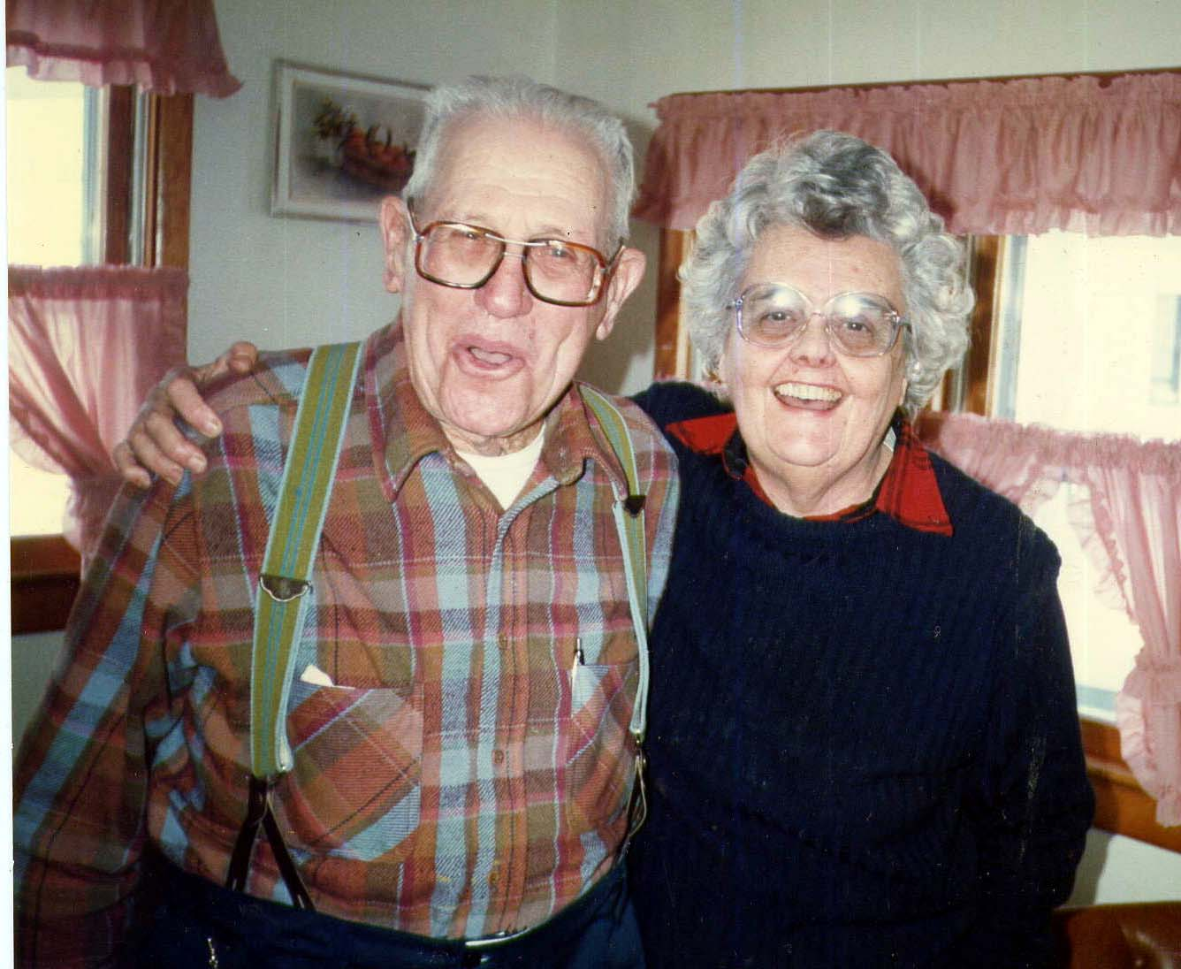

Joe Miller and Ann Cottrell Free

The conversation was audio taped at Joe Miller’s home in Edinburg, Virginia in January of 1988 by Ann Cottrell Free, Elissa Blake Free and William Ward Nooter. It was transcribed in 2008.

Contact information:
Elissa Blake Free
4204 45th Street NW
Washington, D.C. 20016
202.537.1434
elissabill@gmail.com

© Elissa Blake Free 2008

Lantz Mill History
Conversation with Joe Miller in January of 1988
Elissa Free, Bill Nooter, Ann Cottrell Free
[Much of the discussion is about the ownership history of the John Miley Maphis House at 56 Bell’s Lane in Lantz Mill, which was purchased in October of 1987 by Elissa and Ann Free.]

JM: . . . There were B O W E R S . . .
EF: They owned the house for a while we think.
BN: Who was Phil Bowers?
JM: Oh Phil Bowers, he was a father, he was a grandfather of Phil Hutchinson.
BN: Okay, we took the deed backwards and Lloyd and Floyd had it here in 1946 but, see, Philip Bowers bought it from the Kellers in 1900.
JM: That might have been possible.
BN: And then about 1916 Phil Hutchinson got it. Does that sound right?
JM: The Bowers man bought it from the Kellers and he was Phil Bowers and he was Phil Hutchinson’s grandfather.
EF: Oh, so it’s really been the Hutchinson place, that family?
BN: Bowers got it in 1900.
JM: Then the Bakers got a hold of it between him and Bowers, and Phil Bowers was Phil Hutchinson’s grandfather.
EF: So Maphis had it during the Civil War?
JM: Civil War – yes. Maphis
EF: We heard the house had been used as a hospital during the Civil War.
JM: I can’t answer that. I don’t know of any. Now during the Civil War they only had a little skirmish up there and. I told the lady, I believe I did, you go down to the library you can find that.
ACF: I know where the library is.
BN: In Lantz Mill
JM: A little skirmish there. I do know this. Have you been up the old road up past the church?
EF: Up past the church?
BN: [Rt.] 809?
JM: Yeah. Instead of going straight on you, have you swung around the church? Well you know as you pass the church and the cemetery, on the old road now, and get pert near up to Lantz Mill, there is a little building on the left up there, and then another house on the right, a Yankee was up on the roof. It wasn’t that building, that’s been torn down. A Yankee was up there spying on the Confederates and old man Cles Silcott (phonetic) was a sharpshooter for the Confederate Army and he shot him off that roof from across the creek.
EF: And that building is there?
JM: No. The original building that he was on . . .
ACF: It’s a little dinky building there on the left hand side
JM: It’s still there, another building, a man tore the old one down and rebuilt it. The road the highway that you all live on now was the original highway.
BN: It’s on this map.
EF: Yeah because the way you get to Lantz Mill now that’s a relatively new road isn’t it?
JM: Yea.
BN: So this is 1885 and we think that his our house here, this the bend in the creek, and it shows that road, then there is this old road back here which we can still see –
JM: That’s on the south side?
BN: South side.
JM: That was to get to them other farms. Wait a minute. To get to the Christian farm, on the south side of you, all along that branch.
EF: Isn’t it called Christian Run?
JM: Christian Run.
ACF: Somebody blocked that creek; the water doesn’t run real well.
JM: It’s dry. It’s dry. It only runs in the wet time.
EF: Has it always been that way?
ACF: Who the heck had the nerve to . . .
EF: He says it’s always been that way.
JM: This road on the south side of your all’s place went down to the creek and then there was another house down on the creek, you got to that home from that house from that same road.
BN: Further past?
JM: Further down this way, but the old original road now, wasn’t up there like we’re going now and right around this way she went; now here is the creek. Now we’re going in up here at the cemetery . . . if you look to your left there where that building was that I told you, you can see the road bed, there the old road went in and went up here, and crossed the creek right up here, and come out here, and went down and crossed the creek and then went this way again. Now right there is where you all own the Hutchinson property, there’s property, there’s property, there’s property, there’s property. Then, after they discontinued that road then right in this corner here at Lantz Mill is a big white house that’s the first house to the left as you pass where the store used to be, you noticed it ain’t ya?
BN: It’s now where it says storage?
JM: No, right as you pass where the store, there on the left, there is a big white house on the corner there, they did have some horses in the lot, that’s the old Stoneburner place.
EF: The great big one, white house?
JM: Now, they changed this road from here and then went in there, and went out and crossed the creek again, and went on up and come out where you live, and then come down and crossed the creek again.
BN: This is where the mill is here right?
JM: Yea. That’s the mill.
EF: This is the Stoney Creek right? And this is the mill?
JM: That’s the mill.
ACF: We won’t remember this unless we mark it right – and this is the Maphis house.
JM: If it would be pretty warm in the springtime, I wouldn’t mind going along with you.
EF: Oh we would love to do that!
ACF: So, this is the old cemetery, this is old 809 here.
EF: Is this the new road that you drew on there?
ACF: This is the road we take, we cross the creek . . . no bridge left. The bridge is gone.
JM: The bridge is gone. You cross the creek now to go to your house . . . okay you cross and then the road went down along in front of all of them houses, all them, this is the last house, and there it crossed the creek and come out in here behind this building, I told you where they shot that Yankee off of. Then they come back and they changed it now, and here is this big white house. [Stoneburner] I don’t know who lives in it. Then they changed the road. They cut this out and then you come out here and they quit fording the creek.
EF: That’s right. It’s a dead end road.
JM: Changed hands so many times . . . There is where the cider mill was and a chicken coop factory. I don’t know who lives in that house, somebody lives in –
JM: It’s a big white house.
EF: A handsome house.
JM: Walt Stoneburner owned it and lived in there and run the cider mill.
ACF: . . .used to have a railroad that went up in here too.
JM: No.
ACF: Somebody told me there was one.
JM: Way out
ACF: Liberty [Furnace], I got the whole history on that now, I got the whole history on it.
EF: Well good. That is what we are interested in.
JM: The track wasn’t any wider than that. I think about 36 inch track. . . .
ACF: . . . but if you put these together the railroad would come down here . . . okay let’s go back to . . .
EF: You were saying about that skirmish, what about that minie ball in the wall of the house…
JM: That’s where it come from, no doubt, no doubt, no doubt.
ACF: When they shot that fellow?
EF: What year was that?
ACF: Where was that guy standing?
JM: He was down here along the creek, you all’s tract of land some place, at the lower end of it.
ACF: During the Civil War . . . but you said all these little houses, who owned these houses?
JM: All of them houses, some of them torn down, old Bell Nester used to live over there but that’s tore down . . . they built these buildings up since, these new homes. But this house you all bought was up prior to that. And the old Lantz house, now the last one on the end that was there.
EF: Didawick lives there now.
JM: Lantz, Lantz, Jake Brown . . . got that on your list? Jake Brown lived there, the last house.
EF: Yes, indeed, Jake Brown.
JM: That’s where he lived.
ACF: Where’s Didawick?
JM: They come in later. Didawick built a new house.
EF: His barn is old.
ACF: He was right up against the water.
JM: Earle Didawick married Jake Lantz’s daughter.
ACF: Oh . . .
EF: The Earle that lives there now?
JM: No, he’s dead.
EF: This is his father I guess?
BN: Wait a minute. The older Earle Didawick married…
ACF: The one who lives there now is named Earle and that was his daddy?
JM: That was his daddy. His mother was Jake Lantz’s daughter and Jake Lantz owned the house after the Browns. And the Browns, Emma Brown, was his wife and she was a switchboard operator, the first telephone we ever had, I remember as well as if it was yesterday. The first telephone we had in this country the people built it themselves.
EF: Where was that?
JM: They run from Edinburg clean through to Lantz Mill and all around over the countryside and the people went together, the farmers and built it and paid for it, paid for it. And Ms. Emma Brown, then they moved to Edinburg after her husband died, and she operated the switchboard in Edinburg. And then Didawick, and then Jake Lantz got a hold of it, a man by the name of Jake Lantz and his daughter married Earl Didawick and that is where children come from.
EF: How many Jacob Lantz’s were there?
JM: Aw, Jesus Christ!
ACF: That’s the problem.
JM: We don’t know whether they are Lantz’s or Lindemoods. Now, I don’t think you can buy these.
EF: Can we Xerox it or something? Is the High’s Xerox working today?
BN: Is this in the library?
EF: We can Xerox it, yeah. Let me ask you one more thing about the minie ball. Do you know what year that skirmish was?
JM: I do not. That’s just one part of the war that I never kept up with.
ACF: Anyhow, how in the world did the bullet get all the way up there?
JM: Well you see they were on both sides, skirmish, shooting at each other.
BN: All on that hillside?
JM: All on that hillside shooting at one another.
BN: We probably could find some minie balls in that field don’t you think?
JM: Oh, sure they did. And there’s a house in Edinburg, got ‘em in.
ACF: Did you ever see the minie ball in our house?
JM: I got plenty of ‘em. I got plenty of ‘em now.
EF: But ours in the wall?
JM: I know it’s in the wall, but I’ve got them up in my building, the originals, the original ones. Gathered them up. You see these houses in Edinburg got minie balls, they had a fight there in Edinburg, 28 days out of 30. Have you seen that memorial I’ve got up there in Edinburg?
EF: Yes, we got out and read it.
JM: I was the man that got it.
ACF: You did that? You did all the research and everything the whole thing?
JM: I happened to be the only one who had the muster, the roll call. My grandfather is on that thing down there and he’s got four brothers on there with him. We put it up for the Edinburg ole time festival. I went around begged the money . . . $100 bills couldn’t pick them up fast enough. It cost us $4,200 . . .
ACF: It would cost you more than that now.
JM: Do you know when Lantz Mill was settled?
EF: We’ll see if High’s, see if their Xerox works today because maybe we’ll Xerox it today if that’s all right with you.
JM: Do you know when Lantz Mill was settled?
EF: No.
JM: 1740.
ACF: Oh that’s what you told about Jacob Wolf . . . and they didn’t tell that –
JM: I can’t find no more about it than that. I couldn’t find any more –
ACF: Here you go – “Jacob Wolf who build a fort to protect the settlers in the area from Indians –
BN: Whereabouts was the fort?
ACF: “And Lantz left his home in Germany and settled along Monocacy Creek in Maryland,” well that’s near us, “and he acquired 470 acres in Shenandoah County . . . southern side of Stoney Creek.” That’s at the time the area was called Swan Pond Hollow . . . wonder if they had a pond down there with swans on it?
JM: When you get ready I’ll tell you where we think the fort was, when you’re ready.
ACF: “After George’s death in 1793, one of his five children…” JM: See, you all own part of that land, you’ve got part of that land.
ACF: “In 1747 Hans George Lantz left Germany, and then acquired a grant and came down from Maryland . . . 470 aces of Shenandoah County…southern side . . . annual rent of one shilling for every 50 acres to Lord Fairfax. At that time the area was called Swan Pond Hollow. After he died in 1793, one of his five children, Jacob inherited the entire space. During his lifetime he ran the farm, and in 1816 he was made justice of the peace. At this death in 1837 his son George received a portion of the estate ... contained a home place along with a slave girl named Sara.” That’s right, we found that stuff before in the will, with the stipulation that the girl not be sold. We want to know, okay “home place” what was that?
JM: Well now that’s a little bit of mystery. As near as I can get to it,
as near as we could find out, and I had a lot of help on this and as near as I could get to it the home place of the Lantz’s was where, across from the mill you know the big house across from the mill great big rounded porch?
ACF: That doesn’t look old.
AF: Do you think it’s old?
JM: Oh, it’s older than you and me together. It’s been improved ladies. Round porch, it’s all been improved. As we can get to it. Now the old the original Lantz that come in 1740, that’s on up above you, as near as we can get to it. The old cemetery up there.
ACF: Old cemetery, another cemetery?
JM: Yea. I wouldn’t advise you to go to it.
JM: There’s where all these Lantz’s is buried
EF: Oh can you get to it? .
ACF: …I don’t understand . . . Getz just got it this year, in 1987.
JM: . . . He just got it, bought three of them
EF: What’s he going to do with it?
JM: You know he’s building down there you know.
EF: Oh no, he’s not going to develop it is he?
JM: I think he’s got 14 partners already -- but anyhow he owns it back there. He owns it.
ACF: He’s going to put up tacky little bungalows up you mean?
BN: He owns what now?
EF: I’m not sure what he owns –
JM: He owns this tract that this cemetery is on.
EF: But is it behind the Christian place, further over?
JM: Oh my yes. I don’t know where you all travel much or not do you up that way?
EF: Well we ride around.
ACF: Well I know there is a cemetery down there is old, old, old.
EF: I think that’s the wrong way.
JM: Let me draw this for you. Now here is the road, there is the road, that’s the road . . . you all live on 610.
ACF: No, it’s 710 that goes across the creek.
JM: The one that goes across the bridge is 610.
ACF: No it ain’t. It’s 710.
JM: All right. That runs way on up into Hamburg section. Now here is where you go into your house and then you go south now.
BN:…by Ward’s Welding right there.
JM: Now you’re going south, you go down there and you cross, another submarine bridge right there then you go on a little further and then the road turns to the left, all right then you go straight on, go straight on and there is a Y, there is another one turns to the left, there is where you turn to the left, to take you over to that old Lantz cemetery.
BN: Oh really. But you said not to go there. Why not?
JM: He’s got the gate locked. You might have to ask his permission.
EF: Here’s a real map.
JM: I used to know all them road numbers, I worked there 37 years.
EF: What kind of work did you do?
JM: I was the superintendent for the Virginia Department of Highways and I knew all these roads . . . I spent 37 years there and I said when I retired that will be 18 years Friday, since I retired, and I made my mind up when I left I was going to leave the road numbers behind. Don’t know one from the other anymore.
BN: Here’s Edinburg, Lantz Mill, here, here’s 710.
JM: It’s the second road to the left . . . turn to the left there is a Y there, then you turn left going south that will bring you out on 614, the Bowman’s Crossing Road. Goes up by the slaughter house, that will bring you right out there. And there is where the old Lantz cemetery is. Now the old map these new maps don’t show it, but the old maps show you were the old cemetery was . . .
BN: Is there a house there?
JM: . . . on back the lane behind the cemetery of the old house I don’t think anybody lives there.
ACF: It’s bound to be the only cemetery of that age.
JM: It’s the Lantz cemetery. It’s on the right as you go in. It’s where all these old…is buried.
EF: Fantastic, wonderful. Oh there’s the house. That is what we were talking about the Lantz house.
JM: Now wait a minute now. . . . they call the Clem house.
ACF: This is where the man was shot?
JM: No. It’s before you get there you go in this end along the left. This mill was burnt during church raid.
EF: Oh are you talking about that skirmish or something different?
JM: Sheridan burnt the mill down.
ACF: When Sheridan went through and torched everything. He burned everything, was fired.
JM: Don’t get me started woman. Old Custer was worse than Sheridan.
BN: Was Custer down this way?
JM: October 9, 1864 winter was a facing us, and Sheridan and Custer was camped at Raleigh Springs, they were Union men, Yankees. Sheridan came down the valley pike and burned things as he come. Custer come down the back road through Forestville, Mount Clifton, Conicville, Columbia Furnace, and he burnt things as he went, he done every damn thing.
EF: Is that why so many of these old houses are gone?
JM: Burned everything as he came. Went through the yards, if there was a chicken in the yard, the men took their sabers and cut their heads off, if there was a goose in the yard they cut their heads off, if there was a pig in the yard they struck their sabers through the pig and killed him and left him, and left us with nothing. He burned down 2,000 barns, he burned down 60 mills, he destroyed all the fences, he broke up all the farm machinery that we had, $3 million damage and we didn’t have no welfare to help us out, we helped ourselves. Now old Sheridan come, to burn the barn down over there . . .
ACF: Oh, your old barn.
JM: We tore it down in 1918. And old Sheridan come and put the torch to it. And he asked my grandmother, he said “How many boys has you got in the war?” That was Confederates. She said “I’ve got seven,” and she said, “I wish to God I had seven more.” Sheridan said, “Don’t burn the barn.” General Marks, he passed her.

I’ll tell you another damn thing that old Custer done. Fired up here. He was at Woodstock, Custer was, and found a boy out in the woods, about half baked, about half right, squirrel hunting. His name was Getz and he thought he was a bushwhacker, and he captured that boy and, put a rope around his neck and tied him to the back of the wagon. And the preachers and everybody pleaded with him that the boy wasn’t a bushwhacker that he wasn’t altogether sound and he wouldn’t take that part. And he made that poor boy walk, he was a boy about 17, he made that boy walk all the way from Woodstock to Dayton, Virginia, that’s outside of Harrisonburg – back of that wagon. And he shot him there, and killed him. He was the meanest –
EF: What’s a bushwhacker?
BN: Like a sharpshooter.
EF: Like a guerrilla.
JM: They told him when he shot this boy, that he hoped he would die in a blood of grave. And he done it didn’t he? Because the Cheyenne Indians killed him out there didn’t they, am I right?
BN: Custer’s last stand.
JM: Sitting Bull cleaned him off didn’t he? You know what I’m talking about don’t you?
EF: Speaking of Indians what tribe was around here?
ACF: Were they Algonquians or Iroquois?
JM: I can’t recall but one of them right now. The Cheyennes were here. The Shendos. That’s where Shenandoah County got its name.
EF: Wasn’t there an Indian village at Lantz Mill in the beginning?
JM: The Indian fort, let’s go there.
[END OF SIDE ONE] . . .
JM: . . . a big hollow up there, a big deep ravine hollow and with the best, we can get, the fort was in that hollow. And then the pond was up on top of a hill. That is where we think up on the hill . . . on the Getz farm . . . that’s the best we can get to it. We could be wrong.
BN: Is it on Christian Run?
JM: No. It’s back of that yet.
ACF: It’s on the other side of the English peoples’ . . . so that’s Swan Pond Hollow but it stretched way back far . . . heck of a distance back from Stoney Creek?
JM: This whole tract . . . that you got up here was all in this same tract.
ACF: But you said . . . small number of acres in the beginning … must have been about 450 acres.
JM: And the Indians are buried on above you all.
EF: Above us, you mean down that road?
ACF: This spring when there is a fine day we’ll get in the car and drive around these places.
JM: The Indians is buried on up the creek possibly a half mile from you all.
EF: That’s Christian Run creek.
JM: No. That’s Swover Creek. Swover empties into Stoney Creek right where I’m telling you where these Indians was.
EF: Oh, I don’t know where Swover is…
BN: I’ve seen it. Right near the Smith’s.
JM: Going up the creek, there’s a Y there you turn left go down across the creek, that was the old original picnic grounds, and then after you cross that picnic ground, that is where Swover Creek comes down a little branch, you’ve seen that, Swover Creek that empties into Stoney Creek right down there, and then these Indians buried to the left up there.
BN: There’s a nice farm there.
JM: Yes, that farm up there.
BN: Whose farm is that?
JM: Belonged to Delbert Fadely one time. I don’t know who owns it now, it changed hands so many times I don’t know.
BN: Beautiful farm.
ACF: A lot of side roads . . .
JM: These hellraisers we call them
EF: The Hollars. Do you think they ever had that house?
JM: Hallers was the right name.
EF: H A or
JM: I have this book over here.
EF: But do you think they ever had that house?
JM: No, the Lantz’s was in you’re your all’s deal, the Lantz’s
ACF: We still haven’t figured out who had it.
JM: The Lantz’s owned all that sits in there.
EF: How can we find who owned this before Maphis?
JM: Did you find who Maphis bought it from?
BN: Yes. Israel Frye. F R Y E.
JM:. . . tract up in there . . . Israel Frye?
EF: But we couldn’t find any other records for the Fryes, nothing, that we could trace it back to Frye, but Israel Frye, but there is nothing listed, doesn’t even have a will here.
BN: He only had it two years, no, I’m sorry, he sold it to Jacob Lantz for two years in 1854, it wasn’t the original Jacob Lantz.
ACF: Somebody told the Rosenberg woman and Betty Hutchinson that the house was built in 1820, but nobody knows how they got it.
BN: This deed in 1856 Jacob Lantz sold it to John Maphis. And he had bought it from Israel Frye in 1854.
EF: The real estate people told us –
JM: The only Israel Frye that I ever knowed, that knowed him, that he was in the Confederate Army during the Civil War and he lived upon on Swover Creek.
EF: Probably the same person, is his name Israel.
JM: Israel. Iz Frye they always called him.
ACF: You don’t know him?
JM: I just remember and that’s all.
ACF: He was an old man then.
JM: He didn’t die until about 1916.
EF: So you were a little boy and he was an old man?
JM: I was about 15 years old when they begin to die off. I know them.
ACF: Well I knew them. I come from Richmond, and I used to remember going by the soldier’s home and waving to all the old Civil War soldiers. And I was born in 1916.
JM: My granddaddy died and he was in the Civil War and he died in 1917. And I was born in 1903, I was a pretty good size boy.
ACF: That makes sense
JM: My daddy run a broom shop over here, made brooms, and I was a kid and these old men would come to the broom shop and set and talk, and it soaked in, it soaked in, I never forgot it. These old fellows would come and talk about –
EF: Their war stories. So you might have known Maphis then?
JM: I don’t know if that Frye is the man who owned it or not.
BN: Israel Frye and he died in 1916. Where on Swover Creek did he live?
ACF: You got me all mixed up.
BN: He sold it to Jacob Lantz. Jacob Lantz only had it for two years.
ACF: We’ve go to find out who built it.
JM: The house is torn down, there was an old log house, it’s all gone, you went up here and one across the creek, like you’re going to Wakeman’s Grove Church . You been up there haven’t you? The next road to the left as you, after you …your house to the left, across the creek again, up by the big church, Wakeman’s Grove. Then you go down over that big long hill and then you are Swover Creek, you wind around like you’re going to Conicville, that is where he lived.
EF: Do you think that house is log?
JM: Oh, I would say so. It might be. Now there was a saw mill there, they might have sawed that lumber there. See, old Jacob Lantz owned a saw mill, there where the mill is.
EF: Has that mill always been in the same place?
JM: The first mill from what I understand, was a grist mill, and was up where the swinging bridge is and there the dam was that run the water power, see. And then the old man Jacob Lantz had a grist mill and a saw mill.
EF: By the swinging bridge, but that is where it is now?
JM: Then they built the mill later on, old Jake did, on down the stream a little further on down the stream, where it’s setting today. There it was when Sheridan burned it down.
EF: Oh, you mean the other swinging bridge way up the road?
JM: No, the swinging bridge right there at the mill by Didawick. From what I understand, there is where the grist mill was, it was a just small affair, it was just a small affair, and a saw mill.
ACF: But it’s not this mill. The swinging bridge is right here next to that.
JM: And then later o, they built the mill a little down the stream a little further where it sits today, then they went up the creek before you go across where we just talked about where them Indians, there they put the dam in, then they brought the water down on the south side of the creek and across the creek, you can see the old pipe in there yet. That was the mill race. Then it went through underneath the road, goes under the road and then comes on down by this Clem house here and under the road again and went to the water wheel.
ACF: That’s what the real estate agent was telling me the other day.
EF: The real estate people said our house was built in 1820. We don’t know where they got that from.
JM: I don’t know.
BN: We can’t figure out who built it.
ACF: . . . It’s a pity they don’t have that, that’s a horrible looking place now, it’s so trashy looking that storage place.
JM: There’s the old [Union] Forge Church, now that wasn’t on it. Now this church was built in 1845 and lightning struck it and burned it down, and then they went back in 1855 and built a new one. And then in 1923, I believe it is, we put this on the bell, I helped put that bell up there.
ACF: We ought to go up to that church some time. What in the world is that?
JM: Now that is still standing. Let me tell you about that. That’s not the original. Now the original building . . . old man Bill Christian made walnut coffins and rough boxes to bury their people in and –
EF: Did he sell them too?
JM: I just remember him and that’s all... but this is not the building he worked in. He made these coffins and I got receipts up there in my collection where my granddaddy buried his three children and they reached the age of 30 years, and I’ve got the receipts where he paid Bill Christian $17.50 for the coffin and the box to put ‘em in.
ACF: Those would have been your uncles.
JM: His son, now. They lived on across the road on the hill, his son tore the old shop down and built this shop and went to work to make cedar chests in it, they discontinued the coffin business.
BN: What was his son’s name?
JM: John.
ACF: Let’s get back and try to pinpoint
BN: This is William Christian, that is on this map.
EF: Well if Maphis had it during the Civil War then Lantz had it before that . . . Israel Frye . . . no from Jacob Lantz who got it from Israel Frye
ACF: Who build that house, that’s what we’ve got to figure out.
JM: The Maphis’s as far as I get with you…
ACF: That was 1854. When was that skirmish?
JM: That was about ’63. 1863.
ACF: You know there are two houses. Those are back to back houses did you know that?
JM: Yes I did.
ACF: Which on was built first?
JM: I don’t know that.
ACF: But the funny part is what we think of the new part is where the minie ball is. The old part where you got the root cellar at the other end, so that could have been built first.
JM: Is the minie ball visible?
ACF: Yeah.
EF: We want you to come down and see it. I’ll show you where he’s pointing to the minie ball.
JM: I didn’t know you all had bought this piece of property.
ACF: We’ve got it fixed up nice haven’t we?
EF: Let’s see, where’s the picture of him with the minie ball? We put shutters on it. Here is a good shot of the house.
ACF: We think that is the new end.
EF: We don’t know, we think that’s the new end. That’s the end with the minie ball in it though.
ACF: That faces the creek.
JM: I believe that’s the old part. This is the new part.
ACF: Why does this here have the root cellar, the old stone root cellar? You think that’s the . . .
JM: This ain’t got no cellar under it does it? They didn’t build no cellar in those days – have ‘em on top of the ground.
EF: You’re the second person to tell us . . . maybe you’re right.
JM: Listen to me. You had the cellar on top of the ground. They didn’t dig no cellars.
ACF: That’s the fellow from whom we bought the house, a man named Delaney. That’s where the hole is.
EF: You can’t see it from the picture but that is where it is.
BN: And the wood is painted wood.
JM: I didn’t know you all had bought it.
ACF: Well we’re brand new, just October.
EF: He owned it before us. His name is Delaney.
ACF: You think the house closest to the creek…?
JM: Oh yes, I’m sure of that. This is built good.
ACF: This has got a mighty old chimney out here.
JM: That’s got the cellar to it. Back in them days the . . . on top the ground.
ACF: Like a little shed.
JM: They take a rock and build it up.
ACF: Look how old that barn is.
JM: Same thing they did with the old time bake ovens. Ever see one of them?
EF: That is what Betty said she thought that was . . .
ACF: I’ll be darned
JM: They make bake ovens outside
BN: Oh bake ovens.
JM: They had these bake ovens they built them out of rock and they had racks in, they had a big paddle like that you put the bread in, now go there, they go out in the morning and make a fire in them with cord wood, make a great big fire, and then they kept watching that fire and when they take a chicken feather and lay it on that rack and that fire was hot enough to scorch that chicken feather then they took that fire out, they done away with the fire and then they put the bread in to heat.
ACF: A self-contained oven. Did you ever see one?
JM: I had one up here. Same way we made our own soap, you know how that was done don’t you?
ACF: Yes from the hog, from the fat and the lye.
JM: How we made our soap. We saved all the grease year to year and then we had what we called an ash hopper, now don’t get red in the face when I go along with all this I’m going to warn you in time, then we had an ash hopper, saved our wood ashes from the stove during the winter and it was a concern about this big square and about this high and a had a spout down here, and then we would put a layer of ashes in there about that deep and then we put a layer of cedar brush on top of that, and then we put another layer of ashes in, then we would put cedar brush in again. That kept from caking, until that hopper was full and then when it was full, then we went to watering it, went to watering it, we put water in. Now is this what I’m going to tell you, you might not believe but it’s true, everybody had a nighty pot under the bed and they save all that urine and they poured that in the ash hopper to help make this lye. Then they –
ACF: How long did they keep that urine?
JM: Just overnight, when they started watering. And then they checked this juice that come out of this spout and if that scorched a chicken,
feather, burned the feathers off it, then they put water in it but it didn’t do it, keep on watering until that juice come out down there was burning them feathers off the chicken wing, then it was strong enough for lye. Then they boil the soap out there.
ACF: When did you put the lye in?
JM: When we made the soap.
ACF: What good did the urine do was it the ammonia in it
JM: It helped make the lye.
ACF: Could you buy the lye from some place?
JM: Oh, you could buy caustic soda.
ACF: Made your own lye then?
JM: Made your own and then you boiled your soap.
ACF: What it was it was the ammonia in the urine?
JM: And then they had . . .and then we make the soap and we get what you call under the soap, you get the soap to come on top and you cut that out and then what was underneath was all this eat up fat, that what’s they call that was no good, and then you take your skillet, fry pan, or your griddle, and you take it out there and submerge down in the under soap and let it in there for 3-4 days and you brought it out and it looked brand new all that cake, just like brand new. You know the grease accumulates all year . . . keep it in there 3-3 days burn it off it looked like brand new.
ACF: You can buy that sometimes in the country shops. I think they make it up for the tourists. It washed you up pretty well didn’t it, washed your hair and everything. People up here after the war all that burning . . . Civil War or War Between the States, which do you like to say, Civil War or War Between the States?
JM: I call it the Civil War. I have read and studied and they try to tell me and they try to tell you it was over the slaves, I don’t believe a damn word of it. Where do you come from?
ACF: Richmond, Virginia.
JM: The way I get it, that the north was a shoving too much down our throats, they was trying to take our stuff away from us, not slaves now everything, cotton and everything, and we just couldn’t take her any more and they kept shoving down our throats, cut Texas away from us and the south got tired of it and that is what I say brought the war on. I might be wrong. But they say it war of Negro –
ACF: It was a whole bunch of things really.
JM: It was all uncalled for.
ACF: Did they not have slaves up there because they didn’t have many slaves in the valley?
JM: . . . not too many slave graves over there
ACF: Lantz’s girlfriend –
JM: Sara, with the stipulation she was not to be sold.
EF: Was that his girlfriend?
JM: No, no.
EF: Why didn’t he want her sold then?
JM: He didn’t believe in slavery.
ACF: He just didn’t want her sold. She was still a slave.
JM: . . . when they went to capture him and he ran off.
ACF: What we are going to do is . . .
JM: . . . That’s when they captured old man Lantz.
ACF: You mean the Yankees?
JM: No, our own men.
EF: Why?
JM: Because he was sympathizer with the north.
ACF: Because he didn’t believe in slavery.
ACF: He had slaves. That girl was his slave.
EF: I don’t understand. If he was living during the Civil War why couldn’t he have built that house?
JM: There was a blacksmith smith at Lantz Mill, a shoemaker shop, a cider mill, a cannery and a barber shop. There was another big enterprise there, old man Will Wetzel.
EF: There are Wetzel’s there now.
JM: He run, no, they are not relations, he run a big wagon making shop right across from where the old store stands today.
EF: When you say old store do you mean Frank’s storage that building?
JM: There ain’t nothing there it’s all burned down. It’s gone. Right across from the store Will Wetzel run a wagon making shop. He made wagons, he repaired wagons and his equipment for the first part of it was operated by foot power.
EF: And when was that?
JM: And when the gasoline engines come on the market about 1900 then he got a gasoline engine to run his equipment with. And he operated that until he died, and then a man by the name of Davy Wakeman come and bought it and he operated until the insurance got too hot and burned down. So that was the one enterprise and then the cider mill was around there, I done told you about that, we used to take cider up there, apples and have cider made. And ground up worms and all, didn’t make no difference what it was, to make vinegar with. Do you know how to make vinegar? We took apples up there, take three bushels of apples to make a gallon of cider. We’d gather them on the farm here, we had this big farm here and we would take them up to the cider mill to get vinegar. The way we got the vinegar, we rack, had a barrel of vinegar this year and then we’re going to make a new one next year. Then this cider wouldn’t turn to vinegar then we would have to rack the year before off and get the mother out of the barrel, do you know what the mother is?
ACF: I don’t know what you call it, it’s the filmy looking stuff.
JM: Nasty looking thing. That’s called the mother. And sometimes that mother would die and it wouldn’t make vinegar, then you would have to rack it off, come back to life again and put it in that barrel to make vinegar. And if we were going to make apple butter we would boil off this cider at night we would boil 50 gallons of cider down to about 25 and we boil that down today, get it off about 8:00 tonight, and tomorrow morning we would put that back on and the women had the apples already peeled and then you put the apples in that cider and there you made your apple butter . . . didn’t have no money to buy no sugar to put it, used the cider was for the sweetening. Sweet cider.
ACF: What about your cinnamon and stuff like that?
JM: Oh, cinnamon and all the cloves –
ACF: You could get hold of that but couldn’t get the sugar.
JM: Couldn’t buy sugar. Didn’t go no money.
EF: What about honey?
JM: No, didn’t have no honey, didn’t have no money to buy no sugar with either -- there was sweet cider and sweet apples. Then we would put that pot and we would go to school, walk up here to Edinburg School, walked, didn’t have a school bus, walked down there and we’d have corn cakes for breakfast and put that apple butter on the corn cakes take it for our lunch. Didn’t have no cafeterias.
ACF: You’ve got me all mixed up now. How far back do we have the house now?
BN: To Israel Frye. He sold it in 1854. We don’t know when he got it.
ACF: Where did he get it from?
BN: We don’t know, because this deed where this Jacob Lantz bought it from . . . Jacob Lantz sold it to John Maphis in 1856, indicates that it’s the same property that Jacob Lantz got from Israel Frye in 1854 but there is no reference to a deed book or a page and we looked all through the deed books for 1854 and couldn’t find it. Maphis got it in 1856.
JM: I don’t know, I can’t answer.
ACF: We’ve got to find out who built that place that log house.
JM: It might help you a little bit. Might help you a little bit if you want to try it, sometime, I don’t know those dang-burn Hutchinson boys one from the other anymore. One is Lloyd and one is Floyd.
ACF: They are dead both of them.
JM: They were twins. I think one died the day they were burying the other.
ACF: They died . . .
JM: Don’t make any difference. One lived down there and the one lived up there, Lloyd and Floyd, and I don’t know, this is Floyd up there, this is Lloyd down there. Lloyd’s . . . two boys one is dead, one is Paul Hutchinson and he had a boy named Walter and he’s dead, he died of a heart attack and left his widow Marian Hutchinson and she lives down at Pugh’s Run and his, Paul the brother, now you might call him, call her, rather and if Paul is there, he might be able to tell you what that was.
ACF: How old is he?
JM: He’s got a whole lot of deeds, he’s got a whole lot of them.
ACF: You know Mrs. Rosenberger?
EF: Betty Wolverton?
JM: Betty Wolverton.
ACF: She’s Floyd’s daughter. Lives right up there. She and her sister, Ruth Rosenberger –
JM: She lives the side of you.
ACF: Right.
JM: Now you ask her about Paul how to get in touch with Paul and I believe he can help you –
ACF: He’s her first cousin. Is she on good terms with him? I wonder why she didn’t tell . . .
JM: This Paul I’ve telling you about, Phil was his granddaddy.
EF: So is Walter, Dorothy and Lloyd and Philip.
JM: Walter Hutchinson.
EF: Walter.
JM: He died about two years ago. Now Paul ain’t got no phone number because he’s up in Ohio, he lives in Ohio. He comes down here and stays with . . . Walter Hutchinson . . . that’s his wife, that’s his widow. He might help you he’s got a whole lot of them.
EF: Were the people in this area back before the Civil War, were they kind of poor?
JM: Well, I don’t know whether you would say they were poor or not, they didn’t have nothing.
EF: Well, they didn’t have slaves.
ACF: How did this county get so prosperous? You all have a lot of rich people in this county. [END OF TAPE] . . . .
Conversation with Joe Miller in January, 1988
Elissa Free, Bill Nooter, Ann Cottrell Free
Lantz Mill, Virginia
Tape # 2

JM: . . . the North had money . . . they got to trading backwards and forwards and the south and the north begin to put money in the south and we begin to prosper.
ACF: You had fertile land here too big farm country.
JM: That’s the way it kept building up and then it was an agricultural place all farm land and then the railroads . . . up here up the valley
ACF: That helped your prosperity.
BN: When did they put that railroad in? Before 1885
JM: The railroad got to Mount Jackson in 1857, that’s as far as it got. And then there was a ten percent progress from there to Harrisonburg and the war broke out and that stopped it till after the war was over. Then all this farm land we had a lot of tanneries, we had a tannery in Edinburg
ACF: What killed the tanneries was the blight on the white oak, that is if what they tell me is that true.
JM: No. What took the tanneries down . . . couldn’t compete with the others that was the trouble. They didn’t want our tanned bark any more.
ACF: I thought you lost your tanning bark because of the blight.
JM: My god no. They told you wrong. Now I’m going to tell you right and I want you to believe me.
ACF: Well I’ll think about it. Huh, not the blight. It was white oak, wasn’t it special kind of oak?
JM: Yes, it was the black oak and the chestnut oak that’s the only kind you could peel.
ACF: That’s right and the chestnut blight came along.
JM: Oh the tanneries had been shut down 50 years ahead of that, 50 years ahead of that.
ACF: Why couldn’t they compete?
JM: We had too much trouble to go through to get the tan bark juice. And new inventions come in and they can tan it overnight, it took us maybe six months, overnight, overnight.
ACF: And where did you have tanneries besides Star Tannery, that’s in another county?
JM: Edinburg, and had one down at Fairview back of Woodstock there was one and they had one at Cedar Hill and it operated during the Civil War and old man Whisker Barb run the tannery, and he didn’t care who come along whether it was the north or the south whatsoever they got her.
ACF: They sure must have killed a lot of cattle to get all that skin.
JM: Old Whisker Barb, he didn’t care who got her. He let any of them have it, North or South. Then the furnaces up here they were in operation, they dumped a lot of stuff down in Edinburg. You never seen any of that stuff did you that ore?
ACF: They dumped it. Did they pollute the creek?
JM: They hauled it into Edinburg. They hauled it out of these furnaces by the ton the Teamsters, hauled them to Edinburg.
ACF: What were they going to do with is?
JM: Shipped it on into New York or where . . . I’m going to tell you what put them out of commission too. They hauled it down here to Edinburg and they waited up there at the furnaces and they hauled by the ton and the road was so bad they bogged down and they would have to throw it off to get the team to pull the wagon out and they got to Edinburg and they didn’t have half a load. They said we can’t stand that. We’ll put the scales down there. They put the scales at Edinburg and pay you when you come in. They got to dipping the ore out of the Great Lakes, we could not compete, we could not compete. They just shipped it up overnight out of Great Lakes.
ACF: Is that ore still up there now?
JM: It’s up there. It’s up there. I don’t know whether it’s a great amount, but its up there.
ACF: That came from the Mesabi basin up in near Lake Superior and that’s closed down.
JM: 1804 I think the furnace started.
ACF: They made stuff for the Civil War.
JM: The damn Yankees burned it down three times during the Civil War.
ACF: That was a big strategic target.
EF: At Lantz Mill why did that become a settlement, was the mill there first and then people moved in around it.
JM: The mill was there first and had a merchandise store, it was it wasn’t where the original store stood, the old store burned down. The store was just across from the mill in another lot there, there was the store, and it was a big settlement in there and the only place you could get your supplies.
ACF: There certainly was a settlement looking at that map there.
JM: You come for supplies, you see, and then Clems, old man Clem, he came in from over the Fort [Valley] and he built another store there. It burned down, probably you know where it’s at, the vacant lot between two houses you know, after you pass the old store that is there today, there is a house on the right and then a vacant lot between there and the next house is where the big store stood. You could get anything you wanted.
ACF: Is that where the post office was?
JM: The post office was in there.
ACF: Mrs. Runyon, Mrs. Lambert says she owns that little old piece that little building she said that was the post office. She’s the, you know, the Lamberts and the Runyon’s and the Wards, and all that crowd?
JM: The post office was in the store that burned down in ’46 or ’47 then they moved the post office up to that old ragged building.
ACF: That is what she owns, right.
EF: Well, was it called Lantz Mills?
JM: Lantz Mills. And we would just call it Lantz’s Mill.
EF: How come the “s” got dropped off on the map everything it doesn’t have the “s” on Mill?
JM: That’s all it’s ever been called.
ACF: What’s the most historic thing about Stoney Creek?
JM: I think the most historical thing about Stoney Creek is our mills.
ACF: Oh, how many mills you guess you have along Stoney Creek?
JM: I just made a talk on that. Yeah, I belong to the Shenandoah Historical Society.
EF: We just joined last month.
JM: Karen Cooper, she’s a wonderful girl.
ACF: She likes you. She told us to come see you. And she said if we couldn’t catch you we could catch you at McDonalds. So you talked on the old mills?
JM: We had ten mills on the Creek didn’t we?
ACF: I don’t know. You’re telling me. You told me we had ten mills.
JM: The first one was a hemp mill and that was way up there next to Liberty Furnace and they made rope, it was a hemp mill. Now we’re coming towards Edinburg, we got down there, and there was that hemp mill, then we got down to Columbia Furnace, and there was a big flour mill, flour mill at Columbia Furnace, then we come on a little bit farther, there was a big forge, it worked iron, had two hammers weighed 500 pounds apiece. Beat the iron out, whatever you wanted, run by water power. Then we come on the creek a little further there was another big dam across the creek and that run the saw mill, Ben Reinhart’s saw mill. And that is on the road that you go to Wakeman’s Grove Church on. Ben Reinhart’s saw mill, and then you get on down to where you all live, there was another mill, it’s still there today, it’s still there today. Then we come on down a little bit further below you just below your all’s place now, was a big dam across the creek that run Union Forge. Union Forge.
ACF: What was there?
JM: That was a forge where they worked out iron.
ACF: Sure, we were just talking about that.
JM: They worked iron there. They brought the dang burn stuff all the way over from the Fort over here, and teamed it over. And you come a little further down below you all there, right across the creek over here, was another big flour mill. Beam and Benson built it.
ACF: Beam and Benson.
JM: Beam and Benson, got proof up there, my stuff’s all up there, stacked away.
ACF: Where you got all this stuff in the barn?
JM: Bunch of a buildings, can’t keep it here in the house.
ACF: Which building, the little white one?
JM: No, way up there.
ACF: The brown one?
JM: . . . you’re in trouble here.
EF: You know that big house right where you turn to get into Lantz Mill on the right hand side, that great big house, you know about that, people named Shram live there now.
BN: The top of the hill.
EF: The top of the hill, just before you turn the sharp turn to go down into Lantz Mill.
JM: Up on the right, that’s the old Hite house. Old Milt Hite.
EF: And what did he do? He must have been rich because it’s a great big place.
ACF: Those Hites were all rich.
JM: I don’t like to discuss about him. He was a skinner. His grandson lives here in Edinburg, old Joel
BN: He was a skinner, what do you mean?
ACF: He means he cut a big deal.
JM: They always said he …farm …cut that . . . across the creek I just told you about, for surveying it. Got it for nothing.
EF: When was that house built, do you know?
JM: My dear girl, I don’t know.
ACF: That’s a pretty nice house. I wouldn’t mind having it. People named Shram bought it.
JM: The Campbell’s lived there.
ACF: People named Shram have it.
JM: The Campbell’s lived there and they were big money people in this country and he had pear orchards, and they’d pick pears and hauled . . . markets in town, they were big people Campbell’s. And after they all died off the Hites all got away and then they sold it to Miley, a man by the name of Miley, he left it to his niece, her lifetime, and then after her death it was to go to the Woodstock Hospital.
EF: We heard something about that.
JM: And they didn’t want it so they sold it. That’s where these people got it.
ACF: They got it cheap.
JM: They got it dirt cheap. There’s a big ballroom in that house.
EF: Oh you’re kidding.
ACF: There’s a huge acreage and they didn’t pay a lot for it.
BN: Ninety acres.
ACF: Ninety acres, they got a steal on that.
JM: You see this railroad went right through it.
EF: Oh really.
ACF: The Shrams got a steal on that because that thing is worth a million dollars soon.
JM: That was the Campbell’s. That’s the way they got it.
ACF: They sold it too cheap.
EF: Bill is going to run down to the High’s store and Xerox that.
ACF: I got a better idea. Why don’t we do it this way because I don’t want to tire him out. I think we’ve solved a whole lot. Go, and let’s see, stop and get the thing done, go on home, and we’ve got some dogs at home, I’ve got to put some insulation on the spring house, and then come on back and drop it off for him on the way back home. It’s 3:20 now.
JM: I’m going down to Woodstock directly in a few minutes.
EF: We want to make a copy of it and bring it back to you.
JM: Oh you can give it to me some other time.
EF: We want to get it right back to you today.
ACF: You could put it in the mailbox.
AF: What if we put it in your mailbox. Is that alright? If you’re not here, we don’t want to ring the bell and wake her up.
JM: She has to go to work at 4:00 o’clock.
ACF: What place is that? Is that the shirt factory.
JM: I generally go down and get her sandwich for Sunday. She’s got all these offices to get ready for these people to come in. Did I help you all?
EF: Oh yes, it was fascinating.
BN: We want to come back in the spring and look at the things you’ve got.
EF: When the weather is good do you want to ride around with us? In the good weather, in the good weather.
ACF: Oh baloney you’re not old.
JM: This man Getz has bought all this land. Now he wants me to go up there with him and show all this stuff.
ACF: What do you think about this big chicken dispute up here at Columbia Furnace about the rendering plant and all that gunk that is coming into the creek?
JM: I’m going to tell you like I told the man who came here and asked me to sign the petition. He come here early spring and wanted me to sign this petition for him. I said is that for it or against it. He said this is against it. I said I’m for it. He said it ain’t no use to talk to you.
ACF: Why are you for it?
JM: Why I aint bothered it ain't going to bother me. No one else.
ACF: It will bother you.
JM: It ain't going to bother nobody.
ACF: There is so much junk coming in that stream now I wouldn’t put my foot in.
JM: . . . It’s on the same principle of the sewer system of any town. I maintained the sewer system for the town of Edinburg 18 months, the filtering plant, and that water, after it was filtered, dumped into Stoney Creek. It was 95 percent pure and it better had been pure or they’d shut her down.
EF: Yeah but have you seen the stuff that comes in that’s not pure.
JM: They are going to make all this change up there and change it all. But when that water dumps into that creek it has to be 95 percent pure
EF: Not now. Would you drink it?
JM: I didn’t have it. . . . you can’t hardly beat Tammany Hall
ACF: You sure can. I beat them every day. You can always beat Tammany Hall.
EF: Also the air pollution to come over here.
JM: They’ll get all that adjusted they’ll get all that adjusted. I’m just for it. Suppose they shut it down.
ACF: What will happen then?
JM: What would happen. They got about 700 employees there then what
ACF: They wouldn’t shut it down.
EF: We’re talking about the new plant
JM: I know but suppose Wacoal would shut the whole thing down it can happen.
ACF: They don’t need the rendering the stuff is going somewhere else now.
JM: It can happen Wacoal can get mad
EF: They can’t afford to that. Well anyway.
ACF: What I was trying to get at was the history of Stoney Creek because that is why I asked you about the mill, it’s a beautiful stream. Elissa, my daughter, went to Margaret Hoffman’s camp for many years and used to swim in Stoney Creek.
JM: We was raised down here in the creek.
EF: You wouldn’t swim in it now would you
JM: Yeah we had all these dams, had all the water backed up
EF: Would you swim in it now?
JM: I think I would.
ACF: Well come on I’ll take you for a swim this summer. You get sick first. Anyhow you see that is why we love it up here because
JM: Are you living up here are you
EF: Not full-time because we work in the city, in Washington, we come here on the weekends. We’re going to Xerox that and we’ll put it in your mailbox. Okay. We’ll make it ourselves at the High’s.
ACF: At the High’s Ice Cream they have a Xerox there. And we phoned them and they said it was open and then we’ll take that and put it in your mailbox.
EF: So when you go out to get the mail tomorrow it will be there or tonight.
ACF: It will be just about dark when we
JM: You don’t have to do that, I ain't afraid to trust you, you can take it on home with you.
EF: We’re not sure when we’re coming back.
BN: We’ll do it that way in case someone comes by and you need to refer to it again.
ACF: I thought there had been a battle on Stoney Creek, there never was
JM: There was a little skirmish up there but I had never read up on it. It’s down there in the library you can find a little bit of something about it down there in the library. And ask the man
ACF: What’s his name, what’s that fellow’s name Stern something isn’t that name, the librarian, they’ve got a good history room
JM: That Painter boy in there he’s the man that Painter boy in there is the man that can tell you. There is somebody has donated a bunch of books to the library and it’s in there.
ACF: Here get a picture.
JM: Thank you for attending.
ACF: That’s cheesecake you’ll like it. Should I put on lipstick?
JM: Now I like this kind of carrying on.
ACF: That’s the kind of carrying on . . . living up this way.
JM: I hope I’ve been some benefit to you.
ACF: Oh it’s marvelous. Did you know a fellow named Stoner he was a teacher or something. Betty Warden said a fellow named Stoner wrote a history on this place on Lantz Mill, have you ever heard of him
JM: Stoner? A fellow that taught school? Maybe she meant Monroe Hottle H O T T L E, Monroe Hottle he was a great school teacher
ACF: Did he write a history of Lantz Mill too?
JM: He might have.
EF: I wonder where it would be.
JM: He’s dead and gone. I went to school to him when I was a kid. I don’t know of any Stoners.
ACF: I wish his daughter, get a picture of her too.
BN: Well thank you.
EF: We really enjoyed. We look forward to visiting with you some more.
JM: The Historical Society . . .
EF: We went to the one when was that . . . a guy named Bill Wine he did a lecture on how to date old houses . . .in December
JM: I was to make a talk last night but I had to renege on it I couldn’t do it . . . I was going to talk about Edinburg
EF: Well we want to come
JM: After the weather gets better. See I don’t drive much . . .
ACF: Where are you going now Woodstock? Do you travel 81 or 11?
JM: I go down the back way here.
ACF: Which was 11 or 42?
JM: Sometimes I go down 81.
EF: This road here goes to Woodstock, we didn’t know that. Does it go into Woodstock?
JM: Goes out past the winery. Have you been to the winery? Then you go straight on and out there where it says yield right of way you turn to the right and it brings you out on the route . . . Hamilton Motel
ACF: Oh my Hamilton Motel. Don’t you ever eat at that motel
EF: They have good food there don’t they at Hamilton.
JM: Oh yeah.
ACF: Let’s see we’ll get that thing Xeroxed . . .
JM: It’s five below zero out there.
EF: Five below burr. We thought this was the coldest morning so far. We just drove up this morning from Washington. We didn’t spend the night. We were worried about our pipes freezing so we winterized, we drained the pipes. So we have no water so we just came for the day. We’re going back tonight.
JM. You’re going to Washington.
EF: Yeah. He has to go to work tomorrow. I have to go to work Tuesday. See that’s going to be a problem. Historical Society meetings are on Tuesday nights. See that’s difficult for us.
JM: I don’t know when the next one is.
EF: I don’t think they are having one in January because of the weather.
JM: I’ve made a lot of cakes on this stove. When I’m cooking here I have the fire built up . . . Glimpse of the Past it’s called.
EF: You have it here. Is it about this area?
JM: A whole lot of stuff in there.
EF: We ought to get it. Glimpse of the Past. And where can you get it?
JM: Joe . . . Woodstock. He’s a preacher.
EF: And it’s about Edinburg and Woodstock.
JM: You never seen the Whelan’s history.
EF: We’re just starting. He’s going to show us a couple of books.
ACF: This is from this book called History of Shenandoah County, Virginia John W. Whelan, okay the old name let’s see, in the olden days Strasburg was known as Stover Town and Funk Town because of the prominence of Funks and Stovers. I’ll jump down there. Woodstock was for many years termed Miller Town, your ancestors, that was incorporated Lars Woodstock. Woodstock was founded by Jacob Miller and his son Jacob Miller, Jr. Edinburg, 100 years ago was called weird S H R Y O C K after a landowning family and also Stoney Creek this is spelled without the e from its location on the well known stream of that name. At the same time there was a post office at Red Banks four miles up the pike. Awkings Springs was first known as Yellow Springs and the old name of Connickville is Cabin Hill. So Mount Jackson prior to 1826 was Mount Pleasant and a whole bunch of stuff in here like this but I wanted to find out some more stuff about Stoney Creek. There was a Stoney Creek flood page 157. You know anything about that, the flood at Stoney Creek,
JM: What year?
ACF: I’m looking it up. They tell us where we are the water came up to our
JM: ’36.
ACF: That’s the one they told us about, we had quite an embankment.
JM: That’s the one that washed my daddy’s broom shop away. It came up to the kitchen door on the house.
ACF: Edinburg at the mouth of that energetic stream was in the early days called Stoney Creek, yeah it’s already noted. Following up the course of the dashing waters we pass the site of the old Union Forge paused at the busy village of Lantz Mill and after three miles more, it’s only three miles kids, come to the ruins of Columbia Furnace, flour mill, so on. But it was supposed to say in here about the flood. That’s what they said was going to be on 157. Oh here it mentions old Zep who in the heck was Zep. We’ll have to get hold of this book because there are too many things to look up.
EF: Don’t you think there is a copy of this in the library.
ACF: Yes indeed it’s put out by the regional
JM: You can borrow it down at the library.
ACF: They let you do that. It’s amazing. Valley Books in Harrisonburg has it, it costs $30.50. Oh it was just published in 1980 so it’s up-to-date. Well we’ll have to get hold of that. I would be glad
EF: You mentioned another book, would you say the name of that into the tape, I forgot it already. Bill the other book he mentioned, the Touch of History
BN: A Glimpse of History.
JM: Oh that’s Glimpse of the Past. They got it down there. They got it down at their library.
EF: A Glimpse of the Past okay.
ACF: This is fascinating.
EF: Look at all his books.
JM: That aint half of them.
EF: We better let you go on. We got the name, the Glimpse of the Past Okay.
ACF: We’ll see you again. [END OF RECORDING]
APPENDIX N: Log Files: Video and Photo Logging Files
Index to Media
Logs Cover Sheet: Individual interview with Denise Drake through online zoom meeting dated April 8, 2022.
Table of Contents
Video Log Collection:
Denise_Interview_4_08_22.mov
Youtube unlisted Interviewee, William Barber, https://youtu.be/iWQZ8RJ6STU
Youtube unlisted Interviewer, Kathleen Brockway, https://youtu.be/jQfwNBzY9b8
Charity_Apr11_NameSigns.mov
Photo Log Collection:
2022.KLB.001a
22.KLB.001b (Bill’s)
22.KLB.001ba (Kat’s)
22.KLB.001c (Charity’s)
Screenshots of Logged Photo and Video Material
2022.KLB_CAP_Collection_Drake_Set
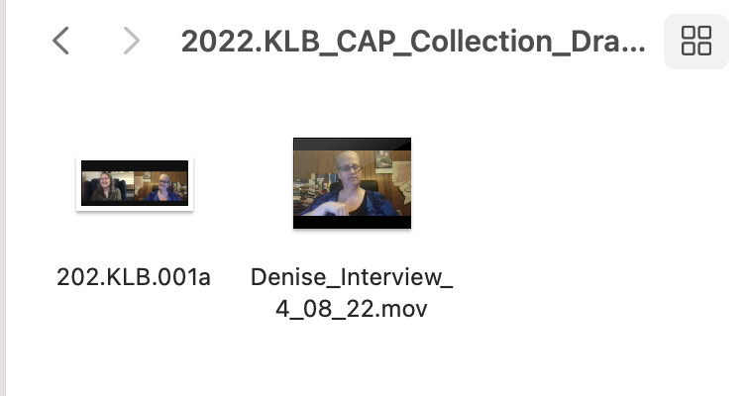
Place: Online Zoom meeting (Interviewee at her home in Virginia and Interviewer at a different home in Maryland)

2022.KLB_CAP_Collection_Barber_Set
Place: On Goucher Campus in Julia Rogers building with the Interviewer in the same room using a different movie.
2022.KLB_CAP_Collection_Warigon_Set
Place: Online Zoom meeting (Interviewee at her home in Maryland and Interviewer at a different home in Maryland)
Video Log Worksheet 1

Researcher: Kathleen L. Brockway Project Name: Capstone Defense Project
Date Logged:
File Name: Video_Log_Brockway

Format:
Format: o MiniDV o DVCAM o MiniDVD o DVD o Digital File o Other:
Digital file type: o MPEG-2 o MPEG-4 o DV o WMV o MOV
o Other:
Digital file location:

Running Time: Hour(s): 1 Minutes: 25 Seconds: 52
Date Recorded (YYYY-MM-DD): 4-08-2022 Location: Online Zoom Meeting

Interviewee/Event: Zoom online meeting, interviewee at her own home and Interviewer at her own home.

Interviewer(s): Kathleen L. Brockway

Subject: Name Signs (or English: Signed Names)

Copyright Owner: Kathleen L. Brockway
Restricted? o No, o Yes, details:

Summary:

A movie shows dual horizontal videos of both interviewer and interviewee in unstructured interview from their homes through online zoom meeting set-up through Goucher College’s platform. Kathleen L. Brockway interviewed Denise Drake in a signed narrative. No captions and audio at that time. Transcription is provided in Appendix K.

Key words: Name, memory, Cleveland Christian

File Name: Denise_Interview_4_08_22.mov

File _1_ of _1_
Summary of the movie in English translation from Sign Language.

TIME CODE CONTENT DESCRIPTION
(HH:MM:SS)
00:00:00 – 00:03:17 Explain the consent form in American Sign Language reciting from the written consent form. Denise agreed. .
00:03:18 – 00:03:40 Explain the kind of video interview we are with zoom online and the description of background.
00:03:41 - 00:06:37 Explain how Denise got her name sign.
00:06:38 - 00:06:51 Stopping, due to technology difficulties.
00:06:52 - 00:08:20 Continued to discuss Denise’s name sign.
00:08:21 - 00:09:46 Denise tells a story about how her grandfather got the name sign.
00:09:47 - 00:10:20 Denise tells about her discovery of her mother’s name sign.
00:10:21 - 00:11:10 Denise tells about her discovery of her aunt’s name sign.
00:11:11 - 00:13:08 Denise tells all name signs identified with her grandfather’s siblings.
00:13:09 - 00:13:10 Discussed the difference of name signs between deaf and hearing.
00:13:11 - 00:14:21 Discussed the difference of name signs between head and chest areas.
00:14:22 - 00:14:44 Mentioned about another family member, Mark Fletcher’s name sign.
00:14:45 - 00:17:05 Story about kids who were assigned new name signs on the first day regardless if they already had name signs before arrival at deaf school.
00:17:06 - 00:20:15 Story about transportation used to take students to school, by train and by horse and cart.
00:20:16 - 00:27:21 Story about Denise first seeing Lantz Mills, what it looked like.
00:27:22 - 01:25:52 Story discussed Denise’s memories of her grandfather.

APPENDIX O: Log Files: Video and Photo Logging Files
Index to Media
Logs Cover Sheet: Individual interview with Denise Drake through online zoom meeting dated April 8, 2022.
Table of Contents
Video Log Collection:
Denise_Interview_4_08_22.mov
Charity_Apr11_Namesigns.mov
Bill’s Interview, Youtube, unlisted: https://youtu.be/iWQZ8RJ6STU [Text: Youtube, 2022]
Kathleen as Interviewer, Youtube, unlisted: https://youtu.be/jQfwNBzY9b8 [Text: Youtube, 2022]
Photo Log Collection:
2022.KLB.001a
2022.KLB.001b
2022.KLB.001c
2022.KLB.001ca
2022.KLB.001cb
Screenshots of Logged Photo and Video Material
2022.KLB_CAP_Collection_Drake_Set
Place: Online Zoom meeting (Interviewee at her home and Interviewer at her home)
2022_KLB_CAP_Collection_Warigon_Set
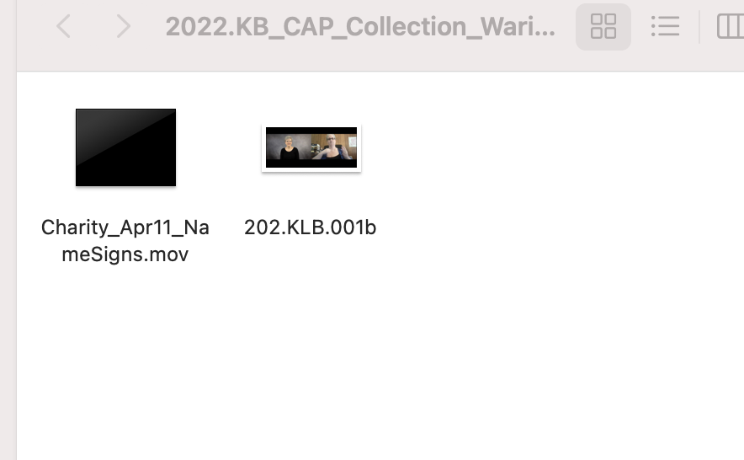
Place: Online Zoom meeting (Interviewee at her home and Interviewer at her home)

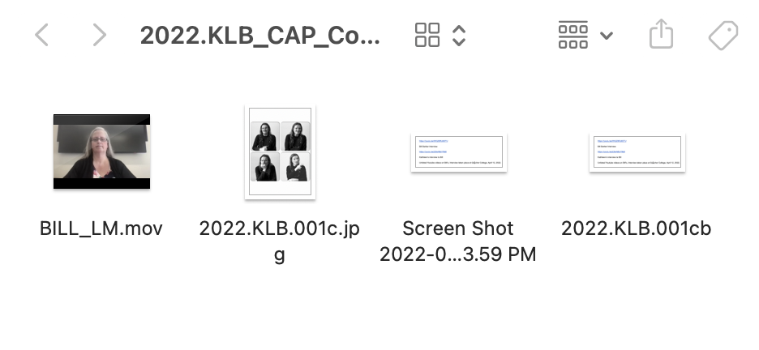
Place: On Goucher College Campus, in Julia Rogers building.

Video Log Worksheet 2

Researcher: Kathleen L. Brockway Project Name: Capstone Defense Project
Date Logged: May 2, 2022
File Name: Video_Log_Brockway

Format:
Format: o MiniDV o DVCAM o MiniDVD o DVD o Digital File o Other:
Digital file type: o MPEG-2 o MPEG-4 o DV o WMV o MOV
o Other:
Bill’s Digital file: https://youtu.be/iWQZ8RJ6STU [Text: Youtube, 2022]
Kathleen’s Digital file: https://youtu.be/jQfwNBzY9b8 [Text: Youtube, 2022]

Running Time: Hour(s): Minutes: 40 Seconds: 48
Date Recorded (YYYY-MM-DD): 4-12-2022
Location: Goucher College, Towson, Maryland

Interviewee/Event: William Barber at Goucher College in the Julia Rogers building’s private room.

Interviewer(s): Kathleen L. Brockway

Subject: Name Signs (or English: Signed Names)

Copyright Owner: Kathleen L. Brockway
Restricted? o No, o Yes, details:

Summary:

A movie shows William Barber, the interviewee, in a structured interview. Kathleen L. Brockway’s iPhone was placed on a tripod. Kathleen L. Brockway interviewed William Barber at Goucher College in the Julia Rogers building on the Campus. Transcription provided in Appendix L. No captions provided in the video.

Key words: Name, Location, Hollar, Union Forge

File Name: Bill_Interview_4_12_22.mov and Kat_Interview_4_12_22.mov

Summary of the movie in English translation from Sign Language.
File _1_ of _2_
A Summary of only 15 minutes out of 00:00:00. A full unedited transcription is provided in Appendix L. The challenge is no time stamp on the Iphone video.

TIME CODE CONTENT DESCRIPTION
(HH:MM:SS)
00:00:00 – 00:00:00 William discussing the strategy of how to interview with an interpreter and me sitting within social distance.
00:00:00 - 00:00:00 Verbal consent was agreed upon reciting in sign language from the consent form.
00:00:00 - 00:00:00 William explained his name sign, B letter from left shoulder to the right hip downward.

00:00:00 - 00:00:00 William discussed how he vaguely found out about the deaf village through his family over the years, but did not grasp it until he was an older adult.

00:00:00 - 00:00:00 Discussed about the Hollar and found out deaf Peter Hollar was connected to his deaf grandmother. He learned the sign “Hollar” name from his own grandmother. V bent handshape on upper cheek area to doward on bottom of the cheek area.

00:00:00 - 00:00:00 Discussed how the first settler, Petter Hollar had two t’s in his first name, then passed down to 3 more Peter Hollar, which became one t in the first name down the generation. First two were identified as hearing, last two were deaf Peter Hollars. Last one died around 1879 at age 60 with no children and marriage.

00:00:00 - 00:00:00 Discussed how Hollar name came was one of the Peter Hollars threw off the horse and his face hit the fence then his jaw was wrecked, hence the name sign on the upper cheek to lower cheek directly were the upper teeth to lower teeth inside his cheek.

File _2_ of _2_

00:00:00 - 00:00:00 William learned pieces and bits from his grandmother and mother when he grew up. He really didn’t pay attention until he began to research the family tree around 10 years ago. He discovered he had more deaf cousins than he expected.

00:00:00 - 00:00:00 William explained he knew of lower land called Lantz Mills, while on the cliff, it was called Union Forge.

Video Log Worksheet 3

Researcher: Kathleen L. Brockway Project Name: Capstone Defense Project
Date Logged: May 2, 2022
File Name: Video_Log_Brockway

Format:
Format: o MiniDV o DVCAM o MiniDVD o DVD o Digital File o Other:
Digital file type: o MPEG-2 o MPEG-4 o DV o WMV o MOV
o Other:
Digital file location:

Running Time: Hour(s): 1 Minutes: 36 Seconds: 12
Date Recorded (YYYY-MM-DD): 4-11-22
Location: online Zoom format

Interviewee/Event: Charity Warigon, online Zoom event

Interviewer(s): Kathleen L. Brockway

Subject: Name Signs (or English: Signed Names)

Copyright Owner: Kathleen L. Brockway
Restricted? o No, o Yes, details:

Summary:

A movie shows dual horizontal videos of both interviewer and interviewee in unstructured interview from their homes through online zoom meeting set-up through Goucher College’s platform. Kathleen L. Brockway interviewed Charity Warigon in a signed narrative. No captions and audio at that time. The transcription is not provided at that time due to time ran out with a hired interpreter by Goucher College. A summary of the signed narrative will be observed by Kathleen L. Brockway. Note: ASL translated into a summary of written English.

Key words: Name Signs, Hollar, witchcraft, VSDB, cross-cultural, CODA, education, farm (signs), Warrensburg Syndrome.

File Name: Charity_Apr11_NameSigns.mov
File _1_ of _5_

TIME CODE CONTENT DESCRIPTION
(HH:MM:SS)
00:00:00 – 00:02:20 Discussing the verbal consent form in sign language, in agreement, reciting from the written consent form.

00:02:21 - 00:03:14 Charity stated her full name, Charity Reedy Warigon and signed her name with letter shape C, repeatedly shaking left to right.

00:03:15 - 00:06:10 Charity and Kathleen discussed the name signs (repeatedly shaking left to right) on several names in her family.

00:06:11 - 00:07:23 Charity explained all three “J” initial letters were passed down three generations in her family with “Jennie” (Virginia was the real name) Charity’s great-grandmother, and then Charity’s brother, James adopted the J letter. Next one was passed down to Charity’s son, Joseph. All used the “pinky” finger and repeatedly touched the other hand, open-handed in a “scoop” motion.

00:07:24 - 00:08:06 Discussed how some others used initial letters repeatedly shaking left to right and were assigned through Virginia School for the Deaf and Blind (VSDB) on their first day of arrival except for Cleveland, who refused to allow a new name sign. I observed Charity’s reaction that she was not aware of this significant information I learned from the other descendant in a different interview.

00:08:07 - 00:10:08 Discussed where Charity’s parents came from and she responded to Lantz Mills through the Hollar brothers, Isaac (father’s side) and David (mother’s side). Parents were not aware they were cousins until Charity and her siblings became adults.

File _2_ of _5_

00:10:09 - 00:11:15 Charity discussed how her father and mother’s families passed down before they discovered they were cousins. My follow up question regarding

Charity’s signed word “chain” and Charity clarified she meant how her parents’ families linked, not because of inter-marriages.

00:11:16 - 00:12:01 Charity discussed how her mother was into research discovery about families of Hollar. Kathleen remarked how the Hollar genealogy book she borrowed from Charity really helped because Charity’s mother identified several more “deaf” identified in the book that the author did not identify as “deaf.” (Observation: Charity looked so proud of what her mother did)

00:12:02 - 00:14:00 Charity told a story how she visited Lantz Mills at an earliest age she can remember going with her father, David. Stated that her father tends to visit the deaf elders who are sick and give support. Charity recalled her father brought her to the house (James Milton Hollar’s house) used to be there, but now gone. Her father explained about Lantz Mills, the island (on the High Bluffs), and some other parts of Lantz Mills including the witchcraft stories.

00:14:01 - 00:14:07 Kathleen clarified with the old sign Charity signed. Charity responded that the sign stands for “witchcraft.”

00:14:08 - 00:14:26 Charity recalled looking around like nothing was there at Lantz Mills when her father remarked there were so many deaf folks living there. She felt like the town did not exist on the map.

00:14:27 - 00:15:24 Kathleen’s surprise reaction was when she learned Charity never knew about the “swinging” bridge until I brought up that. Kathleen remarked that then in Charity’s family, her daughter Amberlin was the first person to walk across that bridge! Charity nodded and smiled in agreement.
File _3_ of _5

00:15:25 - 00:16:36 Charity explains how her parents, David and Frances met each other. She identified her father’s and mother’s name signs as their first letter of their names in repeatedly shaking left to right. They were 10 years apart. She acknowledged
her father was married and divorced before he met her mother. They met after her mother’s graduation from VSDB.

00:16:37 - 00:17:40 Charity explained that her father never graduated from VSDB. He left as a teenager because at that time, VSDB had an oral method approach in focus of speech and lip-reading only. Her father was severely punished by slapping on his hands with a stick by employed adults, and encouraged him not to use sign language. She explained that her father grew up on a farm in full signing communication. Her father missed classes so much, because he was always placed in a “dungeon” as a prisoner on the top floor of the Main Hall on the VSDB Campus to teach him a lesson not to sign.

00:17:41 - 00:17:47 Charity explains why the dungeon was for, as she stated that was the place where students are severely punished to teach them a lesson on bad behavior. Charity’s father was suffering and isolating often in that “dungeon.”

00:17:48 - 00:19:22 Charity explained that her father was at age 16 in 6th grade due to his missing a lot of classwork. During that time in the dungeon, her father decided something risky by finding a way to contact his mother. He managed to get through the window and caught a student walking down on the field and told the student to bring him a pen and paper with an envelope. This student brought what he requested and he quickly wrote a letter to his mother that he was stuck in a “prison” punishing him for signing. This student got the letter from him through the door and secretly mailed it to him.

00:19:23 - 00:19:24 Charity, clarified by mailing through the post office in the old days, usually arrives at a person’s home immediately the next day.

File _4_ of _5

00:19:25 - 00:20:22 Charity’s grandmother rescued her father after receiving the letter. Her father quit schooling at age 16 in 6th grade and began to work out in the real world ever since. Charity emphasized her father was BRILLIANT.

00:20:23 - 00:20:42 Charity continually emphasized that VSDB deprived her father of actual education.

00:20:43 - 00:21:53 Kathleen had a follow-up question, when the oral approach stopped. Charity stated that her father was born in 1919 and he enrolled in 1927 at VSDB. Then he left 1935 at age 16, his school still having an oral approach method. Then Charity explained that her mother got into VSDB shortly afterwards and VSDB allowed sign language approach sometime after 1935’s.

00:21:54 - 00:22:43 Charity explained that her father did not really have a traumatic experience at VSDB except for a lack of education, but was a very optimistic person. He learned to have coping skills through his large deaf family and handled well.

00:22:44 - 00:23:29 Charity explained her father knew how to do a cross-cultural approach between deaf and hearing worlds by reacting differently to get what he needed. He was influenced by his deaf father and hearing (CODA) mother using that cross-cultural approach in conversations between deaf and hearing communities.

00:23:30 - 00:27:00 Charity explained that her father and mother raised Charity and her 4 other siblings on a farm doing hard work, and even used an outhouse for a bathroom! Narrated that everything they washed was in a single sink, such as washing clothes, dishes, and anything. While taking a bath, she had to pour water in the tub and notify every male in the house that she’s taking a bath for privacy reasons, except females are allowed to walk by where the tub/sink was in the kitchen. Coal and wood are used for keeping the house warm. In her child-mind like at age 13, she wanted to get out of the farm culture by attending a school for the deaf in Washington, D. C. 2 hours and half
File _5_ of _5_

away from home’s hard life. She chose to attend Model Secondary School for the Deaf (MSSD) instead of attending VSDB after she grew up in the public school system.

00:27:01 - 00:27:46 MSSD was a completely different culture for her by learning how to use a coin-operated washing machine, unlike her home washing by hand everyday for 13 years. Her life changed with a City-operated culture at MSSD.

00:27:47 - 00:28:30 Kathleen followed up asking if Charity arrived at MSSD with the same name sign, letter C repeatedly shaking left to right. Charity responded no, because when she arrived there, she was assigned as letter C repeatedly touching her left breast-chest area. She recalled because there was another student there already with her same name sign (repeatedly shaking left to right). Charity clarified that when she finished MSSD, she went back to the same name as before.

00:28:31 - 01:36:12 A summary of how Charity learned about Lantz Mills family members and her family (siblings) with name signs. She also explained about her siblings who had a next deaf generation with at least one deaf child each except for one sibling only had one hearing child including Charity’s deaf daughter. Her daughter was identified as type 2 of Warrensburg Syndrome. Charity learned of her family through her mother who had carried the Warrensburg Syndrome.

Groce, N. Everyone Here Spoke Sign Language: Hereditary Deafness on Martha’s Vineyard.
“Island” is a region where unique regional sign language is used in an isolated area. Martha’s Vineyard is an island off the Massachusetts mainland.
Coined by George Marcus in 1985 as mentioned in Dr. Melanie McKay-Cody’s dissertation, Memory Comes Before knowledge. North American indigenous Deaf: Socio-cultural study of Rock/picture Writing, Community, Sign Languages, and Kinship (2019).
Linked to an article: https://www.gallaudet.edu/news/gallaudet-university-launches-new-guides-in-apple-maps/
This was William Christian’s nickname, “Bill.”

