
Journal of Geophysical Research Atmospheres

Supporting Information for
Regional and Seasonal Trends in Tropical Ozone from SHADOZ Profiles: Reference for Models and Satellite Products
Anne M. Thompson^{1,2}, Ryan M. Stauffer¹, Krzysztof Wargan^{1,3}, Jacquelyn C. Witte⁴, Debra E. Kollonige^{1,3}, Jerald R. Ziemke^{1,5}
¹NASA/Goddard Space Flight Center (GSFC), Greenbelt, MD; ²Joint Center for Environmental Systems Research, Univ of Maryland, Baltimore County, Baltimore, MD; ³Science Systems and Applications, Inc., Lanham, MD; ⁴National Center for Atmospheric Research Earth Observations Laboratory, Boulder, CO; Morgan State Univ., Baltimore, MD

Contents of this file

Figures S1 to S7; Tables S1, S2

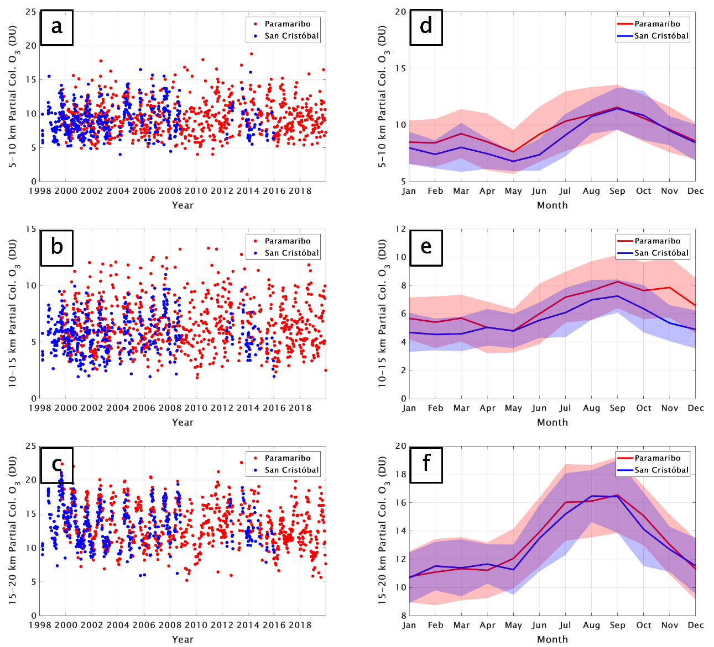

Figure S1. For the Paramaribo (red) and San Cristóbal (blue) SHADOZ data, the time-series (1998-2019) of ozone partial column amounts in (Dobson Units, DU) for (a) the lower FT, defined as 5-10 km; (b) upper FT, defined as 10-15 km; (c) LMS defined as 15-20 km. In (d-f): monthly mean partial column ozone (±1 σ) in DU based on the same soundings as for (a-c).

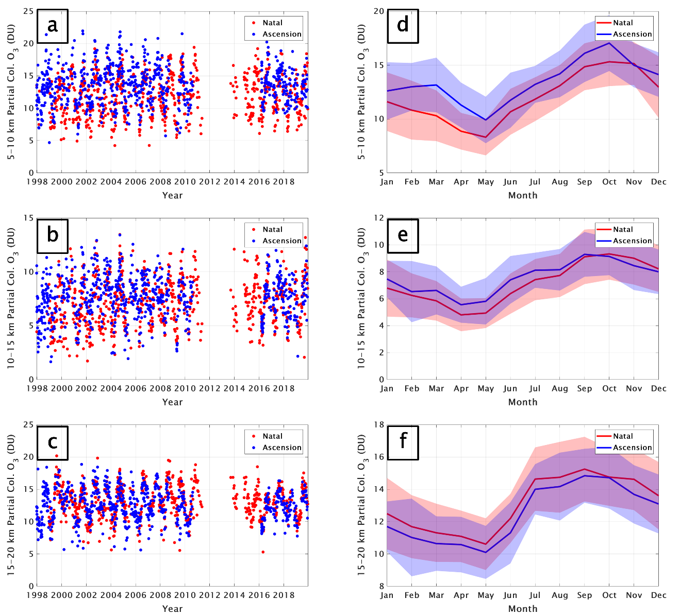

Figure S2. Same as for S1, except that the individual station data are from Natal (red) and Ascension (blue).

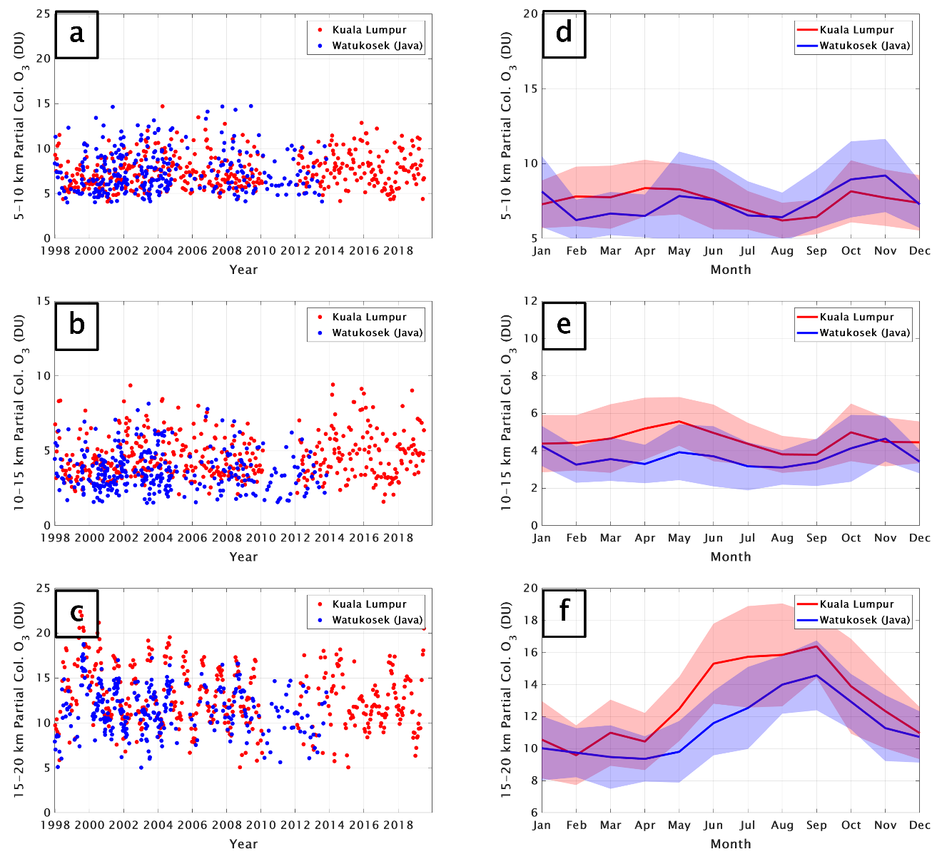

Figure S3. Same as for S1, except that the individual station data are from Kuala Lumpur (red) and Watukosek, Java, Indonesia (blue).
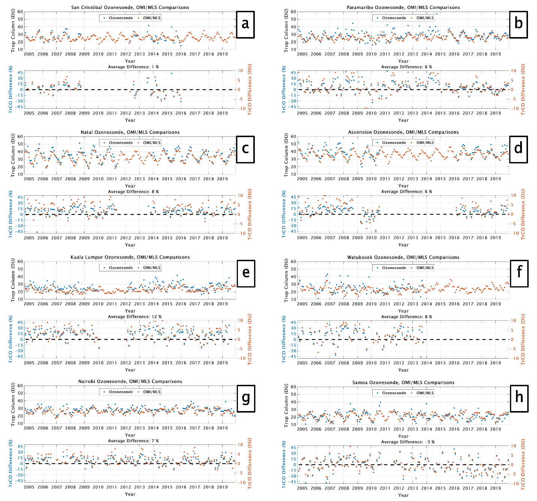

Figure S4. For the 8 stations analyzed, the upper panels in (a) –(h) give monthly mean tropospheric column ozone in DU, estimated from the OMI/MLS residual satellite product (Ziemke et al., 2019) and integrated from surface to tropopause from SHADOZ data; the tropopause is determined from the radiosonde data. In text, the column integrals are referred to as TrCO_{sat} for the OMI/MLS and TrCO_{sonde} for the SHADOZ data. Lower panels give the difference between the two tropospheric columns in % (left scale, blue) and DU (right scale, red).

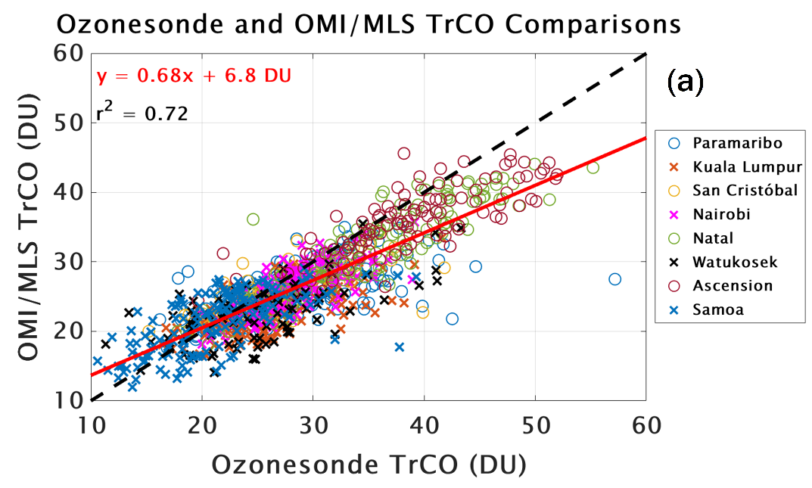

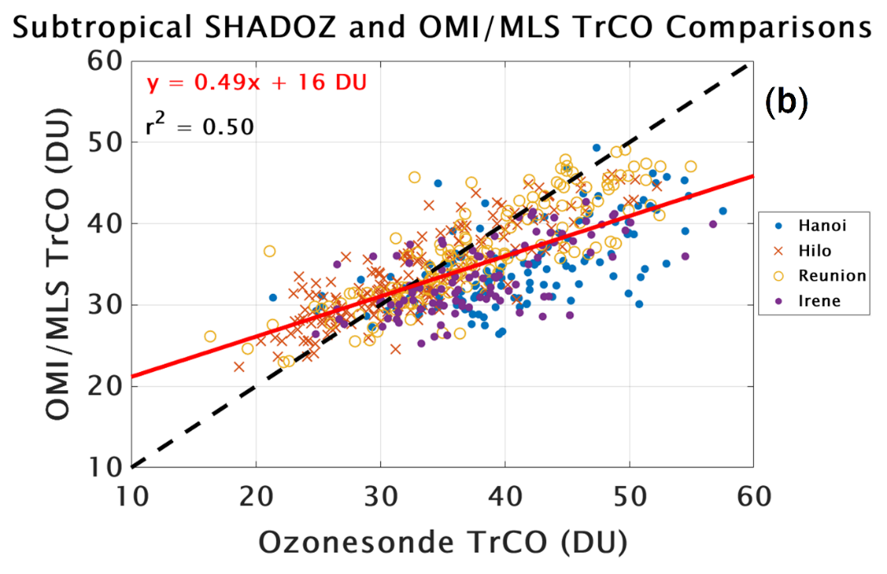
Figure S5. (a) Scatterplot of TrCO_{sat} vs TrCO_{sonde} for the 8 tropical SHADOZ stations in Figure S4; (b) same for the 4 subtropical SHADOZ stations, with latitude > 19N (Hilo, Hanoi) or > 19S (Réunion, Irene). The degraded correlation in the subtropics suggests caution in using OMI/MLS for determining tropospheric ozone trends at the higher latitudes.

Figure S6. Monthly averaged MLR (grey lines) and ozonesonde (black dots) ozone mixing ratios for the two individual and three combination sites in the 5 to 10 km layer. Correlations between MLR model fits and ozonesonde data are shown in each frame.

Figure S7. Monthly averaged MLR (grey lines) and ozonesonde (black dots) ozone mixing ratios for the two individual and three combination sites in the 15 to 20 km (LMS) layer. Correlations between MLR model fits and ozonesonde data are shown in each frame.

Table S1. Same as Table 1 except ozone change is in DU/decade.
Trends by layer, DU per decade | SC+Para | Natal+Ascen | Nairobi | KL+Java | Samoa
Lat, Lon (°): | -0.92, -89.62/5.8, -55.21 | -5.42, -35.38/-7.58, -14.24 | -1.27, 36.8 | 2.73, 101.27/-7.5, 112.6 | -14.23, -170.56
Profiles: | 1227 | 1436 | 941 | 786 | 795
MLR Terms: | MEI+QBO | MEI+QBO | MEI+QBO | MEI+QBO+IOD | MEI+QBO
5-10 km
Jan: | -0.4±0.7 p = 0.233 | 0.3±0.7 p = 0.357 | 0.2±0.7 p = 0.639 | -0.0±0.5 p = 0.947 | 0.5±0.8 p = 0.245
Feb: | 0.1±0.7 p = 0.764 | 0.3±0.7 p = 0.445 | 0.9±0.7 p = 0.018 | 0.8±0.5 p = 0.001 | 0.4±0.8 p = 0.322
Mar: | 0.7±0.7 p = 0.050 | 0.3±0.7 p = 0.471 | 1.2±0.8 p = 0.001 | 0.9±0.5 p = 0.000 | 0.3±0.8 p = 0.400
Apr: | 0.5±0.6 p = 0.121 | 0.4±0.8 p = 0.283 | 0.6±0.8 p = 0.140 | 0.3±0.5 p = 0.267 | 0.1±0.8 p = 0.770
May: | -0.0±0.7 p = 0.995 | 0.6±0.7 p = 0.078 | -0.4±0.8 p = 0.297 | -0.2±0.5 p = 0.327 | -0.1±0.8 p = 0.822
Jun: | -0.1±0.7 p = 0.808 | 0.8±0.7 p = 0.036 | -0.6±0.8 p = 0.125 | -0.2±0.5 p = 0.441 | -0.0±0.8 p = 0.912
Jul: | 0.2±0.7 p = 0.609 | 0.6±0.7 p = 0.114 | -0.2±0.8 p = 0.701 | 0.0±0.5 p = 0.991 | 0.0±0.8 p = 0.947
Aug: | 0.3±0.7 p = 0.345 | 0.1±0.7 p = 0.850 | 0.0±0.8 p = 0.997 | 0.1±0.5 p = 0.665 | -0.2±0.9 p = 0.629
Sep: | 0.4±0.6 p = 0.271 | -0.4±0.7 p = 0.253 | -0.2±0.8 p = 0.679 | 0.3±0.5 p = 0.317 | -0.4±0.8 p = 0.297
Oct: | 0.4±0.6 p = 0.183 | -0.5±0.7 p = 0.196 | -0.1±0.8 p = 0.769 | 0.3±0.6 p = 0.353 | -0.2±0.8 p = 0.624
Nov: | 0.3±0.7 p = 0.435 | -0.2±0.7 p = 0.668 | 0.0±0.8 p = 0.923 | -0.1±0.7 p = 0.660 | 0.3±0.8 p = 0.460
Dec: | -0.2±0.7 p = 0.470 | 0.2±0.7 p = 0.560 | 0.0±0.8 p = 0.991 | -0.5±0.6 p = 0.102 | 0.5±0.8 p = 0.191
Annual: | 0.2±0.3 p = 0.079 | 0.2±0.3 p = 0.143 | 0.1±0.3 p = 0.119 | 0.1±0.2 p = 0.138 | 0.1±0.3 p = 0.226
10-15 km
Jan: | -0.4±0.6 p = 0.162 | 0.5±0.5 p = 0.059 | 0.0±0.6 p = 0.979 | -0.1±0.3 p = 0.456 | 0.2±0.6 p = 0.448
Feb: | -0.3±0.6 p = 0.336 | 0.5±0.5 p = 0.042 | 0.3±0.6 p = 0.350 | 0.1±0.3 p = 0.466 | 0.4±0.6 p = 0.147
Mar: | 0.2±0.5 p = 0.361 | 0.3±0.5 p = 0.198 | 0.6±0.6 p = 0.059 | 0.4±0.3 p = 0.005 | 0.5±0.6 p = 0.123
Apr: | 0.5±0.5 p = 0.055 | 0.1±0.5 p = 0.595 | 0.5±0.6 p = 0.093 | 0.5±0.3 p = 0.000 | 0.3±0.6 p = 0.275
May: | 0.2±0.6 p = 0.511 | 0.2±0.5 p = 0.423 | 0.1±0.6 p = 0.615 | 0.2±0.3 p = 0.133 | 0.1±0.6 p = 0.780
Jun: | -0.2±0.6 p = 0.540 | 0.4±0.5 p = 0.100 | 0.0±0.6 p = 0.989 | -0.2±0.3 p = 0.173 | -0.1±0.6 p = 0.720
Jul: | -0.0±0.6 p = 0.942 | 0.5±0.5 p = 0.044 | 0.1±0.6 p = 0.838 | -0.3±0.3 p = 0.053 | -0.1±0.6 p = 0.779
Aug: | 0.4±0.6 p = 0.155 | 0.4±0.5 p = 0.093 | -0.1±0.6 p = 0.603 | -0.1±0.3 p = 0.500 | 0.1±0.6 p = 0.841
Sep: | 0.5±0.5 p = 0.081 | 0.2±0.5 p = 0.411 | -0.6±0.6 p = 0.062 | -0.1±0.3 p = 0.757 | 0.1±0.6 p = 0.808
Oct: | 0.3±0.5 p = 0.343 | 0.0±0.5 p = 0.919 | -0.6±0.6 p = 0.035 | -0.2±0.4 p = 0.231 | -0.1±0.6 p = 0.778
Nov: | 0.0±0.5 p = 0.904 | 0.0±0.5 p = 0.894 | -0.3±0.6 p = 0.271 | -0.3±0.4 p = 0.120 | -0.2±0.6 p = 0.562
Dec: | -0.2±0.6 p = 0.487 | 0.2±0.5 p = 0.318 | -0.1±0.6 p = 0.780 | -0.3±0.4 p = 0.180 | -0.0±0.6 p = 0.878
Annual: | 0.1±0.2 p = 0.260 | 0.3±0.2 p = 0.001 | -0.0±0.2 p = 0.707 | -0.0±0.1 p = 0.347 | 0.1±0.3 p = 0.243
15-20 km
Jan: | -0.2±1.0 p = 0.733 | 0.3±0.7 p = 0.454 | 0.3±0.8 p = 0.376 | -1.0±0.8 p = 0.015 | -0.5±1.1 p = 0.377
Feb: | 0.1±1.0 p = 0.848 | 0.5±0.7 p = 0.177 | 0.6±0.8 p = 0.152 | -0.4±0.8 p = 0.289 | 0.0±1.1 p = 0.929
Mar: | 0.3±0.9 p = 0.456 | 0.3±0.7 p = 0.341 | 0.7±0.8 p = 0.066 | -0.1±0.8 p = 0.898 | -0.1±1.1 p = 0.926
Apr: | 0.2±0.9 p = 0.623 | 0.3±0.8 p = 0.329 | 0.6±0.8 p = 0.110 | 0.1±0.8 p = 0.795 | -0.7±1.2 p = 0.244
May: | -0.2±0.9 p = 0.688 | 0.5±0.7 p = 0.159 | 0.1±0.8 p = 0.736 | -0.0±0.8 p = 0.942 | -0.8±1.2 p = 0.179
Jun: | -0.6±1.0 p = 0.231 | 0.2±0.8 p = 0.639 | -0.5±0.8 p = 0.242 | -0.6±0.8 p = 0.122 | -0.3±1.2 p = 0.641
Jul: | -0.9±0.9 p = 0.070 | -0.6±0.8 p = 0.146 | -0.7±0.8 p = 0.089 | -1.3±0.8 p = 0.001 | -0.1±1.2 p = 0.924
Aug: | -1.1±0.9 p = 0.020 | -0.8±0.8 p = 0.040 | -0.5±0.8 p = 0.249 | -1.4±0.9 p = 0.001 | -0.4±1.2 p = 0.525
Sep: | -1.1±0.9 p = 0.013 | -0.4±0.8 p = 0.215 | -0.1±0.8 p = 0.742 | -0.9±0.9 p = 0.035 | -0.5±1.2 p = 0.369
Oct: | -0.9±0.9 p = 0.060 | -0.2±0.8 p = 0.502 | 0.0±0.8 p = 0.940 | -0.7±0.9 p = 0.151 | -0.4±1.2 p = 0.537
Nov: | -0.5±0.9 p = 0.265 | -0.4±0.8 p = 0.297 | 0.1±0.8 p = 0.853 | -1.0±1.0 p = 0.043 | -0.5±1.2 p = 0.427
Dec: | -0.3±0.9 p = 0.517 | -0.2±0.7 p = 0.477 | 0.2±0.8 p = 0.670 | -1.3±0.9 p = 0.005 | -0.7±1.2 p = 0.198
Annual: | -0.4±0.4 p = 0.021 | -0.0±0.3 p = 0.528 | 0.1±0.3 p = 0.553 | -0.7±0.3 p = 0.000 | -0.4±0.5 p = 0.115

Table S2. Same as Table 2 except the ozone change is in DU/decade.
Trends by layer, DU per decade | SC+Para | Natal+Ascen | Nairobi | KL+Java | Samoa
Lat, Lon (°): | -0.92, -89.62/5.8, -55.21 | -5.42, -35.38/-7.58, -14.24 | -1.27, 36.8 | 2.73, 101.27/-7.5, 112.6 | -14.23, -170.56
Profiles: | 1227 | 1436 | 941 | 786 | 795
MLR Terms: | MEI+QBO | MEI+QBO | MEI+QBO | MEI+QBO+IOD | MEI+QBO
TH-10 to TH-5 km
Jan: | -0.5±0.6 p = 0.076 | 0.3±0.6 p = 0.239 | -0.1±0.7 p = 0.719 | -0.4±0.4 p = 0.092 | 0.6±0.7 p = 0.110
Feb: | -0.1±0.6 p = 0.624 | 0.3±0.6 p = 0.275 | 0.3±0.7 p = 0.374 | 0.3±0.4 p = 0.215 | 0.4±0.8 p = 0.320
Mar: | 0.4±0.6 p = 0.184 | 0.2±0.6 p = 0.542 | 0.8±0.7 p = 0.036 | 0.7±0.4 p = 0.001 | 0.2±0.8 p = 0.636
Apr: | 0.3±0.5 p = 0.242 | 0.3±0.6 p = 0.329 | 0.5±0.8 p = 0.212 | 0.5±0.4 p = 0.015 | 0.2±0.8 p = 0.696
May: | -0.0±0.6 p = 0.939 | 0.7±0.6 p = 0.034 | -0.3±0.8 p = 0.495 | 0.1±0.4 p = 0.813 | 0.1±0.8 p = 0.802
Jun: | -0.1±0.6 p = 0.841 | 0.8±0.6 p = 0.013 | -0.5±0.7 p = 0.208 | -0.3±0.4 p = 0.153 | -0.0±0.8 p = 0.921
Jul: | 0.1±0.6 p = 0.809 | 0.6±0.6 p = 0.064 | -0.2±0.8 p = 0.701 | -0.4±0.4 p = 0.082 | -0.1±0.8 p = 0.788
Aug: | -0.0±0.6 p = 0.999 | 0.1±0.6 p = 0.673 | -0.0±0.8 p = 0.896 | -0.2±0.5 p = 0.318 | -0.1±0.8 p = 0.736
Sep: | -0.1±0.5 p = 0.846 | -0.2±0.6 p = 0.416 | -0.2±0.7 p = 0.532 | 0.0±0.5 p = 0.970 | -0.2±0.8 p = 0.542
Oct: | 0.1±0.5 p = 0.626 | -0.4±0.6 p = 0.194 | -0.2±0.8 p = 0.585 | 0.1±0.5 p = 0.813 | -0.3±0.8 p = 0.485
Nov: | 0.1±0.6 p = 0.607 | -0.3±0.6 p = 0.324 | -0.0±0.8 p = 0.955 | -0.2±0.6 p = 0.420 | 0.0±0.8 p = 0.921
Dec: | -0.3±0.6 p = 0.309 | 0.0±0.6 p = 0.878 | -0.1±0.7 p = 0.807 | -0.5±0.5 p = 0.040 | 0.5±0.8 p = 0.208
Annual: | -0.0±0.2 p = 0.905 | 0.2±0.3 p = 0.073 | -0.0±0.3 p = 0.955 | -0.0±0.2 p = 0.306 | 0.1±0.3 p = 0.270
TH-5 km to TH
Jan: | -0.5±0.6 p = 0.127 | 0.5±0.4 p = 0.021 | 0.0±0.5 p = 0.863 | -0.1±0.3 p = 0.317 | 0.3±0.6 p = 0.345
Feb: | -0.3±0.6 p = 0.373 | 0.6±0.4 p = 0.010 | 0.3±0.5 p = 0.214 | 0.1±0.3 p = 0.418 | 0.3±0.6 p = 0.297
Mar: | 0.2±0.5 p = 0.365 | 0.3±0.4 p = 0.097 | 0.5±0.5 p = 0.042 | 0.2±0.3 p = 0.072 | 0.3±0.6 p = 0.424
Apr: | 0.4±0.5 p = 0.134 | 0.2±0.4 p = 0.363 | 0.4±0.5 p = 0.125 | 0.5±0.3 p = 0.001 | 0.1±0.7 p = 0.735
May: | 0.1±0.6 p = 0.787 | 0.3±0.4 p = 0.191 | 0.1±0.5 p = 0.604 | 0.5±0.3 p = 0.003 | -0.1±0.7 p = 0.699
Jun: | -0.1±0.6 p = 0.648 | 0.4±0.4 p = 0.066 | 0.1±0.5 p = 0.651 | -0.1±0.3 p = 0.697 | -0.3±0.7 p = 0.350
Jul: | 0.0±0.5 p = 0.878 | 0.4±0.4 p = 0.061 | 0.2±0.5 p = 0.448 | -0.6±0.3 p = 0.000 | -0.2±0.7 p = 0.563
Aug: | 0.2±0.5 p = 0.386 | 0.4±0.4 p = 0.074 | -0.0±0.5 p = 0.905 | -0.5±0.3 p = 0.003 | 0.0±0.7 p = 0.902
Sep: | 0.2±0.5 p = 0.505 | 0.3±0.4 p = 0.162 | -0.4±0.5 p = 0.128 | -0.2±0.3 p = 0.301 | 0.0±0.7 p = 0.932
Oct: | 0.1±0.5 p = 0.801 | 0.1±0.4 p = 0.572 | -0.4±0.5 p = 0.081 | -0.2±0.3 p = 0.149 | -0.2±0.7 p = 0.578
Nov: | -0.0±0.5 p = 0.977 | 0.0±0.4 p = 0.950 | -0.2±0.5 p = 0.364 | -0.6±0.4 p = 0.004 | -0.2±0.7 p = 0.542
Dec: | -0.2±0.5 p = 0.396 | 0.2±0.4 p = 0.333 | -0.1±0.5 p = 0.778 | -0.5±0.3 p = 0.004 | 0.1±0.7 p = 0.861
Annual: | 0.0±0.2 p = 0.875 | 0.3±0.2 p = 0.000 | 0.0±0.2 p = 0.205 | -0.1±0.1 p = 0.055 | 0.0±0.3 p = 0.922
TH to TH+5 km
Jan: | -0.2±1.7 p = 0.831 | 0.8±1.1 p = 0.154 | 1.6±1.7 p = 0.056 | 0.4±1.9 p = 0.661 | 0.2±1.6 p = 0.765
Feb: | 0.2±1.6 p = 0.783 | 1.1±1.1 p = 0.051 | 0.7±1.7 p = 0.368 | 0.4±1.8 p = 0.684 | 0.4±1.7 p = 0.620
Mar: | 0.6±1.5 p = 0.434 | 0.9±1.1 p = 0.087 | -0.4±1.7 p = 0.672 | -0.1±1.9 p = 0.940 | 0.3±1.7 p = 0.704
Apr: | 0.7±1.5 p = 0.328 | 0.6±1.2 p = 0.270 | -0.1±1.7 p = 0.885 | -0.1±1.9 p = 0.934 | 0.1±1.8 p = 0.896
May: | 0.6±1.7 p = 0.455 | 0.5±1.2 p = 0.332 | 0.5±1.8 p = 0.550 | 0.0±1.9 p = 0.965 | -0.5±1.8 p = 0.544
Jun: | 0.4±1.7 p = 0.608 | 0.3±1.2 p = 0.535 | -0.0±1.7 p = 0.980 | -0.4±1.9 p = 0.657 | -1.5±1.7 p = 0.083
Jul: | 0.3±1.6 p = 0.658 | -0.1±1.1 p = 0.892 | -0.7±1.8 p = 0.421 | -0.9±1.9 p = 0.352 | -1.5±1.7 p = 0.073
Aug: | 0.3±1.6 p = 0.728 | -0.2±1.1 p = 0.713 | 0.0±1.8 p = 0.974 | -0.5±2.0 p = 0.567 | -0.4±1.7 p = 0.622
Sep: | 0.1±1.5 p = 0.933 | 0.2±1.1 p = 0.761 | 1.2±1.8 p = 0.172 | 0.1±2.1 p = 0.947 | 0.4±1.7 p = 0.638
Oct: | -0.2±1.5 p = 0.747 | 0.5±1.1 p = 0.380 | 1.2±1.8 p = 0.175 | -0.0±2.2 p = 0.981 | 0.1±1.7 p = 0.911
Nov: | -0.5±1.5 p = 0.545 | 0.4±1.1 p = 0.487 | 0.8±1.8 p = 0.378 | -0.4±2.3 p = 0.703 | -0.5±1.7 p = 0.574
Dec: | -0.4±1.6 p = 0.580 | 0.4±1.1 p = 0.501 | 1.2±1.7 p = 0.160 | -0.2±2.1 p = 0.868 | -0.3±1.6 p = 0.711
Annual: | 0.2±0.6 p = 0.428 | 0.5±0.5 p = 0.052 | 0.5±0.7 p = 0.079 | -0.1±0.8 p = 0.621 | -0.3±0.7 p = 0.310

