Towson University Department of Economics Working Paper Series

Working Paper No. 2017-01

Optimal Progressive Income Taxation in a Bewley-Grossman Framework

by Juergen Jung and Chung Tran

March 2017

© 2017 by Author. All rights reserved. Short sections of text, not to exceed two paragraphs, may be quoted without explicit permission provided that full credit, including
© notice, is given to the source.

Optimal Progressive Income Taxation in a Bewley-Grossman Framework∗

Juergen Jung† Towson University
Chung Tran‡ Australian National University
April 24, 2018

Abstract
We study the optimal income tax progressivity in a Bewley-Grossman model where individuals are exposed to income and health risks over the lifecycle. Our results, based on a calibration for the US economy, indicate that the presence of health shocks requires the government to set higher optimal levels of tax progressivity in order to provide more social insurance for unhealthy low income individuals who have limited access to health insurance. The optimal progressive income tax system includes a tax break for income below
$36, 400 and high marginal tax rates of over 50 percent for income earners above $200, 000. The tax progressivity (Suits) index—a Gini coefficient for income tax contributions by income—of the optimal tax system is around 0.53, compared to 0.17 in the benchmark tax system. Welfare gains from switching to the optimal tax system amount to over 5 percent of compensating lifetime consumption. The presence of health risk amplifies the social insurance role of the progressive income tax system. The optimal tax system in our model with health risk is more progressive than the optimal tax systems in models without
health risk (e.g., Conesa and Krueger (2006) and Heathcote, Storesletten and Violante (2017)). When health risk is removed from the model, the optimal tax system becomes less progressive and thus more similar to the optimal progressivity levels reported in the literature. In addition, the optimal level of tax progressivity is strongly affected by the design of the health insurance system.
JEL: E62, H24, I13, D52
Keywords: Health and income risks, Inequality, Social insurance, Tax progressivity, Suits index, Optimal taxation, General equilibrium.

∗We appreciate comments from Dirk Krueger, Mariacristina De Nardi, Greg Kaplan and participants at the 2017 Midwest Macroeconomics Meetings, the Australian Treasury Workshop on Fiscal Policy Modeling, and the economic seminars at the University of Western Australia, the Victoria University of Wellington, the University of Auckland, the Bank of Japan, GRIPS, Australian National University and Towson University.
†Department of Economics, Towson University, U.S.A. Tel.: 1 (812) 345-9182, E-mail: jjung@towson.edu
‡Research School of Economics, Australian National University, ACT 2601, Australia. Tel.: +61 2 6125 5638,
E-mail: chung.tran@anu.edu.au

Introduction
The economics literature has documented a high degree of inequality in income, wealth and consumption of US households. Two important sources have been identified to contribute to this observed heterogeneity: (i) income risk (e.g., Heathcote, Storesletten and Violante (2008) and Kaplan (2012)) and (ii) health risk (e.g., Deaton and Paxson (1998) and Kippersluis et al. (2009)). In order to equalize consumption opportunities, advanced economies have instituted tax and transfer systems where marginal tax rates increase with income and public transfers target disadvantaged groups such as low income households, the sick and the unemployed (com- pare Table 1). As a result, many tax- and social insurance systems are highly progressive and play a key role in shaping the income distribution across households and over time.
The optimal progressive tax literature has focused on frameworks with income shocks as the sole source of risk (e.g., Conesa and Krueger (2006) and Heathcote, Storesletten and Violante (2017)). Recent studies (e.g., see Capatina (2015) and De Nardi, Pashchenko and Porapakkarm (2017)) demonstrate that health shocks are another important source of risk and inequality. In this paper, we aim to better understand the optimal progressivity of the US income tax system in a lifecycle framework where both income and health risks are present.
We first document summary statistics of health status, income and health expenditures over the lifecycle using data from the US medical expenditure panel survey (MEPS) and demonstrate the important role of health as a source of lifecycle inequality. We then construct a simple partial equilibrium two-period model, where individuals differ not only in their inherent capacity to earn income but also in their state of health and health expenditure, and illustrate analytically that health expenditure and health insurance carry important consequences for the optional design of a progressive income tax system. Finally, we formulate a full dynamic general equilibrium model that generates a distribution of income, consumption and health expenditure similar to observable US data and quantify the role of health factors in determining the optimal level of progressivity of the US income tax system.
Our quantitative model is a combination of two workhorse models in the macroeconomics/public finance and the health economics literature. The quantitative macroeconomics/public finance literature is based on the incomplete-markets heterogeneous agents model initially developed
by Bewley (1986) which was later extended by Huggett (1993) and Aiyagari (1994). In the Bewley-Huggett-Aiyagari framework individuals experience uninsurable shocks to income. In this incomplete market setting, a progressive income tax system can improve welfare through two channels. First, progressive taxes lead to a more equal post-tax distribution of income and wealth, and therefore to a more equitable distribution of household consumption. Second, in the absence of private insurance markets, progressive taxes provide a partial substitute for insurance and can generate more stable household consumption paths over time through the distribution of income from “lucky” high income individuals to “unlucky” individuals who expe- rience large negative shocks to income. However, health risk, medical expenditures and health insurance arrangements are largely absent in this literature.
In order to incorporate health risk factors, we combine the Bewley-Huggett-Aiyagari model with the Grossman model of health capital accumulation (Grossman (1972)) which features prominently in the health economics literature. In the Grossman framework individuals value their health in addition to a consumption goods basket and have a strong motive to smooth both health and the consumption bundle over the lifecycle. Health affects household consumption through direct and indirect channels. First, the utility of consumption itself is affected by the health status of an individual and the availability of more “healthy time.” Second, health is a co-determinant of labor earnings and therefore affects the household’s ability to purchase final consumption goods. In addition, smoothing health over the lifecycle requires healthcare

spending, which subsequently reduces funds available for purchasing final consumption goods. The simultaneous presence of both income and health risks and the institutional insurance arrangements that lower a household’s exposure to such risk shape the distributions of income, wealth and consumption. In our framework progressive income taxes and public health insurance serve as policy tools to provide social insurance against income and health risks.
This modeling extension allows us to capture the lifecycle structure of health risk in con- junction with income risk as observed in the data. Health care spending and health insurance take-up rates over the lifecycle are endogenous and jointly determined with consumption, savings and labor supply. The benchmark model is calibrated to US data of 2010 and incorporates the lifecycle patterns of shocks to income and health. The benchmark model matches labor supply, asset holdings, consumption and health expenditures over the lifecycle. Health expenditures are low early in life because of high initial health capital and low health risk. Health expenditures then rise exponentially later in life because individuals are exposed to more frequent and larger health shocks. The benchmark model also reproduces the hump-shaped lifecycle profile of pri- vate health insurance take-up rates, the income distribution from the Panel Study of Income Dynamics (PSID) as well as macroeconomic aggregates from the National Income and Product Accounts (NIPA).
We next use the calibrated model to quantitatively explore the shape of the optimal pro- gressive income tax function.1 Our main results are summarized as follows: First, the optimal income tax system is highly progressive and imposes a tax break for income below $36, 400, followed by a jump in the marginal tax rate to 25 percent. The marginal tax rate then increases further to over 40 percent for income above $100, 000 and to over 50 percent for income above
$200, 000. The optimal tax system in our model is more progressive than the optimal tax sys- tems reported in the literature that largely abstracts from health risk and the role played by health insurance (e.g., Conesa and Krueger (2006) and Heathcote, Storesletten and Violante (2017)). The large zero-tax bracket at the low end of the income distribution is mainly driven by the high demand for social insurance of the poor unhealthy population who has limited access to private health insurance. The high tax rates at the upper end of the income distribution are required to meet the financing needs of government spending and transfer programs.
In order to compare the progressivity levels of the different income tax regimes, we compute the tax progressivity (Suits) index which is a Gini coefficient for income tax contributions by income. According to Suits (1977), the Suits index varies from +1 (most progressive, the entire tax burden is borne by households of the highest income bracket), through 0 for a proportional tax, to 1 (most regressive, the entire tax burden falls on households of the lowest income bracket). The US income tax system in the benchmark model has a Suits index of 0.17. The optimal US tax system would be much more progressive with a Suits index of 0.54. Under the optimal tax system income inequality decreases significantly. The after-tax-income Gini coefficient decreases from 0.38 in the benchmark economy to 0.31 after the progressivity level is optimized. Large welfare gains of 5.5 percent of compensating lifetime consumption at the aggregate level are realized when switching from the benchmark progressivity to the optimal progressivity. This outcome is mainly driven by large welfare gains of low income individuals that dominate the welfare losses of the higher income groups.
−
The mechanisms behind these results are intuitive. The progressive income tax system is an important channel that redistributes income and supplements the social health insurance system, which is missing from the frameworks used in prior studies. Low income individuals are more likely to have poor health than high income individuals because they do not have adequate access to health insurance through the mixed public/private US health insurance system. Many
1We model progressive income taxes using a two-parameter polynomial following Benabou (2002).

of these individuals are not poor enough to qualify for Medicaid and not rich enough to buy private health insurance on their own or through their employers.2 This poor working class benefits the most from the optimized tax system in terms of welfare improvement. The zero-tax at the lower end of the income distribution allows these individuals to increase their non-medical consumption and invest more in health. Indeed, the medical spending of the uninsured increases under the optimal income tax system. Our findings emphasize the importance of health risk and the healthcare system in determining the optimal level of progressivity of the US income tax function.
Having established the social health insurance effect of a progressive income tax system, we analyze how different designs of the US health insurance system affect the optimal level of income tax progressivity. We consider three alternative health insurance scenarios: (i) the US health insurance system after the introduction of the Affordable Care Act (ACA) in 2010, (ii) a system with Medicare for all individuals that we refer to as universal public health insurance (UPHI), and (iii) a system with no health insurance where individuals rely exclusively on self- insurance. We find that the optimal progressive tax schedule varies significantly across the alternative designs. The ACA strengthens channels that redistribute resources from healthy, high income types to sicker, low income types through premium subsidies and the expansion of Medicaid—a public health insurance program for low income individuals. As a result, the optimal degree of tax progressivity decreases the Suits index to 0.50, compared to 0.54 in the pre-ACA scenario. Under the second scenario with UPHI the optimal income tax system becomes even less progressive. The tax break at the lower end of the income distribution reduces significantly to US$ 26, 200 and the marginal tax rates imposed on top earners are much lower at approximately 31 percent for income over $200, 000. UPHI significantly reduces the residual demand for social insurance provided through the progressive income tax system. The Suits index decreases to 0.43 in this environment. Finally, under the third scenario we eliminate all public and private health insurance from the model. This creates a strong demand for social insurance provided through a more progressive income tax system. In this case the Suits index increases to 0.59.
Furthermore, in order to study the impact of health risk on household heterogeneity, we completely turn off the health risk process in the model. This makes our model similar to previous studies where health risk is not present and income shocks are the only exogenous source of risk. Our results indicate that the optimal tax system in this setting is much less progressive with a Suits index of 0.14 which is also less progressive than the US status quo tax system with a Suits index of 0.17. This result—the optimal system exhibiting a lower degree of progressivity than the current US system—is similar to findings in Conesa and Krueger (2006) and Heathcote, Storesletten and Violante (2017).3 This finding indicates that health risk plays an important role in shaping the optimal tax progressivity and its inclusion results in an optimal level of progressivity that is higher than the current US income tax system.
Finally, we examine how the parametric specification of the income tax function affects the optimal tax progressivity. In our benchmark model, we restrict the two parameter specification from Benabou (2002) to be non-negative in order to remove all transfer components embedded in the tax function since many of these transfers to low income households are already explicitly modeled in our framework (e.g., Medicaid and minimum consumption insurance). However, as a
2Gruber (2008) refers to this group as the poor working class whose income is below the median income but above the eligibility thresholds for public health insurance and income transfers.
3While the optimal taxes in our model become more similar to Heathcote, Storesletten and Violante (2017)
when we shut down the sources of health risk, important differences in the modeling frameworks remain. Most notably, our framework still includes a deterministic health capital accumulation process as well as elements of the US health insurance system.

robustness check, we remove this restriction and use the original functional form as in Heathcote, Storesletten and Violante (2017). Our results show that the optimal progressive income tax function shifts down and marginal tax rates at the low end of the income distribution become negative. These negative taxes are conditional cash transfers that induce poorer individuals to work and save in order to receive these transfer payments. Thus, embedding transfer policies targeting low income households strongly affects the shape of the optimal tax function.
Related literature. Our work is connected to different branches of the quantitative macroeconomics and health economics literature. First, our paper is closely related to the optimal progressive income taxation literature. In a seminal paper, Varian (1980) shows an- alytically how social insurance can be provided via a progressive tax system. More recently, Conesa and Krueger (2006) quantify the optimal progressivity of the income tax code in the US, using a dynamic general equilibrium overlapping generations model with household heterogene- ity due to uninsurable labor productivity risk. They show that a progressive tax system serves as a partial substitute for missing income-insurance markets and results in a more equal distri- bution of income. Erosa and Koreshkova (2007) analyze the insurance role of the US progressive income tax code in a dynastic model with human capital accumulation. Chambers, Garriga and Schlagenhauf (2009) quantify the interactions between progressive income taxes and housing policies to promote home ownership in an overlapping generations model with housing and rental markets. Stantcheva (2015) characterizes an optimal income tax in the presence of a human capital investment decision in a dynamic lifecycle model. Krueger and Ludwig (2016) compute optimal tax- and education policies in an economy where progressive taxes provide social insurance against idiosyncratic wage risk but distort the education and human capital decision of households. McKay and Reis (2016) study the optimal generosity of unemployment benefits and progressivity of income taxes in a model with macroeconomic aggregate shocks and individual unemployment risk. These studies abstract from the implications of health risk and the social insurance role of a health insurance system on the optimal progressivity of the income tax system. Our study includes these components.
Heathcote, Storesletten and Violante (2017) develop a tractable general equilibrium model to study the optimal degree of progressivity of a tax and transfer system. They focus on the trade-offs between risk sharing and the incentives to work and invest in skills. They show how preferences, technology and the market structure influence the optimal degree of tax and transfer progressivity. In order to obtain analytic results they abstract from inter-temporal consumption and savings decisions as well as social insurance programs programs. We analyze a similar problem but develop a quantitative model which take into account more realistic features. In particular, health is an important source of heterogeneity across individuals and over time. The main components of the US social insurance system, including Social Security, Medicaid and Medicare and tax deductible private health insurance, are explicitly modeled. As a result, the optimal income tax system in our setting is more progressive than the benchmark US tax system, which is different from the findings in Heathcote, Storesletten and Violante (2017) who report that the optimal tax system is less progressive than the benchmark US income tax. However, when eliminating health risk from our framework results in an optimal income tax system that is very close to the one in Heathcote, Storesletten and Violante (2017). This finding illustrates the quantitative importance of accounting for health, health risk and health insurance when describing the optimal progressivity level of the US income tax system. In addition, it challenges the finding in previous studies that the US optimal tax system is less progressive.
Our paper is related to the literature on incomplete markets macroeconomic models with heterogeneous agents as pioneered by Bewley (1986) and extended by Huggett (1993) and

Aiyagari (1994). The Bewley model has been applied widely to quantify the welfare effects of public insurance for idiosyncratic income risk (e.g., Hansen and Imrohoroglu (1992), İmro- horoğlu, İmrohoroğlu and Joines (1995), Golosov and Tsyvinski (2006), Heathcote, Storesletten and Violante (2008), Conesa, Kitao and Krueger (2009) and Huggett and Parra (2010)). This literature focuses on the welfare cost triggered by income/labor productivity risk in an envi- ronment without insurance contracts for non-medical consumption. Recently, Capatina (2015) and De Nardi, Pashchenko and Porapakkarm (2017) demonstrate that health shocks are an- other important source of idiosyncratic risk faced by individuals over the lifecycle. In our study we add to this literature by incorporating idiosyncratic health risk into a Bewley framework. We incorporate the micro-foundations of a health capital accumulation mechanism based on the Grossman model which endogenizes medical spending. Our research merges the workhorse models from health economics and the macro/public finance literature to analyze the optimal income tax progressivity in the presence of income and health risk in combination with a realistic depiction of the US health insurance system.
Our work contributes to a growing macro-public finance literature that focuses on health risks and healthcare policy. This literature extends the Grossman model of health capital ac- cumulation (Grossman (1972)) and incorporates health shocks, insurance markets and general equilibrium channels using a more realistic institutional setting (e.g., Jung and Tran (2007), Fonseca et al. (2013), Scholz and Seshadri (2013a) and Jung and Tran (2016) and Yogo (2016)). Jung and Tran (2016) explore the welfare implications of Obamacare. The quantitative model presented in this paper shares many features with our previous model in Jung and Tran (2016) but differs in the income tax polynomial as well as in the subsequent focus on quantitatively characterizing the optimal level of income tax progressivity while taking the redistribution ef- fects of the health insurance system into account. We demonstrate how changes to the health insurance system affect the optimal level of income tax progressivity. Cole, Kim and Krueger (Forthcoming) construct and estimate a dynamic model of health investments and health in- surance in which the cross-sectional health distribution evolves endogenously. They study the impact of social insurance policies aimed at reducing a household’s exposure to health-related risk in health care and labor markets: no prior condition law and no wage discrimination leg- islation. However, they abstract from the social insurance role of progressive income taxes and public health insurance, which is the focus of this paper.
Our paper is connected to the literature on high marginal tax rates for top income earners. Diamond and Saez (2011) advocates for taxing labor earnings at the high end of the distribution at high marginal rates in excess of 75 percent. Badel and Huggett (2015) assess the consequences of increasing the marginal tax rate on US top income earners using a human capital model. Guner, Lopez-Daneri and Ventura (2016) analyze the effectiveness of progressive income tax systems in raising tax revenue. Kindermann and Krueger (2017) find that high marginal labor income tax rates are an effective tool for social insurance in a large-scale stochastic overlapping generations model with optimal marginal tax rates of 90 percent for the top 1 percent earners. Different from these studies, we focus on the optimal marginal tax rates across the entire income distribution. Moreover, we base our analysis on a health capital model where health risk is an additional source of heterogeneity in addition to labor market risk. We also find that very high tax rates at the top are an essential component of the optimal progressive tax system. More importantly, we highlight that such high optimal marginal tax rates at the top are inter- dependent with the marginal tax rates set at the bottom of the income distribution and the government transfer policies already in place.
The paper is structured as follows. The next section present stylized facts from US data about health status, health expenditures and the empirical relationship of health and income. Section 3 describes the insurance and incentive trade-off in a two-period model. Section 4

presents the full dynamic model. Section 5 describes our calibration strategy. Section 6 describes our experiments and quantitative results. Section 7 is devoted to sensitivity analysis. Section 8 concludes. The Appendix presents all calibration tables and figures.

Stylized facts
In this section we document summary statistics of health status, health expenditures, insurance, health financing and income over the lifecycle using data from the Medical Expenditure Panel Survey (MEPS), a longitudinal survey for the US that pays particular attention to medical expenditure and its financing sources. We mainly focus on raw correlations motivating our analysis.
Health status. Due to human biology, health status is highly correlated with age. The literature has used various proxy measures for health status. MEPS provides two measures: Short-Form 12 Version 2 (SF-12v2)4 and Self-Reported Health Status reported as either: 1. excellent, 2. very good, 3. good, 4. fair, or 5. poor. We use the latter to construct a binary “healthy” index. An individual is considered to be healthy if the health status measure is either excellent, very good, or good. This classification is standard in the literature.
Figure 1 displays these two measures over the lifecycle. Panel 1 presents the SF-12v2 index. Young individuals start at a relatively high level of health. The level of health consistently decreases as an individual ages. The “healthy” index Panel 2 of Figure 1 follows a similar pattern. Moreover, we calculate standard deviations of the health status measure over the lifecycle. Panel 3 and 4 show that the variations in health status are relatively small when young and become larger at the end of the lifecycle. This implies that individuals become more exposed to health risks as they get older.
Health expenditure. Figure 2 reports the distribution and lifecycle patters of health expenditures, expressed in 2009 US dollars. Individual health expenditures (exclusive insurance premium payments) are relatively low at young ages but increase significantly from age 50 onward (Panel 2). This is mainly driven by depreciation of health over the lifecycle. On average, individuals in their twenties spend about $1, 500 per year on healthcare whereas older individuals in their fifties spend about $4, 000 per year. Once they pass age 50, health expenditures rise very fast on average. The highest expenditures are incurred by the very old and amount to approximately $10, 000 on average per year. Panels 3 and 4 compare the lifecycle patterns of total health expenditures by health status in levels and as fraction of income. There is a large gap between the spending patterns of the healthy and sick. The sick group spends significantly more over the lifecycle.
Health financing. The US health insurance system is a mixed system where public health insurance programs target the retired population (Medicare) and the poor (Medicaid). The majority of working individuals obtain private health insurance via their employers (Employer- based group health insurance, or GHI from here onward). Panels 1 and 2 of Figure 3 display the financing sources of health expenditures and the insurance take-up rates over the lifecycle, respectively. Private insurance reimbursements and out-of-pocket payments are the two major funding sources for medical spending of the working age population. The fraction of health expenditure financed by private insurance and Medicaid decreases with age, whereas the frac-
4SF-12v2 includes twelve different health measures about physical and mental health and is available as a physical health index as well as a mental health index. Both indices use the same variables to construct the index but the physical health index puts more weight on variables measuring physical health components and the mental health index puts more weight on variables measuring mental health components. Ware, Kosinski and Keller (1996) provides more details on the construction of the SF-12v2 index. We use the physical component of SF-12v2 as an indicator for health status in this study.

tion of health expenditures financed by out-of-pocket funds increases moderately. Around the retirement age of 65 there is a big shift in the magnitude of financing from private insurance toward public insurance including Medicare, Veteran’s benefits, and other state run insurance plans.
Despite the many different types of insurances, about 50 million Americans did not have health insurance in 2010. Employer-based group health insurance policies (GHI) cover only around 60 percent of the working-age population while individual-based health insurance policies (IHI) cover less than 6 percent. A large number of healthy and young individuals do not have health insurance, either by choice or by circumstance. The fraction of the uninsured is highest among young workers below 35. Medicaid picks up less than 10 percent of workers by covering low income individuals. Consequently, about 25 percent of the working population are without health insurance. Gruber (2008) points out the modal uninsured person is a member of the working poor class. Members of this class have income below median income but above the federal poverty level and are therefore not eligible for Medicaid.
Health risks and income gap. Figure 4 presents coefficients of variation for health expenditures and income and the age-profiles of income and out-of-pocket health expenditure for the unhealthy/sick and healthy groups. Panel 2 indicates that there is a significant gap between the income profile between the two groups. Unhealthy/sick individuals exhibit a much lower income path over the lifecycle. This indicates that bad health conditions significantly reduce lifetime income. In addition, unhealthy individuals have to devote a larger fraction of their income to health expenditure. Panels 3 and 4 of Figure 4 present average OOP health expenditure in levels and as fractions of average income for healthy and unhealthy types. On average, the share of OOP health expenditures as fraction of income is less than 8 percent. However, this fraction varies across health states and age. The unhealthy/sick group not only spends more on healthcare in levels but also as fraction of their income, 15 percent on average. Even though Medicare and Medicaid are the main sources of health financing for the elderly, they still pay a significant amount OOP because of co-pays and coinsurance rates. This implies that the US health insurance system fails to fully insure unhealthy Americans against health expenditure risks.
We next calculate the coefficients of variation for income and health expenditures over the lifecycle (reported in Panel 1 of Figure 4). The coefficient of variation for income is fairly stable at around 0.9 before age sixty and rises slightly after retirement. On the other hand, the coefficient of variation for health expenditure is four to five times larger than the coefficient of variation of household income and varies sharply over the lifecycle. It is largest between the age of 20–30. Note that health expenditures are relatively low for young individuals but so is income. This indicates that health expenditure risk can be significant for young individuals who are often credit constrained in addition to having low income.
The stylized facts imply that health risk and healthcare costs are an important source of lifetime inequality in the US. This is partly due to the design of the US health insurance system that lets many young individuals opt out of health insurance or does not provide sufficient financial support to help cover premium payments for individuals who simply cannot afford it. The lack of access to health insurance has implications for the social insurance role of the progressive income tax system.

A simple two-period model
In this section we aim to clarify some of the determinants of optimal income tax progressivity in the presence of medical spending and health insurance. We consider a two period overlapping

generations model with low and high skilled households and a government. Every period a new cohort of young agents of size one is born. In the first period agents work and earn labor income based on their skill type. Agents retire in the second period and face deterministic
health expenditures. A typical agent’s budget constraint in the first period is: c^{i} + s^{i} =
w

( _{i} ) (
1 − l1
1 − τ
+ T , where w
is the skill-specific wage rate, c1 and s1 are consumption and
savings in period 1, T ^{i} is the lump-sum transfer andτ ^{i} is the labor income tax rate. The second
i) i i i i i 1 1

period budget constraint can be written as: c^{i} = Rs^{i} − ρm^{i}, where c^{i} is consumption, R is the
2
1
2
interest rate, m^{i} is total health expenditure, ρ^{i} is the coinsurance rate and ρ^{i}m^{i} is out-of-pocket health expenditure.
Household problem. At the beginning of period 1, a typical household makes deci- sions about consumption, labor supply and savings to maximize her expected utility. Let Γ = w^{i}, R, m^{i}, τ ^{i}, T ^{i}, ρ and V ^{i} Γ denote the state variable vector and the value function,
( \
respectively. The household optimization problem is given by

( \ 

1
1
2
1
u (c^{i} ) + θv (l^{i} ) + βu (c^{i} ) 

1
1
2
1

V ^{i} Γ
= max

1
1
2
1
1
( ) (
)

1
1
1
1 2
s.t.
2
1

ci ,li ,ci ,si  ci + si =

1
1
1 − l^{i} 1 − τ ^{i}
w^{i} + T ^{i} and c^{i} = Rs^{i} − ρ^{i}m^{i}, 

where n^{i} = (1 − l^{i} ) is labor supply when young. It is assumed that the utility function u (c)
is a concave function with u_{c} > 0, v_{l} > 0, u_{h} > 0, and u_{cc} < 0. The F.O.Cs for the household
problem is given by u_{c} (c^{i} ) = ^{θ} v_{l} (l^{i} ) and u_{c} (c^{i} ) = Rβu_{c} (c^{i} ) . The optimal decision rules
1
1
wi
1
1
1
1
2
2
1
2
are c∗1 = g^{c} (Γ \ , l1∗ = g^{l} (Γ \ , s∗1 = g^{s} (Γ \ and c2∗ = g^{c} (Γ \ .
Government problem. The government sets up a tax and transfer system that aims to redistribute income from high to low income agents. The government budget constraint is
),
),

given by
I

i=1
τ ^{i} (1 −
li ) wi
I
=
i=1
T ^{i},
where I
is a number of skill types. The problem to be

solved by the central decision-makers is taken to be that of finding a maximum of a social welfare function, by appropriate choice of tax parameters and subject to the constraint that the
1
government’s budget must balance. The social welfare function SW is the sum of all individual
),

welfare functions,

SW =
I

i=1
V ^{i} (Γ \ .
This is an utilitarian social welfare criterion where the

society’s total, unweighted, expected utility is maximized. Generally, the government problem is written as

I
I

max
τ i,T i
I

i=1
V i (Γ \
st.
i=1
τ i (
1 − l^{i} )
w^{i} =
i=1
T ^{i},

where τ ^{i}, T ^{i} are individual-specific taxes and transfers, respectively. The Lagrange for the government problem is
1

L = max
τ i,T i
I

i=1
V ^{i} (Γ \ + Λ
I

i=1
τ i (
1 − l^{i} )
w^{i} −

I
T ^{i} ,

i=1

where Λ is a Lagrangian multiplier. The FOCs are
1
( \

∂L
∂T i =

I
i=1
∂V ^{i} Γ
∂T i − Λ = 0,
( \

∂L
∂τ i

I
=

i=1
∂V ^{i} Γ
∂τ i
− Λ (
1 − l^{i} )

w^{i} = 0.
1

Log-preference example. We consider a log-form of preferences, V =ln c₁ + θ ln l₁ +
β ln c₂. The household decision rules are given by c^{i} = ¹ I i, c^{i} = ^{β} RI i, l^{i} =
=
1
1+β+θ
2
1+β+θ
1

θ

1+β+θ
1
R
Ii , and n^{i} w i
1+β 1+β+θ
Ii , where
w i
w i = (1 − τ ^{i}) w^{i} and
I i = (1 − τ ^{i}) w^{i} + T ^{i} − ρimi

are the after 1tax wage and net wealt h, respectively. The indirect utility is V ^{i}(Γ ) = B^{i} +
(1 + β + θ) ln
(1 − τ ^{i}) w^{i} + T ^{i} − ρimi
− θ ln f(1 − τ ^{i}) w^{i} .

For simplicity we consider two household types, low and high skills. There is an income gap between these two groups as high skill agents are more productive and have higher wage rate, w^{H} > w^{L}. The government aims to narrow the income gap by redistributing income from high to low skill agents. It runs a progressive income tax system that taxes high income agents relatively more and redistribute more to low (income) agents, τ ^{L} ≤ τ ^{H} and T ^{L} ≥ T ^{H} . The
1
1
R
government budget constraint is given by τ ^{L}
1 − l^{L}
w^{L} + τ ^{H} (1 − l^{H} ) w^{H} = T ^{L} + T ^{H} . The

social welfare function is SW = V ^{L} + V ^{H} . Accordingly, the government problem can be written as

max
τ L,τ H ,T L,T H
s.t.
V ^{L} + V ^{H}

T ^{L} + T ^{H} = τ ^{L} (1 − l^{L}) w^{L} + τ ^{H} (1 − l^{H} ) w^{H} .
1
1
We consider a non-linear tax and transfer system in which the government allows a tax break and transfer to the low skill agents, τ ^{L} = 0 and T ^{L} > 0, while taxing income and giving no transfer to the high skill agents, τ ^{H} > 0, and T ^{H} = 0. The government problem then simplifies to
SW = max V ^{L} + V ^{H} |s.t. T ^{L} = τ ^{H} (1 − l^{H} ) w^{H} .
τ H ,T L 1
Taking the FOCs yields the equilibrium condition
L H
∂V (1 − l^{H} ) w^{H} = − ∂V . (1)
∂T L
1
∂τ H
Expressing health expenditures in terms of income, we have m^{L} = γ^{L}w^{L} and m^{H} = γ^{H} w^{H} ,
where γ^{L} and γ^{H} are health expenditures as fractions of labor income, the FOC becomes
(1−τ ^{H} − ρH γH \w^{H}
R
(

(1 + β)
(1−τ H )
(1 + β + θ) θ

(1 − ρLγL) wL + τ H 1+β
( 1−τ − w
H ρH γH H
R
(1−τ H )
1+β+θ
=
1 − τ H −
R
ρH γH \ − 1 − τ H

Normalizing the coinsurance rate for the high skill agents to ρ^{H} = 0, i.e., health expenditures of the high skill agents are fully covered by the health insurance system, the expression simplifies to

H ( 1 + β + θ ( (
τ
=
1 −
1 −
. (2)
2 + 2β + θ
ρLγL wL

R
wH

2 + 2β + θ
R
wH
The tax and transfer system is progressive as high income households pay higher tax rate, τ ^{H} > τ ^{L}. The above equation describes the link between the optimal top tax rate and income inequality, wL , health expenditure as fraction of income for the low income (skill) agents, γ^{L},
wH
and the coinsurance rate ρ^{L} for the low income (skill) agents. The low skill agents have limited access to the health insurance system, so they have to pay a coinsurance rate ρ^{L} > 0. Our analytical model has implications for the optimal design of a progressive income tax system.

Proposition 1. The optimal income tax system is more progressive if the income gap between low and high skill households is larger.

Proof. The partial derivative of expression (2) with respect to the wage ratio is
− ( 1+β+θ \ (1 − ρ^{L}γ^{L}) < 0 because both 0 < ρ^{L} < 1, 0 < γ^{L} < 1.
2+2β+θ
∂τ ^{H}

∂ wL wH
( =

Proposition 2. The optimal income tax system is more progressive if low income (skill) house- holds face a relatively higher coinsurance rate.
Proof. The partial derivative of expression (2) with respect to the coinsurance rate of the low
2+2β+θ
R
wH

income agent is ∂τ H
∂ρL
= ( 1+β+θ \ γ^{L} ( w^{L} \ > 0.

These analytical results imply that accounting for health insurance has important con- sequences for the optimal design of the progressive income tax system. In a more general environment, the optimal level of tax progressivity depends on model fundamentals including preferences, endowments, technologies, and also the evolution of health risks over the lifecycle and the existing design of the health insurance system.

The quantitative model
In this section, we formulate a more comprehensive model of the US economy including the healthcare sector following Jung and Tran (2016) and quantify the optimal degree of progres- sivity of the US income tax system. In addition, we explore how differently designs of a health insurance system affect the optimal tax progressivity.

Technologies and firms
There are two production sectors in the economy, which are assumed to grow at a constant rate g. Sector one is populated by a continuum of identical firms that use physical capital K and effective labor services N to produce a non-medical consumption good c with a normalized price of one. Firms in the non-medical sector are perfectly competitive and solve the following maximization problem

max
{K, N }
F (K, N ) − qK − wN, (3)

taking the rental rate of capital q and the wage rate w as given. Capital depreciates at rate δ in each period. Sector two, the medical sector, is also populated by a continuum of identical firms that use capital K_{m} and labor N_{m} to produce medical services m at a price of p_{m}.⁵ Firms in the medical sector maximize

max
{Km, Nm}
p_{m}F_{m} (K_{m}, N_{m}) − qK_{m} − wN_{m}. (4)

5We use exogenous price markups to account for the fact that the medical sector is not perfectly competitive and that not all stakeholders pay the same price for otherwise identical medical services. More details about the price markups used in this study can be found in the calibration section.

Demographics, preferences and endowments
The economy is populated with overlapping generations of individuals who live up to a maximum of J periods. Individuals work for J₁ periods and are retired thereafter. Individuals survive each period with age dependent survival probability π_{j}. Deceased agents leave an accidental bequest that is taxed and redistributed equally to the working age population. The population grows exogenously at an annual rate n. We assume stable demographic patterns, so that age j agents make up a constant fraction µ_{j} of the entire population at any point in time. The relative sizes of the cohorts alive µ_{j} and the mass of individuals dying in each period µ˜_{j} (conditional

on survival up to the previous period) can be recursively defined as µ_{j} = ^{π}j µ_{j−1}
(1+n)years
µ˜_{j} = ^{1−π}j µ_{j−1}, where years denotes the number of years per model period.
(1+n)years
and

In each period individuals are endowed with one unit of time that can be used for work
n or leisure. Individual utility is denoted by function u (c, n, h) where u : R³ → R is C²,
++
increases in consumption c and health h, and decreases in labor n. More specifically we use a multiplicative utility function of the form

u (c, n, h) =
j
((c^{η} × (1 − n − 1

[n>0]
n¯ )1−η \κ × h1−κ\1−σ

where
,
1 − σ
n¯_{j} is an age dependent fixed cost of working as in French (2005), η is the intensity

parameter of consumption relative to leisure, κ is the intensity parameter of health services relative to consumption and leisure, and σ is the inverse of the inter-temporal rate of substitution (or relative risk aversion parameter).
Individuals are born with a specific skill type ϑ that cannot be changed and that together with their health capital h_{j} and an idiosyncratic labor productivity shock E^{n} determines their
j
( \
age-specific labor efficiency e ϑ, h_{j}, E^{n} . The transition probabilities for the idiosyncratic pro- ductivity shock E^{n} follow an age-dependent Markov process with transition probability matrix
j
j
Π^{n}. An element of this transition matrix is defined as the conditional probability Pr (E^{n} |E^{n} \,
i,j+1
j
i,j+1
i,j
where the probability of next period’s labor productivity E^{n} depends on today’s productivity
shock E^{n} .⁶
i,j

Health capital
Health capital evolves according to h_{j} = H (m_{j}, h_{j−1}, δ^{h}, ε^{h}\, where h_{j} denotes current health
j
j
capital, h_{j−1} denotes health capital of the previous period, δ^{h} is the depreciation rate of health capital and E^{h} is an idiosyncratic health shock. The exogenous health shock E^{h} follows a Markov
j
j j
process with age dependent transition probability matrix Π^{h}. Transition probabilities to next
j
period’s health shock E^{h} depend on the current health shock E^{h} so that an element of transition
j+1
j
matrix Π^{h} is defined as the conditional probability Pr (E^{h} |E^{h}\ . Individuals can buy medical
j
j+1
j
services m_{j} to improve their health capital. Specifically, the law of motion of health capital

6Heathcote, Storesletten and Violante (2017) model government spending in terms of public goods that enter the preferences directly. In their setting, the utility from the consumption of public goods and social insurance are two main channels of welfare gains. In our analysis, we abstract from the former and focus on risk sharing through social insurance programs. We model public spending programs explicitly. Our modeling approach is similar to the one in Conesa and Krueger (2006). However, we take into account both labor productivity and health risks as well as the institutional setup of the US healthcare sector.

follows

h_{j} =

Investment

ξ j
φ mj

Trend

h j
( \ + 1 − δ h +_{j−1}

Disturbance
h j
ε

. (5)

This law of motion is an extension of the deterministic framework in Grossman (1972). The first two components are similar to Grossman (1972) while the third component can be thought of as a random depreciation rate as in discussed in Grossman (2000).

Health insurance
In the benchmark economy we introduce the main features of the US health insurance system before the implementation of the Affordable Care Act in 2010. The health insurance market consists of private health insurance companies that offer two types of health insurance policies:
(i) an individual health insurance plan (IHI) and (ii) a tax deductible group health insurance plan (GHI). Individuals are required to buy insurance at a plan specific price (or premium) one period prior to the realization of their health shock in order to be insured in the following period. The insurance policy needs to be renewed each period. By construction, agents in their first period are thus not covered by any insurance. The government provides public health insurance with Medicaid for the poor and Medicare for retirees. To be eligible for Medicaid, individuals are required to pass an income and asset test. The health insurance state in_{j} for workers can therefore take on the following values:

in_{j} =


- not insured,
- Individual health insurance (IHI),
- Group health insurance (GHI),
- Medicaid.

After retirement (j > J₁) all agents are covered by public health insurance which is a combina- tion of Medicare and Medicaid for which they pay a premium, premR.
An agent’s total health expenditure in any given period is pinj × m , where the price of
m
j
medical services pinj depends on insurance state in_{j}. The out-of-pocket health expenditure of
m

a working-age agent is given by

o (m_{j}) =

in_{j}
ρ^{in}j × (pinj × m \ , if in
m
j
j
m
j
j
p × m , if in

= 0, (6)
> 0

where 0 ρ^{in}j 1 are the insurance state specific coinsurance rates. The coinsurance rate denotes the fraction of the medical bill that the patient has to pay out-of-pocket.7 A retiree’s
≤ ≤
out-of-pocket expenditure is o (m_{j}) = ρ^{R} × (p^{R} × m_{j}) , where ρ^{R} is the coinsurance rate of
m
m
Medicare and p^{R} is the price that a Medicare patient pays for medical services.
Insurance companies. Workers are randomly assigned to employers who offer group health insurance (GHI) which is indicated by random variable E^{GHI} = 1. The GHI premium, premGHI, is tax deductible and group rated so that insurance companies are not allowed to screen workers by health or age. There is a Markov process that governs the group insurance offer probability. It is a function of the individual’s permanent skill type ϑ. Let Pr E^{GHI}|E^{GHI}, ϑ
( \
j+1
j
be the conditional probability that an agent has group insurance status E^{GHI} at age j + 1 given she had group insurance status E^{GHI} at age j. All conditional probabilities for group insurance status are collected in a 2 × 2 transition probability matrix Π^{GHI}.
j
j+1
j,ϑ
7For simplicity we include deductibles and co-pays into the coinsurance rate.

If a worker is not offered GHI from her employer, i.e., E^{GHI} = 0, the worker can still buy IHI. However, the worker is subjected to screening so that the IHI premium depends on an individual’s age and health, premIHI (j, h), and is not tax deductible.
For simplicity we abstain from modeling insurance companies as profit maximizing firms and simply allow for a premium markup ω. Since insurance companies in the individual market screen customers by age and health, we impose separate clearing conditions for each age-health type, so that premiums, premIHI (j, h) , adjust to balance

j,h j j m
(1 + ωIHI) µj f 11[in (x ,h)=1] (1 − ρIHI) pIHImj,h (xj,h) dΛ (xj,−h) (7)
= Rµ_{j−1} f (1[in (x )=1]premIHI (j − 1, h)\ dΛ (x_{j−1,−h}) ,
j−1,h
j−1,h

where x_{j,−h} is the state vector for cohort age j not containing h since we do not want to aggregate over the health state vector h in this case. The clearing condition for the group health insurances is simpler as only one price, premGHI, adjusts to balance

(1 + ω

J₁
GHI µj j=2
)
f 11[in_{j} (x_{j} )=2]
(1 − ρGHI)

pGHImj (xj )
m

dΛ (x_{j}) (8)

J₁−1

j j
= R µ_{j}
j=1
f (1[in (x )=2]premGHI\

dΛ (x_{j}) ,

where ω^{IHI} and ω^{GHI} are markup factors that determine loading costs (fixed costs or profits). Variables ρ^{IHI} and ρ^{GHI} are the coinsurance rates, and p^{IHI} and p^{GHI} are the prices for health
j,h
m m
care services of the two insurance types. The respective left-hand-sides in the above expressions summarize aggregate payments made by insurance companies whereas the right-hand-sides ag- gregate the premium collections one period prior. Since premiums are invested for one period, they enter the capital stock and we therefore multiply the term with the after tax gross interest rate R. The premium markups generate profits which are redistributed in equal (per-capita) amounts of π^{profits} to all surviving agents.8

Fiscal policy
The government administers various government programs that are financed by a combination of taxes.
Progressive income taxes. The government imposes a progressive income tax code on household incomes. The tax schedule is given by a parametric function τ˜ (y˜) = y˜ λy˜^{(1−τ)}, where τ˜ (y˜) denotes net tax revenues as a function of pre-tax income y˜ , τ is the progressivity parameter, and λ is a scaling factor to match the US income tax revenue. This tax function is
−
8Notice that ex-post moral hazard and adverse selection issues arise naturally in the model due to information asymmetry. Insurance companies cannot directly observe the idiosyncratic health shocks and have to reimburse agents based on the actual observed levels of health care spending. Adverse selection arises because insurance companies cannot observe the risk type of agents and therefore cannot price insurance premiums accordingly. They instead have to charge an average premium that clears the insurance companies’ profit conditions. Indi- vidual insurance contracts do distinguish agents by age and health status but not by their health shock.

fairly general and captures the common cases:
(1) Full redistribution: τ˜ (y˜) = y˜ − λ and τ˜' (y˜) = 1 if τ = 1,

<1

y˜
y˜
(2) Progressive: τ˜' (y˜) = 1 − (1 − τ )λy˜^{(−τ)} and τ˜' (y˜) > ^{τ˜(y˜)}
if 0 < τ < 1,
(3) No redistribution (proportional): τ˜ (y˜) = y˜ − λy˜ and τ˜' (y˜) = 1 − λ if τ = 0,


>1

y˜
y˜
(4) Regressive: τ˜' (y˜) = 1 − (1 − τ )λy˜^{(−τ)} and τ˜' (y˜) < ^{τ˜(y˜)}
if τ < 0.
This tax function has a long tradition in public finance (see Musgrave (1959), Kakwani (1977)) and was implemented into a dynamic setting by Benabou (2002) and more recently used in Heathcote, Storesletten and Violante (2017). This tax function is flexible and can be used to model the transfer programs. Heathcote, Storesletten and Violante (2017) abstract from modeling government transfer programs and allow negative income taxes to act as govern- ment transfers. We instead model government spending explicitly including Medicaid and Food Stamp programs for low income individuals. To avoid double counting we impose a non-negative income tax
τ˜ (y˜) = max 0, y˜ − λy˜^{(1−τ)} .
1
This non-negative tax restriction eliminates all government transfers embedded in the progres- sive tax function.9
Spending programs. The government has the following spending programs: social secu- rity, social transfers to low income earners, public health insurance, and general government consumption. The social security program operates on a Pay-As-You-Go (PAYG) principle in which the government collects a payroll tax τ ^{SS} from the working population to finance social security benefits t^{SS} for retired individuals. The PAYG program is self-financed

J
µ_{j}

f
j=J₁+1

t^{SS} (x_{j}) dΛ (x_{j}) =
J₁
µ_{j}

f
j=1

tax^{SS} (x_{j}) dΛ (x_{j}) .

In addition, the government provides social insurance through a social transfer program (T ^{SI}) that guarantees a minimum consumption level. Public health insurance consists of Medicare and Medicaid. Medicare is financed by a Medicare tax (tax^{Med}) and premium payments (premR) and Medicaid is financed by general tax revenues. In addition, the government needs to finance government consumption (C_{G}) which is exogenous and unproductive. Finally, the government collects accidental bequests from deceased individuals and redistributes them as lump-sum payments t^{Beq} to all surviving working-age individuals.
j
j
j
j
Balanced budget. The government collects consumption tax revenue at a flat rate, τ ^{C} , and income tax revenue at a progressive rate to balance its budget every period. The government budget constraint is given by

J₁

f
C_{G} + T ^{SI} + µ_{j}

1[in (x )=3]
(1 − ρMAid)

p^{MAid}m_{j} (x_{j}) dΛ (x_{j}) (9)

j j m
j=2
f ( )
m
J
+
µ_{j}
1 − ρ^{R}
p^{R} m_{j} (x_{j}) dΛ (x_{j})
f
f

j=J₁+1

m

j=J₁+1

J
= µ_{j}

j=1
f fτ ^{C} c (x_{j}) + tax_{j} (x_{j})

dΛ (x_{j}) +

J
µ_{j}

j=J₁+1

premR (x_{j}) dΛ (x_{j}) +
J₁
µ_{j}

j=1

tax^{Med}dΛ (x_{j}) ,

9We will relax this restriction in our sensitivity analysis.
j

where ρ^{MAid} and ρ^{R} are the coinsurance rate of Medicaid and of the combined Medicare/Medicaid program for the old, respectively.
The government collects and redistributes accidental bequests in a lump-sum fashion to all working-age households

J₁

f
µ_{j}
j
j=1

t^{Beq} (x_{j}) dΛ (x_{j}) =

J
j=1
µ˜_{j} f

a_{j} (x_{j}) dΛ (x_{j}) , (10)

where µ_{j} and µ˜_{j} are measures of the surviving and deceased agents at age j in time t, respec- tively.

Household problem
Individuals at age j J₁ are workers and thus exposed to labor shocks. Old individuals, j > J₁, are retired (n_{j} = 0) and receive pension payments. They do not face labor market shocks anymore. The agent state vector at age j is given by
≤

x_{j} ∈ D_{j} ≡ (a , h
(a_{j}, h_{j−1}, ϑ, E^{n}, E^{h}, in_{j}\ ∈ R₊ × R₊ × R₊ × R₊ × R₋ × Iw if j ≤ J₁,
j
j−1
, ϑ, E^{h}, in \ ∈ R
× R × R
(11)
× R × IR if j > J ,
+
−
1

where a_{j} is the capital stock at the beginning of the period, h_{j−1} is the health state at the beginning of the period, ϑ is the skill type, E^{n} is the positive labor productivity shock, E^{h} is a
j
j
j
j
+
+
j j
negative health shock, in_{j} is the insurance state and w = 0, 1, 2, 3 denotes the dimension of the insurance state of workers and R = 1 is the sole insurance state for retirees as every
I { }
I { }
retiree is on a combined Medicare/Medicaid program. After the realization of the state variables, agents simultaneously chose from their choice set
(c_{j}, n_{j}, m_{j,}a_{j+1}, in_{j+1}) ∈ R₊ × [0, 1] × R₊ × R₊ × Iw if j ≤ J₁,

C_{j} ≡

(c , m a
j
j,
) ∈ R × R × R
if j > J ,

where c_{j} is consumption, n_{j} is labor supply, m_{j} are health care services, a_{j+1} are asset holdings for the next period and in_{j+1} is the insurance state for the next period in order to maximize their lifetime utility. All choice variables in the household problem depend on state vector x_{j}. We suppress this dependence in the notation to improve readability. The household optimization problem is
j+1
+
+
+
1
V (x_{j}) = max u (c_{j}, n_{j}, h_{j}) + βπ_{j}E [V (x_{j+1}) x_{j}] s.t. (12)
{ | }
{C_{j} }
(1 + τ ^{C} ) c_{j} + (1 + g) a_{j+1} + o (m_{j})
1
j+1
1
j+1
1

+ 1[j≤J ∧in
=1]premIHI (j, h) + 1[j≤J ∧in
=2]premGHI + 1[j>J ]premR

= y_{j} − tax_{j} + t^{SI},
j
0 ≤ a_{j+1}, 0 ≤ n_{j} ≤ 1 and (5) .
Variable τ ^{C} is a consumption tax rate, o (m_{j}) is out-of-pocket medical spending depending
on insurance type, y^{W} is the sum of all income including labor, assets, bequests, and profits.
j

Household income and tax payments are defined as
j

y_{j} = e (ϑ, h_{j}, ε^{n}) n_{j}w + 1[j > J
j
W
]tSoc (ϑ) + R (aj + tBeq) + πprofits,

tax_{j} = τ˜ (y˜_{j}) + tax^{SS} + tax^{Mcare},

j j
y˜_{j} = y_{j} − a_{j} − t^{Beq} − 1[in
j+1
=2]premGHI − 0.5 (tax^{SS} + tax^{Med}) ,

tax^{SS}
j
j
= τ ^{Soc} × min (y¯_{ss}, e (ϑ, h_{j}, ε^{n}) n_{j}w − 1[in
=2]premGHI\ ,

j
taxMcare

t
j
= τ ^{Mcare} × (e (ϑ, h_{j}, ε^{n}) n_{j}w − 1[in

j+1
=2]premGHI\ ,

j j j+1
SI = max [0, c + o (m_{j}) + tax_{j} − y_{j}] .
j
Variable w is the market wage rate and R is the gross interest rate and π^{profits} denotes profits

from insurance companies. Variable
y˜_{j} is taxable income,
τ˜ (y˜_{j}) is the progressive income

tax payment and tax^{SS} is the social security tax with marginal rate τ ^{SS} that finances the
j
social security payments tSS . The maximum contribution to social security is y¯_{ss}. The social insurance payment t^{SI} guarantees a minimum consumption level c. If social insurance is paid out, then automatically a_{j+1} = 0, so that social insurance cannot be used to finance savings. For each x_{j} D_{j} let Λ (x_{j}) denote the measure of age j agents with x_{j} D_{j}. Then expression
j
j
∈ ∈
µ_{j}Λ (x_{j}) becomes the population measure of age-j agents with state vector x_{j} D_{j} that is used for aggregation.
∈

Calibration
For the calibration we distinguish between two sets of parameters: (i) externally selected pa- rameters and (ii) internally calibrated parameters. Externally selected parameters are esti- mated independently from our model and are either based on our own estimates using data from the Medical Expenditure Panel Survey (MEPS) or estimates provided by other studies. We summarize these external parameters in Table 2. Internal parameters are calibrated so that model-generated data match a given set of targets from US data. These parameters are presented in Table 3. Model generated data moments and target moments from US data are juxtaposed in Table 4.10

Technologies and firms
We impose a Cobb-Douglas production technology using physical capital and labor as inputs for the final goods and the medical sector respectively: F (K, N ) = AK^{α}N ^{1−α} and F_{m} (K_{m}, N_{m}) = A_{m}K^{α}m N ^{1−α}m . We set the capital share α = 0.33 and the annual capital depreciation rate at
m m
δ = 0.1. They are both similar to standard values in the calibration literature (e.g., Kydland and Prescott (1982)). The capital share in production in the health care sector is lower at α_{m} = 0.26 which is based on Donahoe (2000) and our own calculations. We abstract from changes in production technologies or other possible causes of excess cost growth in the US health sector.

Demographics, preferences and endowments
One model period is defined as 5 years. We model households from age 20 to age 95 which results in J = 15 periods. The annual conditional survival probabilities, supplied by CMS, are
10The calibration strategy is similar to our previous paper Jung and Tran (2016) with small adjustments to accommodate the new income tax polynomial. More details of the calibration strategy and the solution algorithm can be found in Jung and Tran (2016).

adjusted for period length. The population growth rate for the US was 1.2 percent on average from 1950 to 1997 according to the Council of Economic Advisors (1998). In the model the total population over the age of 65 is 17.7 percent which is very close to the 17.4 percent in the census.
We choose fixed cost of working, n¯_{j}, to match labor hours per age group. Parameter σ = 3.0 and the time preference parameter β = 1.001 to match the capital output ratio and the interest rate. The intensity parameter η is 0.43 to match the aggregate labor supply and κ is 0.89 to match the ratio between final goods consumption and medical consumption. In conjunction with the health productivity parameters φ_{j} and ξ from expression (5) these preference weights also ensure that the model matches total health spending and the fraction of individuals with health insurance per age group.
We allow for 4 permanent skill types ϑ is skill type. The permanent skill types are defined as average individual wages per wage quartile. The efficiency unit of labor, i.e., labor productivity, evolves over the lifecycle according to
h − h _{1−χ}
hj,ϑ
hj,ϑ
n
e_{j} (ϑ, h_{j}, ε^{n}) = (e_{j,ϑ})^{χ} ×
exp
j
j,ϑ
× ε for j = {1, ..., J₁} , (13)

where e_{j,ϑ} is the average productivity of labor of the (j, ϑ) types. We estimate e_{j,ϑ} from MEPS data using average wages which results in hump-shaped lifecycle earnings profiles. In addition, labor productivity can be influenced by health. The idiosyncratic health effect on labor productivity is measured as deviation from the average health h_{j,ϑ} per skill and age group. In order to avoid negative numbers we use the exponent function. Parameter χ = 0.85 measures the relative weight of the average productivity vs. the individual health effect. Finally, the idiosyncratic labor productivity shock ε^{n} is based on Storesletten, Telmer and Yaron (2004). We discretize this process into a five state Markov process following Tauchen (1986).

Health capital
We use the health index Short-Form 12 Version 2 (SF 12v2) in MEPS data to measure health capital.11 The SF 12v2 includes twelve health measures of physical and mental health. It is widely used to assess health improvements after medical treatments in hospitals. The SF 12v2 is continuous and varies between between 0 (worst) and 100 (best).
−
−
−
We first define a space for health capital in the model with a minimum health capital level
of h^{min} and a maximum health capital level of h^{max}. We then set the maximum health capital
m m
level h^{max} and map the health index from MEPS data to the health capital space in the model. Note that, we normalize health capital and health production parameters according to the maximum health level. The lower bound of the health grid h^{min} is calibrated.
m
m
We classify individual health status into four groups by age-cohort and health capital quartile (i.e., group 1 has health capital in the 25th percentile whereas group 4 has health capital in the top quartile). We assume that individuals in group 1 are in the best health status, so that there is negligibly small or no health shock. Meanwhile, individuals in the other health groups experience negative health shocks. Group 2 experiences a “small” health shock, group 3 experiences a “moderate” health shock, and group 4 suffers from a “large” health shock. The transition probability matrix of health shocks Π^{h} is calculated by counting how many individuals move across health groups between two consecutive years in MEPS data where we also adjust for period length.
11See Ware, Kosinski and Keller (1996) for further details about this health index.

In order to measure the magnitudes of health shocks, we compute the average health
h

capital of group,
¯i
j,d
with i = {1, 2, 3, 4}. The average health capital per age group is de-

noted Jh¯1
j,d
¯2
j,d
> h
¯3
j,d
> h
¯4
j,d
. We measure the shock magnitude in terms of relative dis-

tance from an average health state of each group to the average health state of group 1,
> h

(h¯{i} − h¯1
(
\ . The vector of shock magnitude in percentage deviation is defined as ε^{h%} =
j,d

j,d
h¯2
0,
j,d
¯1
j,d
j,d ,
j,d
−h¯1

h
h¯3
−h¯1

h
h¯4
j
−h¯1
j,d
¯1
j,d
j,d ,
j,d
¯1
j,d
. This vector is scaled by the maximum health capital level in

h

h
h
h
the model h^{max} and used as the shock levels in the model.
m
The natural rate of health depreciation δ^{h} per age group is calculated by focusing on indi- viduals with group insurance and zero health spending in any given year. We then postulate that such individuals did not incur a negative health shock in this period as they could easily afford to buy medical services m to replenish their health due to their insurance status. This allows us to back out the depreciation rate from expression (5).
j
To the best of our knowledge, there are no suitable estimates for health production processes in equation (5), especially within macro modeling frameworks. A recent empirical contribution by Galama et al. (2012) finds weak evidence for decreasing returns to scale which implies ξ < 0. In our paper we calibrate ξ and φ_{j} together to match aggregate health expenditures and the medical expenditure profile over age (see Figure 5). We assume a grid of 15 health states for our calibration in order to reduce the computational burden.

Health insurance
Group Insurance Offers. MEPS data contain information about whether individuals have received a group health insurance offer fro(m their emplo\yer i.e., offer shock ε^{GHI} = {0, 1}.12
The transition matrix Π^{h} with elements Pr
εGHI|εGHI, ϑ
depends on the permanent skill type
The transition matrix Π^{h} with elements Pr
j+1
j
depends on the permanent skill type
ϑ. We then count how many individuals with a GHI offer in year j are still offered group insurance in j + 1. We smooth the transition probabilities and adjust for the five-year period length.
Insurance premiums and coinsurance Rates. Insurance companies set premiums ac- cording to a person’s age and health status. Premiums premIHI (j, h) will adjust to clear ex- pression (7) . Age and health dependent markup profits ω^{IHI} are calibrated to match the IHI take-up rate by age group. Similarly, premGHI adjusts to clear expression (8) and the markup profit ω^{GHI} is calibrated to match the insurance take-up rate of GHI. The coinsurance rate is defined as the fraction of out-of-pocket health expenditures over total health expenditures. Coinsurance rates therefore include deductibles and copayments. We use MEPS data to es- timate coinsurance rates of γ^{IHI}, γ^{GHI}, γ^{MAid} and γ^{Mcare} for individual, group, Medicaid and Medicare insurance, respectively.
j,h
Price of medical services. The base price of medical services p_{m} is endogenous as we model the production of medical services via expression (4). According to Shatto and Clemens (2011) we know that prices paid by Medicare and Medicaid are close to 70 percent of the prices paid by private health insurance who themselves pay lower prices than the uninsured due to their market power vis-a-vis health care providers (see Phelps (2003)). Various studies have found that uninsured individuals pay an average markup of 60 percent or more for prescription drugs as well as hospital services (see Playing Fair, State Action to Lower Prescription Drug Prices (2000), Brown (2006), Anderson (2007), Gruber and Rodriguez (2007)). Based on this
12We use OFFER31X, OFFER42X, and OFFER53X where the numbers 31, 42, and 53 refer to the interview round within the year (individuals are interviewed five times in two years). We assume that an individual was offered GHI when either one of the three variables indicates so.

information we pick the following markup factors for the five insurance types in the model:
fp^{noIns}, p^{IHI}, p^{GHI}, p^{Maid}, p^{Mcare} = [0.70, 0.25, 0.10, 0.0, −0.10] × p_{m}.
m
m
m
m
m
When the experiments are run, this relative pricing structure is held constant so that Medicaid and Medicare remain the programs that pay the lowest prices for medical services. Thus, providers are assumed to not being able to renegotiate reimbursement rates.

Fiscal policy
Taxes. The consumption tax rate, τ_{C} , is set to 5 percent. We follow Guner, Lopez-Daneri and Ventura (2016) to calibrate the income tax function in the benchmark model. The tax free threshold and progressivity level τ are set at $6, 000 and 0.053. We calibrate the tax scaling parameter to match the relative size of the government budget so that λ = 1.095.
Social security. In the model, Social Security benefit payments are defined as a function of average labor income by skill type: t^{Soc} (ϑ) = Ψ (ϑ) w L¯ (ϑ), where Ψ (ϑ) is a scaling vector that determines the total size of pension payments as a function of the average wage income by skill type. Total pension payments amount to 4.1 percent of GDP, similar to the
× ×
number reported in the budget tables of the Office of Management and Budget (OMB) for 2008. The Social Security system is self-financed via a payroll tax of τ ^{SS} = 9.4 percent similar to Jeske and Kitao (2009). The Social Security payroll tax is collected on labor income up to a maximum of $97, 500.
Medicare and Medicaid. According to data from CMS (Keehan et al. (2011)) the share of total Medicaid spending on individuals older than 65 is about 36 percent. Adding this amount to the total size of Medicare results in public health insurance payments to the old of 4.16 percent of GDP. Given a coinsurance rate of γ^{R} = 0.20, the size of the combined Medicare/Medicaid program in the model is 3.1 percent of GDP.13 The premium for Medicare is 2.11 percent of per capita GDP as in Jeske and Kitao (2009). The Medicare tax τ ^{Mcare} is 2.9 percent and is not restricted by an upper limit (see Social Security Update 2007 (2007)).
According to MEPS data, 9.2 percent of working age individuals are on some form of public health insurance. We therefore set the Medicaid eligibility level in the model to 70 percent of the FPL (i.e., FPL_{Maid} = 0.7 FPL), which is the average state eligibility level (Kaiser (2013)) and calibrate the asset test level, a¯_{Maid}, to match the Medicaid take-up rate.14 Setting the age
×
dependent coinsurance rate for Medicaid γ^{Maid} to MEPS levels, Medicaid for workers is 0.5
j
percent of GDP in the model which underestimates Medicaid spending of workers in MEPS.15 Overall, the model results in total tax revenue of 21.8% of GDP and residual (unproductive) government consumption of 12 percent. The latter adjusts to clear the government budget
constraint (9) .

Properties of the benchmark model
Table 4 and Figures 5, 6 and 8 in the Appendix show that the benchmark model matches the relevant elements of the MEPS data quite well. The model closely tracks average medical
13Our model cannot match the NIPA number because it is calibrated to MEPS data which only accounts for about 65-70 percent of health care spending in the national accounts (see Sing et al. (2006) and Bernard et al. (2012)).
14All model experiments that expand the Medicaid program are percentage expansions based on the model
threshold, FPL_{Maid}. Compare Remler and Glied (2001) and Aizer (2003) for additional discussions of Medicaid take-up rates.
15Overall Medicaid spending in MEPS, workers and retirees, accounts for about 0.95 to 1.02 percent of GDP
according to Sing et al. (2006), Keehan et al. (2011) and Bernard et al. (2012).

expenditures by age group (Figure 5, Panel 1) and reproduces the extremely right skewed distribution of health expenditures shown (Figure 5, Panel 2). Overall, the model generates total health expenditures of 12 percent of GDP. In addition, the model matches the insurance take-up percentages of IHI, GHI and Medicaid by age group as shown in Figure 5, Panels 3, 4 and 5 respectively.
The model reproduces the hump-shaped patterns of asset holdings (Figure 6, Panel 1). However, the lack of a formal bequest motive and the presence of health as an alternative investment vehicle for older agents, makes it difficult to match the high levels of asset holdings of the elderly in the data. On the other hand, the model provides a close fit to the average household income over the lifecycle (Figure 6, Panel 2). Retired individuals decrease their consumption faster than in the data which is a result of the low asset holdings of the elderly (Figure 6, Panel 3). The model provides a close fit for the lifecycle pattern of labor supply (Figure 6, Panel 4).
Figure 7 displays health accumulation and wage income by health status. The model repro- duces the fact that unhealthy individuals follow a lower income path over the lifecycle. Health risk is an important source of lifetime inequality in our model. Figure 8 compares the model income and wage distribution to data from MEPS. The model matches the lower and upper tails of the income distribution with around 12 percent individuals with income below 133 percent of the Medicaid eligibility level (MaidFPL). Finally, Table 4 compares first moments from the model to data moments from MEPS, CMS, and NIPA.

Quantitative analysis
We first quantify the optimal income tax system in the benchmark calibrated economy using a 2-parameter income tax function following Benabou (2002). We then analyze quantitatively how the optimal level of tax progressivity changes under alternative health insurance scenarios.

The optimal degree of tax progressivity
The government problem. In order to characterize the optimal level of progressivity in the tax function in this large-scale OLG model with uninsurable idiosyncratic risk and en- dogenous health spending we follow the Ramsey tradition and restrict the choice dimension of the government similar to Conesa, Kitao and Krueger (2009). We assume that the social welfare function—defined as the ex-ante lifetime utility of an individual born into the station- ary equilibrium—depends on the two parameters of the income tax polynomial: W F (λ, τ ) = V (x_{j=1} λ, τ ) dΛ (x_{j=1}). The government’s objective is to choose the tax parameter values λ, τ that maximize the social welfare function taking the decision rules of consumers and firms as well as competitive equilibrium conditions into account. All other policy variables are
{
{ }
|
kept unchanged.
We implement the government problem as a grid-search over values of parameter τ while letting the scaling parameter λ adjust to keep the government budget (19) balanced. We fix the level of exogenous government consumption C_{G} to the benchmark government consumption

level C_{G}. The tax maximization problem can be written as

W F ∗ = max W F (λ, τ ) (14)
f
{λ, τ }

J
µ_{j}

j=1
s.t.
f tax_{j} (λ, τ, x_{j}) dΛ (x_{j}) = C_{G} + T ^{SI} (λ, τ ) + Medicaid(λ, τ ) + Medicare(λ, τ )
− τ C (λ, τ ) − Medicare Prem(λ, τ ) - Medicare Tax(λ, τ ),
C

where the terms on the right hand side of the constraint are aggregates that depend on the tax parameters due to tax distortions and general equilibrium price effects.
The optimal progressivity of income taxes. Figure 9 presents the results of the tax pro- gressivity optimization. The optimal tax function consists of a scaling parameter of λ∗U S = 2.317 and a progressivity parameter of τ ∗U S = 0.237, which is much higher than the US benchmark case of τ_{US} = 0.053. The optimal tax system is characterized by a tax break for income earners
below US$ 36, 400 followed by a jump in the marginal tax rate to 25 percent and a steep increase thereafter to top marginal rates of over 40 percent for income above US$ 100, 000 and around 50 percent for income above US$ 200, 000.
In Panel 1 of Figure 9 we compare the tax burdens of the US benchmark economy to the economy with the optimal tax system. Panels 2, 3 and 4 present the average tax rates per income group, the marginal tax rates and the after-tax income distribution, respectively. For comparison, we also plot the optimal tax progressivity results from Heathcote, Storesletten and Violante (2017) and Conesa and Krueger (2006).
Under the optimal tax system poor and low income individuals pay almost zero taxes, whereas higher-middle and high income individuals pay significantly more than under the cur- rent US system. The working poor, who are not at the bottom but below median income level, benefit most from this tax break. The tax burden shifts to individuals in the upper in- come groups. Overall, the optimal income tax system is significantly more progressive than the current US system.
The optimal income tax in our model is more progressive than the optimal income tax in previous studies that abstract from endogenous health accumulation and health risk. Heathcote, Storesletten and Violante (2017) use a similar progressive income tax function, but do not impose the non-negative tax restriction. They find a scaling parameter of λ∗HSV = 0.233 and
an optimal progressivity parameter of τH∗ SV = 0.084 which is less than our τ ∗U S = 0.237.
Note that, their perpetual youth model with skill investments is different from our overlapping generations model with health investments. In addition, they do not explicitly track Social Security, Medicare, Medicaid, and minimum consumption insurance. In their model, they include all government spending programs as public goods consumption (C_{G}) into household preferences.
Conesa and Krueger (2006) use an overlapping generations model with a different para- metric specification of the tax function based on Gouveia and Strauss (1994). Health risk and institutional details of the US health insurance system are not modeled. Labor productivity shocks are the only source of household heterogeneity. Retirees are not exposed to income shocks after retirement. Their optimal tax function is a proportional tax of 17.2 percent with a fixed deduction of about US$ 9, 400. In our model individuals are exposed to both income and health risks during their active work life and to health risk during retirement. We find that the optimal tax function is more progressive with much higher marginal tax rates at the high end of the income distribution (compare panel 3 of Figure 9).

Our result is consistent with the more recent literature on income taxation which also finds high marginal tax rates in the range of 75–90 percent for top income earners (e.g., Diamond and Saez (2011), Badel and Huggett (2015) and Kindermann and Krueger (2017)). In particular, Kindermann and Krueger (2017) show that very high marginal tax rates for the top one percent are primarily driven by the social insurance benefits that these high taxes imply. In their model—in order to match the very high concentration of labor earnings and wealth in the data—households have the opportunity to work for very high wages with very low probability. Then, as a result of precautionary motives, the labor supply of these households is not strongly affected by high marginal taxes. The intuition is that during periods of high labor productivity households work hard and earn the majority of their lifetime income. A similar mechanism is present in our framework as households are exposed to health risk throughout the lifecycle. Precautionary motives are relatively strong in our setting because households face severe health shocks at the end of their life as shown in De Nardi, French and Jones (2010). Labor supply and savings of high skilled households are not strongly affected by high marginal tax rates. From the social welfare perspective it is optimal to impose very high rates on high income households so that the government can provide social insurance against idiosyncratic earnings- and health risk through progressive taxes to low income households that are highly exposed to health spending risk.
In panel 4, we present the income distributions of the US benchmark case with the income distribution of the optimal tax case superimposed. The fraction of the households with income below US$ 40, 000 decreases in the optimal tax system; meanwhile, there are more households in with income between US$40, 000 and US$120, 000. Income inequality decreases after intro- ducing the optimal tax system. The Gini coefficient for after-tax income decreases from 0.38 to
0.31. The decrease in income equality is mainly due to the introduction of a more progressive income tax system as well as general equilibrium effects.
Suits index. In order to obtain a better measure of how the level of tax progressivity changes under different tax systems we follow Suits (1977) and construct Lorenz-type tax con- tribution curves and a tax progressivity (Suits) index. This index is widely used in the empirical public finance and tax policy literature; however, it is rarely used in the macro/public finance literature. Intuitively, the Suits index measures the concentration of aggregate tax contributions by income group. Figure 13 illustrates the tax-income Lorenz curve and its relationship to the Suits index. These Lorenz-type curves for tax contributions of the lowest to highest income group provide an aggregate measure of tax progressivity and the relative tax contributions by income group. The Suits index is in essence a Gini coefficient for tax contribution inequality. It varies from +1 (most progressive) where the entire tax burden is allocated to members of the highest income bracket, through 0 for a proportional tax, to 1 (most regressive) where the entire tax burden is allocated to members of the lowest income bracket.
−
Panel 1 in Figure 14 presents the standard Lorenz curve for gross income. Panel 2 displays the Suits curve for income tax contributions by income group. Panel 3 presents the Suits curve for the total tax contribution (progressive income tax and proportional payroll taxes) by income group. As seen in panel 2, the Suits curve for the income tax contribution in the optimal tax system is flatter at the bottom and steeper at the top compared to the benchmark tax system. This indicates that there are significant changes in the allocation of tax burdens across income groups. The Suits index is 0.17 in the benchmark economy. The optimal tax system is more progressive with a Suits index around 0.53.
Macroeconomic aggregates. Macroeconomic and welfare effects are summarized in Table
5. In the optimal tax system the government cuts taxes for households with incomes below US$ 60, 000 per year and imposes higher taxes on households with incomes higher than that. The tax increases distort individuals’ incentives to save and work. Capital in the non-medical and

medical sectors decreases. Weekly hours worked decrease from 29.4 hours to 29.0 hours. These distortions subsequently lead to efficiency losses and lower GDP by about 6 percent.
Welfare. The optimal tax system improves risk sharing across agents and redistributes income toward low income households which can result in welfare gains if distortions of the tax system remain small enough. In order to assess the variation of welfare effects across the income distribution, we compute compensating consumption by permanent income (skill) types. As expected, we find that the welfare effects vary significantly across the four permanent skill types. Workers with medium and high skill levels experience welfare losses, while low skill workers experience welfare gains in the new steady state. The welfare gains are mainly due to improvements in after-tax income and consumption of low skill type agents (see Figure 11). Moreover, under the benchmark income tax and health insurance system, unhealthy and low income individuals who have limited access to the health insurance system do not invest enough in their health. When switching to the optimal progressive income tax system, with a wider zero tax range at the lower end of the income distribution, such individuals have more income and are able to improve their health conditions and consumption. The medical expenditure of the uninsured indeed increases by 15 percent. The tax break at the lower end of the income distribution is essential to provide subsidies/social health insurance to the unhealthy low income individuals who are left out of the health insurance system.
Overall risk reduction can also be observed in Figure 10 which depicts the coefficient of variation of consumption, medical spending and gross income over the lifecycle. After the implementation of the optimal progressive tax, we observe a decrease in the fluctuation by age group of consumption, medical spending and income. This reduced fluctuation in consumption and medical spending can be observed for all income groups.
As reported in Table 5, the welfare gain for the lowest skill type can be large at up to 21 percent of lifetime consumption whereas welfare losses can amount to 33 percent for the highest income types. Overall, there is a net welfare gain of 5.5 percent at the aggregate level when switching to the optimal income tax system. The positive welfare outcome indicates that the welfare gains resulting from better risk sharing and redistribution dominate the welfare losses caused by tax distortions.

Health insurance and tax progressivity
The health insurance system provides a mechanism to insure against health risk and income risk as it redistributes income to low income and relatively sicker households. In Proposition 1 we have shown that more equal wages lead to less progressivity in the optimum as the need for redistribution decreases. As such the design of the health insurance system will influence optimal degree of the income tax progressivity. In this section we analyze how the design of the health insurance system changes the optimal level of progressivity of the income tax polynomial. We consider two alternative health insurance systems: (i) The US health insurance system after the introduction of the Affordable Care Act (hereafter, ACA) and (ii) a universal public health insurance system (hereafter, UPHI) where the government provides health insurance for all individuals. Note that both systems redistribute more than the current US healthcare system and according to Proposition 1 should lead to a lower degree of optimal income tax progressivity.

The Affordable Care Act (ACA)
The ACA represents the most significant reform of the US health care system since the intro- duction of Medicare in 1965. The key policy instruments embedded in the ACA are: (i) an insurance mandate enforced by penalties, (ii) screening restrictions in IHI markets, (iii) the introduction of insurance exchanges with premium subsidies, (iv) a Medicaid expansion and (v)

new taxes on high income earners. As such, the ACA provides a large redistribution program from healthy high income types to sicker low income types as shown in Jung and Tran (2016). In this section we analyze to what extent the ACA affects the optimal progressivity level of the US income tax system.
The following features of the ACA are explicitly modeled. First, we introduce a penalty of 2.5 percent of taxable income on workers without health insurance which enters the budget constraint as
penalty_{j} = 1[insj+1=0] × 0.025 × y˜_{j},
where 1[ins =0] is an indicator variable equal to one if the household has no health insurance.16 Second, we do not allow IHI companies to screen their clients anymore. The price setting in GHI and IHI markets is now similar, except for the fact that IHI premiums are not tax deductible. Third, workers who are not offered insurance from their employers are eligible to buy health insurance through insurance exchanges at subsidized rates according to
j

 max(0, premIHI − 0.03y˜_{j}\ if 1.33 FPL
j
 ( − j \

j

Maid
≤ y˜_{j} < 1.5 FPL
Maid,

subsidy_{j} =
max 0, premIHI 0.04y˜ if 1.5 FPL
 max(0, premIHI − 0.08y˜_{j}\ if 2.5 FPL
( \IHImax 0, prem − 0.06y˜ if 2.0 FPL_{j}
j
j


j
Maid Maid Maid
≤ y˜_{j} < 2.0 FPL
≤ y˜_{j} < 2.5 FPL
≤ y˜_{j} < 3.0 FPL
Maid, Maid, Maid,

(15)

 max(0, premIHI − 0.095y˜_{j}\ if 3.0 FPL
Maid
≤ y˜_{j} < 4.0 FPL
Maid.

The subsidies ensure that the premiums that an individual pays at the health insurance exchange for IHI will not exceed a certain percentage of her taxable income y˜_{j} at age j. Fourth, the ACA expands the Medicaid eligibility threshold to 133 percent of the FPL and removes the asset test. After the reform is implemented all individuals with incomes lower than 133 percent of the FPLMaid will be enrolled in Medicaid. Fifth, the reform is financed by increases in
capital gains taxes for individuals with incomes higher than $200, 000 per year (or $250, 000
for families). In the model we use a flat income tax on individuals with incomes higher than
$200, 000. Summarizing, we can write the new household budget constraint with the ACA as

(1 + τ ^{C} ) c_{j} + (1 + g) a_{j+1} + o^{W} (m_{j}) + 1[in
j+1
j+1

j+1
j
j+1
=1]premIHI + 1[in =2]premGHI
j

= y_{j} + t^{SI} − tax_{j} − 1[in =0]penalty_{j} + 1[in
=1]subsidy_{j} − tax^{ACA}.

The optimal income tax polynomial. We next fix the level of unproductive government consumption C_{G} at the US benchmark level, turn on all the features of the ACA just described and solve the government maximization problem (14) for the optimal income tax progressivity rate τA∗ CA. We report the results of this exercise in Table 6, column 3 and Figure 12.
The optimal tax function after the ACA is characterized by a zero tax break up to US$
30, 300, a scaling parameter of λ∗ACA = 2.117, and a tax progressivity parameter of τA∗ CA =
0.222. The optimal tax progressivity level τA∗ CA is slightly smaller than τU∗ S = 0.237 in the benchmark case prior to the ACA.17
Figure 12 compares the two optimal tax systems: one before ACA and one after ACA. As seen in panel 3, the optimal marginal tax schedule shifts left after introducing the ACA. This indicates that the fixed deduction is smaller and the marginal tax rates are larger for each income group which implies less progressivity overall as measured by the Suits index. Households with annual income around $35, 000 would have to pay taxes in the ACA-case whereas before they
16 We do not model employer penalties.
17This is also highlighted by Proposition 1 in our small model.

were not taxed at all. The ACA provides a significant redistribution of wealth from healthy high income types to sicker low income types through subsidies and the expansion of Medicaid. The government factors in the redistribution that is introduced by the ACA when it optimizes the income tax code. As a result, the new optimal tax system with the ACA is less progressive than before.The Suits index is slightly smaller at 0.50, compared to 0.53 in the US benchmark case.
Aggregates and welfare. Columns [3a] and [3b] of Table 6 display the macroeconomic aggregates and welfare outcomes after implementing the ACA with the benchmark income tax system and then the optimal income tax system, respectively. The ACA indeed extends health insurance coverage, but reduces both aggregate output and welfare. This result is consistent with the finding in Jung and Tran (2016). Replacing the US tax system with the optimal tax system reduces aggregate output further, but it improves welfare. The underlying mechanism behind the positive welfare outcome is similar to the baseline analysis. The welfare gain for the lowest skill type is relatively larger, up to 21 percent of lifetime consumption and the welfare loss the highest income types is also larger, up to35 percent. Overall, there is still a net welfare gain of 2.25 percent at the aggregate level when switching to the optimal income tax with the ACA as the welfare gains resulting from better risk sharing and redistribution still dominate the welfare losses caused by tax distortions.

Universal public health insurance (UPHI)
In this section we consider an experiment in which the government extends public health insur- ance for all individuals. The out-of-pocket health expenditure is given by
o (m_{j}) = ρ × (p_{m} × m_{j}) (16)
Specifically, we assume that the coinsurance rate is ρ = 0.2 which is identical to the calibrated value of Medicare in the US benchmark version of the model. We keep all the structural parameter values for preferences, technologies, labor productivity and health shocks identical to the US calibration, but eliminate all private insurance programs. We maintain social security, consumption floor insurance, government consumption and taxes as in the benchmark model. The UPHI system is self-financed by a payroll tax. We then search for the tax progressivity parameter that maximizes welfare of a newborn individual as before.
We report the macroeconomic aggregates and welfare outcomes after introducing the UPHI program in column [4a]. There are significant reductions in output and welfare after introducing the UPHI system. The fiscal distortions due to tax increases to finance the UPHI program are the main driver. As before, we consider a switch from the US income tax system to the optimal tax system. We report the macroeconomic and welfare effects of switching to the optimal tax system with UPHI in column [4b] of Table 6. We display the optional income tax schedule in Figure 15.
Macroeconomic aggregates. The tax increases to finance UPHI distort individuals’ incentives to save and work. Weekly hours worked decrease from 29.4 hours in the benchmark model to 27.1 hours. The change in the health insurance sector affects the sectoral production structure and the allocation of capital and labor across sectors. Capital in the non-medical sector decreases by 14 percent while capital in the medical sector remains almost unchanged. Output in the non-medical sector drops by 10.5 percent while output in the medical sector increases by 2.9 percent. These distortions lead to significant efficiency losses and lower GDP by about 10 percent.
The optimal income tax polynomial. The optimal tax function under the UPHI system includes a zero tax break for incomes up to US$ 26, 200, a scaling parameter of λ∗U P HI = 1.567,

and a tax progressivity parameter of τU∗ P HI = 0.140. UPHI provides (social) health insurance for all types of individuals in the economy.
The poor working class, who are not covered by insurance under the pre-ACA US healthcare system, are now covered by the UPHI system. As a result, the demand for social insurance provided through the progressive income tax system decreases and therefore the optimal degree of progressivity decreases as well. This is again consistent with our result from Proposition 1. The optimal tax schedule shifts down toward zero as shown in Figure 15. The income threshold that remains tax free decreases to US$ 26, 200, which is much smaller than the previous threshold of US$ 36, 400 in the benchmark model. The marginal income tax rates are also lower. The rates imposed on incomes above US$ 200, 000 are reduced to 35 percent, compared to around 50 percent under the optimal tax system in the benchmark US model. This reduction is mainly driven by a relatively smaller need for tax revenue from the top end of the income distribution. Thus, the expansion of public (social) health insurance significantly reduces the demand for social insurance provided through the progressive income tax system. The Suits index of the optimal tax system in this environment decreases to 0.4.
Interestingly, this new optimal income tax function moves toward the optimal ones in Conesa and Krueger (2006) and Heathcote, Storesletten and Violante (2017). This may not be surpris- ing. The introduction of UPHI reduces the individual exposure to health shocks dramatically which makes the model’s incentive structure more similar to previous studies that abstract from health risk and health insurance.
Welfare. The introduction of the UPHI system results in heterogeneous welfare outcomes. The lowest skill type experiences large welfare gains, but all other income groups experience welfare losses. The overall effect is negative. The net welfare loss is 5.13 percent of com- pensating lifetime consumption. The welfare gains are the result of improved risk sharing and more income distribution. However, they are dominated by the welfare losses from tax distor- tions. Switching to the optimal progressive income tax system mitigates the negative welfare effects caused by the introduction of a UPHI system. However, the overall effect is still negative compared to the baseline US insurance system.
−
This finding indicates that the social insurance role of the income tax system interacts with the social insurance role of the public health insurance system. The optimal design of a progressive income tax system is inter-dependent of how the public health insurance system is designed. This result highlights the importance of considering a broader notion of a social insurance system that includes both progressive income taxes and public health insurance.

Sensitivity analysis
In this section we expand our qualitative and quantitative analysis from Section 3 and Section 6 by analyzing three additional scenarios: (i) No health insurance, (ii) no health risk, and (iii) negative income taxes.

No health insurance
Proposition 2 states that as health insurance becomes less generous, the optimal progressivity level increases as more redistribution needs to be financed through the tax system. For our quantitative analysis we consider a hypothetical economy in which the health insurance system is completely removed which results in a coinsurance rate of 100 percent. In this setting, individuals exclusively rely on their own income to cover health expenditures. The OOP health expenditure is given by
o (m_{j}) = p_{m} × m_{j}. (17)

The model still inherits the structural parameter values for preferences, technologies, labor productivity profiles and health shocks from the US calibration. All fiscal policies including social security, consumption floor insurance, general government consumption and taxes are
kept at US levels. However, the entire health insurance system, public and private insurance, is eliminated. We then search for the optimal income tax progressivity rate τn∗oHI that solves the government maximization problem (14) with no health insurance.
We report the macroeconomic and welfare effects in column 4 of Table 7. For comparison, we also repeat the US benchmark steady state values in column 1 and the optimal progressive tax schedule in Figure 16.
Without health insurance individuals rely entirely on private savings and labor income to cover their healthcare costs. That is, individuals are more exposed to health expenditure shocks, especially at the end of the lifecycle. They therefore work longer and save more in order to insure against health expenditure shocks. These precautionary motives raise capital accumulation and labor supply at the aggregate level, which subsequently leads to a large expansion of the economy. As reported in column [4a], output increases by 7 percent, compared to the benchmark economy. Without health insurance, consumption of non-medical goods increases by 6.1 percent whereas consumption of medical goods decreases 7 percent.
The optimal tax function for the no insurance case has a zero tax break up to incomes of US$ 42, 400, a scaling parameter of λ∗noHI = 2.681, and a tax progressivity parameter of τn∗oHI = 0.266. The optimal tax schedule shifts upward toward zero as shown in Figure 16. The zero tax income threshold increases further, compared to the threshold of US$ 36, 400 in the
benchmark model. The marginal income tax rates are also higher. The rates imposed on incomes above US$ 200, 000 are around 50 percent. These increases are due to a relatively larger demand for tax revenue from the top end of income distribution to balance the government budget after further cutting taxes for individuals at the lower end of income distribution. Thus, turning off the health insurance system increases the demand for social insurance provided through the progressive income tax system. As a consequence, the optimal income tax system is more progressive in this setting. The Suits index increases to 0.59, which is higher than 0.57 in the baseline analysis. This result is consistent with Proposition 2.

No health risk
In this section we study to what extent the presence of health risk affects the optimal progres- sivity of the income tax system. We therefore turn off the idiosyncratic health shock component in the model so that the law of motion for health capital reduces to

h_{j} =
Investment

ξ j
φ mj
Trend

h j
( \ + 1 − δ h . (18)_{j−1}

This law of motion is very similar to the original framework in Grossman (1972) in which health follows a deterministic trend over the lifecycle. In this setting, income shocks are the only exogenous source of risk and agent heterogeneity similar to Conesa and Krueger (2006).
We re-solve the government maximization problem (14) with the new law of motion for health capital and summarize the results in column 6 of Table 7. We report the results for the two income tax systems: a) the benchmark US income tax system and b) the optimal income tax system. We display the optimal progressive tax schedule in Figure 17.
We obtain a completely different income tax function when eliminating health risk. The optimal tax function now consists of a tax break for income up to around US$ 4, 000, a scaling parameter of λ_{noH-risk}∗ = 1.091, and a tax progressivity parameter of τn∗oH-risk = 0.085. As

shown in Figure 17, the entire tax function shifts downward and to the left. The marginal tax rates are significantly lower for all households. Overall, the optimal income tax system is much less progressive when health risk is not present. The Suits index for the optimal tax system is only 0.14 in a model without health risk, which is much lower than 0.53 for the optimal tax system in the US benchmark model.
In addition, we compare the optimal tax system in this setting with the optimal one from Heathcote, Storesletten and Violante (2017). Our optimal income tax system moves closer to the optimal one reported in Heathcote, Storesletten and Violante (2017) (compare panel 3 of Figure 17). Note that in this Bewley-Grossman model without health risk, households are only exposed to income risk similar to Conesa and Krueger (2006) and Heathcote, Storesletten and Violante (2017). This result emphasizes that the presence of health risk is an important determinant of the optimal progressivity level of the income tax system.

Negative income taxes allowed
We finally examine how the parametric specification of the income tax function affects the optimal tax progressivity. In our benchmark model, we use the two parameter specification from Benabou (2002) with a non-negative tax restriction to remove transfer components embedded in the tax function. As a robustness check, we relax this restriction and use the original specification from Benabou (2002). The tax polynomial then simply becomes
τ˜ (y˜) = y˜ − λy˜^{(1−τ)}.
This specification allows for government transfers for poor households through negative taxes. We solve the model again for the optimal tax progressivity which results in λ∗negIncTax = 1.808 and τn∗egIncTax = 0.180. We again report total taxes, the average tax rate and the marginal tax
rates by income in Figure 16 and steady state results in column 6 of Table 7.
The optimal marginal tax rates are negative for households with very low income. This implies that poor households receive transfers from the government via the tax system itself in addition to government transfers such as Social Security, Medicaid and consumption insurance. The tax payments become positive only when incomes rise above US$ 28, 300. The marginal tax rates are around 20 percent when household income reaches US$ 30, 000. Households with incomes above US$ 100, 000 and US$ 200, 000 face marginal tax rates of over 35 percent and 42 percent, respectively.
Compared to the baseline analysis, we find that the marginal tax rates are substantially lower when negative taxes are allowed. The entire tax function shifts downward and to the left. The households at the bottom of the income distribution receive transfers through negative tax rates, while the households at the top pay less in taxes under the new optimal tax system. It is important to note that taxable income includes labor and capital income. The amount of transfer benefits depends on an individuals labor and capital income. The negative marginal tax rates therefore induce low income individuals to work and save more. In our model, there are two means-tested social insurance programs for the poor. The negative tax rates partially mitigate the adverse effects of the asset and income tests. This subsequently has implications for aggregate efficiency and the distribution of income in our general equilibrium setting. Our finding indicates that the government transfers to low income individuals through negative taxes strongly affect the shape of the optimal progressive tax function, especially tax rates for top income individuals.
In addition, we compare our results to Heathcote, Storesletten and Violante (2017) who use a similar specification for their progressive income tax function. We find that the optimal progressive income tax system in this setting moves toward their optimal tax system, but is

still more progressive. The main reason is due to our different modeling approach. We use a Bewley-Grossman model where both health and income risks are present as exogenous sources of heterogeneity. We also explicitly model the main social insurance programs including a consumption floor insurance, Social Security, Medicaid and Medicare, which are assumed away in Heathcote, Storesletten and Violante (2017).

Conclusion
In this paper we investigate the optimal level of progressivity of an income taxation in a Bewley- Grossman model with health capital where individuals face uninsurable income and health risks over the lifecycle. In our setting health affects utility and labor productivity so that health serves as a consumption and as an investment good. Individuals subsequently smooth their consumption in the presence of idiosyncratic health and earnings shocks using a limited set of instruments. Individuals choose to invest in their health via purchases of medical services. The income and wealth distribution is a function of both stochastic, persistent, and exogenous earning risk and health risk and endogenous health capital accumulation.
We calibrate the benchmark model to match the US economy in 2010 and quantitatively characterize the optimal progressivity of the US income tax system. We show that the optimal income tax system is very progressive with much higher levels of progressivity than the US benchmark income tax system. Our findings highlight that the progressive income tax plays a key role in shaping the income distribution across households. Income inequality decreases under the optimal system as measured by after-tax income Gini coefficients. A fundamental tax reform that switches the US benchmark tax system to the optimal tax system results in large welfare gains. However, the welfare effects are non-linear. The poor and lower-middle income households gain because of lower taxes whereas high income earners suffer from higher taxes, which suggests political challenges when implementing such a reform.
Moreover, we quantify the optimal progressivity of the income tax code under alternative designs of the health insurance systems: the implementation of the ACA, the expansion of Medicare for all and no health insurance. Our results indicate that the optimal level of tax progressivity is highly dependent of which health insurance system is in place. Furthermore, we demonstrate that the optimal income tax progressivity level is affected by the interaction between income and health risks over the lifecycle. The presence of health risk significantly amplifies the social insurance role of the progressive income tax system. Finally, we find that the parametric specification of the progressive tax function matters quantitatively for the design of the optimal progressive income tax system.
In this paper we only focus on a progressive income tax system. Broader tax instruments can be investigated in our framework. For example, a switch from a progressive income tax to a progressive consumption tax is an interesting case. Analyzing the optimal design of the whole tax and transfer system in this environment is another possible avenue to investigate. In addition, we leave bequest motives, health state dependence of survival and transition dynamics for future extensions.

References
Aiyagari, Rao S. 1994. “Uninsured Idiosyncratic Risk and Aggregate Saving.” The Quarterly Journal of Economics 109(3):659–684.
Aizer, Anna. 2003. “Low Take-Up in Medicaid: Does Outreach Matter and for Whom?” The American Economic Review 93(2):238–241.
Anderson, Gerard. 2007. “From ’Soak The Rich’ To ’Soak The Poor’: Recent Trends In Hospital Pricing.” Health Affairs 26(3):780–789.
Badel, Alejandro and Mark Huggett. 2015. “Taxing Top Earners: A Human Capital Perspec- tive.” Working Paper .
Benabou, Roland. 2002. “Tax and Education Policy in a Heterogeneous Agent Economy: What Levels of Redistribution Maximize Growth and Efficiency?” Econometrica 70(2):481–517.
Bernard, Didem, Cathy Cowan, Thomas Selden, Lining Cai, Aaron Catling and Stephen Hef- fler. 2012. “Reconciling Medical Expenditure Estimates from the MEPS and NHEA, 2007.” Medicare & Medicaid Research Review 2(4):1–19.
Bewley, Truman. 1986. Stationary Monetary Equilibrium with a Continuum of Independently Fluctuating Consumers. In Werner Hildenbrand, Andreu Mas-Colell (Eds.), Contributions to Mathematical Economics in Honor of Gerard Debreu. North-Holland.
Brown, Paul. 2006. Paying the Price: The High Cost of Prescription Drugs for Uninsured Californians. CALPIRG Education Fund.
Capatina, Elena. 2015. “Life-cycle Effects of Health Risk.” Journal of Monetary Economics
74:67–88.
Chambers, Matthew, Carlos Garriga and Don E Schlagenhauf. 2009. “Housing Policy and the Progressivity of Income Taxation.” Journal of Monetary Economics 56(8):1116–1134.
Cole, Harold L., Soojin Kim and Dirk Krueger. Forthcoming. “Analyzing the Effects of Insuring Health Risks: On the Trade-off between Short-Run Insurance Benefits vs. Long-Run Incentive Costs.” Review of Economic Studies .
Conesa, Juan Carlos and Dirk Krueger. 2006. “On the Optimal Progressivity of the Income Tax Code.” Journal of Monetary Economics 53:1425–1450.
Conesa, Juan Carlos, Sagiri Kitao and Dirk Krueger. 2009. “Taxing Capital? Not a Bad Idea after All.” American Economic Review 99(1):25–48.
Council of Economic Advisors. 1998. Economic Report of the President, United States Govern- ment Printing Office.
De Nardi, Mariacristina, Eric French and John Bailey Jones. 2010. “Why Do the Elderly Save?
The Role of Medical Expenses.” Journal of Political Economy 118(1):39–75.
De Nardi, Mariacristina, Svetlana Pashchenko and Ponpoje Porapakkarm. 2017. “The Lifetime Costs of Bad Health.” NBER Working Paper .
Deaton, Angus S and Christina Paxson. 1998. “Aging and Inequality in Income and Health.”
The American Economic Review 88 (2):248–253.

Diamond, Peter and Emmanuel Saez. 2011. “The Case for a Progressive Tax: From Basic Research to Policy Recommendations.” Journal of Economic Perspectives 25(4):165–190.
Donahoe, Gerald F. 2000. “Capital in the National Health Accounts.” Health Care Financing Administration, Sept. 28, 2000.
Erosa, Andres and Tatyana Koreshkova. 2007. “Progressive Taxation in a Dynastic Model of Human Capital.” Journal of Monetary Economics 54:667–685.
Fonseca, Raquel, Pierre-Carl Michaud, Titus Galama and Arie Kapteyn. 2013. “On the Rise of Health Spending and Longevity.” IZA DP No. 7622.
French, Eric. 2005. “The Effects of Health, Wealth, and Wages on Labor Supply and Reitrement- Behaviour.” Review of Economic Studies 72:395–427.
Galama, Titus J., Patrick Hullegie, Erik Meijer and Sarah Outcault. 2012. “Empirical Evi- dence for Decreasing Returns to Scale in a Health Capital Model.” Working Paper, Health, Econometrics and Data Group at the University of York.
Golosov, Mikhail and Aleh Tsyvinski. 2006. “Designing Optimal Disability Insurance: A Case for Asset Testing.” Journal of Political Economy 114 (No 2):257–279.
Gouveia, Miguel and Robert P. Strauss. 1994. “Effective Federal Individual Income Tax Func- tions: An Exploratory Empirical Analysis.” National Tax Journal 47:317–339.
Grossman, Michael. 1972. “On the Concept of Health Capital and the Demand for Health.”
Journal of Political Economy 80(2):223–255.
Grossman, Michael. 2000. Handbook of Health Economics. Elsevier North Holland chapter The Human Capital Model, pp. 347–408.
Gruber, Jonathan. 2008. “Covering the Uninsured in the United States.” Journal of Economic Literature 46(3):571–606.
Gruber, Jonathan and David Rodriguez. 2007. “How Much Uncompensated Care Do Doctors Provide?” Journal of Health Economics 26(6):1151–1169.
Guner, Nezih, Martin Lopez-Daneri and Gustavo Ventura. 2016. “Heterogeneity and Govern- ment Revenues: Higher Taxes at the Top?” Journal of Monetary Economics 80:69–85.
Hansen, Gary D. and Ayse Imrohoroglu. 1992. “The Role of Unemployment Insurance in an Economy with Liquidity Constraints and Moral Hazard.” Journal of Political Economy 100(1):118–142.
Heathcote, Jonathan, Kjetil Storesletten and Giovanni L. Violante. 2008. “Insurance and Op- portunities: A Welfare Analysis of Labor Market Risk.” Journal of Monetary Economics 55(3):501–525.
Heathcote, Jonathan, Kjetil Storesletten and Giovanni L Violante. 2017. “Optimal Tax Pro- gressivity: An Analytical Framework.” Quarterly Journal of Economics forthcoming.
Huggett, Mark. 1993. “The Risk-Free Rate in Heterogeneous-Agent Incomplete-Insurance Economies.” The Journal of Economic Dynamics and Control 17(5-6):953–969.

Huggett, Mark and Juan Carlos Parra. 2010. “How Well Does the U.S. Social Insurance System Provide Social Insurance?” Journal of Political Economy 118(1):76–112.
İmrohoroğlu, Ayşe, Selahattin İmrohoroğlu and Douglas Joines. 1995. “A Life Cycle Analysis of Social Security.” Economic Theory 6(1):83–114.
Jeske, Karsten and Sagiri Kitao. 2009. “U.S. Tax Policy and Health Insurance Demand: Can a Regressive Policy Improve Welfare?” Journal of Monetary Economics 56(2):210–221.
Jung, Juergen and Chung Tran. 2007. “Macroeconomics of Health Saving Account.” Caepr Working Papers 2007-023.
Jung, Juergen and Chung Tran. 2016. “Market Inefficiency, Insurance Mandate and Welfare:
U.S. Health Care Reform 2010.” Review of Economic Dynamics 20:132–159.
Kaiser. 2013. “Where Are States Today? Medicaid and CHIP Eligibility Levels for Children and Non-Disabled Adults.” Kaiser Family Foundation Fact Sheet.
Kakwani, Nanak C. 1977. “Measurement of Tax Progressivity: An International Comparison.”
The Economic Journal 87(345):71–80.
Kaplan, Greg. 2012. “Inequality and the Lifecycle.” Quantitative Economics 3.3:471–525. Keehan, Sean P., Andrea M. Sisko, Christopher J. Truffer, John A. Poisal, Gigi A. Cuckler,
Andrew J. Madison, Joseph M. Lizonitz and Sheila D. Smith. 2011. “National Health Spending Projections Through 2020: Economic Recovery And Reform Drive Faster Spending Growth.” Health Affairs 30(8):1594–1605.
Kindermann, Fabian and Dirk Krueger. 2017. “High Marginal Tax Rates on the Top 1%?
Lessons from a Life Cycle Model with Idiosyncratic Income Risk.” Working Paper .
Kippersluis, Van Hans, Tom Van Ourti, Owen O’Donnell and Eddy Van Doorslaer. 2009. “Health and Income Across the Life Cycle and Generations in Europe.” Journal of Health Economics 28:818–830.
Krueger, Dirk and Alexander Ludwig. 2016. “On the Optimal Provision of Social Insurance: Progressive Taxation versus Education Subsidies in General Equilibrium.” Journal of Mone- tary Economics 77:72–98.
Kydland, Finn E. and Edward C. Prescott. 1982. “Time to Build and Aggregate Fluctuations.”
Econometrica 50(6):1345–1370.
McKay, Alisdair and Ricardo Reis. 2016. “Optimal Automatic Stabilizers.” NBER Working Paper .
Musgrave, Richard A. 1959. The Theory of Public Finance: A Study in Public Economy. New York, McGraw-Hill, 1959.
Phelps, Charles E. 2003. Health Economics. Upper Saddle River, New Jersey: Pearson Educa- tion Inc.
Playing Fair, State Action to Lower Prescription Drug Prices. 2000. Center for Policy Alterna- tives.

Remler, Dahlia K., Jason E. Rachling and Sherry A. Glied. 2001. “What Can the Take-Up of Other Programs Teach Us About How to Improve Take-Up of Health Insurance Programs?” NBER Working Paper 8185.
Scholz, Karl J. and Ananth Seshadri. 2013a. “Health and Wealth in a Lifecycle Model.” Working Paper.
Shatto, John D. and Kent M. Clemens. 2011. “Projected Medicare Expenditures Under An Illustrative Scenario with Alternative Payment Updates to Medicare Providers.” Centers for Medicare and Medicaid Services, Office of the Actuary (May).
Sing, Merrile, Jessica Banthing, Thomas Selden, Cathy Cowan and Sean Keehan. 2006. “Rec- onciling Medical Expenditure Estimates from the MEPS and NHEA, 2002.” Health Care Financing Review 28(1):25–40.
Social Security Update 2007. 2007. SSA Publication No. 05-10003.
Stantcheva, Stefanie. 2015. “Optimal Taxation and Human Capital Policies over the Life Cycle.” NBER Working Paper 21207.
Storesletten, Kjetil, Christopher I. Telmer and Amir Yaron. 2004. “Consumption and Risk Sharing Over the Life Cycle.” Journal of Monetary Economics 51(3):609–633.
Suits, Daniel B. 1977. “Measurement of Tax Progressivity.” The American Economic Review
67(4):747–752.
Tauchen, George. 1986. “Finite State Markov-Chain Approximations to Univariate and Vector Autoregressions.” Ecomomics Letters 20:177–181.
Varian, Hal R. 1980. “Redistributive Taxation as Social Insurance.” Journal of Public Economics
14:49–68.
Ware, John E., Mark Kosinski and Susan D. Keller. 1996. “A 12-Item Short-Form Health Survey: Construction of Scales and Preliminary Tests of Reliability and Validity.” Medical Care 34(3):220–233.
Yogo, Motohiro. 2016. “Portfolio Choice in Retirement: Health Risk and the Demand for Annuities, Housing and Risky Assets.” 80:17–34.

Appendix

Appendix A: Recursive equilibrium

Given transition probability matrices JΠ^{n} J1 and JΠ^{h} J
j
j=1
j
j=1
, survival probabilities {π }J

and exogenous government policies tax (x_{j}) , τ ^{C} , τ ^{SS}, c, y¯_{ss} J , a competitive equilibrium is
j=1
J
j
j=1
j=1
a collection of sequences of distributions {µ_{j}, Λ_{j} (x_{j})}J of individual household decisions
{c_{j} (x_{j}) , n_{j} (x_{j}) , a_{j+1} (x_{j}) , m_{j} (x_{j}) , in_{j+1} (x_{j})}_{j=1} , aggregate stocks of physical capital and ef- fective labor services {K, N, K_{m}, N_{m}} , and factor prices {w, q, R, p_{m}} such that
- {c_{j} (x_{j}) , n_{j} (x_{j}) , a_{j+1} (x_{j}) , m_{j} (x_{j}) , in_{j+1} (x_{j})}J solves the consumer problem (12),
j=1
- the firm first order conditions hold in both sectors

w | = | F_{N} (K, N ) = p_{m}F_{m,N}m (K_{m}, N_{m}) ,
q | = | F_{K} (K, N ) = p_{m}F_{m,K}m (K_{m}, N_{m}) ,
R | = | q + 1 − δ,

- markets clear

K + K_{m} =

N + N_{m} =

J
µ_{j}
j=1

f
J1 f

µ_{j}

j=1

(a (x_{j})) dΛ (x_{j}) +
J
j=1 f

µ˜_{j}a_{j} (x_{j}) dΛ (x_{j}) ,

N + N_{m} =
µ_{j}
e_{j}(x_{j})n_{j} (x_{j}) dΛ (x_{j}) ,

j=1

- the aggregate resource constraint holds

G + (1 + g) S +

J
µ_{j}

f
j=1
(c (x_{j}) + p_{m}m (x_{j})) dΛ (x_{j}) = Y + p_{m}Y_{m} + (1 − δ) K,

- the government programs clear

J
µ_{j}
j

f
j=J₁+1

t^{SS} (x_{j}) dΛ (x_{j}) =
J₁
µ_{j}

f
j=1

tax^{SS}

(x_{j}) dΛ (x_{j}) ,

M ^{G} +

J
µ_{j}

f
j=1
T SI

t^{S} I ( x_{j}) dΛ (x_{j} ) + G =
j

J
µ_{j}
j=1

f fτ ^{C} c (x_{j}) + tax_{j} (x_{j})

dΛ (x_{j}) , (19)

- ) the accidental bequest redistribution program clears

J₁

f
µ_{j}
j=1

t^{Beq} (x_{j}) dΛ (x_{j}) =
j=1 f

µ˜_{j}a_{j} (x_{j}) dΛ (x_{j}) ,

- the insurance system is self-financed so that insurance payouts over all participants equal premium contributions and/or ear marked tax collections and
j
J
- the distribution is stationary µ_{j+1}, Λ (x_{j+1}) = T_{µ,Λ} (µ_{j}, Λ (x_{j})) where T_{µ,Λ} is a one period transition operator on the distribution.

9.2 | Appendix B: Tables
 | Marginal Tax Rate | Single Taxable Income | Married Filing Jointly
 | 10% | $0 - $9,325 | $0 - $18,650
 | 15% | $9,326 - $37,950 | $18,651 - $75,900
 | 25% | $37,951 - $91,900 | $75,901 - 153,100
 | 28% | $91,901 - $191,650 | $153,101 - $233,350
 | 33% | $191,651 - $416,700 | $233,350 - $416,700
 | 35% | $416,7001 - $418,400 | $416,701 - $470,700
 | 39.6% | $418,401+ | $470,700+
 | Table 1: | 2017 Marginal tax rates | in the US

Parameter Description Parameter Values Source
Periods working J₁ = 9
Periods retired J₂ = 6
Population growth rate n = 1.2% CMS 2010
Years modeled years = 75 from age 20 to 95
Total factor productivity A = 1 Normalization
Growth rate g = 2% NIPA
Capital share in production α = 0.33 Kydland and Prescott (1982)
Capital in medical services prod. α_{m} = 0.26 Donahoe (2000)
Capital depreciation
δ = 10%
Kydland and Prescott (1982)
Health depreciation δ_{h,j} = [0.6% − 2.13%] MEPS 1999/2009
Survival probabilities π_{j} CMS 2010
Health Shocks Technical Appendix MEPS 1999/2009
Health transition prob. Technical Appendix MEPS 1999/2009
Productivity shocks see Section 3 MEPS 1999/2009
Productivity transition prob. Technical Appendix MEPS 1999/2009
Group ins. transition prob. Technical Appendix MEPS 1999/2009
Price for med. care: uninsured ν^{noIns} = 0.7 MEPS 1999/2009
Price markup for IHI insured ν^{IHI} = 0.25 Shatto and Clemens (2011)
Price markup for GHI insured ν^{GHI} = 0.1 Shatto and Clemens (2011)
Price markup for Medicaid ν^{Maid} = 0.0 Shatto and Clemens (2011)
Price markup for Medicare ν^{Mcare} = −0.1 Shatto and Clemens (2011)
Coinsurance rate: IHI in % Coinsurance rate: GHI in %
γ ∈ [22, 46, 48, 49, 50, 53, 52, 50]
IHI
j
γ ∈ [33, 33, 33, 34, 36, 36, 45, 50]
GHI
j
MEPS 1999/2009 MEPS 1999/2009

Medicare premiums/GDP 2.11% Jeske and Kitao (2010) Medicaid coins. rate in % γ^{Maid} ∈ [11, 14, 17, 16, 17, 18, 20, 22] Center for Medicare and
j
Medicaid Services (2005)
Public coins. rate retired in % γ^{R} = 20 Center for Medicare and
 |  | Medicaid Services (2005)
Payroll tax Social Security: | τ ^{Soc} = 9.4% | IRS
Consumption tax: | τ ^{C=}5.0% | Mendoza et al. (1994)
Payroll tax Medicare: | τ ^{Med} = 2.9% | Social Security Update (2007)
Progressivity parameter | τ =0.053 | Guner et al. (2016)
The tax break threshold | US$ 6, 050

Table 2: External parameters
These parameters are based on our own estimates from MEPS and CMS data as well as other studies.

Parameters Description Parameter Values Calibration Target Nr.M.

Pref. of consumption vs. leisure η = 0.43 to match labor supply and p×M 1
1
Y
to match K and R
σ = 3.0
Relative risk aversion
Y
Discount factor β = 1.0 to match K and R 1
1
Y
to match labor supply and p×M
Pref. of consumption/leisure vs. health κ = 0.75

GHI markup profits ω
GHI
Y
= 0 to match GHI take-up 1

IHI markup profits ω_{j,h} ∈ [0.6 − 1.5] to match spending profile 8
Health production productivity φ_{j} ∈ [0.2 − 0.45] to match spending profile 15
TFP in medical production A_{m} = 0.4 to match p×M 1
Y
Effective labor services production χ = 0.85 to match labor supply 1
1
Y
to match p×M
ξ = 0.26
Production parameter of health
Health productivity θ = 1.0 used for sensitivity analysis 1
Pension replacement rate Ψ = 40% to match τ ^{soc} 1

Fixed time cost of labor
l¯j ∈ [0.0 − 0.7] to match avge. work hours 9

Minimum health state h_{min} = 0.01 to match health spending 1
Asset test level a¯_{Maid} = $150, 000 to match Medicaid take-up 1
Total number of internal parameters 44
Table 3: Internal parameters
We choose these parameters in order to match a set of target moments in the data.

Moments Model Data Source Nr.M.
Medical expenses HH income 17.6% 17.07% CMS communication 1
Workers IHI 5.6% 7.2% MEPS 1999–2009 1
Workers GHI 61.1% 62.2% MEPS 1999–2009 1
Workers Medicaid 9.6% 9.2% MEPS 1999–2009 1
Capital output ratio: K/Y 2.7 2.6 − 3 NIPA 1
Interest rate: R 4.2% 4% NIPA 1
Size of Social Security/Y 5.9% 5% OMB 2008 1
Size of Medicare/Y 3.1% 2.5 − 3.1% Dept. of Health (2007) 1
Medical spend. profile Figure 5 Figure 5 MEPS 1999–2009 15
IHI insurance take-up profile Figure 5 Figure 5 MEPS 1999–2009 7
Medicaid ins. take-up profile Figure 5 Figure 5 MEPS 1999–2009 7
Average labor hours Figure 6 Figure 6 PSID 1984–2007 7
Total number of moments 44

Table 4: Matched data moments
We choose internal parameters so that model generated data matches data from MEPS, CMS, and NIPA.

Benchmark Model
  - US Tax System B. Optimal Tax System
Output (GDP ) 100 94.34
Capital (K_{c}) 100 93.55
Capital (K_{m}) 100 99.28
Weekly hours worked 29.40 29.03
Non-Med. Consumption (C) 100 93.13
Med. consumption (M ) 100 99.42
Med. spending (p_{m}M ) 100 100.46
Workers insured (%) 78.59 75.55
Medicaid (%) 9.56 6.19
Interest rate (r in %) 5.07 5.08
Wage rate (w)
100.00
99.94
Gini (Total income) 0.44 0.41
Gini (Net income) 0.38 0.31
Suits index (Income tax) 0.17 0.53
Progressivity parameter (τ ) 0.053 0.237
The tax break threshold (US$) 6, 060 36, 360
Scaling parameter (λ) 1.095 2.317
Welfare (CEV): 0 +5.64
- Income Group 1 (Low) 0 +20.85
- Income Group 2 0 +11.89
- Income Group 3 0 −9.11
- Income Group 4 (High) 0 −31.84

Table 5: Macroeconomic and welfare effects when switching from the benchmark US tax system to the optimal progressive income tax system.
This table presents steady state results comparing the benchmark economy with the US tax system (column a)) to the equilibrium outcome with the optimal progressive income tax system (column b)). Data in rows marked with the % symbol are either fractions in percent or tax rates in percent. The other rows are normalized with values of the benchmark case. Each column presents steady-state results. CEV values are reported as percentage changes in terms of lifetime consumption of a newborn individual with respect to consumption levels in the benchmark.

40

1 Benchmark 2 ACA 3 UPHI
US-Tax 2A. US-Tax 2B. Opt-Tax 3A. US-Tax 3B. Opt-Tax
Output (GDP ) 100 98.48 92.44 93.82 89.54
Capital (K_{c}) 100 98.10 90.87 91.00 85.96
Capital (K_{m}) 100 102.21 100.58 101.86 100.52
Weekly hours worked 29.40 28.59 28.13 27.85 27.19
Non- Med. Consumption (C) 100 96.97 89.82 90.80 85.66
Med. consumption (M ) 100 102.10 101.09 103.75 102.89
Med. spending (p_{m}M ) 100 97.40 96.61 93.80 92.97
Workers insured (%) 78.59 99.59 99.62 100 100
Medicaid (%) 9.56 14.75 10.12 NA NA
UPHI (%) N A NA NA 100 100
Interest rate (r in %) 5.07 5.06 5.12 5.24 5.29
Wage rate (w) 100.00 100.05 99.77 99.19 98.97
Gini (Total income) 0.44 0.45 0.43 0.45 0.44
Gini (Net income) 0.38 0.37 0.31 0.36 0.32
Suits index (Income tax) 0.17 0.17 0.50 0.20 0.43
Progressivity parameter (τ ) 0.053 0.053 0.222 0.053 0.14
The tax break threshold (US$) 6, 060 6,060 30, 300 6,060 26, 260
Scaling parameter (λ) 1.095 1.095 2.118 1.095 1.567
Welfare (CEV): 0 -2.61 +2.25 -5.13 −4.32
  - Income Group 1 (Low) 0 +0.44 +21.07 +12.08 +22.18
  - Income Group 2 0 -2.62 +7.35 -5.29 −2.50
  - Income Group 3 0 -4.78 −14.01 -16.79 −23.45
  - Income Group 4 (High) 0 -4.80 −35.17 -19.78 −36.71
Table 6: Health insurance arrangements and optimal progressive income tax system: The macroeconomic and welfare effects. This table presents steady state results of the optimal progressive income tax systems with different health insurance systems: [1] Benchmark model: the US health insurance system before the ACA reform and benchmark income tax system, [2] ACA: the US health insurance system after the ACA, and [3] UPHI: Universal public health insurance system: Medicare for all individuals. For each case, sub-column a) US Tax: the US benchmark income tax system, and sub-column b) Opt. Tax: the optimal income tax system. Data in rows marked with the % symbol are either fractions in percent or tax rates in percent. The other rows are normalized with values of the benchmark case. Each column presents steady-state results. CEV values are reported as percentage changes in terms of lifetime consumption of a newborn individual with respect to consumption levels in the benchmark.

41

1 Benchmark 4 No Health Insurance 5 No Health Risk 6 Negative Tax
 | US-Tax | A. US-Tax | B. Opt-Tax | A. US-Tax | B. Opt-Tax | A. US-Tax | B. Opt-Tax
Output (GDP ) | 100 | 107.57 | 104.08 | 95.82 | 93.35 | 99.94 | 89.92
Capital (K_{c}) | 100 | 116.48 | 113.07 | 90.20 | 86.64 | 99.90 | 86.98
Capital (K_{m}) | 100 | 99.71 | 100.34 | 126.74 | 125.38 | 100.01 | 95.11
Weekly hours worked | 29.40 | 31.20 | 31.29 | 28.23 | 27.51 | 29.36 | 26.43
Non- Med. Consumption (C) | 100 | 106.17 | 101.49 | 87.64 | 84.89 | 99.92 | 88.65
Med. consumption (M ) | 100 | 93.06 | 92.92 | 128.71 | 128.65 | 100.04 | 98.28
Med. spending (p_{m}M ) | 100 | 87.78 | 87.72 | 108.66 | 108.50 | 99.97 | 97.42
Workers insured (%) | 78.59 | 0 | 0 | 2.38 | 2.25 | 78.88 | 81.56
Medicaid (%) | 9.56 | 0 | 0 | 2.38 | 2.25 | 9.73 | 7.19
Interest rate (r in %) | 5.07 | 4.44 | 4.37 | 5.21 | 5.31 | 5.07 | 5.38
Wage rate (w) | 100.00 | 103.13 | 103.48 | 99.32 | 98.86 | 99.99 | 98.55
Gini (Total income) | 0.44 | 0.44 | 0.41 | 0.46 | 0.46 | 0.44 | 0.45
Gini (Net income) | 0.38 | 0.39 | 0.33 | 0.39 | 0.38 | 0.38 | 0.34
Suits index (Income tax) | 0.17 | 0.20 | 0.59 | 0.09 | 0.14 | 0.17 | 0.53
Progressivity parameter (τ ) | 0.053 | 0.053 | 0.266 | 0.053 | 0.085 | 0.053 | 0.180
The tax break threshold (US$) | 6, 061 | 6,061 | 42, 425 | 6,061 | 4, 041 | 6,061 | 28, 283
Scaling parameter (λ) | 1.095 | 1.095 | 2.682 | 1.095 | 1.090 | 1.095 | 1.808
Welfare (CEV):  - Income Group 1 (Low) | 0  0 | -1.30  +0.34 | +5.14  +15.59 | -5.59  +14.57 | −5.66  +19.61 | -0.06  +0.07 | +3.36  +27.71
- Income Group 2 0 -2.64 +12.27 -6.52 −6.01 -0.10 +5.65
- Income Group 3 0 -1.09 −7.03 -18.86 −22.67 -0.12 −14.29
- Income Group 4 (High) 0 0.04 −31.14 -19.37 −27.07 -0.11 −30.73

Table 7: Sensitivity analysis: The macroeconomic and welfare effects.
This table presents steady state results in the model economies with no health risk or no health insurance or Negative income tax allowed. [4] No Health Insurance
- The health insurance system is removed; [5] No Health Risk - Health Risks are eliminated; [6] Negative income tax - The non-negative tax payment is removed; For each case, sub-column a) US Tax: the US benchmark income tax system and sub-column b) Opt. Tax: the optimal income tax system. Data in rows marked with the % symbol are either fractions in percent or tax rates in percent. The other rows are normalized with values of the benchmark case. Each column presents steady-state results. CEV values are reported as percentage changes in terms of lifetime consumption of a newborn individual with respect to consumption levels in the benchmark.

  - Appendix C: Figures

    - SF-12v2 index: Mean
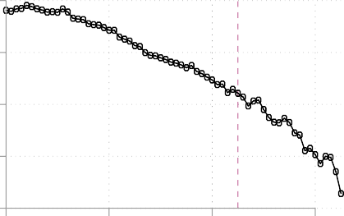
55

50
Index: 0-100

45

40

35
20 40 60 80
Age

    - Healthy
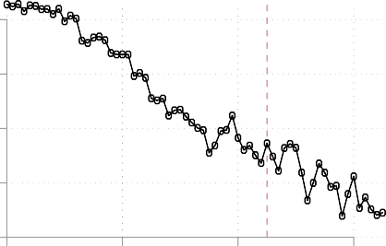
95

90
% healthy

85

80

75
20 40 60 80
Age

    - SF-12v2 index: Standard Deviation
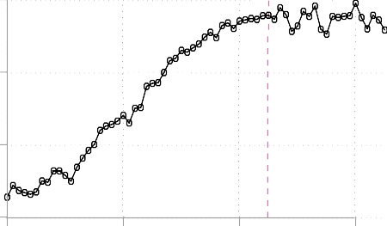
12

10

8

6
20 40 60 80
Age

    - Healthy: Standard Deviation
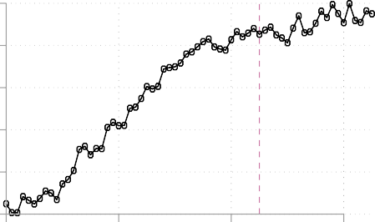
45

40

35

30

25

20
20 40 60 80
Age

Source: MEPS 1999-2009

Figure 1: Health status over the lifecycle
Note that, SF12v2 index is physical health index from Short-form 12 version 2. Self-reported index is Self- Reported Health Status, including 1-Excellent, 2-Very Good, 3-Good, 4-Fair, and 5- Poor Health. The healthy group consists of 1, 2 and 3; meanwhile, the unhealthy/sick group consists of 4 and 5.

0.50

0.40
- Health Exp.: Historgram

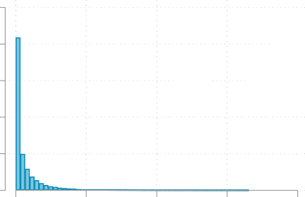
- Health Exp.: Over lifecycle
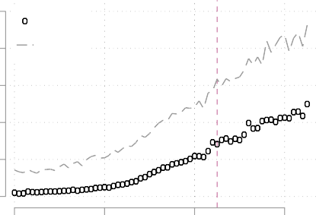
- Median
8 Mean

0.30

0.20

0.10

0.00

0 20 40 60 80
$1,000

6

4
$1,000

2

0
20 40 60 80
Age

[3] Health Exp.: Healthy vs Sick
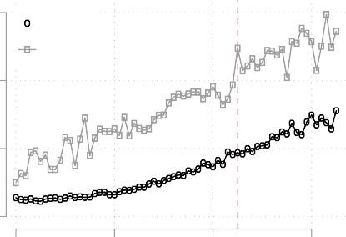
15 Healthy
Sick
10
$1,000

[4] Health Exp.: % of income
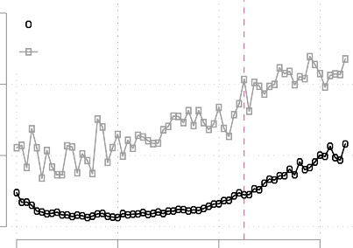
150 Healthy
Sick
100
%

5 50

0
20 40 60 80
Age

0
20 40 60 80
Age

Figure 2: Total health expenditure across health state and over the lifecycle

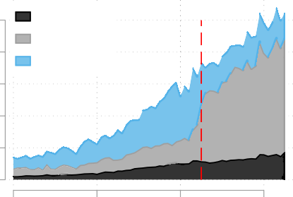
- Health financing
10 Out-of-Pocket Public

100

Not insured Public
- Insurance status

8 Private
$1,000
6

4

2

0
20 40 60 80
Age
80 Private 60
40
%

20

0
20 40 60 80
Age

- Private insurance
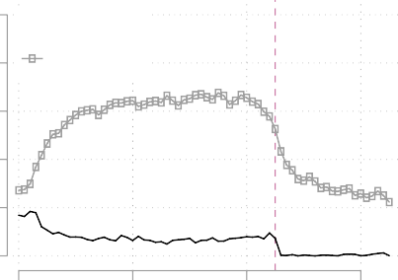
100 IHI-Individual

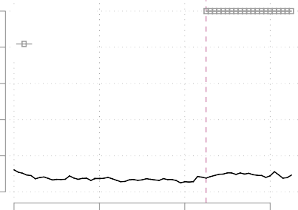
100 Medicaid

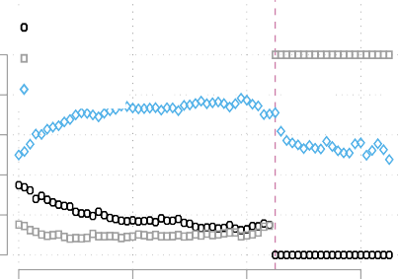
- Public insurance

80 GHI-Group 80 Medicare

60 60
%
%

40 40

20 20

0
20 40 60 80
Age
0
20 40 60 80
Age

Figure 3: Health financing and insurance take up rates over the lifecycle

4.0
3.5
3.0
2.5
C.V.
2.0
1.5
1.0
0.5

- Coefficient of variation
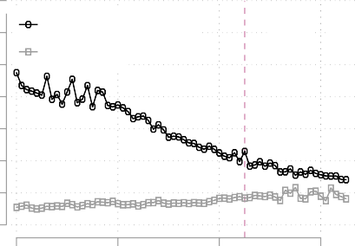
Health Exp. Income

70 Healthy
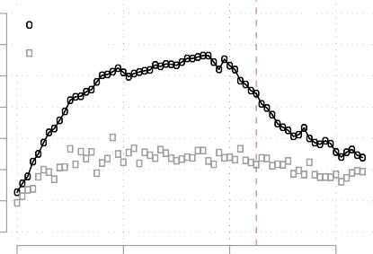
60 Sick
50
$1,000
40
30
20
10
0

- Total income

20 40 60 80
Age
20 40 60 80
Age

- Out-of-pocket health exp. (OOP)
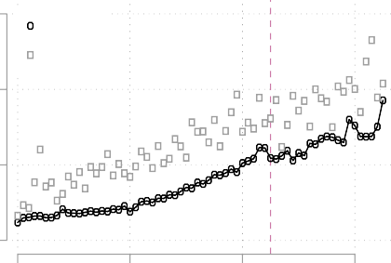
3 Healthy Sick

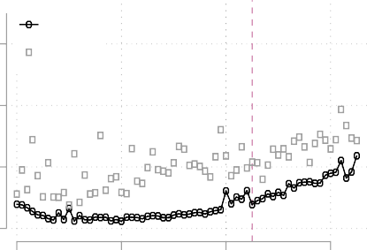
Healthy
30 Sick

- OOP as % of income

2
$1,000
20
%

1 10

0
20 40 60 80
Age
0
20 40 60 80
Age

Figure 4: Health status, income and out-of-pocket (OOP) health expenditure

140

120
Med-Spend. % of Income

100

80

60

40

20

0
- Medical Spending in % of Income
Dat | a MEPS
Mo | del
 |  |  |  | Reti
20 30 40 50 60 70 80 90
Data CMS
red: 65
Age

0.7

0.6

0.5

0.4

0.3

0.2

0.1

0.0
- Med-Spend. Distr.
Data
Model
0 20 40 60 80
Med. spending ($1,000)

100
Data Model
[3] IHI %

100
Data Model
[4] GHI %

100
[5] Medicaid %

80 80 80
Data Model

60 60 60
%
%
%

40 40 40

20 20 20

0
30 40 50 60
Age
0
30 40 50 60
Age
0
30 40 50 60
Age

Figure 5: Health expenditure and insurance take-upModel vs. data from MEPS 2000-2009

1.4

1.2
Normalized Log Assets

1.0

0.8

0.6

0.4

0.2
- Assets

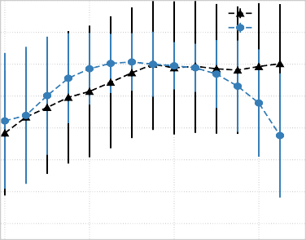
1.2
Data
Model
Normalized Log Income

1.0

0.8

0.6

0.4

0.2
- Income

0.0
20 40 60 80
Age

0.0
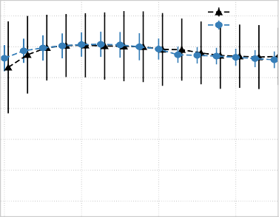
20 40 60 80
Data
Model
Age

1.0
Normalized Log Consumption

0.8

0.6

0.4

0.2

- Consumption

- Avge Labor Hours per Week
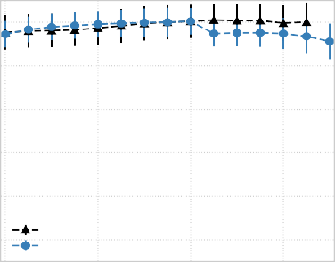
34
Data
Model
 |  |  | D  M | ata odel

32

30

28
Hours

26

24

22

0.0

20 40 60 80
Age

20

20 30 40 50 60
Age

Figure 6: Moment matching using PSID 1984-2007 and CPS 1999-2009
Blue lines are model generated data moments and black dotted lines are PSID data in Panel 1 and 2 and CPS data in Panel 3.

[1] Wage Income by Health Status) [2] Wage Income by Sick/Poor
Mean Wage Income (Normalized)
Mean Wage Income (Normalized)

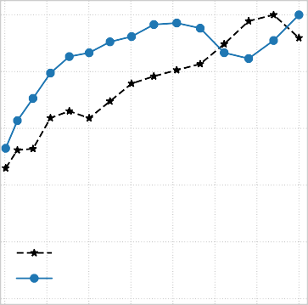
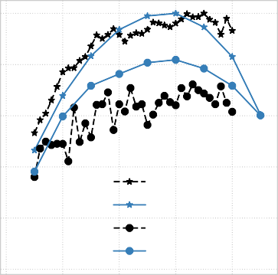
1.0 1.0
MEPS
Model

MEPS-Healthy Model-Healthy MEPS-Sick Model-Sick

0.8 0.8

0.6 0.6

0.4 0.4

0.2 0.2

0.0
0.0 0.5 1.0 1.5 2.0 2.5 3.0 3.5
Health Capital
0.0

20 30 40 50 60
Age

Figure 7: Moment matching using MEPS 2000-2009
Blue dots are model generated data moments and green dots lines are from PSID data.


- Income Distribution
 |  |  |  |  |  | D M | ata odel

0.025

0.020

0.015

0.010

0.005

0.000

0 20 40 60 80 100 120 140
Income in $1,000

- Wage Distribution

0.035
 |  |  |  |  |  | D M | ata odel

0.030

0.025

0.020

0.015

0.010

0.005

0.000

0 20 40 60 80 100 120 140
Wage in $1,000

Figure 8: Moment matching using MEPS 2000-2009
Blue dots are model generated data moments and green dots lines are from PSID data.

      - Total Tax
Bench | mark-U.S. Ta | x
Bench | mark-Optimal
HSV (  CK (2 | 2017)-Optimal 006)-Optimal

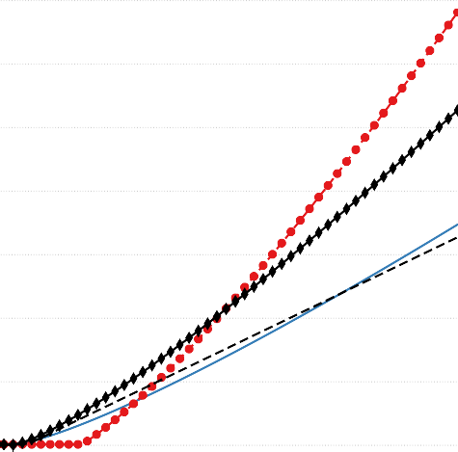
70

60

50
Taxes in $1,000

40

30

20

10
      - Average Tax Rate
40
Bench | mark-U.S. Ta | x
Bench | mark-Optimal
HSV ( | 2017)-Optimal
CK (2 | 006)-Optimal

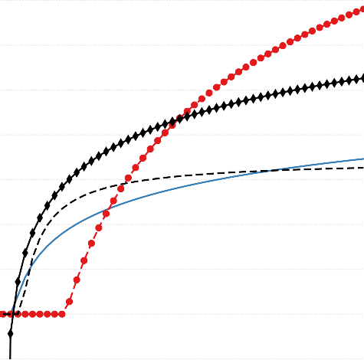
35

30

25

20
%

15

10

5

0

0 50 100 150 200
Income in $1,000

0

5 0 50 100 150 200
Income in $1,000

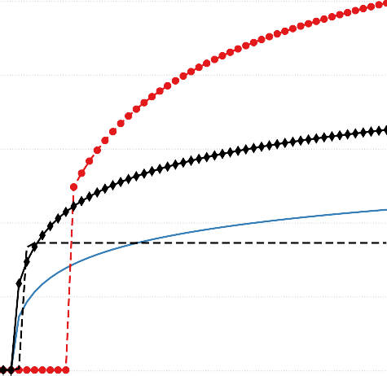
      - Marginal Tax Rate

Benchmark-U.S. Tax Benchmark-Optimal HSV (2017)-Optimal CK (2006)-Optimal

50

40

30
%

20

10

0

0 50 100 150 200
Income in $1,000

0.014

0.012

0.010

0.008

0.006

0.004

0.002

0.000
      - After-Tax Income Distribution
 |  | Benchm | ark-U.S. Tax
 |  | Benchm | ark-Optimal
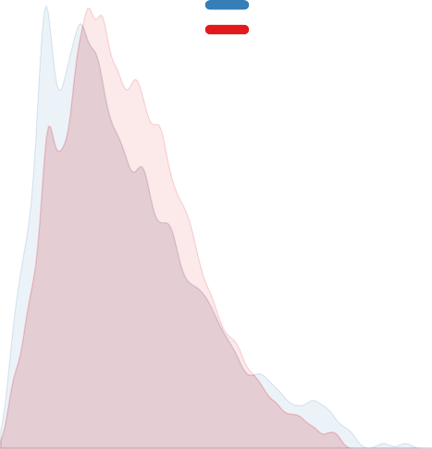
0 50 100 150 200
Disposable Income in $1,000

Figure 9: The optimal income taxes in the benchmark calibrated economy
Progressive income taxes of the pre-ACA benchmark case are based on Guner, Lopez-Daneri and Ventura (2016) that uses the tax polynomial introduced in Benabou (2002). The Conesa and Krueger (2006) case is based on a model without health shocks and health insurance and uses a tax polynomial based on Gouveia and Strauss (1994). The optimal tax function consists of a tax break up to US$ 36, 400, a scaling parameter of λ∗ = 2.317,
and a tax progressivity parameter of τ ∗ = 0.237.

0.0
- Consumption (C)
- Medical Spending (p_{m}M)
0

2.5 2

5.0 4
Coef. of Variation (%)
Coef. of Variation (%)

7.5 6

10.0 8

12.5 10

15.0 12

17.5 14

20 40 60 80 100
Age

20 40 60 80 100
Age

- Income (I)
0

2

4
Coef. of Variation (%)

6

8

10
12

14
20 40 60 80 100
Age

Figure 10: Change in the coefficient of variation by age group after introducing the optimal progressive income tax.
We report the difference in the coefficient of variation of variable x by age group: CV(x-optimal) - CV(x-US benchmark) where x is either consumption, medical spending or gross income.

[1] Net Income [2] Consumption

10

10 5
Percent Change (%)
Percent Change (%)

0
0
5

10 10

15
20
20

30
Poor Income 2 Income 3 Rich
Income Groups

25

Poor Income 2 Income 3 Rich
Income Groups

- Healthcare Quantity

0

2
Percent Change (%)

4

6

8

10
Poor Income 2 Income 3 Rich
Income Groups

0.05

0.00
Percent Change (%)

0.05

0.10

0.15

0.20

0.25

0.30
- Health
Poor Income 2 Income 3 Rich
Income Groups

- Percent Bad Health
0.06

0.05

0.04
Percent Change (%)

0.03

0.02

0.01

0.00
Poor Income 2 Income 3 Rich
Income Groups

Figure 11: Changes after introducing the optimal progressive income tax system
We express the difference in percentage changes of average values per income group from optimizing taxes in the benchmark economy.

- Total Tax
Bench  ACA- | mark-Optimal Optimal

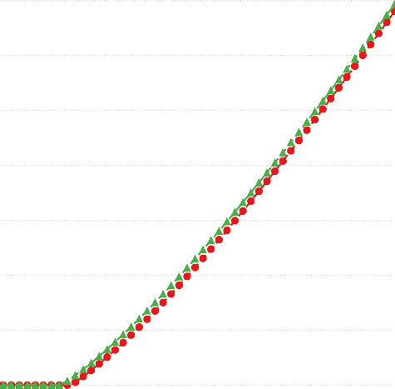
70

60

50
Taxes in $1,000

40

30

20

10
- Average Tax Rate
40
Bench  ACA- | mark-Optimal Optimal

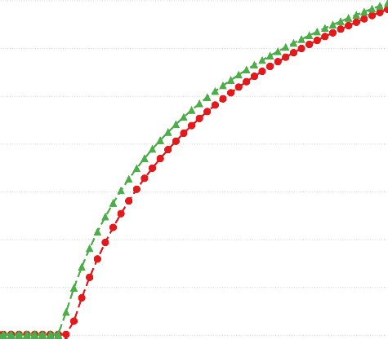
35

30

25

20
%

15

10

5

0

0 50 100 150 200
Income in $1,000

0

5 0 50 100 150 200
Income in $1,000

- Marginal Tax Rate
Bench  ACA- | mark-Optimal Optimal

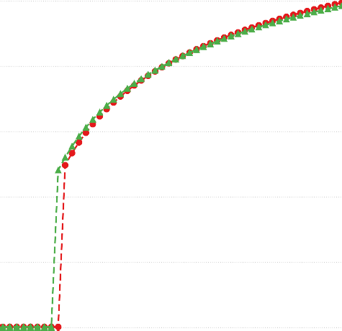
50

40

30
%

20

10

0

0 50 100 150 200
Income in $1,000

0.016

0.014

0.012

0.010

0.008

0.006

0.004

0.002

0.000
- After-Tax Income Distribution
 |  | Bench  ACA-O | mark-Optimal  ptimal
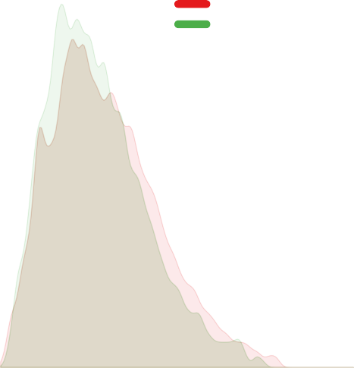
0 50 100 150 200
Disposable Income in $1,000

Figure 12: The optimal income tax systems before and after the ACA
Progressive income taxes of the pre-ACA Benchmark case are based on Guner, Lopez-Daneri and Ventura (2016) and use the tax polynomial introduced in Benabou (2002). The red-circled line is the optimal tax without the ACA and the green-triangle line is the optimal tax with the ACA. The optimal tax function after the ACA is characterized by a tax break up to US$ 30, 300, a scaling parameter of λ∗ = 2.117, and a tax progressivity
parameter of τ ∗ = 0.222.

1.0

0.8

0.6
Income-Tax (cumulative %)

0.4

0.2

0.0
Tax Lorenz Curves and Suits Index

 | Suits Index = | A
 |  | A + B
 |  | A | B
0.0 0.2 0.4 0.6 0.8 1.0
Income (cumulative %)

Figure 13: Lorenz curves and Suits Index for the income taxes
The Tax Lorenz-type curve and Suits index measure the degree of disproportionality between pretax income and tax contributions by means of a relative concentration curve. The Suits index is essentially a Gini coefficient for tax contributions by income group. It varies from +1 (most progressive) where the entire tax burden is allocated to households of the highest income bracket, through 0 for a proportional tax, and to −1 (most regressive) where the entire tax burden is allocated to households of the lowest income bracket.

1.0
- Lorenz-Curves: Income

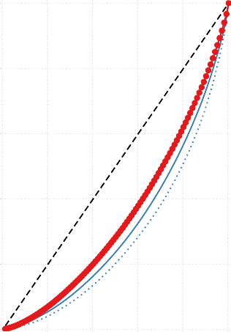
1.0
45
Bench: Income Bench: After-Tax Inc.
Bench-Optimal: After-Tax Inc.
- Suits-Curves: Income-Tax

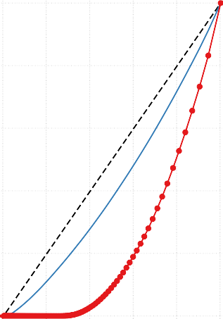
1.0
45
Benchmark Benchmark-Optimal
- Suits-Curves: Total-Tax

0.8
Income-Tax (cumulative %)
Total-Tax (cumulative %)
0.8
0.8

0.6
Income (cumulative %)
0.6
0.6

0.4
0.4
0.4

0.2
0.2
0.2

0.0 |  |  |  |  |  | 0.0 |  |  |  |  |  | 0.0
0.0 | 0.2 | 0.4 | 0.6 | 0.8 | 1.0 | 0.0 | 0.2 | 0.4 | 0.6 | 0.8 | 1.0 | 0.0 | 0.2 | 0.4 | 0.6 | 0.8 | 1.0

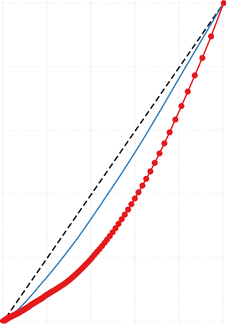
Population (cumulative)
45
Benchmark Benchmark-Optimal
Income (cumulative %)
Income (cumulative %)

- Lorenz: After-Tax Inc. & ACA
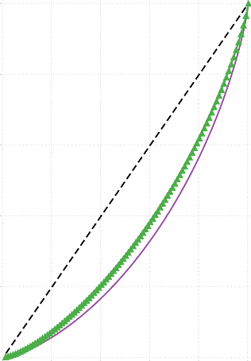
1.0
45
ACA
ACA-Optimal

1.0
- Suits: Income-Tax & ACA

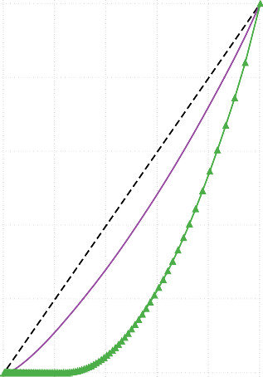
1.0
45
ACA
ACA-Optimal
- Suits: Total-Tax & ACA

0.8
After-Tax Income (cumulative %)
Income-Tax (cumulative %)
Total-Tax (cumulative %)
0.8
0.8

0.6
0.6
0.6

0.4
0.4
0.4

0.2
0.2
0.2

0.0 |  |  |  | 0.0 |  |  |  |  |  | 0.0
0.0 | 0.2 | 0.4 | 0.6 | 0.8 1.0 0.0 | 0.2 | 0.4 | 0.6 | 0.8 | 1.0 | 0.0 | 0.2 | 0.4 | 0.6 | 0.8 1.0

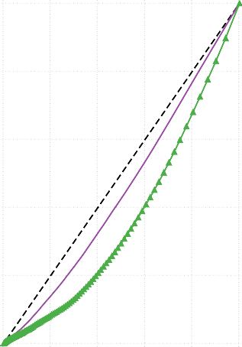
Population (cumulative %)
45
ACA
ACA-Optimal
Income (cumulative %)
Income (cumulative %)

Figure 14: Income and Income Tax Lorenz Curves
Panel [1] presents Lorenz curves of taxable income (pre-ACA Benchmark), Panel [2] presents Suits curves of progressive income taxes based on Suits (1977) and Panel [3] presents Suits curves of total taxes, that is consumption taxes, progressive income taxes, and payroll taxes for social security and Medicare. For the ACA case total taxes also include a new tax on investment income of high income earners and penalties for being uninsured. Panel [4-6] present the cases with the ACA.
Progressive income taxes of the pre-ACA Benchmark case are based on Guner, Lopez-Daneri and Ventura (2016) and use the tax polynomial introduced in Benabou (2002). The ACA case uses the same tax structure as the pre-ACA Benchmark case.

- Total Tax
Bench  UPHI- | mark-Optimal Optimal

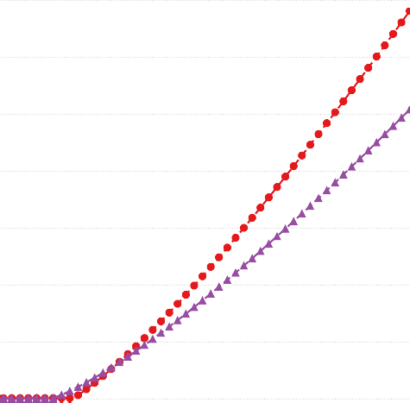
70

60

50
Taxes in $1,000

40

30

20

10
- Average Tax Rate
40
 |  | Bench | mark-Optimal
 |  | UPHI-O | ptimal

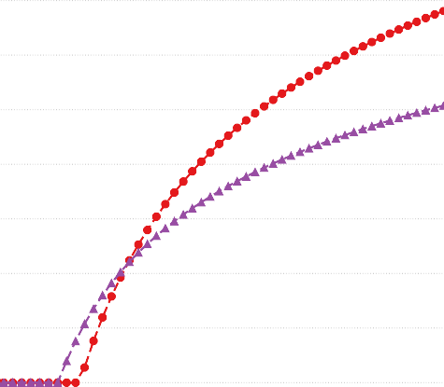
35

30

25

20
%

15

10

5

0

0 50 100 150 200
Income in $1,000

0

5 0 50 100 150 200
Income in $1,000

- Marginal Tax Rate
Bench  UPHI- | mark-Optimal Optimal

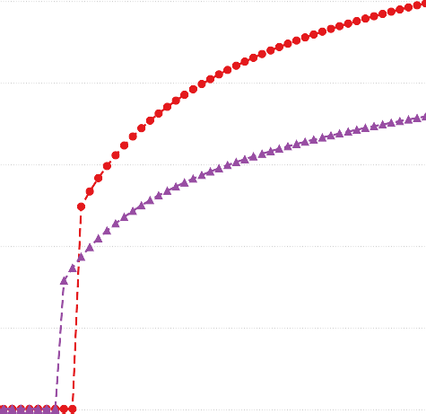
50

40

30
%

20

10

0

0 50 100 150 200
Income in $1,000

0.014

0.012

0.010

0.008

0.006

0.004

0.002

0.000
- After-Tax Income Distribution
 |  | Bench | mark-Optimal
 |  | UPHI-O | ptimal
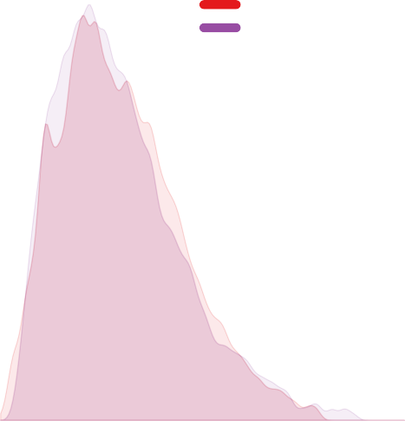
0 50 100 150 200
Disposable Income in $1,000

Figure 15: The optimal income tax system after introducing a universal public health insurance (UPHI) system
Progressive income taxes of the pre-ACA Benchmark case are based on Guner, Lopez-Daneri and Ventura (2016) and use the tax polynomial introduced in Benabou (2002). The red-circled line is the US optimal tax benchmark case without the ACA and the purple-triangle line is the optimal tax with UPHI. The optimal tax function consists a tax break up to US$ 26, 200, a scaling parameter of λ∗ = 1.567, and a tax progressivity parameter of τ ∗ = 0.140.

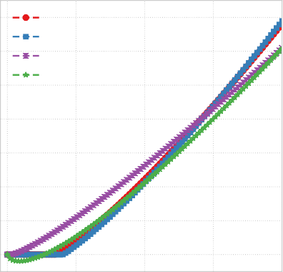
  - Total Tax
Benchmark-Optimal
- No Insurance-Optimal
- No Health Shock-Optimal
- Negative Taxes-Optimal
70

60

50
Taxes in $1,000

40

30

20

10

0
  - Average Tax Rate
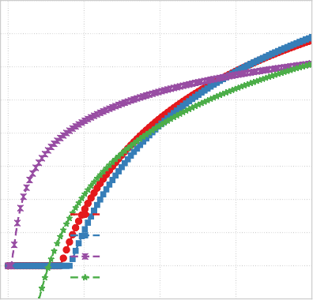
40
50
35

30 40

25
30
20
%
%

15 20
10
Benchmark-Optimal 10
5 [1] No Insurance-Optimal
0 [2] No Health Shock-Optimal
  - Negative Taxes-Optimal 0
- Marginal Tax Rate

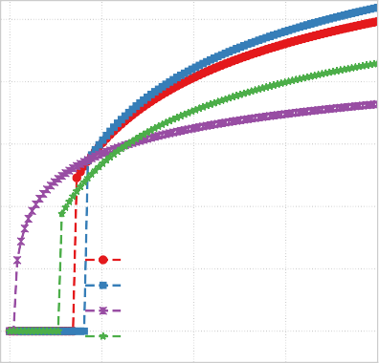
Benchmark-Optimal
  - No Insurance-Optimal
  - No Health Shock-Optimal
  - Negative Taxes-Optimal

0 50 100 150 200
Income in $1,000
5 0 50 100 150 200
Income in $1,000
0 50 100 150 200
Income in $1,000

0.014

0.012

0.010

0.008

0.006

0.004

0.002

0.000
  - After-Tax Income Distribution
 | B  N | enchmark-  o Insuranc | Optimal  e-Optimal
0 50 100 150 200
Disposable Income in $1,000

0.016

0.014

0.012

0.010

0.008

0.006

0.004

0.002

0.000
  - After-Tax Income Distribution
Benchmark-Optimal
No Health Shock-Optimal
0 50 100 150 200
Disposable Income in $1,000

0.014

0.012

0.010

0.008

0.006

0.004

0.002

0.000
  - After-Tax Income Distribution
 | Be  Ne | nchmark-O  gative Taxe | timal  s-Optimal
0 50 100 150 200
p
Disposable Income in $1,000

56
Figure 16: Sensitivity analysis of optimal taxes
Progressive income taxes of the pre-ACA Benchmark case are based on Guner, Lopez-Daneri and Ventura (2016). The red-circle line is the optimal tax without the ACA, the blue squares line is the optimal tax without any health insurance contracts, the purple-x line is the optimal tax structure allowing for negative taxes and the and the green starred line is the optimal tax without any idiosyncratic health shocks. The no insurance case: a tax break up to US$ 42, 400, λ∗ = 2.681 and
τ ∗ = 0.266; the negative tax case: a tax break up to US$ 28, 300, λ∗ = 1.808 and τ ∗ = 0.180.

    - Total Tax
 |  |  |  | No H-Sho | ck-U.S. Tax
 |  |  |  | No H-Sho HSV (201 | ck-Optimal 7)-Optimal

70

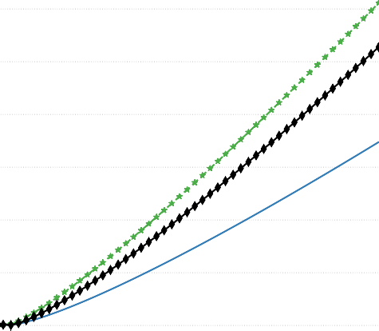
60

50
Taxes in $1,000

40

30

20

10
    - Average Tax Rate
40
 |  |  |  | No H-Sho No H-Sho | ck-U.S. Tax ck-Optimal
 |  |  |  | HSV (201 | 7)-Optimal

35

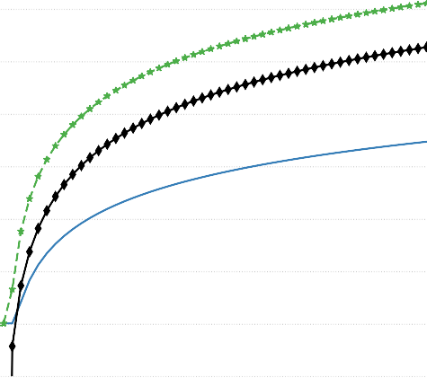
30

25

20
%

15

10

5

0

0 50 100 150 200
Income in $1,000

0

5 0 50 100 150 200
Income in $1,000

    - Marginal Tax Rate
 |  |  | No H-Sho |  | ck-U.S. Tax
 |  |  |  | No H-Sho HSV (201 | ck-Optimal 7)-Optimal

50

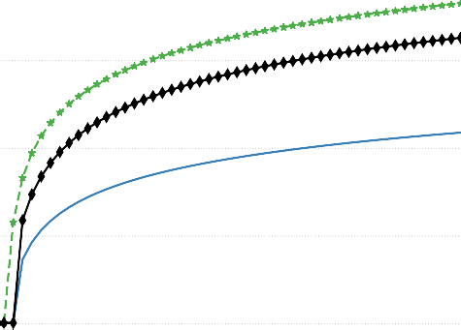
40

30
%

20

10

0

0 50 100 150 200
Income in $1,000

0.016

0.014

0.012

0.010

0.008

0.006

0.004

0.002

0.000
    - After-Tax Income Distribution
 |  | No H-Sho  No H-Sho | ck-U.S. Tax  ck-Optimal
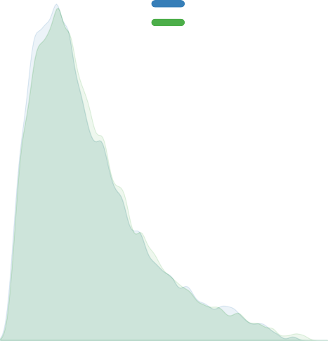
0 50 100 150 200
Disposable Income in $1,000

Figure 17: No health shock case
Progressive income taxes of the pre-ACA Benchmark case are based on Guner, Lopez-Daneri and Ventura (2016) and use the tax polynomial introduced in Benabou (2002). The blue solid line is the US tax case, the green line with star markers is the optimal tax case for the no health shock version of the model and the black line with diamond markers is the. The optimal tax function consist of a tax break up to US$ 4, 040, a scaling parameter of λ∗ = 1.091, and a tax progressivity parameter of τ ∗ = 0.085.
57

