Early Childhood Education: Environmental Factors’ and Interventions’ Impact on Diagnosis in Disadvantaged Communities
John C. Dowding

Submitted in Partial Fulfillment of the Requirements for the
Degree of Master of Education

May 2017

Graduate Programs in Education
Goucher College

Table of Contents
List of Tables | i
Abstract | ii
I. Introduction | 1
Overview | 1
Statement of Problem | 1
Research Question | 1
Operation Definitions | 2
II. Review of the Literature | 3
Disabilities/Developmental Delays in Early Childhood Education | 3
Identification of Disabilities/Delays | 5
Pre-referral Interventions vs. RTI | 6
Misdiagnosis/Lack of Diagnosis in Disadvantaged Communities | 12
Summary | 14
III. Methods | 15
Design | 15
Participants | 15
Instruments | 16
Procedure | 16
IV. Results | 18
V. Discussion | 26
Implications | 27
Threats to Validity | 28
Connections to Previous Studies | 29
Implications for Future Research | 30
Summary | 31
References | 32

List of Figures
1. Figure 1.1 Question #1 | 18
2. Figure 1.2 Question #2 | 19
3. Figure 1.3 Question #3 | 19
4. Figure 2.1 Question #4 | 20
5. Figure 2.2 Question #7 | 20
6. Figure 2.3 Question #8 | 21
7. Figure 2.4 Question #5 | 21
8. Figure 2.5 Question #6 | 22
9. Figure 2.6 Question #9 | 22
10. Figure 3.1 Question #10 | 23
11. Figure 3.2 Question #11 | 23
12. Figure 3.3 Question #12 | 24
13. Figure 3.4 Question #14 | 24
14. Figure 3.5 Question #13 | 25

Abstract
The purpose of this study was to determine the impact of environmental factors in disadvantaged communities on misdiagnosis or a lack of a diagnosis, and the implications of pre-referral and Response to Interventions (RTI) on student identification for services based on the perceptions of staff working in an early childhood education center. The measurement instrument that was used for this study was a hard copy survey given to staff members in an early childhood education center in northeast Washington, DC. The perceptions of the staff were positive about pre-referral intervention and RTI’s ability to remedy the environmental factors children are confronted with in disadvantaged communities. Future research should investigate the various success rates of pre-referral interventions and RTI in various different communities to determine the impact of environmental factors in different communities on children’s social-emotional development and academic progress.

CHAPTER I
INTRODUCTION
Overview
Children and adults, specifically staff members in an early childhood education center, in disadvantaged communities encounter environmental factors that present challenges that can compromise pre-referral interventions and Response to Intervention (RTI) capabilities. Pre-referral interventions and RTI are models of strategies and methods that focus on aiding children with their social-emotional development and academic progress in disadvantaged communities (Block, Balcazar, & Keys, 2002). Environmental factors such as socio-economic status, homelessness, prejudice, stigma of disabilities, and domestic abuse impact a child’s need for services and a diagnosis, and contributes to children receiving a misdiagnosis or a lack of a diagnosis. The purpose of this study was to determine the impact of environmental factors in disadvantaged communities on misdiagnosis or a lack of a diagnosis, and the implications of pre-referral and Response to Interventions (RTI) on student identification for services based on the perceptions of staff working in a early childhood education center.
Statement of Problem
This study examined staff members' of an early childhood education center perceptions of environmental factors, pre-referral interventions, and Response to Interventions (RTI) in disadvantaged communities and the impact that they have on a misdiagnosis or a lack of a diagnosis for a child.
Research Question
What are the perceptions of staff regarding environmental factors, pre-referral interventions, and Response to Interventions (RTI) in disadvantaged communities and the impact that they have on the diagnosis or services that children receive?
Operation Definitions
The following variables are examined in this study. A variable in this study is the people chosen to participate in this survey, which were staff members from an early childhood education center. Another variable is the community that was identified as to where the participants would be picked. The community that was chosen is a disadvantaged community in northeast Washington, DC. Additionally, a variable examined in this study is the perceptions of the community’s environmental factors and their beliefs on the success of pre-referral interventions and RTI. The environmental factors that are present in the disadvantaged community are variables as well that were examined in this study. The variable of environmental factors within this study that were examined was homelessness, domestic abuse, socio-economic status, stigma of disabilities, and prejudice.
Pre-referral interventions normally includes a team of professionals (IE: Special Needs Coordinator, Mental Health Consultant, Doctor, Therapists, etc), staff members who work with the child in the center, and family members/guardians. The team employs the interventions in five adaptive stages that use evidence based strategies and methods to assist the child who is presenting behavioral and/or learning concerns (Buck, 2013). RTI is a tiered process, which normally includes three rigid tiers, with each tier building upon the previous tier. With RTI, the next tier cannot be accessed until the previous tier has been fully explored and implemented.

CHAPTER II
REVIEW OF THE LITERATURE
The literature review is comprised of four sections that will first define disability and developmental delay concerns. The second section explores the environmental factors of disadvantaged communities, which will lead into a review of best practices for early identification of special education needs. The final section will compare the use and effectiveness of pre-referral interventions and response to interventions.
Disabilities/Developmental Delays In Early Childhood Education
Early identification for a disability or delay in early childhood education is not only important for a child’s development and health but also for his/her future. Mackrides and Ryherd (2011) stated that “6-8% of American children enter kindergarten with an undetected developmental delay” (p. 1). This statistic illustrates how pertinent it is to understand and define what constitutes a concern for a disability/delay in a child. Without this fundamental understanding, the proper tools, and staff support, that rate of unidentified children will remain the same or grow. Because early intervention has a positive impact on IQ, academic achievement, and future employment as an adult with children that have a low socioeconomic background (Mackrides & Ryherd, 2011). It’s important for families and educators to be clear about developmental concerns and interventions to ensure long-term negative consequences do not emerge from failure to address early concerns about development or learning.
What constitutes a concern from the perspective of an early childhood educator depends upon the child’s age and the relevant norms for where the child should be developmentally. Moreover, assessors and caregivers need to take into consideration various areas of development, and have a clear definition of the concern which is applied consistently to children at the school or center. An aspect of identifying a disability/delay that should be noted is what Harrison (2005) calls the difference between identification and diagnosis. It is essential that the person conveying a concern about a child can discern that “identification focuses on an educational need, as opposed to a diagnosis, which centers on a cause for the noted difficulties” (Harrison, 2005, p. 3). Noting this difference can help teams determine what interventions need be implemented once a concern has been established. Moreover, teams should know that a disability can only be diagnosed after an evaluation or multiple evaluations. Mistaking the identification of a concern with a diagnosis can be detrimental to a child because it can present the wrong impression to others who will be working with the child. Additionally, confusing identification with a diagnosis can limit the investigation of possible other delays or disabilities by immediately assuming a diagnosis, which could be incorrect, should dictate pre-determined interventions.
Concerns can arise in or stem from more than one area of a child’s development. In infancy – pre-k, the main areas of concern tend to be communication, gross motor, fine motor, problem solving, cognitive, adaptive, social-emotional. Recognizing the different areas of development is crucial in differentiating a concern from a disability because if assessors fail to look at multiple issues that may be affecting the child, and an incomplete or incorrect diagnosis drives the services he or she is provided, it could “…prevents students from receiving additional services that may be necessary for school success” (Cormier-Lavergne, 2010, p. 44).
In addition to not recognizing the importance of all areas of development, when a school/center does not have unified procedures and/or good operational definitions for what constitutes a concern, and when it does not follow other best practices, it can also impede the assessment and diagnostic process, leading to the child failing to receive services he or she may require. The definition of disabilities or delays reflected in or caused by a concern need to be explicit and clear, so there is minimal confusion as to what is being discussed. Second, the definition is understood in the same manner by the school/center’s staff. Furthermore, the definition is understood with other organizations that the school/center’s staff interacts with, and is understood by affected families. The concern is assessed in a way that yields factual data, observations, and assessment results. Lastly, the information gathered about the concern aids the process of creating effective interventions that will achieve the most positive outcomes for the child and the school/center. These interventions include modifications to the environment or they are specifically tailored to address a true learning difference identified in a child (Dombrowski, Kamphaus, Barry, Brueggeman, et al. 2006).
Early Identification of Disabilities/Delays
Best practices for early identification reflect and include understanding of the theories, methods, and strategies in which early childhood schools and/or child care centers employ to identify a concern about a possible developmental delay or disability. While the theories, methods, or strategies employed by a school/center/organization staff are pertinent, in the pre-diagnosis stage it is essential and legally mandated, by the Individuals with Disabilities Act (IDEA), that implementing interventions to help determine and discriminate whether a disability or a developmental delay is present. Schools with students who have been identified with a developmental concern or are at risk are required by IDEA to implement interventions that will help him/her to make sufficient progress towards reaching their goals. Interventions required by IDEA, are preferred to be enacted and observed as early as possible to achieve maximum impact in the child’s academic career (Cormier-Lavergne, 2010).
Without interventions or with too few interventions, children in need of support may fall behind in various developmental areas. Schools that provide students few to no interventions or programs that were designed to close achievement gaps in a child’s academic career and developmental achievements have higher rates of disadvantaged students who have reading delays that are compounded with low cognitive skills (Harrison, 2005). Schools that do not offer interventions or very few interventions have more children with low cognitive skills and that is exacerbated in disadvantaged communities in which the rates of low cognitive skills are higher. The lack of proper interventions can lead to a misdiagnosis that could have been addressed by interventions. Pre-referral interventions explore the entirety of the child’s life that impacts their education, such as their family life, socio-economic status, etc. Best practices in identifying and assessing a concern help ensure the cause of the concern is properly identified and the interventions address it appropriately and in a timely manner.
Another aspect of best practices in early identification of a disability/developmental delay, and the use of interventions involved in the process, is that teachers in schools and child care centers are supported by their administrators. Support includes professional development and training in implementing interventions. Hooper (2011) stated that teachers should be able to complete tasks such has differentiating their instruction, have a fundamental understanding of how to write practical and functional IEP goals and to implement interventions.
Pre-referral Intervention vs. RTI
This section of the paper will focus on primarily two types of interventions, one being pre-referral intervention and the other being Response Tiered Intervention, which are the most successful interventions. These interventions have been discussed in the operational definitions section, and the practicalities and application will be discussed in the methods section of this paper. Pre-referral intervention has been promoted as a way to lower the amount of improper special education evaluations, eligibilities, and placements for children, especially children who have backgrounds that are culturally diverse (Buck, 2013).
Pre-referral interventions, in early childhood education, specifically for infants – 5 years old, is preferred to RTI, because it looks at the whole child, and includes multiple factors in his/her life rather than just focusing on the area of concern itself as does RTI. PRI includes a team of professionals, staff, and family that employ problem solving strategies and methods with the intention of addressing the needs of students who display behavioral and/or learning concerns (Buck, 2013). PRI includes teachers, social workers, administrators, therapists, parents, and/or other pertinent people in the child’s life. Another positive facet of pre-referral intervention is that it avoids the traditional screening approach of an “emphasis on student deficits, rather than how environmental aspects of the classroom could be contributing to the student’s problems” (Buck, 2013, p. 1). This can reduce the chance of children being misdiagnosed with a developmental delay or a disability because of a focus on problems that could be misdiagnosed. Pre-referral intervention includes looking at environmental factors such as, “has there been a change at home?”, “what socio-economic situation does the child come from?”, “does the child come from a family with a history of disabilities?”, “are there any new health concerns that have come up in the child’s life?” etc. which could impact the child’s developmental status and educational functioning. Additionally, PRI acknowledges that not all developmental delays, learning issues or social emotional/behavioral concerns are an indication of or rooted in a disability.
Pre-referral intervention normally occurs in five stages. In the first stage, referral to prereferral, an adult in the child’s life such as a staff member/educator at his/her school, or a family member acknowledges that the child is struggling in one more area in his/her academics. The areas included are academics, social/emotional skills, and behavior. In this stage, the school’s intervention team/pre-referral team receives a referral. During the second stage, problem analysis, the intervention team schedules and holds a prereferral meeting to discuss the concerns that has been presented in the referral. This meeting can also include the child’s parent(s)/guardian(s). The third stage, prereferral intervention generation (which takes place during the initial prereferral meeting) is when the intervention team, with the possible inclusion of the parent(s)/guardian(s), deliberates about what strategies and methods will best make sufficient progress towards resolving the child’s delay, concern, and/or difficulties. The fourth stage, prereferral intervention implementation, is immediately enacted after the prereferral meeting. The prereferral interventions are implemented by all pertinent school staff members such as: teacher(s), assistant teacher(s), and a classroom aide(s). Staff members at times also assist the teacher with data collection to allow the teacher to fully implement the intervention strategies. The fifth stage, follow-up, once a predetermined amount of time, usually 4-6 weeks, has passed, the intervention team schedules and holds another meeting. During this meeting the teams discusses the progress or lack of progress that the child has made since the interventions were implemented. If the child has displayed sufficient progress indicating that the concern has been resolved, then the child’s case can be closed and there is no need for any other actions to take place. If a child has exhibited insufficient progress indicating that there has been little or no improvement, then various actions or a combination of actions will be decided on. The staff member(s) that have been implementing the intervention strategies can be told to enact altered and adjusted versions of initially determined strategies, or they can be instructed to implement ultimately new strategies, and to continue to collect data regarding the delay, concern, and/or difficulties. During the fifth stage the intervention team might also decide that a referral for a thorough evaluation by an organization, agency, assessment, that might lead to the child acquiring an IFSP/IEP (Buck, 2013). As is seen in the five stages, all pertinent members’, which includes parents, input is highly valued and all the factors that impact the area of concern with the child are investigated. Likewise, the child is allotted a pre-designated amount of time to benefit from the interventions to see if he/she is successful before even being considered for referral for an evaluation. Furthermore, pre-referral intervention takes into account that an intervention might need modification to work best or that a completely new intervention should be attempted before a referral is made. This allows the child the best chance of receiving the help that he/she need to achieve his/her goals and to not be misdiagnosed with a developmental delay or a disability if one is not the actual cause of the child’s behavior or issue of concern.
Response to Intervention (RTI) is a process that involves three tiers which, compared to pre-referral intervention’s five stages, are a rigid, specific process that is followed in order. RTI is a process that has less room for differentiation than PRI. The stages of PRI can be modified to each specific situation, school and/or center. With RTI, each tier builds upon the previous one and cannot be reached until the previous tier is fully exhausted. The first tier, high-quality classroom instruction, screening, and group interventions, involves all children within a school/center receiving high-quality instruction that is provided by school staff that are qualified and employ scientifically based instruction. This eliminates the possibility that a child’s delay and/or difficulties are due to deficient instruction. In this tier, children are consistently and periodically assessed to create a baseline for the children’s academics and behaviors, and to recognize children who are struggling and need supplementary supports. Furthermore, these children that have been identified as at risk students receive additional instruction throughout the day while they attend a school and/or center. The first tier can last up to eight weeks, but not longer than eight weeks. At the end of the predetermined time, or 8 weeks, if the child has displayed sufficient progress then the additional supplemental support is removed. Children who exhibit insufficient progress continue to the second tier. The second tier, targeted interventions, is when a child is given increased comprehensive instruction. The type of intensive instruction is based on the child’s current levels of performance and his/her rates of progress. During this tier the instruction and interventions are implemented in small group settings as a supplement to general curriculum instruction. This tier lasts longer than the first tier (8 weeks) but usually does not last longer than a grading period. At the end of the grading period, if the child has displayed sufficient progress then the child can go back to the first tier or return completely back to general curriculum instruction. Children who exhibit insufficient progress continue to the third tier. The third and final tier, intensive interventions and comprehensive evaluation, a child is provided with individualized interventions that specifically address the child’s delay, concern, and/or difficulties. A child who displays sufficient progress will return to the second tier or back to general curriculum instruction. Children who exhibit insufficient progress in response to the individualized interventions in the third tier are then referred for an intensive evaluation which can lead to the child receiving an IFSP/IEP. Information, data, and anecdotal observation notes from the previous three tiers are employed to make a decision in regards to the child’s eligibility for special services (Gorski, 2016).
A part of the first tier assumes best practices from administrators, teachers and instructors that are knowledgeable in all pertinent instructional methods, strategies, practices and interventions in order to provide students with the best quality education possible. Additionally, the first-tier states that there should be a continuous assessment of students to have a healthy amount of data to create a baseline for students to better gauge what type of intervention, if any, is needed to help the, achieve their goals. This tier also suggests that children in this tier should receive supplemental instruction throughout their day. The interventions “are differentiated instructional strategies that provide academic support in a general education setting” (Gabriel, 2011, p. 25) and “teachers are responsible for implementation and documentation of the interventions (Gabriel, 2011, p. 45). Additionally, during the first tier, teachers can decide what adaptations to instructional strategies must be made to help a student achieve his or her goals. Therefore, the first tier relies heavily on the total structure of the school/center because of the administrators’ need to make sure that their teachers are educated and sufficiently informed so they are able to properly execute the interventions needed to help children progress If after tier one interventions a child has not shown the pre-determined amount of progress, he or she is moved to the second tier. The main difference between tier one and tier two is that in tier two, the differentiated instruction is not only presented in a general education setting but may also be administered in settings where the child receives instruction in a group that normally includes other students who are also on the second tier. Another distinction from the first tier is that the second tier can take longer than 8 weeks to determine whether or not there has been sufficient progress demonstrated and if the child should move on to the third tier or not. Generally, in tier two the teacher is still the main provider of the differentiated instruction but other personnel, such as special educators and related service providers, may also administer additional supports to the child. The final tier, tier three, “is referred to as intensive individual interventions” (Gabriel, 2011, p. 17). These solely focus on the delay that the child is still displaying. Third tier interventions are no longer with other students and are purely individualized and administered as one on one instruction. If a student does not reach his/her goals or show sufficient progress after the individualized interventions, he or she is referred for an evaluation to determine whether or not he or she qualifies for special education services.
Both pre-referral intervention and response to intervention methods are successful processes to learn about concerns about children, positively impact their progress, and lower the chances of the child being misdiagnosed as having an educational disability. Pre-referral interventions focus on the student as a whole, and considers a spectrum of factors in their life which could result in concerns, such as; what his or her home environment, health status and how has he or she done historically, and data can be collected from a variety of school staff and family members/caregivers. This aspect of pre-referral intervention is related to Harrison’s (2005) distinction between identification and diagnosis, because it focuses on investigating the concern thoroughly and identifying interventions to help as opposed to being a direct line to a diagnosis. Thus, a sudden change in the child’s life such as a change in parental custody, a death in the family, or a temporary health issue that impacts school performance is less likely to result in a diagnosis of a disability or a developmental delay. RTI, focuses primarily on the child in the educational setting and the factors that stem from the educational setting that they are in. Each part of RTI is a reaction to the interventions in the previous tier not being successful. The solution proposed by RTI that is not immediately effective is a continued level of exclusion for the child who is not progressing with the idea that the exclusion will allow for more intensive individualized interventions.
Misdiagnosis/Lack of Diagnosis in Disadvantaged Communities
A misdiagnosis can also consist of a lack of a diagnosis when observations, assessment tools and other indicators suggest that a child truly does have a disability or a developmental delay. One contributing factor to a lack of appropriate diagnoses in disadvantaged communities is their cultural perspective of disabilities and how their viewpoint is based on a social mindset than in a medical context.
The lack of social justice in disadvantaged communities can lead to those in the community developing an understanding of disabilities or developmental delays as a social obstacle as opposed to a medical or inherent condition that needs to be treated. For example, “…having a spinal cord injury is a physiological impairment, but it is the inaccessibility of buildings as a matter of public policy that creates a barrier and results in exclusion” (Block, Balcazar, & Keys, 2001, p. 6). Due to shortcomings of public policy, such as: lack of proper funding, building accommodations, etc., the population in that community is not afforded to opportunity to look at the disability from the medical approach. Instead, the individuals in that neighborhood facing this challenge must determine how they will adapt to the inability to access a specific building or area and how that might affect them socially and otherwise. Therefore, when it is determined by the child’s team/school staff that a referral for an evaluation to assess if there is a disability or a developmental delay is needed, it should not be surprising when the parent(s) are not eager to bring their child to be evaluated. Additionally, The parent(s) may look at it as a social challenge in a community that has poor public transportation, or due to socio-economic situations they might have to work longer hours that inhibit them from being able to bring their child to be evaluated. Another conclusion that can be derived from examining how disadvantaged communities perceive disabilities and developmental delays is that it has been heavily influenced from a history of prejudice towards their population which will be discussed next.
Prejudices, many which are manifested in public policies that affect multiple facets of individuals’ lives, may negatively impact parent(s) of a child who is displaying signs of a possible disability or a developmental delay. When challenged by multiple social adversities, parents, even when they want to medically address their child’s developmental concern, may be preoccupied with the injustices that they are attempting to overcome or cope with. For example, social barriers and oppression, poverty, and exclusion, resulting from reduced opportunities and insufficient resources, is what people living with various stigmas endure (Block, et al., 2002, p. 3). This failure to address a possible disability or developmental delay could affect the child later in their life and result in perpetuating a cycle of generational poverty.
Summary
In conclusion, the process of early identification in early childhood education and the interventions involved in the determination of whether a referral for a special education evaluation is necessary or not has many facets to be considered. First, the concern is described clearly and the definition of the disability or developmental delay is clearly and concisely defined by the institution that the child attends and in accordance with federal and state definitions. The school/center has built a foundation based on best practices with early identification of disabilities or developmental delays. Moreover, the child’s team understands and recognizes the community from which the child comes as well as the factors and influences that are characteristic of that community. Research shows that when teachers have a fundamental understanding what a concern for a disability or developmental delay is and could reflect, they can implement best practices for early interventions that lead to resolution of the problem and/or appropriate early identification of disabilities or developmental delays.

CHAPTER III
METHODS
The purpose of this descriptive study was to examine the impact of environmental factors in disadvantaged communities on misdiagnosis or a lack of a diagnosis, and the implications of pre-referral and Response to Interventions (RTI) on student identification for services. This study examined the knowledge of the staff in an early childhood education center in regards to pre-referral interventions, RTI, and environmental factors and their impact on children’s eligibility.
Design
This study employed a descriptive survey method based on data collected from the researcher’s custom survey. The collected data is from the 2016-2017 school year from an early childhood education center located in a disadvantaged community in northeast Washington DC.
Participants
This study’s participants included staff from an early childhood education center that services children from a disadvantaged community in northeast Washington DC. The study focused on five groups: special needs service providers, teachers, instructional coaches, mental health consultants, and other (I.E. classroom assistant, classroom aide, etc.). Of the 15 participants who responded to the survey, 33.3% were teachers, 26.7% were special needs service providers, 20% were instructional coaches, 13.3% were other (I.E. classroom assistant, classroom aide, etc.), and 6.7% were mental health consultants. 86.7% of the 15 participants that responded were female and 13.3% were male.

Instruments
The instrument that was used for this study was a researcher created hard copy survey. The survey consisted of 14 questions which inquired about participants’ knowledge and opinions regarding three areas of relevance to the research: environmental factors in disadvantaged communities, pre-referral interventions, and RTI. The targeted environmental factors in the research were: socio-economic status, homelessness, prejudice, stigma of disabilities, and domestic abuse. The survey first determines the participants’ knowledge of the environmental factors in disadvantaged communities, pre-referral interventions, and RTI. Opinions on which environmental factors in disadvantaged communities most impact a child’s need for services are explored before the survey explores the significance of factors on the child’s social-emotional development and academic progress. Included in the survey are the opinions of staff and community members on the topic of which environmental factor most contributes to either a misdiagnosis or the lack of a diagnosis in a disadvantaged community. Additionally, the survey investigates the effectiveness of pre-referral interventions and RTI in combating the negative impact of the aforementioned environmental factors. Lastly, the research determined the early childhood education center’s preference between pre-referral intervention and RTI methods and strategies.
Procedure
This study took place during the 2016-2017 school year during the spring quarter. The survey was created to be presented to an early childhood education center in a disadvantaged community in Washington DC. The school is in a community that has high poverty rates, homelessness and domestic abuse and these environmental factors impact the community that the center serves and their children. Moreover, members of the community that the center serves are subjected to prejudice. The members of the community also perpetuate higher rates of stigmas towards disabilities. Five groups were identified for the survey and included people that work for and/or in the early childhood education center. The identified five groups were special needs service providers, teachers, instructional coaches, mental health consultants, and other (I.E. classroom assistant, classroom aide, etc.). The survey was distributed to 40 individuals, of which 24 were special needs providers, 10 teachers, 3 instructional coaches, 2 other (classroom assistant, classroom aide, etc.), and 1 mental health consultant. The survey was collected and input into Google Forms to calculate the results.

CHAPTER IV
RESULTS
A total of 15 participants completed the survey of the 40 who were asked to respond for a response rate of 37.5%. Of the 15 participants that responded to the survey, 33.3% were teachers, 26.7% were special needs service providers, 20% were instructional coaches, 13.3% were other (I.E. Classroom assistant, classroom aide, etc.), and 6.7% were mental health consultants. 66.6% of the participants that responded are directly employed by the early childhood education center (teachers, instructional coaches, other). 33.4% of the participants that responded are employed by other companies but contractually work for the early childhood education center (special needs service providers, mental health consultant). 86.7% of the respondents were female whereas 13.3% were male.
Figures 1.1 – 1.3 show the knowledge of participants regarding environmental factors, pre-referral interventions and response to interventions.
Figure 1.1 Question #1
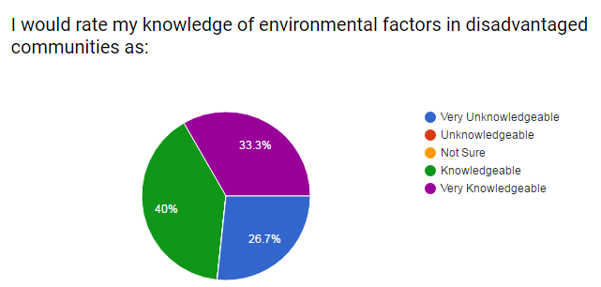
73.3% of participants declared that they are knowledgeable about environmental factors in disadvantaged communities. and 26.7% were determined to be very unknowledgeable. 0% marked that they were not sure, and unknowledgeable.

Figure 1.2 Question #2
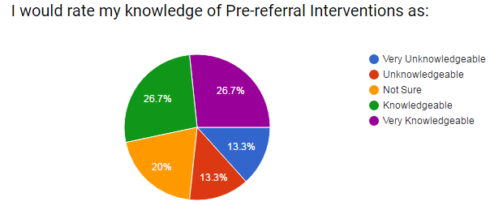
53.4% of respondents rated their knowledge of pre-referral interventions as knowledgeable. 20% of the participants were not sure, while 13.3% indicated that they were unknowledgeable, and 13.3% claim to be very unknowledgeable. Therefore, 26.6% declared some degree of no knowledge of Pre-referral Interventions.

Figure 1.3 Question #3
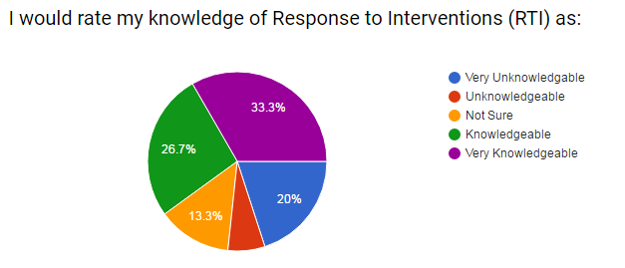
60% of the participants indicated that they had knowledge of RTI. 26.6% of respondents indicated that they have no knowledge of RTI. 13.3% of the participants marked that they were unsure about their knowledge of RTI.

Figures 2.1 – 2.6 Reports details about environmental factors, their impact on children’s development and misdiagnosis or lack of diagnosis.
Figure 2.1 Question #4
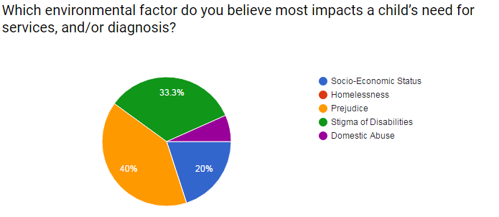
40% of the participants indicated that prejudice is the environmental factor that most impacts a child’s need for services, and/or diagnosis. Stigma of disabilities received 33.3%, socio-economic status received 20%, and domestic abuse received 6.7%.

Figure 2.2 Question #7
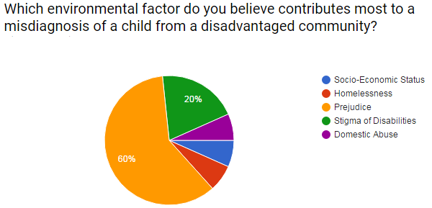
60% of the participants indicated that prejudice is the environmental factor that most contributes to a child from a disadvantaged community receiving a misdiagnosis. Stigma of disabilities received 20%, and domestic abuse, homelessness, and socio-economic status each, individually, received 6.7%.

Figure 2.3 Question #8
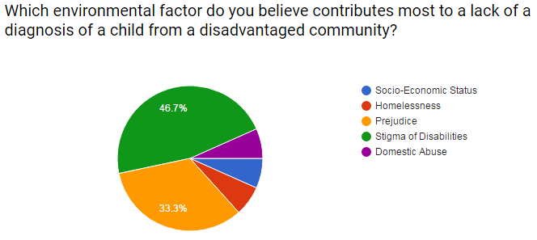
46.7% of the participants indicated that stigma of disabilities is the environmental facto that most contributes to a child from a disadvantaged community not receiving a diagnosis. Prejudice received 33.3%, domestic abuse, homelessness, and socio-economic status each, individually, received 6.7%.

Figure 2.4 Question #5
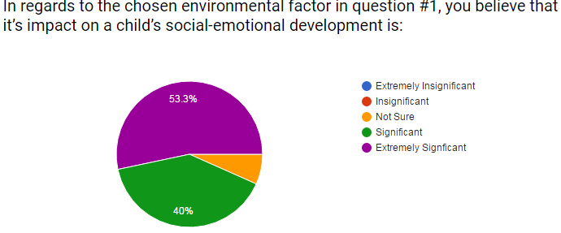
53.3% of the participants indicated that they believe that the environmental factor that they chose in question #1 has an extremely significant impact on the child’s social-emotional development. 40% marked the environmental factor’s impact as significant. Therefore, 93.3% declared that the environmental factor they chose has some degree of a significant impact on a child’s social-emotional development. 6.7% declared that they were not sure.

Figure 2.5 Question #6
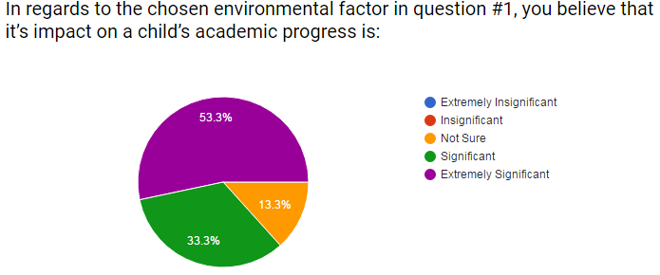
53.3% of the participants indicated that they believe that the environmental factor that they chose in question #1 has an extremely significant impact on the child’s academic progress. 33.3% marked the environmental factor’s impact as significant. Therefore, 86.6% declared that the environmental factor they chose has some degree of a significant impact on a child’s academic progress. 13.3% declared that they were not sure.

Figure 2.6 Question #9
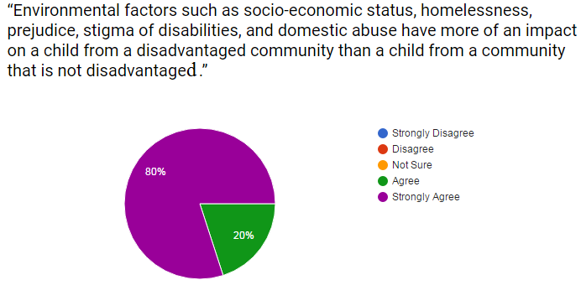
80% of the participants indicated that they strongly agree that environmental factors have more of an impact on a child from a disadvantaged community than it does on a child that is not from a disadvantaged community. 20% indicated that they agree with the statement. Thus, 100% of the participants indicated that to some degree they agree that environmental factors have more of an impact on a child from a disadvantaged community than it does on a child that is not from a disadvantaged community.

Figures 3.1 – 3.5 show responses regarding interventions.
Figure 3.1 Question #10
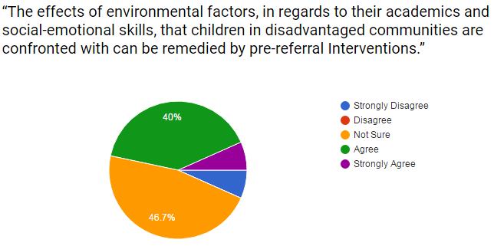
46.7% of the participants indicated that they are not sure if pre-referral interventions can remedy the effects of environmental factors on children’s social-emotional development and academic progress in disadvantaged communities. 46.7% of the participants indicated that they agree, and 6.7% indicated that they strongly disagree.

Figure 3.2 Question #11
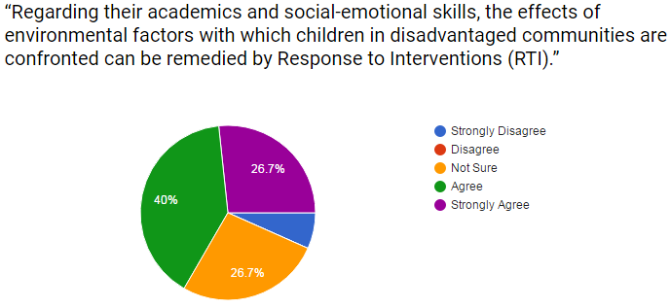
66.7% of the participants indicated that they agree that RTI can remedy the effects that environmental factors in disadvantaged communities have on children’s social-emotional development and academic progress, 26.7%indicated that they are not sure, and 6.7% indicated that they strongly disagree.

Figure 3.3 Question #12
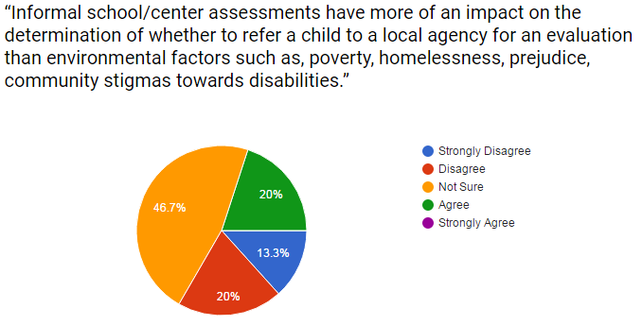
46.6% of the participants indicated that they are not sure if informal school/center assessment can have more of an impact than environmental factors in disadvantaged communities have on whether a child is referred to a local agency for an evaluation to determine eligibility for special services. 20% indicated that they agree, 20% indicated that they disagree, and 13.3% indicated that they strongly disagree.

Figure 3.4 Question #14
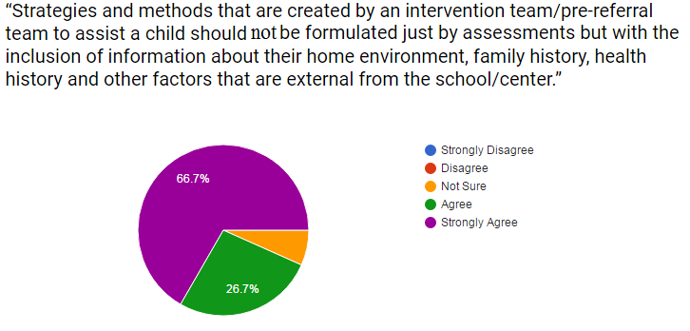
66.7% of the participants indicated that they strongly agree that information about a child’s home environment, family history, health history, and other factors that are external from the school/center should be included with assessments in the creation of the strategies and methods by an intervention team/pre-referral team. 26.7% indicated that they agree, and 6.7% indicated that they are not sure.

Figure 3.5 Question #13
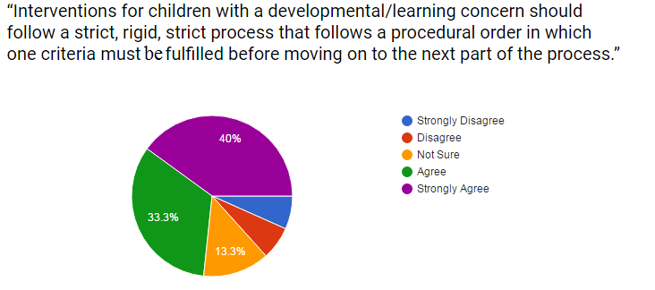
40% of the participants indicated that they strongly agree that interventions for children with a developmental/learning concern should follow a strict, rigid, strict process that follows a procedural order in which one criteria must be fulfilled before moving on to the next part of the process. 33.3% indicated that they agree, 13.3% indicated that they are not sure, 6.7% indicated that they disagree, and 6.7% indicated that they strongly disagree.

CHAPTER V
DISCUSSION
The purpose of this study was to examine staff members' of an early childhood education center perceptions of environmental factors, pre-referral interventions, and Response to Interventions (RTI) in disadvantaged communities and the impact that they have on a misdiagnosis or a lack of a diagnosis for a child. Specifically the study explored what environmental factors have the most significant impact on a child receiving a misdiagnosis or a lack of a diagnosis; furthermore, what, if any impact does pre-referral interventions and RTI on remedying the environmental factors in disadvantaged communities; and whether pre-referral interventions and/or RTI have a greater positive impact with children in disadvantaged communities than the negative impacts of the environmental factors that they face. The participants’ perception of environmental factors in disadvantaged communities indicated prejudice as being the factor that had the most impact on a child’s need for services and/or a diagnosis; 40% believe that it most impacts a child’s need for services, and/or diagnosis, 60% believe it most contributes to a misdiagnosis, and 33.3% believe it contributes most to a lack of a diagnosis.. Additionally, the staff members who responded to the survey believe that prejudice is also the environmental factor that most contributes to a child being misdiagnosed in a disadvantaged community. Half of the participants (46.7%) viewed pre-referral interventions as a means to remedy the negative impacts of the environmental factors they are confronted with in their community. Conversely, the other half of the respondents were not sure about what type of impact pre-referral has on combating the negative environmental factors found in disadvantaged communities. More than half of the participants’ perception of RTI was that it has the ability to have a positive impact on a child’s academic and social-emotional skills. Staff’s perception was overall positive in regards to pre-referral intervention and RTI being capable of remedying the environmental factors children are confronted with in disadvantaged communities.
Implications
The results of the survey showed that respondents believed that the interventions have a positive impact on a child’s development. The data collected determined that the participants’ overall belief was that the environmental factors in disadvantaged communities had a greater negative impact on a child’s development, and them either receiving a misdiagnosis or a lack of a diagnosis. Respondents in the survey held similar beliefs in the potential of pre-referral interventions’ and RTI’s capabilities with resolving the challenges children face, from environmental factors, in disadvantaged communities. Survey results showed, with both pre-referral interventions (PRI) and RTI, that less than 10% (6.7%) of the respondents disagreed that is has the capacity to rectify the negative effects of environmental factors in disadvantaged communities. The majority of the respondents concluded that both intervention methods have the wherewithal to assuage the effect of environmental factors on children that are prevalent in disadvantaged communities. When comparing respondents’ knowledge of PRI (53.7%) and RTI (60%), the results indicate the implication for more professional development in regards to PRI and RTI. While the study did not determine specifically how each group of participants responded, half (53.4%) were employees (Special Needs Service Providers, Instructional Coaches, Mental Health Consultants) who are, from the researcher’s experience, more likely to have a background knowledge of PRI and/or RTI, and the other half (46.6%) were employees (Teachers, classroom assistant, classroom aide) who are, more likely to not have a background knowledge of PRI and/or RTI. Therefore, professional development for staff should target teachers, classroom assistants, and classroom aides. Furthermore, it can also be implied that classroom staff (teachers, classroom assistants, classroom aides), due to their belief in the potential of both PRI and RTI, are possibly implementing these interventions without connecting them to the overall processes. This is implied because the classroom staff play an integral role in implementing the strategies and methods from PRI and RTI, yet it can be implied that many of them indicated some degree of lack of knowledge of PRI and/or RTI. Embedded professional development from staff members such as the instructional coaches, special needs service providers, and mental health consultants needs to be improved for classroom staff members to connect their actions to the processes behind PRI and/or RTI.
Threats to Validity
There were threats to validity detected in this study. An internal threat to the validity is regarding the quantitative data, in which the response rate to the survey was 37.5%, which is 12.5% less than half of the participants that were given the survey. The sample size included 15 participants, which being small, poses an internal threat. Additionally, another internal threat is that the survey was created by the researcher. The survey was only provided to individuals that are from and/or work in a disadvantaged community and was not provided to another community that is not disadvantaged. Therefore, an external threat is the possibility of a response bias due to the survey being distributed to only one population group via selection bias. Another external threat to validity within this study is social desirability bias. The majority of the survey respondents were participants who view the researcher as a supervisor. Thus, there is a possibility that a portion of the respondents’ answers where determined through the prism of that reality.

Connections to Previous Studies
There are links between this study and previous research. Buck (2011) presented research in regards to children who have a culturally diverse background and the impact that pre-referral intervention has on those children receiving a misdiagnosis. Compounded with Hooper’s (2011) research, in which it is stated that teachers should have an essential understanding of how to implement interventions, Buck and Hopper’s research does not connect to the findings within the current study. The findings in the survey contradict Buck and Hopper’s research as the respondents, half of them, indicated that they are not sure of their knowledge of pre-referral interventions, yet the survey showed that the majority of the participants believe that pre-referral interventions can remedy the effects of environmental factors in disadvantaged communities. Therefore, the survey presents findings that imply that the participants do not connect their understanding of pre-referral interventions with the success of the interventions that are implemented. Additionally, the research and the findings within the survey do not support Buck’s statement about pre-referral interventions because it does not show that, in the opinion of the participants, if more of the participants were knowledgeable about it there would be higher success among the respondents with implementing pre-referral interventions in a disadvantaged community.
Another study that connects to this study comes from Block, et al. (2001). In their study, they discuss prejudice and stigmas of disabilities and the impact that they have on individuals in disadvantaged communities. This study indicated that 40% of the participants indicated that prejudice most impacts a child’s need for services, 60% of the respondents marked that prejudice is the environmental factor that contributes most to a misdiagnosis of a child in a disadvantaged community, and 46.7% of the participants indicated that stigma of disabilities contributes most to a lack of a diagnosis of a child from a disadvantaged community. Thus, this study, like Block, et al. (2001), found that the two most frequently noted environmental factors from a disadvantaged community that impacts a child diagnosis are prejudice and stigmas of disabilities.
Implications for Future Research
An implication for future research would be to provide a survey, similar to the one in this study, to a community that is not disadvantaged to compare the findings within this study. A casual-comparative research study could find the differences of beliefs and perspectives in the potential of pre-referral interventions and RTI in disadvantaged communities, and non-disadvantaged communities. A researcher would present the survey not only to a community that is disadvantaged but to an early childhood education center in a non-disadvantaged community. To expand the results of the casual-comparative research a researcher can determine what defines a community as disadvantaged, middle class, and upper class and then provide a survey to a center in each defined community. Moreover, in lieu of a self-created survey, a researcher should use a survey where items have been piloted for validity. Using such surveys in each designated community could provide more clarity on the beliefs and perspectives professionals in early childhood have on pre-referral interventions and RTI.
Another implication for future research would be to conduct quasi-experimental research in relation to this study’s inquiry. A researcher could select three groups of children in disadvantaged communities and three groups of children in a community that are not in disadvantaged communities. In the disadvantaged communities one group would not be introduced to pre-referral interventions or RTI, another group would be exposed to pre-referral interventions, and a third group would be exposed to RTI other a determined period of time. The children selected in the groups would be students who are impacted by the environmental factors in the disadvantaged community. The researcher could compare each groups’ academic and social-emotional progress of the designated period of time to determine whether pre-referral interventions or RTI had more of a positive impact or success rate. In concert with that experiment, the same experiment would be taking place at the same time but with children from a community that is not disadvantaged. The findings between each community would be analyzed to determine the success rates of pre-referral interventions and RTI in the differing communities, and to indicate if there are any similarities between the communities.
Summary
This study examined the perspectives staff members, in an early childhood education center in northeast Washington, DC, have of pre-referral interventions and Response to Interventions (RTI) on children in disadvantaged communities. Information from other research, in relation to the knowledge ability of staff and the success of intervention implementation, was contradicted by beliefs and perspectives indicated on this study’s survey. Staff members who responded to the survey displayed a disconnect between knowledge of pre-referral interventions and RTI, and the success of the implementation of each type of intervention method. Similarities with the findings of the survey to other researchers’ studies were found in connection to the environmental factors that most effect children in disadvantaged communities. The perspectives of the participants in the study, in regards to the environmental factors that most effect children in disadvantaged communities, mirrored findings in previous research. Future supplementary research should seek to investigate the various success rates of pre-referral interventions and RTI in a multitude of different communities to determine the impact of environmental factors in different communities on children’s social-emotional development and academic progress.

References
Bertelli, M. O., Munir, K., Harris, J., & Salvador-Carulla, L. (2016). "Intellectual developmental
disorders": Reflections on the international consensus document for redefining "mental retardation-intellectual disability" in ICD-11. Advances in Mental Health and Intellectual Disabilities, 10(1), 36-58. Retrieved from https://goucher.idm.oclc.org/login?url=http://search.proquest.com.goucher.idm.oclc.org/docview/1757859183?accountid=11164
Block, P., Balcazar, F. E., & Keys, C. B. (2002, Fall). Race, poverty and disability: Three strikes
and you're out! or are you! Social Policy, 33, 34-38. Retrieved from https://goucher.idm.oclc.org/login?url=http://search.proquest.com.goucher.idm.oclc.org/docview/220686572?accountid=11164
Block, P., Balcazar, F., & Keys, C. (2001). From pathology to power: Rethinking race, poverty,
and disability. Journal of Disability Policy Studies, 12(1), 18. Retrieved from https://goucher.idm.oclc.org/login?url=http://search.proquest.com.goucher.idm.oclc.org/docview/211197237?accountid=11164
Buck, G. (2013). Prereferral Interventions. In E. Fletcher-Janzen, K. Vannest & C. Reynolds
(Eds.), Encyclopedia of special education: A reference for the education of children, adolescents, and adults with disabilities and other exceptional individuals. Hoboken, NJ: Wiley. Retrieved from https://goucher.idm.oclc.org/login?url=http://search.credoreference.com/content/entry/wileyse/prereferral_interventions/0
Cormier-Lavergne, T. (2010). Does a classification of developmental delay lead to special
education in subsequent evaluations? using logistic regression analysis to predict evaluation outcomes (Order No. 3410654). Available from Education Database. (506428797). Retrieved from https://goucher.idm.oclc.org/login?url=http://search.proquest.com.goucher.idm.oclc.org/docview/506428797?accountid=11164
Dombrowski, S. C., Kamphaus, R. W., Barry, M., Brueggeman, A., et al. (2006). The solomon
effect in learning disabilities diagnosis: Can we learn from history?School Psychology Quarterly, 21(4), 359-374. Retrieved from https://goucher.idm.oclc.org/login?url=http://search.proquest.com.goucher.idm.oclc.org/docview/195366038?accountid=11164
Gabriel, L. R. (2011). Systems and structures at a high performing high poverty school: A case
study using RTI to promote student achievement (Order No. 3465996). Available from Education Database. (884317666). Retrieved from https://goucher.idm.oclc.org/login?url=http://search.proquest.com.goucher.idm.oclc.org/docview/884317666?accountid=11164
Gorski, D. (n.d.). What is RTI? Retrieved November 22, 2016, from
http://www.rtinetwork.org/learn/what/whatisrti
Harrison, A. G. (2005). Recommended best practices for the early identification and diagnosis of
children with specific learning disabilities in ontario. Canadian Journal of School Psychology, 20(1), 21-43. Retrieved from https://goucher.idm.oclc.org/login?url=http://search.proquest.com.goucher.idm.oclc.org/docview/224376930?accountid=11164
Hooper, B. B. (2011). Preparing early childhood special educators for inclusive practice(Order
No. 3453650). Available from Education Database. (867271073). Retrieved from https://goucher.idm.oclc.org/login?url=http://search.proquest.com.goucher.idm.oclc.org/docview/867271073?accountid=11164
Mackrides, P. S., D.O., & Ryherd, S. J., EdM. (2011). Screening your child for developmental
delay. Pediatrics for Parents, 27(11), 21-22. Retrieved from https://goucher.idm.oclc.org/login?url=http://search.proquest.com.goucher.idm.oclc.org/docview/1017708403?accountid=11164

